AN-NAJAH NATIONAL UNIVERSITY

FACULTY OF ENGINEERING AND INFORMATION
TECHNOLOGY
Computer Engineering Department


Software Graduation Project

Palestinian-chalet

Students:
Amer Zagha
Amr Salman

Supervisor:
Dr.Mona Demaidi

Jan, 2024

Acknowledgement

This work would not have been possible without first God and then our families and friends. We are especially indebted to Dr. Mona Demaidi, who were supportive of our professional goalsand who actively worked to provide us with psychological support.
We are very pleased to work with the Dr. Mona Demaidi and take advice from her andconstructive criticism that made the project a realizable project on reality.
No one was more important to us in the pursuit of this project than my family members. I wouldlike to thank our parents, who are the ultimate role models.

We worked hard and diligently throughout the project, and we tried to create a way to facilitate everyone who can use our program and anyone who wants to spend a beautiful vacation and wants to make his decision without any confusion and with credibility.

We would like to thank Dr. Mona Demaidi again for all her efforts and information, and we would like to thank our university and everyone who accompanied us during our years of study.
”

Amer, Amr

Content
1. Abstract 1
2. Introduction 2
2.1. Constraints 2
2.2. Earlier course work 3
3. Literature Review 3
3.1. Booking.com 3
3.2. SimplyBook.me 4
3.3. What advantages does "Palestinian Chalets" offer? 5
4. Methodology 5
4.1. Architecture & Technologies Utilized 5
4.1.1. System Design 5
4.1.2. System Architecture 6
4.1.3. Technologies Utilized 7
4.1.4. Node.js with Express for Back-end: 7
4.1.5. Flutter for mobile app: 8
4.1.6. MySQL for Data Base: 9
4.2. Use Case Diagrams 9
4.2.1. User- Use Case Diagram: 9
4.2.2. Admin – Use Case Diagram 11
4.2.3. Activity Diagram: 11
4.3. Functional Requirements 12
4.4. Nonfunctional Requirements 13
4.5. Class Diagram and Data Base 14
4.5.1. Class Diagram 14
4.5.2. Database Design 15
5. Results and Discussion 15
5.1. Opening Page: 15
5.2. Sign up Page 16
5.3. Login 18
5.4. Forget Password page 19
5.5. Home 20
5.6. Booking page 21
5.7. Profile Page: 25
5.8. Reservation page: 26
5.9. Edit chalet page: 26
5.10. Owner's chalet reservations: 27
5.11. Maps Page: 28
5.12. Notification page : 29
5.13. Chat page : 31
5.14. Edit profile page: 33
5.15. Favorite Page: 34
5.16. Search page: 35
5.17. Admins pages: 36
5.17.1. Login admin : 36
5.17.2. Chalet acceptance page: 37
5.17.3. This page is for displaying users: 37
5.17.4. Page to display the vaulted chalets in the city: 38
5.17.5. Page to view reservations: 38
5.17.6. Reset password: 39
6. Conclusions and Recommendation 39
6.1. Summary 39
6.2. Future work 40
7. References 40

Abstract

With the advancement of technology and its use in solving many problems, we had to use it
to find a solution to the problem of renting chalets in Palestine, and from here came the idea
of our project.
We will allow chalet owners to display their chalets on the application and publish pictures
of the chalet, its location, description, and rental price.
However, before adding the chalet to the application, the approval of the official must be
obtained to ensure that the safety conditions and specifications are met.
Tenants search for a chalet in the location they want and the specifications they want.

Introduction

While people have begun to prefer going to private chalets with their families rather than going to public swimming pools and gardens due to the privacy available in these chalets, it has become annoying for a person to search for the numbers of the chalet owners or their pages on social networking sites such as (Facebook, Instagram) and not know if there is a suitable reservation. Available for the day you want it
It has become necessary to create a program that makes the user more comfortable in arriving at the chalet he wants and knowing all the chalets surrounding his area without the need for long research.
Then came the idea of making an application (Palestinian Chalets), which allows every user, whether an owner or a tenant, to benefit from it.
In the case of the owner, he can offer his chalet for rent, which helps him in organizing reservation times and displays the location of his chalet on the map.
In the case of the tenant, our application is the easiest way for him to obtain a suitable reservation for him with the least effort and time possible and with all the details he wants.Constraints, Standards/Codes and Earlier course work

Constraints

There are a small set of limitations that the system can face, including:

- Fear of data security breach.

- The process of converting the reservation and payment method to a computerized method, with the amount of people who find it difficult to use and understand such applications, constitutes a major challenge, as in the Arab world in particular there is still a limit in dealing with smart programs, and people prefer pen and paper.

- The main beneficiaries of reservation applications are tenants and owners at the same time, as the tenant finds his request in the fastest possible way and with the best quality.
- As for the owner, these applications are one of the best ways to market his chalets, as every user of the application will see his chalets for rent, unlike social networking sites that do not offer them to everyone without paying money.

Earlier course work
One of the most fascinating parts of the endeavor is its preparation. We look for innovative frameworks that will enable us to accomplish the objectives of our project. This stage offered us a solid understanding of the available frameworks and technologies utilized in the creation of our website and our mobile applications, saving us time studying these frameworks.

Literature Review
In general, an appointment scheduling system, also known as an appointment booking system or appointment management software, is a solution that makes it easier for service providers to manage appointments. The tools in the appointment management solution can include: online booking. Booking mobile applications. In this chapter we will list some systems that are similar to our system. However, each system has his pros and cons, and while some of the systems contain some extra or irrelevant features, but all of them discussed appointment scheduling system.

Booking.com
Booking.com’s mission is to make it easier for everyone to experience the world.
By investing in the technology that helps take the friction out of travel, Booking.com seamlessly connects millions of travellers with memorable experiences, a range of transport options and incredible places to stay - from homes to hotels and much more. As one of the world’s largest travel marketplaces for both established brands and entrepreneurs of all sizes, Booking.com enables properties all over the world to reach a global audience and grow their businesses.
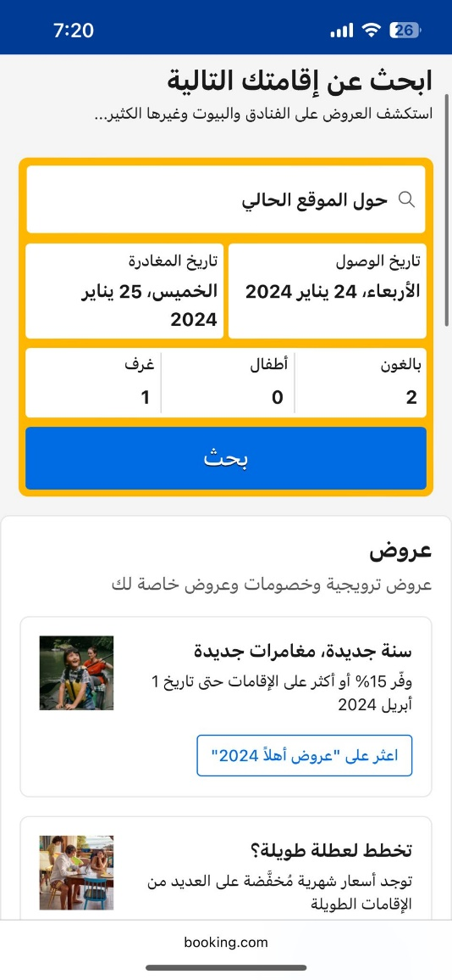
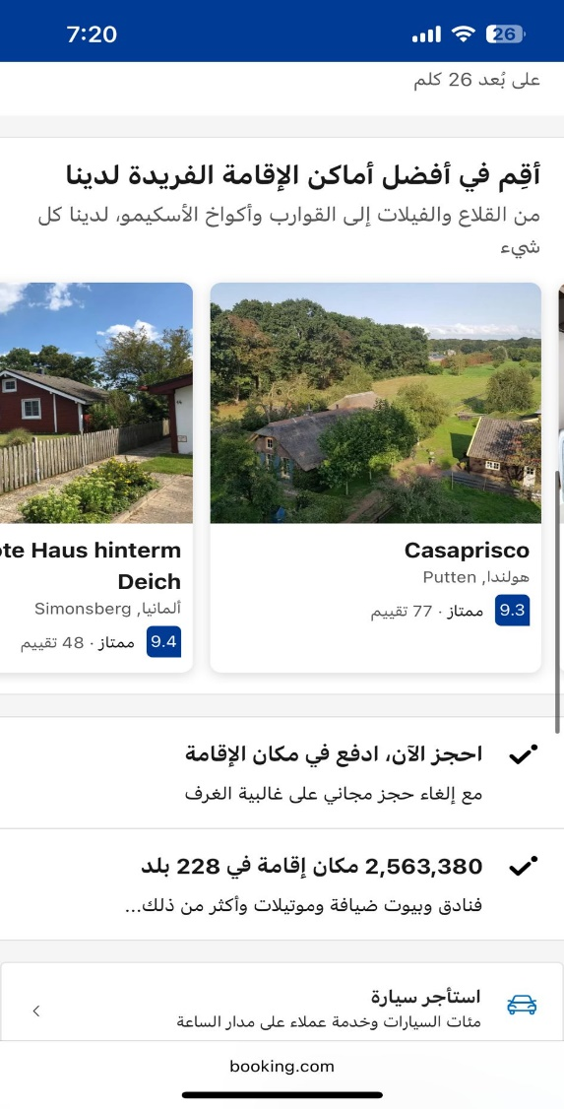

Figure 4.1.1: Booking.com

SimplyBook.me
IOS application. Users will receive notifications about new bookings and reminders about upcoming appointments for free through the app.[2]
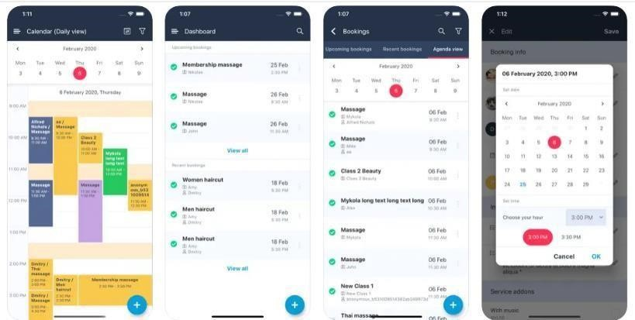
4.2.1 : SimplyBook.me

What advantages does "Palestinian Chalets" offer?
We've diligently merged the finest features offered by various apps, aligning them with contemporary software technology. Our user interfaces are designed to be straightforward and user-friendly, catering to users of all ages, and this concept has been implemented across both web and smartphone platforms.

Methodology
In this section, we delve deeper into the research methodology employed in this study, aiming to fulfill the objectives outlined in earlier chapters. The focus will be on examining the research design, the approach to sampling, and the methods used for data collection.

Architecture & Technologies Utilized
This chapter will present various structures essential for constructing and organizing our system. These structures consist of software components, their interconnections, and the characteristics of both these components and their connections.

System Design
In this section, we explore the technical architecture of our system. By examining the system-level design, understanding the data flow throughout the entire system becomes more straightforward. This component, which can be considered the core framework of our system, provides the essential elements our system encompasses, as depicted in the image below.
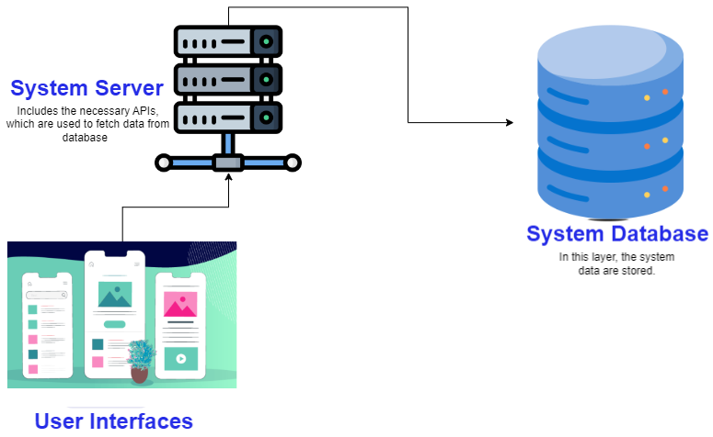
5.1.1 : System Design

System Architecture
- Users are prompted to input their personal details as required.
- This information is transmitted to the server for analysis before being systematically organized within the database.
- The server manages the data gathered from the application, saves it to the database, handles inquiries from the system application and individual users, and subsequently retrieves the data from the database.
- The user will reach the main/home interface that contains the services provided by the system.
- The tenant will schedule the reservation for the chalet on the day he wants within the available dates.
- The owner will receive a notification that a reservation has been made for one of his properties by the tenant
- The appointment will be stored in the system's database in addition to the necessary information.
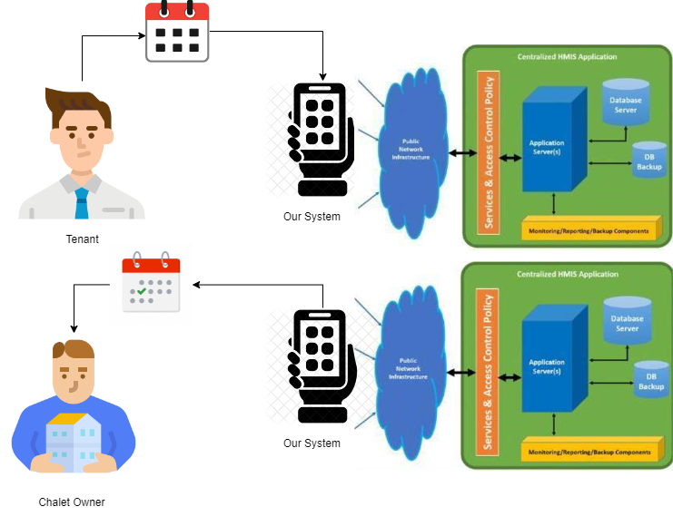

5.1.2 : Appointment System In Data Base

Technologies Utilized
A web application consists of three layers at the very least: client-side (frontend), server-side (backend), and database (persistence layer), in this section we will show you the technologies used in building all of the above towards the following:

Node.js with Express for Back-end:
Node.js, in tandem with Express, forms a powerful combination for backend development and building robust APIs. Node.js, known for its event-driven architecture and asynchronous I/O, provides a scalable and efficient runtime for server-side applications. Express, a minimal and flexible Node.js web application framework, simplifies the process of creating APIs and handling HTTP requests. Together, they enable developers to craft performant backend systems, allowing for the seamless integration of database operations, business logic, and the creation of dynamic APIs that can be easily consumed by frontend applications. The Node.js-Express duo has become a popular choice among developers seeking a fast and scalable solution for server-side development.

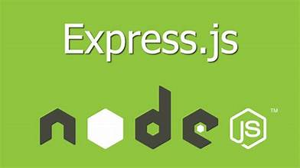
4.1.4.Node.js with Express for Back-end:

Flutter for mobile app:
As stated on the Flutter website, it's unnecessary to maintain distinct code bases for iOS and Android platforms. Flutter enables the creation of a unified codebase that can be deployed across multiple platforms, including web, desktop, and mobile. This approach leads to faster application deployment and is more economical.



5.1.4 Flutter

MySQL for Data Base:
The MySQL website indicates that MySQL is the leading Open Source SQL database management system. It is created, distributed, and backed by Oracle Corporation. This database system is designed as a client/server model featuring a multithreaded SQL server compatible with various back ends. It includes a suite of client programs and libraries, tools for administration, and an extensive selection of application programming
interfaces (APIs).



5.1.5 : MySql for DataBase

Use Case Diagrams
The use case diagram is the most important parts of the UML that illustrate the actors of our system and the relationships between the use cases.

User- Use Case Diagram:

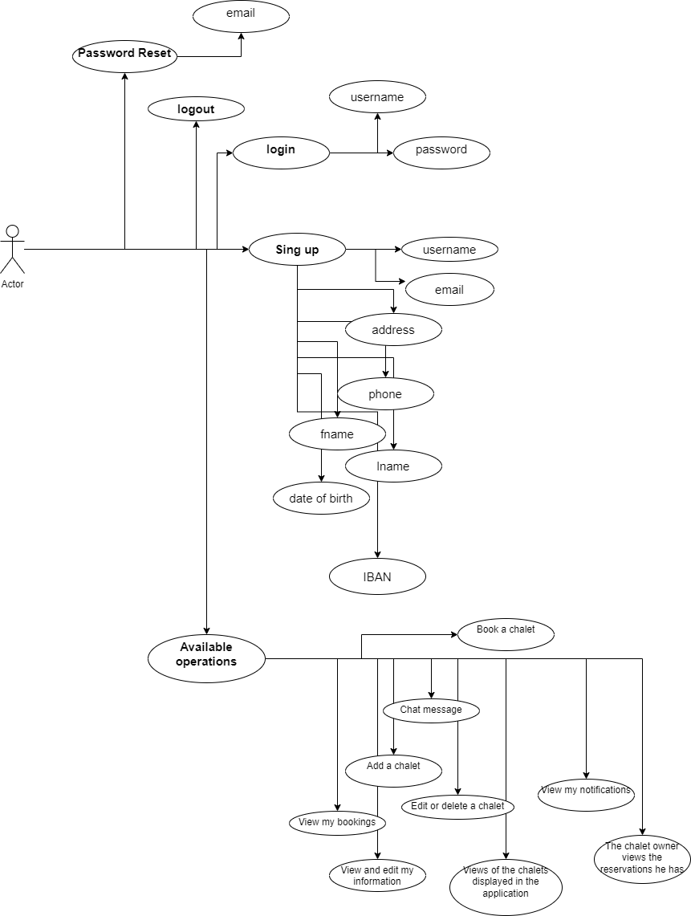
Figure 4.2.1: User - Use Case Diagram

Admin – Use Case Diagram

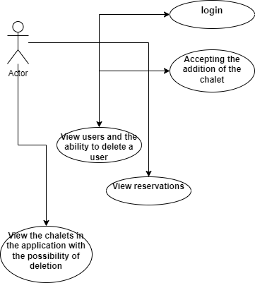
Figure 4.2.2: Admin – Use Case Diagram

Activity Diagram:

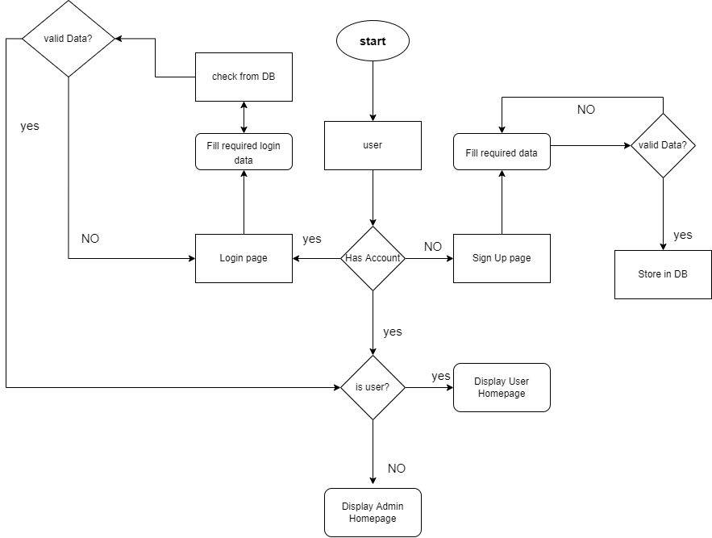
Figure 4.2.3: Activity Diagram

Functional Requirements
Developers need to execute product functionalities or features to enable users to fulfill their tasks. It is essential for both the development team and stakeholders to have clarity on these elements. Functional requirements typically detail the actions of a system when faced with specific conditions.
- The system must provide a login interface for each user.
  - The system must have a login interface for the {Tenant, owner}.
  - The system must have a login interface for the admin.

- The system must provide a registered interface for each user.
  - The system must provide a signup form for the Users.

- The system must store the data for each registered user.
  - The system must store the User’s {Tenant, owner} personal information.
  - The system must store the admin’s personal information.

- The system must provide a map service for User’s site.
  - The system map supports the location of the Chalets.

- The system must provide an appointment schedule.

- The system must provide modification interfaces for the owners’ chalets.

Nonfunctional Requirements

These are criteria designed to improve a system's performance, detailing its capabilities and limitations in practice. Essentially, they are the specifications that outline the system's performance characteristics, reliability, security, and more.

Reliability: System failure is unacceptable, and once data reaches the system it must be stored.
Ease of use: The system will be understandable interfaces, so it is easy to use.
Security: Only authorized users can access their data.
- Performance: the system must respond in real time.

Class Diagram and Data Base

Class Diagram

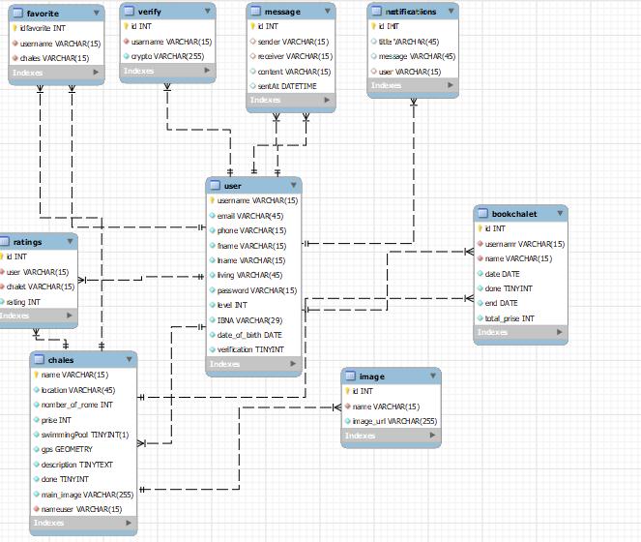
Figure 4.5.1: Class Diagram

Database Design

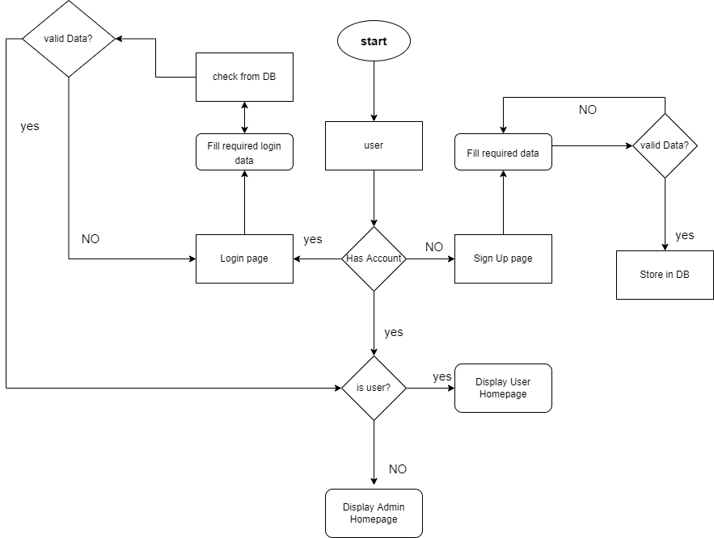
Figure 4.5.2: Database Design

Results and Discussion
This section is dedicated to presenting and analyzing the final outcomes of our project. The chapter is organized into various segments, with each one focusing on discussing one or several functionalities provided by your application.

Opening Page:
It is the first interface that the user sees when opening the application, and it asks him to choose whether to log in or create a new account

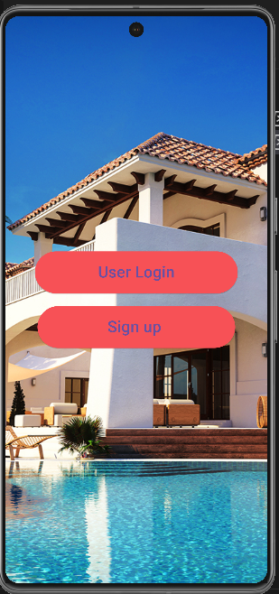
Figure 5.1.1: Opening Page

Sign up Page
If the user clicks on Sign Up, a new account creation page will appear asking him to enter all his personal information. If he already has an account, he can click on log in below. It will take him to the login page.
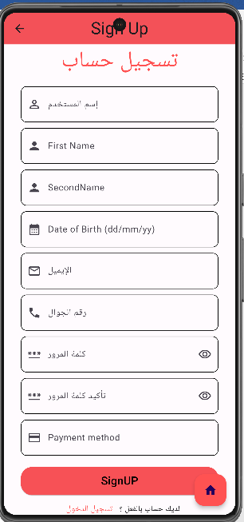
Figure 5.2.1: Sign up Page

Login
Here the user can login in the system by entering his username and password in correct form, if the user don’t have account, he will click on the “Register Now” button.
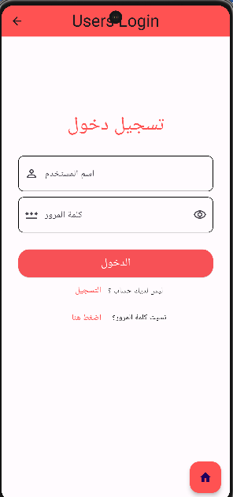
Figure 5.3.1: Login page

Forget Password page
On this page, the user enters his email and then a verification code will be sent to him in order to change the password
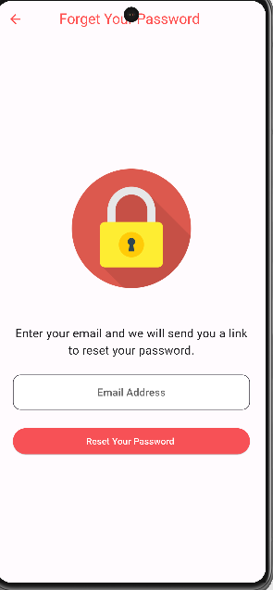

Home
This page contains the main components of the project, which displays the chalets that appear to the user so that he can choose from among them the appropriate chalet for him to book.
Of course, we do not forget the presence of components such as the favorites list and the search and filtering process
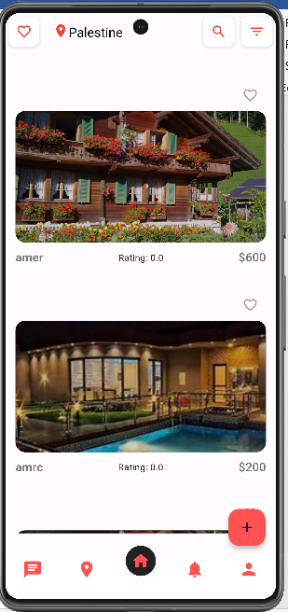

Figure 5.5.1: Home page

Booking page
The most important page in the project on which the reservation process is carried out by the user to reserve the chalet on the day he wants
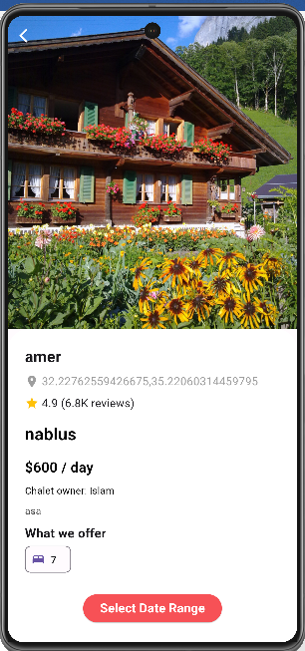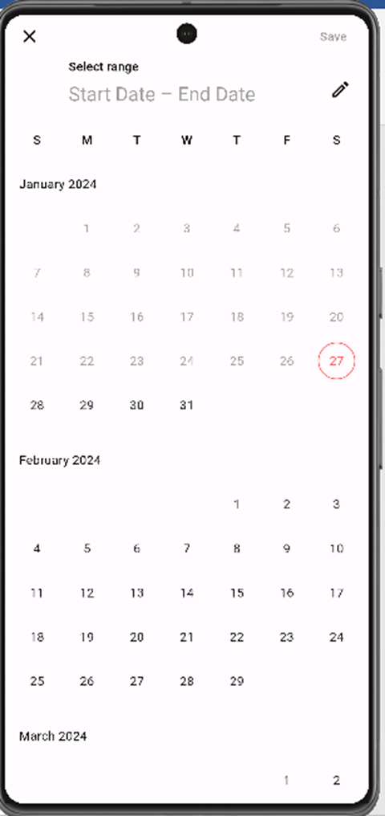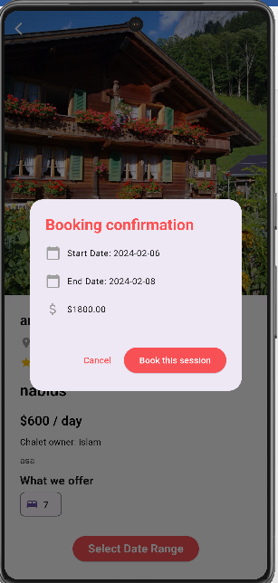

Figure 5.5.1: Booking page

Profile Page:
The page that contains each user's personal information and all the things he needs for his reservations, whether he is an owner or a tenant.

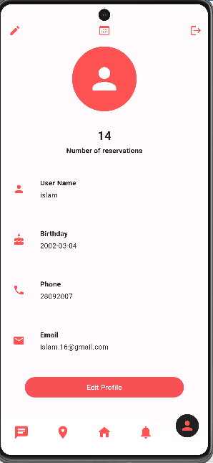
Figure 5.7.1: Profile page

Reservation page:
This page displays the user's reservations in a simple and streamlined manner
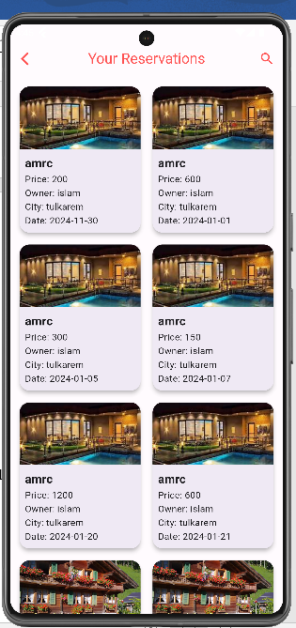

Edit chalet page:
This page is for chalet owners, as it enables them to modify the information of any chalet of their own.
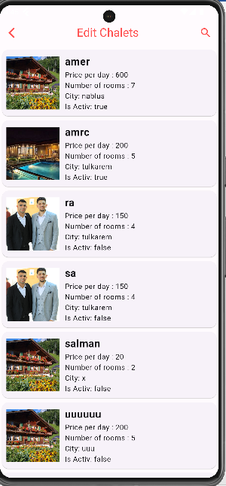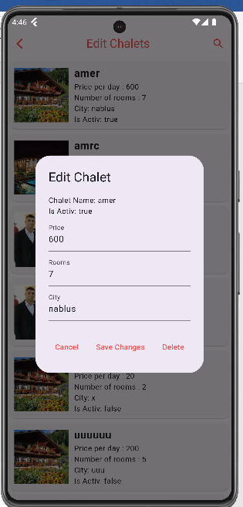

Owner's chalet reservations:
This page contains all the owner's chalet reservations with tenant information.

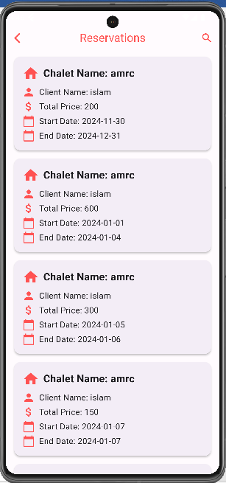

Maps Page:
This page contains a live map that shows each user his location and the chalets surrounding it, making it easy to reach the chalets and choose between them for each user.
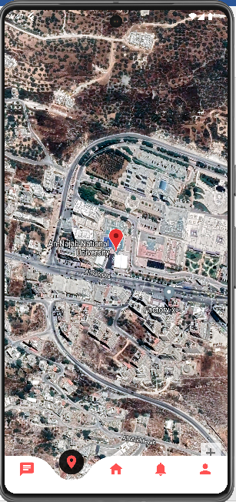

Notification page :

A notifications page displays notifications for each user at the Real time
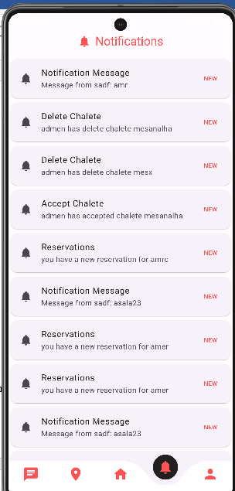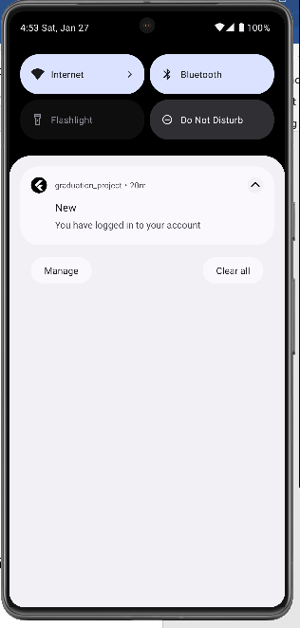

Chat page :

A conversations page displays all users, and the user can make real-time conversations.

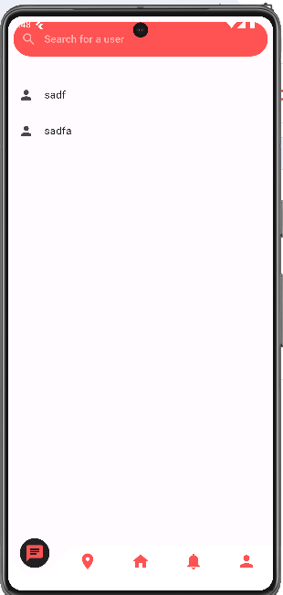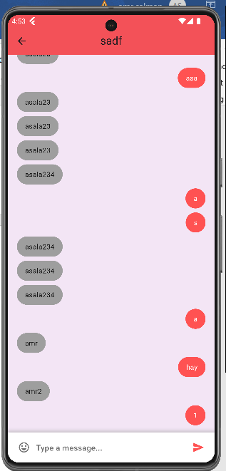

Edit profile page:

This page is for the user to make edits in his personal information.

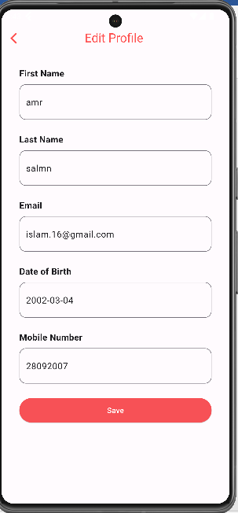

Favorite Page:

This page used to display the chalets that the user loves it and save it to another time later

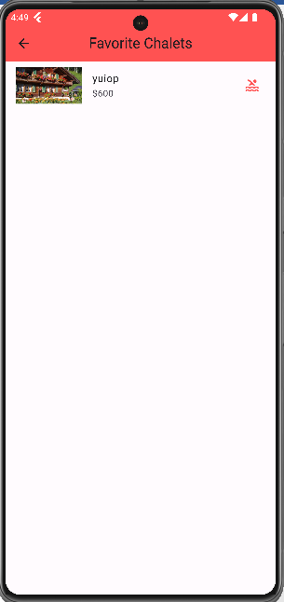
Figure 5.15: favorer Page

Search page:

This page is intended to display specific chalets that the user is searching for .
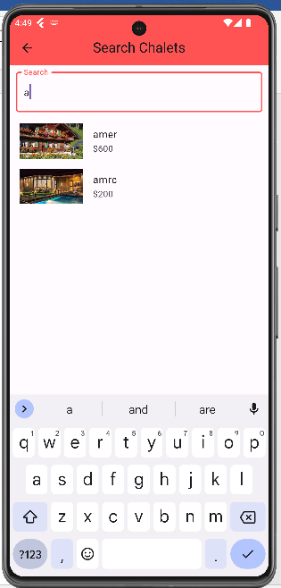
Figure 5.16: search page

Admins pages:

Login admin :
This page is for the admin to log in



Chalet acceptance page:
This page is for the admin to accept or reject requests to add the shell
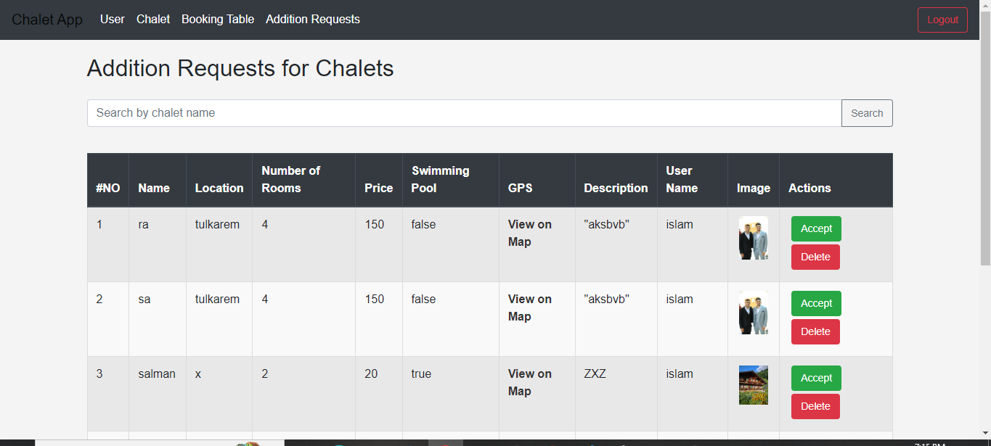

This page is for displaying users:
On this page there are all the users, their information, and the user’s status. Whether the account was activated from the email after Signup or not.
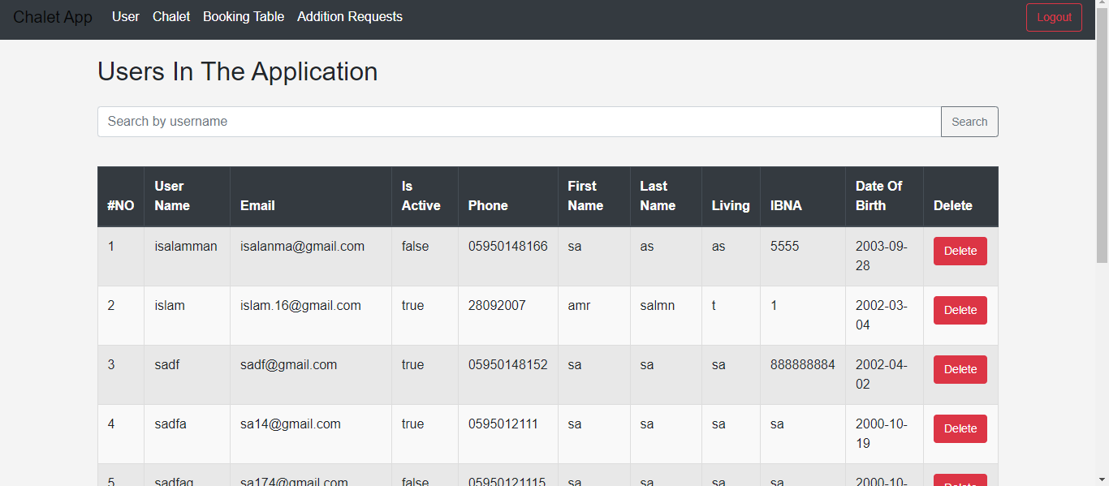

Page to display the vaulted chalets in the city:
This page displays all the chalets that have been accepted in the application with their information, and the admin can delete a chalet from them.
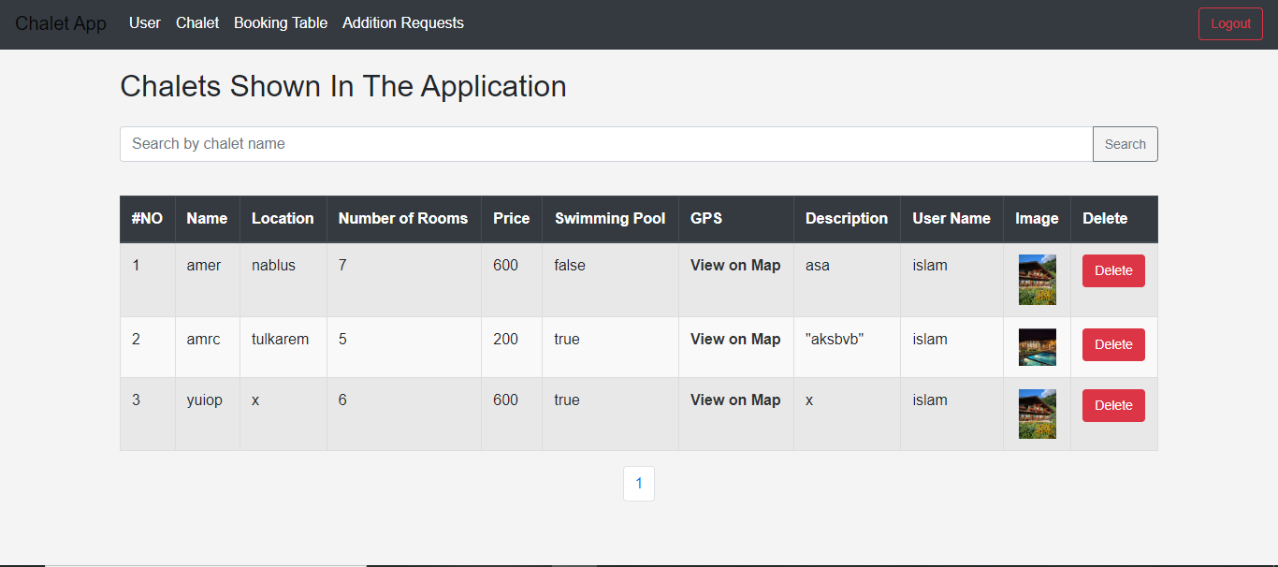

Page to view reservations:
This page displays the seminaries made by users
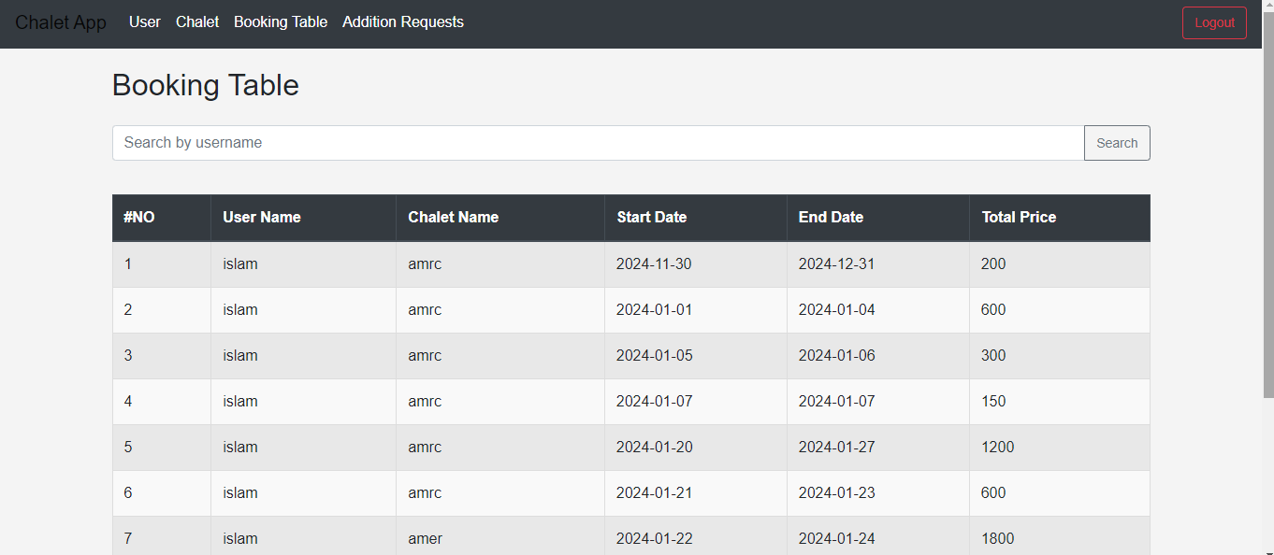

Reset password:
Enter your email and a reset will be sent to him.
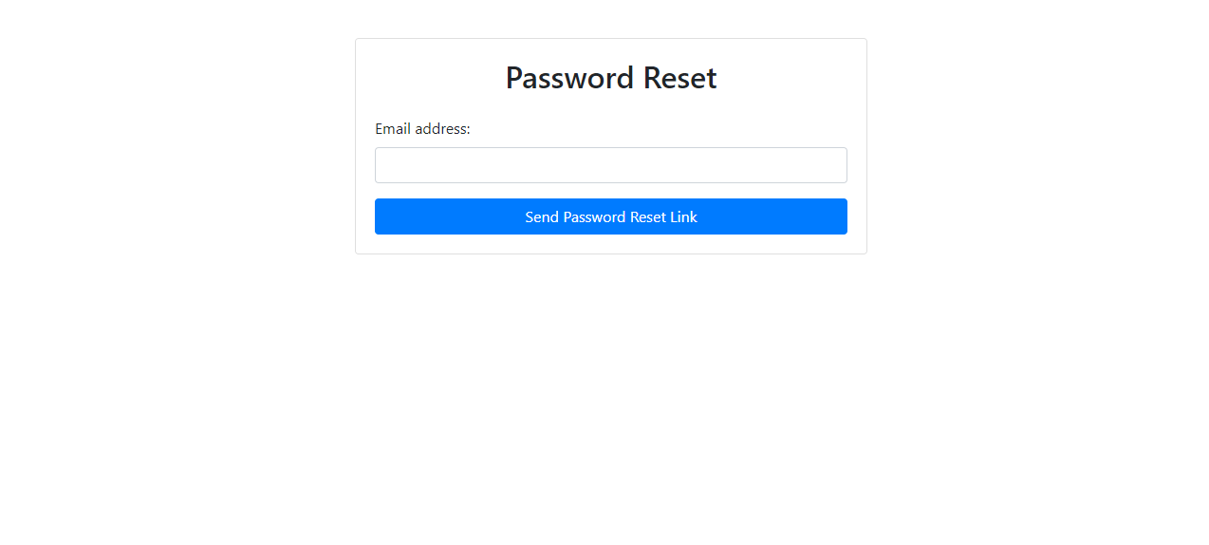

Conclusions and Recommendation
We're going to highlight the most significant project outcomes in this section.

Summary
What we always strive for is technological development in all aspects of practical life. Therefore, after thinking deeply about it, we found that it is very important to automate the process of registering reservations so that we facilitate the process for the owner and the tenant. The owner benefits from knowing all of his chalet reservations in the same application and can view them quickly and with ease.
As for the tenant, he can now book the chalet he wants smoothly and in the best way to choose in terms of location, price, and geographical area.

Future work

While the current system, "Palestinian chalets," provides a comprehensive solution for managing Reservations, there are several areas that can be further enhanced in future iterations. The following are some potential avenues for future work:

- Enhanced Search Filters:
Anticipate more refined and detailed search criteria, allowing users to narrow down chalet options based on precise preferences.

- Augmented Reality Integration:
Experience chalets in augmented reality, providing a realistic and immersive preview of accommodations before booking.

- Smart Recommendations:
Benefit from personalized recommendations based on travel history, preferences, and previous bookings, optimizing the selection process.

.

