
Al – Najah National University
Factually Of Engineering
Electrical Engineering Department

Monitoring and Controlling System in a Chicken Farm

Students:
Eman Madi
Maysoon Mohanna

Supervisor :
Dr. Jamal Kharousheh.

Contents
Abstract…………………………………………….…4
Chapter one : Introduction
  - Introduction…………………………………………….5
  - Objectives……………………………………..................5
  - Where we can use this project?..........................................5
  - Project definitions…………………………….................6
1.4.1 Why we need SMS control system? …………….……...6
1.4.2 What is SMS ?...................................................................6
1.5 Introduction to AT commands…………...………….........8

Chapter two: Project Idea and Problem Statement
2.1 Project Idea………………………………………...…...10
2.2 Problem statement……………………………………..11
Chapter three: AT Command Test
3.1 AT Test…………………………………………….…12
3.1.1 To perform test………………………………..12
3.1.2 Sending SMS…………………………….……16
3.1.3 Receiving SMS………………………………..17
3.1.2 Reading a message…………………...……….18

Chapter four: Project Hardware and Software
4.1 Connecting mobile to PIC (16F877)…………………...20
4.2 Project Hardware…………………………….………...23
4.2.1 Hardware Elements……………………….…….22
4.3 Project software…………………………….…………27
4.3.1 project flow chart …..……….………….............27
4.3.2 Project Code ………………………………..….28

problems ………………………………………...…..38

Appendixes …………………………………………….. 39

References ……………………………………………….44

Abstract:
In our project we aim to control such place and monitor it by making direct communication between the Mobile and Microcontroller (PIC 16F877) , in our case a chicken farm in order to help the owners to control the farm temperature degree with respect to weather conditions, and it can be use in security purposes such as monitor any unfamiliar movement in the farm by using modern technologies especially SMS technology.

In order to detect the farm temperature we will use a temperature sensor, and for motion monitoring we will use an infra red sensor.
After we will take the signal to the PIC it will send an SMS to the owner’s mobile who will send another SMS to determine the action that he want such as turn on a conditioner or a fan if it is hot or turn on a heater if it is cold .
Or turn on an alarm if anyone cut the infrared sensor.
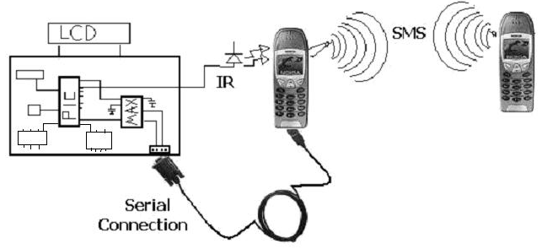
Fig.: Project general view

Chapter One Introduction
1.1 Introduction:
The mobile communication is now available every where the easy with which you can deal with mobile phone to make calls and to make SMS made the mobile phone very popular we can also see that the SMS price is very cheap and because of that we made our minds to co this project to add anew dimension to the mobile phone .
Our project offers wide range of remote monitoring and controlling actions .
Imagine you can monitor and control any place you want via SMS as turning on fans ,heaters ,alarms ……etc .

1.2 Objectives :
1-our project aims to allow owners to monitor and control their farms or houses devices from far places.
2-allow owners to control their farms or houses by cheap cost.

1.3 Where we can use this project?
We can use this project in any place need to be controlled and monitored , such as your home, company ,farms , …….
In our case we choose the chicken farm to control and monitor it.

1.4 Project definitions
1.4.1 Why we need SMS control system?
SMS control system is very useful at the place we have the devices that we need to monitor & control them from any where , such that when we are in travel .
Monitoring & controlling device from a far location is wonderful thing so , we enjoy in working on this project because of it is multi –application.
This project application can be used in every home , school ,office , factory ,and any residential ,commercial ,educational and industrial building .
1.4.2 What is SMS ?
Short message service (SMS) is the ability to send & receive short alphanumeric messages to and from mobile telephones . the first short text message is believed to have been transferred in 1992 over signaling channels of a European GSM network .
Since this successful trial SMS usage has been the subject of tremendous growth .
Work on the standardization of SMS was initiated by ETSI –actually it was created as part of the GSM phase 1 standard , and it is now being carried out in the scope of 3GPP activities . since it is initial introduction in GSM networks, SMS has been ported to other network technologies such as GPRS and CDMA .
The short messages service allows users to exchange messages containing a short amount of text –up to 160 characters .these messages can be sent from GSM /UMTS mobile devices & also from a wide range of other devices such as internet hosts , telex , and facsimile . the SMS is a very mature technology supported by 100% of GSM handsets and by most GSM networks worldwide.
1.4.3 Advantages and disadvantages of SMS :
- Advantages of SMS:
1-SMS allows users to directly transmit messages To each other without operator
2- store and forward If the recipient is not available when the message arrives the message is stored
3- when the message is sent all the delivery details and processes are handled by the SMS center which is located at the mobile network operators site .
4- message delivery notification User is informed that his or her message has been delivered to the destination point .in a circuit –switched data transmission environment a dedicated line is formed between the two points and the user is kept apprised of the connection delivery situation.
- Disadvantages of SMS
1-limited message length
Because of the limitations associated with the MPA( mobile application part) signal layer ,an SMS message may contain maximum 160 characters in a GSM environment for latin characters & a max of 140 for non latin characters
2- inflexible structure
The frame work of the SMS protocol data unit that was defined in GSM 03.40 standard is not flexible enough .data coding scheme , origination address ,protocol identifier , and other header fields .
3- slow signal channel
Congestion in the SMS traffic may give rise to overuse .this inefficient use makes network operator anxious about the potential service bottlenecks.
4- always store & forward
In current SMS architecture all messages must pass through the SMS center before pointing to the destination address.

1.5 Introduction to AT commands:

AT commands are instructions used to control a modem.
AT is the Abbreviation of Attention , every command line starts with "AT" for this reason modem commands are called AT commands .
Many of the commands that are used to control wired dial-up modems ,such as:
- ATD (dial)
- ATA(answer)
- ATH(hook control)
- ATO (return to on line data state)

Are also supported by GSM/GPRS modems and mobile phones.

Besides this common AT command set , GSM/GPRS modems and mobile phones support an AT command set that is specific to the GSM technology ,which includes SMS -related commands .
The following table lists the AT commands that are related to the writing and sending of SMS messages:
AT command | Meaning
+CMGS | Send message
+CMSS | Send message from storage
+CMGW | Write message to memory
+CMGD | Delete message
+CMGC | Send command
+CMMS | More messages to send
+CMGR | Read SMS messages
+CMGL | list SMS messages

One way to send AT commands to a mobile phone or GSM/GPRS modem is to use a terminal program. A terminal program's function is like this: It sends the characters you typed to the mobile phone or GSM/GPRS modem. It then displays the response it receives from the mobile phone or GSM/GPRS modem on the screen. The terminal program on Microsoft Windows is called HyperTerminal

Chapter two Project Idea and Problem Statement

2.1 Project Idea:

The goal of this project is monitoring & controlling the temperature degree in a chicken farm by SMS from far place ,this achieved by using two part one is serial port with mobile & temperature sensor & infra red sensor that sense the change in degree in the farm & any unfamiliar movement , this part can send SMS to second part which is simply mobile tell the owner what happens to the degree if it is high or low & if there is any unfamiliar movement this part called (sensing part) . then the owner of the mobile decide the action to return the degree in the farm suitable by sending SMS to the first part to make specific action like turn on fan or heater ,& turn on alarm system this called the (controlling part ).

The following block diagram illustrate the idea :

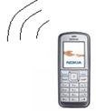

SMS
Interfacing
Circuit .

Sensing & monitoring System

Fig. : Basic Over view

2.2 Problem statement :

To get started doing our project several points are to be determined :

1- type of GSM network :

In our project we select GSM 900 MHZ JAWWAL it is the available one in Palestine

2- Type of mobile useable :
We decide to use Nokia 6070 mobile phone, it is support AT commands & easy to deal with it

3- SMS Coding System:
We must know how the coding system of SMS in the network work .

4- Sensors behavior:
a- Temperature sensor:
We must learn how the sensor read the change in temperature degree & how we can read data from it & that will explain later .

b- infrared sensor:
We must learn how the sensor sense the unfamiliar movement in the farm & how we can read data from it & that will explain later .

Chapter Three AT Command Test

We find that the PIC support the AT commands , so we decide to use these command to program the PIC , to do so first we must test our mobile response for this commands by the following AT test.

3.1 AT Test
After we succeed in finding the right mobile which supports the AT commands, we started looking for it's AT command.

Fig: The mobile phone & it is serial we use

3.1.1 To perform test:
To use HyperTerminal to send SMS to your mobile phone using AT commands we follow the procedure below:
- Connect your mobile phone to a computer by using a serial cable.
- Run HyperTerminal by selecting Start -> Programs -> Accessories -> Communications -> HyperTerminal.
- In the Connection Description dialog box, enter a name and choose an icon you like for the connection. Then click the OK button.
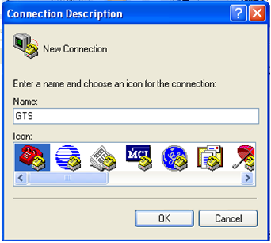
Fig.: HyperTerminal's Connection Description dialog box
4. In the Connect To dialog box, choose the COM port that your mobile phone is connecting to in the Connect using combo box. For example, choose COM1 if your mobile phone is connecting to the COM1 port. Then click the OK button.
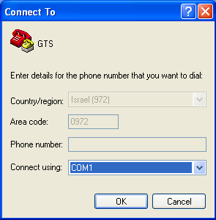
Fig. : HyperTerminal's Connect dialog box.
5. The Properties dialog box comes out. Enter the correct port settings for your mobile phone. Then click the OK button.
In our case the baud rate to be 115200 bps ,the other parameters are :
data bits 7,parity none ,stop bits 1,fiow control none
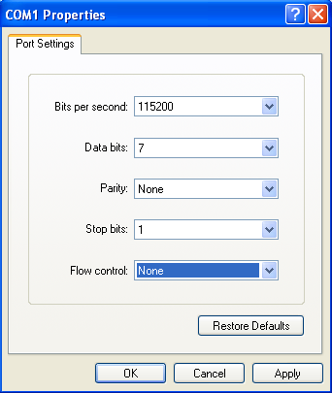
Fig.: The COM properties box
6. Then go to file > properties>setting >ASCII setup> echo typed characters locally then click the ok button.

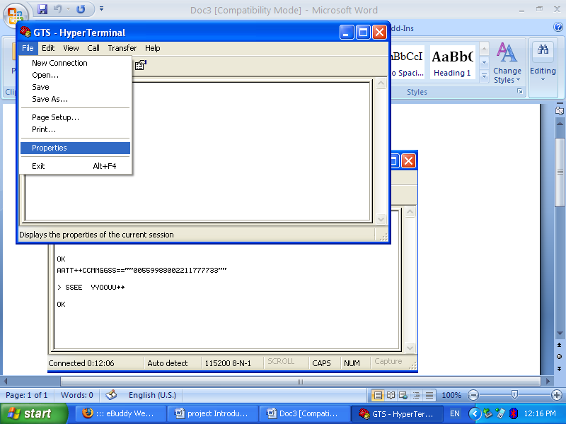

Fig. : properties
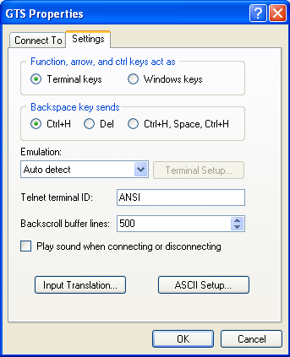
Fig. : Settings
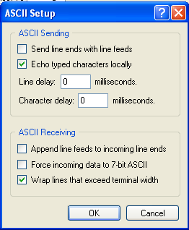
Fig. : ASCII Setup

After that the first step to start your test Type " AT " on the Hyper Terminal , then the GSM phone " mobile" will respond with an " OK "

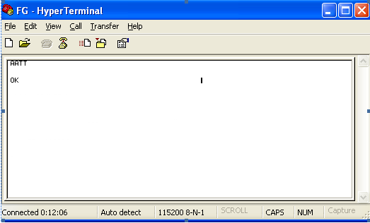
Fig. : AT Response

3.1.2 Sending SMS:

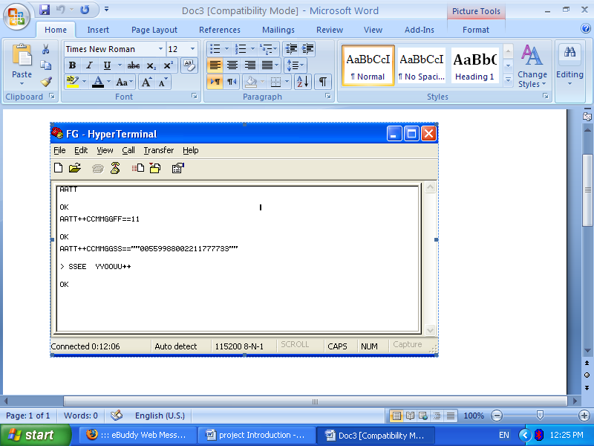
Fig . : Sending SMS

1- Line1:"AT" is sent to the GSM/GPRS modem to test the connection . the GSM/GPRS modem sends back the result code "ok" (line 2), which means the connection between the hyper terminal program & the GSM/GPRS modem works fine .

2- Line 3: the AT command +CMGF is used to instruct the GSM/GPRS modem to operate in SMS text mode . the result code "ok" is returned (line 4) , which indicates the command line "AT +CMGF=1" has been executed successfully .

3- Line 5 and 6: the AT command +CMGS is used to send an SMS text message to GSM/GPRS modem "0599* * * * * * " is the recipient mobile phone number . after typing the recipient mobile phone number ,you should press the enter button of the keyboard .

The GSM/GPRS modem will then return a prompt">" and you can start typing the SMS text message when finished ,press ctrl+z of the keyboard .

4- line 7: the result code "ok" indicates the execution of the AT command +CMGS is successful.

3.1.3 Receiving SMS :

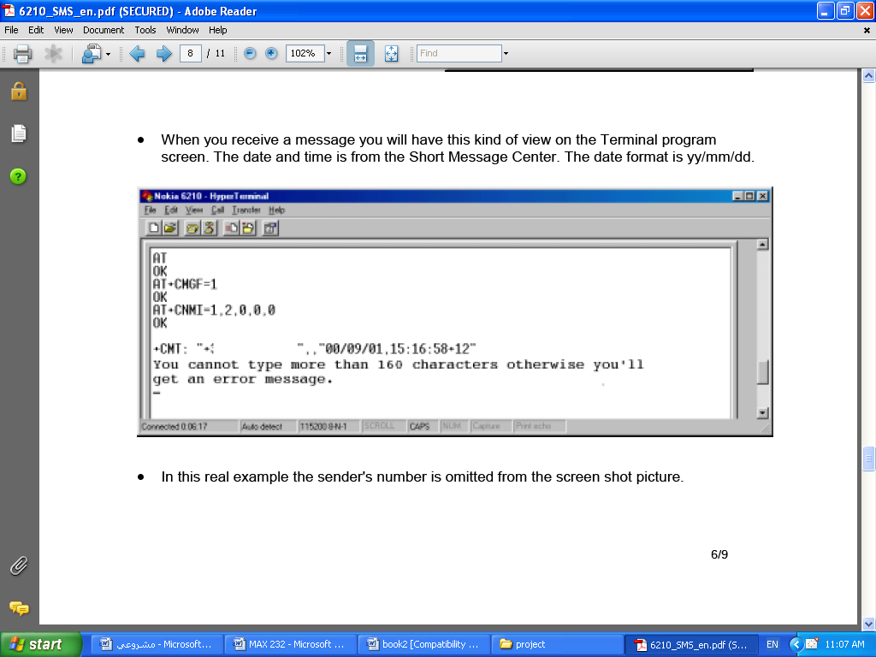

Fig. : Receiving SMS

1- line 1:"AT" is sent to the GSM/GPRS modem to test the connection .the GSM/GPRS sends back the result code "ok"(line 2), which means the connection between the hyper terminal program & GSM/GPRS modem works fine .

2- line 3 :the AT command +CMGF is used to instruct the GSM/GPRS modem to operate in SMS text mode . the result code "ok" is returned (line4), which indicates the command line "AT+CMGF=1" has been executed successfully

3- line 5: the AT command +CMGR is used to receive SMS text message of the GSM/GPRS modem ."0599 * * * * * *" is the sender mobile phone number

4- Line 6:the result code "ok" indicates the execution of the AT command +CMGR is successful .

3.1.2 Reading a message:

The AT command responsible for this is :
AT + CMGR

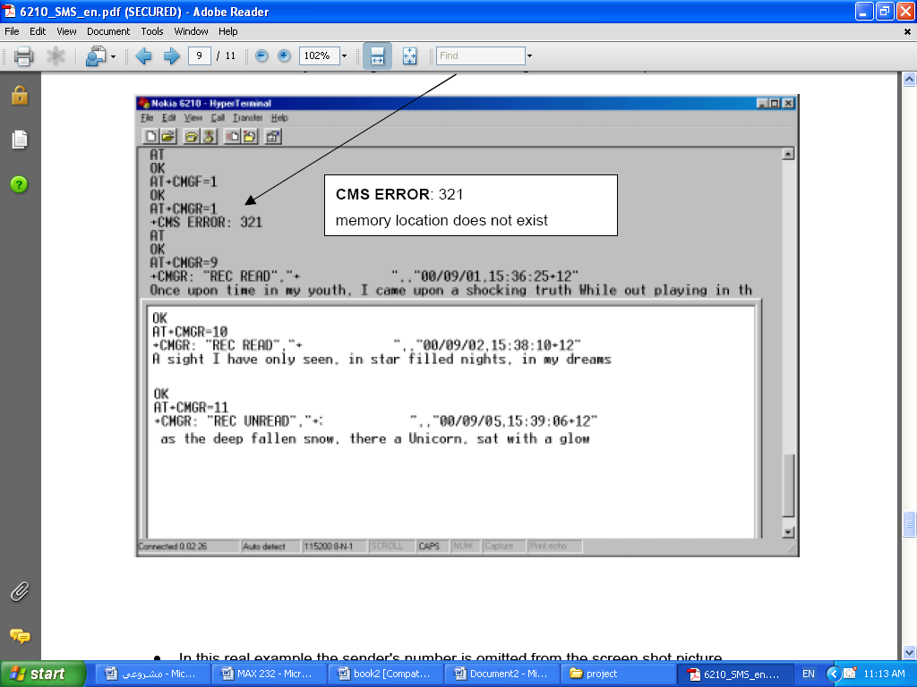
Fig. :Reading Message

Chapter Four Project Hardware and Software

4.1 Connecting Mobile to PIC (16F877)

A microcontroller , PIC 16F877, is connecting with a RS232 transceiver to provide a 9600 bps serial link to the Nokia 6070 mobile phone .

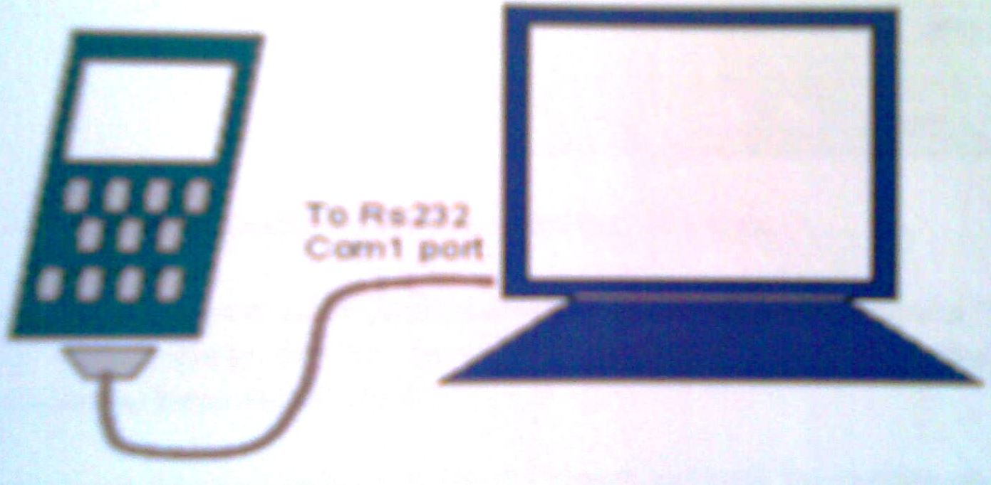
Fig. : Mobile To Serial

With this circuit we can monitor temperature degree and any un familiar movement , and controlling them by sending and receiving SMS message with any mobile phone.

4.2 Project Hardware

To perform this project we need to perform hardware which consist of two parts .

Part One :

Part one is a monitor & sensing part that consist of
First we build the basic cct of PIC & we add to it LCD to show & notice the commands when comes out from mobile to PIC & vise versa ,also we add (DB9) connector to interface the mobile phone with PIC & we need to add an interfacing to the element which we want to control like fans ,heaters …..etc .
Part Two :

Simply mobile phone to receive the change in degree from first part. And to send orders to first part to control elements or machines or what we need to control.
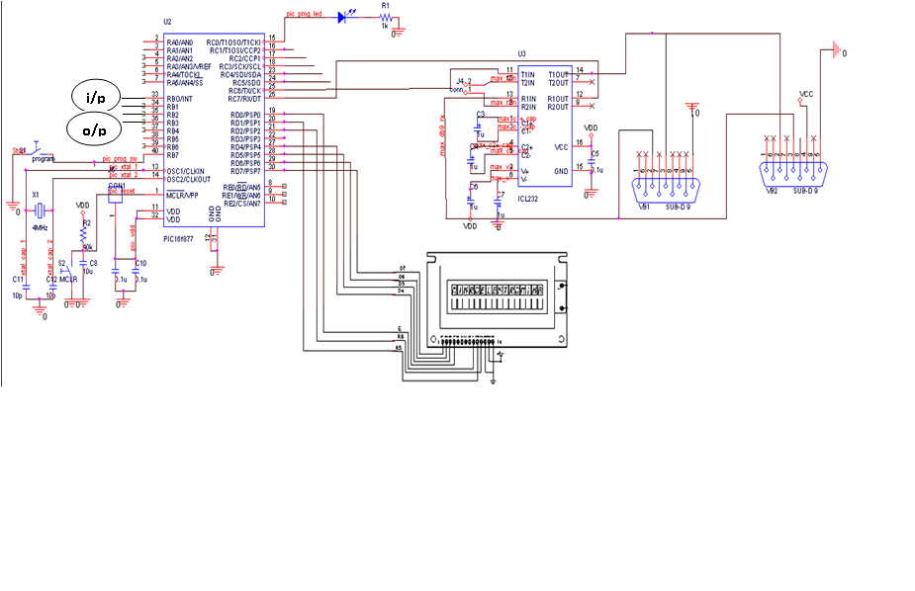

Fig. : Schematic Diagram

4.2.1 Hardware Elements:

1- Microcontroller (PIC16f877):

A microcontroller is a miniature computer . it is an integrated chip (IC) that has a central processing unit (CPU) ,random access memory (RAM) ,read only memory (ROM) and other components that is present in a computer. the PIC microcontroller is manufactured by microchip technology Inc .

We choose PIC 16f877 microcontroller for the following reason :
1-it is a flash programmable device (no need for UV eraser ).
2-it has a built –in EEPROM (non- volatile memory ).
3-it is in-circuit programmable (only a small circuit needs to be built for programming ).
4-it has support for various boot –loader .
5-it is cheap .
We use the PIC to control some external devices ,a microcontroller executes a user program which is loaded in its program memory .in our project we received data from sensors located in farms,
then data is sent to external output devices (mobile) in SMS form & then it received SMS from mobile that include orders to control devices as conditioners or heaters .

2-Voltage Regulation
The voltage regulator circuit consisted of a MC7805ACT chip which would provide a step down from 12V to 5V , The 100 μF Capacitor provide circuit protection.
Additionally, the module would need to provide protection against both incorrect setup and any possible voltage spikes.

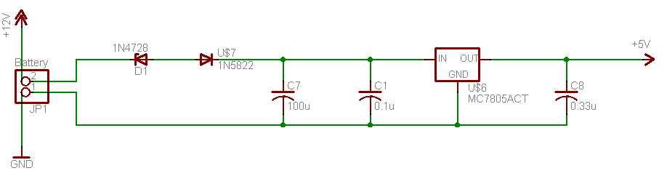
Fig. : Voltage Ragulator

3- Max232:
We can send and receiving data at the same time due to the lines of sending and receiving data (full-duplex mode).
Fig. MAX 232
4- Lcd:

A liquid crystal display (LCD) is an electronically-modulated optical device shaped into a thin, flat panel made up of any number of color or monochrome pixels filled with liquid crystals and arrayed in front of a light source (backlight) or reflector. It is often utilized in battery-powered electronic devices because it uses very small amounts of electric power.

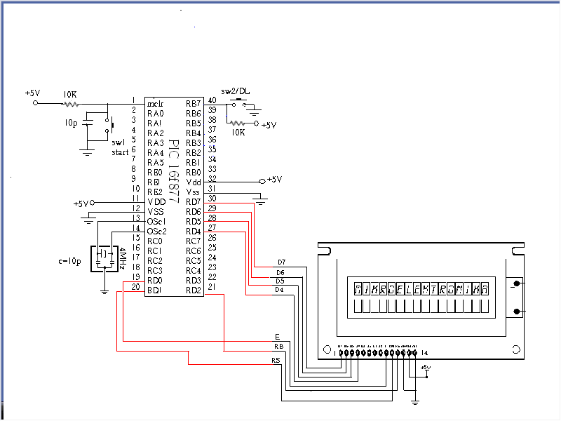
Fig. :LCD

5- Precision temperature sensor
The LM335 are precision temperature sensors which can be easily calibrated. They operate as a 2-terminal Zener and the breakdown voltage is directly proportional to the absolute temperature at 10mV/K. The circuit has a dynamic impedance of less than 1 Ω and operates within a range of current from 450μA to 5mA without alteration of its characteristics.

Calibrated at +25oC, the LM335 have a typical error of less
than 1oC over a 100oC temperature range. Unlike other sensors, LM335 have a linear output.

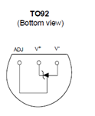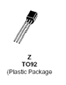
Fig. : Temperature Sensor

- Application Hints:

There is an easy method of calibrating the device for higher accuracies .
The single point calibration works because the output of the LM335 is proportional to the absolute temperature with the extrapolated output of sensor going to 0V at 0K ( –273.15oC).

- Temperature sensor calibration:
We make calibration for this sensor by building the following circuit , then measuring the output voltage while changing the temperature the sensor exposure to .
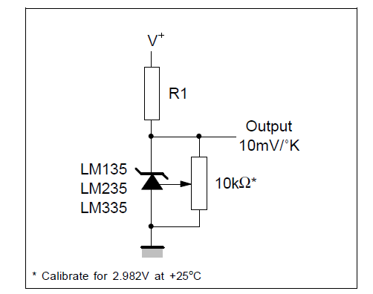
Fig. : Temperature Sensor Diagram

- The practical calibration:

At 20 c° the output voltage = 2.5 V.
At 30 c° the output voltage = 3.5 V.

6- Infrared Sensor:
Infrared light lies between the visible and microwave portions of the electromagnetic spectrum. Infrared light has a range of wavelengths, just like visible light has wavelengths that range from red light to violet.
IR circuits:
This circuit has two stages: a transmitter unit and a receiver unit. The transmitter unit consists of an infrared LED and its associated circuitry.
IR transmitter:
The transmitter circuit consists of the following components:
- IC 555
- Resistors
- Capacitors
- IR LED

The IR LED emitting infrared light is put on in the transmitting unit. To generate IR signal, 555 IC based a stable multivibrator is used. Infrared LED is driven through transistor BC 548.
IC 555 is used to construct an a stable multivibrator which has two quasi-stable states. It generates a square wave of frequency 38kHz and amplitude 5Volts. It is required to switch ‘ON’ the IR LED.
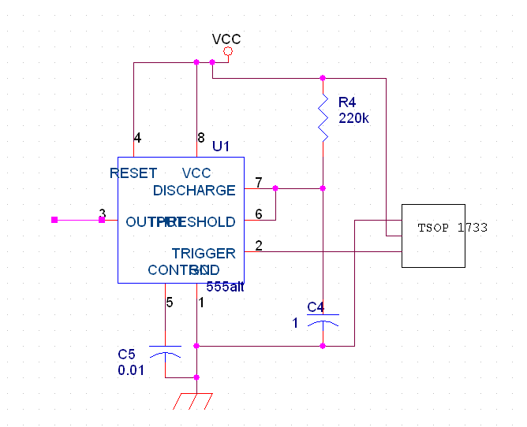

Fig :infrared transmitter cct
IR Receiver:
The receiver circuit consists of the following components:
- TSOP1738 (sensor)
- IC 555
- Resistors
- Capacitors
The receiver unit consists of a sensor and its associated circuitry. In receiver section, the first part is a sensor, which detects IR pulses transmitted by IR-LED. Whenever a train crosses the sensor, the output of IR sensor momentarily transits through a low state. As a result the monostable is triggered and a short pulse is applied to the port pin of the 8051 microcontroller. On receiving a pulse from the sensor circuit, the controller activates the circuitry required for closing and opening of the gates and for track switching.

The IR receiver circuit is shown in the figure below.

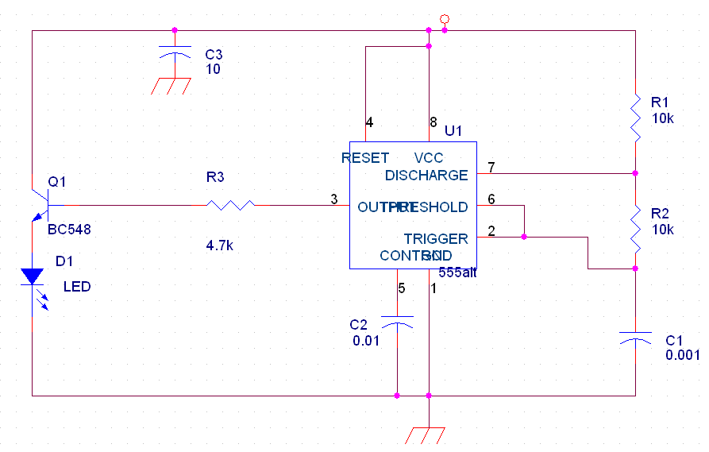

Fig : infrared receiver cct

4.3 Project software

4.3.1 Project flow chart:

4.3.2 Project Code

#include "ADC_on_new_picc.h"
#include <LCD.C>
#include <float.h>
#include <math.h>
void SendSms();
void TestAdc();
void readSms(int x);
void fan(int command);
void killEcho();
void initRecSms();
void delSms (int pos);
////////////////////////////////////////////////////////////////////////////////////////////////////////////////
int i,j;
char c1,c2;
int index = 0;
char str[50];
int flag = 5;
int pos = 0;
char number[11];

void SendSms();
void delSms (int pos);
void Fan(int command);//if command =0 turn the fan off if command =1 turn the on
int fanst = 0;///off
int x;

/////////////\
float power;
float valv;
float vali;
//float Vmpp;
float max;
//float Isc;
//float Impp;
////////////
#int_AD
AD_isr()
{
if(x==0)
{
set_adc_channel(1);
x=1;

}
else
{
set_adc_channel(0);
x=0;
}
}
////////////////////////////////////////////////////////////////////////////////////////////////////////////////
#int_RDA
RDA_isr()
{
index = 0;
i = 0;
c1= getc();
if(c1=='+')
{
disable_interrupts(INT_RDA);
disable_interrupts(global);
while(c1!='O')
{
while (kbhit())
{
c1=getc();
if(c1!='\n'&&c1!='\r')
{
str[index]= c1;
}
if(index==16)
printf(LCD_PUTC, "\n");
index++;
}
restart_wdt();
}
c1= getc();
pos = str[10]-'0';
i=0;
index =0;
delay_ms(1000);
readSms(pos);
delay_ms(3000);
restart_wdt();

while (kbhit())
{
c1=getc();
i++;
if(i==100)
break;
restart_wdt();
}
i=0;
enable_interrupts(INT_RDA);
enable_interrupts(global);
// restart_wdt();
delSms(pos);
restart_wdt();
}
}

void main()
{

setup_adc_ports(AN0_AN1_AN3);

setup_adc(ADC_CLOCK_INTERNAL);
setup_psp(PSP_DISABLED);
setup_spi(FALSE);
setup_timer_0(RTCC_INTERNAL|RTCC_DIV_1);
setup_timer_1(T1_DISABLED);
setup_timer_2(T2_DISABLED,0,1);
setup_comparator(NC_NC_NC_NC);
setup_vref(FALSE);
lcd_init();
initRecSms();
fan(0);
enable_interrupts(INT_AD);
enable_interrupts(INT_RDA);
enable_interrupts(GLOBAL);
restart_wdt();
printf(LCD_PUTC, "\fStarting........");
i=0;

while(1)
{
restart_wdt();
}

}
void TestAdc()
{
i=0;

while (kbhit())
{
c1=getc();
i++;
if(i==100)
break;
restart_wdt();
}

max= 0.0;
power=0.0;
i=j=0;
j=15;
x=0;
set_adc_channel(0);
enable_interrupts(INT_AD);
enable_interrupts(global);
///////////////
//printf(LCD_PUTC,"\fstartadc");
while(i<15)
{
if(x==1)//ch1
{
vali =read_adc();
delay_ms(5);
vali=(vali/1023.0);
vali=vali*3;

}
if(x==0)//x=0 ch0
{
valv= read_adc();
delay_ms(5);
valv=(valv/1023.0);
valv=valv*5;
}
power=valv*vali;
if(power>max)
{
max=power;
sprintf(str,"MaxPower =%2.2f w ,volt%2.2f v,Cur%2.2f A",max,valv,vali);
}
printf(LCD_PUTC, "\fWorking..%d",j);
i++;
j--;
delay_ms(1000);
}

sprintf(number,"%s","0599748051");
SendSms();
// printf(LCD_PUTC,"\fMAXPower=%2.1f wat",max);
//printf(LCD_PUTC,"\n End Working...");

}

////////////////////////////////////////////////////////////////////////////////////////////////////////////////
void readSms(int x)
{
i =0;
flag = 5;
printf("AT+CMGR=%d",x);
PRINTF("%c",0x0D);
PRINTF("%c",0x0B);
c1 = '!';
c2='!';
printf(LCD_PUTC,"\f%d",x);
for(index = 0 ;index <50;index++)
{
str[index]= 'c';
restart_wdt();
}
index =0;
while(c1!='O')
{
while (kbhit())
{

c1=getc();

if(i>61)
{
if(c1!='\n'&&c1!='\r')
{
str[index]= c1;

index++;

}

restart_wdt();
}
i++;
restart_wdt();
}
restart_wdt();

}
c1=getc();

index = 0;
printf(LCD_PUTC, "\f");
/*for(index = 0 ;index <50;index++)
{
printf(LCD_PUTC, "%c",str[index]);
if(index==16)
printf(LCD_PUTC, "\n");
restart_wdt();
}*/
index=0;
delay_ms(5000);
while((index <50 )&&( flag==5))
{
//printf(LCD_PUTC, "\floop%d",index);
restart_wdt();
if((str[index] =='o')||(str[index] =='O'))
{
if((str[index+1] =='n')||(str[index+1] =='N'))
{
flag = 0;
break;

}///on command
else if((str[index+1] =='f')||(str[index+1] =='F'))
if((str[index+2] =='f')||(str[index+2] =='F'))
{
flag = 1;
break;

}///off command
restart_wdt();
}
else if((str[index] =='s')||(str[index] =='S'))
{
if((str[index+1] =='t')||(str[index+1] =='T'))
if((str[index+2] =='a')||(str[index+2] =='A'))
if((str[index+3] =='t')||(str[index+3] =='T'))
if((str[index+4] =='u')||(str[index+4] =='U'))
if((str[index+5] =='s')||(str[index+5] =='S'))
{
flag = 2;
break;

}////status command
restart_wdt();

}
else if((str[index] =='t')||(str[index] =='T'))
{
if((str[index+1] =='e')||(str[index+1] =='E'))
if((str[index+2] =='s')||(str[index+2] =='S'))
if((str[index+3] =='t')||(str[index+3] =='T'))

{
flag =3;
break;

}////status command
restart_wdt();

}
index++;
restart_wdt();
}
if(flag==0)
{

printf(LCD_PUTC, "\f On Command");
fanst =1;///fan on
fan(1);

}
else if(flag==1)
{
printf(LCD_PUTC, "\f OFF Command");
fanst =0;///fan off
fan(0);

}
else if(flag==2)///////
{
printf(LCD_PUTC, "\f status Command");
sprintf(number,"%s","0599748051");

if(fanst==0)
{
sprintf(str,"%s","fan is off");
}
else if(fanst==1)
{
sprintf(str,"%s","fan is on");
}

SendSms();
restart_wdt();
}
else if(flag==3)
{
printf(LCD_PUTC, "\f test Command");
//start testing
//fan(0);
TestAdc();
restart_wdt();
}
else
printf(LCD_PUTC, "\f%d Error",flag);
restart_wdt();
i=0;
index = 0;
}
////////////////////////////////////////////////////////////////////////////////////////////////////////////////
void SendSms()
{

PRINTF("AT+CMGF=1");

PRINTF("%c",0x0D);
PRINTF("%c",0x0B);
/////////

while( c1!='O')
{
while ( !kbhit() )
{
restart_wdt();
}

c1= getc();

}
c1= getc();

/////////
delay_ms(200);
PRINTF("AT+CMGS=\"%s\",129",number);
PRINTF("%c",0x0D);
PRINTF("%c",0x0B);
delay_ms(200);
PRINTF(str);
PRINTF("%c",0x1A);
PRINTF("%c",0x0D);
PRINTF("%c",0x0B);
delay_ms(200);
i=0;

while (kbhit())
{
c1=getc();
i++;
if(i==100)
break;
restart_wdt();
}
i=0;

}

////////////////////////////////////////////////////////////////////////////////////////////////////////////////
void initRecSms()
{

printf("AT+CMGF=1");
PRINTF("%c",0x0D);
PRINTF("%c",0x0B);
while( c1!='O')
{
while ( !kbhit() )
{
restart_wdt();
}

c1= getc();

}
c1= getc();
printf(LCD_PUTC, "\f1");
delay_ms(4000);
printf("AT+CNMI=2,1,0,1,0");
PRINTF("%c",0x0D);
PRINTF("%c",0x0B);

while( c1!='O')
{
while ( !kbhit() )
{
restart_wdt();
}

c1= getc();

}
c1= getc();
printf(LCD_PUTC, "\f 2");
delay_ms(1000);
restart_wdt();
printf(LCD_PUTC, "\f SMS init");

}
////////////////////////////////////////////////////////////////////////////////////////////////////////////////

////////////////////////////////////////////////////////////////////////////////////////////////////////////////
void delSms (int pos)
{
printf("AT+CMGD=%d",pos);
PRINTF("%c",0x0D);
PRINTF("%c",0x0B);
while( c1!='O')
{
while ( !kbhit() )
{
restart_wdt();
}

c1= getc();
restart_wdt();
}
c1= getc();
printf(LCD_PUTC, "\f SMS deleted");

}
////////////////////////////////////////////////////////////////////////////////////////////////////////////////
void fan(int command)
{
if(command == 1)//turn the fan on
{
output_bit( PIN_B0, 1);
}
else if (command ==0) //turn the fan off
{
output_bit( PIN_B0, 0);
}
}
////////////////////////////////////////////////////////////////////////////////////////////////////////////////

Problems

1. It is difficult to choose the kind of temperature sensor & to find it is correct cct that we will use it to calibrate it .

2. The connection between microcontroller (PIC) and mobile phone.

3. Programming the microcontroller (PIC).

Appendix
Data sheets
Microcontroller (PIC 16F877):

LCD:

PROPRTIES | PIN #
DATA (D7) | 1
DATA(D6) | 2
DATA (D5) | 3
DATA (D4) | 4
DATA (D3) | 5
DATA (D2) | 6
DATA (D1) | 7
DATA (D0) | 8
ENABLE | 9
RS | 10
RB | 11
GROUND | 12,13
VCC | 14

Temperature sensor LM 335:

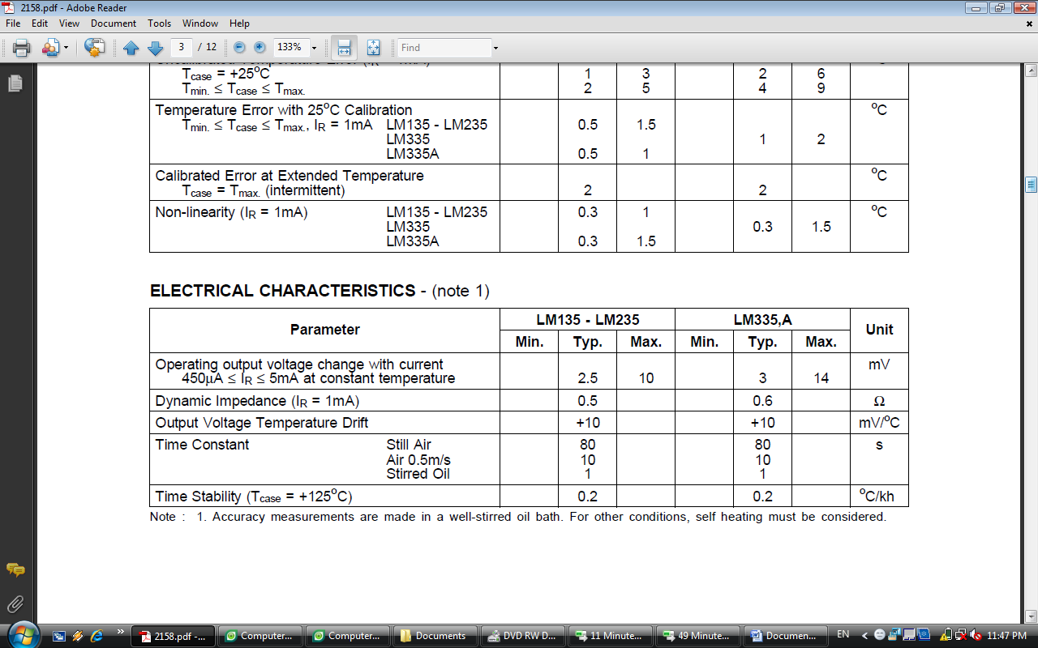
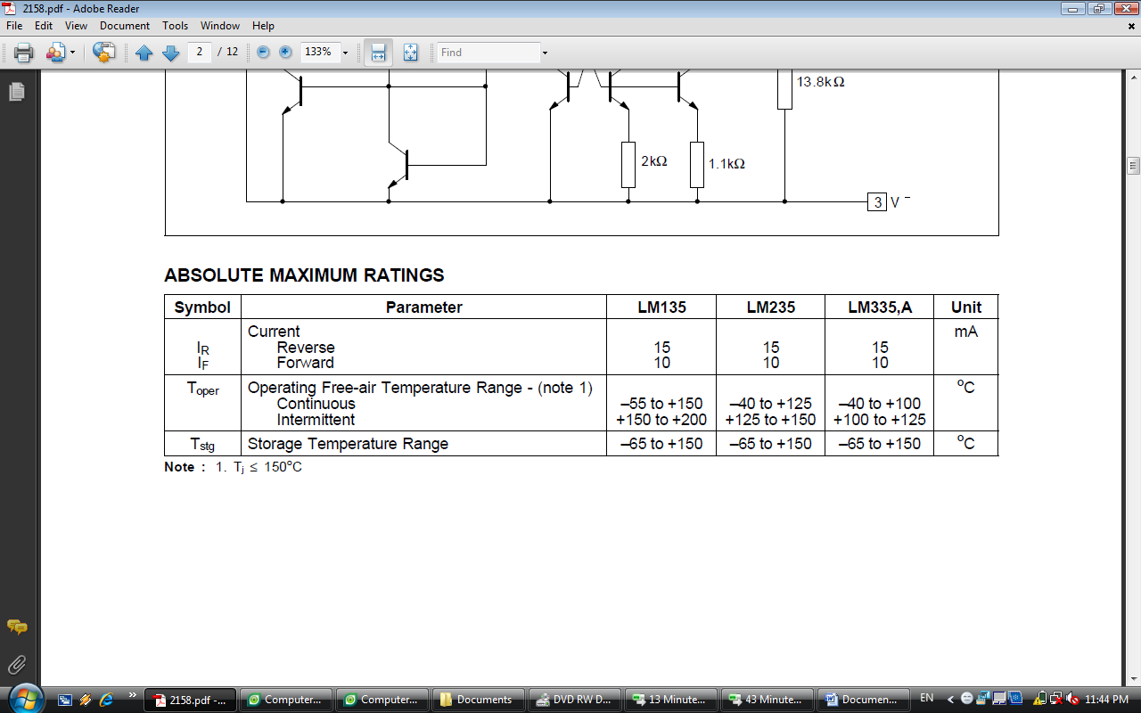

IR Sensor:
- Transmitter Circuit

- Receiver Circuit

References

- Cellular Online, “Extended ETSI Hayes AT command parameters for SMS” [Online Document], Available HTTP: http://www.cellular.co.za/at_etsi.htm.\

- Pettersson, Lars, “SMS and the PDU Format” [Online Document], Available HTTP: http://www.dreamfabric.com/sms/

- www.developershome.com/sms/howToUseHyperTerminal.asp

- http://www.embedtronics.com/nokia/fbus.htm

- ww1.microchip.com/downloads/en/AppNotes/21895d.pdf

- www.circuits-lab.com

- cognoscis.wordpress.com/.../modulated-ir-sensor/ elka.brawijaya.ac.id/.../RS232_adapter.PNG

