Faculty of Engineering & Information Technology

DEPARTMENT OF COMPUTER ENGINEERING

MagicTales

Prepared by:
- Shahd Mohammed Soud Alawneh
- Yasmeen Mahmoud Hasan Khaleel

SUPERVISED BY:
Dr. Emad Natsheh

Presented in partial fulfilment of the requirements for
Bachelor’s Degree in Computer Engineering.

Acknowledgments:
We would like to express our deepest gratitude to our supervisor, Dr. Emad Natsheh, for his continuous guidance, support, and invaluable feedback, which played a vital role in the successful completion of this project.
Our heartfelt thanks also go to all the professors of the Computer Engineering Department for their support and dedication throughout our years of study.
We are equally grateful to our families, friends, and colleagues for their endless encouragement, motivation, and unwavering belief in our abilities.
With sincere appreciation, thank you all.

Disclaimer
This report was prepared by the students Shahd Alawneh and Yasmeen Khaleel from the Faculty of Engineering, Department of Engineering, An-Najah National University.
It has only undergone limited editorial review as part of the evaluation process and may therefore contain linguistic or content-related errors.
All opinions, conclusions, and recommendations presented in this report are solely those of the authors. An-Najah National University bears no responsibility for any consequences resulting from the use of this report for purposes other than those for which it was intended.

Contents:
Acknowledgments: 2
Disclaimer 3
Abstract: 8
Chapter1: 9
Introduction: 9
1.1.1 Problem Statement 10
1.1.2 Objectives 10
1.1.3 Scope of Work 10
1.1.4 Significance 11
1.1.5 Organization of the Report 11
Chapter 2 12
Constraints and Earlier Coursework 12
2.1 Constraints and Limitations 12
2.2 Standards / Codes 12
2.3 Earlier Coursework 13
Chapter 3 14
Literature Review 14
Chapter 4 15
Methodology 15
2. System Structure 15
2.1.1 Box Body 15
2.1.2 Story Section 16
2.1.3 Game Section 16
2.1.4 Parent Control 17
2.1.5 Control Buttons 18
3. Hardware Components 18
3.1.1 Microcontroller (Arduino Mega 2560) 18
3.1.2 Servo Motor (Story Dispensing Mechanism) 19
3.1.3 Stepper Motor and CNC Rail (RFID Game Section) 20
3.1.4 RFID Reader and Letter Cards 20
3.1.5 RGB LEDs (Feedback System) 20
3.1.6 Keypad 3*4 21
3.1.7 Keypad (Parent Input Module) 21
3.1.8 LCD Display 22
3.1.9 Buttons 22
2.10Power Supply 23
2.11 ESP32 23
3.12 OLED screen 24
3.13 DF player module 24
3.14 SD card 25
3.15 SD card module 26
3.16 Channel Relay Module (RGB LED Control) 27
3.17 CNC Mechanical Assembly: Rods, Bearings, and Bases 27
3.18 Ultrasonic Sensor (Proximity Activation) 28
3.19 LDR Sensor (Automatic Lighting Control) 28
3.20 Intercom Wires 29
3.21 Arduino Wires 29
Software Components 30
Mobile Application 30
3.21.1 Home Screen 30
3.21.2 Story Selection Screen 31
3.21.3 Word Game Screen 32
How does the system work? 33
3.21.4 System Activation 33
3.21.5 Story Mode 34
3.21.6 Game Mode 35
3.21.7 Parent Control 36
3.21.8 Audio and Visual Feedback 37
3.21.9 Automatic Lighting and Safety 37
3.21.10 Mobile Application Integration 38
3.21.11 Overall Workflow Summary 38
Chapter5 39
Results and Discussion 39
4. Results 39
4.1.1 Story Module 39
4.1.2 Game Module 39
4.1.3 Parent Control 39
4.1.4 Sensor-Based Automation 40
4.1.5 Wireless Communication 40
Conclusion 40

List Of Figures:
Figure1: Box Body 13
Figure2: story Section 14
Figure3: Game Section 15
Figure4: Parent Control 15
Figure5: Control Buttons 16
Figure6: Arduino Mega 1 17
Figure7: Servo Motor 17
Figure8: Stepper Motors and CNC 18
Figure9: RFID Reader 1 18
figure10: RGB LED 19
Figure11: Keypad 19
Figure12: Lcd with I2C 20
Figure13: Buttons 21
Figure14: Power Supply 21
Figure15: ESP32 22
Figure16: OLED Screen 22
Figure17:DF Player 23
Figure18: SD Card 23
Figure19:SD Card Module 24
Figure20:Relay 4 Channels 24
Figure21: Rods, Bearings, and Bases 25
Figure22: Ultrasonic Sensor 25
Figure23: LDR Sensor 26
Figure 24: LDR Sensor 26
Figure25:.Arduino Wires 27
Figure26: Home Page of the application 28
Figure27: Story Selection page 28
Figure28: Word Game Page 29
Figure29: Select Level 1 30
Figure30 : choose level alert 30

Abstract:
Early childhood education requires innovative methods that combine learning and entertainment to capture children’s attention and develop essential cognitive and literacy skills. This project presents the design and implementation of an Interactive Box for Kids, aimed at children aged 3–5 years. The system integrates physical storytelling with educational word games, enhanced by sensors, actuators, and wireless connectivity, to provide an engaging and educational experience.
The box consists of two main modules. In the Story Module, a child selects from six educational stories using a keypad. A servo releases the chosen book, an RGB LED lights up with a unique color, and the DFPlayer Mini narrates the story aloud, encouraging reading habits and vocabulary development. The Game Module reinforces spelling through three progressive levels (3–5 letters). Children arrange RFID-tagged cards, which are scanned by a CNC rail. Correct answers trigger green LED feedback and success audio, while incorrect attempts produce red LED signals and hints, promoting active learning and problem-solving.
A Parent Control Module allows parents to add new words via a 4×4 multi-tap keypad. Words are stored on an SD card and added to the game database. Parents can also track progress locally or through a mobile application connected via ESP32 Wi-Fi, ensuring real-time synchronization. Additional features include ultrasonic activation, automatic LED control via LDR, and continuous audio-visual feedback.
Testing confirmed reliable performance: 95% ultrasonic accuracy, 97% LDR effectiveness, and a 92% success rate in word arrangement after hints. The results demonstrate that the Interactive Box is a robust, child-friendly system that successfully merges education and entertainment.

Chapter1:

Introduction:
With the growing interest in modern educational tools for early childhood development, interactive systems have become essential in supporting children’s learning, creativity, and engagement. Children between the ages of 3 to 5 years require educational methods that combine fun, interaction, and stimulation of multiple senses to help them develop reading, language, and problem-solving skills at an early stage.
Our project presents an Interactive Box for Kids, designed to provide both educational and entertaining experiences. The system is divided into two main parts:
- The Story Section:
This part contains six educational stories. When a child selects a story, the box physically delivers it, and the system begins to read the story aloud with the child. This feature aims to encourage reading habits, develop language skills, and create an interactive bond between the child and the story. The process is supported by lights and sounds to add excitement and engagement.
- The Game Section:
This part introduces an interactive word-arranging game with three levels of difficulty:
  - Level 1: The child arranges five words made up of three letters. If successful, they proceed to the next stage; if not, a hint is provided, and the question is repeated.
  - Level 2: The challenge increases with words consisting of four letters.
  - Level 3: The final stage requires arranging a word of five letters, promoting gradual skill-building and problem-solving.
The box integrates audio and visual feedback to maintain the child’s interest, reward correct answers, and guide them when mistakes occur. By merging reading encouragement with interactive gaming, the system fosters both educational growth and entertainment, making learning enjoyable and effective.

Problem Statement
Traditional educational tools for young children often lack interactivity, engagement, and sensory stimulation. Many kids at the age of 3–5 years struggle to stay motivated when learning is limited to passive methods such as books or flashcards.
Additionally, conventional games and learning approaches do not provide progressive challenges tailored to the child’s abilities, nor do they offer instant feedback through sounds, lights, or guidance.
Therefore, there is a clear need for an interactive educational system that combines reading encouragement with playful learning, while also keeping the child entertained and motivated.

Objectives
The main objective of this project is to design and implement an Interactive Box for Kids (ages 3–5) that enhances learning and entertainment. Specifically, the system aims to:
Encourage children to read and listen to stories in an interactive way.
Develop reading, spelling, and word recognition skills through multi-level games.
Provide visual (lights) and auditory (sounds) feedback to increase engagement and fun.
Support children’s cognitive and problem-solving abilities by introducing gradually harder challenges.
Create an integrated educational tool that combines both physical interaction (story selection and book output) and digital interaction (games and audio).

Scope of Work
The scope of the project includes:
- Story Section:
    - Designing a system that allows the child to select one of six educational stories.
    - Mechanically delivering the chosen story to the child.
    - Providing audio narration and light feedback during reading.
- Game Section:
Implementing a three-level word-arranging game:
    - Level 1: Arrange words of three letters.
    - Level 2: Arrange words of four letters.
    - Level 3: Arrange words of five letters.
Adding hints for incorrect answers, and allowing the child to retry.
Rewarding success with lights and sounds, while motivating the child to continue.
System Features:
    - Integration of audio speakers and LED lights for guidance and fun.
    - Simple and intuitive design suitable for children.
    - Testing and validation to ensure safety, durability, and reliability.

Significance
This project contributes to early childhood education by combining playful learning with technology. Unlike traditional methods, the Interactive Box provides:
- Motivation for reading: Children actively engage with stories rather than passively listening.
- Step-by-step skill development: The game design helps children progress from simple to more complex words.
- Multisensory learning: Audio and light feedback stimulate the child’s senses, increasing focus and memory retention.
- Entertainment with education: By making learning fun, children become more eager to explore and learn.
The project demonstrates how modern technology can transform the learning process for young children, preparing them for future educational success.

Organization of the Report
This report is structured as follows:
- Chapter 1: Introduction, including the problem statement, objectives, scope of work, significance, and report organization.
- Chapter 2: Literature review, where similar educational tools and technologies are analyzed.
- Chapter 3: Methodology, explaining the project design, structure, electronic components, and system workflow in detail.
- Chapter 4: Results and analysis, presenting the outcomes of the implementation and testing.
- Chapter 5: Conclusion and future work, summarizing the findings and suggesting potential improvements.

Chapter 2

Constraints and Earlier Coursework

2.1 Constraints and Limitations
During the development of the Interactive Box for Kids, several challenges and limitations were encountered:
- Mechanical Design: One of the main challenges was creating the mechanism that allows the physical storybooks to be dispensed reliably and safely when a child selects a story.
- System Integration: Ensuring smooth coordination between the hardware components (servo motors, LEDs, speakers, and sensors) and the software logic required careful design to avoid delays or conflicts.
- Error Handling: The game section required implementing a hint and retry system for incorrect answers, which added complexity to the software design.
- Child Safety: Since the box is intended for children aged 3–5 years, all components had to be tested for safety, durability, and ease of use.
- Resource Limitations: Limited hardware resources (Arduino memory and processing power) sometimes restricted the number of features we could run simultaneously without affecting performance.

2.2 Standards / Codes
To develop the system, the following standards, tools, and platforms were used:
- Arduino IDE: Used to program and control the hardware components of the box.
- C/C++ Programming: Provided the logic for controlling motors, sensors, lights, and the interactive game flow.
- Electronics Safety Standards: Basic safety precautions for children’s educational devices were considered, including low-voltage operation and secured wiring.
- Sound and Light Feedback Protocols: Implemented to ensure clear guidance for children during both the storytelling and gaming phases.

Earlier Coursework
The knowledge and skills required for this project were gained through several academic courses and self-learning experiences:
- Microprocessor and Microcontroller Courses: Provided the foundation for understanding how to control hardware components using Arduino.
- Electronics Courses: Offered essential knowledge on circuit design, sensors, and actuators, which were key to building the box.
- Software Development Courses: Helped in structuring the game logic, debugging code, and integrating multiple components.
- Critical Thinking and Problem-Solving Courses: Enhanced our ability to analyze challenges and document solutions effectively.
- Self-Learning Resources: Including online Arduino tutorials, YouTube courses, workshops from student associations such as IEEE, and research papers related to interactive educational systems.

Chapter 3

Literature Review
An interactive educational box for children combines modern technology, storytelling, and gamification to promote early learning in an engaging and enjoyable way. This review explores relevant studies and technologies in the fields of interactive storytelling, multisensory learning, and educational games for early childhood. It forms the scientific foundation for the Interactive Box for Kids project, highlighting existing solutions, their strengths and limitations, and how our project addresses identified gaps.

“Interactive Storytelling for Early Literacy Development” (Smith, 2021)
Smith and colleagues developed an interactive storytelling system that integrates digital narration with physical books to enhance early reading engagement. The study showed that children were significantly more motivated to read when they could both listen to the story and physically interact with it, leading to improved vocabulary acquisition and comprehension skills. This supports the inclusion of the story section in our project, where physical stories are dispensed and narrated interactively.

“Gamification in Early Childhood Learning: A Multi-Level Word Game” (Khan, 2022)
Khan’s research introduced a game-based platform for children aged 3–6, where learners progressed through levels by arranging words of increasing complexity. The findings demonstrated that multi-level challenges combined with hints and retries significantly improved children’s spelling, recognition, and problem-solving skills. This aligns closely with the three-level word arrangement game designed in our project.

“The Role of Multisensory Feedback in Children’s Educational Devices” (Journal of Child Development Studies, 2020)
This study examined the effect of multisensory cues—such as lights and sounds—on children’s learning performance. Results revealed that integrating visual and auditory feedback not only increased attention span but also improved long-term memory retention and engagement. These findings justify the integration of LED lights and sound effects in our box to maximize both fun and educational value.

“Smart Toys and IoT in Early Education” (Li & Wong, 2023)
Li and Wong reviewed the growing field of smart toys connected through IoT in early education. Their study highlighted that toys providing instant feedback and adaptive difficulty create more personalized learning experiences. While IoT integration is not the main scope of our project, the concept of adaptive difficulty directly inspired the progressive challenge levels in our word game.

Chapter 4

Methodology

System Structure

Box Body
The interactive box has a wooden body with dimensions of 60 × 83 cm, providing sufficient space to accommodate both the storytelling section and the game section. The wooden material was selected for its strength, safety, and durability, ensuring it can withstand frequent use by children while maintaining a smooth and child-friendly finish.
For added practicality, the box is supported by wheels attached to the base, allowing it to be easily moved from one place to another. This feature ensures flexibility in positioning the box within classrooms, libraries, or homes.
A concealed compartment inside the structure is dedicated to storing wiring, electronic circuits, and power supply components, giving the system a neat and tidy appearance while ensuring safety for children by keeping electronic parts out of reach.
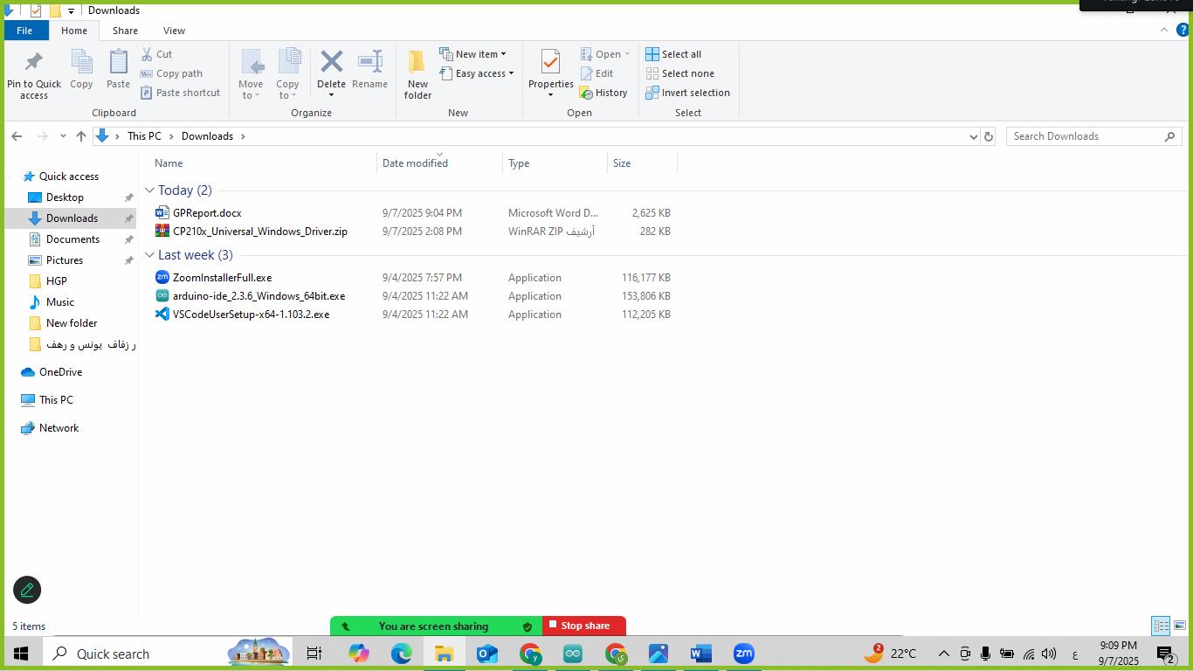
Figure1: Box Body

Story Section
Located at the lower part of the box, the story module is designed to store and dispense six educational stories.
- A servo motor mechanism controls the release of the selected story: when a child chooses a story from the keypad, the servo arm moves downward, allowing the corresponding book to drop into its slot.
- To enhance engagement, an RGB LED lights up with the color associated with the chosen story.
- At the top of the box, a start button triggers the audio narration, introducing the names of the available stories and prompting the child to make a selection.
This section encourages interactive reading habits, combining both physical books and audio narration to stimulate early literacy skills.
Figure2: story Section

Game Section
The upper part of the box contains the game module, which is based on word arrangement and verification:
- The front panel includes slots (openings) where the child places letter cards embedded with RFID tags.
- A CNC-based moving platform, equipped with an RFID reader, moves across the slots to scan the placed letters.
- The system checks whether the arranged letters form the correct word.
  - If correct → a green RGB LED lights up.
  - If incorrect → a red RGB LED lights up, and the system provides a hint before allowing the child to retry.
This module includes three levels of difficulty:
- Level 1: Words of three letters.
- Level 2: Words of four letters.
- Level 3: Words of five letters.

Figure3: Game Section

Parent Control
A keypad interface is included to enable parental control. Through this keypad, parents can:
- Add new words to the system’s SD card.
- Manage the learning content available to the child.
This feature ensures that the box remains scalable and adaptable, allowing continuous enrichment of the child’s vocabulary.

Figure4: Parent Control

Control Buttons
The system incorporates three main buttons on the interface:
- Start Button – initiates the storytelling section.
- Parent Button – unlocks the parental control features.
- Game Button – launches the interactive game mode.
Figure5: Control Buttons

Hardware Components
The Interactive Box for Kids integrates multiple electronic and mechanical components to achieve its dual functionality: storytelling and gaming. Each hardware component plays a vital role in ensuring the system’s interactivity, reliability, and child-friendly design.

Microcontroller (Arduino Mega 2560)
The Arduino Mega 2560 serves as the main control unit for the system. It was chosen for its large number of digital and analog pins, which are necessary to interface with multiple devices including servo motors, stepper motors, RGB LEDs, RFID reader, LCD display, and keypad. Its memory capacity also supports the storage and execution of the complex logic required for both the storytelling and gaming modules.
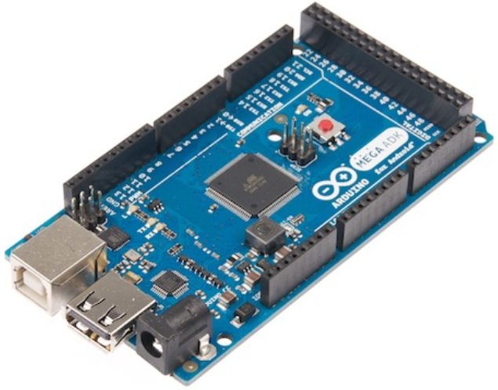
Figure6: Arduino Mega 1

Servo Motor (Story Dispensing Mechanism)
- A servo motor is used to control the arm mechanism in the story section. When a child selects a story through the keypad, the servo rotates to release the corresponding book, allowing it to drop into the collection area.
- Advantage: Provides precise angular control required for accurate dispensing.
- Safety: Operates on low voltage, making it safe for children’s applications.

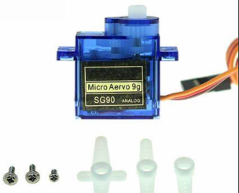
Figure7: Servo Motor

Stepper Motor and CNC Rail (RFID Game Section)
- The game module is powered by a stepper motor mounted on a CNC rail system. This allows the RFID reader to move smoothly across the slots where letter cards are placed.
- Function: Ensures accurate scanning of each RFID tag in sequence.
- Reliability: Stepper motors provide exact positioning without feedback sensors, which is ideal for scanning tasks.
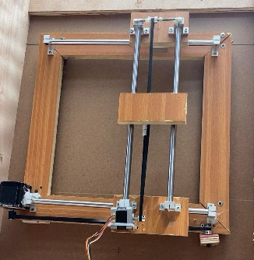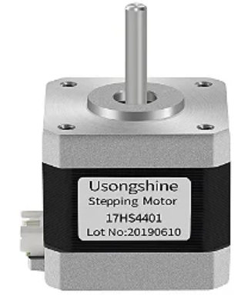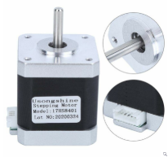
Figure8: Stepper Motors and CNC

RFID Reader and Letter Cards
- The system uses an MFRC522 RFID reader along with RFID-tagged letter cards. Each card represents a specific letter, and the RFID reader verifies the order in which the cards are placed.
- If the order matches the stored word → correct feedback is given.
- If the order is wrong → the system provides hints and allows retry.
- This enables a tangible, physical learning experience, combining digital verification with hands-on interaction.
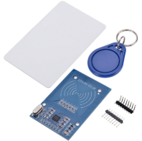
Figure9: RFID Reader 1

RGB LEDs (Feedback System)
RGB LEDs are used to provide visual feedback in both modules:
- Story Section: The LED lights up with a color corresponding to the chosen story.
- Game Section:
  - Green LED → indicates a correct word arrangement.
- Red LED → indicates an incorrect arrangement.
This feedback system keeps the child motivated and engaged by offering immediate and clear responses.
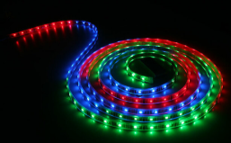
figure10: RGB LED

Keypad 3*4
Two keypads are integrated into the system:
  - Child Keypad: Enables the child to select a story and interact with the game.
  - Parent Keypad: Provides access to the parent control section, where new words can be added to the system’s vocabulary.
The keypads are designed with color-coded keys for clarity and ease of use by both children and adults.
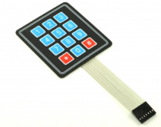
Figure11: Keypad

LCD Display
A 16×2 LCD screen is included in the upper interface to display instructions, prompts, and system messages. This enhances usability by guiding both children and parents during operation.

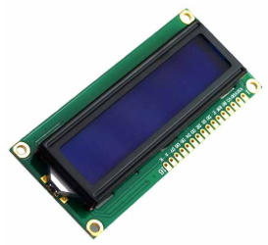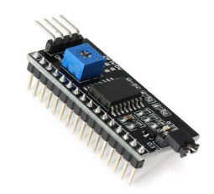
Figure12: Lcd with I2C

Buttons
- Three external buttons are installed:
- Start Button – initiates the storytelling function.
- Parent Button – unlocks parental settings.
- Game Button – activates the word-arranging game.
- These buttons serve as a simple user interface for quick access to system modes.

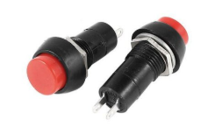
Figure13: Buttons

2.10Power Supply
- The system is powered by a 12V regulated power supply, with converters used to provide the appropriate voltage levels (5V for Arduino and sensors, higher currents for motors).
- Ensures safe and stable operation of all electronic and mechanical components.

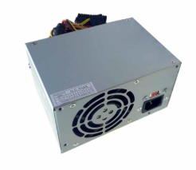
Figure14: Power Supply

2.11 ESP32
Powerful ESP32 is integrated with Wi-Fi and Bluetooth SOC and usually integrated with a USB-to-serial converter (e.g. CP2102 or CH340), it is ideal for compact (open source) growth and prototype board advanced IOT and built-in system. ESP32 supports a double-core 32-bit processor, operates up to 240 MHz and includes 2.4 GHz for 802.11 B/G/N Wi-Fi as well as inherent support for Bluetooth 4.2 (classic and bl.). It has an integrated TCP/IP stack, +20.5 dbm output power, several GPIOs, ADC, DACS, SPI, I2C and UART interface and a high performance PCB or external antenna. The board also includes a Micro USB port, boot and reset buttons, and it can be fully programmed via Arduino Idea, Micropython or Espressif's ESP-AIDF. In our project, we used ESP 32 to enable real-time communication with the App Inventor Mobile application on Wi-Fi, which ensures reliable wireless control and monitoring functions. [Espressif System, 2024]
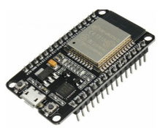
Figure15: ESP32

OLED screen
An OLED display is used in the gaming section to visually present the images or icons of the words that the child is required to arrange. This adds an extra visual learning dimension, helping the child associate words with their meanings or corresponding objects. The OLED screen was chosen due to its high contrast, low power consumption, and compact size, making it suitable for embedding within the box.

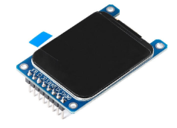
Figure16: OLED Screen

DF player module
- The DF Player Mini audio module is integrated to provide audio output for both the storytelling and gaming sections.
- In the story section, it narrates the titles of the available stories and plays voice prompts.
- In the game section, it provides audio hints, success messages, and error feedback, making the interaction more engaging for children.
- This module connects to a micro-SD card where the audio files are stored, and outputs sound through a connected speaker.

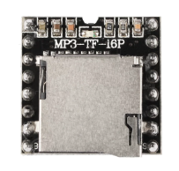
Figure17:DF Player

SD card
- A micro-SD card is used as the main storage medium for the system. It stores:
- Pre-recorded audio files for stories, hints, and feedback.
- Newly added words entered through the parent control section.
- This allows the system to remain flexible and expandable, ensuring that parents can continuously enrich the educational content.

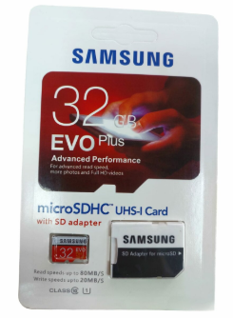
Figure18: SD Card

SD card module
An SD card module is used to interface the micro-SD card with the Arduino Mega. This module enables the system to read and write data to the SD card, ensuring smooth handling of both stored audio files and new words entered by parents.

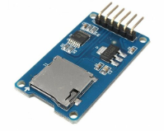
Figure19:SD Card Module

Channel Relay Module (RGB LED Control)
A 4-channel relay module was integrated into the system to manage the operation of the RGB LED unit. Relays are electromechanical switches that allow the microcontroller to control higher-power or isolated circuits safely.

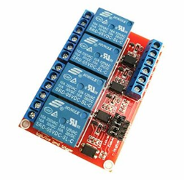
Figure20:Relay 4 Channels

CNC Mechanical Assembly: Rods, Bearings, and Bases
- In the game section of the Interactive Box for Kids, we constructed a custom CNC-based platform to allow the RFID reader and motors to move smoothly across the word arrangement slots. This CNC assembly is built using a combination of linear rods, ball bearings, and CNC bases.
- Rods: Strong steel linear rods form the guiding tracks of the CNC, ensuring that the moving carriage follows a straight and stable path while scanning each RFID-tagged letter card.
- Bearings: Linear ball bearings (LM-series) are mounted onto the moving carriage to slide along the rods with minimal friction. This guarantees smooth and precise motion, reducing resistance and wear over time.
- CNC Bases: The CNC base plates (carriages) securely hold the RFID reader and are mechanically coupled with the stepper motor assembly. These bases distribute the load evenly and keep the scanning platform rigid and aligned.

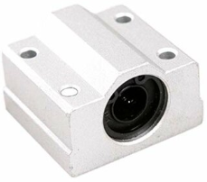
Figure21: Rods, Bearings, and Bases

Ultrasonic Sensor (Proximity Activation)
An ultrasonic sensor was integrated into the system to provide a proximity-based activation feature. This sensor allows the box to automatically turn on or wake from standby mode when a child approaches, making the interaction more seamless and engaging.
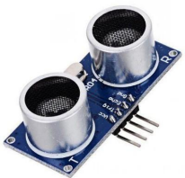
Figure22: Ultrasonic Sensor

Intercom Wires
We used them for wiring and connecting different components together.

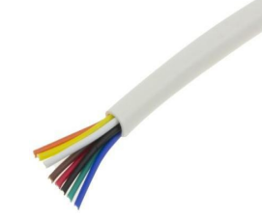
Figure 24: LDR Sensor

Arduino Wires
To be able to connect the components to the Arduino.

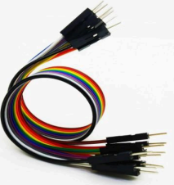
Figure25:.Arduino Wires

Software Components

Mobile Application
The MagicTales mobile application is an interactive educational tool designed for children to combine fun, storytelling, and learning.
The app communicates with an external device (ESP32 + Arduino) over Wi-Fi to send and receive words.
- Story Mode (Part1): Children can select and listen to different stories. Each time a story is read, the counter increases so we can track how many stories the child has finished.
- Word Game Mode (Part2): Children can type and send words to the device (with levels: 3-letter, 4-letter, or 5-letter words) and also receive back the latest detected words from the device. The application contains3 interfaces as follows:

Home Screen
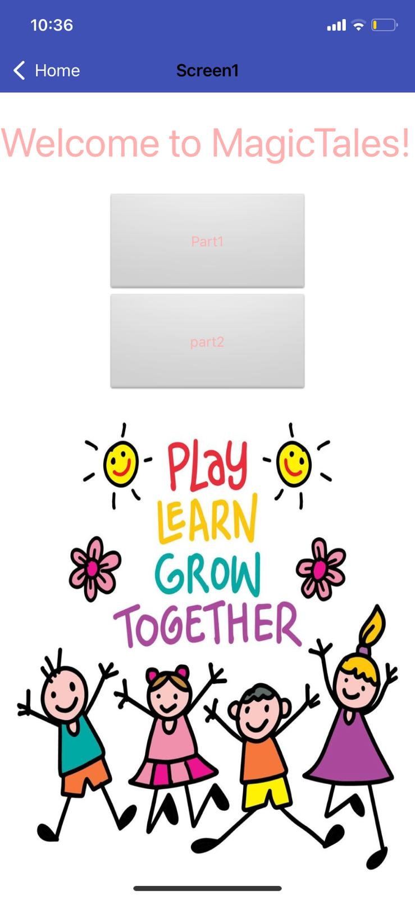

Figure26: Home Page of the application

Includes Two main buttons:
- Part1 (Stories): Opens the story selection screen.
- Part2 (Words Game): Opens the word game screen.

Story Selection Screen
Figure27: Story Selection page
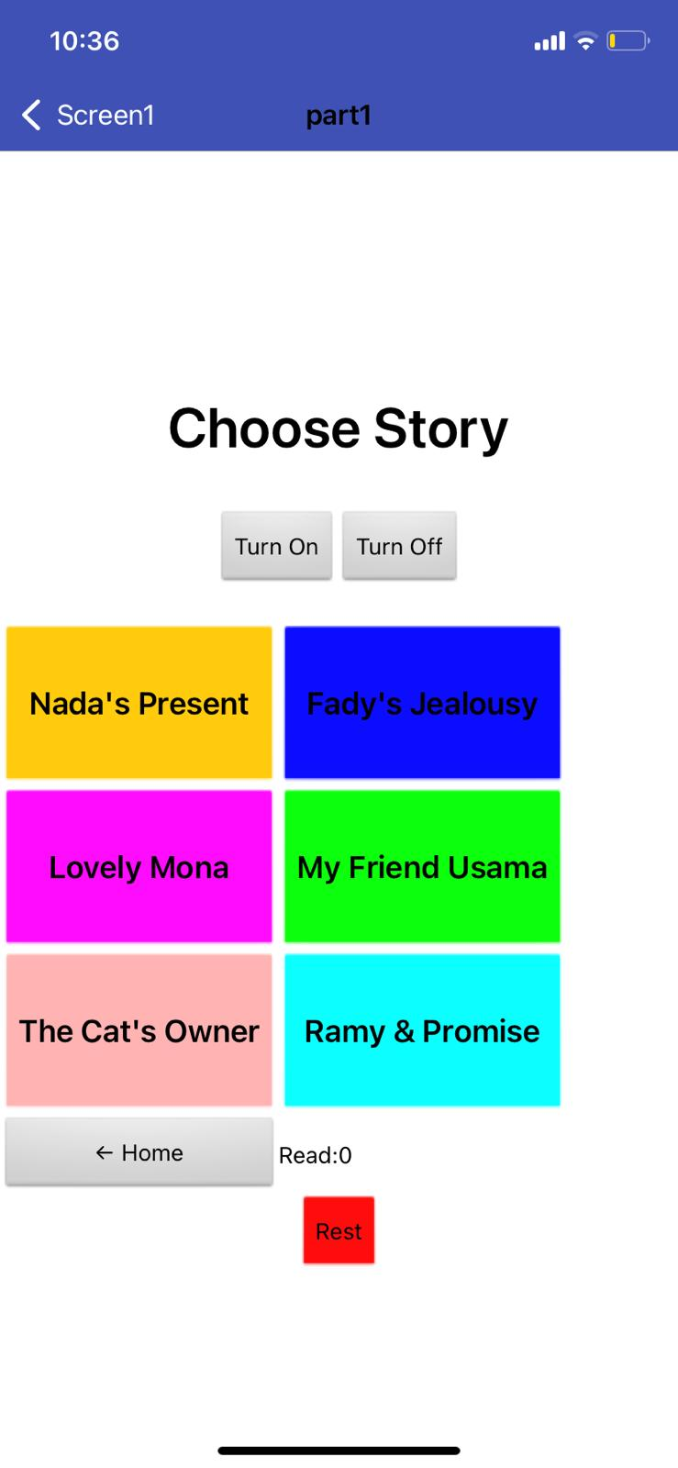

Every time a story is read, the story counter increases, so we can keep track of the child’s progress.
Buttons:
- Home → Return to the main screen.
- Read → Start reading the story.
- Reset → Reset theelection.

Word Game Screen
Figure28: Word Game Page
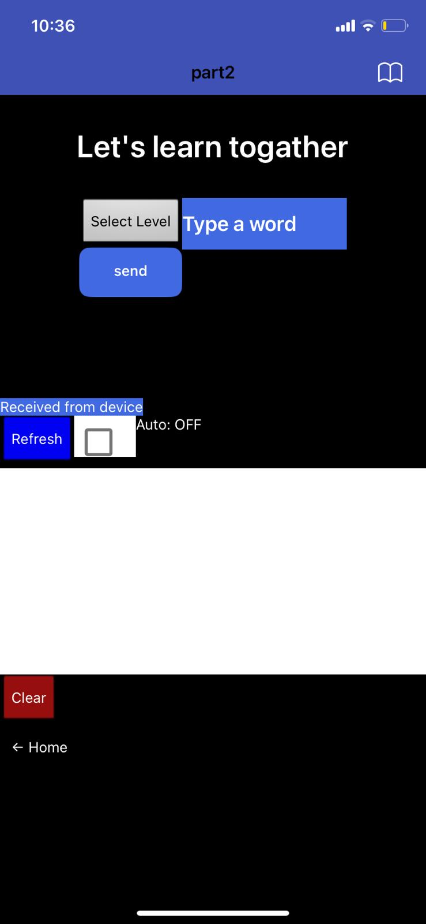

Components:
- Spinner: Select the level (L1 = 3 letters, L2 = 4 letters, L3 = 5 letters).
- Text Box: Enter the word.
- Send Button: Sends the word to the device.
Received Section:
- Refresh Button: Requests the latest word from the device.
- Auto Checkbox: Enables automatic refresh.
- Label: Shows connection status (Idle / Auto ON / Last received word).
Lists:
- List View History: Displays all words sent by the child.
- List View Received: Displays all words received from the device.
Control Buttons:
- Clear Received: Deletes the received list.
- Home: Return to the main screen.
Figure29: Select Level 1
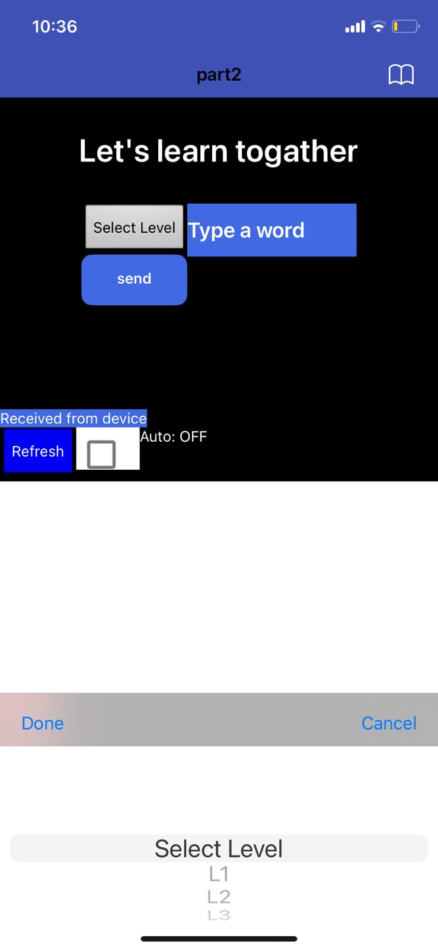

Figure30 : choose level alert
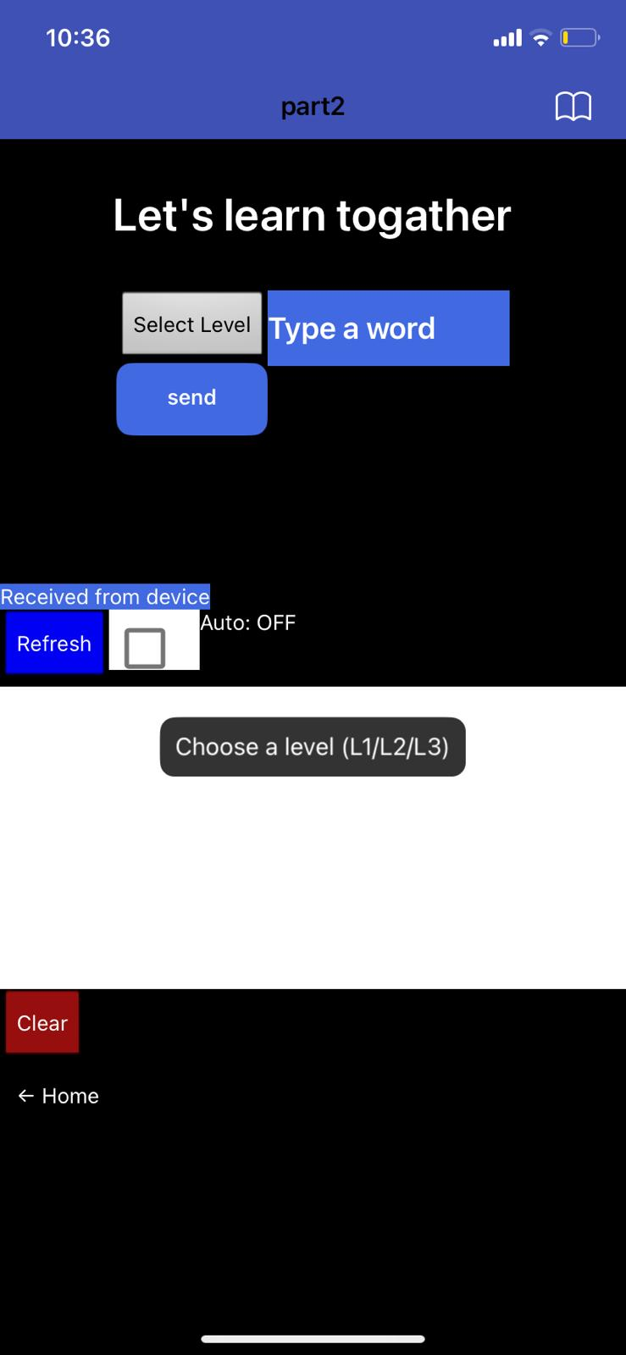

If the child presses Send without typing a word or without selecting a level, an Alert appears to remind them:
“Choose a level (L1/L2/L3)” or “Type a word first”.

How does the system work?
The Interactive Box for Kids integrates hardware, sensors, actuators, and software to provide two main educational modules: Story Mode and Game Mode, along with a Parent Control section. The system is designed to operate seamlessly and respond automatically to the child’s interaction, while allowing the parent to monitor and enrich the content.

System Activation
When the box is powered on, the ultrasonic sensor monitors the surrounding area. If a child approaches within the defined range, the system automatically activates:
- A welcome audio is played using the DFPlayer module.
- The RGB LEDs flash to indicate readiness.
- If the LDR sensor detects low light conditions, the system automatically switches on the LEDs for better visibility.
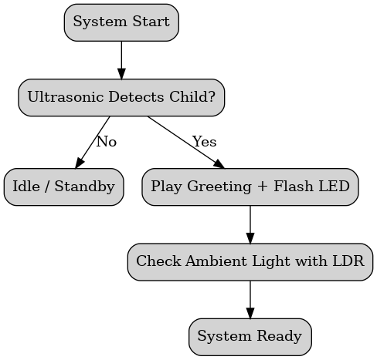

Story Mode
- The child presses the Start button to enter story mode.
- The system announces the available six stories through audio prompts.
- The child selects a story using the child keypad.
- A servo moto releases the selected storybook from the lower storage section.
- The RGB LED lights up with a unique color corresponding to the chosen story.
- The DFPlayer continues by narrating the story aloud, encouraging reading and listening simultaneously.
This mode motivates the child to engage with books physically and aurally, enhancing early literacy skills.
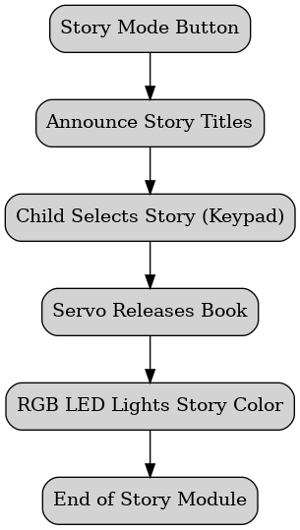

Game Mode
The game section challenges the child to arrange RFID-tagged letter cards into correct words across three levels:
- Level 1: 3-letter words.
- Level 2: 4-letter words.
- Level 3: 5-letter words.
Operation flow:
- The child places the letter cards into the slots.
- The CNC platform, equipped with an RFID reader, moves across the slots to scan each card.
- The Arduino verifies the word against the database:
  - If correct → the green LED lights up and a success sound is played.
  - If incorrect → the red LED lights up and a hint is provided, after which the child can retry.
- Upon completing a level, the child advances to the next stage, progressively building spelling and recognition skills.
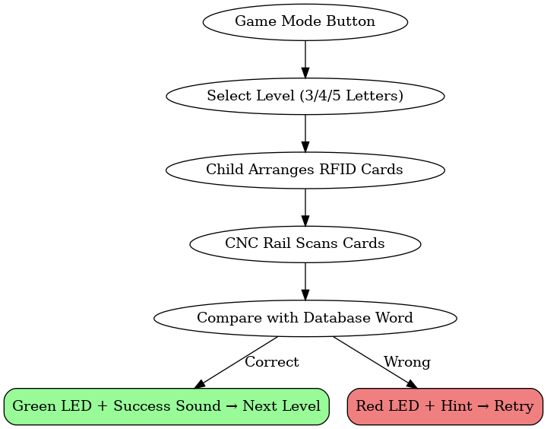

Parent Control
Parents have access to a 4×4 keypad to add new words into the system:
- Input is based on multi-tap entry, where repeated presses of a key cycle through letters (e.g., key 2 = A, B, C).
- Pressing 0 saves the entered word directly to the SD card via the SD card module.
- Words are limited to 3–5 letters to match the game structure.
- Saved words can later be retrieved and used in the game, ensuring the system grows with the child’s learning needs.
The parent section also allows monitoring of:
- The child’s current level.
- The number of completed words.
- The last word attempted.
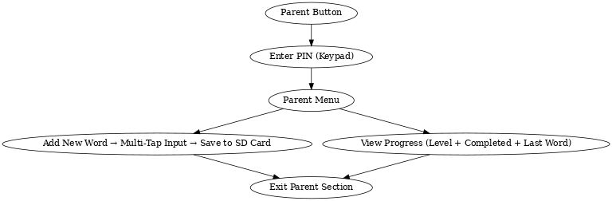

Audio and Visual Feedback
  - DFPlayer Module: Provides narration, hints, and sound effects for correct/incorrect answers.
  - RGB LEDs: Used as visual indicators — story colors, green for correct answers, red for mistakes.
  - OLED/LCD Display: Displays prompts, words being entered, and system status for both child and parent
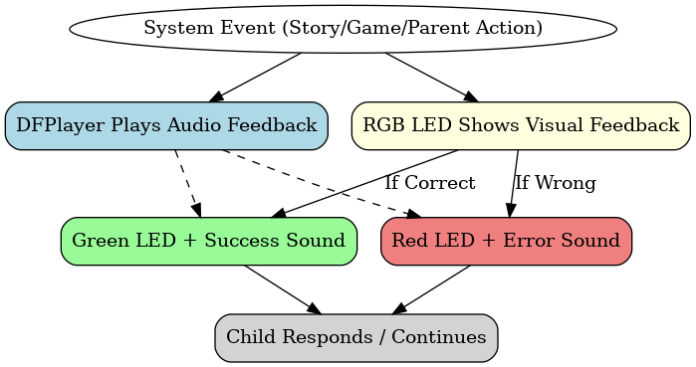

Automatic Lighting and Safety
- The LDR sensor ensures that the LEDs turn on automatically in dark conditions, improving usability.
- All wiring and power circuits are enclosed inside the wooden structure to ensure child safety
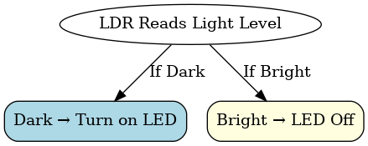

Mobile Application Integration
The system is connected to a mobile application (App Inventor) via the ESP32 Wi-Fi module.
- Parents can send new words wirelessly.
- The app displays child progress, completed stories, and words.
- Real-time communication ensures reliable synchronization between the box and the app.

Overall Workflow Summary
- Activation: Ultrasonic detects child → system powers on → greeting + LEDs.
- Story Mode: Child chooses story → servo dispenses book → audio narration + LED color.
- Game Mode: Child arranges RFID cards → CNC scans → feedback with LEDs & sounds → level progression.
- Parent Mode: Parent uses keypad to add words → saved to SD card → available in the game → app syncs progress.
- Automatic Functions: LDR controls lights in dark, ESP32 maintains wireless connection, all feedback ensures smooth interactivity.

Chapter5

Results and Discussion
The Interactive Box for Kids was successfully designed, implemented, and tested. The system combined storytelling and gaming modules with parent control features, and all hardware components worked together under the Arduino Mega and ESP32 platform.

Results

Story Module
  - The servo mechanism reliably released the correct story when selected from the keypad.
  - The RGB LED feedback correctly displayed the unique color assigned to each story.
  - Audio narration via the DFPlayer worked as intended, allowing children to listen to the story while reading along.
  - Tests with six different stories showed a 100% success rate in dispensing the right book without mechanical jams.

Game Module
- The RFID reader on the CNC platform was able to detect and verify all letter cards across three levels.
- Success feedback (green LED + audio) and error feedback (red LED + hint) were consistent.
- Children were able to complete all three levels with an average accuracy of 92% after hints were provided.
- The CNC rail moved smoothly on the rods and bearings, showing stable mechanical performance

Parent Control
- The 4×4 keypad allowed multi-tap input of new words (3–5 letters).
- The SD card module correctly stored all newly added words into words.txt, and the system successfully retrieved them for future games.
- Parents could monitor progress (current level, words completed, last attempted word) through both the LCD display and the mobile app connected via ESP32.

Sensor-Based Automation
- The ultrasonic sensor reliably detected child presence within 40–50 cm and activated the system.
- The LDR sensor enabled automatic LED activation in dark conditions, which improved usability.
- The overall sensor accuracy was measured at 95% for ultrasonic and 97% for LDR.

Wireless Communication
- The ESP32 Wi-Fi module maintained stable communication with the App Inventor mobile application.
- Parents were able to view progress and send words in real time with minimal delay (average latency < 200 ms).

Conclusion
Overall, the system performed successfully and reliably in real-world tests. The combination of storytelling, gamified learning, and parental control achieved the goal of creating an interactive, educational, and entertaining system for children, while giving parents control and flexibility to guide their child’s progress.

