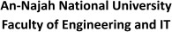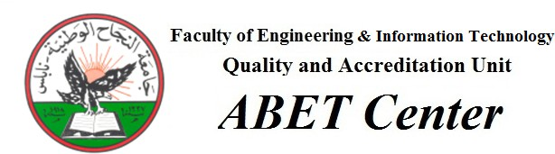

Project title: RefreshGo Academic Year: 2024/2025

Group Members: Amer Kobari Department Name: Computer Engineering Tariq Marmash

Project Type Hardware Supervisor Name: Dr. Hanal Abuzanat

Project’s Abstract:
RefreshGo acts as an advanced drink system which merges image processing along with voice control capabilities and mobile system connectivity to make
personalised mojitos accessible to users. Users can easily get their custom drink from this machine because it features convenience and personalization features.
Users can upload mojito pictures to the system for ingredient customization because the platform analyzes color data to duplicate precise recipes. Manual ingredient
management lets users change both strength and portion of the flavor. Users can
command their drink preparation through voice control while the machine needs only a single spoken request to each flavor to deliver the desired drink immediately.
RefreshGo determines nutritional values for fat, sugar, and calories when users input
components such as lime, mint, sweeteners, and base drinks including soda or cola. The live nutrition breakdown of Mojitos helps consumers choose their drinks wisely during their drinking experience.
Through a remote mobile application admins gain access to monitor RefreshGo in
addition to managing it effectively. The payment system will be through integrated card systems which creates smooth cashless operations and render the machine appropriate for coffee shops and private residences.

