Acknowledgment

We would like to thank our graduation project supervisor Professor Hamdallah Bearat for his patient guidance and encouragement throughout the course. We would like also to thank Professor Afif Hasan, Dr. Ayser Yasin and Dr. Mohammad Alsayed. We are thankful for the lab technicians for helping us complete our experiments: Eng. Ahmad Khader and Mr. Jamal Fakhoury.
In this occasion we want to thank all Energy Engineering and Environment professors for their support.
Table of Contents
List of Figures IV
List of Tables V
Abstract VI
1. Introduction 1
1.1 Problem Statement 1
1.2 Objectives 1
1.3 Scope 1
1.4 Backgrounds 2
1.4.1 Heat Transfer 2
1.4.2 Solar Energy 3
1.4.3 Lenses 4
2. Literature Review 7
2.1 Solar Thermal vs. Photovoltaics 7
2.2 Solar Collectors 8
2.2.1 Flat-Plate Collectors 9
2.2.2 Concentrating Collectors 10
2.2.3 Central-Receiver Collectors 11
2.3 Fresnel lenses 12
2.3.1 Imagining systems: 13
2.3.2 Noun imagining systems: 13
2.4 Properties of aluminum 14
2.5 Glass 15
2.6 Energy Storage 15
2.6.1 Energy Storage in Solar Systems 15
2.6.2 Water Storage 16
2.6.3 Phase Change Energy Storage 17
2.6.4 Chemical Energy Storage 17
3. Methodology 18
3.1 Hemispherical Solar Concentrator with lenses. 18
3.1.1 Model description 18
3.1.2 Materials and Methods 18
3.2 Flat plate solar concentrator with lenses. 22
3.2.1 Flat Plate Solar Concentrator – Mold Preparation: 22
3.2.2 Flat Plate Solar Concentrator – Lenses Combination: 25
4 Results and Analysis 30
4.1 Sample of Calculations 32
5 Conclusion and recommendations 40
6 References 41
7 Appendices 43

List of Figures
Figure 1: Convex Lens. After [4] Figure 2: Types of Converging lenses. After [4] 5
Figure 3: Concave Lens. After [4] 6
Figure 4: Scheme for Solar Thermal Power Plant. After [7] 7
Figure 5: Scheme for Photovoltaics electricity generation. After [6] 8
Figure 6: flat collector parts. After [7] 10
Figure 7: Solar tower. After [7] 11
Figure 8: Fresnel lens. After [8] 12
Figure 9: imaging and non-imaging lenses. After [8] 14
Figure 10: A typical system using water tank storage with circulation. After [7] 16
Figure 11: Scheme for conventional lens 19
Figure 12: Drawing circles on wet clay 20
Figure 13: Lens Mold 21
Figure 14 : Fixed Lenses in the box. 23
Figure 15 : Glass Puffing. 24
Figure 16 : Fired mold with metallic support box. 25
Figure 17 : Glass Drilling by Circular Glass Drill 26
Figure 18 : Damaged Plates. 27
Figure 19 : Lenses fixing. 27
Figure 20 : Solar Concentrator wooden Body. 28
Figure 21 : Aluminum inner layer. 29
Figure 22: flat plat vs flat plat with lenses 31
Figure 23: Efficiency results. 33
Figure 24: Condensed water. 34
For our system: Figure 25: Scheme for hemisphere clarification. 35
Figure 26: The effect of improvement on the lenses system. 37
Figure 27: the weight of salt and glass dish. 38
Figure 28: Glass dish with salt in the system. 38
Figure 29: The weight of the glass dish and salt after water removed. 39

List of Tables

Table 1: Water temperatures in conventional flat plate versus flat plate solar collector with lenses. 30
Table 2: Energy and Efficiency calculations for flat plate system and lenses plate system. 32
Table 3: Readings after improvement on lenses system. 36

Abstract

Around the world there are many solar energy systems like photovoltaic systems, solar concentrating systems and many more systems, but the low efficiency, storage and low amount of solar density are still of the main challenges faced in these systems.
The idea of our project is about how to improve the use of solar energy in solar thermal systems. We made a solar thermal concentrator using lenses. The system consists of a flat plate glass that has a number of fitted lenses in term of increasing the surface area, this glass was placed on a wooden box with a black plate of aluminum in the inner side, where the temperature measurements took place.
A comparative experiment was done to compare between our flat plate with lenses and the conventional glass plate, the glass with lenses reached 90ºC while the normal glass reached 57ºC only. The produced plate gave us temperatures in a shorter time than the conventional normal one.
To apply this system in an practical way, we dried 50 g of Sodium Sulfate Decahydrate to extract water from it and we succeeded by 52% water extraction.

Introduction

1.1 Problem Statement
Solar energy systems include different types of energy conversion systems like photovoltaics and solar concentrators. The sun as the source of energy has low energy density, which mostly increases by solar concentrating systems.
As we have many different types of concentrators, there is still lack of attention toward concentrating solar radiation using lenses. Regionally, research related to solar thermal concentrators is really scarce, which causes also limitations on using these systems. Only conventional solar water heaters are in common use.

1.2 Objectives
In this project, our goal was to find efficient, simple and low maintenance design for solar thermal lenses concentrator, which uses lenses to increase the solar density. Which can be used as solar water heater with higher efficiency than conventional systems, in energy storage or producing water from air humidity using thermochemical cycle.

1.3 Scope
One of the most popular problems in conventional solar systems is the systems efficiency. It is known that the sun (as a renewable source of energy) has relatively low density which results in low system efficiency. To solve this problem we decided to improve the conventional glass plate area by adding lenses to its surface. The outer surface of the flat glass has numerous lenses, they are grouped and fitted close to each other. Lenses shall increase the concentration area, so that the concentration ratio will increase.
The aim of this design is to increase the area of concentrator and decrease the area of receiver (increasing concentrating ratio) to reduce losses and to get as high solar density as possible. The concentrating ratio for the design was limited due to low experience in this field in our country so we had to make the design with slightly small dimensions.
The significance of our design is finding new solutions for the low solar density to get new simple and affordable product with higher characteristics.
This report contains: the latest studies in solar energy systems (especially solar concentrators), the methodology of our system and the final results we have obtained.

1.4 Backgrounds

1.4.1 Heat Transfer
The energy is defined as the ability of any object or system to do work on another system. Energy can be found in different forms, such as chemical Energy, mechanical energy, kinetic energy, thermal (heat) energy…etc. (all these letter should be small). Energy can be transferred in different ways, due to the variety of its forms. [1]
Thermal energy is the form of energy that is transferred from one system to another depending on temperature difference. [1] The scientific field that deals with the amounts of thermal energy transferred is called Heat Transfer.
Heat can be transferred in three different ways: conduction, convection and radiation. These three modes have different mechanisms but all of them require the presence of temperature difference to allow heat transfer from high temperature object/system to the lower ones.
To know more about these three modes, here is a brief description of each one:
- Conduction: is the transfer of heat energy between substances in direct contact. The energy transfer is from more energetic molecules/atoms to less energetic ones. It could happen between solids, liquids and gases.
- Convection: is the transfer of heat that occurs between solid materials (surfaces) and fluids (gases or liquids). The principle of this mode is the motion of the fluid, in other words if there is no motion for fluid then the mode is conduction. As the fluid moves faster, the convection is greater.
- Radiation: Unlike conduction and convection, radiation is the way of energy transfer with absence of contact between the heat source and the heated object. Energy is emitted in the form of electromagnetic waves. So, it does not require a medium for heat to be transferred. [1]

1.4.2 Solar Energy
The sun is one of the most important renewable source of energy. In ancient times the role of sun was limited to daylighting and energy source for creatures in earth. Nowadays many energy specialists are working hard to find the most effective way to convert solar energy into useful form of energy.
History of Solar energy
Solar energy in simple words is the energy provided by the Sun. It is a free renewable source and its applications are relatively new.
- The ability to use solar power for heat was the first discovery. In 1767 a Swiss scientist built the first thermal solar collector, which was later used to heat water and cook food. [2] The first commercial patent for a solar water heater was in 1891. [3]
- Producing electricity from solar energy was the second discovery. In 1839 a French physicist realized that the Sun’s energy could produce a "photovoltaic effect" (photo = light, voltaic = electrical potential). In the 1880s, selenium photovoltaic (PV) cells were developed that could convert light into electricity with 1-2% efficiency ("the efficiency of a solar cell is the percentage of available sunlight converted by the photovoltaic cell into electricity"). [3]
“Solar technology advanced to roughly its present design in 1908 when William J. Bailey of the Carnegie Steel Company invented a collector with an insulated box and copper coils.”
We still use solar power in the same two forms today, thermal and photovoltaic. [3]

1.4.3 Lenses
A lens is a transparent piece made from glass or plastic with one or two curved surfaces. It works by refraction. Refraction is a phenomenon that causes change in light rays direction. [4]
Conventional Lenses
In lenses object seems bigger or smaller than they are that’s because the rays come from a point that is further away or closer from their actual source, that depends on the type of lens. [4]
Types of lenses:
- Convex lenses
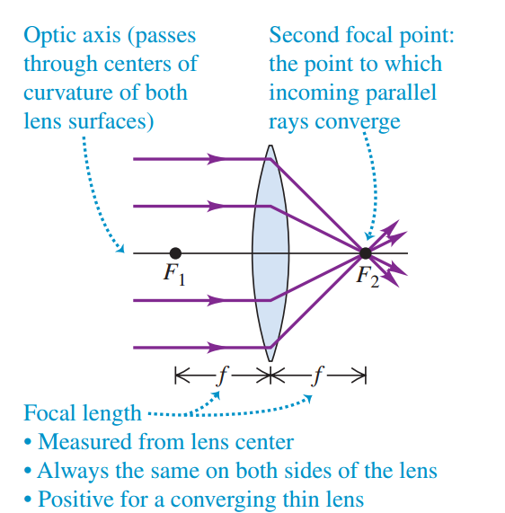
A convex lens is a glass or plastic piece, the outer surface bulge outward in the center (Thicker at the center than at the edges). It’s called sometimes converging lens because light rays passed through it become close to each other (they converge). The refracted rays grouped in one point called focal point. As shown in Figure 1. [4] We have three types of converging lenses as shown below in Figure 2
Figure 1: Convex Lens. After [4]
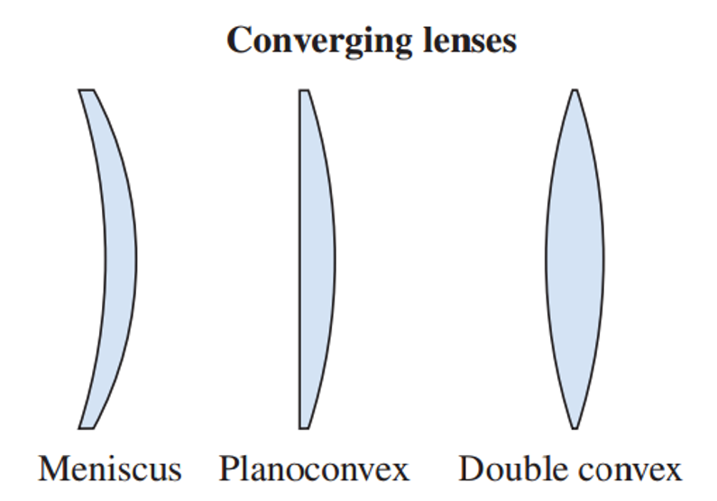
Figure 2: Types of Converging lenses. After [4]

- Concave lenses.
Unlike Convex lenses, concave lenses are thinner at the center than at the edges. The other name of these lenses is diverging lenses, because light rays that pass through the lens are spread out (diverge). The refracted rays seem to come from one point, which is called focal point. As shown in Figure 3. [4]
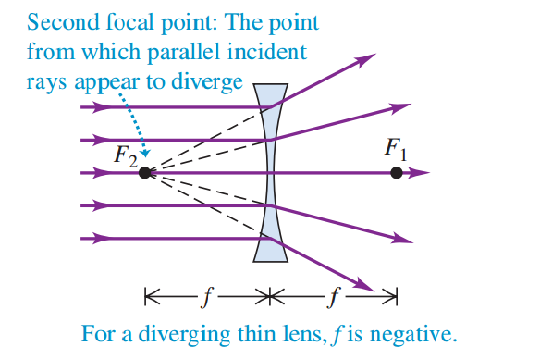
Figure 3: Concave Lens. After [4]

Literature Review

2.1 Solar Thermal vs. Photovoltaics
It is important to understand the difference between solar thermal and solar panel (PV) systems. Let’-us take electric power generation as an example to know how each system work.
In solar thermal, solar energy is concentrated and converted into thermal energy. This energy is stored in a fluid (water or air), then a heating engine is used to extract that energy and finally turn a generator to produce electricity. [5]
The fluid heated by the concentrated sunlight can be liquid, gas or super critical fluid. Many types of engines can be used including steam engines, gas turbines, Stirling engines, etc. Engines efficiency is often between 30% and 40%, and are capable of producing 10-100 megawatts of power. [5]
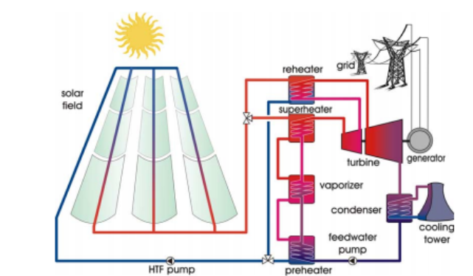
Figure 4 shows solar thermal power generation plant.
Figure 4: Scheme for Solar Thermal Power Plant. After [7]
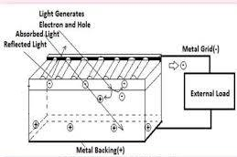
Photovoltaics (PV) systems converts sunlight directly to electricity. Solar cells are made of layers of semiconductor materials (usually silicon). When PV cell recieves incident light from the Sun , the energy motivates electrons to be emitted from their atoms, allowing the electrons to flow through the material to produce electricity. Figure 5 shows a scheme for a PV cell. PV systems can be used only during daytime. Electrical storage is neither easy nor efficient like heat storage in thermal power plant. Solar energy can be stored as heat energy during all daytime and then convert it into electricity. [6]

Figure 5: Scheme for Photovoltaics electricity generation. After [6]

2.2 Solar Collectors
Solar collector is a device that is used as special type of heat exchanger which transforms the radiation energy to heat by increasing the energy density.
In the solar collector, energy transfer is from a distant source of radiant energy to a ﬂuid. The ﬂux of incident radiation is, at best, approximately 1100 W/m2 (without concentration), and it is variable. The wavelength range is from 0.3 to 3 µm. Variable and low fluxes present unique problem in solar collectors’ analysis. [7]
Briefly it is to collect, absorb and transfer solar energy to working fluid, such as water or air.
Types of solar collector include:
- Glazed flat-plate collectors.
- Parabolic dish collectors.
- Parabolic trough collectors.
- Batch collectors.
- Evacuated-tube collectors.
- Power towers.

2.2.1 Flat-Plate Collectors
Flat-plate collectors can be designed for applications requiring energy delivery at moderate temperatures, up to 100ºC above ambient temperature. They use both beam and diffuse solar radiation, tracking system is not required, only little maintenance is required. They are mechanically simpler than concentrating collectors. The major applications of these units are in solar water heating, building heating, air conditioning, and industrial heat process. [7]
Description of flat-plate collectors
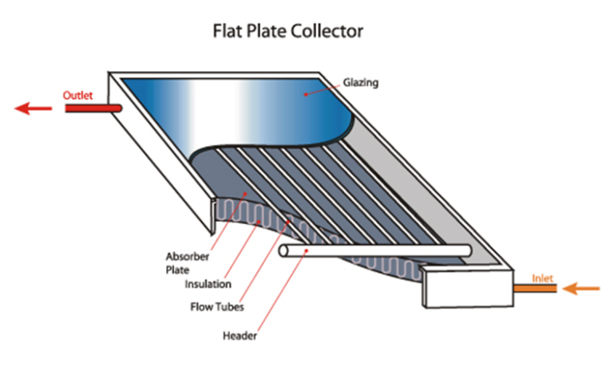
The important parts of a typical liquid heating ﬂat-plate solar collector, as shown in Figure 6, are the ‘‘black’’ solar energy-absorbing surface with means for transferring the absorbed energy to a ﬂuid, envelopes transparent to solar radiation over the solar absorber surface that reduce convection and radiation losses to the atmosphere, and back insulation to reduce conduction losses. Orientation optimized for the flat collectors depending on location and the operational time of year. [7]
Figure 6: flat collector parts. After [7]
The solar radiation absorbed by a collector per unit area of absorber is equal to the difference between the incident solar radiation and the optical losses.
The difference between the ambient temperature and absorber temperature causes three types of heat loss to surrounding, convection, conduction and radiation. [7]

2.2.2 Concentrating Collectors
For many applications it is desirable to deliver energy at temperatures higher than those possible with ﬂat-plate collectors. Energy delivery temperatures can be increased by decreasing the area from which heat losses occur.
This is done by interposing an optical device with large area between the source of radiation and the energy-absorbing surface. The small absorber will have smaller heat losses compared to a ﬂat-plate collector at the same absorber temperature.
The ratio between optical concentrator area and absorbing surface area known as concentration ratio.
Concentrators can be reﬂectors (mirrors) or refractors (lenses), can be cylindrical or surfaces of revolution, and can be continuous or segmented. Receivers can be convex, ﬂat, or concave and can be covered or uncovered also Concentration ratios can vary over several orders of magnitude. Tracking systems and maintenance are required for these systems.
The absorbed solar radiation per unit area of absorber surface depends on optical characteristics of the concentrator and receiver.
Concentrating collectors have optical properties which vary with the geometry of the device. [7]

2.2.3 Central-Receiver Collectors
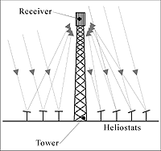
The central-receiver, or ‘‘power tower,’’ concept for generation of electrical energy from solar energy is based on the use of very large concentrating collectors. The optical system consists of a ﬁeld of a large number of heliostats, each reﬂecting beam radiation onto a central receiver as shown in figure 7.
Figure 7: Solar tower. After [7]

Several additional optical phenomena must be taken into account. Shading and blocking can occur in this systems. [7]

2.3 Fresnel lenses
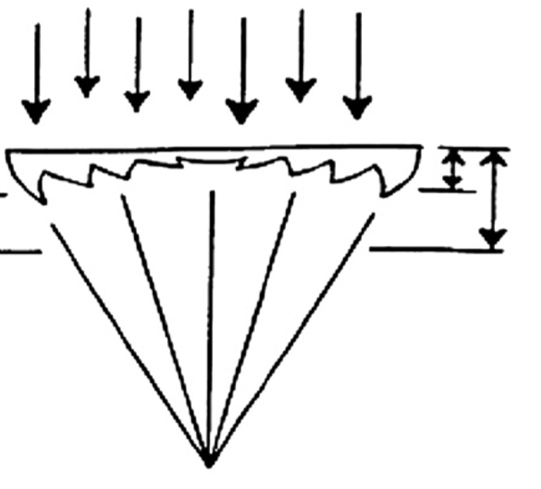
Fresnel lens is a multi-connected primes all of them have the same slop of lens surface but without the full body materials, as shown in figure below. [8]
Figure 8: Fresnel lens. After [8]

Recently Fresnel lenses became great choice in solar concentration field of energy, because it takes small volume, light mass and it’s effectively increase the sun energy density. At the beginning glass was the only material for Fresnel lenses, glass mostly use for high temperature applications. For other applications poly methyl methacrylate (PMMA) is used. (PMMA) become available at 1950s, and it’s widely use now because its transmissivity and refraction index are close to that of glass, its thermal stability up to 89c and its resistance to sunlight. [9]
Most recent researches in Fresnel concentration are focused on two systems:
- Imagining system.
- Non-imagining systems.

2.3.1 Imagining systems:
The imagining Fresnel lenses refract the light from object to focal plane in form of image with some aberration. Applications like photovoltaic usually use imaging Fresnel lenses but with accurate tracking system. [8]
In 1951 the first imagining Fresnel lens from plastic material was made. [10] This lenses shows its applicability for many applications in light collecting where volume and weight are limited like camera view screen. [11]
Imagining linear Fresnel lenses solar concentrate could reach (60-143ºC) for water heating. While the daily efficiencies of collection was 50% at concentrating ratio equal 5. But its need a high accurse two axis tracking system, due to this tracking sensitivity and hot spot problems the suitability for this systems is questionable. [8]

2.3.2 Noun imagining systems:
It is lens concentrating system and its concentrate the light without saving the imaging quality.
As the imaging quality is not required in solar concentrating systems but instead high uniform flux is demand, the non-imaging concentrators become more common since it’s discovered in 1965. [8]
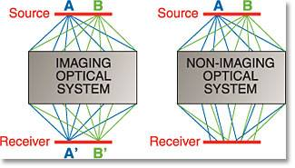
Figure 8 will show the difference between imaging and non-imaging Fresnel lenses.
Figure 9: imaging and non-imaging lenses. After [8]

2.4 Properties of aluminum
Aluminum, after iron, is the second most important metal in industrial and commercial uses. It has plenty of properties that make it widely used these days.
Weight:
One of the well-known properties of the aluminum that it has low weight, and there for low density. The density of aluminum is one-third the density of steel.
Conductivity:
Aluminum is an excellent conductor of heat and electricity. An aluminum conductor weighs approximately half as much as a copper conductor having the same conductivity. The thermal conductivity of the aluminum at 20ºC is 272 W/m · K.
Corrosion:
Aluminum is a highly reactive metal that has a high resistance to corrosion in many environments because of the presence of a thin, highly adherent film of aluminum oxide. When a fresh surface of aluminum is exposed to air or water, a surface of thin film of aluminum oxide immediately begins to form and grow rapidly. This layer is dense and provides excellent corrosion protection. The layer is self-repairing if damaged. [12]

2.5 Glass.
Glass is an amorphous rigid material, mostly transparent, basically it is consist of minerals mixture of sand (silica), lime and soda in specific amounts. Glass is made by melting minerals at very high temperatures.
It has wide range of uses from packaging and construction to fiber optics.
Glass properties
- Hard: Surface resists scratches and abrasions.
- Chemical Corrosion-Resistant: Affected by few chemicals. Resists most industrial and food acids.
- Optical Properties: Reflects, bends, transmits, and absorbs light. [13]

2.6 Energy Storage
Solar energy is a time-dependent energy resource. Energy needs for a very wide applications are also time dependent but in different fashion than the solar energy supply. Consequently, the storage of solar energy is necessary to make it meet applications energy needs. [7]

2.6.1 Energy Storage in Solar Systems
(Energy may be stored in the form of sensible heat of a liquid or solid medium, as heat of fusion in chemical systems, or as chemical energy of products in a reversible chemical reaction. Mechanical energy can be converted to potential energy and stored in elevated ﬂuids. Products of solar processes other than energy may be stored; for example, distilled water from a solar still may be stored in tanks until needed, and electrical energy can be stored as chemical energy in batteries.)
“The choice of storage media depends on the nature of the process.”[7]

2.6.2 Water Storage
Water is the ideal fluid to store heat for many solar systems. Energy is added to and removed from this type of storage unit by transport of the storage medium itself as shown in Figure 11.
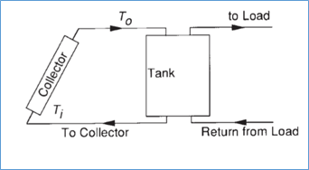

Figure 10: A typical system using water tank storage with circulation. After [7]

Where Ti is the input temperature and To is the output temperature.
The energy storage capacity of a water storage unit operating over a temperature difference is given by:
$$Q_{s}={\left(m C_{p}\right)}_{s} ∆T_{s}$$
where Q_{s} is the total heat capacity for a cycle operating through the temperature range $∆T_{s}$ and m is the mass of water in the unit, C_{p} is the heat capacity of water. [7]

2.6.3 Phase Change Energy Storage
Materials that change phase in a suitable temperature range may be useful for energy storage, if several criteria can be satisﬁed. The phase change must be accompanied by a high latent heat effect, and it must be reversible over a very large number of cycles without serious degradation. The phase change must occur with limited super cooling or superheating, and means must be available to contain the material and transfer heat in and out. Finally, the cost of the material and its containers must be suitable. If these criteria can be met, phase change energy storage systems can operate over small temperature ranges, have relatively low volume and mass, and have high storage capacities. [7]

2.6.4 Chemical Energy Storage
Some chemical reactions might be used to store energy. None of them have been used in practical applications yet, and it still has both technical and economic challenges.
An ideal thermochemical reaction for energy storage is to use heat energy with endothermic reaction to get a new product AB + heat → A+B, then reverse the reaction to permit recovery of the stored energy. Thermal losses from the storage units are restricted to sensible heat effects, which are usually small, compared to heats of reaction. [7]

Methodology

3.1 Hemispherical Solar Concentrator with lenses.

3.1.1 Model description
The idea started with making a hemispherical solar thermal concentrator, which has the shape of hemisphere with a number of lenses within its structure. We used 3Dmax software to draw approximate shape for the solar concentrator.
We have asked multi expertise and manufactures about the ability to make a glass concentrator with the desired shape, all of them rejected our request because of limited machines and materials. Based on all these difficulties, we decided to make the mold structure with simple elements.
This experimental section contains the methods of creating the mold structure.

3.1.2 Materials and Methods
The working procedure for solar concentrator has multi steps, which can be divided into three practical steps:
- Creating the positive mold: which is the first step, here we constructed a structure which is similar to the final shape of the concentrator.
- Creating the negative mold: in this step, a layer of clay should be casted on the positive model to give us the negative mold or imprint.
- Glass Casting/Blowing: in this step the solar thermal lens concentrator becomes ready.
As mentioned before, creating the positive mold structure was the first practical step in the solar thermal concentrator design. The first stage in positive mold structure is creating lenses with the same radii, to stick them after that on the hemispherical model. To get lenses with the same radii, we considered that each lens originally was a ball. Figure 14 should demonstrate this consideration well. The reason behind this consideration is that each straightforward cutoff from ball’s surface makes focal point in the middle of this ball.
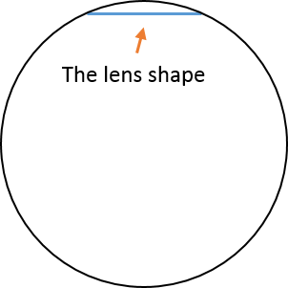
Figure 11: Scheme for conventional lens

Two different methods were followed in the process of creating composite lenses mold.
Method 1
We tried first to make these lenses from clay, a pottery specialist helped us to complete this procedure. Here are the steps we followed in this process:
- We brought a Styrofoam ball and cut it from the middle (make it 2 symmetrical parts).
- Then we took one half and formed a layer of unfired clay on it.
- Circles were made on the outer surface by a thin metallic tool (similar to scalpel), as shown in the Figure below.
- Finally, we allowed it to dry for a week.

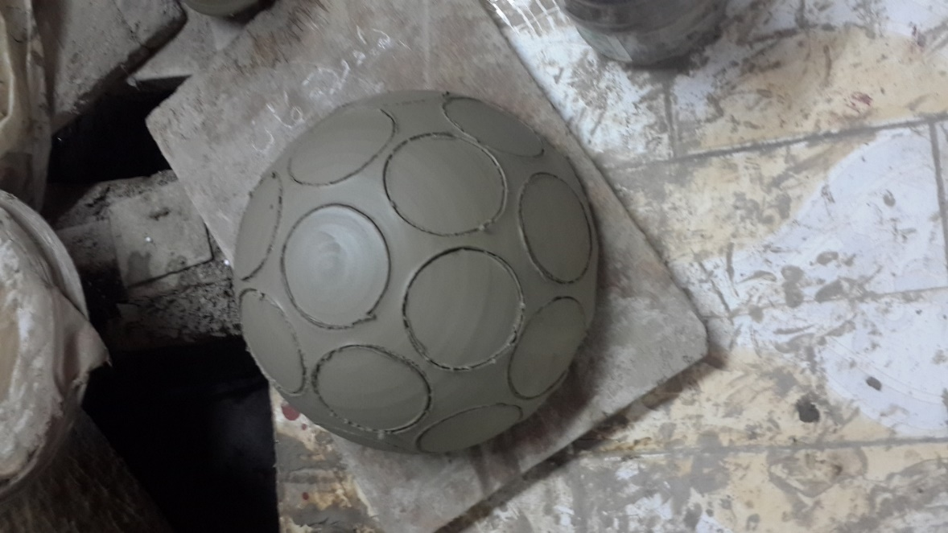

Figure 12: Drawing circles on wet clay
Meathod 2
We tried to think about a more accurate mechanism to get lenses with similar shape and dimentions as possible as we can. The best machine that could help us doing symmetrical molds with high accuracy was the three dimentional printer (3D printer).
To use the 3D printer we needed first to draw a 3 dimensional model on AutoCAD software and to give the order to the printer. The material used in the printer was a polymer.
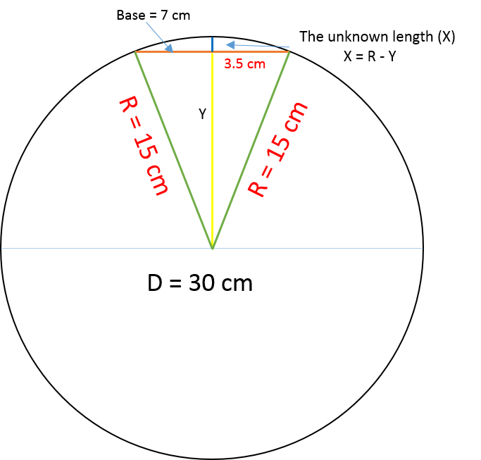
We assumed that the base of the conventional lens is 7 cm in diameter and the ball we are cutting from has a diameter of 30 cm
Calculations:
Phitagors theory:
$$Y^{2}+{3.5}^{2}={15}^{2}$$
Y = 14.58
X = 15 – 14.58 = 0.4 cm
Reffering to the previous calculations, lenses mold were done by the 3D printer with:
Base (diameter length) = 7 cm and hieght = 0.4 cm
Figure below shows the final sample of the lens mold (mold or model).
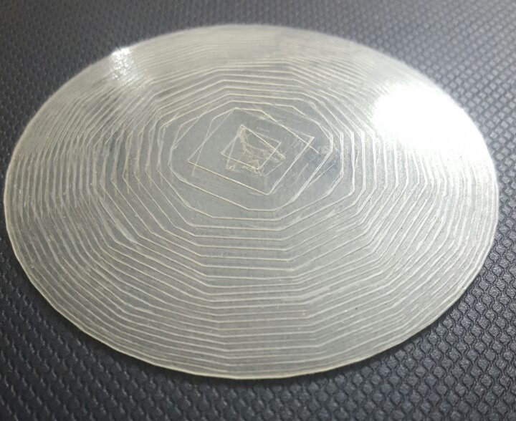

Figure 13: Lens Mold

It was possible to find a way for making a hemispherical mold with the produced lenses, on the other hand, the casting stage was hard to be reached with that mold shape.
Due to the difficulty that faced us in finding practical way for hemispherical glass blowing or casting, we decided to change the shape of the concentrator into a flat shape to make it easier without changing the main idea of the concentrator.

3.2 Flat plate solar concentrator with lenses.
Two different experiments were conducted to get the flat plate solar concentrator with lenses. The first one has failed while the second succeeded, both methods are listed in details.

Flat Plate Solar Concentrator – Mold Preparation:
As mentioned before, we applied the same solar concentrator principle but we did change the concentrator shape. The lenses printed by the 3D printer were used to produce the flat plate concentrator mold.
We needed to produce the solar concentrator negative mold in term of using it later for glass casting and getting the solar concentrator (as the positive final shape). For the negative mold we decided to choose a material with high heat tolerance so that it can endure the high temperature of the melted glass. We chose the mixture of gypsum, sand and water with the volumetric ratio of 1: 1: ¾.
The needed materials for this experiment were:
- Lenses mold (from 3D printer).
- White gypsum.
- Sand.
- Water.
- Wooden box.
- Silicon.
The Following steps show the procedure of making the flat plate solar concentrator mold:
- A wooden box with (50 cm X 50 cm) was used for holding the negative mold.
- We covered the bottom plate with a hard nylon.
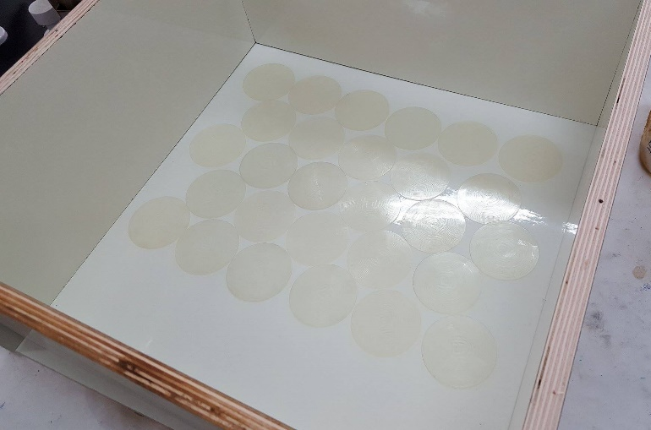
- The lenses have been fixed in the plate by silicon. As shown below.
Figure 14 : Fixed Lenses in the box.
- A 1 L of sand and 1 L of gypsum were mixed together and 3/4 L of water added to the mixture.
- After the mixture was mixed well, it has been poured on the plate to get the negative mold of the concentrator.
(For more softness, a small piece of wet cotton was used to swab the rough surface of lenses area.)
- We left the mold around 2 weeks to get dry.
After the mold has dried and became ready, we took it to a glass-blowing factory. The glass in the furnace was melted on 1400ᵒ C.
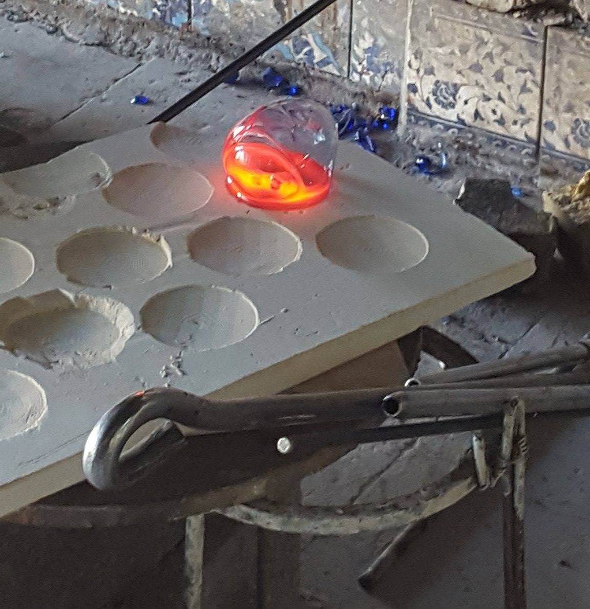
We started first with a small piece of the melted glass. When we put the glass on a part of the mold, a puffed glass was formed. Figure below shows the results.
Figure 15 : Glass Puffing.

Probably, the formed glass ball was formed because of the evaporation of the residual water in the mold. To solve this problem, we decided to make a new mold and fire it on 1200ᵒ C before taking it to the blowing factory.
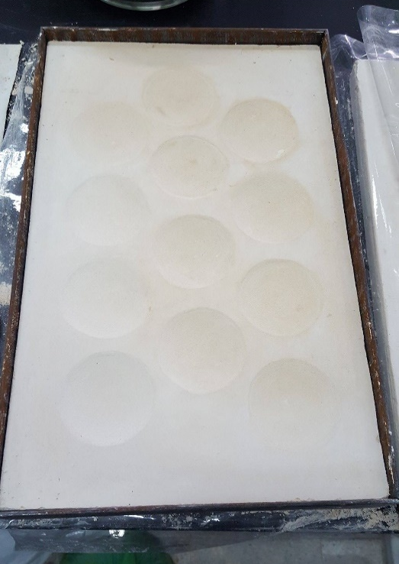
After firing, we made a metallic box to support and carry the mold safely. As shown in figure 16.
Figure 16 : Fired mold with metallic support box.
We have taken the fired mold to the blower to repeat our experiment in glass blowing, but this has also failed due to the primitive instruments that they use in the work shop. The sample was not clear and it had some bubbles inside it with some bumps on the surface.
All of the experiments we have done to get a solar concentrator mold and glass casting failed, so we looked for a new method to get a solar concentrator with lenses.

Flat Plate Solar Concentrator – Lenses Combination:
As mentioned before, we didn’t find any practical way of getting completely one homogeneous structure of solar concentrator with lenses, so we decided trying to combine lenses together in term of getting the solar concentrator.
The new idea was about bringing a prepared lenses and combine them in a flat glass. This process was achieved by drilling a flat glass by a circular glass cutter. This circular cutter/drill has the same diameter of the lenses that would be fixed on the removed parts.
Here is the procedure of preparing a flat plate solar concentrator by combining lenses:
- We started by choosing the dimensions of the flat glass, which is 53cm X 36cm.
- We chose lenses with a diameter of 7 cm.
- On the glass, we marked the positions of the circles. (Took into account the distance between the circles, to avoid glass weakness and cracks).
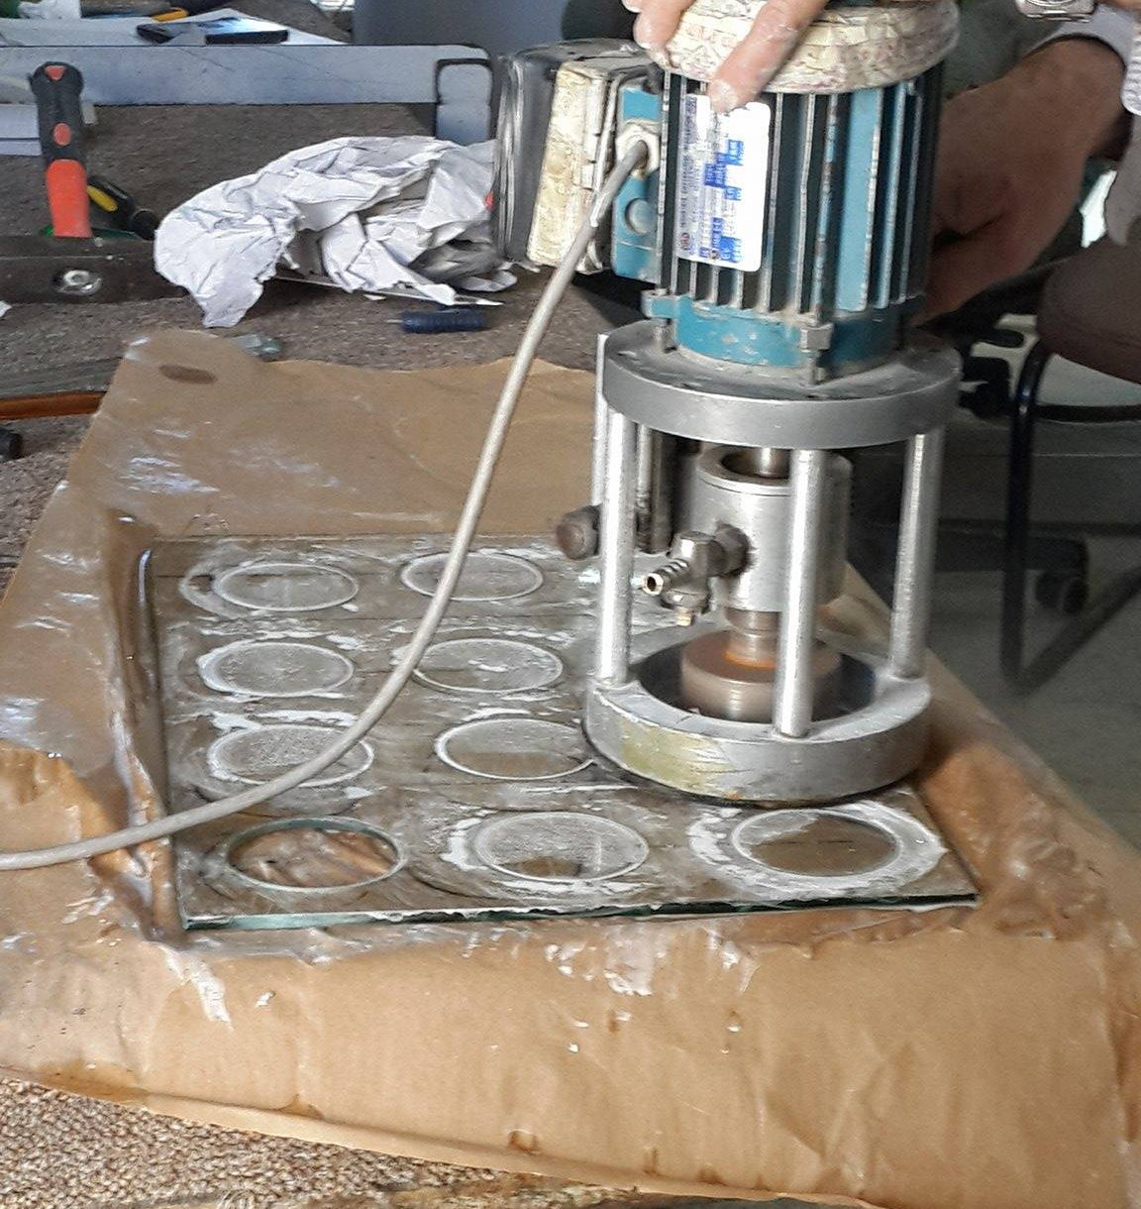
- Drilling process started, as shown in figure 17.
Figure 17 : Glass Drilling by Circular Glass Drill
Note: water should be poured on the drill every now and then to reduce the friction heat.
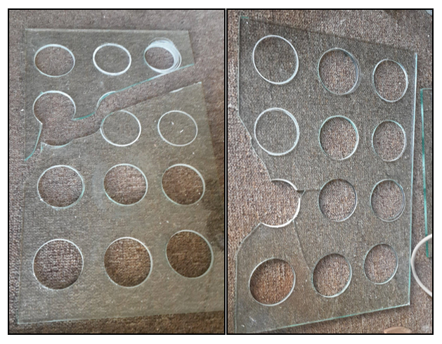
Figure below shows two damaged plates.
Figure 18 : Damaged Plates.
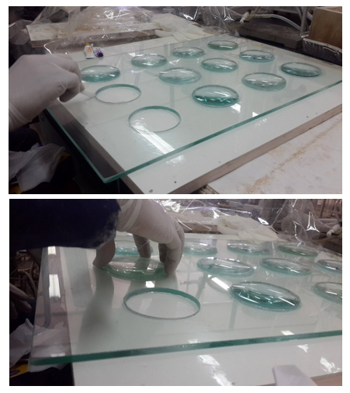
- Each hole has been replaced by a lense. Lenses were fixed well in two stages in order to fix them and prevent any air leakage.
Figure 19 : Lenses fixing.
To determine the temperature that we could reach in the system, we needed to construct the system’s body. The body was made of wood for insulation, and to get the benefit from the solar radiation we installed a black aluminum layer in the inner side of the box. For further insulation, the aluminum were made from two layers with insulation layer between them.
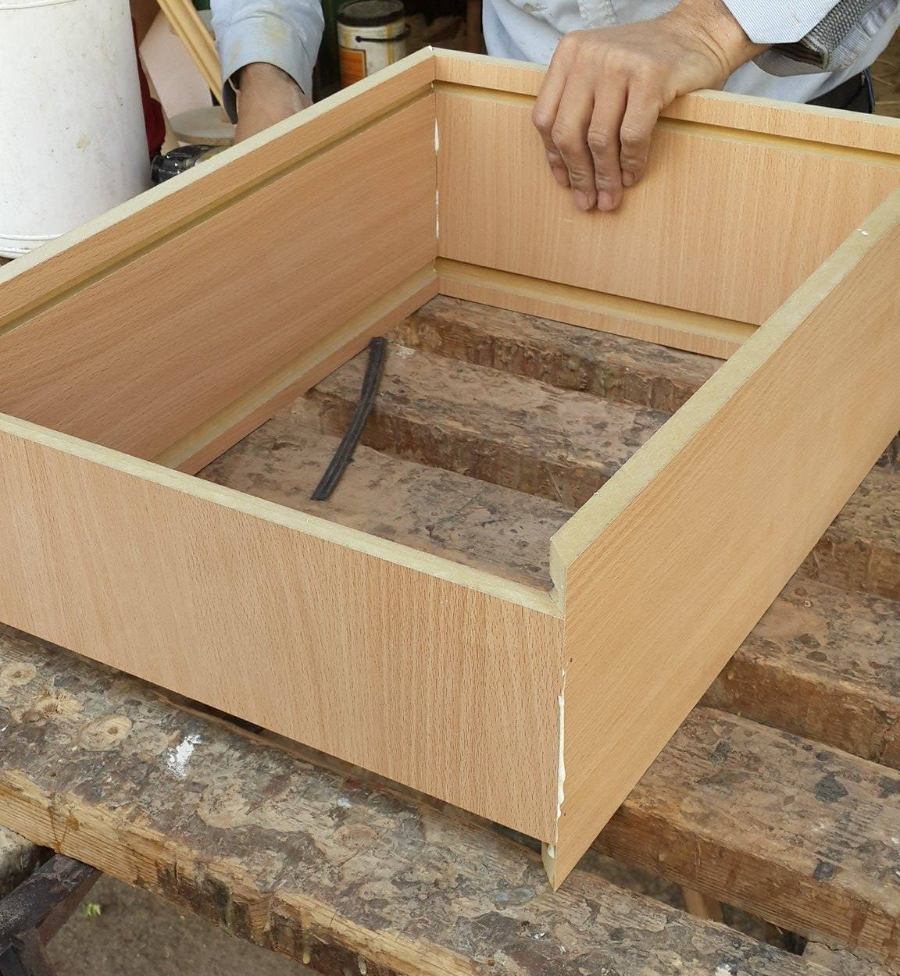
Figures below show the wooden box and the aluminum black layer.
Figure 20 : Solar Concentrator wooden Body.
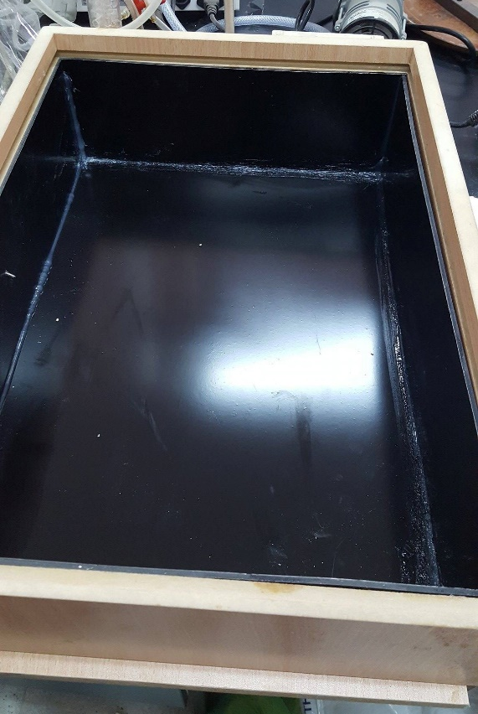
Figure 21 : Aluminum inner layer.
The system at this stage was ready for the experimental measures. A quantity of water (1.5 L) were added to the box and the glass plate was installed in its position and the whole system was left under the artificial radiation to measure the water temperature.
To know whether our produced plate with lenses is good or not, a comparison between conventional flat plate and flat plate with lenses should be occurred.
For constant gain of solar radiation, an artificial energy source was supposed to be used. Temperature was measured and recorded every 15 minutes by a thermocouple. All readings and figures are shown in Results and Analysis chapter.

Results and Analysis

In our experiment, we compared between the temperatures of the water in our system by changing the cover glass. Two plates were used in this experiment, the first one is the clear flat plate (conventional flat plate) while the second one is produced flat plate solar concentrator with lenses.
The experiment was done in the Renewable Energy Lab at An-najah National University, the work conditions were:
Room Temperature = 25ᵒ C
The Pressure = 1 atm.
Radiation = 820 W/m² (constant radiation from artificial lighting source).
Water temperature at the beginning = 23ᵒ C
Water mass = 1.5 kg
Water specific heat = 4.18 kJ/kg ᵒC (the specific heat is: the heat required to raise the temperature of a substance one degree.)
Temperature measured by a thermocouple every 15 minutes and recorded as shown in table below:
Table 1: Water temperatures in conventional flat plate versus flat plate solar collector with lenses.
Time (Minutes) | Temperature (degree Celsius ᵒC)
Time (Minutes) | Flat Plat | Flat Plate with lenses
15 | 34 | 37
30 | 45 | 50
45 | 52 | 60
60 | 54 | 66
75 | 57 | 69
90 | 57 | 73
105 | 58 | 76
120 | 58 | 79
135 | 58 | 80

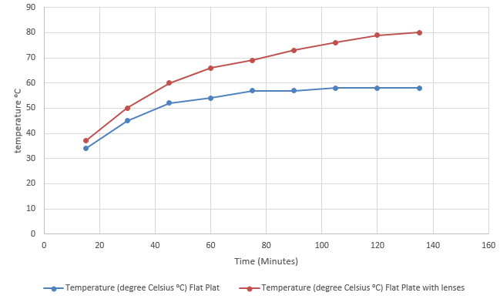
For convenience, tables were converted into curves as shown in figure22.
Figure 22: flat plat vs flat plat with lenses
The figure demonstrates that applying lenses to the system can notably improve the rate of temperature rising.
The artificial incident radiation = 820 W/m2
Glass Area = 0.2 m²
The incident radiation per system area = $\frac{820 W}{m2} ×0.2 m2=164 W$

4.1 Sample of Calculations
- Gained Energy and Power:
From flat plate – after 15 minutes:
$$Q=mC_{p}∆T$$
$$Q_{after 15 minutes}=1.5 kg×4.18\frac{kJ}{kg℃}×\left(34-23\right)℃=68 kJ$$
$$Power=\frac{68 kJ}{15 min×60 sec}=75.5 Watt$$
- The instantaneous efficiency:
$$Efficiency=\frac{P_{output}}{P_{input}}=\frac{75.5 W}{164 W}=46\%$$
Table below shows the quantity of energy gained and the efficiency:
Table 2: Energy and Efficiency calculations for flat plate system and lenses plate system.
Time | Flat Plat |  |  |  | Flat Plate with lenses
Time | Temperature (ºC) | Energy (kJ) | Power (W) | Efficiency (%) | Temperature (ºC) | Energy (kJ) | Power (W) | Efficiency (%)
15 | 34 | 68 | 75.5 | 46 | 37 | 87.8 | 97.5 | 59.5
30 | 45 | 69 | 76.6 | 46.7 | 50 | 81.5 | 90.5 | 55.2
45 | 52 | 44 | 48.7 | 29.7 | 60 | 62.7 | 69.6 | 42.4
60 | 54 | 12.5 | 13.9 | 8.4 | 66 | 37.6 | 41.8 | 25.5
75 | 57 | 18.8 | 20.9 | 12.7 | 69 | 18.8 | 20.9 | 12.7
90 | 57 | 0 | 0 | 0 | 73 | 25.1 | 27.9 | 17
105 | 57 | 0 | 0 | 0 | 76 | 18.8 | 20.9 | 12.7
120 | 57 | 0 | 0 | 0 | 79 | 18.8 | 20.9 | 12.7
135 | 57 | 0 | 0 | 0 | 80 | 6.3 | 7 | 4.3
Overall | - |  |  | 16 | - |  |  | 26.9

Comparing between the temperature results that we got from changing the glass cover of the solar concentrator system it’s obvious that the produced glass plate with lenses gave higher temperatures in shorter time.
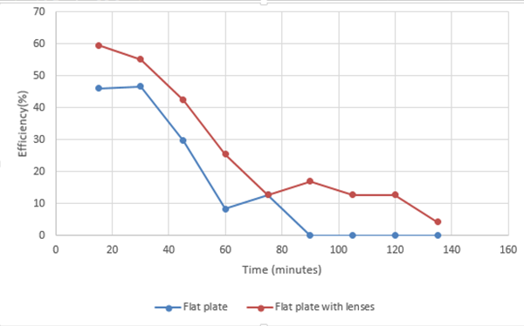
Curves below (figure 23) clarifies efficiency results from table 2.
Figure 23: Efficiency results.
From this curve, it has been observed that the instantaneous and overall efficiency are always higher in the system with lenses.
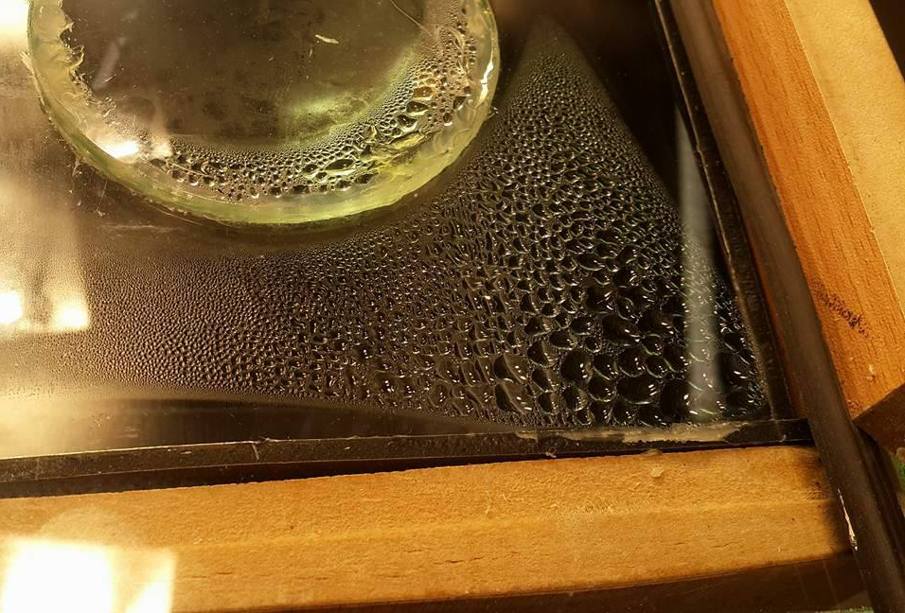
A problem was occurred during the experiment, which was the water condensation on the plate inner surface, which reduced the amount of energy gain. Figure below shows water condensation on the plate.
Figure 24: Condensed water.
Two main reasons played a key role, the first one is the increasing in the outer surface, which increases the amount of the concentrated radiation. The second reason is the shape of the lense from the inside helpt the condensed water to drop.

The Concentration Ratio:
It is defined as the ratio between the concentrator opening area and the aperture area that receives
all the solar radiation concentrated by the system.
$$CR=\frac{Area of concentrator}{Area of receiver}$$
To calculate the concentration ratio, we need to know the area of the dome (lenses).
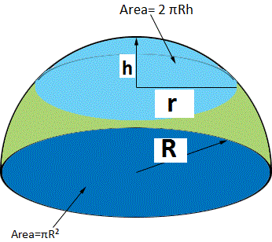
Area of the dome:
$$A_{dome}=2πRh$$
$$R=\frac{r^{2}+h^{2}}{2h}$$
Area of the holes:
$$A_{hole}=πR^{2}$$
For our system: Figure 25: Scheme for hemisphere clarification.
Lense diameter = 7.5 cm , r = 3.75 cm
h for the lense = 0.5 cm
Hole diameter = 7.5 cm
Number of holes = 12 hole
$$R=\frac{{3.75}^{2}+1²}{2×1}=7.5 cm$$
$$A_{dome}(Lense)=2πRh=2π×7.5×1=47.3 cm^{2}$$
$$A_{all domes}(Lenses)=12×47.3=567.5 cm^{2}$$
$$A_{removed holes}=πr^{2}×12 hole=π{\left(3.75\right)}^{2}×12=528 cm^{2}$$
The area of the plate:
$$A_{plate}=Length×Width=53×36=1908 cm^{2}$$
$$A_{plate}without holes=1908-528=1380 cm^{2}$$
$$A_{plate}with lenses=1380+567.5=1974.5 cm^{2}$$
The concentration ratio:
$$CR=\frac{Area of concentrator}{Area of receiver}=\frac{1947.5}{1908}=1.02$$
While this ratio is relatively small but it makes a good effect on the system by improve rising temperature.
From the previous results, it’s clear that the solar concentrator with lenses gives higher temperature in shorter time than the clear flat plate, so it was chosen for the experimental improvement.
We decided to put a hard transparent nylon on the water surface to reduce the amount of condensed water on the plate.
The experiment was repeated and new results were recorded in table below.
Table 3: Readings after improvement on lenses system.
Time (Minutes) | Temperature of improved solar concentrator with lenses (ºC)
15 | 38
30 | 52
45 | 61
60 | 67
75 | 73
90 | 75
105 | 80
120 | 82
135 | 86
150 | 90

To demonstrate the results from table (1) and table (3) the results were converted to curve as shown in figure (25), which shows the effect of improvement.
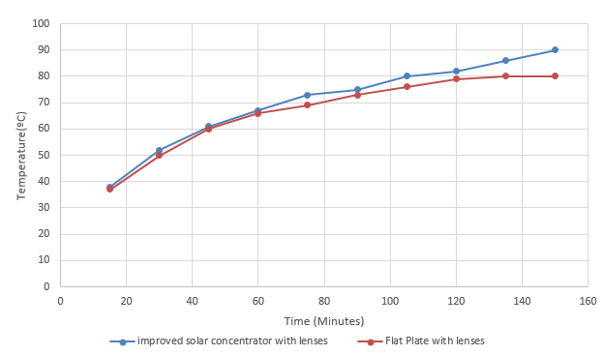
Figure 26: The effect of improvement on the lenses system.
The solar concentrator with lenses proved that it is better, so we decided to use it in another practical application. Sodium Sulfate Decahydrate ($Na_{2}SO_{4}∙10H_{2}O)$ was supposed to be the salt that we used in thermochemical cycle.
To start the experiment, we turned on the system and the inside air started to warm up, it reached 90ºC in 45 minutes.
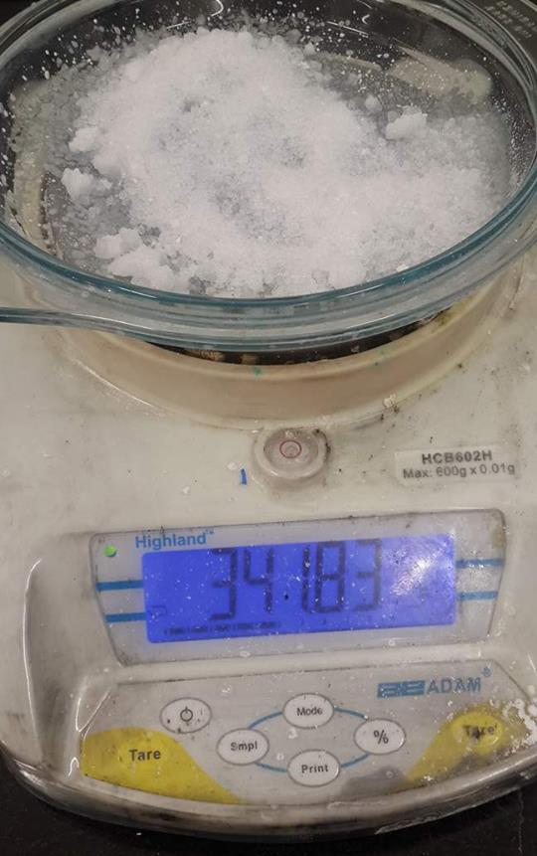
We took 50 grams of the salt and put them in a dish which weighed 291.7g
Figure 27: the weight of salt and glass dish.

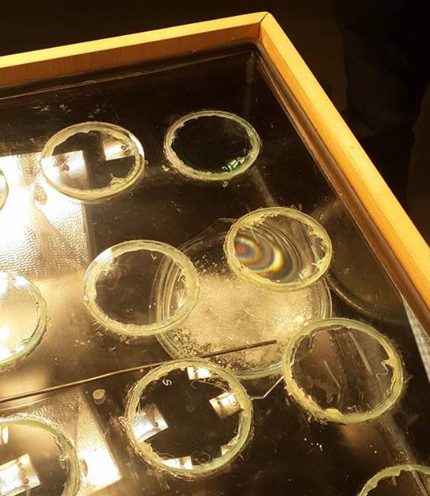
The dish and the salt were placed inside the system for one hour. As shown in figure below.
Figure 28: Glass dish with salt in the system.
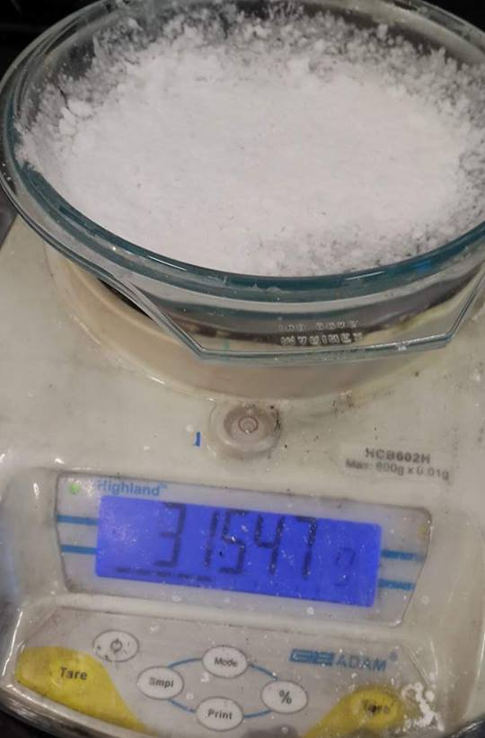
After 1 hour, we reread the weight to obtain the amount of lost water.
Figure 29: The weight of the glass dish and salt after water removed.
The percentage of removed water:
$$Removed water (g)=341.83 g-315.47 g=26.36 g$$
$$Removed water \%=\frac{26.36 g}{50 g}=52.7 \%$$
The salt lost 26 grams of its weight, which equals to 52.7 % of the salt weight. This percentage is relatively good considering the simplicity of the system and the process short time.

Conclusion and recommendations

We were able to produce a new solar concentrator system. By applying two different plates (conventional flat plate and flat plate with lenses) on the system, different results have been measured, from the results the lenses plate proved better temperatures raising and efficiencies. Both systems had water condensation problem, by adding a hard nylon layer on water, better results were achieved (the temperature reached 90C◦ in 150 minutes). After the lenses system has proved its effectiveness in water heating, another practical application experiment was conducted (extract pure water from the air humidity by using Sodium Sulfate salt), after drying the salt for one hour on 90C◦ in the lenses system, it lost 52.7 % of its mass as a pure water.
Recommendations:
- Design a system for collect vapor and condense it.
- Improve system insulation and prevent all leakages.
- Use lenses with larger curvature to increase concentrating ratio.

References

[1] Yunus, A. Cengel, and A. Boles Michael. "Thermodynamics: An engineering approach." McGraw-Hill, New York (2006).
[2] Solar Cooker International, 1995, Solar Cookers: How to Make, Use and Understand, 8th Edition.
[3] US Department of Energy [Internet].; [accessed on 13th December 2016]. Available from: https://www1.eere.energy.gov/solar/pdfs/solar_timeline.pdf
[4] Young, H. D., Freedman, R. A., & Ford, A. L. (2012). Chapter 34: Geometric Optics in University physics with modern physics. pp 1157-1206 (12th ed). San Francisco, CA: Pearson.
[5] Quaschning, V. (2004). Technical and economical system comparison of photovoltaic and concentrating solar thermal power systems depending on annual global irradiation. Solar Energy, 77(2), 171-178.
[6] Hersch, P., & Zweibel, K. (1982). Basic photovoltaic principles and methods (No. SERI/SP-290-1448). Solar Energy Research Inst., Golden, CO (USA).
[7] Duffie, J. A., & Beckman, W. A. (2013). Solar engineering of thermal processes (Vol. 3). New York: Wiley.
[8] Xie, W. T., Dai, Y. J., Wang, R. Z., & Sumathy, K. (2011). Concentrated solar energy applications using Fresnel lenses: A review. Renewable and Sustainable Energy Reviews, 15(6), 2588-2606.
[9] Leutz, R., & Suzuki, A. (2012). Nonimaging Fresnel lenses: design and performance of solar concentrators (Vol. 83). Springer.
[10] Miller, O. E., McLeod, J. H., & Sherwood, W. T. (1951). Thin sheet plastic Fresnel lenses of high aperture. JOSA, 41(11), 807-815.
[11] Boettner, E. A., & Barnett, N. E. (1951). Design and construction of Fresnel optics for photoelectric receivers. JOSA, 41(11), 849-849.
[12] Ghali, E. (2010). Corrosion resistance of aluminum and magnesium alloys: understanding, performance, and testing (Vol. 12). John Wiley & Sons.
[13] Bach, H., & Neuroth, N. (Eds.). (2012). The properties of optical glass. Springer Science & Business Media.

Appendices

Calculations of instantaneous energy, power and efficiency for flat plate solar concentrator with lenses.
Energy and Power equations:
$$Q=mC_{p}∆T$$
$$P=\frac{Q}{T}$$
Efficiency:
$$Efficiency\%=\frac{P_{output}}{P_{input}}×100\%$$
Flat Plate – every 15 minutes
From 23ºC to 34ºC
$$Q_{after 15 minutes}=1.5 kg×4.18\frac{kJ}{kg℃}×\left(34-23\right)℃=68 kJ$$
$$Power=\frac{68 kJ}{15 min×60 sec}=75.5 Watt$$
$$Efficiency=\frac{75.5 W}{164 W}×100\%=46\%$$
From 34ºC to 45ºC
$$Q_{after 15 minutes}=1.5 kg×4.18\frac{kJ}{kg℃}×\left(45-34\right)℃=69 kJ$$
$$Power=\frac{68.93 kJ}{15 min×60 sec}=76.6 Watt$$
$$Efficiency=\frac{76.59 W}{164 W}×100\%=46.7\%$$
From 45ºC to 52ºC
$$Q_{after 15 minutes}=1.5 kg×4.18\frac{kJ}{kg℃}×\left(52-45\right)℃=44 kJ$$
$$Power=\frac{34.89 kJ}{15 min×60 sec}=48.7 Watt$$
$$Efficiency=\frac{48.7 W}{164 W}×100\%=29.7\%$$
From 52ºC to 54ºC
$$Q_{after 15 minutes}=1.5 kg×4.18\frac{kJ}{kg℃}×\left(54-52\right)℃=12.5 kJ$$
$$Power=\frac{12.54 kJ}{15 min×60 sec}=13.9 Watt$$
$$Efficiency=\frac{13.9 W}{164 W}×100\%=8.4\%$$
From 54ºC to 57ºC
$$Q_{after 15 minutes}=1.5 kg×4.18\frac{kJ}{kg℃}×\left(57-54\right)℃=18.8 kJ$$
$$Power=\frac{18.8 kJ}{15 min×60 sec}=20.9 Watt$$
$$Efficiency=\frac{20.9 W}{164 W}×100\%=12.7\%$$
From 57ºC to 57ºC
$$Q_{after 15 minutes}=1.5 kg×4.18\frac{kJ}{kg℃}×\left(57-57\right)℃=0 kJ$$
$$Power=\frac{0 kJ}{15 min×60 sec}=0 Watt$$
$$Efficiency=\frac{0 W}{164 W}×100\%=0\%$$
Overall from 23ºC to 57ºC
$$Q_{overall}=1.5 kg×4.18\frac{kJ}{kg℃}×\left(57-23\right)℃=213.18 kJ$$
$$Power=\frac{213.18 kJ}{135 min×60 sec}=26.3 Watt$$
$$Efficiency=\frac{26.3 W}{164 W}×100\%=16\%$$
Flat Plate with lenses – every 15 minutes
From 23ºC to 37ºC
$$Q=1.5 kg×4.18\frac{kJ}{kg℃}×\left(37-23\right)℃=87.8 kJ$$
$$Power=\frac{87.78 kJ}{15 min×60 sec}=97.5 Watt$$
$$Efficiency=\frac{97.5 W}{164 W}×100\%=59.5\%$$
From 37ºC to 50ºC
$$Q=1.5 kg×4.18\frac{kJ}{kg℃}×\left(50-37\right)℃=81.5 kJ$$
$$Power=\frac{81.5 kJ}{15 min×60 sec}=90.5 Watt$$
$$Efficiency=\frac{90.5 W}{164 W}×100\%=55.2\%$$
From 50ºC to 60ºC
$$Q=1.5 kg×4.18\frac{kJ}{kg℃}×\left(60-50\right)℃=62.7 kJ$$
$$Power=\frac{62.7 kJ}{15 min×60 sec}=69.6 Watt$$
$$Efficiency=\frac{69.6 W}{164 W}×100\%=42.2\%$$
From 60ºC to 66ºC
$$Q=1.5 kg×4.18\frac{kJ}{kg℃}×\left(66-60\right)℃=37.6 kJ$$
$$Power=\frac{37.6 kJ}{15 min×60 sec}=41.8 Watt$$
$$Efficiency=\frac{41.8 W}{164 W}×100\%=25.5\%$$
From 66ºC to 69ºC
$$Q=1.5 kg×4.18\frac{kJ}{kg℃}×\left(69-66\right)℃=18.8 kJ$$
$$Power=\frac{18.8 kJ}{15 min×60 sec}=20.9 Watt$$
$$Efficiency=\frac{20.9 W}{164 W}×100\%=12.7\%$$
From 69ºC to 73ºC
$$Q=1.5 kg×4.18\frac{kJ}{kg℃}×\left(73-69\right)℃=25.1 kJ$$
$$Power=\frac{25.1 kJ}{15 min×60 sec}=27.9 Watt$$
$$Efficiency=\frac{27.9 W}{164 W}×100\%=17\%$$
From 73ºC to 76ºC
$$Q=1.5 kg×4.18\frac{kJ}{kg℃}×\left(76-73\right)℃=18.8 kJ$$
$$Power=\frac{18.8 kJ}{15 min×60 sec}=20.9 Watt$$
$$Efficiency=\frac{20.9 W}{164 W}×100\%=12.7\%$$
From 76ºC to 79ºC
$$Q=1.5 kg×4.18\frac{kJ}{kg℃}×\left(79-76\right)℃=18.8 kJ$$
$$Power=\frac{18.8 kJ}{15 min×60 sec}=20.9 Watt$$
$$Efficiency=\frac{20.9 W}{164 W}×100\%=12.7\%$$
From 79ºC to 80ºC
$$Q=1.5 kg×4.18\frac{kJ}{kg℃}×\left(80-79\right)℃=6.3 kJ$$
$$Power=\frac{6.3 kJ}{15 min×60 sec}=7 Watt$$
$$Efficiency=\frac{7 W}{164 W}×100\%=4.3\%$$
Overall from 23ºC to 80ºC
$$Q_{overall}=1.5 kg×4.18\frac{kJ}{kg℃}×\left(80-23\right)℃=357.39 kJ$$
$$Power=\frac{357.39 kJ}{135 min×60 sec}=44.1 Watt$$
$$Efficiency=\frac{44.1 W}{164 W}×100\%=26.9\%$$

