Abstract :
Steam distillation used to separate rosemary oil. This project focused on building steam distillation apparatus and how to extract oil and improve the quantity.
In the experimental part we design and install pilot plant steam distillation unit, and the capacity of steam distillation unit is determined to be 71 liter .

The steam distillation unit of 71 L capacity having proper condenser. The oil yield is 18g oil per 1 kg of dry rose marry.
The modification on reservoir is very important and contributed to increase of the yield.

Objective:
Design of pilot plant steam distillation unit with capacity more than 70 L for production different types of essential oils (rosemary ,mintol, thymol) that have different uses in cosmetics, flavoring and healing.

Problem:
Collected waste plants From PAPA project at Al-Fara’a to used in our experiment part, extract oil and improve the quantity.

Methodology:
- Preparation of different plants by drying (rosemary, mentol ,thymol).

- Design and installation of steam distillation unit made of stainless steel having different components and boiling vessel and condenser.

Table of Contents Page
Abstract:……………………………………………………………………………..1
Objective: . . . . . . . . . . . . . . . . . . . . . . . . . . . . . . . . . . . . . . . . . . . . . . . . … . . . . . 2
Problem:. . . . . . . . . . . . . . . . .. . . . . . . . . . . . . .. . . . . . . . .. . . . . . . . . .. . . . . . . . . . . .3
Methodology: . .. . .. .. . . . . . . . . . . . . .. . . . . . . . . . .. . . . . . . . .. . . . . . . .. . . . . . . . . . . . . . . . .4
Introduction:………………………………………………………………….………5
Experimental part:………………………………………………………………….24
Results and Discussion:…………………………………………………………….28
Conclusion &Recommendations:…………………………………………………..29
References:………………………………………………………………………….30

List of figures:
Figure (1): Sun Drier …………………………………………………………….….21
Figure (2): The cooker ………………………………………………………………22
Figure (3): The condenser …………………………………………………………...23
Figure (4): steam distillation unit…………………………………………………….26 Figure (5): steam distillation unit after changing the receiver .…..……………….....26 Figure(6): The new steam distillation unit…………………………………………...27

List of tables :
Table (1): Some Common Water soluble aroma Chemicals in Essential Oil ………..8
Table (2): Comparison between water, water and steam and steam distillation …….11
Table (3): The result …………………………………………………………………28

Introduction :

Steam distillation used to separate essential oils from leaves and stems of medicinal plant such as rosemary oil. Our previous project focused in evaluating the antibacterial effects of these oils namely, rosemary, menthol and thymol (and carvacrol) oils.
The biotechnology coworkers have isolate Media otitis bacterial. The bacteria are cultivated in a proper cultivation media, then with different concentration of methanol essential oil extracts and aqueous phase extracts the inhibitory effects of these oils evaluated.
The investigated essential oils have killed these types of bacterial in concentration above 350 mg/ml. These results are fit with other researcher results.
The aqueous phase does not show antibacterial affect and these oils are suggested to be used as flavoring and in cosmetics.
The oils of Origano have presented higher effects in comparison with other oils while the essential oils of Mintha has shown lower effect in comparison with the other oils as presented in our previous project. [project 1]

The three most common methods for capturing essential oils from plants are:
1-Steam distillation :
The most common process used to obtain essences is steam distillation. The resulting substance is what is known as essential oil.

2-Solvent extraction :
This method is used for delicate plants such as jasmine, where the heat from steam distillation would destroy the essential oil. Solvent extraction is also a preferred method for low yielding plants such as rose, where steam distillation is not as economical. The aromatic material is extracted from the plant via a multi-step process, which involves using a solvent, an alcohol, and a series of vacuum distillation, agitation, freezing and filtering techniques. The resulting fragrant product is called an absolute.
3-Cold expression :
Essences collected in this way are squeezed (expressed) from the rind or peel of a citrus fruit.
Extraction of Essential Oils Using Steam distillation Method:

Steam distillation is a special type of distillation or a separation process for temperature sensitive materials like oils, resins, hydrocarbons, etc. which are insoluble in water and may decompose at their boiling point. The fundamental nature of steam distillation is that it enables a compound or mixture of compounds to be distilled at a temperature substantially below that of the boiling point of the individual constituent. Essential oils contain substances with boiling points up to 200°C or higher temperatures. In the presence of steam or boiling water, however, these substances are volatilized at a temperature close to 100°C, at atmospheric pressure.
Fresh, or sometimes dried, botanical material is placed in the plant chamber of the still and the steam is allows to pass through the herb material under pressure which softens the cells and allows the Essential Oil to escape in vapor form. The temperature of the steam must be high enough to vaporize the oil present, yet not so high that it destroys the plants or burns the Essential Oils. Besides the steam tiny droplets of Essential Oil evaporates and travel through a tube into the still's condensation chamber. Here Essential Oil vapors condense with the steam .The essential oil forms a film on the surface of the water. To separate the Essential Oil from the water, the film is then decanted or skimmed off the top. The remaining water, a byproduct of distillation, is called floral water, distillate, or hydrosol. It retains many of the therapeutic properties of the plant, making it valuable in skin care for facial mists and toners (A solution containing chemicals that can change the color of a photographic print).In certain situations, floral water may be preferable to be pure essential oil, such as when treating a sensitive individual or a child, or when a more diluted treatment is required. Rose hydrosol, for example, is commonly used for its mild antiseptic and soothing properties, as well as its pleasing floral aroma.
A number of factors determine the final quality of a steam distilled essential oil. Apart from the plant material, most important are time, temperature and pressure, and the quality of the distillation equipment. Essential oils are very complex products. Each is made up of many, sometimes hundreds, of distinct molecules which come together to form the oil's aroma and therapeutic properties. Some of these molecules are fairly delicate structures which can be altered or destroyed by adverse environmental conditions. So, much like a fine meal is more flavorful when made with patience, most oils benefit from a long, slow 'cooking' process.
It is possible that longer distillation times may give more complete oil. It is also possible however, that longer distillation time may lead to the accumulation of more artifacts than normal. This may have a curious effect of appearing to improving the odor, as sometimes when materials that have a larger number of components are sniffed, the perception is often of slightly increased sophistication, added fullness and character, and possibly, and extra pleasantness. [2]

Advantages of using Steam Distillation:

The advantage of Steam Distillation is that it is a relatively cheap process to operate at a basic level, and the properties of oils produced by this method are not altered. As steam reduces the boiling point of a particular component of the oil, it never decomposes in this method. This method apart from being economical, it is also relatively faster than other methods.
Water into the solvent. These materials are then recovered through vacuum distillation of the solvent which results in a secondary essential oil [3]. Some common water soluble aroma chemicals in essential oils are listed in Table [1].

Table 1: Some Common Water soluble aroma Chemicals in Essential Oil
Slightly soluble  (<500ppm) | Moderately soluble  (501-1999ppm) | Very Soluble  (>2000ppm)
Aldehyde C11  Aldehyde C12(lauric)  Aldehyde C12 MNA  Amyl cinnamic aldehyde  Amyl salicylate  Benzyl salicylate  Cedrol  Citronellol  Citronellyl butyrate  Citronellylformate  Eudesmol  Geranellylformate  Lemonene  Linalyl acetate  a-Pinene | Calamene  1,8-Cineole  Nerol  Neryl acetate  Rose oxide | Benzlaldehyde  Benzyl acetate  Cinnamic alcohol  Citronellyl acetate  a-copanene  Eugenol  Geranial  Geraniol  Lemonene  Linalool  Mentone  Myrcene  (E)-β-ocimene  Phenylethylacetate  Phenylthylalcohol  Sabinene  Terpineol-4-ol  a-Terpineol  Terpinolene

Another method that will contribute to minimizing oil loss due to constituent solubility in water during the separation phase is to control the outgoing distillate temperature from the condenser. Where oils are less dense than water, there will be an optimal temperature range where oil particles will freely float to the top of the distillate upon condensation. Some literature on distillation practices misses the point about the effect of condensation temperatures on oil yields [4]. Based on private experience, the higher the temperature of the outgoing distillate, the freer will be the oil particles to float to the top. For example, tea tree oil droplets will float to the water distillate twice as fast at 60C than at 40C. The upper temperature limit will be restricted by the potential loss of low boiling volatiles during condensation. This has implications on the design of the specific condenser for specific crops and set range limits upon the temperature that distillation can take place, to achieve a specific outgoing distillate temperature range.

Water and steam Distillation :
Water and steam distillation involves the storing of the plant material above a water bath Situated in the bottom of the charge vessel and heating the water either through direct fire Steam jacket or closed or open steam coil. Water and steam distillation produces saturated wet steam at the prevailing vessel pressure, which is usually atmospheric pressure. Within this configuration, unlike water distillation, only steam comes in contact with the plant material.
Water and steam distillation is not very suitable for fine materials as steam will find a low resistance path and tend to create channels. This means that steam will not flow through the whole mass of plant material and an incomplete distillation will take place. If the plant material is loosely packed, the same effect will happen, as the material will offer no resistance to the steam.
Water and steam distillation may take a long period of time to reach operating temperature as the plant material needs to be heated up with only saturated steam. This may cause early condensation and wetting of the plant material as in table [2].
Due to the limits on pressure that can be built up in the charge vessel, water and steam distillation will have only a limited effect on extracting high boiling materials from plant materials. However there is less opportunity for hydrolysis to occur than with water distillation. Water and steam distillation has another advantage over steam distillation as there are fewer decomposed products during the process due to less chance of plant material drying out. However water and steam distillation will take a lot longer. Water and steam distillation can produce very good results under reduced pressure.
Water and steam distillation is much cheaper to set up than steam distillation facilities and lends itself to portable stills that can be transported from place to place.

Table 2 : Comparison between water, water and steam and steam distillation
 | Water Distillation | Water& Steam Distillation | Steam Distillation
Construction | Usually simple constructed, based on ancient designs. | Inside vat contains a grill where plant material rests above the water. | Utilises an outside steam source
Plant Material Suitability | Finely powdered materials such as woods and rhizomes, flowers that congeal with steam. Not suitable for materials that contain acidic material which can saponify, water soluble or high boiling constituents. Material must be completely covered with water. | Can be used for most herb and leaf materials. Material must be packed in a uniform manner to avoid channeling of steam. | Most materials, except fine powders.  Good for high boiling materials. Material must be packed in a uniform manner to avoid channeling of steam.
Hydro-diffusion | Excellent | Good | Steam should be slightly wet to promote diffusion.  Superheated or high pressure steam can dry out the plant material and inhibit diffusion.
Available Pressure | Atmospheric pressure | Atmospheric pressure | Can be adjusted for both high and reduced pressure.
Available Temperature | 100C, but care must be taken not to burn the plant material from direct heat on the sides. | Approximately 100C | Can be increased or reduced according to pressure used.
Hydrolysis condition | Usually a high rate of ester hydrolysis. | Hydrolysis is usually low, however excessive wetting of the plant material through prolonged distillation can promote hydrolysis during later stages of distillation. | Slight hydrolysis
Rate of Distillation & Yield | Slow rate of distillation. Low rates of yield due to hydrolysis and loss of water soluble constituents into the water. High boiling constituents often left undistilled. | Moderate distillation rate. Good yield if no channels occur in charge. Usually good yields. | Fast rate of distillation. Good yield if no channels occur in charge. Usually good yields.
Steam Distillation :
Steam distillation employs an external steam generation system, external to the charge vessel. This configuration provides much more control (depending upon the boiler capacity) than water and steam distillation. This is because in steam distillation the wetness fraction, temperature and pressure can be manipulated according to needs and conditions. However, it is a misconception that greater steam volumes and increased pressures have positive effects on the process in all cases. As mentioned previously, dry and superheated steam has the effect of drying out plant material, which potentially halts distillation through the stopping of hydro-diffusion process. Faster steam flow rates do not necessary mean quicker recovery times. Fabricated steam boilers cost much more to run than water bathes and may lead to high distillation costs, especially if they require petrochemical feed stocks. However if steam distillation facilities are designed and built with the correct steam ratings, they are much more economical to run than water and steam distillation systems. A comparison between water, water and steam and steam distillation is shown in Table 2.

The Condenser System :
A condenser in an essential oil distillation system is a heat exchange or dissipating device. The condenser must not only cool the condensate vapour into a liquid , but also cool the condensate to the temperature range where the oil will separate spontaneously from the water.
The usual array for a condenser system is a tube or set of tubes running through a sealed water reservoir to cool the pipes. It is immediately attached to the top of the charge vessel to collect all vapour exiting the vessel . The design of the condenser must ensure that the vapour flow is turbulent inside the tubes to prevent high velocity vapour freely flowing through the condenser and maximize exposure to the cooler walls. A baffle is usually installed at the beginning of the condenser to disrupt a straight steam flow for this purpose. Failure to achieve those conditions would result in some vapour failing to condensate . Within the condenser system the flows of vapour and cooling water should be in opposite directions at the maximum possible speed. The condenser must be sensitive enough to react on the vapour flow very quickly . The required number of tubes and length of the condenser depends on, the rate of distillate flow, the pressure, the temperature of the cooling water and desired exit temperature range of the distillate.
The condenser must remove the equivalent amount of heat that is needed to vaporize the distillate, plus the additional amount of heat to reach the optimal distillate temperature range of the condensate distillate exiting the condenser. The rate of which heat would be removed from the distillate can be represented by the flowing equation :
Q = UA∆t
Where Q = the heat removed by unit of time
U = a constant determined by operating conditions (condensing and cooling made up of a number of factors) usually a constant is used.
A = the area available for heat removal
∆t = the temperature difference between the vapour and the cooling medium.
U is made up of a number of factors including the flow rates of cooling water and vapours, the material that the condenser is constructed, and usually a constant is used due to the difficulty to calculate. The value of U increases as these factors increase. Thus according to the equation, the surface area can be as large or small as desired, as long as the other factors compensate . However the overall capacity of the distillation system will have great bearing on the condenser area. Condenser sizes will also vary in size according to the temperature of available cooling water on site, thus condensers in temperate and tropical areas will reflect this in size.
Using a condenser system with the wrong capacity for the distillation system will have a number of operational consequences. A too efficient condenser system will deliver the distillate at a temperature below the optimum range, which could lead to cool air outside being sucked into the system . This outside cooler air in the condenser tubes could create expansion and contraction of vapours in the condenser leading to splattering and intermittent distillate outflow. This could also occur is the cooling water is too cold . If the condenser is too small for the distillation system , then the still must be operated with lower steam rates, which would lengthen distillation times and open up the possibility of hydrolysis to occur within the vessel .

The Separator System :
Before leaving the subject of distillation in this chapter, some words about the separator system must be mentioned. The function of the separator is to as quickly as possible separate the oil from the distillate water. As distillate water volume is much greater than oil, it is important that water can be removed continuously. Oil and water separates according to specific gravity forming two layers. Lighter than water oils will float to the top and heavier than water oils will sink to the bottom. This must be considered in separator design for water removal .
If the specific gravity of oil and water is very close, the two components will not separate immediately. Distillate flowing into the separator must therefore not disturb the surface area and flow into the body of the water to prevent surface turbulence. The separator must also be large enough so that drained water does not carry away micro-scopic oil droplets. Temperature plays a crucial role in separation, where it should be moderately warm to increase the relative specific gravity differential of the oil and water. Raised temperature of the distillate water will allow the small oil particles to rise to the top of separator quicker in a similar manner to the condenser exit temperature range where there will be an optimal separator water temperature range to promote oil-water separation. [5]
During distillation, the more volatile constituents tend to vaporize quicker and the less volatile constituents vaporize later in the distillation . This leads to an oil that will vary in constituents during the distillation period. By changing separation flasks at particular points during a single distillation, oils of different constituent profiles can be collected. This is different uses and values to particular customers. Many distillers also use this principal to collect specific fractions during the distillation, which can later be blended together to create a whole oil that meets with certain specific specifications, such as standard.
The water distillate will always be saturated in oil and directly dumping it would lead to a loss in yield. For this reason some distillers ( water and water steam distillation ) will channel the water distillate back into the still vessel for re-distillation in what is called cohobation , mentioned previousl . For this purpose the separator must be placed higher than the still vessel proper so distillate water in the separator can be fed back into the still through gravity.

CO₂ and supercritical CO₂ fluid extraction (SCF) :
CO₂ and supercritical fluid (SCF) extraction displays great benefits over solvent extraction in that this process does not leave behind any solvent residuals. CO₂ is an inert and non-flammable material, so is considered both safe and "green". This method also produces very close to nature extracts due to the absence of heat in the process, thus leaving high volatile constituents intact in any extract, which are often absent in the top notes of oils extracted through different methods such as steam distillation. The lack of heat and inertness of the solvent also prevents the creation of any artifacts such as sulphur compounds . The powerful penetrating and diffusion properties of CO₂ also pick up high boiling compounds with high molecular weights between 200-400, which are difficult to extract through distillation and contribute to the back notes of oils. CO₂ and SCF extraction save time over other methods [6] and are much cheaper to operate due to wide availability of CO₂ and the ability to recycle it.
Supercritical fluid extraction allows selectivity through changing the solvent density during the extraction. The critical point for CO₂ is 31°C at approximately 24 bar, sub-critical liquefied CO₂ (between -55°C and 31°C through 5 to 74 bar) where it acts as a non-polar solvent. Thus, CO₂ can have the density of a liquid solvent and the diffusion properties of a gas, which allows very good permeation through plant and organic materials. Thus the extraction process can be carried out with CO₂ as a liquid or gas, according to temperature and pressure limits set during the extraction . The solubolisation characteristic of CO₂ increases with the density of the fluid, which can be controlled through changing pressure, where higher pressures will enable the diffusion of large quantities of organic compounds. Dissolved compounds are recovered through reducing the carrier density by decreasing pressure or increasing temperature. Because of the high vapour pressure of CO₂ at room temperature and atmospheric pressure, all traces of the gas can be easily removed from the volatile oil through lowering the pressure.
One of the weaknesses of CO₂ extraction is the lack of solvent polarity which makes the extraction of certain polar materials difficult. This however can be solved through the addition of a polar solvent like methanol or ethanol to increase the polarity of the carrier [7]. CO₂ extraction would in many cases produce aromatic extracts that are lower in some terpenes, as they are sometimes produced through chemical reactions in the distillation process . Likewise, extracts produced through CO₂ extraction may be higher in esters due to the absence of hydrolysis in this process. CO₂ extracts tend to be produced for specific specialized flavor and fragrance applications, due to the high capital costs involved in setting up a plant, but is a technology that is creating a lot of interest.
Other solvents have been used for the extraction of flower oils. Robertet and Cie perfected a process utilizing butane as a solvent to extract aromatic materials out of delicate flowers. Where conventional solvent extraction has sometimes given unsatisfactory results from many perfumes point of view, butane extracts have been considered to be closer to nature in olfactory profile. However the process is costly and very dangerous due to the caustic and flammable nature of butane. The plant extracts from this process have also been criticized for not being 'green' products, due to the environmental undesirability of butane.
Dr. Peter Wilde developed a method of solvent extraction utilizing refrigerant Hydroflurocarbon 134a in the early 1980's in the United Kingdom . This process is called phytonic extraction and extracts called 'florasols' . Phytonic extraction utilizes HFC-134a (1,1,1,2-tetrafluoroethane) as a solvent which is non-flammable gas under normal conditions and accepted as a food grade extractive solvent. The process involves permeating the solvent as a gas through the biomass a number of times to extract aromatic materials until it is saturated, when it is pumped into an evaporator. In the evaporator the gas is compressed resulting in the solution boiling and producing a very quick separation with the solvent as a liquid with the extracted material. The evapourated gas is called and recycled back through the bio-mass. The process does not emit any effluents like other processes and the equipment is cheaper than CO₂ systems because of the very low levels of pressure used in the phytonic process. This technology has been utilized in the commercial production of flower oils in Thailand.

Hydro-Diffusion Distillation :
Hydro-Diffusion distillation is a variation on steam distillation where steam is introduced on the top of the vessel and condenses through the plant material in the still , where the distillate is collected and condensed under the plant material which rests on a grill or perforated tray. Through steam traveling down the still, there is more time for the volatiles and fatty acids floating on the plant material to have contact with the steam .in the case of wood and seeds that have many high boiling compounds, which are difficult to vaporize in an ordinary still, this system may be effective. This would be valuable when fatty acids contribute to the flavor of a material and it is desirable in the oil, thus, hydro-diffusion distillation may return an oil more representative of the plant’s natural profile [8].
It is reported that hydro-diffusion distillation gives quicker distillations with lower steam consumption than conventional steam distillation [9]. However this process is governed by the physical laws that govern any other type of distillation and the fact that the steam travels downwards whilst cooling may effect the transfer of latent heat decrease distillation time, the tendency to saturate the plant material near the bottom may also lead to hydrolysis and lead to lesser yields. However, hydro- diffusion distillation appears popular within the aromatherapy industry in Europe.

The extraction of aromatic materials using volatile solvents :
The extraction of aromatic materials from plants was first experimented with in the early 1800’s. Various solvents like chloroform , benzene, carbon disulphide, methyl and ethyl alcohols were used. One of the major problems was the loss of solvent through evaporation with the advent of light fractions of petroleum and the development of a closed apparatus.
Most technical problems were solved and the process became commercially viable as an alternative to enfleurage. Interest in the process grew with a number of independent groups in grass utlisting the process around the mid 1850’s.
A solvent extraction system consists of an extraction tank, a solvent distillation unit under vacuum, a washing tank for ethanol extraction and another vacuum distillation unit. The process utilizes a pure solvent to wash and penetrate the plant material, which dissolve the volatile constituents, resins, waxes and some pigment within the tissue. This is done either in a stationary tank where the solvent is circulated around the plant material or with a slow rotary mixer array to stir the plant material with the solvent. Some system may undertake the washing process a number of times to ensure all the aromatic material are removed from the plants. After the washing is complete, live steam is injected into the system to vaporize any solvent remaining on the plant material, where it is filtered ,re-purified and used again. The washing process occurs at room temperature.
In the second stage, the solvent is pumped into a vacuum distillation chamber, where the solvents then vacuum distilled away leaving the semi –solid material previously dissolved from the plant material, during the washing. The vacuum distillation is conducted at the lowest temperatures possible, usually around 50-60̊C. The remaining material is called a concrete, which contains up to around 50% waxes, resins and fats, along with some natural pigments.
As waxes and fats are not very soluble in perfumes and fragrances, the waxy materials need to be removed from the concrete. This is achieved through repeated washing of the concrete in warm alcohol and then in a further process , a gentle distilling away of the alcohol under vacuum to leave a substance called an absolute. The absolute maybe an almost pure aromatic substance, but may also still contain some natural plant pigment . the absolute can be treated with activated charcoal to absorb pigment like chlorophyII. however, this process does not absorb all pigments, leaching the color of many absolutes with tinge of red-brown.
The selection of solvent is critical to the whole process. Idally, the solvent must be non- flammable, non-toxic, environmentally acceptable, non-odorous, highly volatile with a uniform boiling point that does not leave residual behind, inert and non reactive to the volatile constituents of plant and absorb moisture remaining in the plant material. No solvent meets all the above criteria and different solvents will display different properties on various materials in plants. The weakness of hydrocarbon solvents is that they dissolve waxes, pigment and other unwanted organic materials in plant. Thus compromises must be made in the selection of solvent for the process.
Petroleum ether fractions consist of saturated paraffin and dissolve minimal amount of waxes and pigments. Hexane and pentane are chemically inert and completely volatile, and thus suited for the extraction. Hexane and pentane are chemically inert and completely volatile, and thus suited for the extraction of volatile component of flowers. Hexane usually contains traces of naphthalene, sulphur and benzene derivatives, which have questionable odours. It is important that a very pure grade is used. Hexane is usually rectified and purified until it is almost totally odourless. This used to be undertaken by the operators before using in the extraction process, but most companies now supply a specially purified grade for solvent extraction. Benzene, a coal tar derivative was once used as a solvent. It is less selective in dissolving waxes and produced higher concrete yields. However, due to the carcinogenic properties of benzene, use is but all discontinued.

Sun and Solar Drying :

The term ‘sun drying’ is used to describe the process whereby some or all of the energy for drying of foods is supplied by direct radiation from the sun.
For centuries, fruit, vegetables, meat and fish have been dried by direct exposure to the sun. The fruit or vegetable pieces were spread on the ground on leaves or mats while strips of meat and fish were hung on racks. While drying in this way, the foods were exposed to the vagaries of the weather and to contamination by insects, birds and animals. Drying times were long and spoilage of the food could occur before a stable moisture content was attained. Covering the food with glass or a transparent plastic material can reduce these problems .A higher temperature can be attained in such an enclosure compared to the sereached by direct exposure to the sun. Most of the incident radiation from the sun will pass through such transparent materials. However, most radiation from hot surfaces within the enclosure will be of longer wavelength and so will not readily pass outwards through the transparent cover. This is known as the ‘greenhouse effect’ and it can result in shorter drying times as compared with those attained in uncovered food exposed to sunlight.[10]

A transparent plastic tent placed over the food, which is spread on a perforated shelf raised above the ground, is the simplest form of covered sun drier. Warm air moves by natural convection through the layer of food and contributes to the drying. A simple sun drier is shown in Fig.(1). Different perforated shelves can be placed under this plastic tent.[11]

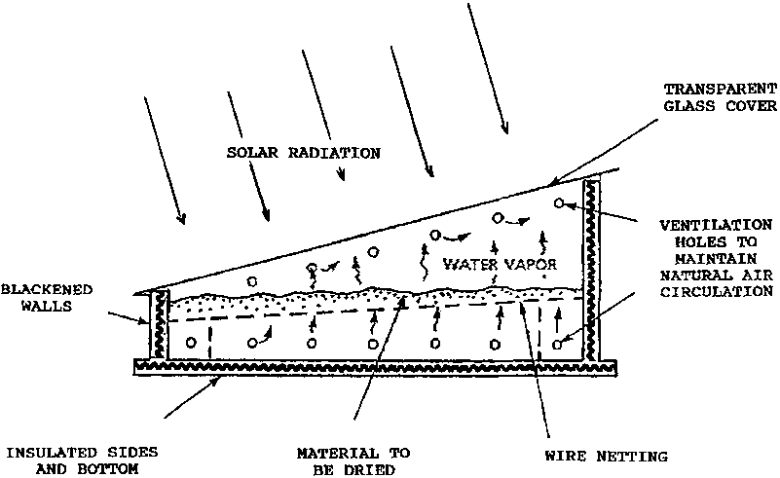

Figure (1) : Sun Drier

The capacity of such a drier may be increased by incorporating a solar collector. The warm air from the collector passes up through a number of perforated shelves supporting layers of food and is exhausted near the top of the chamber. A chimney may be fitted to the air outlet to increase the rate of flow of the air. The taller the chimney, the faster the air will flow. If a power supply is available, a fan may be incorporated to improve the airflow still further. Heating by gas or oil flames may be used in conjunction with solar drying. This enables heating to continue when sunlight is not available.[12]

A facility for storing heat may also be incorporated into solar driers. Tanks of water and beds of pebbles or rocks may be heated via a solar collector. The stored heat may then be used to heat the air entering the drying chamber. Drying can proceed when sunlight is not available.
Heat storing salt solutions or adsorbents may be used instead or water or stones. Quite sophisticated solar drying systems, incorporating heat pumps, are also available.[13]

Design process :
- Design and install pilot plant steam distillation .
- The capacity of steam distillation unit is determined to be 71 liter.
This due to following reasons:
It was more easy to design with stainless steel cooker with this volume that purchase from Ansar company at AL-Bira Ramallah .

Next step is preparation of flanges
Design of firmly closed cover requires, two flanges, two iron flanges with 4mm thick, 45cm internal diameter and 50 cm of outer diameter containing 6 opening for threads.
Three stainless steel joint are welded on cooker as seen on fig (2), for introduction of steam 3\4 inch galvanized tube is used 1\2 inch galvanized tube for discharging the liquid, 2 inch galvanized tube for delivery the vapor to a condenser.

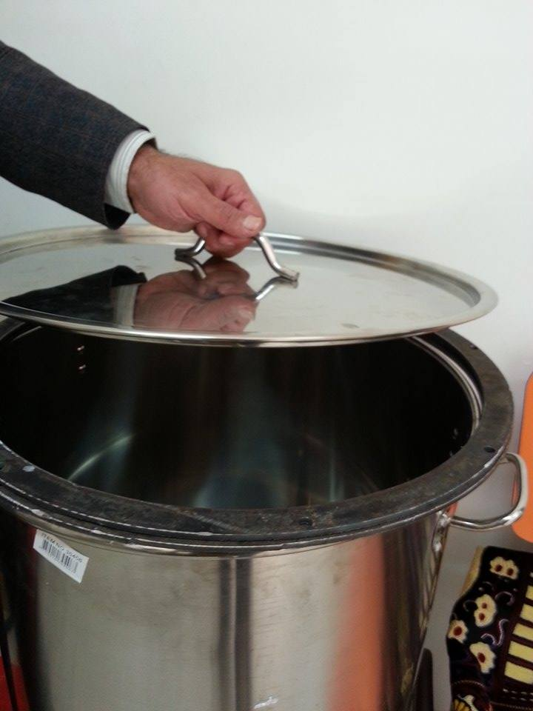
Figure(2): The cooker

The condenser is made of 4 inch galvanized tube containing 1\2 inch of brass coil with about 25m long. The steam that contains the volatile oil passes through the condenser where condense from the vapor to liquid and collected in a receiver.
The cooling media is a water, the cooling condenser is shown in fig(3).
The well distribution of entering steam is achieved by using perforated pipe. The distribution pipe contains 10 perforation with a diameter 3mm.
Plant are placed on perforated vessel inside the distillation unit.
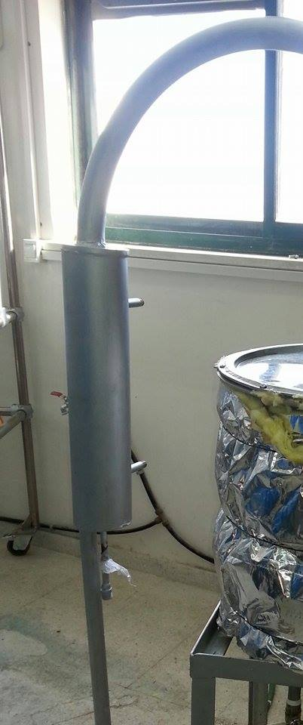
Figure(3): The condenser

Resevoir
The design of receiver is as follow:
- Design this unit then we designed another unit which manefstated seelater
- This equipment is glass and the volume of it small, so we need another receiver with proper volume and metallic which is suitable for other designed steam distillation unit.

We have already glass resevoir. This resevoir goes through modifications. The water entrain automatically. There is a tube for reseiving the condenser. The oil is gather and removed by special tube and valve.

Experimental part :
Many extraction experiments are carried out to investigate the behavior of different herbs by using steam distillation unit .

Steam Distillation process of Essential Oils:

Distillation steps:
- Place fresh plant matter or dried botanical in the bottom chamber of distiller. Loosely pack the chamber.
- Turn on the steam of distillation unit and turn on the cooling water in to condenser. It should take about a half an hour for the steam to pass through the chamber into the condenser.

- It needs between one to two hours before finishing the process. Most of the oil will come off plant matter within the first hour of the distillation process.
4) Turn the distillation unit off. Wait for the entire unit to cool down . At this point the essential oil will have risen to the top of the water in the cooling tank in the reservoir.
5) Skim the oil off the top and put it in a glass bottle for storing. Some distillation units have valve at the bottom of the cooling chamber (batch distillation). Slowly open this valve and release the water
6) Our new style of receiver was developed which allow to separate the oil from the condensed water.
7) Get collection bottle and open the valve to drain the oil into the collection bottle.
8) It is also known that different cases may be faced, oil is very slightly dissolve in water, or some polar organic constituents dissolve in water. Other ways were not applied to use in the project but may be needed to extract the Essential Oil from the co-distilled Water. Oil is soluble in non-polar solvents like Diethyl Ether (CH3CH2OCH2CH3). Ether is added to the Oil-Water mixture in a Reparatory Funnel. This funnel allows the two solvents to layer and subsequently we can drain one solvent layer away from the other.
After a few moments of shaking, the Oil will Partition into the Ether layer. Draining the Water layer from the Ether removes the Oil from the Water. The partitioning is almost never complete, so an Extraction is usually carried-out multiple times. The resulting Ether layers are collected and combined. (Caution must be observed when shaking the system. First, the system must be vented continuously because of vapor build-up that occurs within the flask. Second, the shaking cannot be too vigorous or else the system will emulsify. If emulsification occurs, separation of the two layers will become very difficult.) , then a mixture of Oil and Ether that must be separated. However, this is not a major problem. The Ether will boil at a low enough temperature that it can simply be boiled off from the Essential Oil. After the Ether is stripped off, isolation of the Essential Oil is complete.

Experiment 1:
1. Rosemary leaves (Rosmarinusofficinalis) were collected from plants growing in Sinnokrot farms, the leaves were air dried almost for one week at room temperature.
2. Weight the dried plant which is about 1000g.
3. Placed the dried plant in the bottom of distillation vessel. The distillation unit of 20L size.
4. Turn on the steam generator, the amount of steam passes through steam chamber in distillation unit is controlled by steam valve and pressure gauge.
5. Most of the oil is extracted within the first hour of the distillation process.
6. Turnoff the distillation unit. Wait to cool down. At this point the essential oil will have risen to the top of the water in a special separation unit.
7. The steam distillation unit and extract oil are shown in fig (4.a , 4.b).
9.5ml oil was achieved from 1000 g rosemary: 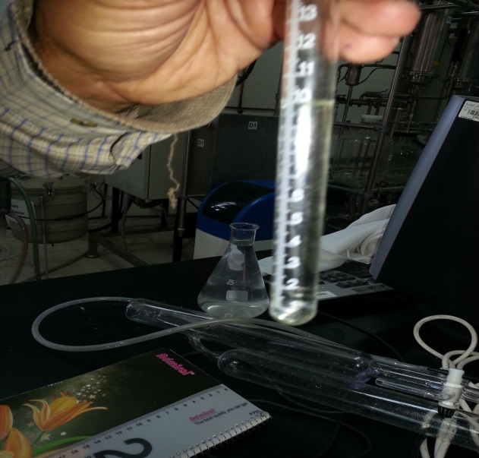 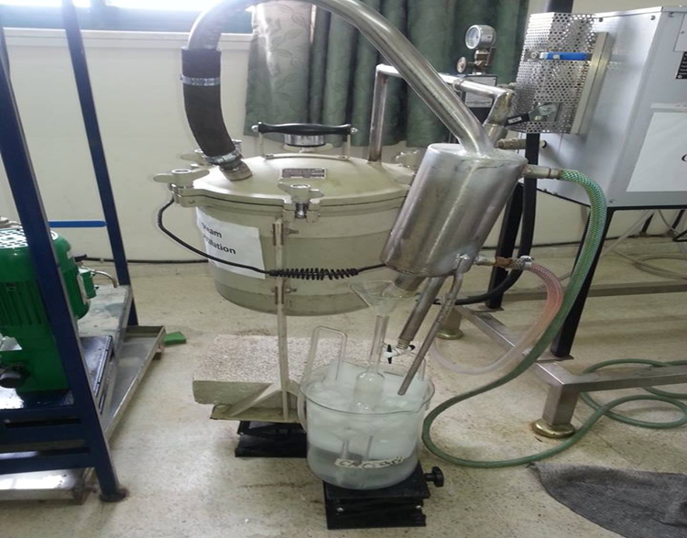
Figure (4.a):amount of oil Figure(4.b):steam distillation unit
Experiment 2:
Here there is a repetation of experiment 1, except carrying a modification of reservoir. There is a separate passage to condense and a separate path to oil see fig 5.

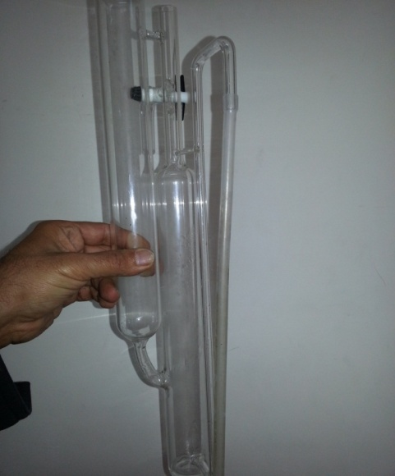
Figure (5): reservoir .
Experiment 3:
Weight 1000 g of dried Rosemary in steam distillation unit shown in figure (4).
The operating conditions and steps similar to previous experiments. Here large distillation unit was used with the size of 70 L.
About 1000ml distillate in 1 hour (water + oil). Cooling water flow rate about 100L/hr.
Obtained amount of oil is 18ml.
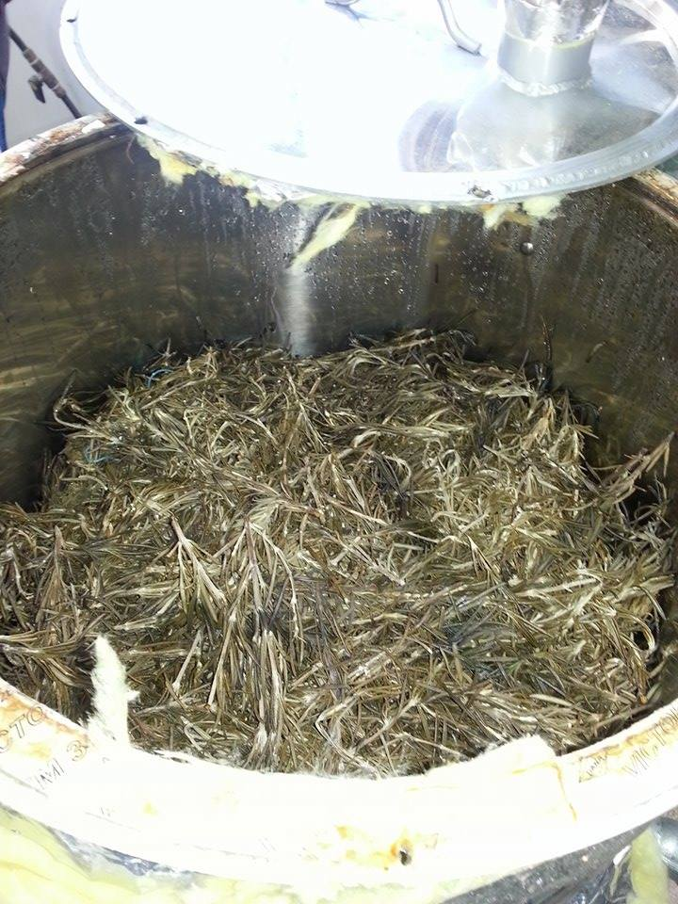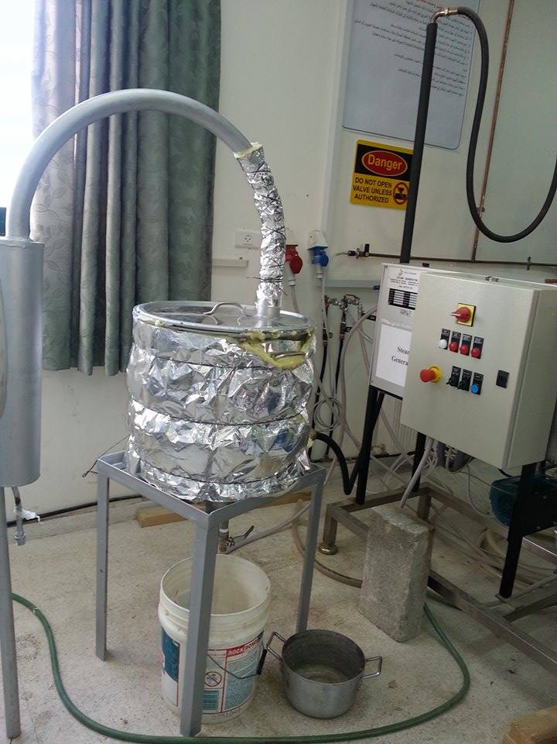
Figure(6.a):the amount of plants Figure(6.b):the new steam distillation unit

Result and Discussion:
The entering hot steam is caused the evaporation of the essential oil, so the condensed oil/water mixture enter the reservoir at the place where oil collected this causes to its evaporation and loosing.
Some modification on reservoir is occurred for changing the feed (condense water oil)entrance point to reservoir.
The feed will not face the oil layer at all, it goes to the system where it separated into oil and water.
The amount of oil obtained from the first experiment is about 9.5ml of oil from 1000g of dry rosemary while after modification we have got 13.5 ml of oil from the same amount of rosemary.
After changing completely the apparatus with proper condenser the amount of oil obtained is 18 ml. As shown in table 3
Table 3 : The result
 | Exp. 1 | Exp.2 | Exp.3
Dry rosemary | 1000 | 1000 | 1000
oil | 9.5 | 13.5 | 18
Steam D.unit | 20 L | 20 L | 71 L

Conclusion :
After carrying out lot of experiments on the effectiviness of these essential oils on killing bacteria. The Rosemary oil and Thymol oil showed strong effect on killing media otitis bacteria. Then the next step is to build pilot plant to produce consenderable amount of oil. This happened in this part of project.
The modification on resevoir had positive effect on yield and the building 70 L apparatus with propper condenser lead to increase yield from 9.5 ml to 18 ml per 1000 g rosemary.

References :
- Our previous project

- http://ethesis.nitrkl.ac.in/1949/1/satish_final_thesis.pdf

- Bouzid,N.,Toulgoute,K.,(1997),Analyse quantitative of fractions d'huile essentielle pouvant co-exister lors d'hydrodistillation de plants aromatiques,V.79,pp.15-25.

- Boland,D.J., Brophy,J.J., and House, (1991), Eucalyptus Leaf Oils: Use Chemistry, Distillation and Marketing, Melbourne, P.191.

- Hughes,A.D., (1952), Improvements in the Field Distillation of peppermint, Engineering Experimental Station Bulletin No.31,Oregon State College,pp1-64

- T.,(2008), New research into essential oil extraction could help locals.26th January .

- Jian Bo Xiao , Jin Wen Chen , and Ming Xu , (2007),Supercritical fluid CO₂ extractions of essential oil from Marchanta convolute .Vol.,10,No.1.,January 15th

- legast,E,andPeyron,L,(1989),Hydrodiffusion Industrial Technology to Produce Essential Oils by Steam, Vol.2, New Dehli, India, November, pp. 69-73.

- Hall ,R,Klemme,D.,andNiehaus,J.,(1985),The H&R Book:Guide to Fragrance Ingredients, Vol.4,London,Johnson Publications,P.13.

- Brennan, J. G. 1994, Food Dehydration – a Dictionary and Guide, Butterworth-Heinemann,Oxford.

- Barbosa-Canovas, G.V., Vega-Mercado, H. 1996, Dehydration of Foods, Chapman & Hall, New York.

- Bolin, H.R., Salunkhe, D. K. 1982, Fluid Dehydration by Solar Energy, CRC CriticalReviews in Food Science and Technology, 16, 327–354.

- Brennan, J. G. 1989, Dehydration of Foods, in Water and Food Quality, ed. T.M. Hardman, Elsevier Applied Science,London, pp. 33–70.

