An-Najah National University جامعة النجاح الوطنية
Faculty of Engineering and كلية الهندسة وتكنولوجيا
Information Technology المعلومات


Graduation Project Report II

FOUNDATION DESIGN for
a COMMERCIAL MALL in - NABLUS

Prepared By:
Amr Jumaa - 11819886
Angham Kiwan -11821332
Saji Alahmad - 11642901
Jasser Qadous -11317102
Under the supervision of: Dr. Mohammad Ghazal

Submitted in partial fulfillment of the requirements for Bachelor
degree in Civil Engineering

Table of contents | Page Number
اهداء | 3
الآية | 4
abstract | 5
Chapter One: Introduction
1.1 Introduction | 6
1.2 The function of a foundation system | 7
1.3 A brief definition of our problem | 7
1.4 General design considerations | 8
1.5 Classifications of foundation systems | 9
1.6 Foundation systems design options | 12
Chapter Tow: Review of Foundation Systems
2.1 Introduction | 13
2.2 Types of Soil | 13
2.3 Types of Foundations | 14
2.3.1 Shallow foundation | 14
2.3.2 Deep Foundation | 17
2.3.3 settlement | 22
Chapter Three: Structural System of the Building
3.1 Introduction
3.2 Project Building Description
3.3 Structural Loads
3.3.1 Design Loads
3.3.2 Lateral Loading-Seismic Loading
3.4 Design loads for maximum case as per Jordanian Code
Chapter four: Design of Foundation system
4.1 introduction
4.2 Manual Calculation
4.3 Foundation thickness
4.4 Foundation Reinforcement
References

الاهداء
بسم الله الرحمن الرحيم

وَقُلِ ٱعْمَلُواْ فَسَيَرَى ٱللَّهُ عَمَلَكُمْ وَرَسُولُهُۥ وَٱلْمُؤْمِنُونَ))

الى من بلغ الرسالة وأدى الأمانة ونصح الأمة نبي الرحمة ونور العالمين
سيدنا محمد صلى الله عليه وسلم
الى سندي ودرعي الحامي الى من كان معي في كل المواقف الصعبة اليك يا من اتعبته همومنا....
اليك أبي
الى من كان نورها يحتويني اليك يا دنيتي وجنتي اليك يا من حملتي هموما أسقطتها الجبال....
اليك أمي
الى من تعب وبذل قصارى جهده وكان لنا بمثابة الأخ والمعلم والعين الساهرة الى من كان لنا نموذجا يحتذى به
د. محمد غزال
الى من ضحوا بحريتهم من اجل حرية غيرهم
الأسرى والمعتقلين
الى من أكرم منا جميعا
شهداء فلسطين
الى أعمدة العلم والمعرفة الذين خطوا لنا صفحات العلم والمعرفة
أساتذتنا الافاضل
الى كل من ساندني وكل لي بمثابة الأخ والسند الى كل من منحني الطاقة ووقف بجانبي دوما
أصدقائي وأخوتي
الى كل باحث عن فكرة مضيئة تضيء له زقاق الطريق والى أصحاب العقول النيرة والبصائر المستنيرة ومن زررع فينا روح المبادرة

"وَآخِرُ دَعْوَاهُمْ أَنِ الْحَمْدُ لِلَّهِ رَبِّ الْعَالَمِينَ"

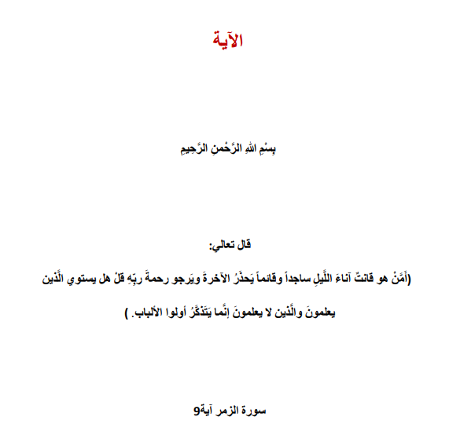

- Abstract:

The main aim of this graduation project is to select and design the most suitable foundation system or systems of Saint Elias Hotel in Bethlehem, Beit sahour. The hotel has 12 floor and the average area of floors is 1200 m2.
The main problem in designing foundations in general is the low bearing capacity of the soil it is standing on and the natural land surrounding it. The bearing capacity is estimated to be 50 KN/m2 (0.5 kg/cm2). In this project we studied Several possibilities for this foundation system in order to find the best system for this project that satisfies the requirements of the loads and the building itself while at the same time being the most economical many suggestions were studied in this project either to use deep foundation or perfuming soil improvement of the soil at the site.
At the end a suitable foundation system will be selected and designed according to the standards. Foundation details (size, thickness, reinforcement, etc.

Chapter One

- Introduction

We can define a foundation system as a Part of a structural system that supports and anchors the superstructure of a building and transmits its loads directly to the earth.

It is generally acknowledged that the foundation system of any structure is the most important element of any structure because the entire load of the structure whatever it may be is carried through its different element then transferred to the foundation system to be released into the soil. generally speaking, the load starts on the slab then moves through it to the beams after that it is released to the columns then to the foundation system after that the foundation system releases the load to the soil, therefor in short it is the system that carries the whole structure and that is why it is widely considered to be the most important system in the whole structure.

In order to have an adequate foundation system we must take into consideration a great number of factors that affect our design, these factors differ from one structure to the other but wither it is the size and shape of it or the intended purpose for the structure whatever it may be, the geographical conditions which could be very limiting and difficult to handle properly, then there is one of the most important factors that we need to take into consideration when designing our foundation system which is the type of the soil it will rest on and its relevant properties which are a crucial deciding factor in the type of foundation system we will be designing , this could be very restricting in itself and is extremely essential in any structural project.

After taking all of the previously mentioned factors into consideration and many others we find that every structure has a unique set of variables that we need to cater to in order to get a proper foundation system for the structure, which in turn leads to each of them having a unique foundation system that handles the specific needs of that structure.

When designing a foundation system, it is essential to conduct a thorough soil investigation, this will give us a clear indication of the type of foundation system we need to use or if we need to do any kind of repair to the soil in a specific manner to insure that it can support the load exerted upon it from the foundation to prevent any type of settlement especially differential settlement that could very well cause the structure to fail which will be a devastating result.

It should be noted that in most cases the foundations of the structure are “substructures” meaning they are completely under the surface of the ground and are invisible to the eye.
We can appropriately generalize that any foundation system is a link between the structure and the soil that is used to release the load from the structure to the soil it is resting on.

- The function of a foundation system

As mentioned before the foundation system is the most important element of any structure and we can summarize its function in the following points:

- To transfer the loads of the building in all its forms to the soil over a large enough area so that neither the soil nor the building fail in any way.

- To provide the structure’s stability from the ground underneath it.

- To distribute the weight of the structure over a large area in order to avoid overloading the underlying soil possibly causing differential settlement.
- To anchor the structure against natural forces including earthquakes, floods, droughts, frost heaves, tornadoes and wind.
- To provide a level surface for construction.
- To anchor the structure deeply into the ground, increasing its stability and preventing overloading.

- To prevent lateral movements of the supported structure when needed.

A brief definition of our problem

In Palestine, east of Bethlehem - Beit Sahour, we have the St. Elias Hotel we want to redesign the foundations for it, which is currently under construction, and it consists of 12 floors, and an approximate area of 1200 m 2.
Where it was created on treated soil.

- GENERAL DESIGN CONSIDERATIONS

There are some general considerations we must take into account when designing our foundation system that can give us a solid starting point for our design. We can summarize them in the following points:

- The depth of the foundation must be below the zone of seasonal volume changes caused by freezing, thawing, and plant growth. Most local building codes will contain a minimum foundation depth requirement.

- The depth of the foundation must be adequate to avoid lateral expulsion of material from beneath the footing.

- In addition to compressive strength considerations, the foundation system must be safe against overturning, sliding, any uplift and against intolerable differential settlement to avoid any distress to the structure.

- The foundation system must be designed considering expansive soil conditions.

- The foundation should be durable and function properly during its assigned service period.

- The foundation must be economical in terms of the method of installation and its execution.

- The foundation and its construction, must meet environmental protection standards
and the laws that are put in place to protect the soil and the environment surrounding the structure.

- Classifications of foundation systems

As discussed before the type of the foundation system is selected based on many criteria but when we initially need to decide on one of the two basic types of foundation systems which are deep foundations and shallow foundations we need to look at the strength and the compressibility of the various soil strata at the site, the specific loads that the footings are subjected to, the position of nearby water tables and the depth of the foundations of the adjacent structures.

Based on the previous criteria we can classify the foundation systems into two basic types specific to the depth of the foundation as follows:
- Shallow foundation: are a specific type of foundation constructed where soil layer is at a shallow depth generally up to 1.5m, while being able to support the structural loads. The depth of shallow foundations is generally less than their width. This type of foundation system contains:

- Strip footing
A strip footing is a type of shallow foundation that is provided for a load-bearing wall, a row of columns which are so closely spaced that their spread footings overlap or nearly touch each other. In such a case, it is more economical to provide a strip footing than to provide a number of single footings in one line. A strip footing is also known as continuous footing.

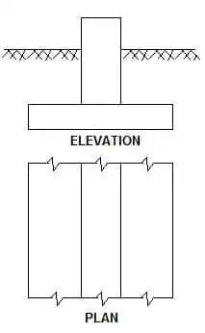
- Spread or isolated footing
A spread or isolated footing is a type of shallow foundation that is also called pad footing or individual footing is built to support an individual column. A spread footing is circular, square or rectangular with a slab of uniform thickness. It can also be built as a stepped to spread the load over a large area.
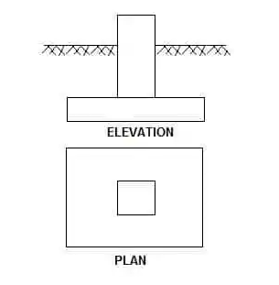
- Combined footing
combined footing supports two columns. It is used when the two columns are so close to each other that their individual footings would overlap. A combined footing is also provided when the property line is so close to one column that a spread footing would be eccentrically loaded when kept entirely within the property line. By combining it with that of an interior column, the load is evenly distributed. A combined footing may be rectangular or trapezoidal in plan.
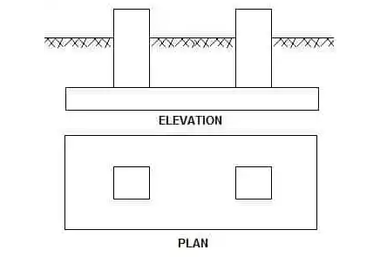
  - cantilever footing
strap (or cantilever) footing consists of two isolated footings connected with a structural strap or a lever. The strap connects the two footings such that they behave as one unit. The strap is designed as a rigid beam. The individual footings are so designed that their combined line of action passes through the resultant of the total load. a strap footing is more economical than a combined footing when the allowable soil pressure is relatively high and the distance between the columns is large.
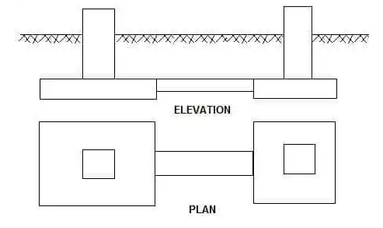
- Mat or raft Foundation.
A mat or raft foundation is a large slab supporting a number of columns and walls under the entire structure or a large part of the structure. A mat is required when the allowable soil pressure is low or where the columns and walls are so close that individual footings would overlap or nearly touch each other. Mat foundations are useful in reducing the differential settlements on non-homogeneous soils or where there is a large variation in the loads on individual columns.
- 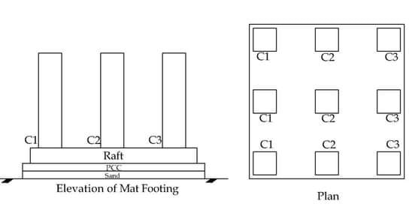

- FOUNDATION SYSTEM DESIGN OPTIONS

The choice of the appropriate type of foundation is governed by some important factors such as
• The nature of the structure
• The loads exerted by the structure
• The subsoil characteristics
• The allotted cost of foundations

When deciding on the foundation system we must take the previous points into consideration and a thorough subsoil exploration needs to be made so we can successfully evaluate the soil characteristics we need to design our foundation system.

Chapter Two
Review of Foundation Systems

- Introduction

As a general review of foundation systems we will address the general types of soil and foundations that would be considered in any foundation system no matter what the structure may be, the importance of soil investigation will be discussed as well as settlement in the foundation system.

- Types of Soil

There are many types of soil around the world and they can be categorized in many different ways, there is clay or expansive soil, sandy or loose soil which is not preferable in building structures. Another method of categorizing the many types of soil would give us two types called top soil which is the soil on the surface of the earth and sub soil which is soil below the surface of the earth below a depth of about 300mm.
When looking into building any structure we must do a detailed soil investigation to figure out which type of soil we are dealing with and give us the characteristics of the soil we intended to erect the structure on wither it’s the depth of the layers, depth of an existing water table or simply finding the bearing capacity of the soil which is a key factor in deciding the type of foundation system we design. We ca do this by following the United Stated Department of Agriculture (USDA) classification is presented in Figure 2.1.

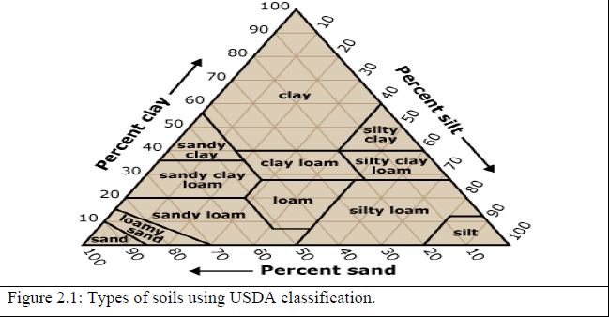
- Types of Foundations

As discussed previously when selecting the proper type of foundation, we need to consider the type of soil and its characteristics and the loads excreted upon it from the structure and the types of foundation systems can be broadly generalized into two types with a wide verity of different systems that fall within their classification, they are deep foundation system and shallow foundation systems.

Shallow foundation:
Shallow foundations are foundation systems that are built close to the ground surface or at a shallow depth. Shallow foundations are used when subsoil exploration proves that the soil that is affected by the building could resist the superimposed stresses without causing excessive settlements, or failure.
This type of foundation usually refers to those being rested on stratum with adequate bearing capacity and laid less than 3m below ground level. common examples include pad, strip or raft foundations.
The selection of the right type of shallow foundation normally depends on the magnitude and disposition of the structural loads and the bearing capacity of the subsoil.
A combination of two or three types of shallow foundation in one single structure is not uncommon. We can classify shallow foundation of the following type:

Wall or strip footing
Strip foundations (or strip footings) are a type of shallow foundation that are used to provide a continuous, level (or sometimes stepped) strip of support to a linear structure such as a wall or closely-spaced rows of columns built centrally above.

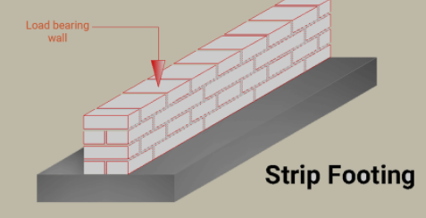

Isolated footing
Isolated footings (also known as Pad or Spread footings) are commonly used for shallow foundations in order to carry and spread concentrated loads, caused for example by columns or pillars.

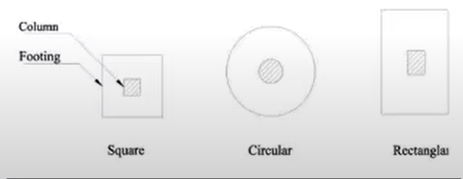

Combined footing
Combined footings are constructed for two or more columns when they are close to each other and their foundations overlap.

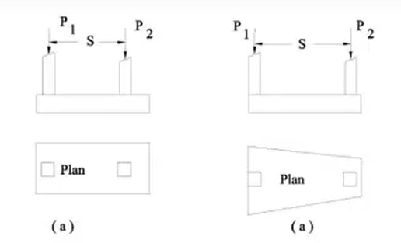

Raft(mat) foundation
Raft foundation is a large combined thick slab designed to seat and support the whole or a large part of a structure.
A raft is usually used when subsoil is weak. Or closely located and with deviated loadings it also serves as transfer slab to combine and tie up all the vertical loading elements to the plate. form foundation. By doing so, differential settlement can be avoided.

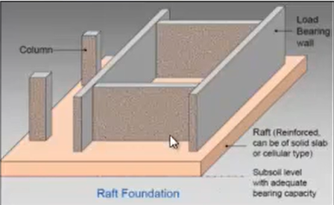
- Strap or Cantilever footing
It’s a type of shallow foundation that mainly consists of two isolated footings connected with a lever or strap. The two footings behave as one unit. The footings are designed in a way that their combined line of action passes through the resultant total load. We use a strap system instead of a combined footing system when the soil pressure is high and/or the distance between columns is too large keeping in mind that the strap system is more economical.
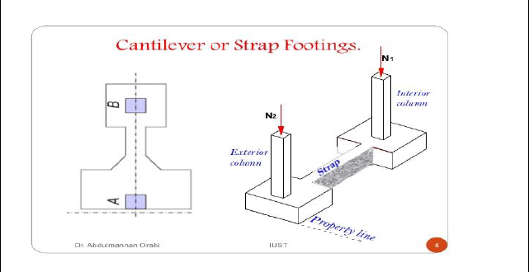

- Deep Foundation

We tend to use deep foundation only when they are extremely needed and are the only option because they are extremely difficult to implement properly compared to the other options and are very expensive. They are used when the soil investigation indicates that the soil will not be able to carry the load of the structure therefore we need to reach a lower layer of the soil that would have a high enough bearing capacity to carry the load it needs to. This is achieved by using one of the following foundation systems.

Caissons foundations
Caisson foundation is a shaft of concrete placed under a building column and extended down to a rock. Also is known as pier foundation. It is a permanent sub-structure that, while being sunk into position, permits excavation to proceed inside and also provides protection for workers against water pressure and collapse soil.
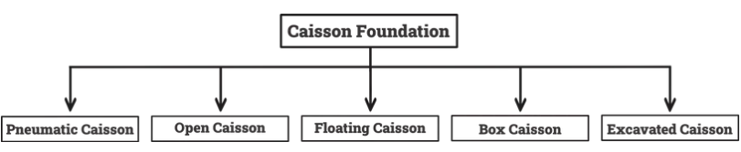

Shaft foundations
A pier foundation is easier to build and less costly than the other concrete foundation. It best for building site with a low likelihood of earthquakes or hurricane force wind because the house is not as deeply or heavily embedded into the ground.
Drilled shafts are classified according to the ways in which they are designed to transfer the structural load to the substratum.

Pile foundations
Pile foundations are principally used to transfer the loads from superstructures, through weak, compressible strata or water onto stronger, more compact, less compressible and stiffer soil or rock at depth, increasing the effective size of a foundation and resisting horizontal loads. They are typically used for large structures, and in situations where soil is not suitable to prevent excessive settlement.
Pile foundations are deep foundations. They are formed by long, slender, columnar elements typically made from steel or reinforced concrete, or sometimes timber. A foundation is described as 'piled' when its depth is more than three times its breadth (ref. Atkinson, 2007).

Piles foundation can be classified into the following
  - End bearing piles
  - Friction piles
  - Settlement reducing piles
  - Tension piles
  - Laterally loaded piles
  - Piles in fill

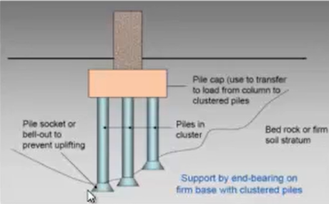

  - Basements

They are hollow foundations designed to provide space in the workplace or for storage under the ground floor and its structural design is functionally designed to withstand external and hydrostatic pressures and is designed in open excavation areas.

  - Buoyancy rafts (hollow box foundations)
They are hollow structures that are used to reduce the loads on the soil to achieve low density. These foundations can be soaked and can be designed in open spaces.
  - Cylinders

Cylinders are a type of caissons that are considered small single-cell

- settlement
settlement occurs when the soil cannot handle the load exerted upon it from the structure which leads in turn to it losing its strength and integrity causing the structure to tilt or sink to its new level as it is resting on it. This happens in most types of soil some more than the other for example sandy soil will most likely settle over time and if the structure’s load is enough it will show settling before the structure is complete, as for clay soil for example it takes some time to settle up to a few years.
This is a very serious issue that needs to be dealt with properly and the way to do it is in the designing process because the entire structure could collapse if differential settlement occurs in it as it will tilt to one side and fail.

