

An-Najah National University
Faculty of Graduate Studies

ENHANCING RESOURCE UTILIZATION IN EDGE COMPUTING USING DEEP Q-NETWORK

By Yazan Jarrar
Supervisor Dr. Anas Toma

This Thesis is Submitted in Partial Fulfillment of the Requirements for the Degree of Master in Artificial Intelligence, Faculty of Graduate Studies, An-Najah National University, Nablus, Palestine.
2026

ENHANCING RESOURCE UTILIZATION IN EDGE COMPUTING USING DEEP Q-NETWORK
By
Yazan Jarrar

This Thesis\Dissertation was Defended Successfully on 1/18/2026 and approved by

Dr. Anas Toma
Supervisor |  | Signature
Dr. Yousef Daraghmeh
External Examiner |  | Signature
Dr. Imad Natsheh
Internal Examiner |  | Signature

Declaration

I, the undersigned, declare that I have submitted the thesis entitled:

ENHANCING RESOURCE UTILIZATION IN EDGE COMPUTING USING DEEP Q-NETWORK

I declare that the work provided in this thesis, unless otherwise referenced, is the researcher’s own work and has not been submitted elsewhere for any other degree or qualification.

Student's Name: | Yazan Ahmad Taher Jarrar
Signature: | 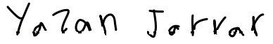
Date: | 1/18/2026

Table of Contents
Table of Contents IV
List of Tables VI
List of Figures VII
List of Appendices VIII
Abstract IX
Chapter One: Introduction 1
1.1 Background and Motivation 1
1.2 Theoretical Basis 2
1.3 Problem Statement 3
1.4 Research Gap and Challenges 5
1.5 Objectives of the Study 5
1.6 Contributions of the Study 6
1.7 Organization of the Thesis 7
Chapter Two: Literature Review 8
2.1 Local Optimization Approaches 8
2.2 Global Optimization Approaches 11
2.3 Toolchains in the literature (PyTorch, Optuna) 15
2.4 Relation to NP-hard Problems and Bin Packing 15
2.5 Summary 16
Chapter Three: Methodology 18
3.1 System Environment 18
3.1.1 Static Environment 20
3.1.2 Dynamic Environment 21
3.1.3 DQN Training Environment 22
3.2 Algorithms 25
Chapter Four: Datasets and Data Generation 35
4.1 Data Distribution Analysis and Pre-processing 37
4.2 Feature Normalization 37
4.3 Handling Outliers and Distribution Robustness 37
Chapter Five: Experiment Design and Setup 38
5.1 System Configuration 39
5.2 Static Environment 39
5.3 DQN Training Procedure and Evaluation 41
5.4 Dynamic Environment 45
Chapter Six: Results 49
6.1 Static Environment 49
6.2 Dynamic Environment 51
Chapter Seven: Results Discussion 57
7.1 Limitation 58
7.2 Conclusions and recommendations 58
References 60
Appendix A Figures 65
Appendix B Tables 74
الملخص ب‌

List of Tables
Table 1 Summary of previous studies 16
Table 2 Configuration of the simulator for the static environment 21
Table 3 Configuration of the simulator for the dynamic environment 22
Table 4 DQN cross-parameters 24
Table 5 Static environment experiment configurations 40
Table 6 Tuning configurations 41
Table 7 Optuna search ranges 43
Table 8 Dynamic Environment Comparison Configurations 47
Table 9 Comparison legend details 48
Table 10 SA and Greedy comparison 50

List of Figures
Figure 1 Edge computing system 19
Figure 2 Edge computing scheduler 26
Figure 3 Deep Q Network Scheduler Architecture and Workflow 32
Figure 4 SA Scheduler solution representation 34
Figure 5 Training environment Data Generation Flow 36
Figure 6 Dynamic environment correlation heatmap. 38
Figure 7 DQN training evaluation and cross-parameter tuning 44
Figure 8 Task failure rate (%) as a function of number of devices for a fixed window size. 52
Figure 9 Algorithm overhead (µs) and task failure rate (%) as functions of number of edge devices. 53
Figure 10 Algorithm overhead (µs) and task failure rate (%) as functions of window for environment with and without WLAN limitation. 55

List of Appendices
Figure A.1 DQN training flow 65
Figure A.2 Simulated annealing percentage of improvement over the greedy approach (window 0.01) 66
Figure A.3 Simulated annealing percentage of improvement over the greedy approach (window 0.02) 66
Figure A.4 Simulated annealing percentage of improvement over the greedy approach (window 0.03) 67
Figure A.5 Simulated annealing percentage of improvement over the greedy approach (window 0.04) 67
Figure A.6 Simulated annealing percentage of improvement over the greedy approach (window 0.05) 68
Figure A.7 Simulated annealing percentage of improvement over the greedy approach (window 0.06) 68
Figure A.8 Simulated annealing percentage of improvement over the greedy approach (window 0.07) 69
Figure A.9 Simulated annealing percentage of improvement over the greedy approach (window 0.08) 69
Figure A.10 Simulated annealing percentage of improvement over the greedy approach (window 0.09) 70
Figure A.11 Simulated annealing percentage of improvement over the greedy approach (window 0.10) 70
Figure A.12 Simulated annealing percentage of improvement over the greedy approach (window 0.11) 71
Figure A.13 Static environment data histograms 71
Figure A.14 Training environment data histograms 72
Figure A.15 Dynamic environment data histograms 72
Figure A.16 Algorithm overhead (µs) as a function of number of devices for a fixed window size. 73

Table B.1 Static environment data analysis 74
Table B. 2 Training environment data analysis 74
Table B. 3 Dynamic environment data analysis 75

ENHANCING RESOURCE UTILIZATION IN EDGE COMPUTING USING DEEP Q-NETWORK
By Yazan Jarrar
Supervisor Dr. Anas Toma

Abstract
This thesis focuses on designing and evaluating machine learning techniques to enhance the scheduling process in an edge computing environment, especially for IoT applications, with the goal of maximizing the number of tasks executed within a specified window limit. Maximizing task completion within deadlines increases throughput and service quality, while missed deadlines can degrade system performance and render results unusable.
This study investigates the two proposed algorithms, Simulated Annealing (SA) and Deep Q Network (DQN), to determine if they outperform the existing solutions for batch task scheduling in an edge computing environment. To validate the results, we used real world Augmented Reality (AR) and Internet of Vehicles data generated by the EdgeCloudSim simulator. The results clearly show that our proposed algorithms outperform others solutions, especially where the resources are strictly constrained.
The results show that our simulated annealing-based algorithm achieved up to a 71% reduction in task failure rate compared with the baseline algorithm when tested in static environments using real IoT and AR data. They also show that our Deep Q-Network based scheduler consistently achieved the lowest failure rates across dynamic scenarios, especially under higher constraints. Moreover, the Deep Q-Network model evaluated in a dynamic environment required substantially less overhead time, under one-third of the simulated annealing algorithm’s runtime, while both algorithms outperformed other baseline algorithms by up to 10% in task failure rate.
These findings support the thesis objective of maximizing the edge resource utilization while ensuring task batches complete within a specified window limit and highlight the efficiency of the Deep Q-Network based scheduling algorithm.
Keywords: Edge Computing, Internet of Things (IoT), Task Scheduling Algorithms, Reinforcement Learning, Deep Q-Network (DQN), Simulated Annealing, EdgeCloudSim, Virtual Machine Resource Optimization.

Chapter One: Introduction

Background and Motivation
In recent years, the rapid growth in the number of connected devices and the increasing need for low-latency processing, especially for time-sensitive applications, have exposed the limitations of traditional cloud computing models. The centralized nature of cloud data centers causes delays, which are unsuitable for time-sensitive applications. As a result, edge computing has emerged as a solution to enhance the latency issues where computation and data storage are moved closer to the user or device.
The Internet of Things has further increased the demand for edge computing. With billions of devices generating very large amounts of data in real-time, transmitting data to distant cloud servers for processing is becoming increasingly time-consuming and inefficient. Edge computing offers a scalable solution by allowing local data processing and decision-making. However, this distributed new system has its own challenges in resource management, scheduling, and task offloading strategies.
In the context of vehicles, the concept of the Internet of Vehicles (IoV) has emerged, and such a use case can utilize edge computing to develop it from the perspective of performance, availability, and the number of resources needed in the vehicle itself. Vehicular edge computing offers applications to improve the availability of services in vehicles, and it achieves this by partially offloading tasks into edge servers [1]. Such an environment usually contains not only multiple offload destinations but also multi-access communication technologies such as WLAN, WAN, and cellular networks.
For applications such as augmented reality (AR), which requires real-time responsiveness and substantial processing resources, this distributed approach has great potential to overcome the limited processing power and battery life issues of running large tasks on IoT devices. AR is a promising application that can benefit from edge computing. It works by overlaying digital content onto the physical world in real-time, which requires very fast processing of sensor data, environment mapping, and user input. Any delay in computation will severely affect the experience and make it unusable. Since AR devices are typically resource constrained, offloading computation to edge servers becomes an attractive solution. However, deciding what to offload, when, and where is a complex decision-making problem affected by multiple factors such as network conditions, device capabilities, and server availability.
In the edge computing architecture of the IoT, devices that usually have limited resources can offload the tasks or a subset of the tasks into other processing units with a larger number of resources. which can enhance the execution time of the task. However, in reality, taking the decision of offloading the task or not and where to offload it is a much harder decision to make.
Determining whether and where to offload a task is challenging because, in the real world, numerous uncontrollable variables will affect the decision-making process, and making the wrong decision could give the opposite results. However, we do not have unlimited resources, so we aim to find the best scheduling decision for all the tasks in hand within a time window while aiming to maximize the virtual machines as much as possible.

Theoretical Basis
Machine learning allows systems to learn from past data and modify their behavior accordingly. By finding and learning hidden patterns in task execution and resource usage, ML models can predict future workload and adjust scheduling decisions on the fly. In this work, we utilize these capabilities to create adaptive schedulers that analyze past task performance and forecast VM demand, with the aim of maximizing throughput and meeting strict time-window constraints.
EdgeCloudSim is a simulator built by a group of researchers to sum up a wide range of concepts such as Cloudlet [2], Mobile Cloud Computing [3], and Fog Computing [4]. It has been built and used to simulate scenarios and test algorithms in a controlled sandbox environment [5]. It provides a modular architecture to provide support for a wide range of functionalities such as network modeling, device mobility model, and tunable load generator.

Problem Statement
Edge IoT workloads often arrive in batches with strict completion windows. Given a limited and heterogeneous pool of edge/cloud VMs, the core problem is to decide, per batch, which and where to offload tasks, ensuring that:
- The batch completes within its time window.
- The number of simultaneously used VMs (hence the resource cost) is minimized.
This study frames batch scheduling as a constrained optimization problem under latency and capacity limits.
1.3.1 Problem Definition
We denote our instruction set as (I_{i}​), which must be completed within a time window W. We can offload the instructions to a pool of virtual machines (V_{j}​) hosted on edge or cloud servers, ensuring the total execution time of I_{i} does not exceed W, while we strive to minimize the number of VMs used, denoted by (R). We assume that there are (m) heterogeneous VMs, and each has a different estimated response time (τ_{i,j}) for each instruction.
(τ_{i,j}) can be estimated using this equation.
$$τ_{ij}=\frac{I_{i}}{ρ_{v_{j}}}+\frac{D_{i}}{B_{j}}$$ | (1.1)

where (I_{i}) is the size of the instruction set to be executed on server (j), where ($ρ_{v_{j}}$) is the instruction per second of the server, (D_{i}) is the data size in bytes of the instruction set, and (B_{j}) is the communication speed from the edge device to the server (bytes per second).
Our goal is to minimize the number of VMs used by scheduling the set of instructions between all possible near-optimal solutions. This means that we want to distribute the workload efficiently across the fewest possible VMs. And the number of VMs used can be calculated using Equation 2.
where every processing node (j) can execute multiple tasks at the same time but without exceeding the use of 100% of the VM, and this can be calculated using Equation 3 and Equation 4.
Mathematically
Objective: Minimize R
Such that:
$$R= \sum_{V=1}^{m}{x_{V}}>0$$ | (1.2)

Where $x_{V}$ equals the set of instructions running on the virtual machine V.
Moreover:
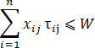 | (1.3)
where x_{ij} = 1 means that the set of instructions Ii is selected to be executed on the virtual machine V_{j}; otherwise, x_{ij} = 0.
Which also means:
$$R=\sum_{i=1}^{n}{f\left(x_{i}\right)>W}$$ | (1.4)
where f(x) is the total execution time, n is the total number of tasks, W is the window constraint, and xi is the task.
This problem is similar to the bin packing problem, and it is proven to be an NP-hard problem by Toma et al. [6], which means if we have as many VMs as needed and we have (n) number of tasks, the time complexity to find the optimal solution will be O(2^n). Therefore, we will try to have an optimization technique and find a near-optimal solution.

Research Gap and Challenges
The traditional optimization techniques have failed to scale with the growing need for fast, high quality scheduling decision because of the large number of demands and resources. This increases the exploration-exploitation time required by the traditional optimization techniques to reach efficient solutions. This limitation highlights the need for modern approachs, such as machine learning–based schedulers, to address the problem.

Objectives of the Study
Our methodology uses machine learning’s strong capabilities. We can optimize the task allocation and optimize the resource utilization in an environment where the tasks come in batches while we are limited by the time completion constraint (window). This will overcome other solutions by considering more information from the limited parameters using machine learning, which will increase the quality of scheduling decisions. We will achieve this by focusing on the following parts:
- Designing Machine Learning-Based Scheduling Algorithms: Design efficient scheduling algorithms powered by machine learning to optimize resource utilization in dynamic environments.
- Evaluating the algorithms under different environments: Evaluate the effectiveness of the proposed schedulers against classical optimization approaches in terms of task completion and resource utilization.
- Optimizing Task Execution Under Time Constraints: Maximize the number of tasks completed within a specified time window, addressing latency-sensitive applications in IoT and AR environments.
This research aims to achieve certain objectives that could greatly benefit the field of edge computing. Within the domain of edge computing, adopting smarter strategies for scheduling and managing resources could optimize it by enhancing efficiency, quicker response times, and improved scalability.
The main specific objectives:
- Formulate the batch scheduling problem with explicit window and VM usage objectives.
- Design a DQN-based scheduler and an SA heuristic for batch offloading.
- Evaluate both methods on static (real AR/IoT) and dynamic (EdgeCloudSim) workloads against standard baselines.
- Quantify the tradeoffs based on failure rate, VMs used, and decision overhead to identify the regimes where each method excels.

Contributions of the Study
- Design a DQN-based scheduler and an SA heuristic for batch offloading.
- Evaluate both methods on static (real AR/IoT) and dynamic (EdgeCloudSim generated IoV) workloads against standard baselines.
- Build a new simulation environment to train the DQN scheduler.
- Support batch data generation in EdgeCloudSim simulator.
The successful implementation of these contributions impacts the field by providing:
- Reliability: reduced late (failed) tasks under tight windows compared with baselines.
- Resource efficiency: complete batches with fewer concurrently used VMs on average.
- Decision latency: keep the scheduler overhead low enough for practical deployment.
- Robustness: maintains performance under changing load, VM availability, and WLAN constraints.

Organization of the Thesis
The thesis is structured as follows:
- Chapter 1 provides an introduction to the research objective, motivation, and context.
- Chapter 2 focuses on the previous work and key concepts such as edge computing, offloading, etc.
- Chapter 3 is about the methodologies used for the comparison and the proposed algorithms.
- Chapter 4 focuses on the data (how it is gathered or generated).
- Chapter 5 provides information about the experiments.
- Chapter 6 reports the results.
- Chapter 7 discusses the results and concludes the findings.

Chapter Two: Literature Review
Research on edge computing has grown rapidly, driven by the demand for real-time responses in resource-constrained environments. Various studies have introduced heuristic-based, fuzzy logic-based, and learning-based methods to manage task scheduling and resource allocation. However, there is a clear need for more globally optimized solutions that tackle the problem from a batch scheduling perspective, rather than making local decisions for individual tasks in isolation.
Other limitations might also reduce the efficiency of many proposed algorithms, such as time constraints and location constraints.
This chapter contains the literature on the history of the problem, algorithms, and tools in the following sections in order:
- Local Optimization Approaches
- Global Optimization Approaches
- Toolchains in the Literature
- Relation to NP-hard Problems and Bin Packing
- Summary

Local Optimization Approaches
Heuristic Approaches:
Heuristic approaches make local decisions usually in an iterative manner where the next decision depends on the previous one.
Toma et al. [6] introduced a heuristic-based scheduling algorithm that optimizes the scheduling problem by calculating the execution time and network latency to use as parameters. Although their approach improved the decision-making speed, it was not designed to handle large-scale complexity or situations with significant constraints on the number of edge servers.
Similarly, Toma et al. [7] explored approaches to enhance computer vision tasks in constrained devices by controlling the resolution and other inputs, such as execution location, as parameters to generate different “execution versions” of the same task. These will be input to the adaptive dynamic programming algorithm that will determine the execution version that maximizes the quality.
However, while Toma et al.’s dynamic programming-based approach achieved a good balance between execution quality and performance, it mainly worked on a per-task or small batch level and assumed that suitable edge or cloud resources would always be available. In environment where network conditions change rapidly, workloads vary widely, and resources may be limited, more flexible, adaptive, and globally optimized methods are needed.
In another research, Sonmez et al. [8] implemented a simple moving average (SMA) and used it as a baseline to compare with other algorithms. The SMA baseline introduces a degree of adaptivity by maintaining, for each processing tier, a fixed‐length history of recent success rates. At each scheduling decision, the orchestrator computes the mean success probability over that window and routes the incoming task to the tier exhibiting the highest moving average. Although this statistical heuristic can respond to short‐term fluctuations in failure rates, it neither constructs a predictive model nor employs any explicit exploration strategy—consequently, when system conditions evolve more rapidly than the window length permits, the SMA may adapt too slowly and select suboptimal targets. Recent VM placement heuristics from consolidation studies also echo our constraints: e.g., density-based clustering (DBSCAN) implemented by Tandon et al. [9] on assigning VMs to physical can reduce active servers—useful when we explicitly aim to minimize the number of used VMs but face a drawback of its long algorithm overhead time. However, because the heuristic works in iterative manner, it makes them slower than machine learning approaches, which causes them to fail in strict time constraints.

Fuzzy logic methods:
Fuzzy logic works by mapping input from crisp space to fuzzy space, and this makes the algorithm able to make decisions based on the degree of membership.
Workload orchestration in edge computing has also been explored through fuzzy logic. Sonmez et al. [10] and Almutairi et al. [11] employed fuzzy inference systems to determine whether tasks should run locally, at the edge, or in the cloud, based on parameters such as task length, bandwidth, VM utilization, or CPU utilization. Sonmez et al. used a two-stage fuzzy system to first pick the best edge server and then decide between that server and the cloud. While this approach might reduce the scheduling quality, it dramatically optimizes the scheduler’s decision speed. Almutairi et al. used a single-stage system, considering multiple parameters such as (CPU demand, network demand, delay sensitivity, resource utilization, and resource heterogeneity) to determine the VM that minimizes the overall latency. Also implemented on a similar problem by Jin et al. [12], extensions that mix fuzzy rules with security and load-balance constraints in industrial settings show that such systems remain flexible but still rely on carefully tuned membership functions and rule bases.
While such systems are flexible, their performance depends heavily on well-chosen membership functions and rules, and they may not fully capture the complexity of large-scale resource optimization. The problem with such systems is that they are constrained by manual rule-tuning, and they are not able to scale for large-scale VM clusters.
Game-theoretic Approaches:
Game-theoretic offloading works by modeling the interactions among multiple autonomous agents (e.g., mobile devices, edge servers) similar to a strategic game. Each agent aims to optimize its own utility without caring about the other. Wang et al. [13] modeled each vehicle as a selfish agent in a non-cooperative offloading game. By iteratively repeating best‐response updates, the fleet converges to a Nash equilibrium that trades off between the individual task latency and the failure risk. While mathematically the theory stands, its equilibrium‐centric can neglect fast dynamics and may demand higher computation overhead. Reliance on equilibrium causes the algorithm to be slow, which makes it not very suitable for real-time applications.

Global Optimization Approaches
Hierarchical and distributed approaches:
It works by splitting the system into n-tier architecture, where the load is split between the tiers.
Hierarchical architectures, such as the one proposed by Tong et al. [14], arrange multiple tiers of edge-cloud servers to improve resource usage so that the topology will be split into multiple levels of VMs so that the edge servers at the lowest level will offload tasks to a higher level if needed. They introduced workload placement algorithms to balance loads among these layers, which takes (the number of CPU cycles needed) then apply branch and bound to find the optimal server. We also utilized simulated annealing to figure out how to allocate the capacity of a higher-tier server to a lower-tier server’s tasks so it represented the solution as a vector of the capacity allocation from the higher tier to its children. While this approach achieved very good results, the research mainly focused on topology and changes to architecture instead of scheduling itself. With the proposed architecture, the system is split into multiple separate parts. Instead of applying the scheduling on all the systems at once, it gets applied on parts, which could reduce the scheduling quality. The problem with such a structure is that it optimizes the load distribution but not the scheduling quality, as it is not applied to the entire system.
Machine learning and reinforcement learning:
Neural networks and reinforcement learning (RL) have gained attention as a way to handle dynamic, complex scheduling environments. Chen [15], along with Wang et al. [16], surveyed how ML approaches, especially deep learning, can enhance edge computing tasks such as image processing or object detection. Shi et al. [17] leveraged deep reinforcement learning for task offloading decisions in vehicular edge computing, adapting to real-time changes. The approach followed by it is to handle per task and the environment input represented (data size of tasks, computational complexity of the task, coordinates of the edge computing server, and the coordinates of the vehicles), and the action of the agent will be where to offload the task and how much of the task to offload (can offload even a proportion) with the objective of minimizing overall system cost. Also, Khayyat et al. [18] applied deep learning to approach near-optimal offloading policies in vehicular cloud systems, with configuring the environment similar to Shi et al. [17] but without proportion percent for actions.
Sun et al. [19] implemented the Multi-Armed Bandit (MAB), which casts task offloading as a classical exploration–exploitation dilemma. By employing an upper confidence bound strategy, the orchestrator continually weighs the benefit of probing under-tested tiers (exploration) against capitalizing on those with strong empirical success rates (exploitation). As tasks accrue, this online-learning mechanism incrementally sharpens its probability estimates and gravitates toward the optimal offloading workload. MAB genuinely learns from each outcome, delivering markedly lower failure rates so long as the environment remains reasonably stable.
In their work, Sonmez et al. [8] presented a two-stage, machine-learning-based workload orchestrator (in addition to SMA mentioned above) for multi-access, multi-tier vehicular edge computing environments. This consists of two stages: first, to classify each offloading target (edge, cloud via RSU, or cloud via cellular) as “likely to succeed” or “likely to fail,” and then, regressing on the expected service time, they are able to dynamically schedule tasks efficiently to minimize both task‐failure rate and end‐to‐end latency​. As it has succeeded in giving great results in such an environment where tasks arrive separately, it might not give an efficient solution in case the tasks come in batches.
Meng et al. [20] introduced a deep neural network-based mechanism that decides which servers to offload tasks to by using the task size as input to the deep neural network, and it outputs whether the task should be processed locally or offloaded. After that, the tasks will be stored in a stack and processed based on their priority. The objective is to reduce latency and resource overhead. Nonetheless, most ML-based studies operate under an online scenario, where tasks arrive unpredictably and the scheduler lacks knowledge of future workloads. While online methods are realistic, they may not yield the most globally efficient solutions for a given set of known tasks.
Some works, such as that of Sada et al. [21], employed hybrid genetic algorithms to improve inference accuracy and energy efficiency by choosing between processing on an edge server or locally (local has less processing quality but no network delay), and to do so they represented the solution as a vector of length n, where n is the number of tasks in the batch. The j-th element of the vector is an integer representing the chosen model index for the j-th task; however, their primary focus was on selective task offloading rather than optimizing resource usage in scenarios with limited servers. In another work, Wang et al. [22] utilized multi-agent reinforcement learning by integrating directed acyclic graph (DAG)-based task modeling, multi-agent reinforcement learning with MADDPG, and GRU-based resource prediction, which enabled them to make offloading decisions at the subtask level while accounting for task dependencies to improve global optimization and resource utilization. However, similar to other solutions, this one may not yield the most globally efficient solutions for a given set of known tasks.
Others have tried implementing DQN and double deep Q-network (DDQN) on similar problems. Yang et al. [23] implemented DQN to tackle the offloading on multi-tier computing networks problem and succeeded in optimizing the problem in comparison to other existing solutions in terms of system overhead, user satisfaction ratio, and storage usage. On the other hand, Li et al. [24] implemented a DDQN solution to enhance the performance of offloading tasks on edge computing networks by reducing the total latency of the task execution and algorithm overhead time compared to some baseline algorithms. However, both of these studies did not consider the batch task offloading scenarios, and DDQN has some disadvantages compared to DQN in such environments like batch task offloading, and these disadvantages are as follows:
- Simpler architecture and fewer hyperparameters
DDQN requires the synchronization of two networks (online and target), which increases the implementation complexity and tuning effort. However, DQN’s single-network approach reduces potential integration errors in a batch offloading context, which also makes the DQN model faster in making predictions (Gao et al. [25]).
- Better exploration via the optimistic bias
DDQN has built-in bias reduction, which might dampen the optimistic overestimation in exploration in batch scenarios. The final reward helps discover better offloading strategies sooner (Lan et al. [26]).
- DDQN has almost no impact on overestimations in low variance environments.
Edge computing network usually has a size of the tasks that is almost identical compared to virtual machines’ processing power in such environment which makes the extra complexity of DDQN unnecessary (Pentaliotis et al. [27]).
In addition, ZHANG et al. [28] recently introduced a smart manufacturing resource scheduling framework that tightly integrates a deep convolutional neural network (CNN) with an improved DQN variant—namely, a double dueling DQN augmented by prioritized experience replay and a noisy network (D3QPN2). In their formulation, the scheduling process is cast as a multistage sequential decision problem, while a suite of heuristic dispatching rules defines the action space. The deep CNN is then trained to approximate the state action values, and the D3QPN2 module selects actions that minimize the make span. Furthermore, the empirical evaluation on standard public benchmarks shows that the hybrid CNN–D3QPN2 approach learns high-quality scheduling policies and consistently outperforms traditional heuristics in terms of shorter completion times by up to 22%. While powerful, current reinforcement learning research is not built to be able to handle batch-oriented scheduling efficiently.
Simulated Annealing
Compared with traditional optimization techniques such as linear programming, SA can efficiently explore large solution spaces. It handles complex, multi-objective scheduling problems without getting stuck in local optima, achieving this by balancing exploration and exploitation through its hyperparameter. Unlike artificial neural networks, which typically require large labeled datasets, RL and SA excel in these dynamic situations without the need for predefined training data.

In addition, SA often outperforms other heuristic optimization techniques in terms of convergence speed. Comparisons with genetic algorithms and particle swarm optimization (Basu et al. [29]; Joshi et al. [30]; Jia et al. [31]) show that if configured correctly, SA can converge faster than other population-based techniques. Furthermore, the reason for its efficiency is that after the cooling phase, SA shifts focus to exploitation, refining the solution locally.

Toolchains in the literature (PyTorch, Optuna)
Beyond the algorithms themselves, most studies rely on a fairly standard tool stack for implementation. PyTorch is commonly used to build deep RL schedulers and to run GPU-accelerated training; its dynamic computation graphs make rapid iteration and debugging straightforward. Hyperparameter tuning—covering network size/depth, learning-rate schedules, and exploration settings—is often handled with Optuna, which uses sampler-based search (e.g., TPE and multivariate samplers) and early pruning to cut weak trials and reduce run time. As a result, PyTorch and Optuna have become a practical default in edge-computing ML experiments [32] [33].

Relation to NP-hard Problems and Bin Packing
This scheduling challenge shares similarities with NP-hard problems such as bin packing. In bin packing, with the objective to fit items of various sizes into the minimum number of bins. Similarly, we must “pack” tasks onto a limited number of VMs. Previous studies, for example, Guerriero [34] and Fang et al. [35], have explored machine learning and reinforcement learning to solve these types of complex packing or allocation problems. According to their findings, learned policies can outperform static heuristics and may be adapted to edge computing contexts.
However, many existing edge solutions either assume abundant remote resources (Toma et al. [6]; Xiao et al. [36]) or focus on decisions at the device level, without considering global, batch-based scheduling. More robust global optimization methods (those that consider all tasks at once) are less common. Toma et al. [7] and Sada et al. [21] addressed batch scenarios without deeply integrating the advanced machine learning technique. Standard bin packing doesn't consider the latency and time constraints of tasks, which is critical for edge computing.

Summary
Reinforcement learning and simulated annealing are highly effective in scheduling tasks on a virtual machine to optimize resource utilization. They outperform the greedy approach used by other solutions. RL learns from interactions and adapts well to dynamic environments, making it suitable for real-time decision-making.
Table 1 summarizes the results of the research:
Table 1
Summary of previous studies
Reference | Approach | Scheduling Mode | Optimization Scope | Main Objective | Resource Assumption | Key Limitation | Suitable for Batch VM Minimization
Toma et al. [6] | Greedy | Batch | Global | Latency | Assumes available edge/cloud | overhead time | Yes
Toma et al. [7] | Dynamic Programming | Online | Local | Quality/Latency | Assumes available resources | Per-task optimization only | No
Sonmez et al. [10] | SMA  ML | Online | Global | Success Rate | Vehicular Edge | Slow adaptation to rapid changes | No
Tandon et al. [9] | DBSCAN Clustering | Batch | Local | VM Consolidation | Physical Servers | High overhead, not latency-driven | No
Almutairi et al. [11] | Fuzzy Logic | Online | Local | Latency | Heterogeneous VMs | Manual rule tuning required | No
Wang et al. [13] | Game Theory | Online | Local | Utility/Latency | Autonomous Agents | High computation overhead | No
Tong et al. [14] | Hierarchical | Batch | Global | Load Balance | Multi-tier Hierarchy | Focus on topology, not scheduling | No
Shi et al. [17] | Deep RL | Online | Local | System Cost | Vehicular Edge | Per-task decision making | No
Khayyat et al. [18] | Deep Learning | Online | Local | Offloading Policy | Vehicular Cloud | No proportion for actions | No
Sun et al. [19] | Multi-Armed Bandit | Online | Local | Failure Rate | Multi-tier | Requires a stable environment | No
Sonmez et al. [8] | Two-Stage ML | Online | Local | Latency/Failure | Multi-access Edge | Not designed for batches | No
Meng et al. [20] | DNN | Online | Local | Latency/Resource | Edge Servers | Lack future workload knowledge | No
Sada et al. [21] | Hybrid Genetic | Batch | Local | Energy/Accuracy | Edge vs Local | Selective offloading focused | No
Wang et al. [16] | Multi-Agent RL | Online | Global | Resource Uti. | DAG Tasks | Subtask level, complex dependencies | No
Yang et al. [23] | DQN | Online | Local | User Satisfaction | Multi-tier | Storage/Overhead focus | No
Li et al. [24] | DDQN | Online | Local | Latency | Edge Computing | Unnecessary complexity for low variance | No
Zhang et al. [28] | CNN + D3QPN2 | Batch | Global | Makespan | Manufacturing | Complex, not suitable for time constraints | No

Chapter Three: Methodology
We study two optimizers for batch offloading—Deep Q Network (DQN) and Simulated Annealing (SA)—across static and dynamic environments. Those two approaches are chosen because they give a good balance between exploration and exploitation without neglecting the overhead time. More details on this were explained in the literature review. Static experiments replay fixed AR/IoT traces without network effects; dynamic experiments use EdgeCloudSim with mobility and WLAN constraints. The balance among reliability, efficiency, and latency is analyzed using:
- Failure rate under a window constraint.
- Number of simultaneously used VMs.
- Scheduler overhead time.
For RL training and model implementation, we adopted PyTorch for its dynamic graphs and CUDA acceleration, and Optuna for efficient hyperparameter search (e.g., learning rate, gamma, batch size, and window/task split sizes). Optuna’s TPE sampler and pruning reduce the trial cost in our high-dimensional space. These choices minimize the engineering overhead while supporting fast iteration during DQN training and SA tuning.

3.1 System Environment
This part focuses on the environments used in this research for testing, tuning the SA, and comparing it with other baseline algorithms introduced in previous research by Toma et al. in [6].
The architecture used in the research is shown in Figure 1.

Figure 1
Edge computing system
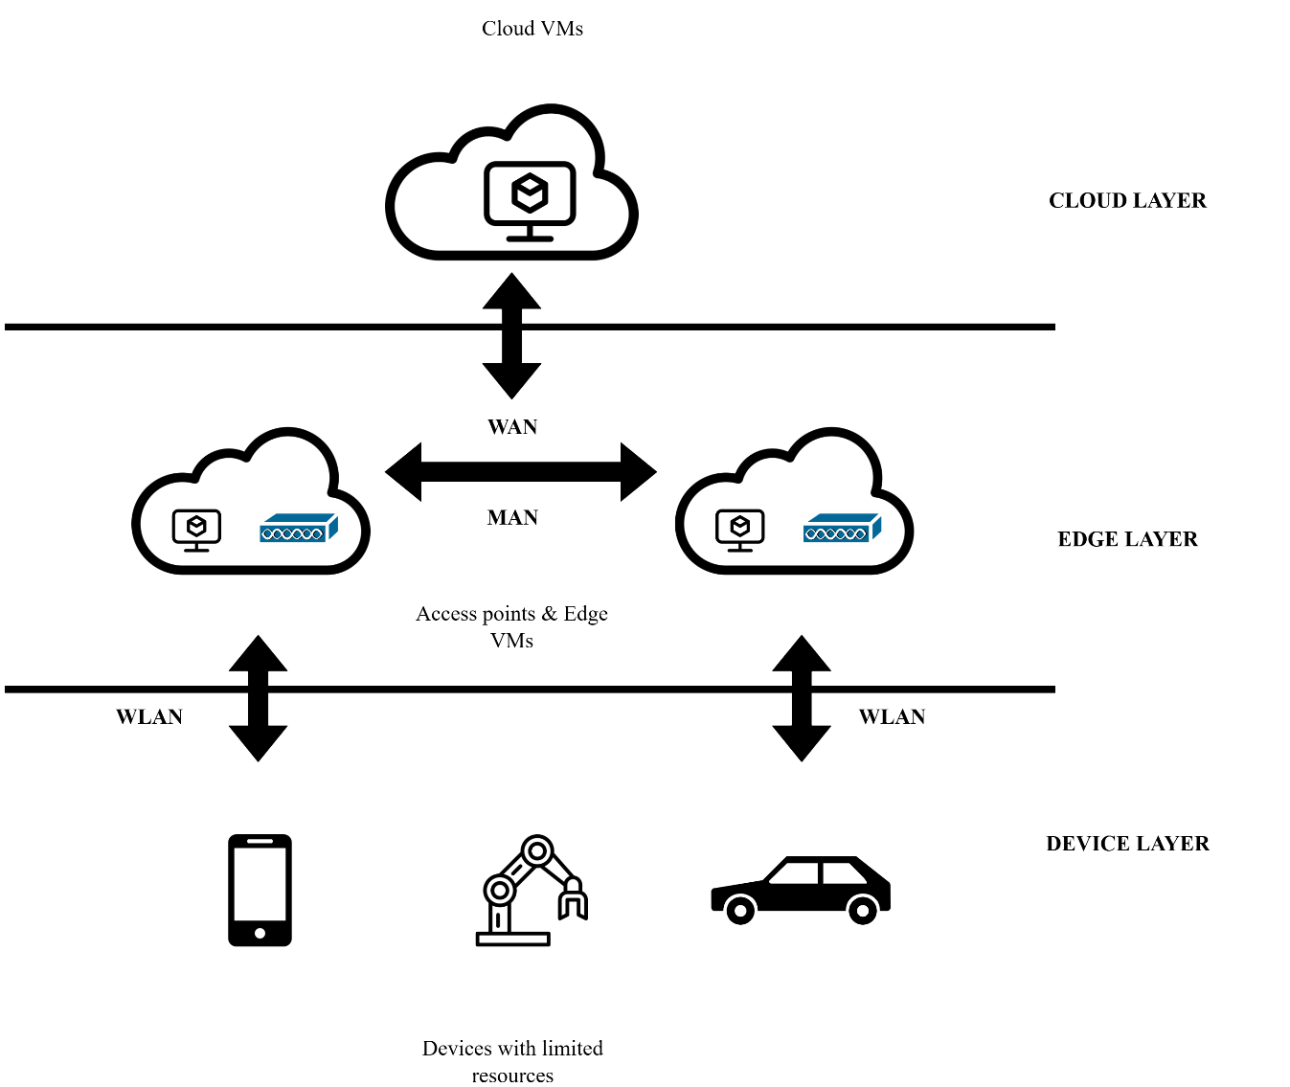

The adopted architecture, as shown in Figure 1, is built in a multi-level structure that contains the following components:
- End Devices: IoT or mobile devices that generate the tasks. These devices have limited processing power, so they offload the complex operations.
- Edge Servers: More available servers that can process the tasks; they are closer to the end devices, but they have limited processing power.
- Cloud Servers: The big unlimited servers that can process tasks, but they have high latency as they are far from the end devices.
- Virtual Machine (VM) Resources: The servers that process the tasks; their performance is measured by their execution speed (MIPS) and availability.
Architecture Rationale:
This multi-tier architecture is selected to optimize batch scheduling because while the tasks come in big numbers at the same time, it is not easy to assign them to a VM in this complex environment. The edge layer requires a low-latency option for time-sensitive tasks, while the cloud layer absorbs overflow when edge resources are exhausted. This hybrid approach directly supports the research objectives of batch scheduling ensuring groups of tasks complete within a fixed window and VM minimization.

3.1.1 Static Environment
The static environment uses the same architecture shown in the image in Figure 1. In this environment, we are depending on predefined data, and then we do the scheduling and compare the results. For this environment, we have gathered task data, and we offload the processes offline to determine the near-optimal offloading decision. This offloading decision will be based on the MIPS of the VM, which is the number of instructions the VM can handle. Each task has a predefined number of instructions, and our objective is to finish the processing within a specific window of time.
- Configuration of the simulator
These are the default values, but depending on the experiment, some of them are tweaked.

Table 2
Configuration of the simulator for the static environment
Parameter | Value
Number of mobile devices | 500
Number of hosts in the cloud datacenter | 1
Number of VMs per cloud host | 4
Number of edge data centers | 14
Number of Hosts per Edge Data Center | 1
Number of VMs per edge data center host | 2

- Structure of the Environment
We adopt the structure introduced by Toma et al. [6] as shown in Figure 1. All three tiers exist in the environment, but the communication model is static, which means that networking parameters (routing, latency, etc.) are not taken into consideration.

3.1.2 Dynamic Environment
The dynamic environment used is totally built on the EdgeCloudSim, and the simulator (for VM latency, utilization, etc.) mainly controls it, but we have the ability to configure the stats and define the structure for this experiment.
- Configuration of the simulator
These are the default values, but depending on the experiment, we will tweak some of them.
Table 3
Configuration of the simulator for the dynamic environment
Parameter | Value
Total simulation duration | 30
Initial warm-up period before the measurement begins | 0.01
Ram of VM | 8000 MB
Core per VM | 2
MIPPS of VM | 10000
- Structure of the environment
The structure used for this is a 3-tire edge similar to the one shown in Figure 1. but without the device ability to process. This structure was chosen as it gives better ability to compare with other algorithms introduced by other researchers. It was used by Sonmez et al. [5] it mimics moving vehicles that offload tasks but we did some modification to adapt it to this experiment, as here we are experimenting on a batch of tasks not one by one. Because the environment here is dynamic, we must consider the routing of the tasks (from device to edge or cloud VMs) and multiple metrics such as the mobility of the, device and the bandwidth. Also, we introduced two new metrics, i.e., Window and Limit Edge on the Same WLAN (instead of a network threshold, as it is very hard to determine the latency in advance due to the networking structure).

3.1.3 DQN Training Environment
To train the DQN model, we need a fast-generating simulator, and to make the solution general, we need a system that can generate new simulation data as fast as possible and orchestrate the scheduling results fast. In this case, neither the first static setup nor the second dynamic simulator mentioned above is able to cover the need, and this is because the first setup depends on a fixed number of resources and a fixed number of demands without real networking, which is also needed to train the DQN model. On the other hand, the dynamic approach is so complicated that it is slow to generate, which means it will be slow to train the model on multiple episodes. To work around these obstacles, we created a new training environment specifically for training the model, which covers all needed functionalities from both previous frameworks.
- Configuration
These configurations were chosen based on the result of running Optuna research to find the best parameters.
Table 4
DQN cross-parameters
Parameter | Value
Weight of the final score
  0.1625835260372698
Positive reward | 5.208108707484158
Negative reward | -1.47482960147064
Batch size | 64
Gamma | 0.9798760181610706
Learning rate | 0.003764457802568369
Number of layers | 1
First-layer units | 32
Window split size | 10
Task split size | 7
Refresh rate | 27

- Structure of the environment
The training environment follows a simplified three-layer abstraction (device, edge, cloud) as shown in Figure 1, but abstracts away the physical network topology and detailed latency modeling. However, for the task-to-VM assignment applicability, which simulates the (only on the same WLAN) constraint and random task, resource sizes are considered in this environment. The environment loop proceeds as follows:
- Initialize the environment and agent.
- Episode loop and scenario refresh.
- Task-level loop (state to action to reward).
- DQN replay and target update.
- Periodic evaluation and model saving.
- Scenario Generation: At the start of each refresh interval, the DataGenerator module creates a new DataRequest object containing a randomized set of tasks and VMs.
- State Normalization: DataUtils converts each task’s resource requirements and available VM capacities into a fixed-size state vector, incorporating window and index features.
- Action Selection: The DQNAgent selects an action (VM index) and a split index via ε-greedy policy.
- Reward Computation: Upon assignment, DataUtils computes the immediate reward based on execution success, latency proxies, and final performance weight.
- Experience Replay & Target Update: Transitions are stored in the replay buffer; periodic batch updates to the Q-network and target network synchronize weights.
This decoupled structure enables rapid iteration during the hyperparameter search while preserving fidelity in the task scheduling dynamics.

3.2 Algorithms
The parameters that can affect the decision of the algorithm are the task instruction size, the time window needed for the tasks, the VMs’ speed in MFLOPS, applicable VMs (either network or limit edge on the Same WLAN) and the number of tasks. These parameters can be gathered from EdgeCloudSim and static code analyzers.
The algorithms in this research will follow the same window-based scheduling approach proposed by Toma et al. in [6] and the applicable VMs.
The features that the scheduler will depend on to take the decision will be as follows:
- Task instruction size (can be retrieved using static analyzers).
- VM instructions execution speed in MFLOPS (will use the same VM configuration as in Toma et al. research [6]).
- The task size in KB.
- Furthermore, the task is applicable to which VMs (in case they are on the same WLAN or not).
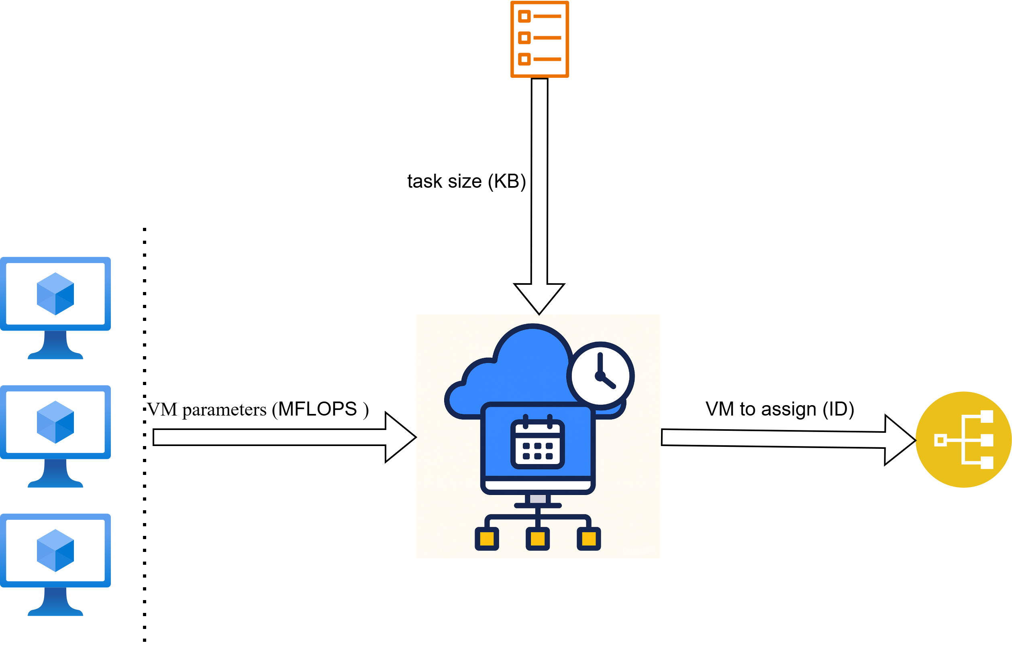
Figure 2
Edge computing scheduler
This research consists of two parts implementing the scheduler shown in Figure 2, which are the following:
- Scheduler that uses Deep Q Networks (DQN) to optimize the scheduling decision.
DQN is a popular reinforcement learning (RL) algorithm that combines Q-learning with a deep neural network. This makes it possible to manipulate the large state space that the algorithm uses. Traditional Q-learning-like RL methods struggle. Unlike simpler RL methods that rely on grid representations, DQN uses neural networks to estimate Q values, which allows more effective management of the complex and continuous state operations space. Compared with the DQN-based methods, DQN is more suitable for such cases. The ability to balance exploration and exploitation through the replay of experience and target networks makes DQN a good choice for scheduling tasks.
The machine-learning model will schedule each task based on available resources, task demand, and remaining tasks because of the number of parameters that cause the solution space to be so large.
The parameters will be normalized and presented as a vector, and the solution will be evaluated based on the number of failed tasks (less is better). The result will be the mapping of tasks to VMs, as the model should grasp the best mapping pattern based on the parameters.
The input will consist of the following:
The DQN model solves the problem by processing the tasks in sequence, where each task is assigned to a VM. The agent is able to make the decisions based on the environment state, available actions, and reward signal.

  - State Representation (Input Vector)
To represent the complex state of the environment, we normalized it into a fixed-length input vector, allowing the neural network to process it. Table 3.1 details the components of this vector.
Feature Components | Description
Relative Task Size | The execution time of the current task is normalized by the maximum task execution time in the batch.
Remaining Task Histogram | A normalized histogram vector representing the distribution of execution times for all remaining (unassigned) tasks.
Skip Status | A flag indicating if the current task has been previously skipped/deferred.
VM Window Availability | A normalized histogram vector representing the available time windows on VMs, filtering for network reachability (WLAN constraints).
Task-to-Window Ratio | The ratio of the current task’s execution time to the largest available window in each VM group.
VM Scarcity Signal | The ratio of applicable VMs in a group to the number of remaining tasks, indicating resource tightness.

Detailed State Components
    - First input (Relative Task Size): This input shown in Equation 3.1 captures the task execution time relative to max execution time of all the tasks in the batch; this is needed so that the model can determine the size of the task relative to other tasks.

$$first input=\frac{Task execution time}{Max execution time}$$ | (3.1)
    - Second input (Remaining Task Histogram): this input shown in Equation 3.2 captures the normalized remaining tasks execution times by classifying them into multiple groups based on execution times, and the execution time split size hyperparameter was represented as a normalized vector of the count of each group.
$$second input= \frac{|A_{i}|}{j} for i=0,1,…,n-1$$ | (3.2)
where A is the bucket (group) of the task, n is the total number of buckets, and j is the total number of tasks.
    - Third input (Skip Status): to determine if the skip option is allowed and this input give insight to the model if the task was skipped before or not as the model could decide to move the task to last of the queue of the tasks in the batch as shown in Equation 3.3.
$$third input=A_{x}$$ | (3.3)
where A contains all tasks’ count of skip operation, and x is the current task.
    - Fourth input (VM Window Availability): this input represents the normalized VM available windows. The VMs are classified into multiple groups based on the current window, window split size hyper-parameter, and the (maximum window available) hyper-parameter represented as a normalized vector of the count of each group. Equation 3.4 is used to check if the window is suitable for this assignment, and Equation 3.5 is used to calculate the fourth input.
$$V\left(i,x\right)=\left\{\begin{aligned}1, &max(A_{i})≥x \\ 0, max\left(A_{i}\right)<x\end{aligned}\right.$$ | (3.4)
$$fourth input=\left\{\begin{aligned}\frac{|A_{i}|}{j}, &V(i,x)>0 \\ -1*\frac{\left|A_{i}\right|}{j}, &V(i,x)=0\end{aligned}\right. for i=0,1,…,n-1$$ | (3.5)
where A is the bucket (group) of VMs, V is the available action function, max (Ai) returns the VM with the biggest window in bucket i, n is the total number of buckets, and j is the total number of VMs.
    - Fifth input (Task-to-Window Ratio): This input shown in Equation 3.6 represents the ratio between the task execution time and the biggest window in each bucket. This will give an indication to the model of the weight of the current task for each bucket.
$$fifth input=\left\{\begin{aligned}\frac{x}{max⁡(A_{i})}, &\left|A_{i}\right|∙V(i,x)>0 \\ 0 , &\left|A_{i}\right|∙V(i,x)=0\end{aligned}\right. for i=0,1,…,n-1$$ | (3.6)
where A is the bucket(group) of VMs, V is the available action function, max (Ai) returns the VM with the biggest window in bucket i, n is the total number of buckets, and j is the total number of VMs.
    - Sixth input (VM Scarcity Signal): represents the ratio between VMs with the least applicable tasks (tasks can be assigned to it) in the bucket and remaining tasks (not assigned yet) shown in Equation 3.7. Here we give the model some information about the applicability of VM in each bucket.
$$sixth input(x)= \frac{B_{ij}}{x} for i=0,1,…,n-1$$ | (3.7)
where j is the task, x is the total number of unassigned tasks, Bij is the total number of applicable tasks on this specific, and n is the total number of buckets.
  - Action Selection
The action is performed by selecting a specific Virtual Machine (VM) index from the available VM pool. A decision $a_{t}=j$ assigns the current task to VM $j$. The scheduler uses an ($ϵ$)greedy policy, choosing the action with the highest Q-value (exploitation) or a random one (exploration) during training.
  - Reward Function
The reward function guides the agent to minimize the task failure rate. is calculated as:
$$R=r_{validity}+r_{efficiency}$$ | (3.8)
Where:
$r_{validity}$: The intermediate reward that equals 5 is a task getting assigned and -1 if the task is not assigned. These values were decided using Optuna search.
$r_{efficiency}$: A terminal reward given at the end of batch equals the percentage of total tasks assigned multiplied by 100.

  - Scheduling Workflow
The interaction between the agent and the environment proceeds task by task until the batch is complete. Figure 3 and Figure A.1 illustrate both the scheduler architecture and the detailed workflow.

Figure 3
Deep Q Network Scheduler Architecture and Workflow
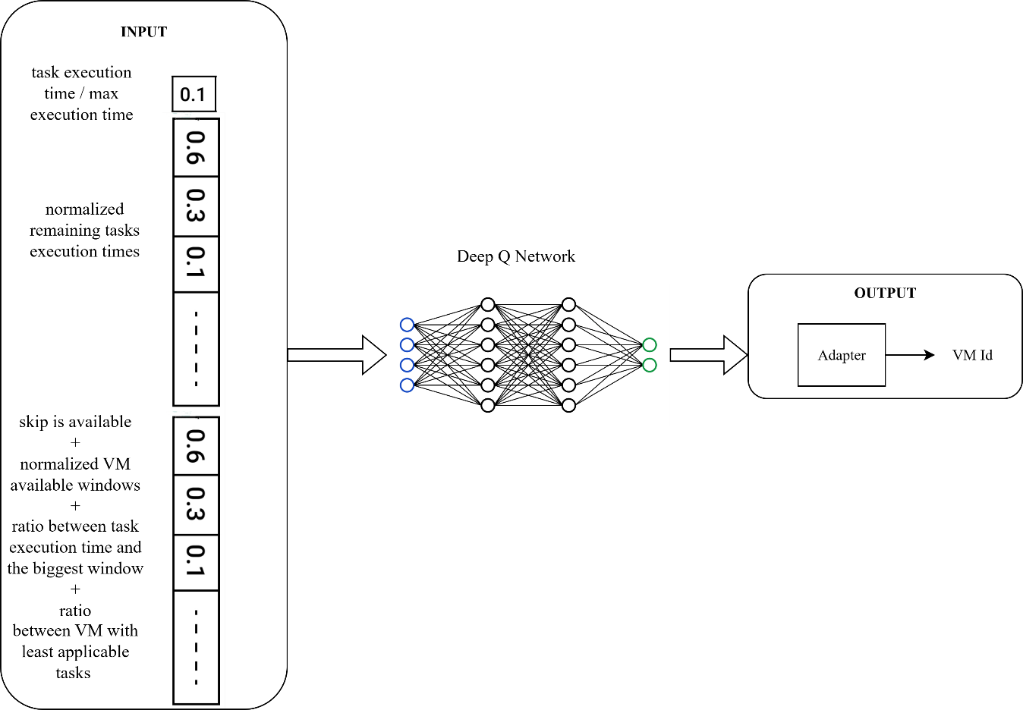

- Scheduler based on simulated annealing to optimize the scheduling problem. Will optimize the scheduling decision for each task based on available resources, task demand, and remaining tasks because of the number of parameters that cause the solution space to be so large. Evaluation for each solution in the solution space based on the number of failed tasks used (less is better). The representation of the solution will be an array of integer as shown in Figure 4, where the index is the task and the value is the VM. Furthermore, here are the key steps of the algorithm:
- Input task data.
- Create the initial solution (best-first).
- Simulated annealing loop.
- Return the best-found solution.
Neighbor Solution:
A neighbor is generated by swapping two task–VM assignments and then greedily refilling displaced tasks where feasible (respecting the window and WLAN rules). This local move preserves feasibility while exploring alternatives that can reduce failures or VM count.
Will obtain the neighbor solution by swapping the tasks between two VMs and filling the remaining tasks anywhere they fit.
Figure 4
SA Scheduler solution representation
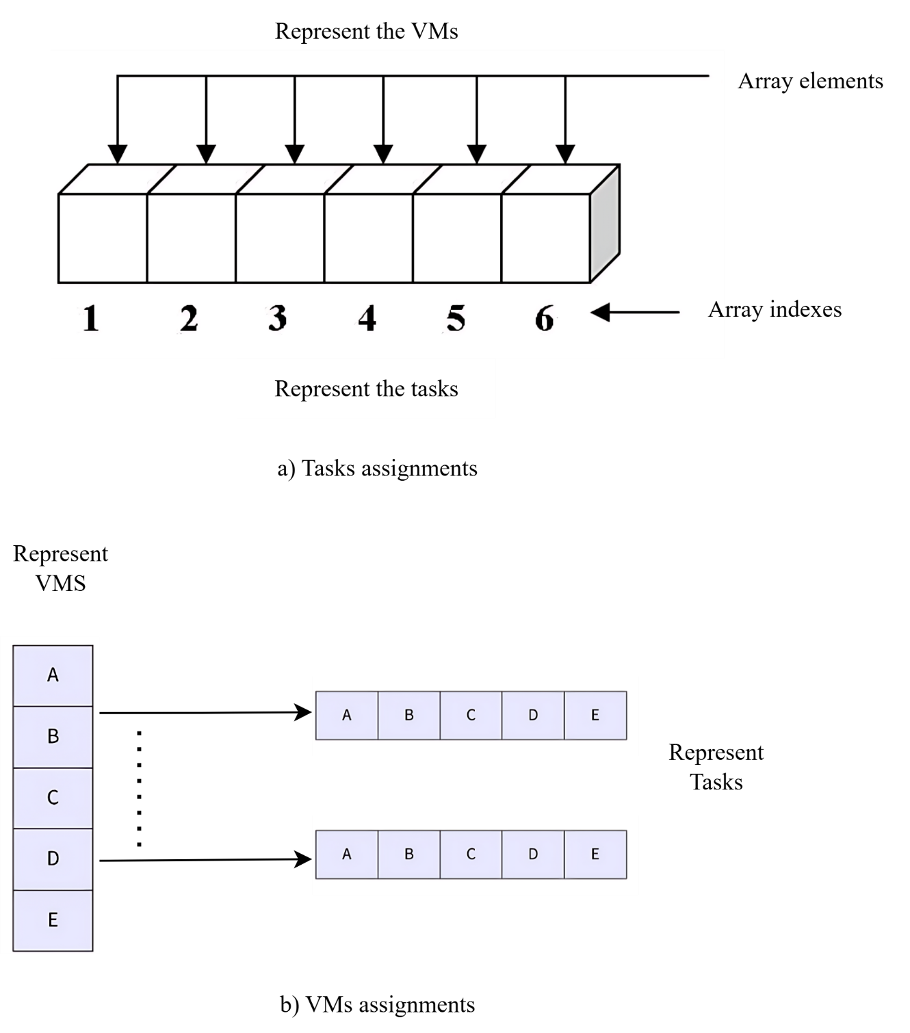
The solution representation shown in Figure 4 is a combination of a hash table and an array so that we are able to get any needed task or VM as fast as possible.
The analysis methodology used in this research is quantitative because we compare and analyze the performance of our and other solutions.

Chapter Four: Datasets and Data Generation
In this research, we used multiple data sources based on the environment (static, dynamic, training), and for each comparison, the same data source was used for all the algorithms in the experiment. The data sources are as follows:
- Data gathered from the execution of augmented reality tasks (static environment)
The data used were gathered from real augmented reality tasks by Toma et al. [6], and reused in this experiment for the static environment to do the comparison.
- Data generated using the EdgeCloudSim load generator (dynamic environment)
This data is automatically generated based on some configurations the user can specify for the experiment in the simulator. The one used by us is the one implemented by Sonmez et al. [5] for the vehicular edge experiment but with the addition of support for task batching and support to control the number of VMs.
- Data generated using a custom data generator (training environment): The algorithm shown in Figure 5 describes how the data is generated. This data is custom data generated at runtime with the purpose of supporting all functionality needed to train the DQN model. It mimics different scenarios where we have different capacities and task sizes and also where the tasks do not apply to all VMs (to simulate only the same WLAN limitation).

Figure 5
Training environment Data Generation Flow
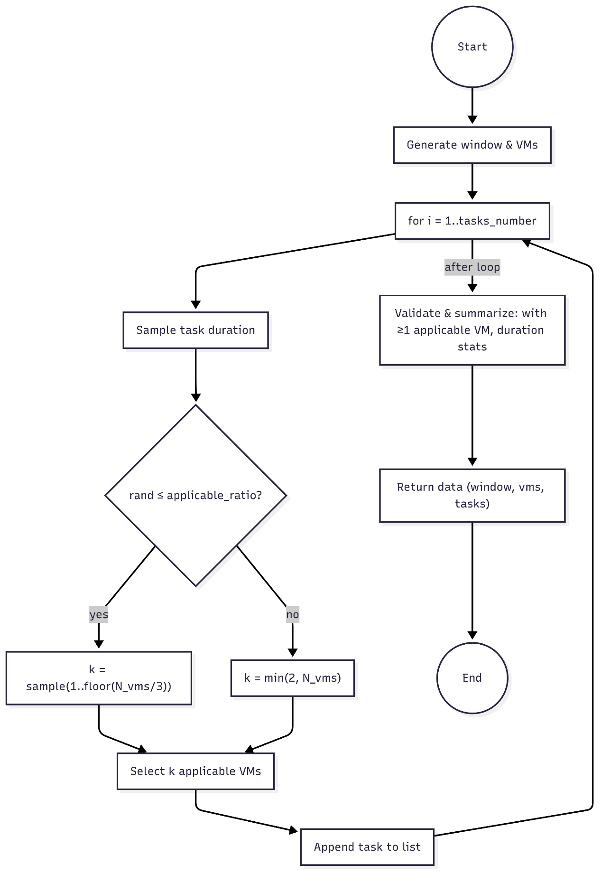

4.1 Data Distribution Analysis and Pre-processing
For the DQN model to learn effectively, we prepare the data first. Also, to make sure that the comparison between different algorithms is fair, we need to analyze how the data is distributed. This section explains the steps we took to process the data.

4.2 Feature Normalization
The inputs for the Deep Q-Network like task execution times and window sizes come in different scales. This causes instability in the gradient during the training, so to fix this, we normalized all inputs to the ranges [0, 1]. For example, the task execution time $t_{i}$ is divided by the maximum task size ($\frac{t_{i}}{t_{max}}$), this way the neural network will deal with consistent values no matter how big the workload is.

4.3 Handling Outliers and Distribution Robustness
- Static Environment Analysis:
In Figure A.13 and Table B.1, we present a descriptive analysis of the static‐environment experiments, where the task sizes ranged from roughly 2.3 KB to 70 KB (mean ≈ 4.11 KB, σ ≈ 2.71 KB). Server‐side execution latencies exhibit a heavy tail: although the median is low (0.285 ms), the mean (22.08 ms) is driven upward by outliers reaching 225 ms (75th pct ≈ 0.309 ms, max = 225 ms). Edge execution times tell a similar story, with a median of 1 ms but an average of 22.73 ms and a maximum of 225 ms—implying that, under certain conditions, edge nodes sometimes perform no better (and at times worse) than the central server. Also, in the histogram, we can notice that the parameters are positively skewed.
- Training Environment Analysis
Figure A.14 and Table B.2 shows our training‐environment data. Here, per‐task execution times are very light on average (mean ≈ 1.54 ms) yet exhibit substantial variability (σ ≈ 5.32 ms), spanning from sub‐millisecond to 50 ms for the slowest traces. Meanwhile, the number of applicable VMs per task is tightly clustered around two: 50% of the tasks had exactly two eligible VMs, with a minimum of one and only a handful of tasks (up to three) reaching the upper bound. This confirms that our training workload is both fast‐moving and constrained in VM choice. Also, in the histogram, we can notice that the length parameter is positively skewed, but the other parameter is nearly uniform.
- Dynamic Environment Analysis
Finally, Figure A.15 and Table B.3 detail the dynamic‐environment data generated by the edge simulator from 100 simulated devices. Serving WLAN IDs span 0–39 (mean ≈ 18.8, σ ≈ 12.7), reflecting a mixture of network attachments. The spatial metric xpos varies widely (mean ≈ 7,716, σ ≈ 5,084) from positions near 111 up to 15,888, indicating that our dynamic tests covered both proximal and distant IoT endpoints. Together, these statistics validate that our dynamic scenarios capture realistic variability in device loads, network contexts, and mobility. Also, in the histogram, we can notice that the length parameter is positively skewed, but the other parameters are nearly uniform. Moreover, if we take a look at the correlation matrix in Figure 6, we will notice that the serving WLAN and device ID are 100% correlated, which also indicates that the generated data capture realistic variability in distributing the loads.
Figure 6
Dynamic environment correlation heatmap.
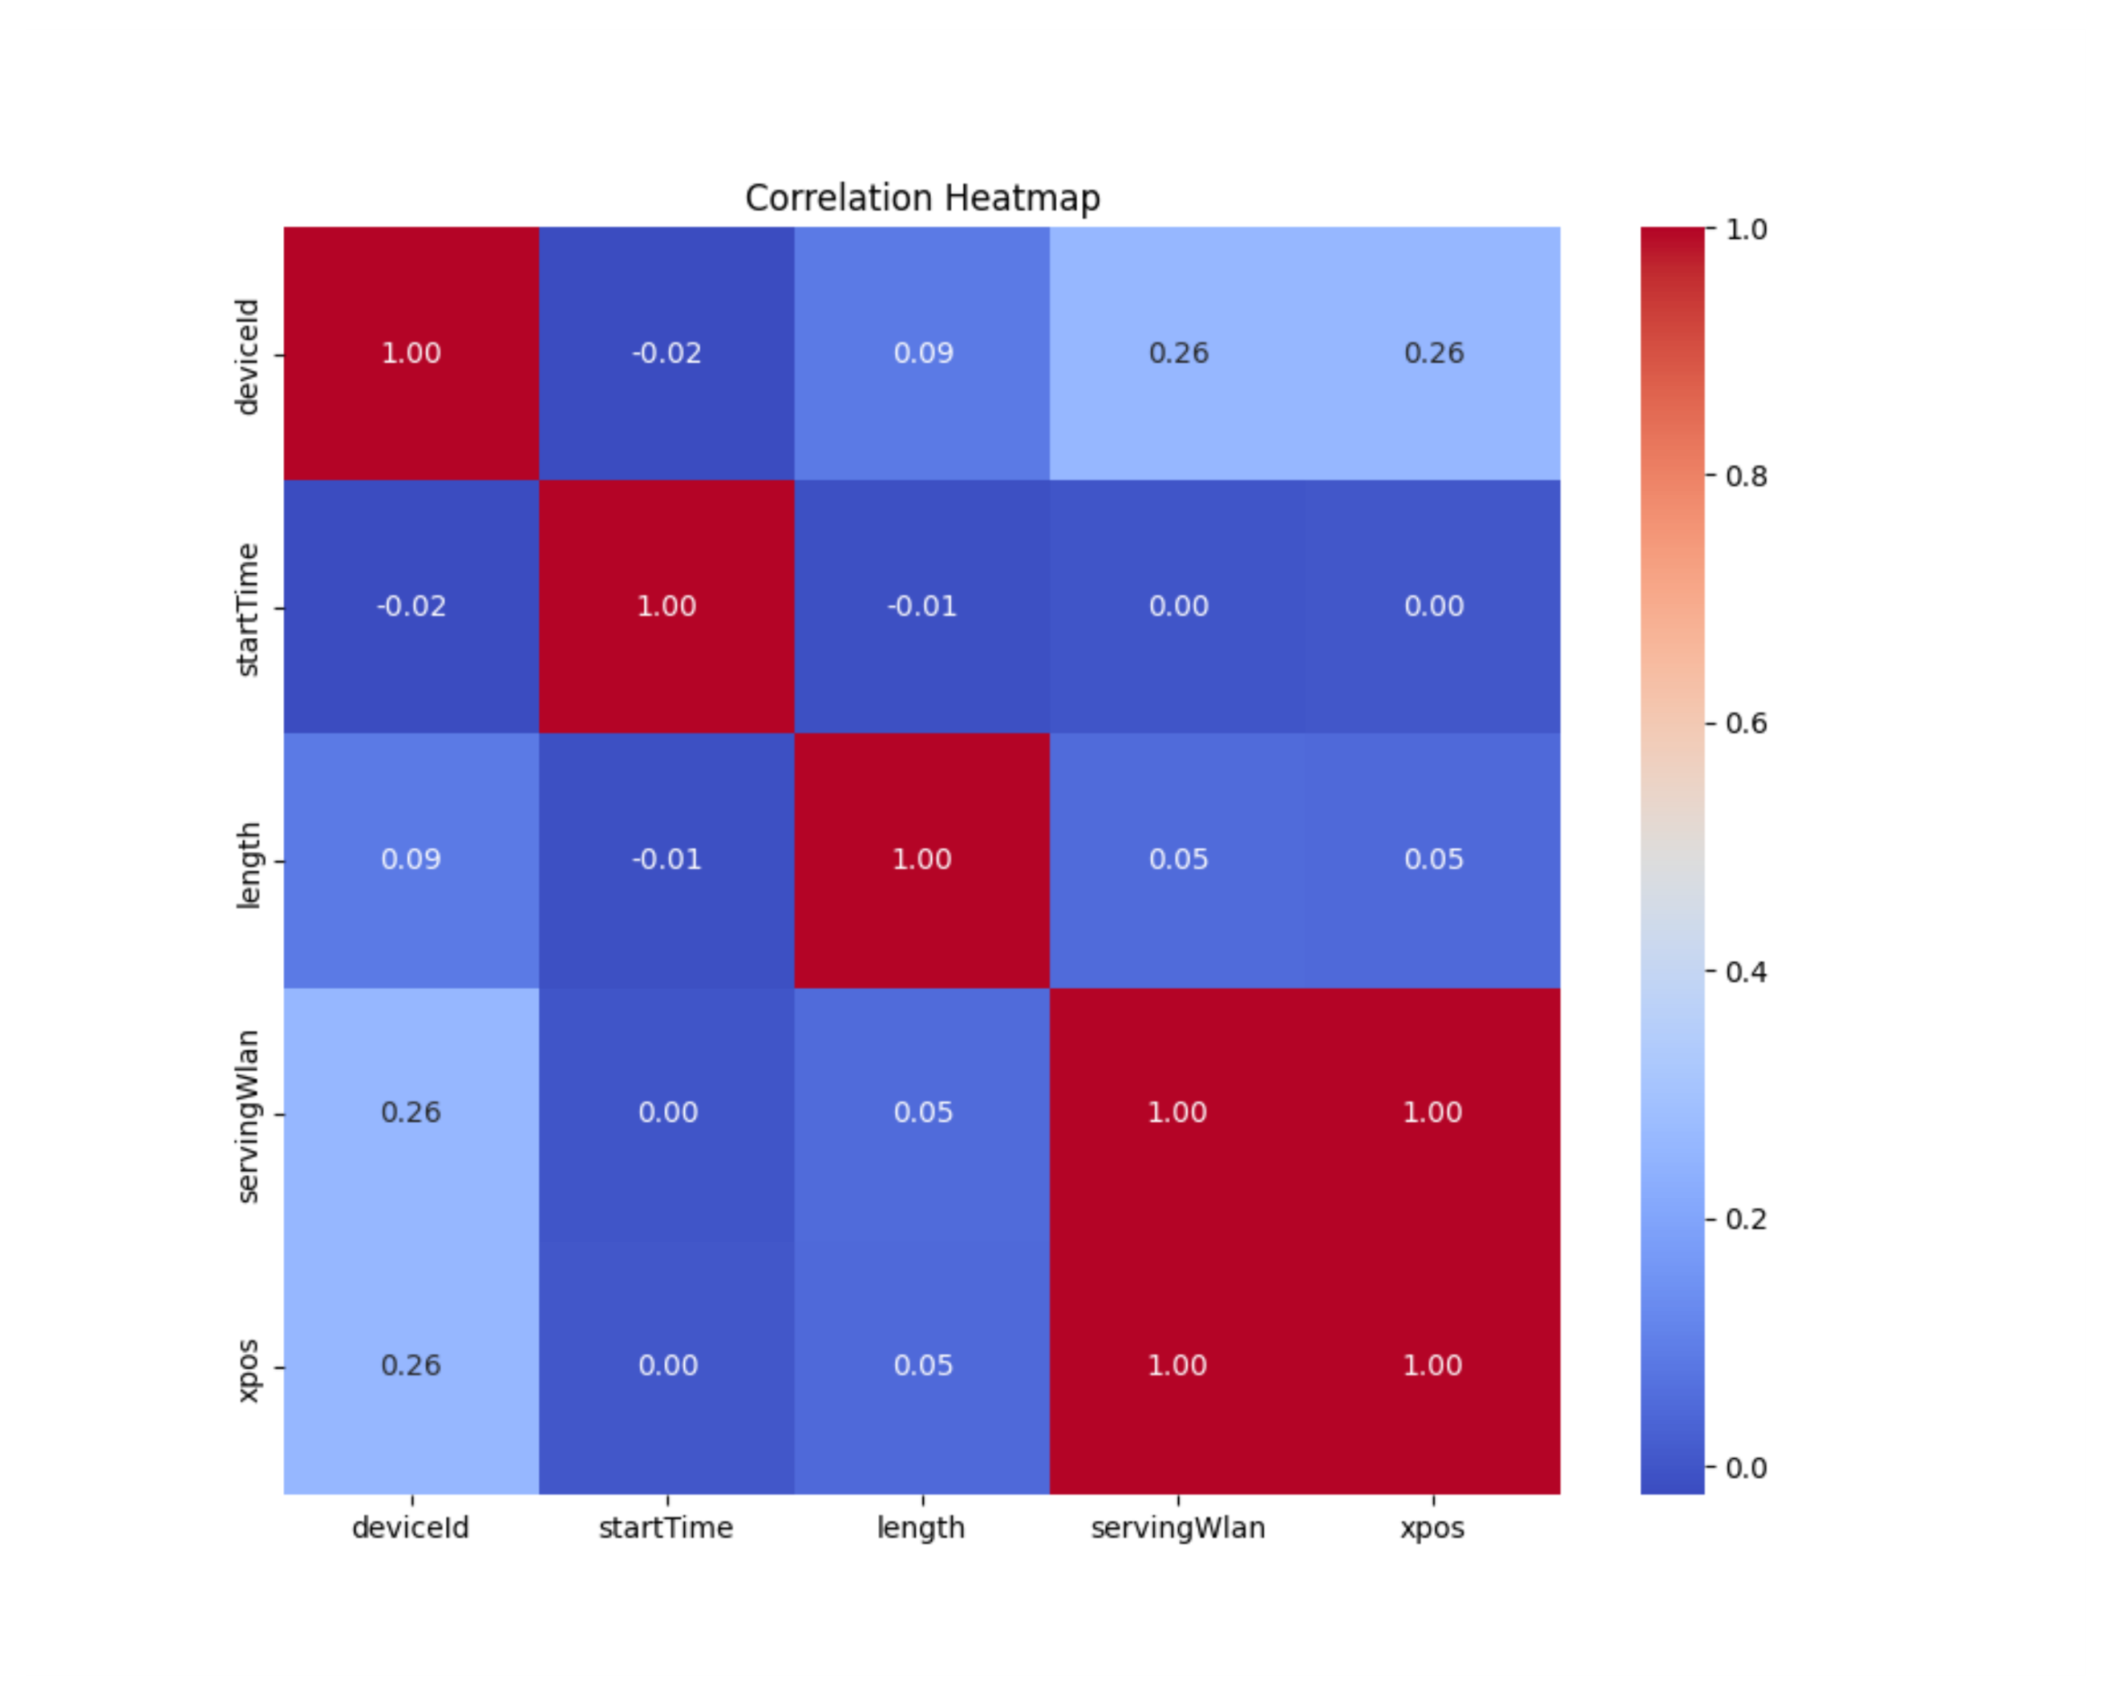

Chapter Five: Experiment Design and Setup
In this section, we configure the proposed algorithms in the mentioned environments and the baseline algorithms mentioned in the literature to assess the performance of our proposed solutions.
The full experimental code and datasets are available in our public GitHub repository [37].

5.1 System Configuration
All experiments in this research were conducted on this computing environment with the following configurations:
- Processor: Intel Core i7-13700H (14 cores, 20 threads, up to 5.0 GHz)
- RAM: 16 GB DDR5 @ 5200 MHz
- GPU: NVIDIA RTX 4060 Laptop GPU (8 GB VRAM)
- Storage: 512 GB NVMe SSD
- Operating System: Windows 11 Pro (64-bit)
- Software Environment:
  - Python 3.12
  - NumPy 2.0.2
  - PyTorch 2.5.1+cu121
  - Optuna 4.2.1
These configurations were used in all the experiments mentioned in this section.

5.2 Static Environment
For this environment, we experimented with the SA-based algorithm against the Greedy approach proposed by Toma et al. [6] with the aim of seeing if our proposed approach is indeed improving the proposed Greedy approach and comparing them based on the number of failed tasks and the algorithm’s overhead time delay. Because our SA algorithm works by starting with an initial solution that is based on the greedy approach, it optimizes it with the aim of reducing the number of failed tasks.
To perform the comparison, we compared the two algorithms to observe the number of failed tasks based on these criteria:
- Total number of tasks to be offloaded.
- Window size
Furthermore, these experiments were performed within these ranges for each experiment:
Table 5
Static environment experiment configurations
Parameter | Value
Maximum number of tasks | 5999
Number of tasks, step size | $⌊ (Maximum number of tasks*step number)/ 10 ⌋$
Minimum number of tasks | $⌊ Maximum number of tasks / 10 ⌋$
Window minimum value in seconds | 0.01
Window maximum value in seconds | 0.2
Window step size | 0.01
Number of iterations (to obtain average results) | 3

The window ranges for our experiment are shown in Table 4, chosen based on experimenting with multiple values, and the result will show this in more detail, and taking a bigger range or smaller step size for the window will not result in any measurable difference. However, before running the experiment, we ran the parameter search for simulated annealing to determine the best parameters for such a use case.
We performed the parameter search on these ranges, and the output is shown in Table 5 and Results as follows:
- Cooldown rate: 0.99
- Number of iterations: 916

Table 6
Tuning configurations
Parameter | Value
Cooldown maximum value | 0.99
Cooldown min value | 0.9
Cooldown step size | 0.01
Window minimum value in seconds | 0.01
Window maximum value in seconds | 0.2
Window step size | 0.01
Number of iterations | 5
For tuning, we did not take any bigger cooldown range because the ratio of enhancement compared to time needed is very big, and here in this task the overhead time of the algorithm is critical, which means if we increase the cooldown, the overhead time will also be increased. For the tuning, we took the worst-case scenario results, which means if in any experiment we needed the highest number of iterations, we will take it as the final value to be used in the comparison.

5.3 DQN Training Procedure and Evaluation
In this environment, we trained our DQN model before comparing it in the dynamic environment.
We are aiming to perform the training in an environment where we can generate and test the scenarios as fast as possible, especially since we will need to search and tune a large number of cross parameters.
The cross parameters we need to tune and search are both the parameters needed for the algorithm and the parameters needed for the ANN.
The parameters needed for the algorithm are those either needed by DQN (like gamma) or the ones needed by our algorithm (such as window split size). These parameters are the following: gamma, epsilon decay, final score weight, negative reward, positive reward, refresh rate, task split size, and window split size.
The parameters needed for the ANN: learning rate, batch size, number of layers (this one is fixed as we are trying to minimize the overhead time latency of the algorithm as much as possible), and number of neurons.
The number of cross parameters is large, so determining the best tuning parameters is impossible. Therefore, we searched the parameter using Optuna, which is an efficient, flexible framework for automating the search and optimization of these cross parameters by treating hyperparameter tuning as a black-box optimization problem. It dynamically constructs and explores the search space—searching values for our algorithm-level parameters (gamma, epsilon decay, window split size, etc.) and ANN-level parameters (learning rate, batch size, number of neurons) and uses pruning strategies to discard unpromising trials early, which allows us to run and evaluate many configurations quickly. By leveraging adaptive samplers such as the Tree-structured Parzen Estimator (TPE) and its built-in parallelization support, Optuna ensures that computational resources are focused on the most promising regions of the parameter space, dramatically speeding up the discovery of high-performing settings without manual intervention.

Table 7
Optuna search ranges
Parameter | What it does | Type | Search Space
Learning rate | Learning rate for the ANN | Float | 1e-5 … 1e-2
gamma | Weight of the future reward | Float | 0.80 … 0.99
Batch size | ANN batch size | Categorical | 32, 64, 128
Epsilon decay | To control exploration and exploitation | Float | 0.990 … 0.999
Final score weight | The weight of the final reward | Float | 0.0 … 1.0
Negative reward | Penalty if the agent skips the task | Float | –10.0 … 0.0
Positive reward | The reward if the agent assigns a task | Float | 0.0 … 10.0
Refresh rate | After how many episodes will the environment change? | Integer | 1 … 100
Task split size | How many categories do we have for all tasks’ execution times? | Integer | 3 … 10
Window split size | How many categories do we have for all VMs available windows? | Integer | 3 … 10
Number of layers | ANN layers | Integer | 1
Number of neurons | Number of neurons for the ANN | Categorical | 32, 64, 128, 256

For each parameter, we specified a range depending on the parameter, type: either float, categorical, or integer. All the details for the ranges used are shown in Table 8, and to find the best configuration for the training, we performed 50 searches on the ranges listed in Table 8 and after that, we took the best configurations listed in Table 3.
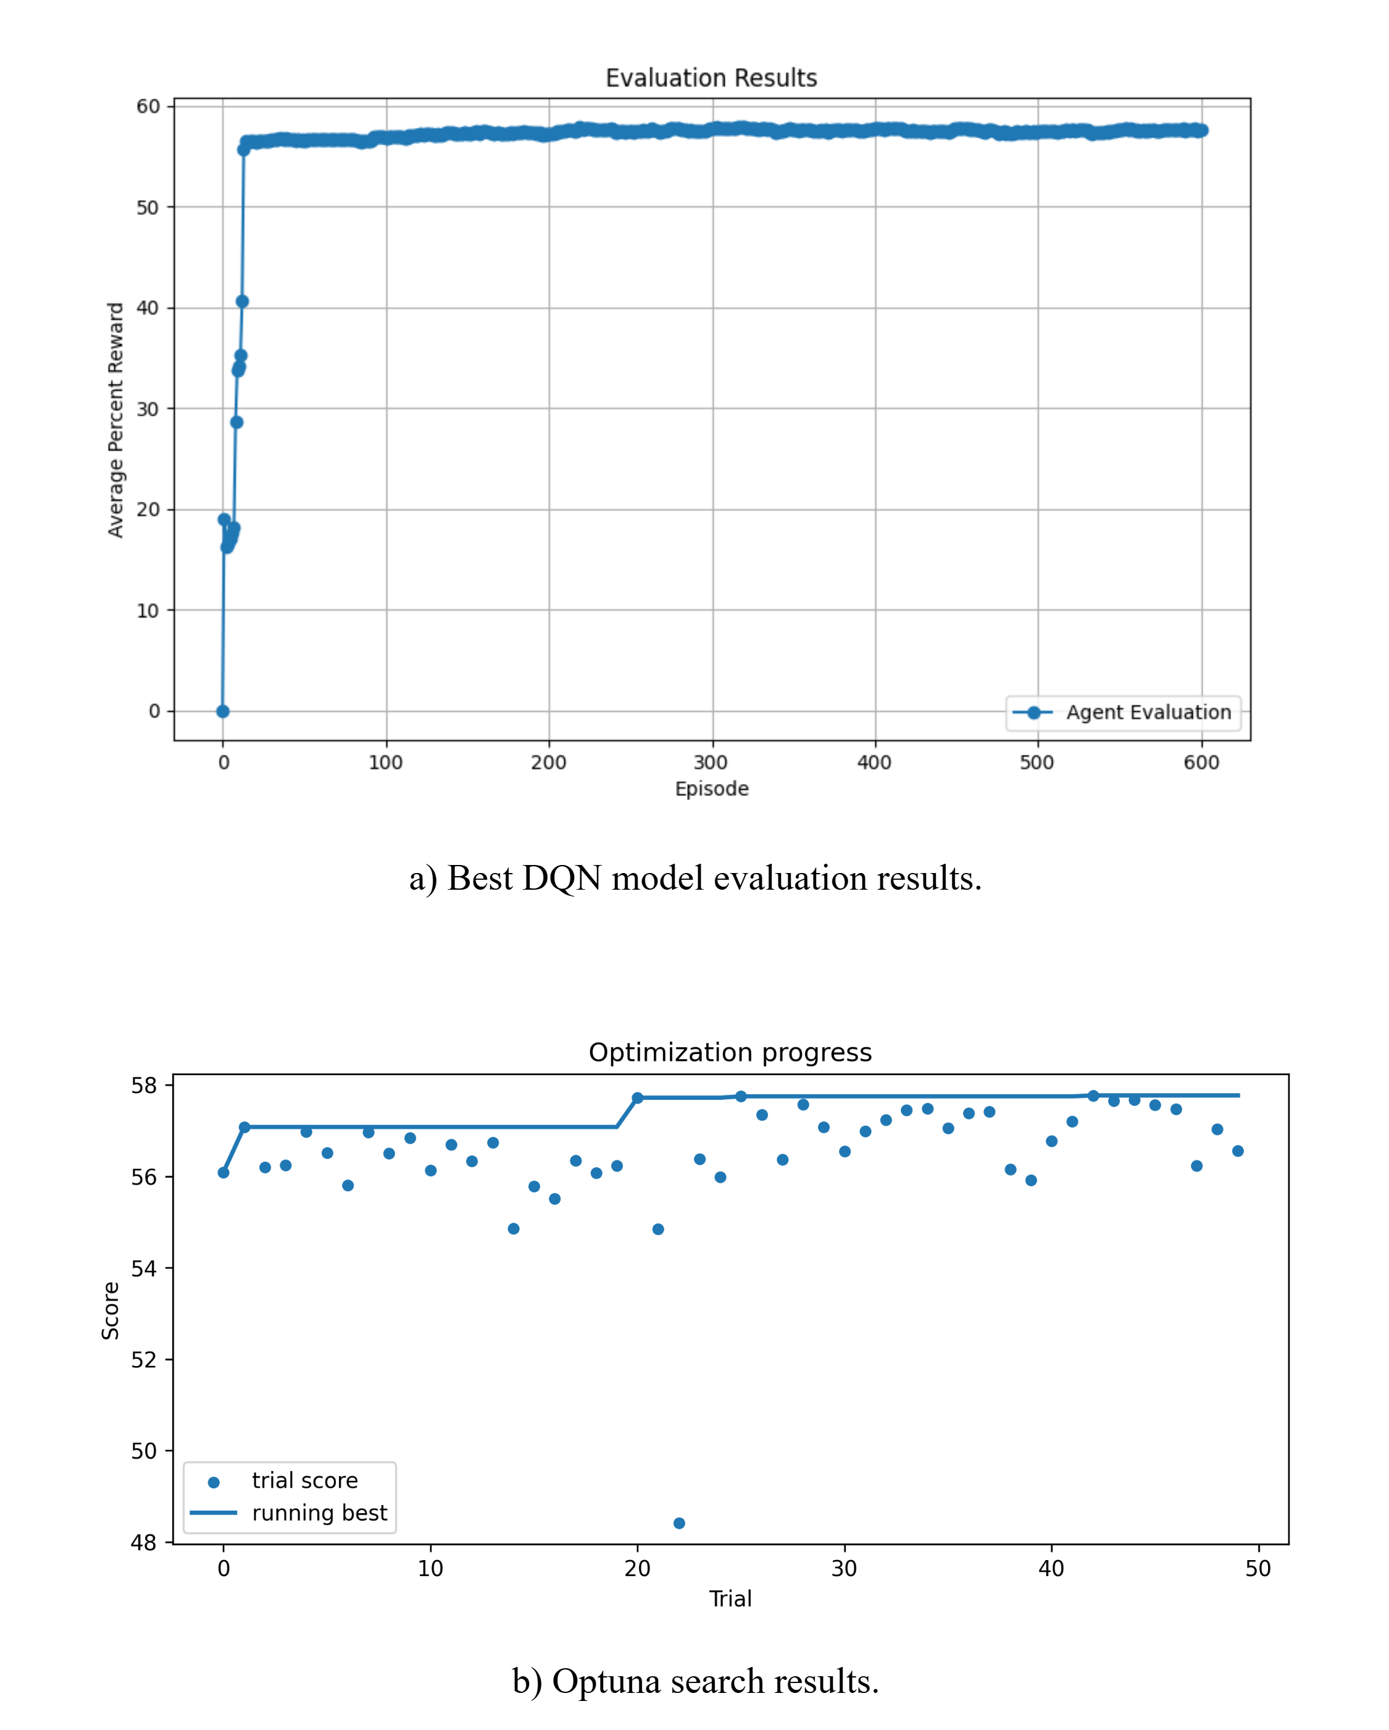
Figure 7
DQN training evaluation and cross-parameter tuning
For the evaluation of our model training, we had a fixed 100 test scenarios, and we kept testing the model after each episode. As Figure 7 shows, the model converged early and reached its best result at ~220 episodes. We saved the best model and used it in the comparison. These configurations used for the top model were based on the result of Optuna search for the best configuration out of 50 searches, as shown in Figure 7.
- Simple Moving Average by Sonmez et al. [8].
- Multi-Armed Bandit by Sun et al. [19].
- Game Theory Based on Wang et al. [13].

5.4 Dynamic Environment
In this environment, we compared our two proposed techniques and other algorithms proposed by Sonmez et al. [5], Sun et al. [19], and Wang et al. [13].
The competitors in the experiments are as follows:
- Random.
- Moving average.
- Multi-Armed Bandit.
- Game Theory Based
- AI-based.
- Simulated Annealing.
- ANN (trained by us).
All these algorithms were used in all experiments in the dynamic environment, and all of them were configured and then compared with the parameters mentioned in Table 9, which contains the default values used in this dynamic environment on the cloud edge simulator unless any change to the parameter is mentioned.
The experiments are as follows:
- Changing Devices with Fixed Windows and Edge Devices: Tested on three window values (0.3, 1.8, 3.6). This assesses the effect of changing the number of devices on the number of failed tasks, and it is repeated across the three windows to evaluate the scaling of the results.
- Changing the number of edge devices with fixed window and devices: This assesses the effect of changing the number of edge devices on the number of failed tasks.
- Changing windows with a fixed number of devices and a fixed number of edge devices: This assesses the effect of changing windows on the number of failed tasks.

Table 8
Dynamic Environment Comparison Configurations
Parameter | Value
Window (independent variable) | (0.3-3.6)
Window step size | 0.3
Only Same WLAN (independent variable) | False-True
Window (when it is not the independent variable) | 1.8
Only Same WLAN | False
Number of Devices (independent variable) | (10-100)
Number of Devices step size (independent variable) | 10
Number of Devices | 100
Number of edge VMs (independent variable) | 30-150
Number of edge VMs step size (independent variable) | 30
Number of edge VMs | 80

Table 10 shows the legends configuration for all the legends of the results for the comparison, and this will help us identify the result of each algorithm.
Table 9
Comparison legend details
Legend name | Algorithm | Color
BATCH DQN | Our DQN model | Red
BATCH SA | Our SA algorithm | Blue
MAB | Multi-Armed Bandit | Green
GAME THEORY | Game Theory Based | purple
RANDOM | Random selection | black
PREDICTIVE | Simple Moving Average | Light blue
AI BASED | AI BASED | Orange

Chapter Six: Results
In this section, we show the results of running the experiment on the two environments to compare the proposed algorithms with the baseline algorithms mentioned in the literature to assess the performance of our proposed solutions.

6.1 Static Environment
For the comparison between the SA and greedy approach proposed by Toma et al. [6] under a static environment with value ranges as shown in Table 4, here are snippets of results where SA has shown improvement over the greedy algorithm shown in Table 7. We had improvement of performance up to ~71% under certain cases but with extra overhead time. The overhead time for the simulated annealing algorithm is influenced by two main parameters, which are the number of iterations and the cooldown time, and we can notice in the experiments that the more the number of tasks is increased, the more overhead time the simulated annealing algorithm needs, unlike the greedy approach that is much less affected by the increase of the number of tasks.
To assess the percent of improvement that SA archives, we compared SA-based algorithm to the greedy approach. Figure A.2 to Figure A.12 shows that and indicate the following:
- At first, when the environment was very constrained (window 0.1), SA could not make any improvement. Furthermore, this is because there is no room for enhancement in such a scenario where the resources could barely process a small number of tasks, if any.
- As the window increases, we will notice that the SA starts to improve the greedy approach.
- As the window increases, the chart will move toward the x-axis. Furthermore, this means that the relation between the number of tasks and the window is opposite.
- After reaching (window 1.1), the improvement ratio dropped to zero, which means now the SA and Greedy are giving the same results.

Table 10
SA and Greedy comparison
Number of tasks | Window | Greedy overhead time (ms) | Greedy average percentage of failed tasks (%) | SA overhead time (ms) | SA average percentage of failed tasks (%) | Percentage of improvement (%)
1199 | 0.04 | 1 | 4.59 | 27.67 | 2.59 | 43.57298
1799 | 0.04 | 0.33 | 36.41 | 82.67 | 22.33 | 38.67069
1799 | 0.05 | 4 | 6.67 | 30.33 | 3.82 | 42.72864
2399 | 0.05 | 6 | 30.01 | 98.33 | 21.87 | 27.12429
2399 | 0.06 | 8 | 4.34 | 36.67 | 2.56 | 41.01382
2999 | 0.06 | 8.67 | 23.47 | 117.33 | 18.21 | 22.41159
2999 | 0.07 | 5 | 3.93 | 34.33 | 1.87 | 52.4173
3599 | 0.07 | 3.33 | 18.62 | 106 | 13.76 | 26.10097
3599 | 0.08 | 1.67 | 1.19 | 33.33 | 0.34 | 71.42857
4199 | 0.08 | 3.67 | 15.31 | 106.67 | 11.3 | 26.1920314
4799 | 0.08 | 6 | 25.9 | 205 | 21.3 | 17.7606178
4799 | 0.09 | 4.67 | 8.67 | 92 | 5.58 | 35.6401384
5399 | 0.09 | 5.67 | 18.8 | 216.33 | 15.71 | 16.4361702
5399 | 0.1 | 5.33 | 4.7 | 67 | 2.44 | 48.0851064
These results show a big enhancement noting that the Greedy approach is suitable for such environments, where the environment has a limited number of variables. In this experiment, for example, we have only a window as a limitation in the static environment, which gives us a good indicator that SA will work even better under a more complex environment where we have networking and more realistic scheduling like the one provided in EdgeCloudSim.

6.2 Dynamic Environment
The results shown in this section are for the comparison between our proposed algorithms and the baselines proposed by other research as stated in Chapter Five, and the results describe the following scenarios:
- Changing Devices with Fixed Windows and Edge Devices: tested on three window values (0.3, 1.8, 3.6); other than that, the experiment configuration is the general one mentioned in Table 9. The results of the comparison are shown in Figure 8 and Figure A.16.
- as it shows when the window size was equal to 0.3, the DQN model and SA did overcome all other algorithms, with DQN giving slightly better results than SA, especially when the number of devices was lower (between 10 and 20), but when the number of devices increases, the failure rate for all other algorithms reaches 100%, meaning that they fail to schedule any task (this is a tighter environment). However, if we take a look at the overhead time, we will notice that both the algorithms take more time than the other baseline, but DQN takes less than 1/3 of the time needed by SA while overperforming it.
- When the window size is equal to 1.8, we will notice that all the algorithms except for MAB are given better results, especially when the number of devices was lower. However, as we increase the number of devices, meaning the constraints are stricter and the number of tasks is higher, the failure rate increases until all of them reach a 100% failure rate except for DQN and SA. Overall, the DQN model has the least failure rate compared to other algorithms. However, for the overhead time, we will notice that when the number of devices was 50, the difference between AI-based, predictive, DQN, and random times was very small, and at this period, the failure rate for all these three was also close.
- Window size 3.6, which means we have a lesser constraint. We notice that almost all the algorithms did achieve good results, especially the AI-based algorithm, which overall outperformed all the other algorithms, and DQN came after it with almost similar results from the timing perspective. We noticed a similar pattern to the previous window sizes, except that the gap between the DQN and AI-based algorithm is becoming smaller.
- When the number of devices was low, we got a higher overhead spike for our algorithms in comparison to when the number of devices was increased, and the reason for that is the ratio between demand and resource starts low and grows bigger as the number of devices increases. Which oversight the effect of increasing input size.
Figure 8
Task failure rate (%) as a function of number of devices for a fixed window size.
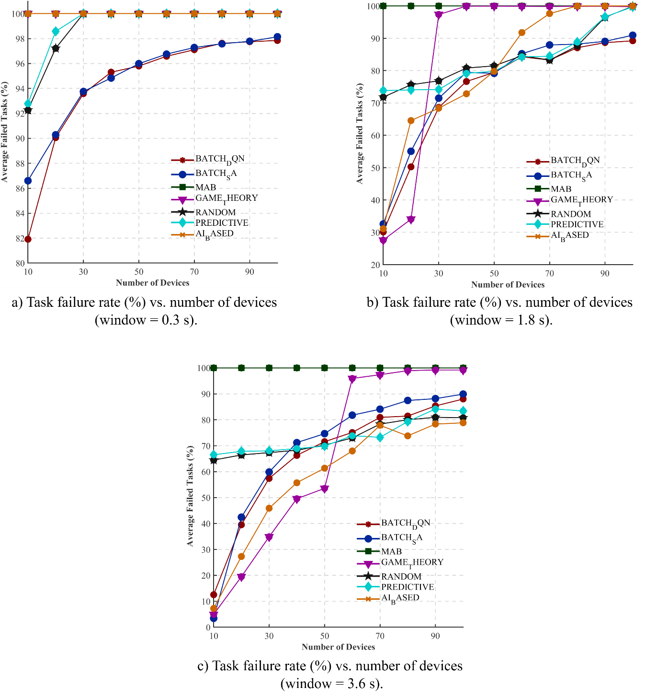

- Changing the number of edge devices with fixed windows and devices.
The experimental configurations are the general ones mentioned in Table 9. The results of the comparison are shown in Figure 9.
- The lower the number of edge devices, the lower the number of processing units. In the comparison, we noticed that the stricter the environment, the better our algorithm performs compared to the baseline, which means that the number of resources (VMs) is opposite to the number of demands (tasks).
- The ratio between demand and resources decreases as the number of edge devices increases, which explains the increase of the overhead time when increasing edge devices. But there is also the factor of increasing the input size that will increase the time as well.
Figure 9
Algorithm overhead (µs) and task failure rate (%) as functions of number of edge devices.
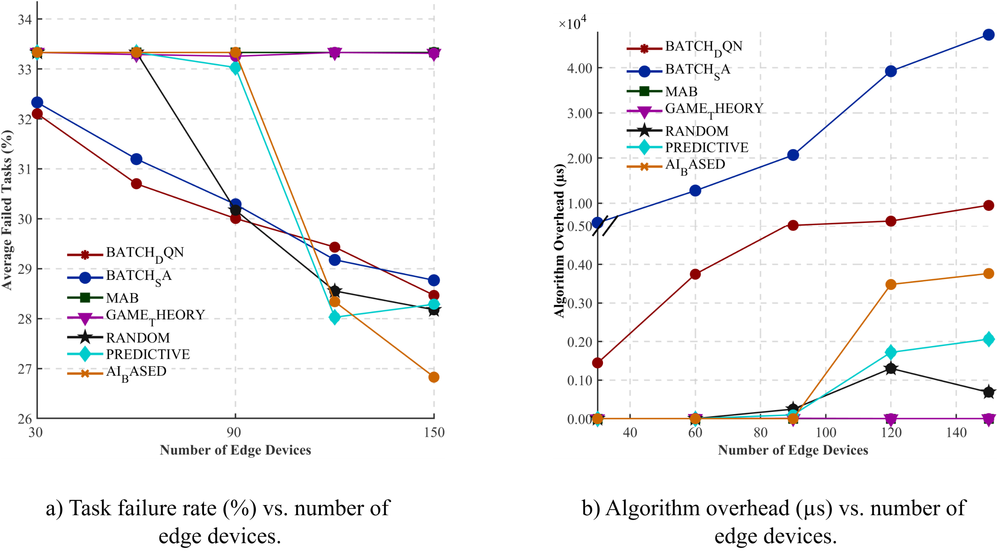

- Changing windows with a fixed number of devices and fixed number of edge devices:
The general experiment configurations are listed in Table 9. The results of the comparison are shown in Figure 10.
- When the offloading task is not limited to the same WLAN edge VMs, the stricter the window, the more our DQN model and SA algorithms outperform other algorithms. However, at window 2.1s, the random and predictive algorithms started to give similar results and outperformed our algorithms. This is because they have less overhead time. AI based on the other hand gave similar results at 2.7s and then outperformed all other algorithms and that because it was designed to work in a non-strict environment, and the algorithm was built to split the load between VMs, which enabled it to take advantage of this environment. Overall, DQN and SA achieved more steady performance and better overall results. Regarding timing, DQN has a slightly larger overhead than the baseline algorithms, whereas the SA overhead time was more than 10 times the DQN overhead time.
- When we applied a limitation on the edge VMs to allow offloading tasks only on edge VMs on the same WLAN, we saw that our algorithms outperformed all other algorithms, and this gap keeps widening as the window increases. And even though SA has outperformed DQN in task failure rate, the overhead shows that it takes more than 10 times the time needed by the DQN.
- The overhead time was directly affected by the limitations of the environment, as the ratio between the demand and resource is decreasing as the window increases. The area of solution improvement is getting limited, which led the SA to take longer while trying to optimize the solution. On the other hand, the DQN and other algorithms are not much affected, and the overhead time increases. But they were mainly affected by the increase of the solution space caused by the increase of the window value.

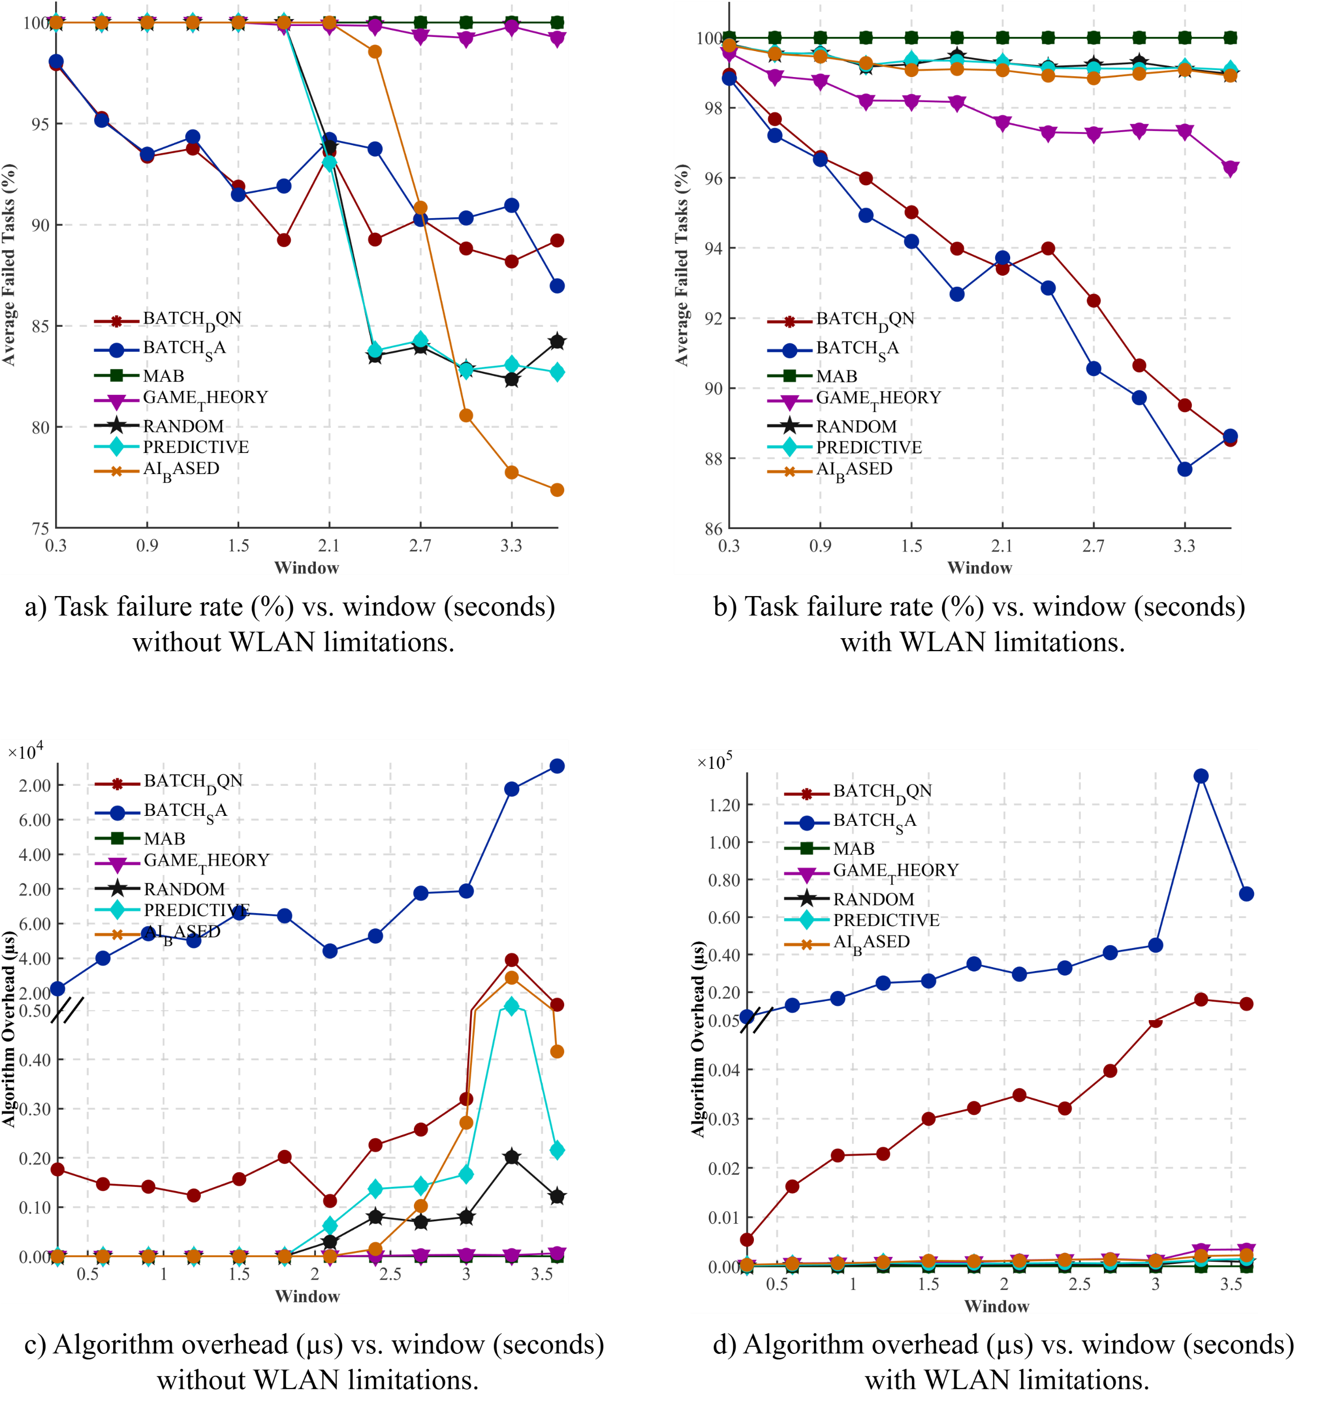
Figure 10
Algorithm overhead (µs) and task failure rate (%) as functions of window for environment with and without WLAN limitation.

Overall, our algorithms outperformed other baseline algorithms, especially when the environment (big number of tasks, low number of resources, or limiting tasks to specific VMs) is considered, which means whenever we have more constraints, our proposed solution outperforms.
We also noticed that MAB had to deal with all tasks in a batch, which means it cannot predict any pattern without historical data. Random task offloading yields acceptable results and outperforms other algorithms in some scenarios (i.e., when the load is low). This is because task offloading is split between all VMs on average instead of putting the load on one specific VM. This is not an accurate offloading behavior, but it gave good results in specific scenarios with its very short algorithm overhead time.
Putting all of this together, we can conclude that DQN gave the overall best results considering the percentage of failed tasks and algorithm overhead time, especially when compared with the SA algorithm, which, while it gives good results, takes a very long time to make the offloading decision.

Chapter Seven: Results Discussion
This chapter focuses on the design and evaluation of machine learning to power scheduling algorithms for edge computing, especially for IoT environments, with the goal of maximizing the number of tasks executed on virtual machines while ensuring that task batches are completed within the specified window limit. Through extensive investigation of whether reinforcement learning will outperform traditional optimization techniques such as simulated annealing. Furthermore, we experimented on real data gathered in previous research and on generated data. These experiments and comparisons have taken place on the popular simulator EdgeCloudSim, and we were able to build a model that exceeds all other existing solutions, especially in a highly constrained environment (high load, limited applicable VMs per task).
The results showed that our simulated annealing algorithm achieved up to a 71% reduction in the task failure rate compared to the greedy baseline when tested in a static environment with real IoT and AR data gathered by other researchers and also showed that our DQN-based scheduler consistently achieved the lowest failure rates across dynamic environment scenarios (especially with higher constraints) while also requiring less overhead time under one-third of the simulated annealing-based algorithm time, outperforming other baseline algorithms. These results support the aim of maximizing the number of tasks to be executed on virtual machines while ensuring that task batches are completed within the specified window limit and highlight the effectiveness of the DQN-based scheduling algorithm.
These findings align with the findings of Sonmez et al. [8] that show their proposed AI-based algorithm outperforming other baseline algorithms, which are the following:
- Random.
- Moving Average by Sonmez et al. [8].
- Multi-Armed Bandit by Sun et al. [19].
- Game Theory Based on Wang et al. [13].
Furthermore, as it is mentioned in the literature, most of the previous researches assumed that we have an unlimited number of devices. However, as we can see in the experimental results, whenever the environment is more constrained and has more limitations, the performance of these algorithms will degrade dramatically, unlike our proposed algorithms, which gave more stable linear results and achieved lower failure rates in the more constrained environments.
The observed increase in load on the resources (the demand) or decrease of the number of devices over the tasks that can process suggests that whenever we have more load the batch scheduling-based algorithms enhance the utilization of the resources.
These findings are significant because reducing the resource need for the same number of tasks without crossing a time limit means that the less power consumption and the less resources we will need, which has not been thoroughly explored in previous research.

7.1 Limitation
Despite the progress made, there will always exist areas of enhancements, such as optimizing the DQN model to capture broader information of the environment. These point to the need for more studies that might explore enhancing the model to increase the efficiency.
Also, several limitations in the experiment should be considered. First, the sample size was relatively small for the real data gathered by Toma et al. [6], which may limit the generalizability of the results. Additionally, the study relied on simulator-generated data, which might introduce bias. Future research should address these limitations by experimenting with larger, more diverse samples and objective measures.

7.2 Conclusions and recommendations
The experiments achieved quantified results that clarify the trade-offs observed and support the conclusions:
- Maximum improvement (static tests): The SA-based scheduler reduced the task failure rate by up to 71.43% compared to the greedy baseline.
- Average improvement (static tests): Across the static cases, SA achieved an average reduction in failure rate of ≈36.40% (median ≈37.16%) relative to the greedy algorithm.
- Decision-latency trade-off (static tests): SA’s average decision overhead in the static experiments was ≈89.55 ms, versus ≈4.52 ms for the greedy approach; SA requires roughly 20× higher decision latency on average for the static cases.
- DQN performance (dynamic tests): In dynamic environments, the DQN scheduler achieved the lowest failure rates overall while keeping algorithm overhead to <~33% of the time required by SA in comparable dynamic runs. Under very tight constraints, many baseline algorithms' failure rates reached 100%, whereas DQN and SA continued to schedule tasks successfully.
- Behavior under different constraints: The proposed methods (SA and DQN) show increasing advantage as constraints grow (more tasks, fewer resources, or stricter WLAN/VM limits), with DQN providing the best balance between low failure rate and low decision latency.
In summary, all the tested algorithms have their strengths and weaknesses:
- Simulated annealing: finds near-optimal batch mappings; higher decision latency, excels under tight windows.
- DQN (ours): best overall balance—lowest failures under constraints with ~⅓ SA’s overhead; robust to varying load and WLAN limits.
Overall, the DQN-based algorithm provided the best balance compared to the other algorithms in batch scheduling. The work here is a strong foundation for future research and for real-world scenarios such as IoT and AR applications, hoping that these findings will be valuable for both academic and practical advancements in enhancing edge computing resource utilization.
It is recommended to further optimize the DQN model to capture more environmental information and to conduct additional studies that explore extra enhancements in highly constrained environments. Additionally, experiments on real-world apps following the edge computing paradigm with heterogeneous hardware, network variability, and energy constraints should be carried out to assess the scheduler’s performance in real life environments.

References

[1] | K. Zhang, Y. Mao, S. Leng, S. Maharjan and Y. Zhang, "Optimal delay constrained offloading for vehicular edge computing networks," in 2017 IEEE International Conference on Communications (ICC), 2017, pp. 1-6.
[2] | M. Satyanarayanan, P. Bahl, R. Caceres and N. Davies, "The case for vm-based cloudlets in mobile computing," IEEE pervasive Computing, vol. 8, p. 4, 2009.
[3] | H. Dinh, C. Lee, D. Niyato and P. Wang, "A survey of mobile cloud computing: architecture, applications, and approaches," Wireless communications and mobile computing, vol. 13, pp. 1587-1611, 2013.
[4] | F. Bonomi, R. Milito, J. Zhu and S. Addepalli, "Fog computing and its role in the internet of things," in Proceedings of the first edition of the MCC workshop on Mobile cloud computing, 2012, pp. 13-16.
[5] | C. Sonmez, A. Ozgovde and C. Ersoy, "Edgecloudsim: An environment for performance evaluation of edge computing systems," Transactions on Emerging Telecommunications Technologies, p. e3493, 2018.
[6] | A. Toma, S. Samara and M. Qamhieh, "Edge Computing Systems: Modeling and Resource Optimization for Augmented Reality and Soft Real-time Applications," Journal of Network and Systems Management, vol. 31, p. 79, 2023.
[7] | A. Toma, J. Wenner, J. E. Lenssen and J.-J. Chen, "Adaptive quality optimization of computer vision tasks in resource-constrained devices using edge computing," in 2019 19th IEEE/ACM International Symposium on Cluster, Cloud and Grid Computing (CCGRID), 2019, pp. 469-477.
[8] | C. Sonmez, C. Tunca, A. Ozgovde and C. Ersoy, "Machine learning-based workload orchestrator for vehicular edge computing," IEEE Transactions on Intelligent Transportation Systems, vol. 22, pp. 2239-2251, 2020.
[9] | A. Tandon and S. Patel, "DBSCAN based approach for energy efficient VM placement using medium level CPU utilization," Sustainable Computing: Informatics and Systems, vol. 43, p. 101025, 2024.
[10] | C. Sonmez, A. Ozgovde and C. Ersoy, "Fuzzy workload orchestration for edge computing," IEEE Transactions on Network and Service Management, vol. 16, pp. 769-782, 2019.
[11] | J. Almutairi and M. Aldossary, "A novel approach for IoT tasks offloading in edge-cloud environments," Journal of Cloud Computing, vol. 10, pp. 1-19, 2021.
[12] | X. Jin, S. Zhang, Y. Ding and Z. Wang, "Task offloading for multi-server edge computing in industrial internet with joint load balance and fuzzy security," Scientific Reports, vol. 14, p. 27813, 2024.
[13] | Y. Wang, P. Lang, D. Tian, J. Zhou, X. Duan, Y. Cao and D. Zhao, "A game-based computation offloading method in vehicular multiaccess edge computing networks," IEEE Internet of Things Journal, vol. 7, pp. 4987-4996, 2020.
[14] | L. Tong, Y. Li and W. Gao, "A hierarchical edge cloud architecture for mobile computing," in IEEE INFOCOM 2016-The 35th Annual IEEE International Conference on Computer Communications, 2016, pp. 1-9.
[15] | J. Chen and X. Ran, "Deep learning with edge computing: A review," Proceedings of the IEEE, vol. 107, pp. 1675-1694, 2019.
[16] | X. Wang, Y. Han, V. C. Leung, D. Niyato, X. Yan and X. Chen, "Convergence of edge computing and deep learning: A comprehensive survey," IEEE Communications Surveys \& Tutorials, vol. 22, pp. 869-904, 2020.
[17] | W. Shi, L. Chen and X. Zhu, "Task offloading decision-making algorithm for vehicular edge computing: a deep-reinforcement-learning-based approach," Sensors, vol. 23, p. 17, 2023.
[18] | M. Khayyat, I. A. Elgendy, A. Muthanna, A. S. Alshahrani, S. Alharbi and A. Koucheryavy, "Advanced deep learning-based computational offloading for multilevel vehicular edge-cloud computing networks," IEEE Access, vol. 8, pp. 137052-137062, 2020.
[19] | Y. Sun, X. Guo, J. Song, S. Zhou, Z. Jiang, X. Liu and Z. Niu, "Adaptive learning-based task offloading for vehicular edge computing systems," IEEE Transactions on vehicular technology, vol. 48, pp. 3061-3074, 2019.
[20] | L. Meng, Y. Wang, H. Wang, X. Tong, Z. Sun and Z. Cai, "Task offloading optimization mechanism based on deep neural network in edge-cloud environment," Journal of Cloud Computing, vol. 12, p. 76, 2023.
[21] | A. Sada, A. Khelloufi, A. Naouri, H. Ning and S. Dhelim, "Selective Task offloading for Maximum Inference Accuracy and Energy efficient Real-Time IoT Sensing Systems," arXiv preprint arXiv:2402.16904, 2024.
[22] | Y. Wang, Z. Huang, Z. Wei and J. Zhao, "MADDPG-Based Offloading Strategy for Timing-Dependent Tasks in Edge Computing," Future Internet, vol. 16, p. 181, 2024.
[23] | X. Yang, Y. Wu, Y. Yang and W. Zhang, "Deep Q-Network-based Task Offloading for Multi-Tier Computing Networks," in 2024 IEEE/CIC International Conference on Communications in China (ICCC), IEEE, 2024, pp. 1817-1822.
[24] | M. Li and Z. Yang, "Double deep Q-network-based task offloading strategy in mobile edge computing," in 4th International Conference on Internet of Things and Smart City (IoTSC 2024), SPIE, 2024, pp. 290-298.
[25] | L. Gao, "Comparison of dqn and double dqn reinforcement learning algorithms for stock market prediction," in 2023 International Conference on Data Science, Advanced Algorithm and Intelligent Computing (DAI 2023), Atlantis Press, 2024, pp. 169-177.
[26] | Q. Lan, Y. Pan, A. Fyshe and M. White, "Maxmin q-learning: Controlling the estimation bias of q-learning," arXiv preprint arXiv:2002.06487, 2020.
[27] | A. Pentaliotis, "Investigating Overestimation Bias in Reinforcement Learning," 2020.
[28] | Y. ZHANG, Z. Yuanhao and Z. Xiaodong, "Manufacturing resource scheduling based on deep q-network," Wuhan University Journal of Natural Sciences, vol. 27, no. Wuhan University, pp. 531-538, 2022.
[29] | M. Basu, P. Deb and G. Garai, "Hybrid of particle swarm optimization and simulated annealing for multidimensional function optimization," International Journal of Information Technology, vol. 20, 2014.
[30] | M. Joshi, M. Gyanchandani and D. Rajesh Wadhvani, "Analysis Of Genetic Algorithm, Particle Swarm Optimization and Simulated Annealing On Benchmark Functions," in 2021 5th International Conference on Computing Methodologies and Communication (ICCMC), 2021, pp. 1152-1157.
[31] | F. Jia and D. Lichti, "A comparison of simulated annealing, genetic algorithm and particle swarm optimization in optimal first-order design of indoor TLS networks," ISPRS Annals of the Photogrammetry, Remote Sensing and Spatial Information Sciences, 2017.
[32] | A. Paszke, "Pytorch: An imperative style, high-performance deep learning library," arXiv preprint arXiv:1912.01703, 2019.
[33] | T. Akiba, S. Sano, T. Yanase, T. Ohta and M. Koyama, "Optuna: A next-generation hyperparameter optimization framework," 2019, pp. 2623-2631.
[34] | F. Guerriero and F. P. Saccomanno, "A Machine Learning Approach for the Bin Packing Problem," in 2023 IEEE 12th International Conference on Intelligent Data Acquisition and Advanced Computing Systems: Technology and Applications (IDAACS), 2023, pp. 436-441.
[35] | J. Fang, Y. Rao, X. Zhao and B. Du, "A Hybrid Reinforcement Learning Algorithm for 2D Irregular Packing Problems," Mathematics, vol. 11, p. 327, 2023.
[36] | H. Xiao, J. Zhao, Q. Pei, J. Feng, L. Liu and W. Shi, "Vehicle selection and resource optimization for federated learning in vehicular edge computing," IEEE Transactions on Intelligent Transportation Systems, vol. 23, pp. 11073-11087, 2022.
[37] | Y. Jarrar and A. Toma, "Experiment Code Repository," GitHub, 22 July 2025. [Online]. Available: https://github.com/yazanj082/edge-resource-optimization-ml. [Accessed 22 July 2025].
[38] | L. Tidjon, B. Rombaut, F. Khomh and A. E. Hassan, "An empirical study of library usage and dependency in deep learning frameworks," arXiv preprint arXiv:2211.15733, 2022.

List of Abbreviations
Abbreviation | Meaning
IoT | Internet of Things
VM | Virtual Machine
AR | Augmented Reality
WAN | Wide Area Network
WLAN | Wireless Local Area Network
RSU | Road Side Unit
IoV | Internet of Vehicles
SMA | Simple Moving Average
RL | Reinforcement Learning
ANN | Artificial Neural Network
ML | Machine Learning
MAB | Multi-Armed Bandit
DDQN | Double deep Q-network
CNN | Convolutional Neural Network

Appendix A
Figures
Figure A.1
DQN training flow
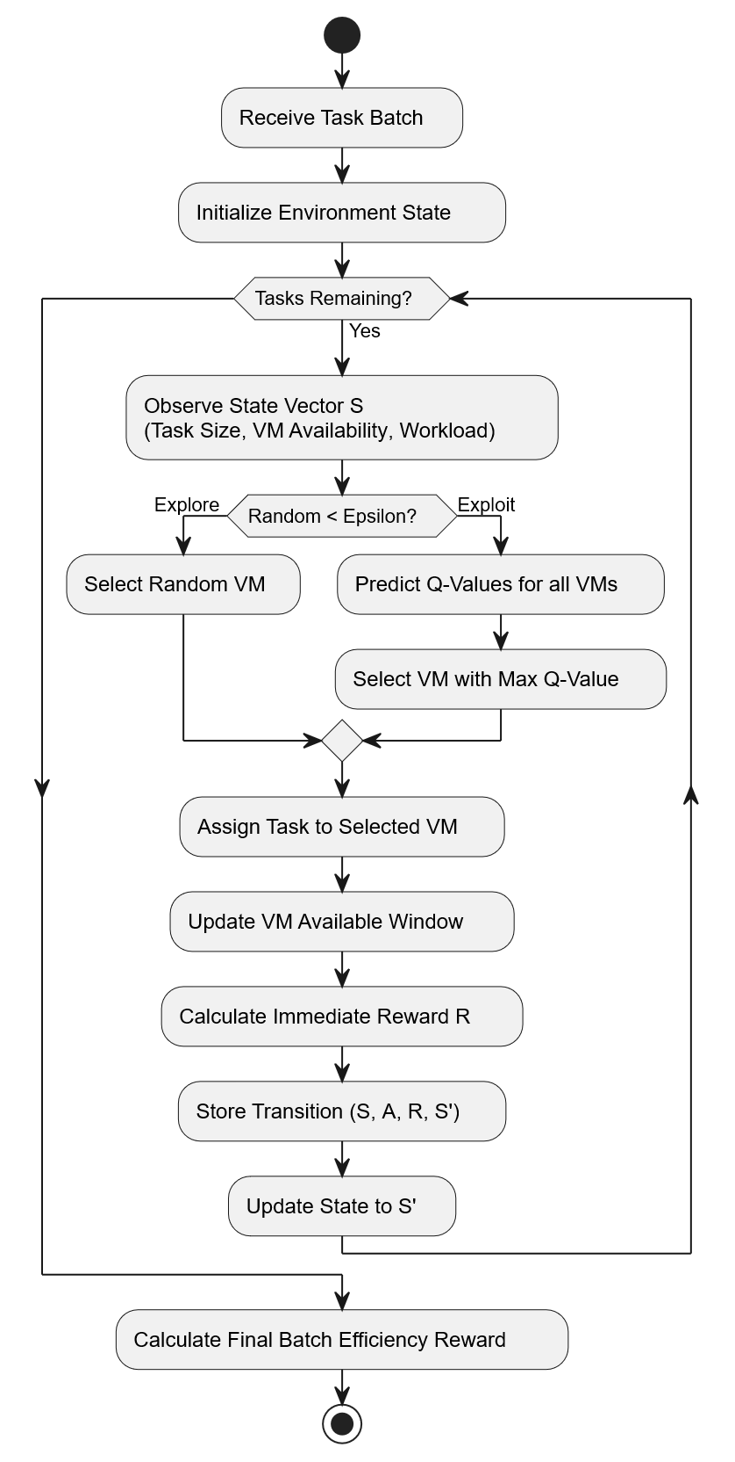
Figure A.2
Simulated annealing percentage of improvement over the greedy approach (window 0.01)
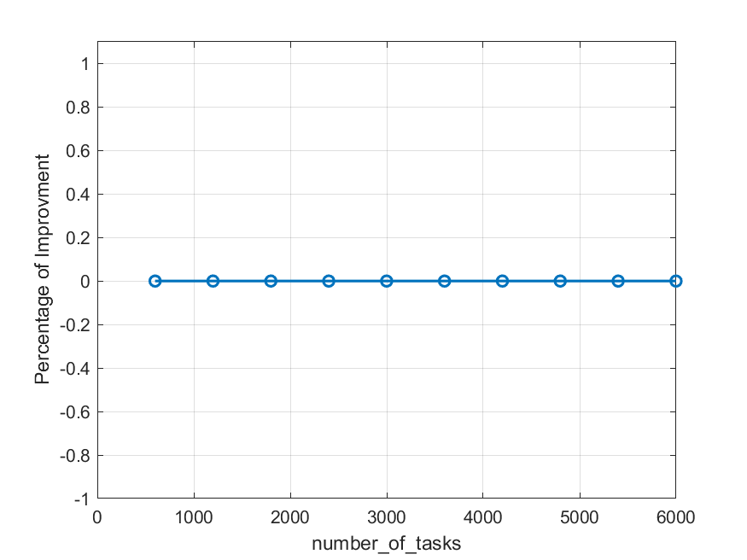
Figure A.3
Simulated annealing percentage of improvement over the greedy approach (window 0.02)
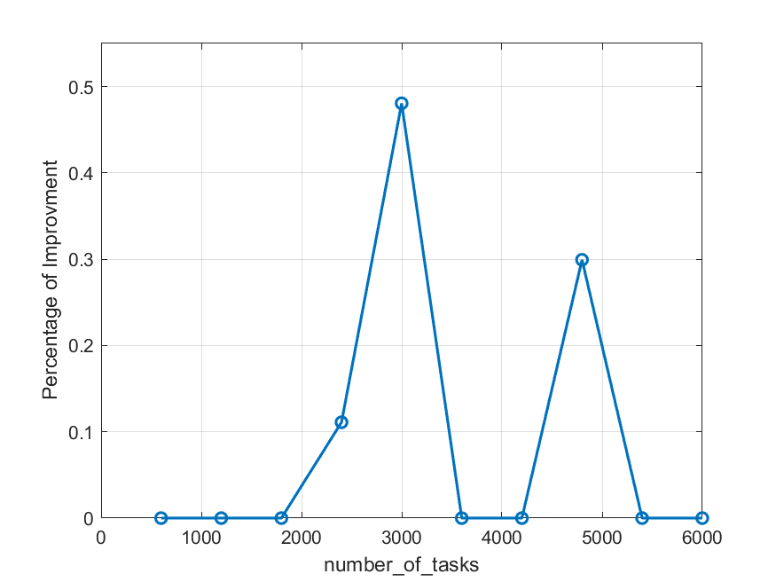
Figure A.4
Simulated annealing percentage of improvement over the greedy approach (window 0.03)
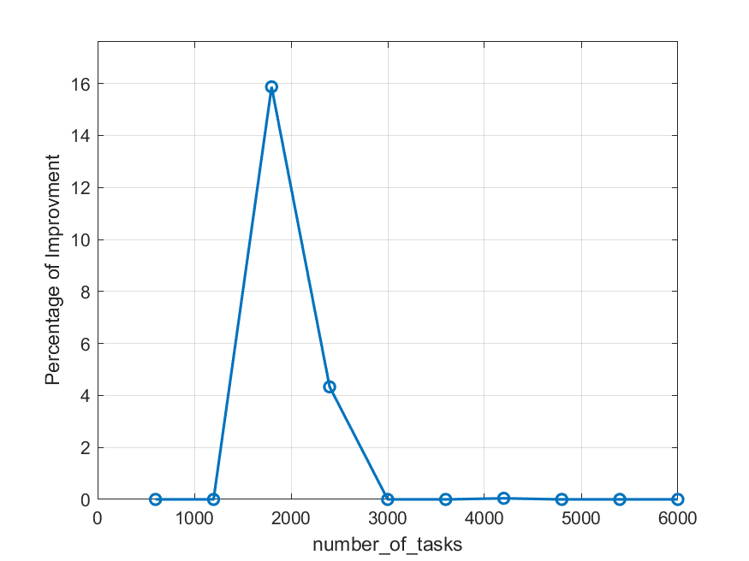

Figure A.5
Simulated annealing percentage of improvement over the greedy approach (window 0.04)
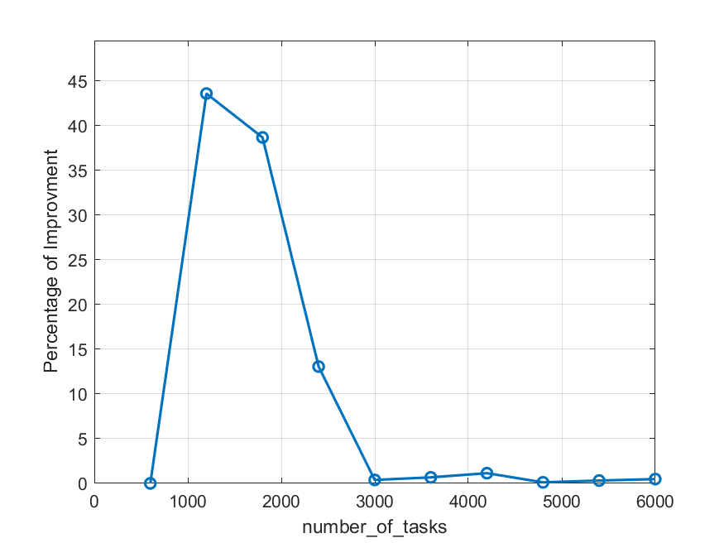
Figure A.6
Simulated annealing percentage of improvement over the greedy approach (window 0.05)
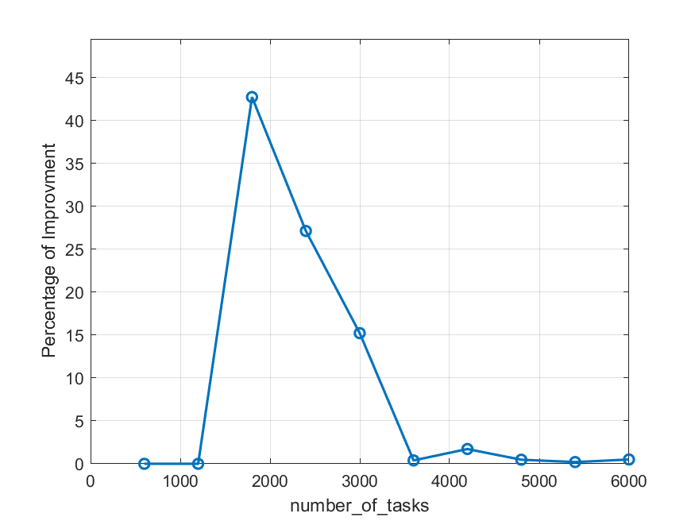
Figure A.7
Simulated annealing percentage of improvement over the greedy approach (window 0.06)
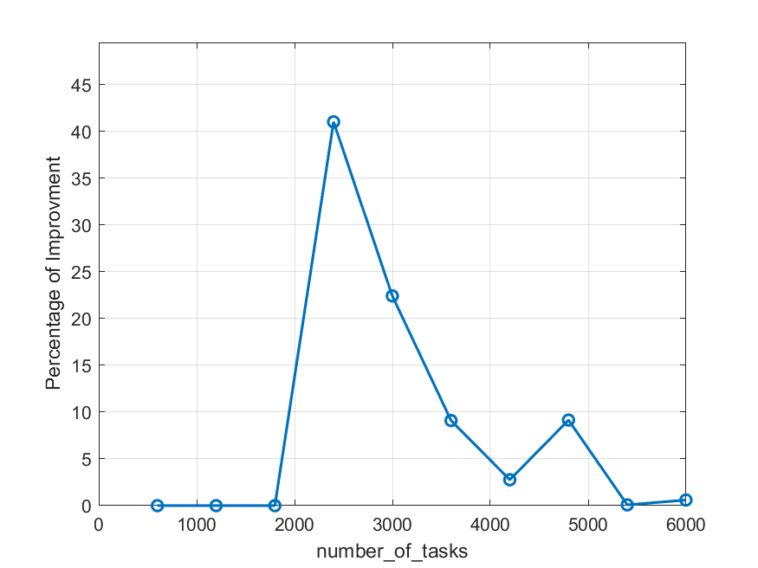
Figure A.8
Simulated annealing percentage of improvement over the greedy approach (window 0.07)
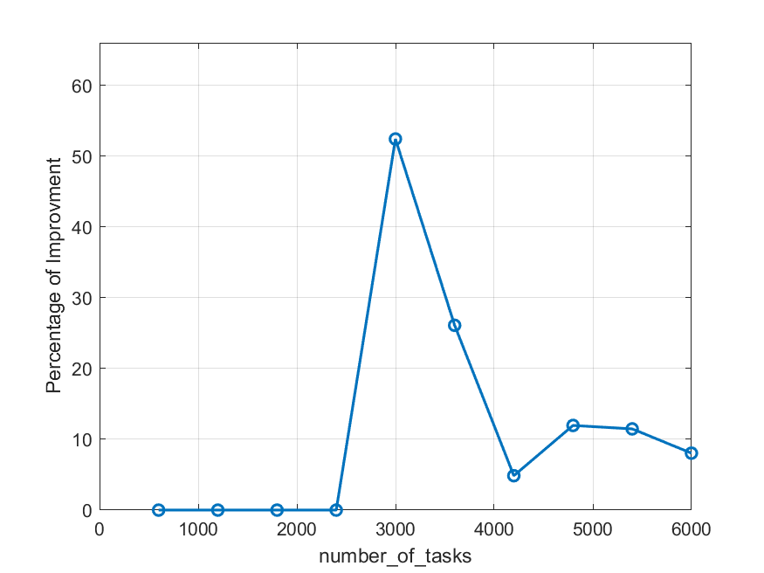
Figure A.9
Simulated annealing percentage of improvement over the greedy approach (window 0.08)
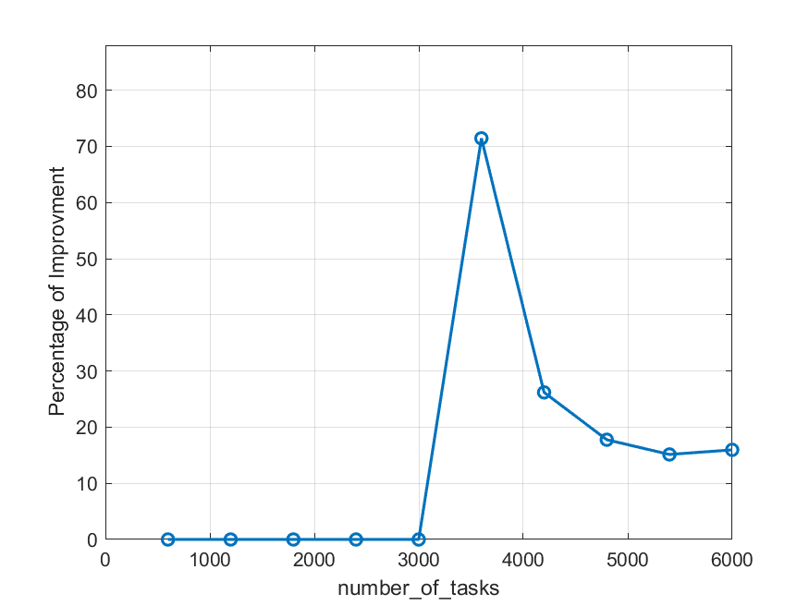
Figure A.10
Simulated annealing percentage of improvement over the greedy approach (window 0.09)
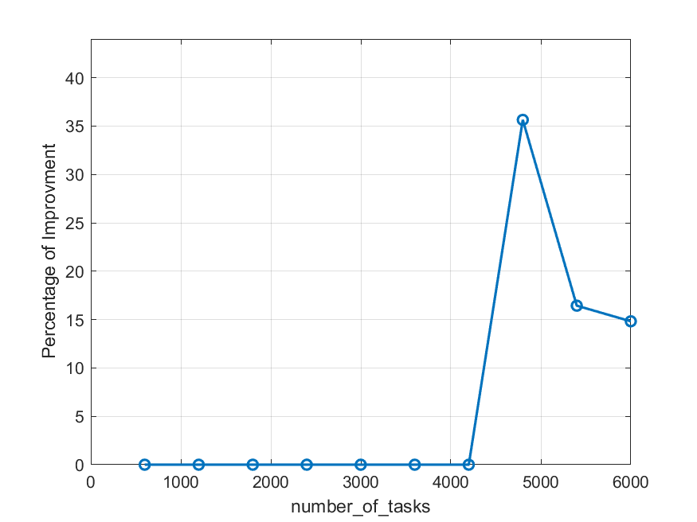
Figure A.11
Simulated annealing percentage of improvement over the greedy approach (window 0.10)
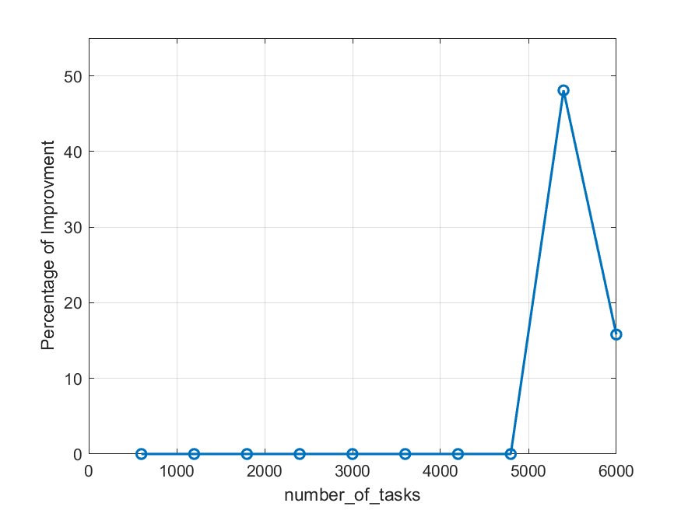
Figure A.12
Simulated annealing percentage of improvement over the greedy approach (window 0.11)
Figure A.13
Static environment data histograms
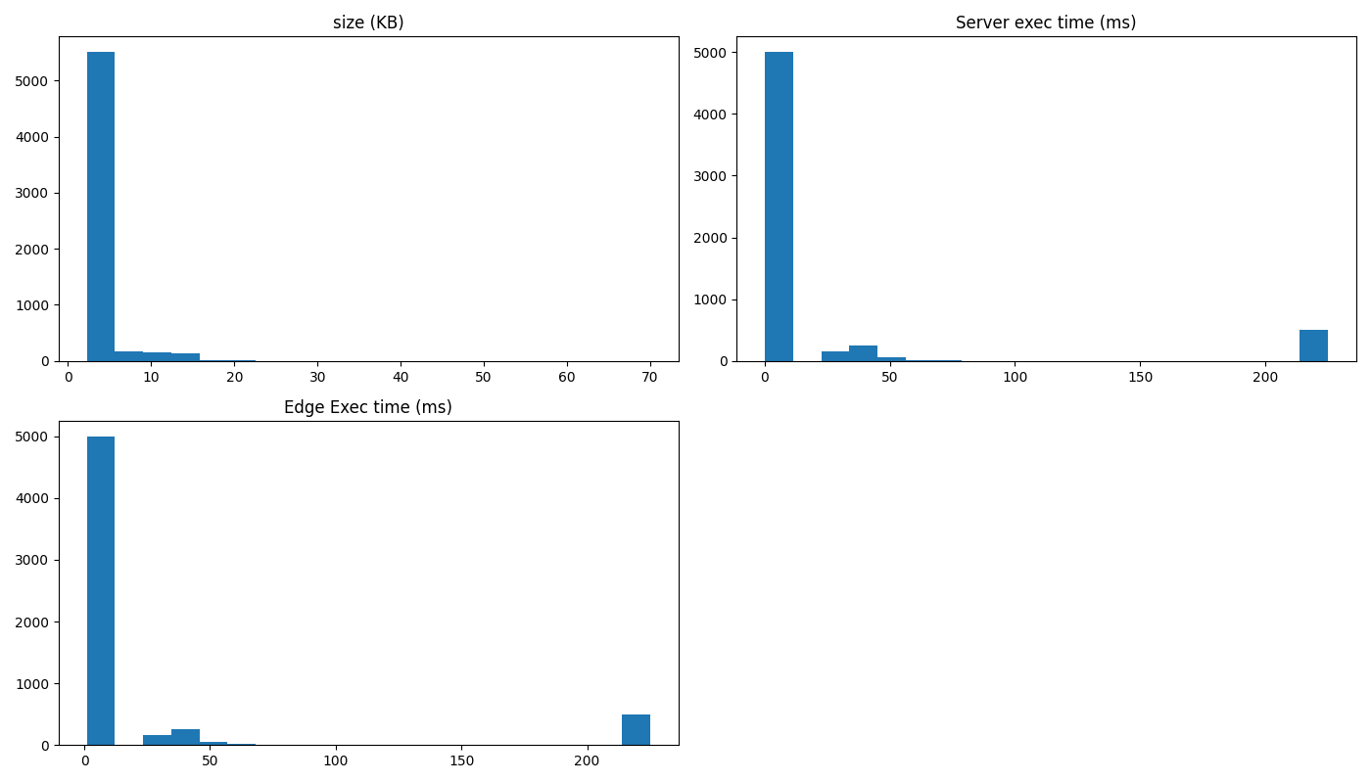

Figure A.14
Training environment data histograms
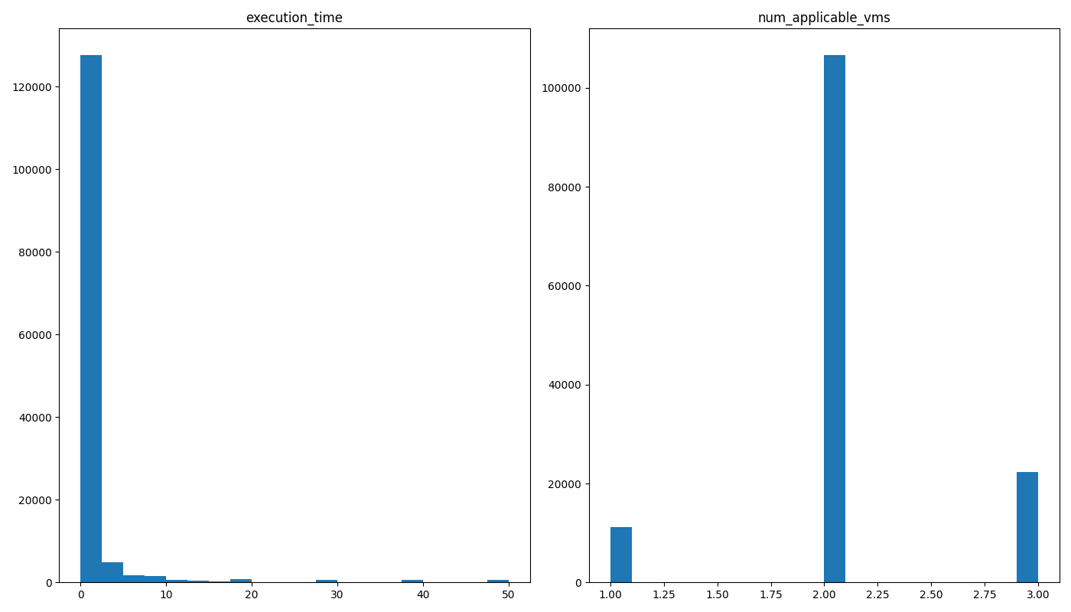
Figure A.15
Dynamic environment data histograms
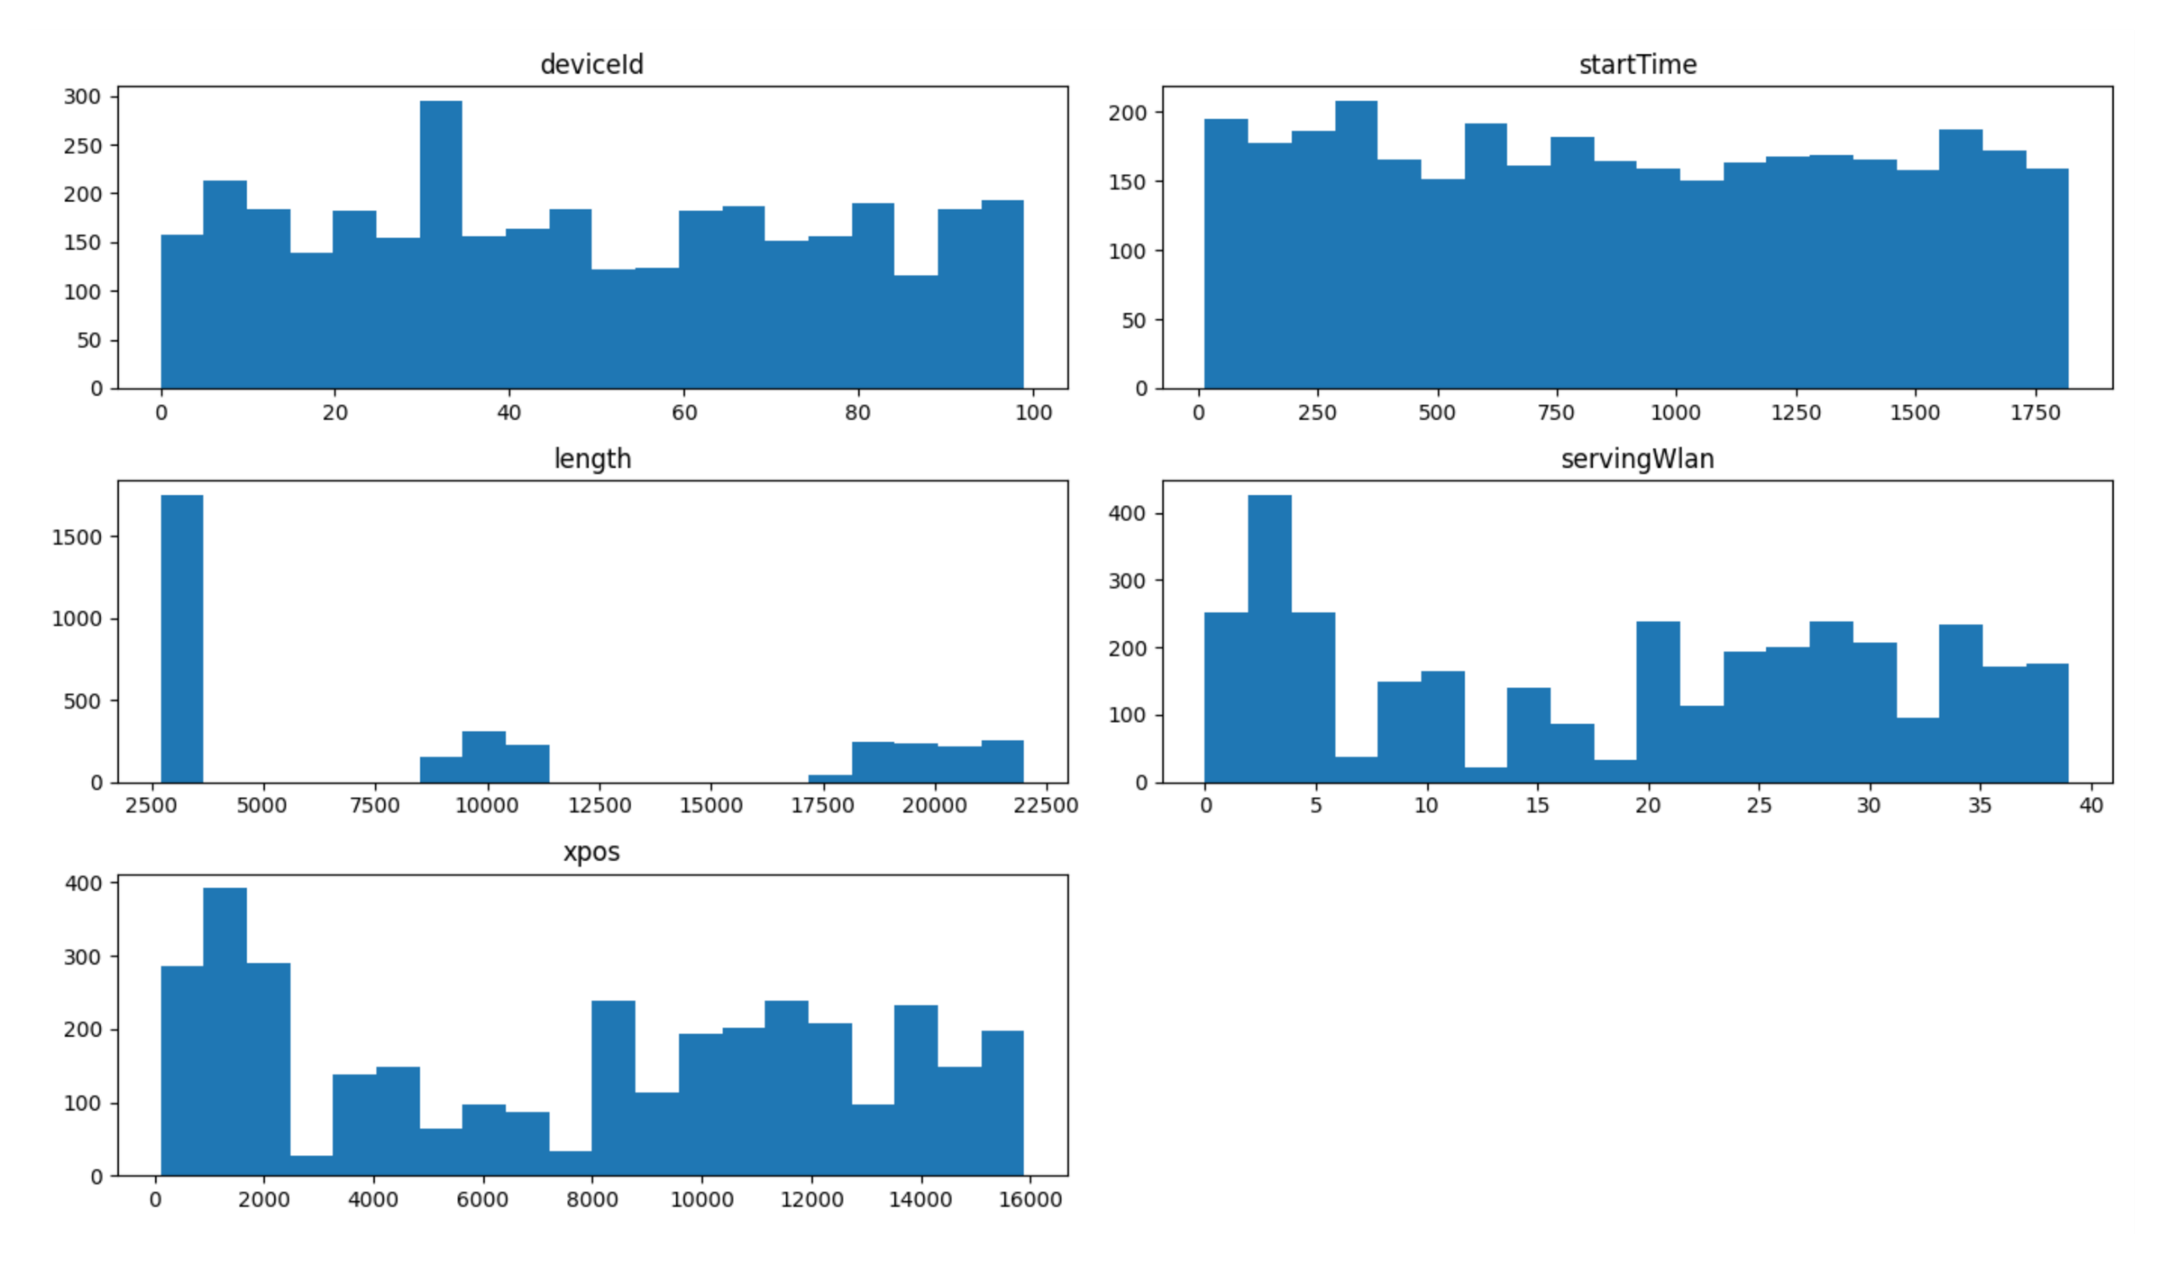

Figure A.16
Algorithm overhead (µs) as a function of number of devices for a fixed window size.
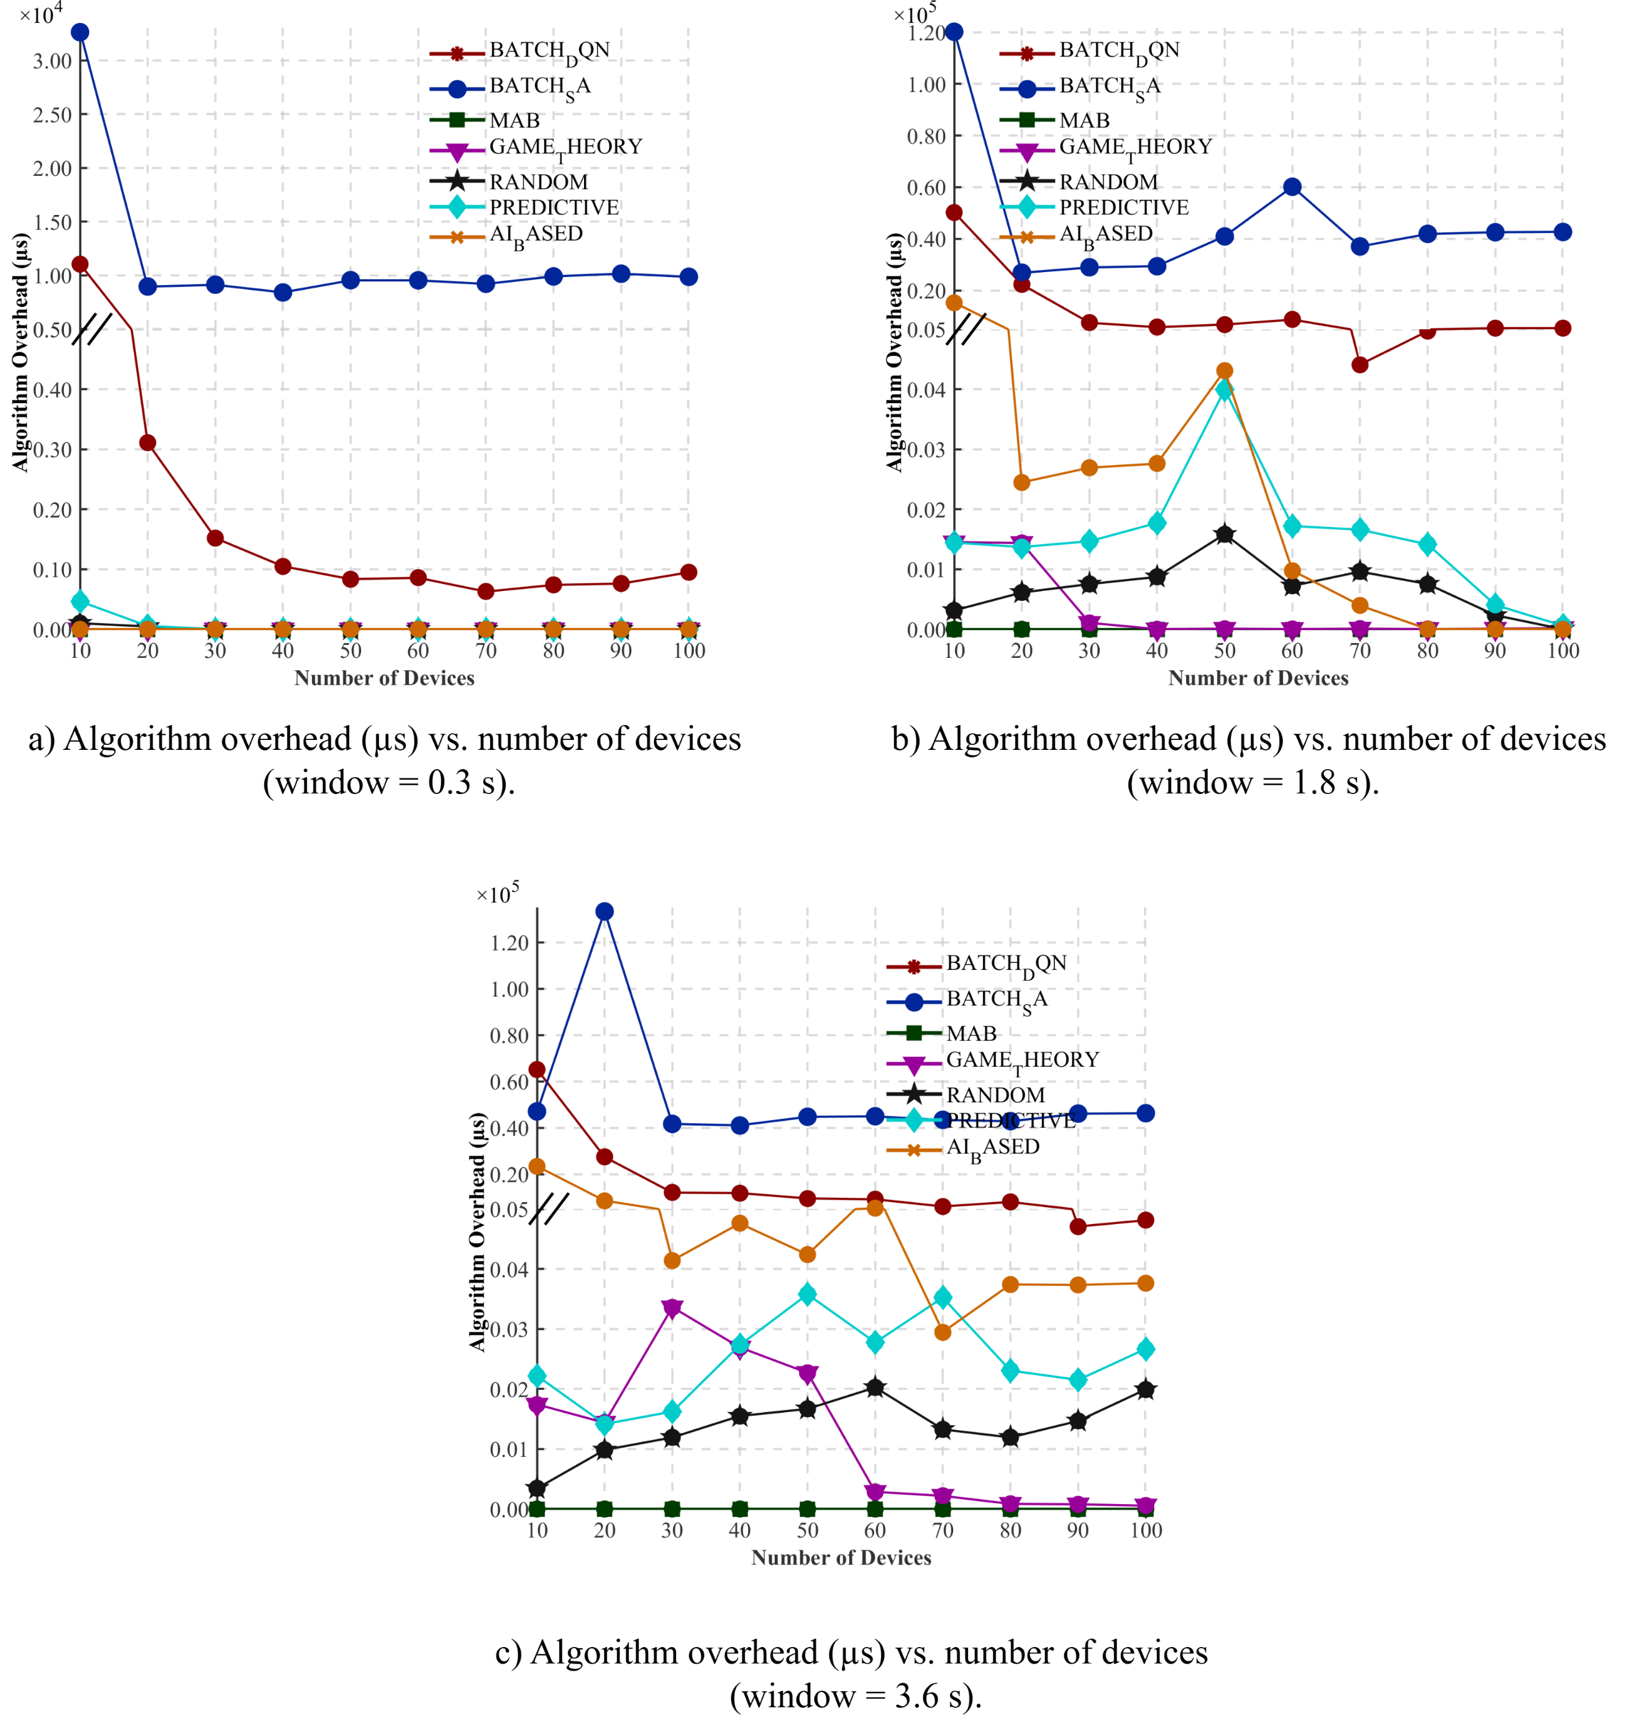

Appendix B
Tables
Table B.1
Static environment data analysis
 | Size (KB) | Server execution time (ms) | Edge Exec time (ms)
count | 5999 | 5999 | 5999
mean | 4.112597 | 22.08371 | 22.73096
std | 2.713517 | 62.10867 | 61.90752
min | 2.2567 | 0.179688 | 1
25% | 3.13895 | 0.266602 | 1
50% | 3.3166 | 0.285156 | 1
75% | 3.9252 | 0.308594 | 1
max | 69.9596 | 225 | 225

Table B. 2
Training environment data analysis
 | execution_time | num_applicable_vms
count | 140200 | 140200
mean | 1.539231 | 2.07933
std | 5.320439 | 0.482578
min | 0.001 | 1
25% | 0.1224 | 2
50% | 0.305911 | 2
75% | 0.725974 | 2
max | 50 | 3

Table B. 3
Dynamic environment data analysis
 | deviceId | startTime | length | servingWlan | xpos
count | 3431 | 3431 | 3431 | 3431 | 3431
mean | 48.58379 | 898.7713 | 9306.278 | 18.80472 | 7715.952
std | 29.2385 | 528.4529 | 7335.686 | 12.72129 | 5084.034
min | 0 | 14.59726 | 2700 | 0 | 111
25% | 24 | 434.0491 | 2984 | 5 | 2082
50% | 46 | 890.1621 | 3291 | 21 | 8540
75% | 73.5 | 1364.309 | 18512.5 | 30 | 12220
max | 99 | 1821.815 | 21998 | 39 | 15888

جــــامعــــــــة النجاح الوطنية
كليـــــة الدراســــــــات العليــــــا

تحسين استخدام الموارد في الحوسبة الطرفية باستخدام الشبكات العصبونية العميقة للتعلّم المعزّز (Deep Q-Network)

أعداد يزن جرار
إشراف انس طعمة

قدمت هذه الرسالة استكمال لمتطلبات الحصول على درجه الماجستير في الذكاء الاصطناعي، من كلية الدراسات العليا، في جامعة النجاح الوطنية، نابلس- فلسطين.
2026

تحسين استخدام الموارد في الحوسبة الطرفية باستخدام الشبكات العصبونية العميقة للتعلّم المعزّز (Deep Q-Network)
أعداد يزن جرار
إشراف انس طعمة

الملخص

تركز هذه الرسالة على تصميم وتقييم تقنيات تعلم الآلة (Machine Learning) لتعزيز عملية الجدولة في بيئة الحوسبة الطرفية (Edge Computing)، خاصة لتطبيقات إنترنت الأشياء (IoT)، بهدف زيادة عدد المهام المنفذة ضمن نافذة زمنية محددة. إن تعظيم إكمال المهام ضمن المواعيد النهائية يؤدي إلى زيادة الإنتاجية وجودة الخدمة، بينما يمكن أن يؤدي تفويت المواعيد النهائية إلى تدهور أداء النظام وجعل النتائج غير قابلة للاستخدام.

تبحث هذه الدراسة في الخوارزميتين المقترحتين، (Simulated Annealing - SA) وشبكة Q العميقة (Deep Q-Network - DQN)، لتحديد ما إذا كانتا تتفوقان على الحلول الحالية لجدولة دفعات المهام في بيئة الحوسبة الطرفية. وللتحقق من صحة النتائج، استخدمنا بيانات الواقع المعزز (AR) الحقيقية وبيانات إنترنت المركبات (IoV) التي تم إنشاؤها بواسطة محاكي EdgeCloudSim. وتظهر النتائج بوضوح أن الخوارزميات المقترحة تتفوق على الحلول الأخرى خاصة حيث تكون الموارد محدودة للغاية.

تُظهر النتائج أن الخوارزمية القائمة على (Simulated Annealing) حققت انخفاضًا يصل إلى 71% في معدل فشل المهام مقارنةً بخوارزمية الأساس عند اختبارها في بيئات ثابتة باستخدام بيانات IoT وAR حقيقية. كما تظهر النتائج أن المجدول القائم على شبكة Q العميقة (Deep Q-Network) حقق باستمرار أقل معدلات فشل عبر السيناريوهات الديناميكية، خاصة في ظل القيود العالية. علاوة على ذلك، تطلب نموذج Deep Q-Network الذي تم تقييمه في بيئة ديناميكية وقتًا إضافيًا (overhead time) أقل بكثير، أقل من ثلث وقت تشغيل خوارزمية ال (Simulated Annealing)، بينما تفوقت كلتا الخوارزميتين على خوارزميات الأساس الأخرى بنسبة تصل إلى 10% في معدل فشل المهام.

تدعم هذه النتائج هدف الرسالة المتمثل في تعظيم استغلال موارد الحوسبة الطرفية مع ضمان إتمام دفعات المهام ضمن حد زمني محدد، وتبرز كفاءة خوارزمية الجدولة القائمة على شبكة Q العميقة (DQN).
الكلمات المفتاحية: الحوسبة الطرفية، إنترنت الأشياء (IoT)، خوارزميات جدولة المهام، التعلّم التعزيزي، شبكة Q العميقة (DQN)، Simulated Annealing (SA)، EdgeCloudSim، تحسين موارد الآلات الافتراضية.

