بسم الله الرحمن الرحيم

An-Najah National University

Faculty of Engineering
Computer Engineering Department

Graduation Project 2
RoboWars

Accomplished By:
Tariq Sabri
Yousef Dheede

Supervisor: Dr. Hanal Abu Zant

Presented in partial fulfillment of the requirement for Bachelor’s degree in Computer Engineering

2024

Table of Content
Table of Contents
Component Usage 4
Testing and Results 5
Challenges and Learnings 5
Conclusion 6
Future Work and AI Integration 6
References 6

Acknowledgment

The authors acknowledge the work of Najah National University staff for the support throw the learning journey. They also thank their parents for their unwavering support throughout their years of life. Finally, a sincere thank you to Dr. Hanal Abu Zant, our supervisor, for guiding us in the direction of making this project possible.

Disclaimer
This report was written by Tariq Sabri and Yousef Dheede from the Computer Engineering Department, Faculty of Engineering, An-Najah-National-University. It has not been altered or corrected, other than editorial corrections, as a result of the assessment and may contain language and content errors. The views expressed in it and any outcomes and recommendations are solely ours. An-Najah National University accepts no responsibility or liability for the consequences of this report being used for a purpose other than the purpose for which it was commissioned

Abstract

This project involves the design and construction of two fighting robot cars, equipped with a range of sensors and control mechanisms. The primary components include an Arduino Mega, ESP32, four LDR sensors, four SW-520D sensors, a laser sensor coupled with a small servo. The SW sensors detect impacts, reducing the health of the car. The core idea is to simulate a combat scenario between the two robot cars.
Key features include:
- Movement Control: Utilizing two H-bridges; one for forward and backward motion via DC motors, and another for steering. Additionally, a servo motor (MG995) is installed at the front with a bulldozer blade for physical combat.
- Sensing Mechanisms: LDR sensors for detecting laser hits, decreasing the car's health, and SW-520D sensors for impact detection.
- Wireless Control: The cars are controlled using the XY app, connected through the ESP32 module.
- Additional Features: A laser diode acts as a 'laser gun', and a limit switch adds more interactive elements to the combat scenario.
The project demonstrates a blend of mechanical design, electronic circuitry, and software programming, showcasing skills in robotics, sensor integration, and control systems.

Used Components
- Arduino Mega: Serves as the central processing unit, controlling various sensors and motors.
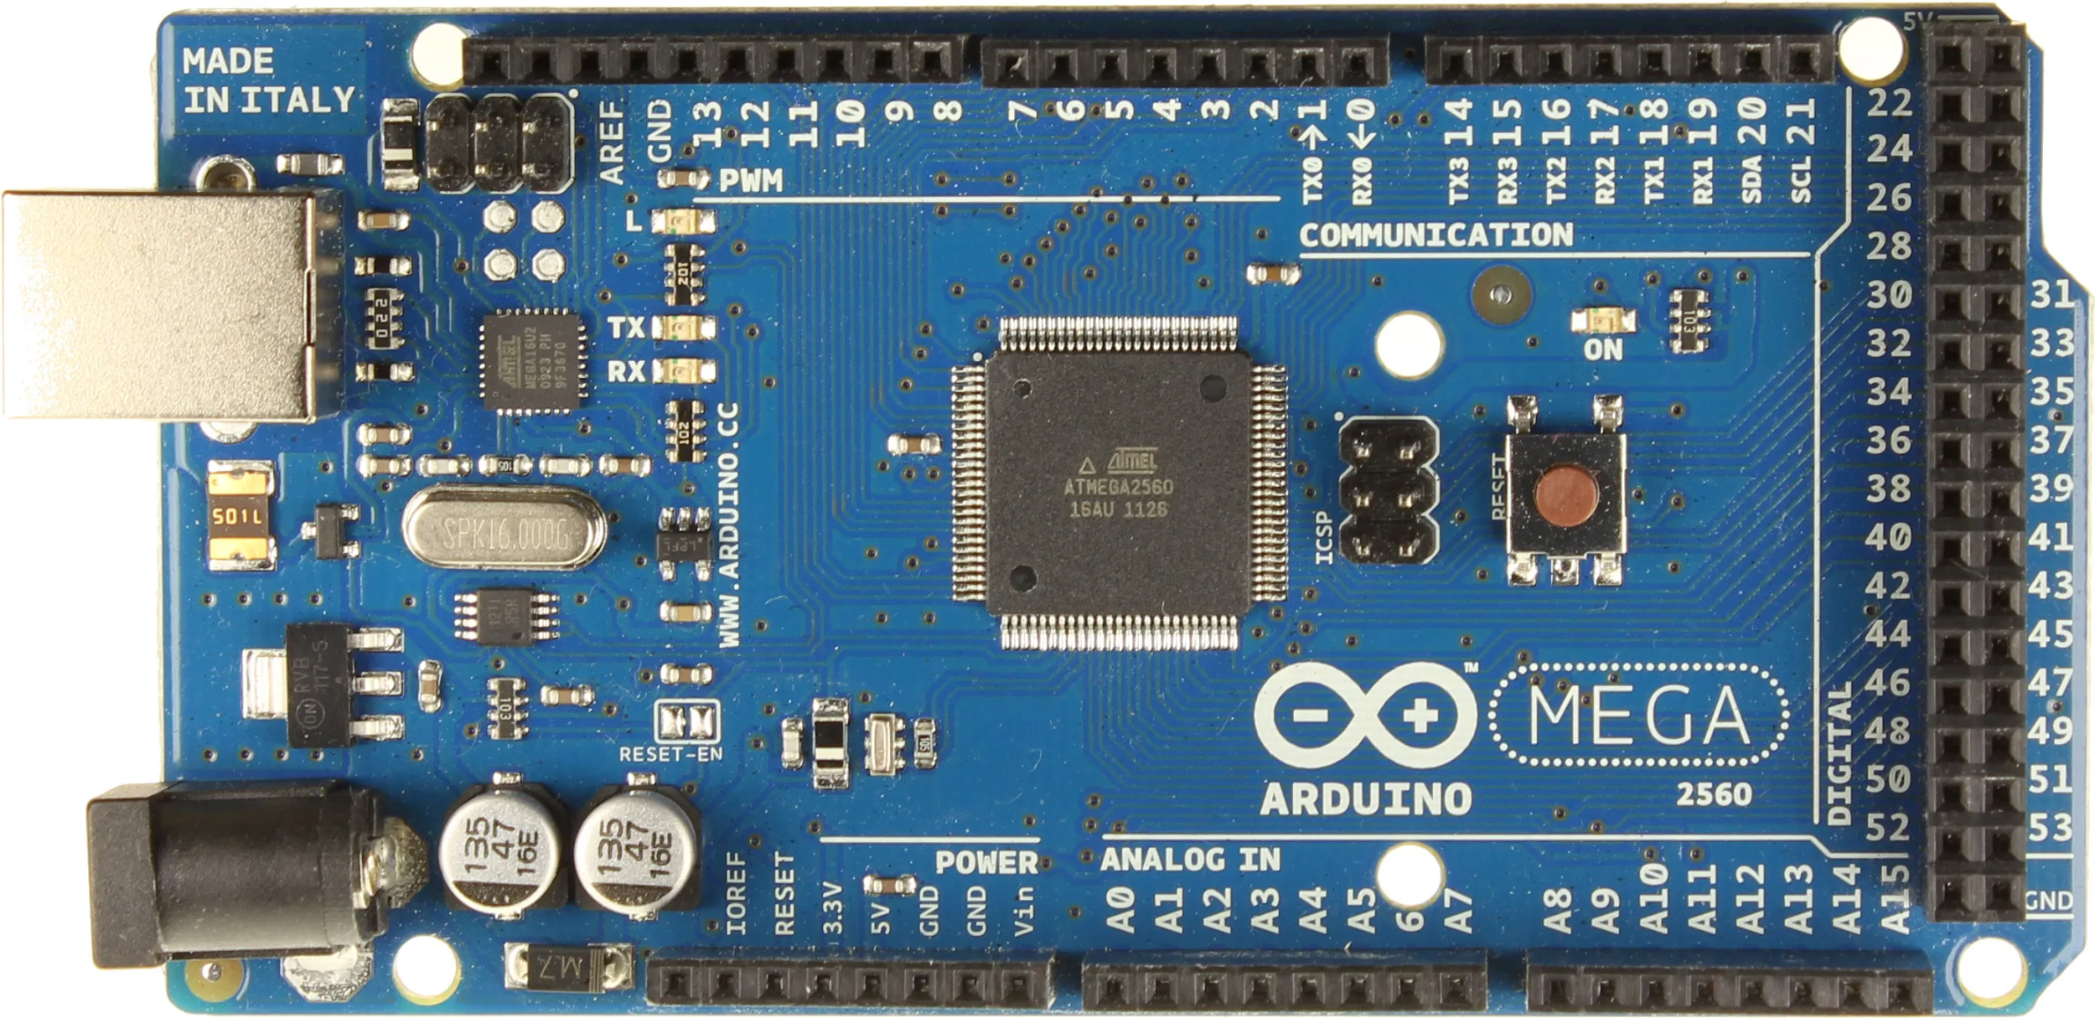

- ESP32: Used for wireless communication and control through the XY app and MIT app inventor.
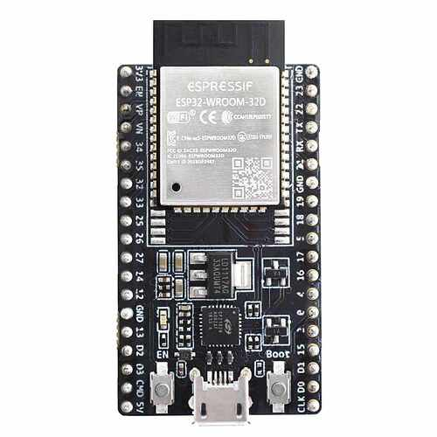

- LDR Sensors (1): Detect laser hits, contributing to the combat simulation by decreasing the car's health.
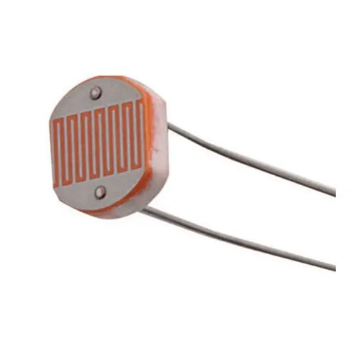

- SW-520D Sensors (4): Detect impacts and collisions, affecting the car's health.

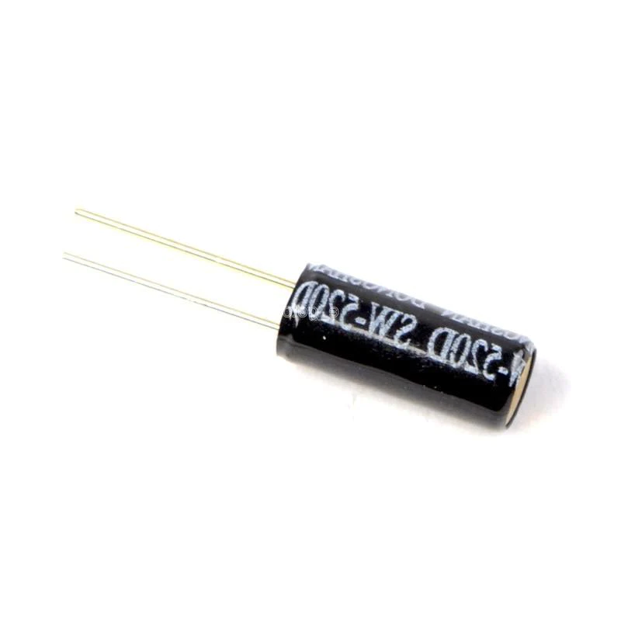
- Laser Sensor: Acts as an offensive weapon in the combat scenario.
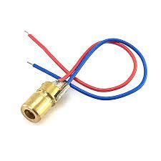
- H-Bridges : Control the movement of the DC motors for forward/backward and left/right movements.
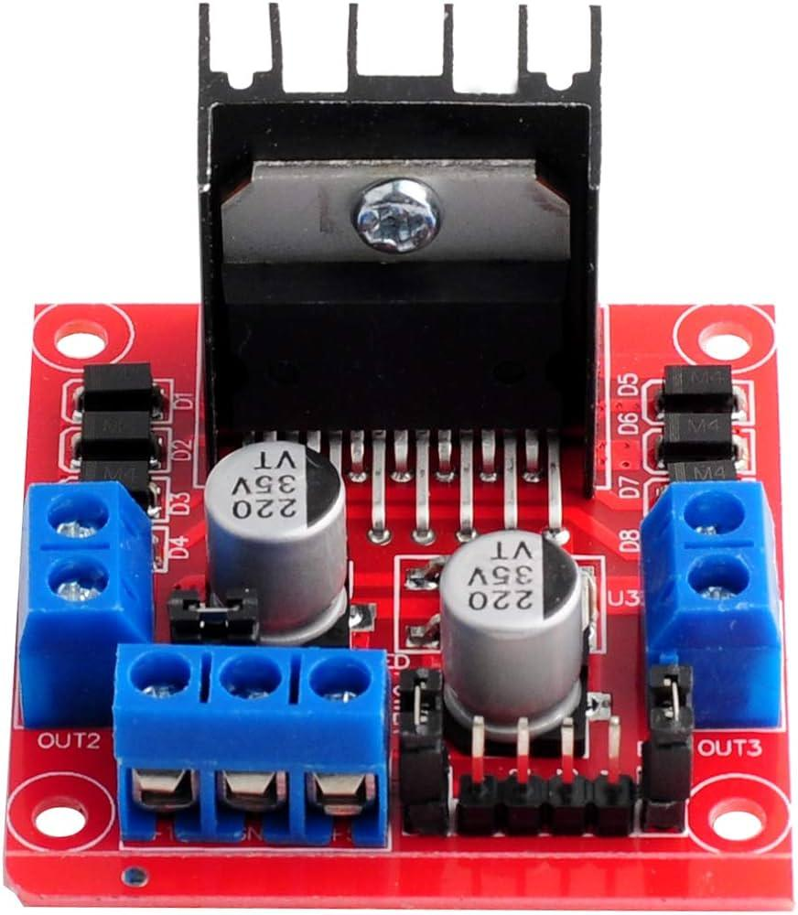

- DC Motors: used inside the forward backward motors.
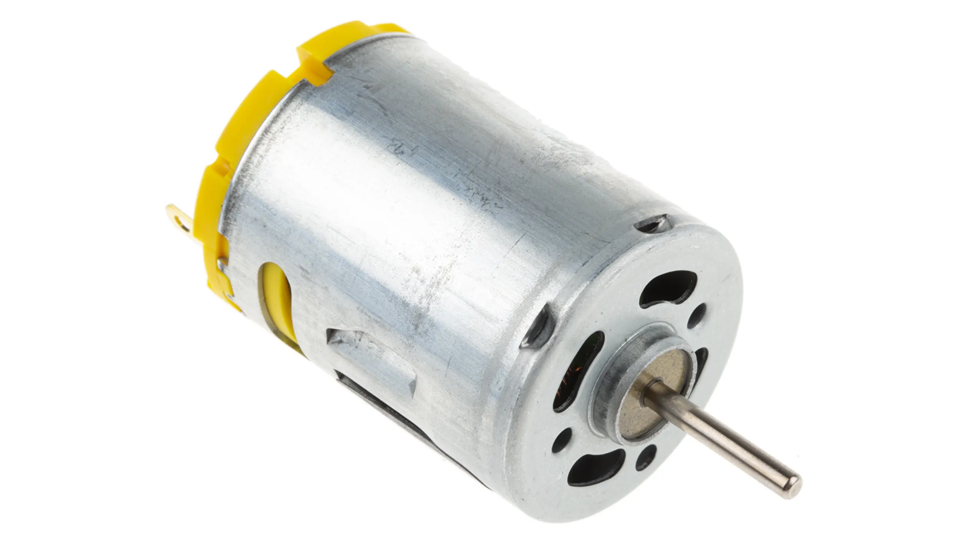

- Servo Motor (MG995): Operates the bulldozer hand for physical combat.
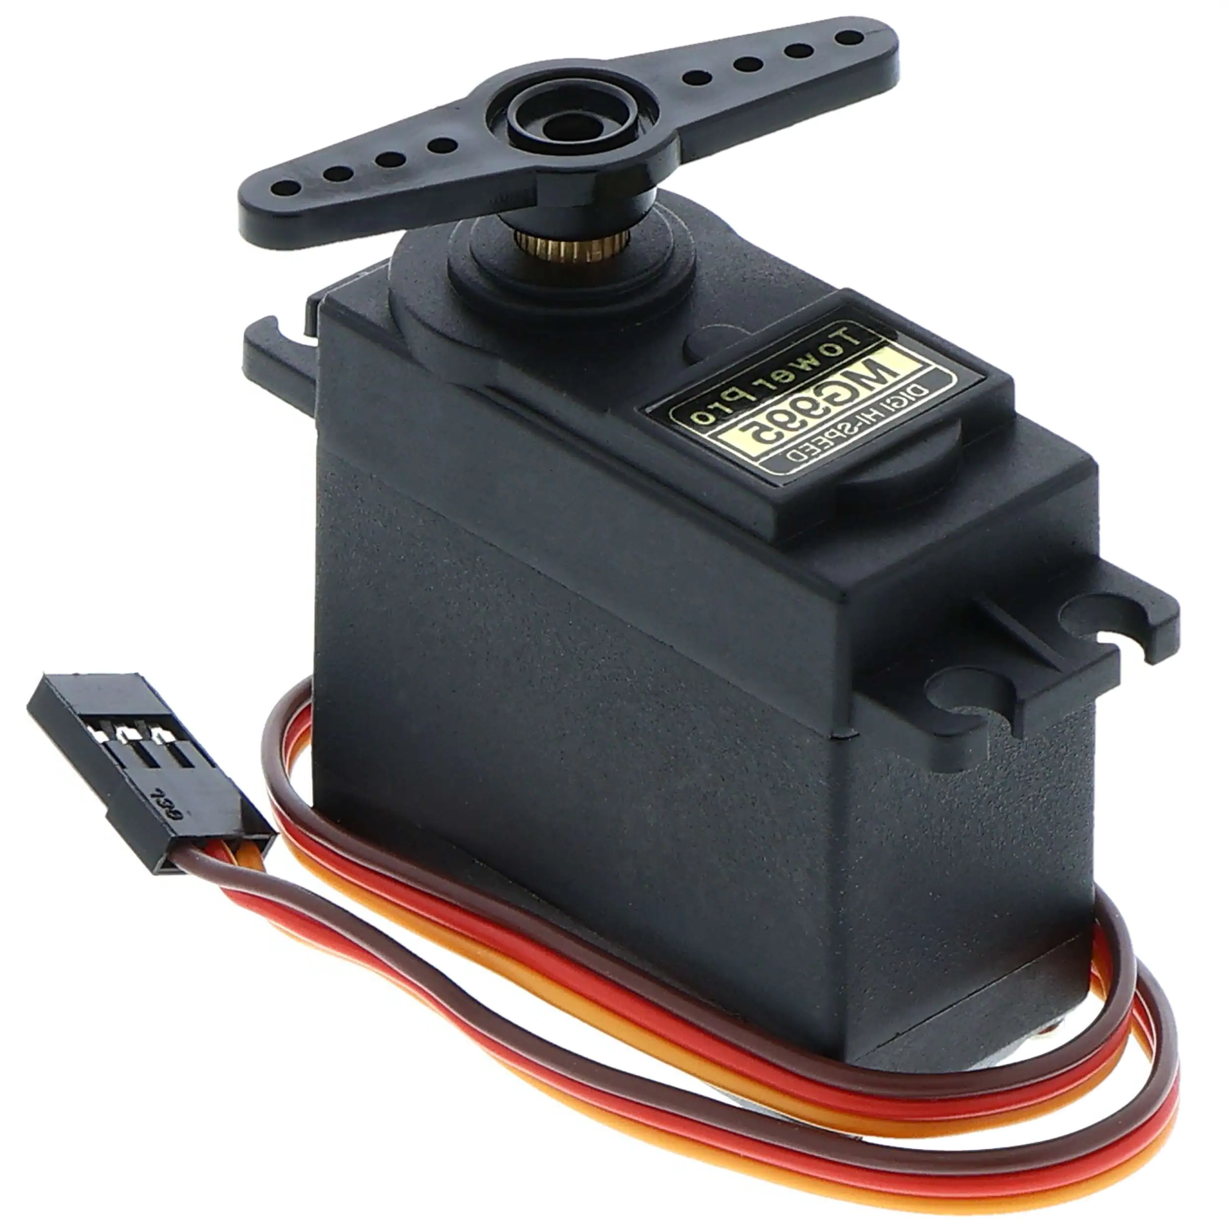
- Servo: used to move the laser diode to change the aim on the opponent.

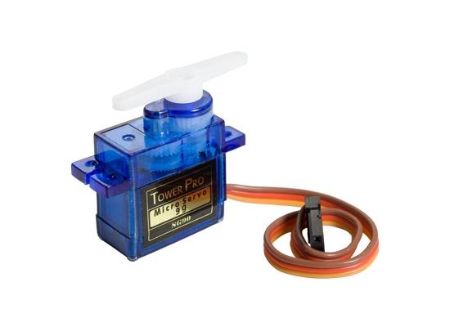

Testing and Results
During the testing phase, we encountered several challenges:
- Power Consumption: The high-power demand of the motors and sensors led to rapid battery depletion, requiring frequent recharging.
- Battery Limitations: The capacity of the batteries used was insufficient for prolonged use, leading to shorter operation times than anticipated.
- Hardware Limits: due to the prices of the sensors and tools in our country and not finding the needed equipment’s in the shops.

Challenges and Learnings
The project faced challenges including time constraints, limited hardware resources, financial limitations, and the ongoing conflict in Palestine. These factors required innovative problem-solving and adaptability.

Conclusion
This project successfully demonstrated the integration of various electronic components and control systems to create a functional and interactive fighting robot car. The experience gained in robotics, sensor integration, and software programming is invaluable and contributes significantly to the field of computer engineering.

Future Work and AI Integration

In future iterations of this project, we plan to integrate AI algorithms to enhance the autonomous capabilities of the robot cars, enabling more sophisticated combat strategies and decision-making processes.

References
- "Arduino Mega Official Page," Arduino. https://www.arduino.cc/en/Main/ArduinoBoardMega2560
- "ESP32 Official Documentation," Espressif Systems. https://docs.espressif.com/projects/esp-idf/en/latest/esp32/
- "Using Arduino with Python," Real Python. https://realpython.com/arduino-python/
- "ESP32 with Arduino IDE," Random Nerd Tutorials. https://randomnerdtutorials.com/getting-started-with-esp32/
"Robot Wars: Inspiration for Combat Robots," Robot Wars TV Series. https://www.robotwars.tv/

