1.1 Introduction:
Palestine is characterized by a climate of bitter cold in winter, which we need engineers search for solutions to architectural, mechanical, thermal, environmental and low cost.
Given the high cost of electricity and other energy resources floated the idea of this system which relies on solar energy by a large and provides a lot.
This research aims to study the principles of design for the villas to rely on the heating system under floor heating and environmental requirements and natural resources of the villa and choose the most appropriate location that meets these requirements and specifications and then exit through the recommendations of this study.

*The design of the building has been done in a way that provides natural comfort with minimal need for HVAC systems. The main criteria for the design were:
- Maximize heat gain in winter via passive solar system and proper insulation,
- Minimize heat gain in summer via proper shadowing, proper insulation and adequate ventilation.
*These criteria can be achieved in the residential Building of Nablus Zone with the following parameters:
- High insulation of all external walls, slabs and basement floor
- Proper shading of sunshine in summer that will allow sunshine to penetrate glazing areas in winter
- Proper natural ventilation for summer
- Moderate thermal mass of the building
- Use of Passive and Active solar system for heating the building in winter and increasing air ventilation in summer.

1.2 Site:

The site occurs in Nablus city, surrounded by villas from the two directions ( east and north ) and a 5m width street from south, and the site area is (800) m².
The building consists of a basement with an area of (121) m², and a ground floor with an area of (270) m², and a first floor with an area of (180) m².
An application of the solar energy system is used called (Under Floor Heating) for heating in winter and ventilating in summer.

1.3 Drawings:

1.3.1 The Building View :

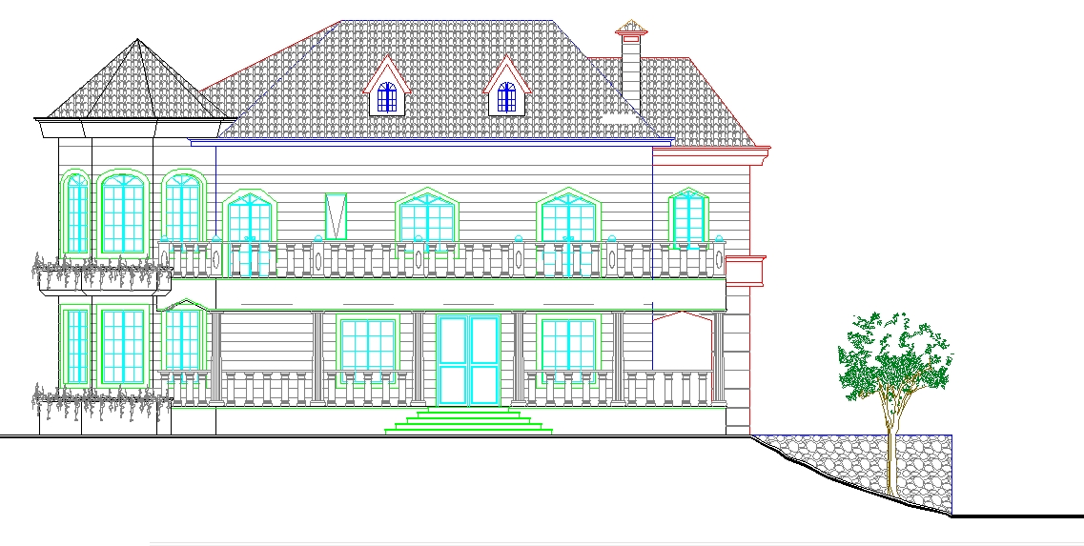

Figure (1.1): North View

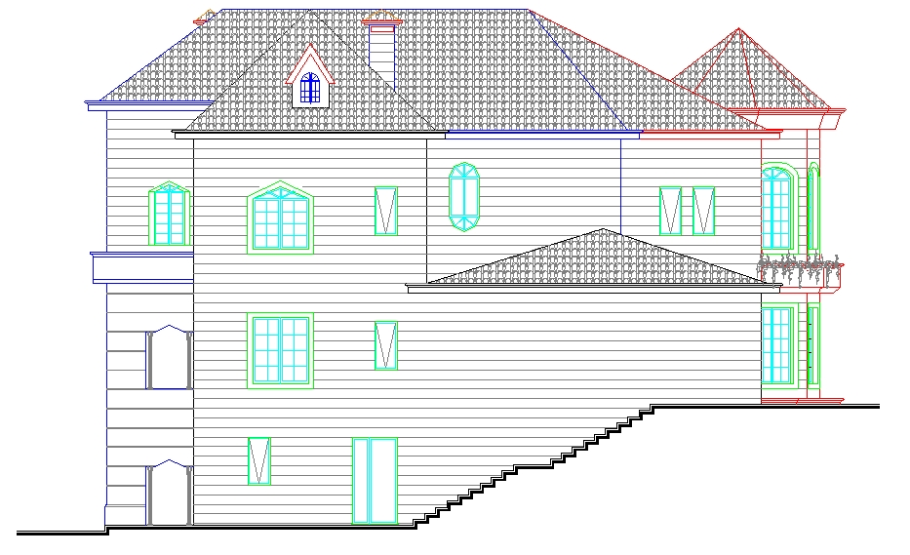

Figure (1.2): south view

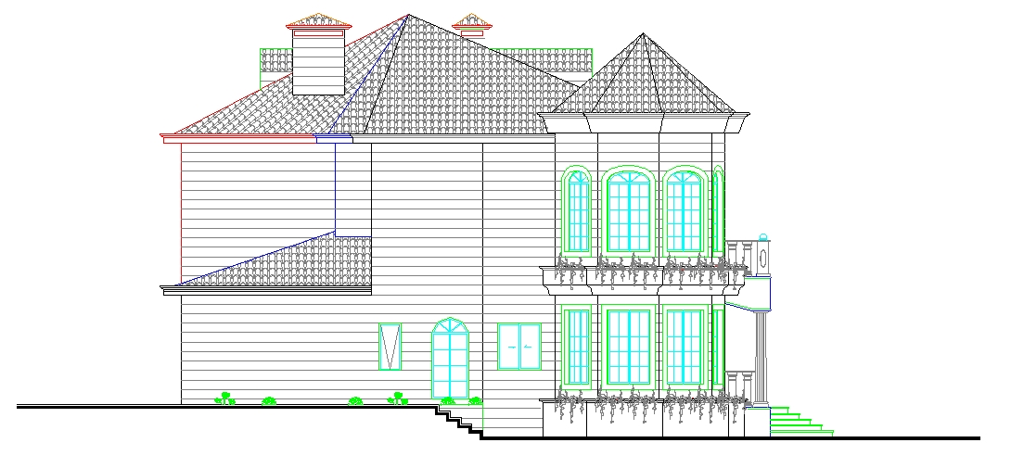

Figure (1.3): East view

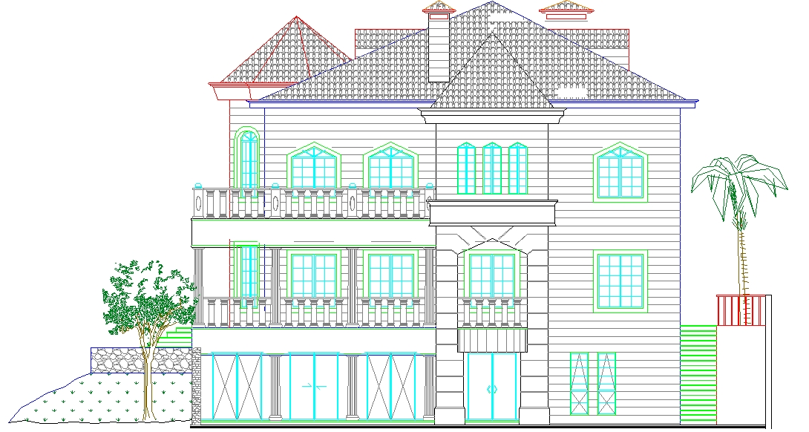

Figure (1.4): west view

1.3.2 The Building Plans :

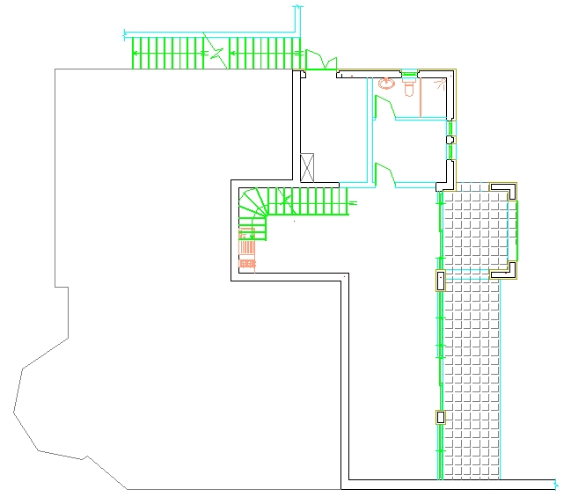
Figure (1.5): Basement Floor

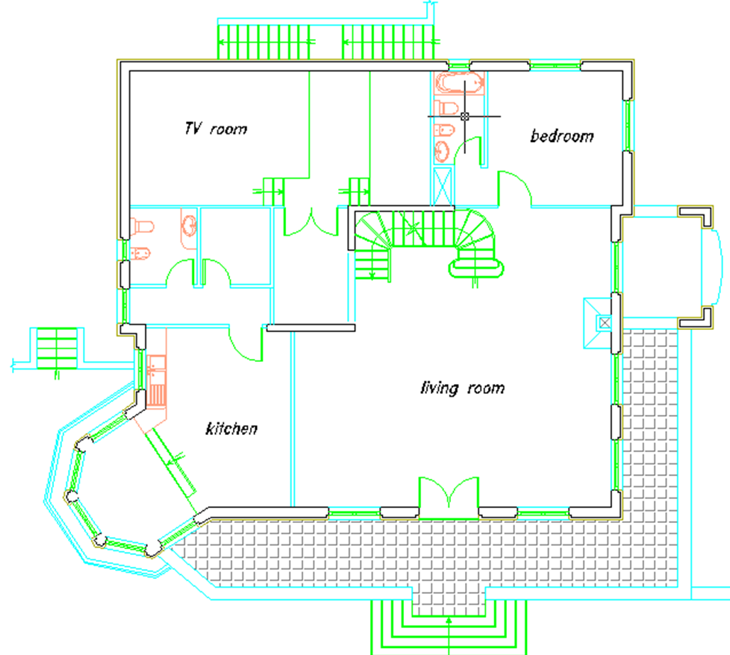

Figure (1.6): Ground Floor

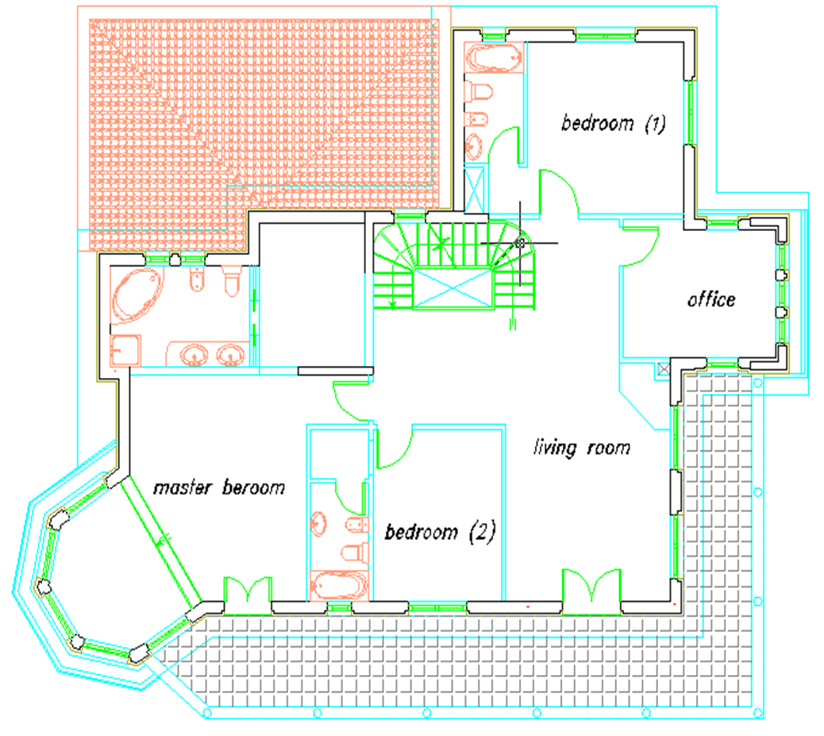

Figure (1.7): First Floor

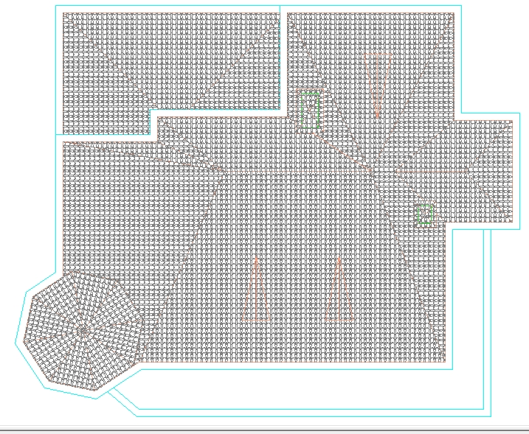
Figure (1.8): The Roof

