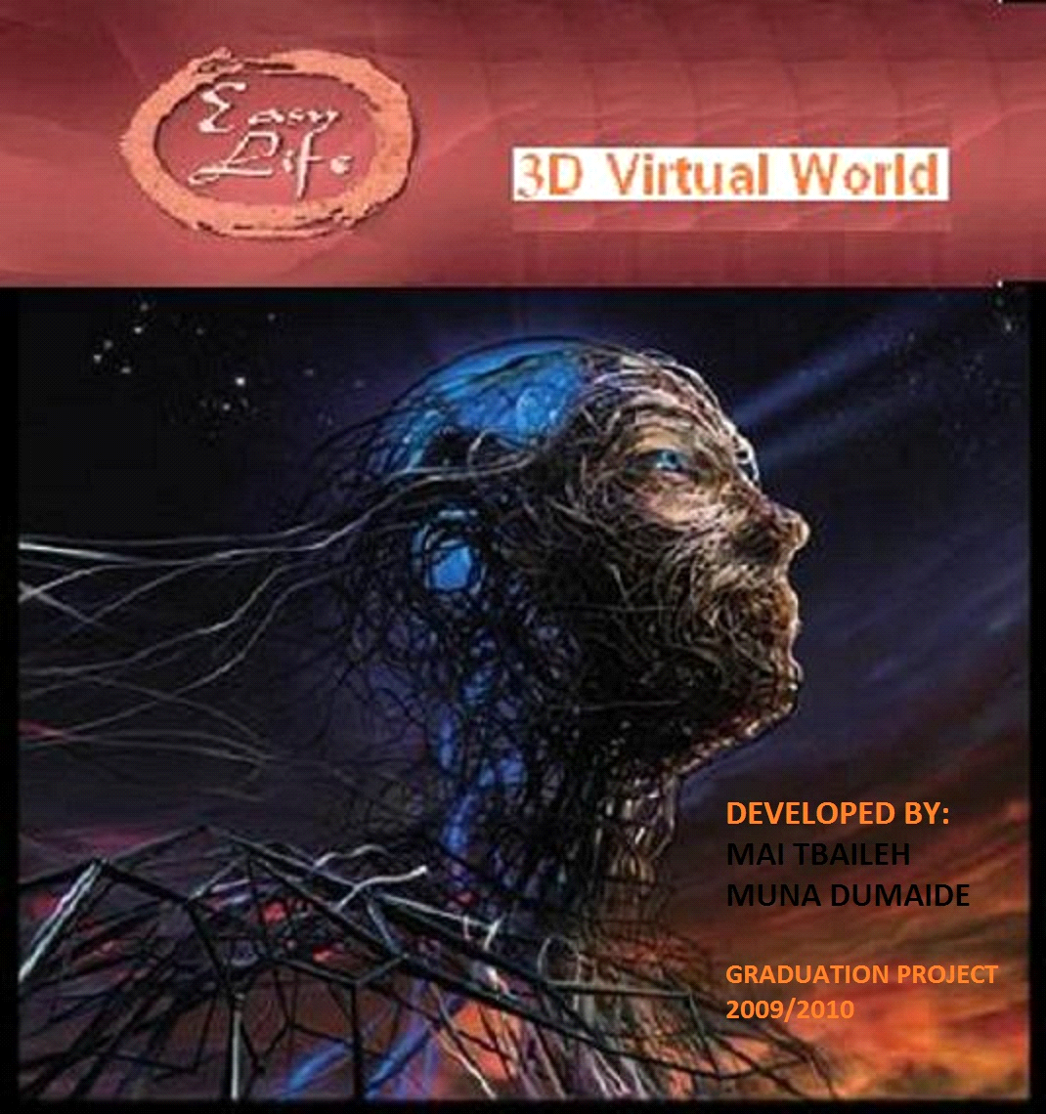

ITRODUCTION
EASY LIFE is a three dimension game.In easy life you can meet new people in a virtual world consists of many beautifull scenes.People also can chat ,hang out and have fun in many animated scenes.Easy life offers you a 3d creative advertising ,in which you can create your own advertisement and upload it to the game.
Easy life 's users can express themself and their personality,by dressing up in different styles and customise their look,their clothes,shoes,hairstyles and more.Also they can express themself by designing their own home furnishing it and shopping for the latest fashions and furnitures.
Easy life also entertains it's useres by offering them a 3d games like shooting and chance home,in which people can amuse their times playing these games and increasing their credit in the game.People also can spend nice times in watching movies in cinema with their freinds.


HARDWARE REQUIREMENTS
1)Supporting OS
Xna is one of Microsoft production,so the supporting operating system are :Windows xp, windows vista,winows 7.

2)Graphic cards
Grpahic card must have at least 1.1 pixel shader and 1.1 vertex shader. Nvidia or ATI graphic card will surely work.

TECHNICAL SOFTWARE REQUIREMENTS
1) XNA Game Studio 3.1 .
Microsoft® XNA® Game Studio 3.1 enables hobbyists, academics, and independent game developers to easily create video games for Xbox 360, Windows, and Zune by using optimized cross-platform gaming libraries based on the .NET Framework in the C# programming language.XNA Game Studio 3.0 or 3.1 is required to create games for Xbox LIVE Indie Games. (taken from xna creators club online).

2) Visual C# 2008 Express Edition
The Microsoft Visual C#® Express Edition is an IDE that combines ease-of-use and power into a free and convenient package that includes Microsoft IntelliSense® technology, code colorization, syntax checking, refactoring, and much more.
(taken from xna creators club online).

During developing the game we notice that no graphical user interface available in xna.So we use a package which called Neoforce Controls and here is some descreption.
3)Neoforce Controls Package
This package is very powerfull which enables the developper to use graphical user interface in creating games.For example buttons and textboxes needed in chatting and doing actions in games.This package related to Tom Shane.

4)Skinning Sample Package
Two dll needed to make animated models.By defaults you can move models by changing the x position,y position ,z position or rotation but it will be artificielle motion to do animations you must design models by maya and then export these models as animated models. Skinned Model and skinned model pipeline are the two dll's needed which offers you a skinned model processor which will process the bones of the model.

5) Autodesk MAYA
Maya ,is a high_end 3D computer graphics and 3D modeling software package originally developed by Alias System Coorporation and owned by Autodesk.Maya is used in the film and TV industry,as well as for computer and video games,architectural visualisation and design.(taken from wikibedia).

6)MICROSOFT SQL SERVER 2005
SQL server is a tool for configuring,managing,and administering databases.We created our databases uses this tool.

7)GSMCOMM LIBRARY
Gsmcomm library,is a communication library for use with GSM mobiles phones which depends on AT commands.It's mainly used for performing SMS_related tasks.The library basically features the possibility to send,read,delete,store,import and export SMS messages.Another important feature in GsmComm is to notify the application about new incoming messages.We use the above feature so Easy Life's user can send SMS to increase his credit in game.So when message come our server will notify with the new message and this will update the credit of the SMS owner.

WORKING STEPS
1)DEALING WITH MODELS IN MAYA
The first step in our project was how to deal with models,so some of our models were downloaded from websites like turbosquid and others,those websites offer free models.And also we design some of the models like streets in our game,also the terrain and the backgrounds of easy life.Maya also was used to customise the models,change their scale, positions and their textures.Clips and animations also take alot of our time,we used Maya to make clips like walking ,moving head and many interactions with the enviroment.

2)LEARNING ABOUT XNA AND GAMING DEVELOPMENT
Secound step was dealing with xna,so we begin first by download the visual studio 2008 to ensure the existing of (.NET framework 3.5 ).Then we download the xna 3.1 visual studio.Then we begin discovering the new program and how to begin programing by using Msdn forums and xna creators online club.We begin practising by simple games to take some experience.

3)PIPELINING BETWEEN MAYA AND XNA
This step is very important step.Here we join between our models which we already designed or customised by Maya and programing and developing in xna.Xna supports this feature by improving the content pipelining which is the main improvement in XNA if we compare it with the DIRECT X .So we begin to add items to the content.Xna supports many types of items to add and use in developing games such as
1-Models ,to add 3d models their extentions must be (.FBX).
2-Textures,to add textures 2d or 3d or even any images the available extentions are the ordinary extensions of images and (.tga).
3-Audio files.To add audio file voice in games their extensions must be either .wav or .mp3 and they must be added and loaded as Sounds Effect.
4-Animated Models,this extention must be .FBX,but when we loaded we loaded as skinned model processor to take this advantage we used a skinning sample dll.
5-Vedio,to add vedio to your game this must be of type( .wmv).
After adding the items to our project by programming we can draw it and update these objects and models with respect to player's press in the keaboard.

4)PROVIDE GRAPHICAL USER INTERFACE FOR THE GAME
One of the main problem which we faced in developping Easy life is that no graphical interface exists in XNA.But Easy life is a community game so graphical user interface as buttons,textboxes and combo box is essential in a community games where we need to chat with a specific contact.Neoforce Control is a package developped by Tom Shane And it;s free with a liscence of free using in developing game.This DLL is very usefull and it give you the ability to create forms as if you use an ordinary windows forms in C #,also it give you the events of controls.

5)CREATING DATABASE
The database is essential in any project.In Easy life we create a database by using Microsoft sql server 2005.For each user we save information about his name,real name,birth date,status,the appearence and other table for the furniture of each easy life's users.

6)NETWORK ISSUES
Easy life is a network game,so network isuues take alot of our time.We used Tcp ip connection by creating a thread for each user sign in.In updating each second each user sends his x position y position z position,rotation,and his appearence to the server.And the server each second brodcast the updates of all users.

7)ADVERTISMENT IN EASY LIFE
Creative way of advertising in Easy Life ,you can apload your advertisment to the server and put your advertisment.Market scene has many avertisment by walking in the street you can be able to see and listen to the advertisment.

8)GAMES IN EASY LIFE
Easy life give you the apportunity to play multible games such as shooting and chance home.So we create a 3d games embeded in Easy Life to increase the suspence .

9)USING SMS TO INCREASE CREDIT
Using the GsmComm library which depends on the AT commands for nokia mobile 6230 we can using these commands to send recieve sms from pc by using gsm modem by connecting the mobile serialy to the pc or by bluetooth .In Easy Life user can send a message from his mobile to a serially connected mobile to the server.The server will updates the credit of the user by increasing 50 points to the user for each SMS.

10)EASY LIFE EFFECTS AND VOICE INTERACTIONS
Interactions between the avatar(user's model)is done by some sound effects added to the enviroments.Two methods used to provide the scenes with sounds which are:
1-By using Sound effect,we add some sounds of two available extention (.mp3 ,.wav) and when we add them then we load them as sound effect and we play these sounds in a specific condition.For example we play animals sounds when we go to the park.
2-By taking the advatage of Windows narrator.Windows Narrator is one of the accessories which exists in any Microsoft operating system like windows XP,windows Vista,Windows 7.so by using the speechlibrary.dll we can create a variable of spvoice and give it the speech we want to say.

QUICK TOOR IN EASY LIFE
Easy Life has many scenes and the following some images taking as snapshots from the game and each image explain some of the features of each scenes.

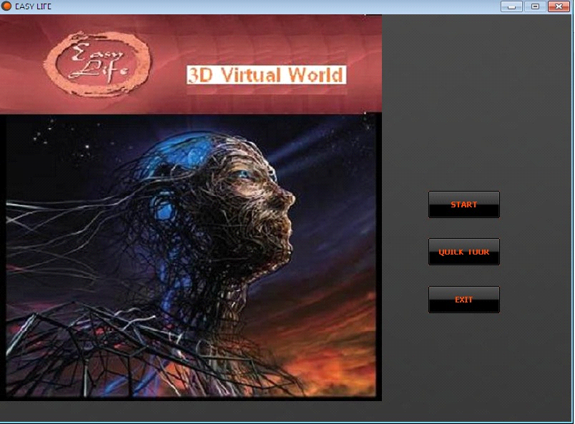
IF YOU PRESS START A SIGN IN FORM WILL APPEAR SO AS TO FILL YOUR ID AND YOUR PASSWORD IN THEIR PLACES AND PRESS SIGN IN.
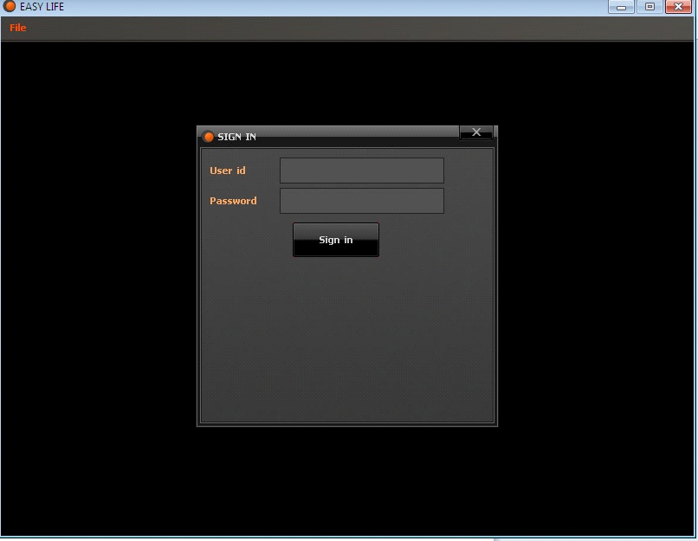

ELSE IF YOU PRESS QUICK TOUR THESE IMAGEAS WILL APPEAR AS SLIDES
EASY LIFE ALSO HAS A MAP SO BY PRESSING ON THE MAP YOU CAN MOVE TO ANY PLACE
AND YOU WILL SEE WHEN OF THESE PLACES
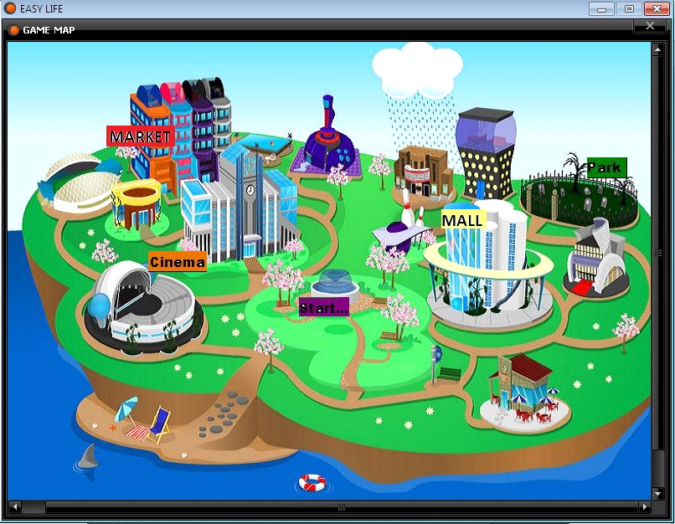

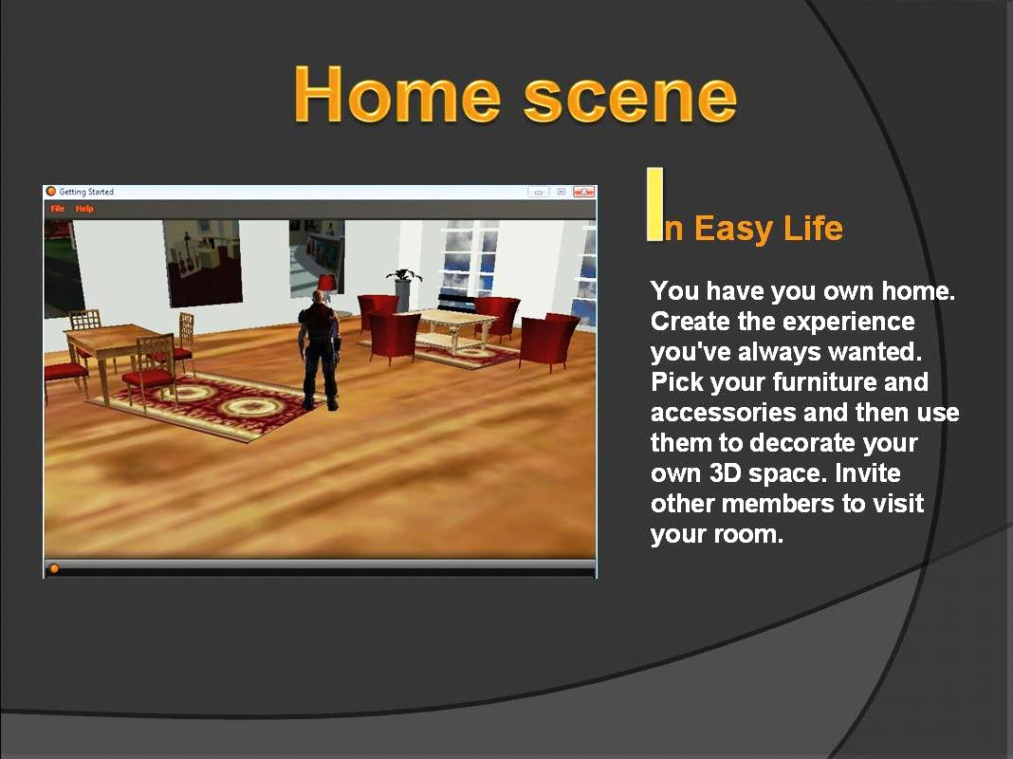
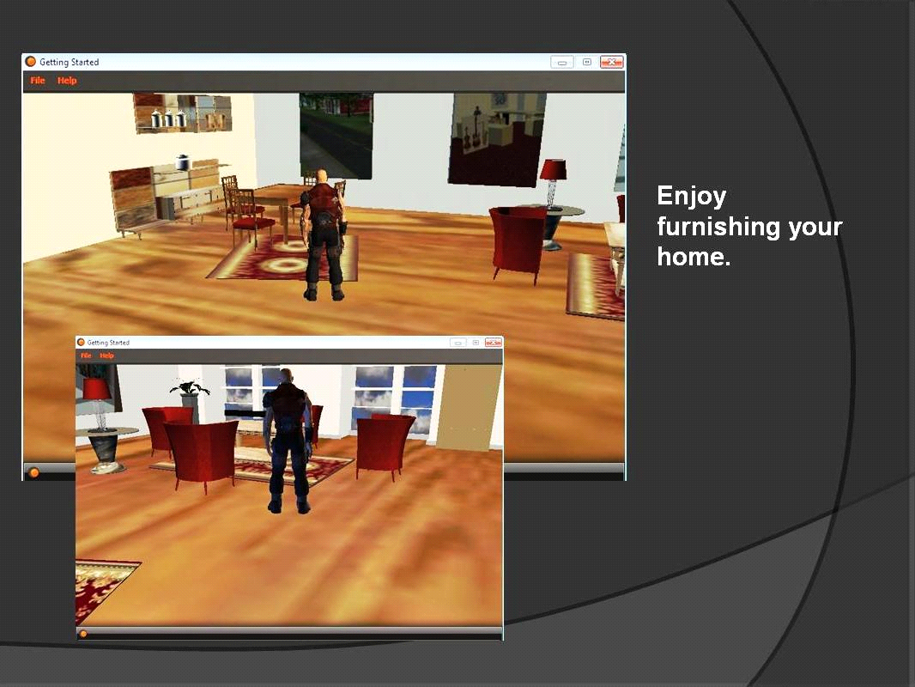

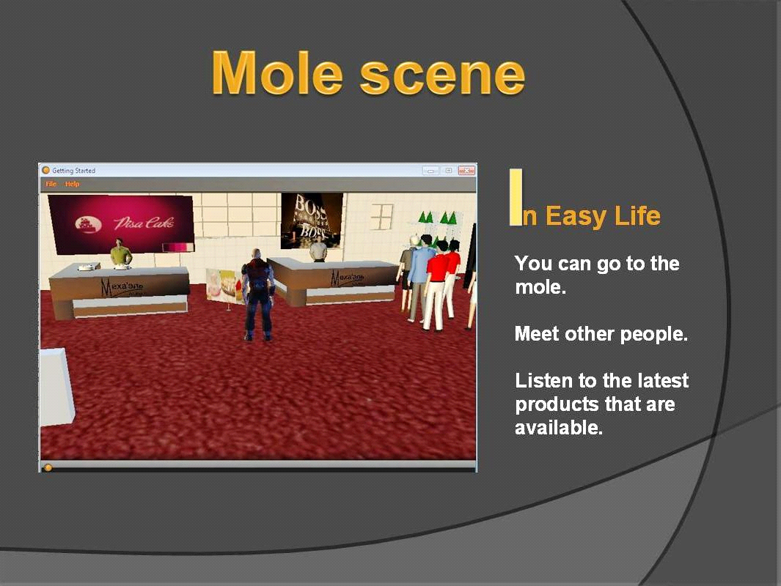
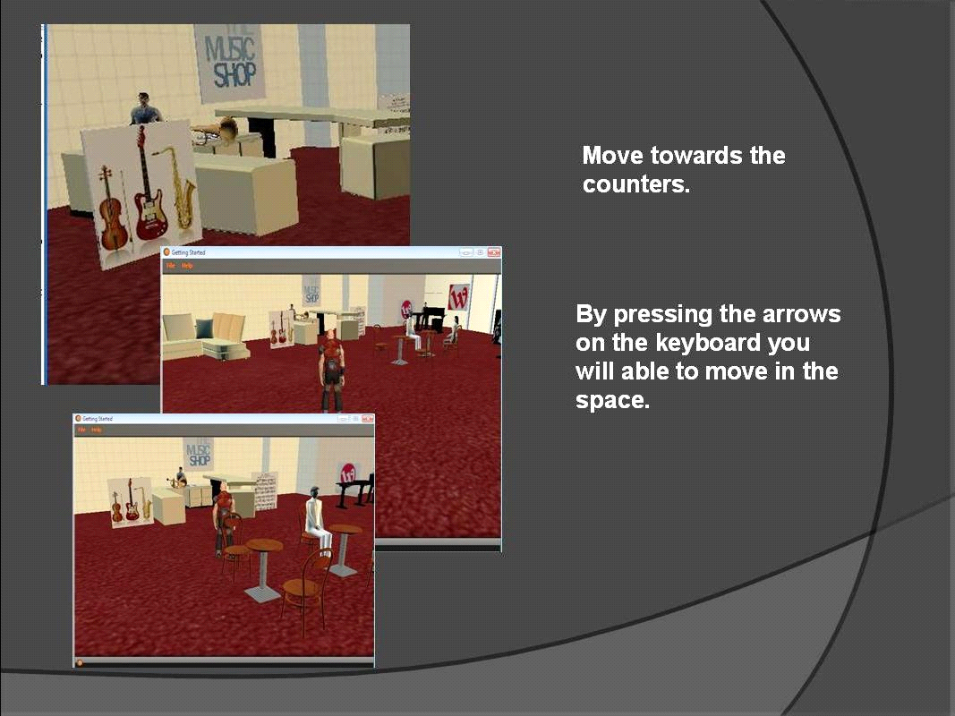

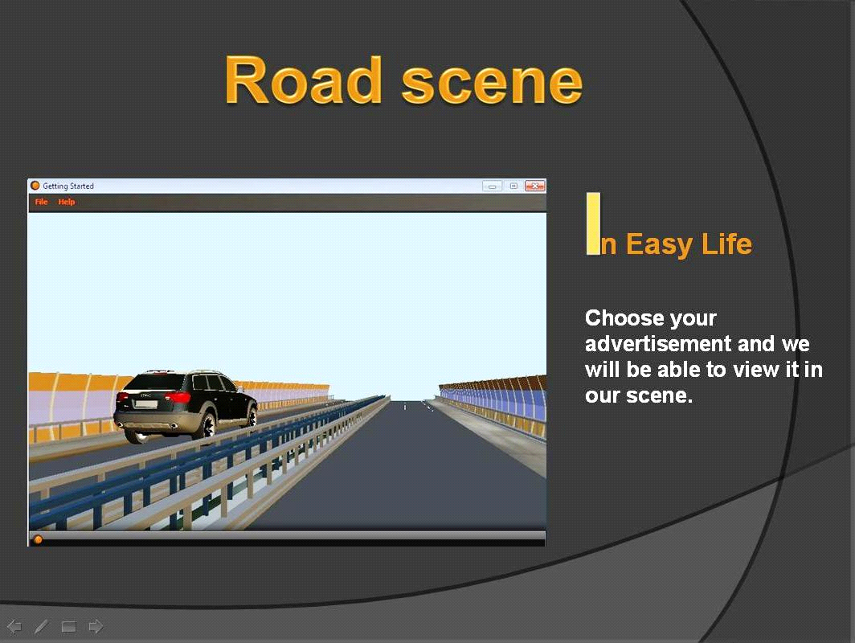
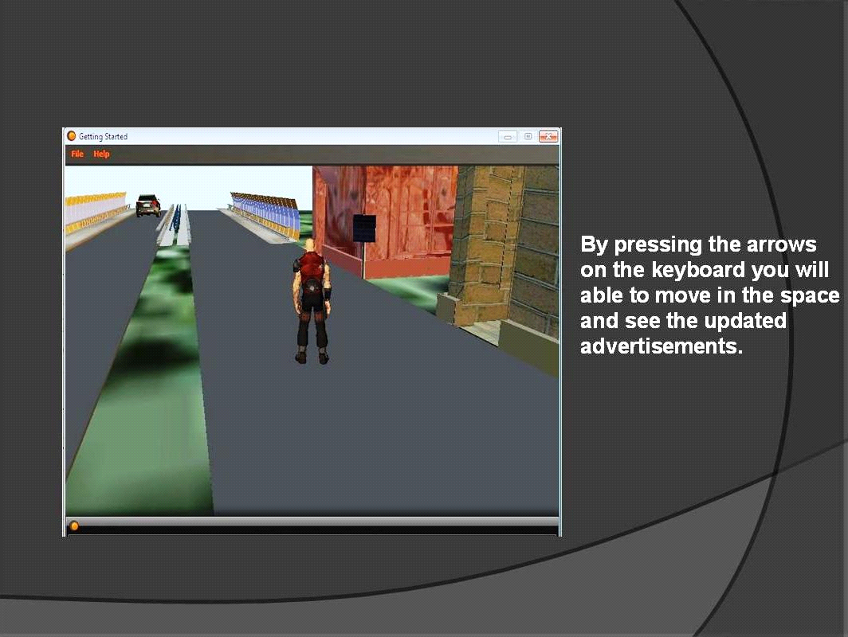

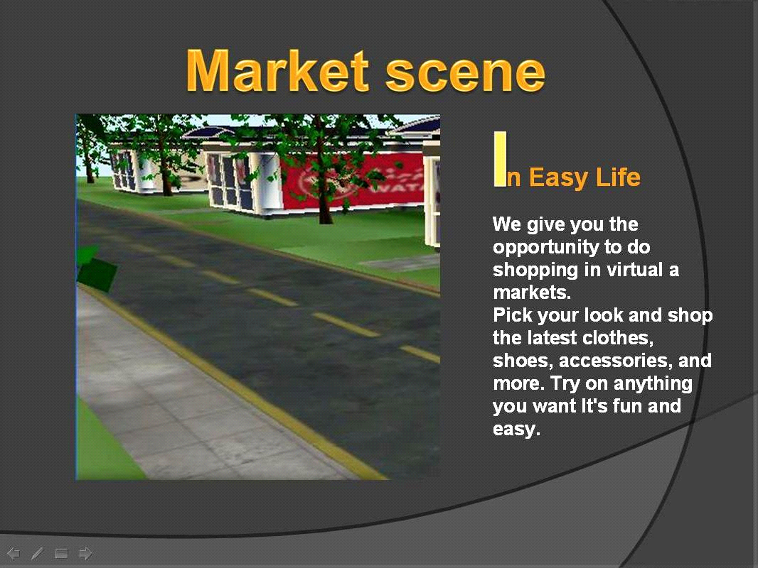
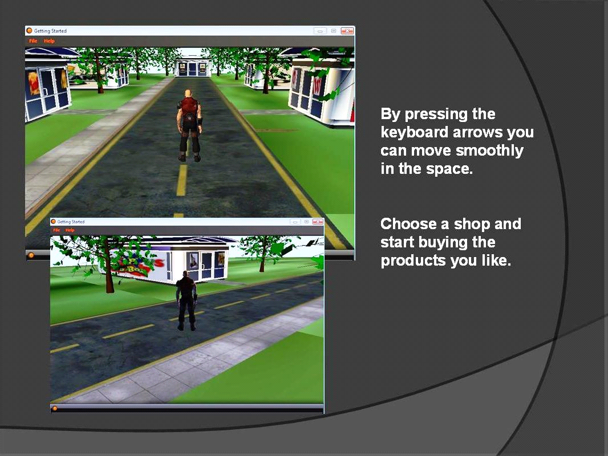
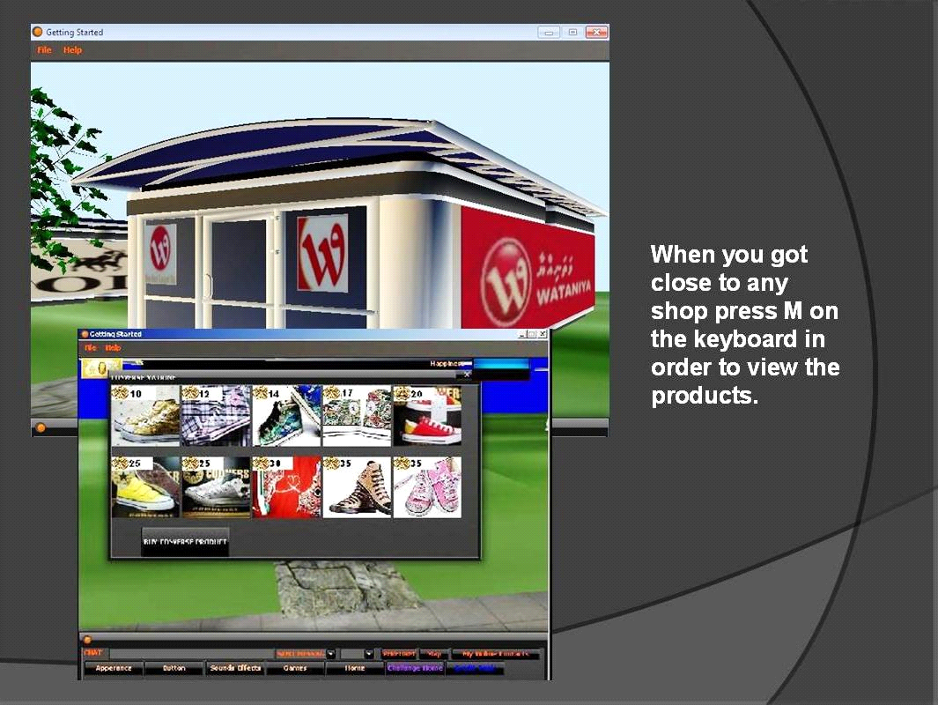

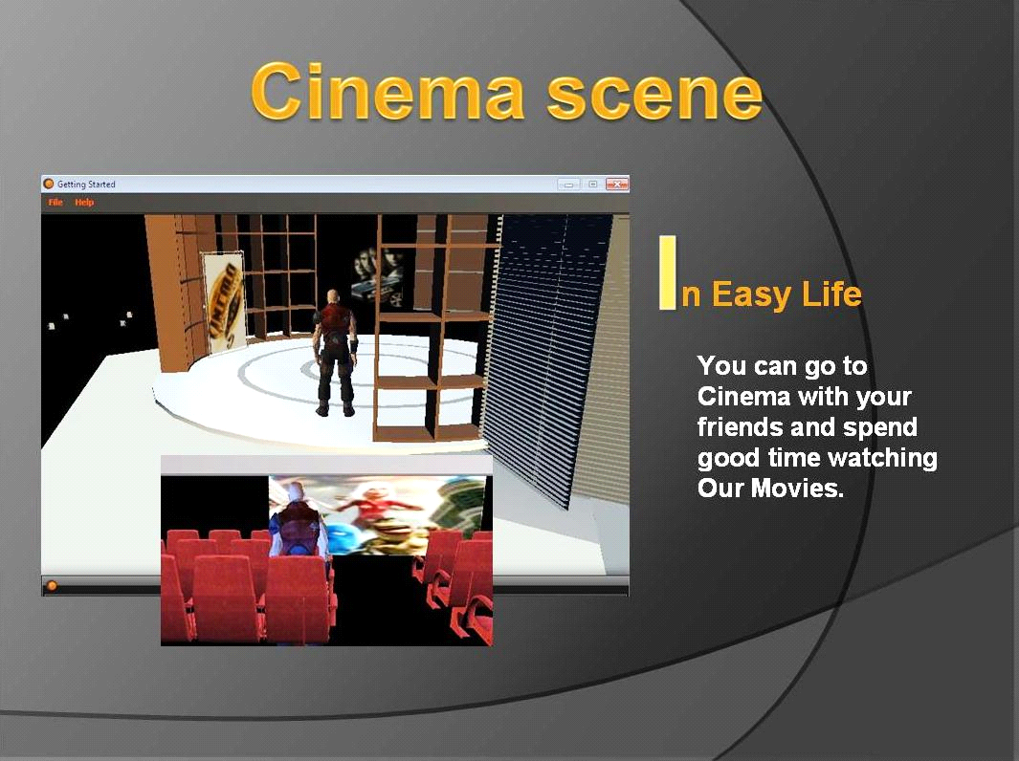
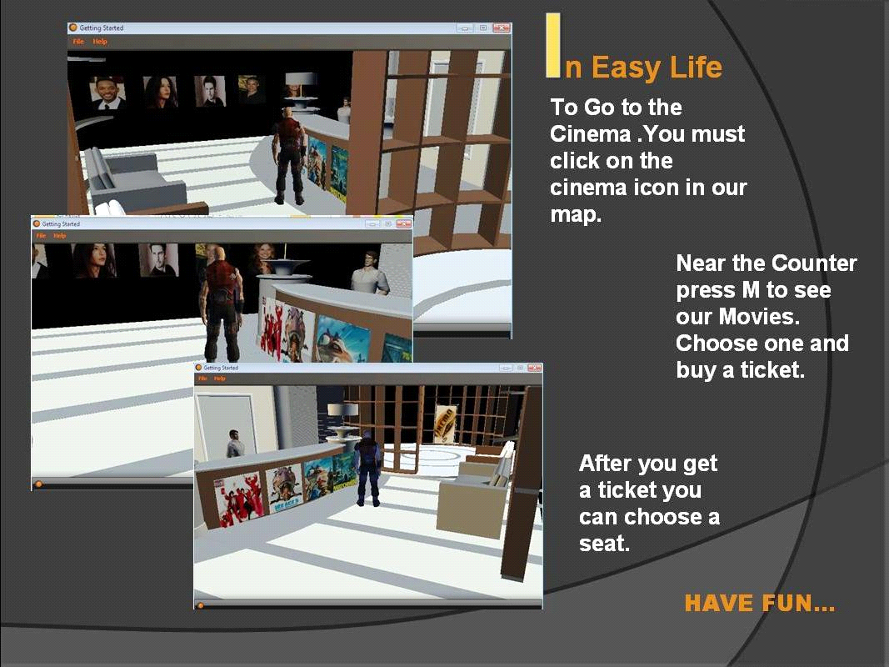

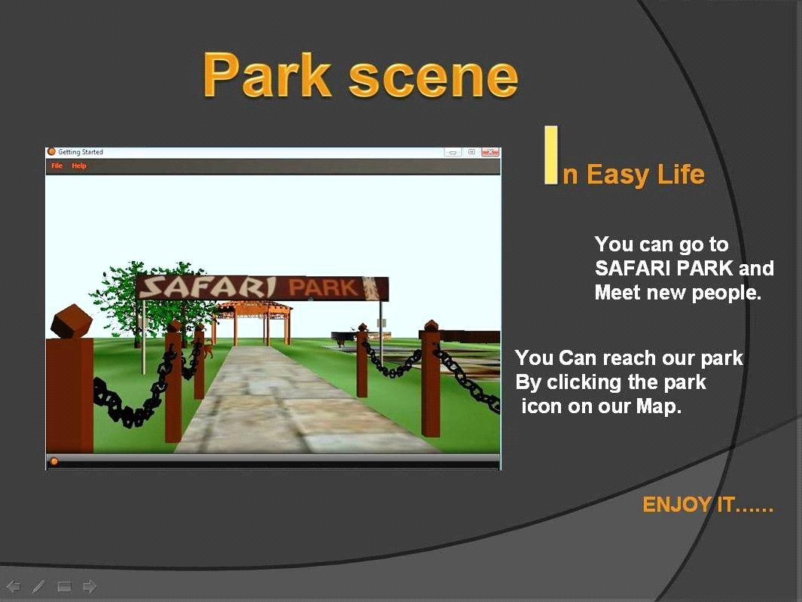
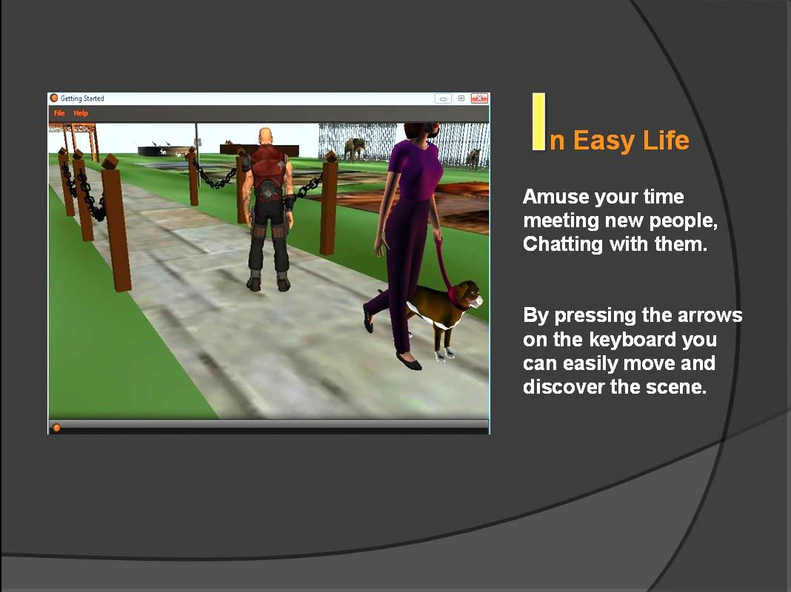
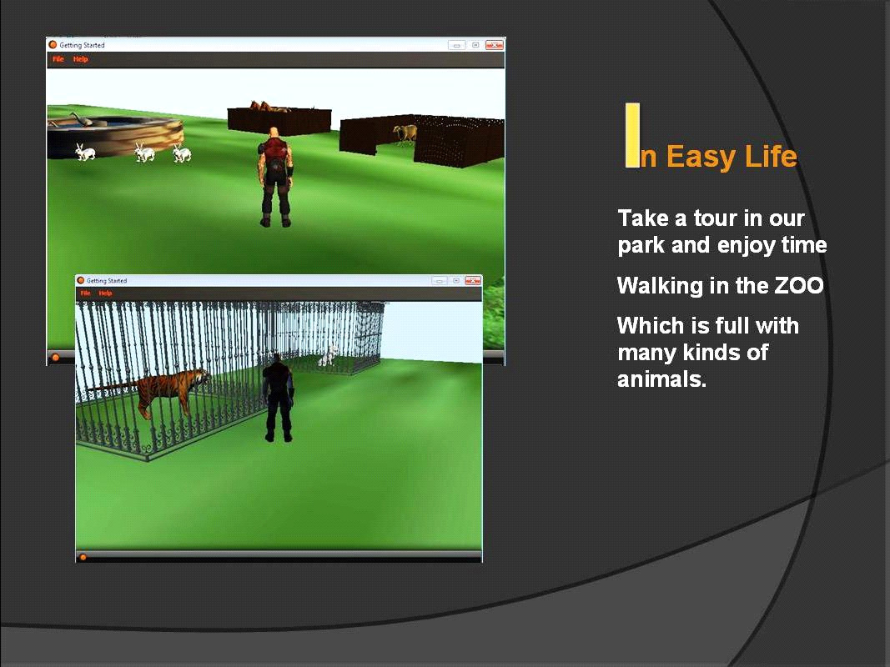

MANY GAMES ARE AVAILABLE IN EASY LIFE TO INCREASE YOU CREDIT.
FIRST SHOOTING IN THE SPACE
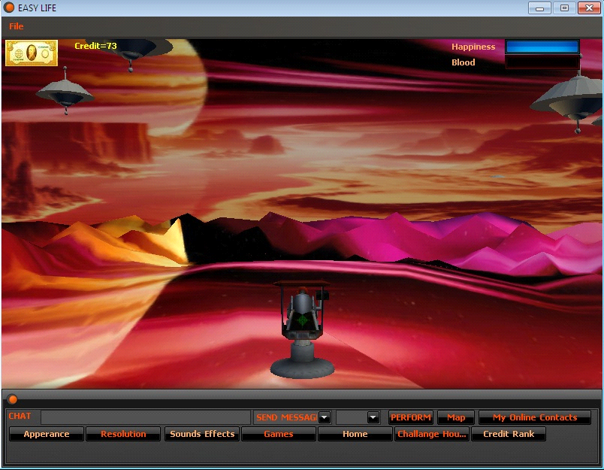

OTHER LEVEL OF SHOOTING IS SHOOTING IN THE MOUNTAIN
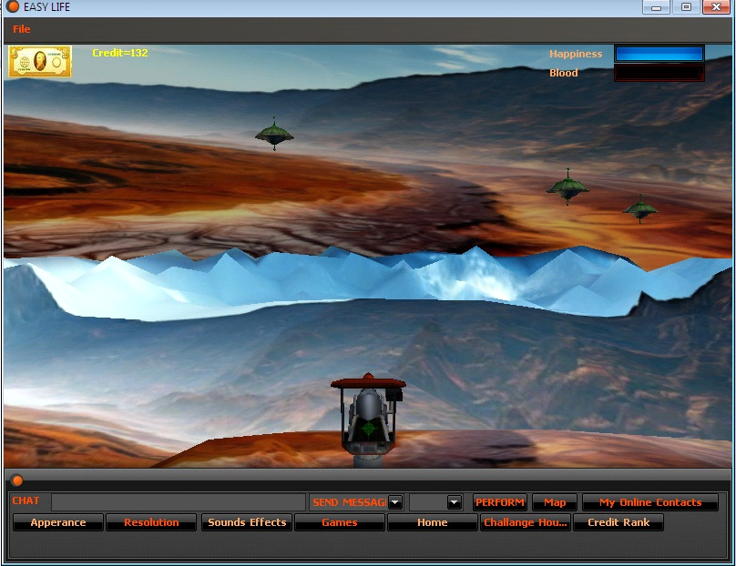

OTHER GAME IS THE CHANCE HOUSE IN WHICH YOU CAN WALK AND DROP THE BOXEX AND CHECK YOUR CHANCE TO INCREASE OR DECREASE HAPPINESS,CREDIT AND BLOOD
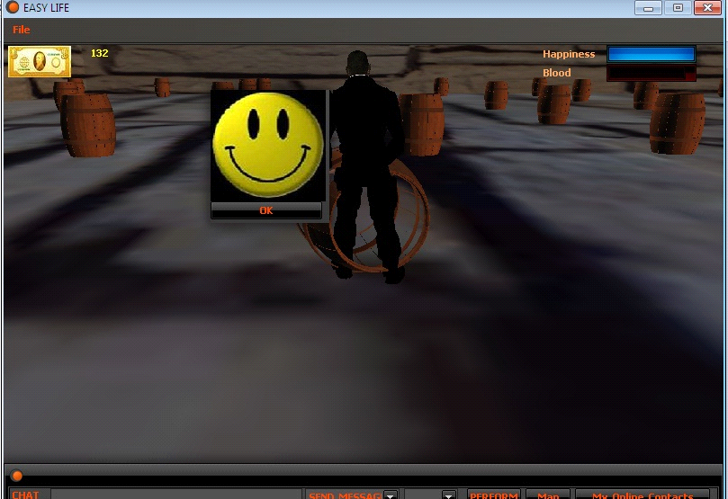

IN EASY LIFE YOU CAN SIGN IN AND DO MANY INTERACTIONS AND THE FOLLOWING PICTURE EXPLAIN SOME.
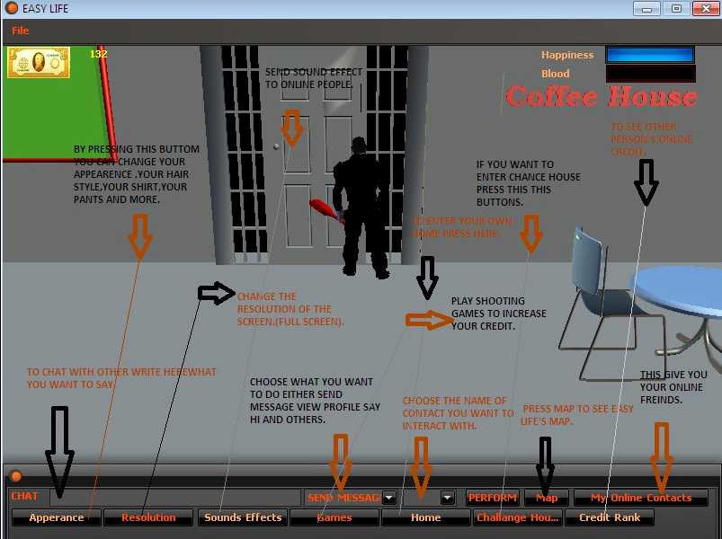

THE END

