
An-Najah National University
Faculty of Engineering and Information Technology Electrical and Computer Engineering Department



PREPARED BY:
Eyas abu saeed
Moahmmad Dawabshied

SUPERVISED BY:
Dr. Samer Arandi

September 0x, 2026

Presented in partial fulfillment of the requirements for Bachelor degree in Computer Engineering.

Dedication
First and foremost, we are grateful to God for his boundless mercy and guidance, which made our journey easier.
The teachings of our beloved prophet Muhammad, peace and blessings be upon him, have been a source of knowledge and illumination in our lives.
To the innocent souls of our martyrs, whose courage inspired hope in our hearts and whose hardships and sacrifices keep us going.
We sincerely thank our families, devoted friends, and outstanding teachers—those who secretly prayed for us, who unwaveringly believed in us, and who loved us without conditions.

This modest endeavor is an expression of the love, support, and fortitude you have shown us during this journey.

Acknowledgment

We would like to sincerely thank Dr. Samer Arandi for his leadership, helpful criticism, and ongoing project support. His dedication, tolerance, and sage counsel helped us grow and motivated us to realize our full potential.

We also want to express our gratitude to all of the instructors in the Department of Computer Engineering who dedicated their time and energy to instructing us, helping us to improve our abilities, and inspiring us during our journey. Their support of our engineering growth and recognition of our efforts has always been an honor and has motivated us to achieve this goal.

We can demonstrate that this result is a direct result of their guidance and assistance. For this, we truly appreciate all of the information, support, and motivation they have given us.

Disclaimer Statement
At An-Najah National University's Faculty of Engineering, Computer Engineering Department, Eyas abu saeed and Mohammed Dawabshieh prepared this report. Other than a few minor editorial corrections made during the assessment process, it has not been changed or edited in any way, so it might still have content and/or arena errors.

The report's conclusions, recommendations, and opinions are entirely those of Eyas abu saeed and Mohammed Dawabshieh; they do not necessarily reflect those of An-Najah National University. The use of the report for any purpose not specifically stated is not An-Najah National University's responsibility or liability.

Table of Contents
Contents
- Introduction 1
- Literature Review 3
  - Similar Machines (Systems) 3
    - Industrial AMP Robotics (AMP Cortex System)
    - Recycleye (Recycleye Robotics)
    - Everest Labs (Everest labs AI Robotics)
  - Technology and Process Techniques 5
    - Automation,Computer Vision, and Object Detection
    - The Smart Recycling and Vending Features
    - The Mechanics of Robotic Sorting Systems
  - Summary and Comparison 8
- Methodology 10
  - Design 10
    - User Interface & Interaction 10
    - Can/Bottle Dispenser
    - Conveyor Belt
    - Robotic Arm
    - Boxes
  - Materials and Tools 15
    - Microcontrollers 15
    - Motors 16
    - Sensors 18
    - I/O Devices 19
    - Drivers 20
    - Others 21
  - Software Development 23
    - Tools 23
    - Arduino Libraries 24
  - Standards and Constraints 25
    - Standards 25
    - Constraints 26
- //Results 28
  - // General Menus 28
- Discussion 30
  - Working Principle 30
    - Container Placement & Conveyor Transit
    - AI Vision & Material Classification
    - Smart Sorting Validation & Capacity Check
    - Robotic Arm Grip & Placement
    - Error Detection & Gripper Feedback

    - LCD System Status Display
    - Challenges and Solutions 33
- Conclusion, Recommendations and Future Work 35
  - Conclusion 35
  - Recommendations 36
  - Future Work 37
References 39

List of Figures (LOF):

Figure 3.1: lcd screen
Figure3.11: Arduino unor3
Figure3.12: esp32
Figure3.13: pi4
Figure3.14: sg90 servo
Figure3.15: mg996r motor
Figure3.16: 12v dc motor
Figure 3.17 : PCF8574 Adapter
Figure 3.18: lcd

Figure 3.2 : Ultrasonic
Figure 3.21: PCA9685 16-Channel PWM Driver
Figure 3.22: 1-Channel Relay Module
Figure 3.23: Illuminated Rocker Switch
Figure 3.24 DC-DC step down bulk convertor
Figure 3.25: Power Supply
3.3: Convyeor Belt
Figure 3.4: Robotic Arm
Figure 3.5 :Boxes
Figure 3.6: Bottle/Can Dispenser

Figures 4.1.1 to 4.1.3 represent sorting of metal can sample
Figures 4.2.1 to 4.2.3 represent sorting of metal can sample
Figure 4.3 Represent final result of sorting

List of Tables (LOT):
Table 1Voltage requirements for each device Table 2:Number of each tool used in the machine Table 3:Arduino libraries used in the project

Nomenclature / List of Symbols:

Roman Letters

V – Voltage (Volts, V)
I – Current (Amperes, A) P – Power (Watts, W)
T – Temperature (°C)

Greek Letters
θ – Step angle of stepper motor (degrees) Ω – Ohm, unit of resistance

Subscripts

DC – Direct Current
AC – Alternating Current

Superscripts

° – Degree symbol, angular measurement

List of Abbreviations

LCD – Liquid Crystal Display LED – Light Emitting Diode PWM – Pulse Width Modulation DC – Direct Current
AC – Alternating Current
ICSP – In-Circuit Serial Programming I2C – Inter-Integrated Circuit
IDE – Integrated Development Environment CAGR – Compound Annual Growth Rate

Abstract
This project presents the design and implementation of a fully automated recycling sorting system capable of classifying beverage containers, including metal cans, plastic bottles, and cardboard juice boxes. The system integrates a motorized conveyor belt with an automated canister loading mechanism that places items onto the belt sequentially. As a container moves along the line, it passes in front of a Raspberry Pi 4 camera module, which captures high-speed images and sends them for processing
.
To achieve high-accuracy classification, the system utilizes a custom-trained version of the YOLOv8 object detection model. While the pre-trained YOLOv8 model is general and can recognize nearly 1,000 object classes with limited domain-specific precision, it was fine-tuned using a dataset of approximately 900 custom-captured images covering all targeted categories (plastic, metal, and cardboard). This targeted training significantly enhanced classification accuracy. Following identification, a 5-axis robotic arm picks up the container and places it into its corresponding designated bin.

The system features robust safety and monitoring mechanisms; each collection bin is equipped with a depth sensor to detect if it is full, preventing the robotic arm from placing items into an overflowing bin. Additionally, to handle potential gripping failures due to precise angular constraints, a fallback mechanism detects unsuccessful picks and routes the container to the end of the belt, where it drops into a designated fallback box. A 4-row LCD screen displays real-time operational data, including the detected material type, item counts for each category, and the estimated total weight per material type. Rooted in a commitment to the positive environmental and economic impacts of recycling, this project demonstrates a reliable, automated waste-sorting solution.

Chapter 1

Introduction

In recent years, latest reports indicate that the waste recycling services market was valued at approximately USD 68.2 to 69.9 billion, and it is projected to grow at a compound annual growth rate (CAGR) ranging from 6.3% to 6.7%, reaching nearly USD 120 billion in the coming years. Specifically, the beverage container market is estimated at USD 28.6 to 30.5 billion, with expectations to reach USD 53 billion at a CAGR of 6.3%.
Recently, waste sorting has become an urgent necessity rather than merely an option, as we face severe environmental damage caused by plastic bottles, metal cans, and other waste discarded on land and in oceans. Furthermore, raw materials are facing a continuous shortage; therefore, recycling helps compensate for this deficit.

Despite this urgent necessity, the recycling sector still suffers from a lack of technological advancement and relies heavily on manual sorting, which poses severe health hazards to workers. The high levels of bacteria present on these wastes can cause serious health complications for human operators. Consequently, introducing technology into this field is essential to safeguard human health and minimize operational errors.

The objective of this project is to design and develop a fully automated sorting system for beverage containers and recyclable waste (such as metal cans, plastic bottles, and cardboard boxes) without human intervention. The system relies on a motorized conveyor belt, an imaging unit connected to a processing device, and a custom-trained YOLOv8 object detection model fine-tuned for high-accuracy material recognition. Additionally, it features a 5-axis robotic arm to direct each item into its designated bin, equipped with fallback mechanisms for failed pickups, depth sensors to monitor bin capacity levels, and a 4-row LCD screen to display real-time data.

The significance of this project lies in its practical application of computer vision, deep learning, embedded control systems, and real-time automation within an integrated engineering environment. From an educational standpoint, it provides students with hands-on experience in hardware-software integration, resolving mechanical synchronization challenges, and bridging artificial intelligence algorithms with real-world applications.

The format of this report is as follows: Chapter 2 examines relevant and earlier research. System design, software and hardware development, and process integration are all covered in Chapter 3's description of the methodology. Results and analysis are presented in Chapter 4. The new findings are thoroughly discussed in Chapter 5. Chapter 6 concludes with conclusions, suggestions, and potential improvements.

Chapter 2

Literature Review

In recent years, the integration of automation, computer vision, and machine learning in waste management has gained significant attention. Traditional waste sorting relies heavily on manual labor, which is inefficient, time-consuming, and hazardous to human health due to bacterial contamination and sharp objects. Consequently, researchers and engineers have increasingly focused on developing automated sorting systems utilizing smart sensors, conveyor mechanisms, and artificial intelligence. This chapter reviews earlier research and technological advancements related to automated waste sorting, object detection models, and robotic arm integration

  - Similar Machines (Systems)

    - Industrial AMP Robotics (AMP Cortex System)
• How it works: Industrial AMP Robotics is a global leader in AI-powered waste sorting. Their technology uses high-speed computer vision (powered by their proprietary AI platform, AMP Neuron) to scan mixed recyclables moving along industrial conveyor belts. High-speed robotic pick-and-place arms then rapidly identify and sort materials—such as plastics, metals, and cardboard—at speeds exceeding typical human manual sorting.
• Relation to Your Project: This directly mirrors your system's architecture, combining a conveyor belt, a computer vision camera, an advanced object-detection AI model, and a robotic manipulator to automate sorting.

    - Recycleye (Recycleye Robotics)
• How it works: Recycleye develops automated sorting solutions using machine learning and computer vision to audit and sort dry mixed recycling. Their AI algorithms analyze high-resolution images of waste streams to classify items by material type, shape, and brand, directing robotic arms to pick and separate items accurately.
• Relation to Your Project: It highlights the exact concept of training object detection models to differentiate between challenging recyclable streams (like plastics, paper, and metal) to overcome the limitations of manual labor.

    - EverestLabs (Everest Labs AI Robotics)
• How it works: EverestLabs provides AI-driven robotics and operating systems specifically designed for Material Recovery Facilities (MRFs). Their smart robotic cells target and recover specific beverage containers, aluminum cans, and rigid plastics from moving waste streams to maximize recovery rates and purity.
• Relation to Your Project: It aligns closely with your project's primary focus on sorting beverage containers and recyclable packaging efficiently using automated robotic guidance.

Technology and Process Techniques

    - Automation,Computer Vision, and Object Detection Nowadays, high-resolution cameras and advanced deep learning models (such as YOLOv8) deployed on automated conveyor lines enhance the sorting accuracy of recyclable materials. By identifying non-biodegradable items, sorting plastics from metals, and anticipating mechanical or sensor adjustments before a failure occurs, these systems increase the overall efficiency and dependability of automated waste management.

    - Smart Recycling and Vending Features Current research highlights technological trends in automated waste separation, such as IoT-enabled monitoring, smart bin tracking, and automated touchless sorting mechanisms. These developments are altering municipal waste management behavior and increasing the adaptability and cost-effectiveness of automated eco-friendly retail and public disposal units.

    - The Mechanics of Robotic Sorting Systems The precise interaction between conveyor speed, computer vision inference time, and robotic manipulator actuation is essential to sorting systems. Maintaining accurate coordination between the camera frame capture and the multi-axis robotic arm is crucial to picking items precisely as desired. Automated sorting is intended to handle high-throughput refuse items rapidly, offering more feasible waste separation than manual human sorting, even though traditional facilities operate at massive industrial scales.

Summary and Comparison

Aspect | Existing Systems Provide | Echo Vision
Automation & Control | Large-scale industrial sorting with high-speed pneumatic and optical sorters [1] | Compact conveyor belt automation with precise computer vision and multi-axis robotic arm control
Technology Integration | Heavy industrial robotic arms (e.g., AMP Cortex) with high-cost proprietary setups [2] | Cost-effective microcontrollers (ESP32 / Arduino), webcams, and optimized AI models (YOLOv8)
Processing & Vision | Industrial-grade server-based cloud processing and hyperspectral camera | Localized edge processing via embedded hardware and standard optical webcams
Industrial Quality Control | Industrial optical sorting sensors + predictive maintenance algorithms [3] Goff, H. D., & Hartel, R. W. (2013). Material Recovery (7th ed.). Springer Science & Business Media. | Real-time object classification + multi-class waste segregation (plastics, metals, paper)
Modern Vending Trends | Contactless public recycling bins, biometric features, and automated smart retail [4] Academic Project. (2005). Automated sorting prototype. University Thesis, University of California. [5]. | IoT-enabled smart sorting stations, automated conveyor-to-bin routing, and low-cost educational recycling units
Soft-Serve Science | ptimal conveyor synchronization and material flow balance ensures high-throughput sorting [6] | Precise camera-to-arm timing and gripping force ensure accurate item picking and binning

There are numerous systems available today that automate the sorting of waste or industrial recycling, but they are primarily designed for large-scale municipal facilities or commercial plants. In a low-cost, compact prototype that is sufficiently integrated to allow for complete automation of the process—from real-time object detection and material classification to conveyor transport, robotic arm picking, and bin sorting—very few systems can take this accessible, educational approach into account.
The project intends to close this gap by developing a fully automated waste sorting line that combines computer vision, embedded systems, and electromechanical design to provide both automated sorting efficiency and educational advantages.

The system design, hardware and software components, materials and tools, as well as the standards and limitations adhered to in this project, are presented in the following chapter, Chapter 3 (Methodology).

Chapter 3

Methodology

  - Design

    - User Interface & Interaction
The user can interact with the machine through:
Switches: used to power the system on and off (e.g., physical toggle or slide switches to disconnect or connect the main power supply and activate operational modes).
• LCD Screen (16x4): displays real-time operational status and system statistics.
The displayed information includes:
1-Connection Status: shows whether the system is connected or disconnected.
2-Material Type: displays the currently identified material category.
3-Statistics: shows container counts and approximate weights for each material type.
4-Gripper Status: indicates whether the robotic arm's container-holding action succeeded or failed.

Figure 3.1: Screen

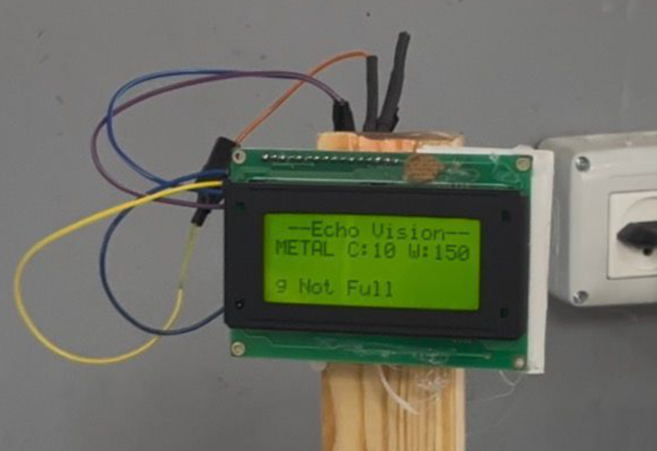

3.1.2 Can/Bottle Dispenser
- Automatic Can Dispenser: Designed and integrated using simple, accessible components despite the inherent mechanical complexity of vertically dispensing cups upright. The mechanism utilizes a plastic cup holder, two servo motors, and wooden sticks, successfully achieving smooth, reliable, and excellent operational results.

Figure 3.6:Dispenser
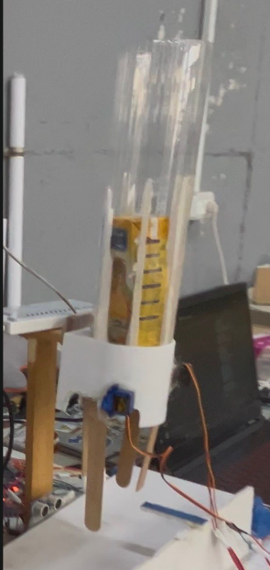

3.1.3 Conveyor Belt
- Conveyor Belt: Operates in a single direction and is controlled by a relay, responsible for transporting the container along its entire journey from start to finish through multiple stages (such as stopping in front of the camera for analysis, then the robotic arm station, etc.). This line is managed entirely through hardware using ultrasonic sensors that send precise signals to control movement or stopping at the required stations.

Figure 3.3: Belt
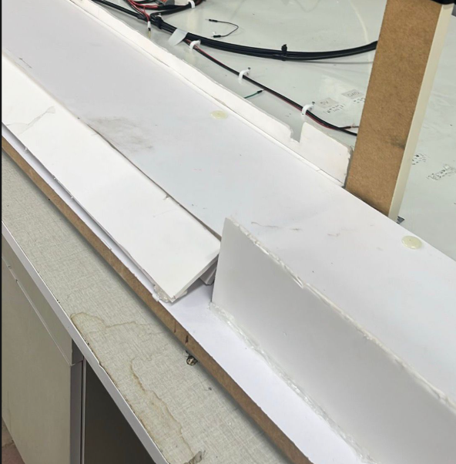

3.1.4
Robotic Arm
- Robotic Arm: A 5-axis robotic arm responsible for picking up containers and sorting them into boxes. It is controlled via custom Python software that enables manual control of each joint using the keyboard, as well as the ability to record arm movements to execute them automatically later.
Figure 3.4 :Arm

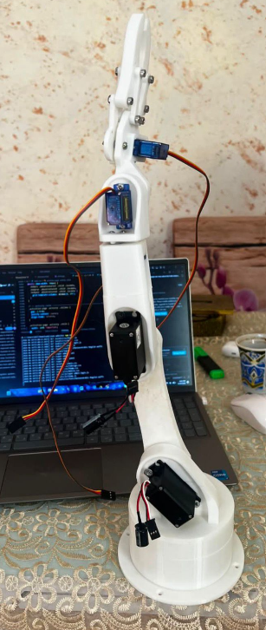

3.1.5 Boxes
Smart Wooden Boxes: Custom-built wooden containers, each dedicated to a specific material type. They feature integrated sensors to monitor capacity in real-time and automatically detect whether the box is full.

Figure 3.5:boxes
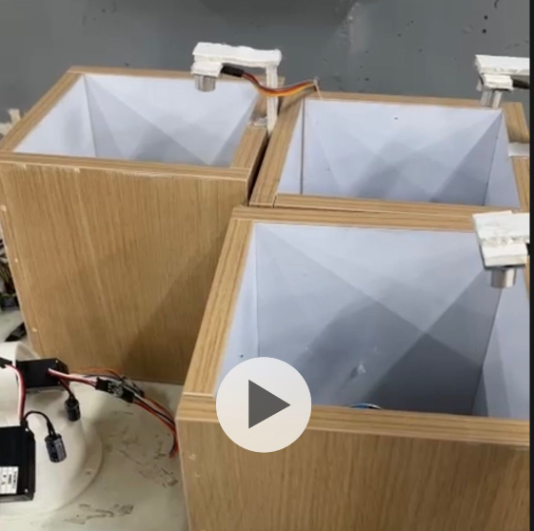

Materials and Tools

    - Microcontrollers

Arduino Uno : A well-known microcontroller based on the ATmega328P, with the following features:
- 14 digital input/output pins (of which 6 can be used as PWM outputs).
- 6 analog inputs.
- 1 UART (hardware serial port).
- 16 MHz crystal oscillator.
- USB connection.
- Power jack.
- ICSP header.
- Reset button.
In this project, the Arduino Uno board was used for conveyor and dispensing management.
Arduino Uno: Dedicated to handling the conveyor belt movement and its associated ultrasonic sensors for motion control and positioning. It also controls the cup/can dispenser mechanism. It communicates and receives execution instructions from the ESP32 via serial communication to regulate its movement.
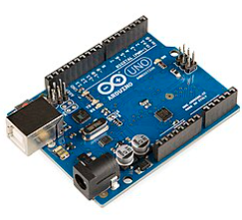
3.11: arduino uno r3
This setup ensured precise local sensor integration, reliable real-time motor actuation, and distributed processing complexity.

ESP32 : A powerful, feature-rich Wi-Fi and Bluetooth-enabled microcontroller system-on-chip, with the following features:
- Extensive digital and analog GPIO pins with superior PWM support for precise servo and motor angle control.
- Built-in support for multiple UART, SPI, and I2C interfaces.
- Integrated SD card interface support for local data logging.
- Ultra-low power co-processor capabilities.
- Integrated Wi-Fi and dual-mode Bluetooth.
In this project, the ESP32 board was chosen as the master controller for the robotic arm and structural sensors.
ESP32: Dedicated to controlling the multi-axis robotic arm actuators—chosen specifically because the arm requires high angle precision, and the ESP32 provides superior and more accurate PWM support compared to the Uno. It also handles the SD card reader module and an ultrasonic sensor dedicated to measuring bin depth. Furthermore, it communicates via serial interface with the Raspberry Pi to receive classification data.
This distribution of tasks ensured high-precision angle execution, local data logging capabilities, and
robust multi-chip communication.

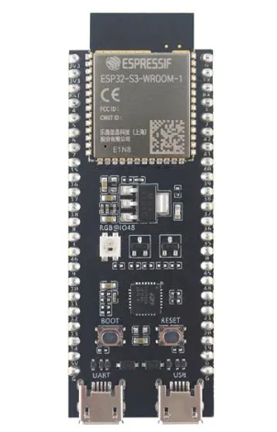
3.12: esp32 s3 dev module
This distribution of tasks ensured high-precision angle execution, local data logging capabilities, and robust multi-chip communication.

Raspberry Pi : A high-performance single-board computer running a Linux environment, with the following features:
- Multi-core ARM Cortex processor capable of handling heavy computational tasks.
- High-speed USB ports and CSI camera connector interface.
- Extensive general-purpose input/output (GPIO) pins.
- Built-in Wi-Fi, Bluetooth, and Ethernet networking capabilities.
- HDMI display outputs and micro-SD card storage slot for the operating system.
In this project, the Raspberry Pi board was used as the core vision processing unit.
Raspberry Pi: Dedicated to running the computer vision and AI model (e.g., YOLOv8 for waste classification). It is directly connected to the camera to capture video frames, process the visual data, identify the object type, and communicate this classification result to the ESP32 via serial communication.
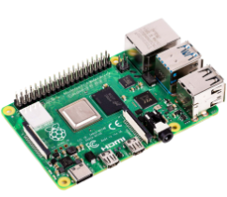
3.13: rassperry pi 4
This setup ensured powerful edge-AI processing capabilities, real-time object detection, and seamless bridge integration with the hardware control layer.

    - Motors
- Tower Pro SG90 Servo Motor : A tiny and lightweight rotary actuator commonly used in small-scale robotics and embedded systems, with the following features:
- vOperating voltage of 4.8V to 6V. vStuck torque of approximately 1.8 kg·cm (at 4.8V). vOperating speed of 0.12 s/60° (at 4.8V). vGear type: Plastic gears. vRotation angle of 180 degrees (90 degrees in each direction). vPWM control signal interface.
- In this project, two Tower Pro SG90 servo motors were used in the robotic arm structure.
- PWM-based control is the primary operating principle: v Pulse Width Modulation: The motor's position is regulated by sending a PWM signal where the pulse duration determines the target rotation angle. v Gear Reduction & Actuation: Internal plastic gears translate the rotational force of the DC motor into precise angular movement for the arm joints or gripper. v Holding Torque: The internal control circuit maintains the shaft position as long as the valid PWM signal is supplied.
- The robotic arm joints are kept at precise, steady angles for the ideal sorting and picking accuracy thanks to these actuators. The ESP32 microcontroller manages the servo motors' PWM control signals in a safe and accurate manner.
- Figure 3.12: Tower Pro SG90 Servo Motor

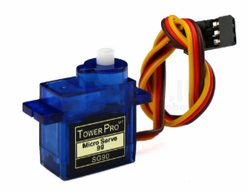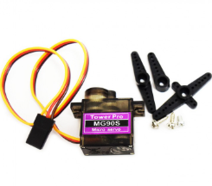
3.14 : sg90 servo, metal and plastic one
MG996R Servo Motor : A high-torque digital metal-gear servo motor commonly used in heavy-duty robotics and mechanical arms, with the following features:
vOperating voltage of 4.8V to 7.2V. vStuck torque of approximately 9.4 kg·cm (at 4.8V) up to 11 kg·cm (at 6V). vOperating speed of 0.19 s/60° (at 4.8V) or 0.15 s/60° (at 6V). vGear type: Durable metal gears. vRotation angle of 180 degrees (90 degrees in each direction). vPWM control signal interface.
In this project, four MG996R servo motors were used in the robotic arm structure to handle high-load joints.
PWM-based control is the primary operating principle: v Pulse Width Modulation: The motor's exact position is regulated by sending a PWM signal where the pulse duration determines the target rotation angle. v Gear Reduction & Actuation: Internal heavy-duty metal gears translate the rotational force into robust angular movement for the primary arm joints and gripper. v Holding Torque: The internal control circuit maintains the shaft position under load as long as the valid PWM signal is supplied.
The robotic arm joints are kept at precise, steady angles capable of lifting and sorting waste items thanks to these high-torque actuators. The ESP32 microcontroller manages the servo motors' PWM control signals in a safe and accurate manner.
3.15 mg996r

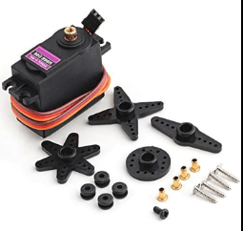

12V DC Motor : A reliable and widely used direct current electric motor commonly used in automation and conveyor systems, with the following features:
vOperating voltage of 12V DC. vHigh torque and speed capabilities suitable for continuous mechanical drive. vBidirectional rotation control via polarity reversal or motor driver modules. vCompact size with integrated or external gear reduction options for increased torque. vDirect power input interface for robust operation.
In this project, a 12V DC motor was used to drive the conveyor belt.
Direct current motor actuation is the primary operating principle: v Electrical-to-Mechanical Conversion: Electrical energy supplied at 12V DC is converted into continuous rotational motion. v Speed & Direction Control: The motor's operation is regulated through driver modules to manage the speed and running direction of the conveyor belt. v Torque Transmission: Mechanical power is transferred from the motor shaft to drive the belt smoothly.
The conveyor belt is kept moving at a steady, reliable speed for the ideal item transport and sorting flow thanks to this continuous operation. The Arduino Uno microcontroller, in conjunction with a motor driver, manages the DC motor's current and switching needs in a safe and efficient manner.

3.16: dc motor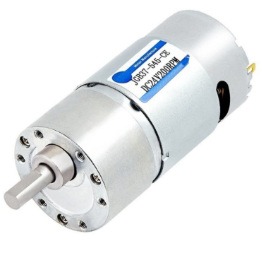

INTERFACE OF MOTORS:

12V DC Motor Pinout & Connections
- Power Terminals (Positive & Negative): Connects to the motor driver output terminals (e.g., L298N or BTS7960) to receive power and control signals.
- Control / Enable Pins: Connected to the Arduino Uno digital and PWM pins via the motor driver interface to regulate speed and direction.

· Tower Pro SG90 Servo Motor Pinout & Connections
- PWM Signal Pin (Orange / Yellow wire): Connected to a digital PWM pin on the ESP32 microcontroller to receive the control angle signals.
- Power Pin ($V_{CC}$ / Red wire): Connected to the 5V power supply source.
- Ground Pin (GND / Brown / Black wire): Connected to the common ground (GND) of the system.

· MG996R Servo Motor Pinout & Connections
- PWM Signal Pin (Orange / White wire): Connected to a high-resolution PWM pin on the ESP32 microcontroller for precise high-torque joint positioning.
- Power Pin ($V_{CC}$ / Red wire): Connected to an external 5V–6V power source (recommended separate from the microcontroller to handle high current draws).
- Ground Pin (GND / Brown / Black wire): Connected to the common system ground (GND).

    - I/O Devices

16 * 4 LCD : An informative output that can be used to display characters and sometimes graphics, it supports two types of information: data or control commands (clear the screen, set the cursor, etc.) and it can be used in both byte-mode (8-bits) or nibble mode (4-bits). It has the following connection pins:

Vcc
- Vss or GND
- Vo: for controlling the contrast via a potentiometer
- D0 - D7: data pins.
- R/W (Read / Write): for selecting reading mode or writing one
- RS (Register Select): for setting the information type (data or control command).
- EN (Enable): for enabling the LCD.

LCD requires two many pins. So, we used I 2C LCD that uses an adapter PCF8574 that converts the LCD multiple connection pins into only four ones (Vcc, GND, SCL and SDA).
It used in this machine to allow the user to monitor and track the transaction (displaying menus, showing results, etc.).
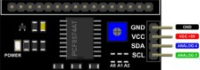

Figure 3.17: PCF8574 Adapter
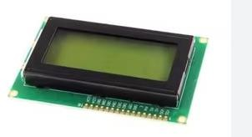
Figure 3.18: 16 * 4 LCD

Sensors:

Ultrasonic Sensor (HC-SR04) : An electronic sensor that measures distance by emitting high-frequency ultrasonic sound waves and calculating the time interval between transmission and echo reception.
It has the following connection pins:
- VCC: Power supply (5V).
- Trig (Trigger): Input pin used to trigger the transmission of ultrasonic pulses.
- Echo: Output pin that produces a pulse width proportional to the measured distance.
- GND: Ground.
In this project, the ultrasonic sensors are mounted above the sorting compartments or containers to detect object presence, measure distance, and monitor the filling status in real-time, providing reliable feedback to the microcontroller.
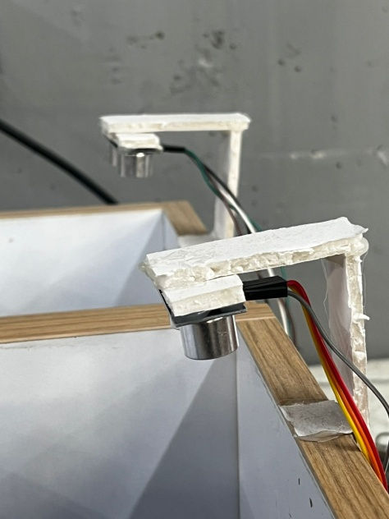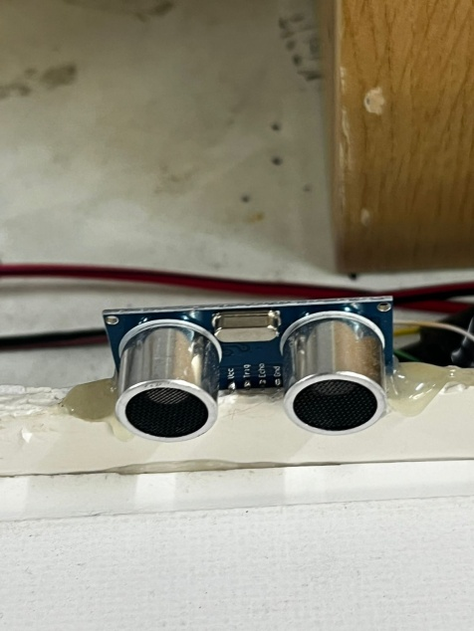
Figure 3.20: Ultrasonic Sensor

    - Drivers
PCA9685 16-Channel PWM Driver : A 16-channel, 12-bit PWM driver controlled via the I2C interface, allowing a microcontroller to control multiple servo motors or LEDs simultaneously while using only two microcontroller pins (SDA and SCL).
It has the following connection pins:
- VCC: Logic power supply (3.3V / 5V).
- GND: Ground.
- SDA & SCL: I2C communication lines for data transmission and clock.
- V+: External power supply input for the connected motors/servos.
- PWM Outputs (0–15): 16 individual PWM channels to control actuators.
In this project, the PCA9685 driver is used to provide independent PWM signals and precise position control for multiple servo motors, reducing the wiring complexity and relieving the microcontroller from handling heavy real-time PWM generation.
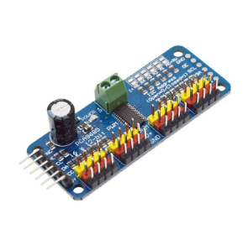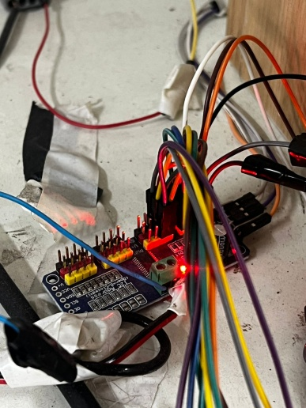

Figure 3.21: PCA9685 16-Channel PWM Driver
    - Others
1-Channel Relay Module : An electrically operated switch module that uses low-voltage signals from a microcontroller to control high-voltage or high-current devices. It acts as an isolation layer, allowing safe switching of AC or DC loads.
It has the following connection pins:
- VCC: Power supply (typically 5V or 12V depending on the module).
- GND: Ground.
- IN (Control Input): Control input pin to activate the relay.
- NO (Normally Open): Output terminal that is open by default, and closes when the relay is activated.
- NC (Normally Closed): Output terminal that is closed by default, and opens when the relay is activated.
- COM (Common Contact): Central connection pin for the relay channel.
In this project, the 1-channel relay module is used for switching high-power components or individual actuators, providing electrical isolation and safe operation controlled by the system's microcontroller.
.

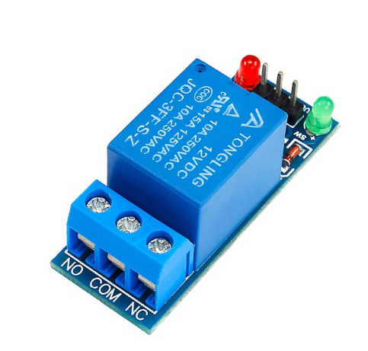
Figure 3.22: 1-Channel Relay Module

DC Diaphragm Pump [12] : A small electrically driven pump that uses a diaphragm mechanism to transfer liquids. The pump operates by moving a flexible diaphragm back and forth, creating suction on one side and discharge on the other, which enables continuous liquid flow.

The main specifications (typical for this pump type) are:

- Operating Voltage: 6–12 V DC.
- Current Consumption: ~0.5–0.7 A.
- Flow Rate: ~1–3 L/min (depending on voltage and load).
- Pressure Capacity: up to 2–3 bar.
- Pump Type: Diaphragm, self-priming, suitable for low-viscosity liquids.

In this project, the DC diaphragm pump is used to deliver milk from the storage container into the mixing chamber. It is powered via a relay module controlled by the Arduino Mega, ensuring safe switching of the pump during the automated process.

Illuminated Rocker Switch : An electromechanical switching device featuring a built-in indicator light, used to manually connect or disconnect the main power supply to the system.
It has the following connection terminals (typically 3 pins):
- Power In (Line / Live): Connects to the main power source input.
- Power Out (Load): Connects to the system components or power supply unit.
- Ground / Neutral: Connected to complete the internal circuit for the illumination lamp.
In this project, the illuminated rocker switch is used as a main power master switch mounted on the enclosure structure, allowing safe manual control and clear visual indication when the machine is powered on.
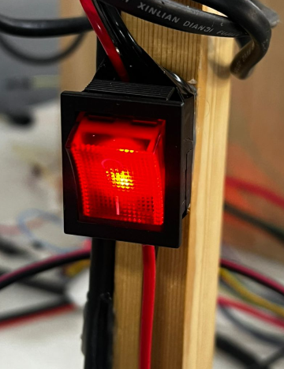
Figure 3.23: Illuminated Rocker Switch
DC-DC Step-Down Converter (Buck Converter) : A high-power adjustable voltage regulator module that steps down a higher DC input voltage to a stable lower DC output voltage with high efficiency. It features large toroidal inductors, aluminum heat sinks for thermal dissipation, and precision multi-turn potentiometers for Constant Voltage (CV) and Constant Current (CC) regulation.
It has the following terminal connections:
- IN+ / IN-: DC input power supply terminals.
- OUT+ / OUT-: Regulated DC output power terminals.
- CV Potentiometer: For adjusting and setting the desired output voltage level.
- CC Potentiometer: For setting the output current limiting threshold to protect connected loads.
In this project, the DC-DC step-down converters are used to regulate and distribute stable, customized voltage levels from the main power source to sensitive electronic modules, sensors, and control sub-circuits.
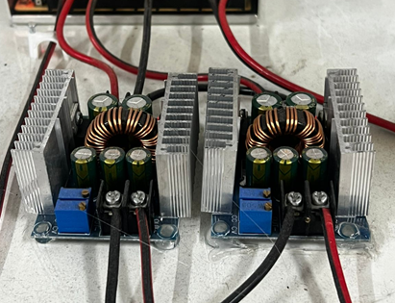
Figure 3.24 DC-DC step down bulk convertor
Switching Power Supply : An enclosed electronic power supply unit featuring an integrated cooling fan and a perforated metallic enclosure for efficient heat dissipation. It is designed to convert alternating current (AC) mains electricity into stable direct current (DC) voltages required by the system's actuators and controllers.
It has the following terminal connections and features:
- L (Live) & N (Neutral): AC mains input terminals.
- Ground (Earth): Safety ground terminal for electrical protection.
- -V & +V: DC voltage output terminals.
- Built-in Fan Control Circuit: Operates automatically according to the working temperature to maintain optimal thermal conditions.
In this project, the switching power supply serves as the primary backbone power source, converting AC wall power into reliable DC power rails to drive the system's high-power components, motor drivers, and control boards safely.

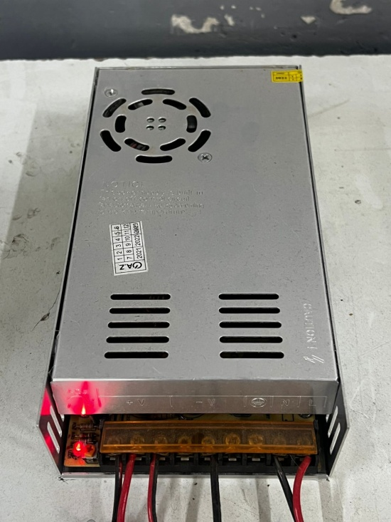
Figure 3.25: Power Supply

The following table shows the number of each tool used in this machine:

Tool | Number of Items
Arduino-Uno | 1
Esp32 s3 module | 1
Raseberry pi 4 | 1
Rasseberry pi camera | 1
16 * 4 LCD | 1
Sg90 Servo motor | 5
Mg996r Servo motor | 4
12v dc motor | 1
Ultrasonic Sensor | 7
PCA9685 driver for servo | 1
Relay | 1
DC-DC step down bulk convertor | 1
Power Supply | 1
Switches | 2
Table 2:Number of each tool used in the machine

Software Development

    - Tools

- Arduino IDE: An open-source environment used to write and upload code to microcontrollers like the ESP32 and Arduino.
- WSL SSH Connection: Used for secure remote connection and management of the Raspberry Pi 4.
- Custom Robotic Arm Software: A dedicated Python script developed to control and calibrate the robotic arm joints.
- PyCharm: Utilized for inspecting, debugging, and managing the AI model code.
- AI Model Training: Models were trained using Ultralytics YOLOv8 frameworks combined with custom dataset annotation workflows and PyTorch for real-time object classification and detection.

    - Arduino Libraries Arduino provides multiple libraries to deal with various hardware tools, the following table shows the libraries used in this project:

Tool | Library -If any
Arduino-Uno r3 | Arduino.h
PCA9685 | Wire.h
Servo Motor | Adafruit_PWMServoDriver.h+Servo.h
UltraSonic | NewPing.h
16 * 4 LCD | LiquidCrystal I2C.h
Dc momtr | -
Switch | -
relay | -
Table 3:Arduino libraries used in the project

For pi4 & Ai module:
CV2
Ultralytics
RPi.GPIO
torch
serial

Standards and Constraints

    - Standards Electrical Safety Standards:
Each component was handled with care by reading its datasheet and understanding its voltage and current requirements. Based on this, isolated external power sources—separated from the microcontrollers' power supply—were used, along with step-down voltage converters (buck converters), drivers, and relays to protect against any electrical hazards.

.
Embedded System Practices:
The microcontrollers were utilized in modern and standard ways. Communication techniques via serial were applied among all microcontrollers, and the code uploaded to them utilized the official environment for each microcontroller.
.

    - Constraints

• Technical & Control Constraints:
- Robotic Arm Complexity: Programming the 6-axis robotic arm posed a significant challenge, as multiple motors had to operate simultaneously at precise, synchronized angles. Additionally, motion jitter occasionally occurred due to the susceptibility of PWM control signals to electrical noise.
- Communication Protocol Overhauls: Establishing reliable, orderly communication between microcontrollers was a major hurdle. Initially, the ESP module communicated via Wi-Fi with the Raspberry Pi; however, due to unstable workshop internet, the system frequently froze. We then switched to Bluetooth, which suffered severe interference from neighboring devices operating on the same frequency channel (confirmed via an RF Analyzer tool), causing repeated disconnects and system halts. The final, robust solution was implemented via wired Serial communication between the devices.
- Power Management: Supplying adequate current for the massive array of motors and hardware modules was extremely difficult. Sourcing a stable power supply capable of delivering 25A proved scarce and was only barely sufficient to handle the peak load.
• Cost Constraints: The overall project expenses exceeded initial expectations due to the extremely high market prices of key components—particularly the Raspberry Pi 4, its dedicated camera module, and other specialized hardware parts locally available at inflated costs.
• Time Constraints: The project was bound to an intensely condensed summer academic semester, imposing a severe time limitation. This rigorous schedule exhausted the team, requiring mandatory daily work from 8:00 AM to 5:00 PM throughout the entire week, leaving minimal room for extended troubleshooting or advanced system optimization.

Chapter 4

Results

Below Figures represent a sample of a metal can.

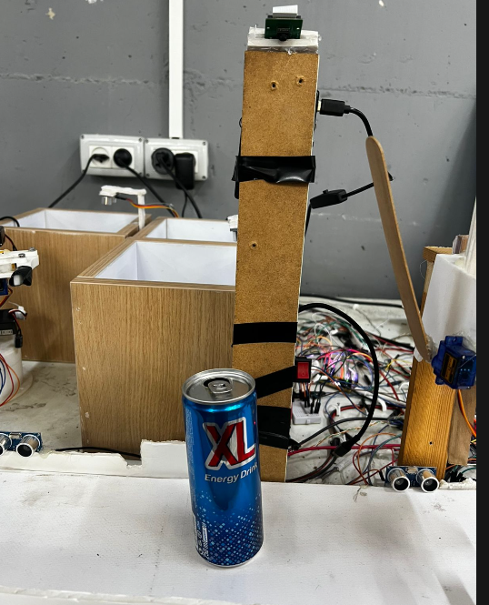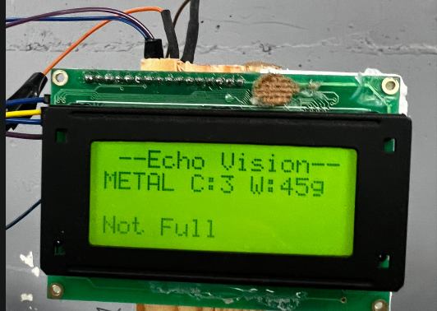

Figure 4.1.1 figure 4.1.3

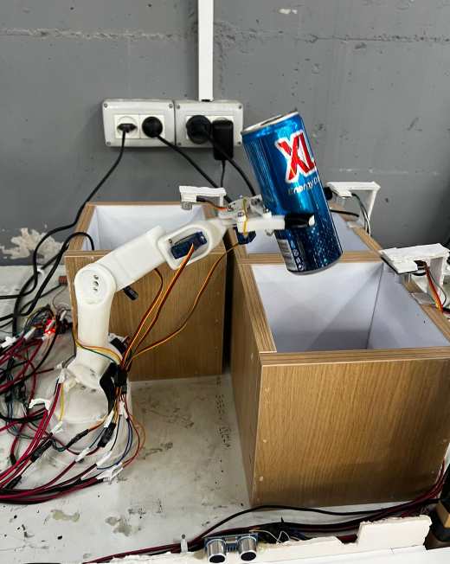 figure4.1.3

Below figures represmt a sample of plastic

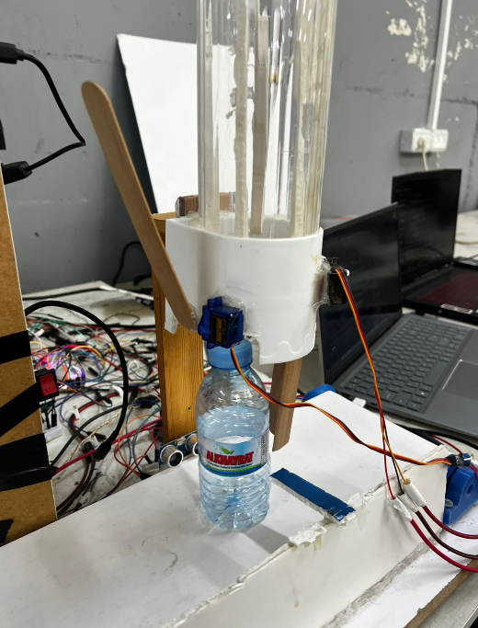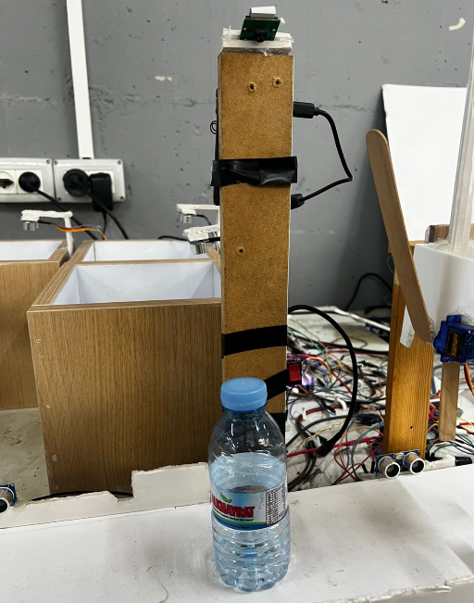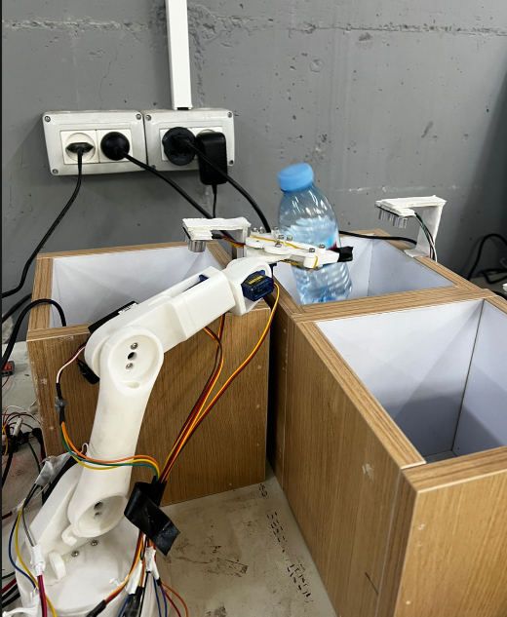

Figure 4.2.1 Figure 4.2.2 Figure 4.2.3

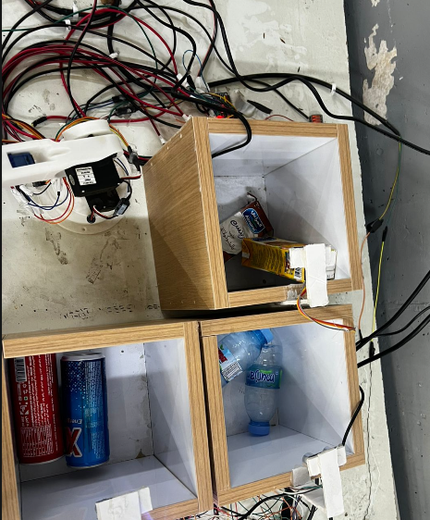
Figure 4.3

Chapter 5

Discussion

5.1 Working Principle

5.1.1 Container Placement & Conveyor Transit:
Using the manual switches, the system is powered on, and the automatic cup/container dispenser releases a container onto the conveyor belt. The single-direction conveyor belt—controlled via a relay and managed entirely through hardware using ultrasonic sensors—transports the container smoothly along its journey.
5.1.2 AI Vision & Material Classification:
he container moves along the conveyor line until it stops precisely in front of the Raspberry Pi camera station. The camera captures the item, and the YOLOv8 AI model processes the visual data to identify and classify the material type.
5.1.3 Smart Sorting Validation & Capacity Check:
Once the material type is identified and communicated to the control unit, the 5-axis robotic arm prepares for pickup. Before executing the grab, the system queries the smart wooden boxes to check their real-time capacity sensors. If the designated storage box is already full, the system bypasses the arm, allowing the container to travel to the end of the line where it falls into a dedicated overflow or error-handling bin.

    - Robotic Arm Grip & Placement: If the target storage box has available capacity, the robotic arm activates its gripper to pick up the container and sort it into the correct box. The arm is driven by custom Python software allowing precise joint movement.

Error Detection & Gripper Feedback:
Container gripping success or failure is actively monitored. Ultrasonic sensors detect whether the container successfully moves away or remains stuck in place, capturing gripping errors or placement failures in real-time.

LCD System Status Display
A 16x4 LCD screen continuously displays real-time operational feedback and system statistics, including:
- Connection status (whether the system is online/connected).
- Currently identified material type.
- Live statistics showing container counts and approximate weights for each category.
- Real-time success or failure status of the robotic arm's gripping action.

Challenges and Solutions
CHALLENGE 1: Robotic Arm Motion and PWM Interference Programming the 6-axis robotic arm to operate simultaneously with precise, synchronized joint angles was extremely difficult. Additionally, motion jitter frequently occurred because the control signals relied heavily on PWM, which is vulnerable to electrical noise.
SOLUTION: We developed custom Python software to carefully calibrate joint movements and record motion paths. While standard PWM control was implemented for the prototype, utilizing closed-loop feedback or digital bus servos in future iterations will completely eliminate jitter.

CHALLENGE 2: Microcontroller Communication and Interference Establishing reliable communication between microcontrollers was a major hurdle. Wi-Fi suffered from unstable workshop internet, and Bluetooth experienced severe interference and dropouts from neighboring devices operating on the same frequency channel (confirmed via an RF Analyzer).
SOLUTION: After testing multiple wireless protocols, we transitioned to a stable, interference-free wired Serial communication network between all microcontrollers, ensuring seamless and uninterrupted data exchange.

CHALLENGE 3: Power Distribution and Current Supply Sourcing an adequate power supply capable of providing sufficient current for the massive array of 5-axis servos, motors, and hardware modules was a major challenge, as finding a stable 25A power supply was difficult and barely sufficient.
SOLUTION: We utilized an isolated external power source combined with step-down (buck) converters, drivers, and relays to safely manage the high current draw. Future versions should integrate industrial-grade multi-rail power supplies with higher headroom.

Chapter 6

Conclusion, Recommendations and Future Work
6.1 Conclusion
In this project, an automated waste sorting and classification system was designed and put into operation as a functional small-scale prototype. Several specialized subsystems were successfully integrated, including a Raspberry Pi 4 running a YOLOv8 computer vision model for real-time object identification, Arduino and ESP32-S3 microcontrollers for hardware management, a PCA9685 driver and relays for motor control, an automated conveyor belt managed by ultrasonic sensors, a 5-axis robotic arm controlled via custom Python software, and smart wooden boxes featuring capacity-monitoring sensors.
By combining advanced computer vision, embedded systems, and electromechanical components, the project effectively illustrated the viability of automating industrial sorting and material handling processes with high precision. The system successfully captured items via camera, classified them in real-time, checked box capacity, and directed the robotic arm or conveyor line to sort materials into their designated compartments autonomously, while handling overflow and grip-failure conditions.
Even though significant progress was achieved, several technical obstacles and limitations were encountered during development. Overcoming wireless network interference by switching to a reliable wired Serial communication protocol, managing adequate current distribution from a 25A power supply for a massive array of motors, and synchronizing simultaneous 5-axis robotic movements while operating under a condensed summer semester schedule presented notable challenges. These difficulties highlight the inherent complexities involved in prototyping automated mechatronic systems.
In conclusion, the developed system design holds high educational and practical value, demonstrating how automation, computer vision, and embedded control are applied in modern industrial environments. Despite tight timeframes and budget constraints, the project successfully met its core objectives, bridging theoretical engineering knowledge with practical system integration. Future developments should focus on upgrading to industrial-grade components, improving power distribution headroom, and expanding sensor reliability for full-scale operation.
6.2 Recommendations
Given the experience gained throughout this project, several recommendations for improving the system's performance and reliability can be made:
- Enhancing Vision Recognition & Processing: Upgrading the computer vision module with dedicated hardware accelerators (such as a Coral TPU or upgraded Raspberry Pi optics) and implementing controlled local illumination will ensure consistent, high-speed classification accuracy under varying workshop lighting conditions.
- Optimizing Motor Control and Power Distribution: Transitioning from standard PWM signals to digital bus servos or closed-loop stepper motors, combined with industrial-grade multi-rail power supplies, will eliminate motion jitter, prevent voltage drops, and enhance overall mechanical stability during simultaneous multi-axis operations.
- Transitioning to Reliable Communication Protocols: Completely replacing prone-to-interference wireless architectures with hardwired, high-speed industrial serial buses or CAN bus networks will guarantee robust, error-free data exchange between microcontrollers and processing units.
- Integrating Advanced Feedback Sensors: Adding secondary feedback mechanisms, such as absolute encoders or vision-based calibration routines, would increase the pick-and-place precision of the 5-axis robotic sorting mechanism and minimize positioning errors or grip failures.
- Improving Structural Rigidity: Transitioning the prototype's physical framework and mechanical joints from lightweight materials to sturdier, precision-machined or 3D-printed industrial-grade structures would reduce mechanical vibrations and extend the operational lifespan of the machine.
6.3 Future Work
The project offers several avenues for future expansion and development:
- Smart Connectivity and Remote Monitoring: Implementing robust IoT capabilities via stable industrial Wi-Fi or MQTT protocols would enable remote monitoring, real-time status dashboards, cloud data logging for sorting performance analysis, and web-based control interfaces.
- Machine Learning Optimization: Future iterations could integrate more sophisticated embedded machine learning and deep learning models (such as optimized YOLOv8 variants on edge accelerators) to dynamically expand the categories of sorted materials and improve real-time classification adaptability under complex conditions.
- Energy Efficiency and Power Management: Optimizing firmware control algorithms, transitioning to high-efficiency drivers, and incorporating smart power-saving sleep states would significantly lower overall energy consumption during idle periods and prevent thermal throttling.
- Commercial Scalability: Transitioning the system from an educational prototype into a commercial-grade sorting machine capable of continuous, high-throughput operation with automated fault recovery mechanisms and industrial-grade sorting speed remains a primary long-term objective.

References
[1] Ultralytics. (2023). YOLOv8: State-of-the-art real-time object detection models. https://github.com/ultralytics/ultralytics

[2] Raspberry Pi Foundation. (n.d.). Raspberry Pi 4 Model B technical specifications. Retrieved from https://www.raspberrypi.com/products/raspberry-pi-4-model-b/

[3] Arduino. (n.d.). Arduino Uno Rev3 documentation and pinout. Retrieved from https://store.arduino.cc/products/arduino-uno-rev3

[4] Espressif Systems. (n.d.). ESP32-S3 technical reference manual: Wi-Fi, Bluetooth LE, and peripheral interfaces. Retrieved from https://www.espressif.com/

[5] NXP Semiconductors. (2020). PCA9685: 16-channel, 12-bit PWM I2C-bus servo driver datasheet. Retrieved from https://www.nxp.com/

[6] OpenCV. (n.d.). OpenCV: Open Source Computer Vision Library documentation. Retrieved from https://opencv.org/

[7] PyTorch Foundation. (n.d.). PyTorch: Tensors and dynamic neural networks in Python. Retrieved from https://pytorch.org/

[8] SparkFun Electronics. (n.d.). HC-SR04 ultrasonic distance sensor datasheet and operational principles. Retrieved from https://www.sparkfun.com/

[9] Tower Pro. (n.d.). MG996R high-torque and SG90 servo motor technical datasheets. Retrieved from http://www.towerpro.com.sg/

[10] Omron. (n.d.). Limit switch technical guide and application principles. Retrieved from https://www.omron.com/

[11] IEEE. (2021). Industrial automation and robotic sorting systems: Design methodologies and computer vision integration. IEEE Transactions on Industrial Informatics.

