Abstract
The ever-increasing reliance of electronic devices that utilize AC power has increased the amount of harmonics that pollute the distribution systems. These
harmonics will increase losses, cause male-function of protection and interfere with Telecommunications. Hence, there is a need for an inexpensive and reliable way to actively filter out harmonics from an AC power line.
Power electronics provides compact, highly efficient solutions for power conversion. However, power electronics has caused many problems for systems, primarily harmonics.
These harmonics increase losses, which cause distortions in voltage waveforms, which cause many problems. One of the things that can be used to filter out harmonic distortion is the active power filter active filter will be used to filter out harmonics as shown in Figure 1.
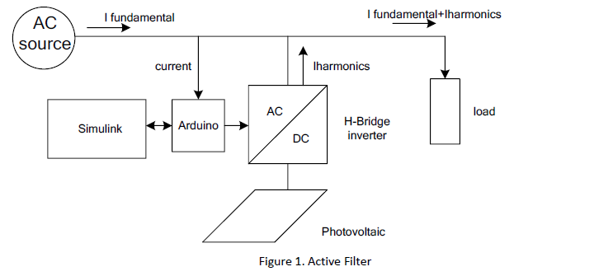
By applying a proper control to the H-Bridge, it can generate the harmonic needed by the non-linear load making the AC source current pure sinusoidal. In this project, fuzzy logic controller will be used to control the active filter. Fuzzy control system is a control system based on fuzzy logic a mathematical system that analyzes analog input values in terms of logical variables that take on continuous values between 0 and 1.
The first part of the project will be to simulate Active filter in MTALB SIMULINK.
The second part will include building the H-Bridge and its gate drives and to control this H-Bridge using MATLAB Simulink and Adriano Controller.

