Structural Design of Multi-Functional Building

2022 – 2023

Supervisor Name: | Dr. Mahmoud Dwaikat
Group Members: | Abdul-Aziz Bashar Al-Kharraz | #11820390
 | Ahmad Sameer khasati | #11819628
 | Mjd Naser Salameh | #11820031
 | Ekrayem Waleed Boshnaq | #11821041
Department Name: | Civil Engineering
Format:
- Single space, Times New Roman.
- 12 pt.
- Maximum 1 page.
Abstract Body:
Items must be provided in the Abstract:
Why do you think this project is important? Please explain the significance of this project in
brief.
In your point of view what are the important aspects that should be covered in the project?
Objective(s): In your view, please explain the main objectives of the project.
Methodology: Give a brief outline of the application development process.
Had this project been done before? Are there any similar applications available today?

Note: Please deliver this abstract early to ensure that your Project has been approved by the department’s projects committee. Registration will not be done without this approval.

ACKNOELEDGMENT:

الحَمْـــدُ لِله الّذي أنْعَـــمَ عَليـْــنَا بِنِعَــمٍ كَثيـرَةِ وَ رَزَقَـنا مِنَ المَـعْرِفَةِ وَ العِــلْمِ لِتَــكونَ مِشـكـاةً تُـضيءُ الدَّرْب
وَ تُــعينُـــنَا عَلى نَوائِبِ الدَّهْــر, وَ الصَّــلاةُ وَ السَّــلامُ عَلى سَيِّدنـا مُـحَمّـدْ خَاتَم الأَنْبِياء وَ المُرسَلين.
نُهْـــدِي هَذا العَمَــل الى مَنْ سَهِرْنَ الَّليَــالِـي الطِّــوَال صَــاحِبـَـاتِ الحَنــانِ أًمَهَـاتًـنا الحَبِيبات
إِلى المـَــاسِ الّذي لا يَنكَـــسِر نَبعُ العَطـــاءِ المُتواصِـل الى الـوالِد حيَّاً وَ مَا بعْدَ الحَياة
إِلى صُناعِ المَجدِ وَ الكَرامةِ حَامِلي رَاياتِ الشَّرَفِ وَ البُطولَةِ شُهَدائِنا الأَبْرَارْ
إِلى قَنـَــادِيــلِ الَّدرْب وَ الشُّمـُــوعِ الّتـِـي لا تَنْطَــفِئ أَسَــاتِذَتـِـنَا الـكِرَامْ
إِلـــى العَــــــرِينِ الّـــذيِ جُمِــعْنـَـا تـَـحـتَ مظـــلّتـِــه قِسْـــمَ
الهَـنْدَسَـــــــةُ المدنيَــــــــــــــــــــــــــــــــــــــــــــــــة
وَ الـى كُـــــلِّ مَنْ سَــــاهَمَ وَ دَعَــــمَ عَمَلَــــنَا هَـــذا
نَخُــصُ بِالـذَّكْـر الدُكتورْ محمود دويكات
وَ إِلَيْكُمْ جَمِيـعَاً نُهْدِي هَذا العَمَل المُتَوَاضِع.

Abstract

Reinforced concrete structures are one of the most popular structural systems used in Palestine. This project is about the structural design of a new Multi-functional building in Nablus city, Sham building one.

This building consists of 15 Stores, with plan area 290.787m2. This project will be divided into two parts. The first part intends to prepare the basic information required to facilitate efficient modeling and structural design and analysis of the building under static loads. The design of concrete elements is controlled by ACI 318-19 code. The second phase will be redesign of building considering gravity as well as seismic loads. This design will be based on IBC - 19. Structural elements such as footings, stairs, columns, beams, slabs and shear walls will be completed and finalized in part two.

To make a mathematical model that represents the reality, 3-D structural model will be made using ETABS 2016 program. The analysis is verified using conceptual hand calculation for sample output from the program. Detailed design of all structural elements for gravity and seismic loads will be done and drawn using AutoCAD program.

Table of Contents
CHAPTER ONE: INTRODUCTION 9
1.1: Project description 9
1.2: Objective 14
1.3: Design code and specifications 14
1.4: Soil properties 15
1.4.1: Site Description 15
1.4.2: Geotechnical Conditions 15
1.5: Materials used in the project 16
1.6: Load combinations and types 17
1.6.1: Loads 17
1.6.2: Load combination 25
1.7: Computer programs 25
CHAPTER TWO: PRELIMINARY DESIGN 26
2.1: Introduction 27
2.2: Structural system 27
2.3: Manually preliminary design 28
2.3.1: Slab 28
2.3.2: Beam Thickness: 30
2.3.3: Columns 31
2.3.4: Shear wall Dimensions 35
CHAPTER THREE: 3D ETABS MODLING 36
3.1: Define materials 37
3.2: Define Sections 39
3.3: Modifier’s for Structural Elements 41
3.4 Define Load Patterns 43
3.5 Load Combination 43
CHAPTER FOUR: ANALYSIS CHECKS: 46
4.1 Compatibility check: 46
4.2 Equilibrium check: 47
4.2.2 Super imposed dead load: 50
4.2.3 Live load: 51
4.3 Stress -strain check: 52
4.4 Deflection check 55
4.4 Latral check : 57
4.4.1 Period check: 58
4.4.2 Base shear check: 61
4.4.3 Response Spectrom: 65
4.4.4 Drift check: 70
4.4.5 P-Delta check : 72
CHAPTER FIVE: DESIGN 74
5.1 Shear strength check for slab: 74
5.2 Design check for beam: 75
5.2.1 Flexural design: 76
5.2.2 Design beam for shear 78
5.3 Design check for column: 83
5.4 Design of slab: 87
5.5 Design of shear wall: 90
CHAPTER SIX: DESIGN OF FOOTHING 91
6.1 Load combinations: 92
6.2 Mat Foundation and Wall footing : 93
6.3 Mat Foundation and Wall footing checks : 94
6.4 Design for Mat Foundation and Wall footing : 97
REFERENCES: 102

List of figure:
Figure 1: Side view of the west side. 10
Figure 2: Side view of the south side. 10
Figure 3: The plan view of the 3rd basement floor (B3). 11
Figure 4: The plan view of the 2nd basement floor (B2). 11
Figure 5: The plan view of the 1st basement floor (B1). 12
Figure 6: The plan view of the ground floor (GF). 12
Figure 7: The plan view of the floor (1-7). 13
Figure 8: The plan view of the floor (8-11). 13
Figure 9: Side cross-section of slab. 18
Figure 10: Typical wall section. 19
Figure 11: Risk category 20
Figure 12: Zone factor. 21
Figure 13: site classification 22
Figure 14: Site Coefficient Fa 23
Figure 15: Site Coefficient Fv 23
Figure 16: Design category. 24
Figure 17: The distribution of load in two-way slab. 28
Figure 18: Critical panel for the slab thickness. 28
Figure 19: ACI minimum dimensions. 30
Figure 20: Beams Layout. 30
Figure 21: Columns Layout. 31
Figure 22: Column 7 Tributary Area. 32
Figure 23: Column 11 Tributary Area. 33
Figure 24: Shear walls layout. 35
Figure 25: Material (Concrete) Properties. 37
Figure 26: Material (Steel) Properties. 38
Figure 27: Slab Section. 39
Figure 28: Wall Section. 39
Figure 29: Sample of Beam Section. 40
Figure 30: Sample of Column Section. 40
Figure 31:Two-way waffle slab modifiers 41
Figure 32: wall modifiers 41
Figure 33: sample of beam modifiers 42
Figure 34: sample of column modifiers 42
Figure 35: Load Patterns 43
Figure 36: Load Combination one 43
Figure 37: Load Combination two 44
Figure 38: Load Combination three 44
Figure 39: Load Combination four 45
Figure 40: Compatibility check 46
Figure 41: Equilibrium check. 51
Figure 42: Selected beam for equilibrium check 52
Figure 43: Top negative moment 53
Figure 44: Bottom negative moment 53
Figure 45: Positive moment. 54
Figure 46 : Critical panel for deflection check. 55
Figure 47: Maximum allowable deflection (ACI318-19) 55
Figure 48: ETABS Deflection values 56
Figure 49: Shear walls to prevent Torsion 57
Figure 50: ASCE values for Ct and X. 58
Figure 51: T from Etabs in X direction. 59
Figure 52: T from Etabs in Y direction. 60
Figure 53: Effective weight from Etabs. 61
Figure 54: Load puttern an earthquake in x-direction. 62
Figure 55: Base shear in X and Y direction. 63
Figure 56: Load puttern an earthquake in Y-direction. 64
Figure 57: function Response Spectrom. 65
Figure 58: Ex and Ey initial. 67
Figure 59: Ex with modifiers (final ) 68
Figure 60: Ey with modifiers (final ) 69
Figure 61: The allowable drift value. 70
Figure 62: Shear check on slab. 74
Figure 63: selected beam for design check. 75
Figure 64: moment in beam. 76
Figure 65: Reinforcement for beam from Etabs. 77
Figure 66: The value of shear for load case. 80
Figure 67: The summary shear details from Etabs. 81
Figure 68: Design of stirrups for beam in latral load. 82
Figure 69: Selected column for design. 83
Figure 70: axial load in column. 84
Figure 71: moment 3 in column 84
Figure 72: P-M3 interaction diagram 85
Figure 73: Rebar percentage for column. 85
Figure 74: Cross section for column. 86
Figure 75: The range of minimum moment 87
Figure 76: minimum moment in x direction. 88
Figure 77: Moment in y-direction for slab 88
Figure 78: Area of steel from Etabs 90
Figure 79: Load combination for footing 92
Figure 80: Layout for strips of footing 93
Figure 81: Check soil pressure from Etabs 95
Figure 82: Check punching shear from Etabs 96
Figure 83: As Top in X direction 97
Figure 84: As Bottom in X direction 98
Figure 85: As Top in Y direction 99
Figure 86: As Bottom in Y direction 100

List of Table:
Table 1: The function and area of each floor 8
Table 2: The factors considered in seismic analysis 15
Table 3: Structural elements compressive strength 16
Table 4: Materials unit weight 16
Table 5: Minimum uniformly distributed live loads (from ASCE7_16) 17
Table 6: Beams Dimension. 31
Table 7: Columns Dimension. 32
Table 8: Beams dead load 47
Table 9 : Columns dead load 47
Table 10: slab dead load 48
Table 11: shear wall dead load 49
Table 12: live loads 51
Table 13: Drift in X-Direction. 70
Table 14: Drift in Y-Direction. 71
Table 15: P-Delta in x-direction. 72
Table 16: P-Delta in Y-direction. 73
Table 17: As for all strips 101

CHAPTER ONE: INTRODUCTION

1.1: Project description

This project is multifunctional building located in the north mountain, Beggar street, Nablus, Palestine. The proposed building will have 290.787m2 plan area and will consist of 15 stories (3 basements) and have a total area of 2810.5 m2. Each floor has its own function, such as: warehouse, commercial, storage, and residential. The following table (Table1) illustrates the function of each floor.

Table 1: The function and area of each floor
Floor | Function | Area (m²) | Height (m) | Elevation(m)
B3 | Storage | 142.00 | 4.50 | -11.50
B2 | Warehouse | 290.50 | 4.00 | -6.75
B1 | Garage | 362.50 | 2.75 | -2.50
G | Commercial | 290.50 | 4.50 | +0.50
F1 | Residential | 290.50 | 3.00 | +3.75
F2 | Residential | 290.50 | 3.00 | +7.00
F3 | Residential | 290.50 | 3.00 | +10.25
F4 | Residential | 290.50 | 3.00 | +13.50
F5 | Residential | 290.50 | 3.00 | +16.75
F6 | Residential | 290.50 | 3.00 | +20.00
F7 | Residential | 290.50 | 3.00 | +23.25
F8 | Residential | 260.50 | 3.00 | +26.50
F9 | Residential | 260.50 | 3.00 | +29.75
F10 | Residential | 260.50 | 3.00 | +33.00
F11 | Residential | 260.50 | 3.00 | +36.25

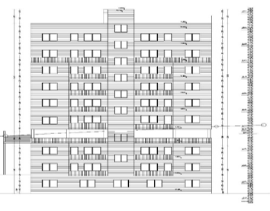
Figure 1: Side view of the west side.

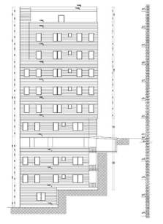
Figure 2: Side view of the south side.

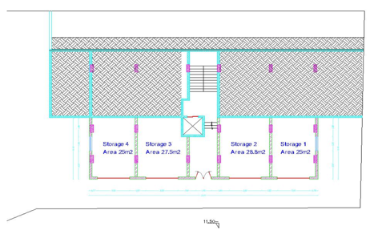
Figure 3: The plan view of the 3rd basement floor (B3).

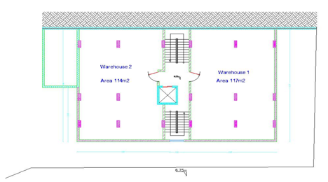
Figure 4: The plan view of the 2nd basement floor (B2).

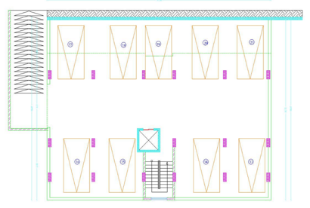
Figure 5: The plan view of the 1st basement floor (B1).

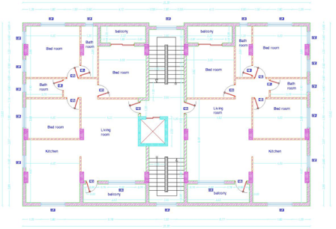
Figure 6: The plan view of the ground floor (GF).

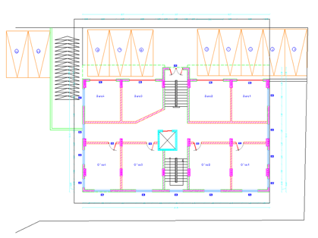
Figure 7: The plan view of the floor (1-7).

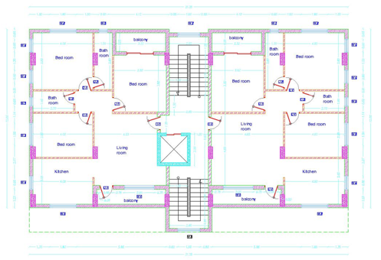
Figure 8: The plan view of the floor (8-11).

1.2: Objective

This project will be divided into two parts. The first part intends to prepare the basic information required to facilitate efficient modeling and structural analysis and design of some structural elements of the building under static loads. Then, in the second part a complete design of the structural elements and seismic design will be considered.

A 3-D structural model will be made using ETABS 2016 program, in order to make a mathematical model that represents the reality. The analysis is verified using conceptual hand calculation for sample output from the program. Detailed design of all structural elements for gravity and seismic loads will be done and drawn using AutoCAD program.

1.3: Design code and specifications

The design of concrete elements is controlled by ACI 318-19 code. The second phase will be redesign of building considering gravity as well as seismic loads. This design will be based on IBC-18. Structural elements such as footings, stairs, columns, beams, slabs and shear walls will be completed and finalized in part two.

1.4: Soil properties

1.4.1: Site Description

The site from geotechnical point of view can be described as follows:
- Through excavation and careful inspection of the site, it was found that the main formation of the soil of the site consisted of white limestone (γ = 23.652), very hard to solid, over the entire depth excavated and the attached drilling records, noting that the drilling of boreholes was carried out from the foundation level after dredging and leveling the site.
- Ground water table was not encountered during the time of investigation (MAY 2022).

1.4.2: Geotechnical Conditions

According to site description and laboratory test results the following geotechnical conditions prevail:
- Type of Foundations
(Mat or raft footings) foundation is recommended to be used for this site. The allowable bearing is 470 KN/m² (4.7 Kg/cm²). So that the depth of the foundation within the rocky layer is not less about 0.5 m.

- Retaining Walls
For designing the retaining walls of the proposed building, the coefficient of the lateral earth pressure at rest (K_{o}) is equal to 0.5. It is recommended to drain the building and protect it from the effects of water and prevent the accumulation and penetration of water into an area incorporation. The excavation product from the surface layer can be used in backfilling works. In general, suitable silt materials are any gravel materials that do not contain organic materials. Roots of plants and the maximum size of the stones does not exceed 15 cm, and the plasticity coefficient is no more than 10.

- Seismicity of the Site

Table 2: The factors considered in seismic analysis
seismic zone | Soil section type | seismic zone factor (Z) | Acceleration-related seismic coefficient (Ca) | Velocity related seismic coefficient (Cv)
2B | B | 0.20 | 0.20 | 0.20

1.5: Materials used in the project

Reinforced concrete is one of the most widely used modern building materials. Fresh concrete can be molded into almost any shape, giving it an inherent advantage over other materials. It consists of two major types:
- Concrete
It is formed through the solidification of a mixture of cement, powder, water and aggregate in fixed quantities, it is strong in compression but weak in tension.
- Steel
Is a common reinforcing bar that is hot rolled and is used widely in the construction industry, especially for concrete reinforcement? Steel rebar is most commonly used as a tensioning devise to reinforce concrete and other masonry structures to help hold the concrete in a compressed state.
Concrete properties
- $F'c$: is the specified compressive strength of concrete using standard cylinders or standard cubes. Usually this is prescribed at the age of 28 days, and it’s measured in MPa.
- $γ$: The specific weight (also known as the unit weight) is the weight per unit volume of concrete, and it’s measured in KN/m². $γ$ For concrete is 25KN/m³
- $Ec$: Concrete modulus of elasticity, and it’s measured for light weight concrete according to this equation (ACI 318-19). $Ec=4700\sqrt{F'c}$

Concrete compressive strength ($F'c$) varies with its structural element. The following tables; Table 3 illustrates the structural element with its compressive strength and Table 4 illustrates the material with its unit weight.
Table 3: Structural elements compressive strength
Structural element | Compressive strength(fc’) (MPa)
Slab, beam | 28
Column, shear wall | 28

Table 4: Materials unit weight
material | γ (KN/m³)
Plain concrete | 23
Reinforced concrete | 25
Tiles | 26
Filling material | 14
Reinforcement Steel properties
Yield strength (Fy): defined as the stress at which a material begins to deform plastically. Before yield point the material will deform elastically and will return to its original shape when the applied stress is removed. Once the yield point is passed, some fraction of the deformation will be permanent and non-reversible.
- Fy is 420Mpa for the steel.
- Modulus of elasticity (E): it’s usually taken 2$×$10⁵ MPa.

1.6: Load combinations and types

1.6.1: Loads
Loads are divided into two categories; gravity loads and lateral loads.

1.6.1.1: Gravity loads

- Dead loads
Are those that are constant in magnitude and fixed in location throughout the lifetime of the structure. It consists of the weight of all materials of construction incorporated into the building including, but not limited to, walls, floors, roofs, ceilings, stairways, built-in partitions, finishes, cladding, and other similarly incorporated architectural and structural items. Usually, the major part of the dead load is the self-weight of the structure.

- Live load
A load produced by the use and occupancy of the building or other structure that does not include construction or environmental loads, such as wind load, snow load, rain load, earthquake load, flood load, or dead load.

Table 5: Minimum uniformly distributed live loads (from ASCE7_16)
Floor | Function | uniform live load (KN/m²)
B3 | Storage | 6
B2 | warehouse | 6
B1 | Garage | 1.92
G | Commercial | 2.5
F1-F11 | Residential | 2.5

- Super imposed dead load
Permanent load resulted from weight of the non-structural elements in structure (plastering, tiling, insulation, filling, etc.).

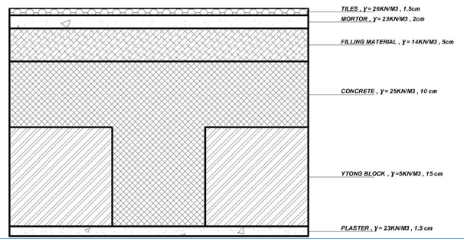
Figure 9: Side cross-section of slab.

The existing superimposed dead load = weight of tiles + weight of mortar + weight of filling + weight of plaster + weight of partitions.

W superimposed = (0.015*26) + (0.02*23) + (0.05*14) + (0.015*23) + (0.17*3) = 2.68 KN/m²

Assuming interior partitions are hollow block with a thickness of 100 mm having 1 KN/m², then
W superimposed = 2.68 +1 = 3.68 KN/m²

- External walls loads
It has been calculated based on the thickness and unit weight for each layer. Which is shown in the (Table 4) above and Cross section in the wall is shown below in (Figure 10).

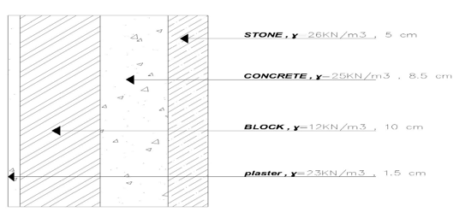
Figure 10: Typical wall section.

W wall | = Σ (thickness of layer × unit weight for each layer)
 | = (0.05*26) + (0.085*25) + (0.1*12) + (0.015*23)
 | = 4.97 KN/m².
On average the elevation of store is 4.5m, assume 20% opening in the wall then:
W wall | = (4.97*4.5) *0.8= 17.90 KN/m.

1.6.1.2: Lateral loads

Lateral load: Seismic loads are indirect dynamic loads that affect the structure through ground motion producing forces in two components, vertical and horizontal. Horizontal components are considered as the most dangerous on the building, because it produces high shear forces. The seismic forces differ according to the nature and geology of the region, seismic region and type of structural system. In graduation project 1, lateral load will not be considered in design, but only for period check.

Seismic loads and wind loads will be discussed in this part of this project.

Spectral acceleration SDs and SD1 will be determined as follows:

- Selection of risk category:
According to table 1.5-1 in IBC 2018, risk category of the building is (II). See figure 11 below
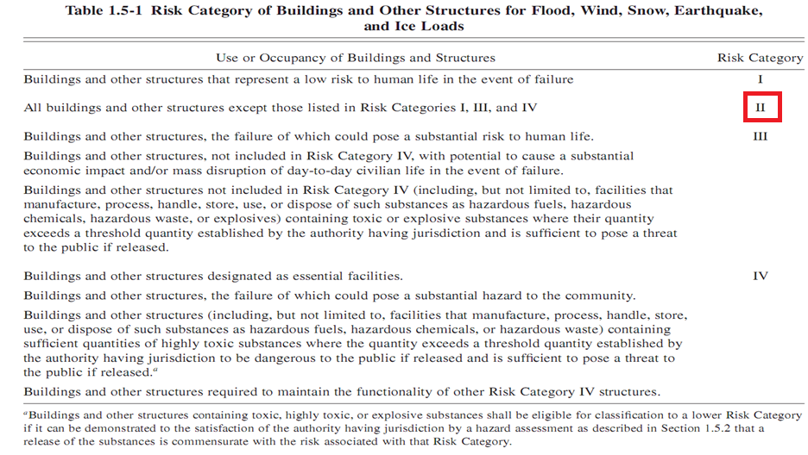
Figure 11: Risk category

- Determine the importance factor Ie:
According to table 1.5-2 in IBC 2018, importance factor Ie = 1.00. See figure 12 below:
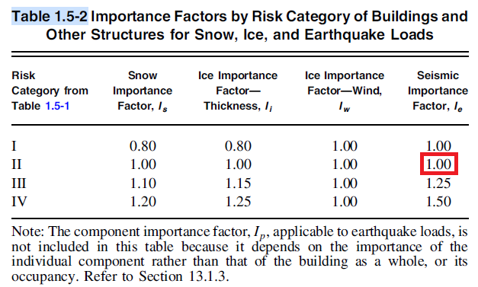
Figure 12: Importance factor
- Determine mapped acceleration parameters Ss and S1:
These parameters depend on the location of the building and seismic zone factor (Z):
Zone factor (Z) for Nablus = 0.2. See figure 12 below:
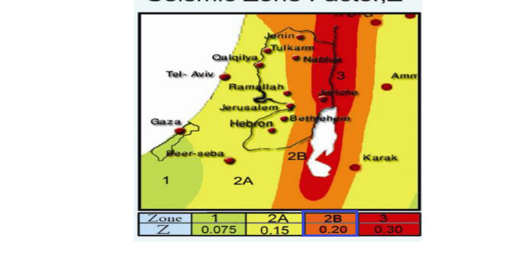
Figure 12: Zone factor.

Ss = Mapped 5% damped, spectral response acceleration parameter
At 0.2 sec≈ (2.5Z) *1.5
Ss = 2.5 *0.2 *1.5 = 0.75

S1 = Mapped 5% damped spectral response acceleration parameter
At 1sec≈ (1.25Z) *1.5
S1 = (1.25 *0.2) *1.5 = 0.375

These values are based on 2% chance of exceedance in 50 years

- Site classification:
This classification depends on soil profile. See figure 13 below
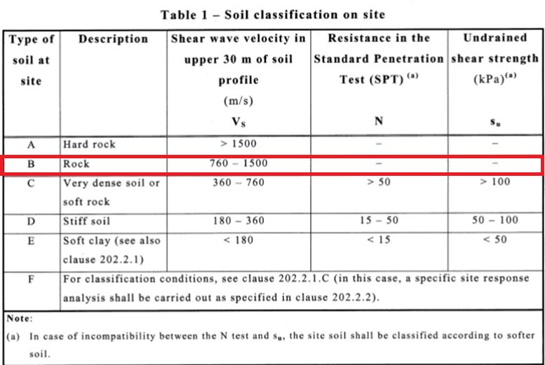
Figure 13: site classification

- Determine site coefficients.
These coefficients depend on the soil profile and the mapped spectral acceleration.
Fa = short-period site coefficient (at 0.2 s-period) = 0.90
Fv = long-period site coefficient (at 1.0 s-period) = 0.80
The values of these coefficients are determined according to Table 11.4-1 and Table 11.4-
2 in IBC 2018 code. See figures 14 and figure 15 below.
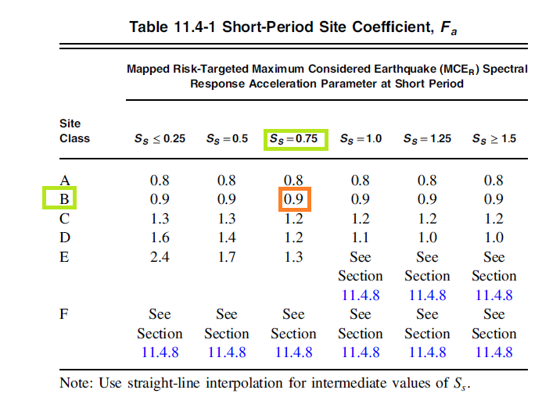
Figure 14: Site Coefficient Fa

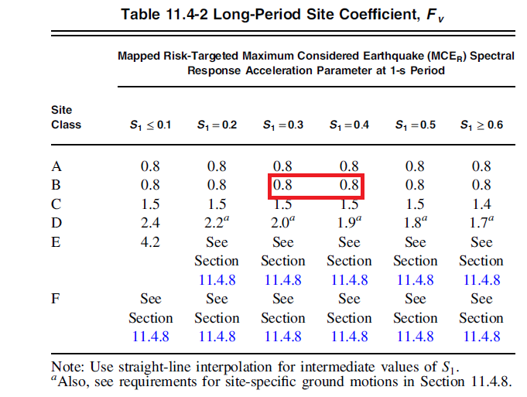
Figure 15: Site Coefficient Fv

- Determination the maximum considered earthquake Spectral Response Acceleration Parameters SMS and SM1.
These parameters depending on both site class and site coefficients and calculated as Follow:

SMS=Fa * Ss = 0.90 * 0.75 = 0.675
SM1=Fv *S1=0.80 * 0.375 = 0.30

- Determine design spectral acceleration SDS&SD1:
SDS =2 SMS /3 →= 2*0.675/3 =0.45
SD1 =2 SM1 /3 → =2*0.300/3 =0.20

- Determine design category:
Design category depends on the design spectral acceleration and seismic design category. See
Figure 16 below. Now choose the value of D because is more dangerous than C.

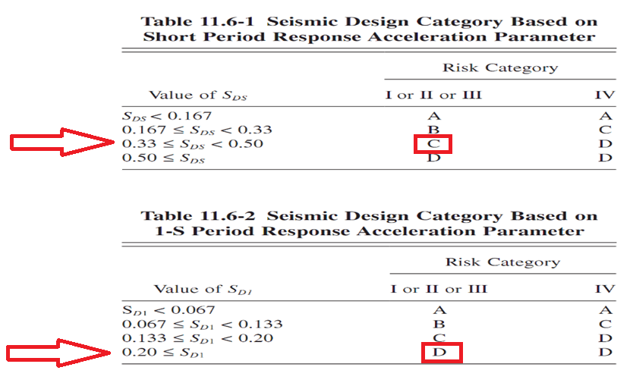
Figure 16: Design category.

1.6.2: Load combination

The Ultimate load combinations according to ACI-318-19 for latral load are :
- U = 1.4D
- U = 1.2D + 1.6L
- U = 1.29D + L + Ex
- U = 1.29D + L - Ex
- U = 1.29D + L + Ey
- U = 1.29D + L - Ey
- U = 0.9D + 1.0Ex
- U = 0.9D - 1.0Ex
- U = 0.9D + 1.0Ey
- U = 0.9D - 1.0Ey
For gravity:
The following load combinations are used according to ASCE_7-10 code:
- 1.4 D
- 1.2 D + 1.6 L
Where:
- D = Dead Load.
- E = Earthquake Load.
- L = Live Load.

1.7: Computer programs

- ETABS 2016: is used to analyze and design the structural elements.
- AutoCAD: is used for plans and draw structural detailing.
- Other programs such as Excel and word.

CHAPTER TWO: PRELIMINARY DESIGN



2.1: Introduction

Preliminary Design is the first phase of the design process. In this stage of the project a preliminary dimension was selected in order to build the 3-D model. To check the validity of 3D model, three verification checks will be made which are compatibility, equilibrium and stress-strain relationships. After studying the 3D model and results, a change of these dimensions could be occurred to get the most suitable dimension that will achieve the strength needs.
The objective of the design phases (preliminary and detailed) is to create a design that will correctly and completely implement the requirements.

2.2: Structural system
The term structural system or structural frame in structural engineering refers resisting Sub-system of a structure. The structural system transfers load through interconnected structural components or members.
The structural carrying system is assumed to be slab-beam-column system, where the gravity loads transfer from the slab to the main beams then to the columns and shear walls, down to the footings. Each element passes the load to another one until reaching the soil and the soil itself spreads it through it. Therefore, the safe structural system is the one that can provide safe path for loads. In this chapter, preliminary dimensions for some elements will be discussed.
This project consists of one block that are shown in figure and the structural slab system used for whole project is two-way ribbed slab.

The structural system consists of main structural elements as follows:
- Slabs.
- Beams.
- Columns.
- Shear walls.
- Footings (Graduation Project II).

2.3: Manually preliminary design

The main objective in this section is determining the preliminary dimensions of the structural elements based on ACI Code.

2.3.1: Slab
Determine the slab structural system and slab thickness. When the slab is supported on all the sides and the length-to-width ratio is less than two, it is considered to be a two-way slab, the possible transfer of loads in this system is in both sides with angle equals 45̊ as shown in the figure below.

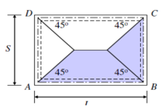
Figure 17: The distribution of load in two-way slab.

2.3.1.1: Structural slab system
There are different types of slabs such as: ribbed, waffle and solid slab. In our project, two-way ribbed slab has been selected due to several reasons:
- Economic reasons.
- Seismic reasons.

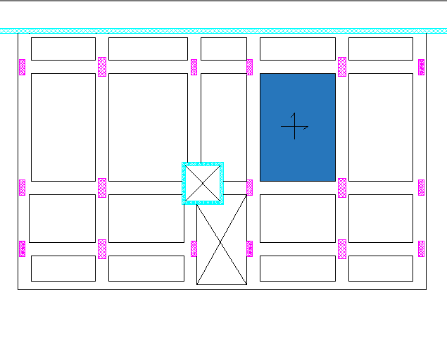
Figure 18: Critical panel for the slab thickness.
The ratio of the longer to the shorter side of $\frac{L}{B}$ of the critical panel is $\frac{6.30}{4.82}=1.307$which less than 2 is so it’s preferable to design the slab as two-way slab.

2.3.1.2: Slab thickness
The minimum thickness of the slab was calculated using “Direct Design Method ".

Check the validity of ACI Coefficients requirements:
- There are two or more spans in each direction. (OK)
- Spans are approximately equal. (OK)
- Loads are uniformly distributed.
- Panels are rectangular with L/B less than two. (OK)
- Successive spans length C/C of supports in each direction does not differ by more than 1/3.
- All loads are gravity with WL/WD Less than two. (OK)

To find an initial thickness of two-way waffle slab, take the critical panel as seen in figure 2.3:
Length (L) = 6.30 m
Thickness will be assumed as:
Thickness = $\frac{L}{33 }*1.15$ = $\frac{6.30}{33}*1.15$ = 0.21954 m
Take thickness = 250 mm for (B3-F11) slab.
This thickness will be checked later according to deflection and strength.

2.3.1.3: Check slab thickness for one way shear for B2

Slab Thickness | = 250 mm
Live Load | = 1.92 $KN/m2$
Superimposed dead load | = 3.68 $KN/m2$
Dead Load | = $\frac{\left(\left(0.55*0.55*0.25\right)-\left(0.4*0.4*0.17\right)\right)*25+(0.4*0.4*0.17*5)}{0.55*0.55}$ | = 4.45 KN/m²
$$Ultimate load(Wu)$$ | = $1.2\left(3.68+4.45\right)+1.6\left(1.92\right)$ | = 12.82 KN/m²
$$∅Vc=∅\frac{1}{6}\sqrt{fc } bw*d$$ | = $\left(0.75\right)\frac{1}{6}\sqrt{28 } \frac{150}{1000}*\left(250-40\right)$ | = 20.83 KN
$$Ultimate load\left(Wu\right)For b_{f}$$ | = $0.55*12.82$ | = 7.051 KN/m²
$$Vu=Wu\left(\frac{l}{2}-\frac{B}{2}-d\right)=$$ | = $7.051\left(\frac{4.83}{2}-\frac{0.4}{2}-0.21\right)$ | = 14.13 KN

Since ΦVc ˃Vu, Slab thickness is adequate for resisting shear (OK). So, use h = 250 mm and there is no need for shear reinforcement.

2.3.2: Beam Thickness:
Minimum thickness of beam was calculated according to minimum deflection provided by ACI318-19 and these dimensions were taken as a preliminary dimension.

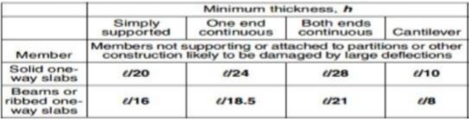
Figure 19: ACI minimum dimensions.

Beams have been distributed according to figure 20 below:

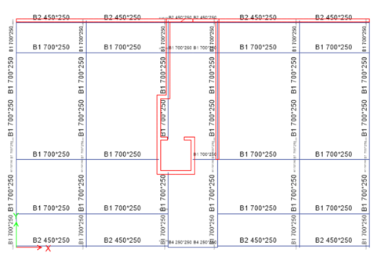
Figure 20: Beams Layout.

Beams have been divided into four beams:

Table 6: Beams Dimension.
Beam name | Dimensions (mm)
B1 | 700×250
B2 | 450×250
B3 | 300×250
B4 | 250×250

In Our Project All Beam are Hidden (h=250). The depth of beams was taken equal to depth of slab. The width of beams was assumed and checked according to deflection and shear resistance.

2.3.3: Columns
Determine the position and the dimension of columns; In general, the positions of the columns were as it was in the original architectural drawings which shown in the appendix, and we determine the preliminary dimension of columns depending on ultimate axial load in each column.

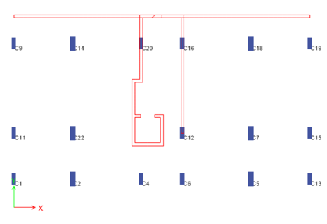
Figure 21: Columns Layout.
Columns have been divided into two groups.

Table 7: Columns Dimension.
Column | Dimension (mm)
C1 | 800*300
C2 | 1000*400

For Column 7:
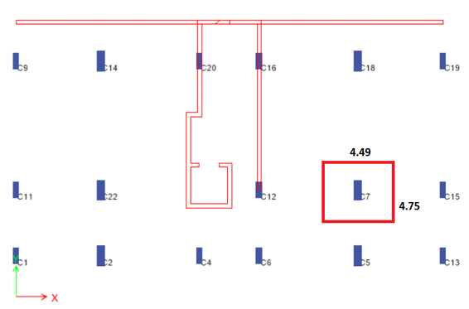
Figure 22: Column 7 Tributary Area.

Axial load calculations

Slab Thickness | = 250 mm
Live Load | = 1.92 $KN/m2$
Superimposed dead load | = 3.68 $KN/m2$
Dead Load | = $\frac{\left(\left(0.55*0.55*0.25\right)-\left(0.4*0.4*0.17\right)\right)*25+(0.4*0.4*0.17*5)}{0.55*0.55}$ | = 4.45 KN/m²
$$Ultimate load(Wu)$$ | = $1.2\left(3.68+4.45\right)+1.6\left(1.92\right)$ | = 12.82 KN/m²

To find initial dimensions of the column, take column C7 as an example which is shown in figure 16 above:

Load = Tributary area x Ultimate load for the slab x Number of stories
= (4.49*4.75) *12.82*15 = 4101.27 KN.

Assume 1% steel ratio, the column is short, and no moment.
$$ØPn=Øℷ(0.85*fc\left(Ag-As\right)+fy(As)$$
$$As=ρAg$$

For columns: $Ø=0.65$ and $ℷ=0.8$
$0.65*4101.27=0.65*0.8(0.85*28\left(Ag-0.01Ag\right)+420(0.01Ag)$)
$$Ag=188949.85{mm}^{2}$$

Take Column 1000*400
These dimensions will be checked later

For Column 11:
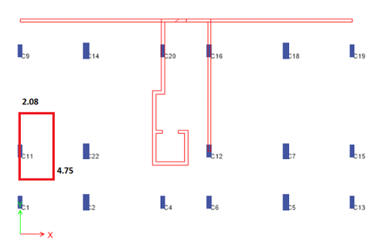
Figure 23: Column 11 Tributary Area.

Axial load calculations

Slab Thickness | = 250 mm
Live Load | = 1.92 $KN/m2$
Superimposed dead load | = 3.68 $KN/m2$
Dead Load | = $\frac{\left(\left(0.55*0.55*0.25\right)-\left(0.4*0.4*0.17\right)\right)*25+(0.4*0.4*0.17*5)}{0.55*0.55}$ | = 4.45 KN/m²
$$Ultimate load(Wu)$$ | = $1.2\left(3.68+4.45\right)+1.6\left(1.92\right)$ | = 12.82 KN/m²

To find initial dimensions of the column, take column C11 as an example which is shown in figure 17 above:

Load = Tributary area x Ultimate load for the slab x Number of stories
= (2.08*4.75) *12.82*15 = 1899.92 KN.

Assume 1% steel ratio, the column is short, and no moment.
$$ØPn=Øℷ(0.85*fc\left(Ag-As\right)+fy(As)$$
$$As=ρAg$$
For columns: $Ø=0.65$ and $ℷ=0.8$
$$0.65*1899.92=0.65*0.8(0.85*28\left(Ag-0.01Ag\right)+420(0.01Ag)$$
$$Ag=87531.32{mm}^{2}$$

Take Column 800*300
These dimensions will be checked later.

2.3.4: Shear wall Dimensions
Shear walls have been distributed according to figure 24 bellow:

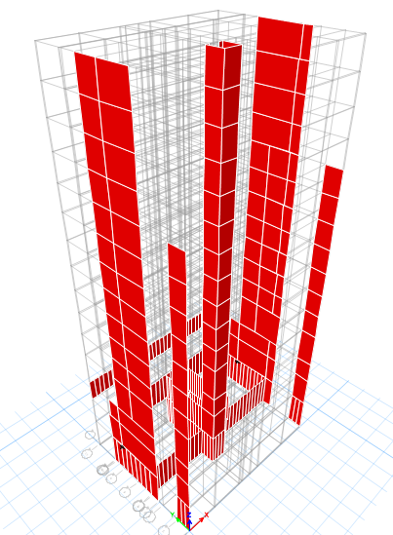
Figure 24: Shear walls layout.
Thickness of Shear walls have been assumed:
Wall 1 = 200 mm.
These thicknesses have been assumed and will be checked later for capacity.

CHAPTER THREE: 3D ETABS MODLING

3D models as built up according to preliminary dimensions which were previously calculated and after that we made the required checks which will be explain later.

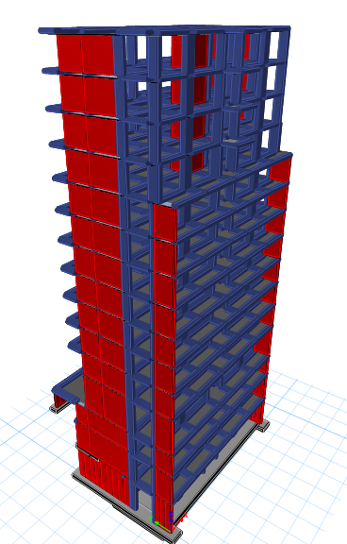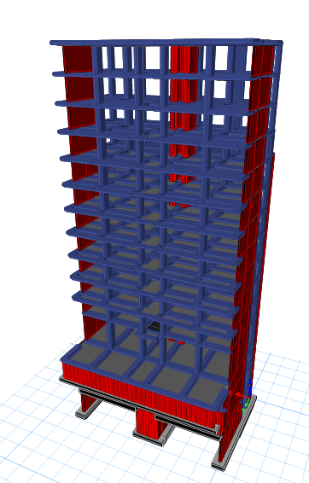

3.1: Define materials

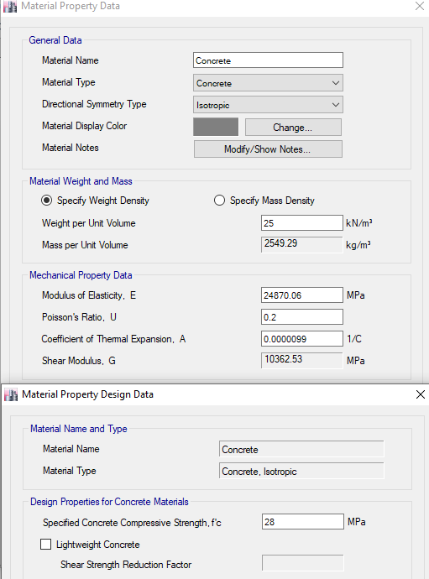
Two materials have been defined in ETABS 2016:
Figure 25: Material (Concrete) Properties.

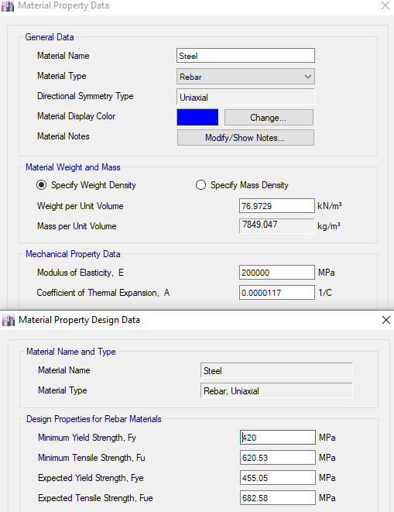
Figure 26: Material (Steel) Properties.

3.2: Define Sections
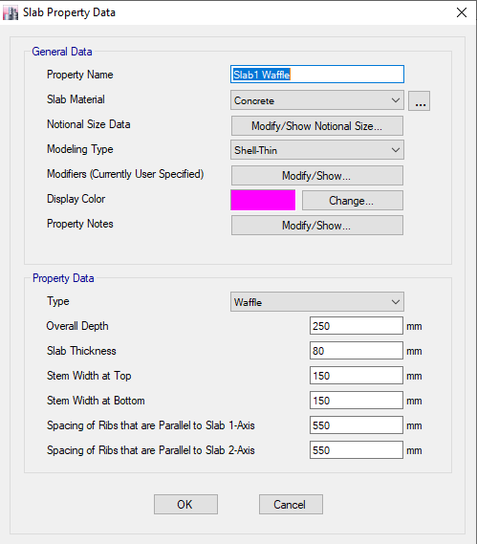
Figure 27: Slab Section.
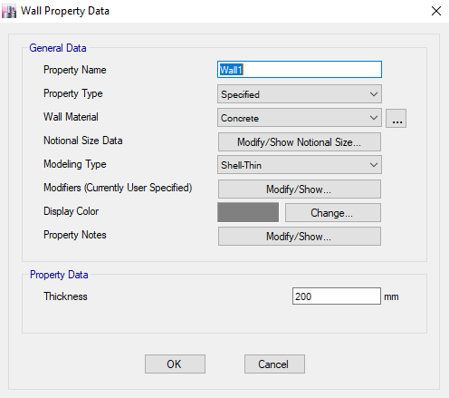
Figure 28: Wall Section.

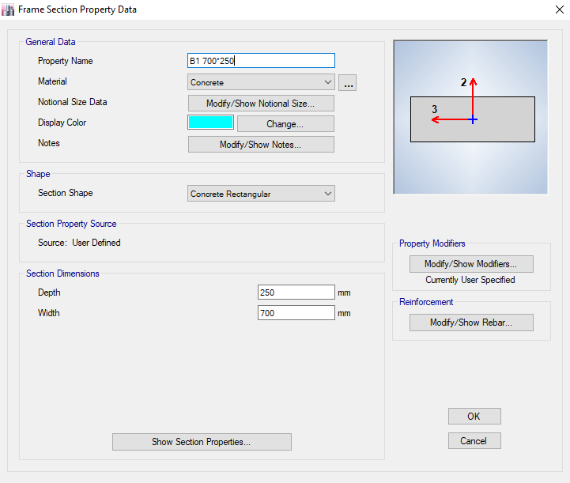
Figure 29: Sample of Beam Section.

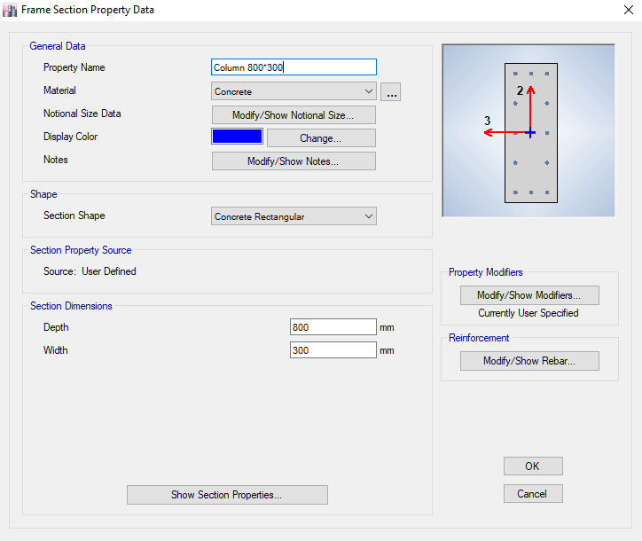
Figure 30: Sample of Column Section.

3.3: Modifier’s for Structural Elements

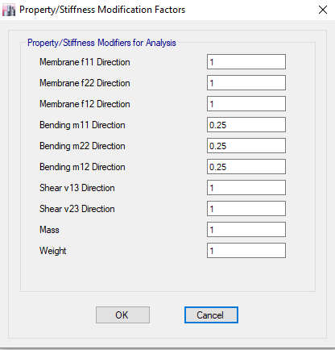
Figure 31:Two-way waffle slab modifiers

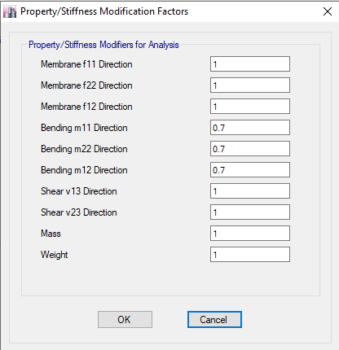
Figure 32: wall modifiers
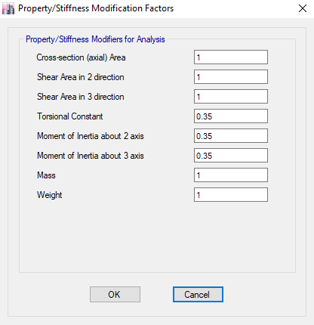
Figure 33: sample of beam modifiers

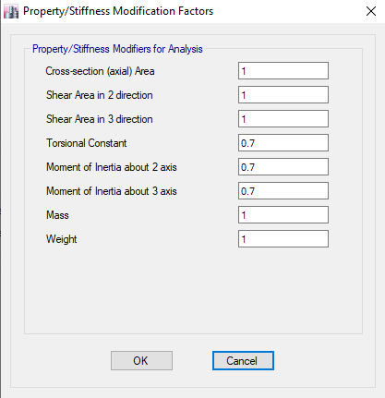
Figure 34: sample of column modifiers

Define Load Patterns
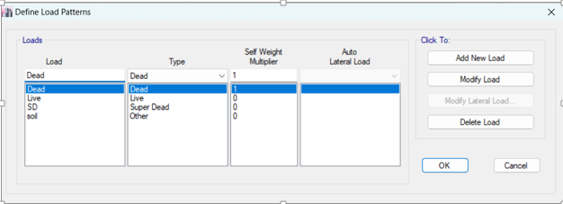
Figure 35: Load Patterns

3.5 Load Combination
- 1.4 (D + SD)
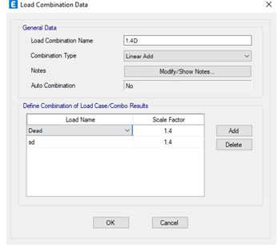
Figure 36: Load Combination one

- 1.2 (D + SD) + 1.6 L
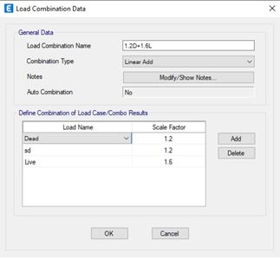
Figure 37: Load Combination two

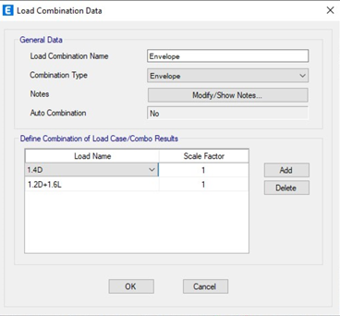
Figure 38: Load Combination three

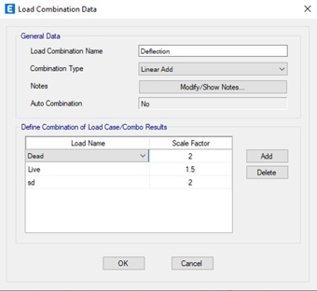
Figure 39: Load Combination four

CHAPTER FOUR: ANALYSIS CHECKS:

4.1 Compatibility check:

This check has been done visually in order to ensure that the structure behaves as a unit.

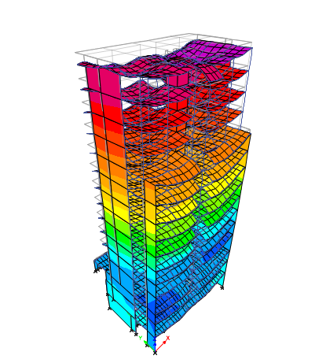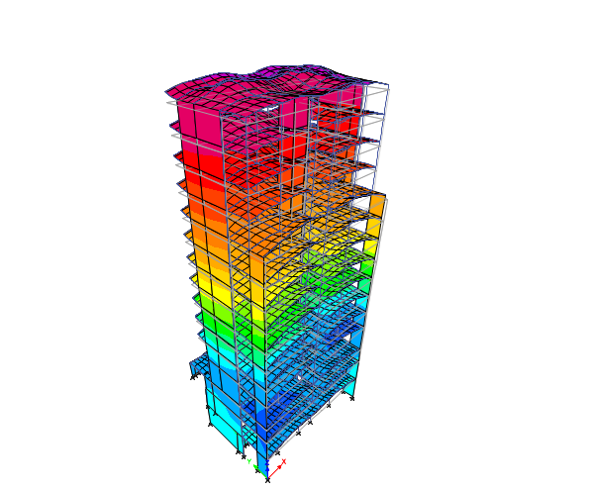

Figure 40: Compatibility check

4.2 Equilibrium check:
4.2.1 Dead load:
The total dead load from ETABS were compared to hand calculated values as shown below:

4.2.1.1 Beams weight:

Table 8: Beams dead load
Table :Sections(mm) | Total length(m) | Width(m) | depth(m) | Weight (KN)
700*250 | 2316.40 | 0.7 | 0.25 | 10134.26
450*250 | 494.6 | 0.45 | 0.25 | 1391.06
300*450 | 250.2 | 0.3 | 0.25 | 469.12
250*250 | 97.48 | 0.25 | 0.25 | 152.31
 |  |  | Total | 12146.75

4.2.1.2 Columns weight:

Table 9 : Columns dead load
Section(mm) | Width(m) | Depth(m)s | Total height(m) | Weight (KN)
800*300 | 0.8 | 0.3 | 518.25 | 3109.5
1000*400 | 1 | 0.4 | 283.5 | 2835
 |  |  | Total | 5944.5

4.2.1.3 Slab Weight:

Table 10: slab dead load
Story | Slab self-weight (KN/m2) | Slab Area(m2) | Weight (KN)
B3 | 3.004 | 132 | 396.528
B2 | 3.004 | 261.44 | 785.365
B1 | 3.004 | 331.29 | 995.195
G | 3.004 | 213.18 | 640.392
1 | 3.004 | 246.03 | 739.074
2 | 3.004 | 246.03 | 739.074
3 | 3.004 | 246.03 | 739.074
4 | 3.004 | 246.03 | 739.074
5 | 3.004 | 246.03 | 739.074
6 | 3.004 | 246.03 | 739.074
7 | 3.004 | 246.03 | 739.074
8 | 3.004 | 210.31 | 631.771
9 | 3.004 | 210.31 | 631.771
10 | 3.004 | 210.31 | 631.771
11 | 3.004 | 240.52 | 722.522
 |  | Total | 10608.836

4.2.1.4 Shear wall weight:

Table 11: shear wall dead load
Wall section (mm) | Story | Length (m) | Hight (m) | Thickness (m) | Weight (KN)
Wall 200 | B3 | 43.26 | 4.5 | 0.2 | 973.35
Wall 200 | B2 | 43.6 | 4 | 0.2 | 872
Wall 200 | B1 | 27.85 | 2.75 | 0.2 | 382.93
Wall 200 | G | 7 | 4.5 | 0.2 | 157.5
Wall 200 | F1 – F11 | 77 | 3 | 0.2 | 1155
 |  |  |  | Total | 3540.78

Total dead load = 12146.75 + 5944.5 + 10608.836 + 3540.78 = 32240.86 KN.
From ETABS → total dead = 32649.38 KN. See Figure 41 below:
$\%Error =\frac{32240.86-32649.38}{32649.38}*100\%=2\%<5\%→OK$

4.2.2 Super imposed dead load:

SD load on slab = load * total area for slab
= 3.68 KN/m² *3531.57 m2 = 12996.18 KN
From ETABS → total SD= 12979.15 KN. See figure 41 below:
$$\%Error =\frac{12996.18-12979.15}{12979.15} *100\%= 0.13 \%<5\% →OK$$

4.2.3 Live load:

Table 12: live loads
Story | Live load (KN/m2) | Slab Area (m2) | Live load on slab (KN)
B3 | 6 | 132 | 792
B2 | 6 | 261.44 | 1568.64
B1 | 1.92 | 331.29 | 636.07
G – F11 | 2.5 | 2806.84 | 7017.1
 |  | Total | 10013.81

From ETABS → 9993.34 KN. See figure 41 below:
$$\%Error = \frac{10013.81-9993.34}{9993.34}*100\%=0.2\%<5\% →OK$$
4.2.4 Soil load:
Manual calculations:
$$P1=\frac{1}{2}*q1*h*b=\frac{1}{2}*53.13*4.5*20.85=2492.46Kn.$$
$$P2=\frac{1}{2}*q2*h*b=\frac{1}{2}*47.304*4*20.85=1972.57Kn.$$
$$P3=\frac{1}{2}*q3*h*b=\frac{1}{2}*32.521*2.75*20.85=932.336Kn.$$
$$P\left(Total\right)=P1+P2+P3=2492.46+1972.57+932.336=5397.36Kn.$$
$P(From ETABS)=5402Kn.$ See figure 41 below:

$$\%Error=\frac{5402-5397.36}{5402}* 100\%=0.086\%<5\%---Ok$$

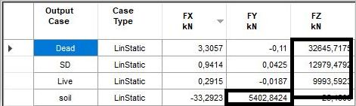
Figure 41: Equilibrium check.
4.3 Stress -strain check:
This check is done in order to ensure that the program calculates the internal forces correctly.
In this check, beam has been selected. See figure 42 below:
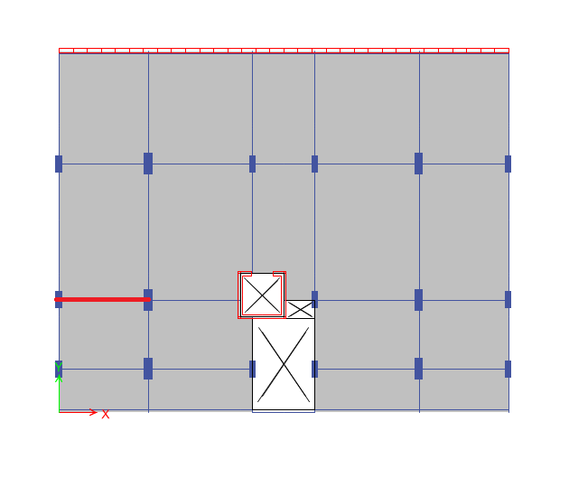
Figure 42: Selected beam for equilibrium check

- Manual calculations:
From live load =1.92 KN/m2
$M0= \frac{W{Ln}^{2}L2}{8}= \frac{1.92*{3.8}^{2}*4.75}{8} =16.94 KN.m/m$

- ETABS results:
Top negative moment = 8.746 KN.m/m. See figure 43 below:
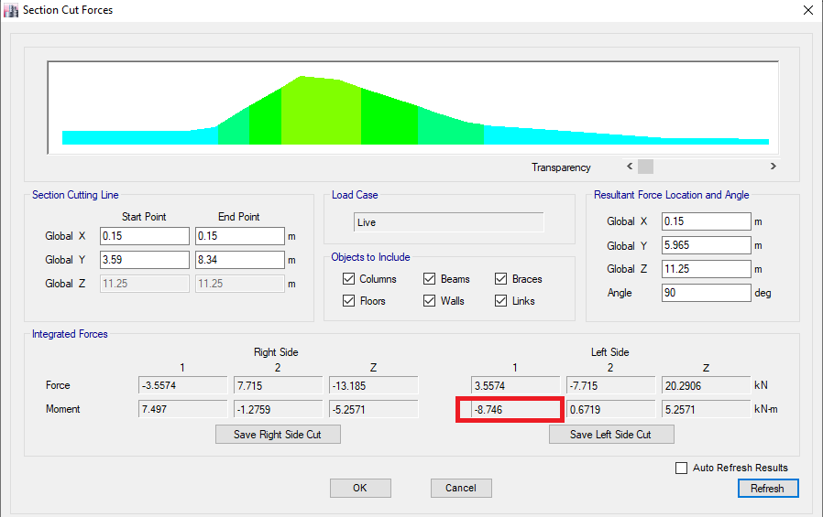
Figure 43: Top negative moment
Bottom negative moment = 7.411 KN.m/m. See figure 44 below:
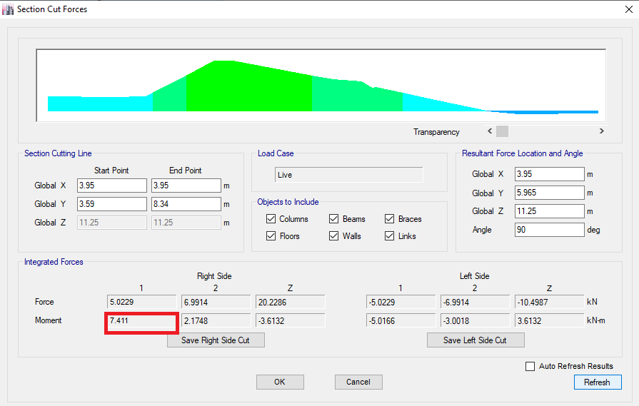
Figure 44: Bottom negative moment
Positive moment = 10.6262 KN.m/m. See figure 45 below:
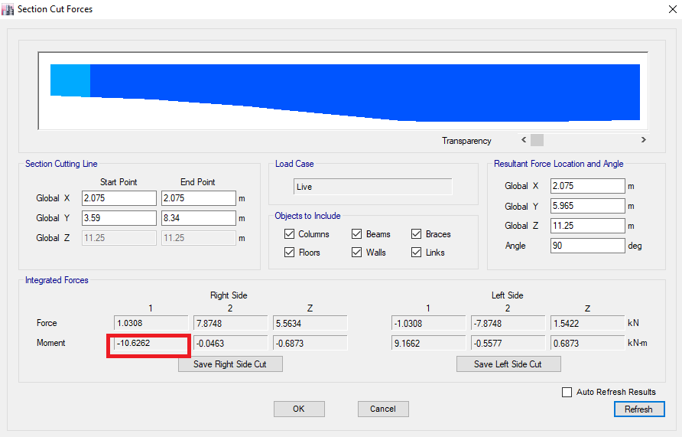
Figure 45: Positive moment.

M (ETABS) = M Positive + (M top + M bottom)/2
= 10.6262 + (7411+8.746)/2
= 18.695 KN.m/m.
$$\%Error = \frac{16.94-18.6262}{18.6262}*100\%=8.4\%<10\%$$

4.4 Deflection check:
This check is done in order to ensure that the deflection of structural elements is not effecting
The partitions, since excessive deflection will make cracks in partitions. Panel of auditorium
Have been selected, since it has the maximum load and will has maximum deflection. See
Figure 46 below:

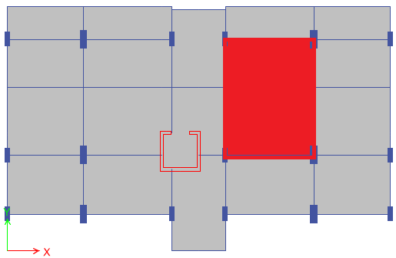
Figure 46 : Critical panel for deflection check.

Allowable deflection according to ACI 318-19:
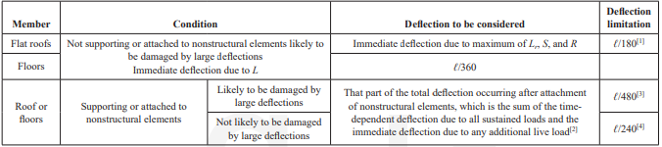
Figure 47: Maximum allowable deflection (ACI318-19)

For long term deflection →allowable deflection =L/240 = (6.30/240) *1000= 26.25mm.
Total deflection = deflection in the middle of slab – average deflection of corners.
Deflection values from ETABS are shown in figure 48 below:
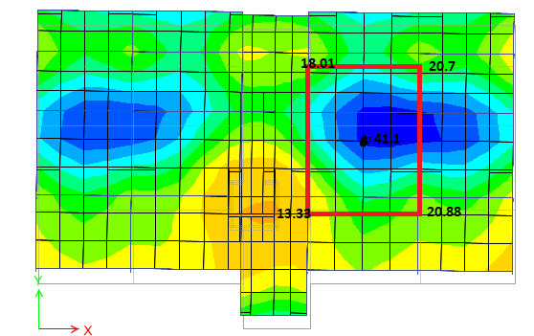
Figure 48: ETABS Deflection values

Total deflection = 41.1-(20.7+18.01+13.33+20.88)/4
= 41.1-17.9 = 23 < 26.25mm → OK.

4.4 Latral check :
Due to the Torsion in first mode ,Shear walls were added to the building in order to adjust the Torsion value. See Figure 49 below:

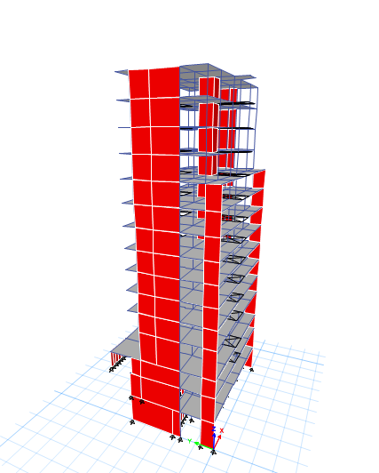

Figure 49: Shear walls to prevent Torsion

4.4.1 Period check:
The approximate fundamental period (Ta) in seconds shall be determined from the following
equations:
Ta = Ct * hnx

Where hn is the structural height and the coefficient Ct and x are determined from Table
12-8-2 in ASCE 7-10. See figure 50 below:

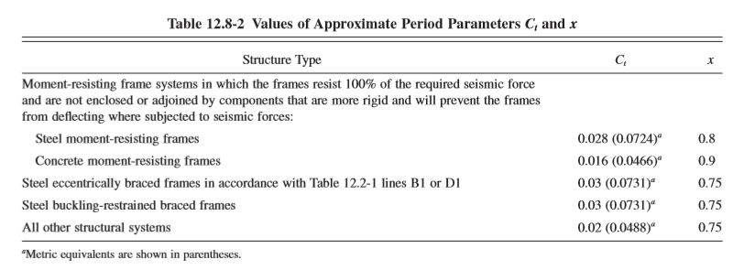

Figure 50: ASCE values for Ct and X.
- Ta=Ct* Hn^x
=0.0466*48.75^0.9=1.54 s.

- Tu= Ta *Cu =1.54*1.5=2.31s.

- T from Etabs in X direction =2.708 . See figure 51 below:
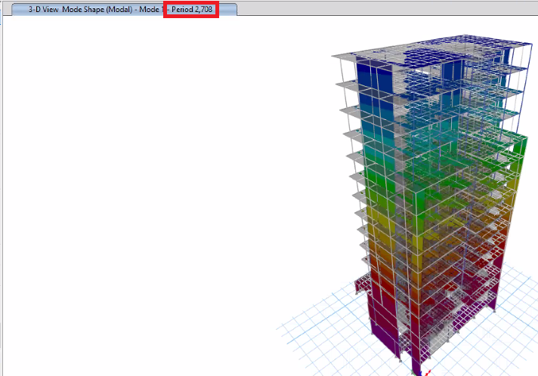

Figure 51: T from Etabs in X direction.
- T Etabs >Tupper ------Take Tupper.

- T from Etabs in Y direction =1.356. See figure 52 below:
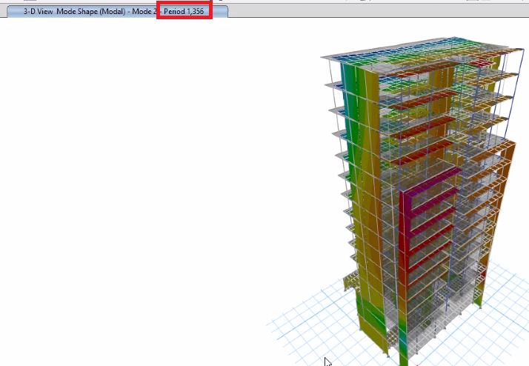
Figure 52: T from Etabs in Y direction.

- T Etabs <Tupper ------Take T Etabs.

4.4.2 Base shear check:
Seismic base shear in the fundamental direction has been calculated as follows:
V = Cs * W such that:
V: seismic base shear.
Cs: seismic response coefficient.
W: effective weight.

- Base shear V =Cs*W (In X-direction )
- W=Dead +super dead+0.25*live load
=35512.41+12977+0.25*9991.95
=50987 Kn. See figure 53 below:
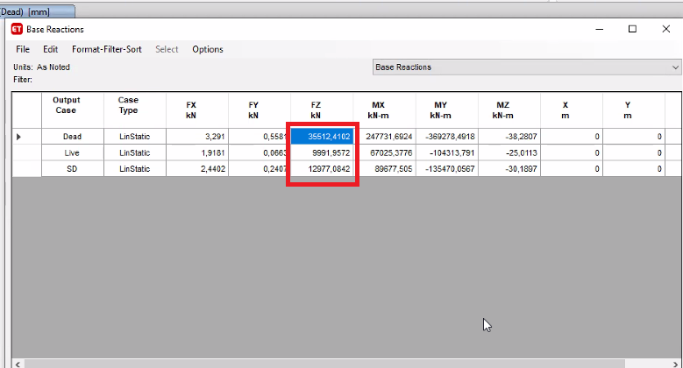
Figure 53: Effective weight from Etabs.
- Cs=SDS*I/R=0.45*1/8=0.056
- Cs min=0.044*SDs*I=0.044*0.45*1=0.0198
Take Cs=0.0198
- V=0.0198*50987.39=1009Kn.

- A load pattern has been defined as an earthquake in x-direction. See figure 54 below:
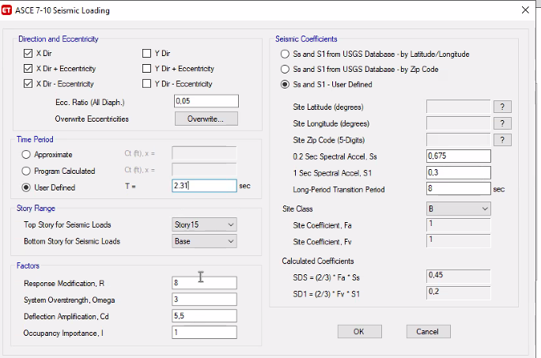
Figure 54: Load puttern an earthquake in x-direction.
- Base shear from Etabs in X direction = 993.3074 Kn.
See figure 55 below:
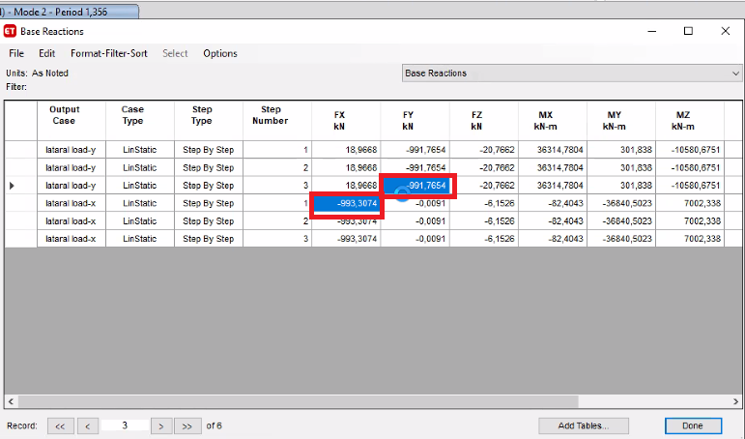
Figure 55: Base shear in X and Y direction.
- % Erorr =(1009-993)/1009 *100% = 1.58 % < 5% → OK.

- Base shear V =Cs*W (In Y-direction )
- W=50987 Kn. See figure 53.
- Cs=SDS*I/R=0.45*1/8=0.056
- Cs min=0.044*SDs*I=0.044*0.45*1=0.0198
Take Cs=0.0198

- V=0.0198*50987.39=1009Kn.

- A load pattern has been defined as an earthquake in Y-direction. See figure 56 below:
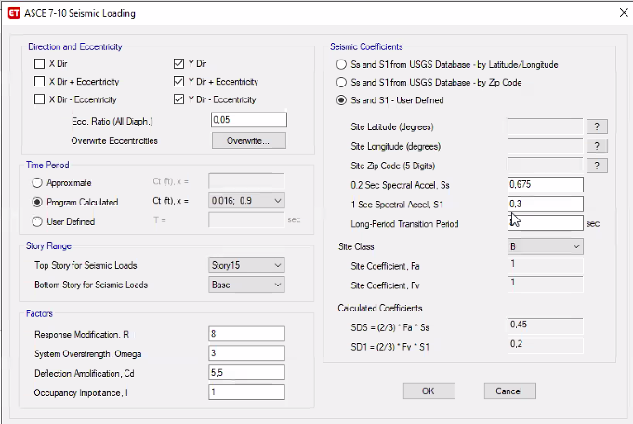
Figure 56: Load puttern an earthquake in Y-direction.

- Base shear from Etabs in Y direction = 991.7654 Kn. See figure 55.
- % Erorr =(1009-991)/1009 *100% = 1.78 % < 5% → OK.

4.4.3 Response Spectrom:
- Define the function Response Spectrom. See figure 57 below:
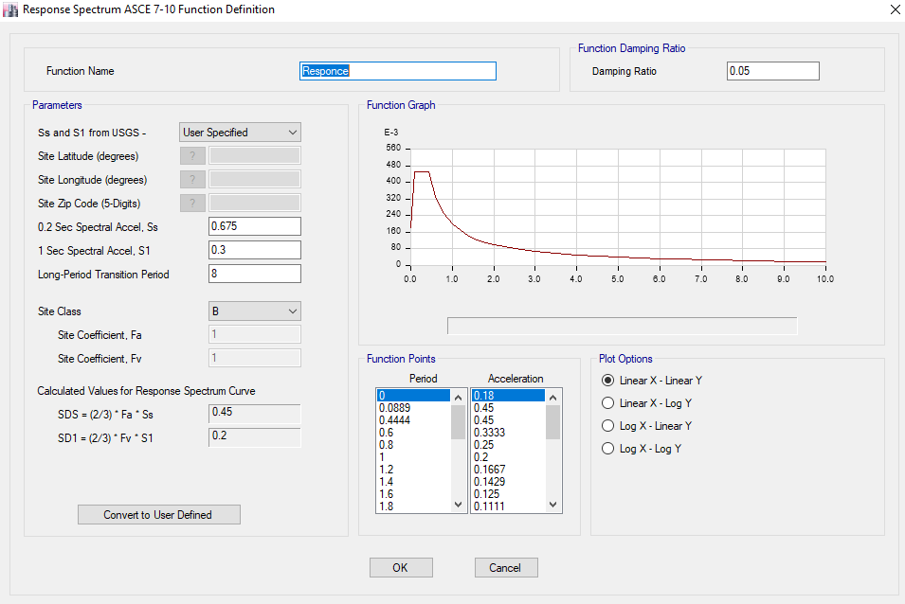
Figure 57: function Response Spectrom.

- Define load case in both directions (Ex and Ey initial)
Factor=9810/R = 9810/8 =1226.25. See figure 58 below:
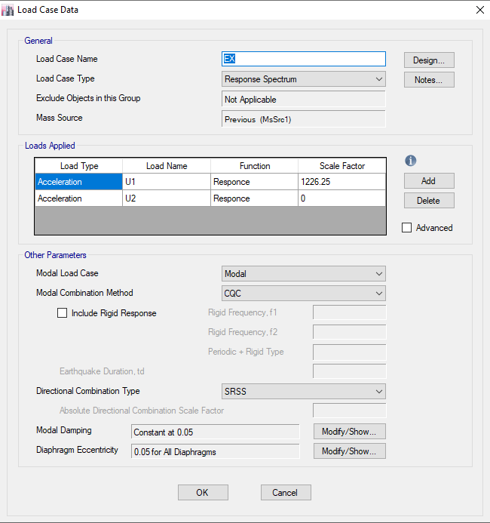

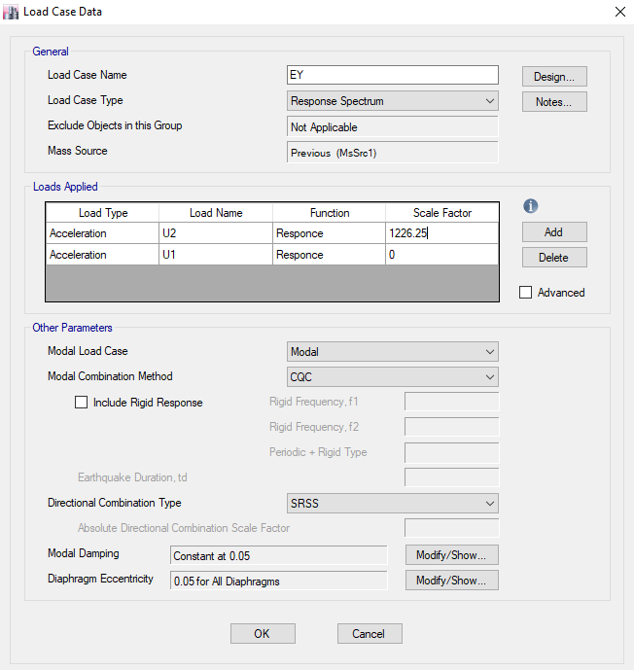
Figure 58: Ex and Ey initial.
- Check base shear from response compared to ELF:
- V(EX)= 369.33 V(ELF-X) =993
modified factor=993/369.33=2.688
Total factor=2.688*1226.25 =3296.16.
→ 0.3Ey must be added to Ex =0.3*1581.86 =474.56. See figure 59 below:
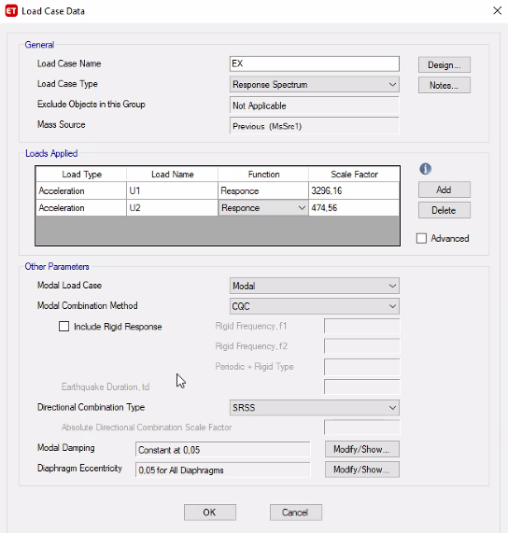
Figure 59: Ex with modifiers (final )

- V(EY)= 763.635 V(ELF-Y) =991
modified factor=991/763.635=1.29
Total factor=1.29*1226.25=1581.86.
→ 0.3Ex must be added to Ey = 0.3*3296.16=988. See figure 60 below:

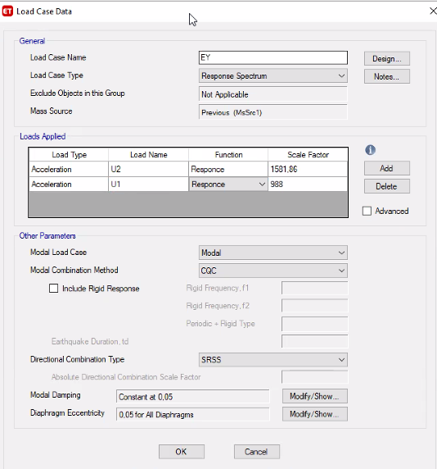
Figure 60: Ey with modifiers (final )

4.4.4 Drift check:
Story drift can be defined as the relative displacement between adjacent story displacements
Such that:
𝜕𝑥 =𝐶𝑑 ∗ 𝜕𝑥𝑒/𝐼𝑒
𝜕𝑥: 𝑖𝑠 𝑡ℎ𝑒 𝑖𝑛 𝑒𝑙𝑎𝑠𝑡𝑖𝑐 𝑑𝑟𝑖𝑓𝑡.
Cd: the deflection amplification factor = 5.5
𝜕xe: is the elastic drift of the story and computed from ETABS.
- Drift in x-direction:
The allowable drift = 0.02 hx. See figure 61 below:
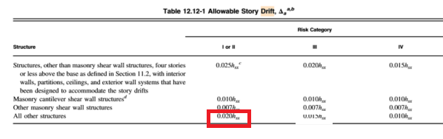
Figure 61: The allowable drift value.
Drift in X-Direction
Story | Delta(elastic) | H | Drift | allowable
15 | 0.001561 | 3 | 0.0085855 | 0.06 | OK
14 | 0.001697 | 3 | 0.0093335 | 0.06 | OK
13 | 0.001802 | 3 | 0.009911 | 0.06 | OK
12 | 0.0105454 | 3 | 0.0579997 | 0.06 | OK
11 | 0.001948 | 3 | 0.010714 | 0.06 | OK
10 | 0.002008 | 3 | 0.011044 | 0.06 | OK
9 | 0.00205 | 3 | 0.011275 | 0.06 | OK
8 | 0.00206 | 3 | 0.01133 | 0.06 | OK
7 | 0.002032 | 3 | 0.011176 | 0.06 | OK
6 | 0.001934 | 3 | 0.010637 | 0.06 | OK
5 | 0.001771 | 3 | 0.0097405 | 0.06 | OK
4 | 0.001249 | 4.5 | 0.0068695 | 0.09 | OK
3 | 0.000272 | 2.75 | 0.001496 | 0.055 | OK
2 | 8.70E-05 | 4 | 0.0004785 | 0.08 | OK
1 | 2.10E-05 | 4.5 | 0.0001155 | 0.09 | OK
Table 13: Drift in X-Direction.

- Drift in y-direction:
Drift in Y-Direction
Story | Delta(elastic) | H | Drift | allowable
15 | 0.000579 | 3 | 0.0031845 | 0.06 | OK
14 | 0.000585 | 3 | 0.0032175 | 0.06 | OK
13 | 0.000587 | 3 | 0.0032285 | 0.06 | OK
12 | 0.003981 | 3 | 0.0218955 | 0.06 | OK
11 | 0.000571 | 3 | 0.0031405 | 0.06 | OK
10 | 0.000558 | 3 | 0.003069 | 0.06 | OK
9 | 0.000536 | 3 | 0.002948 | 0.06 | OK
8 | 0.000506 | 3 | 0.002783 | 0.06 | OK
7 | 0.000468 | 3 | 0.002574 | 0.06 | OK
6 | 0.00042 | 3 | 0.00231 | 0.06 | OK
5 | 0.00036 | 3 | 0.00198 | 0.06 | OK
4 | 0.000264 | 4.5 | 0.001452 | 0.09 | OK
3 | 0.000243 | 2.75 | 0.0013365 | 0.055 | OK
2 | 6.50E-05 | 4 | 0.0003575 | 0.08 | OK
1 | 1.10E-05 | 4.5 | 0.0000605 | 0.09 | OK
Table 14: Drift in Y-Direction.

4.4.5 P-Delta check :
P-Delta effects on story shears and moments and can be ignored if its value is less than 0.1 m.
𝜃 =𝑃𝑥∗ ∆∗𝐼𝑒 / 𝑉𝑥∗ℎ𝑥∗𝐶𝑑
such that:
Px: The total vertical design load at and above level X (From ETABS).
∆ : The story drift.
Ie: Importance factor = 1.25.
Vx: The seismic shear force acting between level X and X-1.
hx: Story height below level x.

- P-delta In X-Direction:
P-Delta in X-Direction
Story | Delta(elastic) | H | P | V | Theta
15 | 0.001561 | 3 | 3630.8094 | 260.3228 | 0.007257264 | OK
14 | 0.001697 | 3 | 6956.9113 | 409.0381 | 0.009620847 | OK
13 | 0.001802 | 3 | 10283.013 | 490.003 | 0.012605358 | OK
12 | 0.0105454 | 3 | 13652.49 | 536.0515 | 0.089525583 | OK
11 | 0.001948 | 3 | 17471.52 | 577.9581 | 0.019629174 | OK
10 | 0.002008 | 3 | 21290.55 | 629.437 | 0.022640034 | OK
9 | 0.00205 | 3 | 25109.58 | 677.5426 | 0.025324183 | OK
8 | 0.00206 | 3 | 28928.61 | 721.0305 | 0.027549892 | OK
7 | 0.002032 | 3 | 32747.64 | 766.185 | 0.028950016 | OK
6 | 0.001934 | 3 | 36566.67 | 827.5974 | 0.028484035 | OK
5 | 0.001771 | 3 | 40385.7 | 903.9142 | 0.026375319 | OK
4 | 0.001249 | 4.5 | 44158.367 | 972.6869 | 0.01260056 | OK
3 | 0.000272 | 2.75 | 48984.728 | 995.69 | 0.004866007 | OK
2 | 8.70E-05 | 4 | 54108.254 | 1348.8225 | 0.000872505 | OK
1 | 2.10E-05 | 4.5 | 58853.95 | 1420.52 | 0.000193346 | OK
Table 15: P-Delta in x-direction.

- P-delta In Y-Direction:
P-Delta in Y-Direction
Story | Delta(elastic) | H | P | V | Theta
15 | 0.000579 | 3 | 3630.8094 | 208.7228 | 0.003357306 | OK
14 | 0.000585 | 3 | 6956.9113 | 356.9285 | 0.003800755 | OK
13 | 0.000587 | 3 | 10283.0132 | 445.5816 | 0.004515543 | OK
12 | 0.003981 | 3 | 13652.4901 | 491.5601 | 0.036855828 | OK
11 | 0.000571 | 3 | 17471.5201 | 521.6355 | 0.006374974 | OK
10 | 0.000558 | 3 | 21290.5501 | 553.349 | 0.0071565 | OK
9 | 0.000536 | 3 | 25109.5801 | 595.7701 | 0.007530161 | OK
8 | 0.000506 | 3 | 28928.6101 | 649.4521 | 0.007512936 | OK
7 | 0.000468 | 3 | 32747.6401 | 713.9394 | 0.007155554 | OK
6 | 0.00042 | 3 | 36566.6701 | 788.7751 | 0.006490233 | OK
5 | 0.00036 | 3 | 40385.7001 | 868.4401 | 0.005580447 | OK
4 | 0.000264 | 4.5 | 44158.3665 | 936.9396 | 0.002764985 | OK
3 | 0.000243 | 2.75 | 48984.7283 | 987.2354 | 0.004384434 | OK
2 | 6.50E-05 | 4 | 54108.2544 | 1003.1682 | 0.000876482 | OK
1 | 1.10E-05 | 4.5 | 58853.95 | 1120.25 | 0.000128422 | OK
Table 16: P-Delta in Y-direction.

CHAPTER FIVE: DESIGN
This chapter will include: design checks, design of slab, design of a beam, and design of a
Column, design of a shear wall.

5.1 Shear strength check for slab:
$$∅Vc=∅\frac{1}{6}\sqrt{fc }bw*d$$
$=(0.75) 1/6 √(28 ) 1000/1000*(250-40)=138.90KN$
The max shear value from ETABS on the critical panel shown in figure 62 below was less than 138.90 KN→OK
Vu from ETABS = 38.016 KN
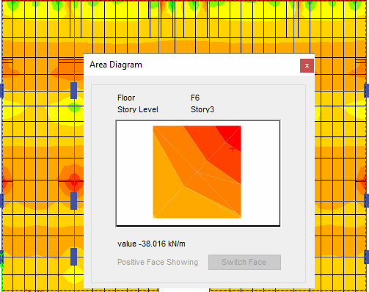
Figure 62: Shear check on slab.

- Hand calculation
Wu = 1.2D+1.6L
= 1.2(3.68+3.15) + 1.6(1.92) = 11.268 KN/m2
$$Vu =Wu\left(\frac{L}{2}-\frac{B}{2}-d\right)$$
$=11.268\left(\frac{6.30}{2}-\frac{0.4}{2}-0.21\right)=35.6 KN<138.90 →OK$
5.2 Design check for beam:
Beam has been selected in fourd story. See figure 63 below:

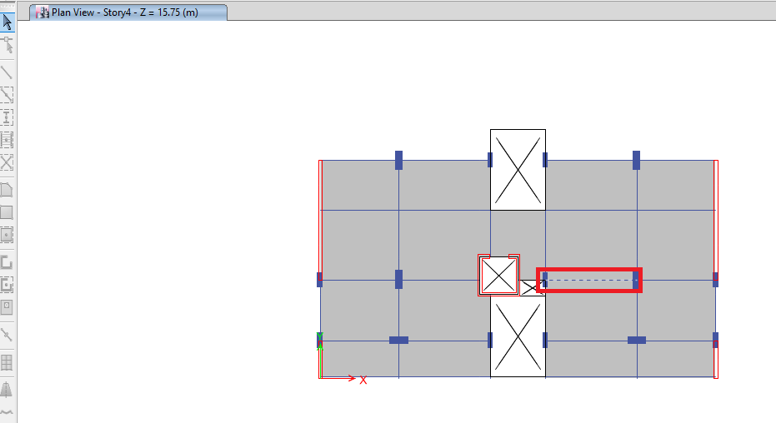
Figure 63: selected beam for design check.

Beam dimensions = 700 X 250mm.
Effective depth = 215 mm.

5.2.1 Flexural design:
For negative and positive moments from ETABS, See figure below 64:

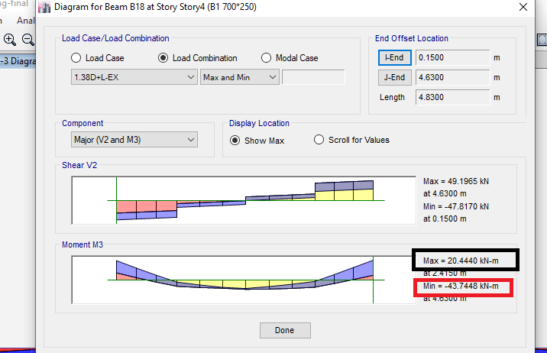
Figure 64: moment in beam.
5.2.1.1 For positive moment = 20.444 KN.m
Where: f’c = 28 MPa, F_{y} = 420 MPa.
$$ρ=\frac{0.85*fc}{fy}(1-\sqrt{1-\frac{2.61*Mu}{b*d^{2}*fc}}$$
$$ρ=\frac{0.85*28}{420}(1-\sqrt{1-\frac{2.61*20.444*{10}^{6}}{700*{215}^{2}*28}} )=0.00168$$

𝜌𝑚𝑖𝑛=1.4/420 =0.0033
0.0033 > 0.00168 →Take ρ = 0.0033
→ As = ρ *b*d =0.0033*700* 215 = 501 mm²
→ Use 4∅14
→As from Etabs =494mm²
%Error =(501-494)/501=1.39% < 5% → OK.
5.2.1.2 For negative moment = 43.7448 KN.m
Where: f’c = 28 MPa, Fy = 420 MPa.
$$ρ=\frac{0.85*fc}{fy}(1-\sqrt{1-\frac{2.61*Mu}{b*d^{2}*fc}}$$
$$ρ=\frac{0.85*28}{420}(1-\sqrt{1-\frac{2.61*43.7448*{10}^{6}}{700*{215}^{2}*28}} )=0.00369$$

𝜌𝑚𝑖𝑛=0.0033
0.0033 < 0.00369 →Take ρ = 0.00369
→ As = ρ *b*d =0.00369*700* 215 = 555 mm²
→ Use 4∅14
→ As from Etabs =581mm²
→%Error =(I581-555)/581=4% < 5% → OK.

For reinforcement from ETABS, See figure 65 below:
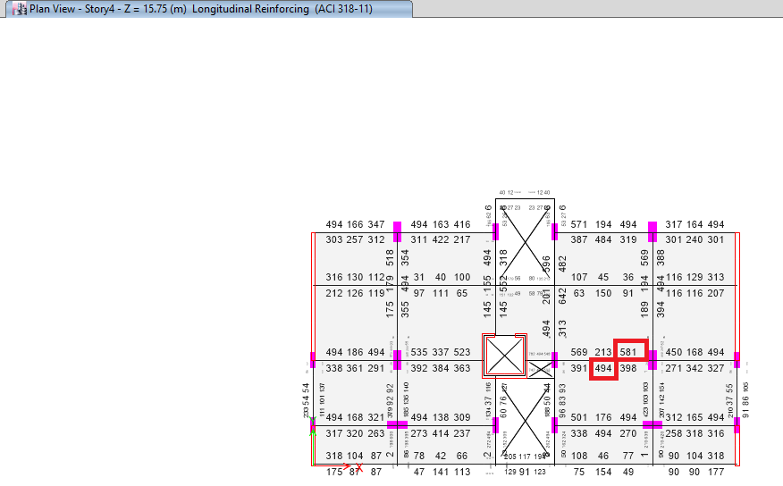
Figure 65: Reinforcement for beam from Etabs.

5.2.2 Design beam for shear
First, we will make sure to calculate the strength of the shear :

- $V=\frac{mp1+mp2}{Ln}+\frac{Wu*Ln}{2}$
→As =569 mm² from Etabs .
$$a=\frac{1.25*As*Fy}{0.85*fc*b}=\frac{1.25*569*420}{0.85*28*700}=17.93mm$$

$$→mp1=1.25*As*fy*\left(d-\frac{a}{2}\right)=1.25*569*420\left(215-\frac{17.93}{2}\right)=61.59Kn.m$$
→As =398mm² from Etabs .
$$a=\frac{1.25*As*Fy}{0.85*fc*b}=\frac{1.25*398*420}{0.85*28*700}=12.5mm$$

$$→mp2=1.25*As*fy*\left(d-\frac{a}{2}\right)=1.25*398*420\left(215-\frac{12.5}{2}\right)=43.61Kn.m$$

- $Vp=\frac{mp1+mp2}{Ln}=\frac{61.59+43.61}{4.48}=23.48 kn.$
- $\frac{Wu*Ln}{2}=\left(1.2+0.2SDs\right)D+L$
$$=1.29*21.9+9.15=37.401 kn$$

$→V1=23.48+37.401=61 kn$.
$$→V factored=\left(1.2+0.4SDs\right)D+L+2E$$
=(1.38*21.9)+9.15+(2*3.15) =46 Kn.

→ Vg= 1.2D+1.6L = (12*20.9)+(1.6*9.15) =39 Kn.

→ The value of shear design = the max value of (V1,V factored ,Vg) = 61 Kn.

→The value of V from load case (Dead , Live .E, 1.2D+1.6L). See the figure 66 below:

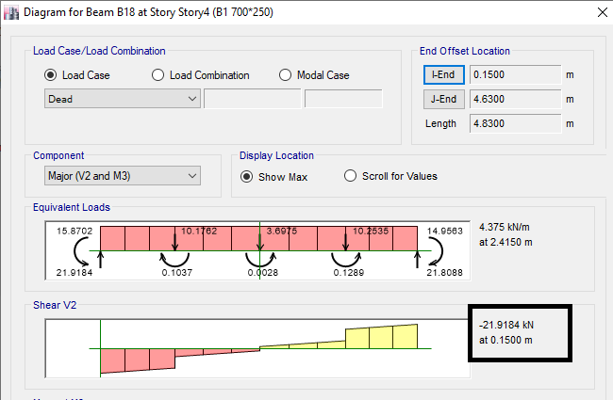

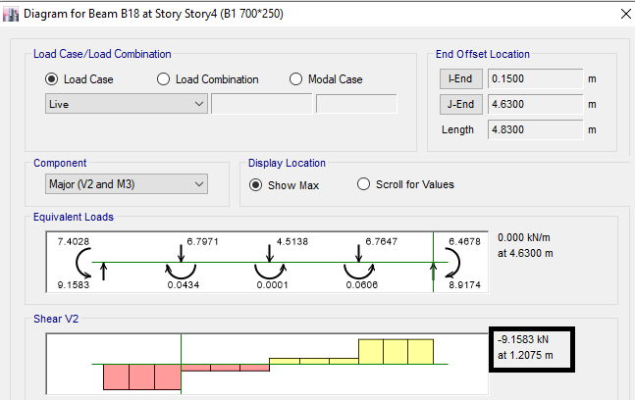

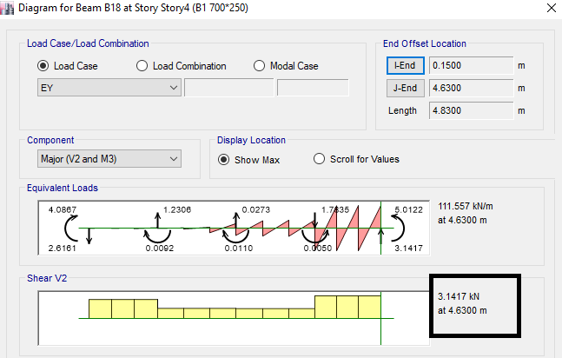

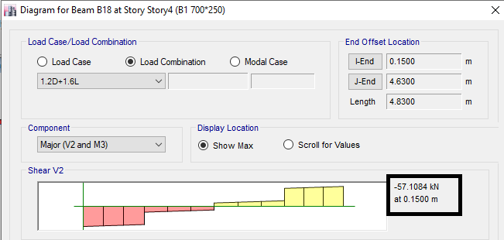
Figure 66: The value of shear for load case.
→The summary shear details from Etabs . See the figure 67 below:

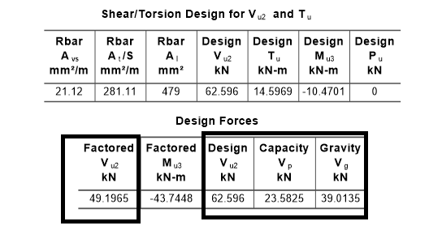
Figure 67: The summary shear details from Etabs.
→ Calculate of Av /s :
$$Vc= \frac{1}{6}*\sqrt{fc}*bw*d /1000$$
$$= \frac{1}{6}*\sqrt{28}*700*\frac{21}{1000}=132.728 KN$$

→∅Vc =99.546 KN.

$$\frac{Av}{s} min=0.35*\frac{bw}{fyt}=0.35*\frac{700}{420}=0.583 mm/m$$
Assume Av = 2 * 78.5 = 157 mm2
→ Take S = 270mm
→Smax = d/2 = 107.5 mm

→ on the side beam :
S max = min (d/4,6db,150mm)
= min (215/4,6*10,150)
Take S= 60mm.
→ at the middle beam :
S = d/2=215/2 =107.5mm. → Take S=100mm. See the figure 68 below:
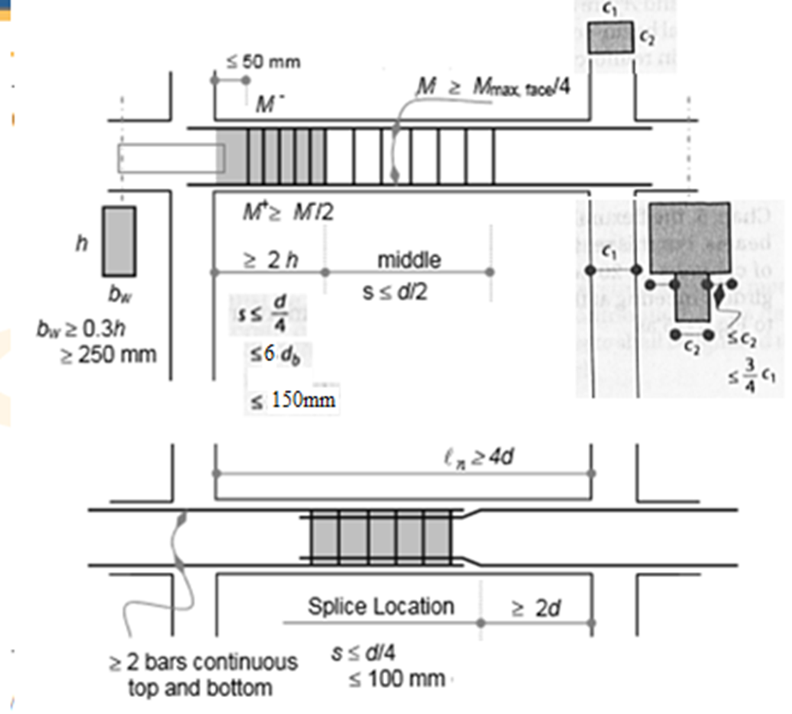
Figure 68: Design of stirrups for beam in latral load.

5.3 Design check for column:
Column at grid (5G) has been selected. See figure 69 below:
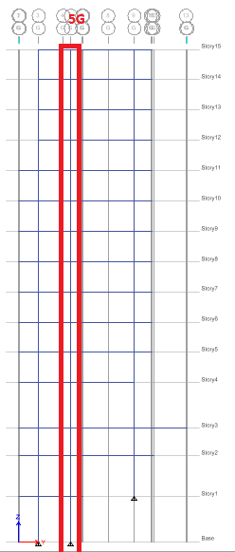
Figure 69: Selected column for design.

Axial load from ETABS = 4475.81 KN. See figure 70 below.
Ultimate moment M3 from ETABS = 101.108 KN.m. See figure 71 below.
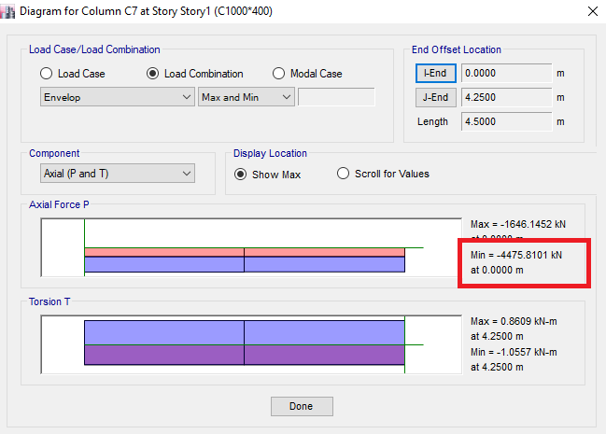
Figure 70: axial load in column.
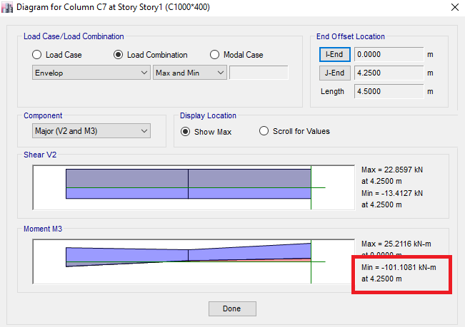
Figure 71: moment 3 in column
Interaction diagram for the selected column has been drawn and the point has been projected
On the diagram. See figure 72 below:
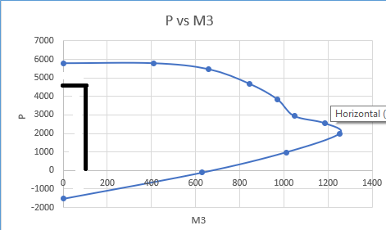
Figure 72: P-M3 interaction diagram
𝜌 𝐹𝑟𝑜𝑚 𝐸𝑇𝐴𝐵𝑆 = 0.01. See figure 73 below.

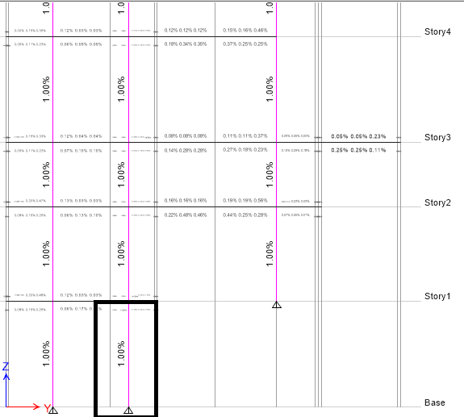
Figure 73: Rebar percentage for column.
➔ As = 0.01 * 1000 * 400 =4000 mm²
➔ Use 16∅18.

Shear design for the column:
Use Av /s min =$0.583 mm/m$
Assume Av = 2 * 78.5 = 157 mm2
→ S=270mm.

On the side column:
S max = min (b/4, 6db, h/4, Sₒ)
= min (1000/4, 6*18, 400/4, 100)mm.
Take S= 100mm.

at the middle column:
S =6db=6*18=108mm. → Take S=100mm.

→ Distance between reinforcement bars
= (1000-80-10-18)/6=148mm < 150mm.

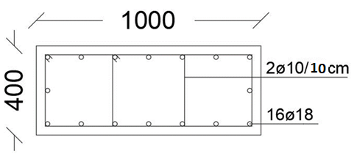
Figure 74: Cross section for column.

5.4 Design of slab:
Minimum steel for slab has been computed = 0.0033*bw*d

Where: b is the width of web = 150 mm
D is the effective depth = 210 mm
As min = 0.0033*150*210 =103.95 mm²

→For positive moment
Let a = $\frac{As*fy }{0.85*fc*bf}$ =$\frac{103.95*420}{0.85*28*550}$ =3.34 mm

∅Mn =∅*As *Fy (d-$\frac{a}{2}$ )
= 0.9*103.95*420*(210- $\frac{3.34}{2}$) *${10}^{-6}$ /0.55
= 14.88 KN.m/m.
→For negative moment
Let a = $\frac{As*fy }{0.85*fc*bw}= \frac{103.95*420}{0.85*28*150}$ =12.22 mm.

∅Mn =∅*As *Fy (d- a/2)
= 0.9*103.95*420*(210- $\frac{12.22}{2}$)*${10}^{-6}$ /0.55
= 14.56 KN.m/m
The moment of slab has been shown between the ranges of minimum moment as shown in figure 75 below:

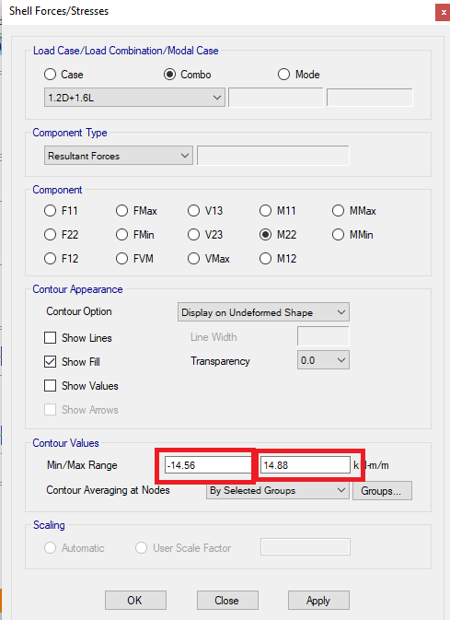
Figure 75: The range of minimum moment
In x direction, all reinforcement are minimum. See figure 76 below:
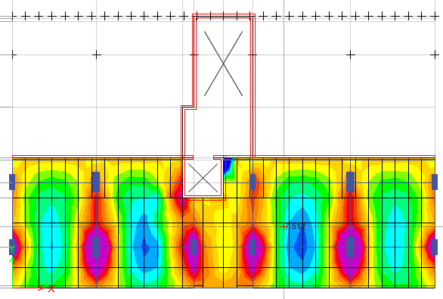
Figure 76: minimum moment in x direction.
In y-direction, reinforcements for all slab are minimum except the following panels. See
Figures 77 below:

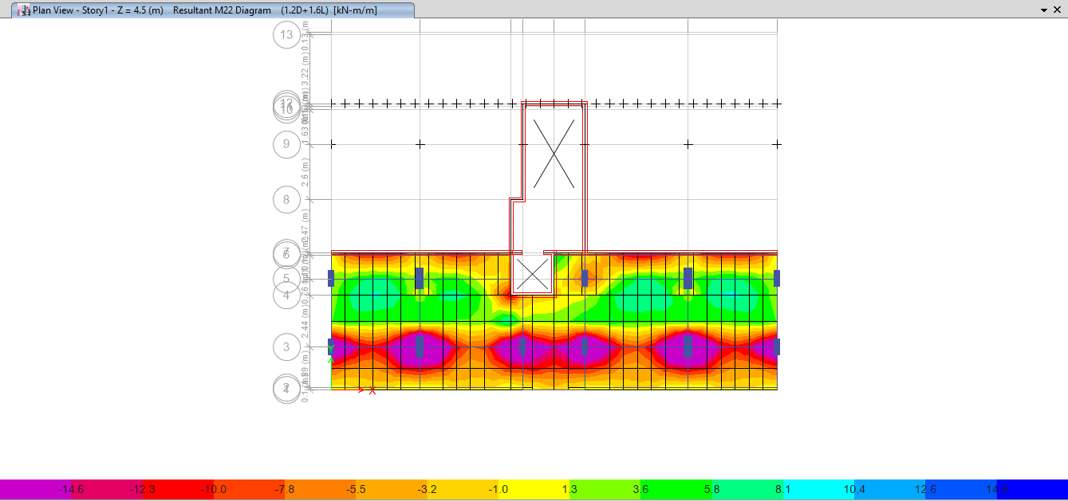
Figure 77: Moment in y-direction for slab
For minimum moment → reinforcement = 103.95 mm2/m.

→ Take 2∅10 for positive moment and negative moment.

For panels in figures above for M11, maximum moment = 35kN.m/m

→For positive moment

∅Mn =∅*As *Fy (d- a/2)
35*0.9 = 0.9*As*420*(210- $\frac{3.34}{2}$)*${10}^{-6}$ /0.55
As = 220mm² → Take 2∅12.

→ For negative moment

∅Mn =∅*As *Fy (d- a/2)
35*0.9 = 0.9*As*420*(210- $\frac{12.22}{2}$)*${10}^{-6}$ /0.55
As= 225 mm² → Take 2∅12.

5.5 Design of shear wall:
Sear wall has been selected in figure 78 below:

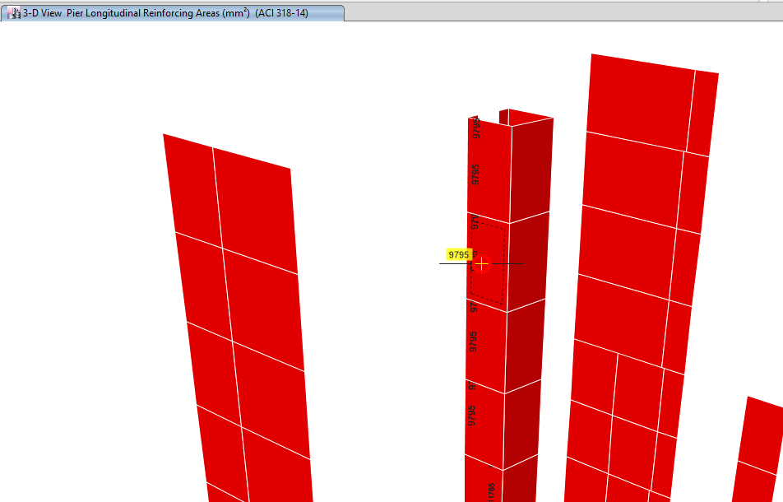
Figure 78: Area of steel from Etabs

Area of steel from Etabs =9795 mm2 along the wall.
= 9795/3=3265 mm2/m→6∅25/m.

CHAPTER SIX: DESIGN OF FOOTHING

The foundations of the building transfer the weight of the building to the ground. While 'foundation' is a general word, normally, every building has a number of individual foundations, commonly called footings. Usually each column of the building will have its own footing.

All foundations are divided into two categories: shallow foundations and deep foundations. The words shallow and deep refer to the depth of soil in which the foundation is made. There are several kinds of shallow footings: isolated footings, combined footings and mat foundations. A pile is basically a long cylinder of a strong material such as concrete that is pushed into the ground so that structures can be supported on top of it.

There are many factors taking into consideration in the selection of footing:

- Design load: The magnitude of the design load dictates the required size of the foundation from a structural standpoint.
- Subsurface formations: The depth and strength of subsurface formations determine the type of foundation chosen.
- Economic considerations: Consider economics in the final selection by Compare the foundation types.

- Isolated footing (Single footing) is used to support the load on a single column. It is usually either square or rectangle in plan. It represents the simplest, most economical type, and most widely used footing. Whenever possible, square footings are provided so as to reduce the bending moment and shear force the three critical sections.
- A basement wall (Wall footing) is thus one kind of retaining wall. But the term usually refers to a cantilever retaining wall, which is a freestanding structure without lateral support at its top. These are cantilevered from a footing and rise above the grade on one side to retain a higher level grade on the opposite side. The walls must resist the lateral pressures generated by loose soils or, in some cases, water pressure. A retaining wall is a structure designed and constructed to resist the lateral pressure of soil when there is a desired change in ground elevation that exceeds the repose of the soil.
- A mat foundation spreads out under the footprint of the building and declines the contact pressure compared to conventional strip or trench footing. It is a suitable solution for low bearing capacity soil, spread footing cover about 70% of the structure, high structure loads, soft pockets or cavities of in the soil to unknown extent raft, and highly compressible soil that extends to a great depth.

This project is a design for some types of footing, which the Mat foundation and Wall Footing

6.1 Load combinations:
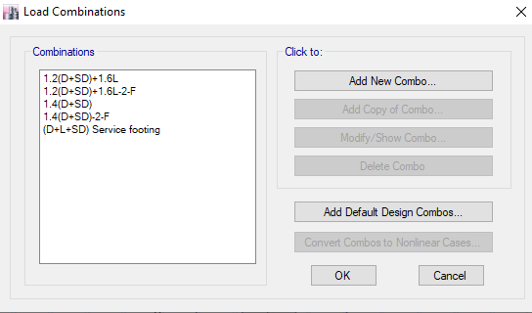
Figure 79: Load combination for footing

6.2 Mat Foundation and Wall footing :
Mat foundation Layout (AutoCAD drawing): See Figures 80 below:

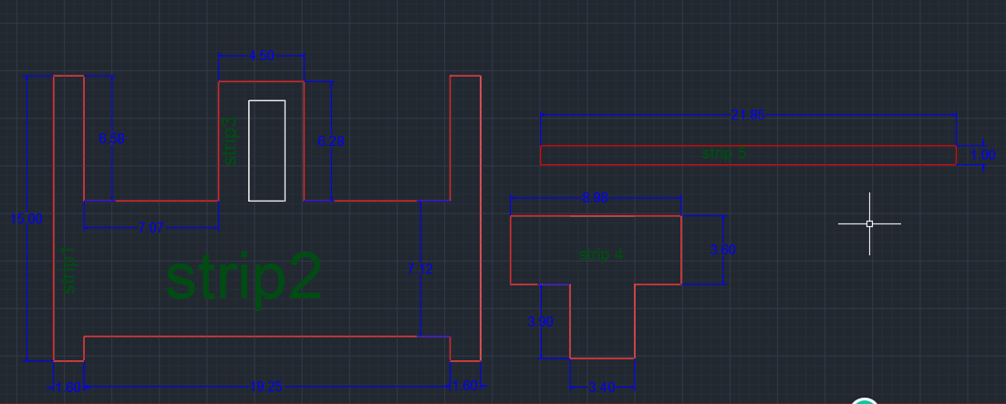
Figure 80: Layout for strips of footing

Allowable bearing capacity of soil = 470 Kn/m²

All dimensions were assumed and checked on Etabs.

Strip name | Thickness(m)
1 | 0.45
2 | 0.77
3 | 0.45
4 | 0.6
5 | 0.35

6.3 Mat Foundation and Wall footing checks :
6.3.1 Check soil pressure :
The pressure must be less than q allowable =470 kn/m². → Ok. See figure 81 below.

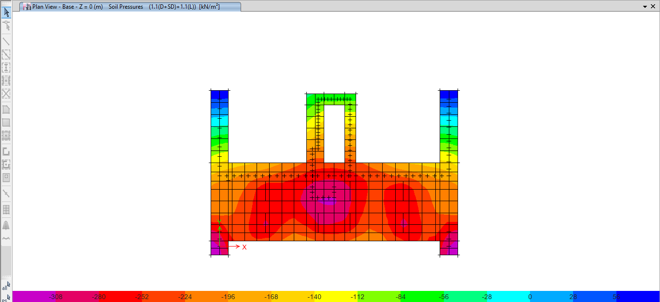

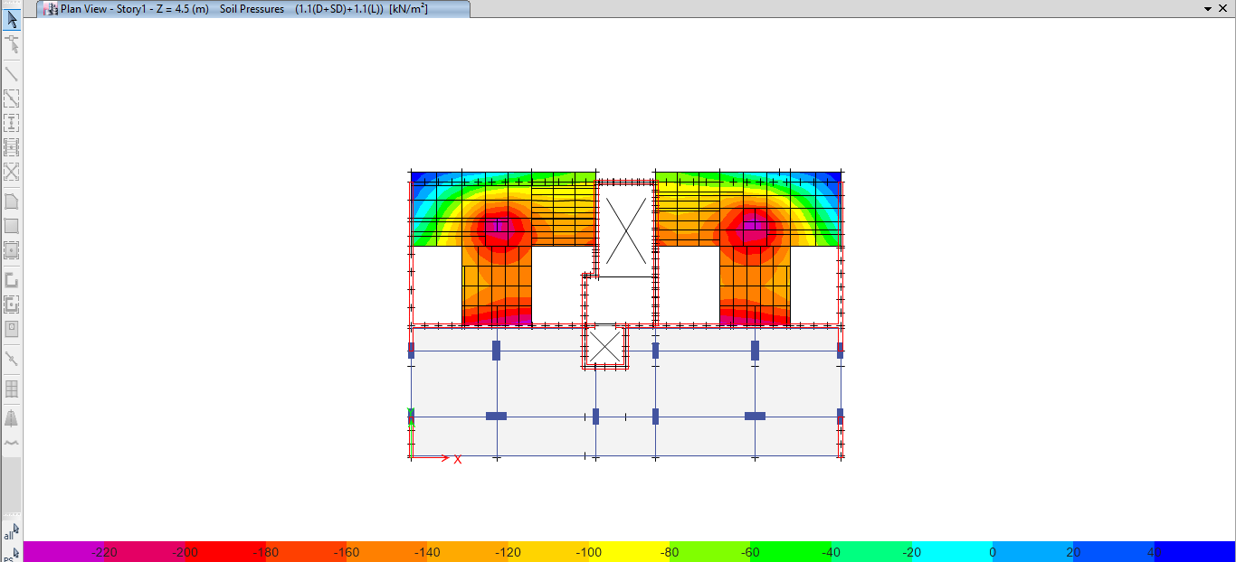

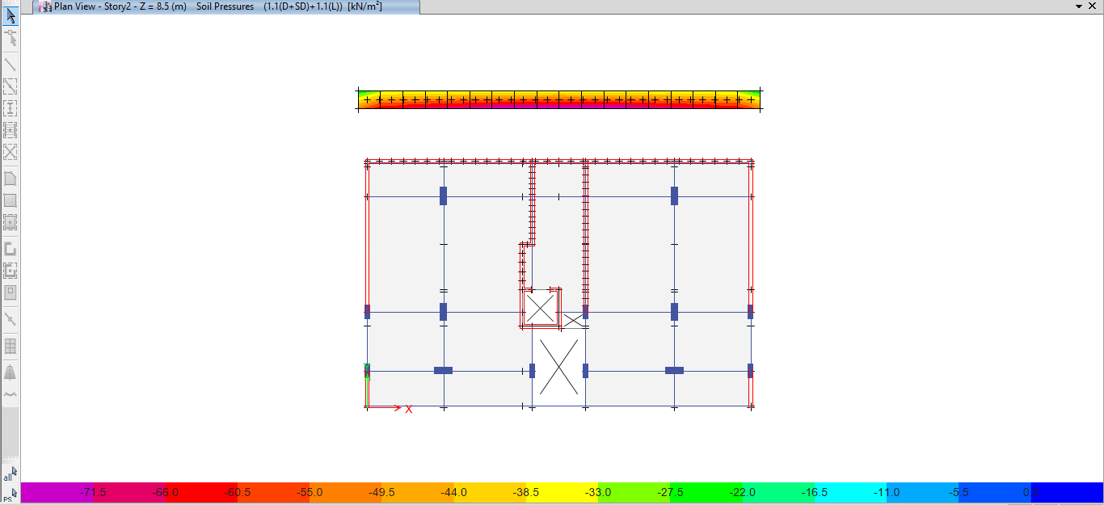
Figure 81: Check soil pressure from Etabs
6.3.2 Check Punching shear :
Check punching shear for mat foundation (less than (1) to get a high factor of safety ). OK
See figure 82 below.

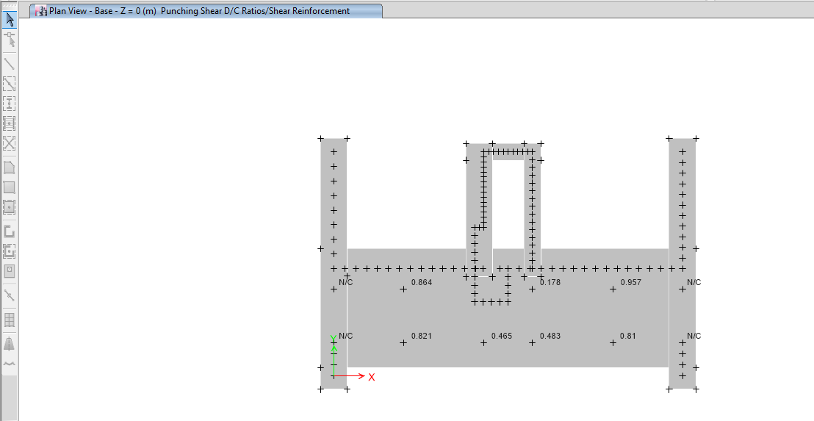
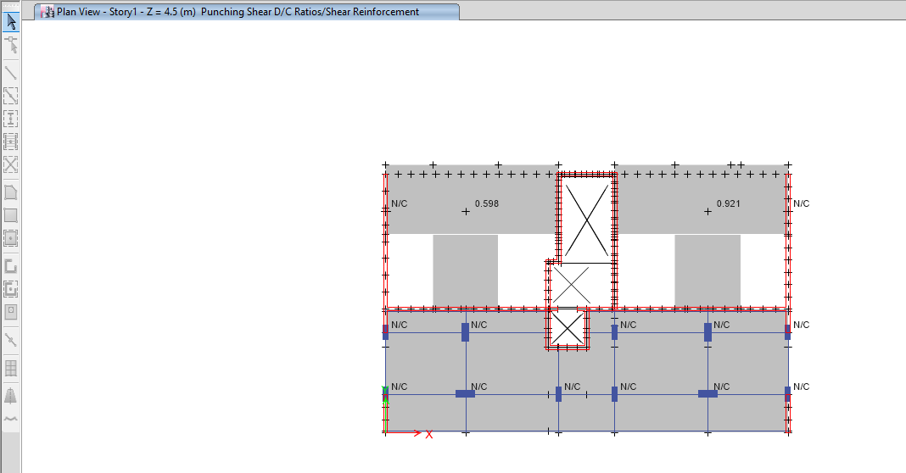
Figure 82: Check punching shear from Etabs

6.4 Design for Mat Foundation and Wall footing :
Sample calculation:
- Strip 1: (h=450mm)
- Area of steel (Top in X direction) from Etabs for (Strip1) =Area of steel min
As min = ρ *b*h =0.0018*1000*450=810mm². →(4∅16/m).
See figure 83 below.
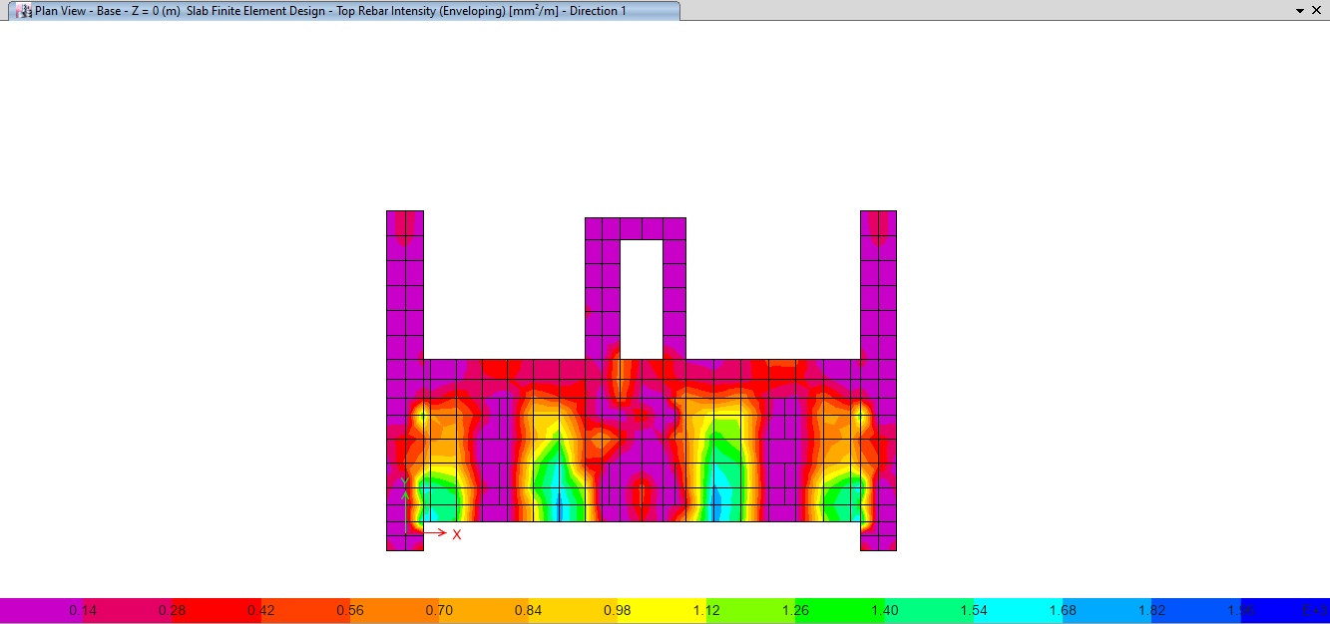
Figure 83: As Top in X direction

- Area of steel (Bottom in X direction) from Etabs for (Strip1) =Area of steel min
As min = ρ *b*h =0.0018*1000*450=810mm². →(4∅16/m).
See figure 84 below.
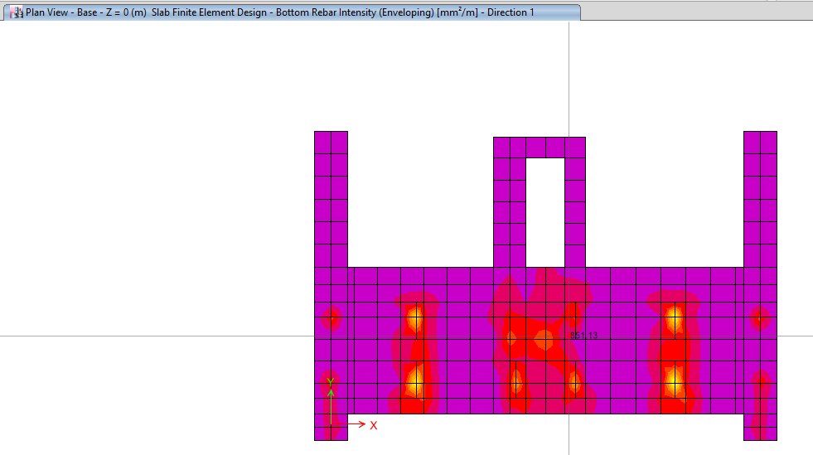
Figure 84: As Bottom in X direction

- Area of steel (Top in Y direction) from Etabs for (Strip1) =Area of steel min
As min = ρ *b*h =0.0018*1000*450=810mm². →(4∅16/m).
See figure 85 below.
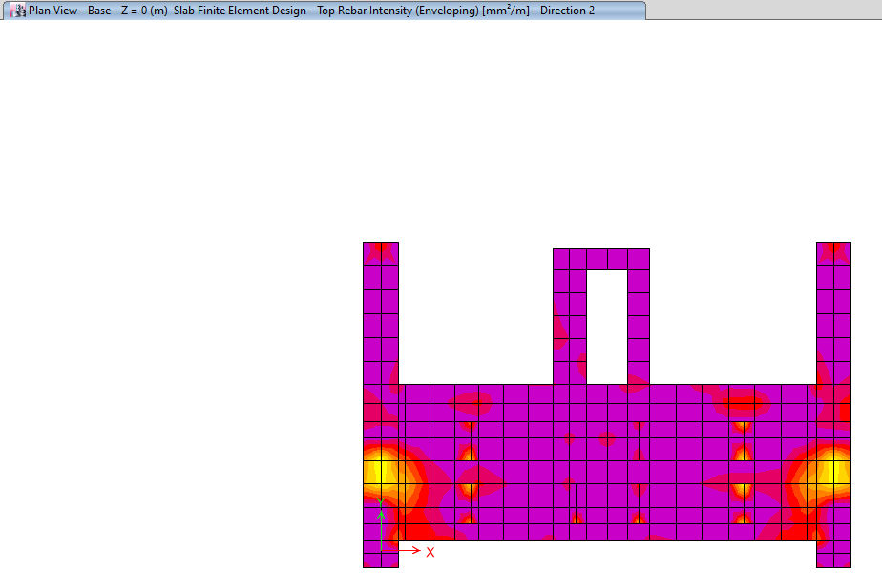
Figure 85: As Top in Y direction

- Area of steel (Bottom in Y direction) from Etabs for (Strip1) =Area of steel min
As min = ρ *b*h =0.0018*1000*450=810mm². →(4∅16/m).
See figure 86 below.
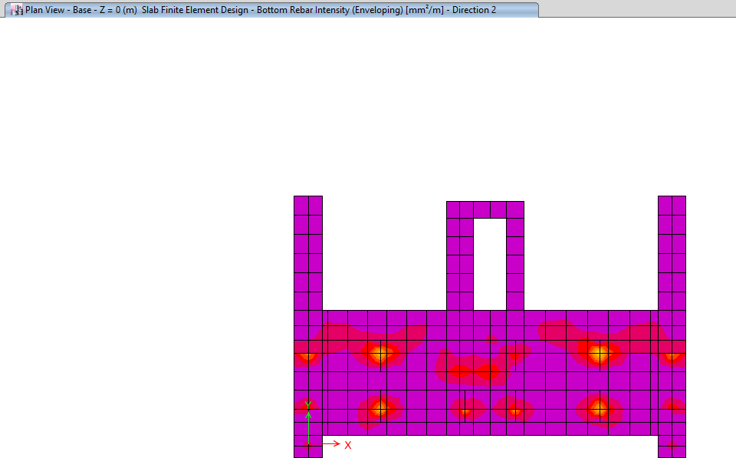
Figure 86: As Bottom in Y direction

→ All stirps the As min > As from Etabs → Take As min.

Table of steel reinforcing for all stirps: See Table 17 below:

Stirps | Direction(x)  Top (As min) | Direction(x)  Bottom (As min) | Direction(y)  Top (As min) | Direction(y)  Bottom (As min)
2 | 1386 mm²  (6∅18/m) | 1386 mm²  (6∅18/m) | 1386 mm²  (6∅18/m) | 1386 mm²  (6∅18/m)
3 | 810 mm²  (4∅16/m) | 810 mm²  (4∅16/m) | 810 mm²  (4∅16/m) | 810 mm²  (4∅16/m)
4 | 1080 mm²  (6∅16/m) | 1080 mm²  (6∅16/m) | 1080 mm²  (6∅16/m) | 1080 mm²  (6∅16/m)
5 | 630 mm²  (4∅14/m) | 630 mm²  (4∅14/m) | 630 mm²  (4∅14/m) | 630 mm²  (4∅14/m)
Table 17: As for all strips

REFERENCES:

- ASCE committee, “American society of Civil Engineers, Minimum Design loads for Buildings and other Structures” American Society of Civil Engineers, Virginia 20191, 2010.
- ACI committee 318 “Building Code Requirements for Structural Concrete (ACI 318M-14)” American Concrete Institute, Michigan, 2014.
- كودات البناء الوطني االردني" كودة االحمال و القوى"عمان, تموز, .2006
- Nilson, Arther H, David Darwin, Charles W. Dolan. "Design of Concrete Structure. Fourteenth edition". New York: McGraw-Hills Companies, Inc, 2010.
- IBC, "International Building Code", 2012.
- American Society for Testing and Materials (ASTM).
- Uniform Building Code (UBC97).

