

An-Najah National University
Faculty of Engineering & Information Technology
Energy and Environment Department

“ Development of Electric Vehicles aggregator Energy Policy Model “

Supervised by:
Dr. Tamer Khatib

Prepared by:
Amal Abu Shomer
Dalia Sharshir

A Graduation Project submitted to Energy Engineering and Environment Department partial fulfillment of the requirements for Bachelor degree in Energy Engineering and Environment.
May- 2018

Table of contents:
Abstract: 5
Introduction: 6
Vehicle to grid (V2G) concept: 8
Aggregator: 10
Charging and discharging process: 11
Technical Benefits of V2G on the grid and Ancillary Services: 13
Impact of V2G on Environment and Economy 18
Vehicle to grid challenges: 19
Vehicle to Grid incentives: 22
Development of Energy policy model: 23
Future Work 28
Conclusion 29
References: 30

List of figures:
Figure 1: Vehicle to grid (V2G) concept. 9
Figure 2: Water filling algorithm. 14
Figure 3: Load levelization. 15
Figure 4: Start up delay of the cycling and peaking units. 16
Figure 5: Influence of prospective gas prices on vehicle acquisition interest. 21
Figure: Energy policy model.6 28

List of tables:

Table 1: Charging Levels. 11
Table 2: Typical data of V2G networks and privacy impact. 22

Nomenclature

EVs : Electric vehicles
V2G : Vehicle to grid
BV : Battery vehicle
PHEV : Plug-in Hybrid Electric Vehicle
RES : Renewable Energy Sources
ISO : Independent system operator
PEV : Plug-in vehicle
GPS : Global Positioning System
TOU : Time of Use
SOC : State of Charge
kW : Kilowatt
BU : Battery Utilization
ER : Electric Range
PLC : The Palestinian Legislative Council
PENRA : Palestinian Energy And Natural Resources Authority
CAIFI : Customer Average Interruption Frequency Index.
SAIDI : System Average Interruption Duration Index.
SAIDI : System Average Interruption Frequency Index.
ASAI : Average Service Availability Index
GHG : Greenhouse gases

Abstract:
Now a days, Fossil fuel shortage and Environment protection are the most important cases. With high Electrical Demand and trying to balance with the available supply, Electric Vehicles and Vehicle-to-Grid (V2G) concept are recognized as solutions and the trend of the future.
Vehicle to grid (V2G) technology allows both grid and vehicle to benefit. Also, it has the potential of reducing the cost of owning and operating Electric Vehicles (EVs) while increasing utility system flexibility. Aggregated battery vehicles (BVs) act as a distributed resource-load and a generation/storage device by their integration on the grid.
The model introduced in this report focuses on the aggregator and its role. Depending on the mechanism of V2G and the relationship between the components and all the parameters and possible cases in this operation.
By reviewing many scientific papers related to Electric Vehicles, V2G and Aggregators, V2G benefits and charging and discharging process are studied. Also
Incentives , challenges , impacts on Environment and the electrical grid are discussed. Gathering these knowledgment into an elaborated energy policy model showing all the parameters that affect each component.

Introduction:

Rising concerns around the world about energy independence, increasing cost of petroleum, global warming impacts and the produced Carbon dioxide ( CO2 ) emissions were the motivators for trending to Renewable Energy Sources (RES) and developing in Transportation field. Transportation sector has the majority of fuel consumption so the new technologies aim to reduce the oil need by making the vehicles more fuel-efficient and by switching to alternative sources of energy. [1]
With using RES and studying their implemented projects, it has been found that extra dispatching resources are needed. Such as thermal power generations, adjustable speed pumped storages, and battery energy storages. Smart grid strategies are expected to utilize distributed generations and controllable loads in the demand side. [2]
Stakeholders like policy makers, engineers and business leaders concluded that Re-electrification of automobile transportation and enhancement of the existing power system grid is one such solution. [3]
Electric vehicle ( EV ) is defined as a vehicle that has a battery and uses electricity supplied from an external power source to operate. EVs have zero emissions and low noise level.
Many types of Electric vehicles are known as :
- Plug-in Hybrid Electric Vehicle PHEVs
PHEV containing two motors, electric motor and internal combustion engine. They run on both electricity and petroleum-based fuel. They plug into the power grid to charge batteries .The generation mix differs based on the available and margin power types. Most regions use their coal and gas technologies and others increase their renewable electricity generation. PHEVs penetration affect demand, generation, electricity prices, and emissions so that it may lead to negative consequences if the combined system is not the optimal. [3]
PHEVs simply do not have enough battery capacity onboard to allow sufficient storage dedication to V2G. [4]
2) The Battery Vehicles (BV)
Battery is recharged by connecting it to the electrical grid through a charging the station that is designed and located based on specific terms.
For all kinds of Electric Vehicles specially the plug-in EVs has the same barriers. The high capital cost, limitations in the driving range and performance like speed and aging still being barriers and strong impediments to take a large share in the car market.[5]
As Electric Vehicles are accepted by all the interested parties and the studies are proving and encouraging this trend, Vehicle to Grid Concept has appeared that combines Electric Vehicles application benefits and the solution of supply is not meeting demand.
In this report for further understanding to the problems previously mentioned, these sections in this report are elaborated. First, the concept of vehicle to grid (V2G) and motivations for this system are introduced in section one and a brief explanation about aggregators in section two. In section three, charging and discharging process and the preferred modes are explained. Then the technical benefits of V2G on the grid and the services are introduced in section four . In section five , stability and reliability of V2G and how it affects them are discussed. Section six explains the economic and environmental impacts and challenges and implementation barriers to V2G are listed in section seven. Finally , section eight introduces some incentives to encourage a higher employment of V2G.Based on the review of these topics, the energy policy model is formulated connecting all the components and their parameters in an understandable way in discussing the possible cases from EV owners and grid point of view.

Vehicle to grid (V2G) concept:

Energy independence and global warming are two rising issues in the world these days, large numbers of research papers are dedicated to try to solve these two problems with new ideas.
Vehicle to grid (V2G) technology is one of the new technologies that involves the help of electric vehicles in supplying electricity to the power grid during the peak times,( it aims to reduce the need for fossil fuels by the development of the battery electric vehicles or BEVs in the form of plug-in vehicles(PEVs) in order to solve these issues.[1]
By using the bi-directional power transfer, which means that the electric power can flow from the electric grid to the electric vehicle in order to charge it(storage device), or the other way from the electric vehicle battery to the power grid in case the grid needs power(generation resource).
The aggregated BVs are a generation-storage device in this case. The entire concept of using the BVs as a distributed resource– load and generation-storage device–by their integration into the grid is known as the vehicle-to-grid (V2G). [1]
Under this concept, the BVs become active players in grid operations and play an important role in improving the reliability, economics and environmental attributes of system operations.
V2G operation include many parties:
- Manufacturer of battery of EV.
- EV manufacturer.
- EV owner.
- Charging stations.
- Workplace and home.
- Aggregator
- independent system operator (ISO)
- Local Distributor
- Regulators

Figure (1) explains the concept of vehicle to Grid .

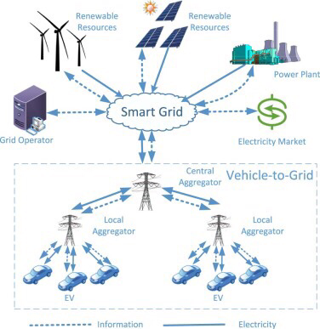
Figure 1: Vehicle to grid (V2G) concept.

Aggregator:

Aggregators are intermediate firms or computerized companies that is responsible for organizing the relationship between the EVs owners and independent system operator (ISO), and gather the power and information from the individual consumers to decide if they will be generation resources or reservoirs. It can be called a “middleman “company. The aggregator company has many forms, it may be a start-up company, or a company for energy trade or the same company that supplies the V2G power system like the local Distributor itself.
The aggregator set the process of V2G and charging and discharging Vehicles and specifies prices according to all the factors and interested sides affecting. Assess the situation of grid and the ability of supply and taking power and sign contracts with the consumers. These contracts differ from participant to other depending on the capacity of the battery and types of services are introduced by vehicle and their number per specific period of time. [6]
A global positioning system (GPS) receiver and internet connection in the EV is required for charging stations and the aggregator. A huge database of EVs and their information database will be with the aggregator, it will contain and help specifying location, availability, capacity, power allocation and the requests between the two sides and their responses. [7]
Aggregator types are divided into:
- Global aggregator .
- Local aggregator.

Charging and discharging process:

Electric vehicles work as storage and generation devices, this means that the battery of the EV will be charged and discharged number of times.
The charging/discharging process of the electric vehicles battery depends on multiple parameters, charging levels, charging time, battery utilization index and charging modes these parameters will be discussed in this section.

- Charging levels: when the consumers want to charge their electric vehicles there are several levels of the charging power and voltage.
  - Level 1.
  - Level 2.
  - Level 3.
among these levels, level 2 is more preferable due to its characteristics such as duration of charging time, the price and impacts on batteries' life.

Table 1: Charging Levels.
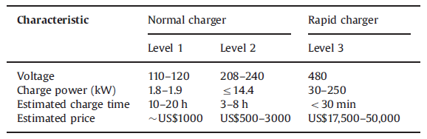

- Charging time: the time in which the electric vehicle will be charged or discharged depends on the time of use of the electric vehicle and the availability of the power grid there is an intelligent charging method for EV where charging facilities in response to TOU price. The purpose is to reduce the stress in the power grid under peak demand where the electric vehicles are discharged during the peak demand periods during the day and charged at night when the electric demand is limited and the prices are less, and to meet the demand response requirements in regulated market. [8]

- Charging modes:

- constant power charging : charging power remains constant at a certain level and the charging time of EVs will vary with different SOC values.
- constant time charging method : charging power depending on the time set to meet the battery energy requirement will be variable. When there is a need to move the EVs’ demand to low load hours, it is better in shaving peak charging demand as EVs charging schedule can be precisely controlled.
A preferred method combines these two ways. The process starts with constant charging power till the battery capacity reaches 70% of SOC and continues with constant time method to complete the remaining 30%.
The time needed for EV charging in both ways varies with the power levels from grid. For example at 6.6 kW power rate, the least charging duration for the previous ways is achieved and the longest at 1.92 kW power rate. [9]

4. Battery Utilization index ( BU ) :
It is the ratio of the actual distance traveled using energy stored in the battery to the total distance that can be overcome according to the electric range (ER). BU value depends on the used driving mode, whether it is in road or metropolitan, freeway or high traffic area .Also the value of electric range for the EV is counted. For example, BEV has the least value of BU as its ER value is the highest in the different driving modes. [9]
When the calculated BU value is 0.444 for example, it means that only 44.4 % of the energy stored in the battery is used for car trips and the remaining 55.6 % of battery capacity can participate in the V2G service.

Technical Benefits of V2G on the grid and Ancillary Services:

- Regulation up and down

Frequency fluctuations in the grid happens because of supply-demand imbalances and Renewable Energy sources unstable output. To maintain these frequency variations, Frequency regulation is needed, which is an ancillary service to stabilize the frequency at its nominal value. [1]
This service can be divided into two types relating to the energy direction :
A- Unidirectional : Energy flows only from or to the grid. To provide regulation service, controllable loads like batteries and flywheels are used and by controlling their play modes.
B- Bidirectional : Energy flows from and to the grid . EVs are used by charging or discharging them according to the grid situation. [2]
Regulation services have a large share in the total ancillary service expenditures by the ISO and considered profitable for EVs owners and grid operators . [7]
It can be introduced by suiting the generation and demand with two sorts of regulation: in
1- Regulation-down service : when the generation is larger than the demand, the frequency value increases. So the excess power in the grid should be reduced by charging the EV batteries.
2- Regulation-up service : when generation is not capable of covering all the demand, power is injected to eliminate the effect of frequency decrease. The EV batteries discharge its storage into grid. [3], [7]

Preferred schemes in achieving Regulation services :
1- state-dependent utility scheme
It depends on the state of charge of the EV battery . So that the power is injected or withdrawn based on battery’s SOC . It prevents the cases of charging batteries with huge amount of power when SOC is high to achieve Regulation- down services and the alternative possible case. Both are unwanted and this scheme algorithm achieve that.
2- Water-filling algorithm for V2G regulation
This algorithm is applied in wireless and wireline communication systems and it was studied and proved to be very effective in V2G regulation services. It depends on having parallel channels and the transmitted signal or power must be the maximum in total. Alos it must consider the initial state of each channel to specify the direction is ascending or descending and to avoid reaching undesirable level.
In figure ( 2) the water filling algorithm is described. The parallel channels are the EVs batteries and power is allocated by knowing which battery has the lowest level of SOC to be charged first in regulation-down case. Similarly, in regulation-up, batteries with low SOC are avoided and the process starts from the highest value of SOC. [6]

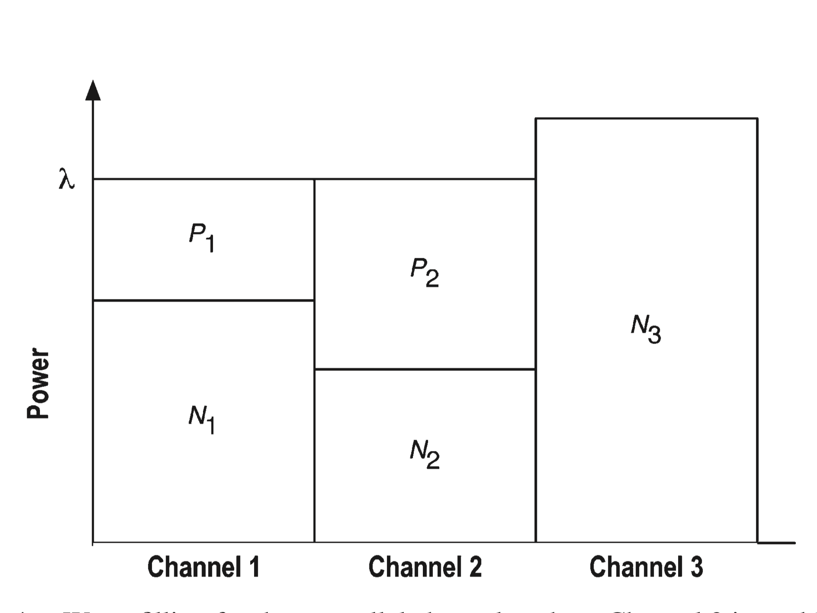
Figure 2: Water filling algorithm.

- Load Levelization

Load profile consists of low-load periods, high-load periods ( off-peak) and on- peak periods . The fluctuation in demand makes ISO and RTO having a complicated work in control, allocating power and forecasting. With the integration of EVs in grid and lack of suitable management of charging process, the operation becomes harder. Here, the aggregated EVs can levelize the loads by charging in low -load periods. The increased demand caused by EVs can be dispatched to reduce the pressure in other periods to flat load curve in low-load period. The aggregation of batteries and paying attention to the SOC of each individual battery will ease the process. Therefore, load levelization offers both the operators and consumers to benefit with the appropriate introduced prices and incentives. [1]
Figure (3 ) illustrates the impact of aggregated EVs in load levilization.

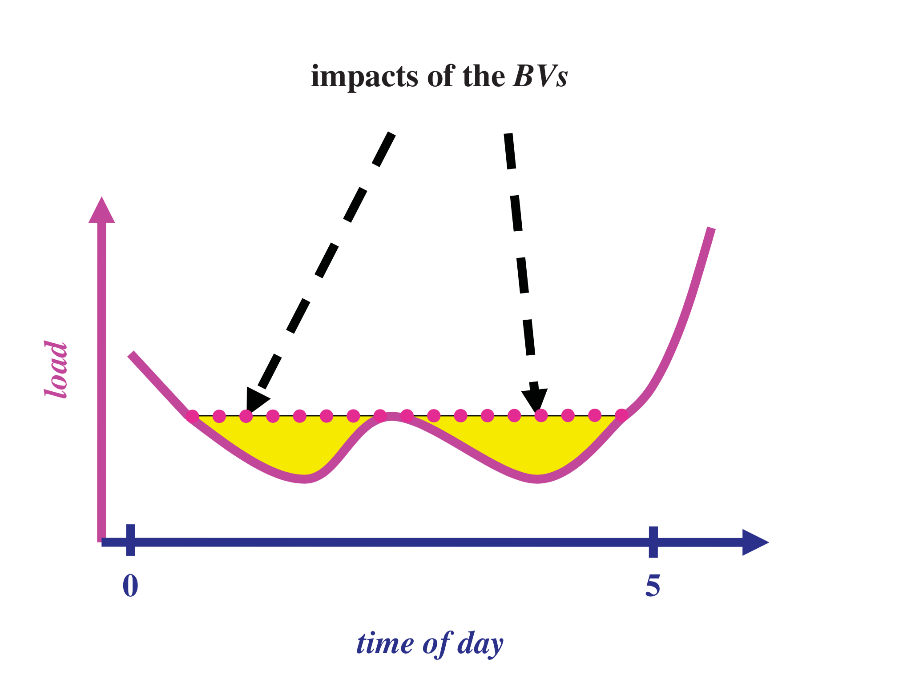
Figure 3: Load levelization.

- Delaying the start-up of the cycling and peaking units

Aggregated EVs in V2G can delay the start-up of the cycling and peaking unit. For the operator, the most important goal is matching generation with load. This can be achieved with aggregated EVs when introducing the needed energy and capacity and starting up the units a few hours before the time. The fast response of Aggregated EVs support its role as an energy source and ensure that The ISO and RTO will supply all required demand. [1]
Figure (4 ) describes the effect of Aggregated EVs in delaying the start up of peak units.

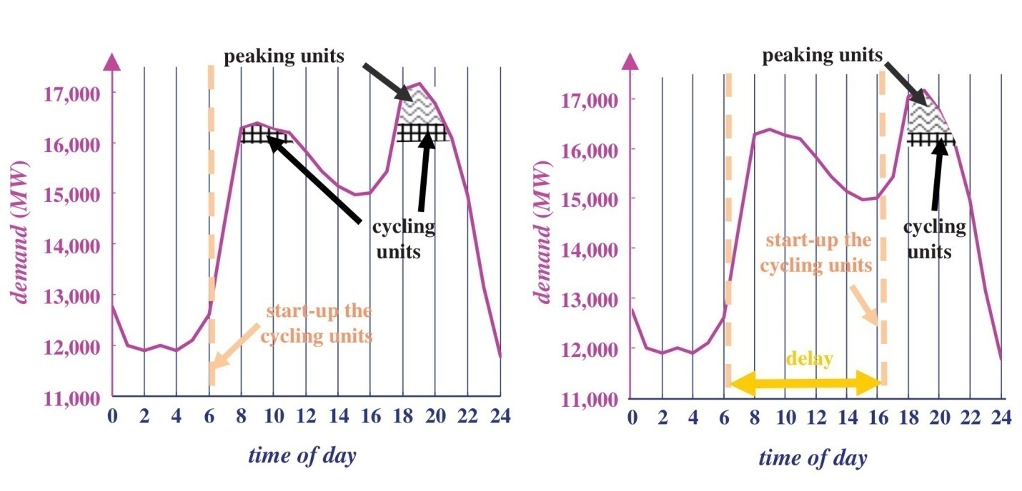
Figure 4: Start up delay of the cycling and peaking units.

Reliability, Stability and Security of Vehicle to Grid
*** Stability
Many indicators are recognized to assess, such as stability index for the system including EVs and variation coefficient of instability index . It increases the quality and customer satisfaction
Stability performance and its indices are calculated depending on the power charging levels of V2G .So that, increasing the difference between levels, stability curve is increased with a gentle slope. It increases the quality and customer satisfaction.
This could reduce the system power losses and voltage deviation. It increases the quality .
*** Reliability
Reliability indices that are known for calculating and assessing are CAIFI, SAIDI, SAIFI, and ASAI.
The common reliability analysis of power systems with EVs is the minimal path method . It is done by forming a topology of distributed system, giving numbers to all the buses and lines and showing the longest and shortest ways to each of the load points. When specifying a power rate of V2G , loads d flow and reliability parameters are calculated for non-short routes and short ones and for the entire system .
In the case of non-short routes, protection devices are the most important factor in calculating Reliability. If it is existed, it will isolates the fault and the failure doesn’t affect the system reliability or the customer . When there are no protection and backup power, reliability performance is affected badly. Here, the importance of integrating EVs into the grid and increasing their numbers appears . The impact of non-short routes parameters on system reliability indices can be decreased as the energy stored in the battery is used to backup in the presence of a fault.
Also discharging levels improve the system reliability whenever are in an acceptable range. So optimizing a plan for charging and discharging EVs will help achieving a high, credible and reliable operating network. [9]

Impact of V2G on Environment and Economy

For the grid, distribution system depends on V2G percentage penetration and V2G owners behaviors. It may eliminate the need for Transmission and Distribution upgrades required to bring more power from a central generation plant. [10]

And for RES and storage systems to mitigate frequency fluctuations and load shifting requirements caused by increasingly high penetration of intermittent power will be essential. V2G should be a major consideration for offsetting the costs of storage at the distribution level.
Lithium ion battery degradation is an important problem. Determining whether or not V2G is harmful for an EV battery is a complex question that need more testing. This testing should be with understanding the concept, control algorithms and impact of V2G.

In Economy, there is a requirement for distributed storage to better manage grid operations and investments in grid infrastructure upgrades such as two-way controllers and smart meters. Such grid improvements will be occurring in the same time with the major transition of utilities from operating a unidirectional electrical grid system to one that fully supports transactions between utilities and customer. Also, smart-grids require the development of standards addressing technical issues such as security and access to in-vehicle data and resources; and a legal framework for liability, data protection and privacy.
For maximizing return on investment for the EV owner requires a stable market that appropriately values V2G export to the electrical grid. The cost arising from Lithium ion battery degradation for a given V2G transaction must be considered. Energy assurance criteria should include necessary standards and rules for protecting the electrical grid as critical infrastructure, particularly in safeguarding grid services from cyber attacks. These may make the provision of service less responsive to precise timing of the market need. However, a robust and diverse aggregate market can handle additional costs while managing reliability.[11]

In Environment, response to policy in the areas of air quality and climate change and the influence on EV uptake drew similar responses from across the four regions. The primary difference was between those who indicated a strong influence and those who indicated a partial or indirect influence. The programs for the purchase of clean vehicles, the policies that link EV with clean energy production and the establishment of zones within urban areas for clean vehicles were all activities that respondents noted as having a strong influence. [12]

Vehicle to grid challenges:

Vehicle to grid technology is based on the bi-directional transfer of electricity, the technology moves beyond smart charging (flexible load control) and connects travel routines, electricity grid stress levels, and various electricity markets, but there are a lot of drawbacks and challenges that are yet to be solved these challenges include the battery degradation and state of charge, challenges facing the manufacturers and consumers of electric vehicles, utility challenges and security challenges.
These challenges will be discussed in this section.

- Battery state of charge (SOC): one of the greatest challenges facing the development and employment of electric vehicles and vehicle to grid is the battery degradation and state of charge.
For a battery, charging is the process of absorbing energy and discharging is the process of dissipation of energy. The process of charging and discharging for one time completes one battery life cycle. Due to natural limitations, the usage of a battery is limited to a fixed number of cycles, after which the battery is of no use to the EV owner.6

- Manufacturer challenges: The most important two challenges facing the manufacturers of the industry are developing the battery storage and commercializing electric vehicles because V2G concept depends on the aggregation of multiple EVs together in order to supply the power grid with electricity.
Fuel prices and the nature of consumers are two important players in the challenges facing manufacturers. When fuel prices rise, customers tend to buy the EVs and when fuel prices drop EVs are less popular.
Influence of prospective gas prices on vehicle acquisition interest is shown in the figure below, 5The black dashed line highlights the tendency to switch from PHEVs to BEVs at 4$/gal.
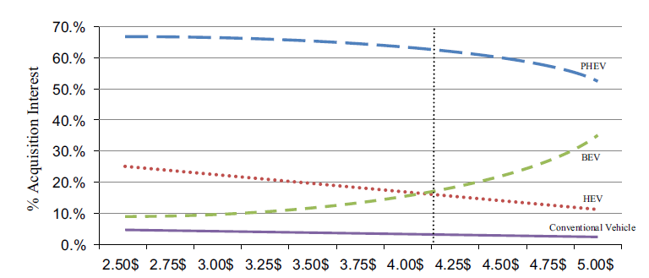
Figure 5: Influence of prospective gas prices on vehicle acquisition interest.

- Utility challenges: Development of infrastructure is needed in order to be able to contain the large numbers of electric vehicles integrated to the grid. PEVs need a communication and control infrastructure for fast and accurate responses to signals received from a central grid operator. Communications facilitate aggregating individual PEVs into a single controllable V2G system for providing effective grid services. [13]

- User challenges: Electric vehicle owners are not still completely convinced to allow service providers to use their cars for providing electricity because their batteries will charge and discharge multiple times and the number of charging and discharging cycles will be more, that affects the battery life and degradation, so they want the manufacturers to offer EVs that are capable of going farther with less charge time and cheaper price than before. [13]
There are other consumer concerns such as the existence of charging stations near their workplace or household, the effect of the electric vehicles charging on their electricity bills and 5the difference between the prices of EVs and fueled vehicles prices.

- Security: electric vehicles as customers don't want its personal information to be leaked out and as service providers, don't want its customers to know who provides the service. there are a lot of sensitive information about the electric vehicles that the users are afraid of sharing with the aggregators because they might be stolen or hacked.[14]

Table (2) below shows typical data of V2G networks and their privacy impact:

Table 2: Typical data of V2G networks and privacy impact.
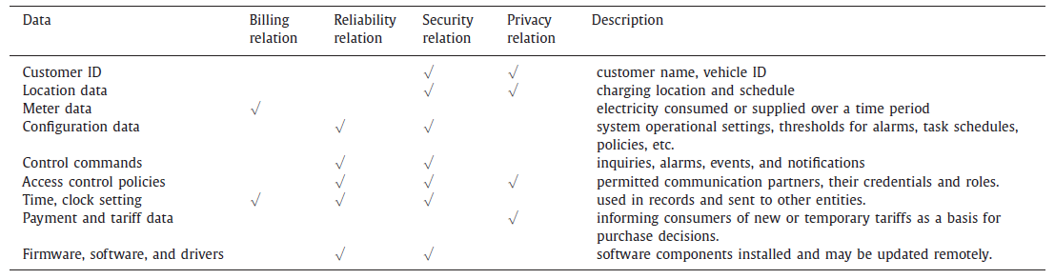

Vehicle to Grid incentives:

Electric vehicles need a lot of incentives from the government and the many manufacturers of electric vehicles in order to encourage people to buy and use electric vehicles.
- Free parking on public roads
- removal of import taxes
- free access to toll roads
- 0% VAT
- access to the bus lane
- free access to road transport ferries
- the government should be responsible for the maintenance and replacement of the batteries. [15]
Some European countries are using these incentives:
- Purchase, VAT, annual ownership tax exemptions.
- support for charging infrastructure.
- Subsidy on new BEV (4000e) and PHEV (2000e).
- Company car reduction like five year exemption of annual ownership tax, 20% purchase tax until 5000 cars or 2019 (revising the phase out of tax exemptions (up at 40%).
- Differentiated parking and Tax rebates for chargers. [16]

Development of Energy policy model:

- Palestinian Council of Ministries
All the ministers are under control by the council.

- The Palestinian Legislative Council (PLC)
All the rules and laws are decided and approved by PLC. It is connected to the Palestinian Energy Authority, Ministry of Energy, Ministry of Telecommunications and Information Technology and the Council of Ministries.

- Palestinian Energy And Natural Resources Authority - PENRA.
It is connected with the Local Distributor And Regulators. Also with the Ministry Of Energy in a parallel relation.

- Ministry of Energy
It is connected with the local Distributor.

- Ministry of Telecommunications and Information Technology
It has its own Regulator which is connected with the charging stations for Information security.

- Local Distributor
It is related to the global aggregator and gives specific information about the grid statues with saving the privacy and security of information. Also it is related with both PENRA and Ministry of Energy .

- Transmission
It is connected with the Local Distributor and Distributed Generation units.

- Distributed Generation
It is related with global aggregator, Transmission and the local Distributor.
It can be : 1- Wind stations
2- Photovoltaic systems

- Global Aggregator:
Control the local aggregators. It is connected with PENRA , with regulator and the local Distributor.
While it is operating, and as it is related with the grid, it cares about:
1- Grid statues: By examining the energy availability and power quality.
2- Electricity price : which is affected by many factors starting from the price is taken from Local Distributor, whether there is a shortage in energy to demand and time. [17]

It faces two cases in Energy availability:
1)Excess Energy : the aggregator has to decide the price which could be :
- Very low selling price : to encourage the local aggregators buy the excess and store it in batteries or make offers for the procumers to charge their EVs in that time.
- Very high purchasing price : when some procumers want to discharge their vehicles, the price will be very high as the grid is not in a need.

2)Lack in Energy : When there is a shortage and the demand can’t be supplied. The aggregator had to buy from the local aggregators and make procumers inject the available power with a suitable price .

- Regulators
Connected with the Energy Authority (PENRA) to assess and control the operation and the relationship between the interested parties.
1- Regulator for Electric Vehicles : To supervise the purchasing and selling process of EVs owners.
2- Regulator for global aggregator : As it is connected to many parts and taking a huge amount of important information from them. Also it is considered the most important component in the network.
3- Regulator for local aggregators : Local aggregator deals with many charging station and EVs owners whom charge and discharge their Vehicles according to their situation. Also the prices need to be watched as many parameters affect in specifying them.

- Local Aggregators :
It is connected with number of charging stations that located in different places and a regulator to supervise the process.
The local aggregator when allocates power to the charging stations consider these parameters :
1- Total circuit losses.
2- injected phase current.
3- Injected power amount .
4- Harmonic Distortions .
5- Line loading limits .
6- EV penetration .
7- Number of charging stations in the same network.

- Charging stations
There are number of charging stations connected to each local aggregator, and connected to EVs and it provides two ways of charging:
- Fast charging

2) Full current charging

** When choosing the way of charging, the most important parameters to consider are:
1- Time
2- Possibility
3- Price

** The technical possibility of charging and discharging can be decided by understanding :
1- Voltage levels
2- Power quality : the number of charging and discharging times affect the quality and cause harmonic distortion.
3- Frequency situation
And these are specified according to many parties and related to many other parameters.

** The selection of charging power level is an optimization process between :
1- Cost of infrastructure
2- Charging time

** Charging time depends on :
- size of battery bank .
- Power rating of the charger.
- Number of EVs connected .

- Procumers :
Electric Vehicles owners acting as producers when selling power to the grid and consumers when charging their EVs. Electric vehicles are connected with charging stations.
Two factors are affecting EVs owners in taking their call to charge or discharge their vehicles:
1- State of Charge of the battery
2- Their situation : if it is urgent to charge or they could not participate in V2G process. [18-20]

These situations are related to the procumers and to the local aggregator:

- Bidirectional : When the EVs owners can charge their and discharge their vehicles upon the grid need and their own needs.
- Unidirectional : It can be in two situations for the EV owner. Firstly, the battery is fully charged and power could be injected to the grid but no possibility to charge and buy electricity. Secondly, the battery is empty and the owner can charge and buy but can’t sell to the grid. So the local aggregator has to deal with these situations, decide the amount of power could be injected or withdrawn from the charging station and give the appropriate price.
- Critical status : when charging process is necessary and it is an emergency case.

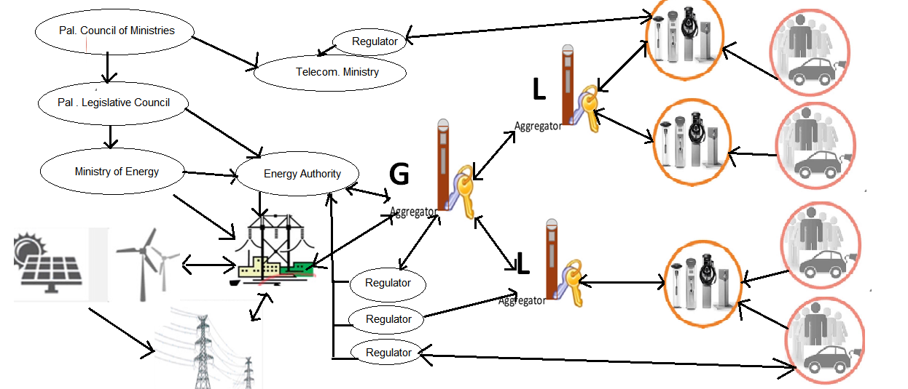

Figure: Energy policy model.6

Future Work

After studying the concept of V2G and reviewing scientific papers in this field, our model is built. With further work and reading about countries around their policy in applying V2G concept in their grids, a scientific paper will be published containing this model and trying to put a suitable policy that can be applied.

Conclusion

Concerns around the world about reducing the greenhouse gas (GHG) emissions and enhancing energy security are growing. Renewable energy sources were one of the solutions, but as they cause fluctuations in the grid and as Transportation sector is a main contributor in depending on fossil fuels, it has been found that having an electric vehicles with batteries may reduce the fluctuations, matching supply with demand and a cleaner environment is found.
The trend goes to EVs and V2G that encourages RES sharing, based on having an intelligent energy management system which is economically and environmentally better alternative to the fossil fuels.
The main objective is achieving a balanced status in the grid with no outages or excessive production. A V2G system can be an ancillary part of a hybrid renewable energy system as a cooperatively performed solution for reliability issues of renewable energy resources.
In our Energy policy model all the components in V2G are studied with their parameters that contribute in deciding charging and discharging ways, the control algorithm and electricity prices. Also it considered SOC properties of individual EVs and supplying EV owner requirements are the top priority.
With the continuous improvement of EV design, finding solutions for battery degradation, awareness of the importance of V2G and the suitable incentives introduced for the owners and other involved sides to participate, a significant success in applying this process will be noticed. Hence, the most important issue to be illuminated is supply-demand imbalance.

References:

[ 1 ] Guille, C & Gross, G " A conceptual framework for the vehicle-to-grid (V2G) implementation," Energy policy, vol.37, no.11, pp.4379-4390, Nov.2009.
[ 2 ] Ota, Y, Taniguchi,H, Nakajima, H, Liyanage, K, Baba, J and Yokoyama, A " Autonomous Distributed V2G (Vehicle-to-Grid) Satisfying Scheduled Charging ,"IEEE Transactions on Smart Grid, Vol. 3, No. 1, March 2012.
[ 3 ] Kempton, K, Udo, V, Huber, V, Komara, K, Letendre, S, Baker, S, Brunner, S, & Pearre, B, "A Test of Vehicle-to-Grid (V2G) for Energy Storage and Frequency Regulation in the PJM System," University of Delaware, Nov 2008.
[ 4 ] Freemana, G, Drennenb, T, Whitea, A, " Can parked cars and carbon taxes create a profit? The economics of vehicle- to-grid energy storage for peak reduction," Energy policy 106, PP. 183-190, March 2017.
[ 5 ] Safaria, M, " Battery electric vehicles: Looking behind to move forward," Energy policy 115, PP. 54-65 , Dec 2017.
[ 6 ] Escudero-Garzás, J, García-Armada, A, Seco-Granados, G, " Fair Design of Plug-in Electric Vehicles Aggregator for V2G Regulation," IEEE Transactions on Vehicular Technology, Vol. 61, No. 8, October 2012.
[ 7 ] "Integration of Electric Drive Vehicles with the Electric Power Grid - a New Value Stream,"
Brooks, A, Gage , T, EVS, AC Propulsion, Berlin, 2001.
[ 8 ] Cao, Y, Tang, T, Li, C, Zhang, P, Tan, Y, Zhang, C, Li. J, "An Optimized EV Charging Model Considering TOU Price and SOC Curve," IEEE Transactions on Smart Grid, Vol. 3, No. 1, March 2012.
[ 9 ] Mozafara, M, Aminib, H, Moradid, H, "Innovative appraisement of smart grid operation considering large-scale integration of electric vehicles enabling V2G and G2V systems," Electric Power systems Research 154, PP. 245-256 , Sep2017
[ 10 ] Chukwu, U, Nworgu, O, Dike, D, " Impact of V2G penetration on Distribution System Components Using Diversity Factor," IEEE Transactions on Smart Grid, Vol. 3, No. 1, March 2012.
[ 11 ] Uddina, K, , Dubarryb, K, Glick, M, " The viability of vehicle-to-grid operations from a battery technology and policy perspective," Energy Policy 113, PP. 342-347, Nov 2017
[ 12 ] Davies, H, Santos, G, Faye, I, Kroon, R, Weken, H " Establishing the transferability of best practice in EV policy across EU borders, " Transportation Research Procedia14, PP. 2574- 2583, April 2016.
[ 13 ] Hossieni, S, Badri, A, Parvania, M, "A survey on mobile energy system ( MESS) Application, Challenges and solutions," Renewable and Sustainable Energy, Vol. 40, PP. 161-170, Dec 2014
[ 14 ] Han, W, Xiao, Y, " Privacy preservation for V2G networks in smart grid: A survey," ElsEVIER, Computer communications 91-92, PP.17-28, June 2016.
[ 15 ] Wan, Z, Zgu, W, Wang, G, " PRAC : Efficient privacy protection for V2G communications in the smart grid," Computers & security, Vol. 62, PP. 246-256, July 2016.
[ 16 ] Kester, J, Noel, L, Rubens, D, Sovacool, B, " Promoting Vehicle to grid V2G in Nordic region: Expert advice on policy mechanism for accelerated diffusion, " Energy Policy, Vol. 116, May 2018, PP. 422-432, April 2018.
[ 17 ] Das, R, Thirugnanam, K, Kumar, P, Lavudiya, R, Singh, M, " Mathematical Modeling for Economic Evaluation of Electric Vehicle to Smart Grid Interaction," IEEE Transactions on Smart Grid, Vol. 5, No. 2, March 2014.
[ 18 ] Jia, Z, Huanga, X, " Plug-in electric vehicle charging infrastructure deployment of China towards 2020: Policies, methodologies, and challenges, " Renewable and Sustainable Energy Reviews 90, PP. 710-727, April 2018
[ 19 ] Hadley, S, Tsvetkova, A, " Potential Impacts of Plug-in Hybrid Electric Vehicles on Regional Power Generation," Electricity Journal, Vol. 22, PP. 1040- 1052, Dec 2009.
[ 20 ] "Encouraging V2G participation through premium tariff rates," Richradson, D, Journal of power sources 243, PP. 219-224, June 2013.

