ABSTRACT

The purpose of this project was to design a remote energy-monitoring and socket-box-controlling system that uses power line communication to send collected data to a centralized location. Once collected, the power data would be displayed on a local web server. Then, our web server graphs, summarizes and displays the data. Users with ID and password access can also automate setting the on/off status of any given socket box with our system’s scheduling feature.
The goal of using a power line communication over wireless is to reduce the overall power consumption of the system, also power line communication is more efficient as a communication medium at homes and factories .

Chapter one : introduction and purposes

1.1 Objectives

Due to the wide range of processes required to complete our project, we broke our objectives into 3 subsystems. This will help keep our goals clear.

1.1.1 reliable Sensing
- Accurately sense the voltage and current waveforms with no more than 5% error.
- Convert the signals into digital data using an ADC.
- Translate the data into a form that can be used by the PLC modem.
- Design an internal dc power supply to power internal ICs

1.1.2 PLC( power line communication )
- Interface the PLC modems with both the sensing and interpreting modules.
- Interpreting and Displaying
- Receive data over the power line.
- Present data using a web-based interface.

1.1.3 Remote access using website server

- Present the power data gathered in a graphical form using web page .
- Controlling the socket power using website .

1.2 Benefits of our proposed system :
• Centralized monitoring makes monitoring multiple loads convenient.
• Data accessible from any internet connected device.
• No need for additional wiring because all communication is done over the existing power lines.

1.3 Features
• Real-time power monitoring of multiple remote locations.
• Web-based interface to conveniently observe collected results
• Power Line Communication
• Internal power supplies that provide appropriate DC voltages for IC
components.
• Microcontroller-based web server minimizes power consumption.

1.4 Applications :

- automatic meter reading (AMR)
- automatic meter management (AMM)
- Street lighting control
- Loads management (which we aim to in our project).
- Home and building automation.
- Burglar alarm system
- Smoke and fire alarm system
- Garage door controllers
- Security system
- Cordless telephones
- Other remote control systems

1.5 The overall design

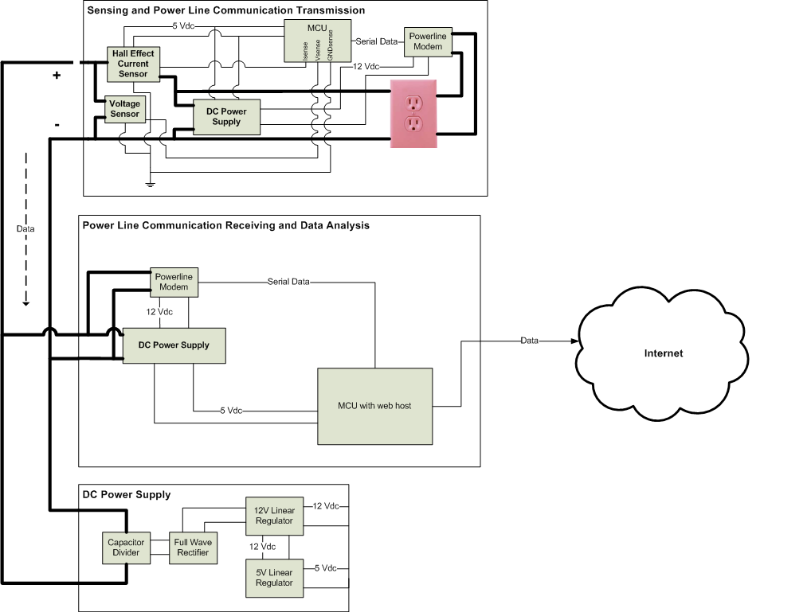

1.6 Subprojects :

1.6.1 Voltage and Current Measurements

The main goal of this project was to measure the voltage and current going into the load .so we make a voltage and current sensing circuit which consist of voltage and current sensor .we build the voltage sensor consist of voltage divider and op amp . as a current sensor we use hall effect sensor (from spark fun company – ACS712 ) , the output readings of this sensors enter to the microcontroller (PIC16F877) and the signals converted to digital values by an ADC . the digital values then multiplied to calculate the power consumed by the load .

1.6.2 Power line communication :

Power line communication or power line carrier (PLC), are system for carrying data on a conductor also used for electric power transmission.
Electrical power is transmitted over high voltage transmission lines, distributed over medium voltage, and used inside buildings at lower voltages.
In our project we use this type of communication . Power line communication utilized the preexisting power lines running inside a house for data communication.
1.6.3Web interface :
As graphical user interface we decided to build a web site using PHP language The web site contain a monitoring and controlling pages to display values and figures of power consumption by the load.We used visual basic to make connection between the data obtained by the microcontroller with the data base of the server. These data imported by the web site .

Chapter two : design overview

2.1 Sensing and power line communication transmission

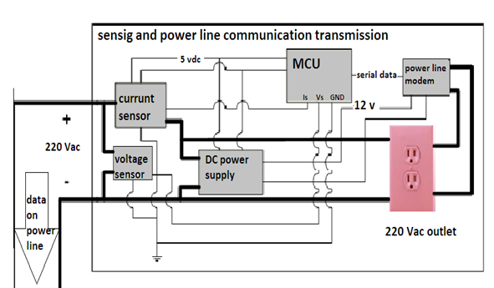

2.2Block description :

2.2.1 Microcontroller (MCU)

The microcontroller will be used to read in the current and voltage data from their respective ADCs. Since this data will be acquired in a parallel fashion, the MCU will convert the data into serial information so it can be transmitted over the power line.

2.2.2 Voltage and current sensors :

The sensing and data transmission will take place in a centralized transmitter that contains a 220 V ac receptacle found in typical household electric systems. We will be creating at least two sensing and transmission circuits so that we can test the receiver's ability to gather data from numerous locations. We want to use a hall effect sensor for current sensing and voltage divider for voltage sensing.

2.2.3Power line modem:
in our project The power line modem will be used to modulate, amplify and transmit the data prepared by the MCU to be transmitted over the power line.

2.3 Power line communication receiving and data analysis

The receiving and data analysis will take place in a centralized receiver that is capable of serving the data to the internet. The receiver will be capable of receiving data from multiple transmitters and analyzing this data to compute real power, reactive power and power factor. The circuit will contain a few subsystems as described below

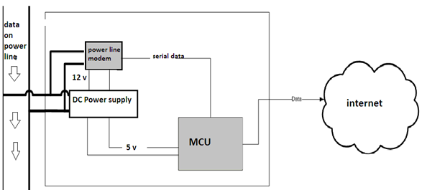

Sub block descriptions :

2.3.1 MCU With Web Host
The microcontroller on the receiving end will serve to acquire the data from the power line modem and present it in a meaningful manner on a web server. The microcontroller will also be tasked with computing the real power, reactive power and power factor from the raw data. Finally, the microcontroller will be able to log this data so it can be reviewed for monitoring energy consumption.

2.3.2 Power Line Modem
The power line modem on the receiver will be used to demodulate the data transmitted over the power line from multiple transmitters. This will effectively be the same power line modem as described in the transmission model .

Chapter three : Subsystems

3.1 Voltage and current sensing
- Design and alternatives:
In this subproject, a circuit was constructed to transform the high amplitude voltage and current waveforms going into the load. Each waveform was linearly scaled to a level which could be read by the MCU’s analog to digital converter. Our circuit consist of voltage and current sensor.

3.1.1Hall effect sensor :
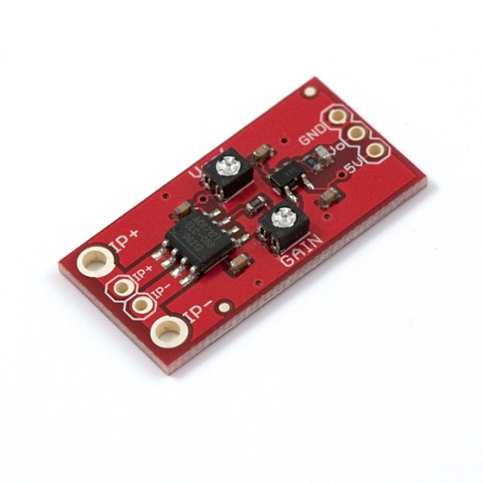
the first choise was the hall effect sensor
This current sensor gives precise current measurement for both AC and DC signals. These are good sensors for metering and measuring overall power consumption of systems. The ACS712 current sensor measures up to 5A of DC or AC current. We added an opamp gain stage for more sensitive current measurements. By adjusting the gain (from 4.27 to 47) you can measure very small currents.
The ACS712 Low Current Sensor Breakout outputs an analog voltage that varies linearly with sensed current. To calibrate, first set the output offset to the desired level (with zero current on the sense lines, read output with a DVM). Then with a known current input (a 100mA limited supply works well for this), set the output deflection with the gain pot.

Sensitivity is then calculated as
$$sensitivity=\frac{V ref – V deflect}{current input}$$

The change in sensor output in response to a 1 A change through the primary conductor. The sensitivity is the product of the magnetic circuit sensitivity (G / A) and the linear IC amplifier gain (mV/G). The linear IC amplifier gain is Programmed at the factory to optimize the sensitivity (mV/A) for the full-scale current of the device.

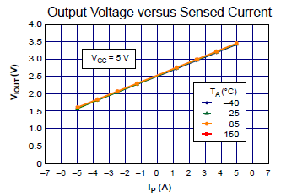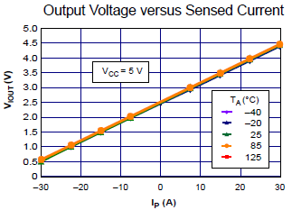
- After we try this sensor and made a lot of tests without any satisfying results . Hall Effect sensors have relatively low sensitivities. In general, Hall Effect sensors are designed to measure relatively large currents (> 1A). Since this circuit needed to measure currents as low possible , this was not a good choice .

The other choice was to use a thermal series resistor to sense the current going through the load .
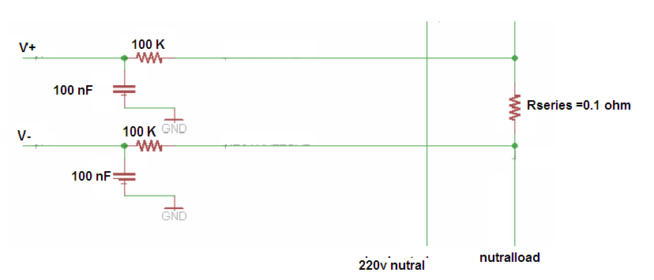 This small, precise resistor was used to obtain a voltage proportional to the current. The sensitivity of this resistor could be as high or as low as wanted. However, increasing the sensitivity also increased its power dissipation.
The microcontroller reads the voltage drop across Rseries and interprets it as current .
We try to sense different currents and different load . the results shown in the figure bellow
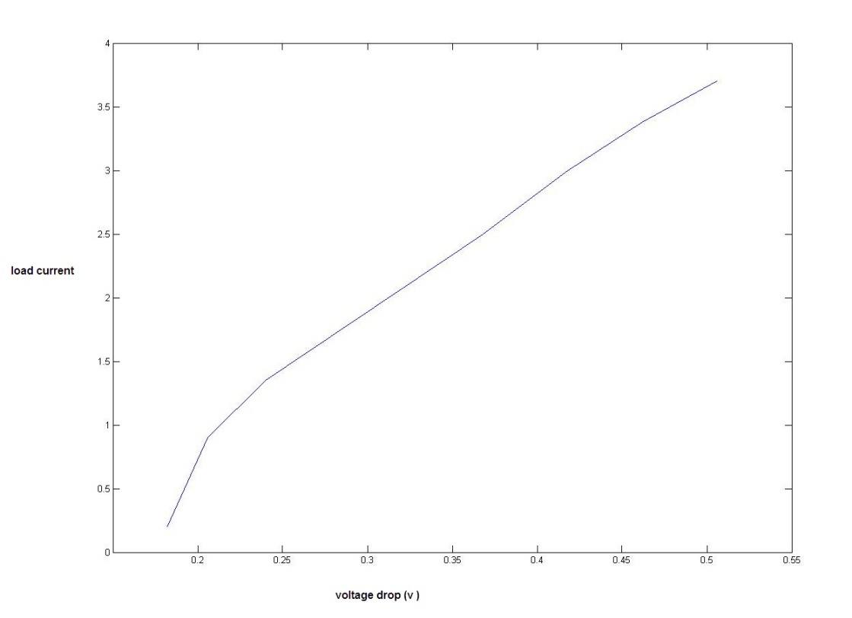

3.1.2 Voltage sensor :
The voltage sensor will be used to measure the voltage available at the transmitter's outlet. It will simply drop the 220Vac line voltage to a level that can be connected to the ADC and converted to digital signals for transmission over the power line.

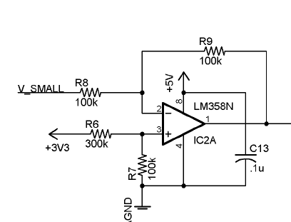
In our design we built this circuit as a voltage sensor ,in the first stage we used an extra transformer which transform from 220v AC to 9v AC , then we made a voltage divider stage to sense the voltage supplied to the load ,and we use an op-amp circuit as a final stage to shift the signal to appropriate value can enter to the ADC .this figures shows the input and the output of the sensor :
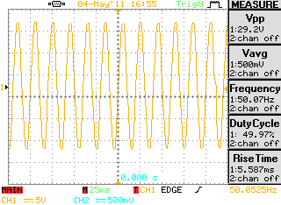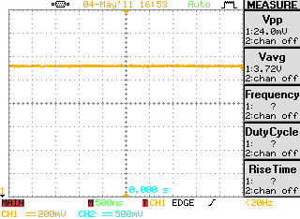
Input signal output signal
3.1.3 Switching technology :
No switch will achieve the ideal behavior of having:

1. Zero power consumption.
2. Zero series resistance.

While some switches approximate this behavior quite well, others do not.
So after we studied several types of switches we decided to use solid state relay as a switch connected to the MCU

A solid state relay (SSR) is an electronic switching device in which a small control signal controls a larger load current or voltage. It comprises a voltage or current sensor which responds to an appropriate input (control signal), a solid-state electronic switching device of some kind which switches power to the load circuitry either on or off, and some coupling mechanism to enable the control signal to activate this switch without mechanical parts

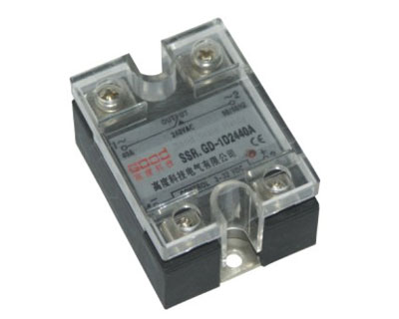

3.1.4 Measurement and controlling flow chart :
Off
Toggle

On

Do for each sample

Read current and voltage (ADC)

Multiply V,I

send data serially to the server

Toggle
No
Yes

3.2 Power line communication :
The overall system structure is shown in the Figure below . The first phase will consist of creating the host unit. The host unit will send instructions through the power line to the appropriate target unit at the designated time. The host unit will link to a LAN or the Internet by means of a host computer, therefore enabling anyone on the network to access the host unit. The second phase will consist of creating target units. The target units receive instructions from the host unit through the power line, and if appropriate the target units then perform the designated command.

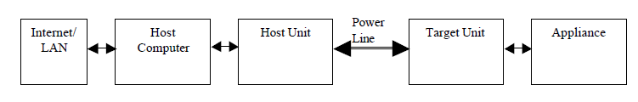

3.2.1 Host Unit
The host unit is the heart of the control system. Instructions can be programmed into the host unit by the host computer. After being programmed, the host unit will be able to run independently. At the appropriate time, the host unit will send out commands via the power line to a target unit.

Host unit hardware :

Power line modem
Microcontroller
RS-232
Host PC
Power lines

3.2.2 Power line modem :
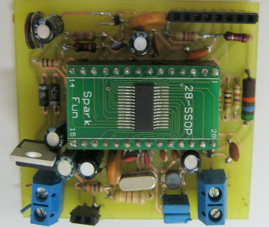

The modem we designed consist of tow main section :
- ST7540 modem and crystal oscillator section.
- Line coupling interface section, with three subsections:

- Transmission active filter
- Transmission passive filter
- Receiving passive filter.

ST7540 modem and crystal oscillator section :

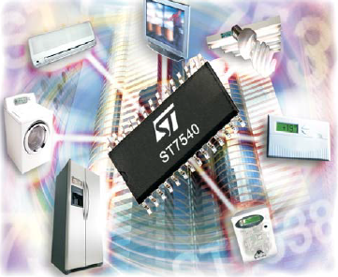

Description

The ST7540 is a Half Duplex synchronous/asynchronous FSK Modem designed for power line communication network applications. It operates from a single supply voltage and integrates a line driver and two linear regulators for 5V and 3.3V. The device operation is controlled by means of an internal register, programmable through the synchronous serial interface. Additional functions as watchdog, clock
output, output voltage and current control, preamble detection, time-out and band in use are included. Realized in Multi power BCD5 technology that allows to integrate DMOS, Bipolar and CMOS structures in the same chip.

Block diagram : 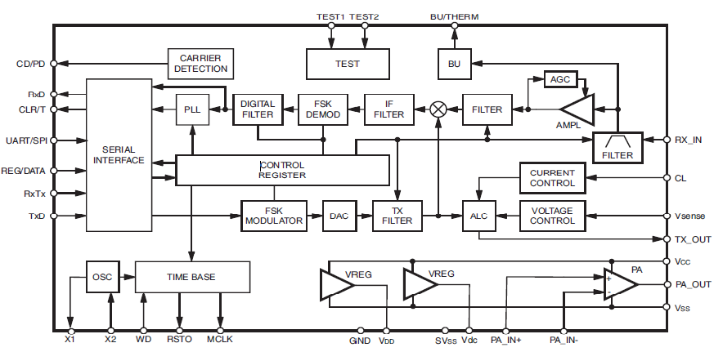

ST7540 is a multi frequency device: eight programmable Carrier Frequencies are available (60, 66, 72, 76, 82.05, 86, 110, 132.5 kHz), and four baud rates (600, 1200, 2400, 4800) Only one Carrier can be used a time. The communication channel could be varied during the normal working Mode to realize a multi frequency communication .Selecting the desired frequency in the Control Register the Transmission and Reception filters are accordingly tuned.

In our design we used the default carrier frequency and bud rate :

- Carrier frequency =132.5 KHz .
- Baud rate = 2400 bps .

St7540 main access :
ST7540 can access the Mains in two different ways:
● Synchronous access
● Asynchronous access
In our design we set the ship to access the main asynchronously
In data transmission mode:
data transmission line (TxD line) value enters directly to the FSK Modulator. The Host Controller manages the Transmission timing (CLR/T line should be neglected).

In data reception mode:

Value on FSK Demodulator is sent directly to the data reception line (RxD line). The Host Controller recovers the communication timing (CLR/T line should be neglected).
Host processor interface
ST7540 exchanges data with the host processor through a serial interface.The data transfer is managed by REG_DATA and RxTx Lines, while data are exchanged using RxD, TxD and CLR/T lines.
Four are the ST7540 working modes:
● Data Reception
● Data Transmission
● Control Register Read
● Control Register Write

REG_DATA and RxTx lines are level sensitive inputs.
In our design we didn’t use the REG_DATA transfer mode because we was working on the default values and modes so we didn’t need it at all.

ST7540 features two type of Host Communication Interfaces:
● SPI
● UART
In our design we used the UART as a Host Communication Interface, The selection can be done through the UART/SPI pin (UART/SPI =1 ) .
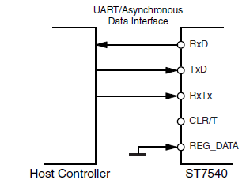
ST7540 allows to interface the Host Controller using a 3 line interface (RxD,TxD & RxTx) in Asynchronous mains access. Since Control Register is not accessible in Asynchronous mode, in this case REG_DATA pin must be tied to GND.

Communication between Host and ST7540.

The Host can achieve the Mains access by selecting REG_DATA=”0” and the choice between Data Transmission or Data Reception is performed by selecting RxTx line (if RxTx =“1” ST7540 receives data from mains, if RxTx=”0” ST7540 transmits data over the mains).

In our project we use the asynchronous way to make communication between the host and the st7540 In Asynchronous Mode, data are exchanged without any data Clock reference. The host controller has to recover the clock reference in receiving Mode and control the Bit time in transmission mode. If RxTx line is set to “1” & REG_DATA=”0” (Data Reception), ST7540 enters in an Idle State. After Tcc time the modem starts providing received data on RxD line.
If RxTx line is set to “0” & REG_DATA=”0” (Data Transmission), ST7540 enters in an Idle State and transmission circuitry is switched on. After Tcc time the modem starts transmitting data present on TxD line.

Carrier/Preamble Detection
The Carrier/Preamble Block is a digital Frequency detector Circuit.
It can be used to manage the MAINS access and to detect an incoming signal.
Two are the possible setting:
– Carrier Detection
– Preamble Detection.

CD_PD Timing during RX
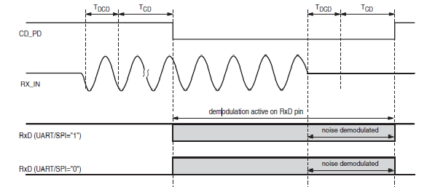

Receiving path block diagram
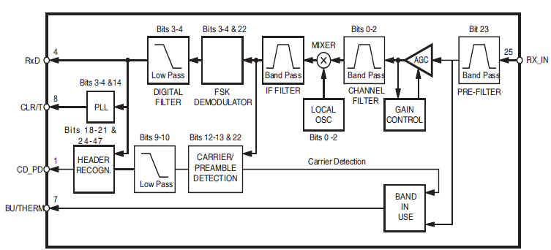

Transmitting path block diagram
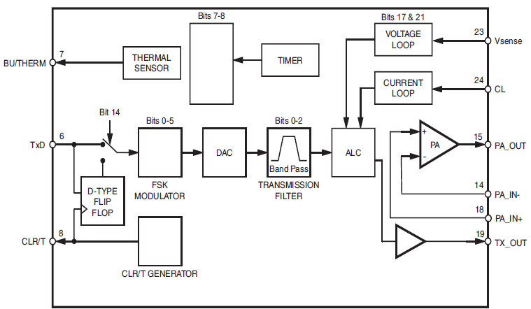

3.2.3 Line coupling interface section:
The mains coupling interface is composed of three different filters:
- Tx active filter
- Tx passive filter
- Rx passive filter.

The RX passive filter was simply a band pass filter centered on the carrier frequency (132 KHz). This part of the circuit simply minimized the amount of noise entering the IC's input pin.
When Transmitting (TX mode), there were 2 stages of filtering. The first was the active stage. This used an internal opamp that filtered the TX_OUT signal as well as added a 6V DC offset. The second stage was the passive high pass filter that only allowed signals higher than 132 kHz to pass.
The transformer in this circuit also provided isolation from high voltage in the line. The ICs had a maximum voltage rating of 14 volts at each of its pins. For this reason, it was extremely important that the chip be isolated from the power line voltage. The isolation transformer ensured the IC pins would be protected.

Target unit :
All target units will be constantly listening for a carrier signal on the power line. If a carrier signal is detected, the target units will receive the data packet from the host unit. If the address contained within the data packet matches the address of the target unit, then the target unit will execute the command contained within the data packet.
Power line modem
power lines
Appliance
Microcontroller

the target unit is just as the host unit hardware except that the microcontroller connected to the appliance not to host computer .

3.3 Web interface :
As graphical user interface we decided to build a web site using PHP language The web site contain a monitoring and controlling pages to display values and figures of power consumption by the load .We used visual basic to make connection between the data obtained by the microcontroller with the data base of the server. These data imported by the web site .
Remote usage of device is achieved using the internet. It has one input/output, the Computer, whose data it uses to display power profiles and to whom it sends remote switching commands. So we will use website page to get communication between the user and the system, so it can be monitored and controlled remotely.
3.3.1 Visual basic interface :
This software is used to connect the database of the server with the microcontroller , the readings sent serially to it and by the visual basic the power and the time sent to the database .

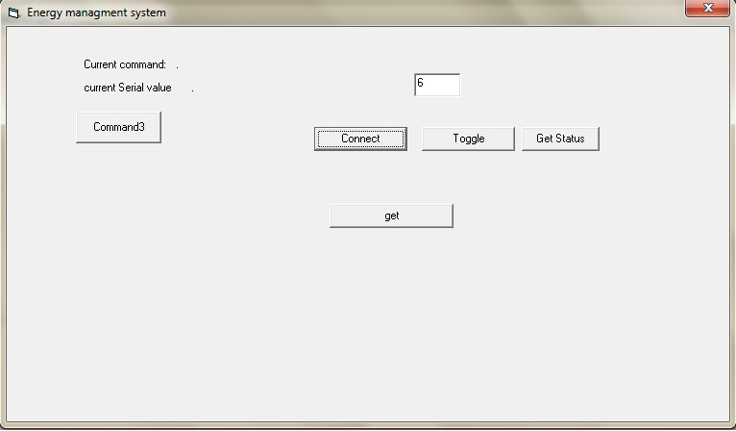

3.3.2 Website server:
To create web server we will use PHP language that will help us to write scripts to parse the data from directory and display it to the user via a web browser that use port 80.also we will allow for hashed user entries, and the ability to save user preferences for the web interface by using MYQSL.

3.3.2.1 About MYSQL
MySQL is the world's most popular open source database software. With its superior speed, reliability, and ease of use, MySQL has become the preferred choice for Web, Web 2.0, SaaS, ISV, Telecom companies and forward-thinking corporate IT Managers because it eliminates the major problems associated with downtime, maintenance and administration for modern, online applications.

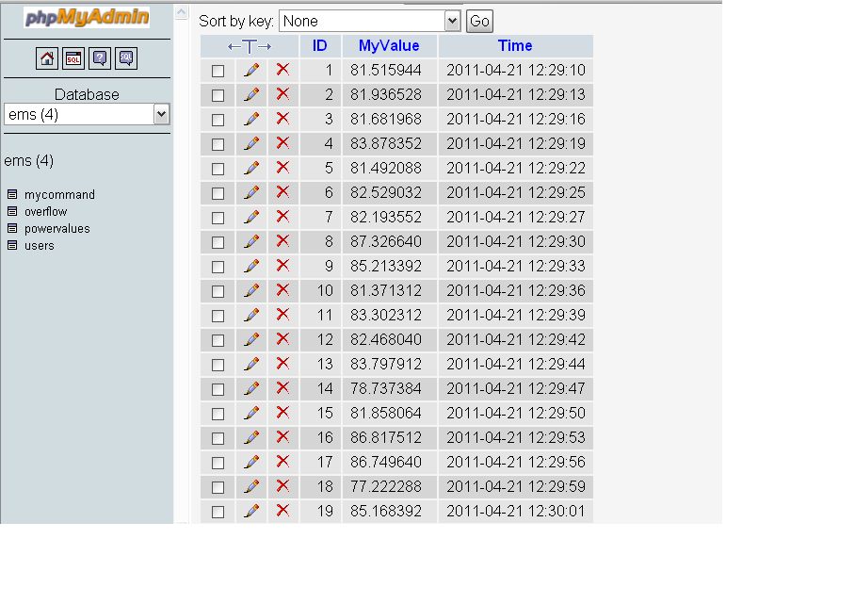

3.3.3About php

PHP is a general-purpose scripting language that is especially suited to server-side web development where PHP generally runs on a web server. Any PHP code in a requested file is executed by the PHP runtime, usually to create dynamic web page content. It can also be used for command-line scripting and client-side GUI applications. PHP can be deployed on most web servers, many operating systems and platforms, and can be used with many relational database management systems (RDBMS). It is available free of charge, and the PHP Group provides the complete source code for users to build, customize and extend for their own use.

Website design :
Our website consist of four main pages :
3.3.3.1 Home page
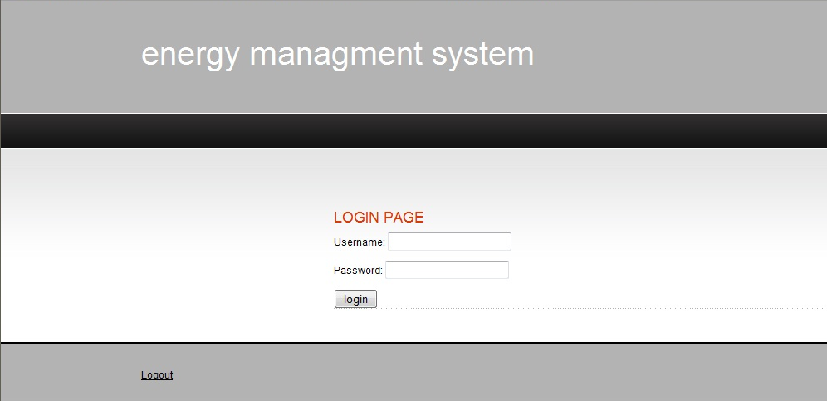

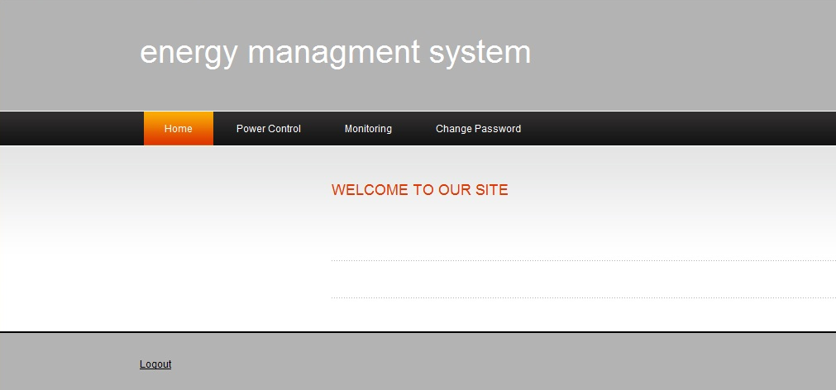

3.3.3.2 Controlling page :
This page allow the user to control the system by toggling it either to the on or off state and then display the state of the system :

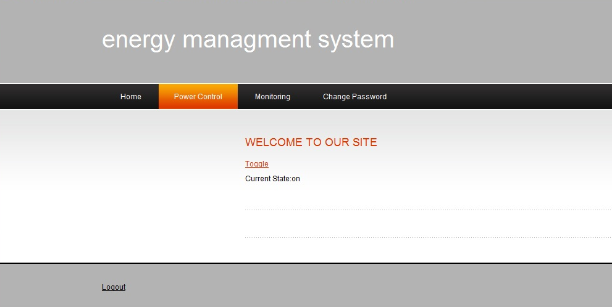

3.3.3.3 Monitoring page :
In this page the user can monitor the power consumption of the load , the reading displayed in the graph is a real time measurements obtained from the database of the server :
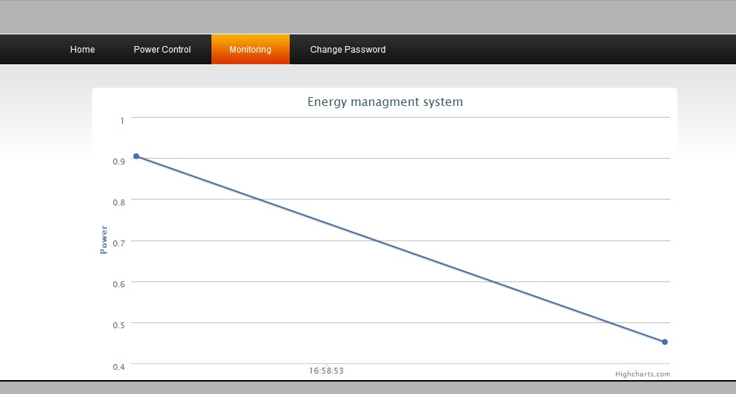

Chapter four : Testing and verifications :

Power line communication testing :
The first test we did was to verify that the power line modem operating as desired .our reference was the datasheet of the modem .
(see appendix )

  - Basic transmission

The first test was a basic serial transmission of a single 8 bit word. The transmitting MCU was programmed to repeatedly send the hex characters 0xAA to the power line modem (PLM). The transmitting PLM was connected to the receiving PLM using 2 wires and not connected through the power lines. The default baud rate was used so that the PLM control register did not need to be programmed.
When the modems and transmitting MCU were powered up, the oscilloscope was used to verify that data was being sent.
Crystal output master clock output
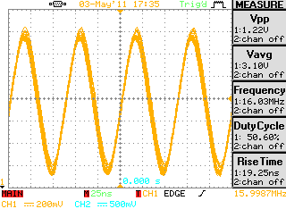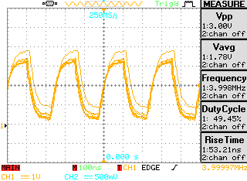

Digital transmitted data :

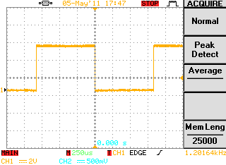

Modulated signal :
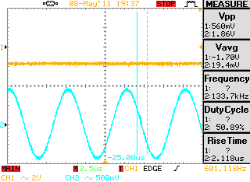
Ch1: represent the 0 data
Ch2 : the fsk modulated signal at frequency of 133.7 KHz

  - High power part :

To isolate the modem circuit we use a coupling transformer to protect the circuit from the mains voltage because the IC`s of the modem operate on maximum 12 V .

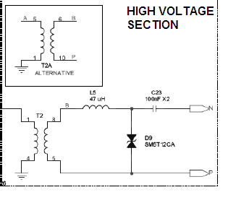
We did a small test on this section we put a 220 v ac on the terminal of the isolating transformer and we saw that the transformer can isolate completely the circuit from the high voltage ,and then we insure that it can pass the high frequency signal.
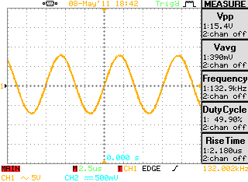
Input signal output signal
Cost of the project :
Part one : sensing circuit
Component name | Number | Cost per one (NIS)
LM385N | 1 | 3
Resistor(for voltage sensor ) | 10 | 4
Hall effect sensor | 1 | 90
Solid state relay | 1 | ------
Power supply | 1 | --------
Other RCL component | -- | 10
PIC16F877 | 1 | 25

Part two : power line communication
Component name | Number | Cost (NIS)
ST7540 | 2 | 186
Capacitors | 30 | 20
Resistors | 20 | 20
socket | 4 | 20
BAT54S | 4 | 6
SM6A12 | 2 | 25
Coupling transformer | 2 | 80
Power inductors | 2 | 20
PIC16F877 | 2 | 50

Schematics:
- Power line modem
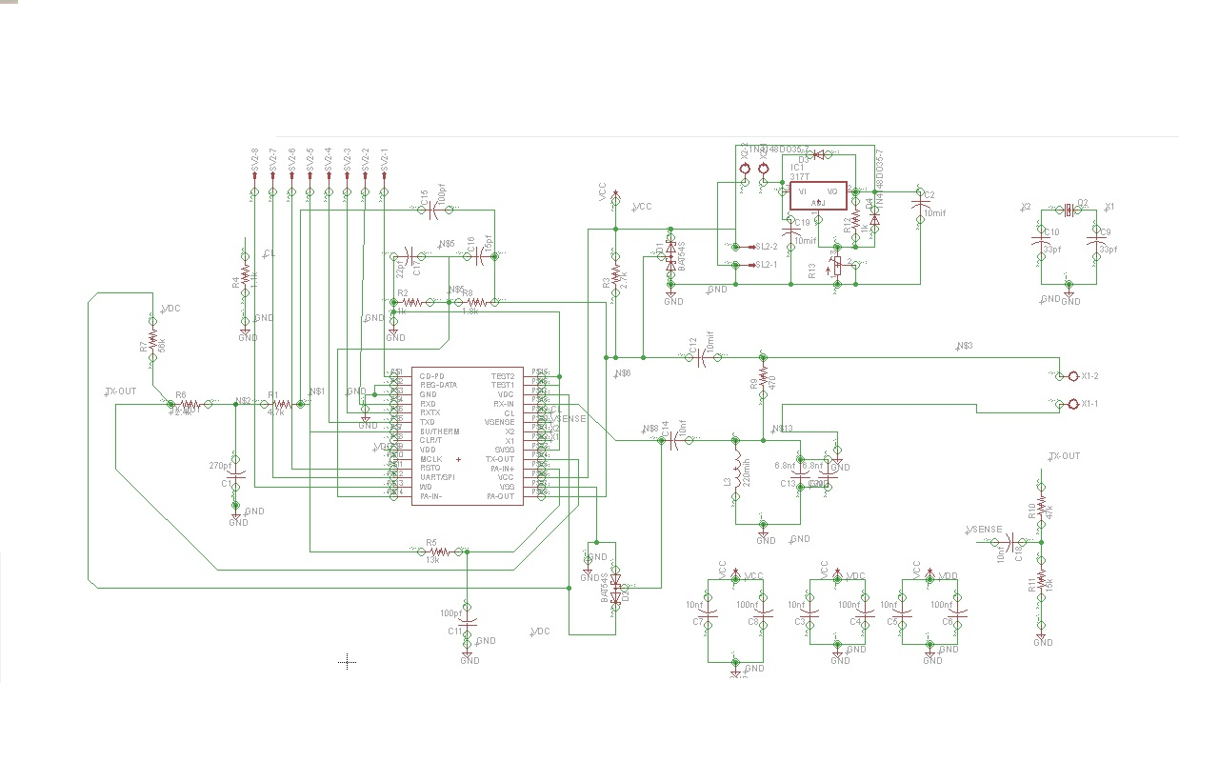

PCB Layout :
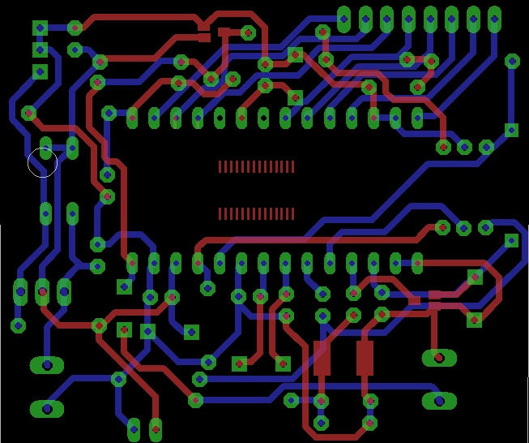

Future work :
Given more time, there are many improvements and development we want to do. first we will try to display and calculate more values about the power consumption such as reactive power and power factor and we will try to display more graphs .
The other aim we will work to achieve it that we will try to make a network of power line modems in the building and for large distance and give each target unit a specific address and display this network on our website in appropriate way .
And we also aim to make our hardware in smallest unit such as very small box represent the smart socket . and make an integrated circuitry that contain all the component of our system .
Appendix :
- Hall effect data sheet
http://www.sparkfun.com/products/8883
- ST7540 data sheet
http://pdf1.alldatasheet.com/datasheet-pdf/view/159265/STMICROELECTRONICS/ST7540.html
- Board datasheet
http://datasheet.octopart.com/EVALST7540-1-STMicroelectronics-datasheet-136517.pdf

References :

- "ST7540 FSK powerline transceiver design guide for AMR" Jan. 28, 2008. [Online]. Available: http://www.st.com/stonline/products/literature/an/12791.pdf. [Accessed: Dec. 8 2009].
- Sparkfun company http://www.sparkfun.com/search/results?term=acs712&what=products.
- "ST7540 FSK powerline transceiver design guide for AMR" Jan. 28, 2008. [Online]. Available: http://www.st.com/stonline/products/literature/an/12791.pdf. [Accessed: Dec. 8 2009].
- Krein, Philip T.. Elements of Power Electronics. New York: Oxford University Press, USA, 1997.
- Cohen, “Computers in use by Country,” Sales and Marketing Management, Vol. 150,p.14, March 1998.
- C. Brown, “Home Smart Home,” Black Enterprise, Vol. 27, No. 8, pp. 87-89, March 1997.
- M. Shwehdi, “A Power Line Data Communications Interface Using Spread Spectrum Technology In Home Automation,” IEEE Transactions on Power Delivery, Vol. 11, No. 3, pp. 1232-1237, July 1996.
- S. Butler, “Smart Toilets and Wired Refrigerators,” US News and World Report, Vol. 126, No. 22, p. 48, 7 June 1999.
- E. Razzi, “Get Smart,” Kiplinger’s Personal Finance, Vol. 54, No. 1, pp.118-123, January2000.
- P. Kingery, “Digital X-10,” http://gardentoys.com/htinews/feb99/articles/kingery/kingery13.htm, Leviton TelCom, USA, 1999.
- X. Feng, “Home Networking,” ftp://ftp.netlab.ohio-state.edu/pub/jain/courses/cis788-
- ST7537 Home Automation Modem, http://us.st.com/stonline/books/pdf/docs/1787.pdf,
STMicroelectronics, USA, 1995.

