

AN-NAJAH NATIONAL UNIVERSITY FACULTY OF ENGINEERING & INFORMATION
TECHNOLOGY
DEPARTMENT OF COMPUTER ENGINEERING

GRADUATION PROJECT I
Grow Together


Prepared by: Tasbeeh Salahat Amani Odeh

Supervised by:
Dr. Alaaldin Almasri

Presented in partial fulfillment of the requirements for Bachelor’s Degree in Computer Engineering

Acknowledgments

We are deeply grateful to our supervisor, Dr.Alaaaldin Almasri, for his con- tinuous guidance, support, and invaluable feedback, which were crucial to the success of this project. We also extend our sincere appreciation to all the professors in the Computer Engineering Department for their support throughout our studies. Additionally, we are thankful to our families, friends, and colleagues for their unwavering encouragement and belief in us. Your support has meant the world to us, and we truly appreciate each and every one of you.

Disclaimer

This report was written by students Tasbeeh Salahat and Amani Odeh at the Engineering Department, Faculty of Engineering, An-Najah National University. It has not been altered or corrected, other than editorial corrections, as a result of assessment and it may contain language as well as content errors. The views expressed in it, together with any outcomes and recommendations, are solely those of the students. An-Najah National University accepts no responsibility or liability for the consequences of this report being used for a purpose other than the purpose for which it was commissioned.

Contents

Acknowledgments 1
Disclaimer 5
Abstract 5
System Structure 5
Machine Body 5
The First Stage 5
The Second Stage 5
The Fourth Stage 5
The Fifth Stage 5
The Sixth Stage 5
The Smell Stage 5
Hardware Components 5
Arduino MEGA 5
Power Supply 5
The Guideline of Power Supply 5
H-bridge 5
Driver 5
DC Motor 5
Stepper Motor 5
Servo 5
Servo Motor 5
Relay 5
LDR 5
Laser 5
Limit Switch 5
Pump 5
Capacitor 5
Relay Two Channel 5
Wires 5
Arduino Wires 5
Speaker Wires 5
ESP32 5
LCD 5
Keypad 5
Plastic Bottle 5
MQ2 Sensor 5
MQ Sensors 5
Nebulizer 5
Results and Discussion 5
Conclusion and Future Work 5
Conclusion 5
Future Work 5
Bibliography5
Bibliography 5
- Chapter1 7
  - Problem Statement 8
  - Objectives 8
  - Scope of Work 9
  - Significance 10
  - Organization of the Report 11
- Chapter 2 12
  - Constraints 12
  - Coding Standards 13
  - Earlier Coursework 13
- Chapter 3 14
  - Technologies and Tools Used in the Project 15
    - Languages and Tools Used in Project Development 15
    - Usage of Advanced Technologies in the Project 15
- Chapter 4 17
  - Authentication 17
  - Land Owner page 18
    - Add Land for Work 18
    - Add Land for Guarantee 23
    - List lands for owner 25
    - Plant Disease Analysis 29
    - My Advertisements 32
    - Transport Feature 32
    - Workers 33
    - Profile 33
    - Reports 34
    - Notification 34
    - Search 34
  - Worker Page 35
    - Notification 35
    - My Guarantee Land 36
    - Ads 39
    - Requests 40
    - Additional Features 41
    - My Schedule 42
    - Advertise Me 43
    - Posts and Communication 44
- Chapter 5 46
- Chapter 5 47
- Chapter 5 48
- Chapter 5 49
- Chapter 6 50
  - Conclusion 50
  - Future work 50

Abstract
This project introduces a comprehensive website and mobile application de- signed to connect landowners with skilled workers, optimizing agricultural land use. The platform enables landowners to lease their land, request la- bor for specific tasks, and receive tailored crop suggestions based on their region’s climate and soil conditions. Workers can register their skills, set their availability, and get matched with nearby land opportunities that suit their expertise. Additionally, agricultural service providers—such as olive presses, transportation companies, mills, can advertise their offerings, pro- vide discounts, and connect with potential clients. By seamlessly linking landowners, workers, and service providers, the platform enhances produc- tivity, fosters job creation, and facilitates access to essential agricultural ser- vices, ultimately contributing to a more efficient and sustainable agricultural sector.

Chapter1

Introduction
Agriculture is one of the most vital sectors contributing significantly to na- tional economies and food security. However, many landowners face difficul- ties in fully utilizing their agricultural land due to a lack of specialized labor or limited resources. At the same time, skilled agricultural workers often struggle to find stable job opportunities that match their expertise, creating a gap between supply and demand in the sector.
This project offers an innovative solution by developing a website and a mobile application that directly connects landowners with skilled agricultural workers. The platform allows landowners to request labor for specific agricul- tural tasks, such as planting or seasonal work like olive harvesting, while also enabling them to choose workers with the right expertise. Similarly, workers can register their skills, set their availability, and specify the areas they are willing to work in, ensuring better access to suitable job opportunities.
Additionally, the platform provides essential agricultural services to sup- port landowners and farmers. Users can request services such as water tankers for irrigation in remote areas, transportation solutions for crops, and access to agricultural service providers like olive presses and mills. Service providers can also promote their offerings and provide special deals, mak- ing it easier for farmers to obtain the necessary resources to enhance their agricultural productivity. By integrating landowners, workers, and service providers into one platform, the project aims to improve land utilization, increase productivity, and create new job opportunities, contributing to the sustainable development of the agricultural sector.

Problem Statement
Despite the vital role agriculture plays in ensuring food security and economic growth, many landowners face difficulties in fully utilizing their agricultural land due to a lack of skilled labor or adequate resources. This results in underutilized land and reduced agricultural productivity. At the same time, skilled workers in the agricultural sector struggle to find stable job opportu- nities that match their expertise.
The existing gap between landowners who require labor and workers seek- ing employment leads to inefficiencies in the agricultural sector, limiting its growth potential. Furthermore, agricultural service providers such as irri- gation, transportation, and milling companies are not easily accessible to landowners and workers, which exacerbates the problem.
This project aims to address these issues by providing an innovative plat- form that connects landowners with skilled workers, improving land utiliza- tion, increasing agricultural productivity, and creating more job opportuni- ties.

Objectives
The main goal of this project is to develop a website and mobile application that directly connects agricultural landowners with skilled workers, facilitat- ing the efficient use of underutilized agricultural land and enhancing produc- tivity in the agricultural sector. The key functionalities and objectives of the system include:
    - Enable landowners to lease their land for specific agricultural tasks, such as planting, plowing, or seasonal work like olive harvesting.
    - Allow skilled workers to register their services, specifying their expertise and availability, and be assigned to nearby farms.
    - Provide landowners with recommendations on the best crops to plant based on their region’s climate and soil type.
    - Integrate agricultural service providers such as olive presses, trans- portation companies, and mills, to offer their services and provide dis- counts to landowners and workers.

    - Improve land utilization and create more job opportunities in the agri- cultural sector.
These objectives aim to enhance efficiency in agriculture by connecting landowners with the right workforce and resources, contributing to the sus- tainable development of the sector.

Scope of Work
The scope of this project encompasses the design, development, and imple- mentation of a website and mobile application that connects agricultural landowners with skilled workers. The system will include both the front-end platform (for landowners and workers) and back-end management to ensure smooth functionality. The key areas of the scope of work include the follow- ing:
    - Design and development of the website and mobile application for own- ers, workers, service providers, and administrators.
    - Development of features for landowners to lease their land for specific agricultural tasks, such as planting, plowing, and seasonal tasks like olive harvesting.
    - Implementation of a system for landowners to receive suggestions on the best crops to plant based on their region’s climate and soil type.
    - Integration of agricultural service providers, such as olive presses, trans- portation companies, and mills, to offer services and provide discounts to both landowners and workers.
    - Development of a system to assign skilled workers to nearby farms based on their location and availability.
    - Implement an AI system to detect plant diseases by analyzing images of crops or sensor data. The system will identify symptoms such as leaf discoloration, wilting, or pest infestation.
    - Implementation of a messaging and notification system to facilitate communication between landowners, workers, and service providers.

    - Testing and quality assurance to ensure smooth user experience and functionality of the website and mobile application.
    - Launching the platform for public use and providing ongoing mainte- nance and support after deployment.
This scope ensures that the platform meets the needs of both agricultural landowners and skilled workers, enhancing land utilization and creating job opportunities while contributing to the efficiency and growth of the agricul- tural sector.

Significance
This smart agricultural application stands out for several reasons. It mod- ernizes the way agricultural land is managed and workers are employed, pro- viding an efficient and easy platform that connects farmers and workers. By merging traditional agricultural practices with modern technology, the application bridges the gap between old methods and new solutions.
The application allows farmers to quickly and easily connect with skilled workers, saving time and offering more flexibility for both parties. It enables workers to find job opportunities that match their skills and availability, while farmers can hire the right people for specific tasks like planting or harvesting. These innovations encourage work efficiency and ensure tasks are completed on time.
Moreover, the application provides farmers with recommendations on the best crops to grow based on the local climate and soil type, making decision- making more accurate and productive. Additionally, the integration of the application with other agricultural service providers, such as transportation companies and mills, makes it a comprehensive solution for improving agri- cultural operations.
This project, through its digital approach, contributes to enhancing sus- tainability in the agricultural sector by ensuring labor availability during critical seasons and reducing agricultural waste. By combining traditional agriculture with digital solutions, the application enhances efficiency, reduces operational costs, and supports the sustainable development of the agricul- tural sector.

Organization of the Report
This report is structured to provide a comprehensive overview of the project. The Introduction section presents an overview of the problem, the project’s objectives, and its significance. The Constraints, Standards, and Tech- nologies section outlines the challenges encountered during the development process, the standards adhered to, and the technologies utilized. The Liter- ature Review discusses the research and scientific papers that influenced the development of the project. In the Methodology section, the approach and process followed during the development are explained in detail. The Results and Discussion section presents the outcomes of the implemen- tation, along with key findings and observations. Finally, the Conclusion and Future Work summarizes the project’s achievements and discusses potential future improvements and enhancements.

Chapter 2

Constraints
During the development process, we faced several challenges, the most no- table ones being:
    - New Technologies: Developing the app and website from scratch, including the front-end and back-end, database, dealing with external APIs, servers, and instant features, was a significant challenge since we were using unfamiliar technologies. This required us to explore different methods, resources, and solutions to address emerging obstacles during the development process.
    - Data Accuracy and Reliability: Ensuring the accuracy and reliabil- ity of the information related to different plant species in the database was challenging, especially since information about the same species can vary across different sources. Additionally, obtaining expert assis- tance was limited due to the lack of specialists in this field.
    - Artificial Intelligence: The Detect AI system relies on artificial in- telligence to identify plant species and detect pests, as well as provide guidance for maintaining plant health based on images uploaded by the user. However, its accuracy depends on the quality of image analysis and the availability of accurate technical data about the plant environ- ment. In some cases, the system provides good plant disease analysis, but it may be less accurate when dealing with complex cases.
    - Time Management: Good time management was essential for the project’s success, as its completion required coordination between sev-

eral tasks such as data collection, research, testing, development, re- quirements definition, and planning. Initially, the lack of experience increased the learning curve and time taken to complete tasks. How- ever, by repeating processes and referring to the same resources, the production pace was accelerated, and work efficiency improved.

Coding Standards
In this project, we followed specific coding standards for each technology: For the back-end, we ensured modularity, used asynchronous program-
ming (async/await), implemented proper error handling, and followed secu- rity practices like input validation and using libraries such as helmet for protection.
For the front-end, we adhered to the principles of state management (us- ing Provider), followed Material Design guidelines, and maintained clean code practices with camelCase naming conventions for variables and wid- gets.
We used Python to train the AI model for image processing. Libraries like TensorFlow and OpenCV were utilized for training the model and pro- cessing plant images to detect pests and identify species. Efficient data pre- processing and model tuning were key components.

Earlier Coursework
We appreciate the rich experience we recieved from the Computer En- gineering Department’s courses we took in the previous years, including Web, Database, Software Engineering, Advanced Software Engineering, Object-Oriented, and Critical Thinking. Going through these courses built a really strong knowledge of the main concepts and basic skills that were necessary to develop the project. Additionally, we had to expand our knowledge and move to more advanced approaches to learn how to use frameworks like Flutter and Laravel like YouTube videos, Udemy courses, and documentation to gain more experience in the web development field.

Chapter 3

Literature Review
Agriculture is one of the cornerstone sectors of many economies; however, many landowners face challenges in fully utilizing their agricultural land. Studies indicate that underutilized agricultural land remains a significant issue in various regions, with much land left idle due to the lack of skilled la- bor or appropriate resources. According to research, improving land use can lead to increased agricultural production and improved economic conditions in rural communities. Research into technologies that connect landowners with skilled workers has emerged as a potential solution to this problem. Smartphone applications and websites have become increasingly popular in facilitating this connection between landowners and agricultural workers. A study conducted in the field of agricultural technology showed that the use of these digital platforms can increase agricultural efficiency and contribute to improving productivity by providing job opportunities for skilled work- ers and ensuring maximum utilization of land. Additionally, artificial in- telligence technologies and mobile applications have proven to be beneficial in improving land management. These technologies offer tailored solutions to landowners based on the climate and soil type of their region, helping to determine the most suitable crops for the soil and ultimately increasing agricultural yields. Furthermore, research has shown that digital platforms connecting skilled laborers with landowners can solve various issues, such as labor shortages in rural areas and logistical challenges like transportation and distance. For farmers, these platforms provide an opportunity to receive specialized help when needed, allowing agricultural tasks to be performed more efficiently and on time.

Technologies and Tools Used in the Project

Languages and Tools Used in Project Develop- ment
In this project, a variety of languages and tools were used to achieve high performance and integration between all system components, both on the front-end and back-end.
      - Front-end: Flutter was used to develop user interfaces for both mo- bile and web applications, enabling the creation of high-performance applications that support multiple operating systems like Android, iOS, and Web. Dart language was used as it supports object-oriented programming and asynchronous programming.
      - Back-end: The back-end of our software project is built using Node.js with Express.js. Node.js delivers high performance, particularly in handling asynchronous operations, which enhances the responsiveness of the system. Express.js is used to efficiently manage and route HTTP requests, simplifying the back-end logic. We’ve implemented the Model-View-Controller (MVC) architecture, ensuring a well- organized and modular codebase. The Model component is responsible for encapsulating the data and business logic, guaranteeing proper data handling and manipulation.
      - Database: MongoDB was used as the main database for the project, providing flexibility in storing unstructured and diverse data. Mongoose was used as an ORM for MongoDB to organize data and perform op- erations efficiently.

Usage of Advanced Technologies in the Project
- Geographic Data Retrieval: A router was used to retrieve data about the agricultural lands by letting the user input province, vil- lage, block, and parcel. The system then retrieves the exact geo- graphical location using maps from (aradi.ps). The response from the router provides details about all lands in the block, with a focus on the land selected by the user, displaying it on the map.

- Text Analysis with Node.js Library: An library in Node.js was used to analyze the textual data extracted from the site, converting it into numerical data such as area, latitude, and longitude, which were then stored accurately in the database.
- Maps and Area Analysis: Maps were used to display the geograph- ical location of the lands and precisely calculate the area using the geographic points obtained from the router. The system allows users to define a specific land area by connecting the input points, form- ing a polygon, which helps users define the desired land area with accuracy.
- Image Processing with MobileNet: The MobileNet model was used for image processing related to plants, where the model detects the type of disease affecting the plant from the image uploaded by the user. The system then provides treatment recommendations based on the detected disease. The model was trained on a large dataset related to plants and their diseases to ensure high accuracy in recognizing agricultural diseases.
- Firebase and Google Cloud Usage: Firebase was used for imple- menting real-time notifications, ensuring updates are delivered to users in real-time. Google Cloud was used to store images of lands and plants, reducing the load on the main database and ensuring secure and scalable image storage.
- Soil Data Retrieval from Geographic Location: A special router was used to retrieve soil data based on the geographical location of the land specified by the user. After entering the location (province, vil- lage, block, and parcel), the system connects to the router to retrieve detailed information about the soil such as its type, moisture, and fertility status. Based on this data, the system provides crop rec- ommendations that are suitable for the environmental conditions and agricultural season, helping farmers make better agricultural decisions.

Chapter 4

Authentication
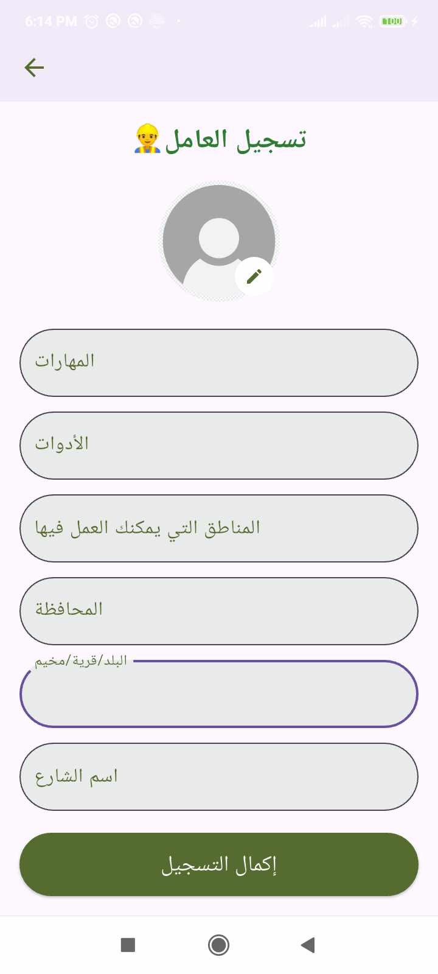
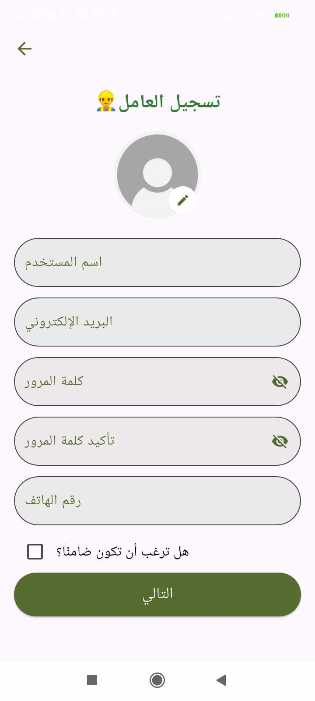
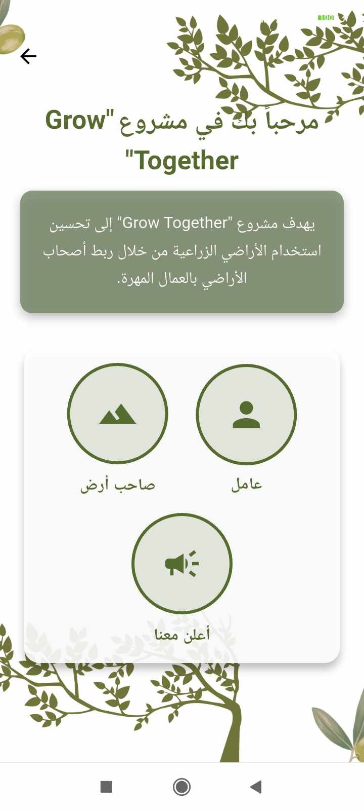

User Role Selection Sign Up - Worker Sign Up – Worker

The authentication process allows users to select their role in the system. The available choices include a worker, a landowner, or a service provider. The images illustrate different steps involved in the sign-up process for workers.

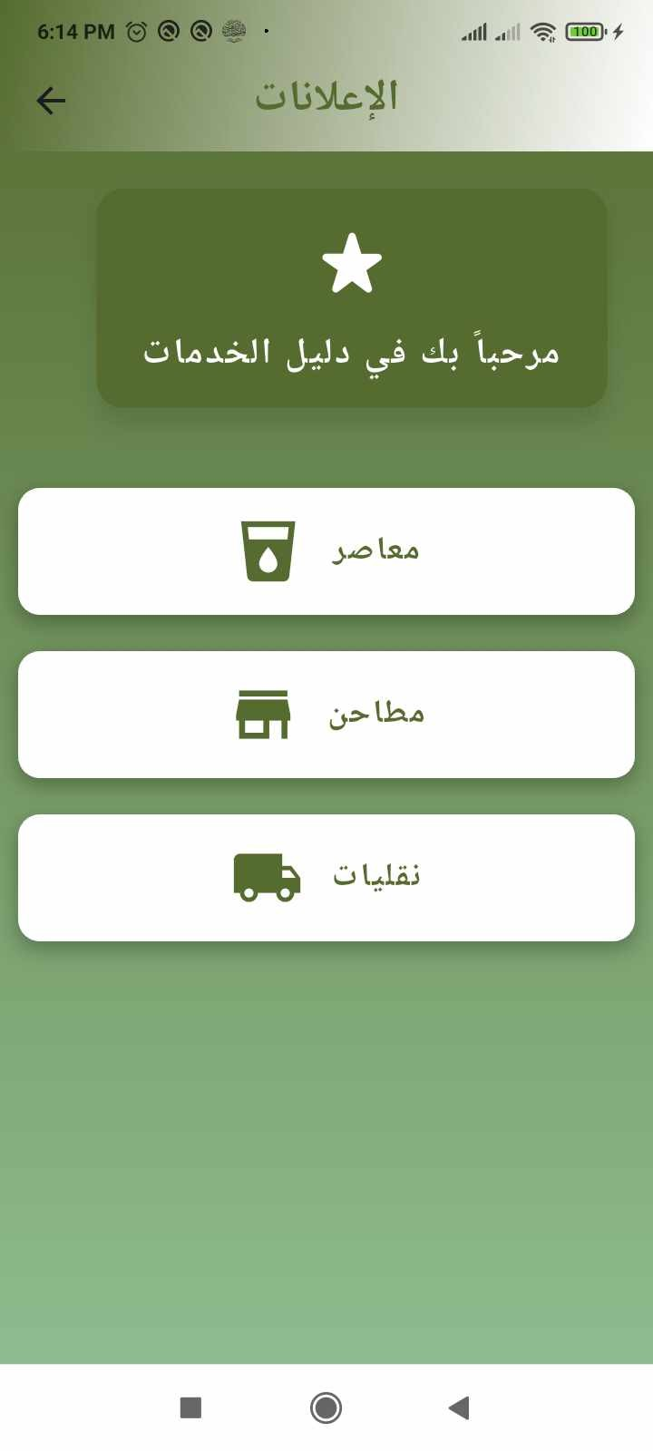
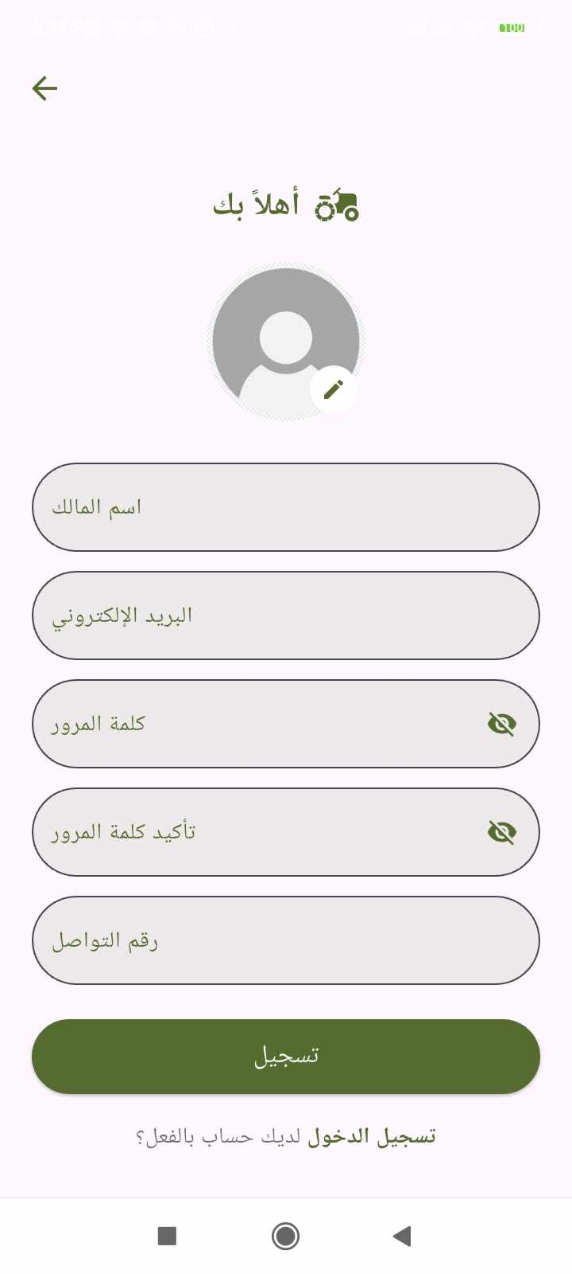
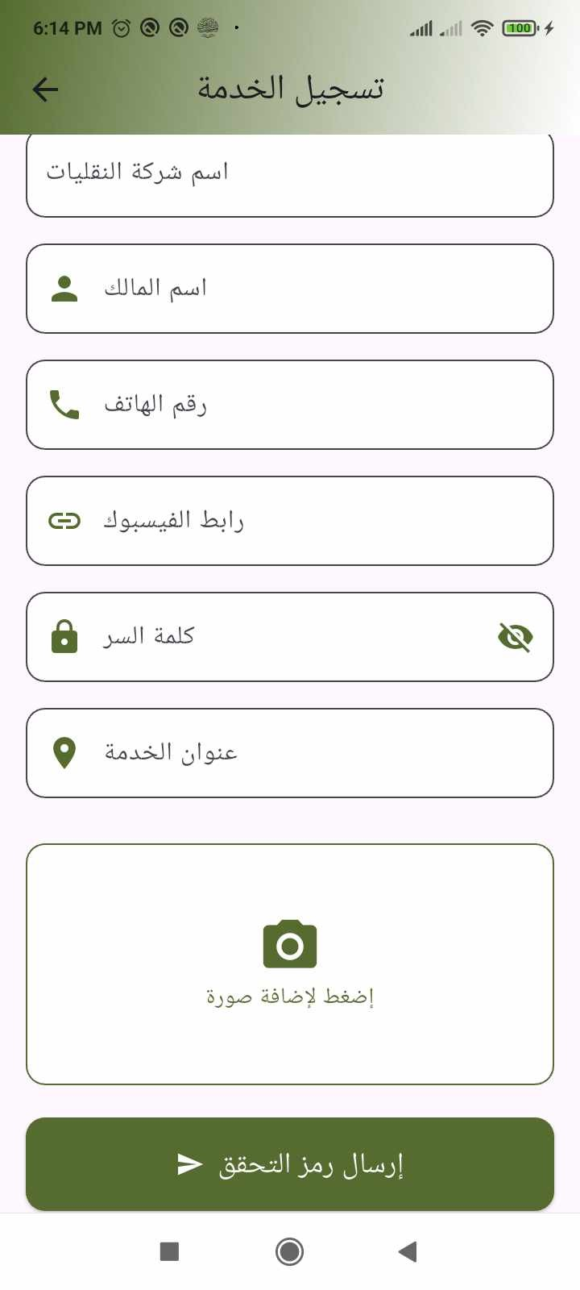
choice Sign Up Owner Sign Up Service

Land Owner page

Add Land for Work
In this feature, the landowner can add their land to search for workers to help with tasks on the land. The landowner enters necessary information such as the governorate, region, block, parcel, and the type of work needed. After the data is entered, the system sends this information to the ”Aradi.ps” website using the API provided by the site. The response from the website is then used to display the land’s location on the map, based on the governorate, region, block, and parcel. Additionally, a land ownership document can be attached to verify that the land belongs to the owner.

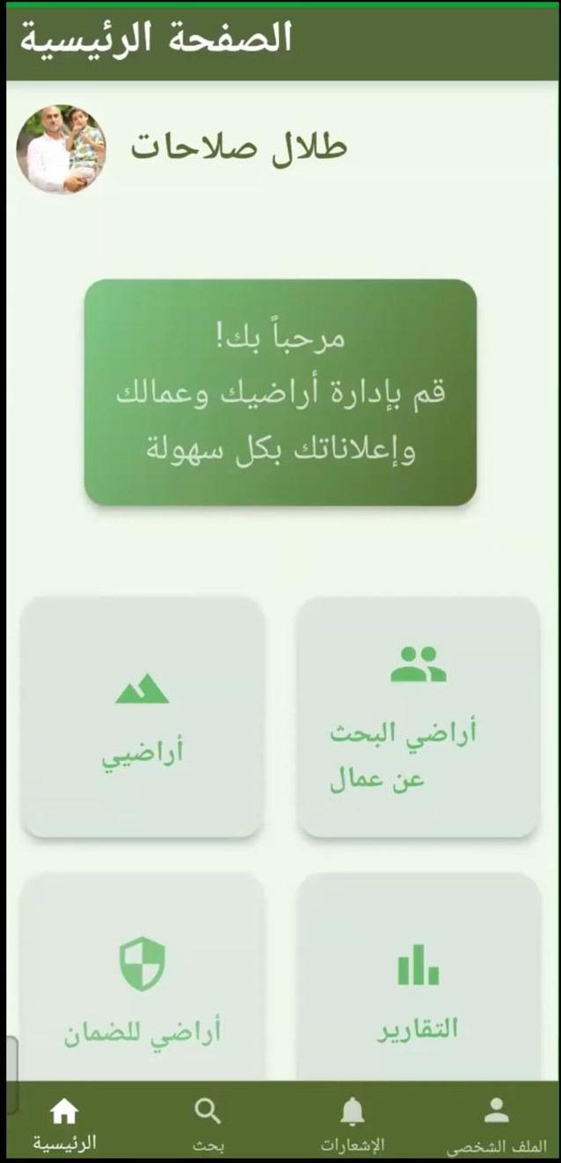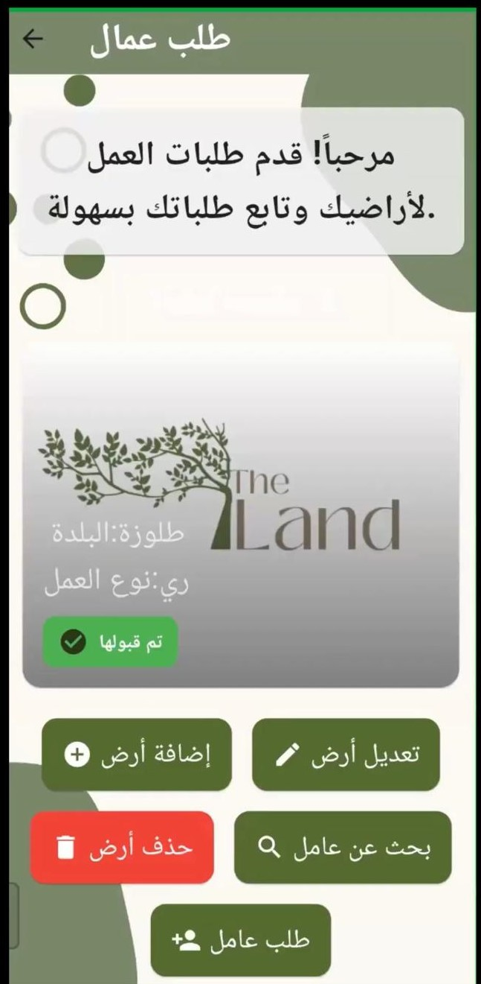
Land owner main page Adding Land for Work.

Once the landowner clicks on the ”Add Land” option, they will be pre- sented with a form where they can enter the necessary details to add their land, such as the land’s location, type of work required, and upload the own- ership document for verification. After adding the land, it will be displayed on the platform, but it will show as ”Not Approved” since it needs to be re- viewed and approved by the admin based on the ownership document before the landowner can proceed to manage the land and hire workers.

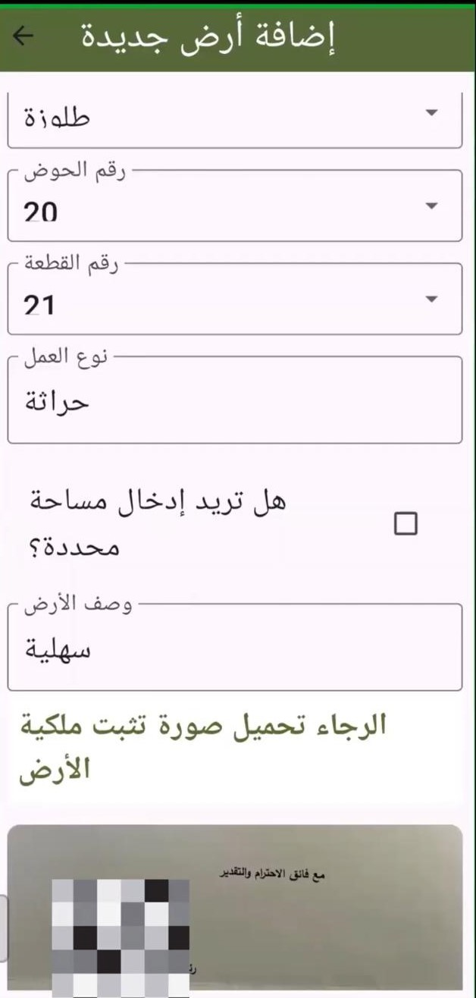
Adding Land for Work. Adding Land for Work.

Additionally, the landowner can update or delete their land information anytime.
The landowner also has the option to create a ”Job Request” for workers by clicking the ”Request Workers” button. This will allow the landowner to create a work advertisement for their land, making it visible to workers who can apply for the job.

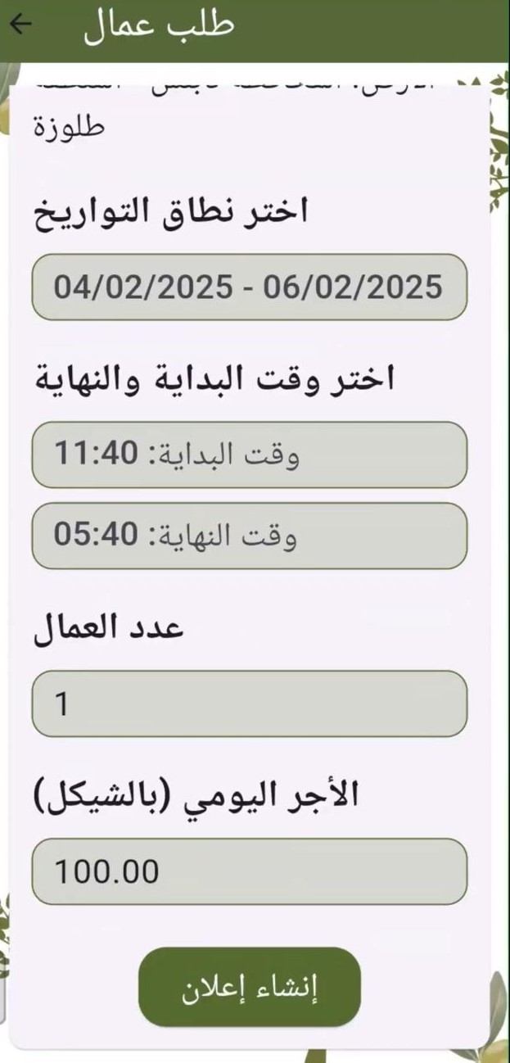
Searching for Workers.

There is also an option for searching for available workers. When the landowner clicks on this option, they will be shown a screen with a list of potential workers available based on their location and the tasks they need to perform.

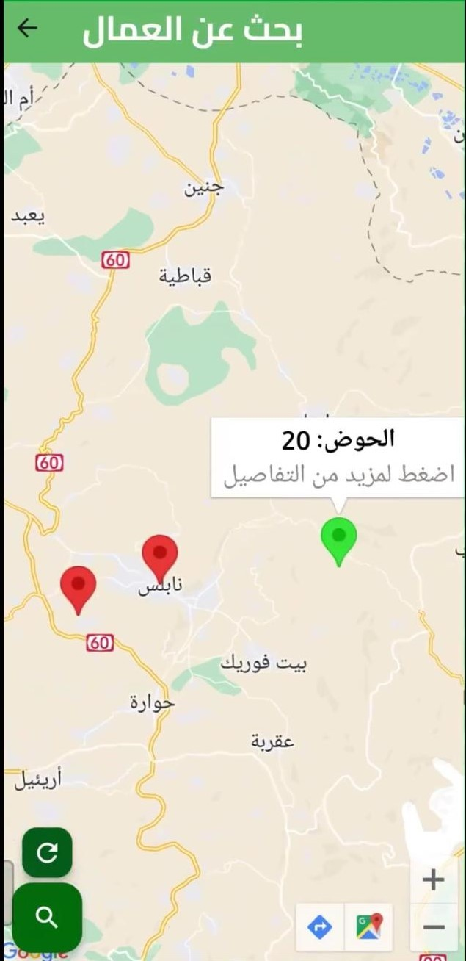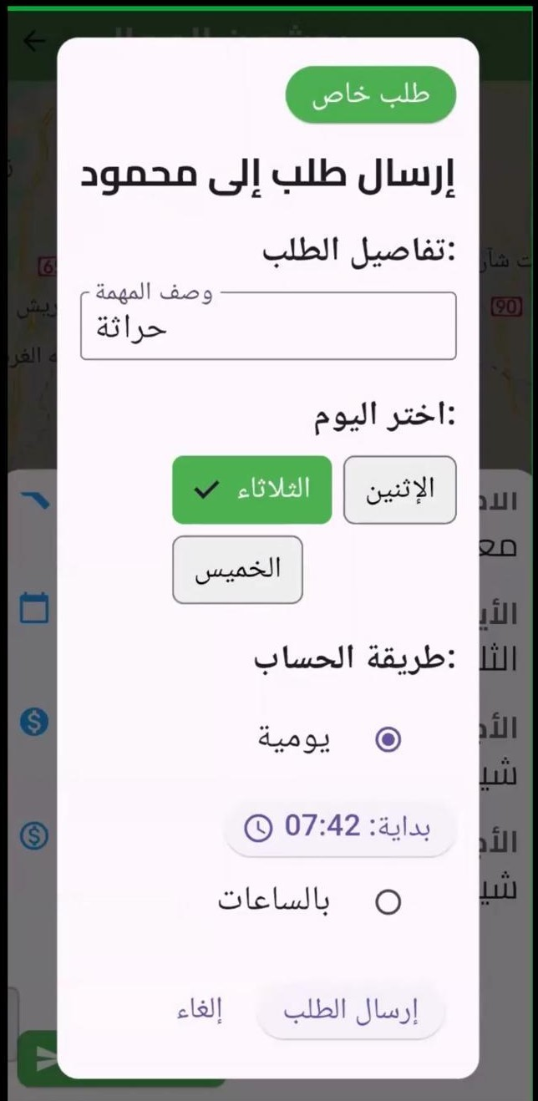

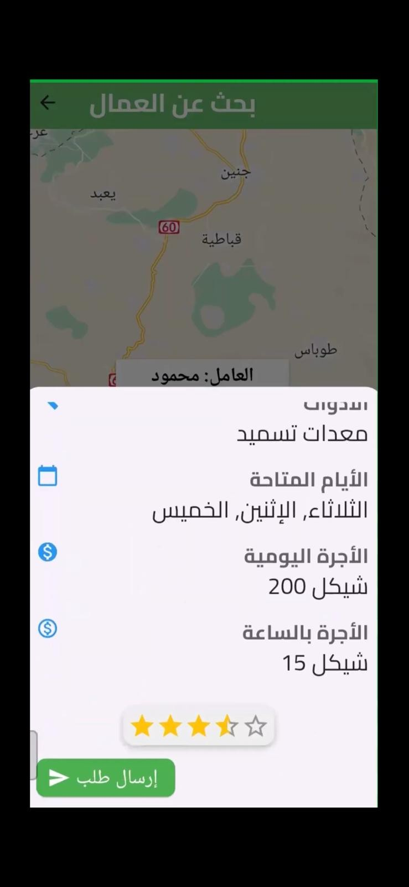
Requesting Workers. Worker List View

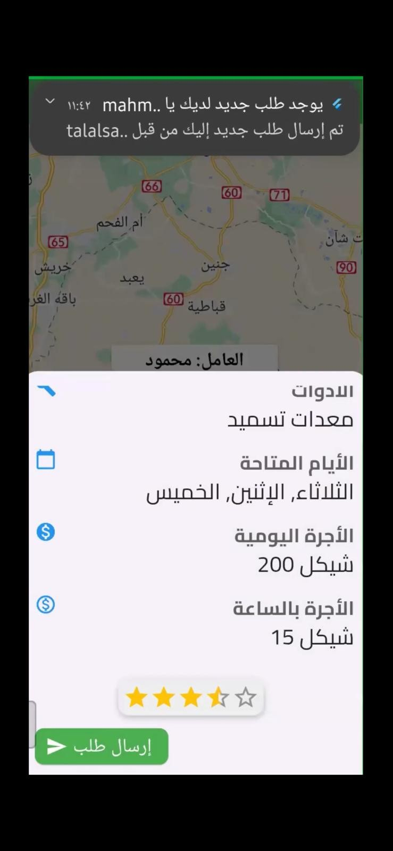
Job Request Submis- sion on firebase.
Job Request for worker.

Add Land for Guarantee
This feature allows users to add land for guarantee, meaning that another party can take responsibility for the land. The user enters the type of work, which can be either **farming** or **harvesting**.
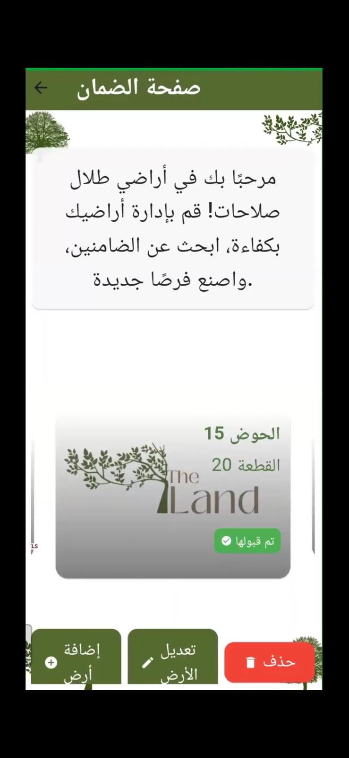
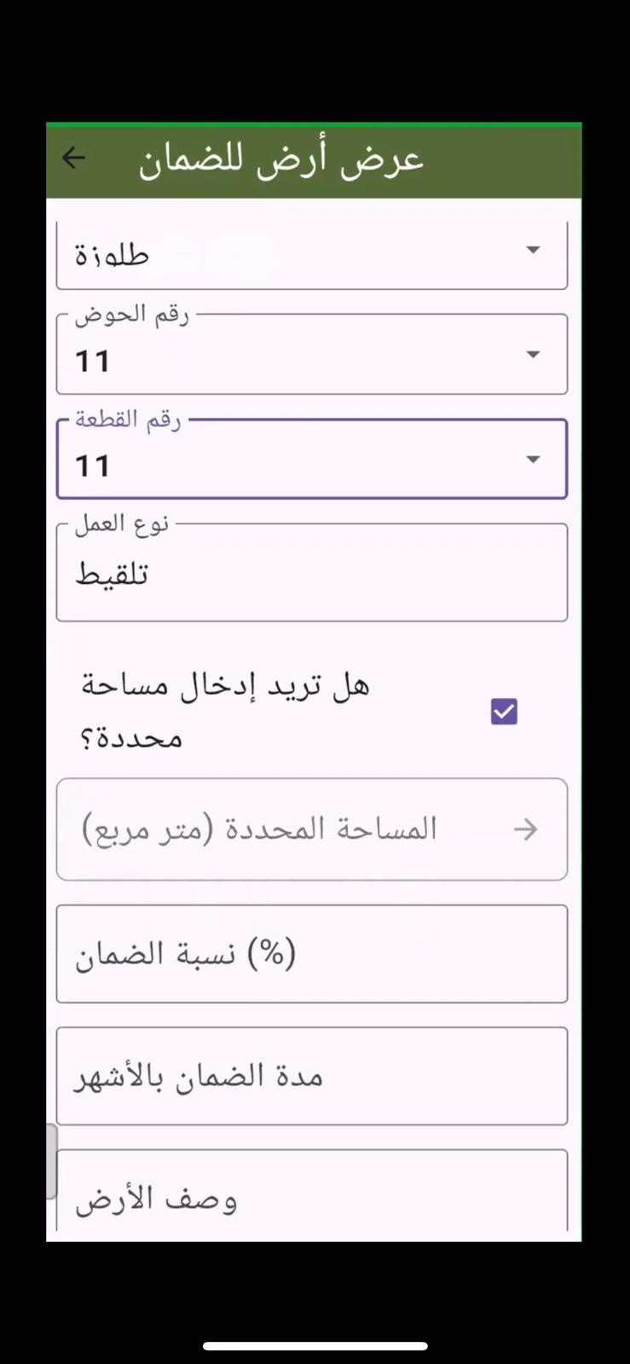
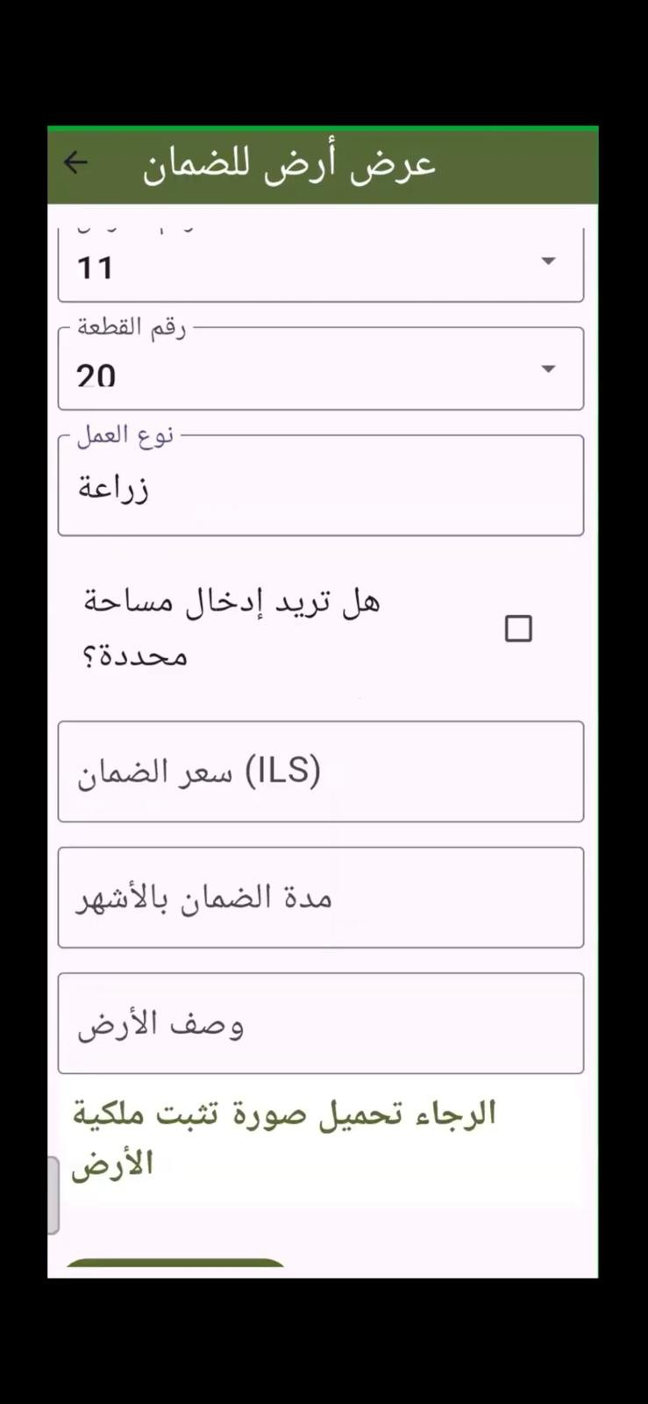
Guarantee Lands List Harvesting Work Type Farming Work Type
Selection Selection

- If the **Farming** option is selected, a field for entering the **guarantee price** appears. - If the **Harvesting** option is selected, a field for entering the **guarantee percentage of the yield** appears.

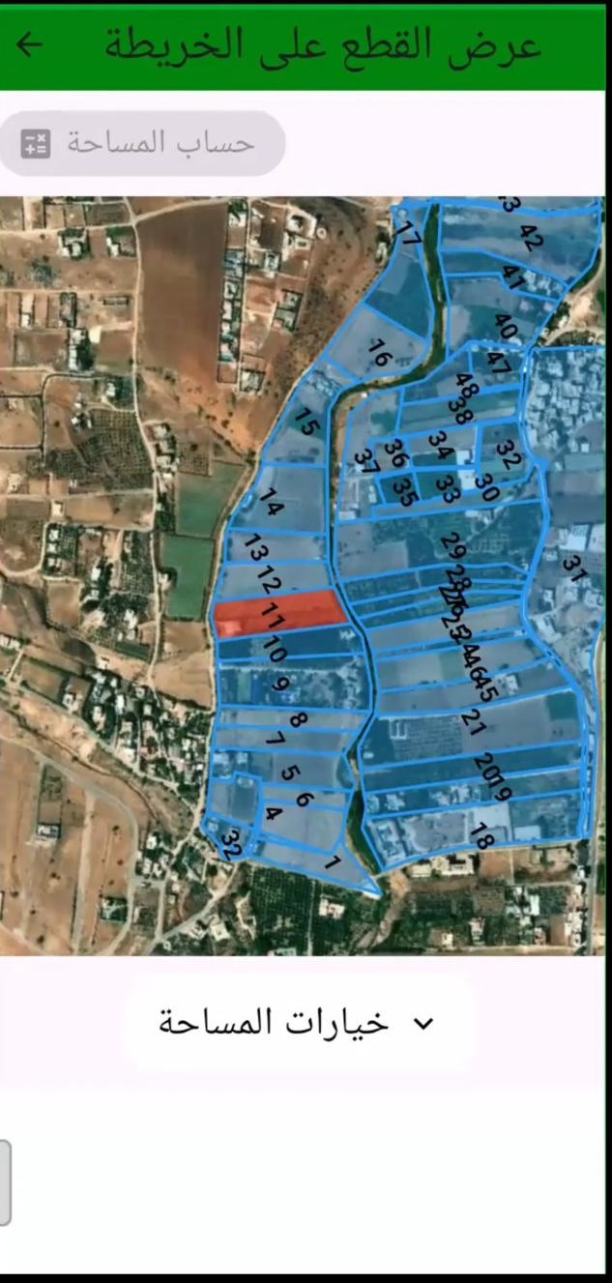
Viewing the Designated Area on the Map

The system suggests specific **area options** based on points returned by the **Aradi.ps** router. These points are connected in groups of four to form proposed designated areas.


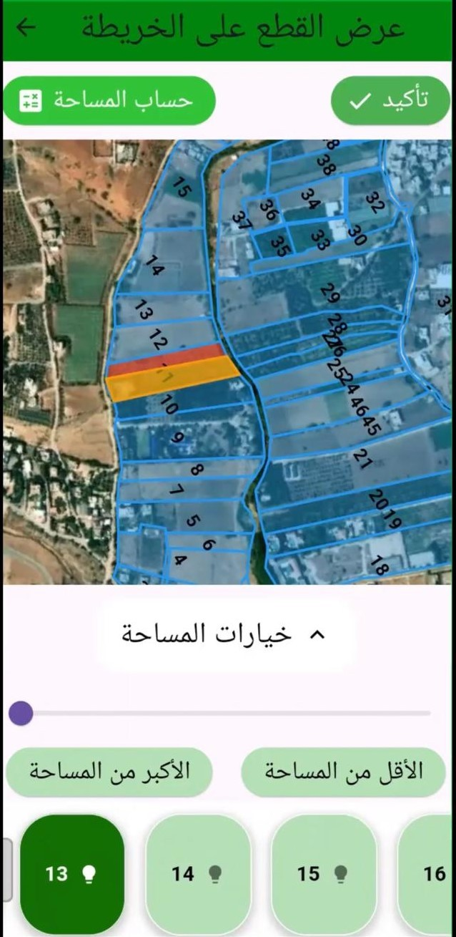
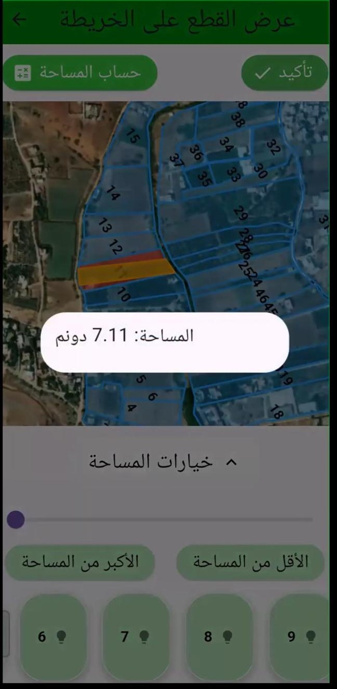
Land Awaiting Approval

Suggested Area
Options Area of Selected
Suggestion

When the admin approves the land, the application sends a notification to the nearest guarantor associated with the land. This process ensures that the guarantor is informed promptly about the approval and can take necessary actions. The system uses the location-based services to identify the nearest guarantor to the land and notifies them in real-time, ensuring quick response times and efficient communication.

List lands for owner
Users can also view all their lands through an interactive **map** and filter them by type (farming or harvesting).

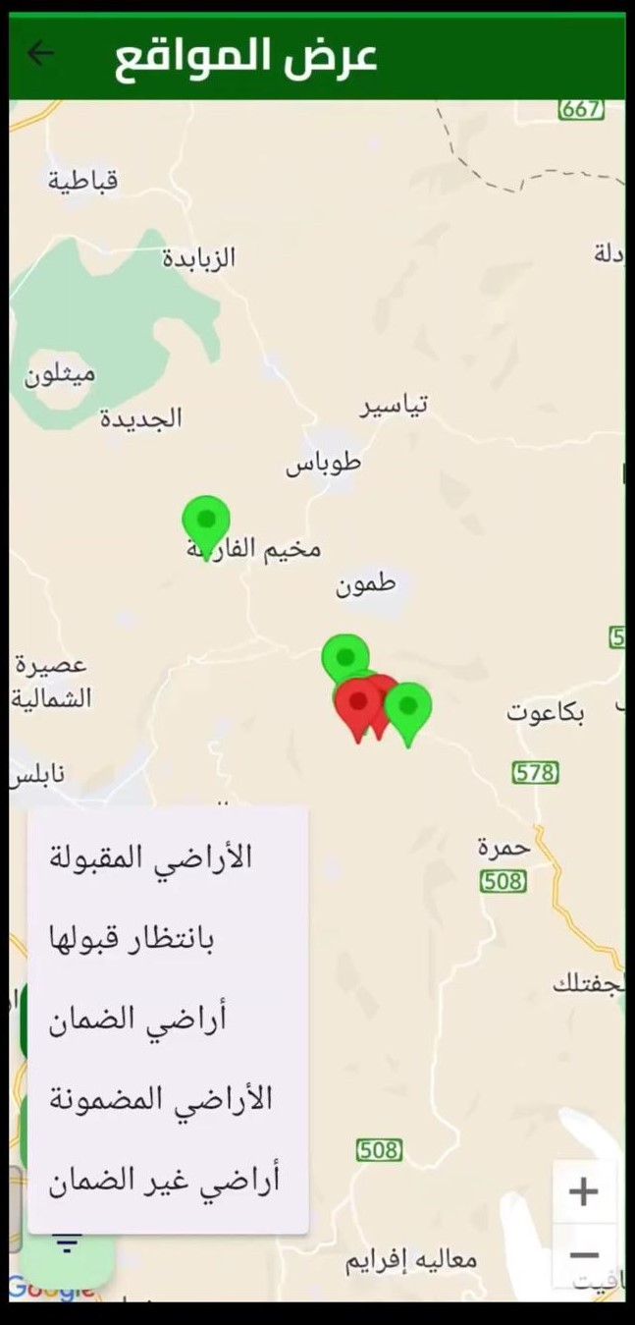
Map displaying user’s lands

To facilitate land management, users can search for a specific land by entering details such as: Plot number,Piece number,Governorate,Town

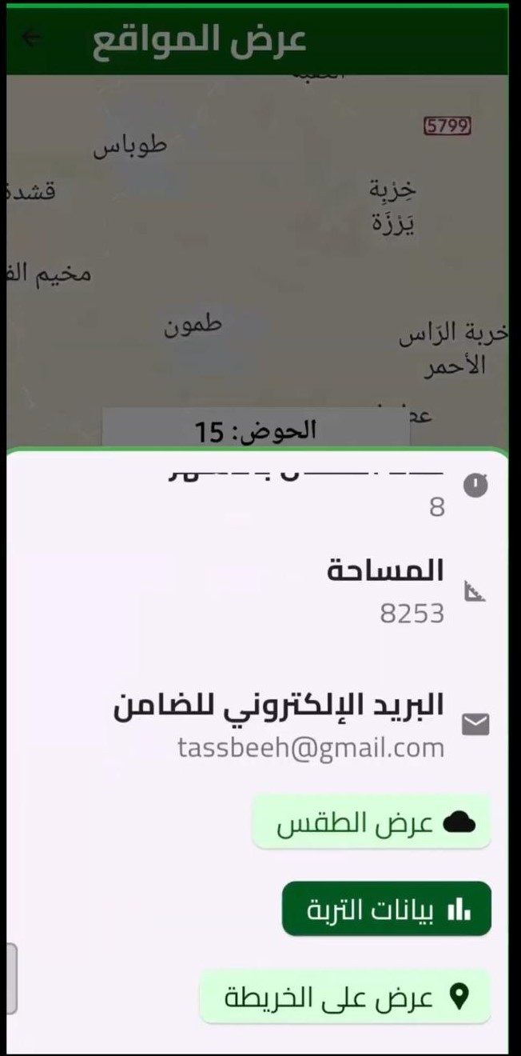
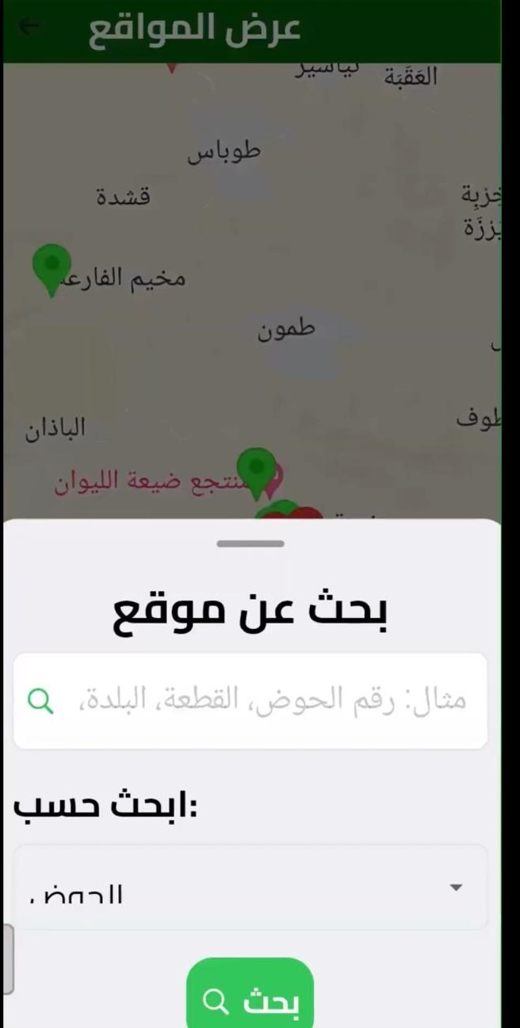

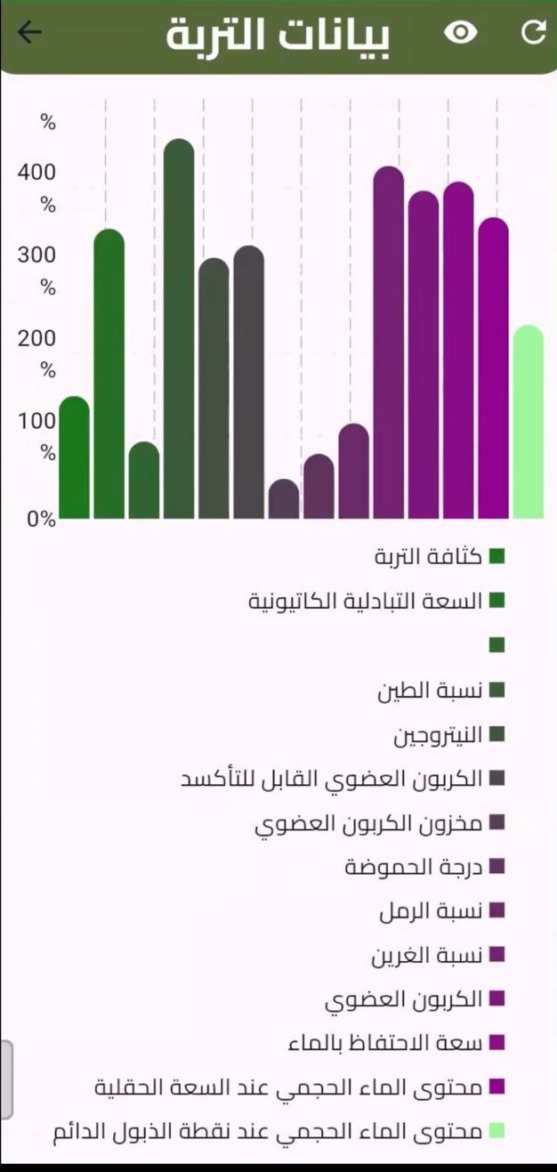
Soil Data for selected land
Search Interface Displaying Land Details

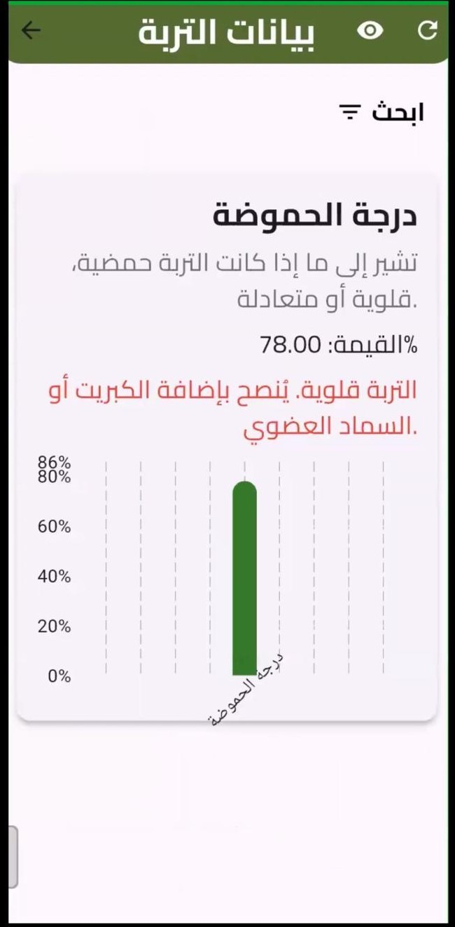
Loss Search Re 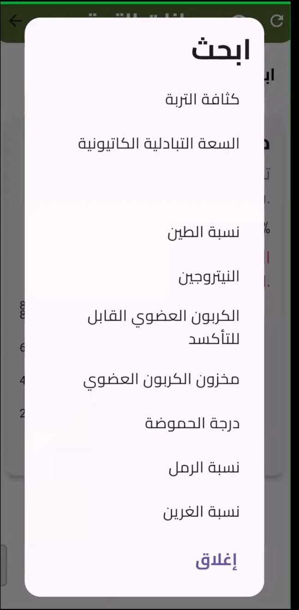sults Filter for Land soil
information

users can view various soil properties along with their values and receive recommendations if any values fall outside the normal range.
For better planning, users can check real-time weather data for their land.

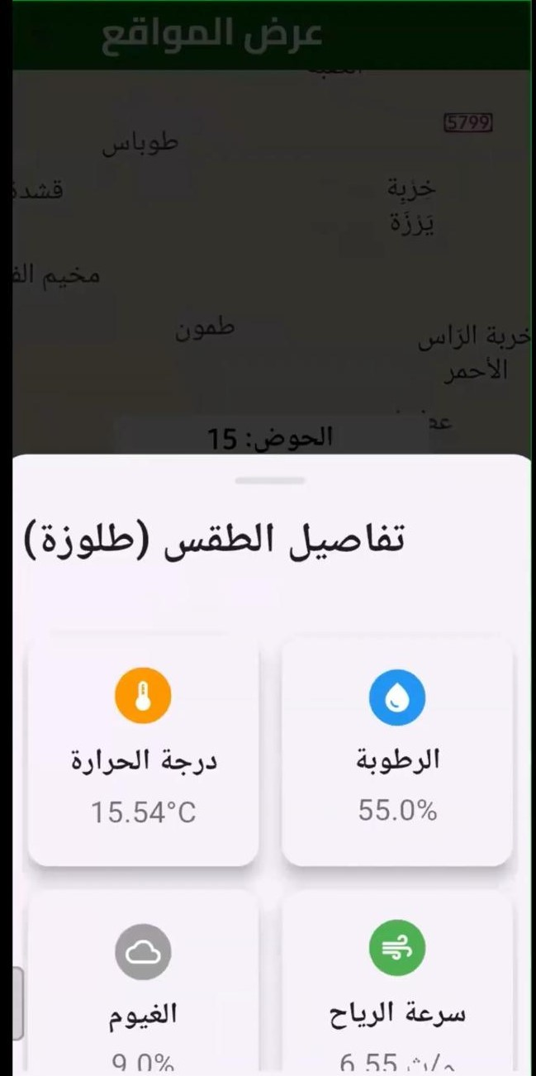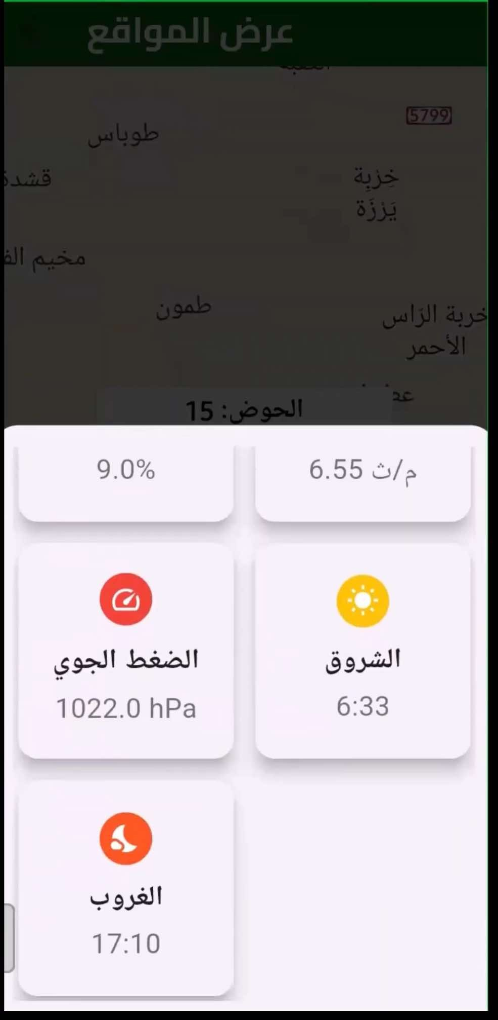
Weather Overview Detailed Weather Con-ditions

Plant Disease Analysis
This feature is an AI module trained on a large dataset of plant diseases. The MobileNet model, implemented in Python, was used to process the data. It was trained with a vast number of images for each type of disease over many years, achieving high accuracy in disease detection ,
When testing the model, users can upload an image of a diseased plant leaf. The system then analyzes the image, identifies the type of disease, and provides the accuracy percentage of the prediction .
Deep Learning and Image Recognition
The system leverages deep learning and image recognition techniques, particularly using MobileNet, a lightweight and efficient convolutional neu- ral network (CNN) model suitable for tasks like image classification, which is ideal for analyzing plant diseases. The model has been trained on a compre- hensive dataset containing thousands (or even millions) of plant leaf images, each labeled with the corresponding plant disease.

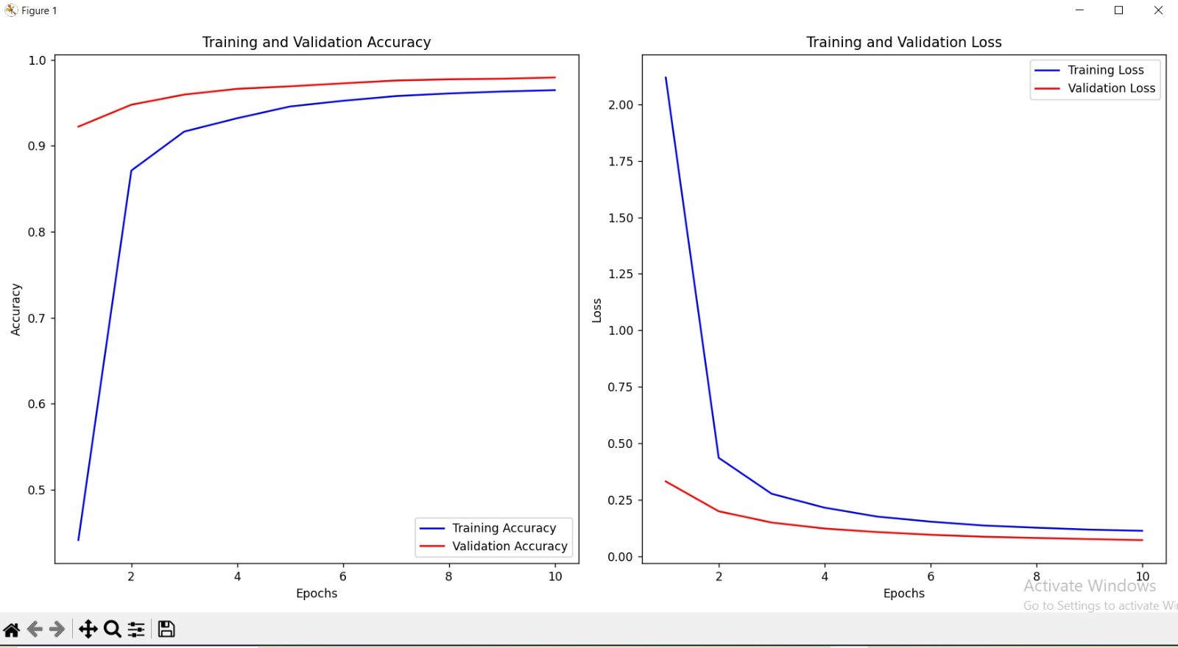
training model result

MobileNet is designed to balance the need for accurate predictions while maintaining a low computational cost. This is crucial for running the system efficiently on devices with limited resources (e.g., mobile phones or low-power computers). Once trained, the model can recognize and classify plant diseases from new images by matching patterns in the uploaded leaf photo. It then provides a confidence score (the accuracy percentage), which indicates how certain the model is about its diagnosis. In practice, users can upload a photo of a plant leaf, and the system will analyze it in real time, offering both the disease name and how confident it is in its prediction. This feature would be very useful for farmers, gardeners, or plant enthusiasts who want to quickly diagnose plant diseases and take the advice for treatment or prevention.

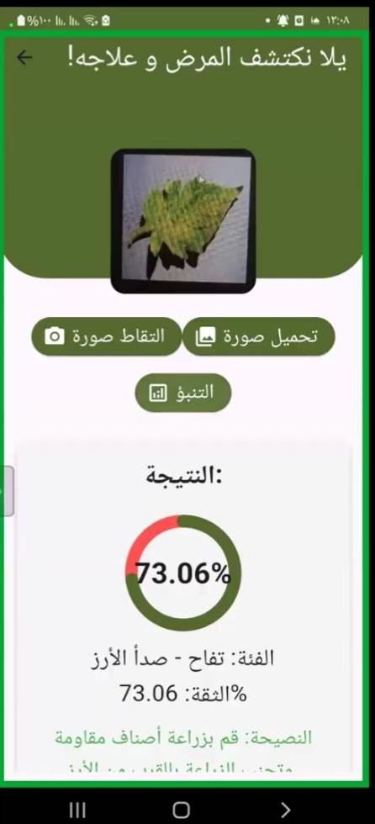
31
result

My Advertisements
In this section, users can view all the advertisements they have created for the lands. Each advertisement is listed with details such as the land’s information and the corresponding image link. The user has the ability to perform actions such as Delete update.

Transport Feature
In this section, the landowner can request a transport order for their land. The landowner has the option to choose between the following transportation requests:
      - Requesting transport from the mill to their land,
      - Requesting transport from their land to the mill,
      - Requesting water tankers to be transported to their land.

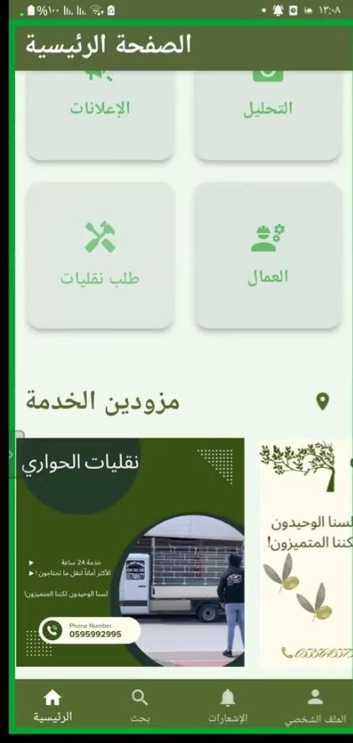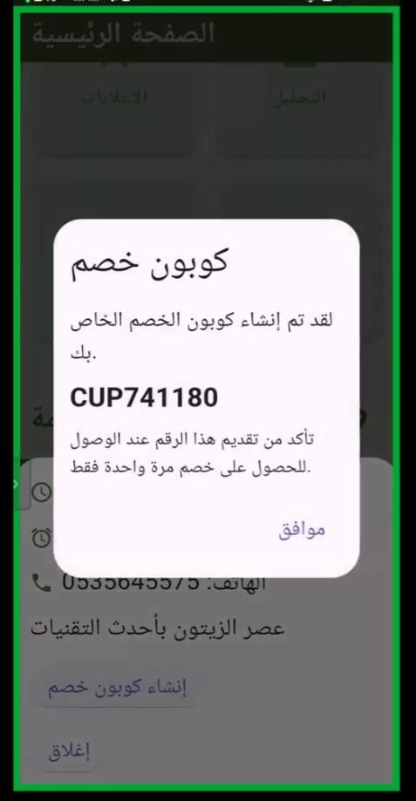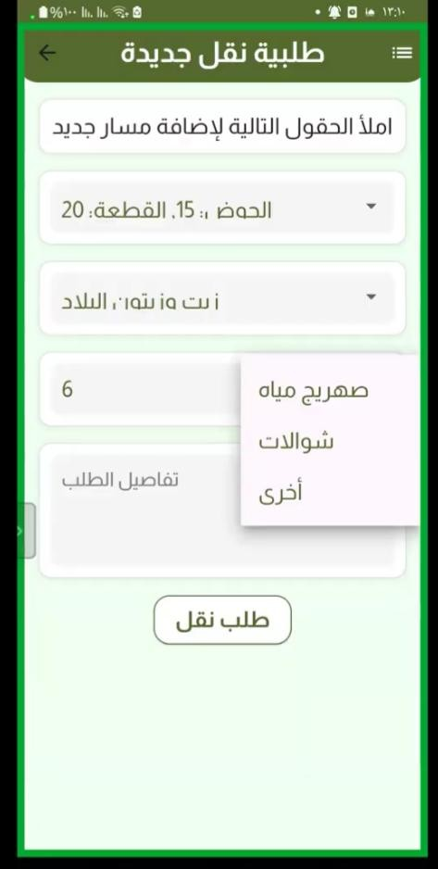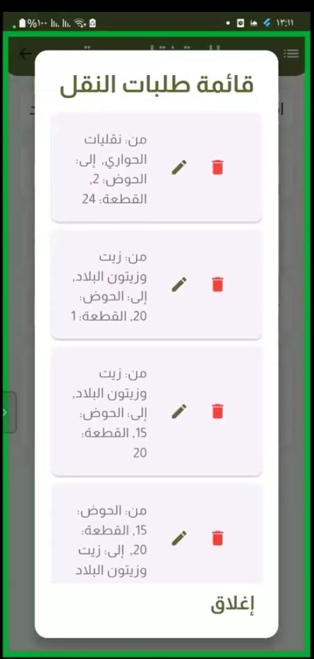

Transport Re- quest
Service-Provider Coupon
Transport Re- quest
Transport Re- quests

Workers
In this feature, the landowner can view the status of their lands and the workers assigned to them. The system distinguishes between two types of lands:
      - Guaranteed Lands: The landowner can view all their guaranteed lands and their statuses. If the land is guaranteed, the landowner can click on the land to see the tasks that have been completed on that particular land (view only).
      - Non-Guaranteed Lands: The landowner can view the workers they have requested, evaluate the workers, and check the worker’s location to confirm their presence on the land.
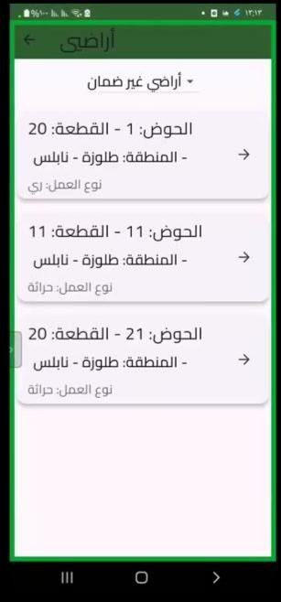
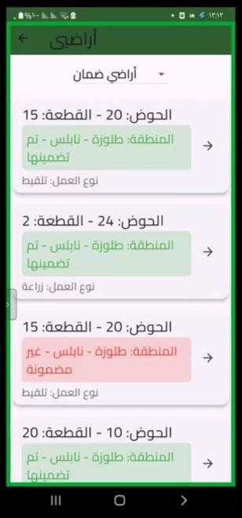
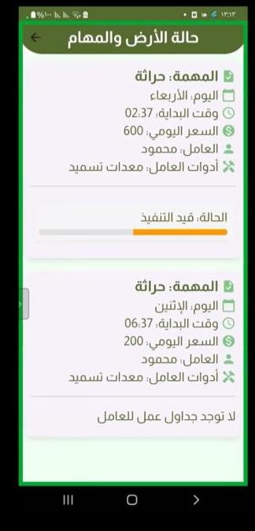
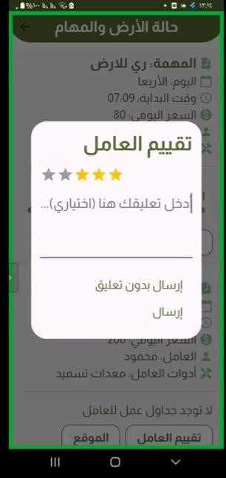
non guarntee guarntee guarntee works non-guarntee

Profile
lands and rating
      - View and edit their profile information.
      - Disable or delete their account if needed.

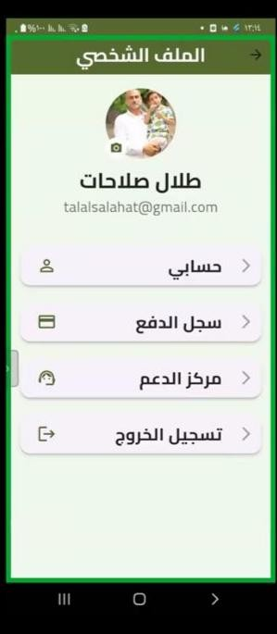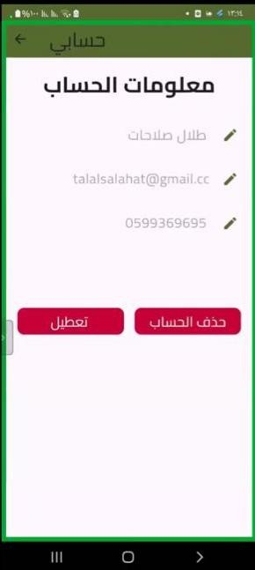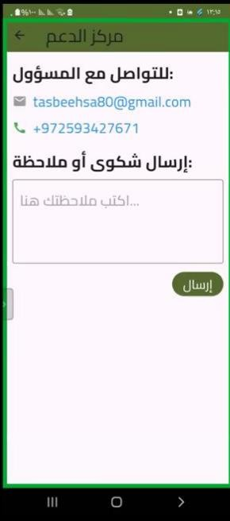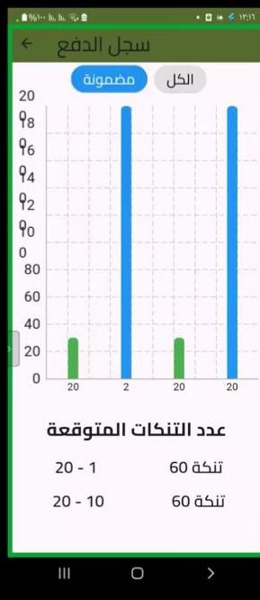
my account my account support center payments rewards

Reports
The landowner can access the reports submitted by the guarantor regarding their land. These reports include details such as the **number of collected sacks** or any **notes** the guarantor wishes to communicate

Notification
This section provides landowners with notifications regarding various re- quests they receive. These may include **work requests** or **guarantee requests** related to their land.
To facilitate better management, the system allows landowners to **fil- ter** these requests based on their **status** (e.g., pending, approved, or rejected). This helps them quickly identify important updates and take nec- essary actions accordingly.

Search
This search page utilizes an API from the Palestinian Ministry of Agriculture to retrieve local market prices for fruits and vegetables. Users can enter the

**region, date, and product** to obtain price details.
The router converts each **city** into a unique **ID** and each **crop** into its specific **ID**, returning a response containing the **lowest and highest prices** for the selected product.

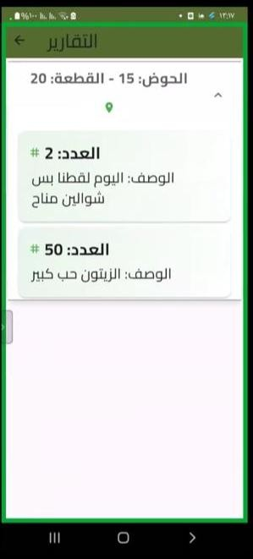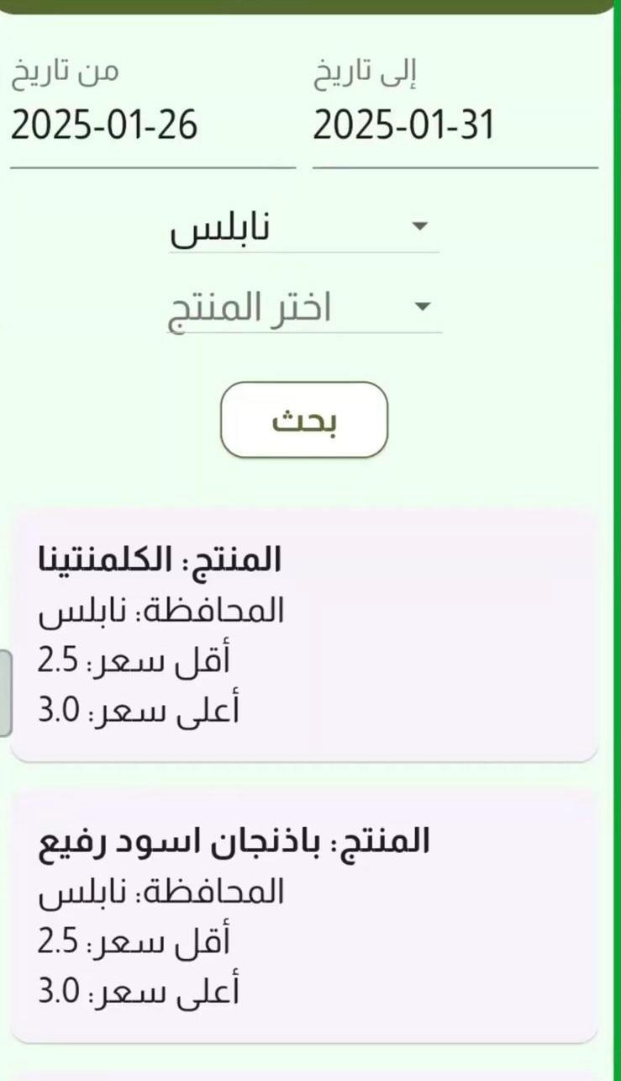

Example of re- ceived requests
Example of a re- port submitted by the guarantor
Price List

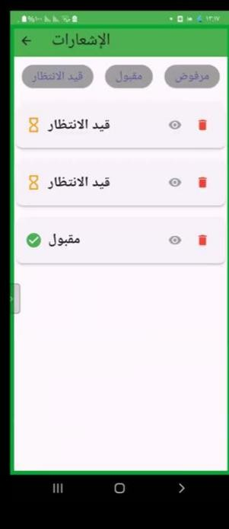
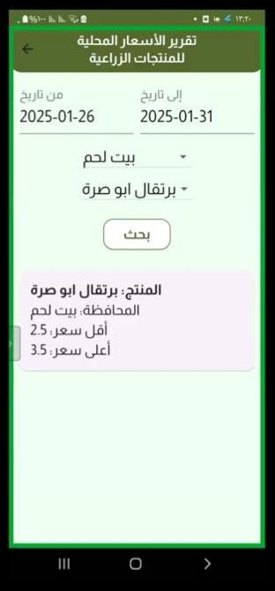
Search prices

Worker Page

Notification
      - Assigned tasks and updates on their work requests.
      - New job opportunities related to nearby lands.
      - Guarantee land advertisements for nearby plots they might be inter- ested in securing.
This system ensures that workers stay **informed and responsive** to new opportunities and their assigned responsibilities.

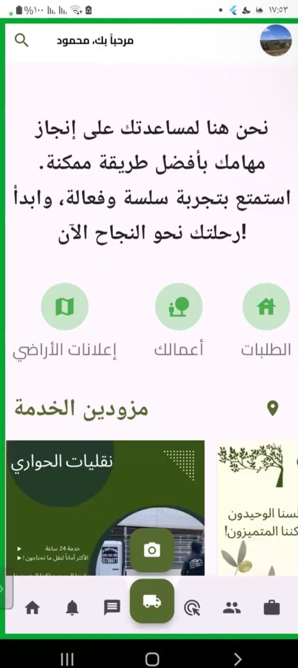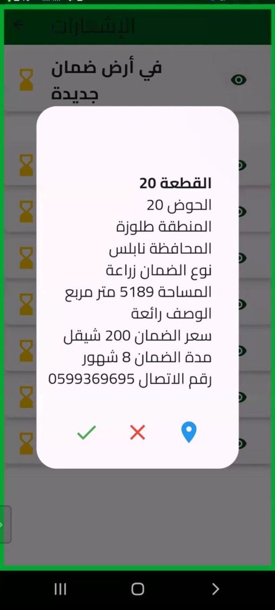
Worker Page Overview Worker Notification System

My Guarantee Land
      - **View land status and tasks**: Here, the worker can check the status of the land and the associated tasks.
      - **Search for workers**: This will display a map with the location of

the land, including detailed information such as soil type, weather, and the exact area of the plot. The worker can see a marker on the map indicating the plot’s location, along with suggested crops for planting based on the weather and the region where the land is located.
The system will also suggest potential crops that can be grown based on the weather and location, and it will show nearby workers who are available for hire. This includes details about the workers, such as their hourly or daily rate, their availability, and their ratings.
If the worker wants to send a request for a worker, there are two types of requests they can make:
      - Normal request: This type of request allows the worker to choose from the available days the worker has posted, and the payment method (either daily or hourly).
      - Custom request: This allows the worker to choose days when the worker is unavailable and set their own price for the work. The payment method can also be chosen (daily or hourly), and if hourly is selected, the worker can specify the start and end times.
If the worker clicks on the ”Reports” button (available only for land types classified as “Picking Guarantee”), they can upload the amount of harvest picked on that day to the landowner.

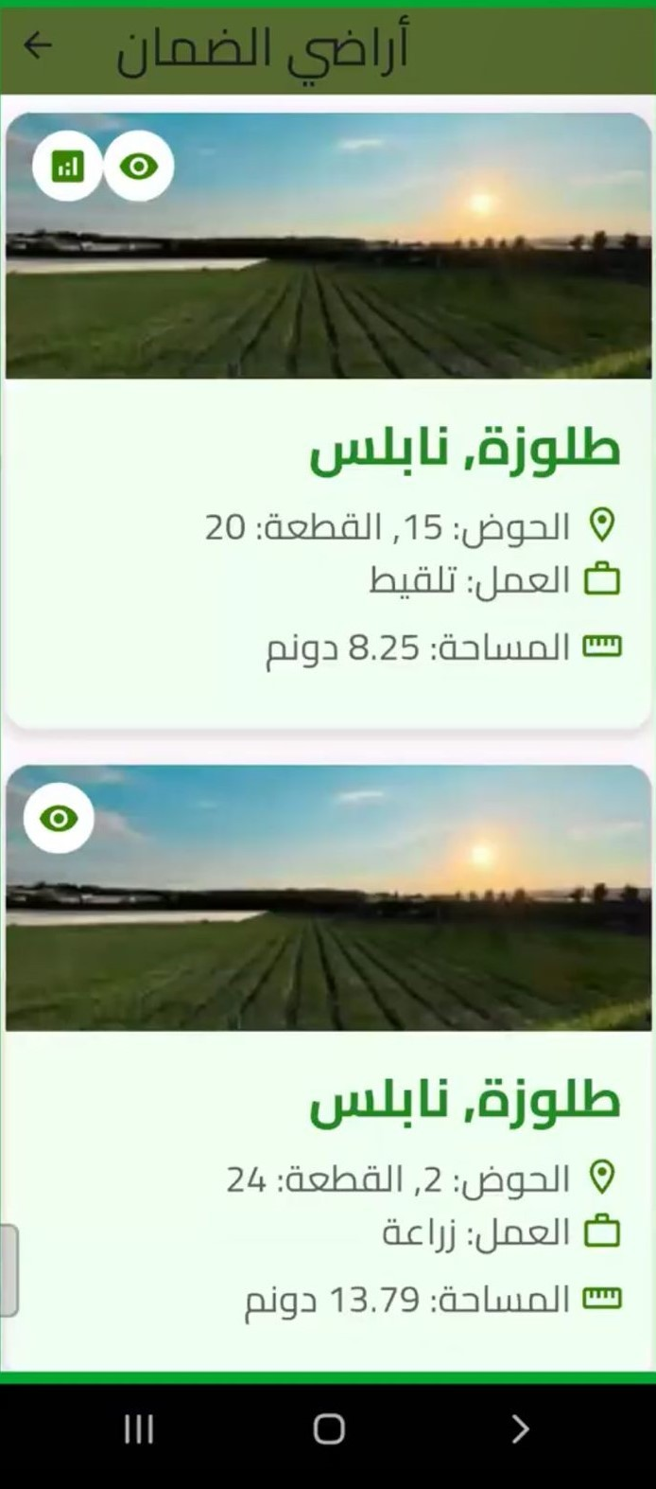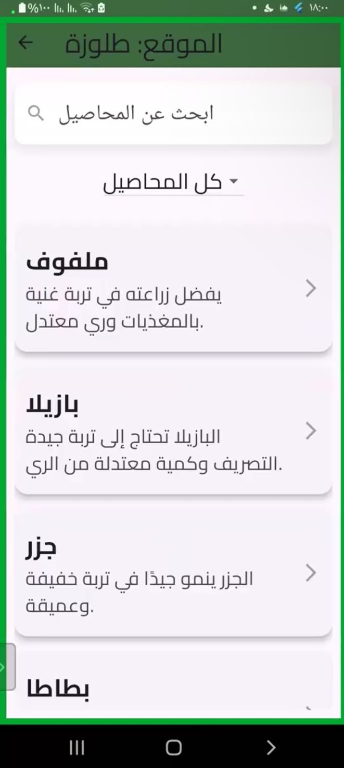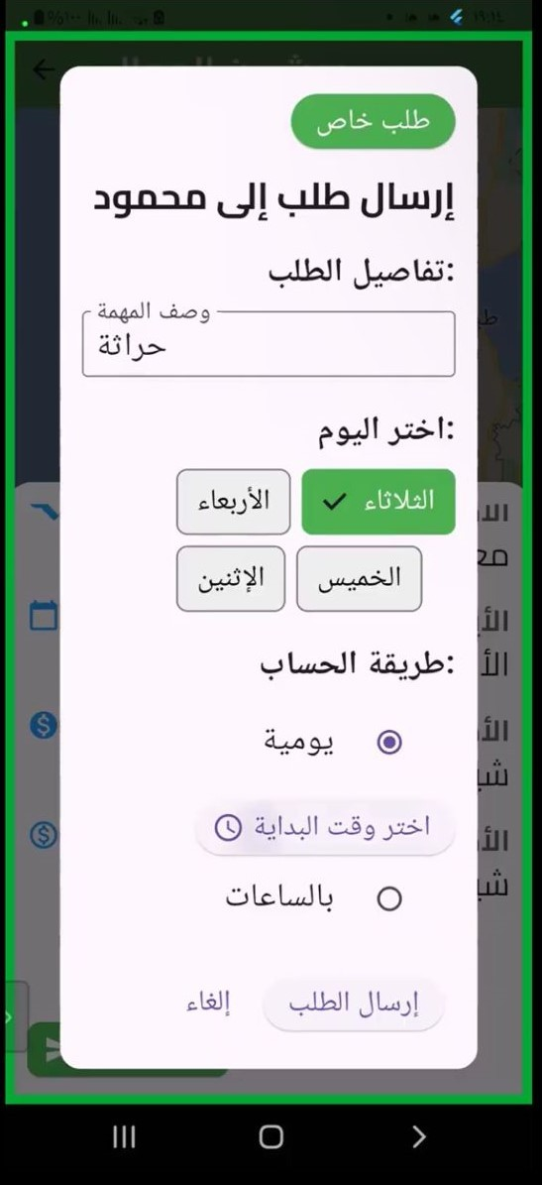
My Guarantee Lands Crops Suggestion Normal Request
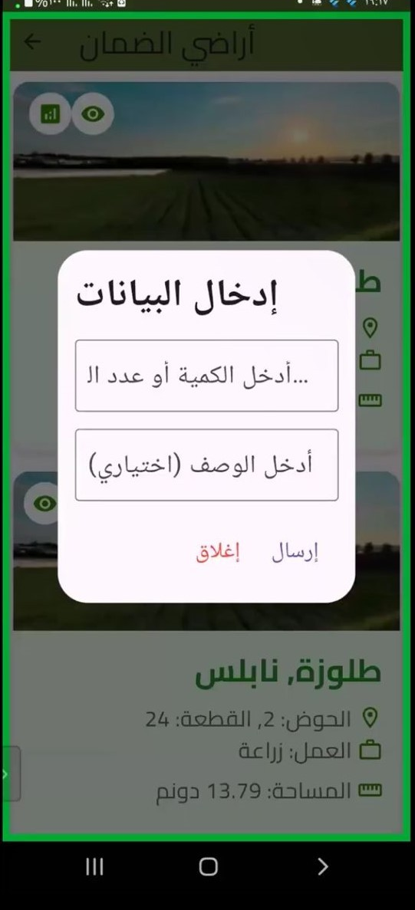
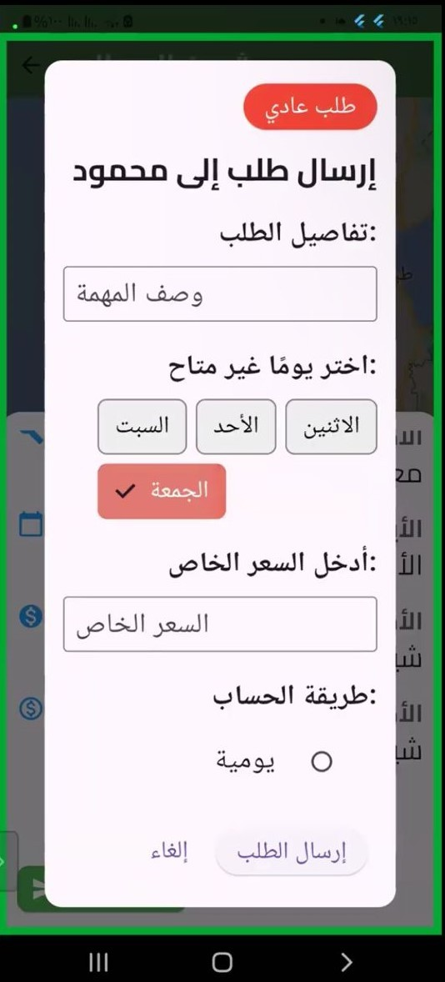

38

Special Request for Worker Reports

For tasks the worker has guaranteed, they can view the tasks assigned to that land and rate the workers they have hired. The worker can also verify the location of the worker when they sign in to the land, similar to the landowner’s view.
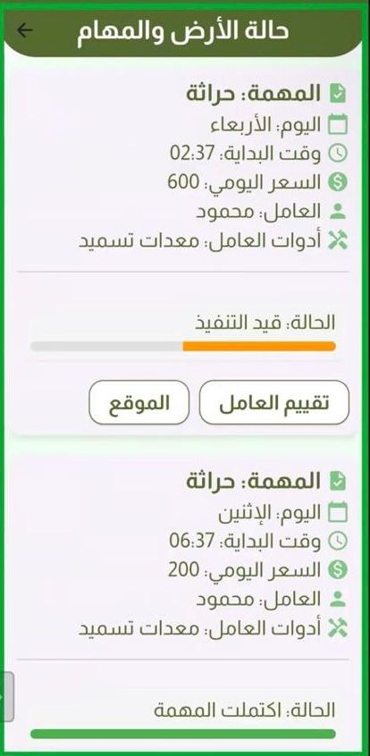
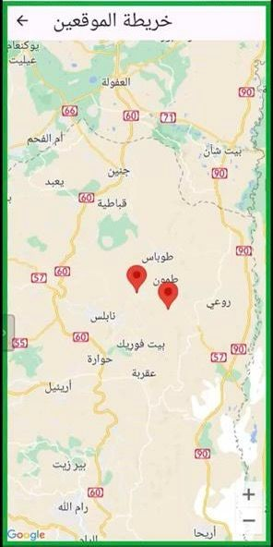
land tasks-rating locations

Ads
In this section, the worker can view the job ads that have been posted and apply to those that match their skills and availability. If the worker is a guarantor, they can also see nearby guarantee lands that have not yet been included and submit a guarantee request for those lands, as explained earlier. Additionally, the worker can filter the job ads using specific search criteria, such as the basin number, plot number, town, and governorate. This allows

the worker to find job opportunities that are most relevant to their location and preferences.
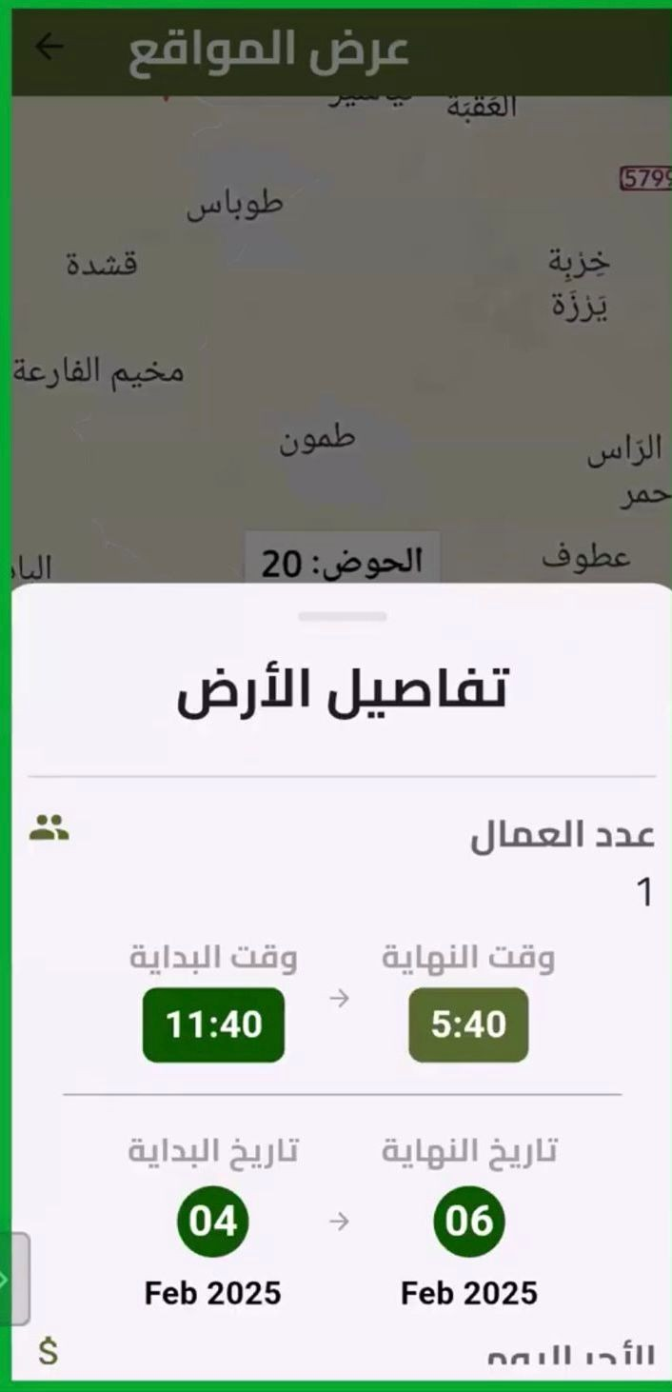
worker announcemnt advirtesment

Requests
In this section, the guarantor can view the requests they have sent to the workers.

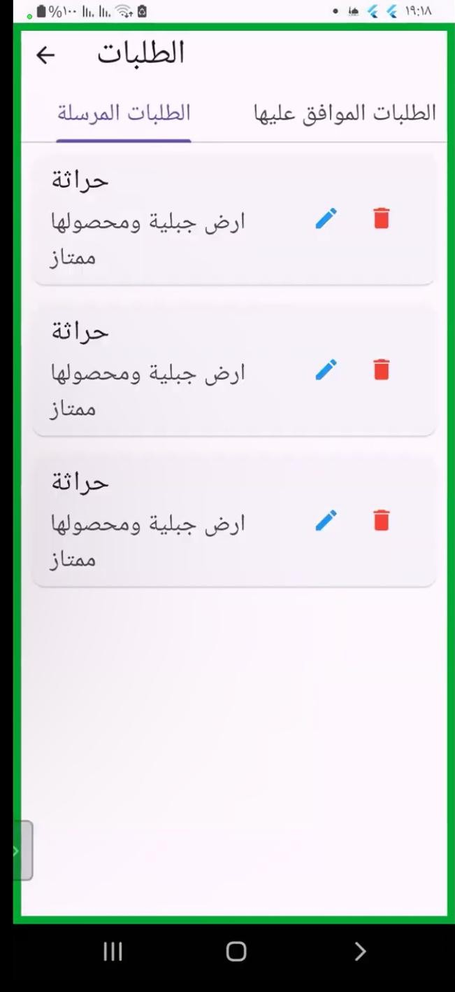
Requests

Additional Features
The worker has access to the same features available to the landowner, in- cluding:
- Market Price Search: Check local market prices for vegetables and fruits.
- Transport Requests: Request transportation for guaranteed lands. - Plant

Disease Detector: Identify and address plant diseases early.

My Schedule
The ”My Schedule” section displays a detailed schedule of tasks that the worker has accepted. It shows the task details, including the date it is sched- uled for. The worker can filter the tasks by date to see what tasks are assigned for each day. When the worker starts a task, they can mark it as ”In Progress,” which updates the task status. The worker also has the option to mark the task as ”Completed” once they finish it. Additionally, when the worker marks the task as ”In Progress” for the first time, the system captures their current location, serving as a form of ”check-in” to ensure the worker’s presence on the land. This location tracking is important for guaranteeing the worker’s presence, and it can be seen by the landowner for verification purposes.
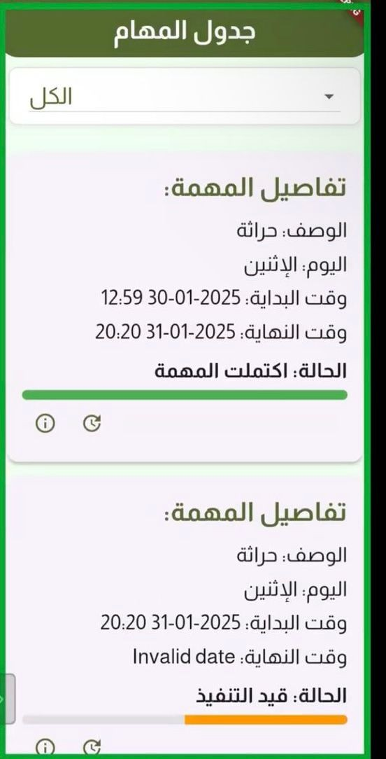
My Schedule

Advertise Me
In this section, as a worker, you have the ability to advertise yourself by entering your daily wage and hourly rate. This allows you to be flexible in accepting job opportunities. If the job is hourly, you can specify your availability for different days, maximizing your chances of getting more work.
Once you’ve posted your advertisement, you can later view it by clicking on the ”eye” icon. This will show you the details of your advertisement, and you will have the option to edit or delete it if needed. After you post your advertisement, people looking for workers in your area can see it, and they can contact you directly.
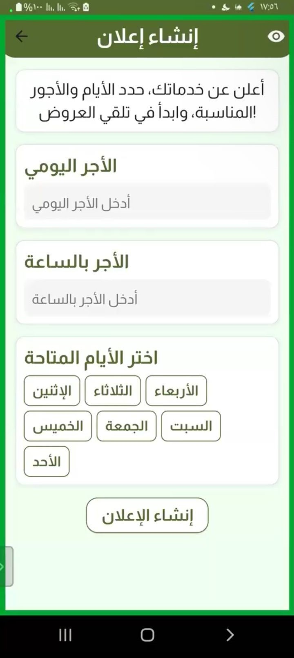
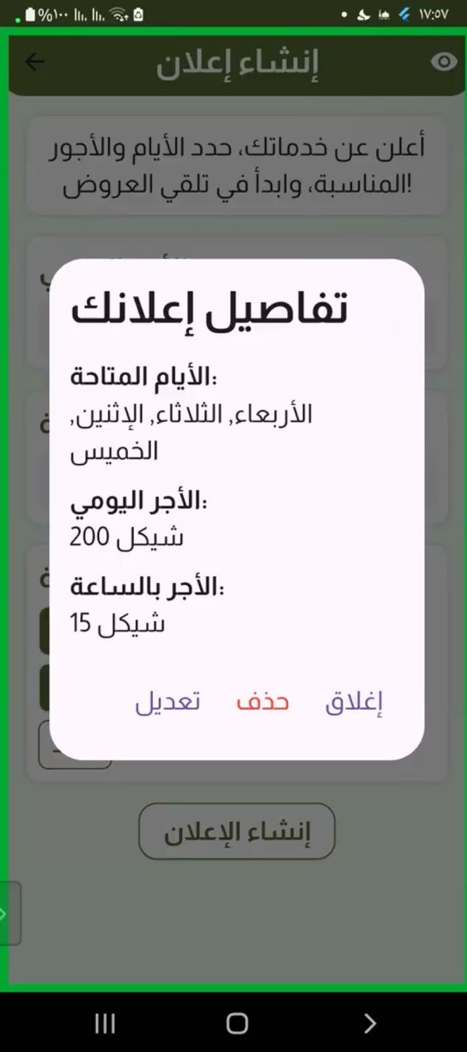
Announce about myself update delete

Posts and Communication
In this section, there is a forum available for all users, serving as a point of communication between users of the application. Users can publish posts, questions, and inquiries, as well as engage with other users by commenting on posts. They also have the ability to like or dislike posts and provide ratings. This feature fosters interaction and knowledge exchange among users, making the platform more engaging and helpful.

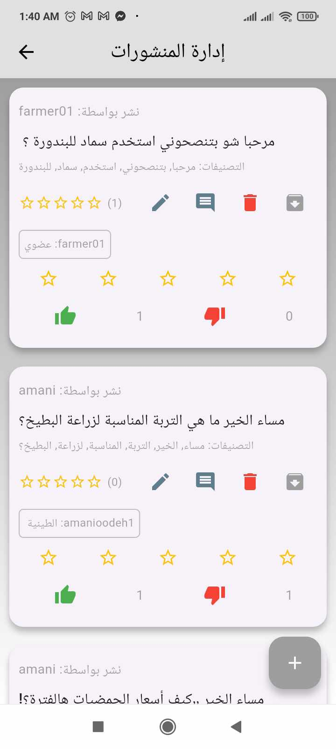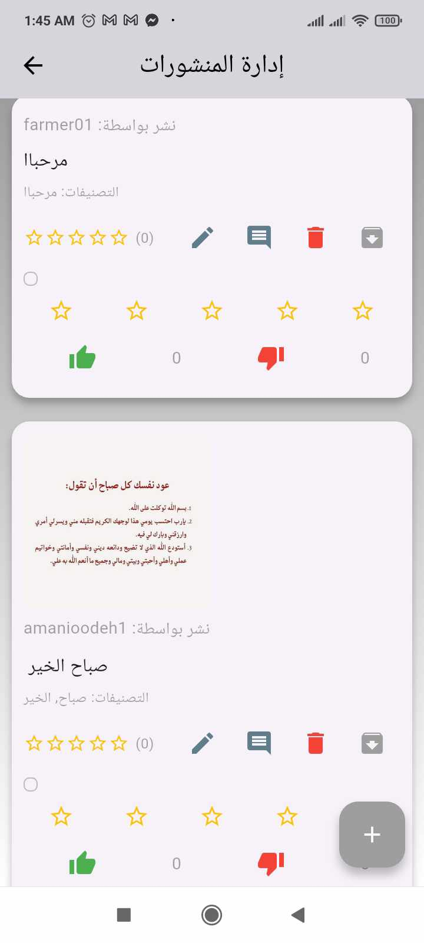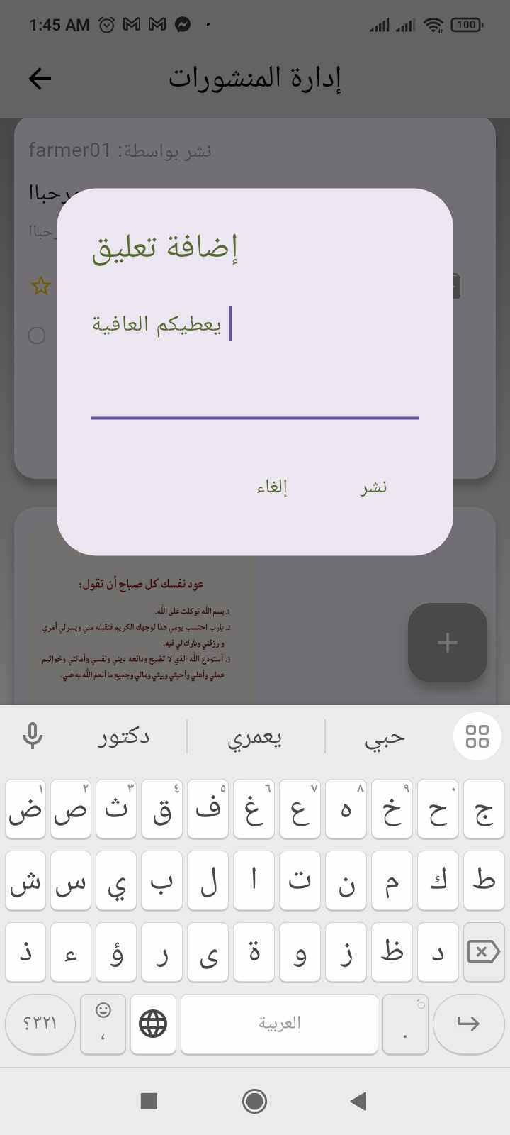

  - Service Provider :

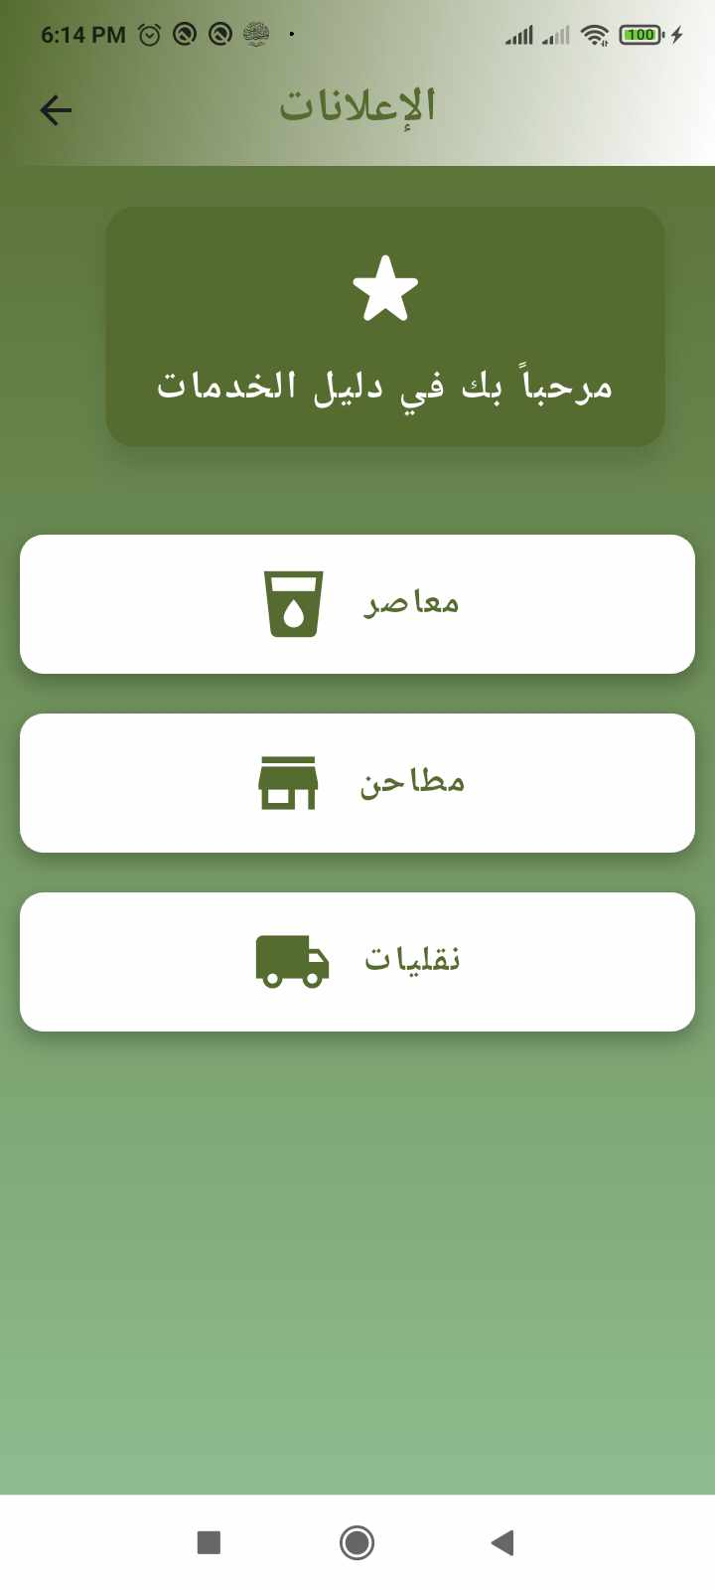

We have three service providers: olive presses, mills, and transportation services. The guarantor can request and communicate with them as needed.

    - transportation Homepage

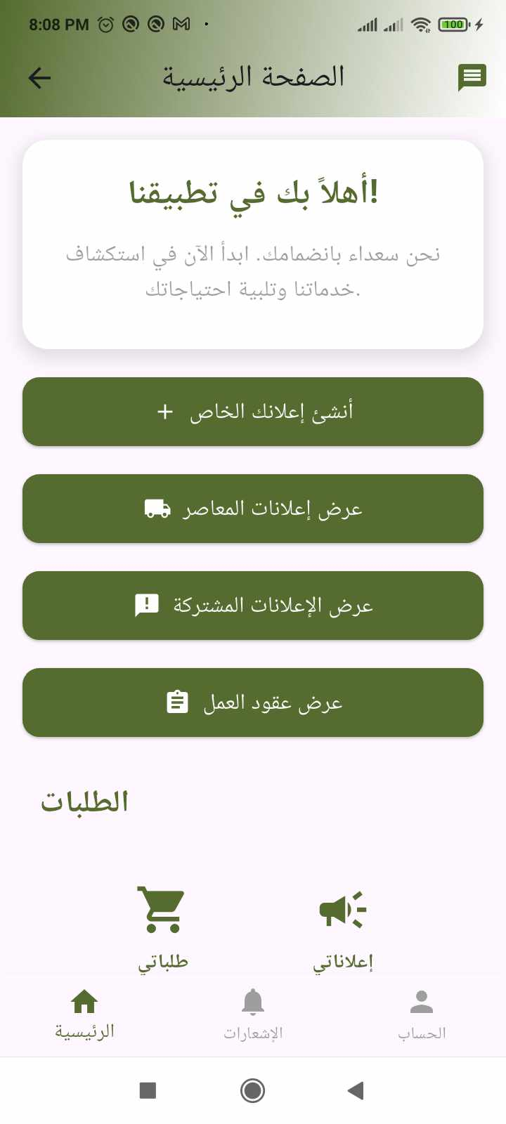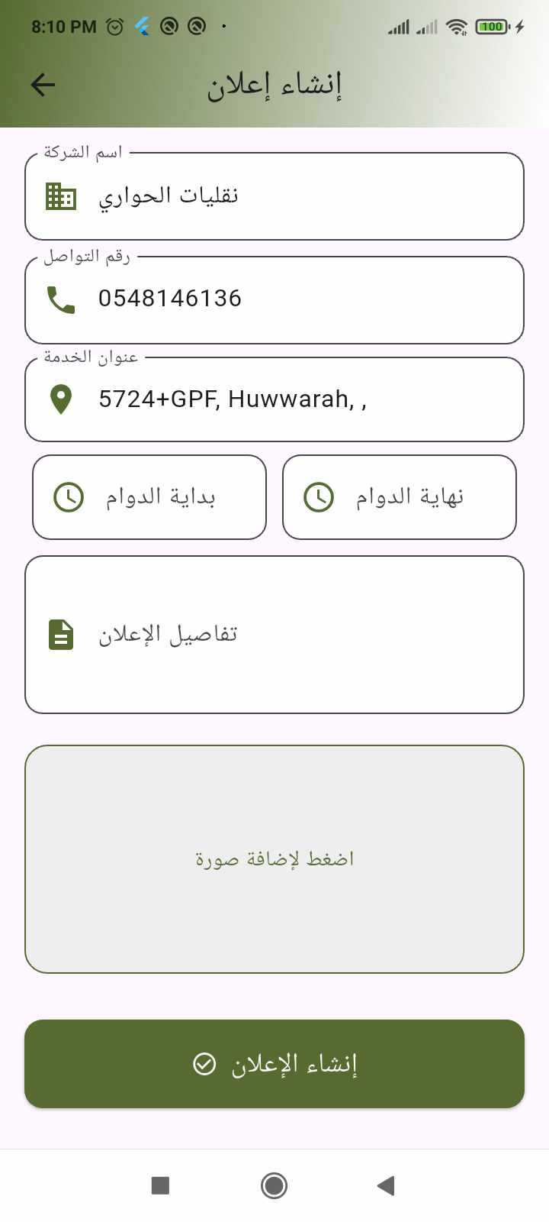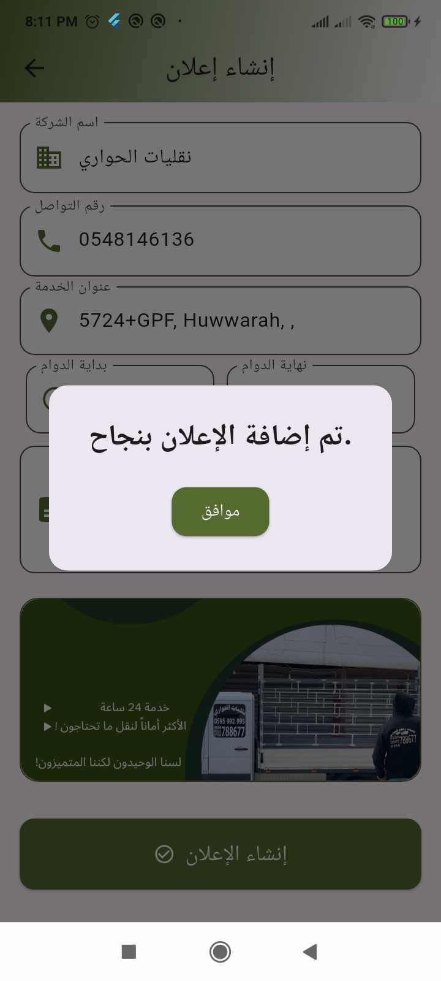

This is the Transportation Services page, where users can create advertisements for their services. They can enter details such as company name, contact information, service location, working hours, and additional details. Users also have the option to upload an image before submitting the advertisement.

    - Advertisements:
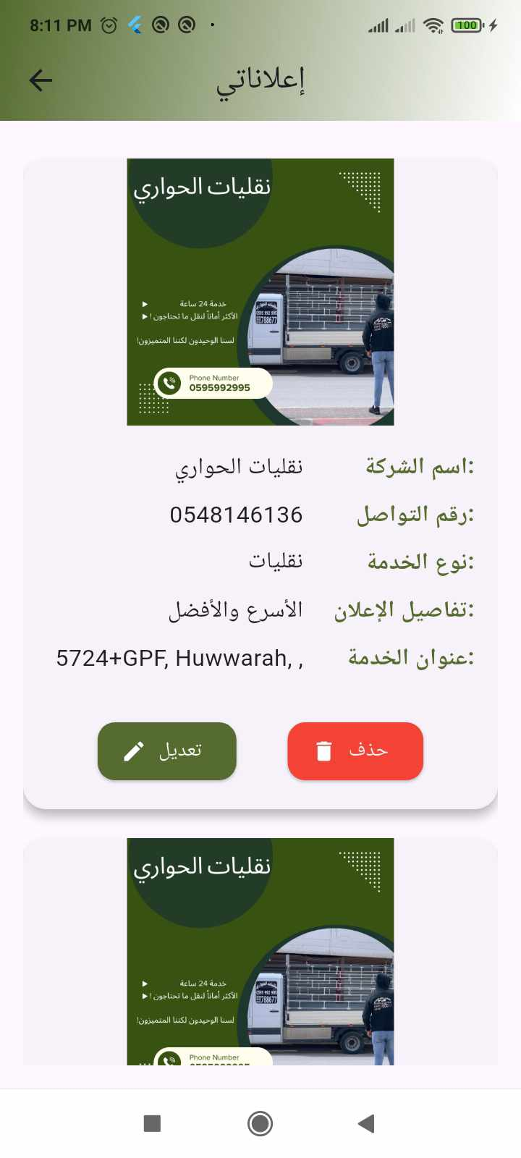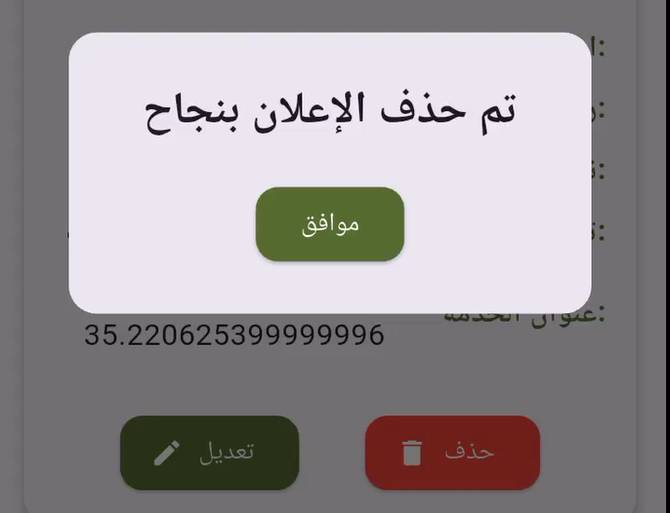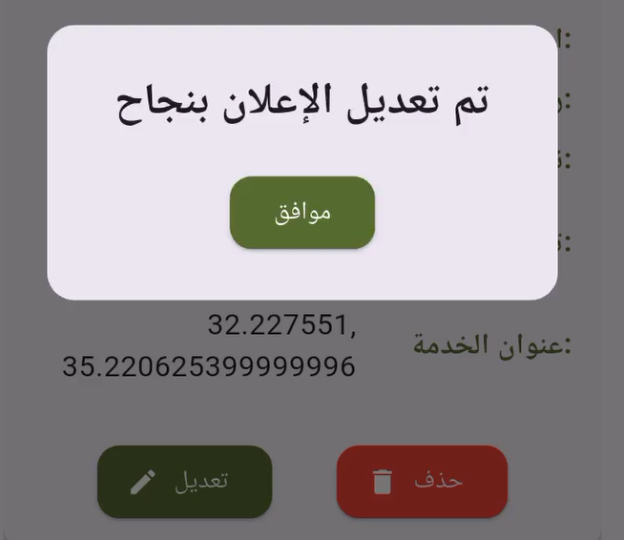

When clicking on "إعلاناتي" on the home page, the user can view the advertisements they have created. They also have the option to edit or delete these advertisements as needed.

4.4.3 Olive Presses Advertisements for Transportation:

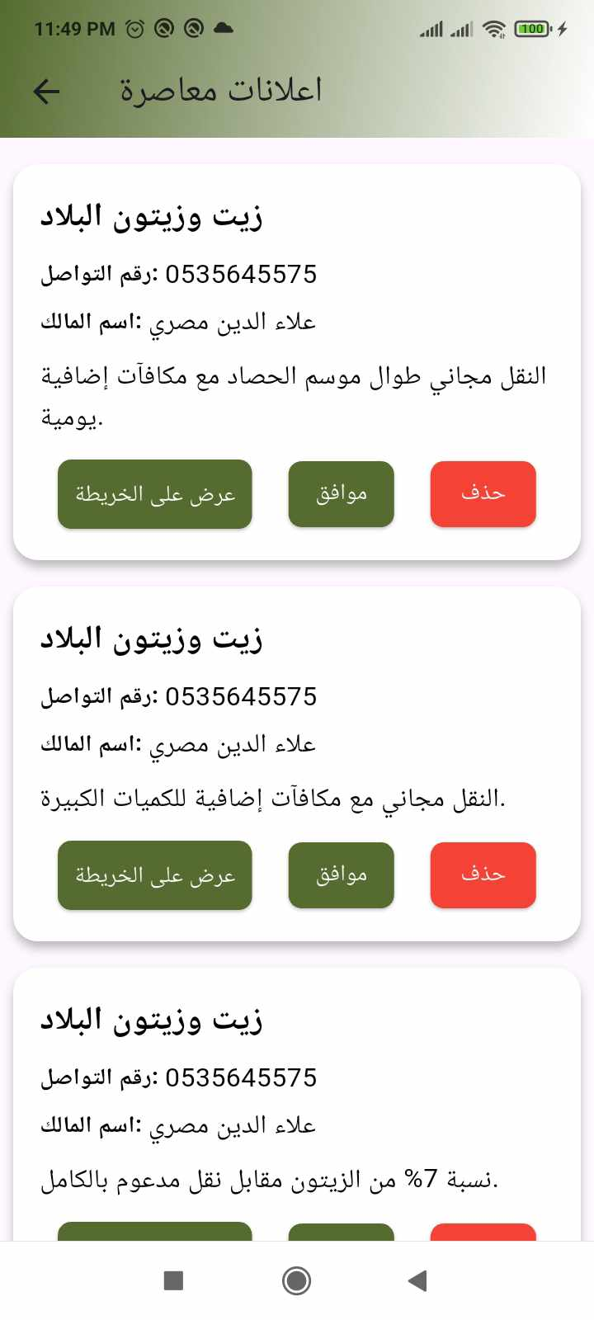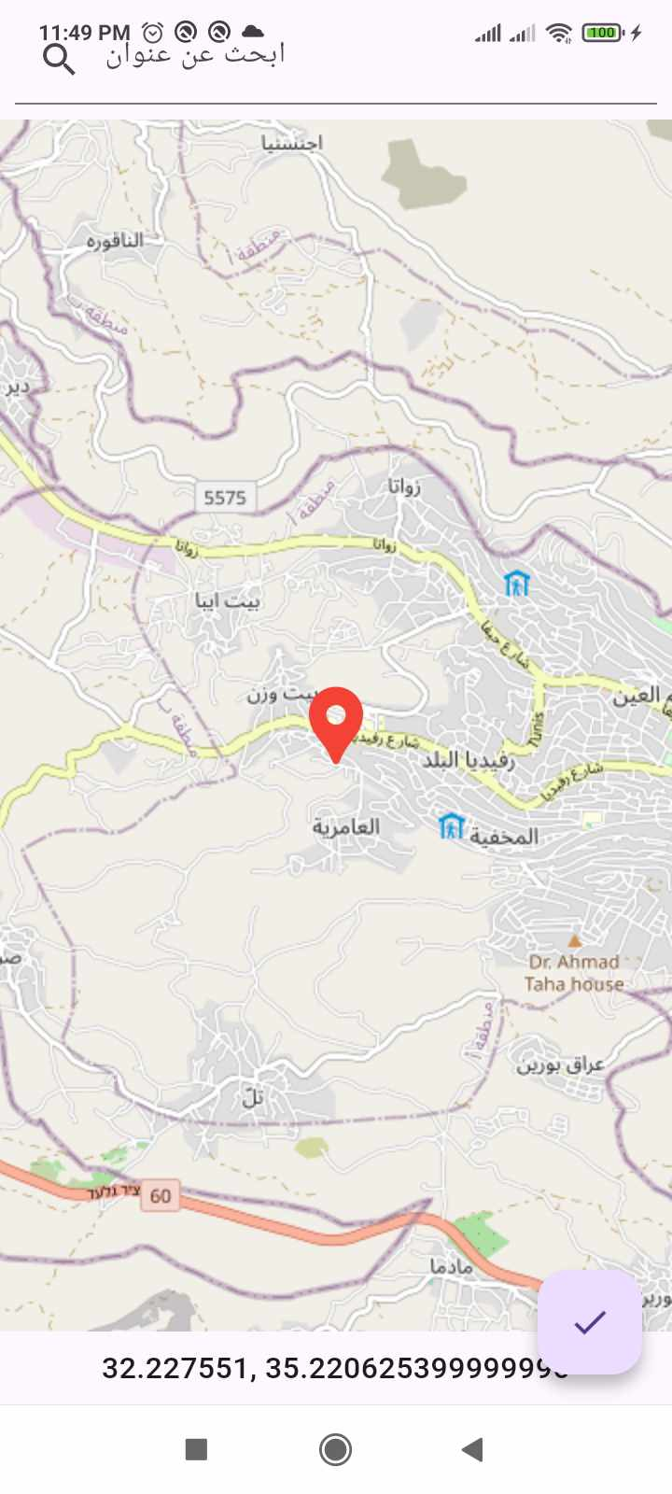

When clicking on "عرض اعلانات المعاصر", all advertisements for these olive presses are displayed. The location of the olive press can also be viewed on the map to accurately determine the location and avoid difficulties in finding the site. Users can choose to approve or decline the advertisement.

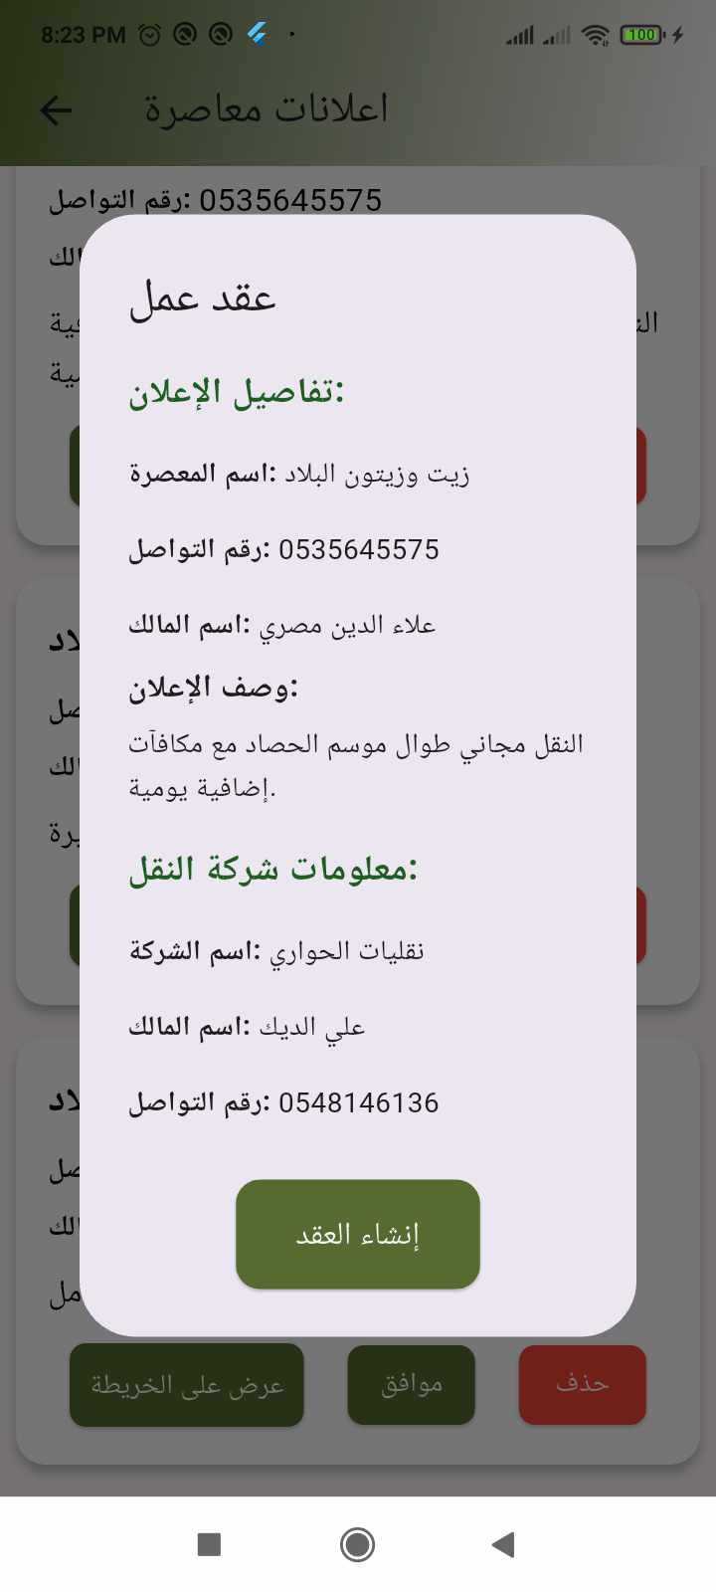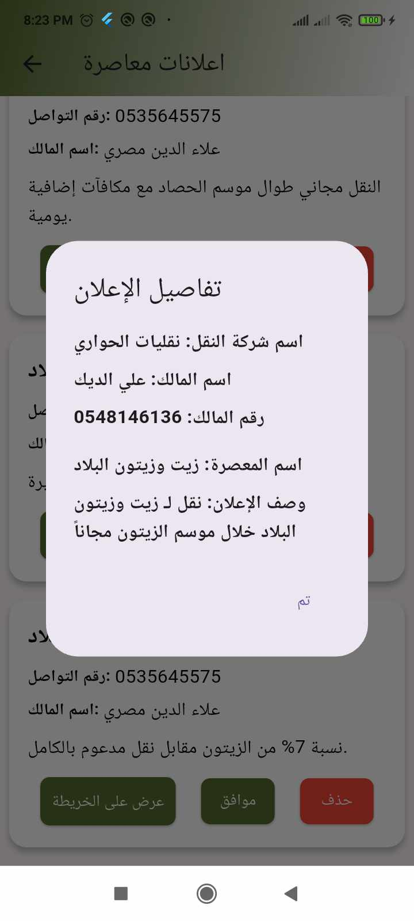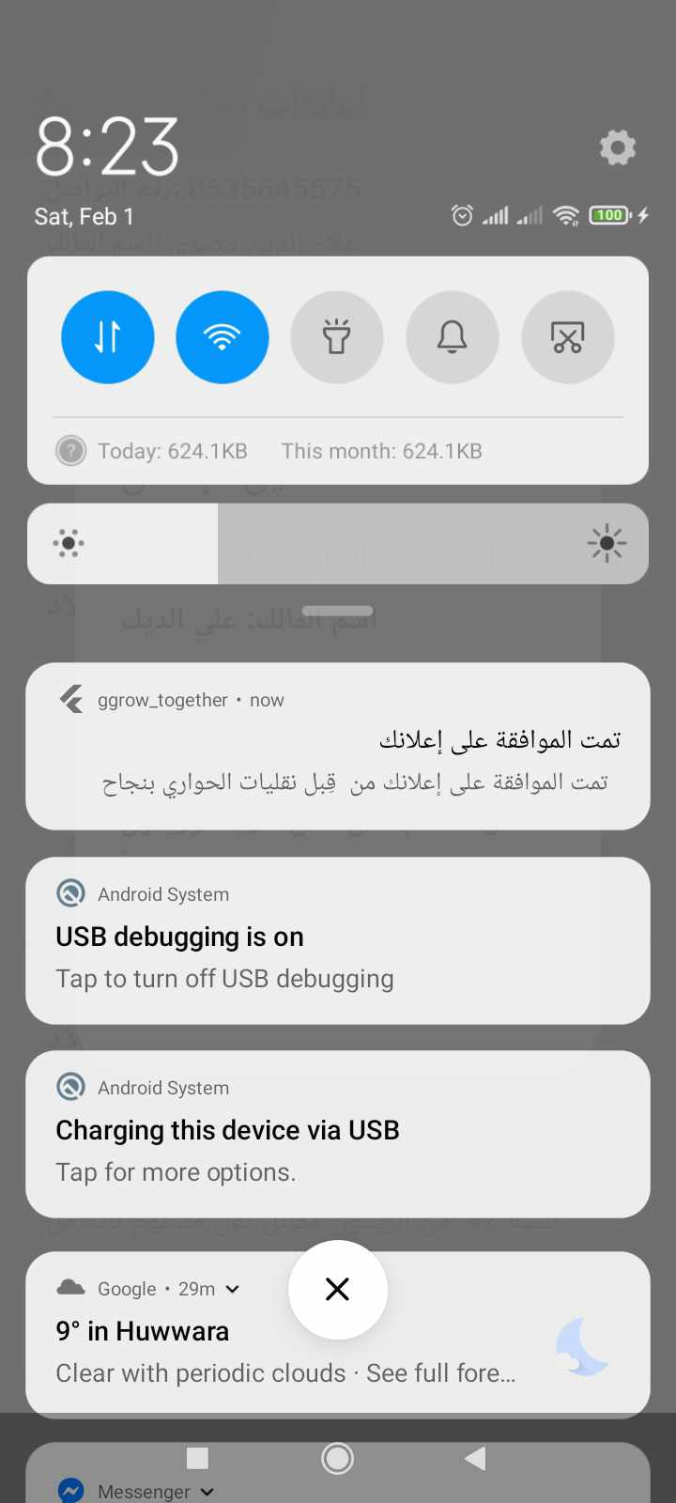

If approved, a dynamic work contract is created and displayed for both parties. Once both parties agree to the contract, a shared contract is officially established between the olive press and the transportation service. Additionally, a notification is sent via Firebase to the olive press owner informing them that their advertisement has been approved by the transportation company.

4.4.4 shared contracts and shared advertisements:

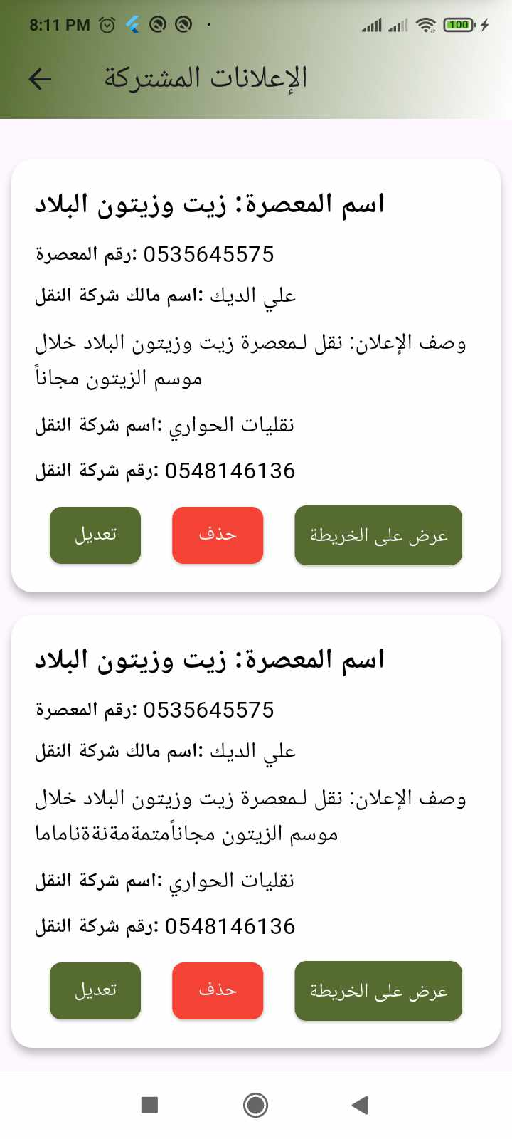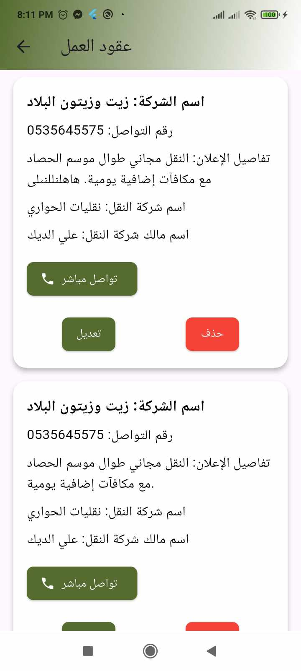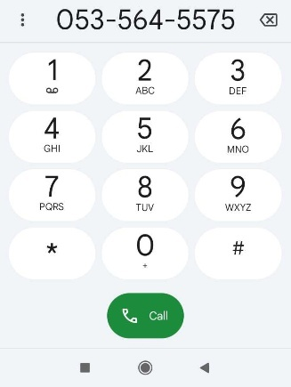

For shared advertisements, they can be deleted or edited, and the location of the olive press where the olives will be transported can be viewed.
For shared contracts, they can be deleted or edited, and it is also possible to directly contact the olive press owner by calling them.

4.4.5Viewing requests:
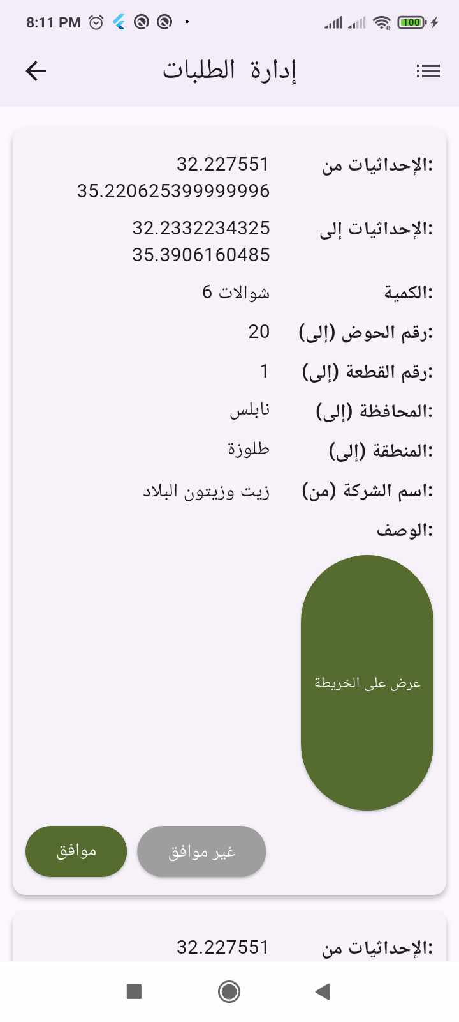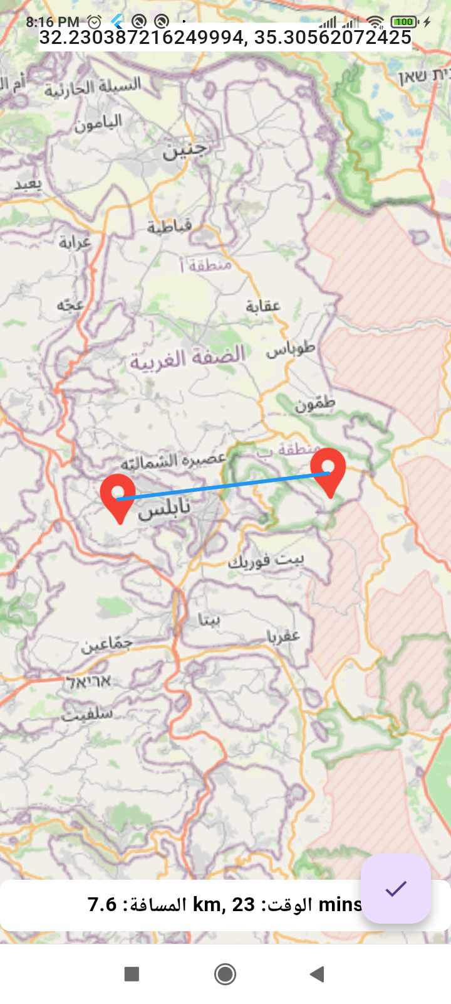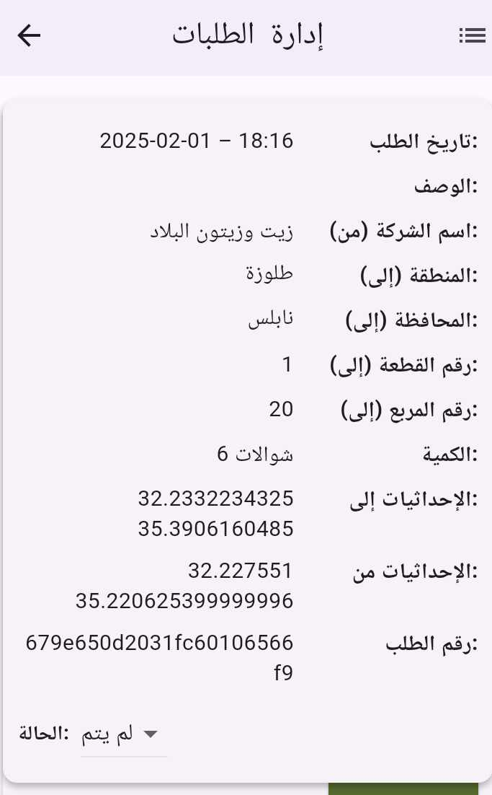

The requests received by the transportation service are displayed, showing the coordinates from the current transportation location to the destination, whether it is a farm or an olive press. The distance and estimated time are also provided. If the request is approved, it moves to the request table, where the initial status is "Not Completed" until the transportation provider updates it to "Completed."

4.4.6 Profile page :

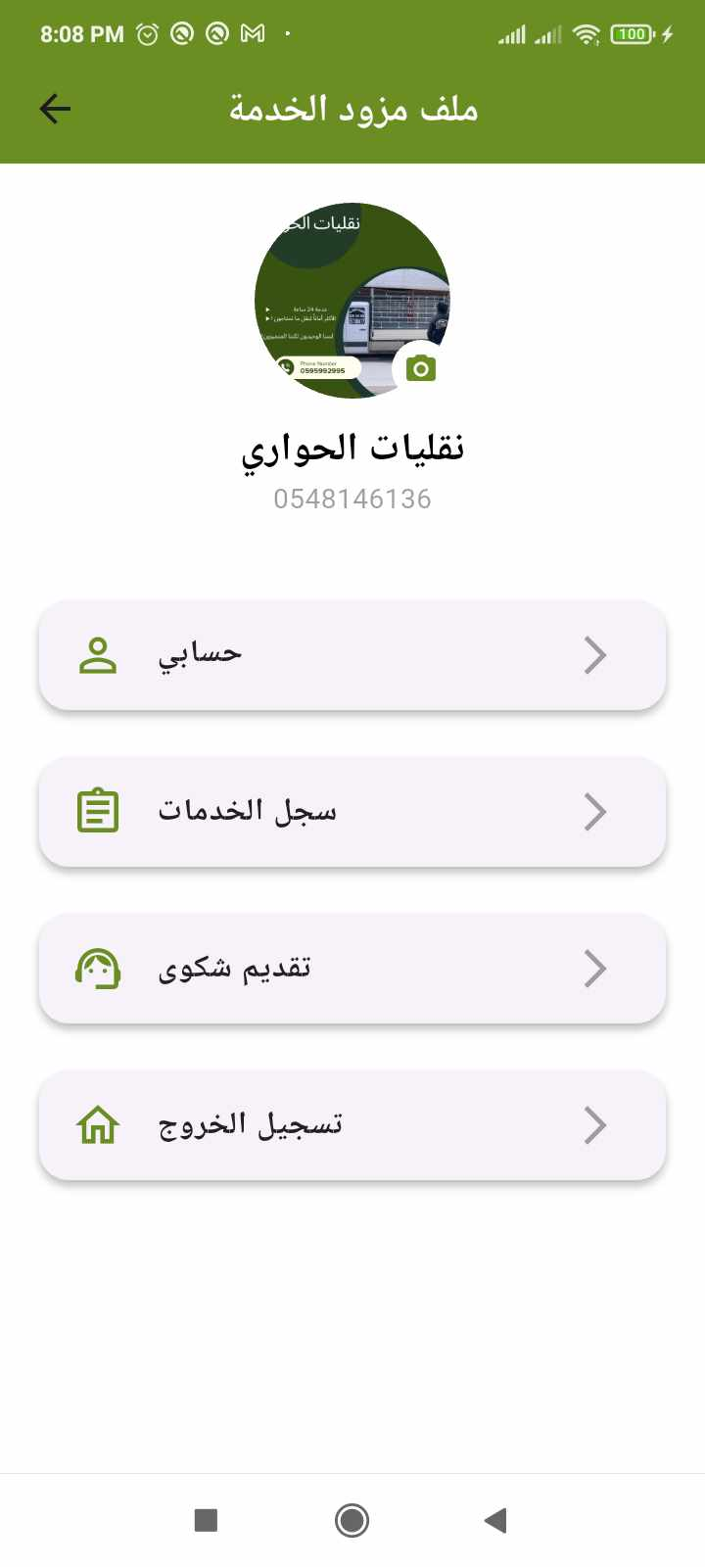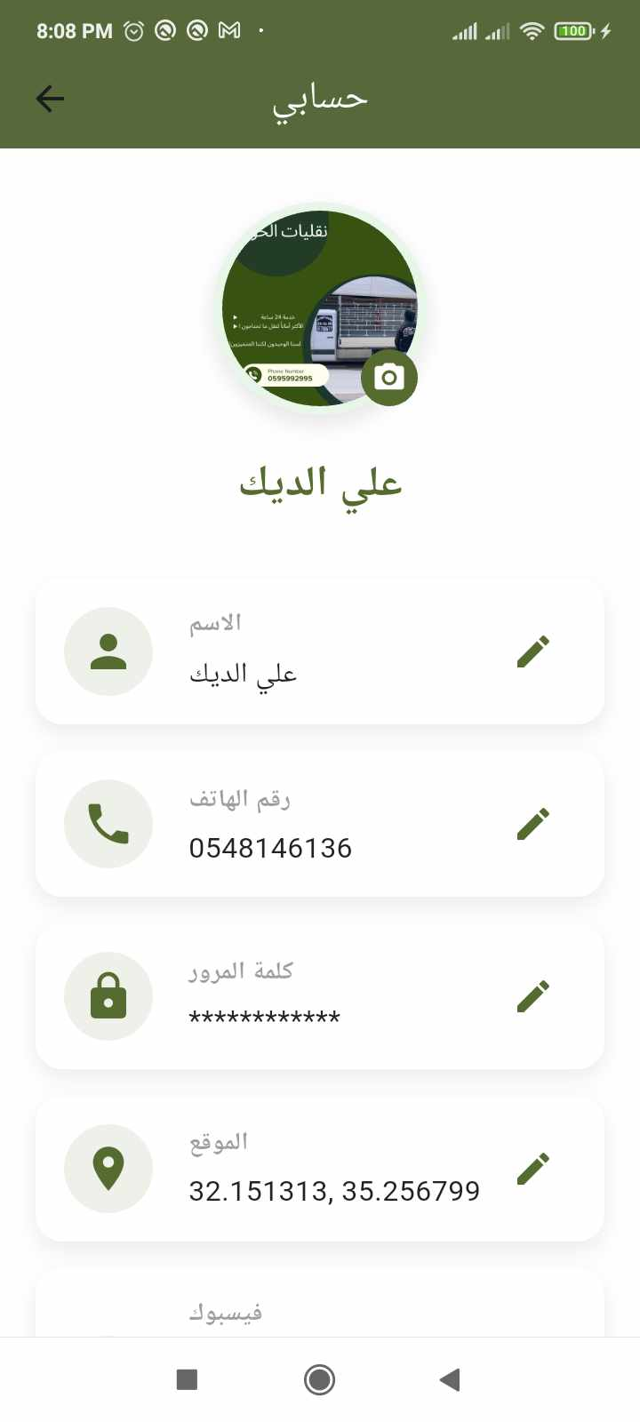
The transportation information is displayed and can be edited.

4.4.7 Messaging:
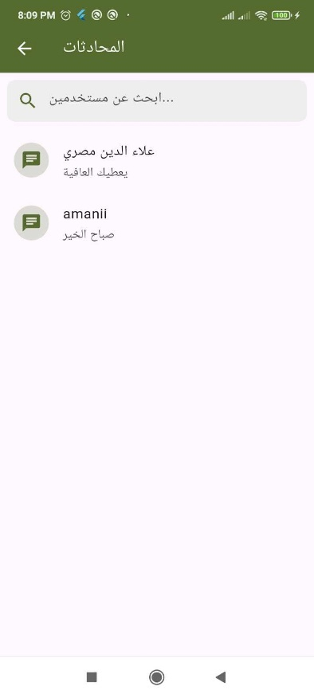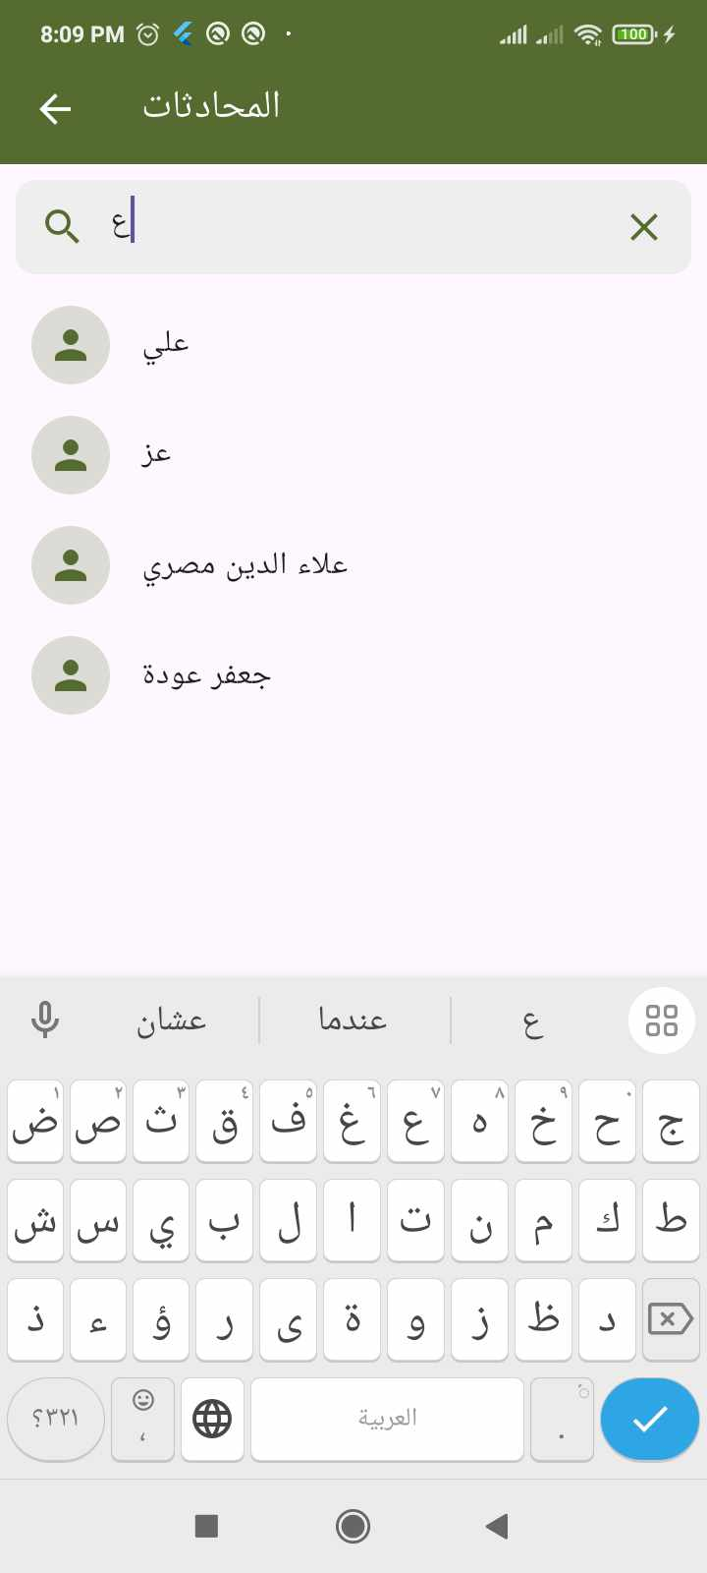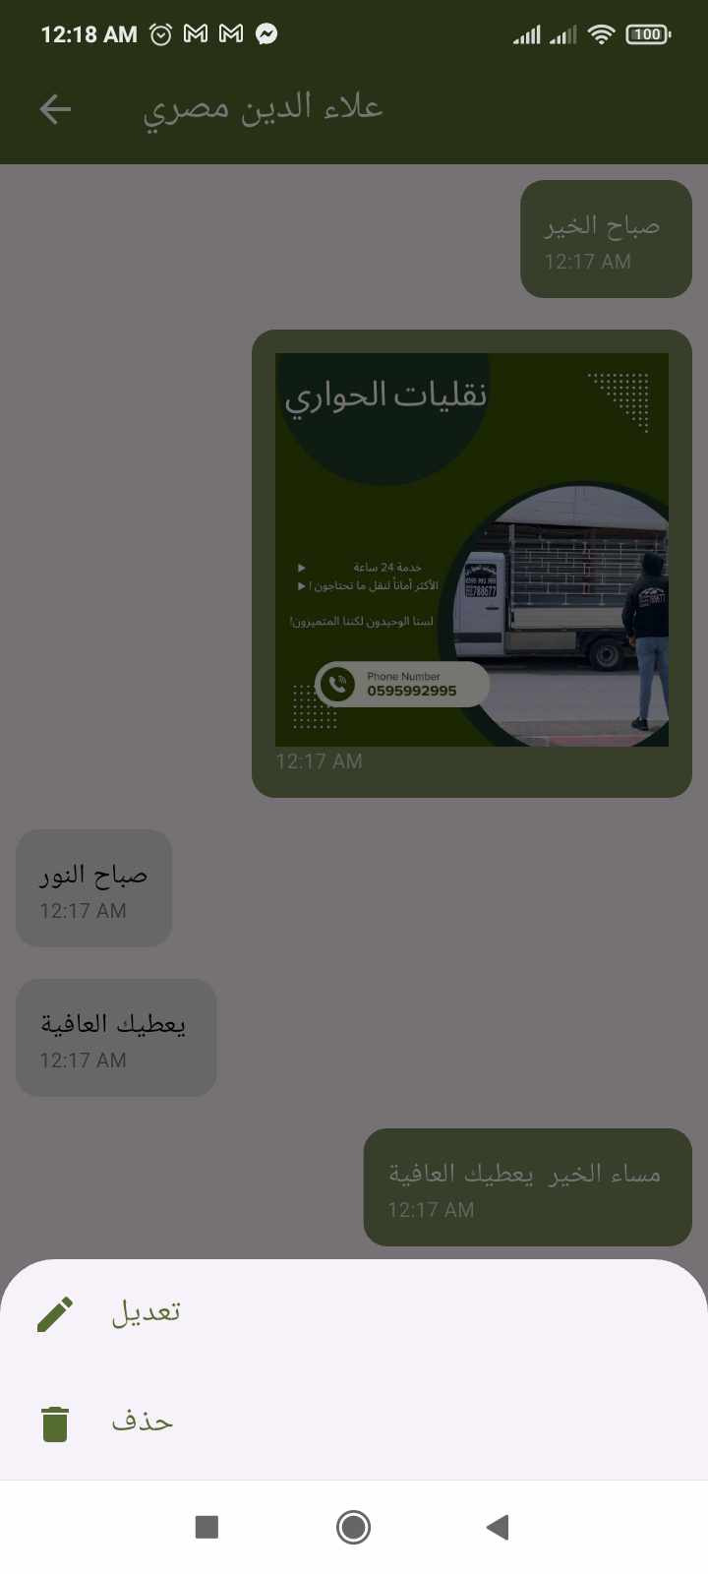
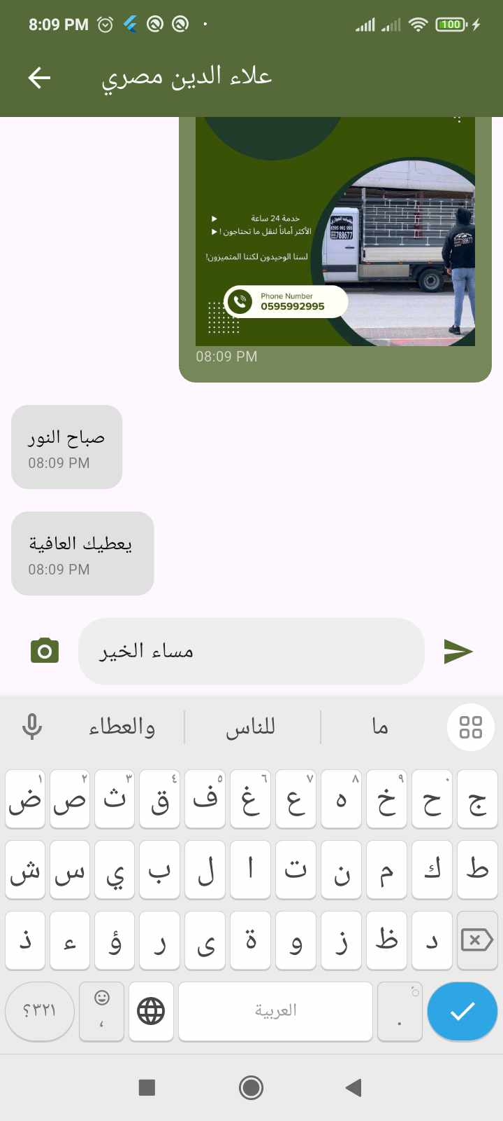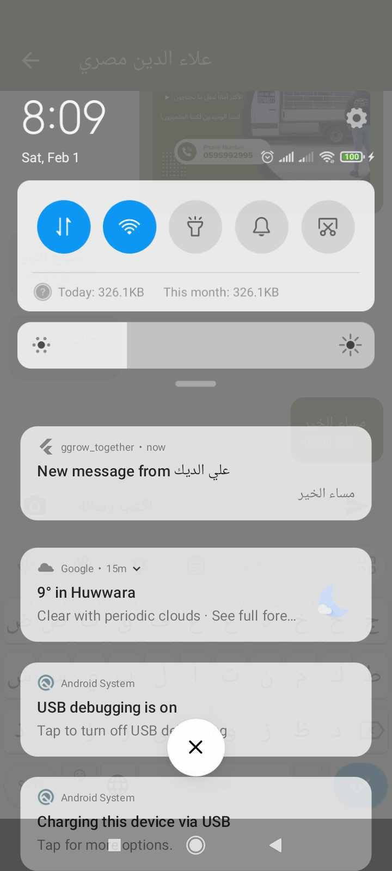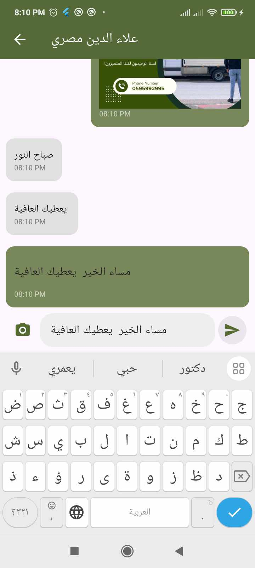

The transportation service or any other user can message users within the app by searching for their name. They can send text messages or images and also have the option to edit or delete messages. The chat system is built using Firebase, and recipients receive a notification via Firebase when a new message is sent to them.

    - Olive presses Homepage

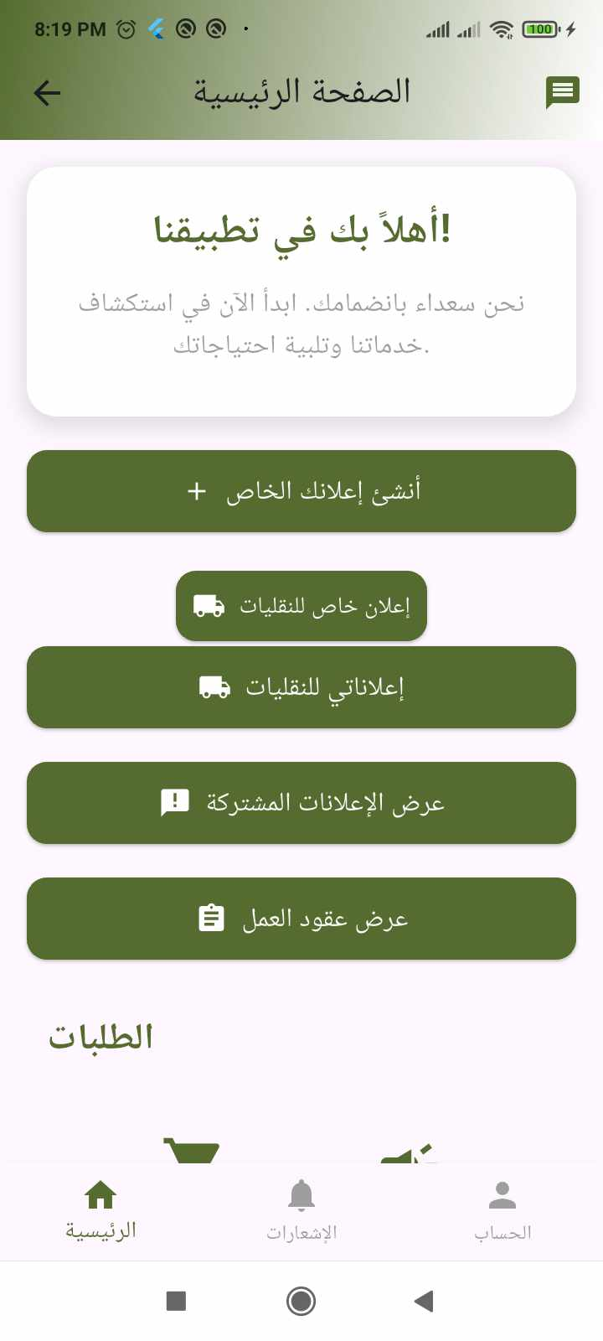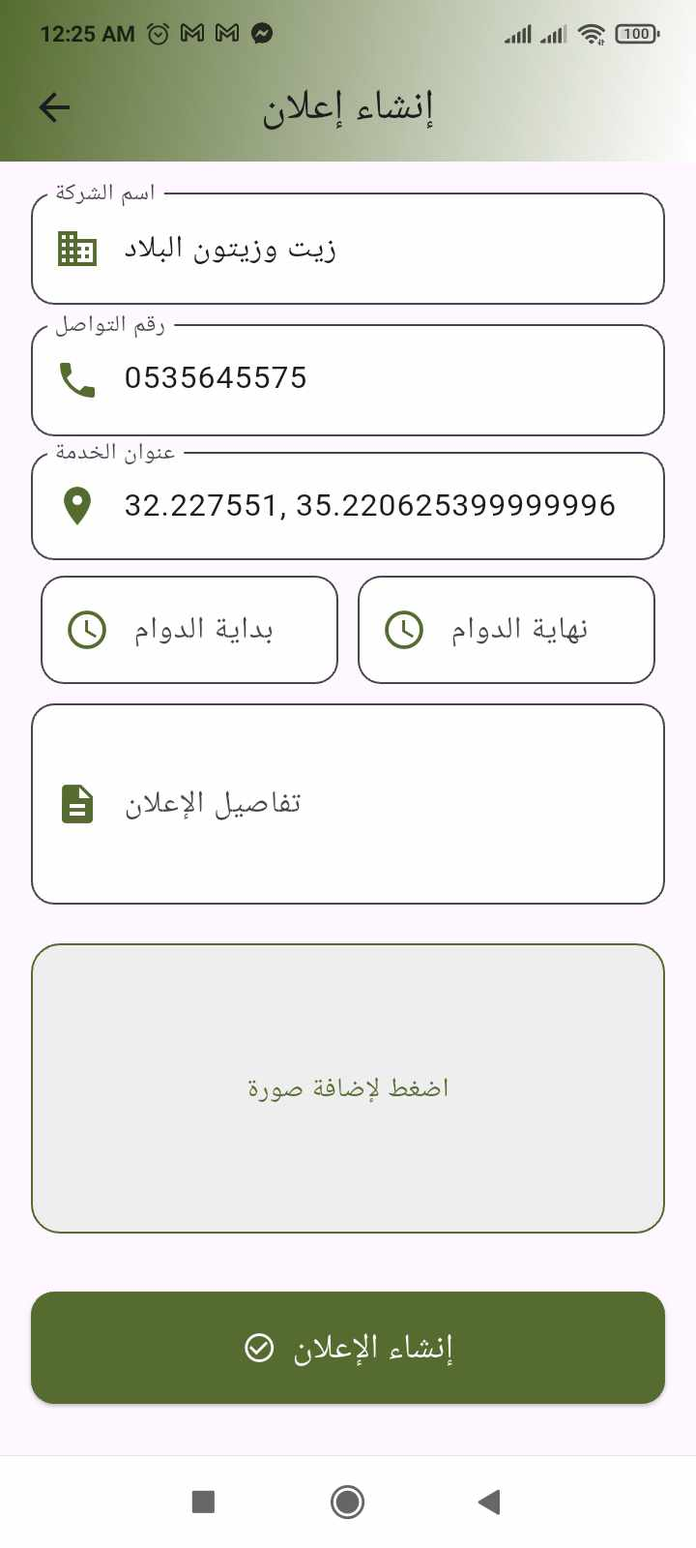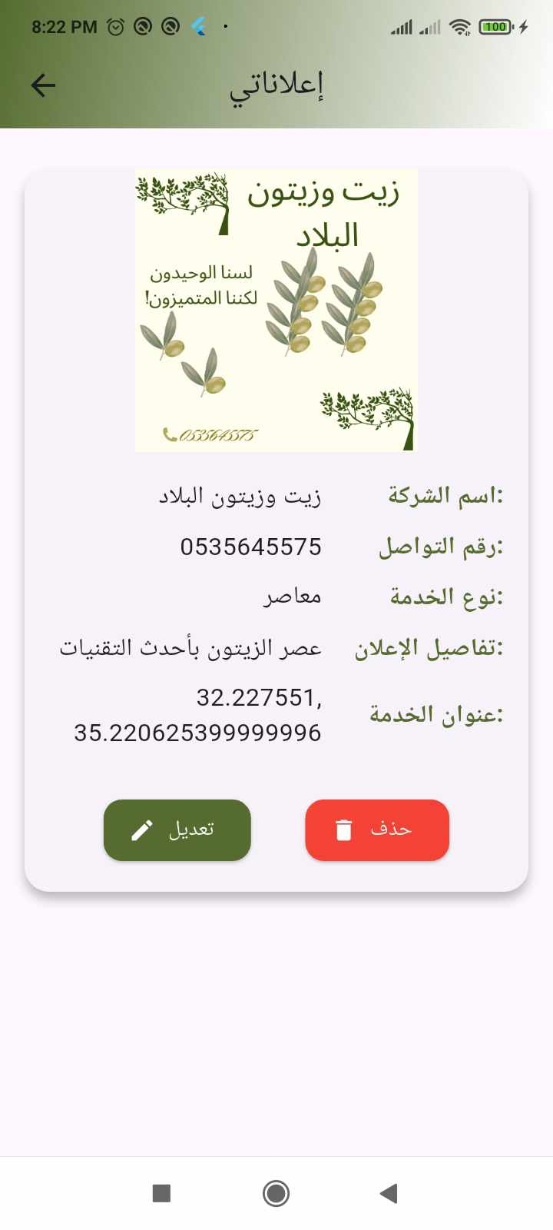
This is the main page for the olive press, where you can create advertisements, view the advertisements it has posted, and has the option to delete or edit them.

    - Special Advertisement For Transportation Service :

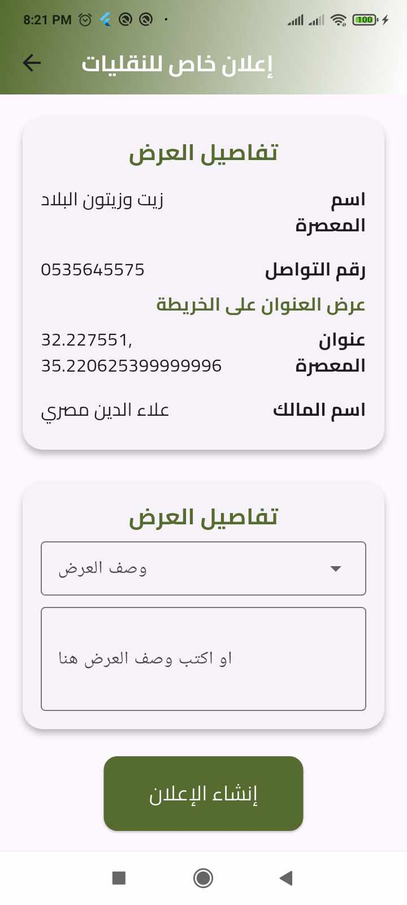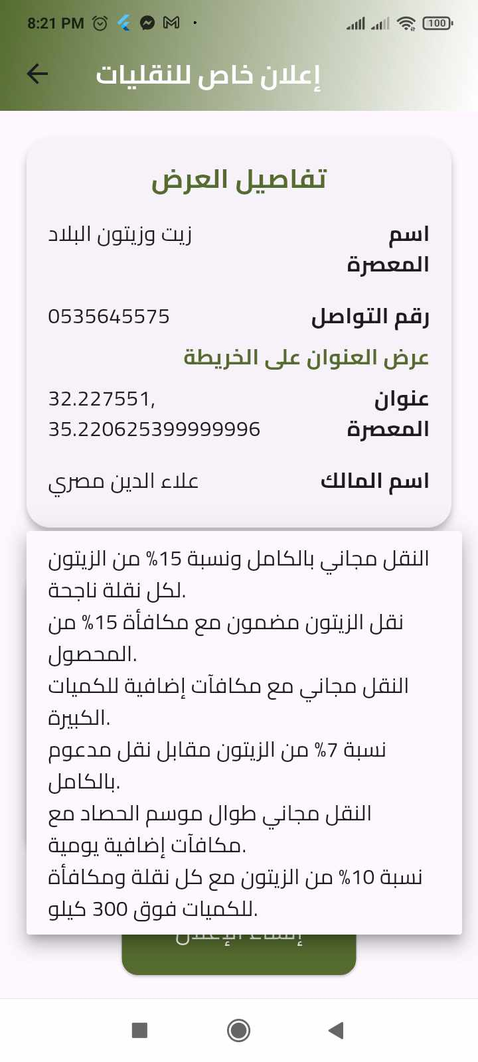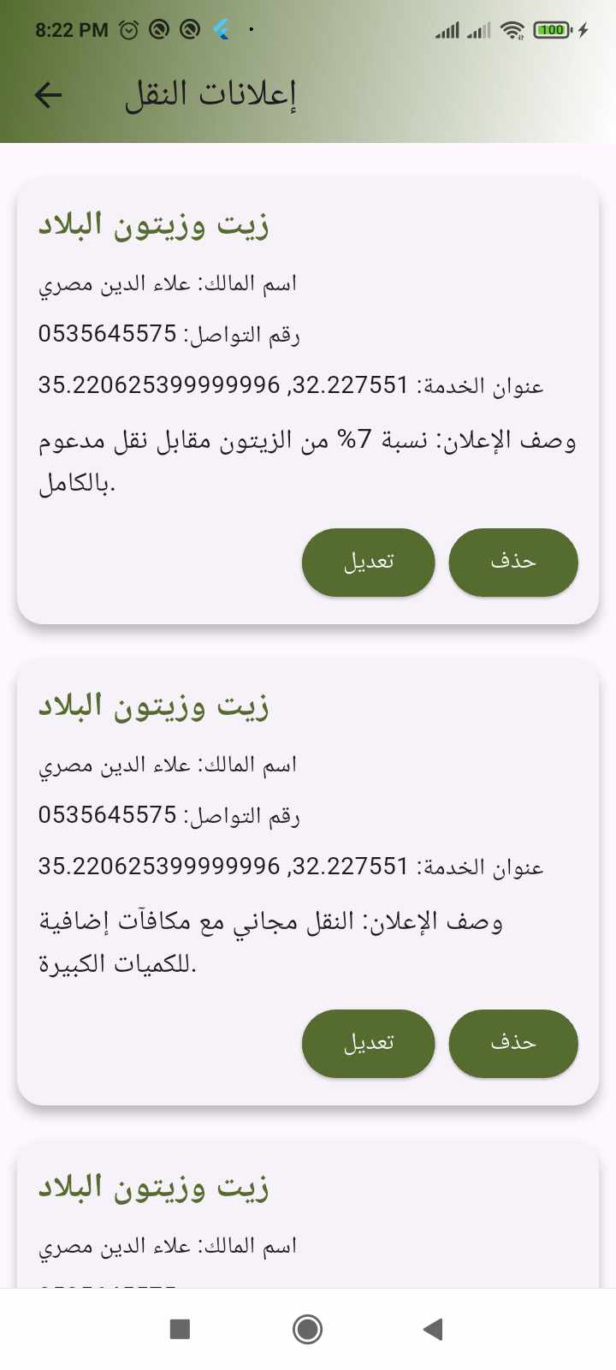
The olive press can create a special advertisement for transportation services, where the transportation provider handles all incoming requests for olive transport to the press in exchange for a fee from the press. This allows the olive press to attract more customers and increase its productivity.
In addition, the olive press can either write a custom advertisement or choose from a suggested list. The advertisements created for transportation services can also be viewed, edited, or deleted as needed.

4.4.10Submit a complaint or feedback:

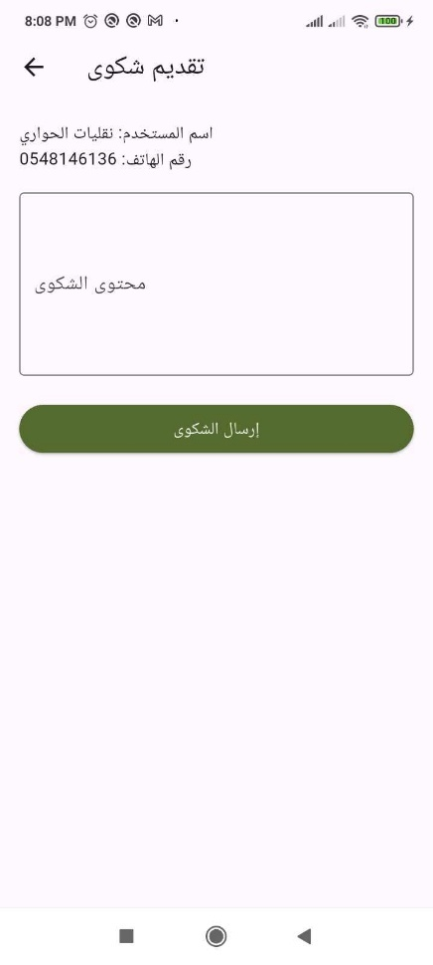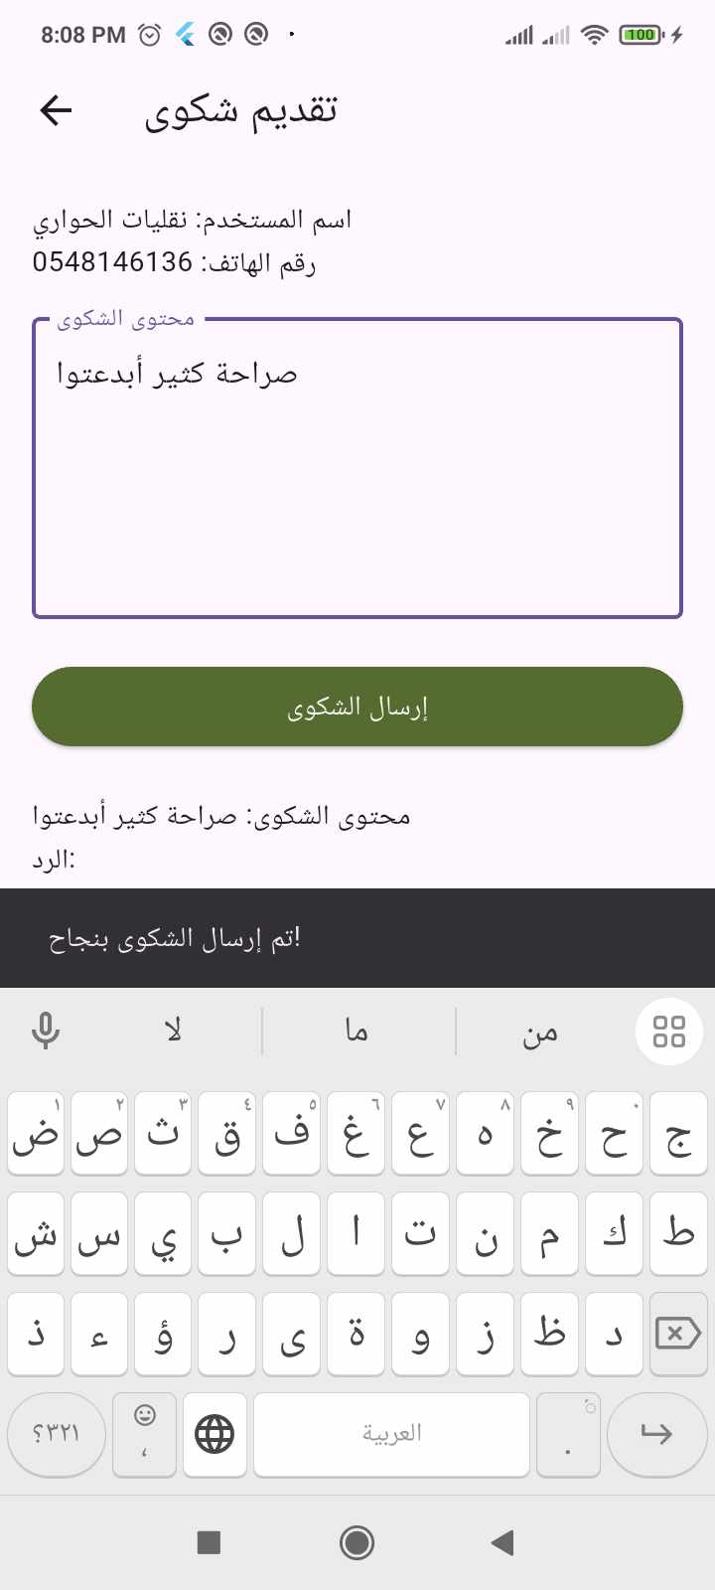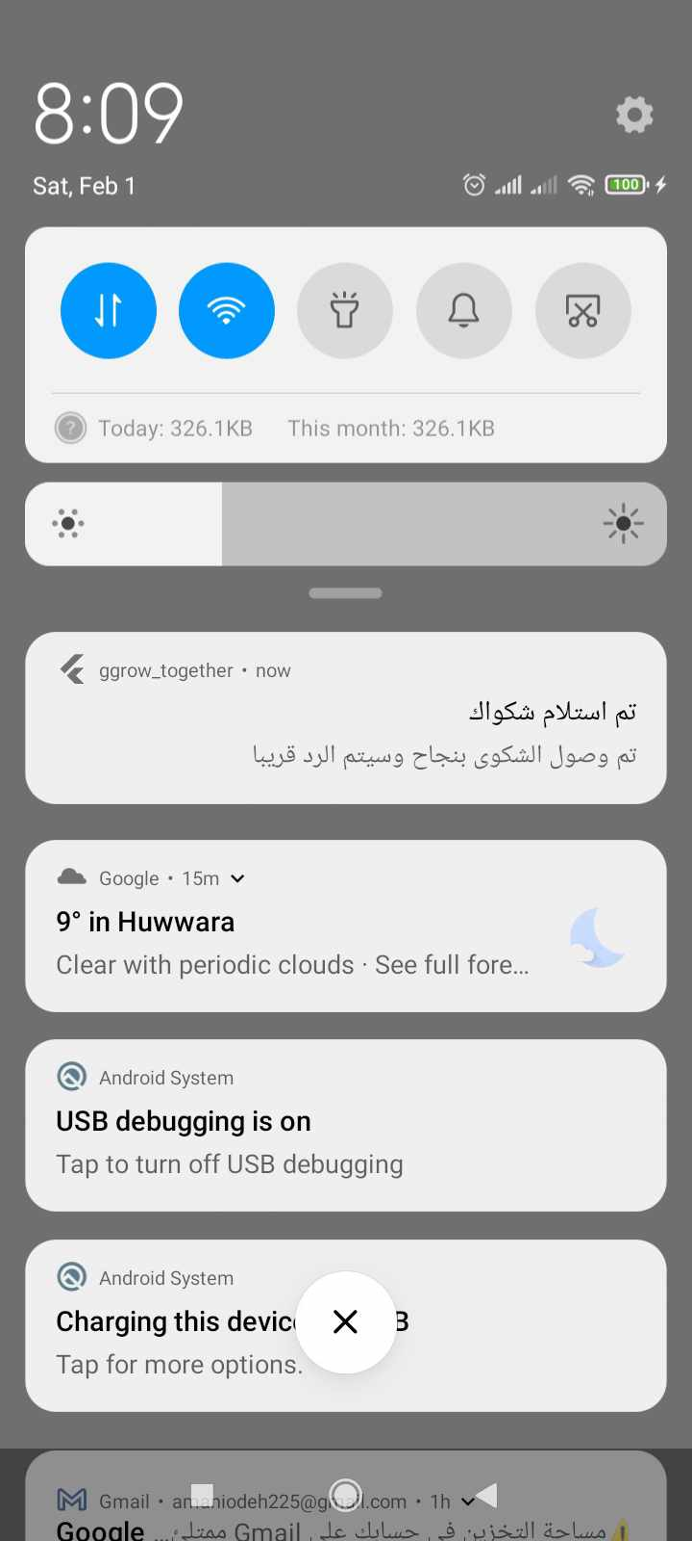

All users can submit a positive or negative complaint. When a complaint is sent, a notification is sent to the user via Firebase, and the complaint is delivered to the admin.

  - Web :
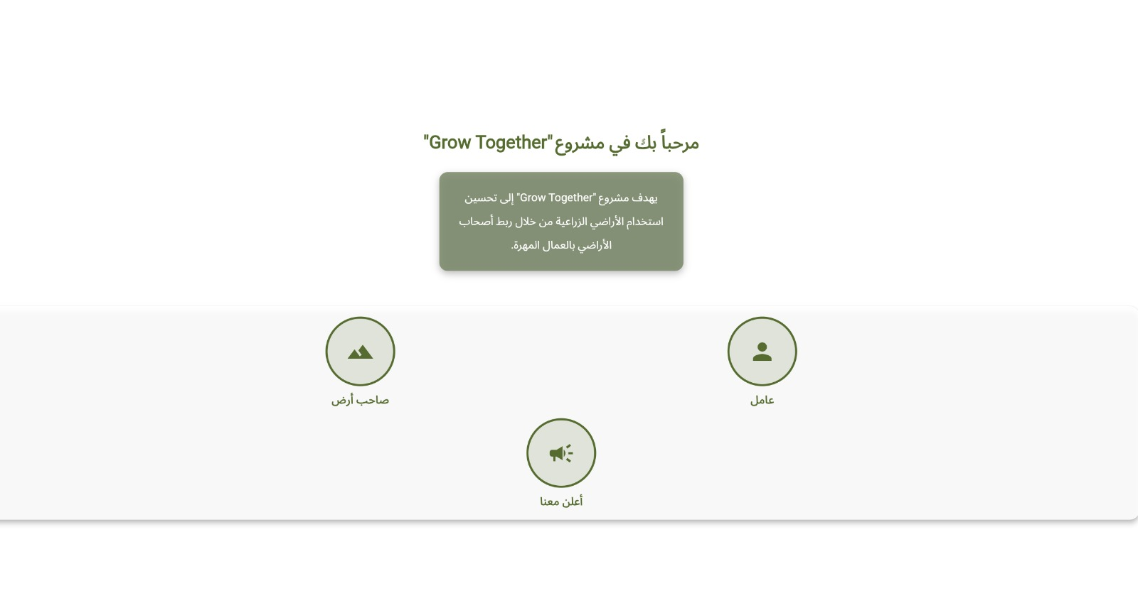

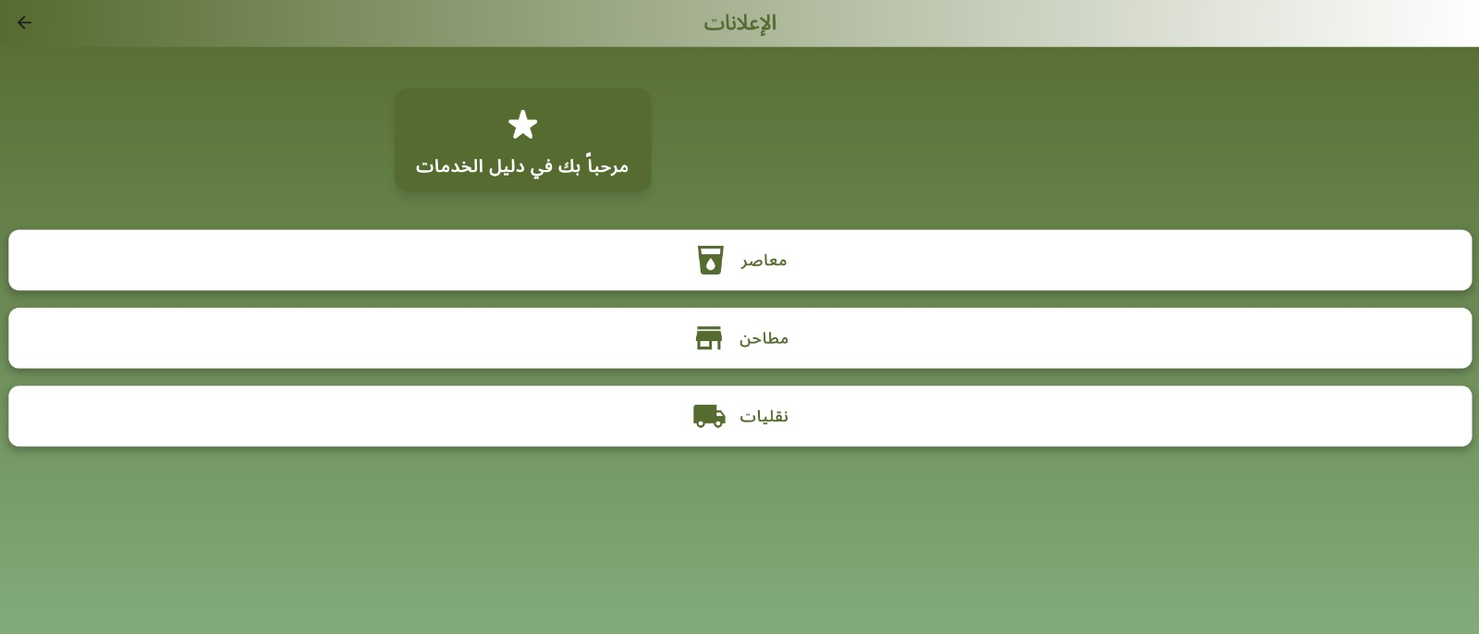
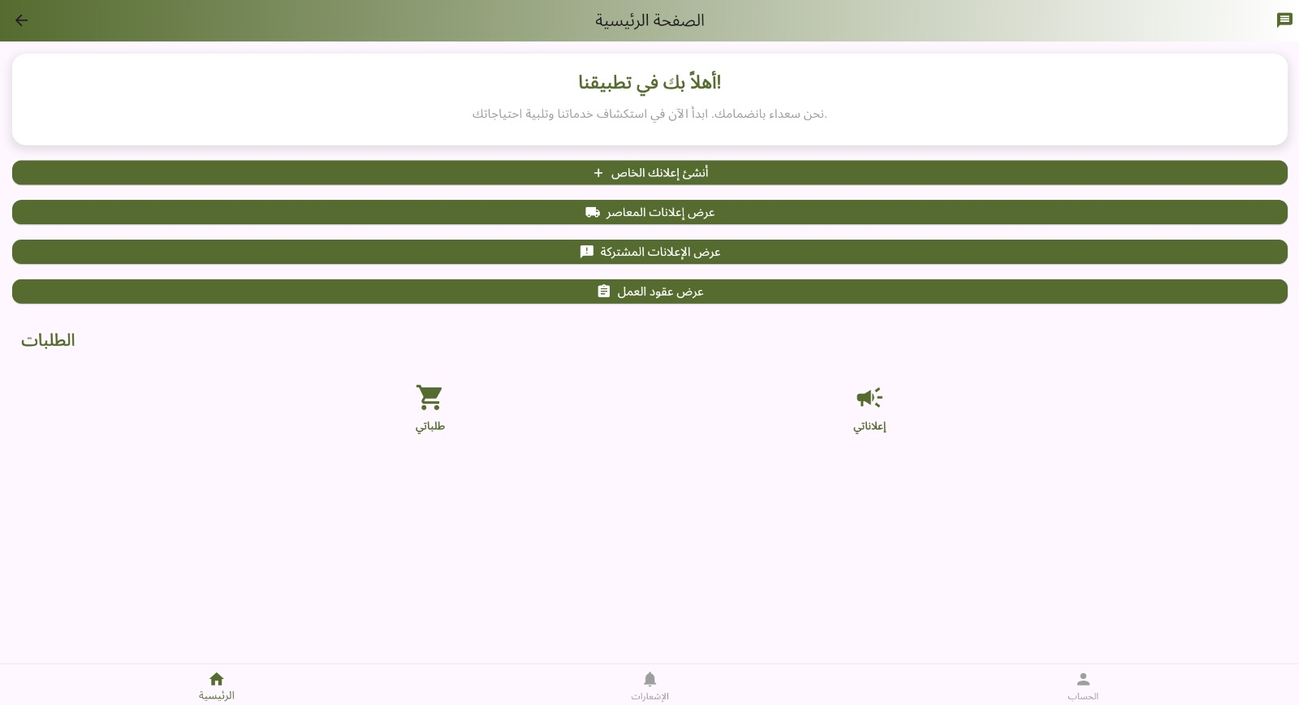

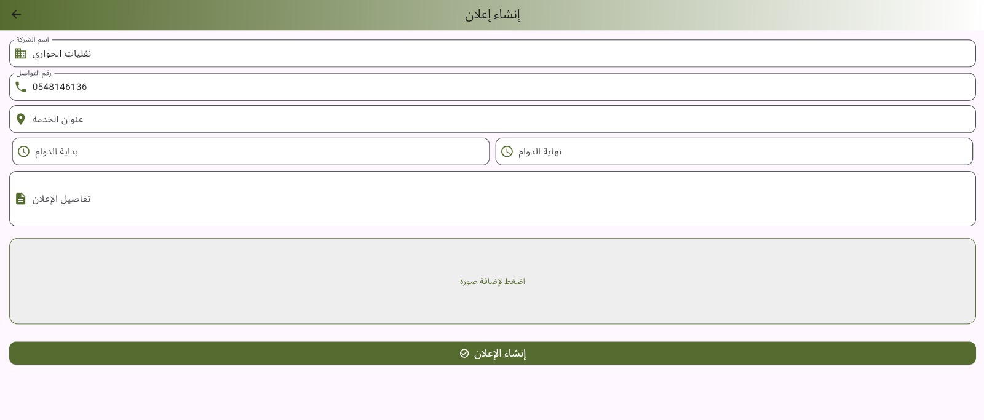
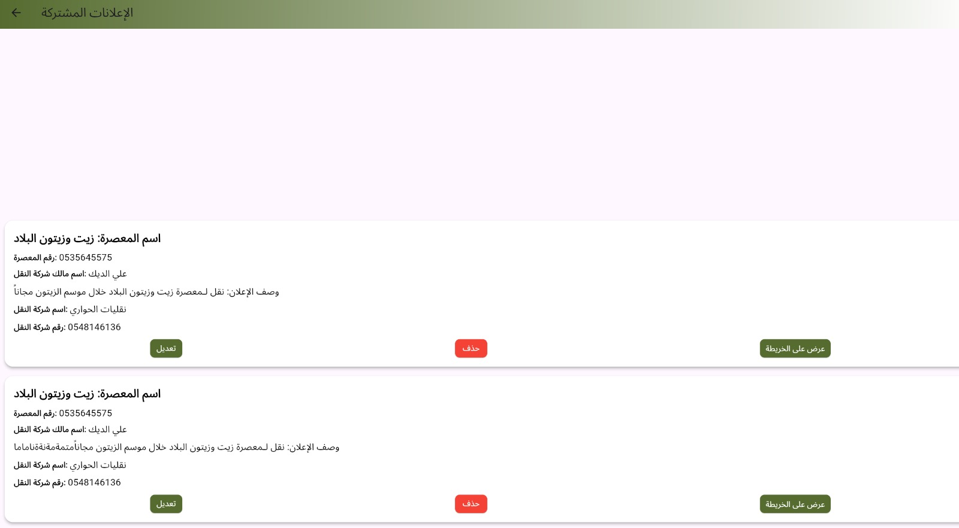

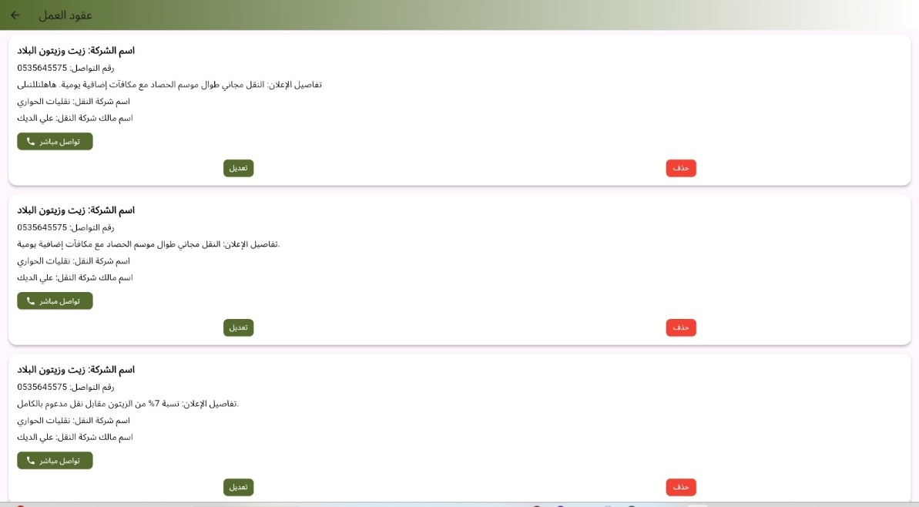

  - Admin:

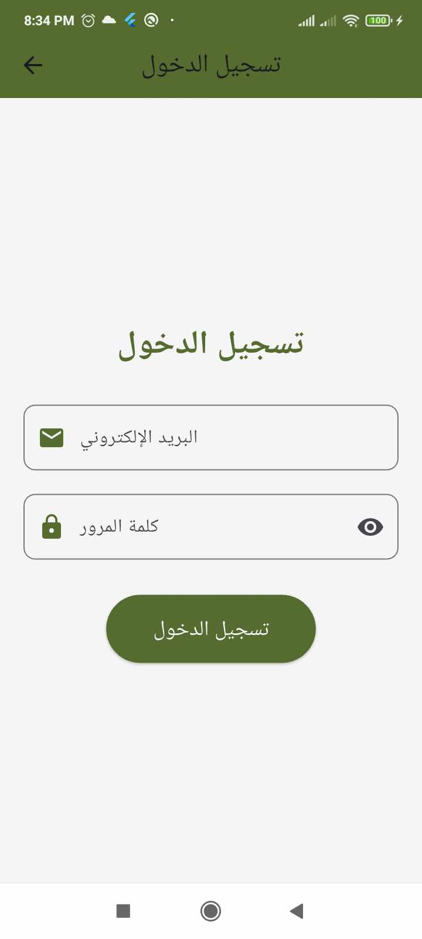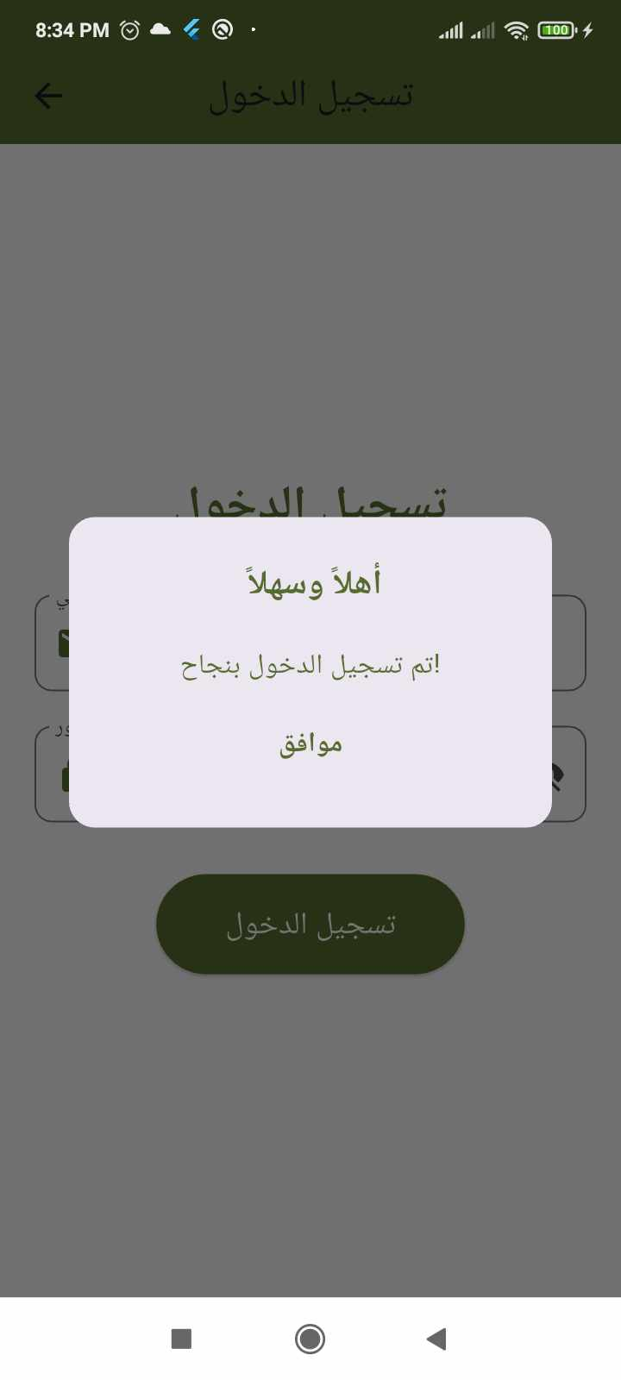

These are the admin pages where they can log in or create a new account when a new admin joins. A welcome message is displayed upon successful registration.

4.6.1 Dashboard for admin:
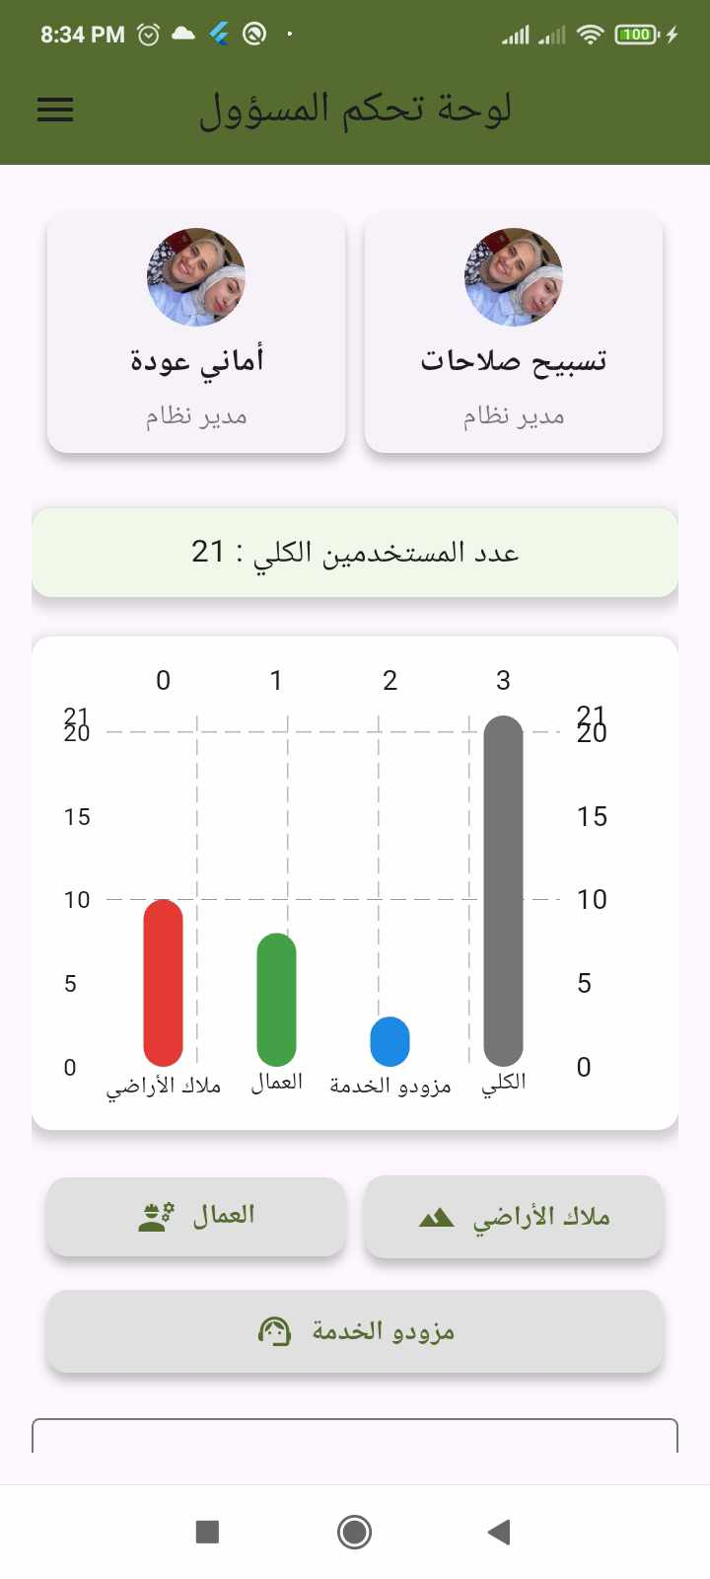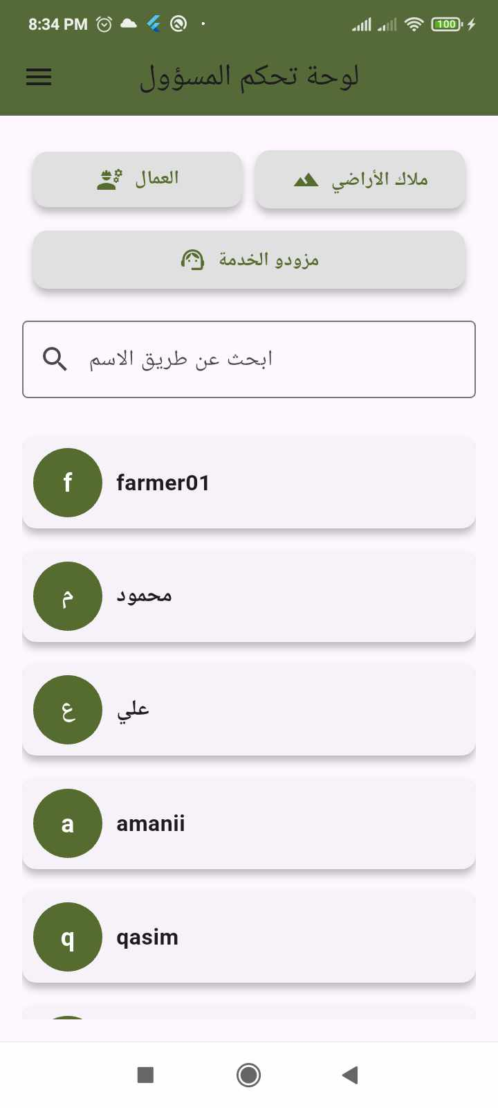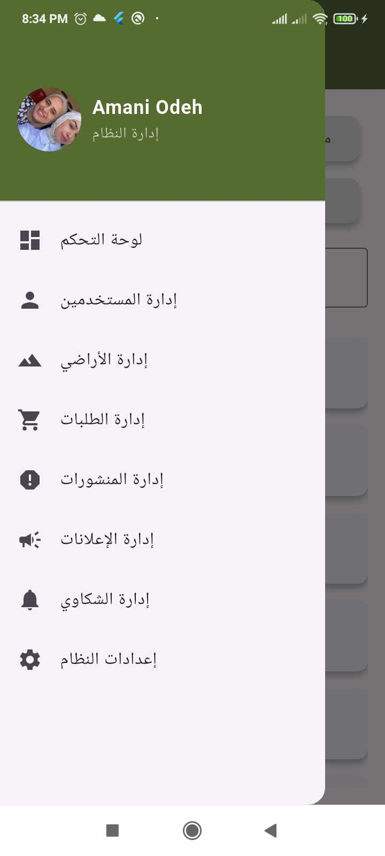
On the main page, the admins of the application are displayed, along with the total number of users. Users can be searched by name and filtered based on their assigned roles. Additionally, the number of users is visually represented using a bar chart.
Admins can also manage various system features, including user management, land management, order management, post management, advertisement management, complaint handling, and system settings.

4.6.2 User management :

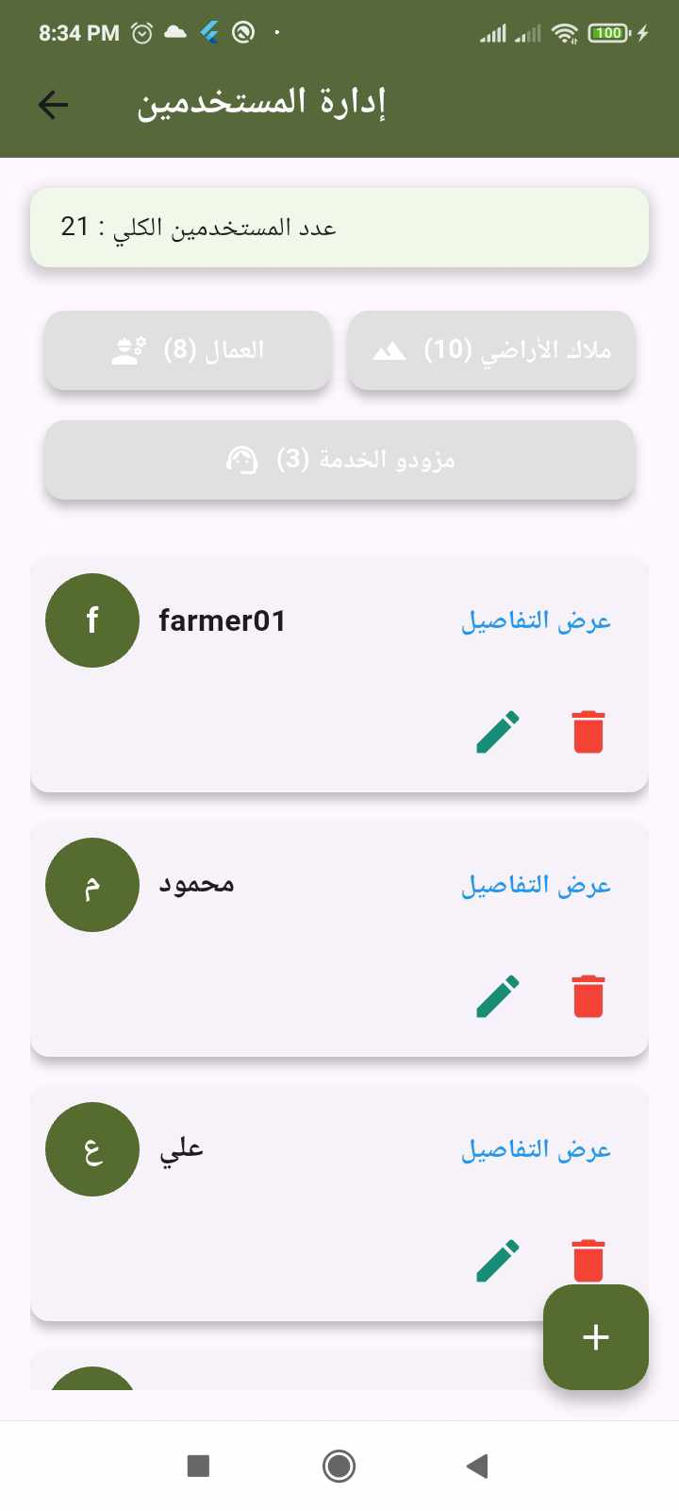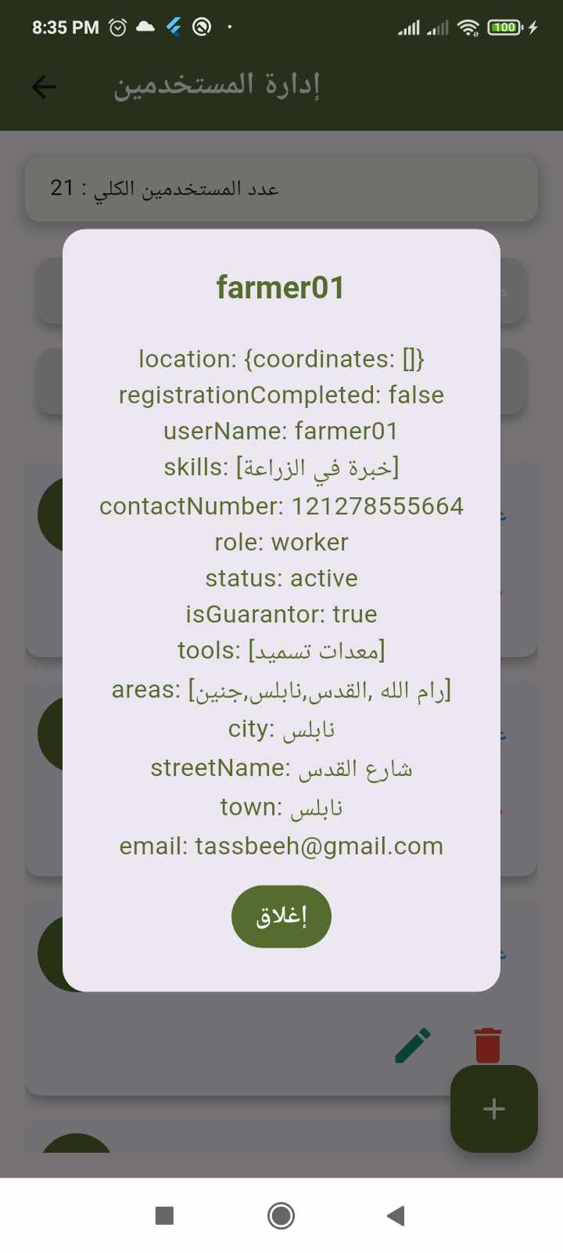
When managing users, the admin can view all users, display the total number of users, and see the count of each user category. Additionally, the admin can view detailed information for each user and has the ability to delete or edit their information.

4.6.3 Land management:

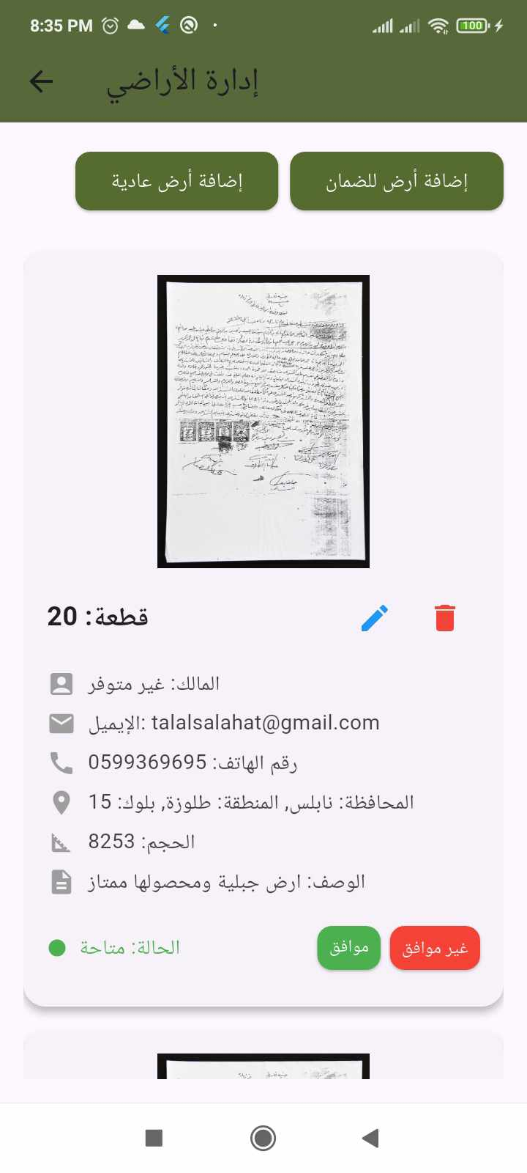
When managing lands, all lands are displayed, and the admin can delete, edit, or add new land. Only the admin has the authority to approve a land listing. Once approved, the landowner gains access to use the land within the application and benefit from all its features.

4.6.4 Order management:

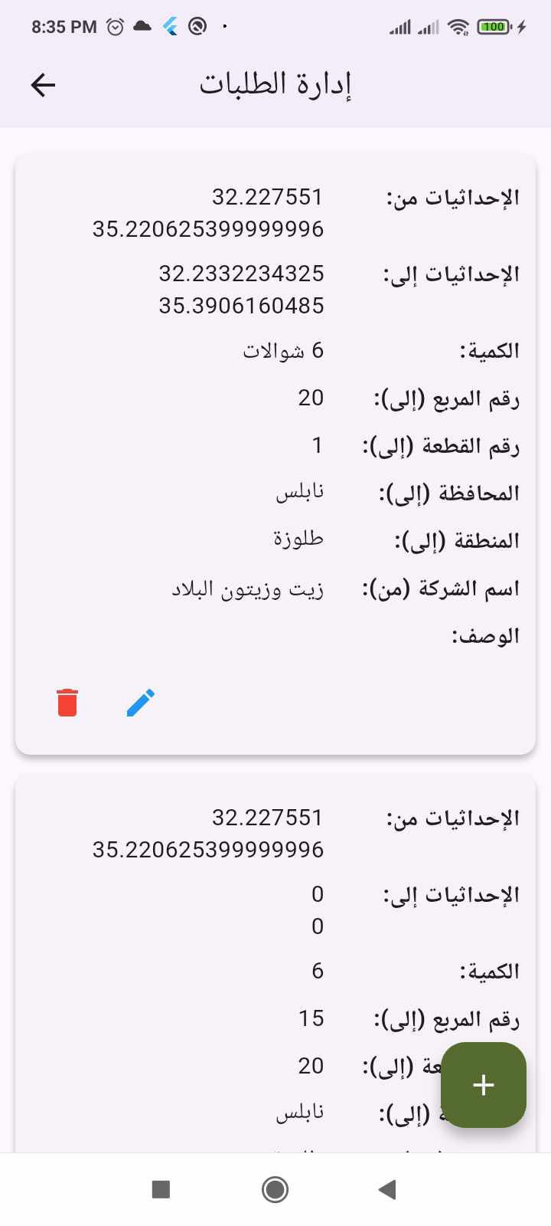
When managing orders, all requests received by service providers are displayed. Orders can be deleted, edited, or a new request can be added as needed.

4.6.5 Posts management:

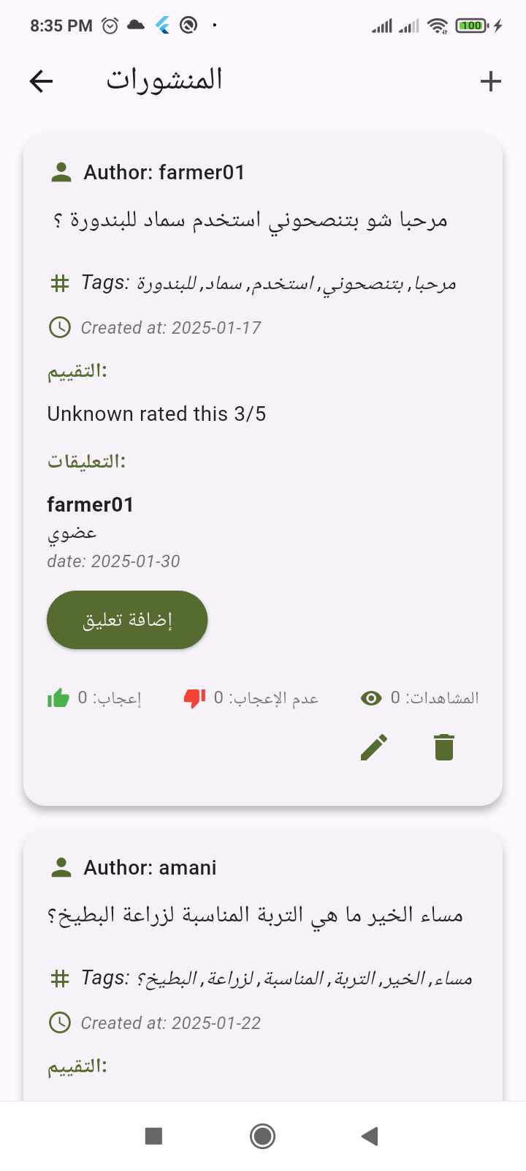
When managing posts, they can be deleted, edited, or a new post can be created. Additionally, comments can be added, and users can like or dislike posts.

4.6.6 Advertisement management:
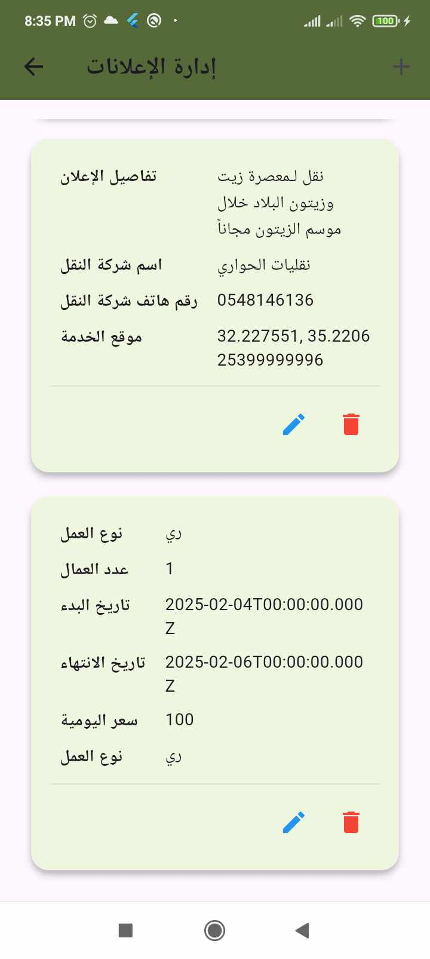

All advertisements created by application users can be managed. Advertisements can be deleted, edited, or new advertisements can be added as needed.

4.6.7 Compliment management:

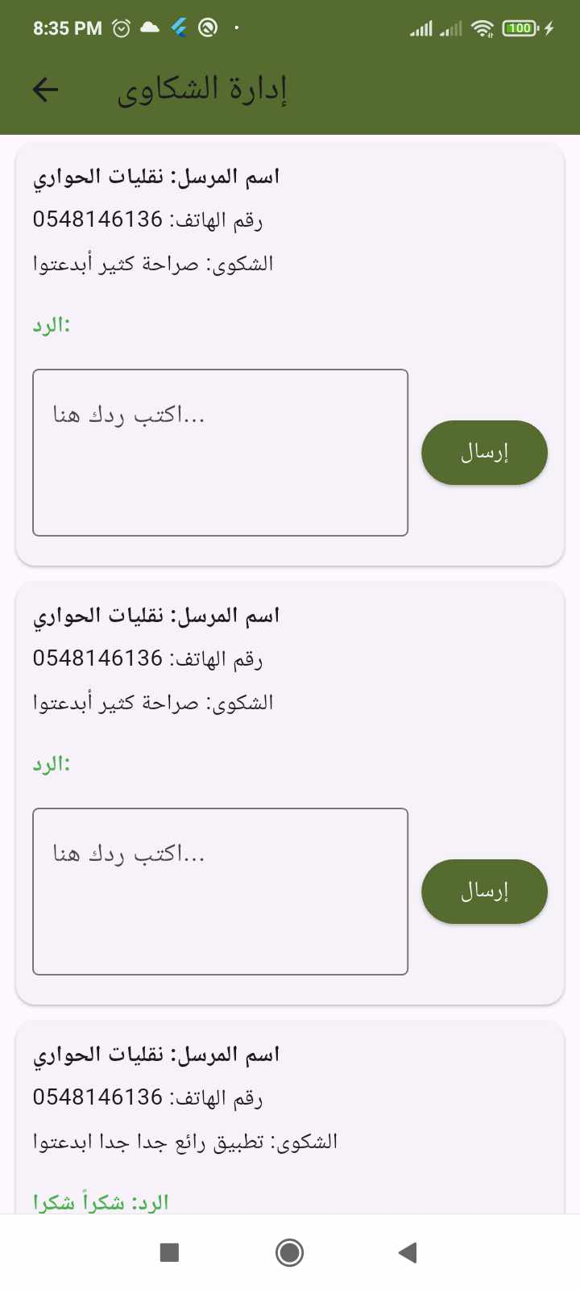
Complaints can be managed by reviewing, responding, and taking necessary actions. The admin can resolve issues to ensure a better user experience.

Chapter 5
Results and Discussion
This project has successfully developed an advanced digital platform designed to optimize agricultural land use by seamlessly connecting landowners with skilled agricultural workers. The implementation of this system has demonstrated substantial benefits, enhancing efficiency, accessibility, and sustainability within the agricultural sector.

A key finding of this study is the platform’s effectiveness in bridging the gap between landowners and agricultural workers. Through an intuitive and structured interface, landowners can effortlessly post job opportunities and recruit workers with the required expertise. Conversely, workers benefit from a dependable source of job opportunities, improving their employment stability and career prospects.

The project also underscores the potential of cutting-edge technologies, such as AI-driven plant disease detection and automated job matching. The integration of MobileNet for plant disease analysis has proven to be highly effective in identifying agricultural diseases, enabling farmers to take timely and informed actions to safeguard their crops. Additionally, real-time weather updates and soil condition retrieval further empower landowners to make strategic and data-driven decisions regarding land management.

Despite its success, the project encountered challenges, including ensuring data accuracy, scalability, and user adoption. However, rigorous testing, iterative development, and user feedback helped overcome these obstacles, leading to a robust and scalable solution. Users reported that the system significantly reduces the time and effort required to find skilled workers and essential agricultural services, ultimately boosting overall productivity.

Moreover, the inclusion of a service provider module has expanded the platform’s functionality by integrating external agricultural service providers such as transportation companies and olive presses. This feature fosters a comprehensive approach to agricultural resource management, ensuring that farmers can access all necessary services within a single ecosystem.

In conclusion, the results of this project illustrate how digital innovations can effectively enhance agricultural efficiency, optimize resource utilization, and create new employment opportunities within the sector. The platform not only modernizes traditional farming practices but also lays the groundwork for future technological advancements in agriculture.

Chapter 6

Conclusion and Future work
  - Conclusion
In conclusion, the development of this digital platform represents a transformative step in agricultural land management by providing a seamless and intelligent connection between landowners, workers, and service providers. The system effectively addresses critical challenges such as labor shortages, underutilized land, and limited access to essential agricultural services. Through the integration of AI, real-time geographic data retrieval, and an intuitive user interface, the platform facilitates efficient and sustainable agricultural operations.
User feedback and testing indicate that the platform significantly enhances land utilization, creates job opportunities, and improves overall productivity. The ability to provide real-time recommendations for crop selection and detect plant diseases adds further value, ensuring informed decision-making and improved agricultural yields.
While this project has successfully achieved its core objectives, there is always room for enhancement. Future developments can refine the platform’s functionality, expand its reach, and introduce new features to optimize agricultural practices further.
In summary, this project demonstrates how digital solutions can revolutionize agriculture, paving the way for more efficient, scalable, and sustainable farming practices. The integration of technology into agriculture is no longer an option but a necessity for advancing food security and economic growth.

Future work
To build upon the success of this platform, several enhancements and expansions can be considered for future development:
- AI-based Predictive Analysis:
  - Develop advanced AI models to predict crop yields based on historical data, weather patterns, and soil conditions.
  - Implement predictive maintenance alerts for farm equipment to minimize downtime and maximize efficiency.
- Expansion of Agricultural Services:
  - Integrate more agricultural service providers, including irrigation solutions, soil testing laboratories, and fertilizer suppliers.
  - Introduce financial assistance features such as micro-loans for farmers and workers.
- Blockchain for Secure Transactions:
  - Implement blockchain technology to enhance the security of financial transactions and contracts between landowners and workers.
  - Ensure transparency and prevent fraudulent activities in agricultural agreements and payments.
- Enhanced User Experience:
  - Develop multilingual support to accommodate a broader user base and promote accessibility.
  - Introduce a chatbot or virtual assistant for real-time assistance to users.
- Automated Land Monitoring:
  - Utilize satellite imagery and IoT sensors to provide real-time insights into soil moisture levels, crop health, and land conditions.
  - Enable automated alerts to notify landowners of critical issues such as drought or pest infestations.
- Mobile App Optimization:
  - Improve mobile application performance to ensure a seamless experience across various devices.
  - Implement an offline mode to allow access in areas with limited internet connectivity.
By incorporating these enhancements, the platform can further evolve into an advanced agricultural management solution, revolutionizing the way land is utilized and labor is employed in the farming sector. These future developments will contribute to more intelligent, data-driven, and sustainable agricultural practices, benefiting farmers, workers, and service providers alike.

Bibliography
- Node.js: https://nodejs.org/en/learn/getting-started/introduction-to-nodejs
- Flutter: https://flutter.dev/learn
- YouTube: https://www.youtube.com
- Firebase:https://medium.com/firebase-developers/what-is-firebase-the-complete-story-abridged-bcc730c5f2c0
- GitHub: https://github.com/

