

An-Najah National University
Faculty of Graduate Studies
EVALUATING ENGINEERING OFFICE DESIGNS IN THE WEST BANK FOR COMPLIANCE WITH ENERGY-SAVING GUIDELINES.
By
Mohammed Taysir salah
Supervisor
Dr. Ayser Yasin

As part of the requirements for the Master of Clean Energy Engineering and Energy Conservation degree, this thesis is submitted to the Faculty of Graduate Studies at An-Najah National University in Nablus, Palestine.
2026

EVALUATING ENGINEERING OFFICE DESIGNS IN THE WEST BANK FOR COMPLIANCE WITH ENERGY-SAVING GUIDELINES.

By
Mohammed Taysir salah

Dedication

To the souls of our righteous martyrs, to our people in Gaza and throughout Palestine.
To everyone who supported and encouraged me, to my father and mother (may God protect them), and to my dear wife, my sons, and my lovely daughter, who were a source of motivation and encouragement throughout my studies.

Acknowledgment
First and foremost, I thank and praise God Almighty for granting me health and well-being, illuminating my path, and bestowing upon me the blessings of knowledge and wisdom.
I extend my deepest gratitude to Dr. Ayser Yassin, my thesis supervisor, for his unwavering support, encouragement, patience, and guidance throughout the thesis preparation process.
I also wish to express my sincere appreciation to my family, friends, and everyone who supported and encouraged me.
Finally, I would like to express my gratitude to all members of the Master's program in Clean Energy and Energy Efficiency for their support and cooperation.

Declaration
The undersigned hereby certifies that I submitted the thesis titled

EVALUATING ENGINEERING OFFICE DESIGNS IN THE WEST BANK FOR COMPLIANCE WITH ENERGY-SAVING GUIDELINES.

I certify that the work included in this thesis is wholly original with no prior submissions for any other degree or academic qualification, unless otherwise noted.
Student's Name:
Signature:
Date:

المحتويات
1
Chapter1 1
Introduction 1
1.1Background of the Study 1
1.2Problem Statement 3
1.3Importance of the study 3
1.4 Research Objectives 4
1.5Research Hypotheses 4
1.6Scope of the Study 5
Chapter 2 6
Literature Review 6
2.1 Introduction 6
2.1.1 Buildings sector and energy in Palestine 6
2.1.2Energy benchmark-Palestine and neighboring countries 8
2.1.3 Challenges and Barriers-Palestine 11
2.1.4 Government and Policy Frameworks -Palestine 12
2.2Previous Survey studies on energy saving and green buildings 13
2.2.1 Awareness of Green Buildings 13
2.2.2 Awareness and Implementation of Energy Efficiency Strategies 14
2.2.3 Promoting Green Building Practices: Policy and Awareness 15
2.2.4 Passive Building Design Strategies 15
2.2.5 Gaps between awareness and practice in green construction 15
2.2.6 Awareness of integration and simulation software for sustainable buildings 16
2.2.7 Engineers’ Perspectives on Sustainability 16
2.2.8 Knowledge and Perception of Renewable Energy among Students 16
2.2.9 Barriers to adopting energy-saving technologies 17
2.3 Summary 18
Chapter Three 19
: Methodology 19
3.1 Research design 19
3.2 Questionnaire assumptions 20
3.2.1 Classifications of engineering offices 20
3.2.2 Engineer experience 22
3.2.3Awareness of energy conservation 23
3.2.4 Practice of energy-saving design 23
3.2.5 Local governmental laws and Local engineering guidelines in Palestine 24
3.2.6 Barriers to adopting energy-saving designs 25
3.2.7 Suggestions to improve the compliance of engineering designs with energy-saving 25
3.3 Population 26
3.4 Inclusion criteria 26
3.5 Exclusion criteria 26
3.6 limitations 26
3.7 Sample size 27
3.8 Variables. 28
3.9 Data collection methods 28
Descriptive cross-sectional questionnaire details 30
3.10 Validity 32
3.11 Pilot study 32
3.12 Ethical Considerations: 32
3.13 Reliability 32
3.14 Data Analysis 33
Chapter Four: Results 36
Introduction 36
4.1Engineering offices classifications and engineers' experience 36
4.2 Levels of awareness of energy-saving and green building principles 38
4.3Engineering practices for energy-saving designs 40
4.4Local laws and engineering guidelines 43
4.5Barriers to adopting energy-saving designs. 44
4.6Suggestions for improving engineering design compliance with energy conservation. 45
4.8Differences between awareness, practice, and local laws scores in terms of both office classification and years of experience. 46
4.9Relationships between practice subdomains in terms of both office class and years of experience 47
Chapter Five 48
Discussion of results 48
5.1 Introduction 48
5.2Awareness of energy-saving and green building principles 49
5.2.1Awareness results indication 50
5.2.2 Awareness of Energy Saving, Comparison with Previous Studies 52
5.3Engineering Practices for Energy-Efficient Designs 53
5.3.1Practice of energy-saving compared with previous studies 60
5.3.2 Energy Saving design Practice and its impact on energy consumption 61
5.4 Local laws and engineering guidelines 65
5.4.1Local laws and engineering guidelines comparison with previous studies 66
5.5 Barriers to Adopting Energy-saving Designs 66
5.5.1Barriers to Adopting Energy-saving Designs in previous studies: 67
5.6 Suggestions for improving engineering design compliance with energy conservation. 68
5.7 Differences in Awareness, Practice, and Local Regulations Based on Firm Classification and Years of Experience 69
5.8 Hypothesis testing: 74
chapter 6 75
6.1Conclusion 76
6.1.1 General conclusions 76
6.1.2Economic aspects: 77
6.1.3 Engineering Codes and Regulations: 77
6.2 Recommendation 78
6.2.1 Technical recommendations 78
6.2.2 Economic recommendations; 78
6.2.3 Engineering Codes and Regulations recommendations: 79
6.2.4 Recommendations for future research: 79
Appendices 86
Appendix A 86
The energy indicators (benchmark) for Egypt, Lebanon, and Jordan 86
Appendix B 88
Renewable Energy and Energy Efficiency Law 2015 88
Appendix C 97
The survey in English 97
The original electronic questionnaire form in Arabic with approvals. 107
Appendix D 120
Copy of the received responses of the survey (287 responses) 120
Appendix-E 144
The approved Electrical tariff in Palestine 2025 144
Appendix-F 150
Net Billing Law issued by the Electricity Sector Regulatory Council - 2025 150

List of Tables
Table 1:Electrical energy consumption 2023 8
Table 2:Monthly energy consumption Jan-2015-Palestine 8
Table 3:Cost-Benefits of Energy Efficiency Actions- Palestine 12
Table 4:Reliability coefficient 33
Table 5:Frequency and percentage of the office classification and years of experience (n-287) 36
Table 6: Awareness of energy saving and green building principles (n=287) 39
Table 7: Frequency and percentage of the features of green buildings considered most important 40
Table 8:Mean score for items towards engineering practices for energy saving designs(n=287) 42
Table 9:Frequency and percentages toward local laws and engineering guidelines (n=287) 44
Table 10Mean score for each item toward barriers to adopting energy-saving design (n=287) 44
Table 11:Suggestions for improving engineering design compliance with energy saving guidlines 45
Table 12differences between awareness,practices,and local laws scores in terms of both office classifications and years of experience (n=287) 46
Table 13Differences between barriers to adopting energy saving designs in terms of office classifications and years of experience(n=287) 47
Table 14:Relations between practice subdomains in terms of both office classification and years of experience (n=287) 48
Table 15:Awareness comparison with previous studies 53
Table 16:Practice comparison with previous studies 61
Table 17:Annual designed area -west bank 61
Table 18:Energy saving analysis-Residential buildings. 62
Table 19:Energy cost -saving analysis-residential buildings 63
Table 20Energy saving-commercial buildings. 64
Table 21:Energy cost saving analysis -commercial buildings 65

List of Figures
Figure 1:Annual development of engineering designs -West Bank 2
Figure 2:Energy Benchmark-Residential sector 9
Figure 3Energy Benchmark-commercial sector 10
Figure 4:Methodology flow chart 19
Figure 5:Engineering offices-west bank-palestine 2025 21
Figure 6:Passive building design 24
Figure 7:Mainsurvey aspects 29
Figure 8:P-value diagram 34
Figure 9;Classification of participant engineering offices 37
Figure 10:Distribution of years of experience of participant engineers 38
Figure 11: Level of awareness of energy saving and green building principles(n=287) 38
Figure 12Level of engineering practice for energy saving designs(n=287) 41
Figure 13:levels of engineering practices for energy saving design(n=287) 43
Figure 14:Engineering responses to variables of awareness 50
Figure15:Residential projects percentage in the West Bank 55
Figure 16:Electrical energy consumption percentage in different sectors 56
Figure 17Energy saving design techniques results 56
Figure 18Suggestions for improving compliance with energy saving guidlines 68
Figure 19:Awareness versus experience of engineers 71
Figure 20 Relations between practices subdomains 73

Abstract
This study evaluates the level of compliance of engineering offices in the West Bank with energy conservation guidelines, given that Palestine and the West Bank suffer from a shortage of energy resources and high prices, which makes energy conservation a top priority. The study measures the level of awareness of energy conservation and its practice during engineering design work. It also examines the obstacles preventing these offices from adhering to energy conservation guidelines. For this purpose, an electronic cross-sectional descriptive quantitative questionnaire was developed and sent to all engineering offices in the West Bank working in the field of engineering design and supervision, and certified by the Engineers' Association(1062 offices). The results of the survey(287 responses) showed that awareness of energy conservation is significantly high, while practice levels are moderate. A significantly weak level of practice is in residential building design, while it is moderate in commercial buildings. Participants emphasized the existence of obstacles to adopting energy-efficient designs, the most significant being a lack of awareness among stakeholders and the high initial costs. These obstacles are followed by a lack of experience in energy-efficient designs and the absence of laws that encourage the adoption of such practices.
Hypothesis testing showed agreement with the results across different axes, with the exception of the office category level.
It was observed that the classification of engineering offices was not positively correlated with increased awareness or energy-efficient engineering practices. In contrast, the personal experience of engineers was strongly correlated with increased awareness and improved energy-efficient strategy practices.
Key words: energy saving, engineering offices, West Bank, green building, awareness, practice, structured questionnaire.

Chapter1

Introduction

1.1Background of the Study
Over the past two decades, green buildings and energy-saving systems have become top priorities in all countries around the world. In Palestine, we have a special situation. Energy is a major challenge facing the local economy due to the lack of local energy sources; most energy sources are imported at high prices.
Palestine relies entirely on imports for its fossil fuel supply and sources, and approximately 87% of its electricity is sourced from neighboring countries. In recent years, rapid population growth, rising living standards, and industrial expansion have significantly increased the nation's energy demand. Despite this growing demand, Palestine has the lowest per capita energy consumption in the region, at 0.79 MWh per inhabitant, while it faces the highest energy costs in the Middle East [1].
In addition to high energy costs, Palestine suffers from difficult economic and political conditions due to the occupation and its control over natural resources, energy sources, and prices. All these difficulties make it important and necessary to rationalize energy consumption through a correct engineering vision and a design that takes into account energy saving, and seeks to use systems that contribute to energy saving [2].
It is important to study engineering plans in Palestine and an examination of their commitment to providing solutions to rationalize energy consumption in general, and electrical energy in particular, and the use of renewable energy systems.
The designer engineer's awareness of the importance of rationalizing energy consumption and the necessity of using renewable energy systems is one of the most important factors that will raise the level of engineering design and engineering plans, and consequently, the buildings constructed will be more compatible with green building guidelines [2].
The rapid transformation of the construction sector in Palestine, particularly in building materials and construction techniques, has significantly increased the energy demand. The country’s diverse climate, with seven distinct climatic zones, adds another layer of complexity to designing and implementing green building solutions. Additionally, there is limited public awareness about the importance of sustainable construction. This study highlights the main challenges of energy conservation, which is one of the requirements for sustainable building practices[3]
Energy efficiency design strategies, categorized into the three distinct phases of building projects: pre-construction (design and planning), construction, and post-construction [4]
The construction sector is a vital part of the Palestinian economy.
This sector is one of the largest consumers of energy and resources, and significantly impacts environmental sustainability.
During the two decades, there has been a significant development and increase in engineering design work through the Engineers Association. The completed areas exceeded 6 million m², with some fluctuations observed during the Corona years and economic difficulties during 2024,2025 due to the general political situation.
The attached Figure 1 shows the development of engineering plans in the West Bank[5].

Figure 1:Annual development of engineering designs -West Bank

Engineering design firms for the construction sector play a key role in any energy conservation and sustainability plan or strategy—their responsibility is designing buildings that meet energy-saving and green building standards and environmental regulations.
Therefore, understanding designing engineers' awareness and practices in these offices is essential to promoting energy-saving construction in the region, which requires a thorough study to evaluate the current situation and explore any tools or means that lead us towards sustainability and energy-saving buildings.

1.2Problem Statement
Despite global and local interest in energy conservation, mainly in engineering sectors, there is a general lack of data in west area of our study.
We lack of data about the level of awareness among engineers in west bank-palestine.
We don’t have any data on compliance levels for energy-saving engineering design in the West Bank.
We have no data about the barriers to compliance with energy-saving designs.

1.3Importance of the study
The importance of this study lies in its ability to provide a cost-effective and advanced step towards rationalizing energy consumption and sustainability.

The study will provide suggestions that will help develop engineering designs and increase their compliance with energy conservation standards.
Improving the level of engineering design in new buildings contributes to energy conservation and sustainability, and reduces the overall sustainability problem in buildings, as the majority of older buildings require retrofitting due to their high energy consumption and weak sustainability systems[6].
Improving engineering plans(designs) and their compliance with energy-saving guidelines reduces emissions and improves the environment.A clear vision for developers, stakeholders, urban planners, and researchers for a more energy-efficient future.

1.4 Research Objectives
The main objective of this study is to evaluate the awareness and implementation of energy-saving and green building strategies among engineering offices in the West Bank.
The study also aims to identify the factors that hinder or facilitate the adoption of energy-saving practices. Specifically, the study seeks to:
- Assess the level of awareness of energy-efficient design strategies and green building concepts among engineering offices.
- Evaluate the extent to which engineering offices implement energy-saving practices in their projects.
- Identify the barriers that limit the adoption of energy-saving and green building strategies.
- Submit suggestions for the improvement of awareness and practice, as well as to reduce and avoid obstacles.
- Examine if there is any relation between the Offices category and engineers' experience and energy-saving awareness and practice.

1.5Research Hypotheses
Based on previous studies and the research context, the following hypotheses are proposed:
Hypothesis 1: Engineering offices in the West Bank possess a a high level of awareness regarding energy efficiency and green building practices.
Hypothesis 2: A level of awareness among engineering offices in the West Bank is significantly higher than the level of practice of energy-saving designs and green building guidelines .
Hypothesis 3: Various barriers, initial cost, limited technical expertise, and a lack of awareness among stakeholders significantly hinder the adoption of energy-saving practices.
Hypothesis 4: The experience of engineers has a significantly positive effect on awareness and practice.
Hypothesis 5: The level of classification of engineering offices has a significant effect on the level of practice of energy-saving designs.
Hypothesis 6: Suggestion that significantly improve energy-saving practice, integration procedure, that include Financial incentives, Courses and technical training, technical support for offices, new office classification, and binding laws for stakeholders to implement energy-efficient buildings

1.6Scope of the Study
The study focuses on engineering offices operating in the West Bank.
It examines their awareness and practices related to green building and energy efficiency guidelines.
It is also focused on the barriers and facilitators influencing adoption.
The study is limited to designer offices involved in building design and construction projects.
Contractors and non-designer engineers are excluded from our study.
Data collection is primarily through structured surveys and questionnaires.

Chapter 2

Literature Review

2.1 Introduction
Palestine lacks sufficient local energy resources, relying on imported energy at high prices.
The building sector (residential, industrial, and commercial sectors)is one of the major energy consumers, as shown later in Table 1.
Energy consumption is often linked to potential environmental impacts.
Energy-efficient design strategies and green building practices are essential tools for reducing energy consumption and promoting sustainability.
Energy-efficient codes and guidelines lead us to achieve several goals, including saving money, reducing the environmental impact of energy sources, and increasing comfort levels.
The successful implementation of these practices depends not only on technical solutions but also on the awareness, knowledge, and attitudes of stakeholders.
Therefore, understanding the level of awareness among engineering firms and engineers is crucial for identifying obstacles and developing effective strategies to promote adherence to energy efficiency and green building guidelines.
This chapter reviews the literature related to green building awareness, energy efficiency applications, and the concept of sustainability among developers, engineers, and other stakeholders.

2.1.1 Buildings sector and energy in Palestine
With reference to energy studies, the building sector is considered the biggest single contributor to world energy consumption and greenhouse gas emissions. And so, a good understanding of the nature and structure of energy use in buildings is a cornerstone for establishing future energy-saving and reducing climate change policies. Availability of the updated data is becoming increasingly important in order to achieve accurate analysis.[7]

The Middle East and North Africa (MENA) region is facing various challenges, including slowing economic progress, high population growth, a high rate of unemployment, and significant environmental pressures.
These problems are exacerbated by global and regional factors, such as climate change. Palestine, like all countries around the world, is already highly vulnerable and is expected to face even more severe impacts of climate change in the future[8].
The energy case in the Middle East, particularly in the West Bank, is complex. It relies mainly on fossil fuels, which are imported from the Israeli side, and usually faces many difficulties in energy supply, while we have an increasing energy demand. These constraints and challenges require engineering firms and designers to incorporate energy efficiency and renewable energy solutions into their designs. This literature review will discuss current research on energy efficiency, renewable energy technologies, and the challenges and opportunities of integrating sustainable energy systems into building designs, with a focus on the West Bank[9].
The Palestinian Authority faces many challenges in protecting its environment, mainly due to the constraints and barriers of the Israeli side.
The lack of control over natural resources, in addition to the urgent need for water, and difficulties in accessing alternative energy sources, and the high energy cost, which is a major challenge for Palestinian people, as electricity is classified as the most expensive in the region.
This heavy energy bill is a constant struggle for many families, highlighting the need to achieve alternative low-cost energy sources that are essential, and reduce energy bills through renewable energy, an important step toward improving the quality of life and creating a more sustainable future in Palestine.[9].

2.1.2Energy benchmark-Palestine and neighboring countries
Palestine consumes megawatt-hours annually, according to the Energy Authority's 2023 report, with consumption rates distributed as per Table 1.[10]
Table 1:Electrical energy consumption 2023
Sectoral distribution of electricity consumption during 2023
Electrical Energy Consumption(MWh) | Sector
4885021 | Residential sector
1690593 | Industrial sector
634965 | Services sector
33212 | Agricultural sector
7243791 | Total
In our attempt to obtain indicators of electrical energy usage across different sectors in Palestine, we referred to studies and reports issued by the Palestinian Central Bureau of Statistics. The most recent study published on the Central Bureau of Statistics website regarding energy indicators in Palestine dates back to 2015, which gives us monthly energy consumption in the residential sector, mainly for apartments, as shown in Table 2[11]
Table 2:Monthly energy consumption Jan-2015-Palestine
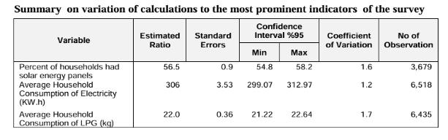
While the average apartment area, according to the Central Bureau of Statistics average area of apartment is 137m2 [12]
And so the energy usage indicator(EUI) for the residential sector, based on the previous data, EUI=annual electrical energy consumption /total area
EUI=(306*12)/137=26.8kWh/m2.a, and so EUI for the residential sector in Palestine, West Bank is around 26.8kWh/m2.a.
In a recent study in 2025 in the Dura area of ​​the southern West Bank, it was noted that the electrical energy consumption of an apartment over the year is 3933.36kWh/year. The average area of an apartment, according to this article =128m2.[13]
and so the energy usage indicator EUI=(3933.36)/128=30.73 kWh/m2. a
The EUI was different from the index of the Department of Statistics in 2015, and this is logical as the percentage of use of air conditioning systems as well as various electrical appliances, has increased due to the development of technology.
To have a clearer picture of the energy index in Palestine for commercial and residential sectors, we reviewed a new study of energy benchmark MENA building technology in 2022, which focuses on energy benchmark of many neighboring countries, as these may help us determine energy indicators in Palestine for both the residential and commercial sectors.[14]
For more details about energy benchmark data, see Appendix A
Figure 2 shows the comparison of Palestine residential sector with neighbored country

Figure 2:Energy Benchmark-Residential sector
The energy Benchmark of residential buildings in Palestine, whether according to 2015 or 2025 data, differs significantly from the readings in the neighboring country, may be as political and economic conditions and high electricity prices.
Regarding the commercial sectors, the only reference study for the energy benchmark is the study of the European aid program with the Municipality of Nablus[15].
The energy benchmark is 153 kWh/m2.a.Figure 3 illustrates the comparison with neighboring countries, where we observe significant differences, particularly in Jordan and Lebanon, while it is consistent with readings from Egypt.

Figure 3:Energy Benchmark-commercial sector
In Figure 3, the Palestinian energy benchmark is high, unlike residential buildings. The energy consumption rate in the commercial sector is high, similar to Egypt's, but lower than in countries with similar residential consumption rates, such as Jordan and Lebanon. This high consumption may be due to commercial buildings being based on the Nablus Municipality building model, which serves as a documented basis for energy calculations. To ensure that this rate aligns with global electricity consumption rates for commercial buildings, we consulted the US Energy Information Administration (EIA) tables[16]. According to the 2022 US tables, the average energy consumption for commercial buildings ranges from 12.6 kWh per square foot(135.6kWh/m².a) to 16.7 kWh per square foot(179.8 kWh/m2.a), which matches our consumption rate based on the Nablus Municipality study. Therefore, this study will be adopted as a reference for the energy consumption rate of commercial buildings in Palestine.
And so, according to the given high energy consumption rates in commercial buildings and the moderate rates in residential buildings, the importance of energy conservation efforts becomes clear.

2.1.3 Challenges and Barriers-Palestine
Several barriers are preventing the widespread adoption of energy-saving solutions and renewable energy systems. Mainly, Political instability conditions, land-use restrictions, limited access to renewable energy technologies, and regulatory obstacles are just a few of the challenges. These challenges, in addition to financial constraints, like initial investment costs for energy-saving practices and renewable energy systems, are a major reason to adopt these solutions, particularly in low-income regions such as the Palestinian territories[17].
The World Bank, in partnership with the Palestinian Energy and Natural Resources Authority (PENRA), and in collaboration with the French Development Agency (AFD), has developed the 2020-2030 Energy Efficiency Action Plan (NEEAP II), an extension of the previous plan (2012-2020). Based on lessons learned and PENRA's vision for the sector, NEEAP II has set a plan for more ambitious energy efficiency targets. To achieve these goals, the implementation of NEEAP II should have begun before 2020 to ensure early results in the next decade, while i think the complicated political and economic atmosphere in the area may affect all these plans[18].
A cost-benefit analysis has been provided by the World Bank Group for energy efficiency action(EE)for the years 2020-2030. The expected energy savings are then compared with the implementation costs. For each EE action, this provides a cost (US$) per kWh saved. When this ratio is less than the price of electricity, there will be a positive return on investment. A summary of all proposed actions is provided in Table 3 below.
Table 3:Cost-Benefits of Energy Efficiency Actions- Palestine
The NEEAP II primarily focuses on electricity, as it is the largest share of the Palestinian energy mix. The plan is to reduce the consumption of energy rather than developing renewable energy sources like solar PV, biomass, or wind, as the potential for these renewable energies has already been explored in a separate study conducted by PENRA [18].

2.1.4 Government and Policy Frameworks -Palestine
Government regulations, guidelines, and policies are very important for energy-saving solutions and renewable energy.
In Palestine, and in the West Bank in particular, there is no separate legislation dedicated to energy efficiency. Rather, this field is mainly regulated by Law No. (14) of 2015 on Renewable Energy and Energy Efficiency see Appendix B). This law focuses more on renewable energy than on energy efficiency and does not include any obligation to follow energy conservation measures.
Even though the Palestinian Authority has made progress in green building codes[2] and energy efficiency standards[17], there is still a gap in their compliance and practice. Many engineering firms focus on short-term initial cost savings rather than long-term running cost reduction through energy savings. For greater success, strong government policies and incentives are key[19].
Impact of Design Codes on Energy Conservation:
Building codes and design standards set the foundation for energy-efficient building practices. In the West Bank, international standards like the International Energy Conservation Code (IECC)[20] Local regulations have a big impact on energy-efficient design. Although with these guidelines, compliance and adoption are generally weak or absent. Many engineers and stakeholders prioritize aesthetics, functionality, and initial cost over energy efficiency and running costs, and this highlights the importance of more stringent enforcement of energy standards.

Different research study, attempts to address gap by proposing a comprehensive design process, the Integrated Energy-Efficient Building Design Process (IEBDP). This process provides a systems theory-based framework that facilitates the integration of various aspects of the energy-efficient alternatives selection process[21]

2.2Previous Survey studies on energy saving and green buildings
By reviewing and examining several previous studies that addressed awareness and practices related to energy conservation, as well as the obstacles preventing the adoption of energy conservation in construction projects.

2.2.1 Awareness of Green Buildings
With reference to the study in Macedonia in 2018, which investigated construction developers, including designers, architects, and civil engineers. It found that most were aware of green building concepts. Developers recognized benefits such as reductions in operational costs and improvements in indoor environmental quality. Implementation was limited due to unclear regulations, financial constraints, and limited technical experience. The study's findings indicate that awareness alone does not necessarily lead to adoption of sustainable practices, a challenge that is likely relevant in the West Bank context, where regulations and incentives may also be underdeveloped[22].
Another study in Pune city in India in 2022 investigates the awareness and perception of green building practices among construction engineers in response to the industry's significant environmental footprint. Utilizing a questionnaire-based survey developed the researchers collected 54 valid responses .The main findings of the research show that the green building awareness varies among different respondents; although there is knowledge about different green materials/methods/technology. limited availability of resources such as manpower, materials, and trainers for green building construction[23].

2.2.2 Awareness and Implementation of Energy Efficiency Strategies
According to a study in Nigeria, the main findings of the study indicate a high level of awareness of energy-efficient design strategies among building professionals in Abuja, Nigeria. Approximately 78% of the surveyed architects and engineers reported being aware of the various energy efficiency measures used in office building design, while only 22% indicated limited or no knowledge of these strategies. In terms of practical application, about 69% of the respondents stated that they frequently implement energy-efficient strategies in their design work, whereas 31% reported a low level of implementation. The study further shows that the highest awareness levels were associated with site planning, natural ventilation, and building orientation. Similarly, building layout and space organization, site planning, and building orientation emerged as the most commonly applied strategies. These results suggest that although awareness exceeds implementation, a substantial proportion of professionals actively incorporate energy-efficient principles into office building designs.: The gap between awareness and actual practice emphasizes the need to examine whether similar gaps exist among engineering offices in the West Bank[24].

2.2.3 Promoting Green Building Practices: Policy and Awareness
A study in Bhutan -India in 2025 for Assessing Awareness and Promoting Green Building Practices for Energy Efficiency: to Reduce Electricity Imports. The analysis shows moderate awarness The results of the questionnaire emphasized that awareness must be coupled with strong policy support, public education, and capacity-building initiatives. Without such support, even well-informed professionals may fail to implement energy-efficient measures. For the West Bank, these findings suggest that examining policy frameworks and institutional support is essential for understanding implementation barriers[25].

2.2.4 Passive Building Design Strategies
This study in Lagos, Nigeria, during 2019, examined architects’ knowledge and application strategies of passive design in the design of terminal buildings among architectural firms in Lagos State, Nigeria, with particular attention to energy-saving considerations. Data were collected through a structured questionnaire administered to 128 architectural firms, using a five-point Likert scale to assess awareness and perceived importance of key passive design measures. The results indicate a generally high level of awareness, with more than 70% of respondents demonstrating sufficient knowledge of passive strategies. Awareness was strongest for natural ventilation (approximately 70–80%), building orientation (around 70–75%), and sun-shading devices (about 70%). daylighting and indoor thermal comfort 70%. Despite this relatively strong awareness profile, the finding shows that, despite a high level of awareness among architects, there should be a focus on underutilized passive strategies to improve energy efficiency and passive building features [26].

2.2.5 Gaps between awareness and practice in green construction
The study of green constructions in China reveals a clear gap between energy-saving awareness and on-site practice in green construction in China. Although a large majority of on-site personnel recognize the importance of energy efficiency, they strongly agree on adopting energy-saving machinery, while the actual implementation is weaker. According to the study, measures related to natural lighting, ventilation, and low-energy construction technologies are moderately adopted, with roughly half of respondents implementing them frequently, while many apply them only occasionally. The study findings indicate that high awareness does not consistently translate into good energy-saving actions. which highlights the need for more effective management support, monitoring systems, and enforcement at the construction site level[27].

2.2.6 Awareness of integration and simulation software for sustainable buildings
A study in Saudi Arabia investigates the integration of Building Information Modelling (BIM) as a mechanism for advancing sustainability within the construction sector. A sample of 940 professionals from the Saudi Council of Engineers, we used a descriptive statistical framework to gauge industry awareness. The survey results indicate that a majority (61%) of practitioners are familiar with BIM, while a notable 39% remain unaware of its applications. The findings also underscore BIM’s efficacy in optimizing life cycle costs, energy consumption, and energy efficiency. Suggestion of adoption of BIM is important to achieve environmental and economic sustainability targets in the region. [28].

2.2.7 Engineers’ Perspectives on Sustainability
According to a research study in the USA, to improve understanding of structural engineers' attitudes toward sustainability, an opinion survey was conducted in Oregon and Washington. Both quantitative and qualitative methods were used. Results highlight that financial constraints and high costs pose challenges to the accurate assessment of energy efficiency, leading to uncertainty. The study also shows gaps and a lack of awareness among key stakeholders regarding informed decision-making. To effectively address these obstacles, the study recommends intensifying public awareness efforts, increasing government incentives, and establishing stringent energy efficiency standards in building codes[29].

2.2.8 Knowledge and Perception of Renewable Energy among Students
With reference to studying in Nigeria, the study of Nigerian engineering students found positive attitudes toward renewable energy, but practical knowledge was limited. They recommended curriculum reforms to strengthen sustainability education. This indicates the importance of professional training and education for enhancing the adoption of sustainable practices among engineering offices, which often rely on the expertise of junior engineers and recent graduates[30].

2.2.9 Barriers to adopting energy-saving technologies
Study on the construction sector in China to find out the main barriers to adopting energy-saving technologies.
The construction sector in China currently consumes 20% of the country's total energy consumption.
This research paper addressed 15 obstacles using data collected through questionnaires and semi-structured interviews.
The study sample consisted of 135 employees working in the Jing-Jin-Tang area.
Based on the results of factor analysis, the barriers were categorized into five groups:

stakeholder attitudes, policies and regulations, supporting resources, and initial cost. Analysis of the entire sample showed that stakeholder reluctance to adopt energy-saving technologies was the biggest obstacle, followed by high initial investment costs and low profitability.
Architects were found to be more interested in adopting energy-saving technologies than contractors[31].

Another study in the USA about barriers to energy-efficient design practices
This study explores the barriers to adopting energy-efficient design practices in the US construction industry. Reviewing 49 studies and interviewing developers, the barriers were categorized as financial, informational, and administrative, with information gaps, particularly inadequate owner education, identified as the greatest challenge. The study recommends increased public education, government incentives, and the enforcement of stringent energy efficiency standards to promote the adoption of sustainable practices in real estate development[32].

2.3 Summary
Previously reviewed studies show several findings:
- Awareness among engineers and developers is moderate to high.
- Practice is generally lower than awareness.
- Professional development is vital for equipping engineers with the skills to adopt energy-saving practices.
- Barriers to adopting energy-saving practice are policies and regulations, supporting resources, and initial cost, administrative, and information gaps, particularly inadequate owner education.
- Policies and institutional support are necessary to transform awareness into a good practice.
These themes form the foundation for the present study, which examines the awareness and practices of engineering offices in the West Bank regarding energy conservation and green building strategies.

Chapter Three

: Methodology

3.1 Research design
Based on the research objectives identified and hypotheses.
A descriptive cross-sectional quantitative design , to assess awareness, engineering practice, local laws for energy conservation, and barriers to energy conservation of engineers in the engineering design offices.
Methodology can be summarized in the following flow chart in Figure 4:

Figure 4:Methodology flow chart
- Referring to Figure 4, we can observe the different stages of the research methodology:
- Defining the research objectives and hypotheses.
- Questionnaire assumptions and main variables definition.
- A questionnaire is designed using a quantitative and cross-sectional format and reviewed by a number of specialists.
- A pilot study.
- Responses are received and then processed using statistical analysis software.
- The results are discussed, and the hypotheses are examined for their consistency with the findings.
- The conclusions and recommendations are then presented.

3.2 Questionnaire assumptions
The questionnaire focuses on the following aspects:
- The engineering firm's classification.
- Engineer's experience.
- Variables to assess the level of awareness of energy saving.
- Variables to assess the level of practice [33].
- Variables to assess Obstacles and barriers that prevent the adoption of energy conservation guidelines.
- Variables to assess Laws and regulations, and their encouragement of energy conservation.
- Suggestions for improving the application of energy conservation systems in engineering work.

3.2.1 Classifications of engineering offices
The engineering offices are classified into four categories [34] :
A. Consulting Office
B. First-Class Engineering Office
C. Second-Class Engineering Office
4. Third-Class Engineering Office
Consulting firms are considered the highest-ranked according to the Engineers Association, while third-class firms are the lowest-ranked. Figure 5 illustrates the distribution of engineering firms according to classification updated at the end of 2025[5].

Figure 5:Engineering offices-west bank-palestine 2025
According to Figure 5, second-class engineering offices constitute the highest percentage among engineering offices in the West Bank at 35.3%, while third-class offices are the lowest at 10.6%. It is also noted that the highest-ranked consulting offices represent 28%, and first-class offices represent 26.1% of the total number of engineering offices, according to the 2025 annual report.[5]
A. The office is classified as a consulting office based on the following:
▪ Each specialization must be headed by an engineer with at least 14 years of documented experience for holders of a first university degree, or 13 years for holders of a second university degree in the required specialization, or 11 years for holders of a third university degree[34].
B. First-Class Engineering Office:
▪ For this classification, each specialization must be headed by an engineer with at least (10) years of experience for holders of a first university degree, or 9 years for holders of a second university degree in the required specialization, or 7 years for holders of a third university degree in the required specialization, provided that at least (7) years of experience in design is documented, and (10) years in a practicing office in the same specialization or any other The following are the criteria approved by the Council of the Engineers office [34]:
C. Second Engineering Office:
An engineering office or company is classified in the second engineering category by the Syndicate according to the following:
▪ This rank requires that each specialization be headed by an engineer with no less than (7) documented years of experience for holders of a first university degree, or 6 years for holders of a second university degree in the required specialization, or 5 years for holders of a third university degree in the required specialization, provided that at least (5) of these years are in the engineering field[34].
D. Third Engineering Office:
An engineering office or company is classified in the third engineering category by the following:
▪ This rank requires that each specialization be headed by an engineer with no less than 5years of experience. Documented years of experience for holders of a first university degree, or 4 years for holders of a second university degree in the required specialization, or 3 years for holders of a third university degree in the required specialization, provided that at least (3) years of these years are in the design field and (5) years are in a practice office in the same specialization or any other body approved by the Board of the Authority[34].

3.2.2 Engineer experience
Engineer experience is classified into four categories[34]:
No. | Years of experience
1 | 1-5 years
2 | 6-10 years
3 | 11-14 years
4 | Over 14 years

- One to five years of experience qualify a design engineer who can work at any engineering office. At the end of the fifth year, they are eligible to open a third-class office.
- Six to ten years of experience. qualify a design engineer who can work at any engineering office. At the end of the seventh year, they are eligible to open a second-class office.
- Ten to fourteen years of experience qualify an engineer to open and license a first-class office.
- More than fourteen years of experience qualify an engineer for a consulting office license, the highest classification according to the Engineers Association.

3.2.3Awareness of energy conservation
The awareness of participants in this survey is assessed through a series of questions covering the following topics:
- Basic awareness of Energy saving and green building guidelines.
- Participants' participation in training courses in energy efficiency and green building design.
- Features of green buildings.
- Economic feasibility of using energy-efficient systems.
- Environmental impact of energy-efficient buildings[33]

3.2.4 Practice of energy-saving design
Through a series of questions, this study attempts to examine the level of energy-efficient engineering design practices implemented by engineering firms, focusing on several key areas:
- Passive building techniques (like natural ventilation, proper orientation, thermal mass, daylight, and shading).as shown in Figure 6.

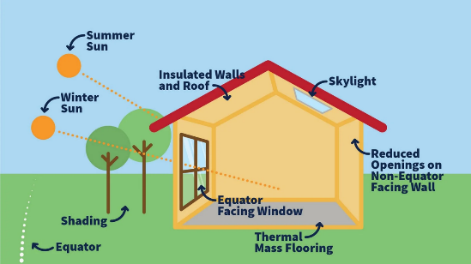
Figure 6:Passive building design
- The use of highly efficient systems like HVAC systems, highly efficient motors, and renewable energy systems.
- The use of management systems (BMS) and building automation systems (KNX) to monitor and control energy consumption of buildings.
- The coordination of design concepts between architectural, mechanical, and electrical engineers for energy-saving designs.
- The use of simulation software for the energy consumption of the designed building.
- The technical specifications of glass windows and curtain walls.
- lighting design, utilize natural lighting, and use highly efficient energy-saving lighting units.
- Priorities of Energy saving and green building in commercial and industrial projects.
- Priorities of energy saving in Residential buildings.
- Feedback data on the energy consumption of the designed building [33]

3.2.5 Local governmental laws and Local engineering guidelines in Palestine
The survey seeks to gauge participants' opinions on the extent to which local engineering guidelines in Palestine encourage the use of energy-efficient designs.
It also explores the degree to which local government laws and guidelines promote the use of energy-efficient designs.

3.2.6 Barriers to adopting energy-saving designs
This section of the survey seeks to understand participants' opinions on the main obstacles to adopting energy-saving practices in engineering design in Palestine.
Building upon the obstacles identified in previous studies, the following obstacles were identified.
- The high initial cost of energy-saving systems is a reason not to use them.
- Lack of experience in designing energy-saving systems is a reason why they are not used.
- The lack of awareness among owners and stakeholders of the importance of energy-saving systems hinders the use of these systems..
- The lack of energy-saving materials, systems, and technologies in the local market hinders the use of energy-saving systems.
- Local laws and regulations do not encourage the use of energy-saving systems

3.2.7 Suggestions to improve the compliance of engineering designs with energy-saving
We conclude the survey with suggestions to improve the alignment of architectural designs with energy-saving guidelines. These suggestions are summarized as follows:
- Financial incentives to encourage offices to adopt energy-efficient designs
- Training and technical courses
- Providing offices with free simulation software for energy-efficient designs
- A new office classification system that highlights and distinguishes offices committed to energy-efficient construction
- Legislation and regulations that mandate relevant authorities to implement energy-efficient buildings

3.3 Population
All engineering offices working in design in the West Bank and holding a classification and accreditation from the Engineers Association of the West Bank, (1062office)[5].

3.4 Inclusion criteria
- All Engineering offices in the West Bank, classified and accredited by the Engineers Association in engineering design.
- All engineering offices with all categories, the first engineering office, the second engineering office, and the third engineering office.
- All Engineering offices in the West Bank, classified and accredited by the Engineers Association in engineering design, specialized in mechanical, electrical, architectural, and civil designs.
- The engineers with experience in design, representing, and working at these design offices.

3.5 Exclusion criteria
- Offices not accredited by the Engineers Association.
- Engineers who do not work in engineering design.
- Engineers who do not work in engineering offices.
- Engineers who work in the contracting field.

3.6 limitations
- Engineering associations in the West Bank face difficulties in communication and a lack of geographical or institutional connections with the engineering field in the Gaza Strip.

- Engineering offices in the West Bank were dealt with in general, and no specific geographical areas were dealt with, but the questionnaire was sent through the engineering association to all West Bank offices.

- The electronic questionnaire was sent to the email addresses of the engineering offices listed and known to the Engineers Syndicate. No administrative or engineering level was specified for the engineer filling out the questionnaire on behalf of the engineering office.

- Gender, age, or any other specific criteria were disregarded because they were not relevant to or did not influence the technical decision; the focus was on engineering offices and engineers in general, which served the purposes of the survey and reduced the number of questions to encourage everyone to complete it.

- The variables most closely related to the research objectives were selected.

- The survey is limited to a restricted number of variables, and many details or fields could be included. However, time constraints and the fear that engineers might be discouraged from filling out the survey due to the excessive detail led us to focus on the headings.

- Many of the topics and issues covered in the survey require separate surveys and research.
- Excluding variables unrelated to the study objectives that may lead to skewed responses and reduce the accuracy of the analysis.
- The survey was limited to major topics primarily related to energy conservation and did not extend to green building details.
- Water conservation was not included in our survey, as we focused on electrical issues mainly.
- Other types of energy, like gas or coal, are not included in our research; analysis for energy consumption of sectors focuses only on electrical energy.

3.7 Sample size
Researchers used a convenience sampling method.
Researchers usually used the sample size Formula shown below in equation (1)
Unlimited population sample
n = (Z^2 * p * (1 - p)) / e^2

Finite population formula
n' = n / (1 + ((Z^2 * p * (1 - p)) / (e^2 * N))) (1)
Where:
N =Population (1062)
Z = Z-score 1.96@(confidence level 95%)
p = estimated population proportion (50%)
e = margin of error (0.05)
n' = sample size for a finite population, which is needed
With reference to the above formula and with the help of the following electronic site
https://www.calculator.net/sample-size-calculator.html?type=1&cl=95&ci=5&pp=50&ps=1055&x=Calculate
as follows: CI-95% and population= 1062 engineering office, Sample size n'= 283 engineering office.

3.8 Variables.
The variables covered by this survey, and consistent with the research hypotheses, are as follows:
- Awareness of energy-saving principles.
- Practice of energy-saving designs.
- Local laws of energy saving.
- Barriers to adopt energy saving designs.

3.9 Data collection methods
Researchers used an online-administered, descriptive cross-sectional quantitative design questionnaire about energy saving (ES), as shown in the reference Google Form address
https://docs.google.com/forms/d/12Mr9MT0wEkaODmKrzN26RDRXd-VD9hGgFWjcLxmHT6o/edit

which consists of several sections, the first of which is determining the classification and experience of the office, followed by five sections of questionnaire topics, as shown in the attached Figure 7.

Figure 7:Main survey aspects
We adopt Statistical analytical methods to analyze the survey collected data. Arithmetic Mean(M) and standard deviation (SD) are used to determine the ranking of the variable on the different factors of awareness, practice, barriers, and local laws.
The arithmetic mean (M),and standard deviation (SD) were computed by the following formulas.
Arithmetic Mean (X̄)[35]
X̄ = (ΣXi) / n (2)
Where:
X̄ = mean score
Xi = individual observation
n = number of observations

Standard Deviation (SD)[35]
SD = √[ Σ(Xi − X̄)² / (n − 1) ] (3)
Where:
SD = standard deviation
Xi = individual observation
X̄ = mean
n = sample size,
SD Value | Interpretation
SD < 0.50 | very consistent responses
0.50 – 1.00 | Moderate agreement responses
SD > 1.00 | High variability (low agreement)
[35]

Descriptive cross-sectional questionnaire details
The survey has been divided into six sections:
Section one: the independent variables, which include the classification of the engineering office and the engineers' years of experience.
Section two: Awareness of energy conservation, Scale (SPSS), which consists of 5 items with a 5-point Likert scale[36] .
strongly disagree | disagree | neutral, | agree | strongly agree.
1 | 2 | 3 | 4 | 5

Section three: practice of energy conservation Scale (SPSS), which consists of 11 items with a 5-point Lik[36].
strongly disagree | disagree | neutral, | agree | strongly agree.
1 | 2 | 3 | 4 | 5
This section divides the questions about energy-efficient design practices into several axes:
- First: Examining the level of interest given to commercial and industrial buildings and the standards of practice in these types of buildings through a set of questions designed to assess this level.
- Second: Residential buildings and examining engineering practices in this sector.
- Third: Practices related to energy conservation in general are addressed through a set of seven questions.
- In total, there are 11 questions to evaluate the overall practice.
Section four: barriers of energy conservation scale (SPSS), which consists of 5 items with a 5-point Likert scale (Cohen, 1988)[36].

strongly disagree | disagree | neutral, | agree | strongly agree.
1 | 2 | 3 | 4 | 5

Section five: Local laws of energy conservation scale (SPSS), which consists of 2 items with a 5-point Likert scale (Cohen, 1988).
1: strongly disagree, 2:disagree, 3: neutral, 4: agree, 5: strongly agree
strongly disagree | disagree | neutral, | agree | strongly agree.
1 | 2 | 3 | 4 | 5

Section six: Suggestions for improving engineering design compliance with energy conservation.
We give the surveyor 6 options to improve compliance based on the different studies and green building guidelines reviewed.
For more details, refer to Appendix C

3.10 Validity
Face validity will be used. The researcher sent the draft of the questionnaire to 3 experts
Dr Aysar Yasin
Dr Mohammed Alsayed
Dr Yahya Saleh
and the feedback was considered accordingly.

3.11 Pilot study
The researcher will distribute the questionnaire to 10 participants to assess the applicability of the study, the time required to complete the instrument, and to evaluate its reliability.

3.12 Ethical Considerations:
The researcher will obtain approval from the Engineers Association to conduct the research. Informed consent has been obtained from the Engineers' Association, and a clear message to engineering offices was included with the questionnaire, explaining its nature and objectives, and informing them that they could at any time not complete the questionnaire, and could withdraw from it without any consequences. also offices and participants were informed that the identities of participants and all received data will be kept confidential.
For details, see Appendix C

3.13 Reliability
Using the SPSS program, the internal consistency of the responses was tested to assess the reliability of the Likert scales in the survey by using Cronbach’s alpha coefficient
Cronbach’s Alpha (α)[37]
Cronbach’s Alpha (α) formula
α = [k / (k − 1)] × [1 − (Σσi² / σT²)] (4)
Where:
k = number of items
σi² = variance of individual item
σT² = total variance
According to scientific references, the minimum acceptable reliability value α is to be over ( .70). [38]
The reliability of the variables, including awareness, practice, laws, and barriers, was examined. The awareness scale demonstrated acceptable reliability (α = .70), while the practice scale showed good internal consistency (α = .77). The local laws scale exhibited excellent reliability (α = .90), and the barriers scale also demonstrated acceptable reliability (α = .70).
Table 4:Reliability coefficient
Variables | n | Cronbach Alpha
Awareness | 5 | .70
Practice | 11 | .77
Local laws | 2 | .90
Barriers | 5 | .70

3.14 Data Analysis
Data were analyzed using the Statistical Package for the Social Sciences (SPSS) version 27. Descriptive statistics, including frequencies, percentages, means, and standard deviations, were used to summarize participants' office categories and professional characteristics, levels of awareness, engineering practices, perceptions of local laws and guidelines, perceived barriers, and suggested improvements related to energy-saving and green building.[39]
Inferential analyses were conducted to examine differences in awareness, practice, and perceptions of local laws according to engineering office classification and years of experience, using one-way analysis of variance (ANOVA). Pearson correlation coefficients were calculated to explore relationships between practice subdomains, office classification, and years of experience. Statistical significance was determined at a p-value of[40]
Pearson Correlation Coefficient (r)
r= Σ [(X − X̄) (Y − Ȳ)] / √ [Σ (X − X̄) ² Σ (Y − Ȳ) ²] (5)
X, Y = variables
X̄, Ȳ = means of X and Y
The correlation coefficient ranges r within the range of -1 to +1
r=+1: perfect positive linear relationship
r=−1: perfect negative linear relationship
r=0: no linear relationship
While p-value measures are a tool for evaluating results and whether it has statistical significance or whether they fall within the null hypothesis, Statistical significance was determined at a p-value of ≤ 0.05 as discussed before, and as illustrated in Figure 8. [40].
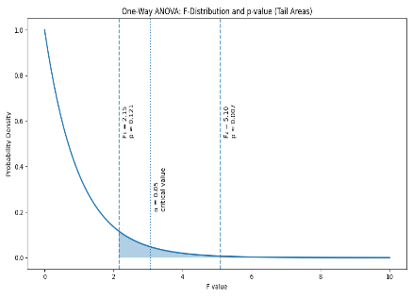
Figure 8:P-value diagram
Figure 8 explains the relation between the F-value statistic and the p-value in One-Way ANOVA. The shaded areas represent the p-values corresponding to different observed F-values.
In the example in Figure 8, the smaller shaded region (F₂) indicates a lower p-value and statistical significance, while a larger shaded region (F₁) shows a higher p-value, so we have no statistical significance. The vertical dotted line represents the critical value at the significance level α = 0.05.

Chapter Four: Results

Introduction
This chapter presents the results of the study on engineers’ awareness, practices, perceived regulatory support, and barriers related to energy-saving and green building designs. The findings are organized to describe participants’ office categories and professional characteristics, followed by analyses of awareness levels, engineering practices, local laws and guidelines, perceived barriers, and suggested improvements. Descriptive statistics and inferential analyses were used to provide a comprehensive overview of the current status of energy-saving design implementation and the factors influencing it.
For more details about the responses of all variables, see Appendix D

4.1Engineering offices classifications and engineers' experience
The distribution of participants by engineering office classification and years of experience is presented in Table 5. Among the 287 participants, the majority worked in consulting offices (n = 178, 62.0%), followed by first-class engineering offices (n = 54, 18.8%). Smaller proportions were employed in second-class offices (n = 36, 12.5%) and third-class offices (n = 19, 6.6%).
Regarding professional experience, nearly half of the participants reported more than 14 years of experience (n = 134, 46.7%). Participants with 1–5 years of experience accounted for 19.2% (n = 55), while those with 6–10 years represented 18.8% (n = 54). The smallest group consisted of participants with 11–14 years of experience (n = 44, 15.3%).
Table 5:Frequency and percentage of the office classification and years of experience (n-287)
Variables |  | n | %
Engineering office classification | Consulting Office | 178 | 62.0%
Engineering office classification | 1st class | 54 | 18.8%
Engineering office classification | 2nd Class | 36 | 12.5%
Engineering office classification | 3rd Class | 19 | 6.6%
Years of experience | 1-5 years | 55 | 19.2%
Years of experience | 6-10 years | 54 | 18.8%
Years of experience | 11-14 years | 44 | 15.3%
Years of experience | >14 years | 134 | 46.7%

By looking at Figure 9, which illustrates the percentages of survey participants and their classifications.

Figure 9;Classification of participant engineering offices

Figure 10 illustrates the percentages of survey participants according to their engineering experience. As shown below, we notice that the highest percentage of respondents have over 14 years of experience.

Figure 10:Distribution of years of experience of participant engineers

4.2 Levels of awareness of energy-saving and green building principles
Figure 11 illustrates the levels of awareness of energy-saving and green building principles among participants. The majority of respondents demonstrated a high level of awareness (64.1%), while just over one-third reported a moderate level of awareness (35.2%). Only a very small proportion of participants fell within the low awareness category (0.7%). These findings indicate that awareness of energy-saving and green building principles is generally high among the surveyed engineers, based on the predefined cut-off points (1-2.33=low, 3.34-3.67=moderate, 3.68-5=high)

Figure 11: Level of awareness of energy saving and green building principles(n=287)
Based on the following cut-off points: 1- 2.33 = low, 3.34-3.67=moderate, 3.68-5=high.
Mean score for each item toward the awareness of energy-saving and green building principles
Participants demonstrated an overall high level of awareness regarding energy-saving and green building principles (M = 3.77, SD = 0.83), while SD indicates moderate consistency. The highest levels of agreement were observed for beliefs related to the environmental and economic value of energy efficiency. Specifically, respondents strongly agreed that energy-efficient buildings contribute to reducing environmental impacts and global warming (M = 4.43, SD = 0.60) and that the use of renewable energy systems is important and economically viable in all buildings (M = 4.41, SD = 0.71).
In contrast, items related to practical exposure and training reflected only moderate awareness. Participants reported moderate agreement that most engineers in their offices possess a basic understanding of green building codes and energy efficiency guidelines (M = 3.44, SD = 1.00)with a notably high SD, which indicates high variability in responses. Similarly, the lowest mean score was observed for the item addressing completion of training courses on energy conservation and green building design among design engineers (M = 2.81, SD = 1.10)with high SD (high variance in responses ). As seen in Table 6.
Table 6: Awareness of energy saving and green building principles (n=287)
Item | Mean | SD | Status
- Most engineers in our office have at least a basic understanding of green building codes and energy efficiency guidelines. | 3.44 | 1.00 | Moderate
- The design engineers in our office have completed training courses on energy conservation and green building design. | 2.81 | 1.10 | Moderate
- The use of renewable energy systems is important and economically viable in all buildings. | 4.41 | 0.71 | High
- Energy-efficient buildings contribute to reducing environmental impacts and global warming. | 4.43 | 0.60 | High
Total Mean Score (4 items) | 3.77 | 0.83 | High
Cut off points; 1-2.33=low, 2.34-3.67=moderate, 3.68-5=high
We note in the results of the variables in the previous table that the standard deviation for the first two items is one or greater than one, which indicates a variation in the engineers' responses, while the third and fourth items range between 0.6 and 0.71, which indicates a moderate consistency of the results, in general the total standard deviation for the awareness moderate consistency.

Table 7 presents the frequency and percentage distribution of green building features considered most important by participants. The majority of respondents indicated that the integration of all energy-saving methods was the most important feature (n = 200, 69.7%). This reflects a strong preference for a holistic approach that combines multiple green building strategies.
Table 7: Frequency and percentage of the features of green buildings considered most important
Item | Responses | n | %
5. Which features of green buildings do you consider? | Renewable energy systems like solar heaters and PV systems | 38 | 13.2%
5. Which features of green buildings do you consider? | building management systems BMS, Smart control systems, KNX | 7 | 2.4%
5. Which features of green buildings do you consider? | high energy-efficient electromechanical systems) | 9 | 3.1%
5. Which features of green buildings do you consider? | high insulation of the roof and walls, and passive building techniques | 33 | 11.5%
5. Which features of green buildings do you consider? | All of them (integration of all energy-saving methods). | 200 | 69.7%

4.3Engineering practices for energy-saving designs
Figure 12 shows the levels of engineering practices for energy-saving designs among participants. More than half of the respondents reported a moderate level of practice (51.9%), while 46.0% demonstrated a high level of engineering practice related to energy-saving designs. Only a negligible proportion of participants fell within the low practice category (2.1%). Based on the predefined cut-off points (low: 1–2.33; moderate: 3.34–3.67; high: 3.68–5), these findings indicate that engineering practices toward energy-saving designs are generally moderate to high among the study sample.

Figure 12Level of engineering practice for energy saving designs(n=287)
based on the following cut-off points: 1-2.33=low, 3.34-3.67=moderate, 3.68-5=high
Mean score for the item toward engineering practices for energy-saving designs
Participants reported a moderate overall level of energy-saving engineering practices (M = 3.48, SD = 0.54), while SD indicates good consistency of responses. Practices in commercial and industrial projects showed a moderate emphasis on energy conservation and green building principles (M = 3.44, SD = 0.78), including attention to energy-efficient systems and the use of BMS/automation technologies.
For residential buildings, respondents show low level of practice toward attention to energy saving (M = 2.21, SD = 0.93), indicating a notable gap in practice. In contrast, energy-efficient building design strategies demonstrated a high level of implementation overall (M = 3.68, SD = 0.57), particularly in passive design approaches, HVAC efficiency, insulation, glazing specifications, and energy-efficient lighting, while the use of simulation software and post-design energy monitoring remained moderate. As seen in Table 8 ,and in Figure 13.

Table 8:Mean score for items towards engineering practices for energy saving designs(n=287)
Item | M | SD | Status
Commercial and Industrial
- Energy conservation and green building are priorities in all construction projects, especially commercial and industrial ones. | 3.57 | 1.01 | Moderate
- In commercial and industrial projects, greater attention is paid to the design of energy-efficient systems and the preparation of bills of quantities and specifications for all systems, including renewable energy systems. | 3.50 | 0.93 | Moderate
- In most of our commercial and industrial projects, energy management systems (BMS) and building automation systems (KNX) are specified to save energy. | 3.25 | 1.04 | Moderate
Total Mean Score for commercial and industrial (3 items) | 3.44 | 0.78 | Moderate
Residential Buildings
- Most engineering designs of residential buildings pay much attention to energy saving. * | 2.21 | 0.93 | Low
Energy-Efficient Building Design
- We usually use passive building techniques (such as natural ventilation, proper orientation, thermal mass, daylight, and shading) in our designs. | 3.80 | 0.87 | High
- We usually coordinate design concepts with the design team, including architects, mechanical engineers, and electrical engineers, to ensure compatibility between the building envelope and electromechanical systems, thereby achieving an energy-efficient building. | 3.51 | 1.00 | Moderate
- The use of simulation software to estimate the energy consumption of designed buildings is one of the main steps in our designs. | 3.02 | 1.07 | Moderate
- We design highly efficient HVAC systems and provide good insulation to improve and save energy consumption in buildings. | 4.26 | 0.70 | High
- One of the main points of the technical specifications of glass in windows and curtain walls is its effect on energy saving. | 3.77 | 0.87 | High
- In lighting design, we focus on utilizing natural lighting and using highly efficient, energy-saving lighting units. | 4.17 | 0.71 | High
- We are usually interested in obtaining feedback data on the energy consumption of the buildings we have designed and on how well the implementation conforms to the design documents. | 3.21 | 1.02 | Moderate
Total Mean Score for Energy-Efficient Building Design (7 items) | 3.68 | 0.57 | High
Total Mean Score (11 items) | 3.48 | 0.54 | Moderate
Cut off points; 1-2.33=negative, 2.34-3.67=neutral, 3.68-5=positive
*Reverse item

Figure 13:levels of engineering practices for energy saving design(n=287)
based on the following cut-off points: 1-2.33=low, 3.34-3.67=moderate, 3.68-5=high

4.4Local laws and engineering guidelines
Participants perceived local laws and engineering guidelines as providing a moderate level of support for energy-saving designs (M = 3.08, SD = 1.10). Both local engineering guidelines in Palestine (M = 3.13, SD = 1.10) and governmental laws and regulations (M = 3.02, SD = 1.10) were rated at a moderate level. As seen in Table 9.
Table 9:Frequency and percentages toward local laws and engineering guidelines (n=287)
Item | Mean | SD | Status
Local engineering guidelines in Palestine encourage energy-saving designs | 3.13 | 1.10 | Moderate
Local governmental laws and guidelines encourage energy-saving designs. | 3.02 | 1.10 | Moderate
Total Mean Score (2 items) | 3.08 | 1.10 | Moderate
Cut off points; 1-2.33=low, 2.34-3.67=moderate, 3.68-5=high

4.5Barriers to adopting energy-saving designs.
Participants reported high perceived barriers to adopting energy-saving designs. The most prominent barriers were the lack of awareness among owners and stakeholders (M = 4.25, SD = 0.75), with SD indicating moderate consistency. the high initial cost of energy-saving systems (M = 4.09, SD = 0.81) SD indicating moderate consistency. A lack of professional experience in designing energy-saving systems (M = 3.78, SD = 0.94), with low agreement of responses, and insufficient encouragement from local laws and regulations (M = 3.72, SD = 0.97) were also rated as high barriers.
In contrast, the availability of energy-saving materials, systems, and technologies in the local market was perceived as a moderate barrier (M = 3.50, SD = 1.04), with the lowest agreement in responses. Overall, these findings suggest that economic constraints, limited stakeholder awareness, and regulatory challenges are the primary obstacles to wider adoption of energy-saving design practices. As seen in Table 10.
Table 10Mean score for each item toward barriers to adopting energy-saving design (n=287)
Item | Mean | SD | Status
- The high initial cost of energy-saving systems is a reason not to use energy-saving systems. | 4.09 | 0.81 | High
- Lack of experience in designing energy-saving systems is a reason why they are not used. | 3.78 | 0.94 | High
- The lack of awareness among owners and stakeholders of the importance of energy-saving systems hinders the use of these systems. | 4.25 | 0.75 | High
- The lack of energy-saving materials, systems, and technologies in the local market hinders the use of energy-saving systems. | 3.50 | 1.04 | Moderate
- Local laws and regulations do not encourage the use of energy-saving systems | 3.72 | 0.97 | High
Cut off points; 1-2.33=low, 2.34-3.67=moderate, 3.68-5=high,

4.6Suggestions for improving engineering design compliance with energy conservation.
Table 11 summarizes participants’ suggestions for improving engineering design compliance with energy conservation. The majority of respondents favored a comprehensive approach, with two-thirds indicating that all proposed measures are needed (n = 191, 66.6%).
Among individual suggestions, Legislative measures aimed at obligating stakeholders to implement energy-efficient buildings were also suggested by a notable proportion of participants (n = 20, 7.0%). Fewer respondents recommended providing engineering offices with free simulation software for energy-efficient designs (n = 16, 5.6%) or establishing a new office classification to distinguish offices committed to energy-efficient construction (n = 8, 2.8%). As seen in Table 11.

Table 11:Suggestions for improving engineering design compliance with energy saving guidlines
Suggestions | n | %
Financial incentives | 28 | 9.8%
Courses and technical training | 24 | 8.4%
Providing offices with free simulation software for energy-efficient designs | 16 | 5.6%
A new office classification that highlights and distinguishes offices committed to energy-efficient construction | 8 | 2.8%
Legislation and laws that help oblige stakeholders to implement energy-efficient buildings | 20 | 7.0%
All of the above | 191 | 66.6%

4.8Differences between awareness, practice, and local laws scores in terms of both office classification and years of experience.
Differences in awareness, practice, and perceptions of local laws were examined according to engineering office classification and years of experience using p-value analysis in SPSS. No statistically significant differences were observed in awareness scores across office classifications, p = .545. Similarly, practice scores did not differ significantly by office classification (p = .309) or years of experience (p = .095). Perceptions of local laws and regulations encouraging energy-saving designs were also comparable across engineering office classifications (p = .880) and experience groups (p = .647). However, a significant difference was observed in years of experience (p = .021). A post hoc test indicated that those participants who have >14 years of experience have higher awareness compared with others. As seen in Table 12.
Table 12differences between awareness,practices,and local laws scores in terms of both office classifications and years of experience (n=287)
Variables |  | n | Awareness |  | Practice |  | Local Law
 |  | n | Mean  (SD) | P-value | Mean (SD) | P-value | Mean (SD) | P-value
Engineering office classification | Consulting Office | 178 | 3.53  (0.46) | 0.545 | 3.60 (0.54) | .309 | 3.10 (1.07) | .880
Engineering office classification | 1st Class | 54 | 3.38 (0.53) | 0.545 | 3.68 (0.41) | .309 | 3.09 (1.01) | .880
Engineering office classification | 2nd Class | 36 | 3.56 (0.55) | 0.545 | 3.55 (0.45) | .309 | 2.94 (1.09) | .880
Engineering office classification | 3rd Class | 19 | 3.57 (0.56) | 0.545 | 3.78 (0.61) | .309 | 3.08 (1.04) | .880
Years of experience | 1-5 years | 55 | 3.34 (0.58) | .021* | 3.51 (0.57) | .095 | 3.19 (1.04) | .647
Years of experience | 6-10 years | 54 | 3.38 (0.55) | .021* | 3.55 (0.51) | .095 | 3.01 (0.99) | .647
Years of experience | 11-14 years | 44 | 3.47 (0.38) | .021* | 3.64 (0.36) | .095 | 2.94 (0.96) | .647
Years of experience | >14 years | 134 | 3.57 (0.54) | .021* | 3.69 (0.53) | .095 | 3.10 (1.12) | .647
One-Way ANOVA
Differences in barriers to adopting energy-saving designs were examined according to engineering office classification and years of experience. No statistically significant differences were observed across office classifications, p = .124, and years of experience (p = .788). As seen in Table 13.
Table 13Differences between barriers to adopting energy saving designs in terms of office classifications and years of experience(n=287)
Variables |  | n | Barriers
 |  | n | Mean  (SD) | P-value
Engineering office classification | Consulting Office | 178 | 3.94 (0.54) | .124
Engineering office classification | 1st Class | 54 | 3.97 (0.67) | .124
Engineering office classification | 2nd Class | 36 | 4.04 (0.55) | .124
Engineering office classification | 3rd Class | 19 | 3.81 (0.57) | .124
Years of experience | 1-5 years | 55 | 3.86 (0.57) | 0.788
Years of experience | 6-10 years | 54 | 3.93 (0.63) | 0.788
Years of experience | 11-14 years | 44 | 3.89 (0.54) | 0.788
Years of experience | >14 years | 134 | 3.84 (0.58) | 0.788

4.9Relationships between practice subdomains in terms of both office class and years of experience
Pearson correlation analysis was conducted to examine the relationships between practice subdomains, office class, and years of experience (n = 287). Office class was not significantly correlated with any of the practice subdomains (all p > .05). Years of experience showed a significant positive correlation with energy-efficient building practices (r = .178, p = .002), suggesting that greater professional experience is associated with increased adoption of energy-efficient building practices.
Commercial and industrial practices were strongly and positively associated with energy-efficient building practices (r = .600, p = .001). Residential building practices demonstrated a weak but statistically significant positive correlation with years of experience (r = .133, p = .025) and with energy-efficient building practices (r = .163, p = .006). As seen in Table 14
Table 14:Relations between practice subdomains in terms of both office classification and years of experience (n=287)
Variables |  | 1 | 2 | 3 | 4 | 5
1. Office class | r | --
2. Years of experience | r | .088 | --
 | P-value | .137
3. Commercial and Industrial buildings | r | -.014 | .105 | --
 | P-value | .820 | .074
4. Residential Building | r | .058 | .133 | .100 | --
 | P-value | .331 | .025* | .091
5. Energy-Efficient Building | r | -.038 | .178 | .600 | .163 | --
 | P-value | .524 | .002* | .001* | .006*
*Sig at p-value ≤ 0.05.

Chapter Five

Discussion of results

5.1 Introduction
The findings of our study showed that the levels of awareness of energy-saving and green building principles among participants are generally high among the surveyed engineers. The majority of respondents demonstrated a high level of awareness (64.1%), while just over one-third reported a moderate level of awareness (35.2%).
It shows that the majority of engineers' engineering practices toward energy-saving designs are generally moderate, according to the study sample. The levels of engineering practices for energy-saving designs among participants reported a moderate level of practice (51.9%), while (46.0%) demonstrated a high level of engineering practice related to energy-saving designs. Only a negligible proportion of participants fell within the low practice category.
In addition to the above items, participants expressed their views on the extent to which local laws and engineering guidelines encourage energy-efficient designs. The survey showed a moderate level of support for energy-efficient designs.
Regarding the obstacles to adopting energy-efficient designs, the survey results showed that the most prominent obstacles are a lack of awareness among owners and stakeholders and the high initial cost of energy-saving systems. Following these, in terms of the survey's ranking, are a lack of professional expertise in designing energy-saving systems and insufficient encouragement from local laws and regulations. In contrast, the availability of energy-efficient materials and technologies in the local market was considered a moderate obstacle.
Finally, regarding participants' suggestions for improving the alignment of engineering design with energy efficiency, the majority supported a comprehensive approach. Two-thirds (66.6%) indicated the need to implement all suggestions, including financial incentives, initiatives to provide engineering firms with simulation software for developing energy-efficient designs, and the development of local legislation that compels stakeholders to adopt energy-efficient designs.

5.2Awareness of energy-saving and green building principles
The majority of respondents demonstrated a high level of awareness (64.1%), while just over one-third reported a moderate level of awareness (35.2%).
Participants demonstrated a high level of general awareness of energy efficiency and green building principles (mean = 3.77, standard deviation = 0.83). The attached Figure 14 illustrates the respondents' interaction with the different variables.

Figure 14:Engineering responses to variables of awareness

5.2.1Awareness results indication
The detailed results of the various variables used to measure awareness indicate the following points:
- The highest levels of agreement were recorded regarding beliefs related to the environmental and economic value of energy efficiency, with participants strongly agreeing that energy-efficient buildings contribute to reducing environmental impacts and global warming (mean = 4.43, standard deviation = 0.60).
This may relate to the following points:
- A good knowledge base gained through university programs and academic courses, and by reviewing sustainability and green building guidelines and codes.
- It's linked to local environmental awareness programs in governmental institutes and local associations, and through the media.
- The environmental impact of energy and global warming are international trends.
- The use of renewable energy systems is important and economically viable in all buildings (mean = 4.41, standard deviation = 0.71).
The high awareness of this point may be due to the following reasons:
- The widespread adoption of solar energy systems in the local market.
- Awareness campaigns and promotions of these systems are being conducted by companies.
- Rising energy prices have made stakeholders and engineers aware of their importance.
- The lack of reliable energy sources makes these systems a priority for all parties.

- In contrast. Participants reported moderate agreement that most engineers in their offices have a basic understanding of green building codes and energy efficiency guidelines (mean = 3.44, standard deviation = 1.00).
This point may highlight the importance of providing engineering offices with:
- Aperiodic publications of energy-efficient engineering instructions and local or international codes.
- A comprehensive and mandatory program to be developed to qualify engineers in engineering codes and energy conservation codes.
- The lowest average score was recorded in the item relating to the completion of training courses on energy conservation and green building design among design engineers (mean = 2.81, standard deviation = 1.10).
This indicates the following:
- The need to develop a plan to assess the level of awareness and knowledge of engineers in any office and provide them with the necessary training courses.
- The necessity of a minimum number of courses or training programs that an engineer must complete to be eligible to work in engineering design.
- However, a significant difference was observed in years of experience (p < 0.021). A subsequent test showed that participants with more than 14 years of experience demonstrated greater awareness compared to others.
This can be explained by their extensive experience and knowledge gained through their expertise, or it may also be because those with greater experience often have access to training courses or workshops due to their managerial positions. This underscores the need to raise awareness among all engineers, regardless of their experience level, through a comprehensive program for developing the engineering sector.

5.2.2 Awareness of Energy Saving, Comparison with Previous Studies
By reviewing several previous studies, A study conducted in Macedonia, which surveyed construction developers, including designers, architects, and civil engineers, found that most were aware of green building concepts. The developers acknowledged benefits such as reduced operating costs and improved indoor environmental quality [22].
Another study conducted in Pune, India, investigated the awareness and understanding of green building practices among construction engineers. A key finding was the varying levels of knowledge and awareness of green building among construction engineers in Pune [23].
According to a study conducted in Nigeria, the results revealed a high level of awareness and application of energy-efficient design strategies among construction professionals in Abuja, Nigeria. Approximately 78% of the architects and engineers surveyed reported being familiar with various energy efficiency measures [24]es [24].
By comparing the results of these studies with existing findings on energy conservation awareness, we observe that the majority of studies indicate an awareness among engineers regarding energy conservation, although the level varies from region to region. The results showed that three of them have a high level of awareness, similar to our findings, while the other studies indicate a moderate to high level of awareness. This makes our results consistent with the findings of other studies.
The following Table 15 summarizes the comparison with the previous studies

Table 15:Awareness comparison with previous studies

5.3Engineering Practices for Energy-Efficient Designs
The study revealed a moderate level of engineering practice compared to a high level of awareness.
- More than half of the participants reported a moderate level of practice (51.9%), while 46.0% demonstrated a high level of engineering practices related to energy-efficient designs. These results indicate that engineering practices for energy-efficient designs generally range between moderate and high among the study sample.
- Mean Score for the Engineering Practices for Energy-Efficient Designs Item
Participants reported a moderate level of overall energy-efficient engineering practices (mean = 3.48, standard deviation = 0.53).
- Commercial and industrial projects :
The study showed that practices in commercial and industrial projects give a moderate focus on energy conservation and green building principles (mean = 3.44, standard deviation = 0.78), including attention to energy-efficient systems, renewable systems, and the use of building management/automation technologies, By studying the results of the survey on variables related to commercial buildings, we note the following:

- The results for the three variables related to this type of project are moderate, with a high standard deviation indicating heterogeneity in the findings.
- The variables assumed that commercial buildings prioritize energy conservation, and responses were at a moderate level, encompassing both energy-efficient and renewable energy systems.
- Despite a high level of awareness regarding renewable energy systems and their importance in energy conservation, their implementation during the design phase of commercial projects is moderate. This confirms that awareness may not translates into practice, even in large-scale projects where the use of renewable energy is clearly economically viable.
- While the design level of the commercial projects is expected to comply with energy saving guidelines, given the high feasibility of energy saving in this type of project, we see that moderate compliance may be because of the requirements of stakeholders regarding the initial cost of the buildings may be among the main reasons for this. This will be addressed in the discussion of obstacles to implementing energy-efficient systems.

- Residential building designs :
Regarding residential buildings, participants highlighted negative practices concerning energy efficiency (mean = 2.21, standard deviation = 0.93) the results indicate the following:
- It indicates a significant gap between awareness and practice.
- This is of particular concern, given that residential buildings constitute 84% of the overall construction sector, representing six million out of 7.2 million square meters according to the 2023 engineers' association report.[41]. Figure 15 shows the proportion of residential projects compared to other types of projects.

Figure15:Residential projects percentage in the West Bank
- High Impact of the low compliance of the energy-saving residential sector on energy consumption. According to the annual report of the Palestinian Energy Authority 2023, the total annual electricity consumption in Palestine is 7,244,787 MWh. The residential sector consumes 76.4% of the total electricity consumption across all sectors. This highlights the importance of focusing on the residential building sector and addressing any shortcomings in energy conservation measures within this sector, as shown in Figure 16[10]

Figure 16:Electrical energy consumption percentage in different sectors
- Energy-efficient strategies:
In contrast, energy-efficient building design strategies demonstrated a generally high level of implementation (mean = 3.68, standard deviation = 0.57), particularly in passive design approaches, HVAC system efficiency, insulation, glazing specifications, and energy-efficient lighting. However, the use of simulation software and post-design energy monitoring remained moderate.
In Figure 17, we can see these variables

Figure 17:Energy saving design techniques results, cut-off points: 1- 2.33 = low, 3.34-3.67=moderate, 3.68-5=high.
The abbreviations on the x-axis refer to the variables ESV1: Passive building techniques , ESV2: coordination and integration of all systems, ESV3: simulation software. ESV4:design high efficient HVAC systems, ESV5: Windows and a curtain wall energy saving specification, ESV6: Natural lighting and highly efficient fixtures, ESV7: Obtaining feedback on the audit data of energy saving.
Based on the results of the sub-section "Energy-Efficient Building Design Strategies" within the section on energy-efficient practices, these results can be interpreted as follows:
- Energy-efficient HVAC systems ESV4, The Mean score of was high (mean = 4.26, SD = 0.7), which is the top result in this section. This may be attributed to many reasons:
- High-energy-saving HVAC systems are a core part that international energy codes and green buildings focus on.
- HVAC systems' features, inverter COP, and EER are among the essential elements that the designer must consider, including thermal comfort and energy-saving features, and these are also tangible for stakeholders in energy saving.
- The extensive commercial and marketing activity of the agents for these systems. These companies conduct training courses for engineering offices, communicate with engineers and stakeholders, and provide programs, catalogs, and explanations that significantly contribute to the adoption of these systems.
- The largest percentage of energy consumption in commercial and residential buildings is due to air conditioning systems, which makes them important to designers and stakeholders alike, and this drives interest in implementing energy conservation through highly efficient systems.
- Natural lighting and high-efficiency LED lighting ESV6. Similarly, the use of natural lighting and energy-efficient lighting such as , was reported at a high level in practice of energy efficient technologies (Mean=4.17, SD=0.71), which could be for many reasons.
- Natural lighting is considered obvious to the public, engineers, and stakeholders as a first choice for saving energy.
- The energy saving of LED lighting fixtures is clear, and it is also measurable.
- LED lighting: Relatively low initial cost and viability in the local markets.
- The public's and stakeholders' awareness of the importance of LED lighting for energy conservation, in addition to the low cost of LED lighting and the importance of natural lighting, encourages and improves designer practice.

- Passive building techniques-ESV1,results shows high practice ( Mean=3.8,SD=0.87) may be related to the following reasons:
- Passive building features like Natural ventilation, building orientation, and thermal mass are commonly introduced in academic programs for engineers, especially architecture engineers.
- Relatively low initial cost and economically feasible for stakeholders.
- Low running and operational costs.

- Low thermal conductivity U value of Windows and curtain walls-ESV5 Respondent shows a high level of practice (Mean=3.77, SD=0.87) for specifications to improve energy saving.
- Despite the high level of responses regarding glass walls, I am not convinced that this is the reality of engineering designs.
- Its specifications are linked to keeping pace with the requirements of green building codes and energy efficiency codes, and this was not strongly reflected in the average responses regarding engineers' awareness of energy efficiency codes.
- The nature of the question posed in the survey may have been more detailed and addressed updated ratios and details of thermal insulation to ensure that the answer was accurate.
- The high prices of energy-efficient and low-conductivity glass windows and facades lead me to suspect that engineers are not paying close attention to these specifications.
- I think mandatory engineering supervision is required during implementation to ensure these specifications are applied, as the price of low-thermal-conductivity glass is significantly higher, which may reduce its adoption by stakeholders.
- On the other hand, the moderate results of other practices, such as the use of simulation software-ESV3 and coordination between different drawings -ESV2(electrical, mechanical, and architectural).
- This may indicate the importance of raising awareness about this point. For example, a passive building design and energy-efficient air conditioning system cannot be achieved without coordination between the air conditioning designer and the designers of walls, ceilings, and glass facades.
- Similarly, the lighting designer needs to coordinate with the architect to utilize the building's natural light to reduce lighting costs.
- We canot achieve high efficiency HVAC without make coordination with architectural designer.
- We cannot have a high-efficient low-energy lighting system with coordinate electrical designer with architectural designer to achieve natural lighting and low cost lighting system .
- Obtaining feedback data-ESV7 about energy saving measures in designed buildings. The results showed moderate results in a survey (Mean=3.21, SD=1.02).

- The fact that the engineer does not receive feedback on the projects being designed may be because a large percentage of projects are carried out without engineering supervision.
- This causes the engineer to lose the ability to follow up on the implementation of the systems that are being designed and specified, and also loses the ability to obtain feedback on what has been accomplished in terms of designs.
- Paying attention to obtaining feedback on the energy performance of designed projects raises the engineer's level of knowledge. Also, it provides an idea of and a measure of the efficiency of systems compared to their theoretical specifications.
- This highlights the importance of having binding laws and regulations requiring the designing engineering office to supervise all systems during the implementation phases, rather than a superficial supervision that sometimes limits itself to partial monitoring of some architectural details.
- Finally, the results of energy-saving strategies practice are encouraging, although a thorough understanding of these techniques and their effective implementation requires extensive training and qualification, which falls under the responsibility of the relevant association and institutions.
- The high practice in energy saving techniques does not reflect on commercial building designs and residential building designs, and this shows a contradiction between theoretical answers about practice and the responses when we deal with specific buildings

5.3.1Practice of energy-saving compared with previous studies
According to a study in Nigeria [24], findings of the study reveal In terms of practical application, about 69% of the respondents stated that they frequently implement energy-efficient strategies in their design work, whereas 31% reported a low level of implementation, while in our results More than half of the participants reported a moderate level of practice (51.9%), while 46.0% demonstrated a high level of engineering practices related to energy-efficient designs,
Although the results differ in terms of numbers, they agree that the level of awareness is
higher than the level of application and practice of energy conservation guidelines.
The following Table 16 shows the summarized data of previous studies compared with our current study.

Table 16:Practice comparison with previous studies

5.3.2 Energy Saving design Practice and its impact on energy consumption
The annual designed construction project area in the West Bank is around 7.2 million square meters in 2022, according to the annual report 2023[41], as shown in Table 17
Table 17:Annual designed area -west bank
The residential designed area is (6,095,311 m2), which constitutes the largest percentage.
The negative response in the survey practice results underscores the importance of highlighting the effects of non-compliance with energy-saving guidelines.
To illustrate the extent of this impact, we present a brief study of energy consumption rates in this sector and its environmental effects through calculations of carbon dioxide values. Conversely, a study should be conducted on energy savings and positive environmental impacts if energy-efficient designs are adopted and implemented in a comprehensive manner.

- Residential building energy analysis:

Annual expected energy consumption of the residential design area in 2022.
Baseline data:
Residential sector designed area at 2022 = (6,095,311 m2)
Electrical energy utilization index (residential benchmark) EUI =30.73KWh/m2. year. According to the data mentioned in the literature review 2.1.2 [13]
Annual electrical energy consumption= Residential area (m2) x EUI(KWh/m2.year) (1)
Annual electrical energy consumption =187,308,907 kWh
If engineering principles are applied in design and implementation in accordance with engineering codes such as ASHRAE (ANSI/ASHRAE/IES 90.2-2018, Energy-Efficient Design of Low-Rise Residential Buildings), energy-efficient buildings can be achieved, with savings 20%,30%, 50%. According to ASHRAE design guideline AEDG for commercial buildings.[42]
CO2eq factor=0.72 (tCO2/MWh) according to Sustainable Energy Access & Climate Action Plan SEACAP, Municipality of Ramallah, Palestine 2022. ref.[43]
In Table 18, we summarized the expected energy saving of a residential building of 2022
Table 18:Energy saving analysis-Residential buildings.
Energy saved = baseline energy × saving %
CO2 saved = (energy saved ÷ 1000) × CO2 factor
The positive economic impact of energy conservation in the residential sector
To study the positive impact of energy savings in the residential sector, the information in Table 21 will be used. Regarding electricity tariffs, the tariff adopted in Palestine for 2025, available on the Electricity Sector Regulatory Authority's website, will be used. The residential tariff for the middle-income bracket was $0.21 for tariff data (see Appendix E ).In Table 19, we estimate economic benefits for the expected savings
Table 19:Energy cost -saving analysis-residential buildings
Residential Sector(designed areas 2022)- Cost Savings Analysis
Scenario | Energy saved (kWh/yr) | Tariff ($) | Energy cost saving ($)/year
20% saving | 37,461,781.41 | 0.21 | 7,866,974.095
30% saving | 56,192,672.11 | 0.21 | 11,800,461.14
50% saving | 93,654,453.52 | 0.21 | 19,667,435.24
The table shows the savings on electricity bills when following savings strategies ranging from partial strategies that contribute to reducing consumption by 20% to comprehensive strategies such as passive building, energy-efficient systems, renewable energy systems, and the use of energy management software. All of these contribute to reducing consumption by up to 50%, and this should be our goal as engineering firms and institutions striving to reduce energy consumption and mitigate the negative effects of high energy consumption.
- Commercial building energy analysis:
Commercial spaces constitute the second largest category in engineering designs, with 941,131m2 area completed in 2022. Although the survey results indicate a greater commitment in this sector, we lack information on the actual implementation of these designs. Through this study, we performed energy calculations to assess the impact of adhering to energy conservation guidelines on consumption and carbon emissions within this sector.
Annual expected energy consumption of the commercial building designed area in 2022.
Baseline data:
Commercial sector designed area in 2022 = (941,131m2)
Electrical energy utilization index (commercial benchmark) EUI =153 kWh/m2. year. According to the data mentioned in the literature review 2.1.2 [15]
Annual electrical energy consumption= commercial area (m2) x EUI(KWh/m2.year) (1)
Annual electrical energy consumption =143,993,043 kWh
If engineering principles are applied in design and implementation in accordance with engineering codes such as ASHRAE (ANSI/ASHRAE/IES 90.2-2018, Energy-Efficient Design of Commercial Buildings), energy-efficient buildings can be achieved, with savings of 20%, 30%, and 50%. According to ASHRAE design guideline AEDG for commercial buildings.[42]
CO2eq factor=0.72 (tCO2/MWh) according to Sustainable Energy Access & Climate Action Plan SEACAP, Municipality of Ramallah, Palestine 2022. ref.[43]
In Table 20, we summarized the expected energy saving of the commercial building of 2022.

Table 20Energy saving-commercial buildings.
Energy saved = baseline energy × saving %
CO2 saved = (energy saved ÷ 1000) × CO2 factor

The positive economic impact of energy conservation in the commercial sector
To study the positive impact of energy savings in the commercial sector, the information in Table 23 will be used. Regarding electricity tariffs, the tariff adopted in Palestine for 2025, available on the Electricity Sector Regulatory Authority's website, will be used.
The commercial tariff (0.235$)for tariff data (see Appendix E ), table 21 shows the cost savings analysis for the commercial sector (designed buildings in 2022).
Table 21:Energy cost saving analysis -commercial buildings
Commercial Sector (designed areas 2022)- Cost Savings Analysis
Scenario | Energy saved (kWh/yr) | Tariff ($) | Energy cost saving ($)/year
20% saving | 28,798,608.60 | 0.235 | 6,767,673.021
30% saving | 43,197,912.90 | 0.235 | 10,151,509.53
50% saving | 71,996,521.50 | 0.235 | 16,919,182.55

From the previous tables, we can see the positive impact of energy savings on the annual electricity bill, especially since our political and economic conditions during the last two years require everyone to work on saving energy due to the difficult economic conditions the country is suffering from.

5.4 Local laws and engineering guidelines
Regarding local regulations, participants found that local laws and engineering guidelines provide a moderate level of support for energy-efficient designs (mean = 3.08, standard deviation = 1.10).
Local engineering guidelines in Palestine, which are primarily the regulations and instructions of the Engineers association, relevant municipalities, and institutions, were rated as moderate (mean = 3.13, standard deviation = 1.10).
The level of support for government laws and regulations on energy conservation was also moderate, but lower than that of engineering guidelines (mean = 3.02, standard deviation = 1.10). We may have the following notes.
- Despite the variation in engineers' responses, their overall assessment of the encouragement provided by engineering guidelines, laws, and government procedures is moderate to weak.
- This indicates a need to review engineering regulations and guidelines, as well as laws and their implementation mechanisms, to increase compliance with energy-efficient building standards.
- The renewable energy law, which was adopted by the government but subsequently suspended following negative reactions from the public and numerous related companies and institutions, underscores the need for laws that are motivating, encouraging, and commensurate with the exceptional circumstances.
(see Appendix F)

5.4.1Local laws and engineering guidelines comparison with previous studies
Based on previous studies, the recommendations align with the conclusions reached regarding laws and regulations.
Both the Chinese[31] and American [32]an [32] Studies recommend raising the level of laws and incentives that encourage the adoption of energy-efficient buildings and practices.

5.5 Barriers to Adopting Energy-saving Designs
Participants shared their opinions on the obstacles to adopting energy-efficient designs.
The most significant obstacles identified by participants were:
- Lack of awareness among owners and stakeholders (mean = 4.25, standard deviation = 0.75).
- High initial cost of energy-saving systems (mean = 4.09, standard deviation = 0.81).
- Lack of professional expertise in designing energy-saving systems. Participants considered this an important obstacle, though less so than the previous ones (mean = 3.78, standard deviation = 0.94).
- Insufficient encouragement from local laws and regulations. Participants ranked this obstacle as less important than the previous points (mean = 3.72, standard deviation = 0.97).
- Conversely, the availability of energy-efficient materials, systems, and technologies in the local market was considered a moderate obstacle (mean = 3.50, standard deviation = 1.04).
With reference to the results, we have the following indications:
- Overall, these results indicate that the economic dimension, due to the high initial costs of energy-efficient systems and limited stakeholder awareness, is among the most significant reasons for the lack of adoption of this approach.
- Regulatory challenges and a lack of expertise are also the main obstacles to expanding the adoption of energy-efficient design practices.
- It should be noted that participants expressed moderate agreement regarding the inadequacy of local technical regulations and laws in providing sufficient encouragement.

5.5.1Barriers to Adopting Energy-saving Designs in previous studies:
In comparison with previous studies, we refer to two studies, one in China and the other in the USA.
- The results of a Chinese study on the obstacles preventing the adoption of energy-saving measures showed that the hesitation of stakeholders to adopt energy-saving technologies was the biggest obstacle, followed by high initial investment costs.[31]
This is entirely consistent with the results we reached in our study.
- The USA study highlights several key obstacles, categorized as financial, informational, and administrative. Inadequate awareness among property owners and stakeholders is identified as the greatest challenge. The study recommends increasing public awareness, providing government incentives, and enforcing strict energy efficiency standards to encourage the adoption of sustainable practices in real estate development.[32]
This also aligns with our study's findings, where stakeholder awareness is the primary obstacle to adopting energy-saving measures. The recommendation to provide incentives to encourage energy conservation also supports our findings, as financial incentives help overcome the high initial costs, which our study identifies as the second largest obstacle.

5.6 Suggestions for improving engineering design compliance with energy conservation.
Figure 18 summarizes participants' responses for improving the compatibility of engineering design with energy-saving guidelines.

Figure 18Suggestions for improving compliance with energy saving guidlines
The majority of participants supported a comprehensive approach to improving adherence to energy-efficient designs and buildings, with two-thirds (66.6%) indicating the need for all proposed suggestions (191 participants).
Individual proposals included financial incentives, supported by 9.8%,and this the most important point after the integrated procedure is to give engineering offices incentives if their plans comply with energy saving guidelines
Raising the professional level of engineers through training and courses was supported by 8.4%. Among the individual proposals, a significant number (7.0%) suggested legislative measures to mandate the implementation of energy-efficient buildings.
In contrast, a smaller number of participants (5.6%) recommended providing engineering firms with free simulation software for energy-efficient designs. The least supported individual proposal was the creation of a new classification system for firms committed to energy-efficient construction (8 participants, 2.8%). As shown in Figure 5.5.

Overall, the majority of engineers support integrated measures to improve the engineering design of energy-saving guidelines,which indicate the following :
- It underscores the need to implement a comprehensive and mandatory plan to achieve a satisfactory level of energy-efficient designs and projects.
- There might be some contradiction between the high levels of awareness and average practices, and the consensus among engineers on the need for a comprehensive plan to improve this commitment.
- Here, I am more inclined to believe that the need for this comprehensive plan confirms that practices may, in reality, fall short of results.
- The issue of weak implementation in a large percentage of projects, especially residential ones, was confirmed by the responses to the reverse question about residential buildings, where the majority emphasized weak adherence to energy-efficient designs in this sector. This leads us to the necessity of considering a comprehensive plan to improve energy efficiency.
- The lack of mandatory monitoring and supervision is also a factor contributing to the low level of commitment from stakeholders. Therefore, mandatory supervision is considered a proposition that will help improve energy-efficient engineering practices.

Differences in Awareness, Practice, and Local Regulations Based on Firm Classification and Years of Experience

Classification of the engineering office
With reference to Table 15, no statistically significant differences were observed in awareness levels among the various firm classifications (p = 0.545). Similarly, practice levels did not differ statistically with respect to firm classification (p = 0.309). Perceptions of local regulations encouraging energy-efficient design were similar across engineering firm classifications (p = 0.880), as were perceptions of obstacles to adopting energy-efficient design (p = 0.124)as seen in Table 16.

Classification results lead us to the following observations:
- This confirms that while firm classification, from the perspective of the professional association, defines a firm's capabilities in designing specific spaces and types of projects—with consulting firms being the highest and third-tier firms the lowest—awareness and practice levels did not differ according to this classification.
- The person who represents the engineering office and interacts with the surveys is not necessarily the highest-ranking person in the office or the office manager, as the survey was sent to the office email, and any of the office's engineers may have done it, so the results reflect the person's experience and not the level of the office.
- One of the survey's features is that the identity of the participating engineer is not revealed. Therefore, we cannot confirm that the participating engineer is the highest-ranking engineer in the firm or the owner of the office, which would align with the firm's classification level. This can be observed by comparing the percentages of participants and their experience levels with the firm's classification levels.
- This suggests that the classification mechanism may not provide any additional or distinct advantages based on classification level and may warrant a re-evaluation of the criteria used for this classification.
- This also indicates the need to raise the level of engineers or the mechanism for accepting them in the engineering office according to its level in line with the classification of the office, as it is important that the level of knowledge and awareness of the engineers in the highest-ranked office be at a level that reflects the office.

Experience of engineers and relations with awareness results
With reference to table 15, regarding engineering experience, a statistically significant difference was observed in years of experience (p = 0.021). Post-analysis revealed that participants with higher experience had higher awareness, and engineers with experience exceeding 14 years had the highest level of awareness compared to others as shown in Figure 19.

Figure 19:Awareness versus experience of engineers

The experience of the engineers' analysis leads us to the following observations:
- This highlights the need to raise the level of awareness of engineers in general through a comprehensive program for all engineering offices and for the majority of engineers, regardless of their experience, despite the higher level of awareness already observed among engineers with more than 14 years of experience.
- This highlights the need to raise the level of awareness of engineers in general through a comprehensive program for all engineering offices and for the majority of engineers, regardless of their experience, despite the higher level of awareness already observed among engineers with more than 14 years of experience.
- Another point, since the rise in the office's classification level was not accompanied by a rise in awareness, unlike the increase in engineering expertise, which was accompanied by increased awareness, it becomes necessary to reconsider the mechanism for classifying offices and to explore additional classifications specializing in energy-efficient buildings. This would contribute to giving an opportunity to offices that employ engineers with practical experience and an awareness of energy conservation.
- The results of the correlation analysis show meaningful differences in how energy-efficient building practices are adopted across building sectors and professional experience levels.
An examination of any sub-correlations between some of the questionnaires in Table 17,the analysis in this table indicates the following :
- We notice that there is a positive correlation between years of experience and practice of energy efficient buildings (r=0.178, p=0.002).
- This positive correlation between experience and adherence to building applications is evident, as increased experience leads to a positive increase in adherence to energy-efficient buildings. This aligns with what was observed in Table 15, where it was noted that increased awareness is also directly proportional to increased years of experience.
- Commercial and industrial practices were strongly and positively correlated with energy-efficient building practices (r = 0.600, p = 0.001).
- This is a logical result, as a high level of interest in energy-efficient design will inevitably lead to an increased interest in and commitment to energy-efficient designs in commercial and industrial buildings.
- This strong correlation between energy-saving design and commercial building design suggests that offices engaged in commercial and industrial projects are more likely to integrate energy efficiency measures, possibly due to higher regulatory expectations, greater project complexity, and increased emphasis on operational cost reduction in these building types.
- In contrast, years of professional experience were found to have a statistically significant positive correlation with energy-efficient building practices (r = 0.178, p = 0.002).
- This finding indicates that engineers with greater professional experience are more likely to implement energy-efficient design strategies, reflecting the cumulative effect of practical knowledge, exposure to diverse projects, and decision-making confidence developed over time.
- A strong and statistically significant positive relationship was observed between commercial and industrial building practices and overall energy-efficient building practices (r = 0.600, p = 0.001).

- Residential building practices demonstrated a weak but statistically significant positive correlation with years of experience (r = 0.133, p = 0.025) and with overall energy-efficient building practices (r = 0.163, p = 0.006). as seen in Figure 20.

Years of experience

(r=0.178) (r=0.133)
Energy-efficient building practice

Residential building -ES practice

(r=0.163)
) r=0.60)
Commercial buildings practice

Figure 20 Relations between practices subdomains

- Although these relationships with residential building designs are modest in strength, they indicate that experience contributes incrementally to improved energy-efficient practices in residential projects, where cost sensitivity and limited client awareness often constrain implementation.
- No other statistically significant relationships were identified, indicating that factors beyond organizational classification—such as regulatory frameworks, economic constraints, and client priorities—play a more dominant role in shaping energy-saving design practices.

Hypothesis testing:
Hypothesis 1: Engineering offices in the West Bank have a high level of awareness regarding energy efficiency and green building practices.
H1 was examined, and the results indicate that it is consistent with what was assumed, as awareness is significantly high(M=3.77).
Cut off points; 1-2.33=low, 2.34-3.67=moderate, 3.68-5=high,

Hypothesis 2: A level of awareness among engineering offices in the West Bank is significantly higher than the level of practice of energy-saving designs and green building guidelines.
H2 was tested, and the results indicated that the level of awareness among engineers is higher(M=3.77) than their practice(M=3.48), which is also consistent with our assumption.

Hypothesis 3: Various barriers, initial cost, limited technical expertise, and a lack of awareness among stakeholders significantly hinder the adoption of energy-saving practices.
H3: Testing of barriers hypotheses shows that the significant high barriers are stakeholders' awareness (M=4.25), initial cost, also a significant barrier(M=4.09), and limited technical experience, also a significant barrier(M=3.78). All these results are consistent with our hypothesis in this regard.

Hypothesis 4: The experience of engineers has a significantly positive effect on awareness and practice.
H4: With reference to Table 12, the one-way ANOVA test show that there is a significant positive effect of experience on awareness level ass(P=0.02,<0.05), which is consistent with H4, while the results show that there is no significant positive relation between experience and practice (P=0.095> 0.05). These results contradict our hypothesis in this regard.
Hypothesis 5: The level of classification of engineering offices has a significant effect on the level of practice of energy-saving designs.
H5 was tested with a result in Table 12, which shows that office classification has no significant positive effect on practice (P=0.309>0.05), which is inconsistent with H5

Hypothesis 6: Suggestions that significantly improve energy-saving practice, integration procedure, that include financial incentives, Courses and technical training, technical support for offices, new office classification, binding laws for stakeholders to implement energy-efficient buildings
H6 was tested in the integrated procedure is significantly high, as 66.6% of responses agree that this procedure will improve energy-saving practice, which is consistent with H6

chapter 6

6.1Conclusion
Overall, the survey analysis revealed several key axes:

6.1.1 General conclusions
- Engineers and engineering offices have a high awareness of energy saving.
- There is a significant positive relation between the years of experience of engineers and the awareness of energy saving.
- Years of professional experience showed a strong positive correlation with energy-efficient building practices in general.
- A higher engineering firm rating does not necessarily lead to higher levels of energy-saving practices, unlike the experience of engineers, which is positively correlated with energy conservation practices.
- Cumulative professional experience contributes to an increased ability or willingness to integrate energy efficiency considerations into building design.
- More experienced engineers possess enhanced technical judgment, greater confidence in proposing energy-efficient solutions, and a greater ability to balance performance and cost requirements with client expectations.
- Energy conservation practices in residential buildings are weak and need to be addressed seriously through laws, regulations, and plans.
- The residential sector needs greater attention from the Engineers Association in terms of engineering guidelines, emphasizing mandatory engineering supervision and the application of all engineering design specifications and plans.
- Failure to adhere to energy conservation measures in the residential building sector leads to significant energy waste, as is evident from the study.
- The strong positive correlation between commercial and industrial building practices and energy-efficient building practices highlights the role of project type in driving energy efficiency adoption. Commercial and industrial projects often require more energy, have more demanding operating conditions, higher long-term costs, and more informed stakeholders, which may lead designers to prioritize energy efficiency measures more systematically than other building types.
- Energy consumption of the commercial sector is relatively high, and savings measures with any percentage will lead to significant benefits in the economic sector
- In contrast, residential building practices showed weak, though statistically significant, correlations with both years of experience and energy-efficient building practices. This suggests that while experience contributes slightly to improving residential design practices, energy efficiency in residential projects remains limited. This deficiency may be attributed to budget constraints, low regulatory pressure, and a lack of awareness among residential clients regarding the long-term importance of energy conservation.
- Overall, these findings reinforce the idea that energy-efficient design practices are more influenced by professional experience and project characteristics than by formal office classification.

6.1.2Economic aspects:
- From an economic perspective, high-responses on practices that do not require high initial costs are easier to implement than engineering practices that do. For example, some passive building practices.
- The absence of energy-efficient practices in residential building design significantly impacts energy costs, energy consumption, and emissions.
- High potential of energy saving measures to achieve 20% to 50 % energy saving, economic savings, and environmental benefits.

6.1.3 Engineering Codes and Regulations:

- The absence of mandatory codes is one reason for the lack of engineering implementation.
- The binding engineering regulations is essential for improving compliance levels.
- A lack of knowledge or awareness of these codes and regulations also contributes to this issue.

6.2 Recommendation

6.2.1 Technical recommendations
- The results suggest a need to focus on enhancing the expertise of engineering teams to raise awareness and ensure the implementation of energy efficiency guidelines.
- The findings suggest a need to develop more effective mechanisms for improving energy efficiency compliance in the residential building sector, which constitutes the largest segment of the construction industry.
- We have to reduce reliance on individual engineers' expertise alone and promote more consistent adoption of energy-efficient design practices across all engineering firms through binding guidelines and public policies that raise standards for engineering offices.
- The mechanism for reviewing engineering plans by the engineers' association auditors needs to be modified so that compliance with energy conservation guidelines is included among the standards and requirements.
- We propose creating a new classification system to distinguish engineering firms qualified for energy-efficient designs.
- We propose a comprehensive plan to raise the level of energy-efficient practices in engineering firms through qualification and training programs for engineering firms and through training and qualifying auditors of energy-efficient engineering plans by the Engineers Association.

6.2.2 Economic recommendations;

- A plan for financial incentives for engineering firms that adhere to energy efficiency standards is needed.
- A plan for financial incentives for stakeholders that adhere to energy efficiency buildings.
- Efforts should be made to reduce the initial cost of energy-efficient systems. While some systems are currently exempt from taxes, broader exemptions are needed to encompass all energy-saving materials like insulation, low U- glass, and other technologies.

6.2.3 Engineering Codes and Regulations recommendations:

- There is a need for mandatory laws to improve compliance with energy-efficient engineering practices.
- Binding engineering laws and regulations are essential to improve compliance levels.
- It is necessary to raise awareness of these laws and regulations.
- The need for laws and regulations that encourage the widespread use of renewable energy systems and promote energy-saving systems through tax exemptions and laws that financially benefit all parties (Win-Win Approach) in purchasing energy produced, given the necessity of energy security, especially after the difficult circumstances we have witnessed in Palestine.

6.2.4 Recommendations for future research:
- A comprehensive study to obtain up-to-date and accurate electrical energy utilization index EUI for local residential, commercial, and industrial buildings, serving as a benchmark for future research.
- A study and survey specifically tailored to design sub-disciplines such as electrical, mechanical, and architectural engineers, focusing on more specialized topics related to energy conservation.
- A study of the current state of engineering supervision for energy-efficient designs and the extent of actual compliance by implementing engineers and other stakeholders.
- A study and investigation into the level of adherence by government buildings and state institutions to energy conservation guidelines and the engineering design standards adopted for these government projects, and whether they comply with energy conservation guidelines.
- Specialized and detailed studies and research for each topic generally addressed in this research, as many details cannot be covered in a single study or survey. However, these can be addressed in dedicated studies and surveys examining the engineering design of these systems, such as air conditioning systems, insulation systems, energy-efficient lighting systems, renewable energy systems, and other topics, each of which warrants in-depth research.
References:
[1] A. Juaidi, F. G. Montoya, I. H. Ibrik, and F. Manzano-Agugliaro, “An overview of renewable energy potential in Palestine,” Renewable and Sustainable Energy Reviews, vol. 65, pp. 943–960, Nov. 2016, doi: 10.1016/J.RSER.2016.07.052.
[2] Dr. Eng. Mutasim Babaa’ chief author + Dr. Eng. Sameh Monna + Dr. Eng. Fuad Baba + Dr. Eng. Muhannad Haj Hussein + Dr. Eng. Abdel-Fattah Hassan, “GREEN BUILDING SECOND EDITION,” 2024. Accessed: Jan. 07, 2026. [Online]. Available: https://www.paleng.org/wp-content/uploads/2024/GBGP-en-2024.pdf
[3] N. Said, “An Overview of Green Buildings Potential in Palestine,” International Journal of Sustainable and Green Energy, vol. 8, no. 2, p. 20, 2019, doi: 10.11648/j.ijrse.20190802.11.
[4] E. M. Erebor, E. O. Ibem, I. C. Ezema, and A. B. Sholanke, “Energy Efficiency Design Strategies in Office Buildings: A Literature Review,” in IOP Conference Series: Earth and Environmental Science, IOP Publishing Ltd, Mar. 2021. doi: 10.1088/1755-1315/665/1/012025.
[5] engineering association -alquds center, “Engineering Offices and Companies Authority annual report 2025,” Jan. 2025.
[6] S. Monna, A. Juaidi, R. Abdallah, and T. Salameh, “Sustainable energy retrofitting for residential buildings in Palestine, a simulation based approach,” in 2021 12th International Renewable Engineering Conference, IREC 2021, Institute of Electrical and Electronics Engineers Inc., Apr. 2021. doi: 10.1109/IREC51415.2021.9427862.
[7] A. Allouhi, Y. El Fouih, T. Kousksou, A. Jamil, Y. Zeraouli, and Y. Mourad, “Energy consumption and efficiency in buildings: current status and future trends,” J. Clean. Prod., vol. 109, pp. 118–130, Dec. 2015, doi: 10.1016/J.JCLEPRO.2015.05.139.
[8] S. R. Ersoy and J. Terrapon-Pfaff, “Sustainable Transformation of Palestine’s Energy System.” [Online]. Available: https://www.researchgate.net/publication/362733703
[9] W. Bank, “Securing Energy for Development in the.”
[10] Palestine energy &natural resources authority, “تقرير سلطة الطاقة 2023,” 2023. Accessed: Feb. 09, 2026. [Online]. Available: https://penra.pna.ps/uc_files/download/app_files/custom-fields/file/altkrryr_alsnoy_2023pdf_173443316027611468874397.pdf?vsig=4f297a7724984905a012b77762e97435
[11] Palestinian Central Bureau of Statistics, “الجهاز المركزي للإحصاء الفلسطيني‬,” 2015. [Online]. Available: http://www.pcbs.gov.ps
[12] Palestinian Central Bureau of Statistics, “The Palestinian Central Bureau of Statistics (PCBS) issues a press release on the occasion of the World Habitat Day and Arab Housing Day Titled: ‘Enhancing Participation and Transparency in Urban Planning,’” 2024. Accessed: Apr. 10, 2026. [Online]. Available: https://www.pcbs.gov.ps/portals/_pcbs/PressRelease/Press_En_WHabitatArabHousingDay2024E.pdf
[13] A. +Alqadi, S. + R. K. Elnokaly, “Development of Energy Performance Benchmarks and Seasonal Heating Performance Ratings for Residential Apartments in a Mediterranean Climate,” Sep. 2025. doi: 10.1108/ARCH-03-2025-0118.
[14] G. Germany et al., “MENA Building Typology and Energy Benchmarks MENA Building Typology and Energy Benchmarks Accelerating zero-emission building sector ambitions in the MENA region (BUILD_ME).”
[15] EuropeAid/132630/C/SER/MULT, “Palestine Municipality of Nablus Sustainable energy action plan (SEAP),” 2016.
[16] moatasem dr ba’baa’, sameh dr mona, and muhannad dr haj hsein, “كود المباني الموفرة للطاقة,” 2023. Accessed: Feb. 09, 2026. [Online]. Available: https://www.molg.pna.ps/ar/categories/2080/%D8%A7%D9%84%D8%A7%D8%AF%D9%84%D8%A9‬‬‬‬‬‬‬‬‬‬‬‬‬‬‬‬‬‬‬‬‬‬‬‬‬‬‬‬‬‬‬‬‬‬‬‬
[17] WORLD BANK GROUP, “Energy Efficiency Action Plan for 2020-2030 – Final Report,” 2020. Accessed: Jan. 16, 2026. [Online]. Available: https://documents1.worldbank.org/curated/en/851371475046203328/pdf/ACS19044-REPLACEMENT-PUBLIC-FINAL-REPORT-P147961-WBGaza-Energy-Efficiency-Action-Plan.pdf
[18] A. Juaidi et al., “An overview of renewable energy strategies and policies in Palestine: Strengths and challenges,” Energy for Sustainable Development, vol. 68, pp. 258–272, 2022, doi: https://doi.org/10.1016/j.esd.2022.04.002.
[19] J. Zhang et al., “Energy and Energy Cost Savings Analysis of the 2015 IECC for Commercial Buildings August 2015.”
[20] G. Kanagaraj and A. Mahalingam, “Designing energy efficient commercial buildings—A systems framework,” Energy Build., vol. 43, no. 9, pp. 2329–2343, Sep. 2011, doi: 10.1016/J.ENBUILD.2011.05.023.
[21] I. S. H. S. Lihnida STOJANOVSKA-GEORGIEVSKA *, “AN EMPIRICAL SURVEY ON THE AWARENESS OF CONSTRUCTION DEVELOPERS ABOUT GREEN BUILDINGS IN MACEDONIA,” Thermal Science , 2018, doi: 10.2298/TSCI170915023S.
[22] A. L. A. and A. D. P. all authors and affiliations Babalu L Rajput babalurajput@nicmar.ac.in, “A Critical Study of Awareness about Green Building Construction among Construction Practitioners in Pune,” sage journal, 2022, doi: https://doi.org/10.1177/297765702022S122.
[23] E. O. I. I. C. E. A. B. S. E. M. Erebor*, “Appraisal of Awareness and Implementation Levels of Energy Efficiency Design Strategies for Office Buildings in Abuja, Nigeria ,” Civil Engineering and Architecture , 2021, doi: 10.13189/cea.2021.090411.
[24] P. K. S. 2, *, A. K. D. 2 Pema Chheda 1, “Assessing Awareness and Promoting Green Building Practices for Energy Efficiency in Bhutan: A Path to Reducing Electricity Imports,” Journal of Sustainability Research, May 2024, Accessed: Dec. 26, 2025. [Online]. Available: https://sustainability.hapres.com/htmls/JSR_1706_Detail.html#
[25] E. O. Ibem, B. E. Udezi, O. M. Oti, and O. A. Fakorede, “Assessment of Architects’ Knowledge of Passive Design Strategies in Terminal Buildings among Architectural Firms in Lagos State,” in IOP Conference Series: Materials Science and Engineering, Institute of Physics Publishing, Nov. 2019. doi: 10.1088/1757-899X/640/1/012038.
[26] J. Zhou, V. W. Y. Tam, and Y. Qin, “Gaps between awareness and activities on green construction in China: A perspective of on-site personnel,” Sustainability (Switzerland), vol. 10, no. 7, Jul. 2018, doi: 10.3390/su10072266.
[27] P. M.-V. C. B. E. Alasmari, “Adopting BIM to Enhance Sustainability. The Saudi Arabia Construction Projects case study,” IOP Conference Series: Earth and Environment, 2023.
[28] Tonatiuh Rodriguez-Nikl Jason Kelley Qing Xiao Katherine Hamme, “Structural Engineers and Sustainability: An Opinion Survey,” Journal of Professional Issues in Engineering Education and Practice, 2014.
[29] S. O. Eshiemogie, J. O. Ighalo, and T. I. Banji, “Knowledge, perception and awareness of renewable energy by engineering students in Nigeria: A need for the undergraduate engineering program adjustment,” Clean. Eng. Technol., vol. 6, p. 100388, Feb. 2022, doi: 10.1016/J.CLET.2021.100388.
[30] P. Du, L. Q. Zheng, B. C. Xie, and A. Mahalingam, “Barriers to the adoption of energy-saving technologies in the building sector: A survey study of Jing-jin-tang, China,” Energy Policy, vol. 75, pp. 206–216, Dec. 2014, doi: 10.1016/J.ENPOL.2014.09.025.
[31] N. Rodriguez, A. Katooziani, and I. Jeelani, “Barriers to energy-efficient design and construction practices: A comprehensive analysis,” Journal of Building Engineering, vol. 82, p. 108349, Apr. 2024, doi: 10.1016/J.JOBE.2023.108349.
[32] W. C. Turner and S. Doty, “ENERGY MANAGEMENT HANDBOOK, SIXTH EDITION.”
[33] Engineers Association - Palestine‬, “Consulting Work Guide - Engineers Association - Palestine‬.” Accessed: Jan. 14, 2026. [Online]. Available: https://www.paleng.org/?p=840‬‬‬‬‬‬‬‬‬‬‬‬‬‬‬‬‬‬‬‬‬‬‬‬‬‬‬‬‬‬‬‬‬‬‬‬‬‬‬‬‬‬‬‬‬‬‬‬‬‬‬‬‬‬‬‬‬‬‬‬‬‬‬‬‬‬‬‬‬‬‬‬
[34] J. Cohen, “Statistical Power Analysis for the Behavioral Sciences Second Edition.”
[35] I. E. Allen and C. A. Seaman, “Likert Scales and Data Analyses.” Accessed: Jul. 01, 2007. [Online]. Available: https://www.bayviewanalytics.com/reports/asq/likert-scales-and-data-analyses.pdf
[36] N. L. Ritter, “Understanding a Widely Misunderstood Statistic: Cronbach’s α,” 2010.
[37] M. Tavakol and R. Dennick, “Making sense of Cronbach’s alpha,” Jun. 27, 2011. Doi: 10.5116/ijme. 4dfb.8dfd.
[38] IBM, “SPSS Statistics 27,” Jun. 16, 2020, IBM: 27. Accessed: Apr. 04, 2026. [Online]. Available: https://www.ibm.com/support/pages/downloading-ibm-spss-statistics-27
[39] P. Saul McLeod, “Understanding P-Values and Statistical Significance,” Simply Psychology, 2025, Accessed: Apr. 04, 2026. [Online]. Available: https://www.simplypsychology.org/p-value.html
[40] Engineering Offices and Companies Authority - Palestine, “Engineers Association Annual Report 2023,” 2023, Accessed: Apr. 24, 2025. [Online]. Available: https://www.paleng.org/?p=166892
[41] B. Liu, “2 | Building Technologies Program buildings.energy.gov,” 2012. [Online]. Available: www.ashrae.org/freeaedg
[42] European Union’s project for the ENP South Countries EUROPEAID / 139067 / DH / SER / MULTI. The SEACAP was prepared with the direct support of Clima-Med experts., “Sustainable Energy Access & Climate Action Plan SEACAP Municipality of Ramallah, Palestine,” 2022.

Appendices

Appendix A

The energy indicators (benchmark) for Egypt, Lebanon, and Jordan

Energy Usage Indicator EUI -Egypt
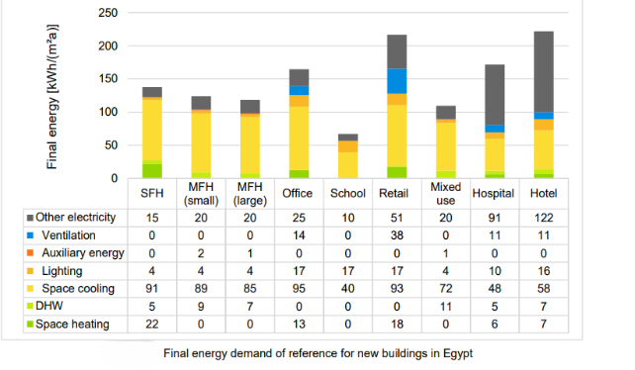

while the energy indicators for electrical energy consumption in Lebanon are shown in[14]
Energy Usage Indicator EUI- Lebanon
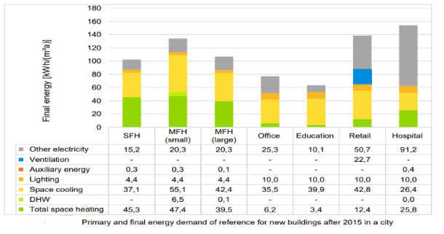
The energy indicators for many types of buildings in Jordan are included in [14]
Energy Usage Indicator EUI-Jordan
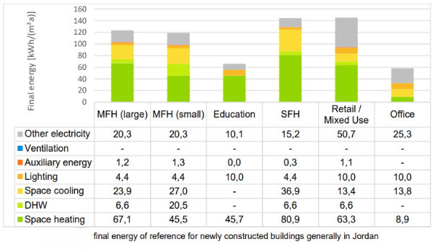

Appendix B

Renewable Energy and Energy Efficiency Law 2015

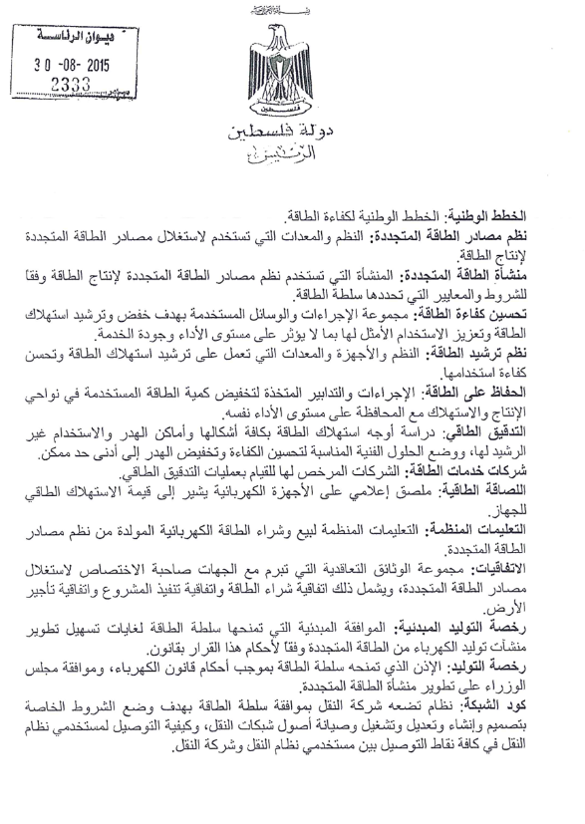
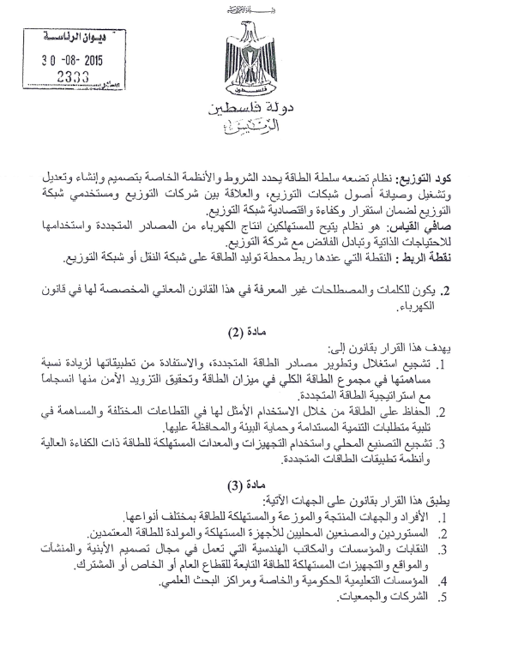

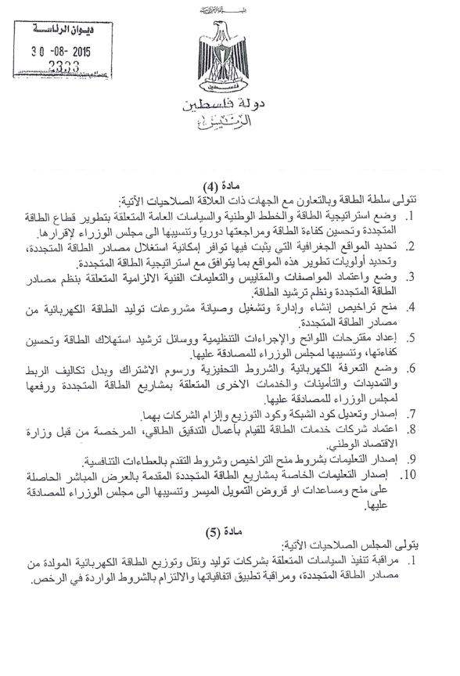
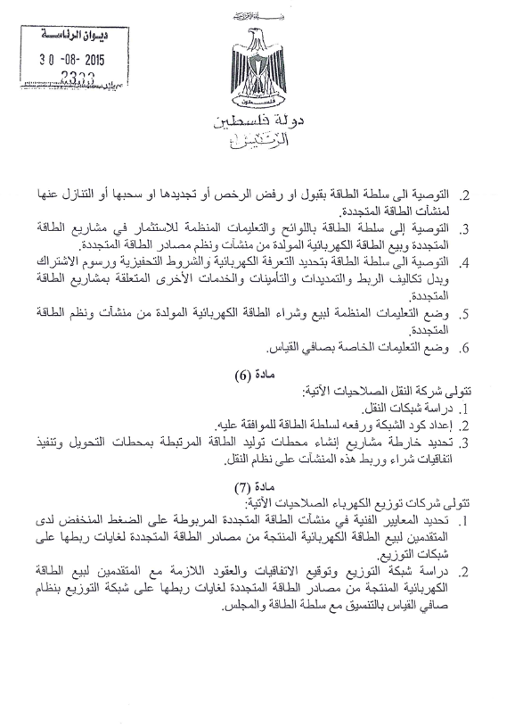

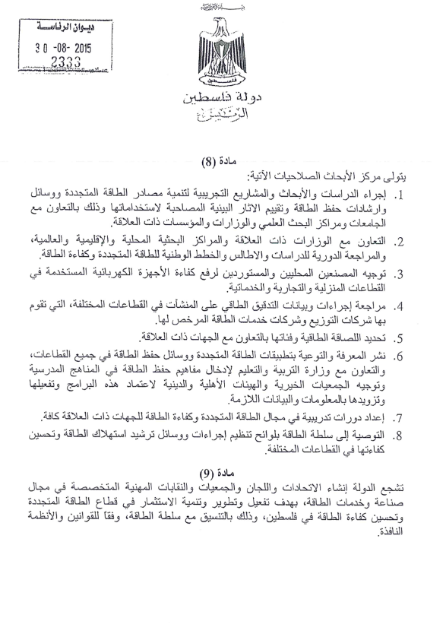
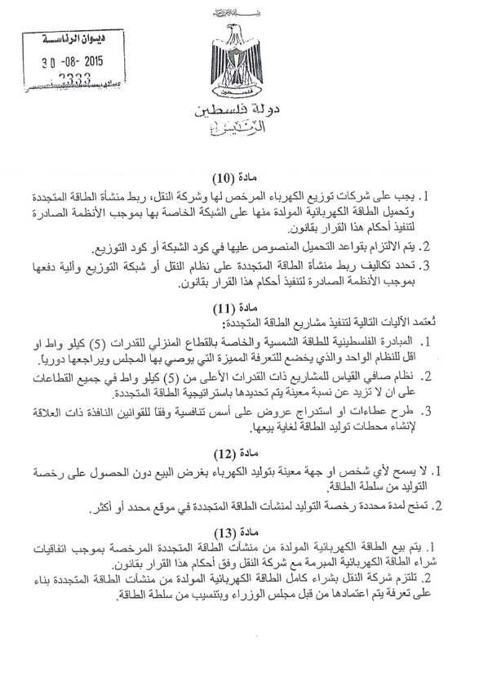
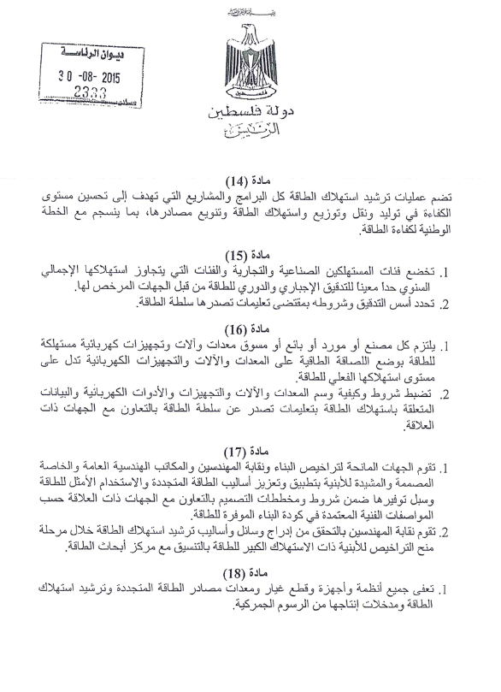

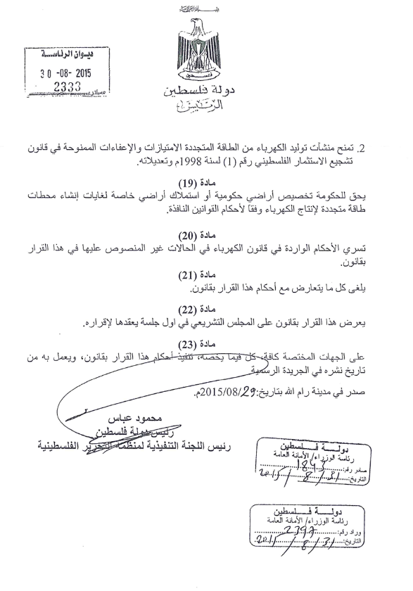

Appendix C

The survey in English
Engineering designs and compliance with energy-saving guidelines.
1.1 Your office classification?
- Third-class engineering office
- Second-class engineering office
- First-class engineering office
- Consulting Office
1.2Years of experience?
- 1-5 years
- 6-10 years
- 11 -14 years
- over 14 years
2. Awareness of energy-saving and green building principles.
2.1 Most engineers in our office have at least a basic understanding of green building codes and energy efficiency guidelines.
- Strongly agree
- Agree
- neutral
- disagree
- strongly disagree

2.2 The design engineers in our office have completed training courses on energy conservation and green building design.
- Strongly agree
- Agree
- neutral
- disagree
- strongly disagree
2.3 Which features of green buildings do you consider most important that affect energy saving?
- high-energy-efficient electromechanical systems
- high insulation of the roof and walls, and passive building techniques
- building management systems BMS, Smart control systems, KNX
- renewable energy systems like solar heaters and PV systems
- all of them (integration of all energy saving methods).
2.4 The use of renewable energy systems is important and economically viable in all buildings.
- Strongly agree
- Agree
- neutral
- disagree
- strongly disagree
2.5 Energy-efficient buildings contribute to reducing environmental impacts and global warming.
- Strongly agree
- Agree
- neutral
- disagree
- strongly disagree
3. Engineering practices for energy-saving designs
3.1 We usually use passive building techniques (like natural ventilation, proper orientation, thermal mass, daylight, and shading) in our designs.
- Strongly agree
- Agree
- neutral
- disagree
- strongly disagree
COMMERCIAL AND INDUSTRIAL (A,B,C***)
A***
3.2 Energy conservation and green building are priorities in all construction projects, especially commercial and industrial ones.
- strongly agree
- mostly agree
- neutral
- disagree
- strongly disagree
B***
3.3 In commercial and industrial projects, greater attention is paid to the design of energy-efficient systems and the creation of bills of quantities and specifications for all systems, including renewable energy systems.
- strongly agree
- mostly agree
- neutral
- disagree
- strongly disagree
Engineering practice of energy saving design -residential buildings
3.4 Most engineering designs of residential buildings do not pay much attention to energy saving.
- Strongly agree
- agree
- neutral
- disagree
- strongly disagree

3.5 We usually coordinate design concepts with the design team, including architects, Mechanical Engineers, and electrical engineers, to ensure compatibility between the building envelope and electromechanical systems, thereby achieving an energy-efficient building.
- Strongly agree
- Agree
- Neutral
- Disagree
- Strongly Disagree
3.6 The use of simulation software for the energy consumption of the designed buildings is one of the main steps in our designs.
- strongly agree
- Agree
- Neutral
- Disagree
- Strongly Disagree

C***
3.7 In most of our commercial and industrial projects, energy management systems (BMS) and building automation systems (KNX)are specified to save energy consumption.
- Strongly agree
- Agree
- neutral
- disagree
- strongly disagree
3.8 We Design: Highly efficient HVAC systems and good insulation to improve and save energy consumption in the buildings.
- Strongly agree
- agree
- neutral
- disagree
- strongly disagree
3.9 One of the main point of the technical specifications of glass in windows and curtain walls are selected based on the effect on energy saving.
- Strongly agree
- agree
- neutral
- disagree
- strongly disagree
3.10 In lighting design, we focus on utilizing natural lighting and using highly efficient and energy-saving lighting units.
- Strongly agree
- agree
- neutral
- disagree
- strongly disagree
3.11 We are usually interested in obtaining feedback data on the energy consumption of the buildings we have designed and how well the implementation conforms to the design documents.
- Strongly agree
- Agree
- Neutral
- Disagree
- Strongly Disagree

4. LOCAL LAWS AND ENGINEERING GUIDELINES
4.1 Local engineering guidelines in Palestine encourage energy-saving designs.
- Strongly agree
- Agree
- Neutral
- Disagree
- Strongly Disagree
4.2 Local governmental laws and guidelines encourage energy-saving designs.
- strongly agree
- Agree
- Neutral
- Disagree
- Strongly Disagree
5. Barriers to adopting energy-saving designs.
5.1 The high initial cost of energy-saving systems is a reason not to use them.
- Strongly agree
- Agree
- Neutral
- Disagree
- Strongly Disagree
5.2 Lack of experience in designing energy-saving systems is a reason why they are not used.
- Strongly agree
- Agree
- Neutral
- Disagree
- Strongly Disagree
5.3 The lack of awareness among owners and stakeholders of the importance of energy-saving systems hinders the use of these systems..
- Strongly agree
- Agree
- Neutral
- Disagree
- Strongly Disagree
5.4 The lack of energy-saving materials, systems, and technologies in the local market hinders the use of energy-saving systems.
- Strongly agree
- Agree
- Neutral
- Disagree
- Strongly Disagree
5.5 Local laws and regulations do not encourage the use of energy-saving systems
- Strongly agree
- Agree
- Neutral
- Disagree
- Strongly Disagree
Suggestions
6.1 Suggestions for improving engineering design compliance with energy conservation.
- Financial incentives
- Courses and technical training
- Providing offices with free simulation software for energy-efficient designs
- A new office classification that highlights and distinguishes offices committed to energy-efficient construction
- Legislation and laws that help oblige stakeholders to implement energy-efficient buildings
- All of the above
The end

The original electronic questionnaire form in Arabic with approvals.
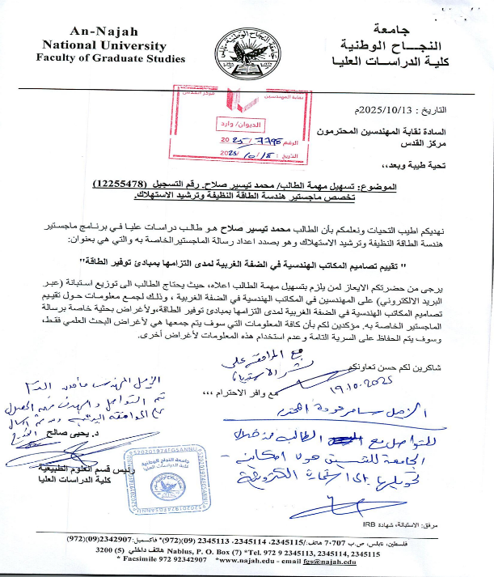
Mon, Oct 20, 2025, 11:41 AM
to mhdsalah

Can't see images? Click here...



دعوة لتعبئة استبيان بحث أكاديمي لرسالة الماجستير

الزملاء الأعزاء
تحية طيبة وبعد
يرجى من حضرتكم مساعدة زميل من خلال تعبئة استبيان بحث أكاديمي لرسالة ضمن برنامج الماجستير في الهندسة في جامعة النجاح الوطنية، والتي تحمل عنوان "تقييم تصاميم المكاتب الهندسية في الضفة الغربية لمدى التزامها بمبادئ توفير الطاقة"، وذلك من خلال الرابط التالي
https://forms.gle/fBEnFHVbaDiJ6Edu7

 | LIKE |  |  | TWEET |  |  | FORWARD

Engineers Association - Jerusalem Center
Professional Associations Complex, Al-bireh, Palestine

Tel: +970 2 2964777 | Fax: +970 2 2964779 | Email: techdept@paleng.org
Unsubscribe

استبيان حول مدى التزام تصاميم المكاتب الهندسية بمبادئ توفير الطاقة
عزيزي المشارك
تحية طيبة وبعد
الاستبيان المدرج ادناه هو ضمن أطروحة الماجستير لطالب في جامعة النجاح الوطنية، كلية الدراسات العليا تخصص الطاقة النظيفة وترشيد الاستهلاك
مقدمة :
مع الارتفاع الكبير في الطلب على الطاقة، وندرة المصادر المحلية، واعتمادنا على الواردات، تزداد الحاجة إلى جعل ترشيد الطاقة وكفاءتها أولوية وطنية،ومما لاشك فيه ان القطاع الهندسي ومهندسي التصميم من اهم الاطراف الذين بامكانهم المساهمة الفاعلة في ذلك من خلال تصاميم ومواصفات هندسية لانبنية ومنشات موفرة للطاقة.
يهدف هذا الاستبيان إلى جمع معلومات من المكاتب الهندسة في (فلسطين -محافظات الضفة الغربية) حول خبراتها ومعارفها وممارساتها المتعلقة بتصميم المباني الموفرة للطاقة والمباني الخضراء. ستساعد إجاباتكم في تحديد التحديات والفرص الحالية لتحسين الامتثال لمعايير توفير الطاقة.
ستُحفظ المعلومات التي تُقدمونها بسرية تامة، وستُستخدم فقط لأغراض البحث العملي والتطوير.
المشاركة في هذا الاستبيان طوعية تمام ويمكنك المشاركة او الانسحاب من الاستبيان في أي وقت دون أي التزامات او عواقب.‏
1.1 تصنيف المكتب الهندسي الذي تعمل فيه
- مكتب هندسي ثالثة
- مكتب هندسي ثانية
- مكتب هندسي أولى
- مكتب استشاري او شركة استشارية
1.2 عدد سنوات الخبرة في مجال التصميم
- 1 الى 5 سنوات
- 6 الى 10 سنوات
- 11 -14 سنة
- اكثر من 14 سنة
2الادراك والوعي الذاتي بمباديء ترشيد الطاقة والابنية الخضراء
2.1 معظم المهندسين في مكتبنا على دراية ولو بسيطة بكود المباني الخضراء وإرشادات توفير الطاقة.
- أوافق بشدة
- أوافق
- محايد
- لا أوافق
- لا أوافق بشدة
2.2 حصل المهندسين المصممين في مكتبنا على دورات تدريبية حول توفير الطاقة والبناء الأخضر في التصميم.
- أوافق بشدة
- أوافق
- محايد
- لا أوافق
- لا أوافق بشدة
2.3ما هي ميزات المباني الخضراء التي تقيمها أكثر من غيرها من حيث الاهمية والتأثير في توفير الطاقة؟
- أنظمة كهروميكانيكية عالية الكفاءة في استخدام الطاقة .
- عزل للأسقف والجدران والتهوية الطبيعية وتقنيات البناء السلبي .
- أنظمة إدارة المباني BMS ,أنظمة التحكم الذكية SMART KNX .
- أنظمة الطاقة المتجددة مثل السخانات الشمسية وأنظمة توليد الكهرباء بالطاقة الشمسية .
- جميع ما ذكر من ميزات بشكل متكامل
2.4ان استخدام انظمة الطاقة المتجددة مهم وذو جدوى اقتصادية في جميع المباني
- اوافق بشدة
- أوافق
- محايد
- لا أوافق
- لا أوافق بشدة
2.5 تساهم المباني الموفرة للطاقة في تقليل التأثيرات البيئية والاحتباس الحراري العالمي
- أوافق بشدة
- أوافق
- محايد
- لا أوافق
- لا أوافق بشدة
3 الممارسات الهندسية واستخدام الأنظمة الموفرة للطاقة
3.1 نحن عادة نستخدم تقنيات البناء السلبي (مثل التهوية الطبيعية، والتوجيه السليم للبناء، والكتلة الحرارية، وضوء النهار والتظليل) في تصاميمنا.
- أوافق بشدة
- أوافق
- محايد
- لا أوافق
- لا أوافق بشدة
3.2 يعد الحفاظ على الطاقة والبناء الأخضر من الأولويات في جميع مشاريع البناء وخاصة التجارية والصناعية.
- أوافق بشدة
- أوافق
- محايد
- لا أوافق
- لا أوافق بشدة
3.3 في المشاريع التجارية والصناعية يتم الاهتمام يشكل أكبر في تصميم الانظمة الموفرة للطاقة وعمل جداول كميات ومواصفات لجميع الأنظمة بما في ذلك انظمة الطاقة المتجددة.
- أوافق بشدة
- أوافق
- محايد
- لا أوافق
- لا أوافق بشدة
3.4 لا تولي معظم التصاميم الهندسية للأبنية السكنية اهتماما كبيرا لتوفير الطاقة.
- أوافق بشدة
- أوافق
- محايد
- لا أوافق
- لا أوافق بشدة
3.5نحن عادة نقوم بتنسيق مفاهيم التصميم مع فريق المصممين مثل مهندسي الهندسة المعمارية والميكانيكا والكهرباء لضمان توافق غلاف المبنى والنظام الكهروميكانيكي لتحقيق مبنى موفر للطاقة.*
- أوافق بشدة
- أوافق
- محايد
- لا أوافق
- لا أوافق بشدة
3.6 يعد استخدام برامج المحاكاة لاستهلاك الطاقة للمباني المصممة أحد الركائز الأساسية في تصميماتنا.
- أوافق بشدة
- أوافق
- محايد
- لا أوافق
- لا أوافق بشدة
3.7 في غالبية المشاريع التجارية والصناعية لدينا يتم توصيف انظمة ادارة الطاقة وانظمة التحكم الذكي BMS,KNX لتوفير استهلاك الطاقة
- أوافق بشدة
- أوافق
- محايد
- لا أوافق
- لا أوافق بشدة
3.8 نقوم بتصميم أنظمة التدفئة والتهوية وتكييف الهواء عالية الكفاءة والعزل الجيد لتحسين وتوفير استهلاك الطاقة في المباني
- أوافق بشدة
- أوافق
- محايد
- لا أوافق
- لا أوافق بشدة
3.9أحد النقاط الرئيسية للمواصفات الفنية للزجاج في النوافذ والجدران الستارية يتم اختيارها على أساس تأثيرها على توفير الطاقة.
- أوافق بشدة
- أوافق
- محايد
- لا أوافق
- لا أوافق بشدة
3.10في تصميم الانارة نهتم بالاستفادة من الانارة الطبيعية واستخدام وحدات انارة عالية الكفاءة وموفرة للطاقة.
- أوافق بشدة
- أوافق
- محايد
- لا أوافق
- لا أوافق بشدة
3.11نحن عادة نهتم بالحصول على تغذية راجعة وقراءات حول استهلاك الطاقة للمباني التي قمنا بتصميمها ومدى توافق التنفيذ مع وثائق التصميم ومع الواقع بعد التنفيذ ؟
- أوافق بشدة
- أوافق
- محايد
- لا أوافق
- لا أوافق بشدة
4 القوانين المحلية والمبادئ التوجيهية الهندسية.
4.1 تشجع التعليمات الهندسية المحلية في فلسطين التصاميم الموفرة للطاقة
- أوافق بشدة
- أوافق
- محايد
- لا أوافق
- لا أوافق بشدة
4.2تشجع القوانين والمبادئ التوجيهية الحكومية المحلية التصميمات الموفرة للطاقة.
- أوافق بشدة
- أوافق
- محايد
- لا أوافق
- لا أوافق بشدة
5معيقات تبني تصاميم هندسية موفرة للطاقة
5.1 الكلفة الاولية المرتفعة لأنظمة توفير الطاقة هو سبب لعدم استخدام انظمة موفرة للطاقة
- أوافق بشدة
- أوافق
- محايد
- لا أوافق
- لا أوافق بشدة
5.2قلة الخبرة في تصميم الأنظمة الموفرة للطاقة هو سبب في عدم استخدامها .*
- أوافق بشدة
- أوافق
- محايد
- لا أوافق
- لا أوافق بشدة
5.3 إن عدم وعي أصحاب العقارات والمطورين بأهمية أنظمة توفير الطاقة يعيق استخدام هذه الأنظمة.*
- أوافق بشدة
- أوافق
- محايد
- لا أوافق
- لا أوافق بشدة
5.4ان عدم توفر المواد والموارد والانظمة الموفرة للطاقة في السوق المحلي يعيق استخدام انظمة موفرة للطاقة.
- أوافق بشدة
- أوافق
- محايد
- لا أوافق
- لا أوافق بشدة
5.5القوانين والتشريعات المحلية لا تشجع استخدام انظمة موفرة للطاقة .*
- أوافق بشدة
- أوافق
- محايد
- لا أوافق
- لا أوافق بشدة
6 اقتراحات لتحسين التزام التصاميم الهندسية بتوفير الطاقة .
- محفزات مالية لاستخدام الأنظمة الموفرة للطاقة
- دورات وتأهيل فني للمهندسين
- تزويد المكاتب ببرامج مجانية للمحاكاة لتصاميم توفير الطاقة
- تصنيف جديد للمكاتب يبرز ويميز المكاتب الملتزمة بالبناء الموفر للطاقة
- تشريعات وقوانين تساهم في إلزام اصحاب المصالح بالأبنية الموفرة للطاقة
- كل ما ذكر أعلاه

انتهى الاستبيان

Appendix D
Copy of the received responses of the survey (287 responses)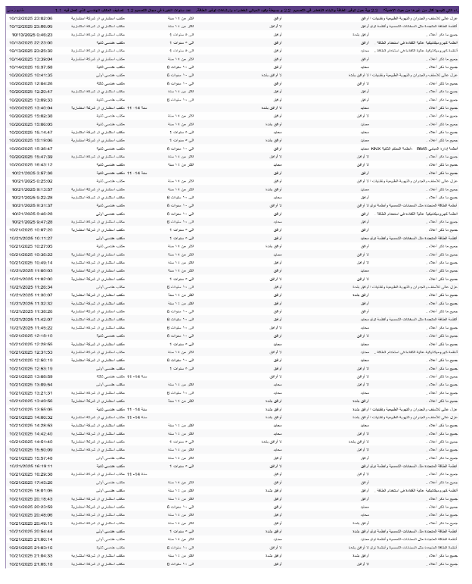
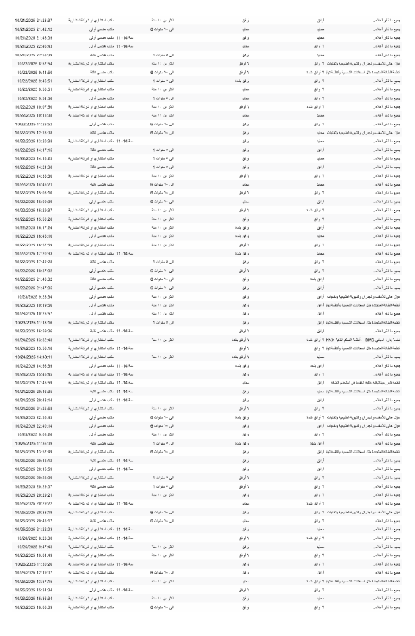
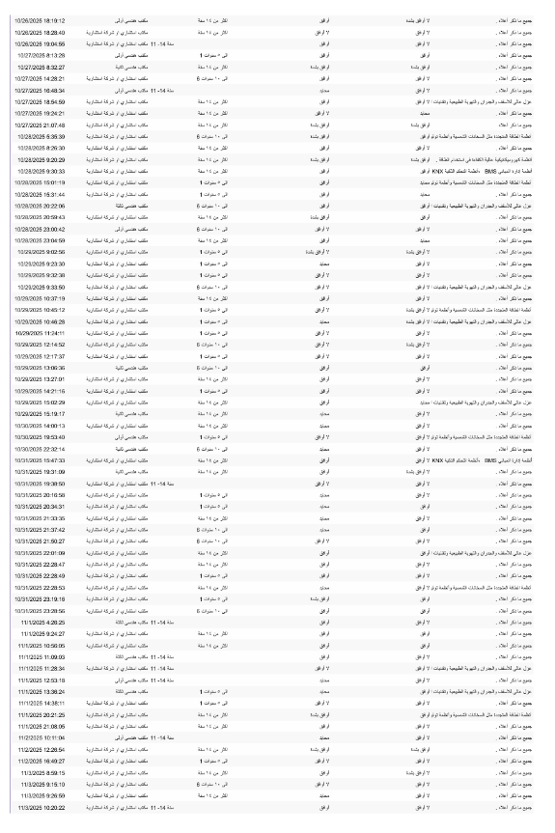
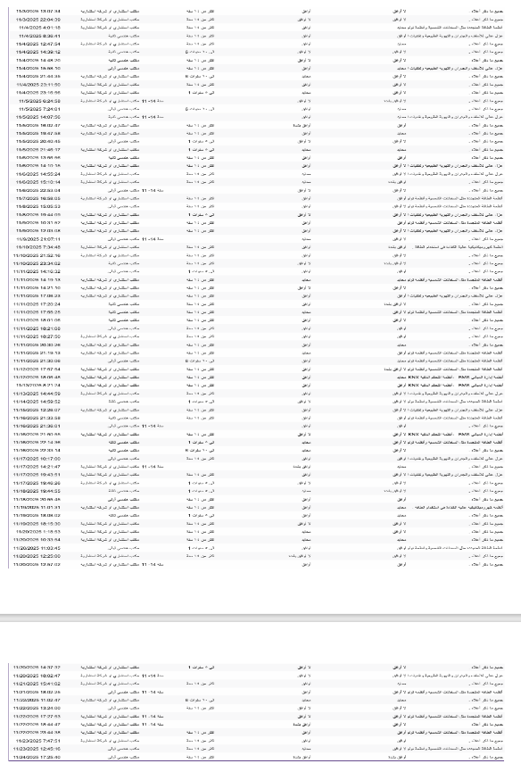
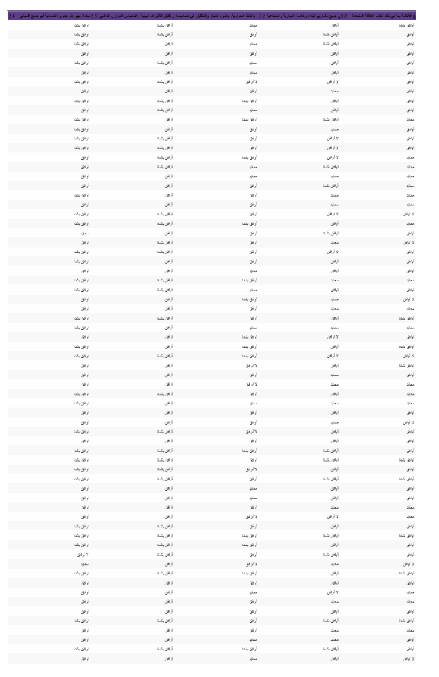
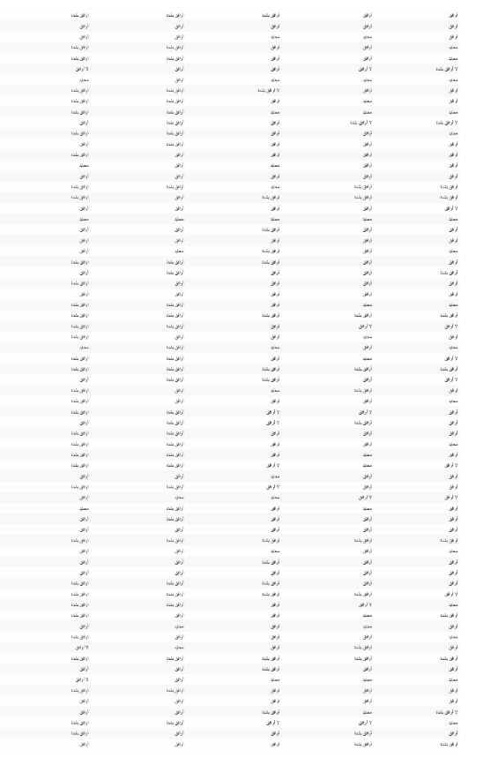
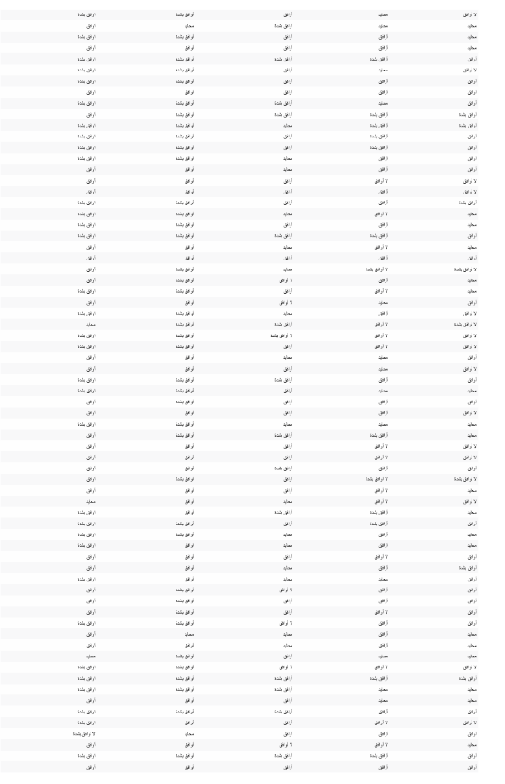
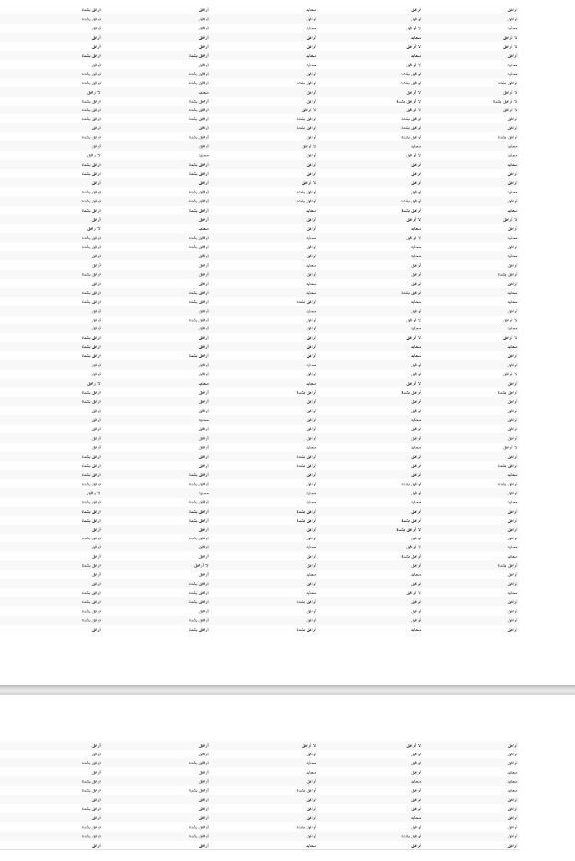
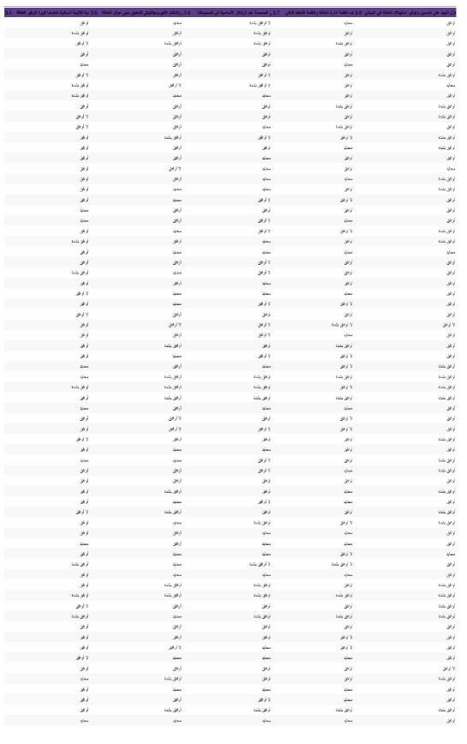
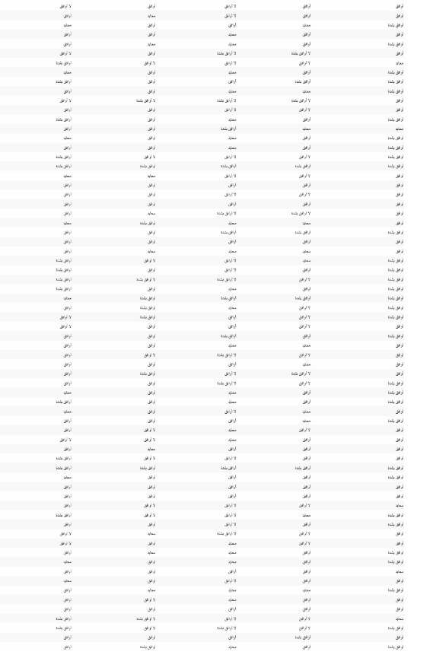
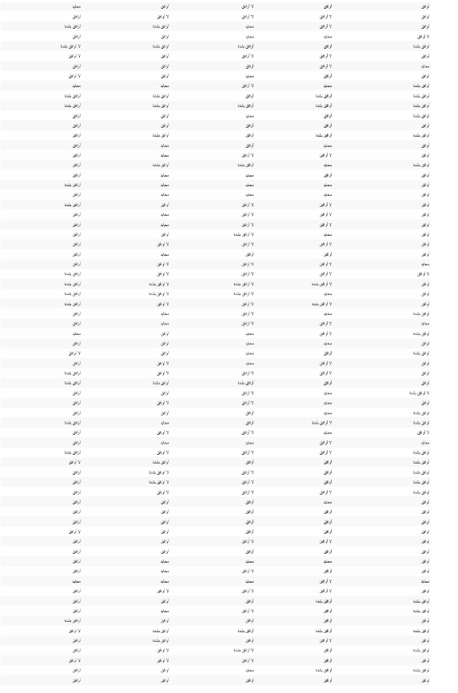
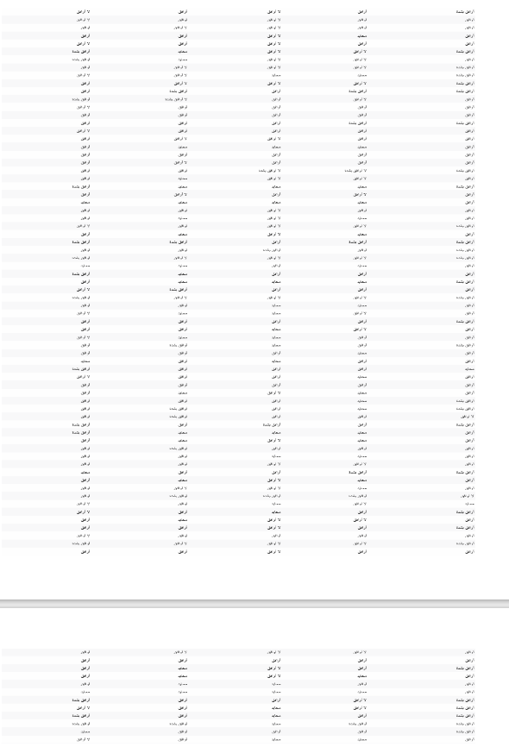
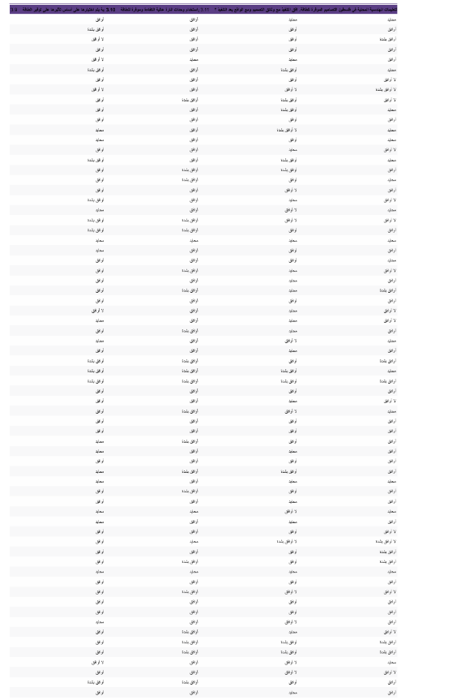
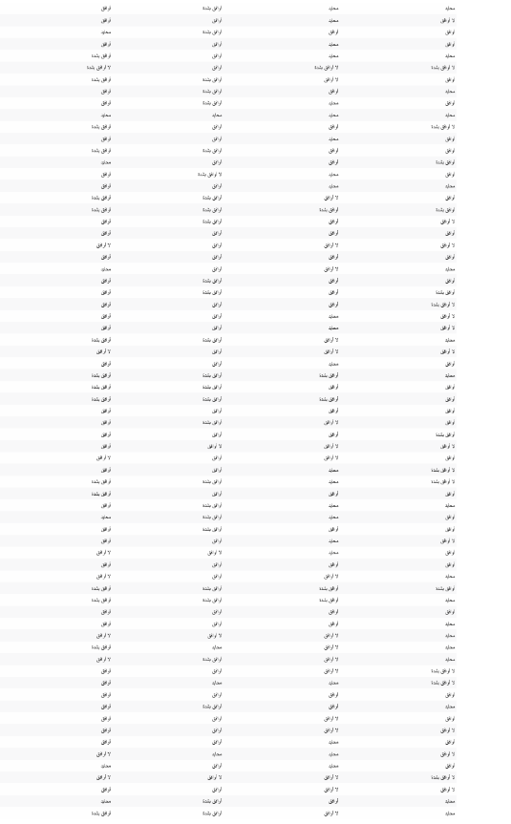
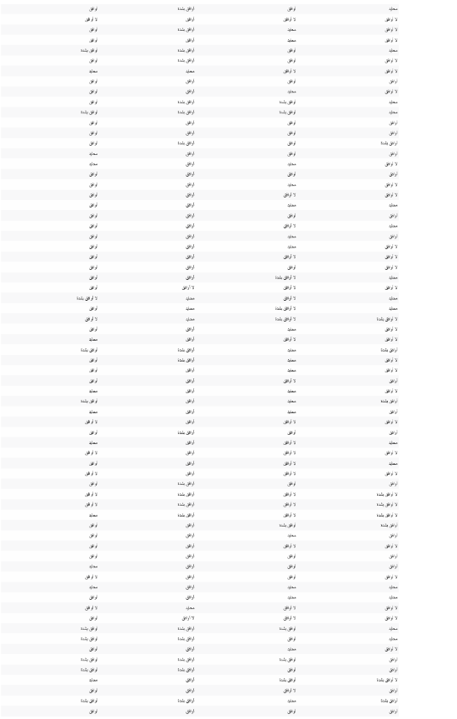
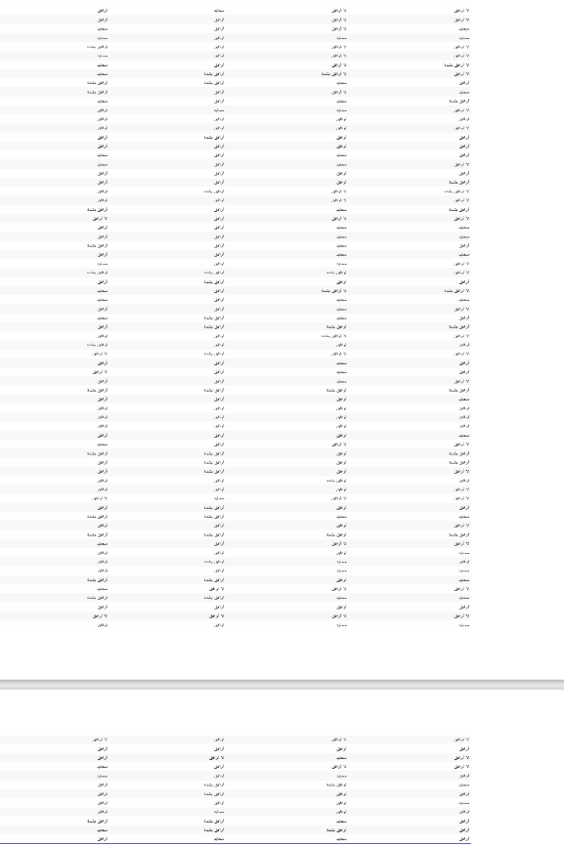
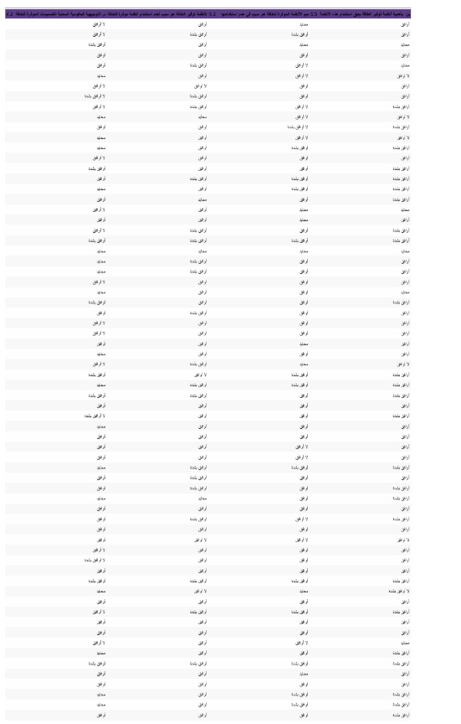
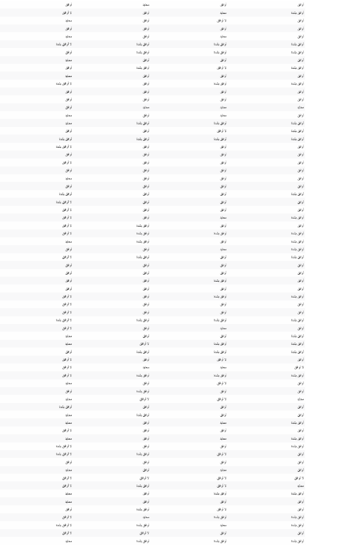
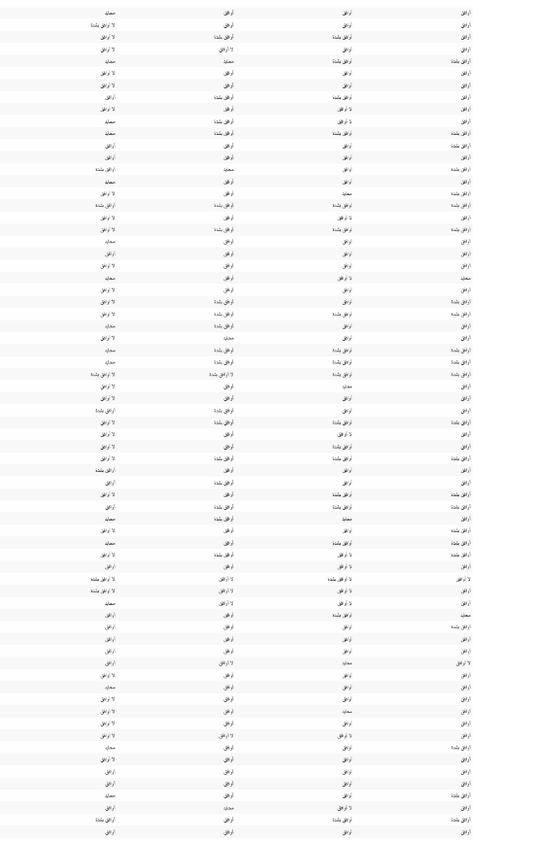
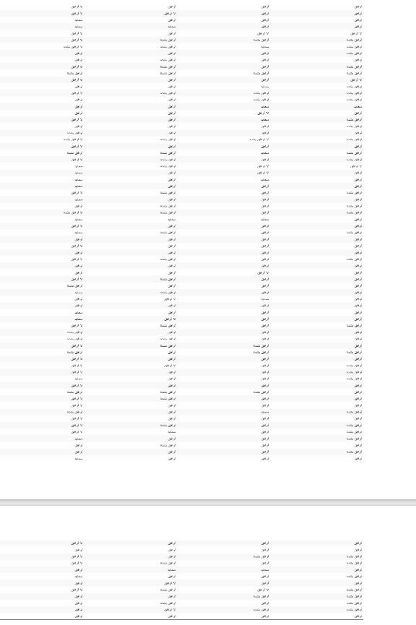
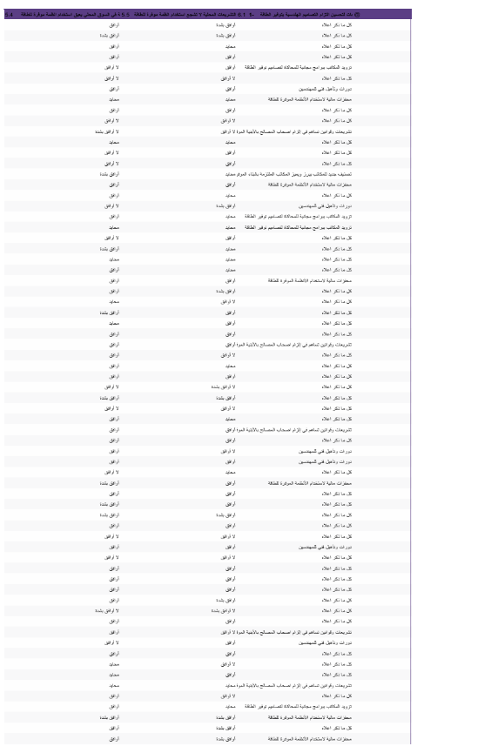
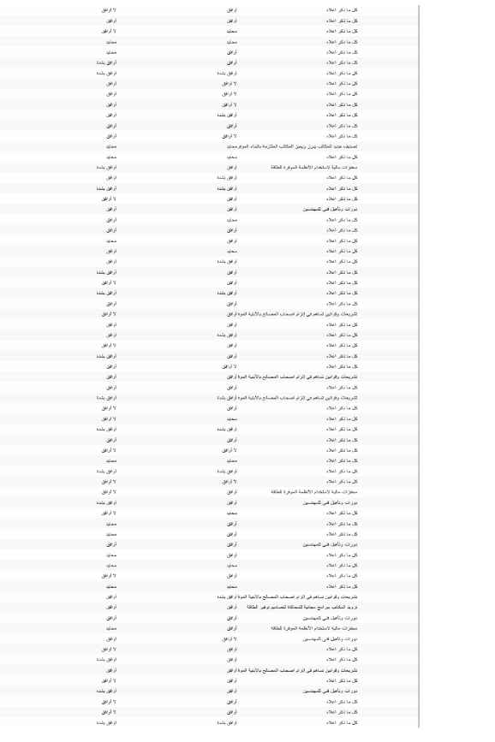
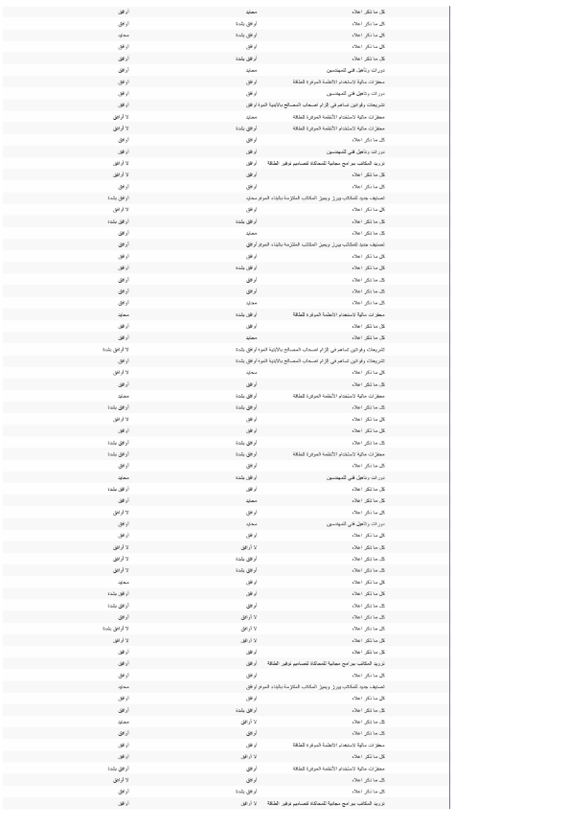
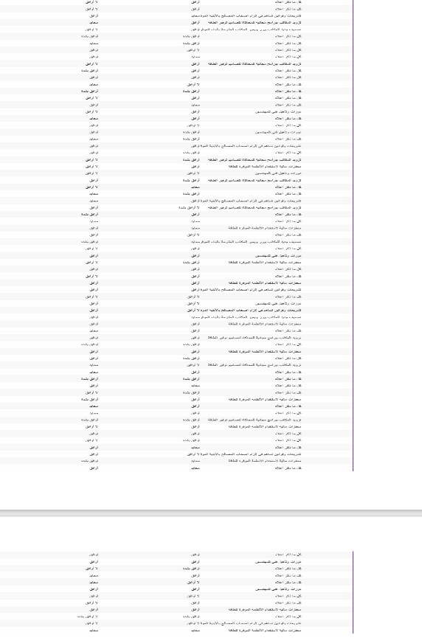

Appendix-E

The approved Electrical tariff in Palestine 2025





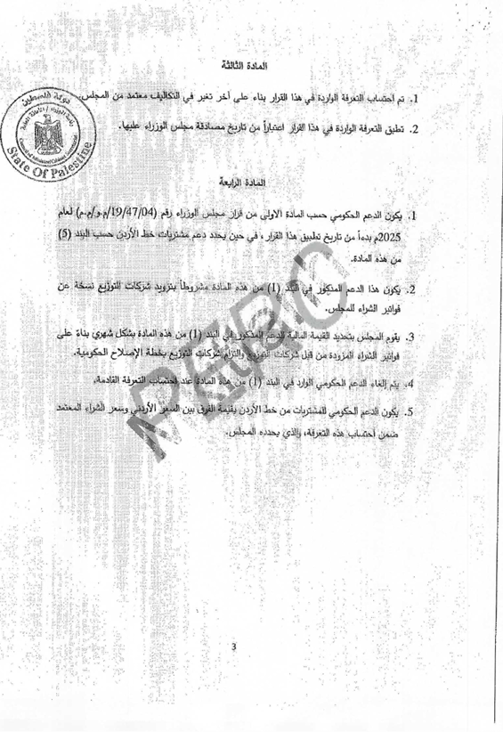

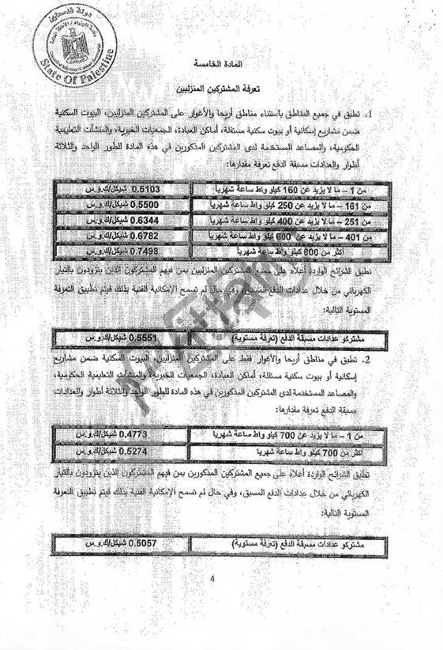

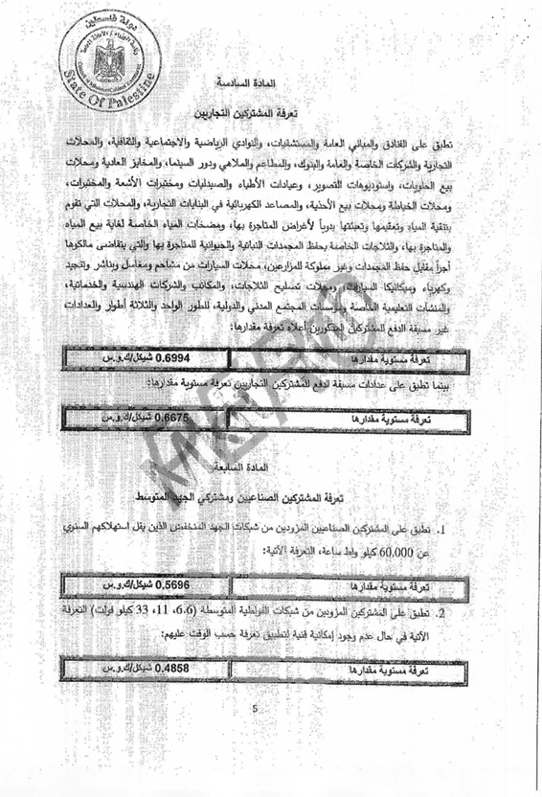

Appendix-F

Net Billing Law issued by the Electricity Sector Regulatory Council - 2025



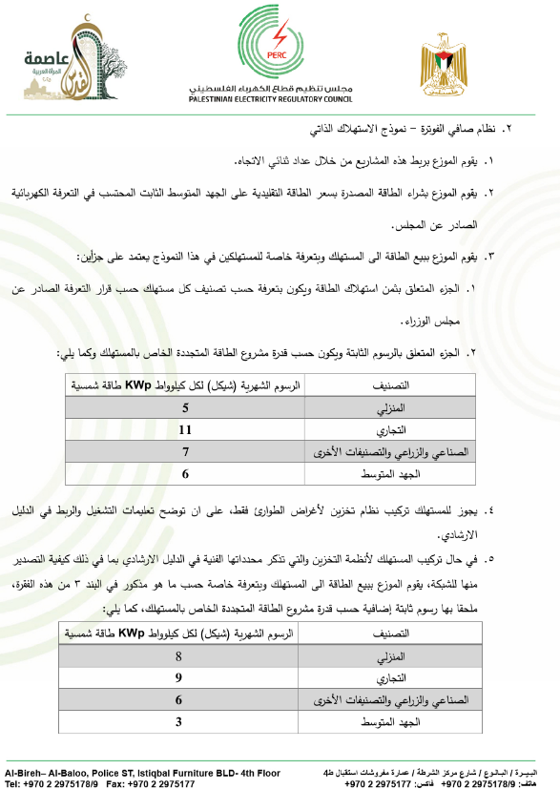




جامعة النجاح الوطنية
كلية الدراسات العليا
تقييم تصاميم المكاتب الهندسية في الضفة الغربية لمدى التزامها بمبادئ توفير الطاقة.
اعداد: محمد تيسير صلاح
إشراف: د. ايسر ياسين
كجزء من متطلبات الحصول على درجة الماجستير في هندسة الطاقة النظيفة وترشيد الطاقة، تُقدّم هذه الرسالة إلى كلية الدراسات العليا في جامعة النجاح الوطنية في نابلس، فلسطين.

٢٠٢٦
الملخص
تقيّم هذه الدراسة مدى التزام المكاتب الهندسية في الضفة الغربية بتوجيهات ترشيد الطاقة، نظرًا لمعاناة فلسطين والضفة الغربية من نقص موارد الطاقة وارتفاع أسعارها، مما يجعل ترشيد الطاقة أولوية قصوى. تقيس الدراسة مستوى الوعي بترشيد الطاقة وممارسته خلال أعمال التصميم الهندسي، كما تبحث في المعوقات التي تحول دون التزام هذه المكاتب بتوجيهات ترشيد الطاقة. ولتحقيق هذا الغرض، تم تطوير استبيان إلكتروني وصفي كمي شامل، وأُرسل إلى جميع المكاتب الهندسية في الضفة الغربية العاملة في مجال التصميم الهندسي والإشراف، والمعتمدة من قبل نقابة المهندسين (1062 مكتبًا). أظهرت نتائج الاستبيان (287 ردًا) أن الوعي بترشيد الطاقة مرتفع، بينما مستويات الممارسة متوسطة. ويُلاحظ ضعف ملحوظ في مستوى الممارسة في تصميم المباني السكنية، بينما يكون متوسطًا في المباني التجارية. وأكد المشاركون وجود معوقات أمام تبني تصاميم موفرة للطاقة، أبرزها نقص الوعي بين أصحاب المصلحة وارتفاع التكاليف الأولية. وتلي هذه المعوقات قلة الخبرة في التصاميم الموفرة للطاقة، وغياب القوانين التي تشجع على تبني هذه الممارسات.... أظهر اختبار الفرضيات توافقًا مع النتائج عبر مختلف المحاور، باستثناء مستوى فئة المكاتب.
لوحظ أن تصنيف مكاتب الهندسة لم يكن مرتبطًا إيجابيًا بزيادة الوعي أو ممارسات الهندسة الموفرة للطاقة. في المقابل، ارتبطت الخبرة الشخصية للمهندسين ارتباطًا وثيقًا بزيادة الوعي وتحسين ممارسات استراتيجيات كفاءة الطاقة.

خلصت الدراسة الى عدد من المقترحات التي تساهم في تحسين مستوى الالتزام وتطبيق تعليمات ترشيد الطاقة من ضمن المقترحات رفع مستوى تأهيل المكاتب الهندسية من خلال تصنيفات تأخذ تراعي مستوى التزام المكاتب وقدرتها على انتاج مخططات وتصاميم موفرة للطاقة واقترحت الدراسة تقديم محفزات مالية للمكاتب التي تلتزم بتصاميم موفرة للطاقة .

الكلمات المفتاحية: ترشيد الطاقة، المكاتب الهندسية، الضفة الغربية، المباني الخضراء، الوعي، الممارسة، استبيان مُنظّم.

