CHAPTER ONE: INTRODUCTION
The main problem is that the units produced from whole production line are 150,000 units; more than 5000 unit of it is deviated from the main production line at exit chute.
Our work is to make a machine that will take the deviated units to compact the unit manually and package it in plastic bags because there is no time to return it again to main production line to avoid the interrupt of the operation to be ready for entering the market.
The design problem is that there is a machine in the factory that makes the job done slowly; our target is to rapid the operation process in order to produce a largest possible number of diapers in short time.
The objectives of the project are to apply our skills on the ground, produce machine that has low price, to provide the factory with a machine that has high efficiency and speed.
The machine deal with deviated diapers, so, our machine must contain high technical and economical characteristics to keep pace with the machines inside the factory.
The figure 1.1 below describes the steps of the production line of the diapers.
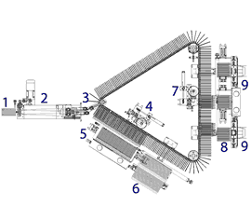  Figure 1.1: Main Production Line | Description  - Product entrance.  - Product conveyor and turning unit, including product presence control.  - Product infeed unit into the stacker plates, including the product counting unit.  - First products expulsion unit for big counts.  - Products compacting unit included in the shuttle system.  - Exit chute for 1 or more rows of products.  - Second products expulsion unit for small counts.  - Products compacting units included in the shuttle system.  - Exit chute for 1 or more rows of products.

In this report, there are many topics that will be raises sequentially to deliver the project idea to the readings easily and smoothly.
The topics are the following:
- Constraints: this part includes all the tools and devices that used to appear the machine in final shape, like, pneumatic cylinders, selectors, PLC circuit, etc...

- Tools Description: this part describes these tools accurately by using figures, table and equations.

- Work process: this topic shows the steps that done in sequentially way from the beginning of the work until the device is switched on, the work process includes a couple of manufacturing operations like, welding, fixing, assemble, lathing, teething, etc...

- Results and analysis: in this part, there are the calculations of the machine like, bolt calculations, welding calculations, force analysis, etc...

- Discussion: the purpose of the discussion is to interpret and compare the results, and if there is any problem to solve.

- Conclusion and recommendation: in this part, the important results and interpretations will be gathered, and will show the points and topics that learnt from the project.
CHAPTER TWO: CONSTRAINTS AND TOOLS DESCRIPTION
2.1 Constraints
# | Device Name | Photo
1 | FESTO Pneumatic double acting cylinder CDEMA 50/500X, 50/300X | 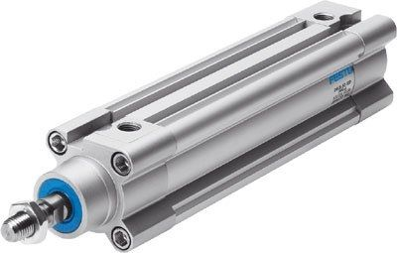
2 | Steel rod plated with chrome | 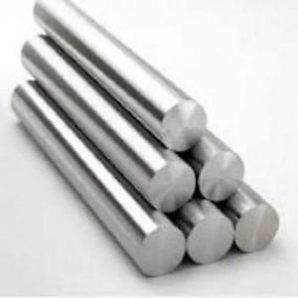
3 | Selector AIGNEP with 5 exists | 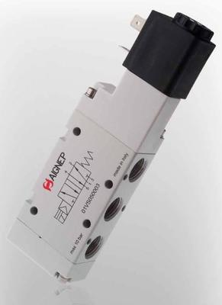
4 | Fiber Glass | 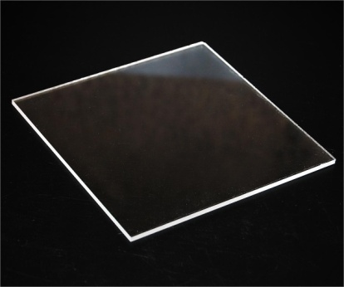
5 | PLC circuit | 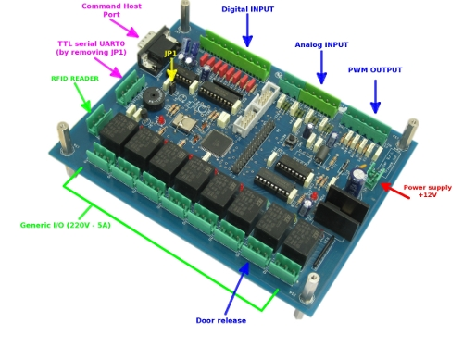
6 | Fiber: to be in contact between the pneumatic cylinder and the product | 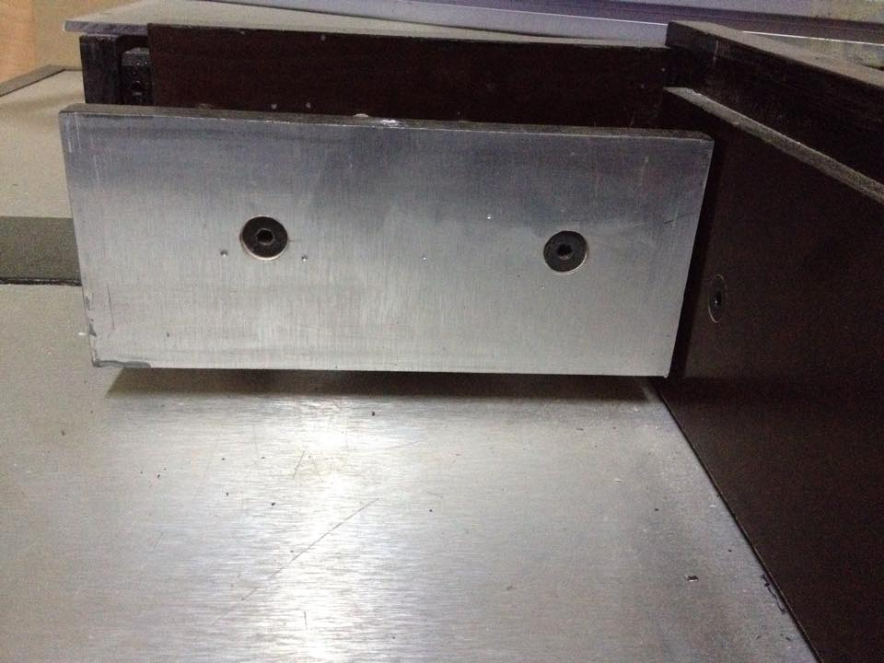
7 | Warning light | 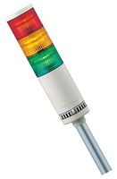
8 | Exit Chute: and dimension for this (25cm long and 14cm width) | 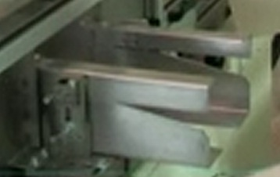
9 | Aluminum plate with 20mm thickness | 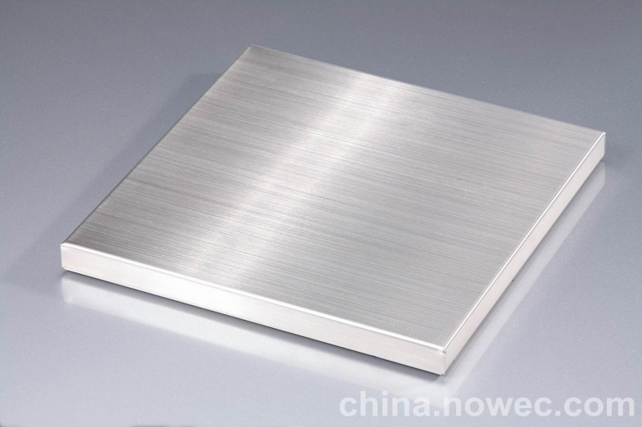
10 | Hexagonal Screws | 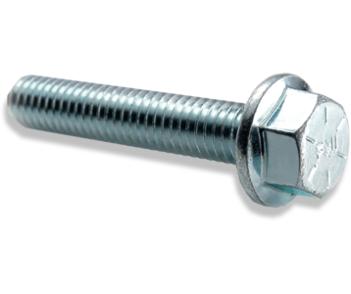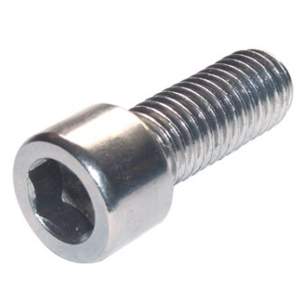
11 | Flat head hexagonal screw | 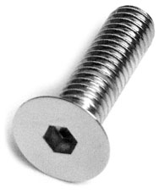
12 | Air pressure valves | 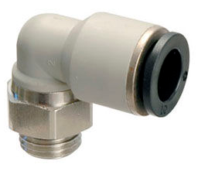
13 | Steel box section with dimension 40x40 mm | 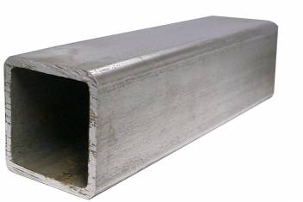
14 | Fini air compressor | 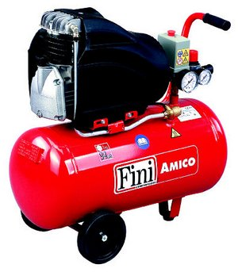
15 | Limit Switch | 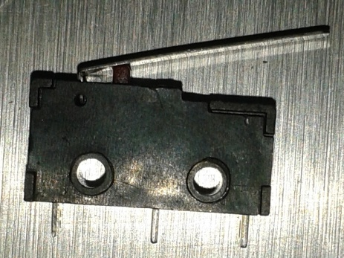

2.2 Tools Description
2.2.1 Double acting cylinder
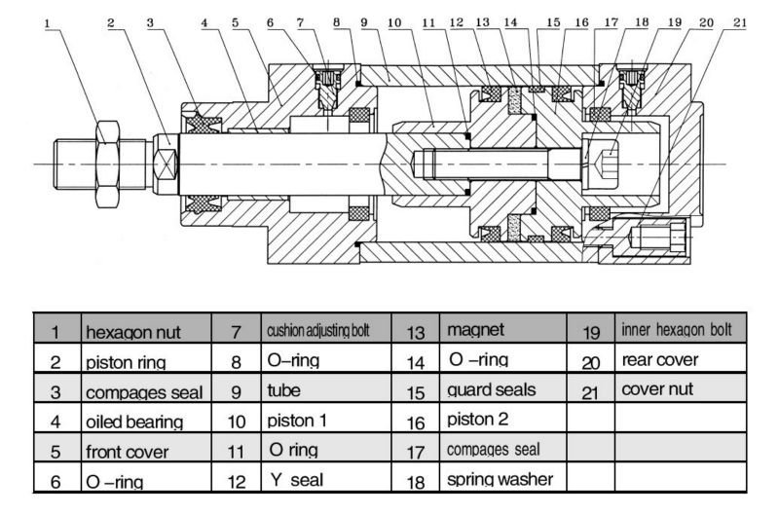
Figure 2.1: Pneumatic cylinder parts
Double acting cylinder is considered to be as a main actuator in any pneumatic systems. Double acting cylinders are more expensive than single acting cylinders, but double acting cylinders are superior to single acting cylinders by any other important measure. Double action cylinders are faster and stronger. In industrial applications, single action cylinders are used if possible, but when speed and force are important double acting cylinders are employed. Applications include opening and closing doors, taking things off conveyor belts and putting things on conveyor belts. They are also used for lifting and moving packages around as well as for presses and punches.

2.2.1.1 Function of the double acting cylinder
Double acting cylinder is an output device that converts the pressure energy to a mechanical energy (linear motion).

2.2.1.2 Way of operation
Double acting cylinder as mentioned has two ports and the air is applied in both directions (forward and backward)

2.2.1.3 Forward (advanced) stroke
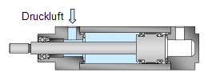
The air is supplied to port (1) and the exhaust air is forced out through port (2) as shown in figure 2.2.
Figure 2.2: Forward movement
2.3.1.4 Backward (return) stroke
The air is supplied to port (2) and the exhaust air is forced out through port (1) as shown in figure 2.3.
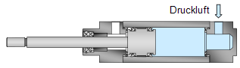
The force produced by the piston during the advance stroke is greater than the force produced during the return stroke due to the area difference between the two sides of the piston. You may refer back to module 2 in basic hydraulic for more details.
Figure 2.3: Backward movement

2.2.1.5 Types
The range of pneumatic cylinders is divided into the following types.
- Cylinders with piston rod
- Rodless cylinders (linear drives)
- Swivel cylinders
- Tandem and multi-position cylinders
- Stopper cylinders
- Clamping cylinders
- Drives with linear guide
- Bellows and diaphragm cylinders

The double-acting cylinder requires compressed air for every direction of movement. On this type of cylinder, the force both the advancing and retracting direction is built up using compressed air. The simplest way of actuating a double-acting cylinder is by using a 5/2-way valve.

2.2.1.6 Advantages
- Force builds up in both directions of movement
- Constant force (dependent on stroke)
- Strokes of several metres are possible
2.2.1.7 Disadvantages
- Every movement uses compressed air
- No defined position in the event of compressed air failure

2.2.1.8 Construction
Depending on the job specification, there are multiple forms of body constructions available:
- Tie rod cylinders: The most common cylinder constructions that can be used in many types of loads. Has been proven to be the safest form.
- Flanged-type cylinders: Fixed flanges are added to the ends of cylinder; however, this form of construction is more common in hydraulic cylinder construction.
- One-piece welded cylinders: Ends are welded or crimped to the tube; this form is inexpensive but makes the cylinder non-serviceable.
- Threaded end cylinders: Ends are screwed onto the tube body. The reduction of material can weaken the tube and may introduce thread concentricity problems to the system.

2.2.1.9 Material
Upon job specification, the material may be chosen. Material range from nickel-plated brass to aluminium, and even steel and stainless steel. Depending on the level of loads, humidity, temperature, and stroke lengths specified, the appropriate material may be selected.

2.2.1.10 Sizes
Air cylinders are available in a variety of sizes and can typically range from a small 2.5 mm air cylinder, which might be used for picking up a small transistor or other electronic component, to 400 mm diameter air cylinders which would impart enough force to lift a car. Some pneumatic cylinders reach 1000 mm in diameter, and are used in place of hydraulic cylinders for special circumstances where leaking hydraulic oil could impose an extreme hazard.

2.2.2 Selector valves
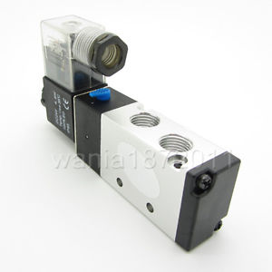
Figure 2.4: Selector valve
There are many types of valves, such as selector, pressure reducing, sequence, check, restrictor, and relief. While the basic function for each type of valve is similar, the design and construction may be very different. Examples of these valves are discussed in the following text.
Selector valves are used in a hydraulic system to direct the flow of fluid. A selector valve directs fluid under system pressure to the desired working port of an actuating unit (double-acting), and, at the same time, directs return fluid from the opposite working port of the actuating unit to the reservoir.
Some aircraft maintenance instruction manuals (MIMs) refer to selector valves as control valves. It is true that selector valves may be placed in this classification, but you should understand that all control valves are not selector valves. In the strict sense of the term, a selector valve is one that is engaged at the will of the pilot or copilot for the purpose of directing fluid to the desired actuating unit. This is not true of all control valves.
Selector valves may be located in the pilot’s compartment and be directly engaged manually through mechanical linkage, or they may be located in some part of the aircraft and are engaged by remote control. Remote-controlled selector valves are generally solenoid operated.
The typical four-way selector valve has four ports—a pressure port, a return port, and two cylinder (or working) ports. The pressure port is connected to the main pressure line from the power pump, the return port is connected to the reservoir return line, and the two cylinder ports are connected to opposite working ports of the actuating unit.
Three general types of selector valves are discussed in this chapter. They are the poppet, slide, and solenoid-operated valves. Practically all selector valves currently in use come under one of these three general types.

2.2.3 PLC circuit
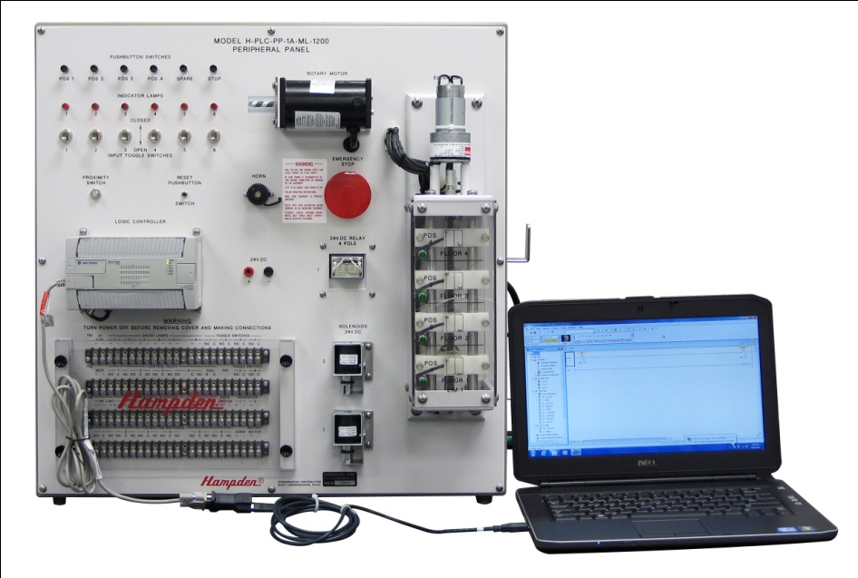
Figure 2.5: PLC circuit connected with PC

A Programmable Logic Controller, PLC or Programmable Controller is a digital computer used for automation of electromechanical processes, such as control of machinery on factory assembly lines, amusement rides, or light fixtures. PLCs are used in many industries and machines. Unlike general-purpose computers, the PLC is designed for multiple inputs and output arrangements, extended temperature ranges, immunity to electrical noise, and resistance to vibration and impact. Programs to control machine operation are typically stored in battery-backed-up or non-volatile memory. A PLC is an example of a hard real-time system since output results must be produced in response to input conditions within a limited time, otherwise unintended operation will result.
The main difference from other computers is that PLCs are armored for severe conditions (such as dust, moisture, heat, cold) and have the facility for extensive input/output (I/O) arrangements. These connect the PLC to sensors and actuators. PLCs read limit switches, analog process variables (such as temperature and pressure), and the positions of complex positioning systems. Some use machine vision. On the actuator side, PLCs operate electric motors, pneumatic or hydraulic cylinders, magnetic relays, solenoids, or analog outputs. The input/output arrangements may be built into a simple PLC, or the PLC may have external I/O modules attached to a computer network that plugs into the PLC.

2.2.3.1 Scan time
A PLC program is generally executed repeatedly as long as the controlled system is running. The status of physical input points is copied to an area of memory accessible to the processor, sometimes called the "I/O Image Table". The program is then run from its first instruction rung down to the last rung. It takes some time for the processor of the PLC to evaluate all the rungs and update the I/O image table with the status of outputs. This scan time may be a few milliseconds for a small program or on a fast processor, but older PLCs running very large programs could take much longer (say, up to 100 ms) to execute the program. If the scan time were too long, the response of the PLC to process conditions would be too slow to be useful.
As PLCs became more advanced, methods were developed to change the sequence of ladder execution, and subroutines were implemented. This simplified programming could be used to save scan time for high-speed processes; for example, parts of the program used only for setting up the machine could be segregated from those parts required to operate at higher speed.
Special-purpose I/O modules, such as timer modules or counter modules such as encoders, can be used where the scan time of the processor is too long to reliably pick up, for example, counting pulses and interpreting quadrature from a shaft encoder. The relatively slow PLC can still interpret the counted values to control a machine, but the accumulation of pulses is done by a dedicated module that is unaffected by the speed of the program execution.

2.2.3.2 Programming
PLC programs are typically written in a special application on a personal computer, and then downloaded by a direct-connection cable or over a network to the PLC. The program is stored in the PLC either in battery-backed-up RAM or some other non-volatile flash memory. Often, a single PLC can be programmed to replace thousands of relays.
Under the IEC 61131-3 standard, PLCs can be programmed using standards-based programming languages. A graphical programming notation called Charts is available on certain programmable controllers. Initially most PLCs utilized Ladder Logic Diagram Programming, a model which emulated electromechanical control panel devices (such as the contact and coils of relays) which PLCs replaced. This model remains common today.
IEC 61131-3 currently defines five programming languages for programmable control systems: function block diagram (FBD), ladder diagram (LD), structured text (ST; similar to the Pascal programming language), instruction list (IL; similar to assembly language) and sequential function chart (SFC). These techniques emphasize logical organization of operations.
While the fundamental concepts of PLC programming are common to all manufacturers, differences in I/O addressing, memory organization and instruction sets mean that PLC programs are never perfectly interchangeable between different makers. Even within the same product line of a single manufacturer, different models may not be directly compatible.

2.2.4 Warning light
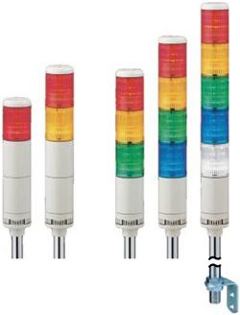
Figure 2.6: Warning lights with several shapes
Stack lights are commonly used on equipment in industrial manufacturing and process control environments to provide visual and audible indicators of a machine state or process event to machine operators, technicians, production managers and factory personnel.

2.2.4.1 Function
Stack lights are used in a variety of machines and process environments; specific colour-coding is assigned by the system designer.
Commonly used colour codes for machine state conditions include:
- RED: Failure conditions such as an emergency stop or machine fault
- YELLOW: Warnings such as over-temperature or over-pressure conditions
- GREEN: Normal machine or process operation
- BLUE: External help request, where an operator might be requesting raw materials, scheduling or maintenance personnel assistance
- WHITE: User-defined conditions specific to a machine, often related to productivity monitoring
- Optionally an audible alarm buzzer, typically in the range of 70-105db, may be added to alert machine operators to high priority conditions.

2.2.5 Fiber glass
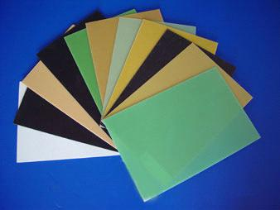
Figure 2.7: Shapes of Fiberglass
Fiberglass is a fiber reinforced polymer made of a plastic matrix reinforced by fine fibers of glass.
Fiberglass is a lightweight, extremely strong, and robust material, and is used for many products. Although strength properties are somewhat lower than carbon fiber and it is less stiff, the material is typically far less brittle, and the raw materials are much less expensive. Its bulk strength and weight properties are also very favorable when compared to metals, and it can be easily formed using molding processes.
2.2.6 Steel rod coated with chrome
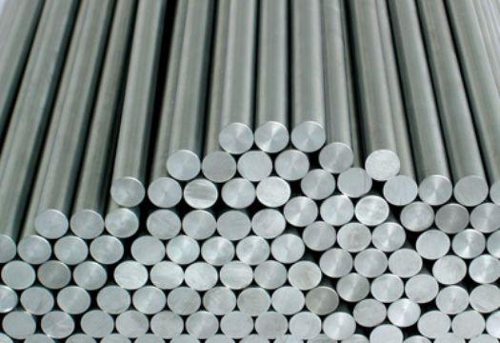
Figure 2.8: Steel Rods
SAE-1045 steel plated with chrome
1045 steel is used when greater strength and hardness is desired, extreme size accuracy, straightness and concentricity combine to minimize wear in high speed applications.
The steel plated with chrome to exploit the properties of it, to achieve smooth surface finish, excellent wear and corrosion resistance for the connecting rods.
2.2.7 Aluminium plate
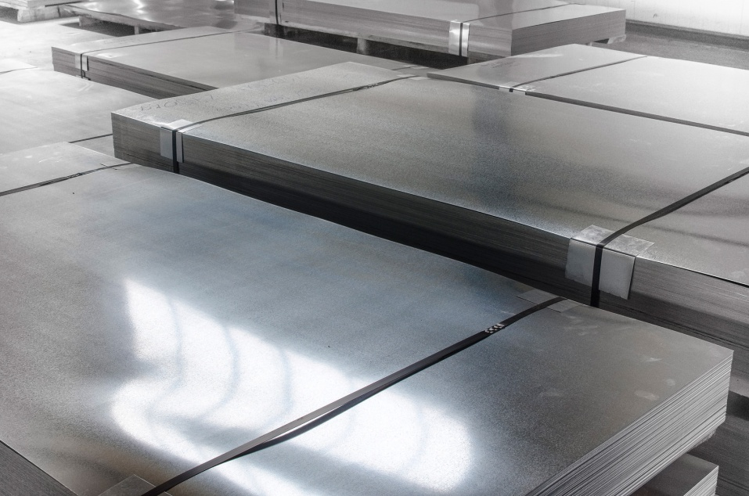
Figure 2.9: Packaged aluminum plates
Aluminium Sheet (Plate) is available in various alloys offering a range of weldability, corrosion resistance and machinability. High strength Aluminium Sheet, such as 7075, can be used in aerospace applications, and high corrosion resistance aluminium alloy sheets are commonly used in marine applications.
Aluminium Plate is a blend of the most desirable features of many individual metals. The result is a cast aluminium plate that meets the challenge of product accuracy demanded by today's industry.
Because of its cast granular structure and stress relieving properties, Aluminium Plate allows high-speed metal removal with little, if any, of the distortion commonly inherent in long grained wrought, flat-rolled metals.
Using proper aluminium machining methods, tolerances in the thousandths can be consistently maintained. Aluminium Plate is finished to 20 micro inches typical on both sides. Thickness tolerances are within +/-.005" from nominal on 1/4"- 4".
Flatness tolerance is maintained within .015" on 1/4"-5/8" thickness and .005" on 3/4"- 4" thickness. Thermal Cycling can be performed up to 800° F under controlled conditions.
Aluminium Plate is produced by continuous casting with each thickness individually cast. By utilizing the most recent developments in casting techniques, the molten metal is continuously fed, eliminating defects from lapses and seams. Thermal gradients are stabilized since heat is removed from both plate surfaces at a balanced rate.

2.2.8 Hexagonal Screws
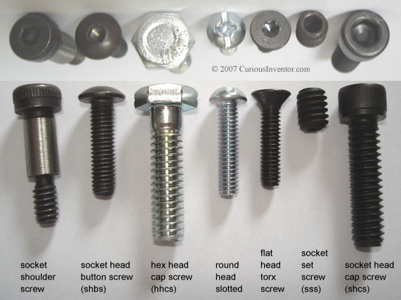
Figure 2.10: Types of hexagonal screws
A hex screw drive uses six-sided fastener heads. The fastener is known as a hex head cap screw. It can be turned with an adjustable wrench, combination wrench, and 6- or 12-point sockets. The hex drive is better than square drive for locations where surrounding obstacles limit wrenching access, because smaller wrench-swing arcs can still successfully rotate the fastener.
The hex socket screw drive has a hexagonal recess and may be driven by a hex wrench, also known as an Allen Wrench, Allen key, hex keyor inbus as well as by a hex screwdriver (also known as a hex driver) or bit. Tamper-resistant versions with a pin in the recess are available.

2.2.9 Fini air compressor
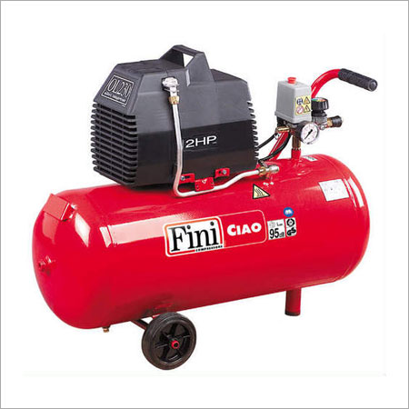
Figure 2.11: Air compressor (Fini type)
Reciprocating air compressors are positive displacement machines, meaning that they increase the pressure of the air by reducing its volume. This means they are taking in successive volumes of air which is confined within a closed space and elevating this air to a higher pressure. The reciprocating air compressor accomplishes this by a piston within a cylinder as the compressing and displacing element.
Single-stage and two-stage reciprocating compressors are commercially available.
- Single-stage compressors are generally used for pressures in the range of 70 psig to 100 psig.
- Two-stage compressors are generally used for higher pressures in the range of 100 psig to 250 psig.
Note that
- 1 HP ~ 4 CFM at 100 psi
And that 1 to 50 HP are typically for reciprocating units. Compressors 100 hp and above are typically Rotary Screw or Centrifugal Compressors.
The reciprocating air compressor is single acting when the compressing is accomplished using only one side of the piston. A compressor using both sides of the piston is considered double acting.
Load reduction is achieved by unloading individual cylinders. Typically this is accomplished by throttling the suction pressure to the cylinder or bypassing air either within or outside the compressor. Capacity control is achieved by varying speed in engine-driven units through fuel flow control.
Reciprocating air compressors are available either as air-cooled or water-cooled in lubricated and non-lubricated configurations and provide a wide range of pressure and capacity selections.

CHAPTER THREE: WORK PROCESS
In the beginning, the table of work was assembled by using welding, then a piece of wood was cut in the form that is appropriate for the whereabouts of pneumatics cylinders, then we have identified the whereabouts of the bolts on a piece of aluminum and punctured by drill with diameter of 8 inches and teething process even commensurate with the screw, then fixed a piece of aluminum in the space next to it final exit place by hexagonal screws.
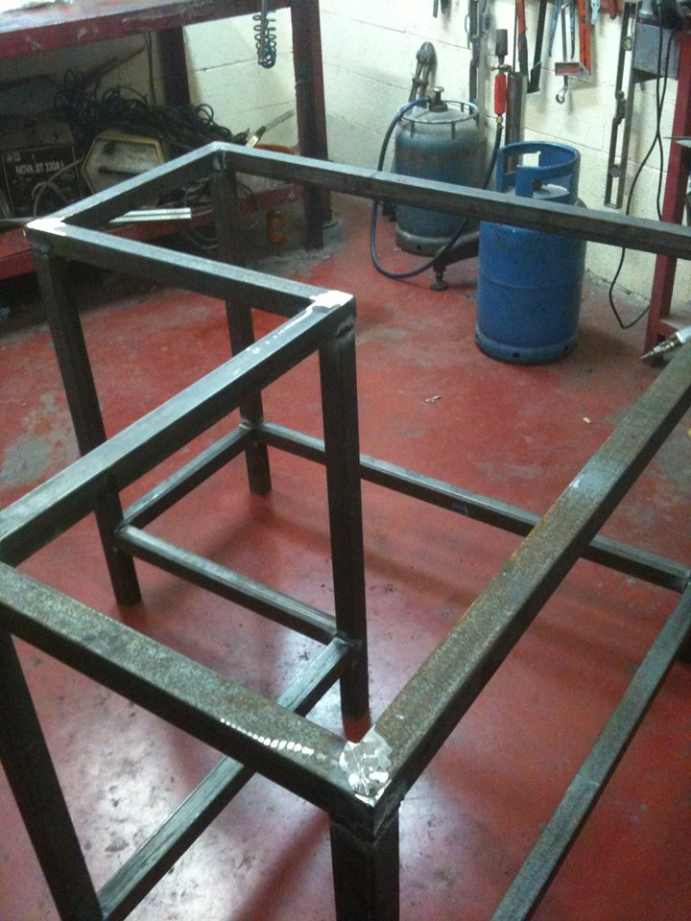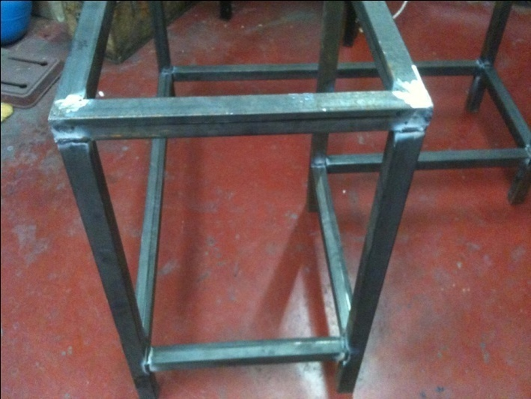
Figure 3.1: Assemble the steel box sections with welding
Figure 3.2: Assemble the steel box sections

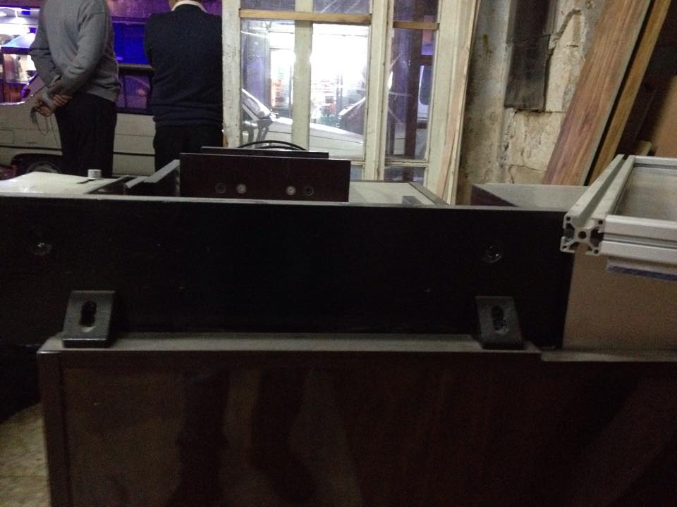
Figure 3.3: Fixing the rectangular Steel

Second, the exit chute dimensions were identified and calculate the length and depth and also combined by hexagonal screws.
Third, the length, width and thickness of the two pieces of steel that will be the carrier of pneumatic cylinders has been calculated, then holes in the location of the bolts that secure the pneumatic cylinders was made by drill in addition to the teething process and then fix steel pieces on the workbench by welding.
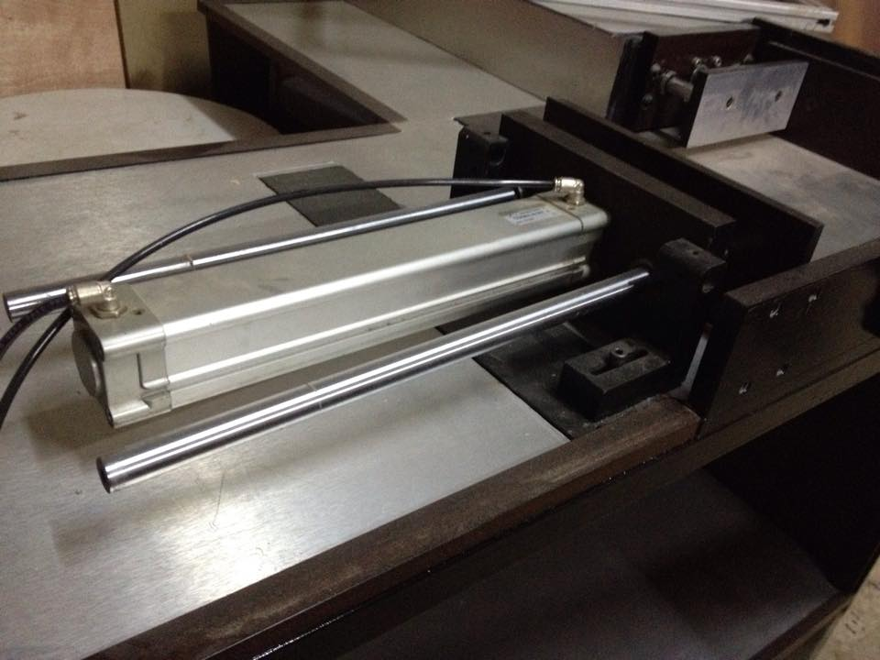
Figure 3.4: Steel plate that carries the pneumatic cylinder
Fourth, links coated steel rod chrome to pneumatic cylinders, and then fix the cylinders with the piece of steel by hexagonal screws.
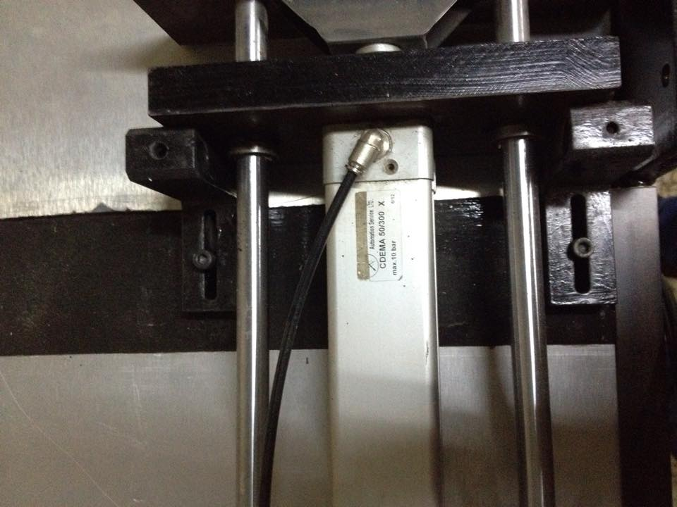
Figure 3.5: Fixing the pneumatic cylinder with steel plate

Fifth, calculate the dimensions of the wooden piece that will be fixed on the front of pneumatic cylinders and fixed it by the hexagonal bolts.
Figure 3.6: Fixing the wooden piece with the pneumatic cylinder
Sixth, fixing the air pressure valves at the entrances and exits of the air in pneumatic cylinders and linked with the air compressor by an AIGNEP Selector and PVC tubes.
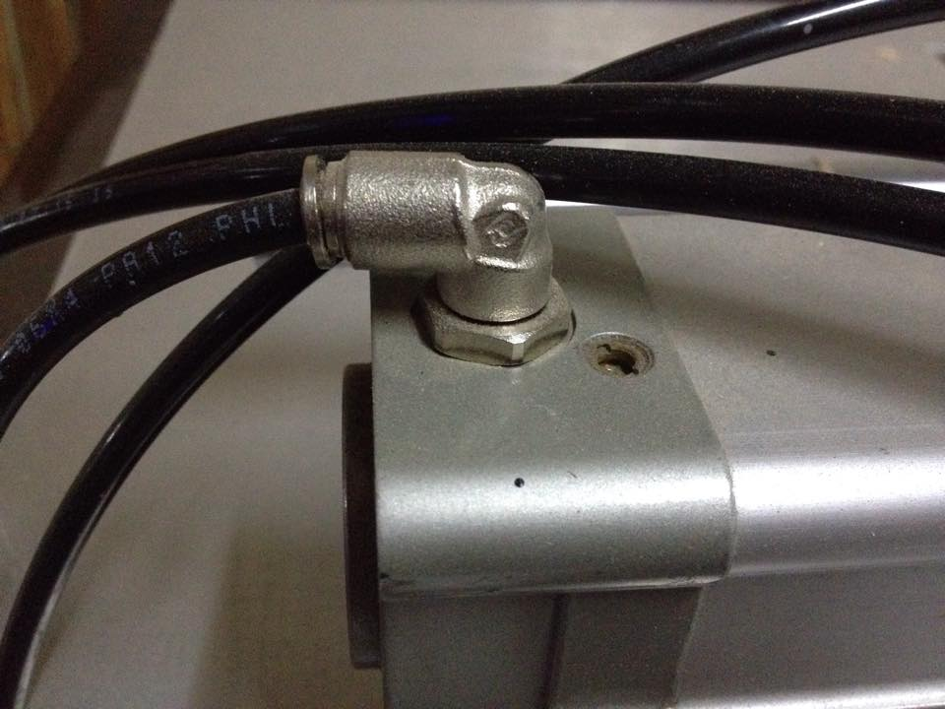
Figure 3.7: Air pressure valve

Seventh, made a frame of aluminum close it by Fiberglass and fixed on the table of work by the corners in order to make a glass-roofed diaper and provide safety to work, and then closed the pneumatics cylinders also with wood and fiberglass.
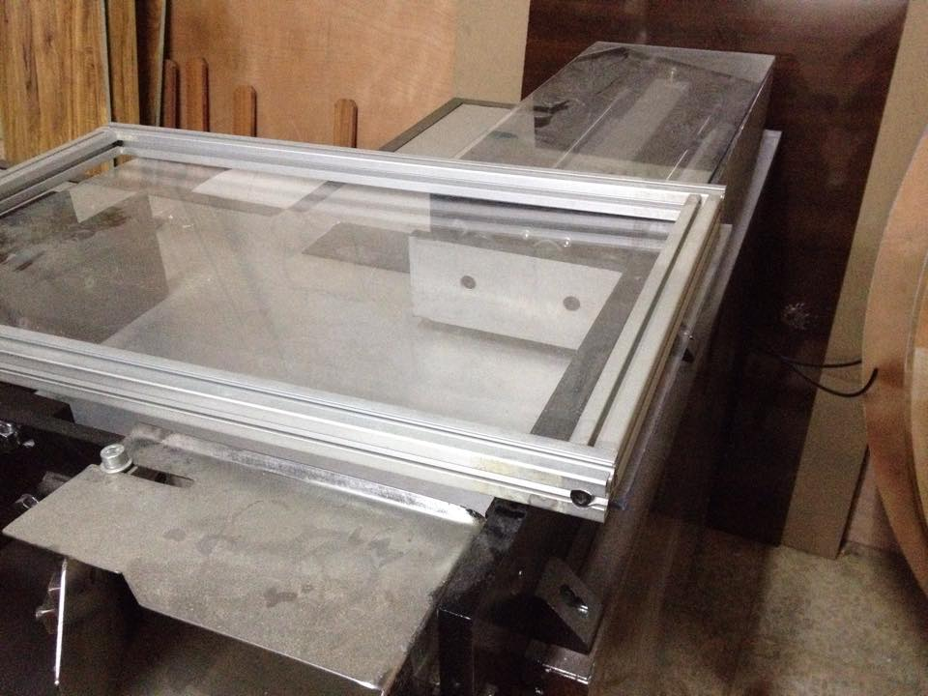
Figure 3.8: Fiberglass frame
Eighth, programming the PLC circuit in order to rapid the work and do it automatically, and then connected it with the pneumatic cylinder.
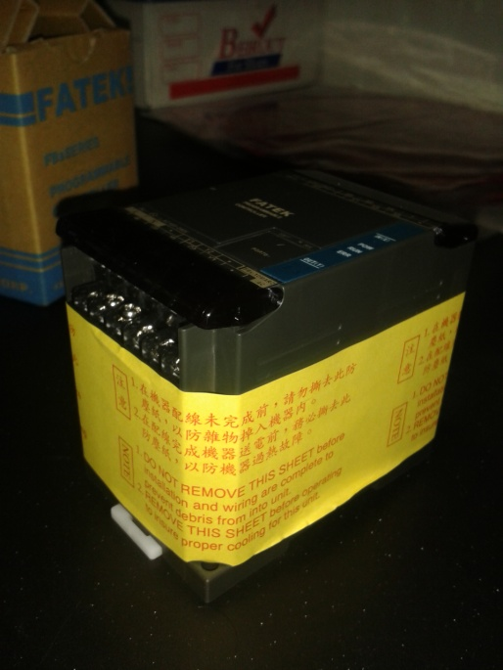
Figure 3.9: PLC circuit

Ninth, collecting all these parts and making check of each part if it is in its place or not.
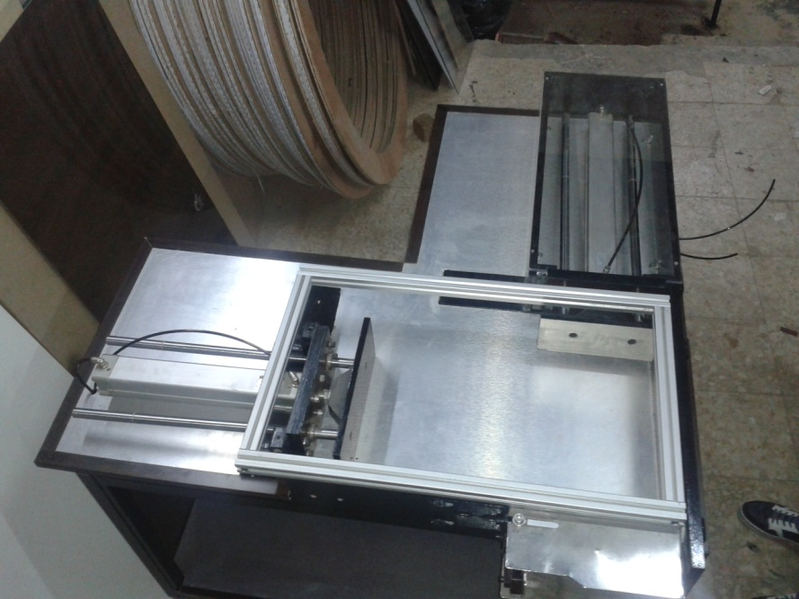
Figure 3.10: Collecting the parts of machine
Lastly, painting all the machine parts that need to paint.

CHAPTER FOUR: RESULTS AND ANALYSIS
4.1 Force Calculations
4.1.1 The first pneumatic cylinder:
Pressure = 6bar = 600 KPa
Length = 32cm = 0.32 m
Width = 12.5cm = 0.125 m
Area = Length*Width = 0.32*0.125 = 0.04 $m^{2}$
Force = Pressure*Area = 600*0.04 = 24 KN
4.1.2 The second pneumatic cylinder:
Pressure = 6bar = 600 KPa
Length = 22.7cm = 0.227 m
Width = 9.7cm = 0.097 m
Area = Length*Width = 0.227*0.097 = 0.022 $m^{2}$
Force = Pressure*Area = 600*0.022 = 13.2 KN
4.2 Welding Calculations
4.2.1 The first Steel plate:
Dimensions of plate:
Length = 51cm, width = 10cm
Dimension of welding as shown in the figure 4.1.
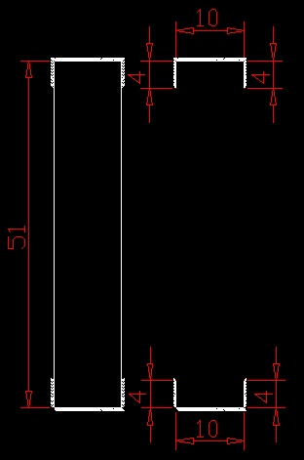
Figure 4.1: Length of the welding points under the first pneumatic cylinder (cm)
By using table (4.1):
A = 0.707h (b+2d) = 7.6*${10}^{-3} m^{2}$
X = b/2 = 0.05m
Y = $\frac{d^{2}}{b+2d}=8.8*{10}^{-3}m$
$I_{u}=\frac{2d^{3}}{3}-2d^{2}y+\left(b+2d\right)y^{2}=3.06*{10}^{-5}m^{3}$
I = 0.707h$I_{u}$= 1.3*${10}^{-7}m^{4}$
From figure 4.2 shown:
$τ^{'}=\frac{Force}{Area}=3.2 MPa$
$τ^{''}=σ=\frac{M c}{I}=52MPa$
$τ={{(52}^{2}+{3.2}^{2})}^{1/2}=52.02 MPa$
$τ_{allowable}=120 MPa$
$n=\frac{τ_{allowable}}{τ}=2.3$ (Safe!)

4.2.2 The Second Steel plate:
Dimensions of plate:
Length = 51cm, width = 10cm
Dimension of welding as shown in the figure 4.3.
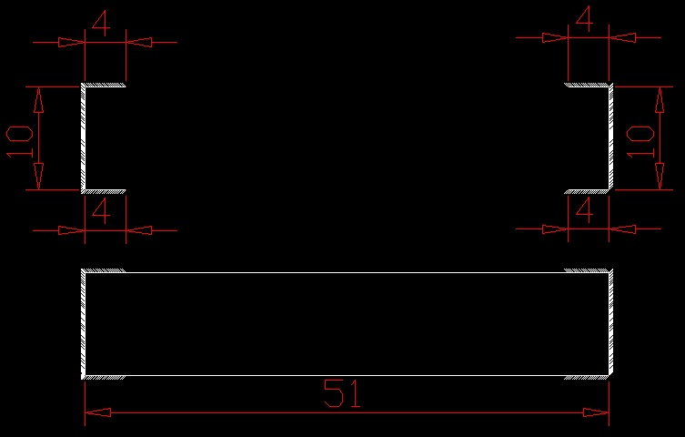
Figure 4.2: Welding points under the second pneumatic cylinder
By using table (4.1):
A = 0.707h (2b+d) = 7.6*${10}^{-4} m^{2}$
X = $\frac{b^{2}}{2b+d}$= $8.8*{10}^{-3}$m
Y = b/2 = 0.05 m
$I_{u}=\frac{d^{2}(6b+d)}{12}=2.83*{10}^{-4} m^{3}$
I = 0.707h$I_{u}$= 1.2*${10}^{-6} m^{4}$
From figure 4.4 shown:
$τ^{'}=\frac{Force}{Area}=17.3 MPa$
$τ^{''}=σ=\frac{M c}{I}=84 MPa$
$τ={{(17.3}^{2}+{84}^{2})}^{1/2}=85.7 MPa$
$τ_{allowable}=120 MPa$
$n=\frac{τ_{allowable}}{τ}=1.4$ (Safe!)

CHAPTER FIVE: CONCLUSION AND RECOMMENDATION
The main idea of our project was constructed and applied by engineering standards; the problem was solved by manufacturing our machine in order to maintain the deviated products.
The machine helped the factory to rapid the production line and decreases the cost of importing the machine from outside the country, so that, the machine costs $40,000 from Italy, our project reduces the cost by changing the electrical motor system to pneumatic cylinder system and it costs around $8,000.
Our project gives us the opportunity to apply the theoretical knowledge in a real life problem. It enhances our skills in different fields like welding, teething, screws and bolt selection, drilling, etc...
Finally, the machine works successfully as we planned and fits with the basic standards.

References:
[1] Brian S. Elliott, Compressed Air Operations Manual, McGraw Hill Book Company, 2006,
[2] Majumdar, S.R, Pneumatic System: Principles and Maintenance, New Delhi: Tata McGraw-Hill, 1995.
[3] Cheng Chi-Neng, Design and Control for The Pneumatic Cylinder Precision Positioning Under Vertical Loading, 2005.
[4] Maher, Michael J. Real-Time Control and Communications, 18th Annual ESD/SMI International Programmable Controllers Conference Proceedings, 1989.
[5] Kinner, Russell H., P.E. Designing Programmable Controller Application Programs Using More than One Designer, 14th Annual International Programmable Controllers Conference Proceedings, 1985.
[6] W. Bolton, Programmable Logic Controllers, Fifth Edition, Chapter 1, Newnes, 2009.
[7] Keller, William L Jr. Grafcet, A Functional Chart for Sequential Processes, 14th Annual International Programmable Controllers Conference Proceedings, 1984.
[8] Knowles, Peter Reginald, Taylor & Francis, Design of structural steelwork, 2nd ed., p. 1, 1987
[9] Shigley J., Richard G.Budynas, J.Keith Nisbett, Shigley’s Mechanical Engineering Design, 9th edition, Chapter 9, 2009

APPENDIX

Table 4.1: Bending properties of fillet welds
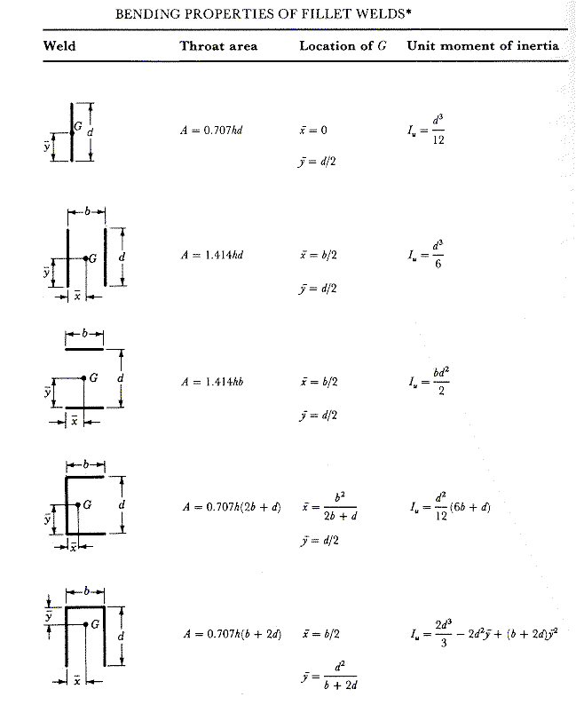

Tools that used in the machine work:
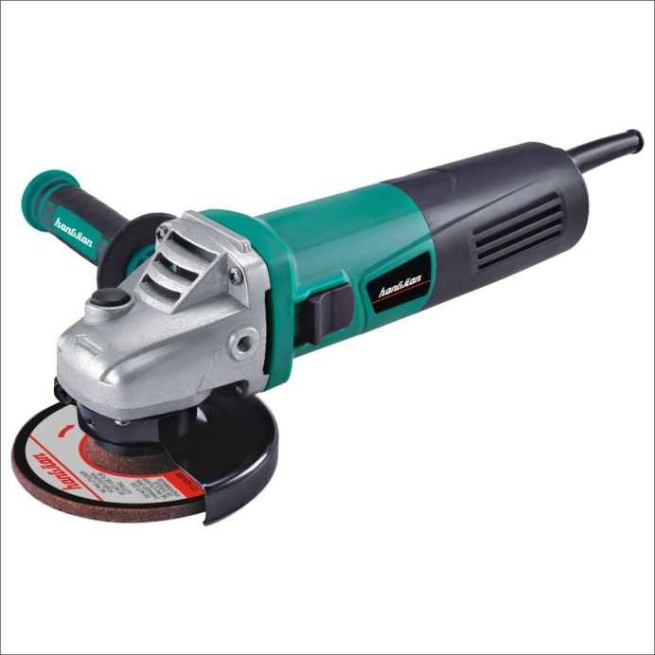
Figure A.1: Chainsaw

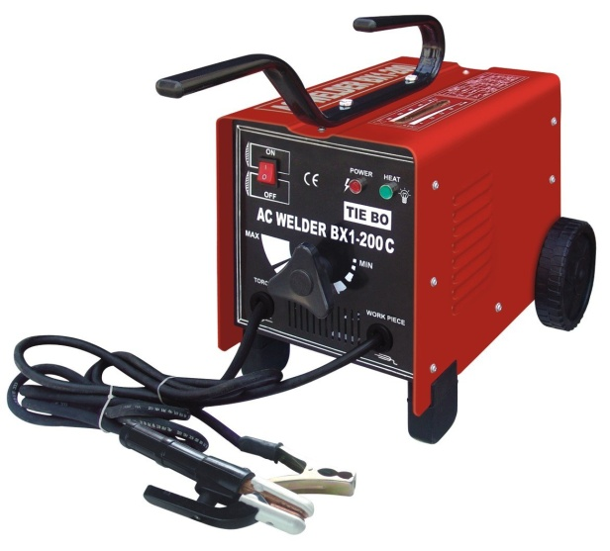
Figure A.2: Welding Machine
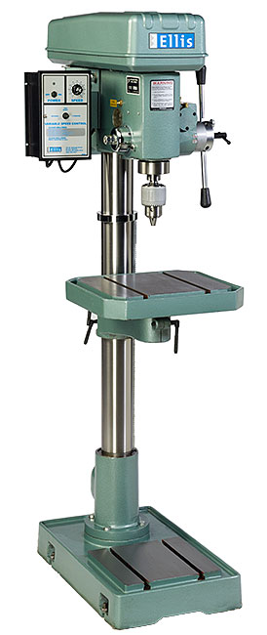
Figure A.3: Drill
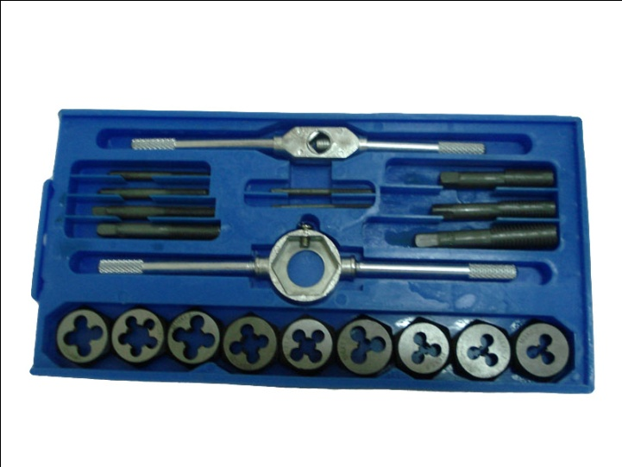
Figure A.4: Teething Tools
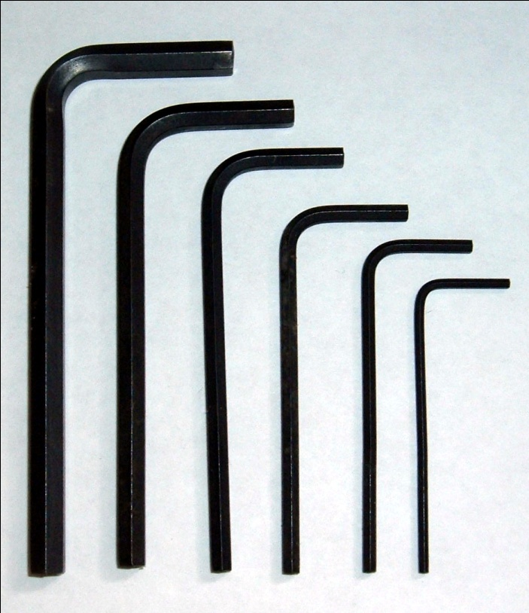
Figure A.5: Hexagonal Screwdrivers
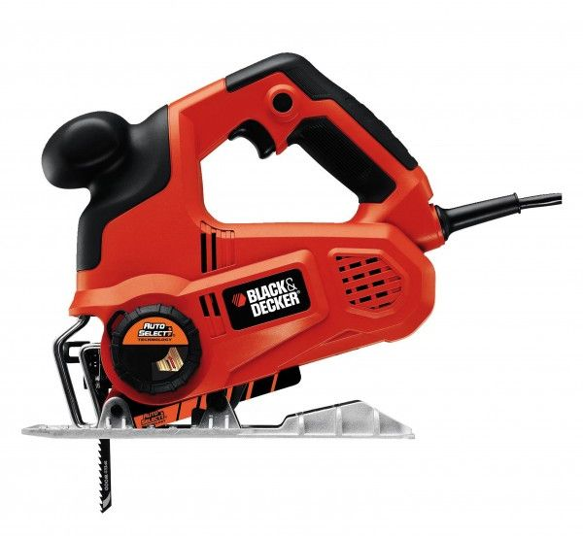
Figure A.6: Wood Saw
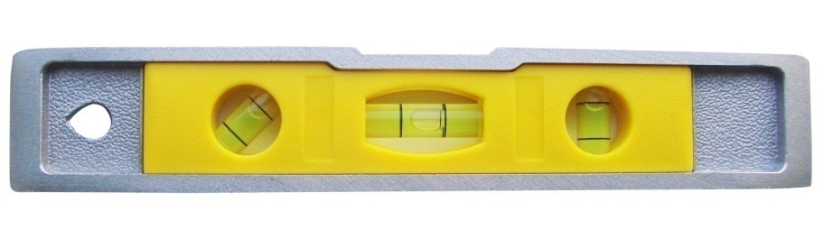
Figure A.7: Level
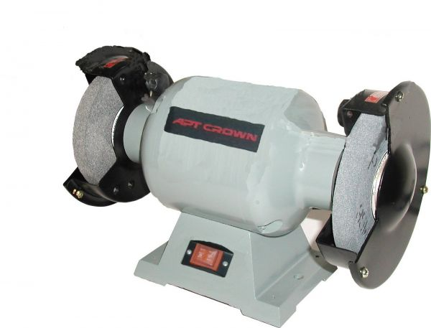
Figure A.8: Grinding Machine
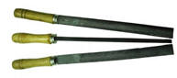
Figure A.9: Chilled

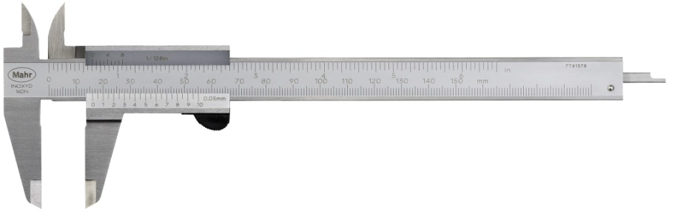
Figure A.10: Caliber

