

An-Najah National University
Faculty of Engineering and Information Technology
Department of Chemical Engineering

Graduation Project (2)
Use of limestone waste in cement
production
Prepared By:
Aya Mustafa
Ghadeer Najajrah

Supervised by:
Dr. Hamdallah Bearat

Report submitted in partial fulfillment of the requirements for graduation with the
Bachelor Degree in Chemical Engineering

December, 2015

Acknowledgement

Thank you god for giving us the courage and the determination as well as guidance in conducting this research study, despite all difficulties.
We would like to dedicate our thesis to our beloved families. And thank you so much for your support.
We wish to thank our supervisor Dr. Hamdallah Bearat for conscientious guidance and encouragement to accomplish this project. Who was more than generous with his expertise
Also we want to thank our examiners Dr. Shadi Sawalha and Dr. Mohammad Al-Sayed for their hints.

And do not forget to thank our department for his support and to supervisor laboratories especially Mr. Yousef Ratrout and Eng. Maha Fuqha

Abstract

Limestone waste powder is an industrial and environmental burden. This fine-grained powder is a by-product of the stone industry. Therefore, exploring new engineering solutions to this problem should be highly beneficial to the industry and the public health and well-being. Hence, the main objectives of this project is to study the effect of calcination temperature (decomposition of limestone) on the production of lime and to investigate the possibility of producing construction materials such as cement, refractories or ceramic materials.
The main procedure in this project is to mix the limestone powder with calcium chloride solution and burn the dry mix at different temperatures: 700 ºC, 800 ºC, 900 ºC, 1000 ºC. Also, samples were burnt at 700 ºC for different time periods to study the effect of time on the calcination process and product. As a result, at higher temperature the weight loss, due to carbon dioxide loss, increases and the lime yield, too. Also, the addition of calcium chloride (CaCl₂) has an effect of lowering the decomposition temperature of CaCO₃ (limestone), increasing the rate of the reaction (hence the released amount of CO₂), and producing a porous and strong material at a temperature as low as 700ºC.

Table of contents

Acknowledgement i
Abstract ii
List of Figures iv
List of Tables v
Chapter One: Introduction and Literature review
1.1 Introduction 1
1.1.Limestone 1
1.2. Applications of limestone 2
Limestone as a filler 2
Plastic and paper industry 2
1.3. Lime (CaO) 3
1.4 Calcination & the heat energy consumed 3
1.4 Environmental effect. 4
1.5 Objectives: 5
1.2. Literature review 6
Chapter Two: Methodology
2. Methodology 8
2.1 Materials 8
2.2 Experimental Procedure 9
Chapter Three: Results and Discussion
3.1 Results 12
3.2 Discussion 18
Chapter Four: Conclusion and Recommendations
4.1 Conclusions 21
4.2 Recommendations 22
4.3 References 23
4.5 Appendices 25
Sample of calculation: 25
Figures 27

List of Figures

Figure (1): Random dumping of the waste (fine grained powder and dust) 4
Figure (2): Powder and white color of limestone 8
Figure (3): Calcium chloride (CaCl2) aqueous 9
Figure (4): Comparison between the loss of CO2 with and without CaCl2. 13
Figure (5): The limestone after burnt………………………………………………..13
Figure (6): The limestone with CaCl2 after burnt………………………….……….14
Figure (7): The relationship between the calcination time and loss of % CO2. 15
Figure (8): Compressive strength test for (CaCO3+CaCl2) block. 16
Figure (9): Compressive strength test for (CaCO3+CaCl2+sand) block. 17
Figure (10): Compressive strength test for (CaCO3) block. 17
Figure (11): Block of limestone with CaCl2 treatment……………………………. 27
Figure (12): The sample after chemical and heat treatment………………………….27

List of Tables

Table (1): The loss weight of CO₂ by calcination of CaCO₃. 12
Table 2: The loss of weight of CO2 by calcination of CaCO3 with CaCl2 (1M) 13
Table (3): The loss of weight of CO2 by calcination of CaCO3 with CaCl2 (2M) 14
Table (4): The effect of calcination time at 700 C. 15

CHAPTER ONE
INTRODUCTION &
LITERATUE REVIEW

Introduction

The stone and marble industry is a major and important sector of the Palestinian economy. Stone is the natural resources and vary according to region, that it is available in different types, quality and colors, such as the white, beige and red colors are found in Bethlehem, where the grey and yellow colors in Birzeit. The main problem of this industry is that it generates a large amount of waste limestone powder estimated about 0.5 million cubic meters per year. Indeed, this is an industrial and environmental burden due to its negative environmental, health, and agricultural impacts. So, one can take advantage of this waste in useful applications to reduce the adverse effect of waste.

1.1. Limestone
Limestone is a sedimentary rock composed mainly of calcite (CaCO3) and magnesite (MgCO3) also it is a by-product of stone industry. It exists in four different mineralogical forms, which are calcite, aragonite (CaCO3), magnesite, and dolomite (CaMg (CO3)2). In nature, the limestone is not found in pure form of calcite, usually it consist of varying amounts of impurities such as; SiO2, Al2O3, Fe2O3, and sulphur. Can be classified according to the origins of limestone. Organic limestone is found in nature such as marble, chalk, lime shell, and coral. And chemical limestone is formed by precipitation reactions of calcium with carbonate ions. [1]

1.2. Applications of limestone
The most application require that the limestone calcined, where the calcium carbonate decompose to produce lime and CO2.

Limestone as a filler
The limestone powder blended with cement at 15 to 20 percent. It found to increase the early strength of concrete and increase the control of bleeding in concrete with low cement content. This cement is known as Portland L limestone cement. The purity of the limestone should be greater than 75% by mass of Calcium Carbonate content. It use as a filler in mixture of asphalt in construction of road and building. [2]
Cement production
Cement produces by blending different materials such as calcium, silica and clay, by heating the blending material at a high temperature about (1000-1200 C) to produce a calcium oxide, in order to achieve a cement clinker. The limestone is a source of calcium due to it is easier to grind than the clinker, to produce a wide particle size distribution in a finished Portland limestone cement. About 80-90 % is limestone while the 15 % is clay are blended, also may be contained other material such as magnesium oxide. [3]
Plastic and paper industry
It used in paper manufacturing with specific particle sizing and color. As an alkali material it reduces acidity of paper, improving the durability of printed material. And as a filler and pigment extender in industrial coatings, protective coating, textured finishes, and plasters. Also, it used as a filler to increase the volume and density of the plastic products, which can reduce the cost of production. [4]

1.3 Lime (CaO)
Limestone uses to produce a lime. It produces by calcination of calcium carbonate (CaCO3) at a high temperature about 1000 ºC. The lime is used in cement manufacture, ceramics and construction materials. The main factors for the estimation of lime reactivity are the surface area, hydration rate and calcination temperature. The small particles size the larger surface area and more reactivity of lime. [5] The calcination temperature has an effect on the production of lime, and the calcination time is the other factors, at specific duration time the reaction occurs depending on the particle size of the limestone. As the particle size increase the duration time increase. [6]

1.4 Calcination & the heat energy consumed
The reaction is endothermic and consists of five process steps: a) heat transfer from ambient to the solid surface, b) heat conduction from surface to the reaction front, c) chemical reaction at the front, d) diffusion of CO2 through the porous oxide layer to the surface and e) the mass transfer into the surroundings. [6]
The kiln temperature has an effect on reaction rate and the size of lime (CaO) particles. Calcination of calcium carbonate is endothermic reaction, requiring 3.16 GJ of heat input to produce a ton of lime (CaO). The reaction only begins when the temperature is above the dissociation temperature of the carbonates in the limestone. This typically is between 780ºC and 1340ºC. Dissociation of the calcium carbonate proceeds gradually from the outer surface to the inside of the particle, that is explained why a porous layer of calcium oxide produced. Only 56.8% of the heat supplied was used to decompose calcium carbonate or in other words 43.2% of the energy was either irreversibly lost to surroundings or not recovered for more useful application. [7]

1.4 Environmental effect.

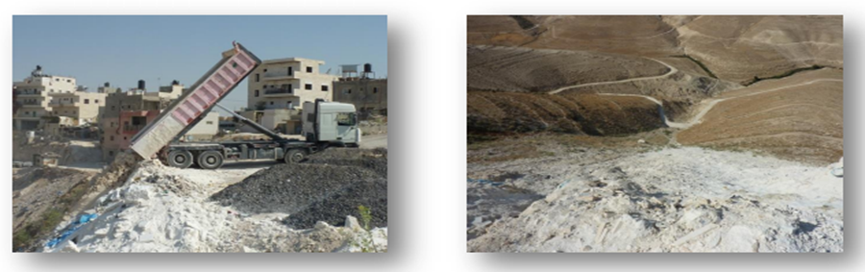
Stone industry has contributed in the environmental problems. This is due to large amounts of waste powder generated during the different cutting operations of stone and the movement of trucks on dirt roads. Also, the industry consumes a large amount of water, approximately 0.5 million cubic meters per year. The water is used to cool the block cutting machines during all cutting operations. So, the slurry (water mixed with fine stone dust) is created. Part of this problem was solved by recycling the slurry, which was collected in the pool and the water was recycled into the production process, but the sludge settle at the bottom, dried and spread along the surrounding area. The dust is the main pollutant of air and it may clog the pores of the soil and it reduces fertility. Random dumping of waste can cause leak of the fine particles into the soil and thus altering the soil texture and composition (see Figure 1 below).

Figure (1): Random dumping of the waste (fine grained powder and dust)

1.5 Objectives:

- To study the effect of calcination temperature (decomposition of limestone) on the production of lime.
- To investigate the possibility of producing construction materials such as cement, refractories or ceramic materials
- Studying the effect of calcium chloride treatment on the loss of CO₂.

2. Literature review

The quantity of waste, which is produced from stone and marble industry, can be estimated around 500,000 tons per year, so many researchers were studied the possibility of re-use of such wastes in useful industries that related to the building and construction materials such as cement, concrete and brick blocks. The study showed the use of marble dust in concrete production as cement replacement or as sand replacement. As a result the concrete made with marble dust as sand replacement achieved better performance compared to concrete made with marble dust as cement replacement. [8]

The usability of waste marble dust as an additive material in industrial brick were investigated. Waste material mixed with industrial brick mortar, the samples having different marble dust composition. They pressed and sintered at three different temperatures 900, 1000 and 1100 ºC. It found that the amount of marble dust additive had positive effect on the physical, chemical and mechanical strength of the produced industrial brick. In addition, the usage of marble wastes for the production of industrial bricks has significant important role on the recycling waste marble powder. [9]
Limestone waste can be utilized for preparation of mineral supplements for livestock, due to its solubility and being a rich source of Calcium. The solubility fractions of limestone waste improved with increase in normality of HCl and decreased the particle size. [10]

CHAPTER TWO
METHODOLOGY

2. Methodology

2.1 Materials
The local and available materials were used to accomplish the experiments and achieve the objectives of the project, limestone powder, HCl and sand were used.

2.1.1 Limestone (samples)
Limestone is a by-product of stone industry, it was used as a source for calcium carbonate (CaCO3), to produce a many useful products or materials such as ceramics or construction materials. The powder and white color of limestone was used, as in the figure (2), which it was supplied from the quarries of Palestine.
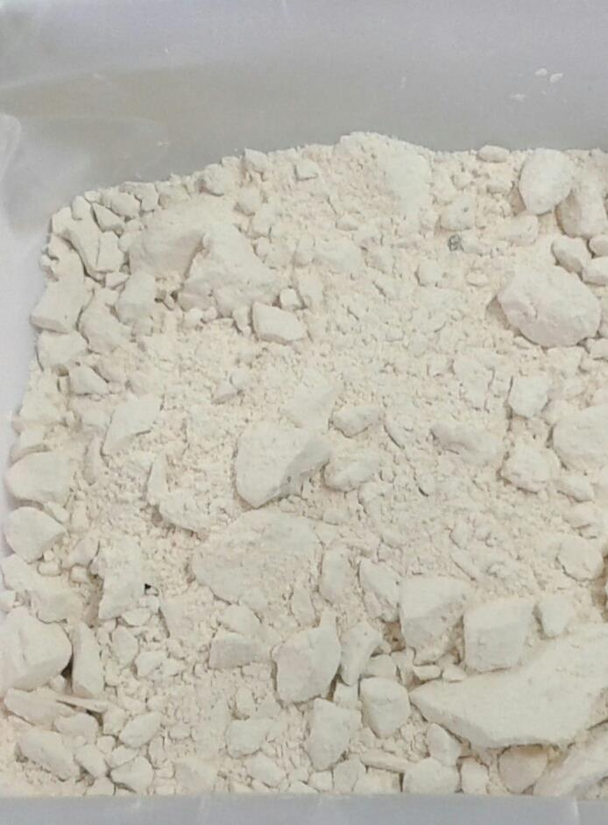

Figure (2): Powder and white color of limestone

2.1.2 Sand
Sand is granular material composed primarily of minerals or organic constitutes such as: carbonates and iron oxides. It is used in various industrial applications, such as building materials and manufacture of refractory brick. Moreover, it is used in glassmaking and molding sands. In this project, sand was obtained from the sea beach and desert. It was used as a source of silica (SiO2), to react with limestone.

2.1.3 Hydrochloric acid (HCl)
It is a very strong acid, the 36.5 % by weight was used. It used to prepare the calcium chloride (CaCl2) solution as shown in figure (3), by the reaction with the limestone powder. In addition the carbon dioxide (CO2) is produced from this reaction.
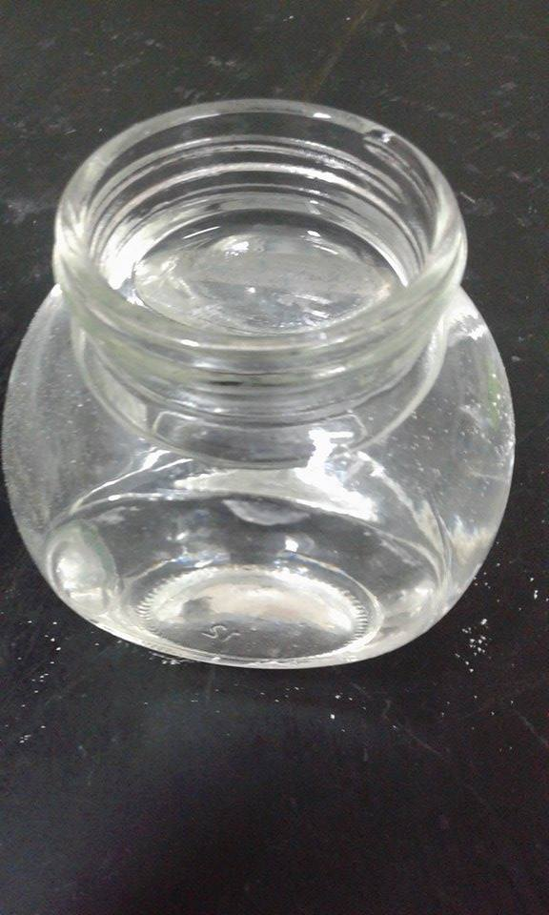

Figure (3): Calcium chloride (CaCl₂) aqueous

2.2 Experimental Procedure
The main step in this work is to hold the calcination reaction at different temperatures and with adding the calcium chloride to limestone before burning of it. To study the effect of some factors on the production lime or loss of CO₂ weight. And the mixture of limestone powder with calcium chloride represent the samples.
The first step, the HCl solution was prepared by diluting 85 mL of the feedstock (37 wt %) in 1 L deionized water to achieve (1M) HCl in concentration. Then 10gm of limestone was dissolved in 200mL (1M) HCl, according to the stoichiometric reaction, to produce the CaCl2 aqueous solution.
The representative samples were prepared by mixing (4.5gm) of limestone powder with 10mL of calcium chloride (equivalent to 20 wt %).
The second step consists in burning the samples in the furnace and varying some factors: calcination temperature, concentration of CaCl₂, and calcination time.
To study the effect of these factors, on the calcination reaction, the following steps were followed:
- Samples of limestone powder were calcined at different temperatures 700 ºC, 800 ºC, 900 ºC, and 1000 ºC for one hour for the production of lime (CaO). (two samples are made at each temperature)
- The limestone powder was mixed with the 1M aqueous CaCl2 solution, dried, and calcined for 1 hour at 700 ºC, 800 ºC, 900 ºC, and 1000 ºC, respectively.
- Mixtures of limestone powder and 1M CaCl2 solution were dried and calcined at 700ºC for 1, 1.5, and 2 hours, respectively.
- Mixtures of limestone powder with 2M CaCl2 solution were dried and calcined for 1 hour at 700 ºC, 800 ºC, and 900 ºC.
In the third step, blocks were made from the mixture of limestone with 2M CaCl2 solution, dried, and calcined at 700 ºC. The latter samples served of conducing of the strength tests and defining applications for this product. The strength test was made by unconfined compression machine.

CHAPTER THREE
RESULT & DISCUSSION

3.1 Results

The evaluation of thermal decomposition of limestone was performed by measuring the mass loss of samples before and after calcination. The mass loss corresponds to the released amount of CO₂, the theoretical percentage of mass loss is 44 %.
To study the effect of temperature variation on the calcination reaction, the loss of carbon dioxide was measured and normalized for each run at different temperature, as shown in Table (1). Normalization was done by dividing the actual parentage of CO₂ lost (measured) by the amount of CO₂ initially present in the samples (theoretical) and multiplying by 100. .
Table (1): The loss weight of CO₂ by calcination of CaCO₃.
T ($°$C) | Loss of CO₂ (%) | Normalized (%)
700 | 14.8 | 33.6
800 | 22.7 | 51.6
900 | 41.6 | 94.5
1000 | 43.2 | 98.2
As the results in the table show, the loss of CO₂ increases with the increase of temperature, which indicates a progress in the calcination reaction, and in turn, the production of lime increases.
Repeating the experiment with addition of CaCl₂ (1M) to limestone to study its effect on the loss of CO₂ at different temperatures. The results of this experiment were tabulated in Table (2).
Table (2): The loss of weight of CO₂ by calcination of CaCO₃ with CaCl₂ (1M)
T ( ºC ) | Loss of CO₂ (%) | Normalized (%)
700 | 16.1 | 45.3
800 | 21.0 | 59.8
900 | 33.3 | 97.3
1000 | 35.0 | 99.2

As noticed from the results in the table above, the loss of CO₂ is more than in the case of burning limestone without of CaCl₂ treatment.

Figure (4): Comparison between the loss of CO₂ with and without CaCl₂.

As shown in the figure, the addition of CaCl₂ has an effect on the loss of CO₂. At 1000 C the effect of adding CaCl₂ is less than that on 700 ºC. Also, as noticed from the experiments, the product which contain CaCl₂ is stronger and harder than that without treatment. As shown in figures (5) and (6).
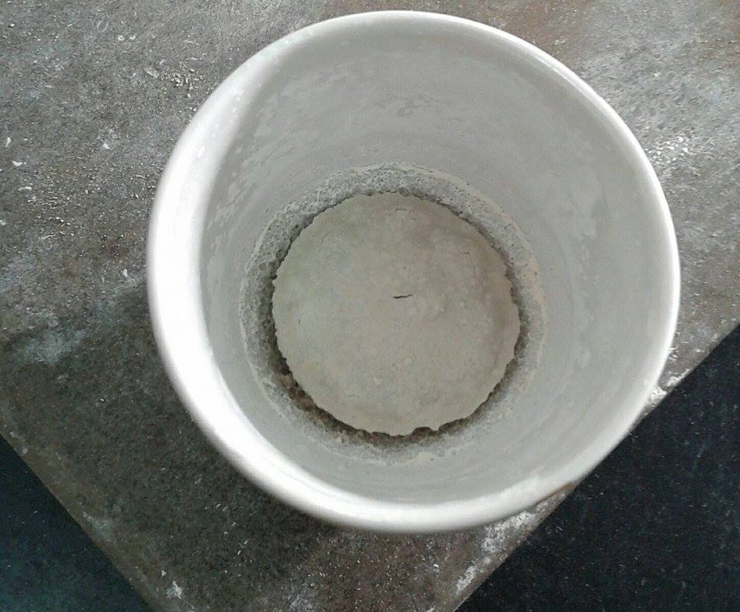
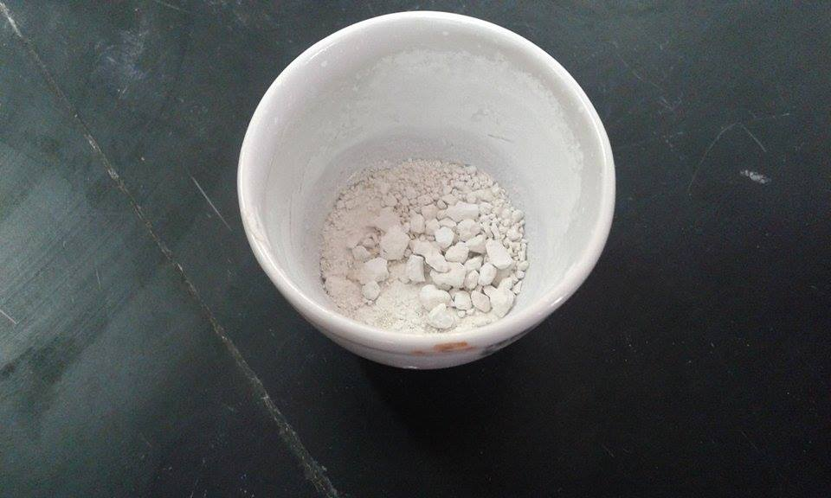

Figure (5): The limestone after burnt. Figure (6): The limestone with CaCl₂ after burnt

Also, the concentration of CaCl₂ was changed to study the effect of concentration on the loss of CO₂.

Table (3): The loss of weight of CO₂ by calcination of CaCO₃ with CaCl₂ (2M)
T ( ºC ) | Loss of CO₂ (%) | Normalized (%)
700 | 2.15 | 5.61
800 | 6.65 | 18.84
900 | 29.3 | 83.0

The weight loss of CO₂ decreased with the increase of the concentration of CaCl₂, which means an adverse effect.
At 700 ºC the samples were burnt for a different time period: 1, 1.5, and 2 hours. To study the effect of calcination time. Table (4) shows the result.

Table (4): The effect of calcination time at 700 ºC.
Time (hr) | Loss of CO₂ (%) | Normalized (%)
1 | 16.0 | 45.3
1.5 | 9.93 | 28.13
2 | 4.25 | 12.5

The weight loss of CO₂ decreased with the increase the burning period. , As noticed from the experiments, in shorter burning duration (1hr) the burned product is harder than that 1.5 and 2 hours.
The figure (7) shows the linearity relation between the calcination time and loss of weight. With increase the time, the loss decrease. Also at 800 ºC the loss of CO₂ was 59.8 and 38.6 % for 1 and 2 hours, respectively.

Figure (7): The relationship between the calcination time and loss of % CO₂.

The blocks were formed and burnt at a temperature of 700 ° C for 3 hours, then tested for strength. The compressive strength of CaCO₃ with CaCl₂ block is 1.225 MPa, (CaCO₃ + CaCl₂ +20% sand) block is 0.932 MPa, and CaCO₃ block is 0.811MPa. As shown in figures 8, 9 and 10 respectively.
This mean that the addition of calcium chloride improved the strength of the material.

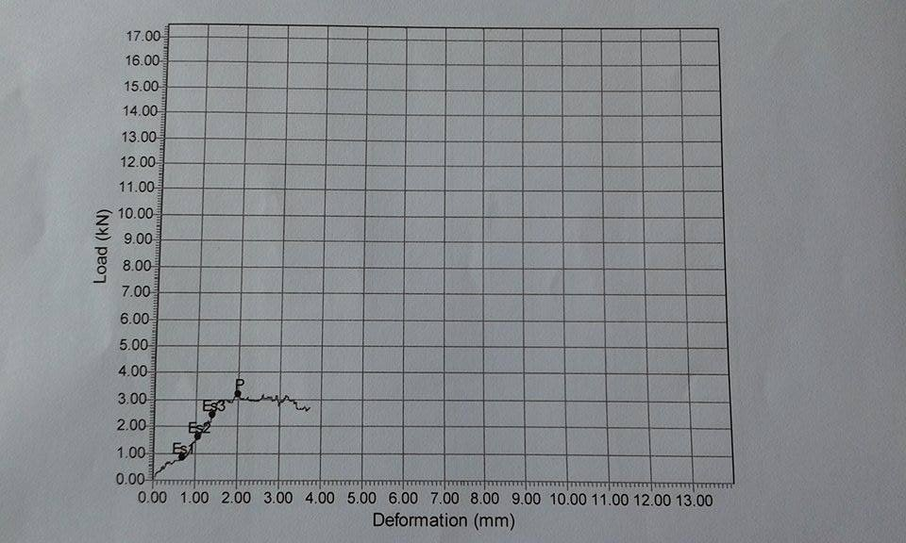

Figure (8): Compressive strength test for (CaCO₃+CaCl₂) block.

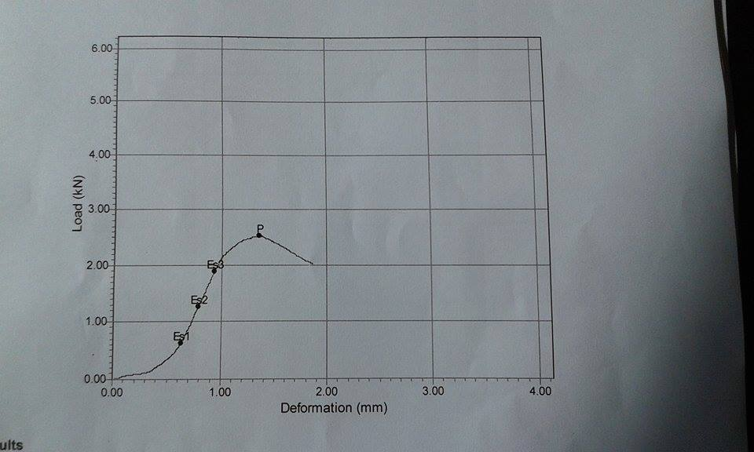

Figure (9): Compressive strength test for (CaCO₃+CaCl₂+sand) block.

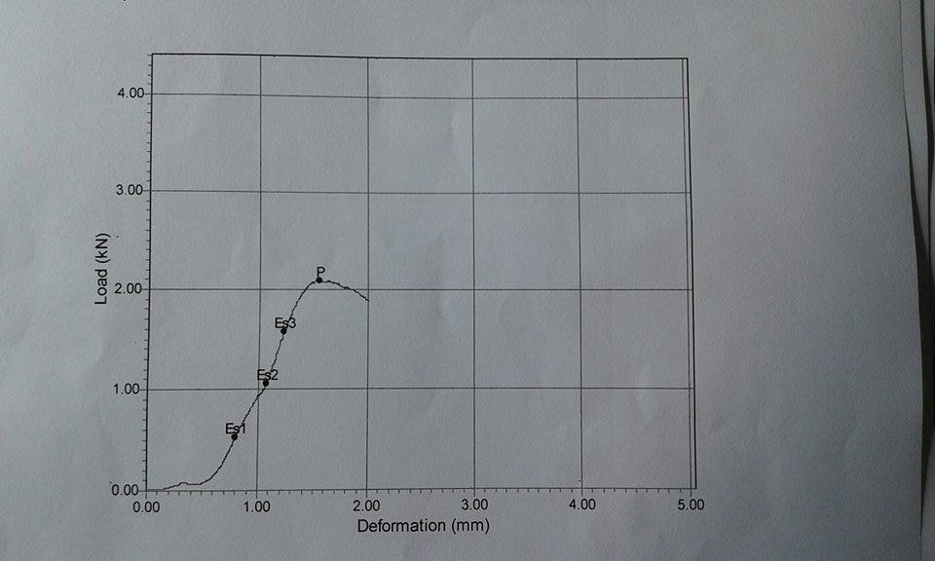

Figure (10): Compressive strength test for (CaCO₃) block.

3.2 Discussion
Limestone was investigated for the production of lime and related ceramic and refractory products at low temperature, much lower in the case of lime than that commonly used (usually in excess of 900ºC). Lime can be used in applications such as construction materials and refractory bricks.
The experiments carried out on the waste powder of limestone industry because it is easy to access, to process, and react at a lower temperature especially when it is pretreated with aqueous chloride solution such as CaCl₂.
In this project, limestone samples were burned at different temperatures (700ºC, 800ºC, 900ºC and 1000 ºC to evaluate the ignition loss (CO₂ % loss) then compared with the theoretical percentage which is 44%, from the results, the best thermal decomposition temperature is 1000 ºC which lost 43.2% of its weight, which is close to the theoretical percentage of CO₂. Needless to say that the limestone powder used is not 100% CaCO₃.
The treatment with calcium chloride solution before calcination has an effect in increasing the yield of CaO product (and hence the percentage of CO₂ emitted). At a temperature as low as 700ºC the weight loss of CO₂ increases by 12 % compared to calcination without chloride pretreatment. Also the product from the burning of limestone with CaCl₂ has a higher porosity and is stronger. Therefore it can be used in applications that require these properties such as refractory bricks.
The time of calcination increases as the dimensionless radius increases (lower surface area). Thus, calcination of a block needs more time than the powder. Because the calcination reaction progresses from the outer surface of the particles into the inner part and that’s explained why a porous layer of calcium oxide is produced.
According to our results, it is found that increasing the calcination time causes the weight loss to decrease. This is an unexpected result and may appear contradicting the kinetic rate laws for an endothermic process that is presumably spontaneous at 700ºC and may seem to disagree with the “common sense”. In fact, this observed effect cannot be explained solely by the loss of CO₂. However, this effect is being observed also by another group working with NaCl-treated limestone powder calcination [11]. This discrepancy can be explained by the fact that in presence of chlorides at 700ºC calcite (CaCO₃) is not reacting through an equilibrium decomposition reaction. The fundamental reaction mechanism is an acid-base reaction. Calcium carbonate is the base while the acid is hydrogen chloride produced through a reaction of water vapor with the chloride present (here CaCl₂). Therefore, this is a solid-gas reaction of CaCO₃ with HCl that gives CaCl₂, CO₂ and H2O. While the first reacts with water to regenerate HCl and to produce CaO, the second (CO₂) diffuses out of the reaction medium and eventually escapes out of the kiln [12, 13]. These reactions continue as long as the HCl and H2O vapors are present in the reaction system [12, 13]. As they escape, reactions slow down and eventually stop at some time, which is dependent on the firing temperature: the higher the temperature the shorter this time is. This explains why more CaCO₃ appears to react below 800ºC than at much higher temperature [6]. Nevertheless, this alone cannot explain why the amount of CO₂ lost at 700ºC decreases with firing time. In fact, we have to remember that CaO is being produced from CaCO₃ at a temperature below the equilibrium temperature of CaCO₃ = CaO+CO₂. This is means that CaO is not stable at this temperature in presence of CO2 and will recombine with CO₂ at 700ºC (from the atmosphere) once HCl is depleted and continue to carbonate during the cooling process down to room temperature. Meanwhile, we have no explanation for the observed decrease in reactivity of CaCO₃ at all temperatures when treated with 2M CaCl₂ solution. Indeed this observation agrees with a previous study on the effect of NaCl that reached its optimal value at 3%NaCl [12]

CHAPTER FOUR
Conclusion & Recommendations

4.1 Conclusions

The main aim of this project is using the limestone waste powder to produce the lime and other ceramic products at “low” temperature through thermochemical treatment. Reactivity is monitored through the loss of CO₂. That concludes to the following results:
- Without chemical treatment, increasing the temperature shows the loss of CO₂ to increases up to 100 % at 1000 ºC; it is about 34 % at 700 ºC.
- The addition of CaCl₂ (1M) has an effect to increase the released amount of CO₂. At 700 ºC the released increases from about 34 % to 45.5 %
- By increasing the concentration of CaCl₂ to 2M the released amount of CO₂ decreased.
- In this project, the optimum calcination’s time is 1 hr at 700 ºC and the product is porous and stronger.
- With increasing the dimensions of sample, the calcination’s time increased.
- The product which is produced from the addition of CaCl₂ to limestone is stronger. And the addition of sand reduced the strength of the product.

4.2 Recommendations

The difficulties were confronted in this project, the analysis equipment, such as XRD, is not available to analyze the limestone and the product after the burning of limestone.
So the recommendations:
- Enhancing the use of limestone waste in industrial applications, due to its wide availability in Palestine.
- Provide equipment and instruments for the students to be able to complete and apply their projects.
- Analyze the samples to determine what is produced and to know respective applications.
- Moreover, the research should be pursued to look much closely at all these effects and parameters to be able to control the reaction processes and the quality of the products.

4.3 References
[1] | Toprak, G. (2007) "Caracteristics of limes produced from marbles and limestone," Turkey .
[2] | Tarun, R. Naik, M (2003) "Limestone powder use in cement and concrete," The university of wisconsin – Milwaukee.
[3] | Tennis, D. et al (2011) "Use of Limestone in Cements at Levels of up to 15%," Portland Cement Association .
[4] | "longcliffe /calcium carbonate," longcliffe Ltd, [Online]. Available: http://www.longcliffe.co.uk/index.asp. [Accessed 21 November 2015].
[5] | kilic,O. (2006) "Effects of limestone characteristic properties and calcination temperature on lime quality," Asian journal of chemistry, vol. 18, no. 1, pp. 655-666.
[6] | Adefila, S. et al (2013) "Investigation of some factors that affect jakura limestone burning," African Journal of Pure and Applied Chemistry, vol. 7, no. 8, pp. 280-290.
[7] | Walmsley, R. et al (2006) "Understanding lime calcination for energy cost reduction," in 59th Appita Conference, New Zealand.
[8] | Aliabdo, A. et al (2014) "Re-use of waste marble dust in the production of cement and concrete," elsevier, no. 50, p. 28–41.
[9] | Bilgin, N. et al (2012) "Use of waste marble powder in brick industry," Elsevier, no. 29, p. 449–457.
[10] | Sawal,R. (2013) "Effect of particle size on solubility of limestone waste," Journal of Chemical and Pharmaceutical Research, vol. 5, no.10, pp. 444-449.

[11] Abu-Rehan, Y., Khuffash, R., Qutmush, O., (2015) Carbonate-Based Cement. Graduation Project 2, Department of Chemical Engineering, An-Najah National University, Nablus, Palestine.
[12] Béarat H., Dufournier D., Ngyuen N., Raveau B. (1989) Influence de NaCl sur la couleur et la composition chimique des pâtes céramiques calcaires au cours de leur cuisson, Revue d'Archéométrie 13, 43-53.
[13] Dufournier, D, (1982) L’utilisation de l’eau de mer dans la preparation des pêtes céramiques calcaires, premières observations sur les consequences d’un tel traitment, Revue d'Archéométrie 6, 87-100.

4.5 Appendices

Sample of calculation:
- HCl (1M) preparation :
(37 % net weight) means: 100 g HCl solution include 37 g HCl pure
MW = 36.5 g/mol, density = 1.18 g/ml
1 M = moles / 1 L solution, moles = mass / Mw , mass = moles × Mw
1 mole HCl = 36.5 g
Mass HCl pure = 1 × 36.5 = 36.5 g
Mass HCl solution = (36.5 × 100) / 37 = 100 g
Volume HCl needed = 100 g / 1.18 = 85 ml
85 ml HCl diluted in 1000 ml H₂O to produce (1M HCl)

- CaCl₂ (aq) preparation :
Let take 10 g CaCO3 powder:
10 g CaCO3×(1 mol CaCO3/100.1 g CaCO3)×( 2 mol HCl / 1 mol CaCO3)×( 1 L HCl/mol HCl) = 200 ml HCl
- To make the percentage between calcium chloride & the mixture ( CaCO3 + CaCl2) = 20%
20 ml of CaCl₂ (1 M) contains: (1mol / L) × 0.02 L = 0.02 mol CaCl₂
Mass of CaCl₂ = 0.02 mol × (111 g / mol) = 2.22 g
So 10 ml of CaCl₂ contains 1.11 g
(1.11g CaCl₂/ x) = 20% ↔ 0.2x = 1.11 , x = 5.61 g ( CaCl₂ + CaCO₃)
5.61 – 1.11 = 4.5 g CaCO₃
So 4.5 g CaCO₃ need 10 ml CaCl₂
- The percentage of impurities in Calcium Carbonate:
The Weight of CaCl2 (aq) before filtration = 176.52 g
The weight of Impurities after filtration = 7.26 g
% of impurities in limestone = (7.26/176.52) × 100% = 4%
% of CaCO3 = 100% - 4% = 96%

- Samples of CaO preparation:
The weight of (4.5 CaCO3 + 10 ml CaCl2 ) before drying = 13.53 g
The weight of (4.5 CaCO3 + 10 ml CaCl2 ) after drying at 110 c = 5.56 g
The weight of mixture after burning at 700 c for 1 hr = 3.96 g
Total loss = (5.56-3.96) / 5.56 = 28.7 %
Cl2 loss = (0.71 / 5.56) = 12.6 %
CO2 loss = (28.7% - 12.76%) = 16.1 %
Initial mass= 4.5 CaCO3 +1.11 CaCl2 = 5.61gm
M _{CO2} = 0.44 ×4.5 =1.98 gm
% CO2 in initial weight = (1.98 / 5.61) ×100= 35.3 %
Normalization: CO2 loss = (16 / 35.3) ×100% = 45.3%

Figures

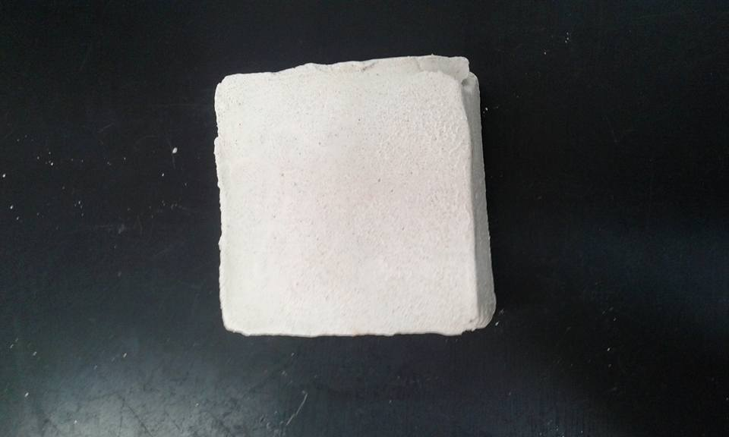
Figure (11): Block of limestone with CaCl2 treatment.
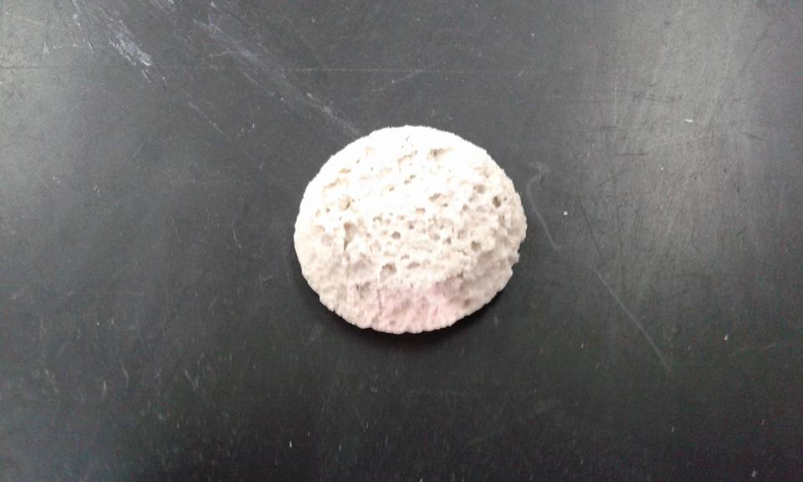

Figure (12): The sample after chemical and heat treatment.

