Table of Contents
ACKNOWLEDGEMENT 4
Introduction 4
Abstract 5
CHAPTER (1) 6
DC Motors : 7
Types Of Dc Motor : 7
Permanent Magnetic Machine 9
CHAPTER (2) 11
DTMF 12
What is DTMF ? 12
How to send DTMF tones : 12
Features of DTMF decoder : 13
DTMF decoder connected to GSM module 13
Chapter (3) 14
PIC Microcontroller 15
CHAPTER (4) : 16
DC-DC CONVERTER : 17
Types Of converters : 17
H-BRIDGE 18
MOSFET/IGBT DRIVERS 18
MOSFET AND IGBT TECHNOLOGY 19
GATE DRIVE REQUIREMENTS OF HIGH-SIDE DEVICES : 19
PWM SIGNAL 21
CHAPTER (5) 24
Project Procedure : 25
Power Supply 25
DTMF: 26
Generation DTMF Tones 27
Decoding the DTMF tone generated : 28
Battery charger 30
H-BRIDGE 31
Features 31
Applications 31
Specification : 31
IGBT'S H-BRIDGE circuit : 32
Specification of dc motor : 35
Final Results : 36
DESIGNING PCB : 37
Feedback: 43
Conclusion 44
References : 45
Appendix (code ) 45

List Of Figures :

Figure : 1 PMM Construction 10
Figure : 2 Symbol and equivalent circuit 19
Figure : 3 Power MOSFET in the High-Side 20
Figure : 4 PWM Signal 21
Figure : 5 5 V POWER SUPPLY 25
Figure : 6 frequency key matrix 27
Figure : 7 Two Pure Sine Waves combine for form the DTMF Tone for "1" 27
Figure : 8 MT887D circuit 28
Figure : 9 MT887D circuit 29
Figure : 10 ADC Circuit 30
Figure : 11 Specification of H-Bridge 31
Figure : 12 IGBT'S H-BRIDGE 1 32
Figure : 13 Gate Drive Circuit 33
Figure : 14 Charactrestec of DC motor 35
Figure : 15 The Output Signal from PIC AND Gate Driver 36
Figure : 16 Voltage At Motor Terminals (to the right at 50 % duty , to the left 75% duty ) 37
Figure : 17 a Pic plus DTMF (CONTROL) Circuit 38
Figure : 18 b Gate Driver Circuit 39
Figure : 19 the first figure showing the routings , the second showing the 3d picture for the project 40
Figure : 20 the 1st figure show the O/P pdf for the pcb , the 2nd show the board a fter burning the pic 41
Figure : 21 After Using the Acid 42
Figure : 22 Picture For The project 43

List Of Tabes :

Table 1 DTMF frequency table 12
Table 2 Type of pic 15
Table 3 specification of pic 18F4620 15
Table 4 Various dc motor speed according to the PWM duty 37

ACKNOWLEDGEMENT

We are deeply indebted to DR. Kamel Subhi for his able guidance, expert advice and showing us the right way of carrying out the research project. We are also thankful to him for giving us the special attention and cooperation in between his very busy hours. We are also grateful to our entire electrical faculty for their efforts to strengthen the fundamental concepts so that one can take up any assignment of serious gravity with confidence. We would like to take this opportunity to express our heart- felt indebtedness towards DR.mazen Rasehk , DR. Nasser Abu Zaid , DR . Falah Hasan DR.Raed Jaber for their support and enlightenment. At this moment we would also like to express our gratitude for the technical staff of our laboratories.

Introduction

The development of high performance motor drives is very important in industrial as well as other purpose applications. Generally, a high performance motor drive system must have good dynamic speed command tracking and load regulating response.
The dc motors are used in various applications such as industries, Robotics, monitoring cameras , DC drives etc, because of their simplicity, ease of application, reliability and favorable cost have long been a backbone of industrial applications. DC drives are less complex with a single power conversion from AC to DC. DC drives are normally less expensive for most horsepower ratings. DC motors have a long tradition of use as adjustable speed machines and a wide range of options have evolved for this purpose. In these applications, the motor should be precisely controlled to give the desired performance. Many varieties of control schemes such as P, proportional integral (PI), proportional derivation integral (PID), have been developed for speed control of dc motors. The proposed controller systems consist of DTMF , Gate Driver , H-bridge and Microcontroller for the speed control.
Many practical control issues (motor control problems):

- Variable and unpredictable inputs
- Noise propagation along a series of unit processes
- Unknown parameters
- Changes in load dynamics

Major problems in applying a conventional control algorithm in a speed controller are the effects of non-linearity in a DC motor. The non-linear characteristics of a DC motor such as saturation and friction could degrade the performance of conventional controllers. Many advance model-based control methods such as variable-structure control and model reference adoptive control have been developed to reduce these effects. However, the performance of these methods depends on the accuracy of system models and parameters. Generally, an accurate non-linear model of an actual DC motor is difficult to find, and parameter values obtained from system identification may be only approximate values.

Abstract

Man has invented many machines and in almost all the machines, ultimately motions have been Controlled by in-situ or through remote techniques. In this direction, the use of DTMF (Dual Tone Multiple Frequency) technique available in a mobile or cell phone is becoming an interesting topic, as it offers many convenient solutions for controlling the various motors both in forward and reverse directions. In fact , once a motor gets controlled, its motion can be translated in many dimensions. The Cell Phone Application group in the Incubation Cell at the SBIT has utilized two cell phones in controlling three motors. In actual situation, DTMF signals have been utilized to control the speed and direction of the dc motor (PMM) and that has wide application form monitoring to the huge machines in some factories .

CHAPTER (1)

DC MOTOR

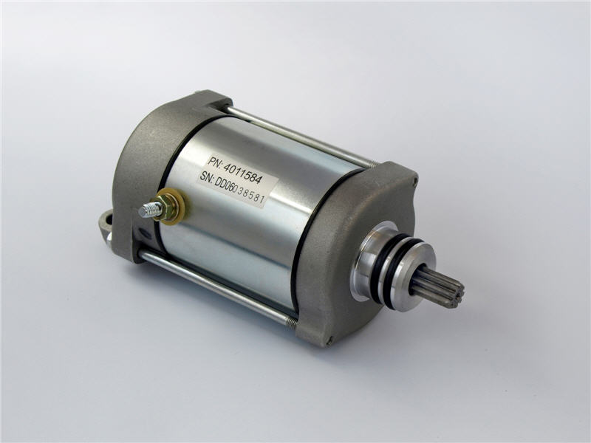

DC Motors :

Motors are an integral part of engineering in today's Society. They are used in a wide variety of applications , from running fans to driving belts to turning wheels. Yet, despite their prevalence in the designs of undergraduate engineering students, most such students have very little idea of how motors actually work, or of how to control them safely and dependably. This project describes DC motors, analyzes them and determines adequate strategies or controlling them in a manner which is both safe and reliable. Stepper and servo motors will not be discussed here, as their form, function, and application are considerably different from that of DC motors , The traditional DC motor needs two current supplies, one through the stator windings to provide the magnetic field and the other through the rotor windings to interact with the magnetic field to generate the motive force. There are three ways of accomplishing this, each one resulting in unique characteristic motor performance. Because they all use wound rotors, they all need a commutator to feed the current into the rotor windings.
Speed is controlled by varying the rotor voltage and hence the rotor current, or by varying the magnetic flux in the air gap by changing the current in the field windings.
With access to both the field and rotor windings, all DC motors offer the facility of simple speed and torque control.‎[8]

Types Of Dc Motor :

Series Wound

The series wound motor has only one voltage supply to the motor and the field winding is connected in series with the rotor winding.

Characteristics :
The series motor has poor speed regulation. It delivers increasing torque with increased motor current but this is at the expense of speed which falls with increasing torque demands.
This motor has a very high starting torque because there is zero back EMF at zero speed however as the speed builds up so does the back EMF causing a reduction in torque.
Increasing the load on the motor tends to slow it down, but this in turn lowers back EMF and increases the torque to accommodate the load.
Speed control is possible by varying the supply voltage.
Under no load conditions the speed will accelerate to dangerous levels possibly causing destruction of the motor. The motor can be reversed by reversing the connections on either the field or the rotor windings but not both.
Regenerative braking is not possible since the field current needs to be maintained but it collapses when the rotor current passes through zero and reverses.

Applications
The series DC motor is an industry workhorse for high and low power, fixed and variable speed electric drives.
Applications range from cheap toys to automotive applications.
They are inexpensive to manufacture and are used in variable speed household appliances such as sewing machines and power tools.
Its high starting torque makes it particularly suitable for a wide range of traction applications.

Shunt Wound
The shunt wound motor also has only one voltage supply to the motor but in this case the field winding is connected in parallel with the rotor winding.

Field Weakening
The speed of a shunt wound motor can be controlled to a limited extent without affecting the supply voltage, by "field weakening". A rheostat in series with the field winding can be used to reduce the field current. This in turn reduces the flux in the air gap and since the speed is inversely proportional to the flux, the motor will speed up. However the torque is directly proportional to the flux in the air gap so that the speed increase will be accompanied by a reduction in torque.

Characteristics
The shunt wound motor turns at almost constant speed if the voltage is fixed. The motor can deliver increasing torque, without an appreciable reduction in speed, by increasing the motor current.
As with the series wound motor, the shunt wound motor can be reversed by reversing the connections on either the field or the rotor windings.
Regenerative braking is possible. Self excitation maintains the field when the rotor current reverses.

Applications
Fixed speed applications such as automotive windscreen wipers and fans

Separately Excited
The separately excited motor has independent voltage supplies to the field and rotor windings allowing more control over the motor performance.

Characteristics
The voltage on either the field or the rotor windings can be used to control the speed and torque of a separately excited motor.

Applications
Train and automotive traction applications.

Permanent Magnet Motors

As the name implies, these motors use permanent magnets rather than electromagnets to provide either the rotor or the stator field. They are used extensively in small DC motors and to an increasing extent in traction applications.

Rotor Magnets

These are by far the most common types of permanent magnet motors. They have no rotor windings but use permanent magnets to supply the rotor field and they behave like shunt wound DC motors with a fixed shunt current.
Their major advantage is the elimination of the commentator.

Field Magnets

These motors have no field winding but use permanent magnets to provide the magnetic field. Current is still supplied to the rotor via a commentator as in other brushed motors and the speed can be controlled by varying the voltage on the rotor windings. In this way their behavior is similar to a series wound DC motor.

Permanent Magnetic Machine

A permanent-magnet motor does not have a field winding on the stator frame, instead relying on permanent magnets to provide the magnetic field against which the rotor field interacts to produce torque. Compensating windings in series with the armature may be used on large motors to improve commutation under load. Because this field is fixed, it cannot be adjusted for speed control. Permanent-magnet fields (stators) are convenient in miniature motors to eliminate the power consumption of the field winding. Larger DC motors are of the "dynamo" type, which have stator windings. Historically, permanent magnets could not be made to retain high flux if they were disassembled; field windings were more practical to obtain the needed amount of flux. However, large permanent magnets are costly, as well as dangerous and difficult to assemble , this favors wound fields for large machines.
low speed, low torque device with large step angles of either 45 or 90 degrees. It's simple construction and low cost make it an ideal choice for non industrial applications, such as a line printer print wheel positioned.
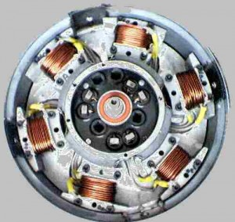
Figure : 1 PMM Construction
Unlike the other stepping motors, the PM motor rotor has no teeth and is designed to be magnetized at a right angle to it's axis. The above illustration shows a simple, 90 degree PM motor with four phases (A-D). Applying current to each phase in sequence will cause the rotor to rotate by adjusting to the changing magnetic fields. Although it operates at fairly low speed the PM motor has a relatively high torque characteristic.

CHAPTER (2)
DTMF

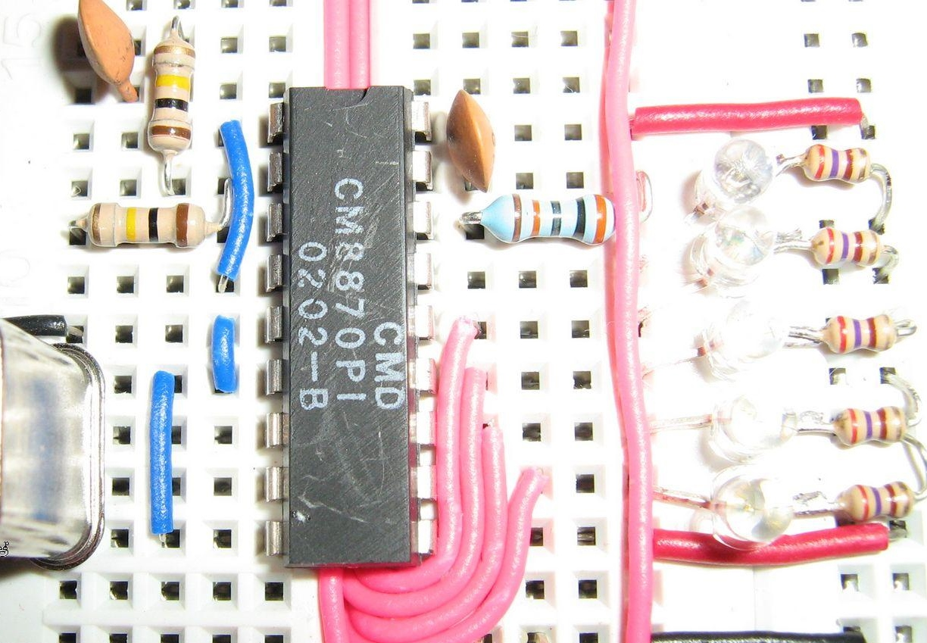

DTMF

What is DTMF ?

DTMF (Dual-tone Multi Frequency) is a tone composed of two sine waves of given frequencies. Individual frequencies are chosen so that it is quite easy to design frequency filters, and so that they can easily pass through telephone lines (where the maximum guaranteed bandwith extends from about 300 Hz to 3.5 kHz). DTMF was not intended for data transfer; it is designed for control signals only. In GSM modules is a DTMF encoder included. The DTMF tones are controlled by AT commands. For encoding you have to use encoder chips or a DSP.

How to send DTMF tones :

Of course you can send DTMF phones using your fixed line phone or cell phone, but if you want to automate the sending of these tones over a phone connection, it becomes difficult because most modems can only send DTMF to dial a number, but when the connection is made, there is no way to send these tones. Some GSM modems do have this feature such as the Wave Com and the Multi tech GSM modems.‎[3]

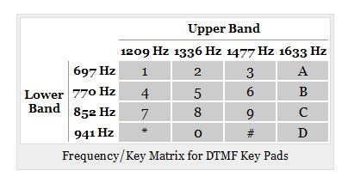

Table 1 DTMF frequency table
This table resembles a matrix keyboard. The X and Y coordinates of each code give the two frequencies that the code is composed of. Notice that there are 16 codes; however, common DTMF dialers use only 12 of them. The "A" through "D" are "system" codes. Most end users won't need any of those; they are used to configure phone exchanges or to perform other special functions. ‎[2]

Features of DTMF decoder :

- Complete DTMF Receiver
- Low power consumption
- Internal gain setting amplifier
- Adjustable guard time
- Central office quality
- Power-down mode
- Inhibit mode
- Backward compatible with MT8870C and MT8870C-1

DTMF decoder connected to GSM module

It is not easy to detect and recognize DTMF with satisfactory precision. Often, dedicated integrated circuits are used. It is rather complicated, so it is used only marginally. Most often, a MT8870 or compatible circuit would be used. The MT8870 is a complete DTMF receiver integrating both the band split filter and digital decoder functions. The filter section uses switched capacitor techniques for high and low group filters; the decoder uses digital counting techniques to detect and decode all 16 DTMF tone-pairs into a 4-bit code. External component count is minimized by on chip provision of a differential input amplifier, clock oscillator and latched three-state bus interface , and we are going to give you an explanation how the circuit of MT8870 Works . ‎[9]

Chapter (3)
PIC
MICROCONTROLLER


PIC Microcontroller
PIC microcontroller was used in this project to obtain the gate signal of the booster switch and to drive the inverter switches using PWM , PIC microcontrollers are broken up into two major categories: 8-bit microcontrollers and 16-bit microcontrollers. Each category is further subdivided into product families as shown in the following table ‎[1]
8-bit MCU Product Family | 16-bit MCU Product Family
PIC10  PIC12  PIC14  PIC16  PIC18 | PIC24F  PIC24H  dsPIC30  dsPIC33

Table 2 Type of pic
PIC 18F4620 was used to generate the required signals. Note that it has 40 pins with different functions.the following is some of the important specification for the MC :
Parameter Name | Value
Program Memory Type | Flash
Program Memory (KB) | 64
CPU Speed (MIPS) | 10
RAM Bytes | 3,968
Data EEPROM (bytes) | 1024
Digital Communication Peripherals | 1-A/E/USART, 1-MSSP(SPI/I2C)
Capture/Compare/PWM Peripherals | 1 CCP, 1 ECCP
Timers | 1 x 8-bit, 3 x 16-bit
ADC | 13 ch, 10-bit
Comparators | 2
Temperature Range (C) | -40 to 125
Operating Voltage Range (V) | 2 to 5.5
Table 3 specification of pic 18F4620

PIC microcontrollers can be programmed in Assembly, C or a combination of the two. Other high-level programming languages can be used but embedded systems software is primarily written in C we suggest writing our code completely in C because it is much faster and easier than writing in Assembly or a combination of languages. mikroc IDE is used to program the pic , we use mikroc for programming
See appendix Appendix (1 )

CHAPTER (4) :

CONVERTER
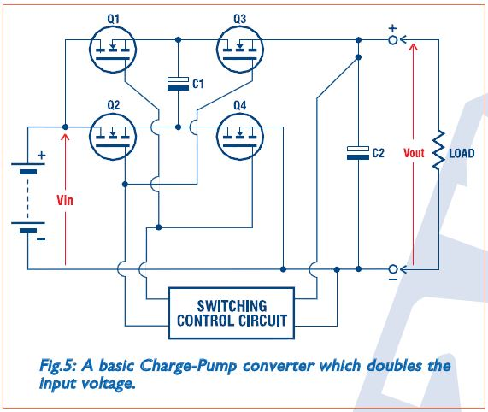

DC-DC CONVERTER :
D DC-DC converters are electronic devices used whenever we want to change DC electrical power efficiently from one voltage level to another. They are needed because unlike AC, DC can't simply be stepped up or down using a transformer. In many ways, a DC-DC converter is the DC equivalent of a transformer .
An important point to remember about all DC-DC converters is that like a transformer, they essentially just change the input energy into a different impedance level. So whatever the output voltage level, the output power all comes from the input there's no energy manufactured inside the converter. Quite the contrary in fact some is inevitably used up by the converter circuitry and We can therefore represent the basic power flow in a converter with this equation:
$P_{in}=P_{out}+P_{losses}$ ………………………………….. (1)
Where Pin is the power fed into the converter, Pout is the Output power and P (losses) is the power wasted inside the Converter Of course if we had a perfect. Converter, it would behave in the same way as a perfect transformer. There would be no losses, and Pout would be exactly the same as Pin. We could then say that.
$V_{in}*I_{in}=V_{out}*I_{out}$ ………………………………….. (2)
Or by re-arranging, we get
$\frac{V_{out}}{V_{in}}=\frac{I_{in}}{I_{out}}$ ………………………………….. (3)

In other words, if we step up the voltage we step down the current, and vice-versa Of course there's no such thing as a perfect DC-DC converter, just as there are no perfect transformers. So we need the concept of efficiency.
$Efficiency\left(\%\right)=\frac{P_{out}}{P_{in}}$ ………………………………….. (4)
Nowadays some types of converter achieve an efficiency of over 90%, using the latest components and circuit techniques. Most others achieve at least 80-85%, which as you can see compares very well with the efficiency of most standard AC transformers‎[5].

Types Of converters :

There are many different types of DC-DC converter, each of them tends to be more suitable for some types of application than for others. For convenience they can be classified into various groups, however. For example some converters are only suitable for stepping down the voltage, while others are only suitable for stepping it up a third group can be used for either Another important distinction is between converters which offer full dielectric isolation between their input and output circuits, and those which don't . Needless to say this can be very important for some applications; although it may not be important in many others we are going to look briefly at each of the main types of DC-DC converter in current use, to give you a good overview. We'll start first with those which don't offer input-output isolation, and then progress to those which do Non-isolating converters.

Non-isolating converters:

The non-isolating type of converter is generally used where the voltage needs to be stepped up or down by a relatively small ratio (say less than 4:1), and there is no problem with the output and input having no dielectric isolation

Isolating converters:

All of the converters we've looked at so far have virtually no electrical isolation between the input and output circuits; in fact they share a common connection. This is fine for many applications, but it can make these converters quite unsuitable for other applications where the output needs to be completely isolated from the input. Here's where a different type of inverter tends to be used. The isolating type , There are two main types of isolating inverter in common use .

H-BRIDGE

In the case of single stage ac to dc power conversion phase – controlled converts , are used to drive the dc machine . whenever the source is a constant voltage dc , such as a battery or diode bridge rectified ac supply , a different type of converter is required to convert the fixed voltage into a variable voltage \ variable current source for the speed control of the dc motor drive . the variable dc voltage is controlled by chopping the input voltage by varying the on and off times of a converter , and the type of converter capable of such a function is known as H-BRIDGE .

MOSFET/IGBT DRIVERS

Modern Power Electronics makes generous use of MOSFETs and IGBTs in most applications and, if the present trend is any indication, the future will see more and more applications making use of MOSFETs and IGBTs. Although sufficient literature is available on characteristics of MOSFETs and IGBTs, practical aspects of driving them in specific circuit configurations at different power levels and at different frequencies require that design engineers pay attention to a number of aspects. An attempt is made here to review this subject with some illustrative examples with a view to assist both experienced design engineers and those who are just initiated into this discipline.

MOSFET AND IGBT TECHNOLOGY

Due to the absence of minority carrier transport, MOSFETs can be switched at much higher frequencies. The limit on this is imposed by two factors: transit time of electrons across the drift region and the time required to charge and discharge the input Gate and ‘Miller’ capacitances. IGBT derives its advantages from MOSFET and BJT. It operates as a MOSFET with an injecting region on its Drain side to provide for conductivity modulation of the Drain drift region so that on-state losses are reduced, especially when compared to an equally rated high voltage MOSFET. 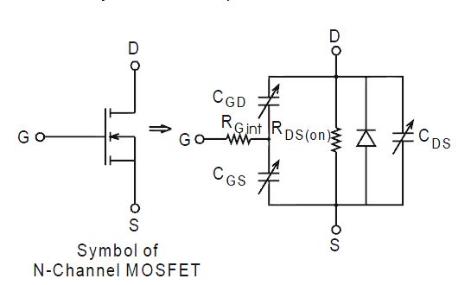summarized
Figure : 2 Symbol and equivalent circuit

GATE DRIVE REQUIREMENTS OF HIGH-SIDE DEVICES :

The gate drive requirements for a power MOSFET or IGBT utilized as a high-side switch (the drain is connected to the high voltage rail) , driven in full enhancement (i.e., lowest voltage drop across its terminals) can be as follows:
1. Gate voltage must be 10 V to 15 V higher than the source voltage. Being a high-side switch, such gate voltage would have to be higher than the rail voltage, which is frequently the highest voltage available in the system.
2. The gate voltage must be controllable from the logic, which is normally referenced to ground. Thus, the control signals have to be level-shifted to the source of the high side power device, which, in most applications, swings between the two rails.
3. The power absorbed by the gate drive circuitry should not significantly affect the overall efficiency.
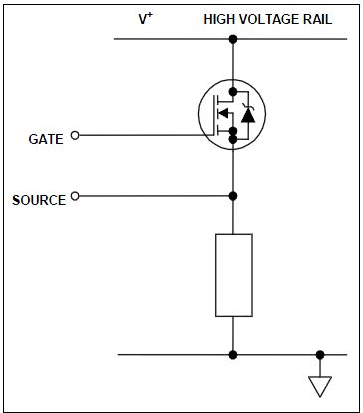
Figure : 3 Power MOSFET in the High-Side
With these constraints in mind, several techniques are presently used to perform this function. International Rectifier’s family of MOS-gate drivers (MGDs) integrate most of the functions required to drive one high-side and one low-side power MOSFET or IGBT in a compact, high-performance package. With the addition of few components, they provide very fast switching speeds, like IR2110, and low power dissipation. They can operate on the bootstrap principle or with a floating power supply. Used in the bootstrap mode, they can operate in most applications from frequencies in the tens of Hz up to hundreds of kHz ‎[8].

Input Logic
Both channels are controlled by TTL/CMOS compatible inputs. The transition thresholds are Different from device to device. Some MGDs, (e.g., IR210) have the transition threshold Proportional to the logic supply VDD (3 to 20 V) and Schmitt trigger buffers with hysteresis equal to 10% of VDD to accept inputs with long rise time.
Other MGDs (e.g., IR2110, IRS212x, and IRS213x devices) have a fixed transition from logic 0 to logic 1 between 1.5 V to 2 V. Some MGDs can drive only one high-side power device (e.g., IRS2117, IRS2127, and IRS21851).Others can drive one high-side and one low-side power device. Others can drive a full three phase bridge (e.g., the IRS213x and IRS263x families).
It goes without saying that any high-side driver can also drive a low-side device. Those MGDs with two gate drive channel can have dual, hence independent, input commands or a single input command with complementary drive and predetermined dead time. Those applications that require a minimum dead time should use MGDs with integrated dead time (half-bridge driver) or a high- and low-side driver in combination with passive components to provide the needed dead time , Typically, the propagation delay between input command and gate drive output is approximately the same for both channels at turn-on as well as turn-off (with temperature dependence as characterized in the datasheet).
For MGDs with a positive high shutdown function (e.g., IRS2110), the outputs are shutdown internally, for the remainder of the cycle, by a logic 1 signal at the shut down input. The first input command after the removal of the shutdown signal clears the latch and activates its channel. This latched shutdown lends itself to a simple implementation of a cycle- by-cycle current control, as exemplified in Section 12. The signals from the input logic are coupled to the individual channels through high noise immunity level translators. This allows the ground reference of the logic supply (VSS) to swing by ±5 V with respect to the power ground (COM).

This feature is of great help in coping with the less than ideal ground layout of a typical power conditioning circuit. As a further measure of noise immunity, a pulse-width discriminator screens out pulses that are shorter than 50 ns or so.

PWM SIGNAL

Many embedded microcontroller applications require generation of analog signals. Sometimes an integrated or stand-alone digital-to-analog converter (DAC) is used for this purpose. However, PWM signals can often be used for generating the required analog signals. PWM signals can be used to create both dc and ac analog signals. The report below discusses using a PWM signals A PWM signal is a digital signal with fixed frequency but varying duty cycle. An example of a PWM signal is shown in Figure 1. If the duty cycle of the PWM signal is varied with time, and the PWM signal is filtered, the output of the filter will be an analog signal.
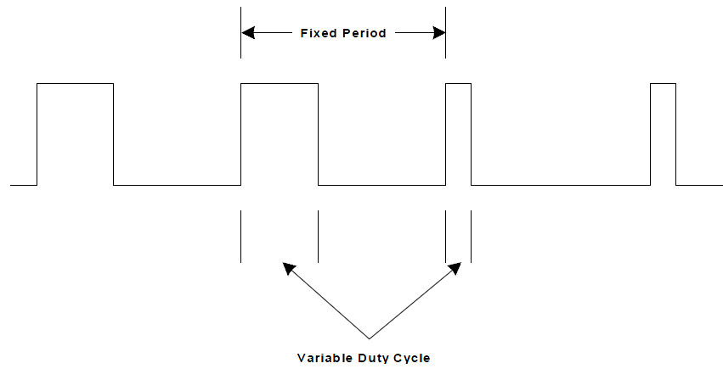
Figure : 4 PWM Signal

Low-Side Channel
The driver’s output stage is implemented either with two n-channel MOSFETs in the totem pole configuration (source follower as a current source and common source for current sinking), or with an n-channel and a p-channel CMOS inverter stage. Each MOSFET can sink or source gate currents from 0.12 A to 4 A, depending on the MGD. The source of the lower driver is independently brought out to the COM pin so that a direct connection can be made to the source of the power device for the return of the gate drive current . An under voltage lockout prevents either channel from operating if VCC is below the specified value (typically 8.6/8.2 V).

High-Side Channel
This channel has been built into an “isolation tub , capable of floating from 500 V or 1200 V to -5 V with respect to power ground (COM). The tub “floats” at the potential of VS. Typically this pin is connected to the source of the high-side device, it swings with it between the two rails. If an isolated supply is connected between VB and VS, the high-side channel will switch the output (HO) between the positive of this supply and its ground in accordance with the input command.
One significant feature of MOS-gated transistors is their capacitive input characteristic (i.e., the fact that they are turned on by supplying a charge to the gate rather than a continuous current). If the high-side channel is driving one such device, the isolated supply can be replaced by bootstrap capacitor (CBOOT),
The gate charge for the high-side MOSFET is provided by the bootstrap capacitor which is Charged by the 15 V supply through the bootstrap diode during the time when the device is off (Assuming that VS swings to ground during that time, as it does in most applications). Since the Capacitor is charged from a low voltage source the power consumed to drive the gate is small .

HOW TO SELECT THE BOOTSTRAP COMPONENTS

the bootstrap diode and capacitor are the only external components scaly required for operation in a standard PWM application. Local decoupling capacitors on the VCC (and digital) supply are useful in practice to compensate for the inductance of the supply lines.
The voltage seen by the bootstrap capacitor is the VCC supply only. Its capacitance is determined by the following constraints:
1. Gate voltage required to enhance MGT
2. IQBS - quiescent current for the high-side driver circuitry
3. Currents within the level shifter of the control IC
4. MGT gate-source forward leakage current
5. Bootstrap capacitor leakage current

Factor 5 is only relevant if the bootstrap capacitor is an electrolytic capacitor, and can be ignored if other types of capacitor are used. Therefore it is always better to use a non-electrolytic capacitor if possible. For more detailed information on bootstrap component , “Bootstrap Component Selection for Control IC’s.”
The minimum bootstrap capacitor value can be calculated from the following equation:
$$Q_{TOT}=Q_{G}+Q_{LS}+\left(I_{LK_GE}+I_{QBS}+I_{LK}+I_{LK_DIODE}+I_{lk_CAP}+I_{DS}\right)*T_{HON}$$

VMin = Minimum voltage between VB and VS.Qls = level shift charge required per cycle (typically 5 nC for 500 V/600 V MGDs and 20 nC for1200 V MGDs)The bootstrap diode must be able to block the full voltage seen in the specific circuit , this occurs when the top device is on and is about equal to the voltage across the power rail. The current rating of the diode is the product of gate charge times switching frequency. For an IRF450 HEXFET power MOSFET operating at 100 kHz it is approximately 12 mA.
The high temperature reverse leakage characteristic of this diode can be an important parameter in those applications where the capacitor has to hold the charge for a prolonged period of time. For the same reason it is important that this diode have an ultra-fast recovery to reduce the amount of charge that is fed back from the bootstrap capacitor into the supply.

CHAPTER (5)
Project Procedure

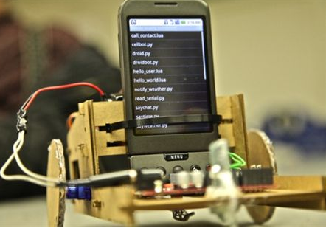

Project Procedure :
Our project divides into main four steps:
- Power Supply .
- Decoding the DTMF tones (circuit & simulation using matlab ).
- Battery charger.
- Programming.
- H-bridge and gate drive.
- Choosing the proper dc motor .
- Designing PCB For whole project .
- Final results including video.

Power Supply

In our project three separately power supply use :
          - 5 v for the pic to operate driven by Voltage regulator .
  - 15 volt for the gate driver (IR 2110) (Printer Power Supply).
  - 31 volt for the loud ,the voltage to be converted (Printer Power Supply).

The following cct describe the procure for provide these required voltages.

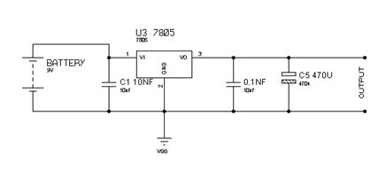
Figure : 5 5 V POWER SUPPLY

DTMF:

          - The MT8870D/MT8870D-1 is a complete DTMF Receiver integrating both the band split filter and digital decoder functions. The filter section uses Switched capacitor techniques for high and low Group filters; the decoder uses digital counting Techniques to detect and decode all 16 DTMF tone pairs Into a 4-bit code. External component count is minimized by on chip provision of a differential input Amplifier, clock oscillator and latched three-state bus interface.

Features
• Complete DTMF Receiver
• Low power consumption
• Internal gain setting amplifier
• Adjustable guard time
• Central office quality
• Power-down mode
• Inhibit mode
• Backward compatible with
MT8870C/MT8870C-1

Applications
• Receiver system for British Telecom (BT) or
CEPT Spec (MT8870D-1)
• Paging systems
• Repeater systems/mobile radio
• Credit card systems
• Remote control
• Personal computers
• Telephone answering machine

Generation DTMF Tones
The sounds used for touch tone dialing are refered to as DTMF (Dual Tone Multiple Frequencies) tones. Each number (as well as the "#" and "*") is represented by a pair of tones. For instance, the number "1" is represented by the frequencies 1209 Hz and 697 Hz.
The following table shows the dtmf frequencies and the corresponding keys.
 |  | Upper Band
 |  | 1209 Hz | 1336 Hz | 1477 Hz | 1633 Hz
Lower  Band | 697 Hz | 1 | 2 | 3 | A
Lower  Band | 770 Hz | 4 | 5 | 6 | B
Lower  Band | 852 Hz | 7 | 8 | 9 | C
Lower  Band | 941 Hz | * | 0 | # | D

Figure : 6 frequency key matrix
For example, in order to generate the DTMF tone for "1", you mix a pure 697 Hz signal with a pure 1209 Hz signal, like so:
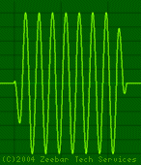 | + | 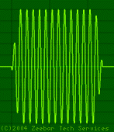 | = | 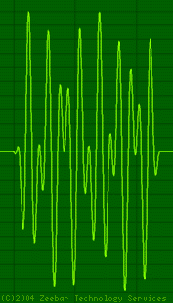
697 Hz Sine Wave  .wav, .au | + | 1209 Hz Sine Wave  .wav, .au | = | DTMF Tone "1"  .wav, .au

Figure : 7 Two Pure Sine Waves combine for form the DTMF Tone for "1"

Decoding the DTMF tone generated :

This circuit used for the decoding using MT887D-1 :
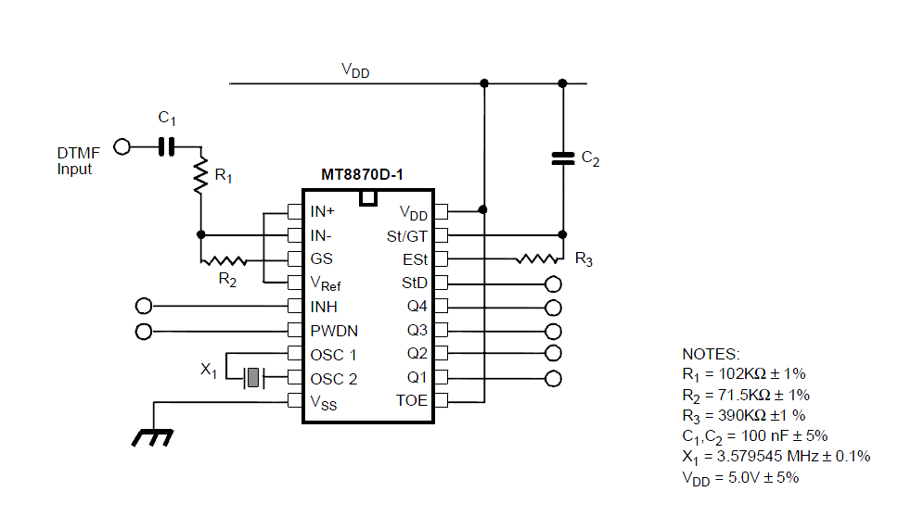
Figure : 8 MT887D circuit

Functional Description

The MT8870D/MT8870D-1 monolithic DTMF receiver offers small size, low power consumption and high performance. Its architecture consists of a bandsplit filter section, which separates the high and low group tones, followed by a digital counting section which verifies the frequency and duration of
the received tones before passing the corresponding code to the output bus.

Filter Section

Separation of the low-group and high group tones is achieved by applying the DTMF signal to the inputs of two sixth-order switched capacitor bandpass filters, the bandwidths of which correspond to the low and high group frequencies. The filter section also incorporates notches at 350 and 440 Hz for exceptional dial tone rejection (see Figure 3). Each filter output is followed by a single order switched capacitor filter section which smooths the signals prior to limiting. Limiting is performed by high-gain comparators which are provided with hysteresis to prevent detection of unwanted low-level signals. The outputs of the comparators provide full rail logic swings at the frequencies of the incoming DTMF signals.

Decoder Section

Following the filter section is a decoder employing digital counting techniques to determine the frequencies of the incoming tones and to verify that they correspond to standard DTMF frequencies. A
complex averaging algorithm protects against tone simulation by extraneous signals such as voice while

Figure : 9 MT887D circuit

Battery charger

To ensure that the system will contain working we must continuously cheek if the battery becomes in low voltage cause the battery uses for our project is BL-4CT 860 mAh Li-Ion
- Talk time: GSM up to 7.5 h
- Stand by time: GSM up to 380 h
- Music playback time (maximum): 26 h
And the phone connecter will stop working if the voltage under 1 volt. So we must ensure that the voltage is much higher than 1 volt.
We imply the ADC feature for this case.

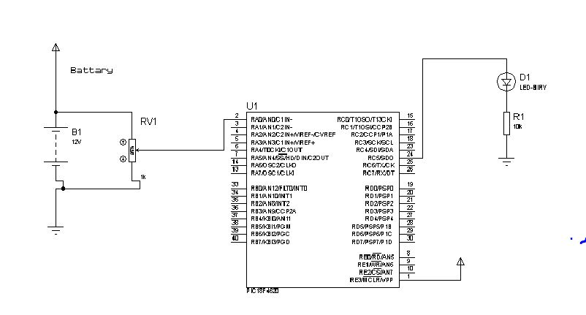
Figure : 10 ADC Circuit

H-BRIDGE
In the case of single stage ac to dc power conversion phase – controlled converts , are used to drive the dc machine . whenever the source is a constant voltage dc , such as a battery or diode bridge rectified ac supply , a different type of converter is required to convert the fixed voltage into a variable voltage \ variable current source for the speed control of the dc motor drive . the variable dc voltage is controlled by chopping the input voltage by varying the on and off times of a converter , and the type of converter capable of such a function is know as H-BRIDGE , IGBT FGH40N60SF is used in our project .

Features

• High current capability
• Low saturation voltage: VCE(sat) =2.3V @ IC = 40A
• High input impedance
• Fast switching
• RoHS compliant

Applications

• Inverter , UPS, SMPS, PFC

Specification :

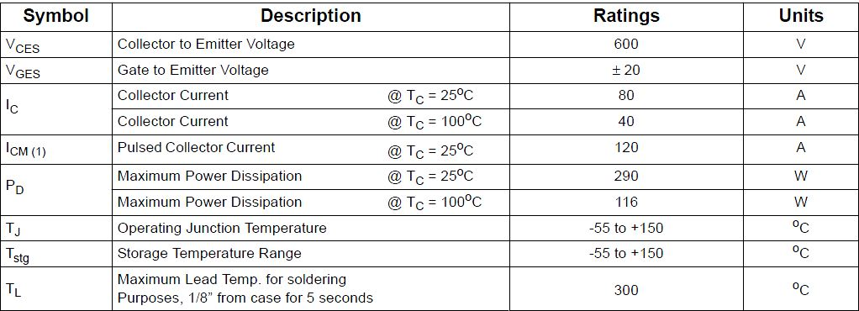
Figure : 11 Specification of H-Bridge

IGBT'S H-BRIDGE circuit :

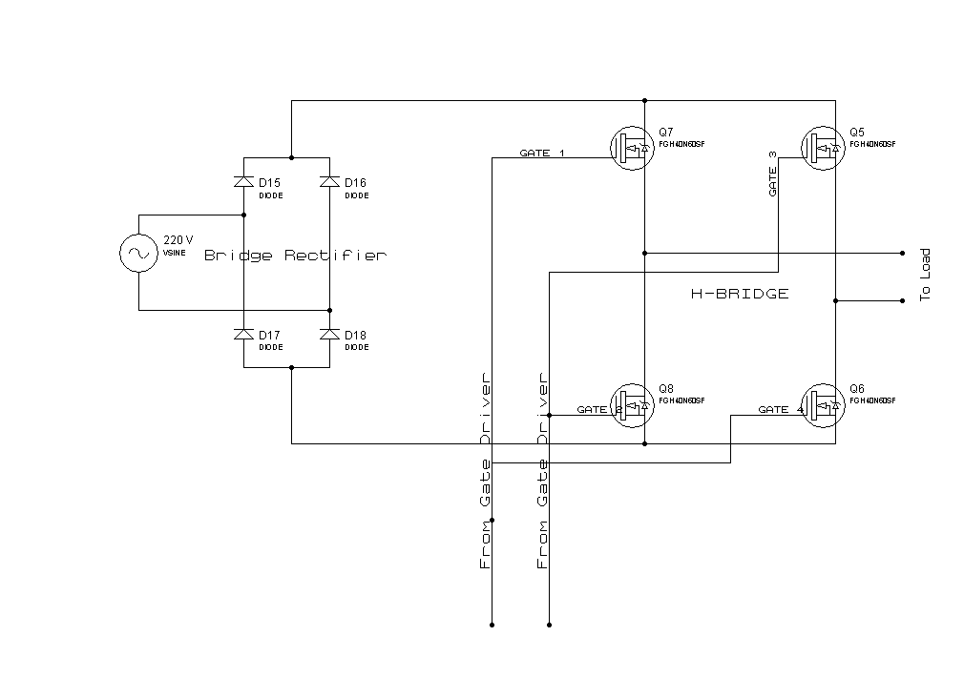
Figure : 12 IGBT'S H-BRIDGE 1

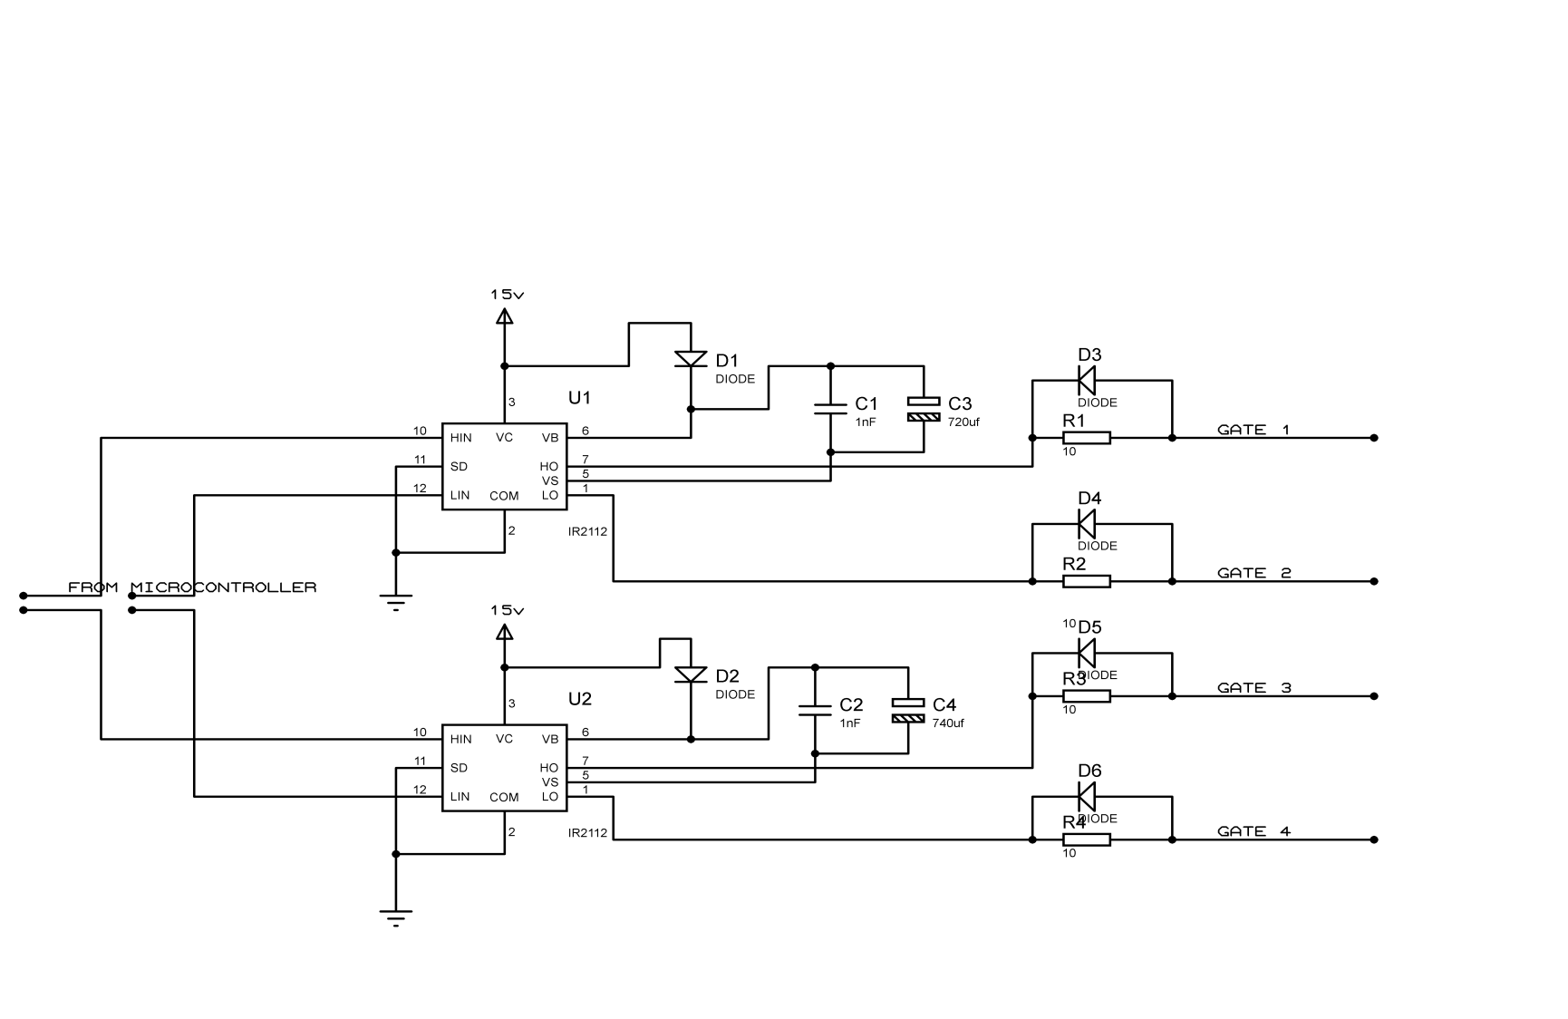
Figure : 13 Gate Drive Circuit

Bootstrap capacitor sizing
To size the bootstrap capacitor, the first step is to establish the minimum voltage drop (ΔVBS) that
we have to guarantee when the high side IGBT is on.
If VGEmin is the minimum gate emitter voltage to maintain, the voltage drop must be:
The value of the bootstrap used in the design approximated using this equation :
$$Q_{TOT}=Q_{G}+Q_{LS}+\left(I_{LK_GE}+I_{QBS}+I_{LK}+I_{LK_DIODE}+I_{lk_CAP}+I_{DS}\right)*T_{HON}$$

Specification of dc motor :

Before we talk about the specification let us talk a little bit a bout the characteristic of dc motor and The relationship between speed, field flux and armature voltage is shown in the following Equation:
Back electromagnetic force:
$$E=K∅N$$
Torque:

Where:
E = electromagnetic force developed at armature terminal (volt)
Φ = field flux which is directly proportional to field current
N = speed in RPM (revolutions per minute)
K = an equation constant

Table 4 shows our calculation to find the constant k multiplied by The flux .
K q= 0.0210

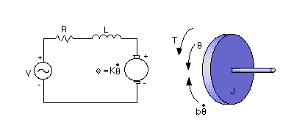
Figure : 14 Charactrestec of DC motor

Figure ( )a :
Figure ( )b :

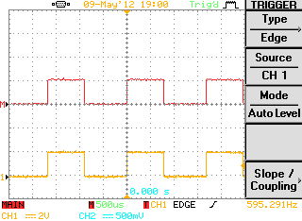
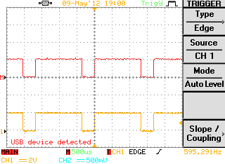
Final Results :

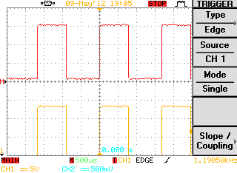
Figure 15 –a : 5 v PWM WITH 75% DUTY AND 600 HZ

Figure 15 –b : 5 v PWM WITH 50% DUTY AND 600 HZ

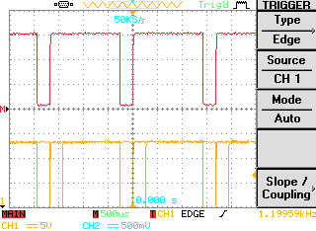
Figure 15 –d: 15v PWM WITH 50% DUTY AND 12kHZ

Figure 15 –d: 15v PWM WITH 75% DUTY AND 12kHZ

Figure : 15 The Output Signal from PIC AND Gate Driver

Figure : 16 Voltage At Motor Terminals (to the right at 50 % duty , to the left 75% duty )

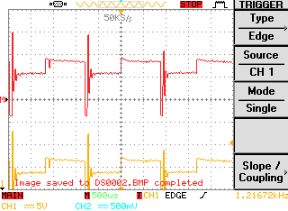
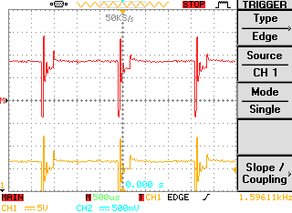
100 | 84 | 64 | 48 | 32 | 16 | Duty  %))
9 | 7.56 | 5.76 | 4.32 | 2.88 | 1.44 | DC volt
427 | 360 | 274 | 205 | 137 | 68 | Speed  rpm

Table 4 Various dc motor speed according to the PWM duty

DESIGNING PCB :
Now, its time to show you a PCB for the project ,proteus ISIS program used for this purpose ,the system go through these steps in order to have a final pcb :
- Ideas to build the circuit .
- Connect the Circuit and verify it works and give the wanted result see figure (17).

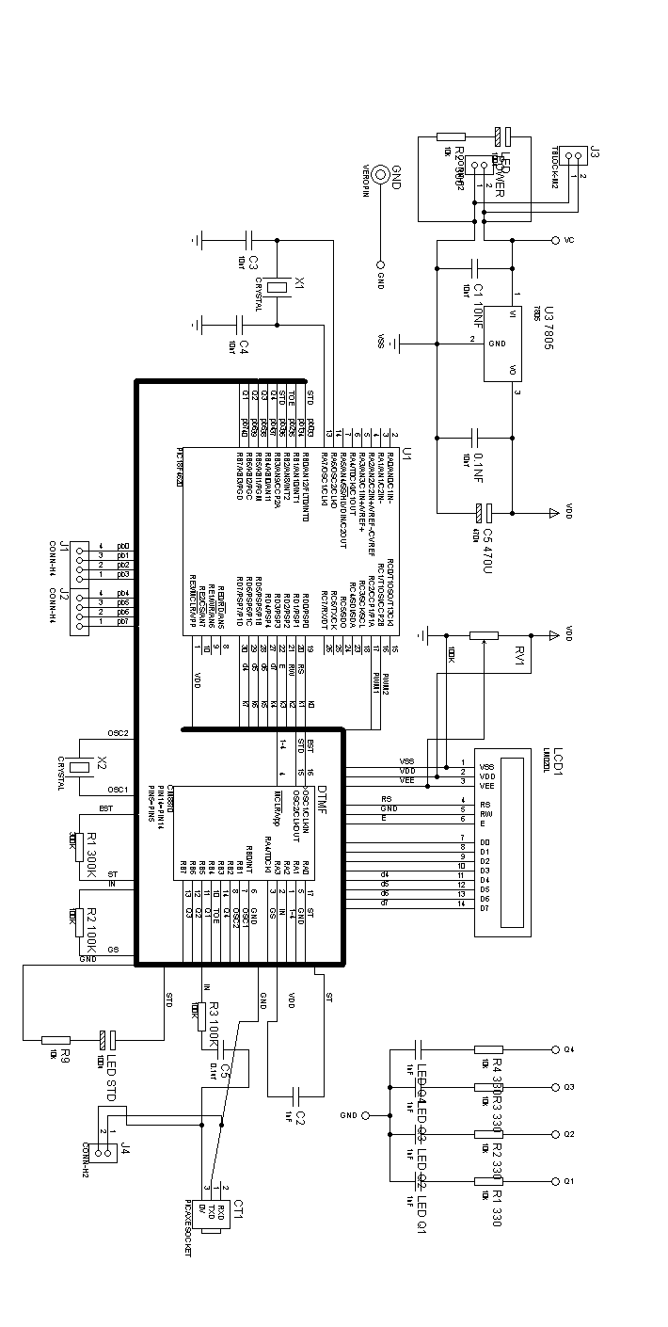
Figure : 17 a Pic plus DTMF (CONTROL) Circuit

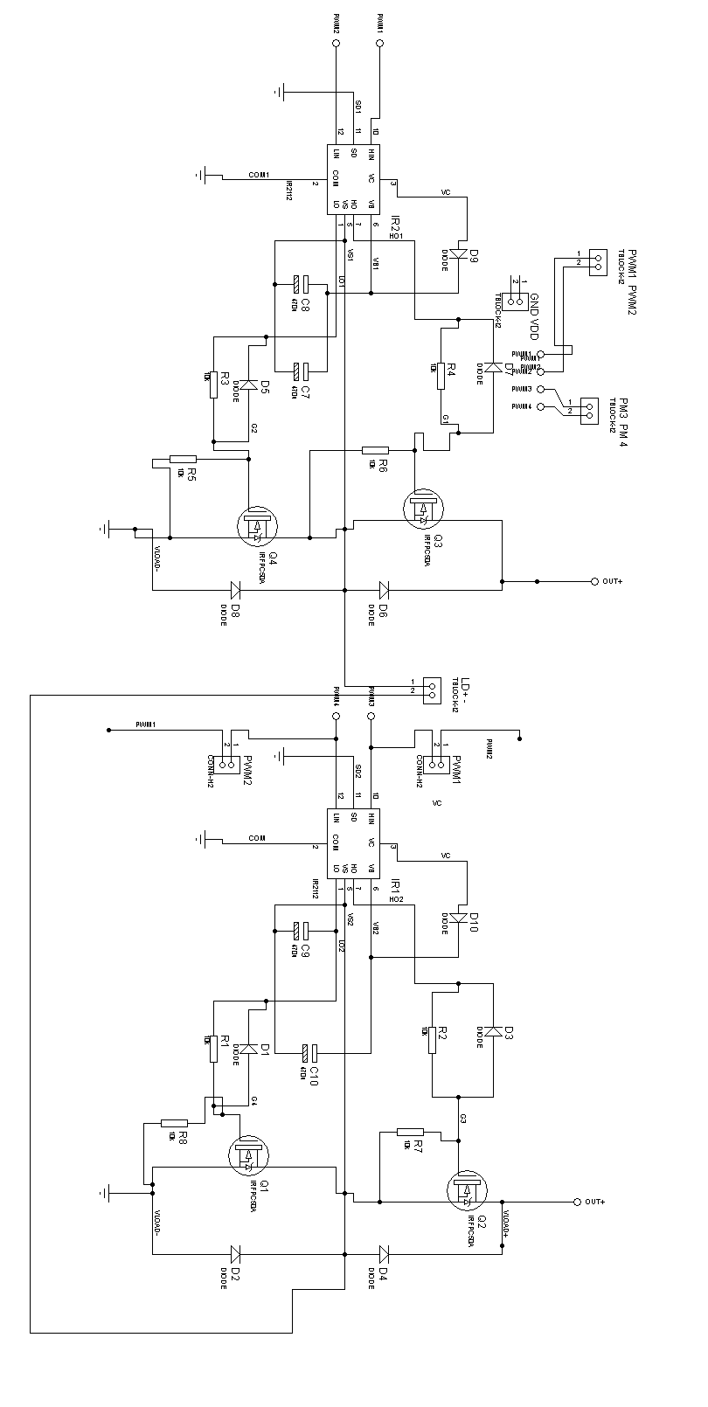

Figure : 18 b Gate Driver Circuit

- Using the ARES ISIS to connect the devices with each other, note that as you plant the device in the program you get on the real PCB see figure (19) .

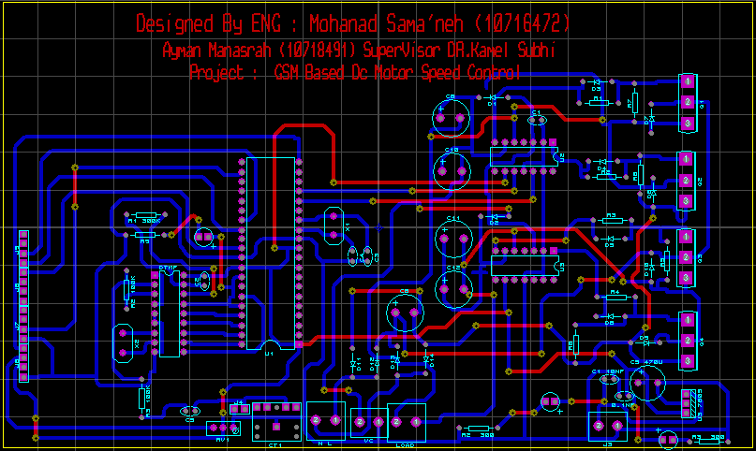

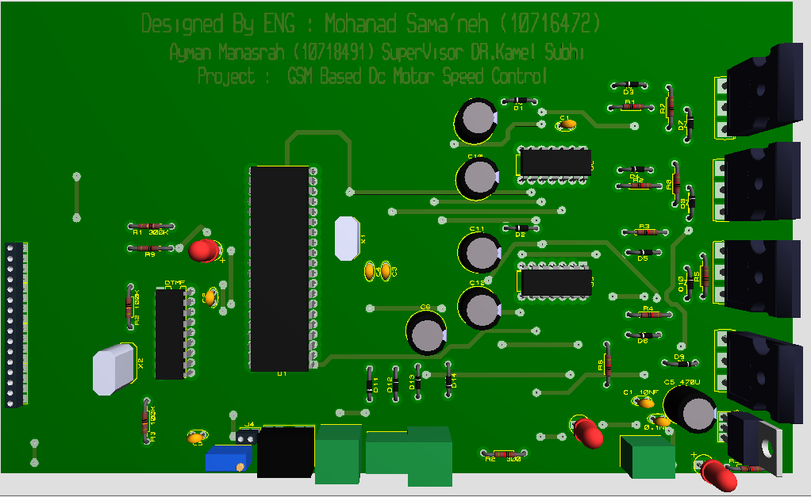

Figure : 19 the first figure showing the routings , the second showing the 3d picture for the project

- Convert the PCB to pdf with high color resolution 600 dBi and that important for the next step see figure (20) a .
- The following picture will be printer and burner on the copper board see figure (20) .

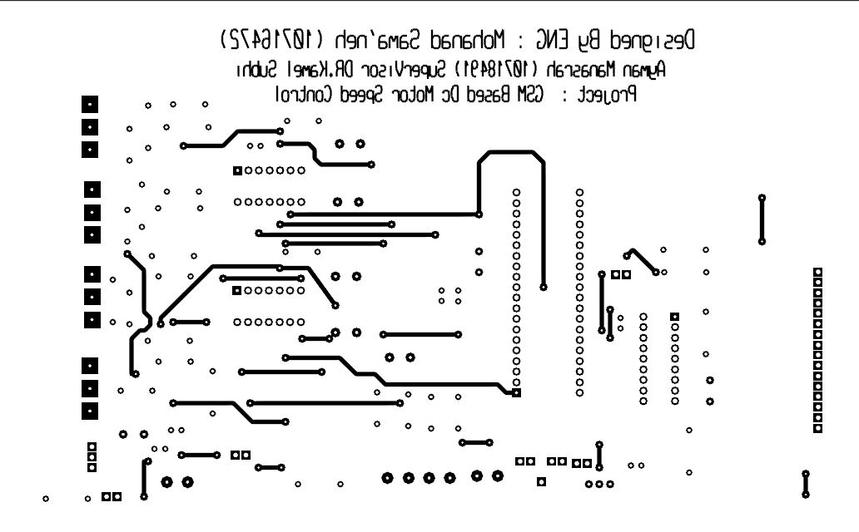

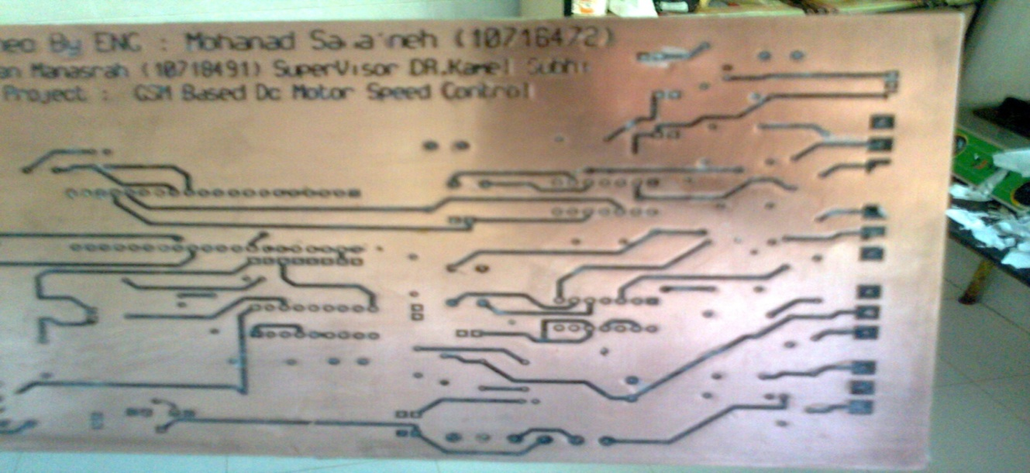
Figure : 20 the 1st figure show the O/P pdf for the pcb , the 2nd show the board a fter burning the pic

- A special acid called ferric acid use to erase the regions that don’t contains writing figure (21) show us the board after using the acid.
- The final step is drilling are check the writing if its as requires.
- We have PCB ready for plotting the devices for the final step before it can be used see figure (2)

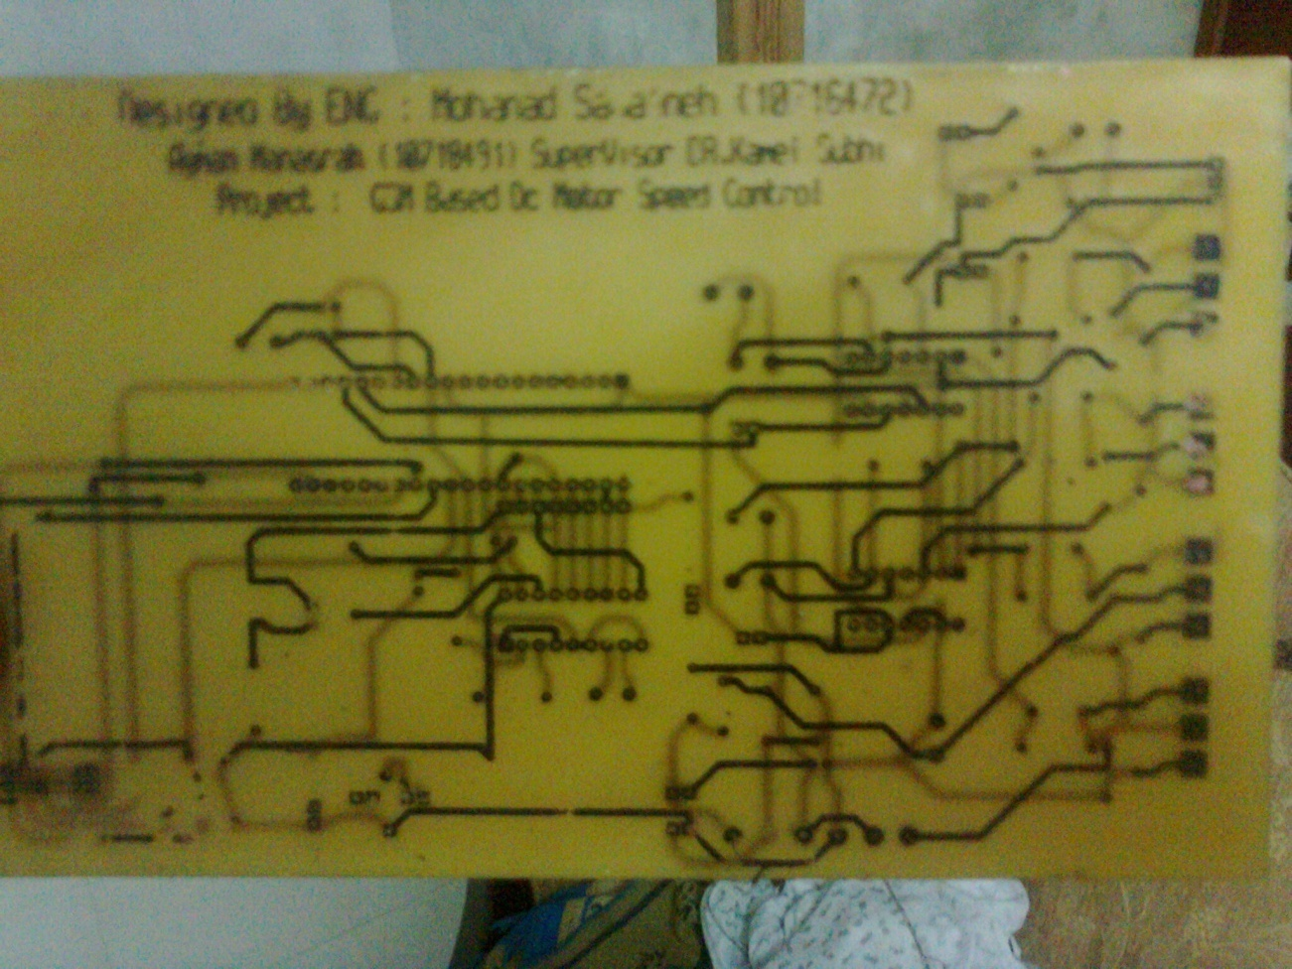
Figure : 21 After Using the Acid
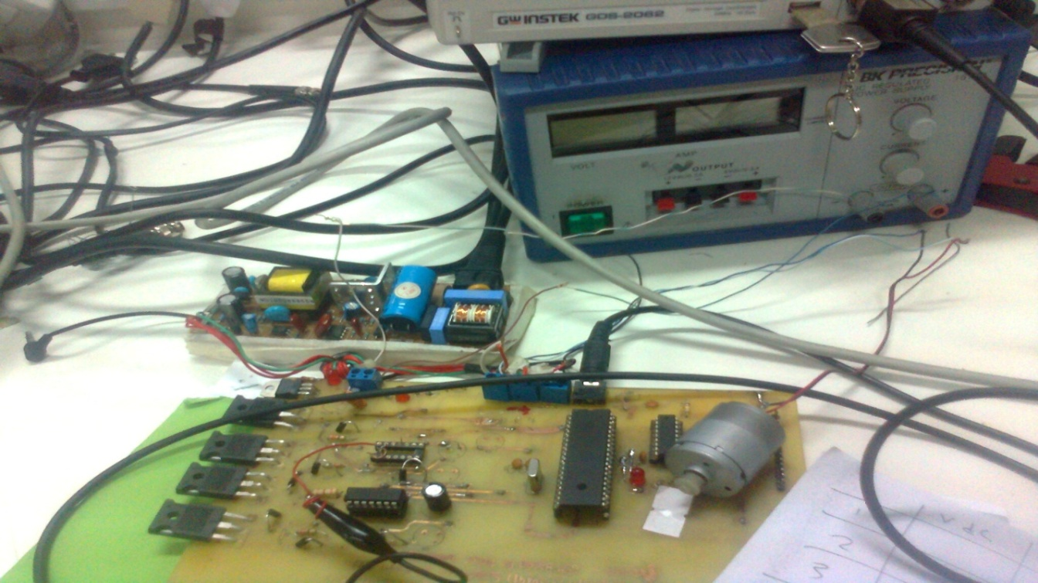
Figure : 22 Picture For The project

Feedback:
The feedback is very important issue to deal with in order to get information a bout the status of the system we successfully decode the tones presenting the numbers pressed in phone number one but what a bout transmitting it back from p.2 ..

The proposed solution is to use UM91214 B unfortunality ( it's an available here , ) to encode the numbers and generate DTMF tone that present the number the next step is to use microcontroller to control the sequence of the tones transmitted according to the required , transmit the tones through the phone #2 to phone number one and the last step is to decode the TONE into numbers .

Conclusion

In our project we worked in a advanced IC'S (IGBT'S , IR2110 , MT887 Decoder and PIC 18F4620 ) That help us to get a result as near as possible to the wanted one .
The necessary code has been made and downloaded in microcontroller by using appropriate software. The analog instructions received by the receiving mobile phone were successfully converted into digital strobes as interrupt signals to the microcontroller through DTMF to BCD converter IC. The actuation of the motor is driven by the output ports of the microcontroller. The proposed work has following advantages over the existing models:

1) The dc motor can be controlled from anywhere on the
globe.
2) A number of devices can be controlled through a dedicated output port bits by writing the individual
controlling algorithm for each device not just dc motor .

References :
- http://www.best-microcontroller-projects.com/index.html
- http://www.gsm-modem.de/dtmf_encoder_gsm_.html
- http://www.smssolutions.net/
- http://www.mpoweruk.com/index.htm
- http://picprojects.org.uk/projects/picprojects.htm
- http://web.eng.gla.ac.uk/groups/dev_mod/
- http://www.micro-examples.com/articles/index.php/PicoDetector
- Electric Motor Drives - Modeling Analysis and Control
- An Embedded Platform For GSM/CDMA Controlled Surveillance Robot
- John. L. Fike, George E. Friend, “Understanding
Telephone Electronics”, Texas Instruments Inc, 1984.
- Vivek Kumar Sehgal, Nitin Chanderwal, Sachin Garg,
Amit Jain, Neeraj Shah, Sumit Gupta: RJ-11 Interfaced
- Embedded Platform for DTMF Based Remote Control
System. ESA 2007: 239-
- Thiagarajan Viswanathan, “Telecommunication
Switching Systems and Networks”, Prentice-Hall India Ltd,
September 2004.

Appendix (1 )
Congratulation project
* Project name: GSM Based Dc Motor Speed COntrol
Designed By :
Mohanad Abed Samaaneh
superviser :
DR : Kamel Subhi

* Description:
Example demonstrates controlling the dc motor through the GSM
: USING GSM and DTMF RECIEVER microcontroller will be programmed to
controll the dc motor according to the required speed
* Test configuration:
MCU: PIC18F4620
Dev.Board: EasyPIC6
Oscillator: HS, 10.0000 MHz
Ext. Modules: -

*/
// Initializing data *
//======================================================
char *text = "Hello " ;
char *textt = "Mohanad" ;
unsigned int number = 00000 ;
unsigned char ch;
unsigned int adc_rd;
unsigned short current_duty1= 128 ;
unsigned int current_duty2= 33 ;
int direction = 1 ; // 1 ::: forword 2 ::: backword
int status1 = 0 ; // 0 : STOP 1 : START // ;
unsigned short freq = 1000 ;
unsigned int value = 0 ;
long tlong;
int bit ;
int oldstate = 0 ;
int reg_status = 0 ; // status of the regester (for the speed )
int speed_array [10] ;
unsigned int count = 0 ;
signed double dcount = 0 ;
unsigned temp = 0 ;
unsigned int get_speed = 0 ;
double pcount = 0;
signed int n_count = 0 ;
double num = 10 ;
unsigned int i = 3 ;

// ============================INterrupt ================================//

//========================================================================//
void print_number ( int number){
tlong = (long)number ; // * 50000; // covert adc reading to milivolts

ch = (tlong / 1000) % 10; // extract 0.01 volts digit
Lcd_Chr(2,9,48+ch); // write ASCII digit at cursor point

ch = (tlong / 100) % 10; // extract 0.01 volts digit
LCD_Chr_CP(48+ch); // write ASCII digit at cursor point

ch = (tlong / 10) % 10; // extract 0.1 volts digit
LCD_Chr_CP(48+ch); // write ASCII digit at cursor point

ch = (tlong / 1) % 10; // extract 0.01 volts digit
LCD_Chr_CP(48+ch); // write ASCII digit at cursor point

}

void interrupt() {
/* // Delay_ms(500) ;
portb.f1 = 1 ;
portb.f2= 1 ;
number = PORTB >> 4;
porta = number ;
bit=PORTA.F3 ;
porta.f3=porta.f0 ;
porta.f0=bit ;
bit=PORTA.F2 ;
porta.f2=porta.f1 ;
porta.f1=bit ;
number = porta ;
// Delay_100ms() ;
portb.f1 =0 ;
portb.f2= 0 ;
TMR0L = 96;
INTCON = 0x90; // Set T0IE, clear T0IF
// goto start ;
*/
}

void PWM1_GENERATION (int current_duty1 ){ //Define The function That Generate PWM

PWM1_Init(600); // Initialize PWM1 module at 5KHz
PWM1_Change_Duty(current_duty1) ; // Set The Duty Of The Signal
PWM1_Start(); // start PWM1
}

void PWM2_GENERATION (int current_duty2 ){ //Define The function That Generate PWM

PWM2_Init(600); // Initialize PWM1 module at 5KHz
PWM2_Change_Duty(current_duty2) ; // Set The Duty Of The Signal
PWM2_Start(); // start PWM1
}

void lcd_con() {
Lcd_Config (&PORTD , 1, 3, 0, 4, 5, 6, 7) ;
LCD_Cmd(LCD_CURSOR_OFF); // send command to LCD (cursor off)
LCD_Cmd(LCD_CLEAR); // send command to LCD (clear LCD)
}
void get1_speed () {

get_speed = speed_array [0] ;
get_speed = get_speed+ speed_array [1]*10 ;
get_speed = get_speed+ speed_array [2]*100 ;
get_speed = get_speed+ speed_array [3]*1000 ;
}
void check_value (){

if (portb.f0==1) {

// Delay_ms(500) ;

portb.f1 = 1 ;
portb.f2= 1 ;
number = PORTB >> 4;
porta = number ;
bit=PORTA.F3 ;
porta.f3=porta.f0 ;
porta.f0=bit ;
bit=PORTA.F2 ;
porta.f2=porta.f1 ;
porta.f1=bit ;
number = porta ;
// Delay_100ms() ;
portb.f1 =0 ;
portb.f2= 0 ;

//speed_array[count]=number ;
// count = count +1 ;

}
}

void reg_value () {
speed_array[count]=number ;
// count = count +1 ;
//print_number (speed_array[count-1]) ;

}
/* get_speed = speed_array [0] ;
get_speed = get_speed+ speed_array [1]*10 ;
get_speed = get_speed+ speed_array [2]*100 ;
get_speed = get_speed+ speed_array [3]*1000 ;

print_number(get_speed) ;
number = 0 ;
get_speed = 0 ;
Delay_1sec() ; */

//==========================main code ======================================//
void main () {
ADCON1 = 0X0F ; // Set AN pins to Digital I/O
INTCON.INT1IE=1 ;
T0CON = 0xC4; // Set TMR0 in 8bit mode, assign prescaler to TMR0
TMR0L = 96; // Timer0 initial value
INTCON = 0x90; // Enable INT0 interrupt
TRISb=0Xf9 ; // CONFIGURE PORTA AS O/P
TRISA=0X00 ;
pie1.rcie=1 ;
intcon.peie=1 ;
pie2.TXIE = 1 ;
porta= 0 ;
lcd_con() ;

// number = 0 ;

for (;;){

check_value() ;
// if (number!=0) {
// reg_value() ;
// count = count +1 ;
// }
print_number (number) ;

// number = 0 ;
// reg_value() ;
// get1_speed() ;
// print_number (get_speed) ;
if (number == 5){
goto start ;

}
}

start :

PWM2_GENERATION (128) ;
// if (reg_status==0) {

// number = 0 ;
//Delay_ms(500) ;
check :
for (;;){

number = 0 ;
check_value() ;
Delay_ms(80) ;

switch(number) {

// case 11 : goto reg_process ; //reg_process ; // * pressed start registering
//case 13 : goto go ; //reg_process_end ;
case 2 : goto increase ;// forword ; // done
case 8 : goto decrease ;//backword ; // done
// case 4 : direction = 2 ; // LEFT
// case 6 : direction = 1 ; // RIGHT
case 7 : goto start_2 ;// start_2 ; //goto start-forword ;//PWM1_GENERATION (128) ;// status1 = 0 ; //START
case 3 : goto stop_2 ; //stop_2; // status1 = 1 ; //STOP
{ default : goto check}// finish ;}

}
}
start_2 :
PWM2_GENERATION (128) ;
goto check ;

stop_2 :
PWM2_GENERATION (0) ;
goto check ;

increase:
current_duty2 = current_duty2 +64 ;
PWM2_Change_Duty(current_duty2);
goto check ;

}

