An-Najah National University

Graduation Project

Supervisor:
Dr. Samer Mayaleh
Faculty of Engineering

Electrical Engineering Department


Prepared by: Nihaya Dmeede 10405165 Farah Damen 10406679

Table Of Content

Abstract 3

Chapter -1-
Theoretical Part

1.1 Why Single phase AC motor? 6

1.2 Single phase AC motor type 7

1.3 Applications on single phase AC motor 10

1.4 Speed Control 11

1.5 Direction Control 12

Chapter -2-
Practical Part

2.1 Design Description 14

2.2 System Description 15

2.3 Full circuit Preview 16

2.4 Hardware 17

2.5 Software 30

Chapter -3-

Problems & Constraints 38

Chapter -4-

Cost 42

Chapter -5-

Conclusion 43

Chapter -6-

Recommendations Cost 44

Chapter -7-

Appendix 45

ABSTRACT

Single Phase Induction Motor
Adjustable Speed-Direction Control
Using Microcontroller


In this project, a single phase induction motor (SPIM) adjustable speed drive control is implemented with hardware setup and software program in PIC-C code.
SPIM is used because it is widely used in our daily life.
The main feature used in microcontroller is their peripherals to realize pulse width modulation.
This Digital control brings low cost, small size and flexibility to change the control algorithm without changes in hardware.




Theoretical Part

Chapter (1)

Introduction

Why Single Phase AC Motors??

- They are useful -- serving as the prime power sources for a seemingly limitless array of small-horsepower applications in industry and in the home.

- Where three-phase power is unavailable or impractical, its single-phase motors to the rescue.

- Single phase AC electrical supply is what is typically supplied in homes, three phase electrical power is commonly only available in a factory setting.
- Single-phase motors -- correctly sized and rated -- can last a lifetime with little maintenance.

(1.2) Single Phase AC Motor Types
Split-phase
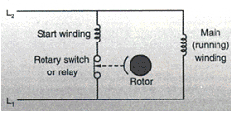
Capacitor start/induction run
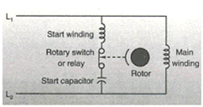

Permanent split capacitor
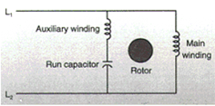

Capacitor start/capacitor run
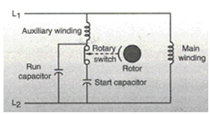

Shaded-pole
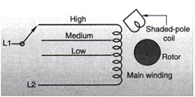

The Motor We Used is:

Permanent split capacitor

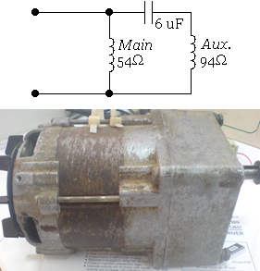
A permanent split capacitor (PSC) motor, Figure shown, has neither a starting switch, nor a capacitor strictly for starting. Instead, it has a run-type capacitor permanently connected in series with the start (Aux.) winding. This makes the main winding an auxiliary winding once the motor reaches running speed. Because the run capacitor must be designed for continuous use, it cannot provide the starting boost of a starting capacitor. Typical starting torque of PSC motors is low, from 30 to 150% of rated load, so these motors are not for hard-to-start applications. However, unlike split-phase motors, PSC motors have low starting currents, usually less than 200% of rated load current, making them excellent for applications with high cycle rates. Breakdown torque varies depending on the design type and application, though it is typically somewhat lower than with a cap start motors.
PSC motors have several advantages. They need no starting mechanism and so can be reversed easily. Designs can be easily altered for use with speed controllers. They can also be designed for optimum efficiency and high power factor at rated load. And they're considered to be the most reliable of the single phase motors, mostly because no starting switch is needed.
Permanent split capacitor motors have a wide variety of applications depending on the design. These include fans, blowers with low starting torque needs, and intermittent cycling uses such as adjusting mechanisms, gate operators and garage door openers, many of which also need instant reversing.

Measured motor Specifications:
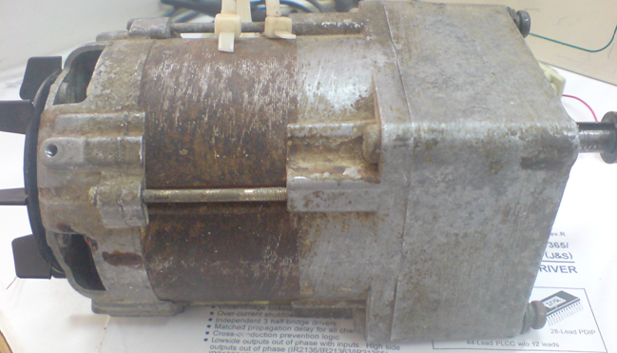

No Load parameters:
- I_{nL}=0.38A
- W= 1436 rpm

Loaded Motor parameters:

- Pout=86w (Measured)
- $η=85\%$ (Estimated)
- $η=\frac{Pout}{Pin}*100\%$
- Pin= V*I =220*I
- P.f$≈$ 1
- I_{fL}=$\frac{Pout}{η*V*p.f}$=$\frac{86}{0.85*220*1}$= 0.45A

Imian=400mA, Iaux=670mA
Turns Ratio (α) =$\frac{Vaux}{Vmain}= \frac{Imain}{Iaux}$ =3.33
θ=$2\tan{α}$=146.57º

Torque measurement:

We measured the torque by loading the motor with some weights connected to the shaft using a cord.
- The cord length (l)= 60cm
- Force (F)= 130N
- T=F*L(m)= 130*0.6= 78 N.m
- T$≅$ (Full load Torque)

(1.3) Applications On SPI Motors

The scope of motor control technology must be very wide to accommodate the wide variety of motor applications in various fields.

Domestic applications

Office equipment, medical equipment… etc.

Commercial applications

Industrial applications

Vehicle applications

Power tools

Hobby equipment

PSC motors applications
With this motor, designs can be easily altered for use with speed controllers. It can also be designed for optimum efficiency and high power factor at rated load.
Include fans, blowers with low starting torque needs, and intermittent cycling uses such as adjusting mechanisms, gate operators and garage door openers, many of which also need instant reversing.

(1.4)Speed control
In general, ac drives work (controlling ac motor speed) by varying the frequency of the current supplying the motor. Although frequency can be varied many ways, and in relation to other variables such as voltage, the most common methods in use today are "volts per hertz," open-loop vector, and closed-loop vector. How these techniques differ determines where each drive type works best.

Volts per hertz
Volts per hertz (V/Hz) technology is the most economical and easiest to apply of the three speed-control methods. Here, the drive controls shaft speed by varying the voltage and frequency of the signal powering the motor.
Now, the rotor of an ac induction motor is magnetically coupled to the stator through an induced magnetic field. The speed at which the magnetic field rotates around the stator is known as synchronous speed and is determined by:
n = 120 f/N
where n is synchronous motor speed, 120 is an electrical constant, f is the applied frequency, and N is the number of motor poles.
The equation illustrates one of the basic principles of speed control: Reducing applied frequency to an ac induction motor causes the magnetic field to turn at a proportionally slower rate, thereby reducing rotor speed.
This is only part of the story, however. Induction motors are designed to operate from line voltage at line frequency. But the whole purpose of V/Hz drives is that they don't hold systems to power line shapes. What they do instead is maintain an optimal voltage-to-frequency ratio, so that the motors their power will produce their rated torque over the widest possible speed range.

(1.5)direction control

Historically Bidirectional Techniques:

Unfortunately, all of these components increase the cost of the system for basic ON and OFF control in two directions.

Present Bidirectional Techniques:
Using an H-Bridge Inverter
The first approach is relatively easy as far as the power circuit and control circuit are concerned. On the input side, a voltage doubler is used and on the output side an H-bridge, or 2-phase inverter, is used as shown in Figure bellow. One end of the main and start windings are connected to each half bridge and the other ends are connected together to the neutral point of the AC power supply, which also serves as the center point for the voltage doubler.
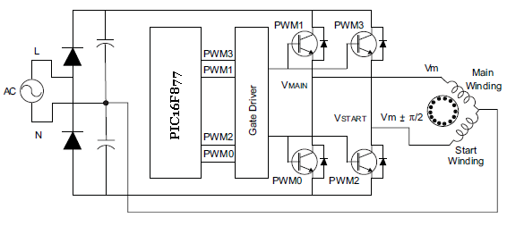
If the voltage applied to the main winding lags the start winding by 90 degrees, the motor runs in one (i.e., forward) direction. To reverse the direction of rotation, the voltage supplied to the main winding should lead the voltage supplied to the start winding.

Using a 3-Phase Inverter
The input section is replaced with a standard diode bridge rectifier. The output section has a 3-phase inverter bridge. The main in Figure bellow.
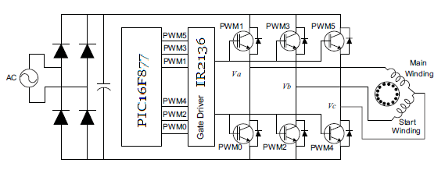
difference from the previous scheme is the way the motor windings are connected to the inverter. One end of the main winding and start windings are connected to one half bridge each. The other ends are tied together and connected to the third half bridge, as shown
With this drive topology, control becomes more efficient; however, the control algorithm becomes more complex. The voltages V a, V b and V c should be controlled to achieve the phase difference between the effective voltages across the main and start windings to have a 90 degree phase shift to each other.
Now, H-bridge inverter method of controlling a PSC type motor has following disadvantages:
- The main and start windings have different electrical characteristics. Thus, the current flowing through each switch is unbalanced. This can lead to the premature breakdown of switching devices in the inverter.
- The common point of the windings is directly connected to the neutral power supply. This may increase the switching signals creeping into the main power supply, and may increase the noise emitted onto the line. In turn, this may limit the EMI level of the product, violating certain design goals and regulations.
- The effective dc voltage handled is relatively high due to the input-voltage doubler circuit.
- Lastly, the cost of the voltage doubler circuit itself is high due to two large power capacitors.
Advantages of using the three-phase control method:
- The main advantage of using the three-phase control method is that the same drive-hardware topology can be used to control a three-phase induction motor. In this scenario, the microcontroller should be reprogrammed to output sine voltages with 120-degree phase shift to each other, which drives a three-phase induction motor. This reduces the development time.
- Power saving.
Microcontroller Resources Requirement (For reversing direction)

Resource | Bidirectional  H-bridge | Bidirectional with three-phase bridge | Notes
Program memory | 2.0 Kbytes | 2.5 Kbytes | --
Data memory | ~25 Bytes | ~25 bytes | --
PWM channels | 2 channels | 3 channels | Complementary with dead time
Timer | 1 | 1 | 8- or 16-bit
Digital I/Os | 3 to 4 | 3 to 4 | For user interfaces like switches and displays
Complexity of  control algorithm | Medium | High | --
 | Bidirectional with H-bridge | Bidirectional with three-phase bridge
Input converter  section | High - Due to voltage doubler circuit | Low - Single phase diode bridge rectifier
Output inverter  section | Medium - Two half bridges. The power switches rated higher voltage | High - three-phase inverter. Using Integrated Power Modules (IPM) is better choice than discrete components
Motor | Low - Starting capacitor is removed from the motor | Low - Starting capacitor is removed from the motor
Development time | Mid-range | Long
Overall cost | Medium | Medium - Efficient control for the given cost

Practical Part

Chapter (2)

(2.1)Design Description

(2.2)System Description

Overall block diagram

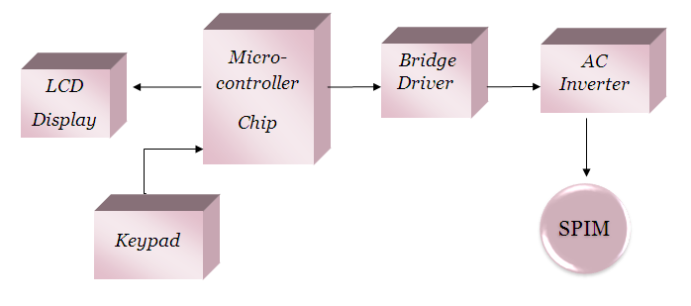

Algorithmic Block Diagram
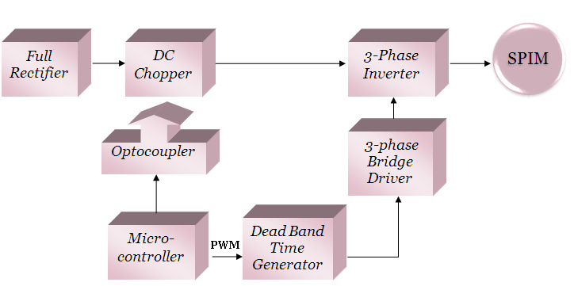

(2.3)Full Circuit Preview
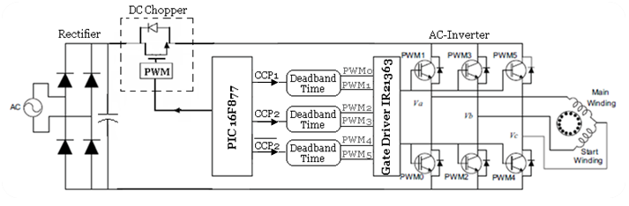

(2.4) Hardware

Bridge Rectifier

Single Phase Full-Wave Bridge Rectifier

The full bridge rectifier (KBPC 35-10) has been used to convert the ac supply to a dc voltage Vdc. The output of the rectifier is the input to the dc chopper which controls the voltage level.
KBPC 35-10: a Single phase silicon bridge rectifier. Maximum recurrent peak reverse voltage 1000 V. Maximum average forward rectified current 35 A. in 4-pin KBPC package.
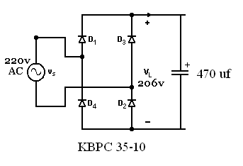

The output dc voltage:
V_{dc} =$206$ v.

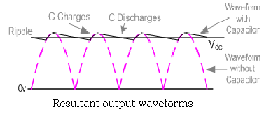

Optocoupler

The Optocoupler used to isolate between high voltage of the chopper and low voltage of the microcontroller, There are many situations where signals and data need to be transferred from one subsystem to another within a piece of electronics equipment, or from one piece of equipment to another, without making a direct ohmic electrical connection. Often this is because the source and destination are (or may be at times) at very different voltage levels, like a microprocessor which is operating from 5V DC but being used to control a triac which is switching 240V AC. In such situations the link between the two must be an isolated one, to protect the microprocessor from overvoltage damage.

We used Optocoupler for isolating between the chopper MOSFET gate and the PWM output from the PIC microcontroller.
Also we were attending to use it in the driver cct of the IGBT, but a problem occurred which is discussed in the Problems chapter.
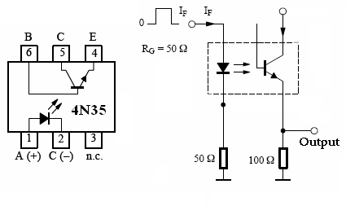

DC Chopper
A dc chopper is a dc-to-dc voltage converter
A DC chopper uses three main components to create variable speed capability
A DC chopper circuit is pictured below
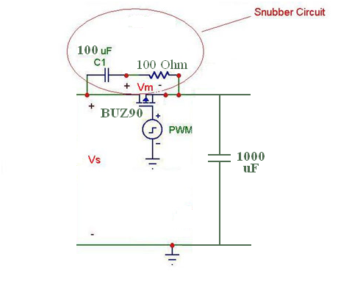
The MOSFET allows current from the source to pass through it, but when it allows current to pass through it is governed by the pulse wave modulator (PWM). The PWM creates pulses, and the high section of these pulses turns on the MOSFET. The longer the MOSFET is turned on, the faster the motor spins. Thus, by varying the high section, commonly referred to as the duty cycle, it is possible to vary the speed of the motor.

MOSFET

The MOSFET conducts for the high portion of the gating signal, and does not conduct for the low portion of the gating signal. The higher the duty cycle of these input waves, the longer the MOSFET acts as a closed switch. We attached a large heat sink to the MOSFET to prevent overheating and breakdown due to large currents.

Circuitry Safety Features
The MOSFET is exposed to high currents and a lot of stress, which raises the concern of safety, and preserving the life of the MOSFET. The MOSFET in our design is protected by a snubber circuit it’s to protect against from the switching stresses of high voltages and currents and to lower the power loss.

The Snubber Circuit
Much of the power lost when using transistors is due to switching. Snubber circuits reduce power losses in transistors during switching and protect them from the switching stresses of high voltages and currents. Switching contributes to a large amount of the power lost when using transistors. Therefore, to conserve energy in our circuit it was a good idea to implement a snubber circuit into our design.

One purpose of the snubber circuit is to alter the voltage and current waveforms produced during switching to an advantage.

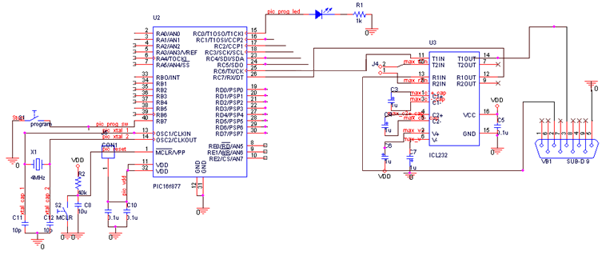
PIC Microcontroller Basic cct

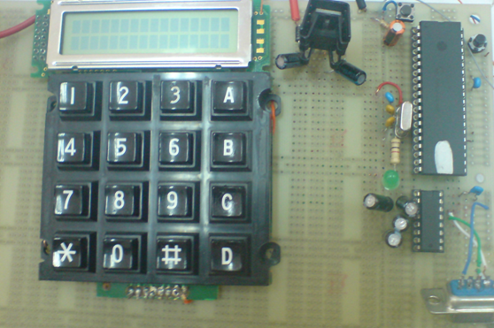

Keypad & LCD Connection
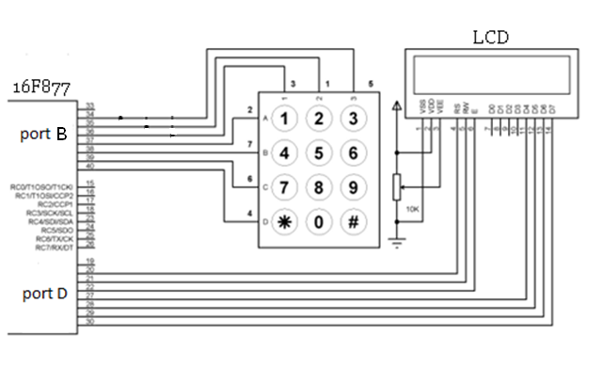

LCD Display:
This display shows speed in addition to the direction of rotation. The display receives its input from the main control unit(PIC 16F877).

Keypad:
The keypad is used to enter the desired speed of the motor, we used the extra push buttons on the keypad for the direction. The output of the keypad goes directly to the control PIC, where it is processed accordingly.
(*) key press indicates Reverse Direction of rotation.
(#) key press indicates Forward Direction of rotation.

Dead Band Time Generator

Simple Deadband Generator Targets Push-Pull Drivers

This simple cct introduces any desired amount of deadband time between alternating output control pulses.
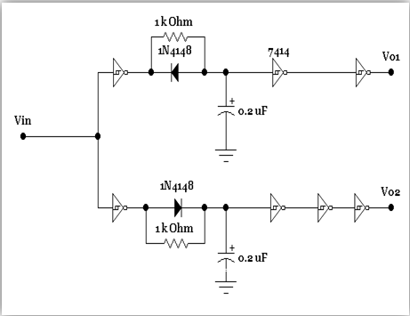
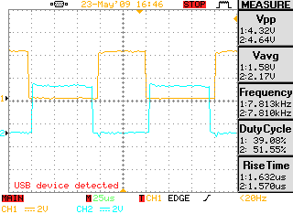

This cct is used In order to avoid cross conduction (two on IGBTs in the same arm) during the transition periods of our IGBT transistors, since cross conduction may results in high current surges being drawn from the power supply.
The simple circuit shown can be used to introduce any desired amount of deadband time between Vo1 and Vo2 control pulses. The circuit employs a Schmitt-trigger inverter IC, the 74HC14. With the diodes, different time delays can be obtained for the rising and falling edges of the drive waveform. The deadband is determined by the RC time constant. The waveforms shown are self-explanatory.
$$τ=R*C$$
Our deadband time is 5µsec.

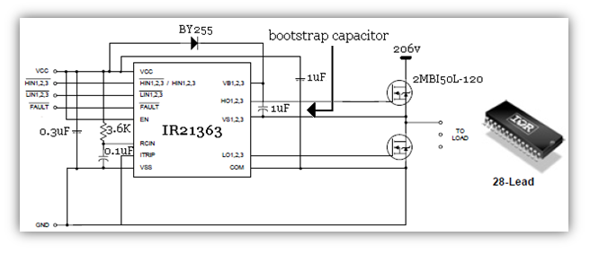
gate DRIVER

IR Gate Driver ICs
Driving a MOSFET or IGBT in the high side position of a half-bridge topology or 3 phase inverter leg offers the additional challenge that the gate voltage is referenced to the source rather than to ground. The source voltage is a floating point at up to the maximum bus voltage, or voltage rating of the MOSFET or IGBT, 600V and up for motor drive, lighting or SMPS applications. IR gate driver uses a patented level shifter technology for high voltage application and offers the only 1200V rating in the industry.
These ICs simplify circuit designs by integrating extensive functionality. They use a low cost bootstrap supply, while opto-coupler-based circuits typically require an auxiliary power supply. IR Gate Driver ICs offer optional single input or dual input programmable deadtime control for low side and high side drivers as well as for 3 phase drivers to provide design flexibility and allows to minimize cross-conduction. Unique 3-phase drivers allow driving a 3 phase inverter using a single IC.
IR Gate Driver ICs enable rugged driver designs
IR Gate Driver ICs are specifically designed with motor drive applications in mind. The newest soft-turn-on limits voltage and current spike and reduce EMI. In addition, they have up to 50V/ns dV/dt immunity and are tolerant to negative voltage transient. The under-voltage lock-out available for most drivers prevents shoot-through currents and device failures during power-up and power-down without any additional circuitry. The output drivers feature a high pulse current buffer stage designed for minimum driver cross-conduction.
Noise immunity is important for the high-side position which has a floating voltage and is susceptible to high noise levels, particularly in motor drive applications. Noise immunity ensures that the MOSFET or IGBT doesn't turn on accidentally. Noise immunity is obtained by using Schmitt-triggered input with pull-down.
IR Gate Driver ICs enable fast switching speeds
IR Gate Drive ICs have ten times better delay matching performance than opto-coupler-based solutions. Delay matching between the low-side and high-side driver is typically within ± 50ns (and as low as ± 10ns for some specialty products), allowing complete dead-time control for better speed range and torque control in motor drive applications. Fast switching also reduces switching power losses and allows leveraging the full benefits of the fastest IGBTs available on the market today for better torque control over a wider speed range.

The IR21363 is a high voltage, high speed power MOSFET and IGBT driver with three independent high and low side referenced output channels. Over current fault conditions are cleared automatically after a delay programmed externally via an RC network connected to the RCIN input.
Our waveforms are as shown:
IR input:
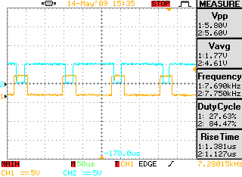
IR output:
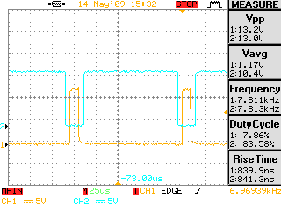

Bootstrap Capacitor
Comprising a bootstrap diode and bootstrap capacitor (see the figure, below). The bootstrap diode may be either integrated within the gate driver IC or external to it. Because the bootstrap capacitor value must be much higher than the MOSFET gate capacitance, it is always external to the IC. When the lower MOSFET is enabled, the bootstrap capacitor charges up to VDD via the bootstrap diode. Thus, the high-side gate driver “floats” at the gate voltage of the high-side MOSFET. For reliable operation, the high side driver must be able to withstand the operating voltage of the high-side MOSFET. Typical maximum voltage ratings for high-voltage gate drivers can range from 80 to 100 V.

Bootstrap diode power loss consists of the forward diode loss while charging the bootstrap capacitor and reverse bias power loss during reverse recovery. These events occur once per cycle, so this diode loss is also proportional to the switching frequency.

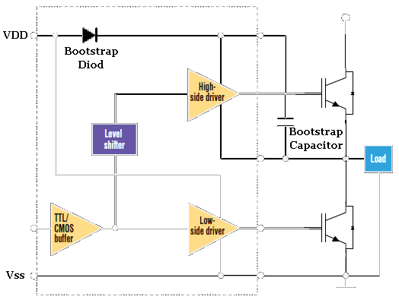

Bootstrap Capacitor Selection:

C_{BOOT} must be correctly selected to ensure proper operation of the device. If too large, time is wasted charging the capacitor, with the result being a limit on the maximum duty cycle and PWM frequency. If the capacitor is too small, the voltage drop can be too large at the time the charge is transferred from the C_{BOOT} to the IGBT gate.

AC Inverter
An AC inverter is used to convert DC voltage to AC voltage. In this model the frequency is fixed and variable output voltage is obtained by varying the pulse width of the chopper switch.
Inverter Structure
One end of the main winding and start windings are connected to one half bridge each. The other ends are tied together and connected to the third half bridge.
With this drive topology, control becomes more efficient; however, the control algorithm becomes more complex. The voltages Va, Vb and Vc should be controlled to achieve the phase difference between the effective voltages across the main and start windings to have a 90 degree phase shift to each other.

$$\left|Va\right|=\left|Vb\right|=\left|Vc\right|=\left|V1\right|$$
The effective voltage across the main and start winding is given as:
$$Vmain=Va-Vc$$
$$Vaux=Vb-Vc$$
The voltages are shown in the phasor diagram in
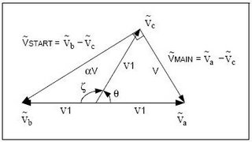
As seen in the phasor diagram, the voltages across phase A and phase B are out of phase.

Figure below shows the phase voltages V_{a} ,V_{b} and V_{c}, and the other figure shows the effective voltages across the main winding (V_{MAIN}) and the start winding (V_{START}). Also shows that the effective phase difference between the voltages is 90 degrees and the effective voltage ratio is α.
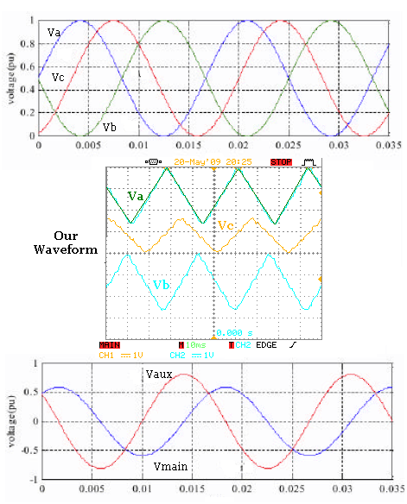

- IGBT Switch

Power switches used for the inverter are type 2MBI50L-120 IGBTs, manufactured by Collmer Semiconductor. They come two IGBTs in a single unit with an anti parallel diode as shown in Figure bellow.

The insulated gate bipolar transistor (IGBT) is an attempt to unite the best features of the bipolar junction transistor and the MOSFET technologies.
IGBT device has good forward blocking but very limited reverse blocking ability. It can operate at higher current densities than either the power BJT or MOSFET allowing a smaller chip size.

The IGBT is a three terminal device. The power terminals are called the emitter (E) and collector (C), using the BJT terminology, while the control terminal is called the gate (G), using the MOSFET terminology.

The main advantages of the insulated gate bipolar transistor (IGBT) are:
- Good power handling capabilities.
- Low forward conduction voltage drop of 2 V to 3 V, which is higher than for
a BJT but lower than for a MOSFET of similar rating.
- This voltage increases with temperature making the device easy to operate in
parallel without danger of thermal instability.
- High speed switching capability.
- Relatively simple voltage controlled gate driver.
- Low gate current.

(2.5)Software Design
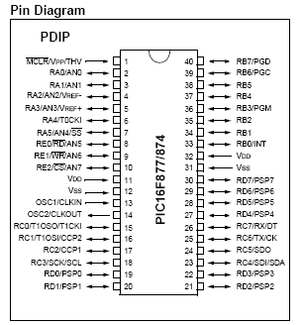
After constructing the basic cct of the PIC microcontroller 16F877, the following ports are used:
Port-B: For keypad.
Port-D: For LCD.
Port-C: RC1 for CCP2 (PWM1), RC2 for CCP1 (PWM2).
Port-A: RA0, chopper MOSFET’s gate square wave signal.

PWM (Pulse width modulation) Signals Generation:

In order to achieve 90º phase shift between main & aux windings, we concluded that the input PWM waveforms must shape in a way or another as the sinusoidal waveforms that the motor must have on its windings. Also, the PWM firing signal must alter its duty cycle rapidly and it must have a nearly high frequency (around 7 KHz was used).

We need 3 signals to be generated:

Two PWM signals from the PIC, one is shifted from the other by 90º. Now the third signal is exactly the opposite of the base (not shifted) signal.

So, we needed two 16 byte signed integer counters to be incremented like this:

From 0 to 32768 & then from -32768 to 0
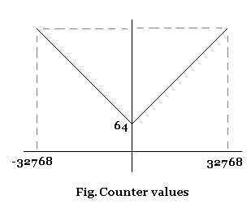

The absolute value function in the PIC is used to make use of the negative value of the counter and to have a continued shape as shown.

- Now how we knew that the motor will take the signal as a semi sinusoidal one with a frequency of nearly 50Hz??

The firing signal was entered in to an R-C (low pass) filter, the output signal which has the nearly 5oHZ frequency obtained by adjusting the counter incremental value (counter1 += 300), as shown below:

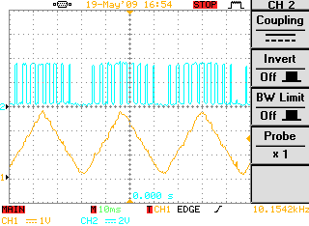

The triangular waveform is the wave expected to have on the terminals of the motor. Above of it is the PWM1 signal. PWM2 signal is the same but with 90º phase shift (±0X4000, according to the direction of rotation) as shown below:

(+): forward, (-): reverse.

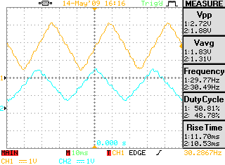

So the PIC C code operates the following:
When the user give the PIC an order to start generating PWM signals (in both forward & reverse direction), an signed int16 counter begin an infinite loop (see Fig. Counter values), with an incremental value of 300 –to adjust the output frequency-. Then the absolute value of the counter is to be taken in order to remain in the positive upper side.
Then the new value is shifted by 15 (divided by$2^{15}$) to prevent the extreme value of the counter from reaching its unwanted maximum value. This value represents the duty cycle of PWM signal.
As explained it is obvious that the duty cycle of both PWMs is variable as we want. The other PWM signal is only shifted by 90º -Vc-(delayed by 90º from Va) and the same procedure is done.
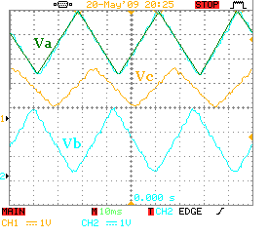
Direction control
When the user want to change the direction of rotation by pressing the reverse key, the program enter the loop of stopping the motor temporarily for a delay time period of 15ms then it enters the loop of generating a PWM signal (Vc) that is shifted also by 90º but (advanced from Va) so the direction will be reversed.
Speed control
The speed was controlled by varying the duty cycle of a square wave generated signal entered to the gate of the chopper MOSFET. Generally in PWM basic concept, when the duty cycle is varied, accordingly the mean (average) value of the DC output voltage is varied directly proportional according to the following relation:
$Vdc=D*Vs$ , where D is the duty cycle
So, when the user types the wanted speed on the keypad that speed will be displayed on the LCD, that speed represent the voltage level that by default represents the duty cycle of the wave signal. The output voltage level goes directly to the terminals of the AC inverter and so affects the voltage that goes to the motor.

Flow Chart
YES
NO
NO
YES
NO
YES
2
3
4
2
2
NO
YES
4
3
4

Chapter (3)

Problems & Constraints
While processing the project stages, SO many tough problems faced us. So, in this section each problem or constraint is illustrated deeply. Also we explained how we solved each one.


Problem #1

DC-Chopper:

In our project we used the DC-Chopper to alter the DC level that represents the input of the AC inverter in order to control the speed of the motor. That is supposed to be done using PWM at the gate of the MOSFET, so while implementing the circuit there was a problem in loading the chopper, why?? Because in order to see the correct output of it, we must attach it with correct load, that is in our case the AC inverter and in that time the inverter was not ready to operate.
Another problem appeared in V_{GS} threshold voltage of the MOSFET used, since the PIC gave us a voltage level only between 0 & 5.

Solution:
An Optocoupler used to solve the problem of the peak-to-peak voltage entered to the gate of the MOSFET by adjusting the collector voltage of the right side of the Optocoupler.

Problem #2

Dead Band Time:

While trying to implement the firing signals of the 3-phase inverter IGBTs –and with the constraint of not switching on two IGBTs in the same arm at the same time- a need of a few μ seconds appears to be inserted in the firing signals. Most of the proposals we checked provided a solution using a feature in the PIC itself, unfortunately our PIC didn’t have that feature and it was hard to program it from scratch.

Solution:
In order to design the dead band thing, we took the decision of building the hardware circuit you have seen in this report having the control on the dead band time according to the input signal frequency.

Problem #3

IGBT Gate Driver:

After taking the choice of using the IGBT type of transistors in the AC inverter implementation, a need for a driver circuit appears in order to switch the IGBT gate on & off.
We preferred to use an already implemented 3-phase bridge driver IC (IR21363) because of its stability characteristics that is excellent both for high & low sides. Having this IC in our hands took 2 weeks. During this period we thought of designing an alternative driving cct by ourselves.
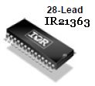

This cct was designed at the begining. This cct achieved the condition of splitting the ground of the low & high sides,
BUT AS USUAL: A PROBLEM OCCURRED!!
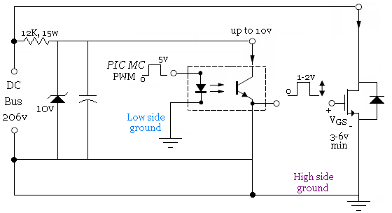

Because the output of the Optocoupler is grounded to the hide side ground –not attached directly as shown below to the IGBTs terminals-, the voltage applied (V_{GS}) was not enough to trigger the gate.
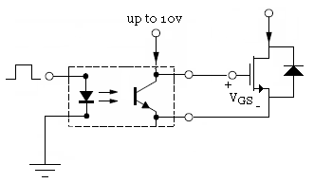
But since the output of the Optocoupler is from the emitter, we cannot attach it as above. So the driver was our only choice.
ALSO,
IR Gate Drive ICs have ten times better delay matching performance than opto-coupler-based solutions. Delay matching between the low-side and high-side driver is typically within ± 50ns, allowing complete dead-time control for better speed range and torque control in motor drive applications. Fast switching also reduces switching power losses and allows leveraging the full benefits of the fastest IGBTs available on the market today for better torque control over a wider speed range.

Problem #4

Inverter Gates Switching:

So many software topologies were applied in order to trigger the IGBT gates, such as:

Also:
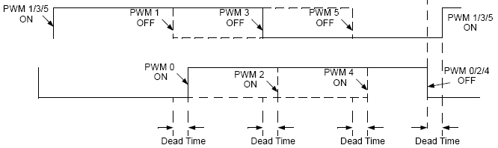
But we approved that they are false, because they didn’t achieve the condition of 90º phase shift between the main & start windings.
So we thought of generating a signal that is approximately introduces the sinusoidal one as shown in the software chapter.

Elements | # Of Needed  Elements | Cost (NIS)
Microprocessor | 1 | 40
PIC Basic cct | 1 | 30
Single phase  AC motor | 1 | 120
LCD | 1 | 40
keypad | 1 | 35
MOSFET | 1 | 10
IGBT | 6 | 120
Uncontrolled full wave  rectifier | 1 | 30
Optocoupler | 1 | 7
Resistors &  Capacitors | -- | 100
IR21363  Driver | 1 | 80
Schmitt &  inverters | 5 | 20

Chapter (4)

The Cost

Overall Cost=632 NIS

Chapter (5)


Conclusion

First this project controls single phase induction motors in both direction & speed. This was done by means of Hardware that is associated with the appropriate Software in order to do the job.

It was discovered during the project that there are several problems with implementing motor control techniques; hardware circuits & software, most notably is:

- Selecting frequency stability range for every stage in the project (i.e. Chopper, inverter, and microcontroller stages). Every part needs to have the correct frequency to operate as required.

Using IGBT switches in driving was more reliable and enjoyable from using BJTs, since driving circuits for the last one is almost disappeared in presence of other rugged switches.

Also we concluded practical work differs a lot from theoretical one, although they cannot be separated from each other.

This work here can be also applied to 3-phase AC motors, not only single phase, since 3-phase inverter is used.

And most important, no matter what happened to our mental state while working in this project, WE LEARNT A LOT ABOUT EVERY THING,

Especially: “HOW TO BE PATIENT”

Last thing

please:

"Don't let this control Project sit in a big folder and not be acted upon!"

Chapter (6)


Recommendations

After a lot of stress and fatigue in implementing this project, we recommend the following, hoping for everyone a good life and health with existence of “MOTORS”:

- First of all we DON’T recommend anyone, anywhere, for any purpose to experiment with the work of this project again. The reason is that one may need a whole year –may be two- just to understand the theoretical aspects that is embedded in this kind of subjects. Another year for doing the practical Part including hardware and software, while maintaining health care above everything.

- Don’t ever, never, let any exposed wires or any exposed charged capacitors in your circuits. You will definatly regret doing this.

- Make sure that grounds in your circuit (high side and low side grounds) are completely separated from each other, IT IS A MATTER OF LIFE AND DEATH.

- Always DOUBLE CHECK on your work before turning on any supply, because an important & expensive part in your circuit might be ON FIRE!

- Don’t be disappointed, LIFE IS HARD!
& ASK Dr. Samer about that

Chapter (7)

Appendix

Software Program on PIC C

#include "E:\Software\1.h"
#include<lcd.c>
char key(){

output_low(PIN_B0);
output_high(PIN_B6);
output_high(PIN_B5);

if (!input(PIN_B4)){
restart_wdt();
return '1';
}
if (!input(PIN_B3)){
restart_wdt();
return '4';
}
if (!input(PIN_B2)){
restart_wdt();
return '7';
}
if (!input(PIN_B1)){
restart_wdt();
return '*';
}

output_low(PIN_B6);
output_high(PIN_B0);
output_high(PIN_B5);

if (!input(PIN_B4)){
restart_wdt();
return '2';
}
if (!input(PIN_B3)){
restart_wdt();
return '5';
}
if (!input(PIN_B2)){
restart_wdt();
return '8';
}
if (!input(PIN_B1)){
restart_wdt();
return '0';
}

output_low(PIN_B5);
output_high(PIN_B6);
output_high(PIN_B0);

if (!input(PIN_B4)){
restart_wdt();
return '3';
}
if (!input(PIN_B3)){
restart_wdt();
return '6';
}
if (!input(PIN_B2)){
restart_wdt();
return '9';
}
if (!input(PIN_B1)){
restart_wdt();
return '#';
}
else{
restart_wdt();
return 'p';
}
}

void main()
{
signed int16 counter1=0;
signed int16 counter2=0;
signed int16 counter3=0;
signed int16 counter4=0;
long duty_main;
long duty_aux;
char t='p';
int i,flag=0,flag2=0;
lcd_init();

setup_adc_ports(NO_ANALOGS);
setup_adc(ADC_OFF);
setup_psp(PSP_DISABLED);
setup_spi(FALSE);
setup_timer_0(RTCC_INTERNAL);
setup_wdt(WDT_2304MS);
setup_timer_1(T1_DISABLED);
setup_timer_2(T2_DIV_BY_1,127,1);
setup_ccp1(CCP_PWM);
setup_ccp2(CCP_PWM);

restart_wdt();

while (true)
{

set_pwm1_duty(0);
set_pwm2_duty(0);

t=key();
restart_wdt();

while (t=='#')
{

y:
if(flag2==0)
{
printf(lcd_putc,"forward");
for(i=1;i<=15;i++)
{
output_low(pin_c1);
output_low(pin_c2);

delay_ms(1000);
restart_wdt();
}
flag2=1;
counter1=0;
}
//signal1//
delay_us(1);
counter1=counter1+600;
counter2 = abs(counter1);
counter2 =(counter2 >>7)+(counter2 >>8);
counter2 =counter2+64;
duty_main = counter2;
set_pwm1_duty(duty_main);

//signal2//

counter3 = counter1 +0x4000;
counter4 = abs(counter3);
counter4 =(counter4 >>7)+(counter4 >>8);
counter4 =counter4+64;
duty_aux = counter4;
set_pwm2_duty(duty_aux);
restart_wdt();
flag=0;
t=key();
if(t=='p')
t='#';

while(t=='*')
{

if(flag==0)

{
printf(lcd_putc,"Reversed");
set_pwm1_duty(0);
set_pwm2_duty(0);
for(i=1;i<=15;i++)
{
delay_ms(1000);
restart_wdt();
}
flag=1;
counter1=0;
}

flag2=0;
delay_us(1);
counter1=counter1+600;
counter2 = abs(counter1);
counter2 =(counter2 >>7)+(counter2 >>8);
counter2 =counter2+64;
duty_main = counter2;
set_pwm1_duty(duty_main);

//signal2//

counter3 = counter1 -0x4000;
counter4 = abs(counter3);
counter4 =(counter4 >>7)+(counter4 >>8);
counter4 =counter4+64;
duty_aux = counter4;
set_pwm2_duty(duty_aux);
restart_wdt();
t=key();
if (t=='p')
t='*';
if(t=='#')
{
restart_wdt();
goto y;
}
}
}
}
}

