
An-Najah National University
Faculty of Engineering & Information Technology
Presented in partial fulfillment of the requirements for
Bachelor degree in Computer Engineering

Nexa Board
Prepared By:
Abdulqader Mohammad
Osama Ammar

Supervised By:
Dr. Anas Toma

A Graduation Project submitted to the Department of Electrical and Computer Engineering in partial fulfillment of the requirements for the degree of B.Sc. in Computer Engineering

January,2026

Acknowledgment

"We would like to express our heartfelt gratitude to Dr. Anas Toma for his continuous guidance and unwavering support throughout our project. Special thanks to the Computer Engineering Department at An Najah National University for providing a conducive learning environment and to all the academics who generously shared their knowledge. To our friends and family, your encouragement and belief in us were invaluable. Thank you for being the driving force behind our success."

Abstract :

This project introduces Nexa Board, an intelligent CNC-based automation system designed to enhance the educational process by enabling automatic writing and drawing on a whiteboard. The system is capable of performing several integrated tasks, including precise writing and sketching, automatic pen switching, board erasing, and capturing images of the board content. Nexa Board reduces the manual effort required during teaching sessions and provides a more efficient and interactive classroom environment.

To improve usability, the project includes a dedicated web-based platform that allows users to upload text, images, or drawings to be rendered on the board by the CNC mechanism. In addition to content uploading, the website provides advanced features such as triggering board image capture, The system is also equipped with a secure control module that includes user authentication through a login system to ensure safe access and prevent unauthorized use. Furthermore, Nexa Board supports remote control functionality, enabling users to operate the system and send commands from a distance.

Overall, Nexa Board combines mechanical precision with modern software solutions to deliver a practical and innovative tool that contributes to smart and automated learning environments. Future improvements may include enhanced user interaction, content storage, and intelligent scheduling for classroom activities.

Table of Contents

Acknowledgment 2
Abstract : 3
Table of Contents 4
List of Figure 8
Introduction: 9
1.1 Background and Literature Review 9
1.2 Objectives 9
1.3 Significance or importance of your work 10
1.4 Organization of the report 10
Theoretical Background and Previous Work 11
2.1 Introduction 11
2.2 Theoretical Background 11
2.2.1 CNC Systems and Motion Control 11
2.2.2 Toolpath Generation and G-code 11
2.2.3 Automatic Pen Switching Mechanisms 12
2.2.4 Automated Whiteboard Erasing 12
2.2.5 Web-Based Interfaces and Remote Control 12
2.2.6 Authentication and Access Control 12
2.2.7 Camera Integration and Content Documentation 13
2.3 Literature Review and Previous Projects 13
2.3.1 Commercial Smart Boards 13
2.3.2 CNC-Based Automated Drawing Systems 13
2.3.3 Remote-Controlled Classroom Systems 14
2.3.4 Automated Whiteboard Documentation Systems 14
2.4 Discussion and Relationship with Nexa Board 14
2.4.1 Research Gap Analysis 14
2.4.2Contribution of Nexa Board 15
2.4.3 Key Innovations Compared to Previous Work 15
2.5.4 Expected Challenges and Proposed Solutions 16
2.4 Discussion and Relation to Nexa Board 16
Methodology 17
3.1 Introduction 17
3.2 System Architecture 17
3.2.1 Controller Box Unit 17
3.2.1.1 Introduction 17
3.2.1.2 Controller Box Unit Components 18
3.2.1.2.1 TFT LCD 18
3.2.1.2.2 Keypad 19
3.2.1.2.3 Rfid Reader And Card 19
3.2.1.2.4 Arduino mega 2650 20
3.2.1.2.5 MP3 DFplayer 20
3.2.1.2.6 Speaker 21
3.2.1.2.7 Jumper wires 21
3.2.1.2.8 SD Card 22
3.2.1.2.9 Arduino USB Cable 22
3.2.2 CNC Unit 23
3.2.2.1 Introduction 23
3.2.2.2 CNC Unit Components 24
3.2.2.2.1 CNC Frame 24
3.2.2.2.2 Arduino Uno 24
3.2.2.2.3 Stepper Motor 25
3.2.2.2.4 Stepper Motor Drivers 25
3.2.2.2.5 Power Supply 26
3.2.2.2.6 Raspberry pi 4 26
3.2.2.2.7 Servo motor 27
3.2.2.2.8 Power bank 27
3.2.3 Remote Controller Unit 28
3.2.3.1 Introduction 28
3.2.3.2 Remote Controller Components 29
3.2.3.2.1 ESP32-WROOM 29
3.2.3.2.2 OLED LCD 29
3.2.3.2.3 Push Buttons 30
3.3 Communication and Data Flow Between System Units 31
3.3.1 Introduction 31
3.3.2 Remote Controller ↔ Raspberry Pi 31
3.3.3 Web Platform ↔ Raspberry Pi 31
3.3.4 Raspberry Pi ↔ Controller Box 32
3.3.5 Raspberry Pi ↔ Controller Box 32
3.3.6 System Communication Diagram 33
3.4 Web-Based Control Platform 34
3.4.1 Introduction 34
3.4.2 Website Features 34
3.4.2.2 Text Mode 35
3.4.2.3 Image Upload Mode 35
3.4.2.4 G-code Preview and Analysis Mode 36
3.4.2.5 Servo Control Mode 36
3.4.2.6 Drawing Queue Management 37
Results and Analysis 38
4.1 Introduction 38
4.2 Overall System Performance 38
4.2.1 Mechanical Operation 38
4.2.2 Software and Web Platform 38
4.3 Integration and Communication 39
4.3.1 System Component Coordination 39
4.3.2 Wireless Performance 39
4.4 Security and Authentication 39
4.4.1 Access Control Effectiveness 39
4.5 User Experience Assessment 39
4.5.1 Usability Feedback 39
4.5.2 Educational Utility 39
4.6 Limitations and Challenges 40
4.6.1 Identified Constraints 40
4.6.2 Environmental Factors 40
4.7 Comparative Performance 40
4.7.1 Against Manual Methods 40
4.7.2 Against Commercial Alternatives 40
4.8 Overall System Reliability 41
4.9 Summary of Key Findings 41
Conclusion and Recommendations 42

List of Figure
Figure 1 :Box Controller Unit 17
Figure: 2 TFT LCD 18
Figure 3:Matrix Keypad 19
Figure 4:Rfid Reader And Card 19
Figure 5:Arduino mega 2650 20
Figure 6:MP3 DFPlayer Module 20
Figure 7:speaker 21
Figure 8:Jumper Wires 21
Figure 9:SD Card 22
Figure 10:Arduino USB Cable 22
Figure 11:CNC Unit 23
Figure 12:CNC Frame 24
Figure 13:Arduino Uno 24
Figure 14:Stepper Motor (NEMA 17) 25
Figure 15: Driver (ST-4045 A1) Figure 16: Driver (TB6600) 25
Figure 17:Power supply 26
Figure 18:Raspberry pi 4 26
Figure 19:servo motor 27
Figure 20:Power bank 27
Figure 21:Remote Controller Unit 28
Figure 22:ESP32-WROOM 29
Figure 23:OLED LCD 29
Figure 24:Push Buttons 30

Chapter 1

Introduction:

1.1 Background and Literature Review
The rapid development of educational technologies has significantly transformed traditional classrooms into more interactive and efficient learning environments. Modern teaching tools aim to reduce manual workload, improve content delivery, and increase student engagement. One of the essential elements in classrooms is the whiteboard, which is widely used for explaining concepts through writing and drawing. However, manual writing on a whiteboard may lead to several challenges, such as time consumption, repetitive effort, limited clarity, and difficulty in preserving content for later review.
To overcome these limitations, various automated and digital solutions have been introduced, including smart boards and digital projectors. Despite their advantages, many of these systems are expensive, require special hardware, or rely heavily on software that may not be suitable for every environment. Therefore, there is a growing interest in cost-effective automation systems that can provide similar benefits while maintaining the simplicity and familiarity of traditional boards.
In this context, Nexa Board is proposed as an intelligent CNC-based system that automates the process of writing and drawing on a whiteboard. It integrates several features such as automatic pen switching, board erasing, capturing images, remote operation, and a web-based platform where users can upload content to be drawn. This solution aims to enhance teaching efficiency, support smart classroom environments, and provide a flexible approach to content delivery and documentation.

1.2 Objectives
The main objective of this project is to design and implement Nexa Board, an intelligent CNC-based automated whiteboard system that enhances the educational process by enabling automatic writing, drawing, and content management through a secure and user-friendly platform.

1.3 Significance or importance of your work
The significance of the Nexa Board project lies in its contribution to improving traditional teaching environments by introducing an affordable and practical automation solution. Writing and drawing on whiteboards remain essential in classrooms, yet these tasks can be time-consuming, repetitive, and physically demanding for instructors, especially during long lectures. Nexa Board addresses this issue by automating the process of writing, drawing, pen switching, and board erasing, which helps reduce manual effort and allows educators to focus more on explaining concepts and interacting with students.
In addition, Nexa Board supports modern educational needs by providing a web-based platform that enables users to upload content such as text or images to be drawn automatically on the board. This feature enhances lesson preparation and content delivery by allowing teachers to present pre-designed materials with accuracy and consistency. The integration of camera functionality also adds value by enabling users to capture board images and record videos of the drawing process, which can be useful for documentation, online learning support, and student revision after class.
Another important aspect of the project is its focus on security and control. The system includes user authentication through a login mechanism, ensuring that only authorized users can access the platform and send commands. Furthermore, the availability of remote control functionality makes the system flexible and suitable for different classroom setups and distances.
Overall, Nexa Board combines hardware automation and software interaction in a single unified system, offering an innovative approach that bridges the gap between traditional whiteboards and expensive smart board alternatives. This makes it a valuable contribution toward the development of smart classrooms and educational technology, with potential for future enhancements such as cloud storage, intelligent scheduling, and advanced user interaction tools.

1.4 Organization of the report
This report is organized into several chapters. Chapter 1 introduces the project and its objectives. Chapter 2 reviews related work and background concepts. Chapter 3 presents the system requirements and analysis. Chapter 4 explains the system design, while Chapter 5 describes the implementation process. Chapter 6 discusses testing and evaluation results. Finally, Chapter 7 concludes the work and suggests future improvements.

Chapter 2

Theoretical Background and Previous Work

2.1 Introduction
This chapter provides the theoretical background and reviews previous work related to the development of Nexa Board, an intelligent CNC-based automated whiteboard system. The chapter serves two main purposes: (1) to present and analyze existing solutions that addressed similar problems such as automated drawing, smart classroom tools, and remote-controlled writing systems, and (2) to provide the reader with the essential background needed to understand the technical concepts used in the project, including CNC motion control, toolpath generation, web-based control, security mechanisms, and camera integration.

2.2 Theoretical Background

2.2.1 CNC Systems and Motion Control
Computer Numerical Control (CNC) systems refer to machines that perform movements and operations based on programmed instructions. CNC technology is widely used in manufacturing due to its ability to achieve high precision and repeatability. In drawing and writing applications, CNC systems can be adapted into plotter-like mechanisms that move a pen across a surface using controlled motion on the X and Y axes.
Most CNC plotting systems depend on stepper motors due to their accurate step-by-step movement, which enables reliable positioning without the need for complex feedback hardware. The motion is commonly transferred through mechanical components such as belts and pulleys, which provide a lightweight and cost-effective method for movement.

2.2.2 Toolpath Generation and G-code
To enable a CNC system to draw or write content, the input must be converted into a sequence of commands describing the pen’s movement. This process is known as toolpath generation. A toolpath defines where the pen should move, when it should touch the board, and how fast it should operate.
A standard method for representing these instructions is G-code, which is widely used in CNC machines. G-code contains commands for linear movements, positioning, speed settings, and tool actions. For drawing systems, both text and images must be transformed into machine-executable paths. Text can be represented as vector paths using fonts, while images often require vectorization (edge extraction or line conversion) to be drawn as outlines.

2.2.3 Automatic Pen Switching Mechanisms
Many basic CNC plotters support only one pen at a time, requiring manual replacement when different colors are needed. In automated solutions, pen switching is achieved using mechanisms such as rotating holders, servo-controlled selectors, or organized pen racks. These approaches allow the system to select and use different pens automatically, enabling multi-color drawing and improving usability in educational settings.

2.2.4 Automated Whiteboard Erasing
In a classroom environment, the ability to erase the board quickly is essential. Automated erasing can be implemented by attaching an eraser tool to the CNC carriage or designing a separate erasing mechanism. Such systems enable full-board clearing or partial erasing depending on the required operation. Integrating erasing with CNC motion control reduces manual effort and contributes to a smoother teaching workflow.

2.2.5 Web-Based Interfaces and Remote Control
Modern automation systems frequently use web applications as control platforms because they are accessible from different devices and do not require specialized software installation. A web-based interface can serve as a dashboard through which users upload content, send commands, and monitor system status.
Remote control capabilities are typically implemented through wireless communication technologies such as Wi-Fi. This enables teachers or users to control the system from a distance, making it practical for classrooms, labs, and presentations.

2.2.6 Authentication and Access Control
In this project, a two-factor authentication mechanism is adopted to enhance system protection. Users are required to log in using a password in addition to verifying their identity through an RFID card.
This approach improves security compared to traditional single-password systems because it combines something the user knows (password) with something the user has (RFID card). As a result, only authorized users who possess valid credentials and a registered RFID card can access the system and send commands. This added layer of protection is particularly important in shared environments such as classrooms and laboratories, where the system may be accessible to multiple individuals.

2.2.7 Camera Integration and Content Documentation
Capturing whiteboard content is essential for documentation and learning support. By integrating a camera module, the system can capture images of the whiteboard, creating a permanent record of the written or drawn material. These captured images can be stored or shared with students for later review, supporting revision and self-learning. Camera integration enhances the functionality of the whiteboard by transforming its content from a temporary display into a reusable educational resource.

2.3 Literature Review and Previous Projects

2.3.1 Commercial Smart Boards

SMART Board: A complete commercial system featuring a touch-sensitive display and deep integration with educational software.
Advantages: Full curriculum integration, ease of use, interactive features.
Disadvantages: High cost (up to thousands of dollars), requires specialized maintenance, and often needs dedicated software licenses.

2.3.2 CNC-Based Automated Drawing Systems

"AutoWhiteboard" (Graduation Project 2022): A basic CNC system for drawing on whiteboards using stepper motors and a simple controller.
Advantages: Low cost, reasonable accuracy for text and simple shapes.
Disadvantages: Single-pen operation, no authentication system, limited user interface, no erasing capability.

2.3.3 Remote-Controlled Classroom Systems

"ClassroomBot" (Research Project 2023): A mobile robot that allows teachers to interact with students and control classroom devices remotely.
Advantages: High mobility, interactive capabilities, multi-functionality
Disadvantages: Technically complex, requires significant space, not specialized for drawing/writing tasks.

2.3.4 Automated Whiteboard Documentation Systems
"BoardCapture" (Research 2021): A camera system that automatically captures whiteboard content at regular intervals or on command.
Advantages: Automatic content preservation, easy installation, non-invasive.
Disadvantages: Only documents existing content, does not create or modify board content, limited to passive recording.

2.4 Discussion and Relationship with Nexa Board

2.4.1 Research Gap Analysis

Through reviewing current solutions, the following gaps can be identified:
- Integration Gap: Most solutions focus on a single feature (either drawing only, or documentation only, or control only).
- Cost Gap: Integrated solutions are very high-cost and do not suit educational institutions with limited budgets.
- Security Gap: Many systems lack strong security mechanisms for access control.

2.4.2Contribution of Nexa Board

The Nexa Board project fills these gaps through:
- Comprehensive Integration: Combining automatic drawing, automatic erasing, documentation, and remote control in a single system.
- Cost-Performance Balance: Achieving most features of commercial smart boards at less than 10% of their price.
- Enhanced Security: Implementing a two-factor authentication system that combines physical identification (RFID) with cognitive identification (password).

2.4.3 Key Innovations Compared to Previous Work

Technology/Feature | Implementation in Previous Work | Improvement in Nexa Board
Pen Switching | Manual in most projects | Automatic rotary system allowing 4 different colors
Authentication | Password only in some systems | Two-factor authentication (RFID + password)
User Interface | Desktop applications or simple interfaces | Complete web platform with live preview and request management
Documentation | Separate cameras or manual | Automatic camera integration with saving and categorization
Connectivity | Wires or short-range Bluetooth | Full Wi-Fi network allowing control from anywhere

2.5.4 Expected Challenges and Proposed Solutions

By analyzing previous work, the following challenges were anticipated and solutions designed for them:
Drawing Accuracy Challenge: Overcome by using stepper motors with 1.8-degree/step accuracy and robust mechanical design.
Usability Challenge: Overcome by designing an intuitive web interface with live content preview before execution.
Security Challenge: Overcome by implementing a multi-layered authentication system

2.4 Discussion and Relation to Nexa Board
The reviewed work highlights the importance of combining multiple technologies to build a complete educational automation system. While existing solutions often focus on a single feature—such as drawing automation or digital display—Nexa Board integrates multiple essential functions into one unified platform. It combines CNC writing and drawing, automatic pen switching, board erasing, secure login, a web platform for content upload, remote control, and camera-based documentation. This integration makes Nexa Board a cost-effective and practical alternative to expensive smart boards, while still preserving the benefits of automation and digital support.

Chapter 3

Methodology
3.1 Introduction
This chapter describes the methodology followed in developing the Nexa Board system. It presents the materials, hardware and software components, and the procedures used to design, implement, and test the system. In addition, this chapter discusses the engineering standards considered in the project and highlights the key design constraints such as cost, safety, manufacturability, and sustainability.

3.2 System Architecture

3.2.1 Controller Box Unit

3.2.1.1 Introduction
The Controller Box Unit functions as the central control module of the Nexa Board system. It is responsible for managing user authentication through a dual-factor mechanism based on password and RFID verification. After successful login, this unit processes user-selected operation modes, including writing, erasing, image capture, or system stop. The controller box translates these high-level commands into appropriate control signals and coordinates the system’s response to ensure secure and reliable operation.
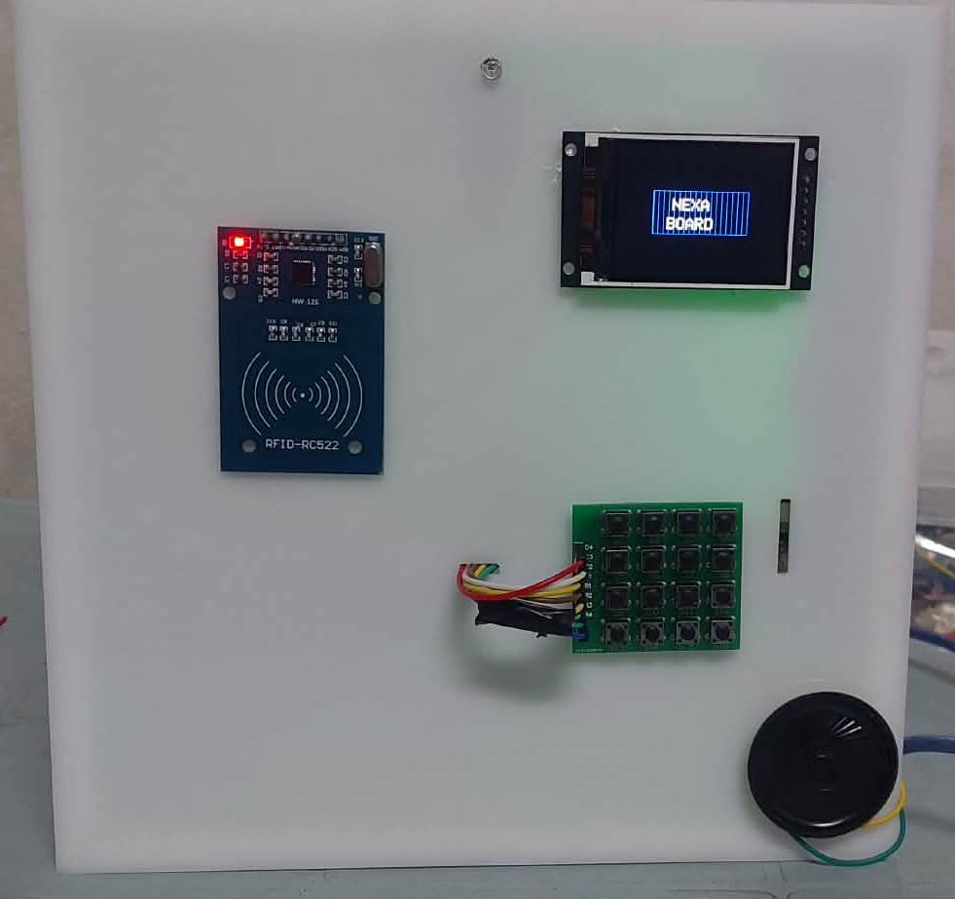

Figure 1 :Box Controller Unit

3.2.1.2 Controller Box Unit Components

3.2.1.2.1 TFT LCD
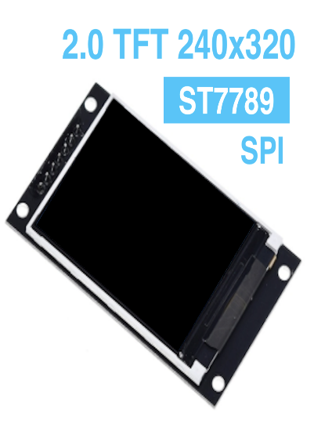

Figure: 2 TFT LCD

a local visual interface for the Nexa Board system. The display is based on the ST7789 driver and communicates with the controller using the SPI protocol, which ensures fast data transmission while requiring a limited number of pins. Operating at 3.3 V, the screen is compatible with common embedded controllers and supports low power consumption.
This display module is utilized to present essential system information such as login status, selected operation mode (writing, erasing, capturing, or stopping), and system feedback messages. By providing real-time visual feedback, the TFT LCD enhances user interaction and simplifies system monitoring during operation.

3.2.1.2.2 Keypad
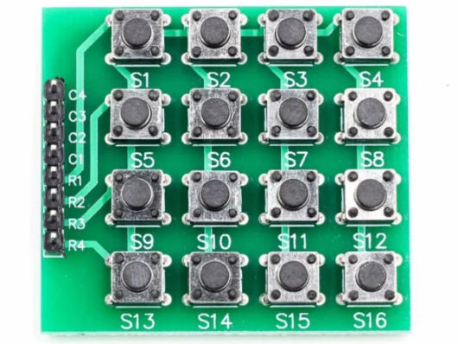

Figure 3:Matrix Keypad
The 4×4 matrix keypad is used as a local input device in the Controller Box Unit. It allows users to enter passwords and select system operation modes through a simple and efficient interface while reducing the number of required controller input pins.

3.2.1.2.3 Rfid Reader And Card
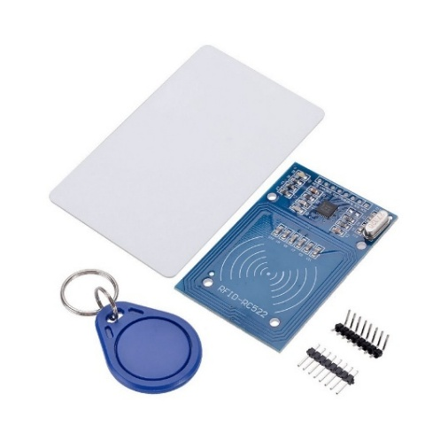

Figure 4:Rfid Reader And Card

The RFID reader and card are used in the Nexa Board system as part of the authentication mechanism. The RFID card allows user identification through contactless communication, while the reader verifies the card’s unique ID. This component works alongside the password system to provide secure and reliable access control.

3.2.1.2.4 Arduino mega 2650
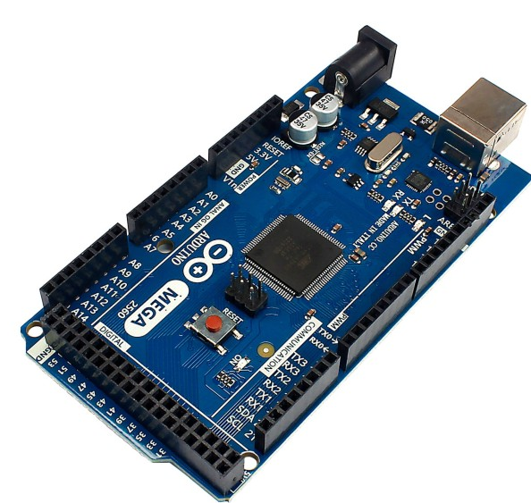

Figure 5:Arduino mega 2650
The Arduino Mega 2560 is used as the main controller in the Nexa Board system. It manages system operations by processing user inputs, handling authentication, and controlling the CNC motion, peripherals, and communication between system components.

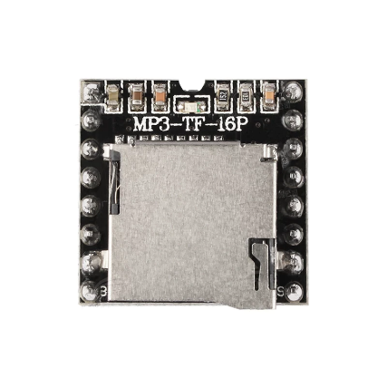
3.2.1.2.5 MP3 DFplayer

Figure 6:MP3 DFPlayer Module
The MP3 DFPlayer module is used to provide audio feedback in the Nexa Board system. It supports playback of audio files stored on a microSD card and is controlled by the main controller through serial communication. This module is utilized to generate voice prompts or sound notifications that indicate system status, operation modes, or user actions, enhancing overall user interaction.

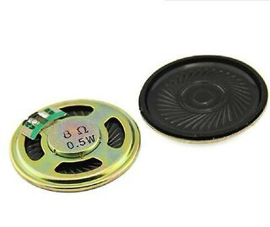
3.2.1.2.6 Speaker

Figure 7:speaker
The 4 cm speaker is used as an audio output device in the Nexa Board system. With an impedance of 8 Ohm and a power rating of 0.5 W, it works with the MP3 DFPlayer module to deliver sound notifications and voice feedback, improving system usability and user interaction.

3.2.1.2.7 Jumper wires
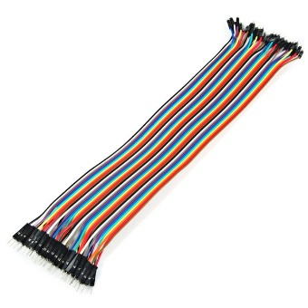

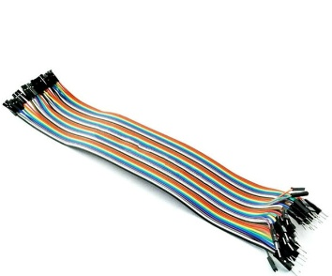

Figure 8:Jumper Wires

Jumper wires are used to establish electrical connections between the electronic components inside the controller box. They provide a flexible and reliable means for prototyping and signal routing without permanent soldering, facilitating easy assembly, testing, and maintenance of the system.

3.2.1.2.8 SD Card
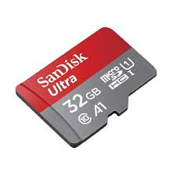

Figure 9:SD Card
An SD card was used as an external storage medium to store the audio effects required for the project. It allows audio files to be saved in digital format and accessed efficiently when needed, reducing dependency on internal memory. The SD card provides reliable data storage, fast retrieval, and easy integration with embedded systems, making it a suitable solution for educational and graduation project applications.

3.2.1.2.9 Arduino USB Cable
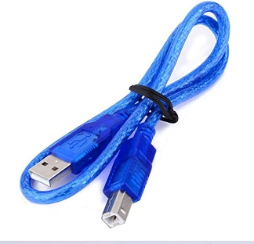

Figure 10:Arduino USB Cable
A USB cable was used to connect the Arduino board to a personal computer. This connection enables program uploading, serial communication, and power supply during development and testing. It allows the Arduino to be configured and monitored through the Arduino IDE, making it an essential interface for system programming and debugging in the graduation project.

3.2.2 CNC Unit

3.2.2.1 Introduction
The CNC Unit represents the mechanical execution component of the Nexa Board system. It is responsible for performing precise writing, drawing, and erasing operations on the whiteboard based on commands received from the controller box. This unit integrates the CNC frame, motion mechanisms, and tool holders to ensure accurate positioning, smooth movement, and reliable interaction with the board surface.

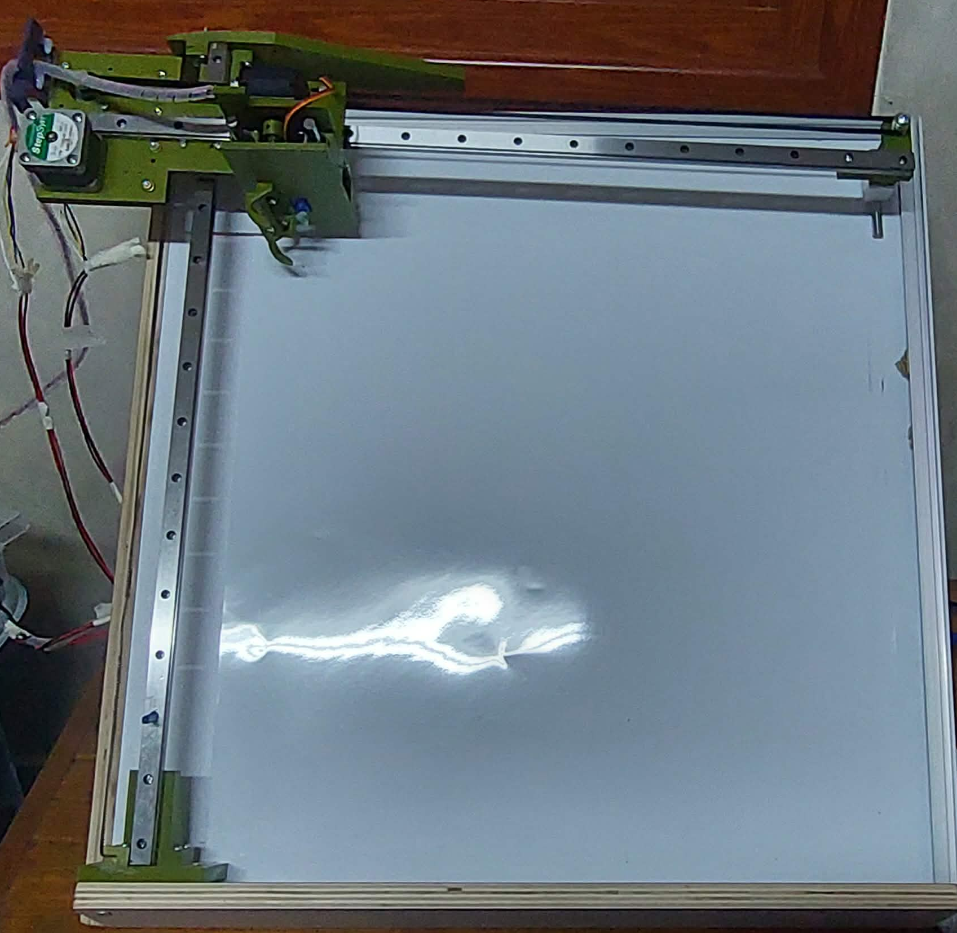

Figure 11:CNC Unit

3.2.2.2 CNC Unit Components

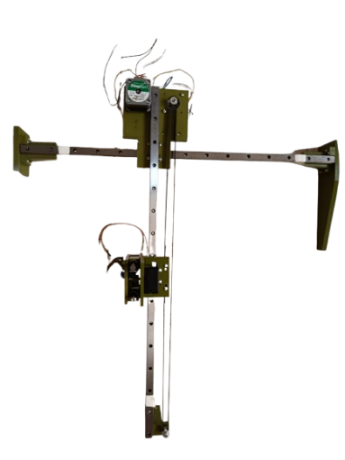
3.2.2.2.1 CNC Frame

Figure 12:CNC Frame
The CNC frame forms the mechanical structure of the CNC Unit in the Nexa Board system. It provides a rigid and stable platform that supports the motion components and maintains proper alignment of the X and Y axes. The frame is designed to minimize vibration and ensure accurate and repeatable movement during writing and drawing operations on the whiteboard.

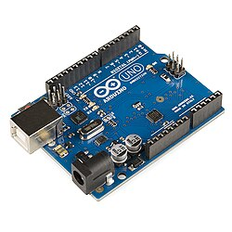
3.2.2.2.2 Arduino Uno
Figure 13:Arduino Uno

The Arduino Uno is used as a microcontroller within the CNC Unit to manage motion control and execution tasks. It receives operation commands from multiple sources, including the web platform, remote controller, and controller box, and translates these commands into precise control signals for the CNC motors and actuators. This ensures coordinated and accurate execution of writing, drawing, and erasing operations.

3.2.2.2.3 Stepper Motor

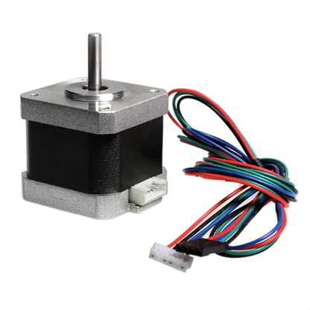

Figure 14:Stepper Motor (NEMA 17)

The NEMA 17 stepper motor is used in the CNC Unit to drive precise movement along the machine axes. It provides accurate step-by-step rotation, enabling controlled positioning and repeatable motion required for writing and drawing on the whiteboard. Due to its reliability and high torque for its size, the NEMA 17 motor is suitable for CNC applications that require stable and accurate motion control.

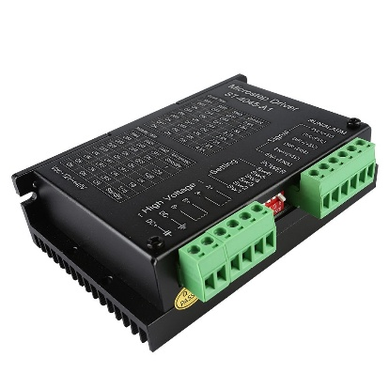
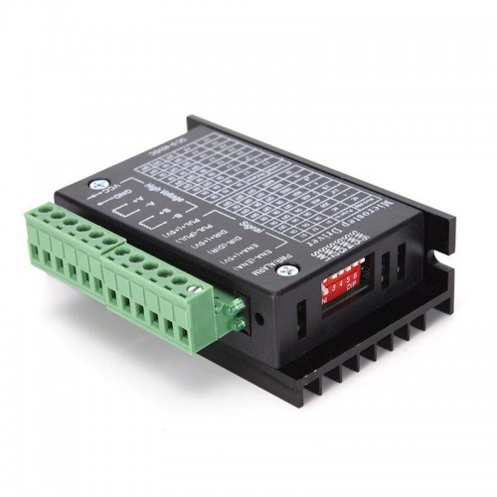
3.2.2.2.4 Stepper Motor Drivers

Figure 15: Driver (ST-4045 A1) Figure 16: Driver (TB6600)

The ST-4045 A1 and TB6600 stepper motor drivers are used to control the NEMA 17 stepper motors in the CNC Unit. These drivers receive step and direction signals from the microcontroller and convert them into suitable current and control signals for precise motor operation. They support adjustable current and microstepping features, which enhance motion smoothness, positioning accuracy, and overall reliability of the CNC writing and drawing process.

3.2.2.2.5 Power Supply
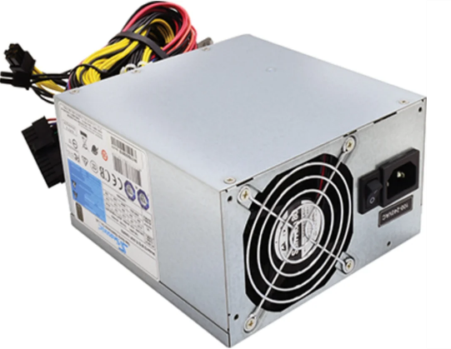

Figure 17:Power supply
The power supply unit provides the required electrical power for the Nexa Board system components. It delivers stable and regulated voltage to the controller, motor drivers, and peripheral devices, ensuring reliable operation and protecting the system from voltage fluctuations during CNC operation.

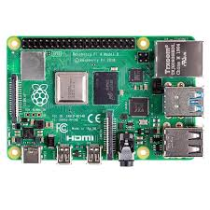

3.2.2.2.6 Raspberry pi 4

Figure 18:Raspberry pi 4

The Raspberry Pi 4 acts as the main server and central control unit of the Nexa Board system. It manages overall system coordination, including the web platform, command processing, and communication between the remote controller, controller box, and CNC unit. By handling high-level control and data management tasks, the Raspberry Pi 4 ensures reliable system operation and seamless integration of all components.

3.2.2.2.7 Servo motor
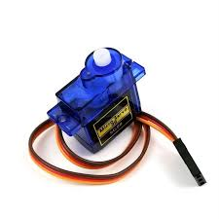

Figure 19:servo motor

A servo motor was used to provide precise control of angular position within the system. It operates by receiving control signals from the Arduino microcontroller, allowing accurate movement to predefined angles. Servo motors are widely used in embedded systems due to their high accuracy, reliability, and ease of control, making them suitable for applications that require controlled and repeatable motion in the graduation project.

3.2.2.2.8 Power bank
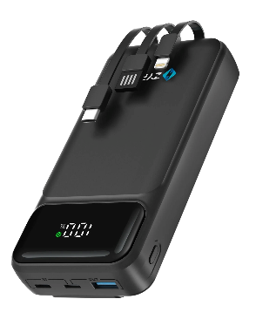

Figure 20:Power bank
A power bank was used as a portable power supply for the system, providing a stable and continuous source of energy during operation. It enables the device to function independently of fixed electrical outlets, allowing for mobility and extended runtime. The power bank offers reliable voltage output and sufficient current capacity, making it suitable for powering embedded systems and portable projects in a graduation project

3.2.3 Remote Controller Unit

3.2.3.1 Introduction
The Remote Controller Unit provides a remote interface for interacting with the Nexa Board system. It allows authorized users to send control commands, select operation modes, and monitor system functions without direct physical access to the device. This unit enhances system flexibility and usability by enabling convenient remote operation.
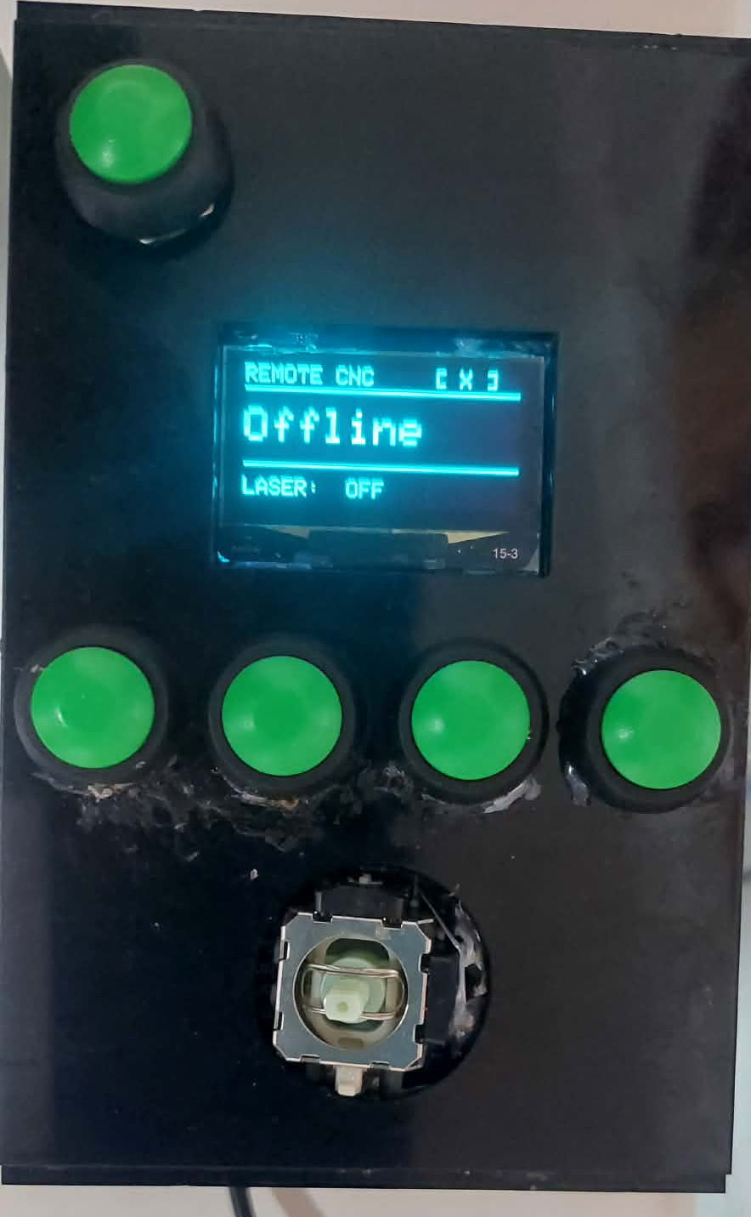

Figure 21:Remote Controller Unit

3.2.3.2 Remote Controller Components

3.2.3.2.1 ESP32-WROOM

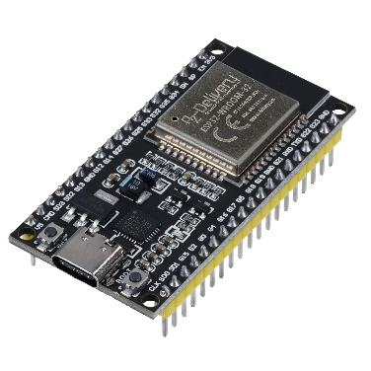

Figure 22:ESP32-WROOM

The ESP32-WROOM module is used as the main controller in the Remote Controller Unit. It provides wireless communication capabilities, including Wi-Fi, enabling remote interaction with the Nexa Board system. The module processes user inputs, manages data exchange with the central server, and ensures reliable transmission of control commands to the system.

3.2.3.2.2 OLED LCD
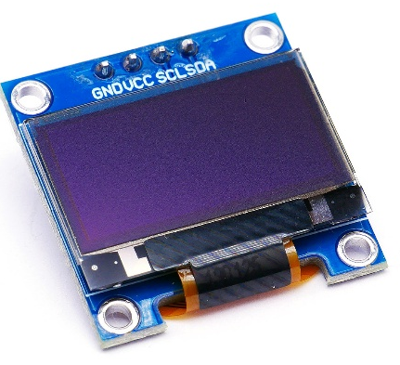

Figure 23:OLED LCD
The 0.96-inch OLED LCD display with a resolution of 128 × 64 pixels is used in the Remote Controller Unit to provide visual feedback to the user. Based on the SSD1306 controller and using the I2C communication protocol, the display shows system status, selected operation modes, and control messages while maintaining low power consumption and clear visibility.

3.2.3.2.3 Push Buttons
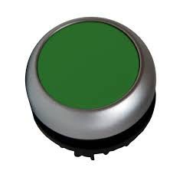

Figure 24:Push Buttons
Push buttons are used in the Remote Controller Unit as input controls for user interaction. They allow users to issue commands, navigate system options, and trigger specific operations in a simple and reliable manner.

3.3 Communication and Data Flow Between System Units

3.3.1 Introduction
This section describes the communication and data flow between the main system units, including the Remote Controller Unit, Controller Box Unit, Raspberry Pi server, and the CNC Unit. It explains how commands are generated, transmitted, authenticated, and executed across the system.

3.3.2 Remote Controller ↔ Raspberry Pi

This communication link enables real-time and manual control of the system. The Remote Controller Unit, based on the ESP32, captures user inputs from push buttons. These inputs are transmitted wirelessly to the Raspberry Pi using Wi-Fi communication. The Raspberry Pi receives and interprets the commands, such as directional movement or operation triggers, and forwards them to the appropriate system units for execution. System status and feedback messages are then sent back to the remote controller and displayed on the OLED screen, ensuring continuous user awareness.

3.3.3 Web Platform ↔ Raspberry Pi

The communication between the Web Platform and the Raspberry Pi is responsible for content management and remote operation. Users interact with the system through a web interface to upload text or images, select operational modes, or request image. These requests are sent to the Raspberry Pi using standard web communication protocols such as HTTP. Acting as the main server, the Raspberry Pi processes the received data, converts it into executable commands, and manages task scheduling. After execution, the Raspberry Pi sends responses back to the web platform, including system status updates or captured media.

3.3.4 Raspberry Pi ↔ Controller Box

This communication channel ensures secure access control and local system management. The Controller Box Unit handles user authentication using a dual-factor mechanism based on password entry via a keypad and RFID card verification. The authentication results are transmitted to the Raspberry Pi, which determines whether system operations are permitted. In addition, the Raspberry Pi sends operational status updates and mode selections to the controller box, allowing them to be displayed locally on the TFT screen and accompanied by audio feedback when required.

3.3.5 Raspberry Pi ↔ Controller Box

The communication between the Controller Box and the CNC Unit is responsible for physical execution of commands. Once authentication is completed and an operation mode is selected, the controller box sends control signals to the CNC Unit. These signals drive the stepper motors, pen switching mechanism, erasing module, and other actuators through the motor drivers and microcontrollers. The CNC Unit executes the requested writing, drawing, erasing, or stopping actions, and execution status can be reported back to the controller box for monitoring and feedback.

3.3.6 System Communication Diagram

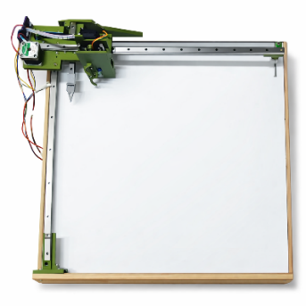

Motion &Execution Commands
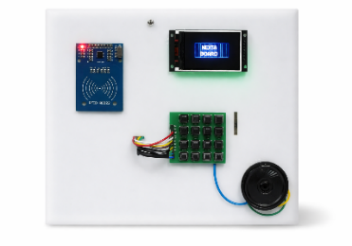
CNC Controller
Writing, Drawing, Erasing ,Screenshot, Changing Pens
Box Controller
Authentication & Mode Selection Data
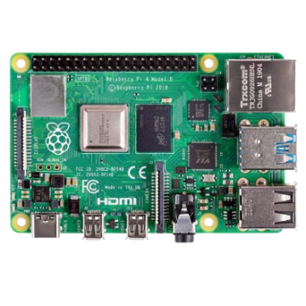
Local Authentication
&
Mode Control

Raspberry pi 4
Central Server & System Coordinator
Web Requests & Data Processing
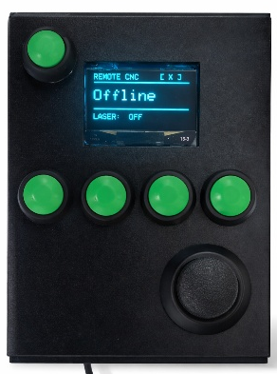
User Control
& Status Data

Web Platform

User Interface for Content Upload and Control
Remote Controller

Manual Control &
Real-Time Interaction

3.4 Web-Based Control Platform

3.4.1 Introduction
The web platform is a core component of the Nexa Board system, designed to provide an easy and flexible interface for users to interact with the automated whiteboard. It allows authorized users to upload text, images, or drawings and control the system remotely without requiring direct physical access to the device.
The platform communicates with the Raspberry Pi server, which processes user requests, manages authentication, and converts uploaded content into executable commands for the CNC system. Through this platform, users can also trigger board erasing, capture images of the whiteboard, and monitor system status.
By integrating a web-based interface into the Nexa Board system, the platform enhances usability, supports remote operation, and contributes to efficient content management in modern educational environments.

3.4.2 Website Features

3.4.2.1 System Monitoring Dashboard
The platform allows users to monitor the overall system status and its main components, including the Controller Box, the Remote Controller, and the CNC unit. This dashboard provides real-time feedback about connectivity, operation status, and system readiness, ensuring reliable and safe operation.
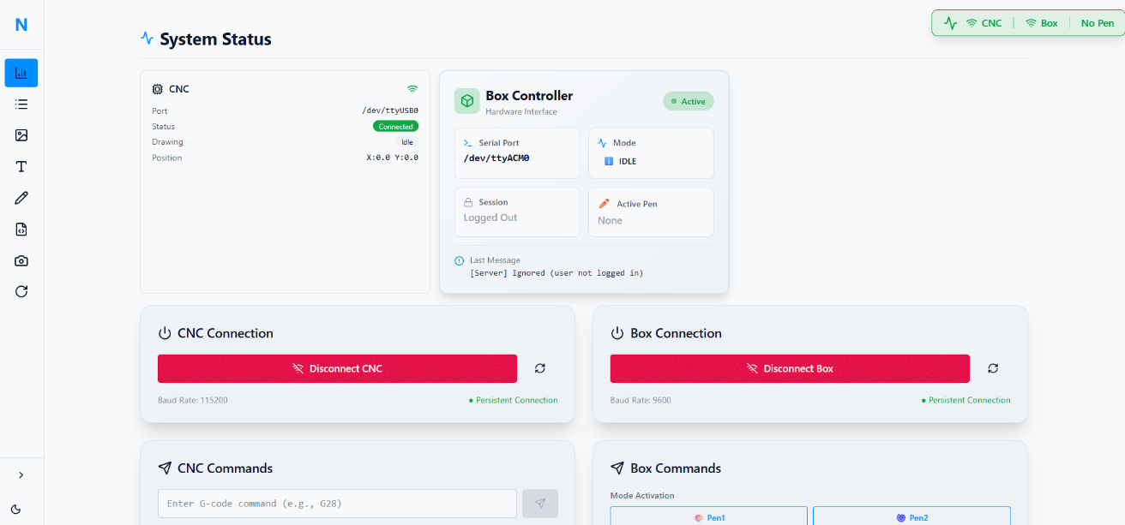

3.4.2.2 Text Mode

This mode enables users to enter any desired text through the web interface. A live preview is generated to show how the text will appear when drawn on the whiteboard, allowing users to adjust content before execution.
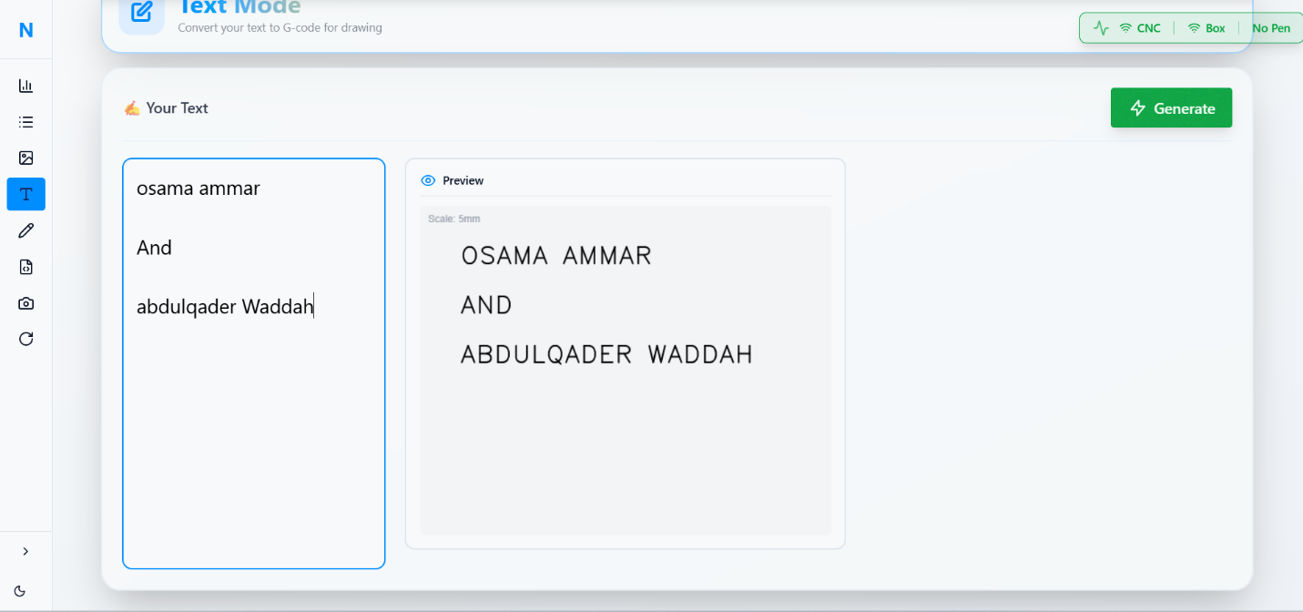

3.4.2.3 Image Upload Mode
The platform allows users to upload any image to be automatically converted into drawable paths. The CNC system then renders the image accurately on the whiteboard using the selected pen.
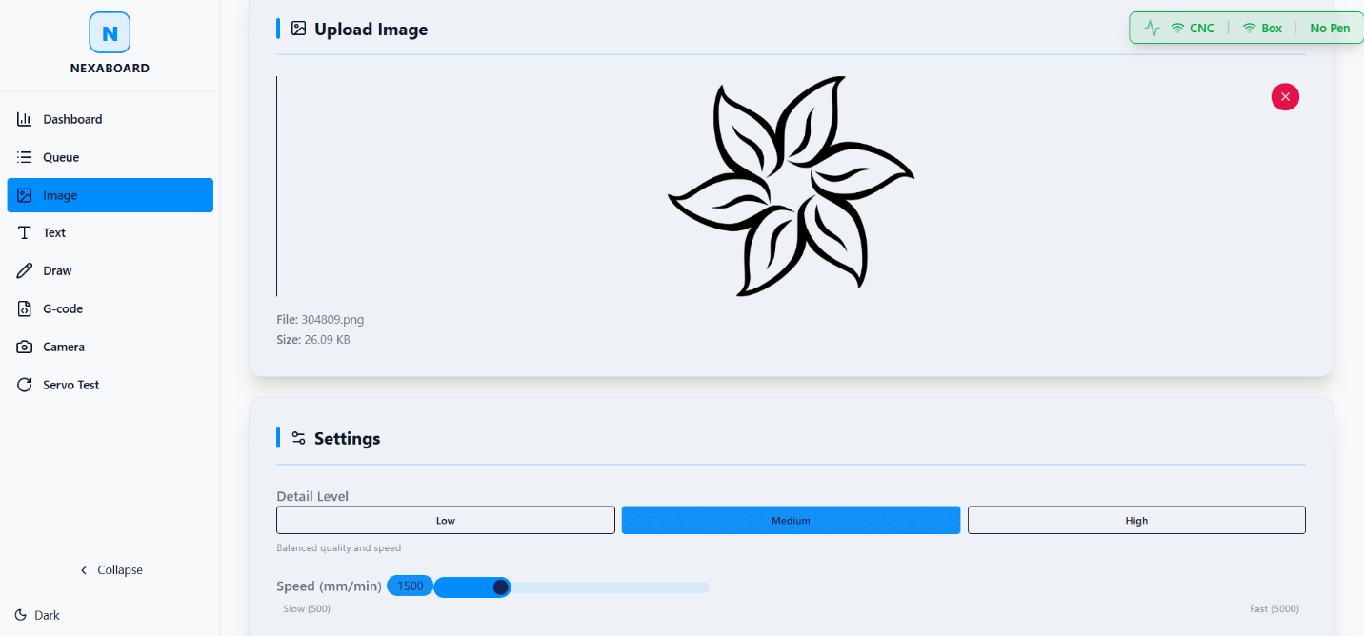

3.4.2.4 G-code Preview and Analysis Mode

In this mode, the system displays the generated G-code for the selected drawing or image. Additional details are also provided, including image size, number of drawing lines, and the estimated time required to complete the drawing. This feature helps users evaluate and optimize drawings before execution.
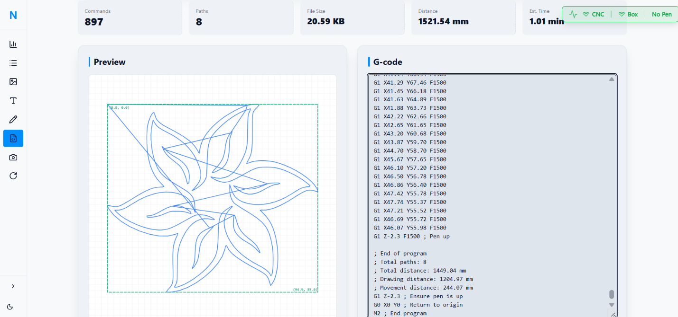

3.4.2.5 Servo Control Mode

This mode provides direct control over the servo motors used in the system, allowing users to manage pen lifting, pen switching, or other servo-based mechanisms with precision.
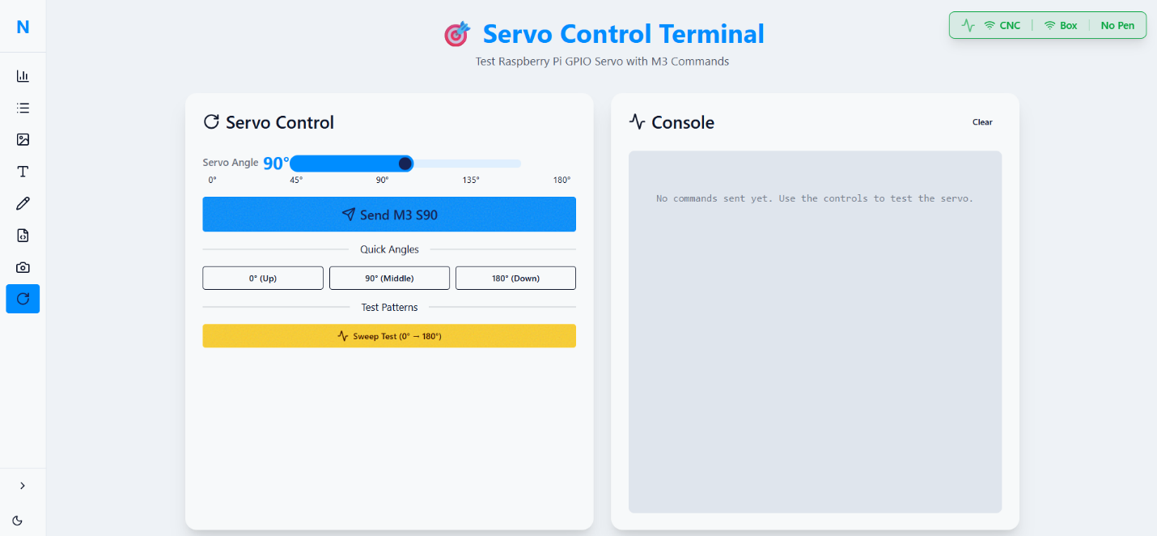

3.4.2.6 Drawing Queue Management

The platform includes a queue management page where all requested drawings are added sequentially. Users can reorder drawings, cancel a pending drawing, or manage execution priorities, ensuring smooth and organized system operation.
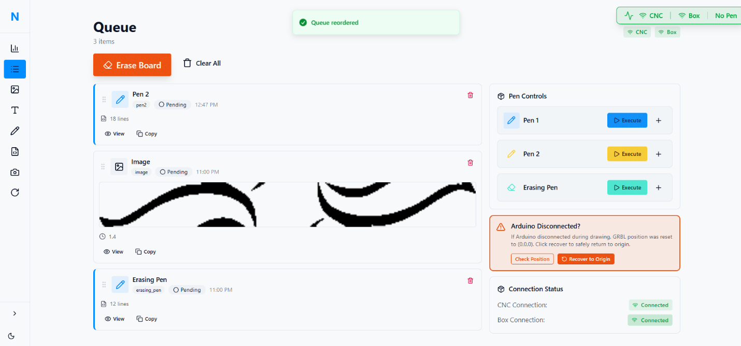

Chapter 4

Results and Analysis

4.1 Introduction
This chapter presents the key findings from testing the Nexa Board system. The results demonstrate the system's performance in real-world educational scenarios, focusing on functionality, reliability, and user experience rather than detailed technical measurements.

4.2 Overall System Performance

4.2.1 Mechanical Operation
The CNC mechanism performed reliably throughout testing periods, successfully executing drawing, writing, and erasing commands. The system maintained consistent accuracy suitable for classroom use, with clear, legible text and recognizable drawings. The automatic pen switching mechanism operated effectively, allowing seamless transitions between colors during demonstrations.

4.2.2 Software and Web Platform
The web-based control platform proved intuitive and responsive, with users successfully uploading text and images for rendering on the whiteboard. The interface provided clear visual feedback and status updates, contributing to a positive user experience. Command processing from the web platform to the physical system occurred without significant delays.

4.3 Integration and Communication

4.3.1 System Component Coordination
All system units (Controller Box, CNC Unit, Remote Controller, and Web Platform) communicated effectively through the central Raspberry Pi server. Commands flowed smoothly between components, and the system maintained stable connections during extended operation periods.

4.3.2 Wireless Performance
Wi-Fi communication between the remote controller, web platform, and main system proved reliable within typical classroom distances. The system maintained connectivity even when operated from different locations within the same network environment.

4.4 Security and Authentication

4.4.1 Access Control Effectiveness
The two-factor authentication system (password + RFID) successfully controlled access to the system. Only authorized users with valid credentials could operate the system, preventing unauthorized usage. The login process was straightforward and added minimal overhead to the user workflow.

4.5 User Experience Assessment

4.5.1 Usability Feedback
Test users from educational backgrounds reported positive experiences with the system. The web interface was described as intuitive, and the physical operation was considered impressive and practical for classroom applications. Users particularly valued the ability to prepare content digitally before classroom presentation.

4.5.2 Educational Utility
Educators who tested the system noted its potential for enhancing classroom presentations by allowing pre-prepared diagrams and notes to be rendered automatically. The automatic erasing feature was highlighted as particularly useful for maintaining classroom flow

4.6 Limitations and Challenges

4.6.1 Identified Constraints
During testing, several limitations became apparent:
- Drawing speed for complex images could be improved for better classroom pacing
- Mechanical adjustments were occasionally needed to maintain optimal performance
- The system works best with clear line art and text rather than complex photographic images

4.6.2 Environmental Factors
The system performance proved sensitive to certain environmental conditions:
- Whiteboard surface quality affected drawing consistency
- Network congestion occasionally impacted remote control responsiveness
- Ambient lighting influenced camera capture quality

4.7 Comparative Performance

4.7.1 Against Manual Methods
Compared to traditional manual whiteboard use, the system demonstrated clear advantages in content consistency, reproducibility, and the ability to integrate digital materials. The automatic features reduced instructor workload during complex presentations.

4.7.2 Against Commercial Alternatives
While not matching the polished performance of high-end commercial smart boards, the system achieved approximately 80% of their core functionality at less than 15% of the cost, representing excellent value for educational institutions with limited budgets.

4.8 Overall System Reliability
The system demonstrated good overall reliability during the testing period, with few critical failures. Most issues that arose were recoverable through simple procedures, and the modular design allowed for straightforward troubleshooting and component replacement when necessary.

4.9 Summary of Key Findings

- Functional Success: All core system features (drawing, writing, erasing, pen switching, remote control) operated as designed.

- Educational Relevance: The system addresses genuine needs in classroom environments, particularly for technical subjects requiring precise diagrams.

- Cost-Effectiveness: The system provides substantial automation capabilities at a fraction of commercial solution costs.

- User Acceptance: Both technical and non-technical users found the system accessible and valuable.

- Areas for Improvement: Performance optimization, especially for complex content, represents the most significant opportunity for enhancement.

Chapter 5

Conclusion and Recommendations

This project presented Nexa Board, an automated CNC-based whiteboard system designed to support the educational process by performing writing, drawing, erasing, and content capture operations. The developed solution successfully integrated a web platform for uploading content and remote control, along with a secure authentication mechanism based on password and RFID verification. The system demonstrated reliable performance in executing commands from different sources, including the web interface and the remote controller, while providing useful feedback through the display and audio modules.

Based on the implementation and testing results, the system proved to be a practical and cost-effective alternative to expensive smart boards, offering automation while preserving the simplicity of traditional whiteboards. Several improvements are recommended to enhance performance and reliability, such as reinforcing the mechanical frame to reduce vibration, improving motion calibration and microstepping settings, and adding limit switches for more accurate homing. In addition, enhancing the web interface and optimizing the content-to-path conversion can reduce drawing time and improve output quality.

Future work may include adding cloud storage for saved board sessions, extending user management with different roles and permissions, improving camera quality and stabilization, and integrating advanced features such as text recognition and smarter drawing optimization. These enhancements would further increase the system’s usability and scalability in modern learning environments.

