

An-Najah National University
Faculty of Engineering and
Information Technology

جامعة النجاح الوطنية
كلية الهندسة وتكنولوجيا المعلومات

Graduation Project Report

Structural Analysis and design of Ammar Tower on Ramallah- Palestine

By:

Karsou Othman (11819320)
Osaid Abu Shanab (11821753)
Mahmoud Najjar (11821751)

Under supervision of:
Dr. Munther Diab

Submitted in partial fulfillment of the requirements for Bachelor degree in Civil Engineering.

Fall-2022/2023

Acknowledgement

Starting with thanking God the most gracious, for the blessing of completing this project. First and foremost, we would like to express our special appreciation to our supervisor Dr. Munther Diab for sharing his wisdom and giving consultant and guidance at every step of the project. This special job would not be done without his precious instructions, constructive comments, and suggestions. To our parents who did not stop giving support through our life. whose prayers were the secret of our success. To our colleagues, brothers, and sisters. To all the people who passed through our journey, who stood beside us with an endless love and support, whose trace was too difficult for days to erase.
Thank you, you have contributed in the success of this project. Without you, this job could not be done.

Table of Contents:

Acknowledgement: 2
List of Tables: 5
List of Figures: 6
Abstract: 8
Chapter 1.Introduction: 9
1:1: General Background: 9
1.2. Objectives of the Project: 9
1.2.1 Main Objective: 9
1.2.2 Specific Objectives: 9
1.3. Project Description: 10
1.3.1. Project Name: 10
1.3.2. Location: 10
1.3.3. Specifications: 11
1.3.4 Floors Heights: 13
1.4. Design building codes: 15
1.5. Materials: 15
1.5.1. Concrete: 15
1.5.2. Steel: 16
1.5.4: other materials 17
1.6. Methods of analysis and design: 18
1.7. Load types and calculations: 18
1.7.1 Dead loads: 18
1.7.2 Live loads: 18
1.7.3 Superimposed dead loads: 18
1.7.3.1 Floor superimposed dead load: 18
1.8. Analyses and Design Principles: 19

Chapter 2. Preliminary Dimensions: 20
2.1. Purposes of The Chapter : 20
2.2. Structural System: 20
2.3. Types of Slab Systems: 23
2.3.1.Flat Slab: 23
2.3.2.Waffle Slab: 24
2.3.3.Voided Slab: 25
2.4. preliminary slabs thickness. 27
2.4.1. Flat Slab 27
2.4.2. Solid Slab 27
2.4.3. Voided Slab 27
2.4.4. Waffle Slab 27
2.4.5. Ribbed slab 27
2.6. Three-dimensional Modeling of the structure: 29
2.6.1. Modling using ETABS: 29
2.6.2. section proparties. 30
2.7.Verification of Structural Analysis: 33
2.7.1.Compatability Check : 33
2.7.2. Equilibrium Check: 34
2.7.3. Internal Force Check on slab : 35
2.7.4. Internal Force Check on beam : 38
2.7.5. Internal force check for Columns : 42
Chapter 3 : seismic analysis. 44
3.1 Definition of Earthquake Engineering. 44
3.2 Effects of Earthquake on Concrete Structures. 44
3.3: methods of analysis 46
3.4: Equivalent static. 47
3.5 Response Spectrum method 51
3.6 Analysis results . 52
3.6.1 forces distribution :…………………………………………………………..52
3.6.2 irregularity check :…………………………………………………………...56

Chapter 4 : design check. 70
4.1 Part To Be Designed 70
4.2 Part To Be Designed. 70
4.3 Properties Modifiers. 71
4.4 Design Load Combinations. 74
4.5 Slab Design. 75
4.6 Beam Design. 82
4.7 Column Design. 92
4.8 Shear Wall Design. 99

References. 100

List of Tables:

Table1.1 : Heights of Table 1floors table خطأ! الإشارة المرجعية غير معرّفة.
Table 1.2 : properties of concrete 15
Table 1.3 : Properties of steel 1.5.3: U-boot beton: 17
Table 1.4 : Density of Materials 17
Table 2.1 : Comparison Between Design Alternatives 28
Table 3.1 : static equivlant forces result 52
Table 3.2 : response spectrum forces result خطأ! الإشارة المرجعية غير معرّفة.
Table 3.3 : base shear distribution om the stories In x direction. خطأ! الإشارة المرجعية غير معرّفة.
Table 3.4 : base shear distribution om the stories In y direction. خطأ! الإشارة المرجعية غير معرّفة.
Table 3.5 : torsional irregularity in x direction 57
Table 3.6 : torsional irregularity in y direction. خطأ! الإشارة المرجعية غير معرّفة.
Table 3.7 : the center of mass and rigidity خطأ! الإشارة المرجعية غير معرّفة.
Table 3.8 : the eccentricity 61
Table 3.9 : story drift in x direction 63
Table 3.10 : story drift in y direction 64
Table 3.11 : p-delta in x direction 65
Table 3.12 : p-delta in y direction 66
Table 4.1 : Properties dimensions 70

List of Figures:

Figure 1.1 : ammar tower . 16
Figure 1.2 : basement floor plan view. 16
Figure 1.3 : ground floor plan view. 16
Figure 1.4 : fifth floor plan view. 16
Figure 1.5 : concrete stress strain curve. 16
Figure 1.6 : Steel Stress Strain curve. 16
Figure 1.7 : Modified Stress Strain Curve for steel. 20
Figure 1.8 : floor section 21
Figure 2.1 : Dual System Structure 20
Figure 2.2 : Shear Wall structure 21
Figure 2.3 : frame system. 22
Figure 2.4 : Flat Slab 23
Figure 2.5 : waffle slab 24
Figure 2.6 : Cobiax System 30
Figure 2.7 : U-Boot System 31
Figure 2.8 : 3d view for structure.. 29
Figure 2.9 : materials used in structure 30
Figure 2.10: section of beams 30
Figure 2.11: section of columns 31
Figure 2.12: section of shear walls 31
Figure 2.13: section of retaining walls: 32
Figure 2.14: Compatibility Check خطأ! الإشارة المرجعية غير معرّفة.
Figure 2.15: Compatibility Check خطأ! الإشارة المرجعية غير معرّفة.
Figure 2.16: Etabs results خطأ! الإشارة المرجعية غير معرّفة.
Figure 2.17: interior span used خطأ! الإشارة المرجعية غير معرّفة.
Figure 2.18: Moment left on Slab خطأ! الإشارة المرجعية غير معرّفة.
Figure 2.19: Moment right on Slab خطأ! الإشارة المرجعية غير معرّفة.
Figure 2.20: Moment positive on Slab 36
Figure 2.21 : beam used خطأ! الإشارة المرجعية غير معرّفة.
Figure 2.22 : Moment left negative on beam 36
Figure 2.23 : Moment right negative on beam 36
Figure 2.24 : Moment right negative on beam خطأ! الإشارة المرجعية غير معرّفة.
Figure 2.25 : Portion of Interior Negative Mu in Column Strip 40
Figure 2.26 : Portion of Exterior Negative Mu in Column Strip 40
Figure 2.27 : Portion of Positive Mu in Column Strip 40
Figure 2.28 : Portion of Column Strip Moment in Beams. 41
Figure 2.29: Column L25 Tributary area 42
Figure 2.30: Axial force on column 42
Figure 3.1 : direction of inertia forces 42
Figure 3.2 : deformation on structure خطأ! الإشارة المرجعية غير معرّفة.
Figure 3.3 : acceleration parameters map خطأ! الإشارة المرجعية غير معرّفة.
Figure 3.4 : occupancy category table خطأ! الإشارة المرجعية غير معرّفة.
Figure 3.5 : seismic importance factors table. 48
Figure 3.6 : soil classification table. 49
Figure 3.7: Design Coefficients and Factors for Seismic 50
Figure 3.8: ASCE 7-16 seismic loading 50
Figure 3.9: ASCE 7-16 function definition 51
Figure 3.10: modal participation mass ratio 56
Figure 3.11: allowable story drift 62
Figure 3.12: vertical structural irregularities خطأ! الإشارة المرجعية غير معرّفة.
Figure 3.13: story stiffness in x direction خطأ! الإشارة المرجعية غير معرّفة.
Figure 3.14: Beam Cross Section 68
Figure 4.1 : Part to be designed 70
Figure 4.2 : verification of stress strain check 71
Figure 4.3 : Beam modifiers 71
Figure 4.4 : column modifiers 72
Figure 4.5 : slab modifiers 73
Figure 4.6 : shear wall modifiers 74
Figure 4.7 : Top rebar in direction 1 75
Figure 4.8 : bottom rebar in direction 1 76
Figure 4.9 : Top rebar in direction 2 76
Figure 4.10: bottom rebar in direction 2 77
Figure 4.11: Slab V13 78
Figure 4.12: Slab V23 79
Figure 4.13: interior beam 82
Figure 4.14: exterior beam 84
Figure 4.15: m1 on column 93
Figure 4.16: m2 on column 93
Figure 4.17: repar precantage 94
Figure 4.18: interaction diagram 95
Figure 4.19: Shear walls layout 99
Figure 4.20: Pier labels definition 99
Figure 4.21: Pier 13 100
Figure 4.22: shear wall details 101
Figure 4.23: interaction diagram 102
Figure 4.24: p13 details 103

Abstract:

This project presents a commercial center being constructed in Ramallah, it consists of 19 floors, but in this project, the number of floors is 25 floors including three floors to be used as garages and they would be explained through this project.
The project aims to present the analysis of this commercial center. Starting with analyzing the structure under the effect of the gravity and earthquake loads to determine the most suitable structural system to be used. The project is analyzed with some challenges, for example the live load on the last floor is very high to consider the weight of the water tanks, in addition to its height, with 100.6 meters height, there will be a special consideration during the analysis process.
The analysis of this building will be according to ASCE 7-16 and the ACI-318-19 to calculate the preliminary dimensions. The layout of column and walls and will be provided based on architectural requirements.
The project outline will be as follows: first, introduction about the project including details about the architectural design, materials properties and the loads that the building is subjected to. Second, preliminary dimensions according to ACI 318-19 and the gravity loads values obtained from ASCE 7-16 code. Third the analysis of the earth quakes loads using the equivalent static method and the response spectrum and the design of the structural elements of the building
The methodology of making checks at results comparing Etabs and manual results. This project is important because it deals with a real, large and existing facility, which is expected to receive a lot of people every day.

Chapter 1. Introduction:

1:1: General Background:

Now days, Ramallah is considered the financial and political center of the west bank, and it can be noticed that the private sector companies and firm’s investments are very active in this governorate.
One of these companies is Amaar group, it’s a real estate investment company, and considered as one of the biggest companies in that field.
In order for Amaar to stand out as one of the most common real estate investment groups, the moderators of the group decided to build a special and unique building that represents their vision and goals.
For that purpose, the engineers came up with a unique architectural design for a tower that has a rare un famous shape in Palestine.
In reality, the building is consisting of 19 stories, 3 basements and 16 floors.

1.2. Objectives of the Project:

1.2.1 Main Objective:

The main objective of this project is to analyze and design Ammar tower for gravity and lateral loads as 19 stories with additional 6 stories building, with different slab systems and compare the results with each other to figure out the best alternative.

1.2.2 Specific Objectives:

- Analyze the structure using ETAB.
- Validate the result by comparing between the manual and the software results.
- Redesign the structure using several alternatives would be discussed and explained. Assumptions of new dimensions for slabs, columns and beams, and the new modifiers and design.
- Reinforce all structure with appropriate reinforcement
- Compare our results of the design selected (alternative)with the original structural design of the tower.

1.3. Project Description:

1.3.1. Project Name:

The project's Name Ammar tower.

Figure 1.1: ammar tower.

1.3.2. Location:

It's located at Al-ersal center in Al-biereh, serve as a commercial building, it locates at elevation of 870m above Mean Sea Level (MSL).

1.3.3. Specifications:

The tower consists of 25 floors including a 3 basement floors for parking, the first 3 floors are used as shops and stores, and the rest of the floors serve as offices.

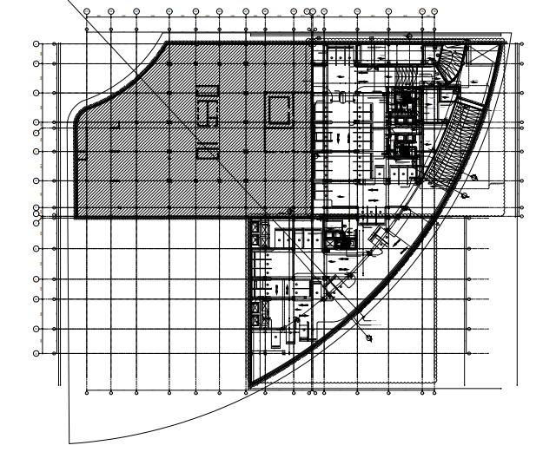
Figure 1.2: basement plan view.

Note: the left part It was not implemented in reality.
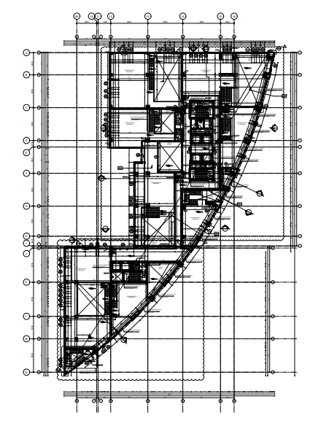
Figure 1.3: ground floor plan view.

Note : the ground floor , first floor , second floor , third floor and fourth floor have the same plan view.

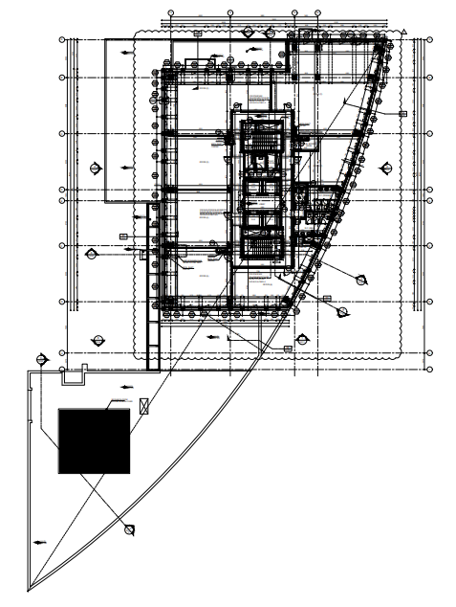
Figure 1.4: fifth floor plan view.

Note : the fifth floor up to the roof have the same plan view.

1.3.4 Floors Heights

The following table summarize the heights of each floor.

Table1.1: Heights of Table 1 floors table.
Floor | Height(m)
Basement 3 | 3.5
Basement 2 | 3.5
Basement 1 | 5.1
Ground floor | 4
F1 | 4
F2 | 4
F3 | 4.5
F4 | 4
F5 | 4
F6 | 4
F7 | 4
F8 | 4
F9 | 4
F10 | 4
F11 | 4
F12 | 4
F13 | 4
F14 | 4
F15 | 4
F16 | 4
F17 | 4
F18 | 4
F19 | 4
F20 | 4
F21 | 4

1.4. Design building codes:

• For materials → American Society for Testing and Materials (ASTM)
• For design → American Concrete Institute (ACI 318-19)

1.5. Materials:

1.5.1. Concrete:

It is basically a combination of sand, aggregate, water and cement. concrete has a broad range of strengths. Concrete has different stress-strain curves for different strength. However, figure below shows the typical stress-strain curve for concrete under compression. As shown in the figure, the relation between stress and strain in concrete start by being linear, where concrete can be considered to behave in elastic manner, but then it tends gradually to behave plastically.
Figure 1.5: concrete stress strain curve.
Concrete used has compressive strength $f_{c}^{/}=28 MPa \left(B 350\right)$for all elements in the structure.$Linear Modulus of Elastisity=E=4700\sqrt{f_{c}^{/}}=24870 MPa.$

Table 1.2: properties of concrete
Property | Value
Compressive strength, fc (MPa ) | 30
Modulus of elasticity, Ec ( GPa ) | 25.7
Unit weight (kN/m3 ) | 25

1.5.2. Steel:

Structural steel is good under tension as well as it has a good ductility. Steel’s stress-strain relation for hot rolled steel is shown in the figure below.
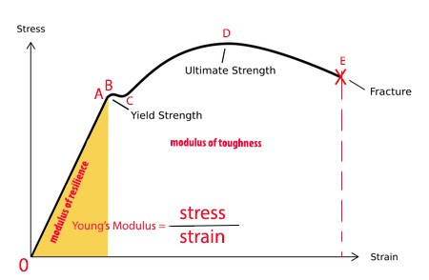
Figure 1.6: Steel Stress Strain curve.

However, a modified curve shown in figure is used for simplification. From the figure, steel has an elastic behavior until a certain point, then it turns to be a plastic material

Figure 1.7: Modified Stress Strain Curve for steel.

Steel is needed to resist the tensile stresses resulting from the loads and to resist shear force. In this project, we have used rebar steel (longitudinal bars) to resist bending effects, shrinkage steel in order to prevent cracks and stirrups to resist shear in beams. Moreover, stirrups in columns bind and hold longitudinal bars. The properties of steel reinforcement are shown in the table below.
Table 1.3:Properties of steel 1.5.3: U-boot beton:
Property | Value
Yielding strength, fy (MPa) | 420
Modulus of elasticity, Es (GPa) | 200
U-Boot® Beton is a recycled polypropylene formwork that was designed to create two-way voided slabs and rafts. The use of U-Boot® Beton formwork makes it possible to create mushroom pillars, with the possibility to have the mushroom in the thickness of the slab.

1.5.4: OTHER MATERIALS

There are non-structural materials that we use in the construction of buildings, such as masonry, sand, blocks, plaster, tiles …etc.

Table 1.4: Density of Materials
Material | Ɣ in kN/m³
Blocks | 12
Filling Materials | 18
Tiles | 26
Plaster | 23
Aggregate | 13
Concrete Mortar | 23
Masonry Stone | 30

1.6. Methods of analysis and design:

The Analysis and design of this project was done by using program of ETABS.
This software is a Structural analysis and design program, analyzes the structures by finite elements method (the element is divided into small parts to get more accurate results). On the other hand, manual calculation will be done to verify the ETABS results (check the validity of the software).
Structural elements were modeled either one-dimensional or two-dimensional elements, which depends on the type of the element to be modeled. For example, beams and columns are simple elements, so they are modeled as a frame (one-dimensional element), but slabs and walls are modeled as an area (two-dimensional element).

1.7. Load types and calculations:

There are different types of loads that can be applied on buildings:
• Gravitational loads such as: live, dead and super dead loads.
• Lateral loads such as: earthquakes and soil pressure.
In phase1 of our project, the structure will be analyzed for gravity and earthquake loads.

1.7.1 Dead loads:

Dead loads include self-weight of structural elements such as: beams, columns, floors and shear wall. These loads are automatically calculated by ETABS program.

1.7.2 Live loads:

Live loads represent the time varying loads and can be classified into: sustained and un sustained loads. It was take as 5 KN/m² for all the floors as it is suitable for this commercial center.

1.7.3 Superimposed dead loads:

Super dead load includes the weight of all nonstructural elements such as: tiles, filling material, plaster and partitions. The details of such loads are shown below.

1.7.3.1 Floor superimposed dead load:

Floors consist of different layers of materials including: tiles, plain concrete, reinforced concrete and gravel as shown in figure 1.8 below. (Dimensions in mm.)
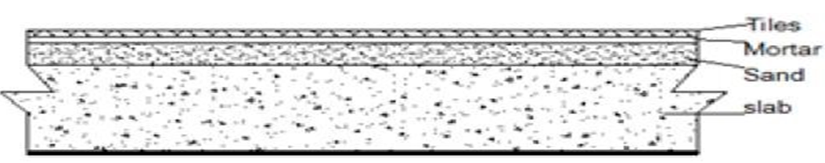
Figure 1.8: floor section.

Assume
Tiles thickness = 5 cm Ɣ = 26 kN/m³
Sand thickness = 10 cm Ɣ = 16 kN/m³
Mortar thickness = 3 cm Ɣ = 23 kN/m³
Based on figure 1.5: WSD = WTile + WMorter +WGravel = 0.05 × 26 + 0.02 × 23 + 0.1 × 16 = 3.36 kN/m2.
Take WSD = 5 kN/m2.

1.8. Analyses and Design Principles:

- All restrains are fixed ended
- The slabs are one- and two-way slabs

Chapter 2. Preliminary Dimensions:

2.1. Purposes of The Chapter:

In any project there are many structural elements that must be designed such as slabs, columns, beams and walls. Preliminary dimensions selection is the first and most important stage in the design process. In this stage a simple manual calculation, using the ACI specifications, will be conducted to get preliminary dimensions of the structural element6s. And then checks must be made on the dimensions such as deflection and shear checks.

2.2. Structural System:

In order to know how to deal with the structure, the most suitable structural system need to be selected for the building. There are several systems each is appropriate according to the structural elements such as;

- WALL-FRAME SYSTEM (DUAL SYSTEM)
The wall-frame or dual system consists of a wall and frame that interact horizontally for a stronger and stiffer system. In this system, the walls are usually solid and can be found around elevator shafts, stairwells and/or at the perimeter of the building. Furthermore, the walls may also give a positive effect on the performance of the frames such as the prevention of a soft-story collapse.
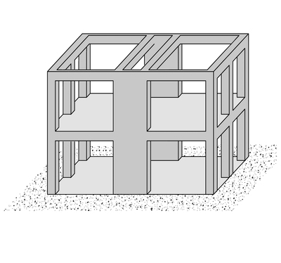
Figure 2.1: Dual System Structure
- SHEAR WALL SYSTEM.

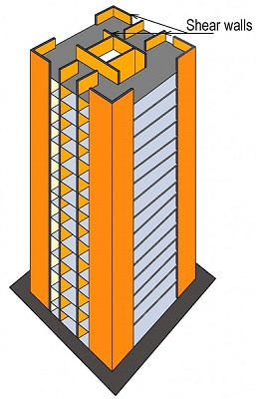
Figure 2.2: Shear Wall structure

Advantages of Reinforced Frame braced with Shear wall:
- The size of the column gets reduced considerable with the use of shear wall in frame.
- It is more resistant to earthquake.
- Speed of construction is fast.

- Frame system:
This system is characterized by that the slabs is based on beams and beams rest on the columns to resist the gravity and different lateral loads, in this system, vertical load transfer path is from slab then to beams, beams to columns and columns to load bearing footing where the footing discharges the loads on the soil suitable for foundation and construction. these structures are generally used to overcome the large forces, moments developing due to the applied loads.
This system is distinguished from the structural construction system in that it differs in how the columns connect with beams (joints) In slab, the frames are characterized by the interconnection of columns and beams (rigid fixed joints), and unification in how to respond to deformations, ensuring consistency the angles between columns and beams connected to them.
The framing structure is one of the strongest and most earthquake resistant systems, as the complete frame made of column, beam and panels works as one unit.

The frame system is used in several cases, including:
(1) In case of horizontal forces (lateral forces), and it is not possible to add shearing walls.
(2) If the spans are wide
(3) If the system contains wide openings in the walls, such as wide windows, Because the walls in this system do not have any structural function

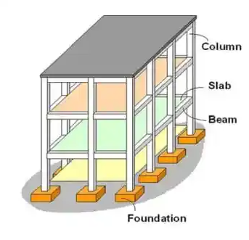
Figure 2.3: frame system.

2.3. Types of Slab Systems:

2.3.1.Flat Slab:

Flat slab is a reinforced concrete slab supported directly by concrete columns without the use of beams.

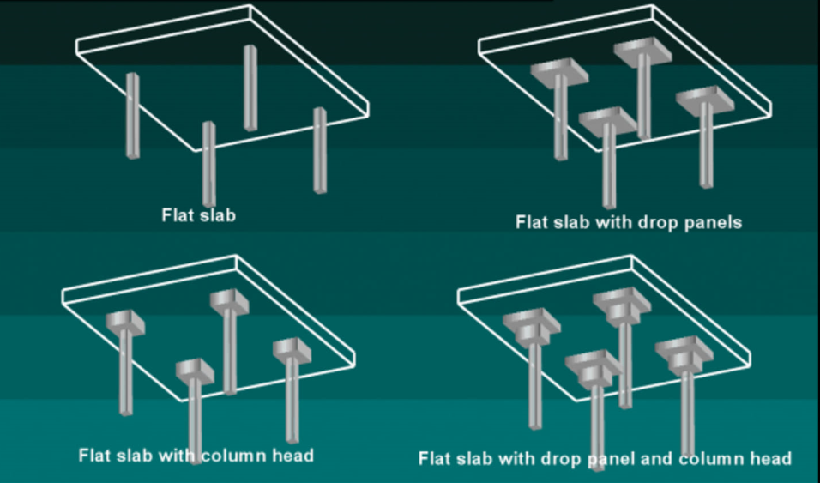
Figure 2.4: Flat Slab

Advantages of Flat Slab:

- Formwork is simple.
- Shear reinforcement is not required at the columns.
- Beams are not used (Therefore underfloor services outside the drops are simple).
- Room layout becomes flexible.
- Building height can be reduced as beams are not used.
- Construction period is less, Formwork being simple.

Disadvantages of Flat slab:
- In a flat plate system, it is not possible to have a large span.
- Not suitable for supporting brittle (masonry) partitions.
- Higher slab thickness.

2.3.2.Waffle Slab:

A waffle slab is a two-way joist slab system reinforced with concrete ribs constructed in the perpendicular direction of each other. These are laid in equal depth having a uniform rib appearance. It is called a waffle as it’s plain upright and holes underneath giving the appearance of waffles.

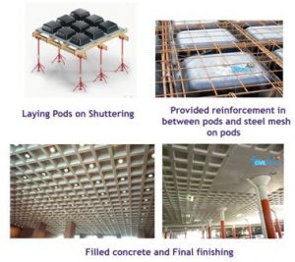
Figure 2.5: Waffle Slab
Advantages of Waffle slabs:
- Waffle slabs are able to carry heavier loads and span longer distances than flat slabs as these systems are light in weight.
- Suitable for spans of 7m – 16m; longer spans may be possible with post-tensioning.
- These systems are light in weight and hence considerable saving is ensured in the framework as the light framework is required
Disadvantages of Waffle slabs:
- Waffle slab is not used in typical construction projects.
- The Maintenance of waffle slabs is expensive and difficult.

- The Construction of the waffle slab required skilled workmanship.

2.3.3.Voided Slab:

A voided concrete slab is a system that removes the non-working or excess concrete from the structural slab and replaces it with void formers.
Cobiax system:
Cobiax is a special bi-axial voided slab system. The concept idea is to omit the non- working concrete from the slab (extra un-required load), the issue that reduces the self-weight (dead load) of the slab up to 35% provide high equivalent stiffness.
Advantages of cobiax slab:
- Engineering benefits (including reducing the amount of concrete and steel - reducing columns - distances between columns up to 20 meters.
- Reducing seismic forces by 20%.
- Save building materials and time.
- The building exhibits better safety behavior in the event of earthquakes.
- Ease and speed in designing and implementing electromechanical works.
- System does not require maintenance as is the case in some other systems.
- It increases the fire resistance of ceilings and reduces the transmission of sound and heat.

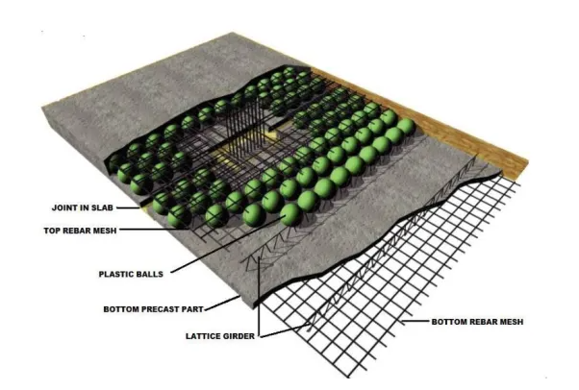
Figure 2.6: Cobiax System.

U-boot system:

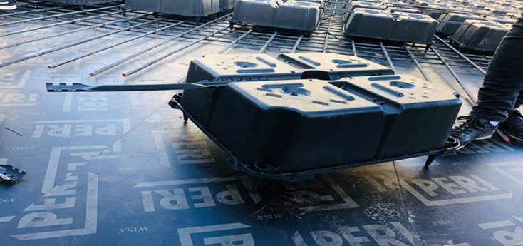
Figure 2.7: U-Boot System

The U Boot technology has got many benefits:
As this technology reduces the weight on the slab regarding its light weight which makes it an earthquake resistant as it reduces 30% of the slab’s weight, so it is suitable for high rise building, hospitals and parking management residential and industrial buildings.
- This is used to construct two-way slab, large span slab, mushroom slab and raft foundation in RCC structure.
- This system is also useful for sound and thermal insulation due to the air space inside it.
- Getting rid of dropped beams.
- Higher resistance to fire.
- The ease and fastness of implementation.
- Green building.
- It’s an environment friend system as it’s produced from recycled materials.
- It reduces the emission of CO2 resulting from the use of cement flat plate slab
- Simple formwork
- No beams

2.4. preliminary slabs thickness.

Critical spans were taken to determine the slab thickness for each system of slabs that will be used in the building, the longest span was found with length equal to 9.52m

2.4.1. Flat Slab

Thickness of slab =$\frac{9.52}{33}$= 0.288 m take thickness = 0.3 m

2.4.2. Solid Slab

Thickness =$\frac{9.52}{36}$= 0.264m take thickness = 0.25m

2.4.3. Voided Slab

Thickness =$\frac{9.52}{25}$ = 0.38m take thickness = 0.40m

2.4.4. Waffle Slab

Thickness = $\frac{9.52}{25}$= 0.38m take thickness = 0.40m

2.4.5. Ribbed slab

Solid slab thickness was figured out as 250 mm as preliminary thickness, in the sake of determining ribbed slab thickness, it’s a must to choose a section that has at least the same value of moment of inertia. To clarify, assumption has been made that blocks dimensions are as (400*200*170) mm, leading to a section with flange width of 550mm and web height equal to 170mm, in addition, web width was selected as 150mm which complies with ACI code recommendations, the only dimension to be calculated now is flange thickness in a way that satisfies the same value of MOI.
The calculated thickness of ribbed slab is as 320mm. however this is a preliminary dimension so it’s recommended to enlarge this value for excessive deformation considerations. The adopted thickness value will be as 350 mm.

Table 2.1: preliminary slabs thickness
Type of slab | Thickness
Flat slab | 0.3 m
Voided slab | 0.25 m
Waffle slab | 0.4 m
Sold slab | 0.4 m
Ribbed slab | 0.35 m

2.6. Three-dimensional Modeling of the structure:

2.6.1. Modeling using ETABS:

The structure is modelled using ETABS with dimension from the existing design documents, with following characteristics:
- Units used KN, m, C.
- Concrete compressive strength, $f_{c}^{/}=30 MPa.$
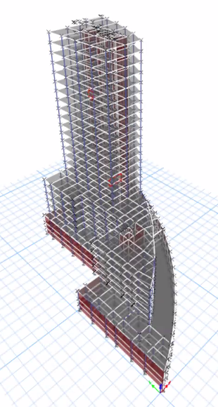
Figure 2.8: 3d view for structure.

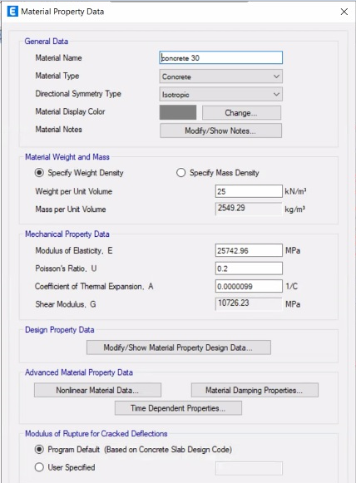
Figure 2.9: materials used in structure.

2.6.2. section proparties.

The section of beams used:
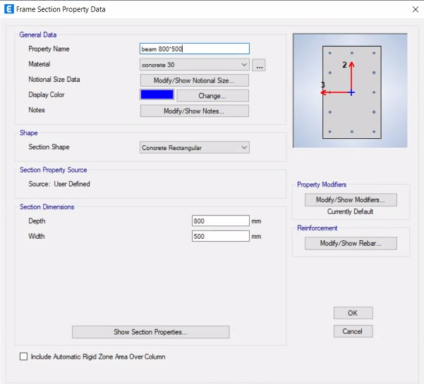
Figure 2.1: section of beams.
The section of columns used:
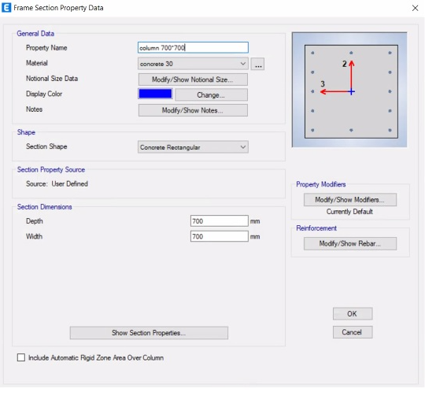
Figure 2.2: section of columns.

The section of shear wall used:
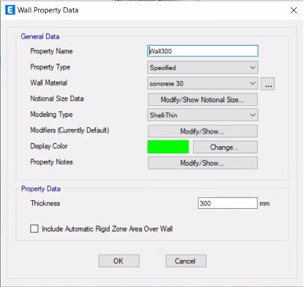
Figure 2.12: section of shear walls.
The section of retaining wall used:
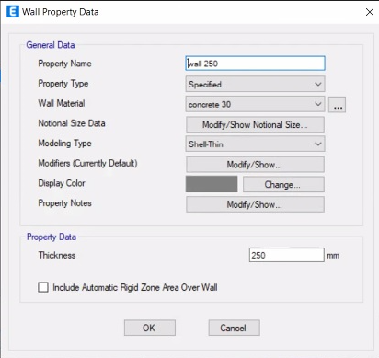
Figure 2.13: section of retaining walls.

2.7. Verification of Structural Analysis:

Different checks need to be done in order to achieve the best simulation of the building. The checks are done

2.7.1.Compatability Check :

When the model run, the whole structure moved as a single unit in each of the two blocks.
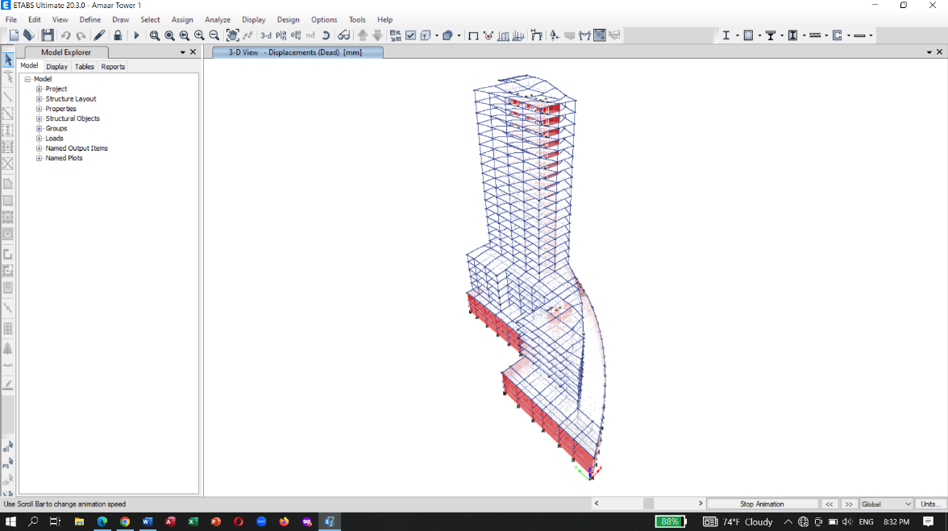
Figure 2.14: Compatibility Check
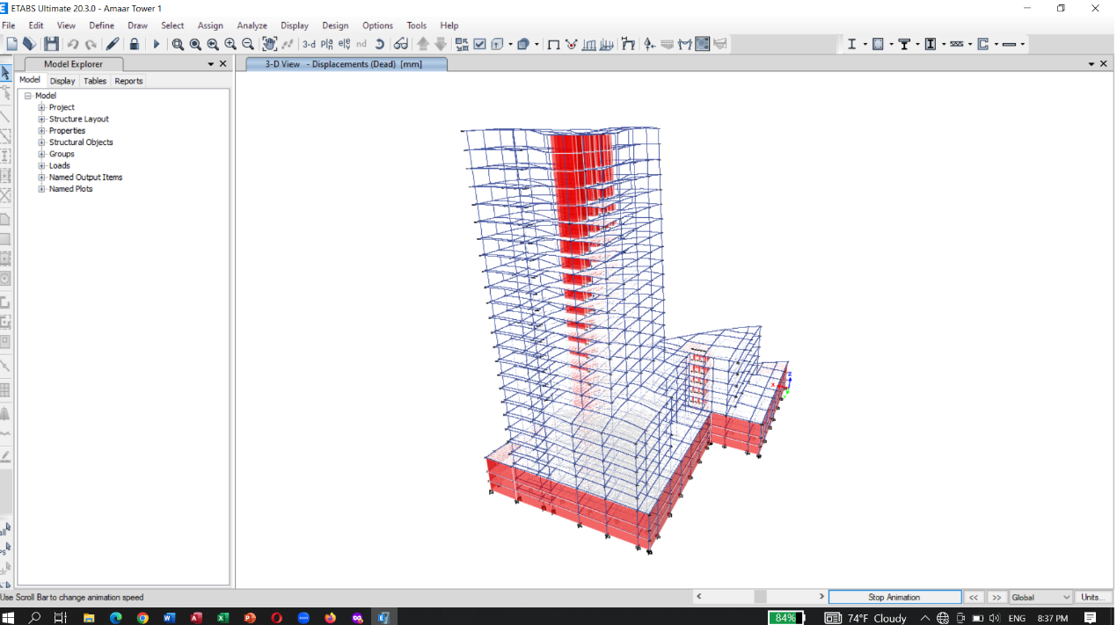
Figure 2.15: Compatibility Check

2.7.2. Equilibrium Check:

ETABS results:
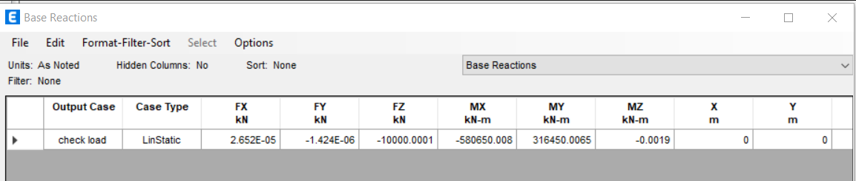
Figure 2.16: ETABS results

The purpose of this check is to make sure that the ETABS program is transferring the loads in the right path.
So it was done by assigning the following load pattern to the last story:
a check load pattern was defined and a point load was assigned on a joint in the last story with a value of 10000 kN, and the base reaction from ETABS, as the previous figure 18,

$$\% difference=\frac{ETABS-HAND}{HAND } *100\%$$
$=\frac{10000-10000}{10000} x 100\%=0\%$

2.7.3. Internal Force Check on slab :

We choose the interior span like the figure show:
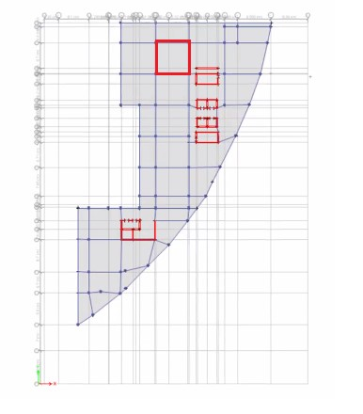
Figure 2.17: interior span used
- Left moment negative on slab:
M_{1(left)} = 131.077 kN.m

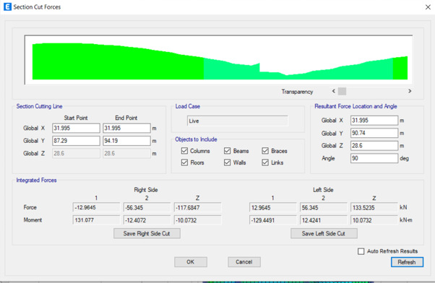
Figure 2.18: Moment left on Slab
- right moment negatives on slab:
M_{2(right)} = 153.91 kN.m

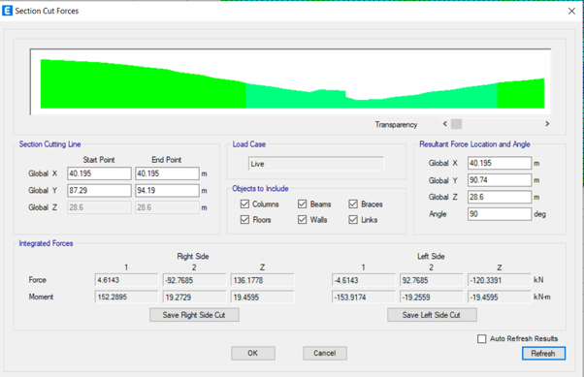
Figure 2.19: Moment right on Slab

- moment positive on slab:
M_{3(positive)} = 122.179 kN.m

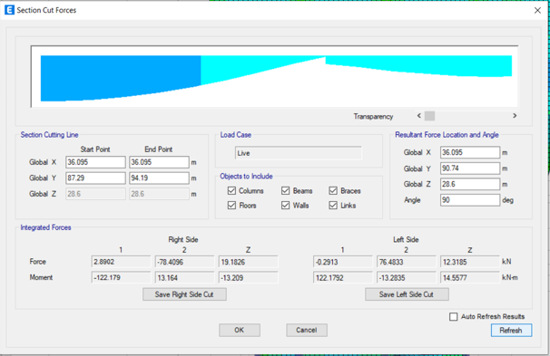
Figure 2.20: Moment positive on Slab
From ETAPS:
M _{(Avg)} = $\frac{M_{1}+ M_{2}}{2}+M_{3}$
M _{(Avg)} = $\frac{153.91+131.077}{2}+122.179$ = 269.67 kN.m
Manual calculation:
M _{(live load)} = 5 kN/m2
Mu = $\frac{(6.9*5)*{(8.9-0.7)}^{2}}{8}$ = 289.97 kN.m
%Error = $\frac{289.97-269.67}{289.97}*100\%$ = 8.72 % < 10 % …. OK

2.7.4. Internal Force Check on beam :

We choose the beam like the figure show:
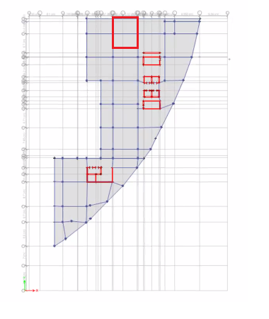
Figure 2.21: beam used
- Left moment negative on beam:
M_{1(left)} = 94.55 kN.m
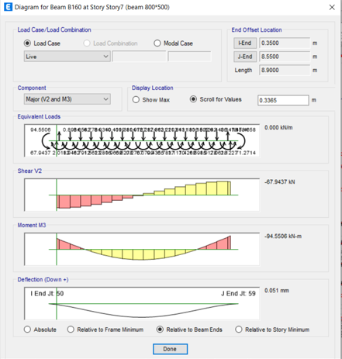
Figure 2.22: Moment left negative on beam
- right moment negatives on beam:
M_{2(right)} = 115.46 kN.m
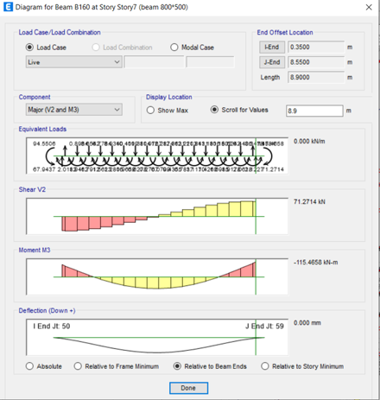
Figure 2.23: Moment right negative on beam
- moment positive on beam:
M_{3(positive)} = 87.8 kN.m
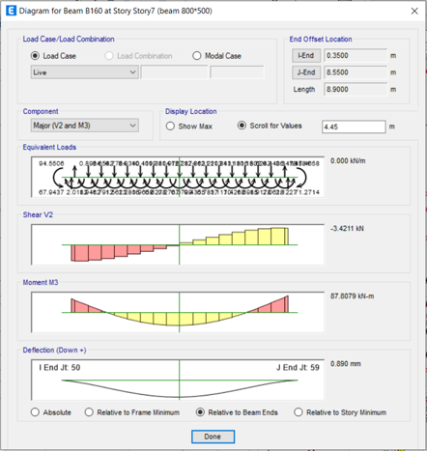
Figure 2.24: Moment right negative on beam
- The moment from ETABS is equal to:

M _{(Avg)} = $\frac{M_{1}+ M_{2}}{2}+M_{3}$
M _{(Avg)} = $\frac{94.55+115.46}{2}+87.8$ = 192.8 kN.m
- The moment by hand is equal to:

- Column strip moments:

α𝑓 =$\frac{I-interior beam}{I-slab}=\frac{4.87*{10}^{10}}{1.55*{10}^{10}}$ = 3.14.
$\frac{L2}{L1}$ = $\frac{6.9}{8.9}$ = 0.77.
B = 0.51 < 2.5

From ACI tables:
The portion of the interior negative moment in the column strip is 0.825.
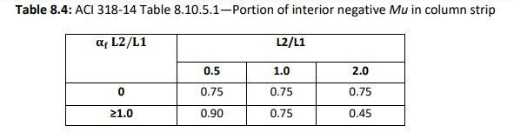
Figure 2.25: Portion of Interior Negative Mu in Column Strip.
The portion of the exterior negative moment in the column strip is 0.875.
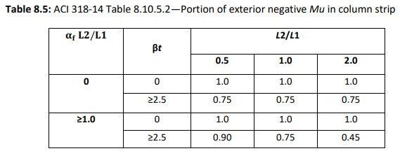
Figure 2.26: Portion of Exterior Negative Mu in Column Strip.
The portion of the positive moment in the column strip is 0.825.
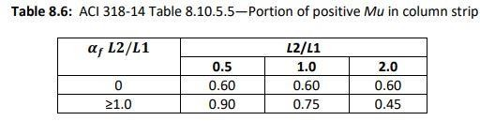
Figure 2.27: Portion of Positive Mu in Column Strip.
M- interior =0.825*188.98 = 155.5 KN.m
M- exterior = 0.875*188.98 = 169.92 KN.m.
M+ = 0.825*101.98 = 83.72 KN.m

- Beam Moments:

α𝑓 * L2 /L1 = 3.14*0.77 = 2.42 1 > 1

It will be equal to 0.85 of column strip moments.

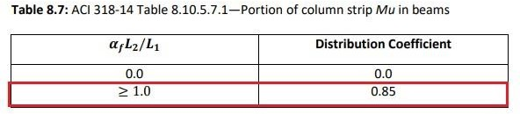
Figure 2.28: Portion of Column Strip Moment in Beams.
M- interior =0.85*155.5= 132.2 KN.m
M- exterior = 0.85*169.92 = 140.2 KN.m.
M+ = 0.85*83.72= 71.2 KN.m
M _{(Avg)} = $\frac{132.2+140.2}{2}+71.2$ = 207.33 KN.m
M _{(ETAB)} = 192.8 KN.m
%Error = $\frac{207.33-192.8}{207.33}*100\%$ = 7.01 % < 10 % …. OK

2.7.5. Internal force check for Columns :

The following column will be the selected column for this check:
Column L 25 in story 25
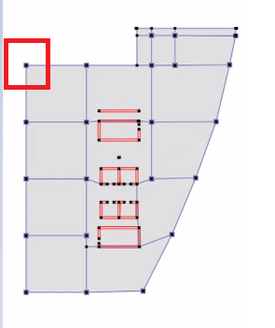
Figure 2.29: Column L25 Tributary area.

- Axial force on column:
P_{(ETABS)} = 348.8 kN.
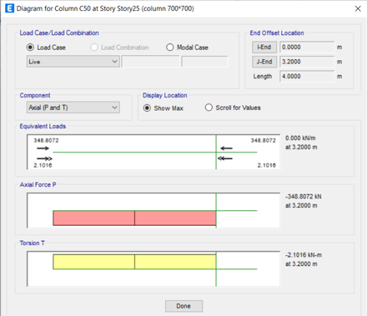
Figure 2.30: Axial force on column.
- Hand calculation:
Tributary Area = $\left(\frac{8.9}{2}\right)*\left(\frac{8.35}{2}\right)$ = 18.57 $M^{2}$.
P_{(Hands)} = 18.57 * 20 = 371.57 kN.
P_{(ETABS)} = 348.8 kN.
%Error = $\frac{371.57-348.8}{371.57}*100\%$ = 6.12 % < 10 % …. OK

Chapter 3: seismic analysis.

3.1 Definition of Earthquake Engineering.

Earthquake engineering is an interdisciplinary branch of engineering that designs and analyzes structures, such as buildings and bridges, with earthquakes in mind. Its overall goal is to make such structures more resistant to earthquakes. An earthquake (or seismic) engineer aims to construct structures that will not be damaged in minor shaking and will avoid serious damages or collapse in a major earthquake. Earthquake engineering is the scientific field concerned with protecting society, the natural environment, and the man-made environment from earthquakes by limiting the seismic risk to socio-economically acceptable levels.

Effects of Earthquake on Concrete Structures.

- Inertia Forces in Structures.
The generation of inertia forces in a structure is one of the seismic influences that detrimentally affect the structure. When an earthquake causes ground shaking, the base of the building would move but the roof would be at rest. However, since the walls and columns are attached to it, the roof is dragged with the base of the building.
The tendency of the roof structure to remain at its original position is called inertia. The inertia forces can cause shearing of the structure which can concentrate stresses on the weak walls or joints in the structure resulting in failure or perhaps total collapse. Finally, more mass means higher inertia force that is why lighter buildings sustain the earthquake shaking better.

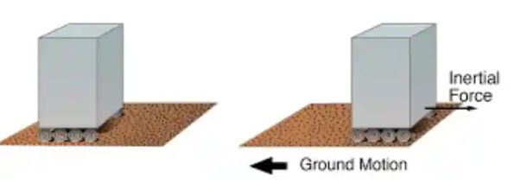
Figure 3.1: direction of inertia forces.

- Deformations in Structures
When a building experiences earthquake and ground shaking occurs, the base of the building moves with the ground shaking. However, the roof movement would be different from that of the base of the structure. This difference in the movement creates internal forces in the columns which tend to return the column to its original position.

These internal forces are termed stiffness forces. The stiffness forces would be higher as the size of the columns gets higher. The stiffness force in a column is the column stiffness times the relative displacement between its ends.

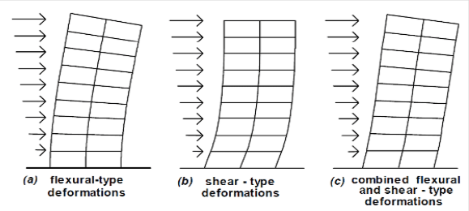
Figure 3.2: deformation on structure.

- Horizontal and Vertical Shaking
Earthquake causes shaking of the ground in all the three directions X, Y and Z, and the ground shakes randomly back and forth along each of these axis directions. Commonly, structures are designed to withstand vertical loads, so the vertical shaking due to earthquakes (either adds or subtracts vertical loads) is tackled through safety factors used in the design to support vertical loads.
However, horizontal shaking along X and Y directions is critical for the performance of the structure since it generates inertia forces and lateral displacement and hence a adequate load transfer path shall be provided to prevent its detrimental influences on the structure.
Proper inertia force transfer path can be created through adequate design of floor slab, walls or columns, and connections between these structural elements. It is worth mentioning that the walls and columns are critical structural members in transferring the inertial forces. It is demonstrated that, masonry walls and thin reinforce concrete columns would create weak points in the inertia force transfer path

3.3: methods of analysis

There are four main methods of the analysis of earthquakes forces:
- Equivalent static method.
- Response spectrum method.
- Time history method.
- Pushover analysis method.
In this project the Equivalent static and the Response spectrum will be used to analyze the effect of the earthquakes on the Tower.

3.4: Equivalent static.

Method is based on first mode response, has been calibrated to provide a reasonable estimate of the envelope of story shear, NOT to provide accurate estimates of story force.
Many factors are being considered in this method to calculate the forces, such as :
- Spectral response acceleration.
- Site soil factors.
- Building Period.
- Response modification factors.
- Importance factor.
Determination of the factors considering that the design is based on the 2% probability of exceedance.
- The Factors S1 and Ss

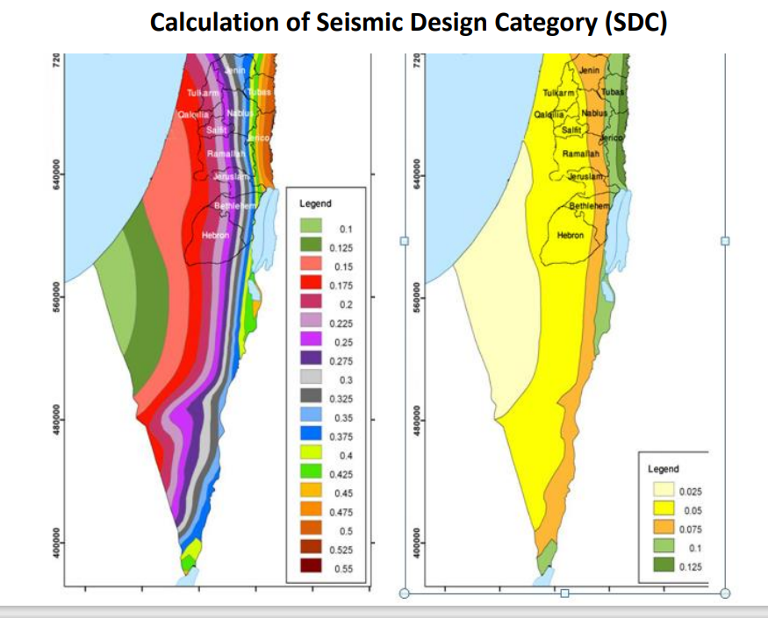
Figure 3.3: acceleration parameters map.

From the figure, for Ramallah city, S1= 0.275 and Ss= 0.075
- Importance factor

In order to determine the importance factor, the occupancy category must be determined first, and from the figure

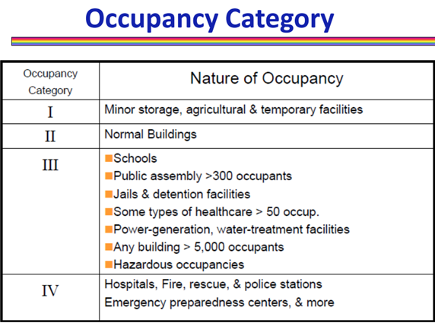
Figure 3.4: occupancy category table.

Ammar Tower is classified in category 3, and according to this category and from the importance factor table, I= 1.25
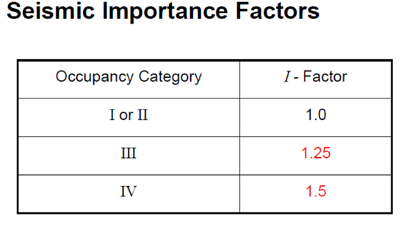
Figure 3.5: seismic importance factors table.
- Site class

Ammar tower was built on rock, that is classified as B site class

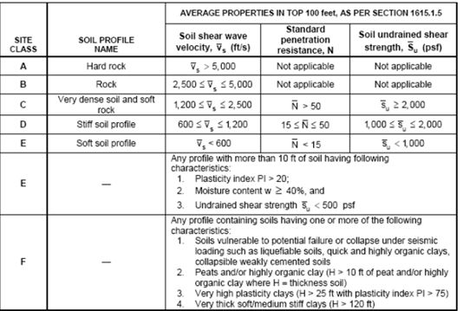
Figure 3.6: soil classification table.

- Response Modification factor

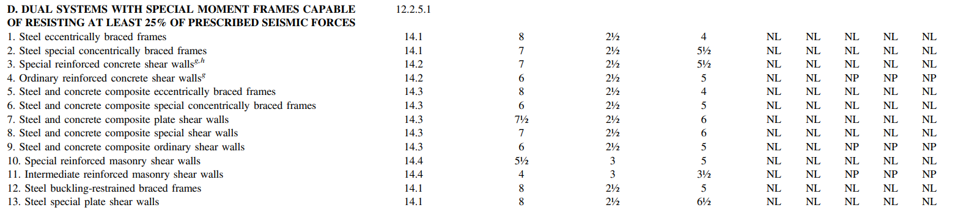
Figure 3.7: Design Coefficients and Factors for Seismic Force-Resisting System
.
The ASCE Code requires a R value of 7 as Response value for the dual system with special Frames and shear walls, but for more strength, R used to calculate the seismic forces is equal to 5.

All the factors were entered to the ETABS To calculate the forces.

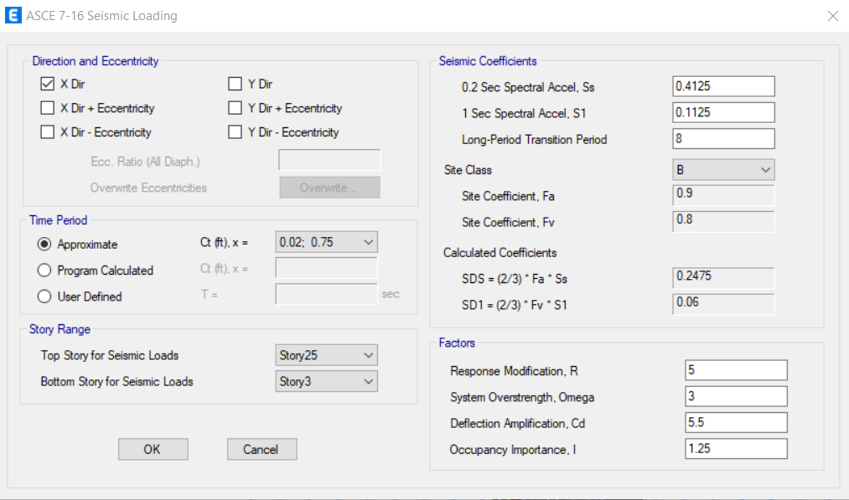
Figure 3.8: ASCE 7-16 seismic loading.

It should be noted that the S1 and Ss factors were multiplied by 1.5, and the load patterns were defined in both directions including eccentricities.

3.5 Response Spectrum method

This method depends on the natural period of the structure and the dynamic properties of the ground motion (displacement, velocity and acceleration).
The response spectrum that has been used in this project is the ASCE7-16 Spectrum

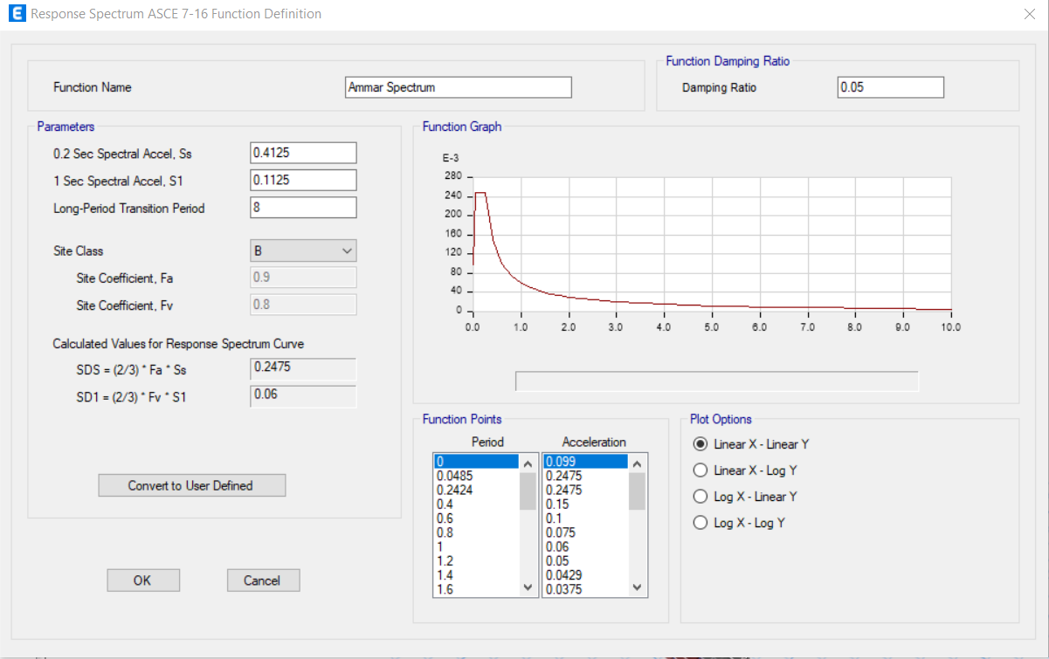
Figure 3.9: ASCE 7-16 function definition.

3.6 Analysis results.

3.6.1 forces distribution.

From the static equivalent the story forces were red as in the following table:

Table 3.1: static equivalent forces result.
V (KN) | Story
767.7182 | Story 25
1422.357 | Story 24
2032.444 | Story 23
2596.195 | Story 22
3120.229 | Story 21
3602.773 | Story 20
4044.912 | Story 19
4447.767 | Story 18
4812.498 | Story 17
5140.31 | Story 16
5432.458 | Story 15
5690.252 | Story 14
5915.065 | Story 13
6108.344 | Story 12
6271.618 | Story 11
6406.521 | Story 10
6514.804 | Story 9
6692.745 | Story 8
6827.951 | Story 7
6913.062 | Story 6
6959.858 | Story 5
6976.957 | Story 4
6976.957 | Story 3
6979.385 | Story 2
6976.435 | Story 1

While the forces from the response spectrum was red as in the following table:

Table 3.2: response spectrum forces result.
Force from Response X(KN) | Story
1309.4909 | Story 25
2040.4849 | Story 24
2325.9373 | Story 23
2254.6798 | Story 22
1995.7456 | Story 21
1799.6382 | Story 20
1864.0019 | Story 19
2129.907 | Story 18
2408.2908 | Story 17
2590.8769 | Story 16
2672.8416 | Story 15
2709.2003 | Story 14
2758.6831 | Story 13
2836.2656 | Story 12
2908.3585 | Story 11
2930.3995 | Story 10
2887.2278 | Story 9
2963.3312 | Story 8
3539.9181 | Story 7
4398.1353 | Story 6
5256.9583 | Story 5
5899.4813 | Story 4
6507.9784 | Story 3
6834.9871 | Story 2
6976.8105 | Story 1

From the two tables, it can be noticed that the distribution of the base shear in the equivalent static is more logical than the response spectrum forces distribution, so the equivalent static results will be used in the analysis checks.

The distribution of the base shear on each individual story is shown in the following tables:

In x direction:
.
Table 3.3: base shear distribution om the stories in x direction.
Vx(KN) | Story
767.7182 | Story 25
654.6383 | Story 24
610.0871 | Story 23
563.7514 | Story 22
524.034 | Story 21
482.5443 | Story 20
442.1389 | Story 19
402.8546 | Story 18
364.7308 | Story 17
327.8122 | Story 16
292.1481 | Story 15
257.7939 | Story 14
224.8132 | Story 13
193.2786 | Story 12
163.2747 | Story 11
134.9024 | Story 10
108.2837 | Story 9
177.9402 | Story 8
135.2059 | Story 7
85.1114 | Story 6
46.7965 | Story 5
17.0983 | Story 4
0 | Story 3
0 | Story 2
0 | Story 1

In y direction:

Table 3.4: base shear distribution om the stories in y direction.
Vy(KN) | Story
767.7182 | Story 25
654.6383 | Story 24
610.0871 | Story 23
563.7514 | Story 22
524.034 | Story 21
482.5443 | Story 20
442.1389 | Story 19
402.8546 | Story 18
364.7308 | Story 17
327.8122 | Story 16
292.1481 | Story 15
257.7939 | Story 14
224.8132 | Story 13
193.2786 | Story 12
163.2747 | Story 11
134.9024 | Story 10
108.2837 | Story 9
177.9402 | Story 8
135.2059 | Story 7
85.1114 | Story 6
46.7965 | Story 5
17.0983 | Story 4
0 | Story 3
0 | Story 2
0 | Story 1

Note: story 1, 2 and 3 are basement stories, so the distribution will start from story 4 which’s considered the ground floor.

3.6.2 irregularity check

This check is performed to determine the effect of the change of the distribution of the load transfer structural elements (columns and walls).
And is being done according to the ASCE7-16 code in the horizontal and the vertical directions.

Horizontal irregularity:

Usually, the modal mass participation ratio results give an indication about the irregularity, according to the ASCE7-16 code, the sum of the rations in each direction should exceed 0.9

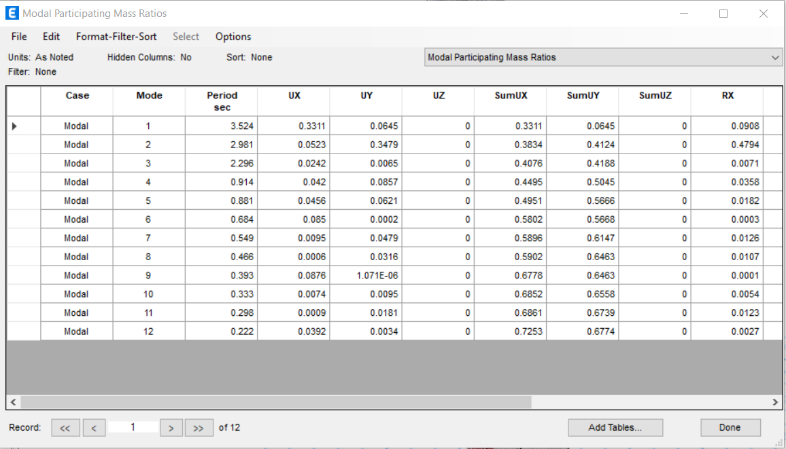
Figure 3.10: modal participation mass ratio.

From the figure above, the Sum of UX= 0.72 and The Sum of UY= 0.67, that gives an indication that the structure is horizontally irregular.

And the results are confirmed with the results of the torsional irregularity check.

In x direction:

Table 3.5: torsional irregularity in x direction.
Torsional irregularity X
Story Number | Max Drift | AVG Drift | Ratio | Check
Story 25 | 4.83 | 4.824 | 1.00 | regular
Story24 | 4.963 | 4.905 | 1.01 | regular
Story23 | 5.118 | 5 | 1.02 | regular
Story 22 | 5.287 | 5.104 | 1.04 | regular
Story 21 | 5.455 | 5.208 | 1.05 | regular
Story 20 | 5.619 | 5.305 | 1.06 | regular
Story 19 | 5.767 | 5.386 | 1.07 | regular
Story 18 | 5.893 | 5.447 | 1.08 | regular
Story 17 | 5.991 | 5.482 | 1.09 | regular
Story 16 | 6.056 | 5.485 | 1.10 | regular
Story 15 | 6.085 | 5.453 | 1.12 | regular
Story 14 | 6.074 | 5.38 | 1.13 | regular
Story 13 | 6.019 | 5.263 | 1.14 | regular
Story 12 | 5.919 | 5.096 | 1.16 | regular
Story 11 | 5.771 | 4.875 | 1.18 | regular
Story 10 | 5.574 | 4.595 | 1.21 | irregular
Story 9 | 5.339 | 4.236 | 1.26 | irregular
Story 8 | 5.187 | 2.197 | 2.36 | irregular
Story 7 | 5.206 | 2.187 | 2.38 | irregular
Story 6 | 3.899 | 1.647 | 2.37 | irregular
Story 5 | 3.132 | 1.338 | 2.34 | irregular
Story 4 | 2.136 | 0.953 | 2.24 | irregular
Story 3 | 0.501 | 0.347 | 1.44 | irregular
Story 2 | 0.219 | 0.145 | 1.51 | irregular
Story 1 | 0.124 | 0.078 | 1.59 | irregular

In y direction:

Table 3.6: torsional irregularity in y direction.
Torsional irregularity Y
Story Number | Max Drift | AVG Drift | Ratio | Check
Story 25 | 2.513 | 2.399 | 1.05 | regular
Story24 | 2.658 | 2.53 | 1.05 | regular
Story23 | 2.83 | 2.684 | 1.05 | regular
Story 22 | 3.016 | 2.847 | 1.06 | regular
Story 21 | 3.203 | 3.009 | 1.06 | regular
Story 20 | 3.381 | 3.162 | 1.07 | regular
Story 19 | 3.545 | 3.302 | 1.07 | regular
Story 18 | 3.688 | 3.423 | 1.08 | regular
Story 17 | 3.806 | 3.524 | 1.08 | regular
Story 16 | 3.895 | 3.601 | 1.08 | regular
Story 15 | 3.949 | 3.65 | 1.08 | regular
Story 14 | 3.964 | 3.668 | 1.08 | regular
Story 13 | 3.93 | 3.649 | 1.08 | regular
Story 12 | 3.837 | 3.587 | 1.07 | regular
Story 11 | 3.664 | 3.467 | 1.06 | regular
Story 10 | 3.381 | 3.267 | 1.03 | regular
Story 9 | 2.938 | 2.91 | 1.01 | regular
Story 8 | 2.641 | 2.068 | 1.28 | irregular
Story 7 | 2.693 | 2.112 | 1.28 | irregular
Story 6 | 2.096 | 1.641 | 1.28 | irregular
Story 5 | 1.755 | 1.374 | 1.28 | irregular
Story 4 | 1.221 | 0.963 | 1.27 | irregular
Story 3 | 0.203 | 0.142 | 1.43 | irregular
Story 2 | 0.068 | 0.053 | 1.28 | irregular
Story 1 | 0.051 | 0.039 | 1.31 | irregular

According to the ASCE7-16, and some ratios are greater than 1.4 , the structure is extreme irregular.
To deal with this irregularity, the eccentricity must be calculated.

a
the Center of mass and rigidity
Story | Diaphragms | Mass X | Mass y | C.M |  | Cumulative x | Cumulative Y | XCCM | YCCm | C.R
 |  |  |  | x_{m} | y_{m} |  |  |  |  | XCR | YCR
Story25 | Diaphragm2 | 2042488.85 | 2042488.85 | 45.2803 | 77.8734 | 2042488.85 | 2042488.85 | 45.28 | 77.87 | 46.10 | 75.48
Story24 | Diaphragm2 | 1862736.16 | 1862736.16 | 45.333 | 77.7295 | 3905225.01 | 3905225.01 | 45.31 | 77.80 | 46.05 | 75.33
Story23 | Diaphragm2 | 1862736.16 | 1862736.16 | 45.333 | 77.7295 | 5767961.17 | 5767961.17 | 45.31 | 77.78 | 46.01 | 75.18
Story22 | Diaphragm2 | 1853604.6 | 1853604.6 | 45.2702 | 77.635 | 7621565.77 | 7621565.77 | 45.30 | 77.75 | 45.97 | 75.01
Story21 | Diaphragm2 | 1862812.64 | 1862812.64 | 45.3337 | 77.7303 | 9484378.41 | 9484378.41 | 45.31 | 77.74 | 45.93 | 74.84
Story20 | Diaphragm2 | 1862812.64 | 1862812.64 | 45.3337 | 77.7303 | 11347191.05 | 11347191.05 | 45.31 | 77.74 | 45.88 | 74.65
Story19 | Diaphragm2 | 1862812.64 | 1862812.64 | 45.3337 | 77.7303 | 13210003.69 | 13210003.69 | 45.32 | 77.74 | 45.82 | 74.45
Story18 | Diaphragm2 | 1862812.64 | 1862812.64 | 45.3337 | 77.7303 | 15072816.34 | 15072816.34 | 45.32 | 77.74 | 45.75 | 74.22
Story17 | Diaphragm2 | 1862812.64 | 1862812.64 | 45.3337 | 77.7303 | 16935628.98 | 16935628.98 | 45.32 | 77.74 | 45.65 | 73.96
Story16 | Diaphragm2 | 1862812.64 | 1862812.64 | 45.3337 | 77.7303 | 18798441.62 | 18798441.62 | 45.32 | 77.74 | 45.51 | 73.66
Story15 | Diaphragm2 | 1862812.64 | 1862812.64 | 45.3337 | 77.7303 | 20661254.26 | 20661254.26 | 45.32 | 77.74 | 45.34 | 73.30
Story14 | Diaphragm2 | 1862812.64 | 1862812.64 | 45.3337 | 77.7303 | 22524066.9 | 22524066.9 | 45.32 | 77.74 | 45.09 | 72.85
Story13 | Diaphragm2 | 1862812.64 | 1862812.64 | 45.3337 | 77.7303 | 24386879.54 | 24386879.54 | 45.32 | 77.73 | 44.75 | 72.26
Story12 | Diaphragm2 | 1862812.64 | 1862812.64 | 45.3337 | 77.7303 | 26249692.18 | 26249692.18 | 45.32 | 77.73 | 44.26 | 71.48
Story11 | Diaphragm2 | 1862812.64 | 1862812.64 | 45.3337 | 77.7303 | 28112504.82 | 28112504.82 | 45.33 | 77.73 | 43.53 | 70.35
Story10 | Diaphragm2 | 1862812.64 | 1862812.64 | 45.3337 | 77.7303 | 29975317.46 | 29975317.46 | 45.33 | 77.73 | 42.38 | 68.66
Story9 | Diaphragm2 | 1862812.64 | 1862812.64 | 45.3337 | 77.7303 | 31838130.1 | 31838130.1 | 45.33 | 77.73 | 40.59 | 66.04
Story8 | Diaphragm2 | 3966595.7 | 3966595.7 | 35.6258 | 64.8273 | 35804725.8 | 35804725.8 | 44.25 | 76.30 | 38.49 | 62.99
Story7 | Diaphragm2 | 4131906.92 | 4131906.92 | 35.3321 | 64.239 | 39936632.72 | 39936632.72 | 43.33 | 75.06 | 38.13 | 62.88
Story6 | Diaphragm2 | 4131906.92 | 4131906.92 | 35.3321 | 64.239 | 44068539.63 | 44068539.63 | 42.58 | 74.04 | 37.80 | 62.90
Story5 | Diaphragm2 | 4095492.81 | 4095492.81 | 35.3187 | 64.2501 | 48164032.44 | 48164032.44 | 41.96 | 73.21 | 37.50 | 63.00
Story4 | Diaphragm2 | 4097790.34 | 4097790.34 | 35.3066 | 64.2301 | 52261822.78 | 52261822.78 | 41.44 | 72.50 | 37.12 | 62.85
Story3 | Diaphragm2 | 7137329.14 | 7137329.14 | 31.8843 | 55.747 | 59399151.92 | 59399151.92 | 40.29 | 70.49 | 35.51 | 59.16
Story2 | Diaphragm2 | 7264433.61 | 7264433.61 | 31.7232 | 55.8356 | 66663585.53 | 66663585.53 | 39.36 | 68.89 | 35.37 | 60.09
Story1 | Diaphragm2 | 7178821.08 | 7178821.08 | 32.198 | 55.8127 | 73842406.61 | 73842406.61 | 38.66 | 67.62 | 35.48 | 60.51

Table 3.8: the eccentricity.

the Eccentricity
Eccentricity |  | Dimension |  | ex/Dx result |  | ey/Dy result
e_{x} | e_{y} | Dx | Dy | % |  | %
0.82 | 2.40 | 31 | 39 | 2.6 | Ok | 6.1 | Ok
0.72 | 2.39 | 31 | 39 | 2.3 | Ok | 6.1 | Ok
0.67 | 2.55 | 31 | 39 | 2.2 | Ok | 6.5 | Ok
0.70 | 2.62 | 31 | 39 | 2.3 | Ok | 6.7 | Ok
0.60 | 2.89 | 31 | 39 | 1.9 | Ok | 7.4 | Ok
0.55 | 3.08 | 31 | 39 | 1.8 | Ok | 7.9 | Ok
0.49 | 3.28 | 31 | 39 | 1.6 | Ok | 8.4 | Ok
0.41 | 3.51 | 31 | 39 | 1.3 | Ok | 9.0 | Ok
0.31 | 3.77 | 31 | 39 | 1.0 | Ok | 9.7 | Ok
0.18 | 4.07 | 31 | 39 | 0.6 | Ok | 10.4 | Ok
0.00 | 4.43 | 31 | 39 | 0.0 | Ok | 11.4 | Ok
0.24 | 4.88 | 31 | 39 | 0.8 | Ok | 12.5 | Ok
0.58 | 5.47 | 31 | 39 | 1.9 | Ok | 14.0 | Ok
1.07 | 6.25 | 31 | 39 | 3.5 | Ok | 16.0 | Not Ok
1.81 | 7.38 | 31 | 39 | 5.8 | Ok | 18.9 | Not Ok
2.95 | 9.07 | 31 | 39 | 9.5 | Ok | 23.2 | Not Ok
4.74 | 11.69 | 31 | 39 | 15.3 | Not ok | 30.0 | Not Ok
2.86 | 1.84 | 52 | 81.1 | 5.5 | Ok | 2.3 | Ok
2.80 | 1.36 | 52 | 81.1 | 5.4 | Ok | 1.7 | Ok
2.46 | 1.34 | 52 | 81.1 | 4.7 | Ok | 1.7 | Ok
2.18 | 1.25 | 52 | 81.1 | 4.2 | Ok | 1.5 | Ok
1.81 | 1.38 | 52 | 81.1 | 3.5 | Ok | 1.7 | Ok
3.62 | 3.41 | 70.5 | 96.915 | 5.1 | Ok | 3.5 | Ok
3.65 | 4.26 | 70.5 | 96.915 | 5.2 | Ok | 4.4 | Ok
3.28 | 4.70 | 70.5 | 96.915 | 4.7 | Ok | 4.8 | Ok

From this table , it can be noticed that the stories 9,10,11 and 12 ratios of the eccentricities Exceed the 0.15 , but the results of the ETABS in these calculations are differ from the reality , because the distribution of the columns and shear walls in each group of stories is the same , so the center of rigidity must have the same two coordinates X and Y, and from the tables, the coordinates are changing from story to other even in the same group , so a 0.1 eccentricity is taken as an average eccentricity for all the stories.

Drift check:
From the code as in the following figure, the allowable story drifts is determined.
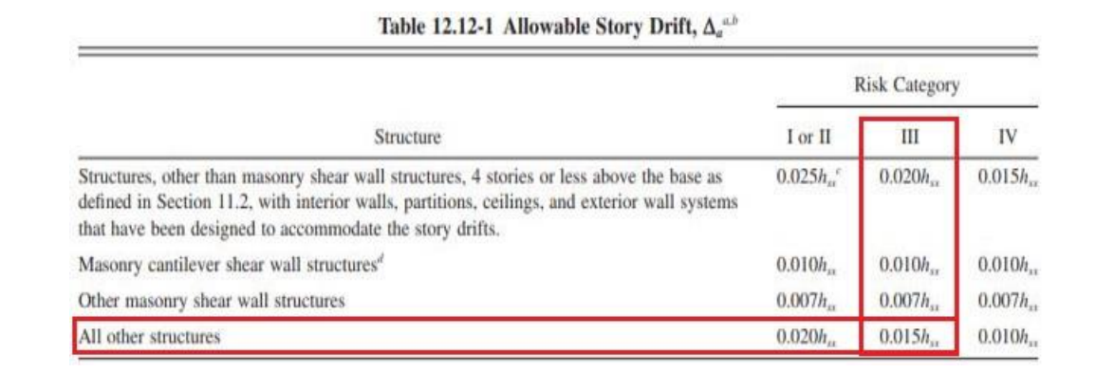
Figure 3.11: allowable story drift.

In X direction:

Table 3.9: story drift in x direction.
Story Drift X
Story | Height(m) | Δ Elastic(mm) | Δ Inelastic(mm) | Δ Service(mm) | Δ Allowable(mm) | Check
25 | 100.6 | 126.816 | 557.9904 | 390.59328 | 1509 | OK
24 | 96.6 | 121.626 | 535.1544 | 374.60808 | 1449 | OK
23 | 92.6 | 116.267 | 511.5748 | 358.10236 | 1389 | OK
22 | 88.6 | 110.711 | 487.1284 | 340.98988 | 1329 | OK
21 | 84.6 | 104.939 | 461.7316 | 323.21212 | 1269 | OK
20 | 80.6 | 98.951 | 435.3844 | 304.76908 | 1209 | OK
19 | 76.6 | 92.753 | 408.1132 | 285.67924 | 1149 | OK
18 | 72.6 | 86.363 | 379.9972 | 265.99804 | 1089 | OK
17 | 68.6 | 79.807 | 351.1508 | 245.80556 | 1029 | OK
16 | 64.6 | 73.119 | 321.7236 | 225.20652 | 969 | OK
15 | 60.6 | 66.339 | 291.8916 | 204.32412 | 909 | OK
14 | 56.6 | 59.511 | 261.8484 | 183.29388 | 849 | OK
13 | 52.6 | 52.685 | 231.814 | 162.2698 | 789 | OK
12 | 48.6 | 45.919 | 202.0436 | 141.43052 | 729 | OK
11 | 44.6 | 39.275 | 172.81 | 120.967 | 669 | OK
10 | 40.6 | 32.823 | 144.4212 | 101.09484 | 609 | OK
9 | 36.6 | 26.645 | 117.238 | 82.0666 | 549 | OK
8 | 32.6 | 21.166 | 93.1304 | 65.19128 | 489 | OK
7 | 28.6 | 15.782 | 69.4408 | 48.60856 | 429 | OK
6 | 24.1 | 10.364 | 45.6016 | 31.92112 | 361.5 | OK
5 | 20.1 | 6.296 | 27.7024 | 19.39168 | 301.5 | OK
4 | 16.1 | 3.017 | 13.2748 | 9.29236 | 241.5 | OK
3 | 12.1 | 0.774 | 3.4056 | 2.38392 | 181.5 | OK
2 | 7 | 0.274 | 1.2056 | 0.84392 | 105 | OK
1 | 3.5 | 0.101 | 0.4444 | 0.31108 | 52.5 | OK

In Y direction:

Table 3.10: story drift in y direction.
Story Drift Y
Story | Height(m) | Δ Elastic(mm) | Δ Inelastic(mm) | Δ Service(mm) | Δ Allowable(mm) | Check
25 | 100.6 | 84.651 | 372.4644 | 260.72508 | 1509 | OK
24 | 96.6 | 81.553 | 358.8332 | 251.18324 | 1449 | OK
23 | 92.6 | 78.282 | 344.4408 | 241.10856 | 1389 | OK
22 | 88.6 | 74.816 | 329.1904 | 230.43328 | 1329 | OK
21 | 84.6 | 71.145 | 313.038 | 219.1266 | 1269 | OK
20 | 80.6 | 67.272 | 295.9968 | 207.19776 | 1209 | OK
19 | 76.6 | 63.208 | 278.1152 | 194.68064 | 1149 | OK
18 | 72.6 | 58.973 | 259.4812 | 181.63684 | 1089 | OK
17 | 68.6 | 54.587 | 240.1828 | 168.12796 | 1029 | OK
16 | 64.6 | 50.076 | 220.3344 | 154.23408 | 969 | OK
15 | 60.6 | 45.468 | 200.0592 | 140.04144 | 909 | OK
14 | 56.6 | 40.794 | 179.4936 | 125.64552 | 849 | OK
13 | 52.6 | 36.087 | 158.7828 | 111.14796 | 789 | OK
12 | 48.6 | 31.388 | 138.1072 | 96.67504 | 729 | OK
11 | 44.6 | 26.74 | 117.656 | 82.3592 | 669 | OK
10 | 40.6 | 22.201 | 97.6844 | 68.37908 | 609 | OK
9 | 36.6 | 17.855 | 78.562 | 54.9934 | 549 | OK
8 | 32.6 | 13.857 | 60.9708 | 42.67956 | 489 | OK
7 | 28.6 | 10.441 | 45.9404 | 32.15828 | 429 | OK
6 | 24.1 | 6.951 | 30.5844 | 21.40908 | 361.5 | OK
5 | 20.1 | 4.232 | 18.6208 | 13.03456 | 301.5 | OK
4 | 16.1 | 1.951 | 8.5844 | 6.00908 | 241.5 | OK
3 | 12.1 | 0.382 | 1.6808 | 1.17656 | 181.5 | OK
2 | 7 | 0.136 | 0.5984 | 0.41888 | 105 | OK
1 | 3.5 | 0.058 | 0.2552 | 0.17864 | 52.5 | OK

All displacements are within the acceptable limits.

P- delta effect:
This check is performed to determine whether an extra bending moment should be considered in the design or not, and the results came as the follows:
In x direction:
Table 3.11: p-delta in x direction.
P-Delta X
Story | Height(m) | Δ Elastic(mm) | Δ Elastic service (mm) | P | Vx | Theta | check
25 | 100.6 | 126.816 | 88.7712 | 35052.525 | 767.7182 | 0.040289 | OK
24 | 96.6 | 121.626 | 85.1382 | 56679.1536 | 1422.3565 | 0.035121 | OK
23 | 92.6 | 116.267 | 81.3869 | 78305.7831 | 2032.4436 | 0.033862 | OK
22 | 88.6 | 110.711 | 77.4977 | 99842.8622 | 2596.1951 | 0.033638 | OK
21 | 84.6 | 104.939 | 73.4573 | 121470.9915 | 3120.2291 | 0.033803 | OK
20 | 80.6 | 98.951 | 69.2657 | 143099.1211 | 3602.7733 | 0.034134 | OK
19 | 76.6 | 92.753 | 64.9271 | 164727.2507 | 4044.9123 | 0.034519 | OK
18 | 72.6 | 86.363 | 60.4541 | 186355.3801 | 4447.7668 | 0.034889 | OK
17 | 68.6 | 79.807 | 55.8649 | 207983.5096 | 4812.4976 | 0.035194 | OK
16 | 64.6 | 73.119 | 51.1833 | 229611.6393 | 5140.3098 | 0.035392 | OK
15 | 60.6 | 66.339 | 46.4373 | 251239.7705 | 5432.4579 | 0.035439 | OK
14 | 56.6 | 59.511 | 41.6577 | 272867.9637 | 5690.2519 | 0.035294 | OK
13 | 52.6 | 52.685 | 36.8795 | 294496.0934 | 5915.0651 | 0.034908 | OK
12 | 48.6 | 45.919 | 32.1433 | 316124.224 | 6108.3436 | 0.034229 | OK
11 | 44.6 | 39.275 | 27.4925 | 337752.354 | 6271.6183 | 0.033197 | OK
10 | 40.6 | 32.823 | 22.9761 | 359380.4843 | 6406.5207 | 0.031746 | OK
9 | 36.6 | 26.645 | 18.6515 | 381008.6146 | 6514.8044 | 0.029803 | OK
8 | 32.6 | 21.166 | 14.8162 | 428796.2769 | 6692.7446 | 0.029118 | OK
7 | 28.6 | 15.782 | 11.0474 | 477298.1388 | 6827.9505 | 0.027002 | OK
6 | 24.1 | 10.364 | 7.2548 | 525085.8006 | 6913.0619 | 0.022865 | OK
5 | 20.1 | 6.296 | 4.4072 | 572873.5137 | 6959.8585 | 0.018048 | OK
4 | 16.1 | 3.017 | 2.1119 | 620684.5519 | 6976.9567 | 0.01167 | OK
3 | 12.1 | 0.774 | 0.5418 | 713367.7733 | 6976.9567 | 0.004578 | OK
2 | 7 | 0.274 | 0.1918 | 798083.5826 | 6976.9567 | 0.003134 | OK
1 | 3.5 | 0.101 | 0.0707 | 884575.5845 | 6976.9567 | 0.002561 | OK

In Y direction:
Table 3.12: p-delta in y direction.
P-Delta y
Story | Height(m) | Δ Elastic(mm) | Δ Elastic service (mm) | P | Vx | Theta | check
25 | 100.6 | 84.651 | 59.2557 | 35052.525 | 767.7182 | 0.026894 | OK
24 | 96.6 | 81.553 | 57.0871 | 56679.1536 | 1422.3565 | 0.023549 | OK
23 | 92.6 | 78.282 | 54.7974 | 78305.7831 | 2032.4436 | 0.022799 | OK
22 | 88.6 | 74.816 | 52.3712 | 99842.8622 | 2596.1951 | 0.022732 | OK
21 | 84.6 | 71.145 | 49.8015 | 121470.9915 | 3120.2291 | 0.022917 | OK
20 | 80.6 | 67.272 | 47.0904 | 143099.1211 | 3602.7733 | 0.023206 | OK
19 | 76.6 | 63.208 | 44.2456 | 164727.2507 | 4044.9123 | 0.023523 | OK
18 | 72.6 | 58.973 | 41.2811 | 186355.3801 | 4447.7668 | 0.023824 | OK
17 | 68.6 | 54.587 | 38.2109 | 207983.5096 | 4812.4976 | 0.024073 | OK
16 | 64.6 | 50.076 | 35.0532 | 229611.6393 | 5140.3098 | 0.024238 | OK
15 | 60.6 | 45.468 | 31.8276 | 251239.7705 | 5432.4579 | 0.02429 | OK
14 | 56.6 | 40.794 | 28.5558 | 272867.9637 | 5690.2519 | 0.024194 | OK
13 | 52.6 | 36.087 | 25.2609 | 294496.0934 | 5915.0651 | 0.02391 | OK
12 | 48.6 | 31.388 | 21.9716 | 316124.224 | 6108.3436 | 0.023397 | OK
11 | 44.6 | 26.74 | 18.718 | 337752.354 | 6271.6183 | 0.022602 | OK
10 | 40.6 | 22.201 | 15.5407 | 359380.4843 | 6406.5208 | 0.021472 | OK
9 | 36.6 | 17.855 | 12.4985 | 381008.6146 | 6514.8044 | 0.019971 | OK
8 | 32.6 | 13.857 | 9.6999 | 428796.2769 | 6692.7447 | 0.019063 | OK
7 | 28.6 | 10.441 | 7.3087 | 477298.1388 | 6827.9505 | 0.017864 | OK
6 | 24.1 | 6.951 | 4.8657 | 525085.8006 | 6913.0619 | 0.015335 | OK
5 | 20.1 | 4.232 | 2.9624 | 572873.5137 | 6959.8585 | 0.012131 | OK
4 | 16.1 | 1.951 | 1.3657 | 620684.5519 | 6976.9568 | 0.007546 | OK
3 | 12.1 | 0.382 | 0.2674 | 713367.7733 | 6976.9568 | 0.00226 | OK
2 | 7 | 0.136 | 0.0952 | 798083.5826 | 6968.9567 | 0.001557 | OK
1 | 3.5 | 0.058 | 0.0406 | 884575.5845 | 6968.169 | 0.001473 | OK

From the Tables results, no need to consider the P-delta effects.

Vertical irregularity
The vertical irregularity check must be performed in order to take into consideration the change in stiffness from story to other, and to determine if there is a soft story or not.
From the ASCE7-16 code, and ass shown in the figure below:

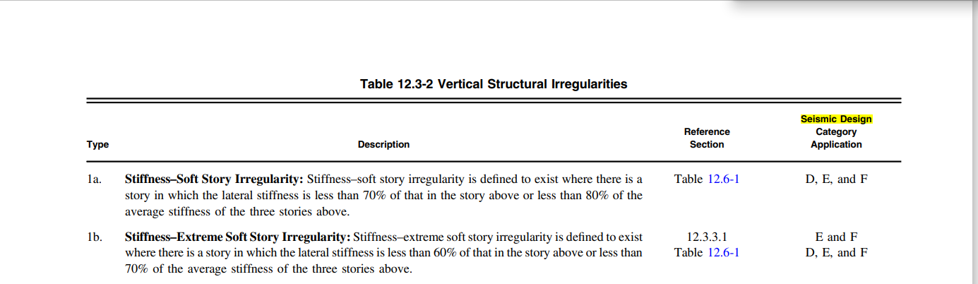
Figure 3.12: vertical structural irregularities.

The story 7 will be checked, because it has a height of 4.5 m and the rest of the floors has the height of 4m.

In X direction:
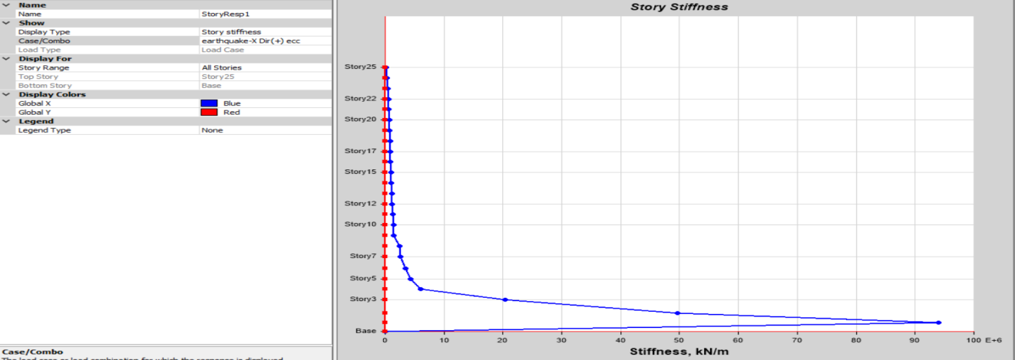
Figure 3.13: story stiffness in x direction.

From the figure, the ratio of the stiffness of story 7 to the stiffness of story 8 is much greater than 0.7 ,and story 9 to the top of the building has a stiffness much less than story 7 , so the stiffness of story 7 to the avg stiffness of stories 8,9 and 10 is greater than 0.8, so there is no soft story in the structure in the X direction.
In Y direction:

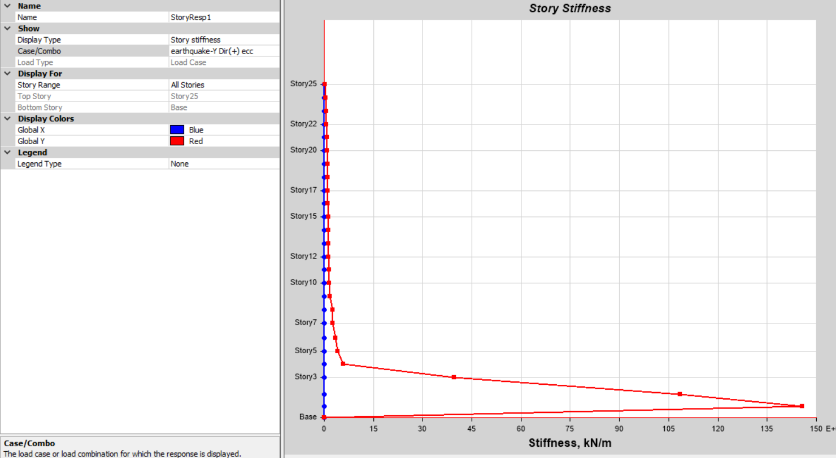
Figure 3.14: story stiffness in y direction.
In the Y direction, there is no soft story either.

Chapter 4 Concrete design.
4.1 part to be designed.
The structure is formed by two isolated parts, and in this project the upper part will be designed.
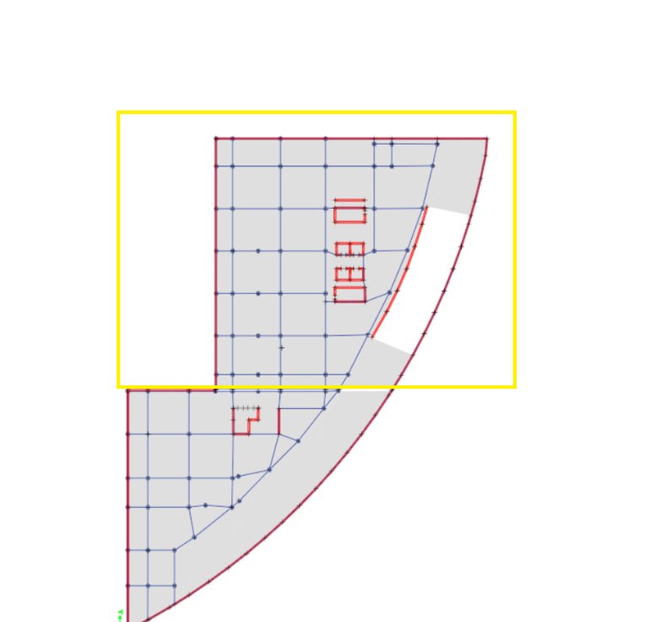
Figure 4.1: Part to be designed.

4.2 Design final dimensions
After a long trial and error iterations to figure out the most suitable dimensions of the structural elements.
the results came out as shown in the following table.
and the details are as follows in the table below.
TABLE 4.1 Properties dimensions.
Property | Cross section(mm)
Slab | Solid slab (300)
Columns (first 7 stories) | 1100*1100
Columns (stories from8 to the top) | 850*850
Beams | 950*600&950*750
Shear walls | 400

And the concrete used is with compressive strength equals to 48Mpa.

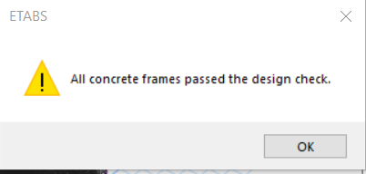
Figure 4.2: verification of stress strain check.

4.3 Properties modifiers.
From the ACI code, the stiffness modifiers are as shown in the following figures:
Beams.

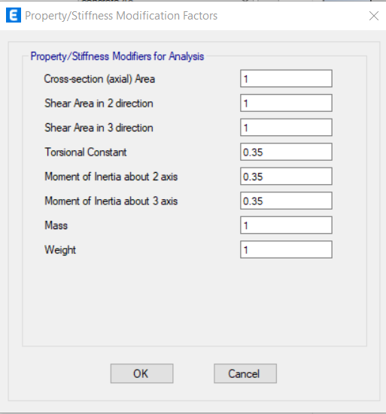
Figure 4.3: Beam modifiers
- Columns.

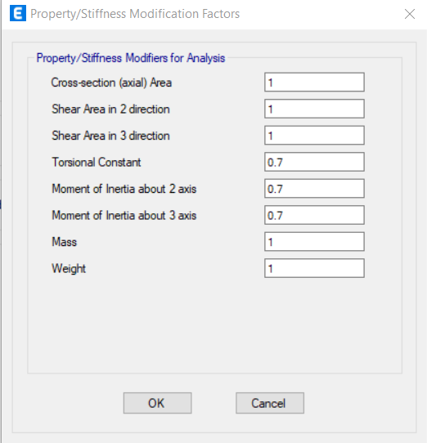
Figure 4.4: Column's modifier.

- Slab.

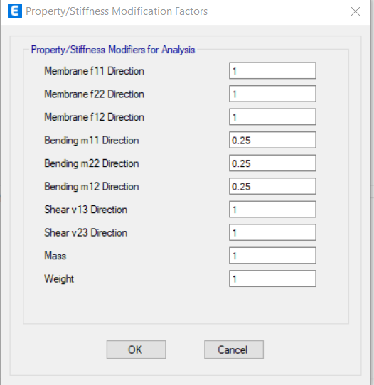
Figure 4.5: Slab modifiers.

- Shear wall modifiers.

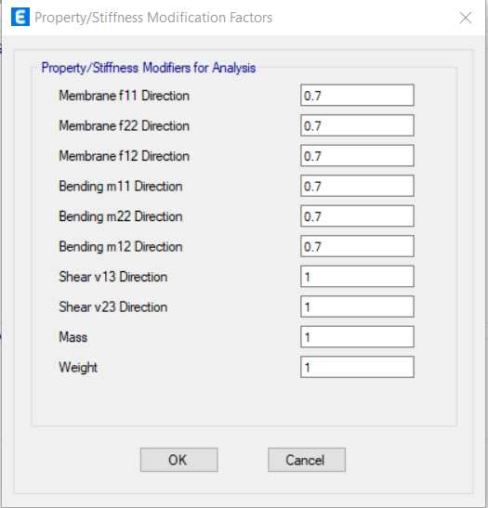
Figure 4.6: Shear wall modifiers

4.4 Design load combinations
Ev= 0.2*SDs*D= 0.2*0.275*D=0.055D
- 1.4D.
- 1.2D + 1.6L.
- 1.2D + L ± Ex + Ev= 1.2D + L ± Ex + 0.055D= 1.25D + L ± Ex.
- 1.2D + L ± Ey + Ev= 1.2D + L ± Ey + 0.055D= 1.25D + L ± Ex.
- 0.9D ± Ex - Ev= 0.9D ± Ex - 0.055D= 0.85D ± Ex.
- 0.9D ± Ey - Ev= 0.9D ± Ey - 0.055D= 0.85D ± Ey.

4.5 Design Slab.
- SLAB DESIGN.
The slab of the 25th story will be designed: ρ min = 0.0018 As min = 540 mm2 /m
As min =540 mm2/m => can be use 4 φ 14/m, any zones of the slab that require an area of steel larger than the minimum will be illustrated in the drawings.

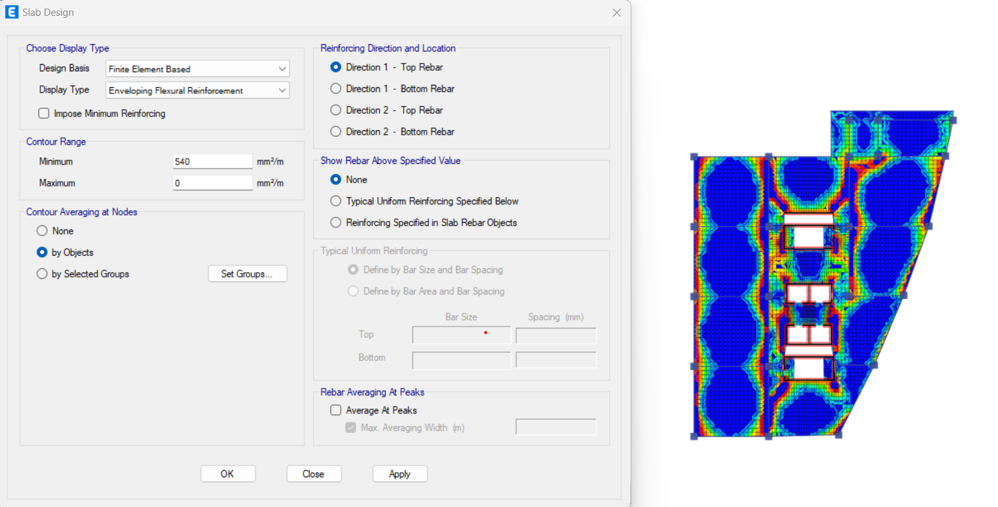
Figure 4.7: Top rebar in direction 1

Figure 4.8: bottom rebar in direction 1

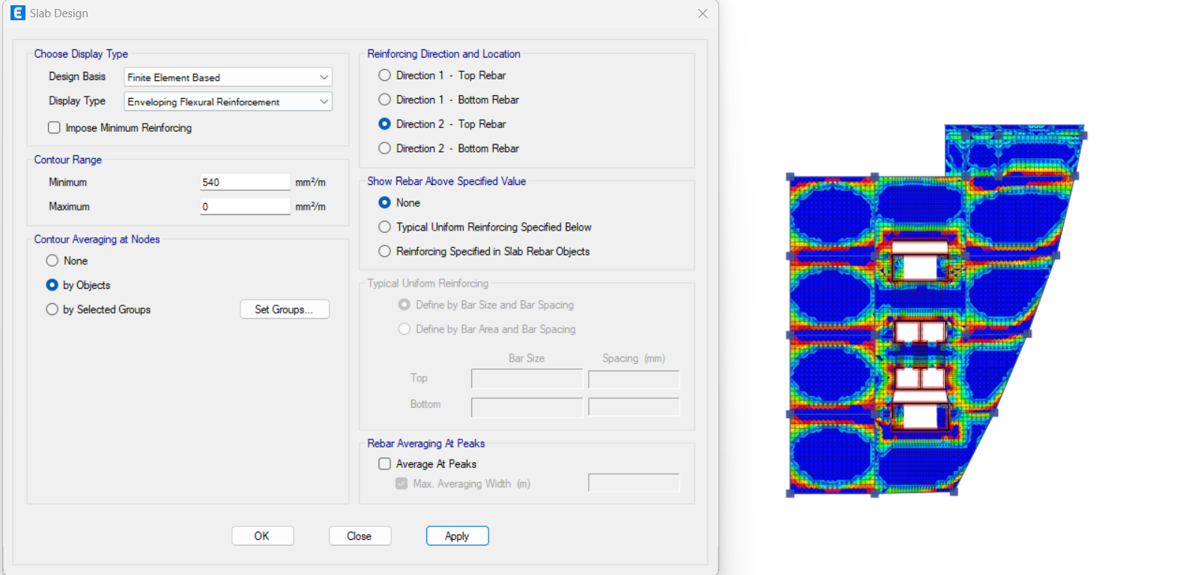
Figure 4.9: Top rebar in direction 2
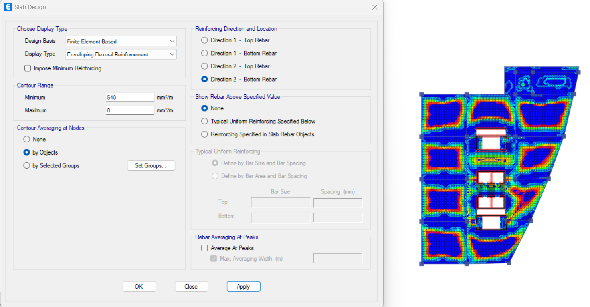
Figure 4.10: bottom rebar in direction 2

- For shear reinforcement.
assume there is no shear reinforcement
ɸVc = φ* 1/6 * fc^0.5 * bw *d = (0.75 * (48) ^{^0.5} * 1000 * 260)/6 = 225.16KN.
the following figures shows the values of the shear force on the slab in both 1 and 2 directions
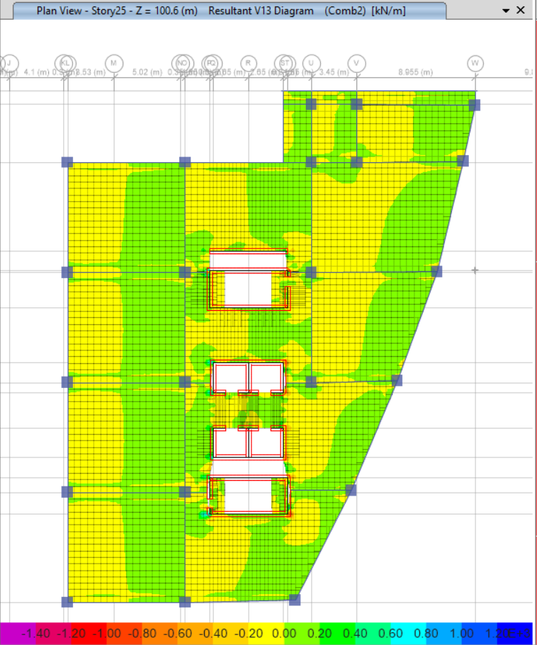
Figure 4.11: Slab V13
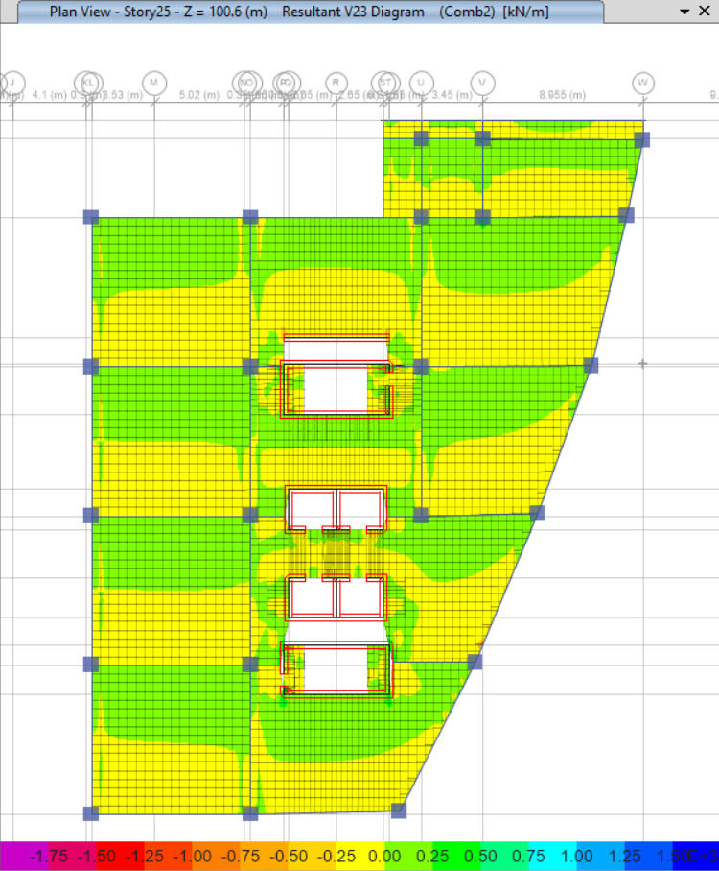
Figure 4.12: Slab V23
From the contour maps in the two figures, the shear force on the slab is less than the nominal shear strength of the concrete, therefor there is no need for shear reinforcement.

- Deflection Check.
DLT = 1.415 DL + 1.83 DD +1.83 DSD
L/240

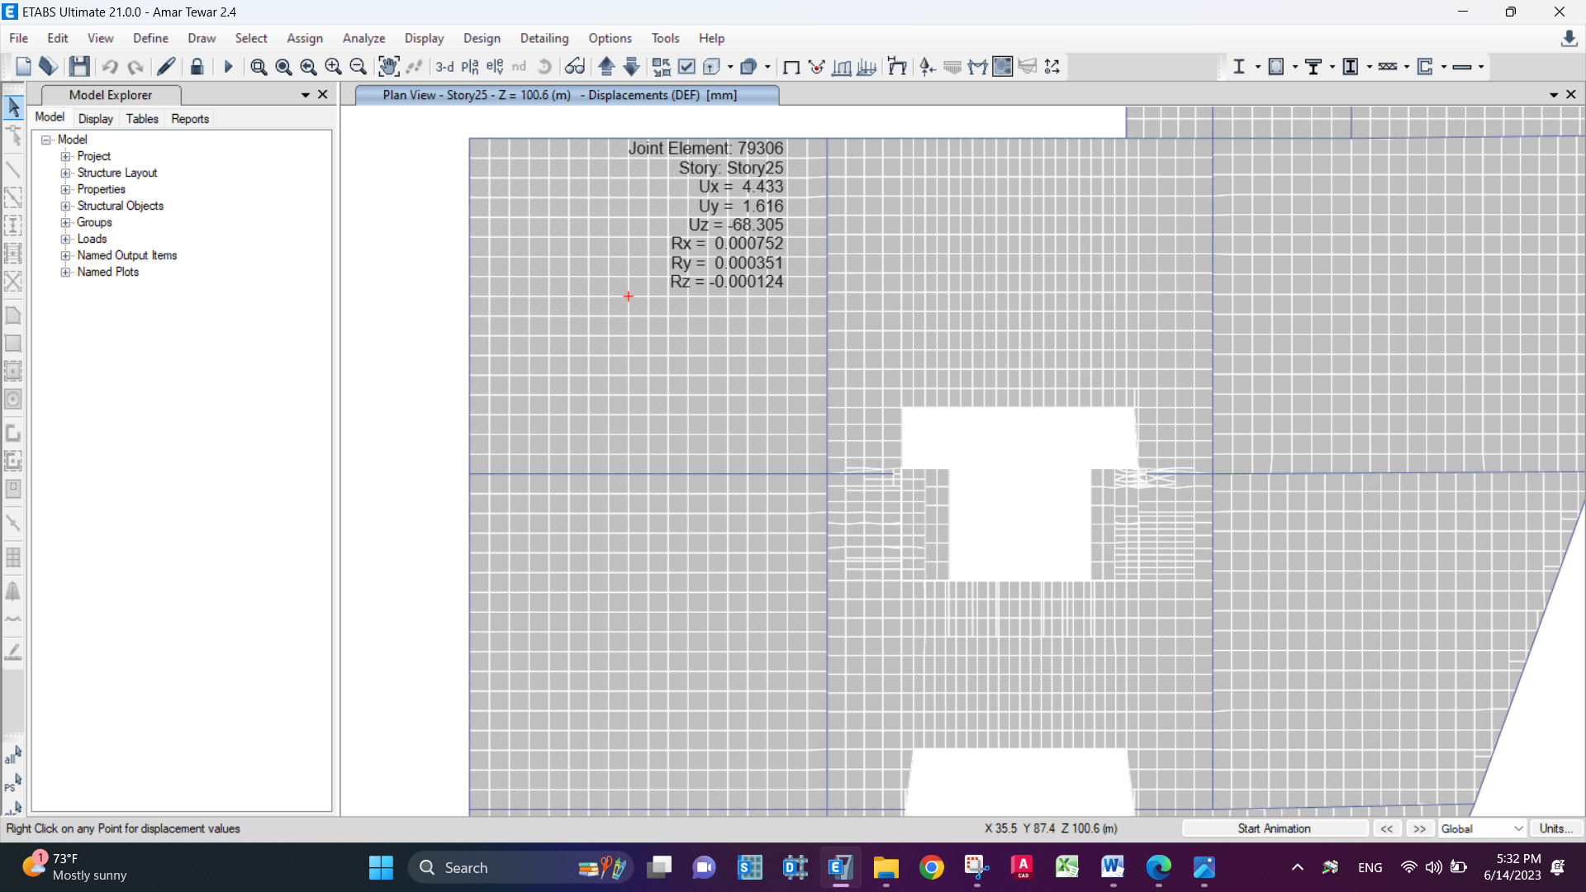

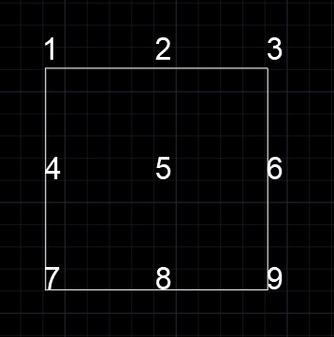

Point | 1 | 2 | 3 | 4 | 5 | 6 | 7 | 8 | 9
Deflection mm | 46.159 | 53.635 | 52.595 | 55.505 | 68.305 | 49.138 | 57.606 | 57.130 | 38.681

line | 1-2-3 | 4-5-6 | 7-8-9 | 1-4-7 | 2-5-8 | 3-6-9
Avg Deflection mm | 4.303 | 15.9835 | 9.2092 | 3.6225 | 12.9225 | 3.545
Allowable deflection mm | 37.08 | 37.08 | 37.08 | 34.7 | 34.7 | 34.7

4.6 Beam design.
The frames on the ETABS were defined as special frames (that is, pressure steel is added at the edges of the beam and the stirrups are thickened at the edges of the beam according to the instructions of the ACI318-19), so the reinforcement given is the full reinforcement of the special frames
- Design for shear and torsion
To illustrate design check, an internal and edge beam will be chosen to be checked by reading shear values on them form ETABS and to compute the required transverse reinforcement then compare it to ETABS results.
Interior beam.
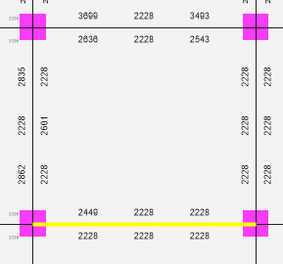
Shear capacity (ɸVc) for 950*600 beam.
ɸVc = 460 kN.
Vu = 541 kN.
Vu > ɸVc, then shear reinforcement is required.
Vc = 460/0.75 = 613.3 Kn.
Vs = 𝑉𝑢/ɸ - Vc
= 541/0.75 -613.3 = 108.033 kN. Figure 4.13: Interior beam.
Av/s = Vs / (fy*d)
= 108.33/ (420*830) = 0.0003 mm2 /mm.
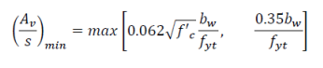
(Av/s) min = 0.062*28^0.5 * 480/420 = 0.375 mm2 /mm
(Av/s) min = 0.35 * 480/420 = 0.4 mm2 /mm →
Av/s < the greater value (Av/s) min.
Av/s= 0.4 mm2 /mm
Since it’s an interior beam, no reinforcement against torsion to be added.
If the spacing is 150 mm between stirrups, then 8mm stirrups can be used.
If the spacing is 100 mm between stirrups at the edge of beam, then 10mm stirrups can be used.

ETABS Concrete Frame Design
ACI 318-19 Beam Section Design (Summary)

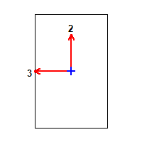

Beam Element Details
Level | Element | Unique Name | Section ID | Combo ID | Station Loc | Length (mm) | LLRF | Type
Story1 | B158 | 96 | beam 950 *600 | Comb1 | 550 | 9450 | 0.748 | Sway Special

Section Properties
b (mm) | h (mm) | b_{f} (mm) | d_{s} (mm) | d_{ct} (mm) | d_{cb} (mm)
600 | 950 | 600 | 0 | 60 | 60

Material Properties
E_{c} (MPa) | f'_{c} (MPa) | Lt.Wt Factor (Unitless) | f_{y} (MPa) | f_{ys} (MPa)
32562.56 | 48 | 1 | 413.69 | 413.69

Design Code Parameters
ϕ_{T} | ϕ_{CTied} | ϕ_{CSpiral} | ϕ_{Vns} | ϕ_{Vs} | ϕ_{Vjoint}
0.9 | 0.65 | 0.75 | 0.75 | 0.6 | 0.85

Design Moment and Flexural Reinforcement for Moment, M_{u3}
 | Design  Moment  kN-m | Design  P_{u}  kN | -Moment  Rebar  mm² | +Moment  Rebar  mm² | Minimum  Rebar  mm² | Required  Rebar  mm²
Top (+2 Axis) | -792.5852 | 0 | 2449 | 0 | 2228 | 2449
Bottom (-2 Axis) | 396.2926 | 0 | 0 | 1210 | 2228 | 2228

Shear Force and Reinforcement for Shear, V_{u2}
Shear V_{u2}  kN | Shear ϕV_{c}  kN | Shear ϕV_{s}  kN | Shear V_{p}  kN | Rebar A_{v} /s  mm²/m
541.1367 | 460.8002 | 172.8001 | 250.5912 | 625.78

Torsion Force and Torsion Reinforcement for Torsion, T_{u}
T_{u}  kN-m | ϕT_{th}  kN-m | ϕT_{cr}  kN-m | Area A_{o}  cm² | Perimeter, p_{h}  mm | Rebar A_{t} /s  mm²/m | Rebar A_{l}  mm²
10.1368 | 45.2199 | 180.8795 | 3740.9 | 2744.4 | 0 | 0

Exterior beam.
Shear capacity (ɸVc) for 950*600 beam.
ɸVc = 197.72 kN.
Vu = 125.94 kN.
Vu < ɸVc, then no shear reinforcement.

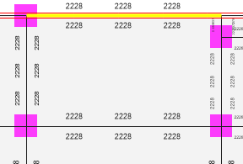
Torsion transverse reinforcement:
Tu = 1.99 kN.m.
Ph = 2744.4 mm.
A0 = 3740.9 mm2.
Vu= 125.9 kN.

Figure 4.14: Exterior beam

Section adequacy:
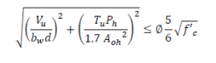
$$\sqrt{{\left(\frac{125.9}{480*830}\right)}^{2}+\left(\frac{1.99 x 2744.4}{1.7 x {3740.9}^{2}}\right)}=0.75\frac{5}{6} \sqrt{28 }$$
→ 1 MPA < 3.3 MPA, Section is quite adequate.

Section capacity against torsion:
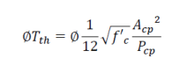
Acp = (d*b).
= 600 x 950 = 570000 mm2.
Pcp = 2(d+b).
= 3100 mm2

ɸTth = $0.75\frac{1}{12} \sqrt{28}\frac{{570000}^{2}}{3100}$ .
= 34.6 kN.m
ɸTth = 45.23 kN.m (ETABS)
Tu < ɸTth, no reinforcement against torsion to be added.

ETABS Concrete Frame Design
ACI 318-19 Beam Section Design (Summary)

Beam Element Details
Level | Element | Unique Name | Section ID | Combo ID | Station Loc | Length (mm) | LLRF | Type
Story1 | B191 | 114 | beam 950 *600 | Comb10 | 9600 | 9600 | 1 | Sway Special

Section Properties
b (mm) | h (mm) | b_{f} (mm) | d_{s} (mm) | d_{ct} (mm) | d_{cb} (mm)
600 | 950 | 600 | 0 | 60 | 60

Material Properties
E_{c} (MPa) | f'_{c} (MPa) | Lt.Wt Factor (Unitless) | f_{y} (MPa) | f_{ys} (MPa)
32562.56 | 48 | 1 | 413.69 | 413.69

Design Code Parameters
ϕ_{T} | ϕ_{CTied} | ϕ_{CSpiral} | ϕ_{Vns} | ϕ_{Vs} | ϕ_{Vjoint}
0.9 | 0.65 | 0.75 | 0.75 | 0.6 | 0.85

Design Moment and Flexural Reinforcement for Moment, M_{u3}
 | Design  Moment  kN-m | Design  P_{u}  kN | -Moment  Rebar  mm² | +Moment  Rebar  mm² | Minimum  Rebar  mm² | Required  Rebar  mm²
Top (+2 Axis) | 0 | -2.6762 | 4 | 0 | 2228 | 2228
Bottom (-2 Axis) | 58.1312 | -2.6762 | 4 | 180 | 2228 | 2228

Shear Force and Reinforcement for Shear, V_{u2}
Shear V_{u2}  kN | Shear ϕV_{c}  kN | Shear ϕV_{s}  kN | Shear V_{p}  kN | Rebar A_{v} /s  mm²/m
125.9418 | 197.7282 | 0 | 63.7913 | 0

Torsion Force and Torsion Reinforcement for Torsion, T_{u}
T_{u}  kN-m | ϕT_{th}  kN-m | ϕT_{cr}  kN-m | Area A_{o}  cm² | Perimeter, p_{h}  mm | Rebar A_{t} /s  mm²/m | Rebar A_{l}  mm²
1.99 | 45.1737 | 180.6949 | 3740.9 | 2744.4 | 0 | 0

- Design against Flexural:

As in shear and torsion in the prior subsection, the same interior and exterior beam will be reinforced once for the flexural resulting from moment, and for the exterior will be reinforced against flexural resulting from moment and torsion.
- Interior beam.

Top bars → Negative moment = -792.5852 kN.m
Bottom bars → Positive moment = 396.2926 kN.m

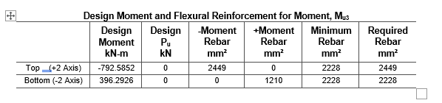
Top rebar percentage, Mu= 792.6 kN.m, b= 950 mm, d = 600 mm.
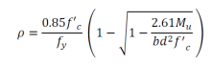
= $\frac{0.85 x 28}{420} \left( 1- \sqrt{1- \frac{2.61 x 792.6}{600 x {950}^{2} x 28 }} \right)$
ρ = 0.00386.
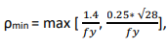
ρmin= 0.00333.
0.00386 > 0.00333
Take ρ = 0.00386.
As = 950*0.00386*600 mm2.
= 2200.2 mm2
As = 2228 mm2 (ETABS).
&error = $\frac{2228-2200.2}{2200.2}=1.26\% OK$.
Bottom rebar percentage, Mu= 396.3 kN.m, b = 600 mm, d = 950 mm.
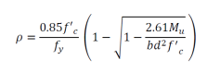
= $\frac{0.85 x 28}{420} \left( 1- \sqrt{1- \frac{2.61 x 792.6}{600 x {950}^{2} x 28 }} \right)$
ρ = 0.00386.
ρmin= 0.00333.
0.00386 > 0.00333
Take ρ = 0.00386.
As = 950*0.00386*600 mm2.
= 2200.2 mm2
As = 2228 mm2 (ETABS).
&error = $\frac{2228-2200.2}{2200.2}=1.26\% OK$

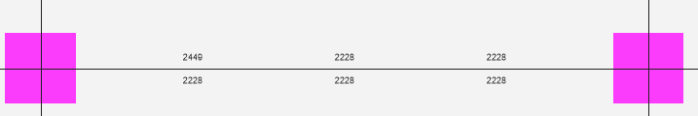

ETABS Concrete Frame Design
ACI 318-19 Beam Section Design (Summary)

Beam Element Details
Level | Element | Unique Name | Section ID | Combo ID | Station Loc | Length (mm) | LLRF | Type
Story1 | B158 | 96 | beam 950 *600 | Comb1 | 550 | 9450 | 0.748 | Sway Special

Section Properties
b (mm) | h (mm) | b_{f} (mm) | d_{s} (mm) | d_{ct} (mm) | d_{cb} (mm)
600 | 950 | 600 | 0 | 60 | 60

Material Properties
E_{c} (MPa) | f'_{c} (MPa) | Lt.Wt Factor (Unitless) | f_{y} (MPa) | f_{ys} (MPa)
32562.56 | 48 | 1 | 413.69 | 413.69

Design Code Parameters
ϕ_{T} | ϕ_{CTied} | ϕ_{CSpiral} | ϕ_{Vns} | ϕ_{Vs} | ϕ_{Vjoint}
0.9 | 0.65 | 0.75 | 0.75 | 0.6 | 0.85

Design Moment and Flexural Reinforcement for Moment, M_{u3}
 | Design  Moment  kN-m | Design  P_{u}  kN | -Moment  Rebar  mm² | +Moment  Rebar  mm² | Minimum  Rebar  mm² | Required  Rebar  mm²
Top (+2 Axis) | -792.5852 | 0 | 2449 | 0 | 2228 | 2449
Bottom (-2 Axis) | 396.2926 | 0 | 0 | 1210 | 2228 | 2228

Shear Force and Reinforcement for Shear, V_{u2}
Shear V_{u2}  kN | Shear ϕV_{c}  kN | Shear ϕV_{s}  kN | Shear V_{p}  kN | Rebar A_{v} /s  mm²/m
541.1367 | 460.8002 | 172.8001 | 250.5912 | 625.78

Torsion Force and Torsion Reinforcement for Torsion, T_{u}
T_{u}  kN-m | ϕT_{th}  kN-m | ϕT_{cr}  kN-m | Area A_{o}  cm² | Perimeter, p_{h}  mm | Rebar A_{t} /s  mm²/m | Rebar A_{l}  mm²
10.1368 | 45.2199 | 180.8795 | 3740.9 | 2744.4 | 0 | 0

- Exterior Beam

The same approach that has been applied to compute longitudinal reinforcement to resist flexural out of moment only is going to be applied here in addition to the value of reinforcement needed to stand against flexural form torsion.

Top and bottom reinforcement from moment:

Top → As = 2228 mm2, Bottom→ As = 2228 mm2

ETABS Concrete Frame Design
ACI 318-19 Beam Section Design (Summary)

Beam Element Details
Level | Element | Unique Name | Section ID | Combo ID | Station Loc | Length (mm) | LLRF | Type
Story1 | B191 | 114 | beam 950 *600 | Comb10 | 9600 | 9600 | 1 | Sway Special

Section Properties
b (mm) | h (mm) | b_{f} (mm) | d_{s} (mm) | d_{ct} (mm) | d_{cb} (mm)
600 | 950 | 600 | 0 | 60 | 60

Material Properties
E_{c} (MPa) | f'_{c} (MPa) | Lt.Wt Factor (Unitless) | f_{y} (MPa) | f_{ys} (MPa)
32562.56 | 48 | 1 | 413.69 | 413.69

Design Code Parameters
ϕ_{T} | ϕ_{CTied} | ϕ_{CSpiral} | ϕ_{Vns} | ϕ_{Vs} | ϕ_{Vjoint}
0.9 | 0.65 | 0.75 | 0.75 | 0.6 | 0.85

Design Moment and Flexural Reinforcement for Moment, M_{u3}
 | Design  Moment  kN-m | Design  P_{u}  kN | -Moment  Rebar  mm² | +Moment  Rebar  mm² | Minimum  Rebar  mm² | Required  Rebar  mm²
Top (+2 Axis) | 0 | -2.6762 | 4 | 0 | 2228 | 2228
Bottom (-2 Axis) | 58.1312 | -2.6762 | 4 | 180 | 2228 | 2228

Shear Force and Reinforcement for Shear, V_{u2}
Shear V_{u2}  kN | Shear ϕV_{c}  kN | Shear ϕV_{s}  kN | Shear V_{p}  kN | Rebar A_{v} /s  mm²/m
125.9418 | 197.7282 | 0 | 63.7913 | 0

Torsion Force and Torsion Reinforcement for Torsion, T_{u}
T_{u}  kN-m | ϕT_{th}  kN-m | ϕT_{cr}  kN-m | Area A_{o}  cm² | Perimeter, p_{h}  mm | Rebar A_{t} /s  mm²/m | Rebar A_{l}  mm²
1.99 | 45.1737 | 180.6949 | 3740.9 | 2744.4 | 0 | 0
4.7 COLUMN DESIGN.
Columns are (70 * 70, 85 * 85, 110 * 110).
Longitudinal reinforcement for Columns: Firstly, column type must be determined to check if columns must be designed for the ultimate moment without magnification or with.
Slenderness check:
Assuming the worst case for end connections, (pin-pin) for the current case
Slenderness ratio = $\frac{KLu}{r}$
K: effective length factor that depends on end or support conditions of the column.
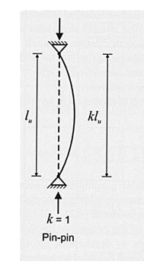
r= 0.3 h for rectangular column,
Lu: unsupported length of the column.
K=1
Lu = 4 * (1.1/2) = 2.2m.
r = 0.3 h = 0.3 * 1.1 = 0.33m
The selected column is shown below Kl/r= $\frac{1*2.2}{0.33}$ = 6.66.
$\frac{KLu}{r}$≤ 34 + 12 M1/M2 ≤ 40
assuming that it’s a single curvature and M1/M2 = 1 (the worst cases), then:
34+12= 46 > Kl/r, and that is a clue that all columns are short.

However, for manual verifications,
M1 = -20.45 kN.m,
M2= 18.9 kN.m
(Double curvature) 34 + 12*(20.45/18.9) = 47 > 6.66 [kL/r] → short column

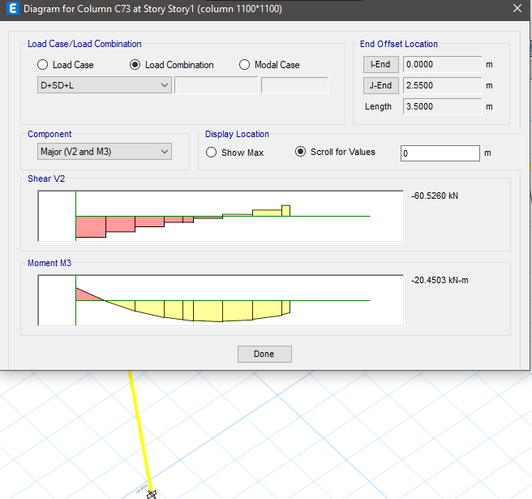
Figure 4.15: M1 on column.
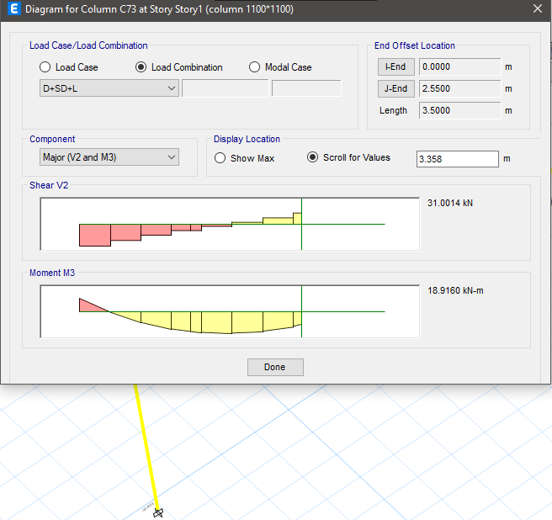
Figure 4.16: M2 on column.
Rebar percentage:
According to ETABS, rebar percentage is (1%), which is the desired value because it’s -according to experts- the most economical design for columns.
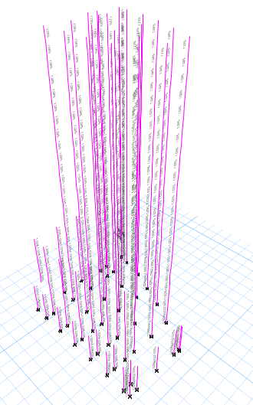

Figure 4.17: Rebar percentage

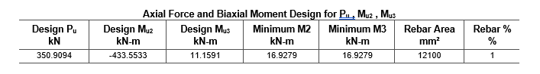

Manual verification:
PU = 350.9 kN.
∅Pn = 350.9 * 0.75 = 263.175
γ = $\frac{1100-2x60}{1100}=0.9$
∅ Pn/ℎ∗𝑏 = $\frac{263.175 x 1000}{1100 x 1100 x 7}$ = 0.03Ksi
∅ Mn/𝑏∗ℎ2 = $\frac{20.45x 1000000}{{1100}^{3} x 7 }$= 0.015 Ksi

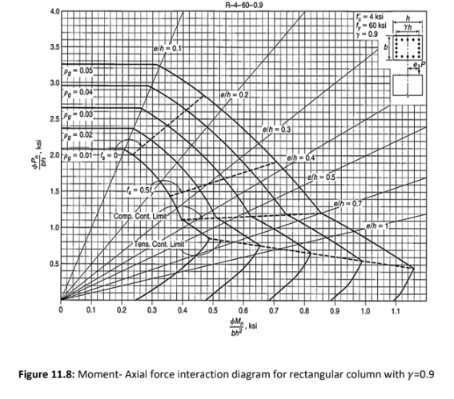
Figure 4.18: interaction diagram.

ρ= 1% from interaction diagrams.
As = 0.01 * 1100 * 1100 = 12100 mm2.
As = 12100 mm2 (ETABS).
%error = $\frac{12100-12100}{12100 }=0\%.$
16 bars of 32 mm will be used → As = 12867.96 > required.
Ties:
Using 14mm ties
S < One-fourth of the minimum column dimension= 1100/4= 275mm.
S < For Grade 60, 6db of the smallest longitudinal bar= 6*14= 84mm.
S< For Grade 80, 5db of the smallest longitudinal bar
The steel used is Grade60, so the spacing is 84mm, taken as 80mm, so use 1Ø14@80mm C/C

ETABS Concrete Frame Design
ACI 318-19 Column Section Design (Summary)

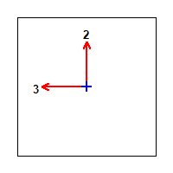

Column Element Details
Level | Element | Unique Name | Section ID | Combo ID | Station Loc | Length (mm) | LLRF | Type
Story1 | C73 | 119 | column 1100*1100 | Comb10 | 2550 | 3500 | 0.702 | Sway Special

Section Properties
b (mm) | h (mm) | dc (mm) | Cover (Torsion) (mm)
1100 | 1100 | 60 | 27.3

Material Properties
E_{c} (MPa) | f'_{c} (MPa) | Lt.Wt Factor (Unitless) | f_{y} (MPa) | f_{ys} (MPa)
32562.56 | 48 | 1 | 413.69 | 413.69

Design Code Parameters
ϕ_{T} | ϕ_{CTied} | ϕ_{CSpiral} | ϕ_{Vns} | ϕ_{Vs} | ϕ_{Vjoint} | Ω₀
0.9 | 0.65 | 0.75 | 0.75 | 0.6 | 0.85 | 2

Axial Force and Biaxial Moment Design for P_{u} , M_{u2} , M_{u3}
Design P_{u}  kN | Design M_{u2}  kN-m | Design M_{u3}  kN-m | Minimum M2  kN-m | Minimum M3  kN-m | Rebar Area  mm² | Rebar %  %
350.9094 | -433.5533 | 11.1591 | 16.9279 | 16.9279 | 12100 | 1

Axial Force and Biaxial Moment Factors
 | C_{m} Factor  Unitless | δ_{ns} Factor  Unitless | δ_{s} Factor  Unitless | K Factor  Unitless | Length  mm
Major Bend(M3) | 1 | 1.000388 | 1 | 1 | 2550
Minor Bend(M2) | 1 | 1.000388 | 1 | 1 | 2550

Shear Design for V_{u2} , V_{u3}
 | Shear V_{u}  kN | Shear ϕV_{c}  kN | Shear ϕV_{s}  kN | Shear ϕV_{p}  kN | Rebar A_{v} /s  mm²/m
Major, V_{u2} | 22.7264 | 472.5257 | 0 | 0 | 0
Minor, V_{u3} | 297.6215 | 0 | 370.1941 | 285.1927 | 1147.27

Joint Shear Check/Design
 | Joint Shear  Force  kN | Shear  V_{u,Top}  kN | Shear  V_{u,Tot}  kN | Shear  ϕV_{c}  kN | Joint  Area  cm² | Shear  Ratio  Unitless
Major Shear, V_{u2} | N/N | N/N | N/N | N/N | N/N | N/N
Minor Shear, V_{u3} | 0 | 285.1927 | 866.8077 | 7100.1197 | 12100 | 0.122

(6/5) Beam/Column Capacity Ratio
Major Ratio | Minor Ratio
N/N | 0.181

Notes:
N/A: Not Applicable
N/C: Not Calculated
N/N: Not Needed

4.8 Shear walls design
The shear walls lay out is shown in the figure
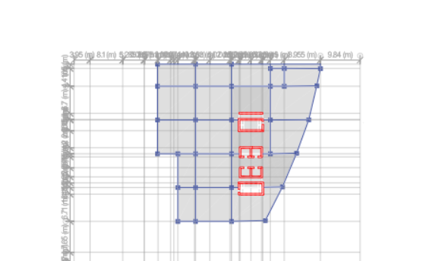
Figure 4.19: Shear walls layout
The pier labels were defined in order to assign them to the walls to obtain the results from the program
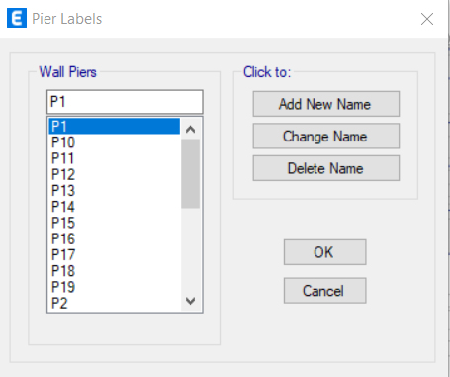
Figure 4.20: c

The calculations of the design verification will be made on the wall section illustrated in the figure, length =5900mm and width= 400mm.

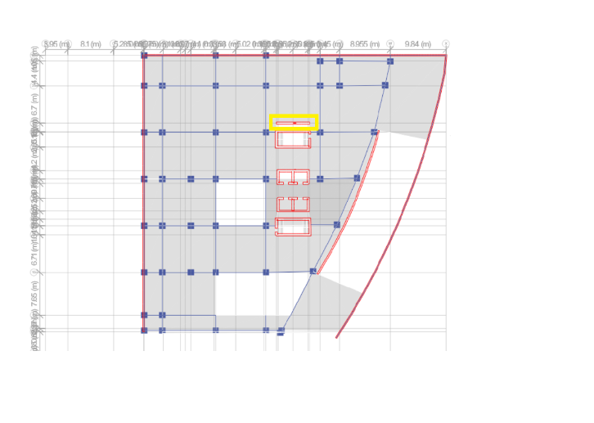
Figure 4.21: pier 13

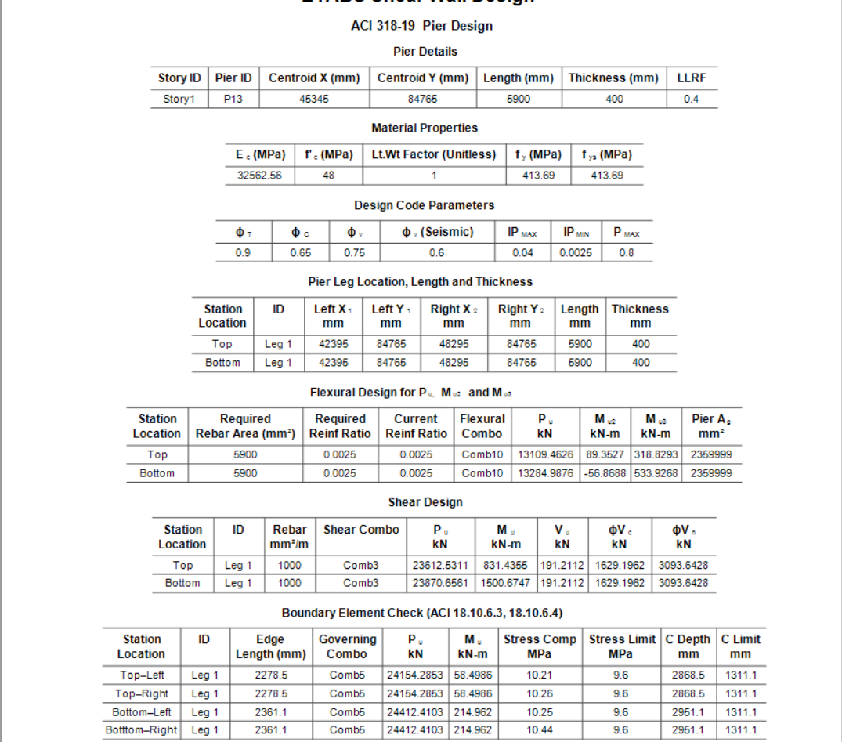

Figure 4.22: Shear wall details
The details are for the p 13 in b3 story
From ETABS, the required area of steel is 5900mm² with steel ratio of 0.0025.
From the details, Pu= 13284.98 KN, Mu=533. 92KN.m
From the following interaction diagram
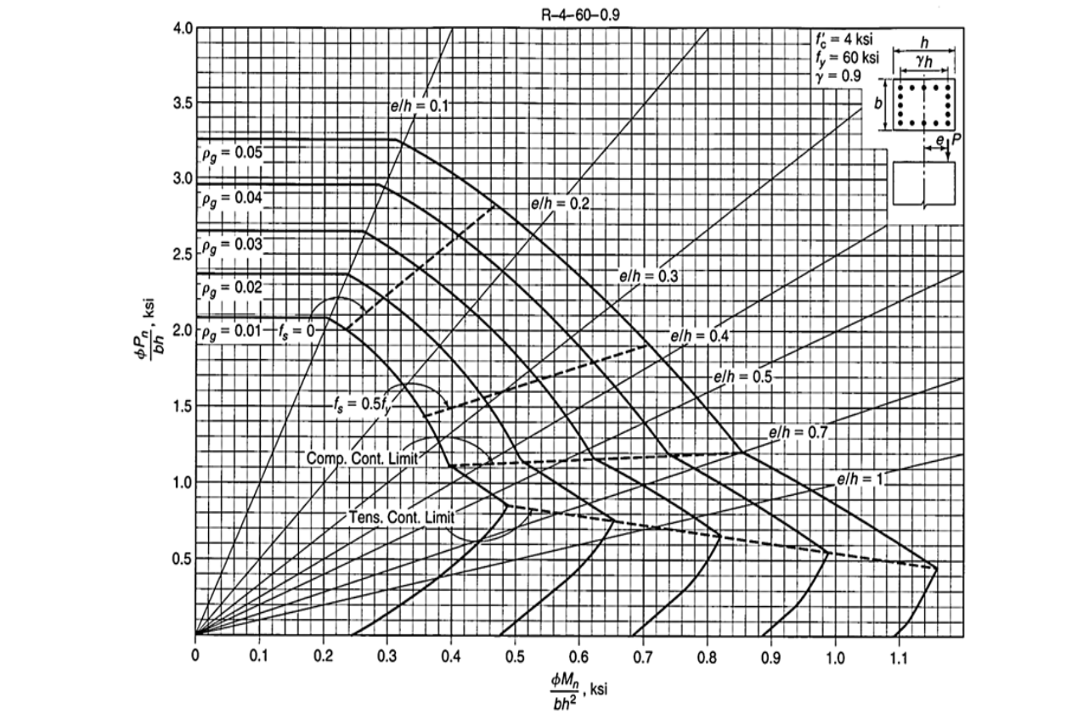
Figure 4.23: Interaction diagram

The values of the Pu and Mu gives a point with coordinates (0.005, 0.8) which is under 0.01 steel ratio, but according to the ACI code the, the steel ratio should not be less than 0.0025, and the above interaction diagram was derived to the sectional properties made designed with a concrete of 4 Ksi( 28 Mpa) while the concrete used in this project is 48 Mpa which will require a steel ration less than 0.0025 , so the reinforcement used in this wall section is 0.0025 , which is the same as Etabs.

- Shear design
Since the ɸVc=1629.19 KN is greater than Vu= 191.21 KN, the minimum area of steel is required, Av/s= 1000mm²/mm (1Ø 10mm@150mm c/c).

Boundary element check
Stress limit is 0.2 f’c= 0.2*48= 9.6 Mpa.
Applied stress= 24412.41*10³/ (5900*400) + 214.96*10⁶ *(5900/2)/ (5900³*400/12) = 10.43Mpa.
Both the stress limit and the applied stress are the same as the Etabs results, so the is a need for a boundary zone.
These boundary elements will act like a column that forms a opposite coupling moments to the applied bending moment from the external loads.
From the Etabs details, the value of c (the depth of the neutral axis) where calculated to be equal to 2951.1mm, but the c limit is 1311.1 mm, and from the equations, the depth of boundary zone is equal to the max (c/2, c-0.1*Lw) which is equal to 741.1mm, taken as 750 mm.
The area of steel will be divided between the two boundary zones (5900/2=2950mm each)
(10Ø20mm) and the middle part of the wall will be reinforced with the minimum steel ratio
That gives an area of steel of 0.0025*4400*400= 4400 mm² (1Ø10@150mm).
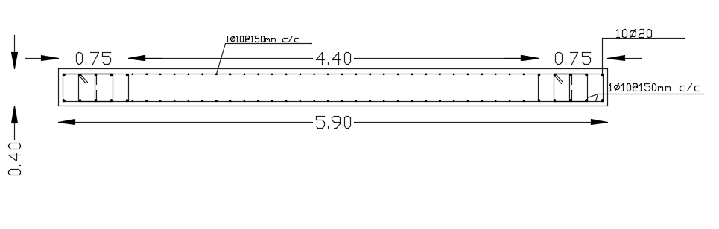
Figure 4.24: P13 details

References.

- ASCE 7-16 code.
- ASCE 318-19 CODE.
- https://theconstructor.org/structural-engg/concrete-frame-construction-types-major-components/34801/
- https://www.facebook.com/CivilEngineerhelp
- https://civiljungle.com/waffle-slab/
- https://www.linkedin.com/pulse/cobiax-voided-slabs-mehmet-kelmendi
- https://theconstructor.org/exclusive/voided-slab-systems/223645/
- https://theconstructor.org/exclusive/voided-slab-systems/223645/

