Cover page
Project title: ………BotStrike…………….. Academic Year: ……Summer 2024/2025………
Group Members: ………Zaid Balout …………….………. Department Name:
……Khalid Yaish…………………..
……………………………………………
Project Type Software or Hardware (Choose one)
Supervisor Name: ………Dr. Anas Toma…………
Format:
- Single space, Times New Roman.

- 12 pt,
- Maximum 1 page.
Abstract Body:
Items must be provided in the Abstract:
- Why do you think this project is important? Please explain the significance of this
Project in brief.
- In your point of view what are the important aspects that should be covered in the project?
- Objective(s): In your view, please explain the main objectives of the project.
- Methodology: Give a brief outline of the application development process.
- Had this project been done before? Are there any similar applications available today?

- Note: Please deliver this abstract early to ensure that your Project has been approved by the department’s projects committee. Registration will not be done without this approval.

Project’s Abstract:
BotStrike is an interactive hardware-based game project that involves controlling small motorized paddles to deflect a moving ball inside a closed arena. Players attempt to hit the ball toward their opponents while defending their own zones. A player loses points when the ball enters their area. The game ends when only one player remains with points.
The entire system will be developed from scratch, including the mechanical structure, electronic circuits, control logic, and gameplay flow. The project also includes an AI-controlled paddle that can track the ball and react to it automatically.
Main Components:
- Motorized paddles (vehicles) for each player with launchers
- Game controllers with joystick and button
- DC motors for paddle movement
- Limit switches to detect motion boundaries
- LED strips or indicators to show player scores
- ESP microcontrollers for logic control and hardware interaction
- Bluetooth modules for wireless communication
Automated Player:
One paddle will be controlled automatically using a vision-based system:
- An OAK-D camera will track the ball in real time
- Image processing will be handled using OpenCV
- The AI logic will determine the paddle’s direction and strike timing
- The microcontroller will receive movement commands accordingly

Design Preview:
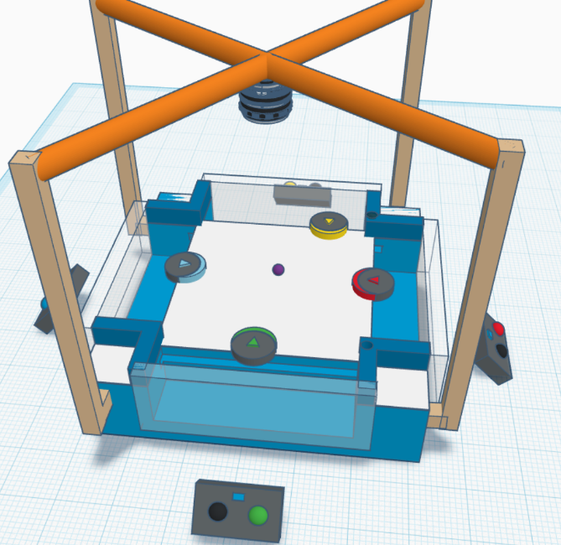
Initial 3D models of the game have been designed to illustrate the expected structure. Screenshots from the 3D design included to provide a clear visual reference.
