Column Design
4.1 General:
Columns are structural element used primarily to support axial compressive loads, that coming from slabs that stand over them.
4.2 Introduction:
Practically columns are subjected not to axial loads but also to moment from direct loading or end rotation.
Columns are classified to short columns and long columns. A short column is one in which the ultimate load is governed by the strength of materials and dimension of the cross section, A long column one in which ultimate capacity is influenced by slenderness, which produced additional bending because of transverse deformation, see Appendix C.
4.3 Types of columns:
Reinforced concrete columns are principally classified into three types according to its section.
Tied columns:
Here in this type the bars are braced or tied at internal closed loops called ties, which are usually square or rectangular columns.
Spiral columns:
This type which the bars warped with a closely spaced spiral of small diameter, usually circular column in which spiral reinforcement is used this kind of columns are used in open area.
Composed column:
This type is rarely used in which rolled sections is used in addition to concrete.

4.4Columns classification:
Short columns:
Strength is related to properties of used material, also short columns are limited by the following equation.
1) Kl/r≤34-12(𝓜u₁/ 𝓜u₂) ……..short column.
2) Kl/r>34-12(𝓜u₁/ 𝓜u₂) .…… Long column
Long column:
Strength is related to slenderness ratio of the column. And here the last equation can't be applied.
Minimum moment imposed in the column:
All columns are assumed to have minimum moment imposed on them defined by minimum eccentricity.
E_{min}≥ (1.5+0.03h) in either direction
.h= overall dimension of the column at rights angle to the axis of the bending.
M _{min}=P _{emin}

Clear spacing:
For each column clear spacing between bars should be largest of the (1.5d_{b}, 1.5 inch, max. aggregate size).
Cover:
Clear cover 5 cm; for exterior exposure.

Spacing between bars:
Spacing between bars should not be less than largest of the following:
1)1.5d_{b}
2)1.5 inches.
3)4/3 max. Aggregate size
Spacing between bars =b/n.
Spacing between stirrups:
Spacing between bars should not be exceeding the least of the following:
1) At least dimension of the column.
2)16d_{b}
3)48d_{s}

4.5Column design:
According to (ACI-2002) code, the load on the column can be calculated from the following equation.
Pd=фPn=ф*λ {0.85* 𝒇'c (Ag-As) +As* ℱy}
Where:
Ф: reduction factor.
Ф: 0.75 for tied column.
Ф: 0.65 for spiral column.
Ag: gross area of the cross section.
ℱy: yield strength of steel.
Check buckling:
Pcr=π² (EI)/ (KL) ²
EI= (0.4Ec x Ig)/ (1+Bd).
Bd=1.4 dead/P_{U}.
Buckling will not occur if………..Pu< ФPcr.
Where: Ф reduction factor=0.75
Check Slenderness ratio:
In order to determine whether the columns is short or long:
1) Kl/r≤34-12(𝓜u₁/ 𝓜u₂) ……..short column.
2) Kl/r>34-12(𝓜u₁/ 𝓜u₂) ….… Long column
Where:
K: effective length factor.
Lu: unbraced length of the column
r: radius of gyration=√I/A

Mu1& Mu2: columns end moments, "smaller and larger respectively"

𝓜u₁/ 𝓜u₂: Positive for a single curvature and negative for double curvature

Design:
4.5.1 Column Design of Block A
4.5.1.a Interior column (circular C20):
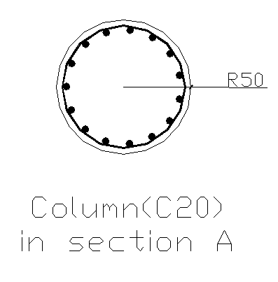
Fig(4-1)Column (20) in Block A
This column has circular shape and we transfer it to equivalent square D=1m ≈ h=b=0.88 m
DL=158.28 ton, Pu=251.77 ton
𝓜 ₁=1.16 ton.m, ₂=1.22 ton.m
From sap 2000
Check if it long or short column in both direction:
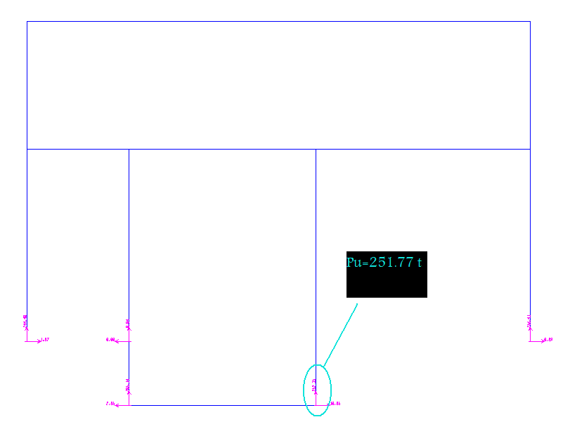
Fig (4-2) Pu from sap2000
In X-X direction:
Ψ_{B}=∑(EI/L)_{C}/∑(EI/L)_{B}
= (0.0491/12)/(0.0759/8.75+0.759/10.03)=0.25
Ψ_{T}=∑(EI/L)_{C}/∑(EI/L)_{B}
= (0.0491/12)/ (7.2*10⁻³ /8.75)=4.97
K=0.75 (braced)
R=0.25
Lu=11.2
Kl/r=0.75*11.2/0.25=33.6 > 34-12*1.16/1.22=22.59
Long column in X-X direction

In Y-Y direction:
Ψ_{B}= 5.3
Ψ_{T}=0.26
(Braced)
K=0.75
R=0.25
Lu=11.2
Kl/r=0.75*11.2/0.25=33.6 > 34-12*16/1.22=22.59
Long column in Y-Y direction

Design of long column:
B_{d}=1.2D/Pu
=1.2*158.28/251.77 =0.7544
I_{eff}=0.4*I_{g}/ (1+ B_{d})
=0.4*0.0491/ (1+0.7544)
=0.01119471 m⁴ =1119471 cm⁴
Pcr=π² (EI)/ (KL) ²
= (π²*151000√240*1119471)/ ((0.75*11.2*100)²*1000)
=3663 ton
Cm=0.6+0.4(𝓜 ₁/𝓜₂)
=0.6+0.4(1.16/1.22) =0.98
$δ$_{ns}=Cm/(1-Pu/ фPc)
=0.98/(1-251.77/(0.75*3663))
=1.08
𝓜c=$δ$_{ns}*𝓜u
=1.08*1.22 =1.32 ton.m

Most columns are subjected to bending moment in addition to axial force.

𝓜_{min} = e_{min} x Pu
Where:
𝓜_{min}: minimum moment required to design columns for bending.
e_{min}: minimum eccentricity
= 0.015+0.03h ; h: column side dimension in m
Pu: ultimate axial force on column.
𝓜u=1.22 ton.m from sap
e_{min}=0.015+0.03*1=0.045 m
𝓜_{min}= e_{min}*Pu
=0.045*251.77 =11.33 ton.m
𝓜c < min so that design for moment should not be performed.

The nominal compressive strength for axially loaded column is:
Take As =0.01Ag
Pd=фPn=ф*λ {0.85* 𝒇'c (Ag-As) +As* ℱy}
251.77*1000=0.75*0.85{0.85*240*((π/4)(100)²– As)+As*4200}
As=78.54 cm²
Check strength:
Pd=0.75*0.85{0.85*240*{(π/4) (100) - 78.54) +4200*78.54}
=1221.5 ton >Pu ok
As= (16 ф25)
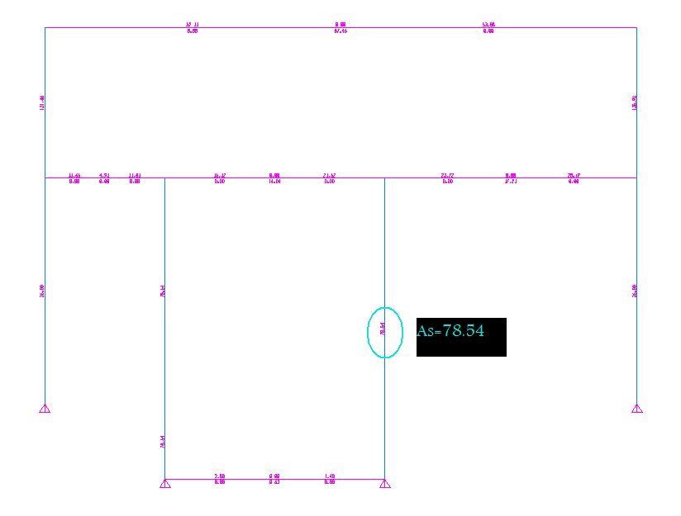
Fig ( 4-3 ) As from sap2000

We note that the area of steel from hand calculation is same as from SAP.

Shear Design:
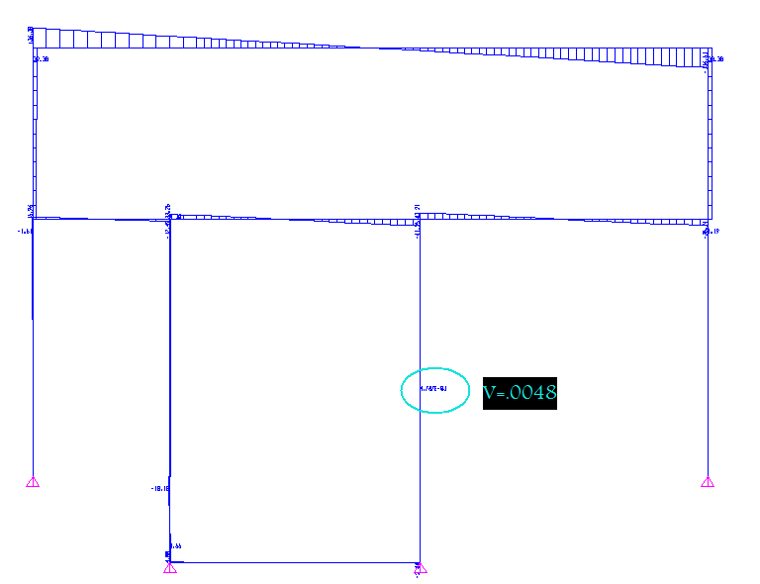
Fig ( 4-4 ) Shear force from sap2000
Vu=0.0048 ton ,
Nu _{(axial load)} =240.6 ton from sap2000
ФVc=0.75*0.53√ 𝒇'c*b*d {1+ Nu/140*Ag}
={0.75*0.53√240*88*83{1+240.6*10³/140*7854}}/10³
=54.82 ton > 0.0048 ton
No need for shear reinforcement use Min shear reinforcement.
[Av/S]_{min}=max {3.5*b_{w}/ ℱy} or {0.2* b_{w}√ 𝒇'c/ ℱy}
={3.5*88/4200=0.073} or {0.2*88* √240/4200}
[Av/S]_{min}=0.05

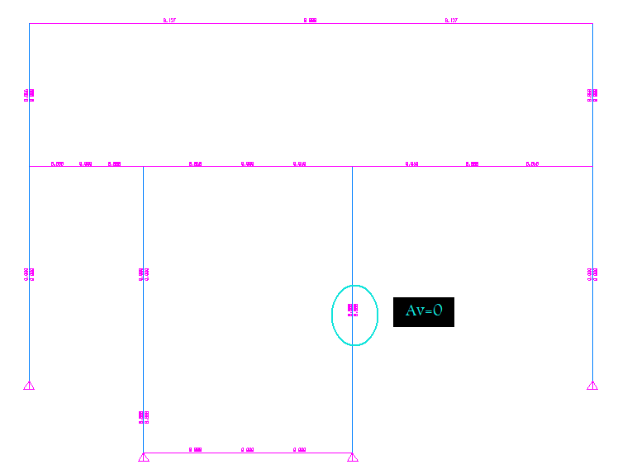
Fig ( 4-5 ) As for shear from sap2000
Pitch (3.5 cm 8.5 cm) Ф=10 mm
2.5 ≤ clear spacing between spirals ≤ 7.5 cm

4.5.1.b Exterior column (square C5):
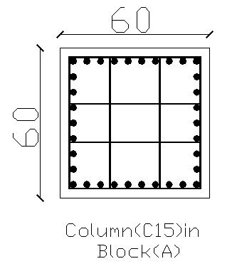
Fig(4-6) Column (15) in Block A
Dimension:
b=h=60 cm
I_{c}=0.0108 m⁴,
I_{L}=0.0225 m⁴,
I_{Eb}=0.2457 m⁴
I_{Tb}=7.2*10⁻³ m⁴
DL=150.12 ton, Pu=212.5 ton
𝓜 ₁=0.88ton.m, ₂=1.57 ton.m
from sap 2000
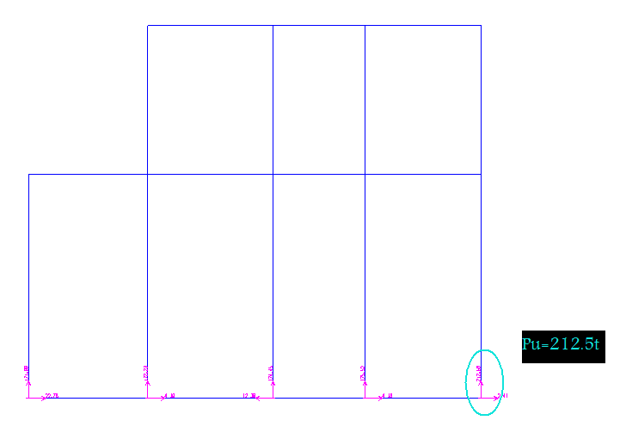
Fig (4-7) Pu from sap2000
In X-X direction:
Ψ_{B}=∑ (EI/L) _{C}/∑ (EI/L) _{B}
= (0.0108/9)/ (7.2*10⁻³ /4.65+7.2*10⁻³ /5.2)=0.41
Ψ_{T}=∑ (EI/L) _{C}/∑ (EI/L) _{B}
= [(0.0108/9) + (0.0108/6)]/ [(0.0225/4.65) +(0.0225/5.2) + (0.2457/4.65) +0.2457/5.2)]=0.03
K=0.85 (braced)
r=0.173
Lu=8.35
Kl/r=0.58*8.35/0.173=28< 34+12*0.88/1.57=34.56
Short column in X-X direction
In Y-Y direction:
Ψ_{B}= 0.87
Ψ_{T}=0.69
(Braced)
K=0.74
R=0.173
Lu=8.35
KL/r=0.74*8.35/0.173=35.72 > 34.65
Long column in Y-Y direction

Design of long column:
B_{d} =1.2D/Pu
=1.2*150.12/212.5 =0.848
I_{eff} =0.4*I_{g}/ (1+ B_{d})
=0.4*0.0108/ (1+0.848)
=2.34*10⁻³ m⁴ =233766 cm⁴
P_{cr}=π² (EI)/ (KL) ²
= (π²*151000√240*233766)/ ((0.74*8.35*100)²*1000)
=1413.6 ton
Cm=0.6+0.4(𝓜 ₁/𝓜₂)
=0.6-0.4(0.88/1.57) =0.376
$δ$_{Ns=}Cm/ (1-Pu/ фPc)
=0.376/ (1-212.5/ (0.75*1413.6))
=0.47
𝓜c=$δ$_{ns}*𝓜u
=0.47*1.57 =0.738 ton.m
𝓜u=1.57ton.m from sap
e_{min}=0.015+0.03*0.6=0.033 m
𝓜_{min}= e_{min}*Pu
=0.033*212.5 =7.02 ton.m
𝓜c <𝓜 min so that design for moment should not be performed.
The nominal compressive strength for axially loaded column is:
Take As =0.01Ag
AS=0.01Ag =36cm²
As= (8 ф 25)
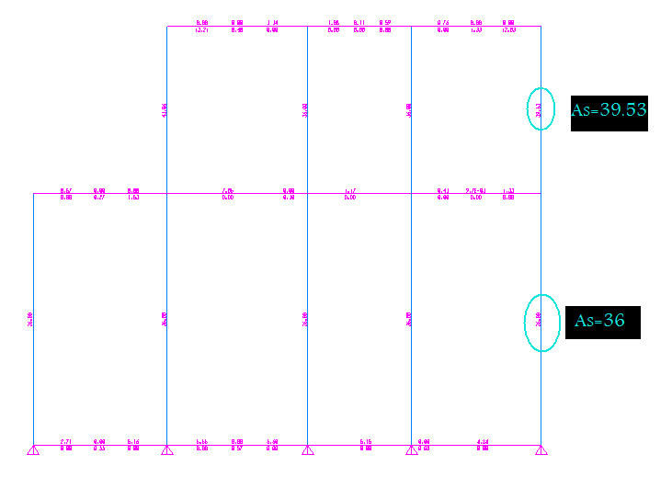
Fig ( 4-8 ) As for shear from sap2000
Check strength:
Pd=фPn=ф*λ {0.85* 𝒇'c (Ag-As) +As* ℱy}
=0.75*0.85{0.85*240*0.99*3600+36*4200}
=560 ton > Pu
Shear Design:
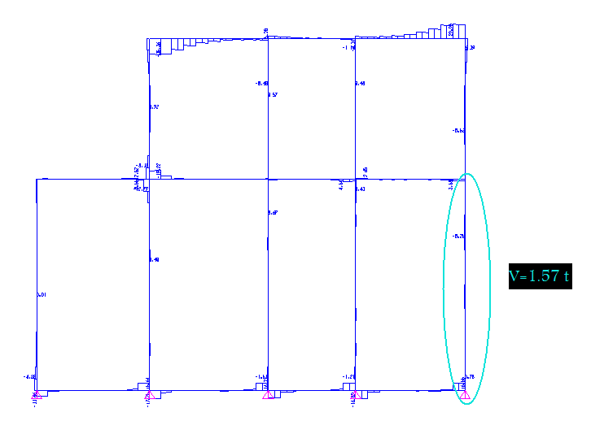
Fig ( 4-9 ) shear force from sap2000
Vu=1.57ton ,
Nu _{(axial load)} =124.6 ton from sap2000
ФVc={.75*.53√240*60*55{1+124.6*10³/140*3600}}/10³
=25.35ton > 1.57 ton
No need for shear reinforcement use Min shear reinforcement.
[Av/S]_{min}=max {3.5*b_{w}/ ℱy} or {0.2* b_{w}√ 𝒇'c/ ℱy}
={3.5*55/4200=0.073} or {0.2*60* √240/4200=.044}
[Av/S]_{min}=0.05
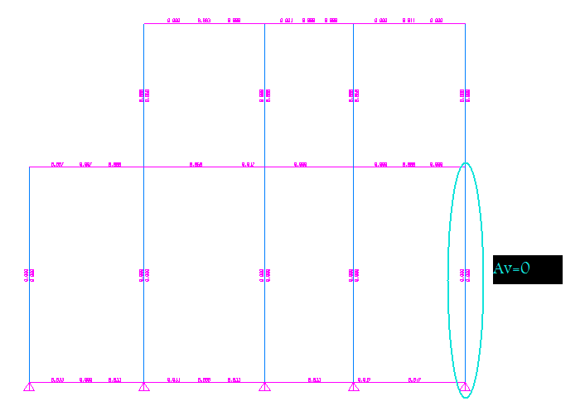
Fig ( 4-10 )As of shear from sap2000

Use 1Ф10/25 cm. Ф=10 mm

4.5.2. Column Design of Block B
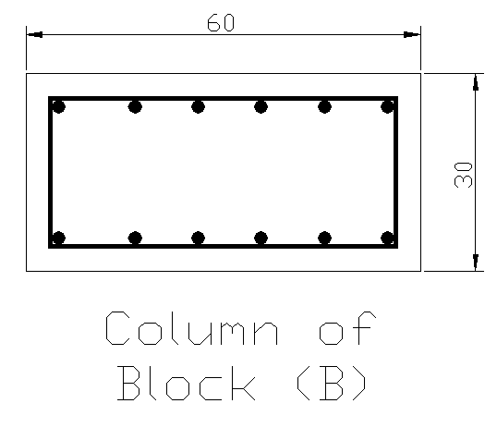
Fig(4-11)column section for Block B
4.5.2.a Exterior column (rectangular C30):
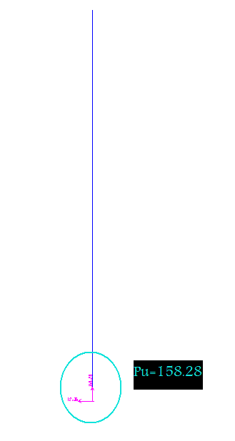
Dimension:
B=30, h=60 cm
I_{c}=1.35*10⁻³ m⁴,
I_{B1}=0.01 m⁴,
I_{EB4}=0.1372 m⁴
Pu=158.28 ton
𝓜₁=3.05ton.m,₂=3.75ton.m
From sap 2000 Fig (4-12 )Pu sap2000

In X-X direction:
Ψ_{B}=∑(EI/L)_{C}/∑(EI/L)_{B}
= [(1.35*10⁻³ /4) + (1.35*10⁻³ /5)] / (0.01/3.18+0.01/6)
= 0.13
Ψ_{T} =∑ (EI/L) _{C}/∑ (EI/L) _{B}
= [(1.35*10⁻³ /5)/ (0.1372/3.18)] =0
K=0.54 (braced)
r=0.087
Lu=4
Kl/r=0.54*4/0.087=24.83< 34+12*3.05/3.75=43.76
Short column in X-X direction
In Y-Y direction:
Ψ_{B}= 0.12
Ψ_{T}= 0
(Braced)
K=0.54
R=0.087
Lu=4
KL/r=0.54*4.4/0.087=24.83 < 43.76
Short column in Y-Y direction
Design of short column:
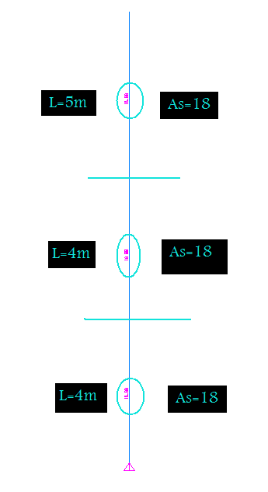
Fig ( 4-13 )As from sap2000
𝓜u/Pu =3.75/158.28=0.024 m
𝜌=𝜌min=0.01
Take As =0.01Ag
AS=0.01*1800=18cm²
As= (8 ф 18)

Check strength:
Pd=фPn=ф*λ {0.85* 𝒇'c (Ag-As) +As* ℱy}
158.28*10³=0.65*0.80{0.85*240*0.99Ag+0.01*Ag*4200}
Ag=158.28*10³/126.9=1247 cm²
We take 60*30 =1800 cm² ok
e_{min}=0.1*h
=0.1*0.6=0.06 m
e_{min} > e ok
𝓜_{min}=e_{min}*Pu
=0.06*158.28 =9.5ton.m
𝓜=3.75 ton.m < 𝓜_{min}.
No need for moment reinforcement.

Shear Design:
Vu=5.53ton
Nu _{(axial load)} =21.8 ton from sap2000
фVc={0.75*0.53√240*30*55{1+21.8*10³/140*1800}}/10³
=11.04> 5.53 ton.
No need for shear reinforcement
use Min shear reinforcement.
[Av/S]_{min}=max {3.5*b_{w}/ ℱy} or {0.2* b_{w}√ 𝒇'c/ ℱy}
={3.5*30/4200=0.073} or {0.2*30* √240/4200=.022}
[Av/S]_{min}=0.05
Use 1Ф10/25 cm.
4.5.2.b Interior column (rectangular C56):
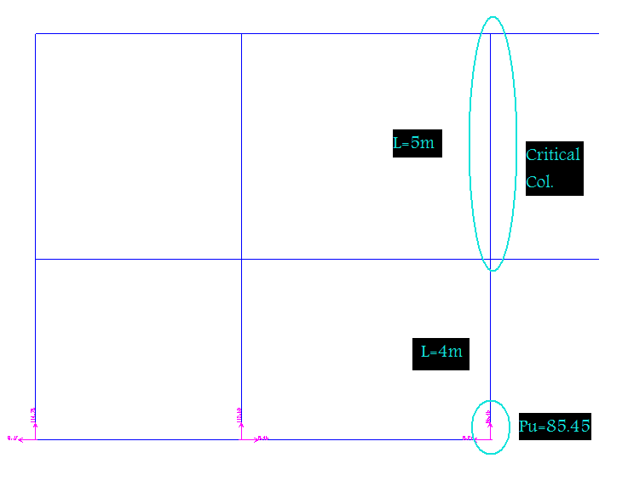
Fig (4-14) Pu from sap2000
Dimension:
B=30, h=60 cm
I_{c}=1.35*10⁻³ m⁴
I_{B3}=6.3*10⁻³ m⁴
I_{B02W}=6.3*10⁻³ m⁴
Pu=85.45ton
DL=48.06 ton.
𝓜 ₁=2.89ton.m,
𝓜₂=3.14 ton.m
From sap 2000

In X-X direction:
ΨB=∑ (EI/L) _{C}/∑ (EI/L) _{B}
= [(1.35*10⁻³/4) + (1.35*10⁻³/5)]/ [(6.3*10⁻³/5.48+6.3*10⁻³/2.42)]
=0.16
ΨT=∑ (EI/L) _{C}/∑ (EI/L) _{B}
= (1.35*10-3/5)]/[(6.3*10- 3/5.48+ 6.3*10-3/2.42)]
=0.072
K=0.85 (braced)
r=0.087
Lu=4.4
Kl/r=0.58*4.4/0.087=29.33 > 34-12*2.89/3.14=22.96
Long column in X-X direction

In Y-Y direction:
ΨB= .25
ΨT=0.11
(Braced)
K=0.58
R=0.087
Lu=4.4
Kl/r=0.85*4.4/0.087=29.33> 34-12*2.89/3.14=22.96
Long column in Y-Y direction

Design of long column:
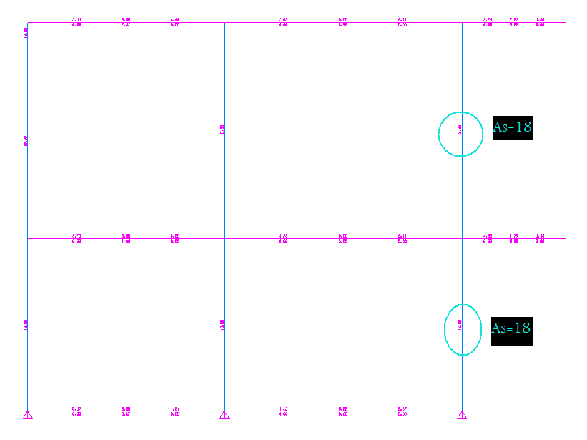Fig (4-15) As from sap2000
Bd=1.2D/Pu
=1.2*48.06/85.45
=0.675
Ieff=0.4*Ig/ (1+ Bd)
=0.4*1.35*10-3/ (1+0.675)
=3.224*10-4 m4 =32240cm4
Pcr=π² (EI)/ (KL) ²
= (π²*151000√240*32240)/ ((0.85*4.4*100)²*1000)
=1142.92 ton
Cm=0.6+0.4(𝓜 1/𝓜2)
=0.6+0.4(2.89/3.14) =0.97
$δ$ns =Cm/(1-Pu/ фPc)
=0.97/ (1-85.45/ (0.75*1142.93))
=1.077
𝓜c=$δ$ns*𝓜u
=1.077*3.14 =3.38 ton.m
e_{min}=0.015+0.03*0.3=0.024m
𝓜min= e_{min} *Pu
=0.024*85.45 =2.015 ton.m
𝓜c < 𝓜min so that design for moment should not be performed.
The nominal compressive strength for axially loaded column is:
Take As =0.01Ag
As=0.01*Ag=0.01*1800=18 cm2

Check strength:
Pd=фPn=ф*λ {0.85* 𝒇'c (Ag-As) +As* ℱy}
=0.65*0.8{0.85*240(60*30-0.01*1800) +1800*0.01*4200
=244071 Kg =244.07 ton> Pu ok

Shear Design:
Vu=0.0.853 ton , Nu _{(axial load)} =82.9 ton from sap2000
ФVc=0.75*0.53√ 𝒇'c*b*d {1+ Nu/140*Ag}
={0.75*0.53√240*55*30{1+82.9*103/140*1800}}/103
=13.5 ton > 0.0048 ton
No need for shear reinforcement use Min shear reinforcement.
[Av/S]min=max {3.5*bw/ ℱy} or {0.2* bw√ 𝒇'c/ ℱy}
= {3.5*30/4200=0.073}
Or {0.2*30* √240/4200}
[Av/S]min=0.025
Ф=10 mm
Use 1 Ф10/25 cm.

