

An-Najah National University
Faculty of Engineering
Chemical Engineering Department
ـــــــــــــــــــــــــــــــــــــــــــــــــــــــــــــــــــــــــــــــــــــــــــــــــــــــــــــــــــــــــــــــ
Graduation Project
Modification of Tire Pyrolysis Oil

Prepared by:
Ahlam Rabay'a

Ahmad Abd Alrazeq
Moayed Jaber
Saja Makhlouf

Submitted to:
Dr. Abd_Alrahem Abusafa
A Graduation Project Submitted to Chemical Engineering Department in Partial Fulfillment of the Requirements for B.S.C/Degree in Chemical Engineering
May, 4, 2015
الإهداء

إلى اللذین أخذا بیدي ووفرا لي سبیل التعلم وكانا لي الوجه الطافح حبا وحنانا،
"والدي الكرام"
إلى من تتلمذت على أیادیھم ،وإلى من أمدوني بنصائحھم، وتوجیھاتھم،
" أساتذتي "
إلى من كانوا لي حشدا لھمتي ,
"إلى كل أفراد دفعتي دون استثناء"

إلى كل هؤلاء أھدي ثمرة ھذا الجھد المتواضع

Disclaimer:
This report was written by student(s) ( Ahlam Rabay'a, Ahmad Abd Alrazeq, Moayed Jaber and Saja Makhlouf ) at the Engineering Department, Faculty of Engineering, An-Najah National University. It has not been altered or corrected, other than editorial corrections, as a result of assessment and it may contain language as well as content errors. The views expressed in it together with any outcomes and recommendations are solely those of the student(s). An-Najah National University accepts no responsibility or liability for the consequences of this report being used for a purpose other than the purpose for which it was commissioned.

Abstract:

Waste tire pyrolysis oil has high potential to replace conventional fossil liquid fuels due to its high calorific heating value, However, the large amounts of sulfurous compounds in this oil hinders its application.

Thus, the aim of this review study was to investigate the possibility to apply the additives like CaO, CaCO₃and acids like phosphoric acid H3PO4, acetic acid CHCOOH, formic acid HCOOH with clay, at different operating conditions to partially remove sulfurous compounds in the waste tire pyrolysis oil under milder reaction conditions without hydrogen consumption.

This review study was carried out for Pyrolytic oils produced in a local tire pyrolysis plant at Jenin Governorate, and for the oil that was produced by thermal and catalytic cracking designed by Dr_shadi sawalha and his students.

The use of phosphoric acid (8 wt.%) was found more economical and effective in desulfurization and improvement of diesel ,lubricating fuel properties of sample oils. The contribution of lime stone CaCO3(5wt%) additive during pyrolysis process was found effective in improvement of diesel, kerosene and lubricating fuel properties of sample oils.Calcium oxide additive to pyrolytic oil was not found to be effective in desulfurization while calcium oxide(5wt%) additive during pyrolysis process was found effective in desulfurization and improvement of lubricating fuel properties of sample oils.

Table of Contents:
Disclaimer........................................................................................................................................ii
Abstract...........................................................................................................................................iii
Lists of table ................................................................................................................................vii
Lists of figure..................................................................................................................................ix
Chapter one: Introduction
Introduction………………………………………………………………………………………1
- 1.1 Environmental pollution ………………………………………………………….......2
- 1.2 Energy ………………………………………………………………………………...3
1.2.1 Energy problems in the world ……………………………………………………………....4
1.2.2 Energy problems in the Palestine …………………………………………….……………. 4
- 1.3 waste in Palestine ………………………………………………………….……….... 4
- 1.4 pyrolysis …………………………………………………………………….………. 5
Chapter two: Liquid fuels
Liquid fuels ……………………………………………………………………………………....6
- 2.1 Crude ………………………………………………………………………………....7
- 2.2 fuel oils ………………………………………………………………………………..7
2.2.1 Characteristics of Fuel Oils ……………………………………………………………...….8
Chapter three: solid waste
Solid waste ………………….………………………………………………………………….. 11
- 3.1 solid definition ……………………………………………………………………...12
- 3.2 solid sources ………………………………………………………………………..12
- 3.3 Impact of Solid Waste …………………………………………………………….…13
- 3.4 Solid waste recycling and substantial development ………………………………...14
3.4.1 Waste Tires ……………………………………………………………………………….14
3.4.2 Worldwide Waste Tires Quantities ………………………………………………………14
3.4.3 Tires Disposal Methods …………………………………………………………………..15
Chapter four: pyrolysis
Pyrolysis …………………………………………………………………………………………19
- 4.1 Process condition ……………………………………………………………………21
- 4.2 Equipment structure and working principle of pyrolysis ……………………………22
- 4.3 description of the process ……………………………………………….…………..23
- 4.4 Composition of tire pyrolysis product …………………………………...……….…24
4.4.1 Solid product …………………………………………………………………...………....25
4.4.2 Gas product ……………………………………………………………………..……..….26
4.4.3 Steel wire ………………………………………………………………………..……..…27
    - Liquid product ……………………………………………………………………....….27
- 4.5 Success and failure of waste tire pyrolysis ……………………………………...….28
Chapter five: pyrolysis oil
Pyrolysis oil …………………………………………………………………………………..…30
- 5.1 Purification of oil ........................................................................................................33
5.1.1 Desulfurization …………………………………………..……………………………….. 33
5.1.2 Oxidative Desulfurization …………………………………………….……………………………………………..33
5.1.3 Hydrodesulphurization Methods ………………………..…………………………….......33
5.1.4 Distillation of Pyrolytic Oils ……………………………………………………..…….....34
5.1.5 Separation of oil by using clay ……………………………………………………..……...34

Chapter six: Experimental Work
Experimental Work ……………………………………………………………..……….….….35
- 6.1 Distillation part ………………………………………………………………………………………………...36
- 6.2 Desulfurization by Additives ……….……………………………………………………………………..37
- 6.3 acid clay treatment ………………………………………………………………………………………………37

Chapter seven: Results
- 7.1 Fractionally Distilled TPO ……………………………………………………..…..38
7.1.1 Distillation for virgin pyrolysis oil ………………………………………………...….….38
7.1.2 Distillation for pyrolysis oil with calcium oxide ………………………………………….39
7.1.3 Distillation for pyrolysis oil with phosphoric acid …………………………………...…40
7.1.4 Distillation for pyrolysis oil with acetic acid .....................................................................41
7.1.5 Distillation for pyrolysis oil with phosphoric acid and formic acid .................................42
- 7.2 Experimental setup for thermal pyrolysis ………………………….………………43
    - Proximate and Ultimate Analysis …………………………………………..………..…44
      - Tires pyrolysis without additive ……………………………………..…………44
      - Tire pyrolysis reactor with additive CaO ............................................................45
      - Tire pyrolysis reactor with additiveCaCO3 ………………..………….………46

- 7.3 Discussion ………………………………………………………………………....49

Chapter eight

- 8.2 Conclusion .................................................................................................................52
- 8.3 Recommendation …………………………………………………………………..52

References ……………………………………………………………………………………………………………………….…53

List of Tables:
Table (3.1): Solid waste resources ………………………………………………………………16
Table (4.1): Weight percent of pyrolysis product ……………………………………………….24
Table (4.2): Elemental analysis of pyrolysis solid residue (carbon black) ……………………...26
Table (4.3): Pyrolysis gas constituent …………………………………………………………..26
Table(4.4): Properties of pyrolysis oil …………………………………………………………..28
Table (5.1): Properties of diesel, crude TPO, TPO at 30 °C ………………….……………..…..31
Table (5.2): Properties of diesel, crude TPO, TPO at 40°C ..........................................................31
Table (5.3): Fuel properties of waste tire pyrolysis oil ………………………………………………..….32
Table (7.1): results Distillation for virgin pyrolysis oil …………………………………….…….38
Table (7.2): results of Distillation for pyrolysis oil with calcium oxide ………………...………39
Table (7.3): results of Distillation for pyrolysis oil with phosphoric acid ....................................40
Table (7.4): results of Distillation for pyrolysis oil with acetic acid ……………………………….41
Table (7.5): results of Distillation for pyrolysis oil with phosphoric acid and formic acid ..........42
Table (7.6): the result of distillation the tires pyrolysis without additive ………………………...45
Table (7.7): Results of tire pyrolysis reactor with additive Ca………………………………………46
Table (7.8): results of Tire pyrolysis reactor with additiveCaCO3……………………………,…47

List of figure:
Fig (3.1): Solid waste recycling ……………..……..………........................................................16
Fig(4.1): Products of the tire pyrolysis ........................................................................................20
Fig (4.2): Tire pyrolysis product …………………..…………………………………………….24
Fig (6.1) simple distillation………………………………………………………………………35
Fig (7.1): results of distillation for virgin oil product ……………………………………….…39
Fig(7.2): Results of Distillation for pyrolysis oil with calcium oxide…………………….……..40
Fig(7.3): results of Distillation for pyrolysis oil with phosphoric acid………………………….41
Fig(7.4): results of Distillation for pyrolysis oil with acetic acid ……………………………….42
Fig(7.5): Results of Distillation for pyrolysis oil with phosphoric acid and formic acid.............43
Fig(7.6): Plant process of apparatus…………….………………………………………………..43
Fig(7.7): the result of tires pyrolysis without additive in catalytic cracking reactor ...................45
Fig(7.8): the result of distillation the tires pyrolysis without additive…………………………..46
Fig(7.9): Results of tire pyrolysis reactor with additive Cao……………………………………47
Fig(7.10): results of Tire pyrolysis reactor with additiveCaCO3………………………………..48

Chapter one
Introduction

Introduction:
Humans have always inhabit two worlds. One is the natural world of plants, animals, soils, air, and water that preceded us by billions of years and of which we are a part. The other is the world of social institutions and artifacts that we create for ourselves using science, technology, and political organization. Both worlds are essential to our lives, but integrating them successfully causes enduring tensions.
Where earlier people limited ability to alter their surroundings, we now have power to extract and consume resources, produce wastes, and modify our world in ways that threaten both our continued existence. To ensure a sustainable future for ourselves and future generations, we need to understand something about the problems surrounding, how our world works, what we are doing to it, and what we can do to protect and improve it.
1.1 Environmental pollution:
It is well known that the production and use of energy from different sources cause many types of a bad effects of environmental pollution on the environment components such as air, water and land, leading to the disruption of the delicate balance where prevailing. Generally pollution is a risk for many different forms because of the direct and indirect impact on human health as a result of contamination of food and water sources. [1]

Toxic air and water pollutants, along with mountains of solid and hazardous wastes, are becoming overwhelming problems in industrialized countries. We produce hundreds of millions of tons of these dangerous materials annually, and much of it is disposed of in dangerous and irresponsible ways.
The types of pollution as follows:
- Water pollution: contamination of natural water bodies by chemical, physical, radioactive or pathogenic microbial substances
- Air pollution: is substance in the air that can have adverse effects on humans and ecosystem such as ash from a volcanic eruption.

- Land pollution: two main parts
- Soil Pollution: basically caused by chemicals which have lots of advantages for the human beings.
- Solid Waste: means any kind of rubbish, tire, Paper, cardboard, plastic, wood, food wastes, glass, metal wastes, ashes, hazardous wastes

1.2 Energy:

There are main different sources of energy that are used in the world to generate power. All of these different sources of energy are used primarily to produce electricity, Here is an overview of each of the different sources of energy that are in use, and what’s the potential issue for each of them.[2]

- Fossil Fuels (Coal, Oil and Natural Gas):

When most people talk about the different sources of energy they list natural gas, coal and oil as the options – these are all considered to be just one source of energy from fossil fuels. Fossil fuels provide the power for most of the world, primarily using coal and oil. Oil is converted into many products, the most used of which is gasoline.

Natural gas is starting to become more common, but is used mostly for heating applications.

- Solar Energy:

Solar power harvests the energy of the sun through using collector panels to create conditions that can then be turned into a kind of power.

- Wind Energy:

Wind power is becoming more and more common. By using large turbines to take available wind as the power to turn, the turbine can then turn a generator to produce electricity.

1.2.1 Energy problems in the world:
The energy problem is mainly in the over-reliance on non-renewable energy sources 90%, which is vulnerable to the rapid entry into force of the sources, in addition to being sources of energy contaminated carry a lot of environmental risks.

1.2.2 Energy problems in Palestine:
Palestine suffers from a scarcity of natural resources and mineral wealth, but the suffering of the Palestinians most lies in the scarcity of conventional energy sources, such as oil and gas, and higher prices, equivalent to the most expensive cities in the world, and moreover, the Israeli authorities control the size and quantity of fuels and their prices, and when allowed to enter, and when prevent. Inspired by this suffering and because of them, Palestinians seek to overcome this dilemma is to find alternative sources for conventional fuels. [3]

1.3 Solid waste in Palestine:
The world in general and Palestine in particular, are facing problem of solid waste, because of the increasing numbers of the population, and the lack of material resources needed to solved this problem and reduce the risks ,the weakness of technical expertise for the management of solid waste, Israel's long years of occupation of the Palestinian territories.
Therefore, we find that solid waste is collected random ways, and assembled in the dumps contrary to the conditions of environmental health, but it's not the solution. Waste to energy process is very simple concept getting the maximum energy from waste, with minimum damage to the environment ,by pyrolysis process. [3]

1.4 Pyrolysis:
Pyrolysis is a form of incineration that chemically decomposes organic materials by heat in the absence of oxygen. Pyrolysis typically occurs under pressure and at operating temperatures above 430 °C and the main products from the pyrolysis of waste tires: solid (char), liquid (oil), and gas. The oil is similar to a commercial Diesel fuel, but sulphur content is higher and cetane number lowe at range (45-55). So we have to desulfurization and purified it, by different process and different operating conditions. [4]

The main objectives can be summarized as the following:
- Investigate the fuels and their important properties.
- Give an overview of solid waste in terms of quantities and methods of disposal.
- Study the pyrolysis process as a method of energy recovery from used car tires.
- Review the literature to find the best practices for modification of pyorlysed oil.

Chapter two
Liquid Fuels

Liquid fuels:
Liquid fuels, with few exceptions, are mixtures of hydrocarbons derived by refining crude petroleum. In addition to hydrocarbons, crude petroleum usually contains small quantities of sulfur, oxygen, nitrogen, vanadium, other trace metals, and impurities such as water and sediment. Refining produces a variety of fuels and other products. Nearly all lighter hydrocarbons are refined into fuels (e.g., liquefied petroleum gases, gasoline, kerosene, jet fuels, diesel fuels, and light heating oil’s). Heavy hydrocarbons are refined into residual fuel oils and other products (e.g., lubricating oils, waxes, petroleum coke, and asphalt). [5]

2.1 Crude:
Crude petroleum from different oil fields vary in hydrocarbon molecular structure. Crude is paraffin-base (principally chain-structured paraffin hydrocarbons), naphthalene - or asphaltic-base (containing relatively large quantities of saturated ring-structure naphthenes), aromatic-base (containing relatively large quantities of unsaturated, ring-structural aromatics), or mixed - or intermediate- base (between paraffin - and naphthalene - base crudes). Except for heavy fuel oils, the crude type has little significant effect on resultant products and combustion applications.

2.2 fuel oils:
Low-sulfur residual fuel oils are marketed in many areas to permit users to meet sulfur dioxide emission regulations. These fuel oils are produced:
(1) By refinery processes that remove sulfur from the oil (hydro desulfurization).
(2) By blending high-sulfur residual oils with low-sulfur distillate oils.
(3) By a combination of these methods.

Fuels, as for any other type of substance, can be assigned some physical and chemical properties (e.g. density, thermal capacity, vapour pressure, chemical formula, etc. However, most of the times, combustion properties are also assigned to fuels, in spite of the fact that these properties depend on the oxidiser (e.g. air, pure oxygen) and the actual process (e.g. the explosion limits depend on the boundary conditions for a given fuel/oxidiser pair). Fuel price, availability, risk, and so on, could also be considered fuel properties. [5]
2.2.1 Characteristics of Fuel Oils:
Characteristics that determine grade classification and suitability for given applications are:
- Density
- viscosity
- flash point
- pour point
- water and sediment content
- carbon residue
- ash
- distillation qualities or distillation temperature ranges
- specific gravity
- sulfur content
- heating value
- carbon-hydrogen content
Density is a fuel property which has direct effects on the engine performance characteristics. Many fuel properties such as cetane number and heating value are related to the density. Fuel density influences the efficiency of fuel atomization and combustion characteristics. Because diesel fuel injection systems meter the fuel by volume, the change of the fuel density will influence the engine output power due to a different mass injected fuel .The ethanol density is lower than diesel fuel density, but biodiesel density higher. [6]
Viscosity is one of the most important fuel properties. The viscosity has effects on the atomization quality, the size of fuel drop, the jet penetration and it influences the quality of combustion. The fuel viscosity is limited both upper and lower. It must be low enough to flow freely at its lowest operational temperature. Too low viscosity can cause leakage in the fuel system. High viscosity causes poor fuel atomization and incomplete combustion, increases the engine deposits, needs more energy to pump the fuel and causes more problems in cold weather because viscosity increases as the temperature decreases. Viscosity also affects injectors and fuel pump lubrication. [7]
The flash point is defined as the lowest temperature corrected to a barometric pressure of 101.3 KPa at which application of an ignition source causes the vapor above the sample to ignite under specified conditions of test. It gives an approximation to the temperature at which the vapour pressure reaches the lower flammable limit. The flash point does not affect the combustion directly, higher values makes fuels more safety with regard to storage, fuel handling and transportation. The flash point is higher than 120°C for biodiesel, must be greater than 55°C for diesel fuel .and it is below 16°C for bio ethanol. In Case of biodiesel-diesel fuel blends the flash point of the blends increase with the increase of biodiesel content.
Pour point is the lowest temperature at which a fuel can be stored and handled. Fuels with higher pour points can be used when heated storage and piping facilities are provided.
Water and sediment content should be low to prevent fouling the facilities. Sediment accumulates on filter screens and burner parts. Water in distillate fuels can cause tanks to corrode and emulsions to form in residual oil.
Carbon residue is obtained by a test in which the oil sample is destructively distilled in the absence of air. When commercial fuels are used in proper burners, this residue has almost no relationship to soot deposits, except indirectly when deposits are formed by vaporizing burners.
Ash is the noncombustible material in oil. An excessive amount indicates the presence of materials that cause high wear on burner pumps. The distillation test shows the volatility and ease of vaporization of a fuel.
Specific gravity is the ratio of the density of a fuel oil to the density of water at a specific temperature. Specific gravities cover a range in each grade, with some overlap between distillate and residual grades. API gravity (developed by the American Petroleum Institute) is a parameter widely used in place of specific gravity. It is obtained by the following formula, where Specific gravities at 60/60°F is the ratio of the mass of a given volume of oil at 60°F to the mass of the same volume of water at 60°F. The API gravity of water at 60°F is 10.0.
Air pollution considerations are important in determining the allowable sulfur content of fuel oils. Sulfur content is frequently limited by legislation aimed at reducing sulfur oxide emissions from combustion equipment. These laws require sulfur content to be below a certain level, usually 1.0, 0.5, or 0.3 %.
Sulfur in fuel oils is also undesirable because of the corrosiveness of sulfur compounds in the flue gas. Although low-temperature corrosion can be minimized by maintaining the stack at temperatures above the dew point of the flue gas, this limits the overall thermal efficiency of combustion equipment. For certain industrial applications, the sulfur content of a fuel must be limited because of adverse effects on product quality. The applications include direct-fired metallurgy where work is performed in the combustion zone.
Heating value is an important property, although ASTM Standard D 396 does not list it as one of the criteria for fuel oil classification. Heating value can generally be correlated with the API gravity. [7]

Chapter three
Solid waste

3.1 Solid definition:
Solid waste which is daily mentioned in our modern society includes either any materials in the solid-state or some liquids, semi-solids in containers which are thrown-away after being used or no more useful. There are various terms relating to solid waste which are widely used. Some people understand it as garbage while others think of rubbish.
It is as easy as pie to look around our neighborhood and figure out what is categorized as solid waste. These are the good examples to distinguish solid waste with many other types of waste: waste tires, scrap metal, furniture, domestic trash, unused toys, empty bottle, etc.
3.2 Solid sources:
Land use and zoning are two considerable sources of solid wastes. In the recent years, there are quite a few approaches in classifying these sources. The following categories, however, are considered as the most helpful and appropriate ones:
- Residential
- Commercial
- Institutional
- Construction and demolition
- Municipal services
- Treatment plant sites
- Industrial
- Agricultural

It is worth noting that definitions and classification of solid waste are not meant to be adequate but vary greatly. It depends on the situation and field which researchers are applying to. Hence, data should be processed with care and reasonable approach when doing research relating to this topic.

3.3 Impact of Solid Waste:
Solid waste without proper and careful process surely leads to series of issues for the society. The first and also the most obvious impact can be seen is the existence of landfills would badly degrade the external appearance of the city. Also, these trashes play a main role in creating other serious problems need addressing.
- Soil and air pollution
The disposal of huge amount of industrial wastes, domestic sewage and unprocessed organic fertilizers severely destroy the balance of soil environment. The solid wastes bring with them the viruses and bacteria of serious illness when being burying under the soil and store them there for years. In the future, as the soil surface is eroded and exposes the garbage back to the air. It would be an ideal opportunity for stored pathogens return and attack the surrounding residents. Also, the wastes will gradually change the pH, which cause the adverse conditions for the living and survival of species utilizing soil as their habitat. Moreover, soil will lose its ability of facilitating crops and food productions which promisingly leads to a food deficit when this situation occurs in a large-scale in the planet.
On the other hand, the decomposition of solid wastes create the toxic gases such as CH₄ .CO₂ , NH₃ … People’s health and living environment are vulnerable to them. The neighborhood areas are also contaminated and this accounts for the upward trend of illness regarding to respiration, skin, eyes and even cancer in these places.
- Water resources
Rainfall must go through the layer of trash buried under soil before joining groundwater. Thus, it would be contaminated and spoiled which is not appropriate for using again. Research has shown that groundwater in polluted regions contain an alert level of heavy metals, organic compounds and viruses. This source of water surely cannot be refined and processed for domestic and manufacturing purposes, as well as become a nutritional source for natural species.
- Social Health
Among the list of toxic wastes which have the worst effect on human health and environment, persistent organic compounds are acknowledged as the most harmful ones They are stable, and long-lasting in normal conditions. The accumulation of these chemicals in human body will consequently cause serious illnesses, especially cancers. They can be met under the forms of waste oil from domestically electric devices, such as lights, transformers and capacitors. Residents of handicraft villages or nearby industrial region and landfill sites are reported to receive the most severe consequences. Abnormal infants, increasing number of respiratory, heart, metal diseases are the most obvious impact that we can observe daily.
3.4 Solid waste recycling and substantial development:
Recycling waste can significantly reduce the toxic emissions into the environment, reducing the pressure on the need to build costly waste treatment facilities and land use; waste of this production process can be raw materials or fuel of other production processes. The significant progress achieved in waste recycling is changing the perception of human-waste as a resource rather than the waste.
3.4.1 Waste Tires:
With the rapid development of automotive industry, “black pollution” is generated by more and more waste tires which are now threatening the human beings’ living environment.
Tire consists of vulcanized rubbers (including styrene butadiene (SBR), natural rubber (NR) and polybutadiene (BR), carbon black, steel, textile cordand small amount of other Additives). The disposal of waste tiers is one of the major environmental issues throughout the world. The durability and immunity of the above material to biological degradation make their disposal and reprocessing difficult. [8]
3.4.2 Worldwide Waste Tires Quantities:
Several million tons of waste tires are generated yearly all over the world, about 2.5 million tons in North America, Japan Produces 1 million tone, and European Community produces more than 2.5 million tons .[9]
In China region, the case is not different especially due to the population and extremely large number of automobiles. China Waste tire generation was expected to be 5.2 million tons in 2010 and thereby becoming one of the world largest producers of waste tires. [9]
Emirates site Economic following news: Center of Waste Management Abu Dhabi revealed that damaged the size of tires in Abu Dhabi, a city of more than 30 million tires, while the number ranges in the western region between 5 to 7 million tires.
In the United States alone, where tire consumption is higher than in any other country, an estimated 250 million scrap tires are being generated annually with no indication of the waste stream slowing. This amounts to more than 1.5% of the municipal solid waste stream or roughly one scrap tire for each person in this country.
In addition, there are some three billion tires stockpiled in US landfills, collection sites, and illegal dumps that pose environmental problems and potential health and fire hazards. In September of 1999, lightning ignited a pile of 5 million scrap tires near Wesley, California, and costs incurred in fighting and extinguishing the fire and for subsequent clean-up of the site are estimated at over $20 million.
In Stockport, England, at a plant that manufactures ground recycled rubber for use in manufacturing safety surfaces, several bags of ground rubber ignited during a shrink-wrap process. The blaze burned out of control and generated large amounts of black smoke killing one man and injuring others. These are only a few of several examples of the dangers of scrap tire stockpiles. Although local, state, and federal governments are desperately. [10]
In Palestine in 2012, about 386 944 scrap tires. [11]
3.4.3 Tires Disposal Methods:
In fact, the most practiced tire recycling methods are tire shredding to recover the steel cords and crumbing of the scrap rubber for use in asphalt and civil engineering projects However, Civil engineering projects do not consume sufficient quantities of crumb rubber to significantly impact scrap tire stockpiles. [8]
Tire recycling (conversion of scrap rubber tires into hydrocarbons for reuse as oils and fuels), and recovery of steel and carbon black, is the most desirable means for economically reclaiming scrap.
Tire recycling is achieved by pyrolysis process of scrap tires. pyrolysis is a thermo chemical decomposition of shredded scrap tires at elevated temperatures in the absence of oxygen (or any halogen). It involves the simultaneous change of chemical composition and physical phase, and is irreversible. The tier pyrlytic product is oil, gas, coal.
Table (3.1): solid waste resources:
Source | Typical Facilities, Activities, or Locations Where Wastes Are Generated | Types of Solid Wastes
Residential | Single-family and multifamily dwellings; low-, medium-, and high-rise apartments | Food waste, paper, cardboard, plastics, textiles, leather, yard wastes, wood glass, tin cans, aluminum other metal, ashes, street leaves, special wastes (including bulky items, consumer electronics, white goods, yard wastes collected separately, batteries, oil, and tires) household hazardous wastes
Commercial | Stores, restaurants, markets, office buildings, hotels, motels, print shops, service stations, and auto repair shops | Paper, cardboard, plastics, wood, food wastes, glass, metal wastes, ashes, special wastes (see above), hazardous wastes
Institutional | Schools, hospitals, prisons, governmental centers | As above for commercial
Industrial  (Non- process waste) | Constructions, fabrication, light and heavy manufacturing, refineries chemical plants, power plants, demolition | Paper, cardboard, plastics, wood, food wastes, glass, metal wastes, ashes, special wastes (see above), hazardous wastes
Municipal solid waste | All of the above | All of the above
Construction and demolition | New construction sites, road repair renovation sites, razing of buildings, broken pavement | Wood, steel, concrete, dirt
Municipal services  (excluding treatment facilities) | Street cleaning, landscaping, catch-basin cleaning, parks and beaches, other recreational areas | Special wastes, rubbish, street sweepings, landscape and tree trimmings, catch-basin debris, general wastes from parks, beaches and recreational areas
Treatment plant sites | Water, wastewater, and industrial treatment processes | Treatment plant wastes, principally composed of residual sludges and other residual materials
Industrial | Construction, fabrication, light and heavy manufacturing, refineries chemical plants, power plants, demolition | Industrial process wastes, scrap materials, nonindustrial waste, including food wastes, rubbish, ashes, demolition and construction wastes, special wastes, hazardous waste
Agricultural | Field and row crops, orchards, vineyards, dairies, feedlots, farms | Spoiled food wastes, agricultural wastes, rubbish, hazardous wastes

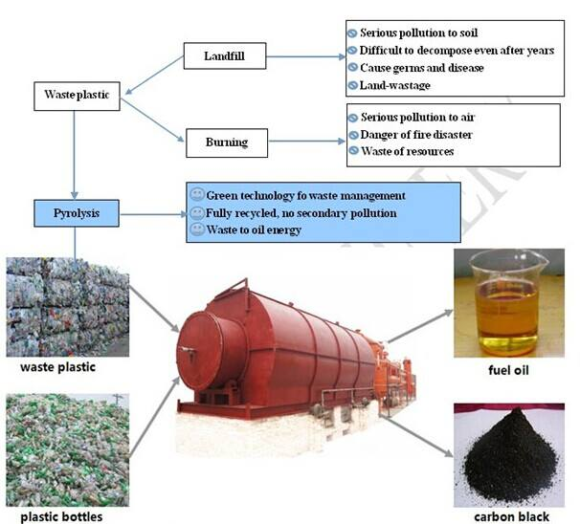
Fig(3.1):Solid waste recycling

Chapter four
Pyrolysis

Pyrolysis:
Pyrolysis is a form of incineration that chemically decomposes organic materials by heat in the absence of oxygen. Pyrolysis typically occurs under pressure and at operating temperatures above 430 °C (800 °F).
In practice, it is not possible to achieve a completely oxygen free atmosphere. Because some oxygen is present in any pyrolysis system, a small amount of oxidation occurs. If volatile or semi volatile materials are present in the waste, thermal desorption will also occur.
The products of the tire pyrolysis process are: Solid residue (30-35 wt %), liquid residue (40-45 wt %), scrap steel (10-15 wt %) and gases (10-15 wt %). [12]

Fig (4.1): products of the tire pyrolysis

4.1. Process condition:
Literature Review:
Pyrolysis of waste tires leads to the production of a solid carbon residue (char), a condensable fraction (pyro-oil) and gases. The percentage of each phase is influenced by process conditions, such as temperature, pressure, heating rate, particle sizes, heat exchange system, catalysis etc.
Williamset. Al [13] pyrolysing waste tire at a temperature between 300 and 720°C and heating rates 5 and 80°C. min⁻¹ found that the maximum conversion of tire occurred at a temperature of 600°C.
Laresgoiti et al. [14] found that the temperature does not significantly influence the char and gas yields over 500°C. However, temperature variations influence the gas composition.
Rodriguez et. al. [15] pyrolysed cross-section samples (2-3 cm wide), representative of whole tire, at 300-700°C. They report that Tire-pyrolysis liquids are a complex mixture of hydrocarbons, which contains 0.4% of N and1.2% of S. About 30% of such liquids are an easily distillable fraction with boiling points (70-210°C) and about 60% of liquids have boiling point range of 150-370°C
Berrueco et al. [16] analyzed the temperature influence on the global yields and the gas composition. They observed that the liquid yield increases with temperature from 400 to 500°C. However at temperatures higher than 500°C, this parameter remained almost constant. The gas yield showed a growth from 2.4 wt% at 400°C to 4.4 wt% at 700°C.
A different distribution of tire into yields (char, liquid and gas) was reported by Chang(30-53 wt% gas, 28-42 wt% oil and 14-28 wt% char).
Zabanioti and Stavropolos.[17] pyrolysing tire in a helium atmosphere in the temperature range 390-890°C and heating rates of 70-90°C min ^{–1} found out that the char yield decreases with temperature reaching an asymptotic value of 20 wt% of raw material, at about 830°C. The gas yield (condensable and non condensable) increases with temperature reaching an asymptotic value of 73wt.% of raw material, at about 830°C.
Barobboti et al. [18] pyrolysed tires in temperature range of400-460°C, nitrogen flow rate of 02-0.5 m³h⁻¹and particle size of 2-20 mm. As optimum conditions they present 430°C, 0.35 m³h⁻¹ and 10 mm, respectively. At these conditions the yield of char and liquid were 32.5 and 51.0 wt%, respectively.
Lee et al. [19] studied pyrolysis of waste tires with partial oxidation in a fluidized bed reactor. They found that with increasing O₂ concentration, the gas yield increases from (22- 43) % since CO₂ generation increases. Energy recovery is about 0.32 with O₂ concentrations up to, 6.5 %, thereafter, energy recovery is reduced to 0.24.
Roy et al. [20] pyrolysed tire rubber at 500°C and a total pressure varying between 0.8 and 28.0 KPa. They found that the yields of gas, oil and pyrolytic carbon black changed little with the pyrolysis pressure. However, the oil composition and the carbon black characteristics depended considerably on the pyrolysis pressure.
4.2 Equipment structure and working principle of pyrolysis:
The Equipment is composed of nine parts:
1) Reactor
2) Emissions Scrubber System
3) Feeding-in System.
4) Dedusting System.
5) Condensation System.
6) Storage oil System.
7) Fuel gas heating system (waste gas processing system).
8) Carbon black slag system.
9) Flue dust removal system.

4.3 Description of the process:
The pyrolysis reactor is a horizontal type revolving split processor which rotates on a horizontal axis. It is a two walled reactor, inside the first wall it is filled with scrap rubber tyres with the help of feeding in system and between the first and second wall it is filled with fuels like coal, wood, un liquefied gas. The Reactor has an adjustable rotation rate from 0.4-0.8 rpm.
The reactor is heated externally. Sealing of reactor is a difficulty technology, pyrolyser. The internal pressure of the reactor is higher than atmospheric pressure. A special friction-type seal was designed and successfully applied to the pyrolysis system with high temperature. But the use of rotary reactor is advantageous for other pyrolysis technologies. Solid wastes with different shapes, sizes, and heating values can be fed into the reactor in batches or continually.
The Reactor is loaded with tires and heated up by the fuel under it. The scrap tires will get converted to gases which is a complex mixture of hydrocarbons and slag when it heated up to a temperature of 700°C in the reactor. The exhaust gases at 550 °C will be transmitted by the pipe on the top of the cracking reactor to the scrubber where impurities such as ash are removed from the exhaust gas.
The cleaned exhaust gas is then sent to a dedusting system where the minute impurities are cleaned off before the gas is sent to condensing system. In the condensing system the gases are cooled to 60 °C. The condensation of the gases is done by the heat exchange.
The liquid part of the gases is condensed to crude oil. Liquid crude oil will be delivered to the storage tank and the un liquefied exhaust gases are transported to exhaust gas recycle system which transports the gases to the bottom of the cracking reactor and used as a fuel to heat up the cracking reactor. The carbon black and the steel wire in the reactor are transmitted out with the help of carbon black slag system. [6]

4.4 Composition of tire pyrolysis product:
Use of pyrolysis as a method for recycling waste tire depends on the market for pyrolysis products. For this reason, characterization of pyrolysis products and possibilities of their application in other processes is very important. At present time, the main application for solid char is its use as active carbon, as reinforcement in rubber industry and as smokeless fuel. [6]
The liquid product is used as a fuel, or a source of chemicals, scrap steel can be melted and with some additives it can be used as normal steel and the gas fraction as a fuel in the pyrolysis process. Quantity of the products produced is given in table below. Tire-pyrolysis liquids are a complex mixture of hydrocarbons, which contains 0.4% of N and 1.2% of S.

Table (4.1): weight percent of pyrolysis product
Products | Weight %
Crude TPO | 40-45
Carbon black | 30-35
Scrap steel | 10-15
Gases | 10-15

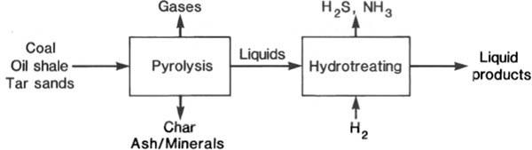
Fig (4.2): Tire pyrolysis product

4.4.1 Solid product:
Carbon Black is one of the main products recycled by pyrolysis technology. The amount of recycled carbon black is 30-35% (depending on the type of tire) of the total amount of scrap tire recycled in the system. Carbon black is used as raw material or main ingredient in many industries and the chemical structure of carbon black strengthens, lengthens the endurance, and improves the coloring features of the materials. [21]
Carbon black produced by pyrolysis application is more economical compared to carbon black produced primarily from petroleum and is more price-efficient to be used as an ingredient in the industries listed:
● Electric cable jacketing
● Conveyor band
● Carrier Bands
● Hose and doormat
● Black nylon bag
● Rubber additive
● Automotive spare parts
● Heat isolation
● Black colorant in rubber materials.

Table (4.2): Elemental analysis of pyrolysis solid residue (carbon black). [21]

Weight % | Element
71 | Carbon
13.3 | Oxygen
5.4 | Iron
2.8 | Sulphur
2.3 | Zinc
1.3 | Calcium
0.3 | Aluminium

4.4.2 Gas product:
From literature review the pyrolysis gases contain CO, CO₂, H₂S and hydrocarbons such as CH₄, C₂H₄, C₃H₆ and C₄H₈, and their unsaturated derivatives. Non-Condensable gasses arise during the recycling application which:
•Has a higher calorific value compared to natural gas.
•Can replace natural gas and propane when stored.
•Can be used as energy resource in gas burners, also used in pyrolysis system.

Table (4.3): pyrolysis gas constituent
Component | Chemical formula
Carbon monoxide | CO
Carbon dioxide | CO₂
Hydrogen sulphide | H₂S
Methane | CH₄
Ethane | C₂H₆
Ethene | C₂H₄
Propane | C₃H₈
Propene | C₂H₆
Butane | C₄H₁₀
Butene | C₄H₈
Butadiene | C₄H₆
Pentane | C₅H₁₂
Pantene | C₅H₁₀
Hexane | C₅H₁₄
Hexene | C₆H₁₂

4.4.3 Steel wire:
Tires contain steel wires and the amount ranges from 10%-15% of the total tire weight. All of the steel present in the tire can be detached after the pyrolysis recycling process is completed. Valuable steel wires are pressed and sold to steel and scrap dealers. [21]
4.4.4 Liquid product:
The liquid phase is the most important product of tire pyrolysis process. Gas chromatography/Mass spectroscopy (GC/MS) is the method for analyzing pyrolysis liquid product, but also for analyzing the gas yield and products of char combustion. Pyrolysis oil contains a lot of aromatics (53.4–74.8%), some nitrogenated (2.47–3.5%) and some oxygenated compounds (2.29–4.85%). [21]
Their GCV 10,000kcal/kg is even higher than that specified for commercial heating oil’s, but the sulphur content (1–1.2%) is close to or slightly below the limit value. Significant quantities of valuable light hydrocarbons such as benzene, toluene, xylene, limonene, etc. were obtained. The concentration of these compounds increases with temperature up to 500°C and then decreases. There is also an important portion of polycyclic aromatics, such as naphthalenes, phenanthrenes, fluorenes, diphenlys, etc.; their concentration as well as that of total aromatics increase significantly with temperature. This oil typically contains 20-25 wt% of naphtha fraction with a boiling point lower than 200°C .The naphtha fraction typically contains 20-25 wt% dl- limonene.
Table(4.4): Properties of pyrolysis oil.
Property | Tire Pyrolysis oil
Heating Value  (kJ/kg) | 43225.9
C (%) | 84.67
H (%) | 10.44
O (%) | 4.17
Cl (%) | n.a
S (%) | ≤1
Density @  30°C (g/cc) | 0.924
Viscosity @  40°C (cp) | 2.69
Flash Point  (°C) | 68

4.5 Success and failure of waste tire pyrolysis:
In 2010, about 3.3 million tones of used tires were managed in an environmentally acceptable manner in the European Union (EU), a 2% increase from 2009About 2.7 million tons of used tires were treated; the balance was either recycled or recovered. [11]
Despite the 30 years of research and development, the pyrolysis of scrap tires and related waste materials has not achieved commercial success in the United States. With economic viability and product quality being the primary stumbling blocks. Despite all these challenges pyrolysis is still considered as a potential waste tire treatment option for developing countries such as South Africa.
Several pyrolysis plants have been shut down in South Africa due to limited and unregulated markets as well as noncompliance with environmental regulations.
South Africa, presently there is one operating pyrolysis plant in Pretoria and another in Durban at the commissioning stage. The Pretoria plant produces pyrolysis oil for industrial applications, the gas is flared and no use for the carbon black has been found. There are 12 other plants in South Africa recycling waste tires for other applications such as rubber crumb, mats and sandals.
The main barriers for the development of tire pyrolysis processes on a commercial scale are: Markets for pyrolytic char are presently not sound. Carbon black char is a fine particulate composed of carbon black, ash, and other inorganic materials, such as zinc oxide, carbonates, and silicates. Its application as virgin carbon black is very much restricted since it contains a lot of impurities ±10% and can only be used as low quality grade carbon black. Similarly the use of char as activated carbon requires upgrading techniques to increase the surface area. Tire pyrolysis oil can be used as a chemical feedstock to recover valuable chemicals such as limonene. However, waste tire oils have a complex mixture of organics and the separation of these compounds to pure products can be costly.

Chapter five
Pyrolysis Oil

Pyrolysis Oil:
Three main products are obtained from the pyrolysis of waste tires: solid (char), liquid, and gas. Char produced from pyrolysis can be used as a solid fuel or as a raw material for activated carbon manufacture. Pyrolysis gas contains high concentrations of hydrogen, carbon dioxide, carbon monoxide, methane, ethane, propane, butadiene, and other hydrocarbon gases with a GCV of approximately 37 MJ/m3 which is enough to provide the energy required by the pyrolysis process.
The pyrolysis liquids, which are oily organic compounds, have a dark-brown color with a strong smell. Density, viscosity and flash point of pyrolytic oils are mostly similar to those of diesel and gasoline while the high percentage of sulfur in pyrolytic oils needs to be separate. The analysis of pyrolytic oils reported by different researchers at varying condition is shown in Table (5.3). Thus Pyrolytic oils have the potential to be used as an alternative fuel provided desulfurized and purified.

Table[5.1]: Properties of diesel, crude TPO, TPO at 30°C:
Property | Conventional Diesel | Crude TPO | TPO
Density(Kg/m³) | 872.3 | 898.7 | 845.6
Viscosity(centi poise)(at 30 °C ) | 4 | 2.8 | 1.51
Calorific value (MJ/Kg) | 45.85 | 41.5 | 42.37
Flash point (°C) | 46 | 40 | 42.37
Pour pointe (°C) | -30 to -40 | -2 | -6

Table (5.2): Properties of diesel, crude TPO, TPO at 40°C:
Property | Conventional Diesel | Crude TPO | TPO
Density(Kg/m³) | 830 | 935 | 871
Viscosity(centi poise)(at 40 °C ) | 2 | 3.2 | 1.7
Calorific value (MJ/Kg) | 46.5 | 42.83 | 45.78
Flash point (°C) | 50 | 43 | 36

Table[ 5.3] :Fuel properties of waste tire pyrolysis oil:
Property | Ref. [26] | Ref. [25] | Ref. [24] | Ref. [23] | Ref. [22]
Flash Point (°C) | 20 | 17.5 | 43 | 65 | 32
Carbon residue (%) | 2.2 | 1.78 | - | - | -
Density (kg L-1) | 0.91 | 0.962 | 0.924 | 0.833 | 0.957
Viscosity cSt (at 40 °C) | 6.30 | - | 3.77 | - | -
Viscosity cSt (at 50 °C) | - | 2.44 | 0.924 | 1.01 | -
Viscosity cSt (at 60 °C) | 2.38 | - | - | - | -
Carbon (wt.%) | 88.0 | 84.26 | - | 79.61 | 85.86
Hydrogen (wt.%) | 9.4 | 10.39 | - | 10.04 | 9.15
Nitrogen (wt.%) | 0.45 | 0.42 | - | 0.94 | 0.65
Sulfur (wt.%) | 1.5 | 1.54 | 0.72 | 0.11 | 1.25
Oxygen (wt.%) | 0.5 | 3.39 | 9.3 | - | 2.87
Initial B.Pt. (°C) | 100 | - | 70 | 38.5 | -
10% B.Pt. (°C) | 140 | - | 114.5 | 58.2 | -
50% B.Pt. (°C) | 264 | - | 296.1 | 174.8 | -
90% B.Pt. (°C) | 355 | - | 386.4 | - | -
Calorific value (MJ kg_1) | 42.0 | 41.7 | 38.0 | 42.66 | 42
Ash (%) | 0.002 | Trace | 0.31 | - | 0.22
Moisture (vol. %) | 4.6 | 0.88 (wt. %) | - | -

5.1 Purification of oil:
Different techniques such as extractive desulfurization, oxidative desulfurization, catalytic desulfurization and hydrodesulphurization have been reported for the desulfurization. [27, 28]

5.1.1 Desulfurization:
Desulfurization of pyrolytic oils can be accomplished by using different additives during pyrolysis or by mixing the additives with the pyrolytic oils after pyrolysis. The commonly used additives are sodium carbonate, zeolite, lime (CaO), and NaOH. Mixing of these additives in different proportions has different desulfurizing effectiveness. [23, 24, 29]

5.1.2 Oxidative Desulfurization:
Oxidative Desulfurization can be carried out at mild operating conditions and have higher efficiency than the hydro desulfurization. In oxidative desulfurization the solvent is added with liquid fuel to remove sulfur content. Acids or mixture of acids are used in oxidative desulfurization. Hydrogen peroxide (H₂O₂ ), Acetic acid (CH₃COOH), Formic acid and Sulfuric acids (H₂SO₄ ) are commonly used in oxidative desulfurization. The use of H₂O₂ in oxidative desulfurization has been reported vigorously because at the completion of conversion H₂O₂ is decomposed into H₂O and O₂, and thus produces no pollutants. The use of acid in combination with hydrogen peroxide (H₂O₂ ) can increase the desulfurization reactions. [26]

5.1.3 Hydrodesulphurization Methods:
Hydrodesulphurization method is common in oil refineries for the removal of sulfur contents of the fossil fuels. High temperature (300–400˚C), high pressure (30–130atm) and active catalysts are required for hydrodesulphurization. Due to high energy demand, the hydrodesulphurization technique becomes uneconomical for the desulfurization of pyrolytic oils. [21]

5.1.4 Distillation of Pyrolytic Oils:
Distillation is useful for separating the liquid fractions. Distillation of desulfurized pyrolytic oil has been investigated by researchers to separate it into its fractions. In a study [30] it was observed that desulfurized pyrolytic oils contain 50% light hydrocarbons which can be easily burn while the remaining 50% heavier hydrocarbons hardly burns. From the distillation temperatures range of pyrolytic oils it was noted that 85% of the pyrolytic oils can be burn in diesel engines. Distillation was carried out between 150-200˚C and it was observed that 80% of the desulfurized pyrolytic oil was distilled easily while the remaining 20% was left out as pyro gas and sludge. [30]

5.1.5 Separation of oil by using clay:
In the first the used lubricating oil is mixed with clay in a reactor .the mixture is preferably heated to between (105 -200) °C .the temperature should not be too great; to avoid cracking the oil. After certain time the mixture is pumped through filter. the clay and contaminant remain in the filter while the oil emerges without the contaminant.[31]

Chapter Six
Experimental
work

Experimental work:
In our project, an alternative fuel for diesel engines will be produced from waste automobile tires by the method of pyrolysis. In order to modify and utilize the pyrolytic oil there are many methods of desulfurization that reduce the high sulfur content of oil such as:
● Desulfurization by Additives as CaO, Ca(OH)₃, CaCO₃.
● Oxidative Desulfurization, acetic acid CH₃COOH, phosphoric acid H₃PO₄ and formic acid HCOOH .
● Acid clay treatment, use the same acid use in Oxidative Desulfurization.
In this report the work was in three procedures:
● Firstly: to distillate the oil that got from company.
● Secondly: to add additive to the oil before distillation.
● Finally: to produce oil by the reactor in the laboratory.
6.1 Distillation part:
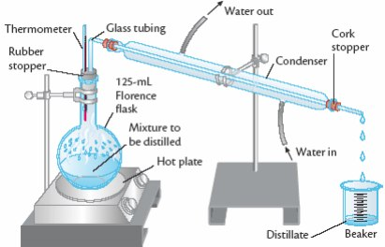
In this part, simple distillation was used as in the figure below:

Figure (6.1): Simple Distillation
Procedure was done by two partition: with additives and without additives. Firstly, 100 mL of oil was added to the flask and heating was started. When heat was raised and oil was boiled at 140 °C, the products were appeared, and the range of temperature when products were appeared was (140-170, 170-220, 220-300, 300-370). The range was compared by petroleum product get product as naphtha, kerosene, diesel, lubricating oil and residue.
6.2 Desulfurization by Additives:
Desulfurization of pyrolytic oils can be accomplished by using different additives during pyrolysis or by mixing the additives with the pyrolytic oils after pyrolysis. The latter is called post treatment of pyrolytic oils.
The commonly used additives are: lime (CaO), slaked lime Ca(OH)₃ and Calcium Carbonate CaCO₃. These additives are mixed in different proportions. 1 % of lime and slaked lime addition to the oil was the best ratio to make the solution very sludgy that don’t have to be distilled (oil disappears).
Desulfurization during pyrolysiscan is achieved at temperature 500 °C where the high liquid is produced. From previous studies mentioned in the literature, the maximum decrease in sulfur content during pyrolysis is achieved at 5 % of Calcium Carbonate, Lime and slaked lime addition to pyrolysis reactor. Sulfur content in the pyrolytic oil is decreased when the amount of the additives increased. The chemical reaction is described in the following equation:
CaO+SO₂→CaSO₃ ……………………..(1). (O. Arpa)
6.3 Acid Clay Treatment:
Firstly, 16 mL of each acid was added to oil with mixing and 40 g of clay was added.
Secondly, a combination of the two acids (8 mL of each one) was added to the oil with mixing and 40 g of clay was added.
Each solutions was left 24 hr before distillation.

Chapter seven
Results and
Discussion

7.1 Fractionally Distilled TPO
7.1.1 Distillation for virgin pyrolysis oil:
In this method the used oil was procured through a pyrolysis plant established recently in Jenin governorate. This plant produces oil from used tiers with heat only and without using any additives either during the heating process or after the production of oil.
The distillation was carried out using 100 mL of oil. The temperature of 170 °C was found to be the boiling point of the oil. The distillation process was started at 170 °C and ended at 370 °C.
35 mL yellow product was produced in the temperature range of 170-220 °C. At 220 °C, no product output was observed.
After that, when the temperature range was changed to (220-280 °C), the product l was 30 mL brown oil. The last product started boiling at 321 °C and finished at 370 °C, it was so dark and about 25 mL. As a result, about 90 % of the feed was converted to products and 10 % residual .

Theoretical fuel properties of distillates that were obtained from petroleum :
1) 140 – 200 °C (Kerosene Range)
2) 200 – 270 °C (Diesel Range)
3) >270 °C (Lubricating Oil) .

Table (7.1): Results Distillation for virgin pyrolysis oil
Temperature range (°C) | Volume of crude oil (mL) | Color | Type of crude oil
170-220 | 35 | Yellow | Kerosene
220-280 | 30 | Brown | Diesel
321-395 | 25 | Dark | Lubricate

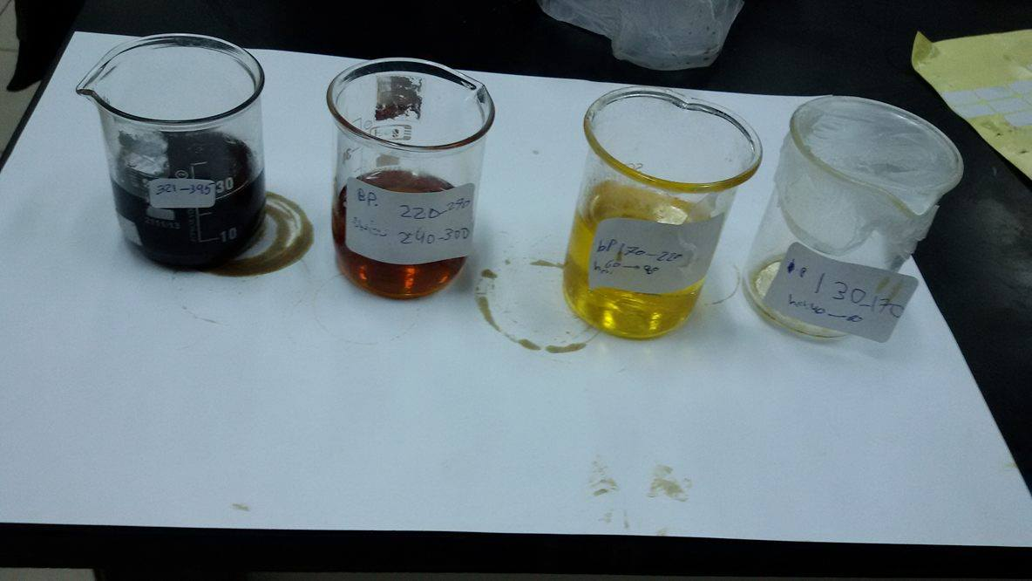

Figure (7.1): Results of distillation for virgin oil product
7.1.2 Distillation for pyrolysis oil with calcium oxide:
The distillation was carried out for 1 g (CaO) that was added to 100 mL oil with mixing for 10 min. The distillation process was started at 180 °C and ended at 280 °C.
10 mL yellow product was produced for the temperature range of 180-280 °C. At 280 °C, no product output was observed. After that, when the temperature range was changed to (280-370 °C), the product l was 30 mL oil color.
As a result, about 40 % of feed was converted to products and 60 % residual.

Table (7.2): Results of Distillation for pyrolysis oil with calcium oxide
Temperature range (°C) | Volume of crude oil (mL) | Color | Type of crude oil
180-280 | 10 | Yellow | Diesel
280-370 | 30 | Oil color | Lubricant

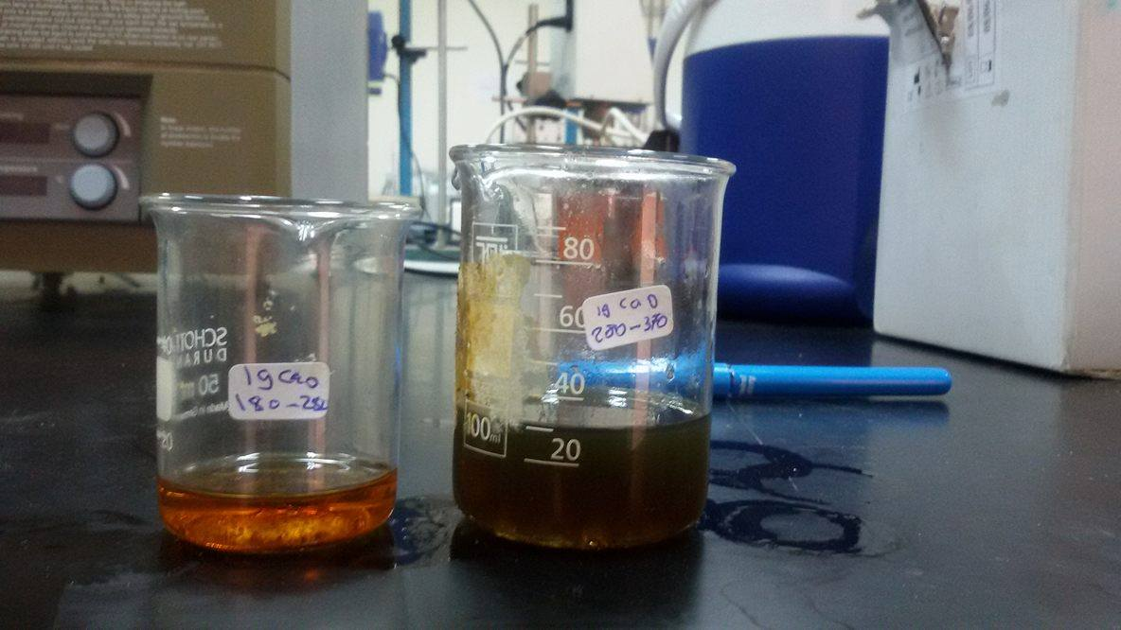

Figure (7.2): Results of distillation for pyrolysis oil with calcium oxide
7.1.3 Distillation for pyrolysis oil with phosphoric acid:
The distillation was carried out for 40 g of clay which was added to 16 mL of H₃PO₄ with mixing for 60 min, then the mixture was added to 200 mL pyrolysis oil and the mixture was left for 8 hr.
About 100 mL was precipitated as a sludge and 100 mL was distilled .Three samples that differ in temperature range, color, volume and type of crude oil were obtained as shown in table (7.3) below.
Table (7.3): Results of distillation for pyrolysis oil with phosphoric acid
Temperature range (°C) | Volume of crude oil (mL) | Color | Type of crude oil
140-290 | 40 | Brown | Diesel
290-330 | 15 | Oil color | Lubricate
Above 330 | 45 | Dark | Lubricate

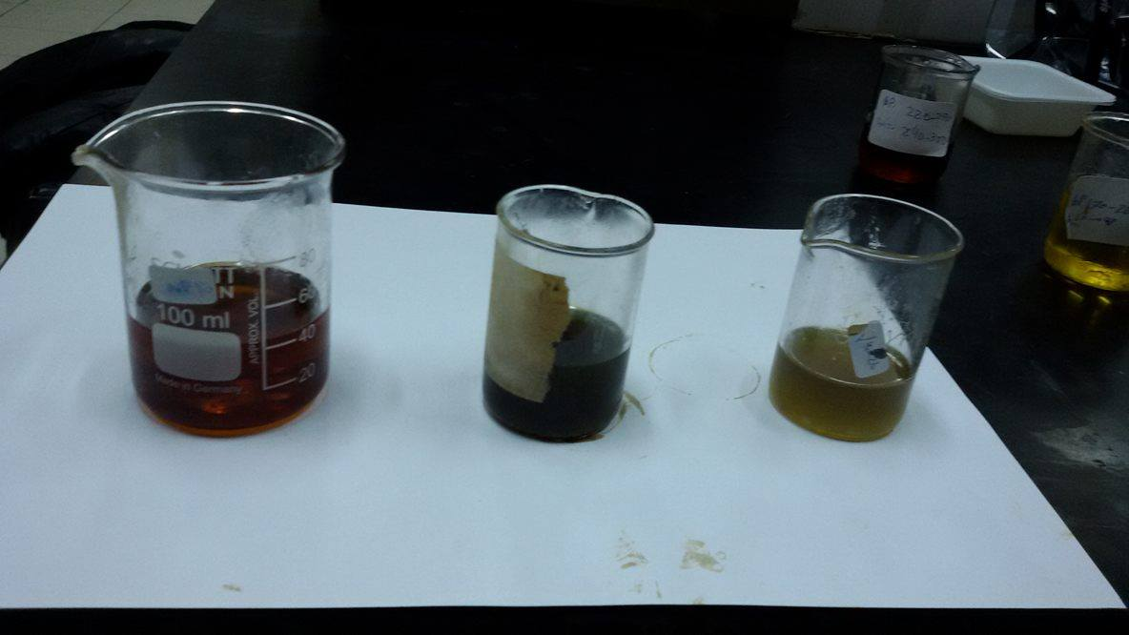

Figure (7.3): Results of distillation for pyrolysis oil with phosphoric acid
7.1.4 Distillation for pyrolysis oil with acetic acid:
The distillation was carried out by adding 40 g of clay to 200 mL pyrolysis oil and 16 mL acetic acid (COOH₃CH) with mixing for 60 min and the mixture was left for 8 hr. About 100 mL was precipitated as a sludge and 100 mL was distilled .
Table (7.4): Results of distillation for pyrolysis oil with acetic acid
Temperature range (°C) | Volume of crude oil (mL) | Color | Type of crude oil
170-310 | 40 | Yellow | Diesel
310-365 | 50 | Dark | Lubricant

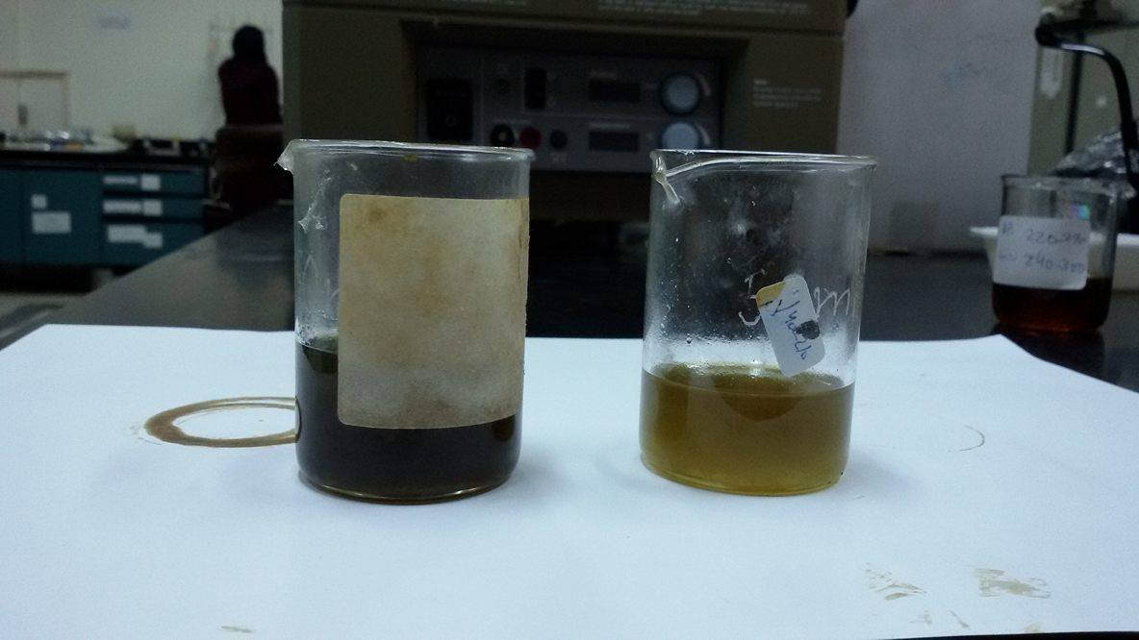

Figure (7.4): Results of distillation for pyrolysis oil with acetic acid
7.1.5 Distillation for pyrolysis oil with phosphoric acid and formic acid :
The distillation was carried out for 8 mL phosphoric acid (H₃PO₄) and 8 mL of formic acid which were added to 200 mL pyrolysis oil and 40 g of clay with mixing for 60 min. The mixture was left for 8 hr.
About 115 mL was precipitated as a sludge and 85 mL was distilled .
Table (7.5): Results of distillation for pyrolysis oil with phosphoric acid and formic acid
Temperature range (°C) | Volume of crude oil (mL) | Color | Type of crude oil
190-220 | 2 | Yellow | Kerosene
220-280 | 6 | Clear yellow | Diesel
280-340 | 8 | Oil color | Lubricate
Above 340 | 15 | Dark | Residue

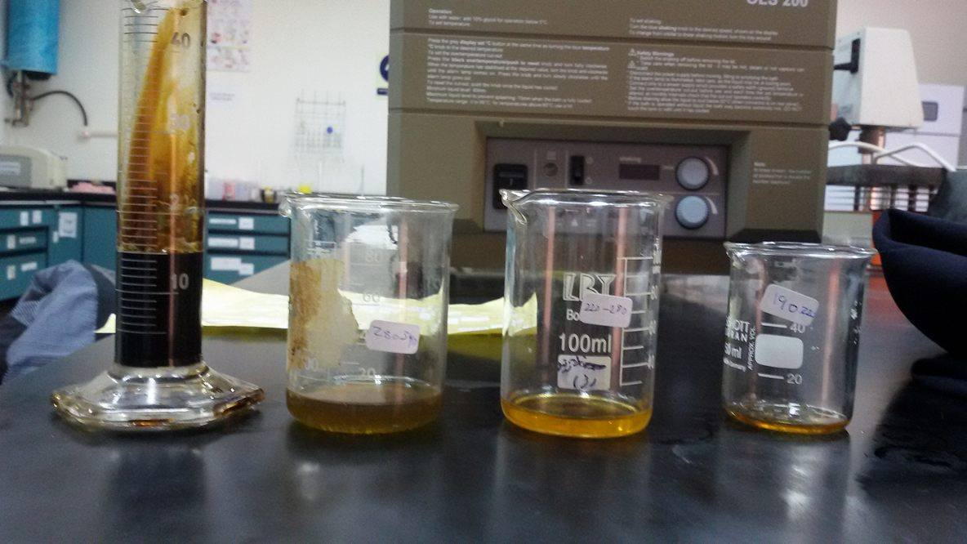

Figure (7.5): Results of distillation for pyrolysis oil with phosphoric acid and formic acid
7.2 Experimental setup for thermal pyrolysis.
Pyrolysis experiments were carried out on waste car tires from 300-550 °C, designed by Eng. Shadi Sawalha and his students.
1 kg of waste tires was taken in the reactor in each run and placed in an electrical heated furnace and the temperature was controlled by controller.

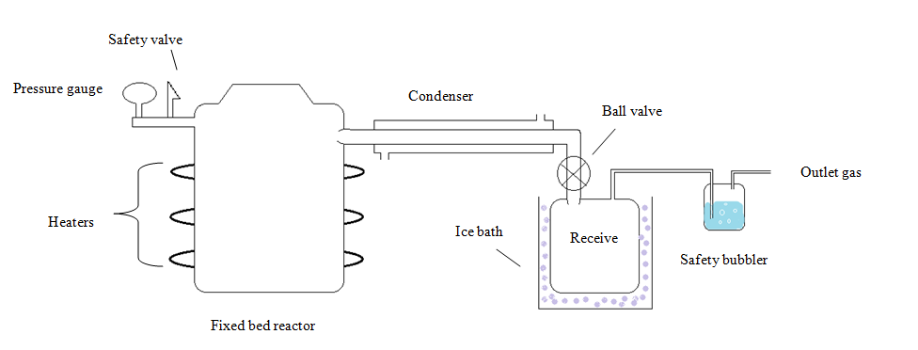
Figure (7.6): Plant process of apparatus
The experimental work for this method was carried out using reactor produced by Eng. Shadi Sawalha and his group. The reactor contains parts that shown in the figure above, the main parts of it are heater and condenser.
The experimental work was done in four parts and at two setup temperature. The first part was by adding the car tier without additives. The second part was by using calcium oxide (CaO) as additive to the car tier. The third one was by adding calcium carbonate (CaCO₃) to the tier. In previous parts, the used temperature was 500 °C. The final part was by using calcium hydro oxide Ca(OH)₂ additives at 400 °C temperature.
In each experiment, 1000 g of car tire were put in the reactor. The final product after pyrolysis was 500 mL as oil product, 500 g as carbon black and 90 g as steel product. This experiment took (60-80) min to finish the pyrolysis tire and no oil was produced from condenser.
    - Proximate and Ultimate Analysis:
      - Tires pyrolysis without additive:
1 kg of tires without additive was fed to catalytic cracking reactor under under a temperature of 500 °C. After 45 min, the products were obtained as follow:
- 401 g coal carbon black
- 95 g steel wire
- 500 mL oil
The 500 mL oil produced from reactor was distilled as in figure (7.7).
The fractional distillation was carried for three temperature ranges as follow:
- 130-170 °C
- 170-220 °C
- 220-270 °C
- 280-360 °C

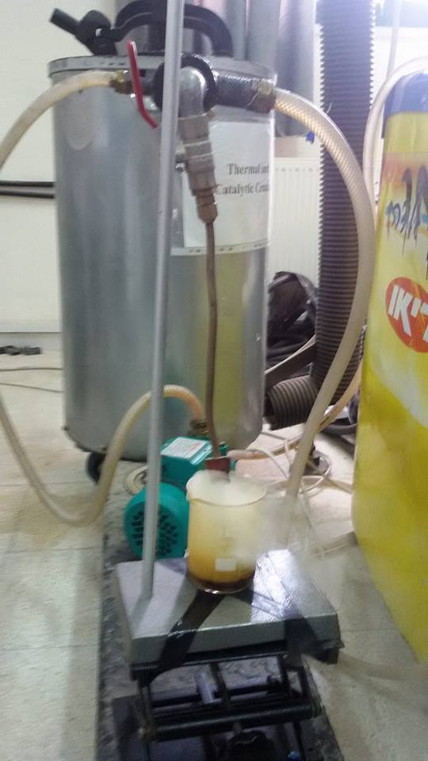

Figure (7.7): The result of tires pyrolysis without additive in catalytic cracking reactor
Table (7.6): The result of distillation the tires pyrolysis without additive .
Temperature range (°C) | Volume of crude oil (mL) | Color | Type of crude oil
130-170 | 2 | Yellow | Kerosene
170-220 | 10 | Clear yellow | Kerosene
220-280 | 20 | Yellow to brown | Diesel
280-360 | 20 | Brown | Lubricate

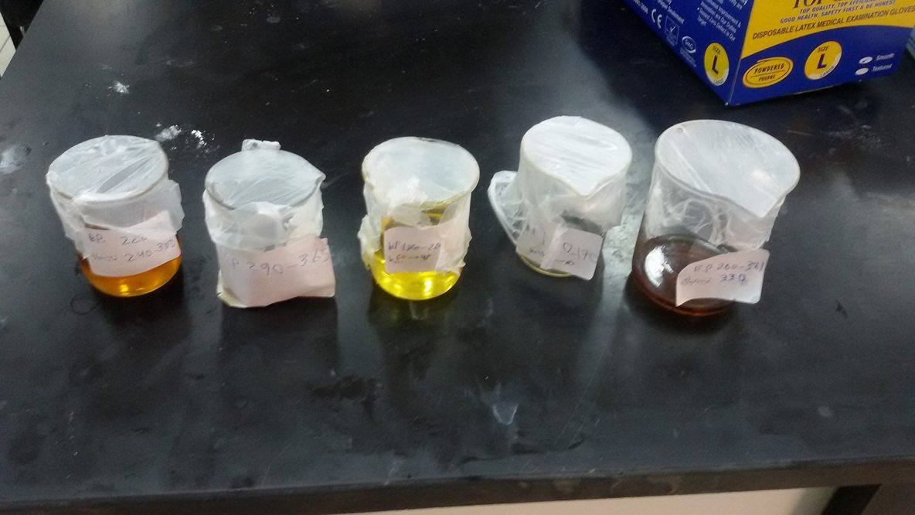

Figure (7.8): The result of distillation the tires pyrolysis without additive

      - Tire pyrolysis reactor with CaO additive:
1 kg of tires with 50 g CaO additive were fed to catalytic cracking reactor under a temperature of 500 °C. The observed product was 500 mL of tire pyrolytic oil, then it was distilled.
The fractional distillation was carried for three temperature ranges as follow:
- 260-300 °C
- 300-330 °C
- 330-360 °C
Table (7.7): Results of tire pyrolysis reactor with additive CaO .
Temperature range (°C) | Volume of crude oil (mL) | Color | Type of crude oil
260-300 | 60 | Dark | Lubricate
300-330 | 50 | Dark | Lubricate
330-360 | 10 | Dark | Lubricate
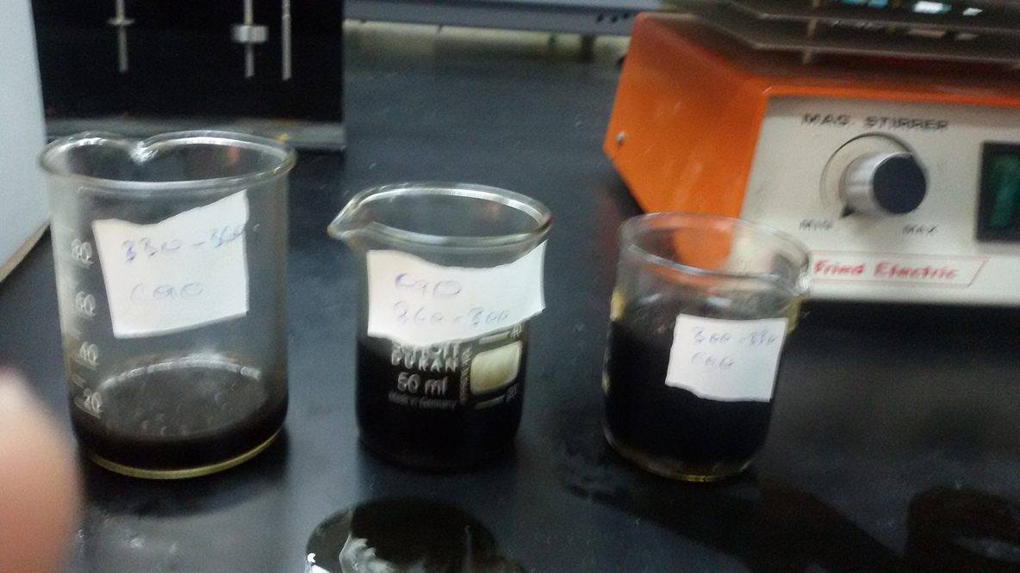
  - Figure (7.9): Results of tire pyrolysis reactor with CaO additive
  - 7.2.1.3 Tire pyrolysis reactor with CaCO₃ additive:
1 kg of tires with 50 g CaCO₃ additive were fed to catalytic cracking reactor under a temperature of 500 °C. The observed product was 500 mL of tire pyrolytic oil, then it was distilled.
The fractional distillation was carried for three temperature ranges as follow:
- 240-260 °C
- 260-300 °C
- 300-320 °C
Table (7.8): Results of Tire pyrolysis reactor with CaCO₃ additive
Temperature range (°C) | Volume of crude oil (mL) | Color | Type of crude oil
240-260 | 10 | Brown | Diesel
260-300 | 19 | Yellow | Kerosene
300-320 | 50 | Dark | Lubricate

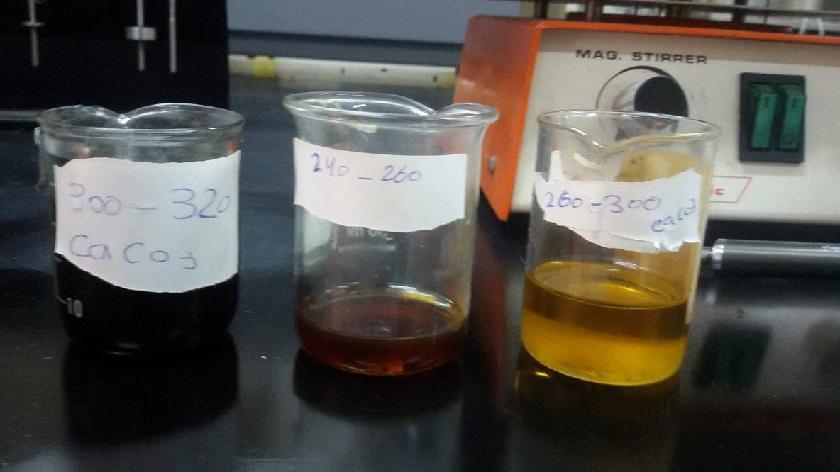

Figure (7.10): Results of Tire pyrolysis reactor with CaCO₃ additive

Tire char residue (30 to 35%), excluding the steel wires produced by waste tire pyrolysis is called tire char, which contains carbon black, high boiling points tar and inorganic ash. The existence of carbon black is due to the fact that carbon black is one of the tire components. Carbon black takes up around 30 % of the original tire mass and is used for strengthening the tire rubber and aid abrasion resistance of tire.[32]
Some studies reported the possibility of using the tire char as a substitute of industrial grade carbon black which is more economical compared to carbon black produced primarily from petroleum and is more price-efficient to be used as an ingredient in the industries like:
1) Electric cable jacketing
2) Conveyor band
3) Carrier Bands
4) Hose and doormat
5) Black nylon bag
6) Rubber additive
7) Automotive spare parts
7.3 Discussion:
The first test was for Pyrolytic oils that obtained from the pyrolysis of car tires (from Jenin plant) which contain high amount of sulfur because sulfur is used for strengthening in tire manufacturing process.
The removal of sulfur was tested with different additives and acids at the same mild operating conditions via oxidative desulfurization. The impact of phosphoric, acetic acid, combination of phosphoric and formic acid and clay, and calcium oxide (CaO) as desulfurizing agent was tested in different quantities at mild experimental conditions.
The other test for pyrolysing of waste car tires without any additive was carried out in catalytic cracker reactor (Eng. Shadi Sawalha) at 500 °C where the high amount of liquid produced, then this produced oil was distilled. The removal of sulfur was tested by pyrolysing of waste tires with additives as CaO ,CaCO₃, then the oil produced was distilled .
The effect of additives on sulfur content is shown in figure (7.3). It is observed from figure (7.1) that the sulfur content of pyrolytic oils is decreased when the phosphoric acid was added to TPO. The maximum desulfurization was achieved by treatment with 8 wt.% phosphoric acid.
Clay “a material made from aluminum silicate” can be used as de-odorizing agent, decolorizing agent and absorbent in purification of waste car tires oils. In this research work, clay was also tested for purification and desulfurization of pyrolytic oils. It is observed that clay does not contribute towards desulfurization of pyrolytic oils. In this research work, the clay amount that used was 40 g (25 % by weight).
The efficiency of acetic acid and phosphoric acid-formic acid mixture on the quality improvement of pyrolytic oil is shown in figures (7.4) and (7.5) respectively. The marginal desulfurization ability of acetic acid and phosphoric acid-formic acid mixture is mainly attributed to the mild operating conditions. The desulfurization ability of these acids may be enhanced at high temperatures, during pyrolysis process but this method cannot be applied because acids at high temperature are very dangerous.
The efficiency of CaO on quality improvement of pyrolytic oils is shown in figure (7.2), which resulting in the desulfurization corresponding to 1 wt.% sulfur in treated oil. The marginal desulfurization ability of CaO is mainly attributed to the mild operating conditions. The desulfurization ability of CaO may be enhanced at high temperatures, during pyrolysis process as mentioned earlier and the percentage of CaO should be less than 1% by weight because when the percentage of CaO is increased, the amount of sludge is increased and this makes the purification process is not economical.
As mentioned earlier, the desulfurization ability of CaO was enhanced at high temperature as shown in figure (7.2). The desulfurization efficiency of CaO was increased at high temperature (500 °C).
Limestone CaCO₃ was also added at high temperature during pyrolysis process and the efficiency of desulfurization ability was very high as shown in figure (7.10).

Chapter Eight
Conclusion
and Recommendation

8.1 Conclusion:
In this research work on pyrolysis process with techniques of desulfurization and purification of pyrolytic oils, the effects of temperature have been discussed. The optimum yield of pyrolytic oils was found in temperature range of 450-500 °C.
Composition and other fuel properties of pyrolytic oil change with varying operating conditions from kerosene range to diesel to lubricant range. The sulfur content of pyrolytic oils can be reduced by using of additives and acids.
Desulfurization of pyrolytic oils can be accomplished by using CaO during pyrolysis or by mixing the additives with the pyrolytic oils after pyrolysis. This latter is called post treatment of pyrolytic oils. The efficiency of adding CaO during pyrolysis at 500 °C is better than mixing of CaO with the pyrolytic oils after pyrolysis process. Moreover, pretreatment fastens the distillation process and makes it smooth. Pretreatment of limestone CaCO₃ (by adding during pyrolysis process) has very high efficiency more than other additive desulfurization because the distilled oils contain wide ranges from kerosene range (yellow color), diesel range (brown color) and lubricant range (oil color).
In oxidative desulfurization of pyrolytic oil, the efficiency of phosphoric acid is better than other acids. High amount of diesel range was produced by phosphoric acid addition (brown color) and more amount of lubricant range was produced (oil color) .

8.2 Recommendation:
There are other methods can be used in the desulfurization of tyre pyrolytic oil which was not used in this research work . including :
- Slaked lime Ca(OH)2 treatment .
- NaOH treatment .
- Acetonitrile treatment(extracting solvent/waste tire pyrolysis oil (v/v) = 4/1).^{[33]}
- Methanol treatment . ^{[33]}
- Concentrated Sulfuric acid treatment and hydrogen peroxide treatment .
- Sodium bicarbonate NaHCO₃ and sodium carbonate Na₂CO₃ treatment .
- TIO2(titanium dioxide) treatment .^{[33]}

These treatment methods of tire pyrolytic oil can be accomplished by using it during pyrolysis or by mixing it with the pyrolytic oils after pyrolysis .

References:
[1] Sharma, V. K.; Fortuna, F; Macarini, M.; Berillo, M; Cornacchia, G. Disposal of waste tyres for energy recovery and safe environment. Appl. Energy, vol. 2000, no. 65, pp 381–394.

[2] Murugan, S. Ramaswamy, M. and Nagarajan, G. "The Use of Tire Pyrolysis Oil in Diesel Engine," waste Management, vol. 28, no. 12, 2008. p. 2743–2749
[3]http://pea-pal.tripod.com/April,30.2016
[4].http://www.cpeo.org/techtree/ttdescript/pyrols.htm .April,30.2016
[5]. Banar, M. V. Alkyildiz, A. Ozkan, Z. Cokaygil and Onay, O. "Characterization of Pyrolytic Oil Obtained from Pyrolysis of TDF (Tire Derived Fuel)," Energy Conservation & Management, 2012. vol. 62, pp. 22-30
[6]. Serumgard J. R. Eastman, A. L. “Scrap Tire Recycling: Regulatory and Market
Development Progress,” ACS Symposium Series 1995, 609, pp. 237-244.

[7]. Gomathi Sankar Thanasekaran properties of various fuel like petrol, diesel on Aug 13, 2015
[8]. Huffman, G. P.; Shah, N. Can waste plastics and tires be recycled economically. CHEMTECH 1998, vol. 28, p.34–43.

[9].Wang H, Xu H, and Xuan X. Review of waste tire reuse and recycling in China –current situation, problems and countermeasures. Vol. 1, Issue 2, July 2013, 81-90

[10]. Roy, C.; Labrecque, B.; de Caumia, B. Recycling of scrap tires to oil and carbon black by pyrolysis. Resour., ConserV. Recycl. 1990,vol. 51,p. 203–213.

[11].The development of national mangle plan for hazardous waste mangment for Palestinian NationalAuthority.EQA

[12].Optimization of fuel production from waste vehicle tires by pyrolysis and resembling to diesel fuel by various desulfurization methods. Ilkılı, H. Aydın and C. Fuel,Vol. 102, 2012, pp. 605–612 .

[13] De Marco, B.M. Caballero, M.A. Cabrero, M.F. Laresgoiti, A. Torres, M.J. Chomón Recycling of automobile shredder resisues by means of pyrolysis J. Anal. Appl. Pyrolysis, 2007; 79 (1-2), 403 - 408

[14].Isabel de Marco Rodriguez, M.F. Laresgoiti, M.A. Cabrero, A. Torres, M.J. Chomon, B. Fuel Processing Technology Vol 72, Issue 1, PP 1-82 (August 2001)

[15]. Berrueco, C. Esperanza, E. Mastral F.J. Ceamanos, J. Garc ´a-Bacaicoa, P. Anal. Appl Pyrolysis , J. vol.73, 2005,pp 65–73
[16]. Zabaniotou, A.A. Stavropoulos, G. Anal. Appl. Pyrolysis vol J. 70 (2003).pp. 711_722
[17].Mahmood M. Barbooti, Thamer J. Mohamed, Alaa A. Hussain and Falak O. Abas, Journal of Analytical and Applied Pyrolysis,vol.72, 2004,pp. 165-170
[18].Jong Min Lee, Jung Soo Lee, Jung Rae Kim and Sang Done Kim, Energy, vol. 20,no .10, pp969-976
[19] Roy, C. Caumia, B. Caumia, B. D. Resour. Conserv. Recy.,vol 4, no1990, pp. 203.
[20].Arevie and discussion of waste tire pyrolysis and derived product . Member, IAENG Nhlanhla. Nkosi and Edison. Muzenda.(2014).
[21] Islam,.M. Tushar and H. Haniu, R. M. "Production of Liquid Fuels and Chemicals from Pyrolysis of Bangladeshi Bicycle/Rickshaw Tire Wastes," Journal of Analytical and Applied Pyrolysis, vol. 82, no. 1, pp. 96-109, 2008.

[22] Banar, M. Alkyildiz, V. Ozkan, Cokaygil A. Z. and Onay, O. "Characterization of Pyrolytic Oil Obtained from Pyrolysis of TDF (Tire Derived Fuel)," Energy Conservation & Management, vol. 62, pp. 22-30, 2012.

[23].S. Murugan, M. Ramaswamy and G. Nagarajan, "The Use of Tyre Pyrolysis Oil in Diesel Engine," waste Management, vol. 28, no. 12, p. 2743–2749, 2008.
[24] Li, S. Yao, Q. Yan and K J. Cen, "Pilot-Scale Pyrolysis of Scrap Tires in a Continuous Rotary Kiln Reactor," Industrial Engineering Chemistry Research, vol. 43, no. 17, pp. 5133-5145, 2004.

[25]. Williams, P. Bottrill R. and Cunliffe, A. "Combustion of Tyre Pyrolysis Oil," Transactions of the Institution of Chemical Engineers, vol. 76, no. 4, pp. 291-301, 1998.

[26]. Alzubaidy, Y. M. Ali, M. Alsuwaidi, R. Alsheikh, A. Attari, F. Leher, A. Raghad, T. Ozkul and K. Zraqi, "Kinetics of Novel Adsorption Desulfurization Techniques for Diesel Fuel Using Different Sorbents," in International Conference on Chemical, Medical and Environmental Issues, Dubai, 2013.

[27].Production of diesel-like fuel from waste engine oil by pyrolitic distillation. O. Arpa, R.Yumrutas and A. Demirbas. Appl Energy, Vol. 87, 2010, pp. 122–127.

[28].Eman A. Emam, 2 Abeer M. Shoaib Re-refining of Used Lube Oil, II- by Solvent/Clay and Acid/Clay-Percolation Processes VOL. 2, NO. 11, Dec 2012

[29].Oxidative desulfurization of tire pyrolysis naphtha in formic acid/H2O2/pyrolysis char system, .D. Bunthid,P. Prasassarakich and N Hinchiranan. Fuel, Vol. 89, 2010, pp. 2617–2622.

[30].Extractive and oxidative-extractive desulfurization of fuels with ionic liquids. Borja Rodríguez-Cabo, Héctor Rodríguez, Eva Rodil, Alberto Arce, Ana Soto. Fuel,Vol. 117, 2014, pp. 882–889.

[31] Rezaun Nabi A.S.M. *, Mahadi Hasan Masud, Q.M.Isteeaqul Alam Purification of TPO (Tire Pyrolytic Oil) and its use in diesel engine 03 (March. 2014)

[32] Williams P T, Besler S. Pyrolysis- thermogravimetric analysis of tyres and tyre components. Fuel.1995; 74: 1277-1283
[33] Photocatalytic Desulfurization of Waste Tire Pyrolysis Oil
Phakakrong Trongkaew 1, Thanes Utistham 2, Prasert Reubroycharoen 3,4 and
Napida Hinchiranan 3,4,* .

