Table of Contents
abstract 3
Chapter1 4
1.1Introduction 4
1.2 Problematic description 4,5
1.3 Applications and features 5
Chapter2 6
2.1methodology 6,7
Chapter3 7
3.1 components 7
3.2 design and construction 7,8,9,10,11
3.3 microcontroller software 12
Chapter4 12
4.1 problems and results 12,13,14,15
Chapter5 15
5.1 future work 15
5.2 Conclusion 15
Refrences 16

Abstract:
The main idea of our laser advertisement projector project is to display characters and texts by reflecting laser beam on a surface, depending on quickly spinning mirrors. With the use of microcontroller circuit, laser beam and constructing a special hardware design. The projector is used for entertainment issues with low cost. This project was carried out by our group as a final year hardware project.

Chapter1
1.1Introduction:
The PIC18F4620 microcontroller is one of the members of the Microchip microcontroller families but equipped with powerful peripherals such as ADC and PWM capabilities. Hence, we used this microcontroller to generate simple and fascinating laser light projector from a cheap keychain laser pointer.
We found that this microcontroller is suitable for controlling the DC motor speed, laser beam and convenient to program with.
The basic idea of laser light shown in many entertainments and advertisements mostly use two methods; the first one is to beam the laser shower on the spectators and the second one is to display the laser drawing pattern on the screen.
In this chapter we will demonstrate the basic idea in details, and the following chapters will discuss the project prototype, design, the constructing process and the final results.
1.2Problematic Description:
The basic idea of the Laser Projector is to create a character projector. By switching on and off a laser beam being reflected off a rotating polygonal mirror, it is possible to display dot matrix style text onto any surface. The prototype we have built uses laser diode taken from cheap key chain laser pointer along with a rotating polygonal mirror which is driven by a brushless 12v dc fan motor. A PIC18 microcontroller controls the motor speed and the laser.
The following figure demonstrates the idea of the project.
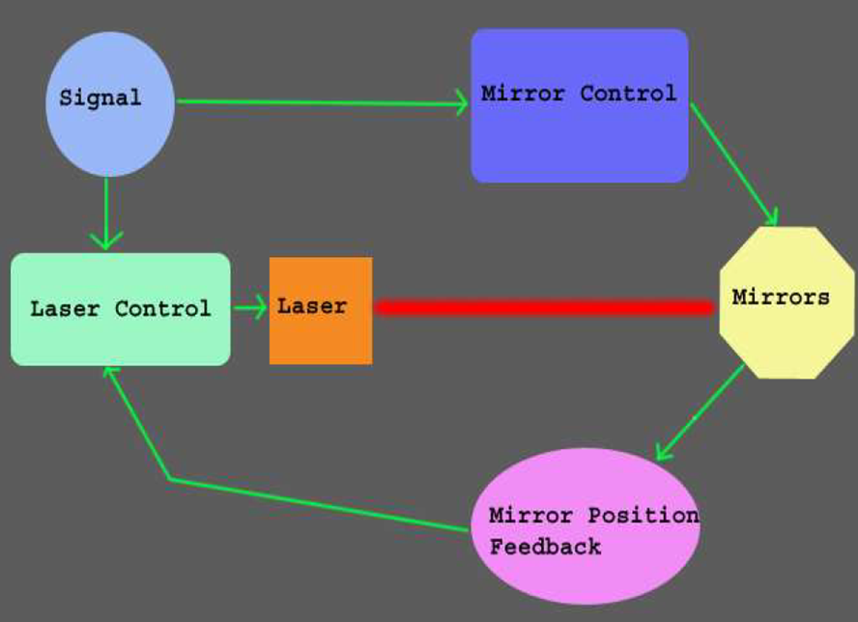
Figure 1.1

1.3Applications and Features:
The main use of this project is in entertainment .It can be used for advertisements to display certain texts and textures. Also it is used for displaying funny animations.
The main features in our laser projector are simplicity and easiness in use. It’s built from simple and cheap components such as mirrors, cheap laser pointer, and IR sensor.
It’s static so the text or animations that will be displayed should be saved in a matrix in the code of the microcontroller. But the user can enter a character to be displayed from the keyboard which is interfaced with the microcontroller.
The main issue that is considered in the project is safety; it may be dangerous because of rotating mirrors on a dc motor .This problem is solved by using efficient glue and cover the project to avoid flying mirrors.

Chapter2
2.1Methodology:
Mirrors are glued tightly shaping a polygon, each edge of it with a different angle. This polygon is spinning quickly on the top of the brushless fan motor .When the laser diode is turned on and off the mirrors will reflect the beam on the surface used to display the text.
Because the mirrors are moving, the reflected laser dot sweeps the screen from left to right, because it does it very quickly your eyes actually see a horizontal solid line, in this case you see 7 lines, due to using 7 mirrors ,one on top of the other because the each mirror is at an angle.
The lines will be shown as in the following figure.
Figure2.2
The spinning speed of the motor is very critical; any slowdown will cause the image to flicker that is why we used line follower sensor, with white bar at the start of each mirror and a black color on the rest of the track. When the mirrors spin, the white and black bars pass the sensor. A micro controller can use this data to compute the fan speed and adjust the laser blinking to the image looks correct.
When the laser turns on and off at the right time we could get the text we need to be displayed. Figure 3 shows an example of text we displayed.
Figure2.3
Chapter3
3.1Components:
The main components of the project are:
•PIC18F4620 Microcontroller and its Basic circuit with 20 MHZ oscillator.
•12v DC Motor.
•5mW laser Pointer.
•ULN2003A-motor (high voltage, high current Darlington arrays).
•7 Pieces of mirrors with sizes 3.5*2.0 cm and 1mm thickness.
•QRD1114 - Reflective Object Sensor.

3.2Design and Construction:
PIC18 was used as a microcontroller in order to control the motor and the laser.
Figure 4 shows the basic circuit of the microcontroller.

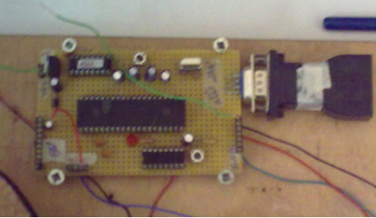
Figure4.PIC 18f4620 basic circuit
The most important part in the project is the polygon .After many days and hours of calibration we designed it using a Nescafé bottle cap .By gluing the mirrors with different angles on the sides of the cap and using a circular wooden board, we construct the polygon.
The angles of the mirrors should be calibrated accurately .Any mistake in the angles will affect the resolution and accuracy of the lines. Concerning with the safety issues we used an efficient glue to glue the mirrors and prevent them to fly.
Figures 5, 6,7 show the polygon’s parts and the shape of mirrors.
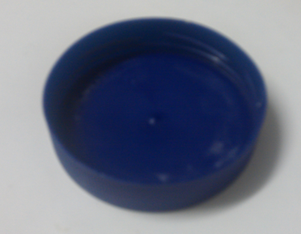
Figure 5.the cap to construct the polygon
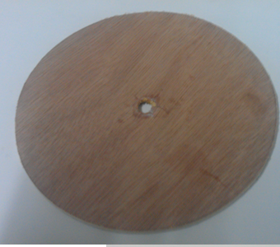
Figure6. The polygon’s wooden base.
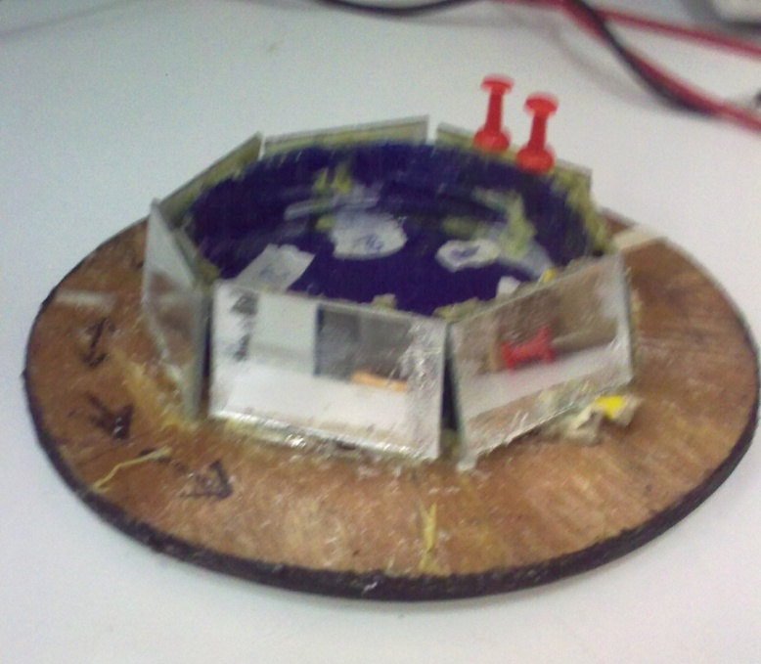
Figure 7.the polygonal mirrors shape
We stick the polygon on the top of the dc motor. Hence the polygon spins quickly with a speed of fan in order to get laser lines and prevent them from fading.
The motor we used is 12v DC as represented in figure 8.we controlled the speed and direction by using the PIC pulse width modulation and ccp commands; with a 90% duty cycle and using ULN2003 chip with 10 volt, we get the required speed of the motor.
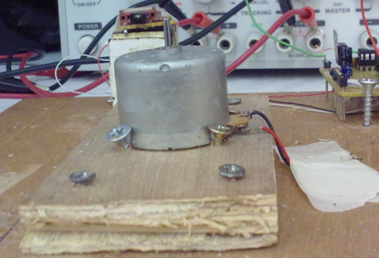
Figure 8.DC motor.
In order to get lines and display texts we used a cheap laser pointer as shown in figure 9.By controlling the laser beam with the microcontroller software we get lines as shown in figure10.
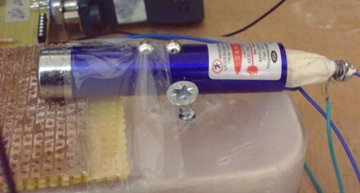
Figure 9.laser pointer
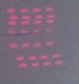
Figure 10.laser lines

We used QRD1114 - Reflective Object Sensor to adjust laser lines and calculate the revolution time of the motor. As shown in Figure11, this sensor consists of an infrared emitting diode and an NPN silicon phototransistor mounted side by side in a black plastic housing. The on axis radiation of the emitter and the on-axis response of the detector are both perpendicular to the face of theQRD1113/14. The phototransistor responds to radiation emitted from the diode only when a reflective object or surface is in the field of view of the detector.
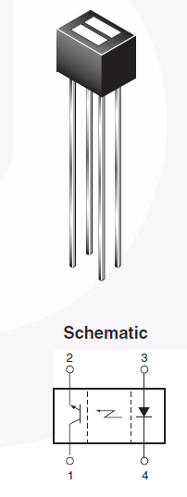
Figure 11.the QRD1114 sensor
When a white bar, on the wooden track, pass the sensor, the PIC’s ADC read value greater than 204.If the ADC read two white sequences, one revolution occur. The estimated time of the revolution is 30.1 MS; this means that each mirror has approximately 4.3 Ms. Also, the white bar indicates the start of reference mirror. Due to the sensor position mirror 3 was the reference.

3.3Microcontroller Software:
We used PIC C program to write the microcontroller software code, boot loader 104 to send the code to PIC chip.
The most important part in the code is how to deal with time in order to create synchronize horizontal lines. We used 50 us delay to obtain approximately 43 pixels on, switching laser on, and 43 pixels off, switching laser off, for the one mirror.
Because of manual calibration of mirrors, the number of pixels differs from one mirror to another and also the delay between each mirror .Changing the delay between mirrors determines the start of each horizontal line. We use empirical method to determine the delay between the mirrors.
The following sub code demonstrates how to create pixels.
////////////////mirror 3 //////////////////////////the reference mirror
output_low(PIN_B1);delay_us(50); //delay for one pixel off
output_high(PIN_B1); delay_us(50);//delay for one pixel on
////////////////////////// mirror 4/////////////////////////////////
delay_us(912);//delay to adjust and synchronize the start of line with the reference(mirror3)
output_low(PIN_B1);delay_us(50);
output_high(PIN_B1); delay_us(50);
We changed the number of on and off pixels to represent the hello text pattern.
Chapter4
4.1Problems and Results:
We faced many problems with designing this projector. The first problem was with designing the polygon; after days of searching we found hexagonal polygon. It’s taken from a kid’s toy box as shown in the figure below.
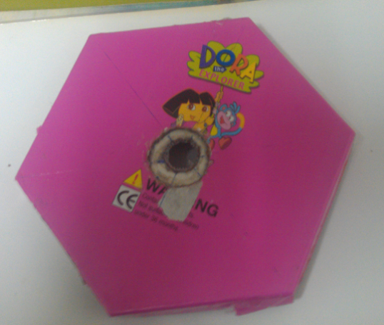
Figure11.the polygon

This polygon has a big size according to the motor’s torque. When we glued the mirrors the load is increased .Hence, the second problem appeared. The motor’s torque didn’t fit with the new load so we decided to decrease the load by choosing thinner mirrors. The first mirrors we used were 3mm thick, we searched on thinner mirrors in the glass shops but we didn’t find suitable thickness. After days of searching and thinking of other solutions, we found 1mm mirrors in the cheap Chinese products. Figure12 displays the difference of thickness in the mirrors.
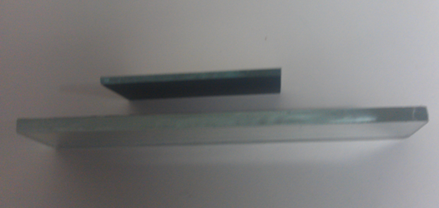
Figure12.mirrors thickness
Although we increased the load, the problem with motor’s torque stills. We solve this problem by replacing the first motor with a higher torque dc motor.
However, the new motor has higher torque than the load this forced us to add extra wooden base on the bottom of the polygon to increase the load and enhance the balance.
The third problem was with calibrating mirrors. It was the main problem that took a lot of time to be solved. The difference between angles is too small; it doesn’t exceed 2 to 5 degrees. This accuracy was so difficult to be achieved with the hexagonal polygon. So, we made our own polygon using the bottle cap, shown before, with dedicated work of adjusting mirrors.
The fourth problem was with the sensor, the glue stuck on it while sticking mirrors. This damaged the sensor and we had to replace it with a new one with a different type.
The fifth problem was in coding. The minimum delay time that PIC understands it is 780us which was too high to represent a pixel; after 8 days of trial and error work on code and searching for a solution, we discovered that the frequency is unsuitable. So, we changed the pic’s oscillator from 4 MHz to 20 MHz.This change allows us to use a 50us delay.
Other problems appear, for example problems when connecting and constructing the microcontroller’s basic circuit, laser beam power and problems with boot loader software program.
After solving all these problems we displayed a HELLO text pattern as a final result. Figures below represent this result.
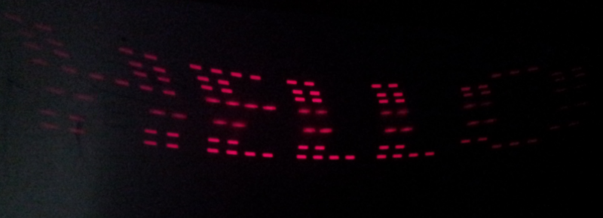
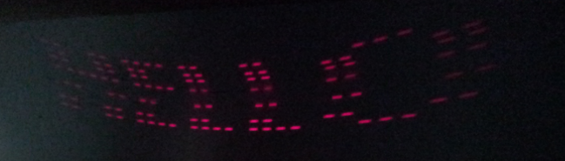
Figure13,14
Notice that the room should be dark to get better laser light intensity.
We are working on getting dynamic text patterns consists of 5 letters entered from a keyboard which will be interfaced with the pic.
Chapter5
5.1Future Work:
To improve the project we will work on enhancing the brightness by using higher power laser beam. Moreover, we will increase the number of mirrors and align more than one laser to increase the number of horizontal lines in order to get better resolution.
5.2Conclusion:
Hard dedicated work and many hours of searching lead to the final result of this project. A laser projector that displays texts and characters. This can be used as cheap tool for advertisement and entertainment. With additional enhancement it could display a funny animations and movable texts.

References:
Websites to demonstrate the basic idea and the techniques of the project.
https://sites.google.com/site/shakirfm/home

