CHAPTER ONE
BREAD AND OVENS

1.1 Introduction
The bread industry has since ancient times, it can not dispense with the bread, is the most important source of food , the bread industry has evolved, and started making bread by putting metal flat plate on the fire and then putting dough above it, It then became a profession.
There are two types of bakeries, semi-automatic and full- automatic, by semi-automatic bakeries each process separate from the other as the mixture process is making without respect to other as well as cutter, rounder and etc, on the other hand, by full-automatic bakeries each process is making with respect to other by sensors system.
A bakery consists of several parts (Dough mixing, Cutting, Rounding, Rolling and Baking). In our project we focus only on the design on an oven for baking of bread.
This oven will be dedicated for Arab bread of a diameter of 15 cm to accommodate 14 loaves which must stay in the oven for a period ranging from 60 seconds to 80 second, at a temperature between (200-250˚C). The metal used is steel with thermal conductivity K=45.3 W/m.˚C and density ρ=7854 kg/m³
We chose bread oven project because of two reasons:
1) Bread ovens in the Palestinian market was manufactured by blacksmiths who do not have the scientific skills in engineering design and production, which may be one reason for the poor in thermal efficiency of the furnace, which reduces the profits to the owners of these ovens and bread prices becomes more and more. For this reason we decide to make the development of our society that increase the Palestinian furnace efficiency to save the energy and increase the profits of ovens owners.
2) Palestinian countryside of Palestinian society used to make bread by primitive methods and the kind of hardship, they plant wheat fields for this purpose, in our oven we will decrease the size and material used to achieve a cheep family oven which withstand the need of the Palestinian villages homes, small markets and restaurants, This furnace produces 81.3 kg of bread in one hour.

1.2 The History of Bread Making
Bread has been an important staple food product to many cultures over the centuries. It is referred to as the “staff of life” in the Bible. Humans have eaten some form of bread since the Neolithic era, when cereals were crushed and mixed with water to form a thick paste that could be cooked over the fire. Stone mechanisms were used for smashing and grinding various cereals to remove the inedible outer husks and to make the resulting grain into palatable and versatile food.
Egyptians Bread making techniques date back as far as 3000BC. The ancient Egyptians were experimenting with different types of grains to produce a variety of bread products with different textures and flavors, this early bread was particularly successful when wild yeast from the air combined with the flour and water starting a fermentation process and slightly raising the crust. Successful bread making was considered an important life skill for ancient Egyptians. Paintings in the pyramids show that the dead were buried with loaves of bread to provide sustenance in the afterlife.
The Romans were the first to perfect Rotary Milling. They used sieves to produce finer flour.
They invented two types of oven,
-Brick Oven
-Three legged pot
The Romans introduced the world to the cottage loaf.

The Vikings made bread mainly from Rye grain, which produces a dense hard bread. The Vikings brought Rye from Scandinavia and produced hard primitive looking flat bread, which had large holes in the middle. To the Normans bread making was very much an organized community activity. Crop rotation practices were in place. They had watermills and windmills constructed close to the fields to facilitate flour production.
In 1266 the first bread control agency the “Assize of Bread” was set up to govern the weight and the price of bread. Guilds facilitated in the development of professional respect for the trade. They also helped to promote bread to the public. The baker’s guilds in England were held to strict standards, with harsh punishments for overcharging or adulterating bread.
The development and use of roller flourmills in the 1800s led to the production of much better quality flours. Resulting flours produced breads, which were lighter and whiter. The 18th century also saw the birth of the loaf tin, and resulting loaf shaped bread, which enabled it to be easily sliced.
The industrial revolution was the next great milestone in the history of bread making. Steam powered mills were constructed to meet the demands of a growing population. In 1815, the Corn Laws prevented the importation of foreign wheat but were revoked in 1846 to keep England from famine.
By the end of the 19th century the steel roller mills had arrived. These mills produced much softer finer flour, which produced better quality breads. Gas ovens replaced wooden and coal burning brick ovens.
By the 20th century highly automated flourmills with steel rollers were in place. This highly automated process resulted in the production of better quality and different varieties of flours. The efficiency of mills also increased dramatically.

1.2.1 Modern Bread Making
There are two main methods of bread making today.
1) Bulk Fermentation Process
2) Chorleywood Bread Process
Bulk Fermentation Process is a traditional method. Ingredients are mixed together to form a dough, and left to ferment from one up to three hours. During fermentation the dough changes from a short dense mass into elastic dough. Using different quantities of yeast and dough temperatures usually controls fermentation time. Smaller craft bakeries favor this method.
In Chorleywood Bread Process the Flour Milling and Baking Research Association of Chorleywood developed this method in 1961. This is the most widely used method of bread making in bakeries today. This method eliminates the time involved for fermentation in the traditional method. In the Chorleywood Bread Process dough development is achieved by high speed mixing and intense mechanical working of the dough in few minutes

1.3 Problems Faced By Bakeries
1.3.1 Loaf weights
The weight of loaves is one of the major issues confronting bakeries. Generally, loaves are packaged into bags that have the loaf weight pre-marked on them.
Legally, a bakery is required to ensure that any loaf may be no less than 5% below nominal weight. Also, the average of any 14 loaves picked at random may not be below nominal.

1.3.2 Consistent loaf quality
Another major issue for bakeries is maintaining product quality. There is significant variation in the quality of loaves. This could be due to a plethora of different factors, and these must be isolated to determine the cause. A loaf’s quality is determined by observing several factors including the color of the crust, the texture of the crumb, the shape, size and of course, flavor.

1.4 Bread Manufacturing Process–Stages
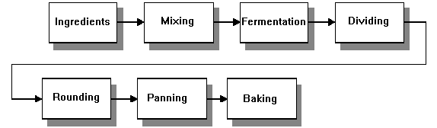
Figure 1.1: Rapid Dough Method of Baking Bread
1.4.1 Dough mixing
The first stage in dough processing is the mixing. During the mixing both the development of the dough and the temperature of the dough are established. If either of them or both of them are not spot on the processing and the product quality will suffer.

1.4.2 Forming
On completion of mixing dough bowl is lifted through tilting hoist and from the hoist bowl is tilted so as dough goes into hopper of Divider Hopper.

1.4.3 Rounding
From divider the dough piece moves to hander up which is mechanical device conical in shape on which dough piece takes curve linear path .It has got blower attached to it which continuously provides air on the path .Basic function of hander up is to give dough piece spherical shape and remove moisture from surface from dough piece

1.4.4 Divider
Dough is cut into two equal dough piece .Its a mechanical device which uses a common crank to cut , push and drop dough piece through divider to conveyor. Volume of the dough piece can be adjusted at divider.

1.4.5 Interproover
Dough pieces are then transferred to buckets of interproover .Here dough piece are allowed to travel for 5- 6 min .This helps in relaxation of dough as it would have stress due to mechanical action on it at divider.

1.4.6 Moulder
It has three set of roller. The dough piece is allowed to pass through these rollers. Now dough piece are slightly flattened.

1.4.7 Final proover
These dough pieces are then carried to platform where these lobes are twisted and kept in moulds; two lobes are twisted in one mould box as per wt required like 400 gms or 800gms loaves. Mould box are greased prior to lobes being put into. Final proover has arrangement for steam which spreads uniformly in entire chamber. Temperatures at final proover are maintained between 36-38ºC.Humidity and temperature are maintained so as to get maximum of yeast activity .Precautions are taken to see if there is over or under development of dough. Speed can be varied at final proover. Dough should rise 3/4 of the mould .vol of mould is 1320cc for 400gm and 2700cc for 800 gm loaves. Travel of trays is longitudinal in swing tray type plant where as in contrary type it is vertical.
Prooving time =75 min
Depending upon design we can define capacity of final proover as cap/cycle: no of loaves. no of racks x no of moulds box per rack x no of mould in each box. After dough has been developed these mould box are then transferred manually to baking oven.

1.4.8 Baking
The oven where the bread is baked, its consist of oven chamber and heat sources and chain conveyor, the dough is translate by conveyor to produce bread.
Temperature for baking bread:
Low-fat bread bakes at a temperature of 200 to 220 degrees Celsius the types of French bread round and rectangular baking at 220 degrees to 245 degrees Celsius.
1.4.9 Slicing and packaging
This is the final section in the bread production process. It has much significance in the overall control system.
Final weights are taken here. These weights are fed back to the main computer and analyzed to calculate new improved set-points and ingredient levels for the next day’s production. With the ability to track particular products through the bakery, bags for each variety may be automatically changed, or alternatively operators may be warned, as a variety change is about to occur.
The slicer provides an opportunity for image analysis to be used on the loaf grain.

1.4.10 Maintenance
Although completely beyond the scope of this project, an added aspect that may be pursued when developing an advanced bakery control system is automated maintenance warnings. Maintenance at a bakery, as at any manufacturing plant, is extremely important. Any loss in production time due to breakdowns is costly and possibly dangerous.
Using sensors already in place for other purposes in the control system (eg sensors that track oven movement), the amount of work that certain motors, chains etc do may be logged. When predefined limits have been reached, warnings may be produced either by on-screen prompts, printed reports, emailing the appropriate employee or a combination of these.
In addition since the communications infrastructure is already set up in the bakery, it should be easier to add other sensors. These may sense values such as vibration in motors and set an alarm state when a critical level is passed.

1.5 Safety recommendations
1.5.1 Pre-operational safety checks
1. Familiarize yourself with and check all oven operations and controls.
2. Ovens used for food preparation must not be used for workshop applications.
3. Never heat a sealed container.
4. Never heat any flammable or combustible liquid in the oven. A fire and/or explosion may result.
5. Ovens must not be used to heat any material that might pose a hazard because of acute or chronic toxicity unless special precautions have been taken to ensure continuous venting of the atmosphere inside the oven.
6. Ensure no slip/trip hazards are present in workspaces and walkways.
7. Do not operate the oven if it is damaged or does not operate properly.

1.5.2 Operational safety checks
1. Pre-heat the oven for no less than 5 minutes to be sure the oven compartment has reached the required temperature.
2. To reduce the risk of fire in the oven cavity do not overheat the breads.
3. Be aware of other people in the immediate vicinity when handling hot material.
4. Use thermal gloves or tongs to remove bread from the oven.
5. Before cleaning material accumulations switch off and allow the oven to completely cool.

1.5.3 Potentional Hazards
1. Burns from hot surfaces
2. Sources of ignition from hot surfaces.
3. Conveyor chain motion

CHAPTER TWO
MECHANICAL DESIGN

2.1 Introduction
A chain is a reliable machine component, which transmits power by means of tensile forces, and is used primarily for power transmission and conveyance systems. The function and uses of chain are similar to a belt. There are many kinds of chain. It is convenient to sort types of chain by either material of composition or method of construction.
In mechanical design it is often necessary to provide for the transmission of power from one shaft to another, or to make one shaft rotate faster or slower than another, this is usually accomplished by means of belts, chains or gears.
Since in our project "BREAD OVEN DESIGN" the temperature inside the oven is more than 200˚C, we cannot use belts. Therefore chains are chose inside the oven, because chains are made of steel which will not fail under high temperatures.
There are two major types of chains used for power transmission: roller chain, and silent chain as shown in figure 2.1

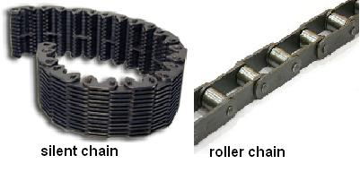
Figure 2.1: chains types [1]

roller chains are probably the most common and are used in a wide variety of low-speed to high speed drivers, so that we will use this type of chains in our design.
In our design we will use electrical heat to produce the bread. electrical heat is chosen instead of fuel or gas combustion because electrical heat is cleaner than fuel one, controlling it is more easily, and it is more safe than fuel and gas combustion.

2.2 Functions of Chain Parts
A- Plate
The plate is the component that bears the tension placed on the chain. Usually this is a repeated loading, sometimes accompanied by shock. Therefore, the plate must have not only great static tensile strength, but also must hold up to the dynamic forces of load and shock. Furthermore, the plate must meet environmental resistance requirements (for example, corrosion, abrasion, etc.).
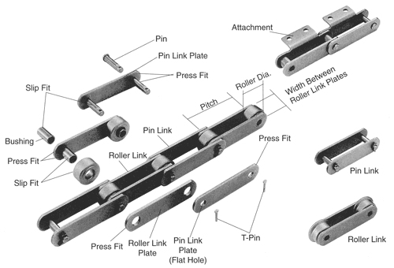
Figure 2.2 : Basic Structure of Conveyor Chain [2]

B- Pin
The pin is subject to shearing and bending forces transmitted by the plate. At the same time, it forms a load-bearing part, together with the bushing, when the chain flexes during sprocket engagement. Therefore, the pin needs high tensile and shear strength, resistance to bending, and also must have sufficient endurance against shock and wear.

C- Bushing
The bushing is subject to shearing and bending stresses transmitted by the plate and roller, and also gets shock loads when the chain engages the sprocket.
In addition, when the chain articulates, the inner surface forms a load-bearing part together with the pin. The outer surface also forms a load-bearing part with the roller's inner surface when the roller rotates on the rail or engages the sprocket. Therefore, it must have great tensile strength against shearing and be resistant to dynamic shock and wear.

D- Roller
The roller is subject to impact load as it strikes the sprocket teeth during the chain engagement with the sprocket. After engagement, the roller changes its point of contact and balance. It is held between the sprocket teeth and bushing, and moves on the tooth face while receiving a compression load.
Furthermore, the roller's inner surface constitutes a bearing part together with the bushing's outer surface when the roller rotates on the rail. Therefore, it must be resistant to wear and still have strength against shock, fatigue, and compression.

E- Cotter Pin, Spring Clip, T-Pin
These are the parts that prevent the outer plate from falling off the pin at the point of connection. They may wear out during high-speed operation, therefore, for this application, these parts require heat treatment.

2.3 Roller Chains
There are standard roller chains and nonstandard roller chains , the American national standards institute (ANSI) has standardized limiting dimension, tolerances, and minimum ultimate tensile strength for chains and sprockets of 0.25 to 3.0 inch pitch, chain pitch is the distance between successive roller or bushing centers, and it is the basic dimension for designating roller chains, but in our design of the oven chain we have chain pitch more greater than 3.0 inch, so that our design will be nonstandard roller chain because it is not covered by any standard tables.
A chain must be used with a sprocket which smoothly engage the rollers on the chain and positively transmit torque and motion; driver sprockets receive power from the prime mover and transfer it to the selected machinery.

2.4 Speed of Chain
In our project of bread oven design we chose a 1.05 m of chain length to be the bakery region which the dough passes throw it, as shown in figure 2.3,
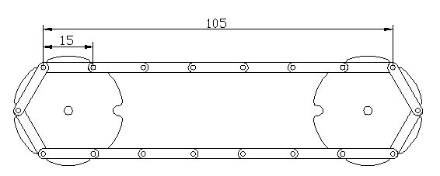
Figure 2.3: Chain length

and the time needed for dough to pass throw that 1.05 m region to become ripe bread is 60 seconds, therefore the chain speed is
$v=\frac{L}{t}$ (2.1)

where
v is the speed of chain in m/s.
t is the time needed for dough to pass throw the chain in seconds.
L is the length of chain part which transports the bread’s dough in meters and determined as :
L = n_{p}* l_{p}
where
n_{p} is number of plates.
l_{p} is width of the plate.
in our design we have
$$L=7*0.15=1.05 m$$

Thus we obtain for the velocity

$$v=\frac{1.05}{60}=0.017 m/s$$

2.5 Sprocket Diameter
In our design we use 4 sprockets to transmit motor power to two chain strands; each sprocket has 6 teeth as shown in figure 2.4,
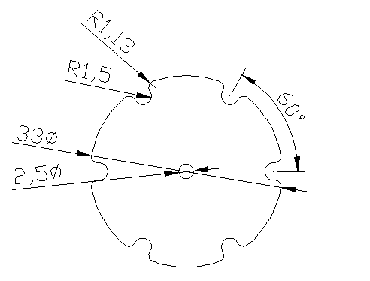
Figure 2.4: Sprocket dimensions

The sprocket has 6 teeth, and the angle between every two teeth is Φ = 360 / 6 = 60, we can determine the value of pitch circle diameter, and the diameter of sprocket by the following formulas:
$\sin\left(\frac{Φ}{2}\right)=\frac{(\frac{P}{2})}{r}$ (2.2)

$$\sin\left(\frac{60}{2}\right)=\frac{0.075}{r}$$

$$r=0.15m=15 cm$$

where
P is chain pitch = 0.15 m
r is the radius of pitch circle of the Conveyor sprocket in meter
Then the sprocket diameter is:
$$r*2+Roll diameter=\left(0.15*2\right)+0.03=0.33 m$$

And sprocket tooth diameter (ds) = the diameter of the roll (dr) which equals 0.03 m = 3 cm, and the sprocket thickness = 0.01 m = 1 cm.

2.6 Chain Pitch and Sprocket Teeth
The number of sprocket teeth is limited by the chain pitch and the chain speed. We chose a 6 teeth sprocket in our design of oven and a 150 mm chain pitch , then we determined the allowable speed of chain as shown in figure 2.5, which was 20 m/min = 0.33 m/s, the chain speed in our design is 0.017 m/s, which is less than allowable speed , so we are in the safe side

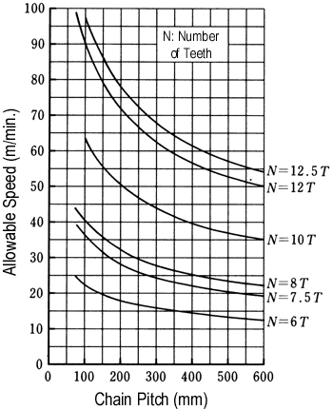
Figure 2.5: Chain Pitch , sprocket teeth , and allowable speed [3]

2.7 Sprocket Revolution
It is important to calculate the angular velocity (rpm) for the driver sprocket to setup the motor gear ratio and to determine the diameter of the shaft.
Head shaft angular velocity can be calculated after selecting a suitable size of drive sprocket, and we will calculate it by the following formula: [4]
$ω = \frac{v* 60}{dp * π}$ (2.3)
where
v is the speed of chain m/s.
dp is the pitch circle diameter meters.
ω is angular velocity in revolution per minute , as shown in figure 2.6,
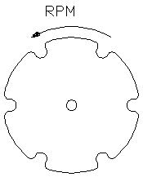
Figure 2.6: Direction of revolution
we have:
dp = 0.30 m
v = 0.017 m/sec
Then,
$$ω = \frac{0.017* 60}{0.3 * π}=1.11 rpm$$

2.8 Chordal Action
You will find that the position in which the chain and the sprockets engage fluctuates, and the chain vibrates along with this fluctuation. Even with the same chain, if you increase the number of teeth in the sprockets (change to larger diameter), vibration will be reduced. Decrease the number of teeth in the sprockets and vibration will increase.
This is because there is a pitch length in chains, and they can only bend at the pitch point. In Figure 2.7, the height of engagement (the radius from the center of the sprocket) differs when the chain engages in a tangent position and when it engages in a chord.
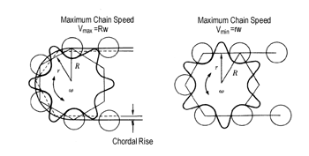
Figure 2.7: The height of engagement [5]

Therefore, even when the sprockets rotate at the same speed, the chain speed is not steady according to a ratio of the sprocket radius (with chordal action). Chordal action is based on the number of teeth in the sprockets: [6]
$Ratio of speed change = \frac{vmax - vmin}{vmax}$ (2.4)
v_{max} = R * ω = 0.15 * 1.11 = 0.16 m/s
v_{min} = r * ω = (cos 30 * 0.15) * 1.11 = 0.14 m/s
$$Ratio of speed change = \frac{0.16 – 0.14}{0.16} = 0.125$$
Figure 2.8 shows the result. In addition to the number of teeth, if the shaft center distance is a common multiple of the chain pitch, chordal action is small. On the other hand, if shaft center distance is a multiple of chain pitch + 0.5 pitch, chordal action increases. Manufacturing and alignment errors can also impact chordal action.
In a flat-belt power transmission machine, if the thickness and bending elasticity of the belt are regular, there is no chordal action. But in toothed-belt systems, chordal action occurs by circle and chord, the same as chains. Generally this effect is less than 0.6%, but when combined with the deflection of the pulley center and errors of belt pitch or pulley pitch, it can amount to 2 to 3 percent.
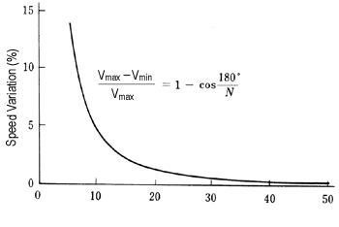
Figure 2-8: Sprocket teeth [7]

2.9 Chain Capacity
Chain capacity is the mass of bread which will be passing throw the chain per hour, chain capacity is an indication of oven productivity per hour and per a day, and it can be calculated by the following formula:
$C = μb * v * 3600$ (2.5)
where
C is chain capacity (kg/h)
v is chain speed (m/s)
$μb$ is mass of bread per meter (kg/m) = mass of bread on one plate over length of one plate, assuming the mass of one bread is 0.1kg, and the plate capacity is only two breads.
$$μb=\frac{0.1*2}{0.15}=1.33 kg/m$$

$$C=1.33*0.017*3600=81.3 kg/h$$

From this value we find that the oven will produce 81.3 kg /h of bread.

2.10 Bread Mass on the Chain (m₁)
It is necessary to know the load of bread dough's which will efforts on chain tension and motor power; it can be calculated by the following formula:

m₁$=\frac{\left(\left(\frac{C}{1000}\right)* L\right)}{ν * 3.6}$ (2.6)
where:
m1 is bread mass on the chain (kg)

m₁$=\frac{\left(\left(\frac{81.3}{1000}\right)* 1.05\right)}{0.017 * 3.6}=1.4kg$$= \frac{\left(\frac{81.3}{1000}\right)* 1.05}{0.017 * 3.6}=1.4 kg$

2.11 Chain Mass (m₂)
The mass of the chain consists of the following masses:
A) Mass of steel chain plates.
B) Mass of steel dough plates.
C) Mass of pins.
D) Mass of rollers.

A) Mass of 18 steel plate with dimensions of (0.15 * 0.34 * 0.006) m as shown in figure 2.9, the volume of one plate (Vp.ch) is:
Vp.ch =0.000306m³
and the mass is a product of volume and steel density, this means that the mass of one plate (mp.ch)is:
mp.ch = 0.000306 * 7854 = 2.403 kg
for 18 plates we get :
18 * 2.403 = 43.25 kg.
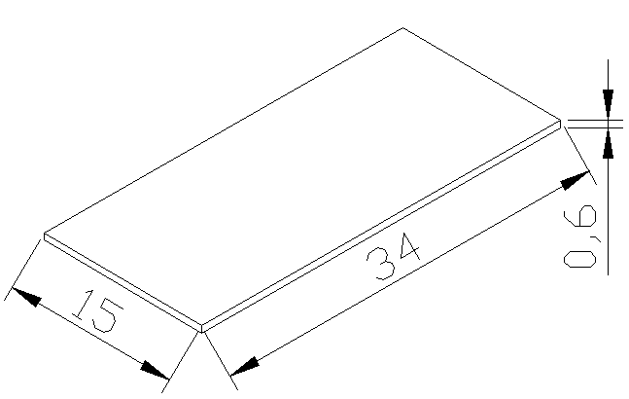
Figure 2.9: Plate dimensions
B) Mass of 72 dough steel plate with dimensions of (0.18 * 0.03 * 0.004) m as shown in figure 2.10, the volume of one plate (Vd.p) is:
Vd.p =0.0000216m³
and the mass is a product of volume and steel density, this means that the mass of one plate (md.p)is:
md.p = 0.0000216 * 7854 = 0.1696 kg
for 72 plates get :
72 * 0.1696 = 12.21 kg
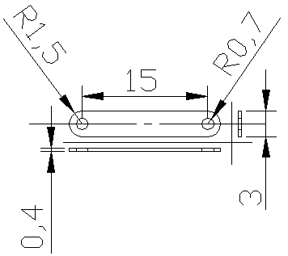
Figure 2.10: Chain plate's dimensions

D) Mass of 36 pin (mp) with dimensions of (0.007 radius * 0.03 length) m as shown in figure 2.11, the volume of one pin (Vp) is:
Vp = 0.007 * 0.007 * 3.14 * 0.03 = 0.000004615m³
and the mass is a product of volume and steel density, which gives the mass of one pin
mp = 0.000004615 * 7854 = 0.036252493 kg
for 36 pins we get:
36 * 0.036252493 = 1.30 kg.

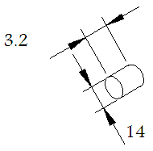
Figure 2.11: chain pin dimensions

E) Mass of 36 rollers (mr) with dimensions of (0.015 radius * 0.015 thickness * 0.007 hollow radius) m as shown in figure 2.12, the volume of one roller (Vr) is:
Vr = (0.015 * 0.015 * 3.14 * 0.015) – (0.007 * 0.007 * 3.14 * 0.015) = 0.00000815 m³
And the mass is a product of volume and steel density, this means that the mass of one roller is:
mr = 0.000008154 * 7854 = 0.064046228 kg
for 36 boxes we get :
36 * 0.064046228 = 2.30 kg.

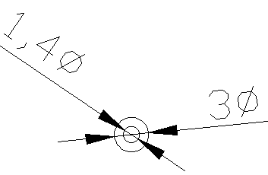
Figure 2.12: Chain box dimensions

Now the mass of the moving parts is the sum of masses of A, B, C, and D, it means that
M₂ = 43.25 + 12.21 + 1.30 + 2.30 = 59.06 kg.

2.12 Chain Pull Calculations
The preferred method of calculating the tension in a conveyor chain is to consider each section of the conveyor that has a different operating condition. This is particularly necessary where changes in direction occur or where the load is not constant over the whole of the conveyor.
For uniformly loaded conveyors there is a progressive increase in chain tension from theoretically zero at A to a maximum at D. This is illustrated graphically in Fig 2.13 where the vertical distances represent the chain tension occurring at particular points in the circuit.

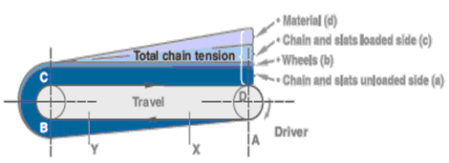
Figure 2.13: Illustrated graphically of uniform load conveyors

The commonly used equation for the allowable tension in the chain is: [8]
$F=\frac{2600000*A}{v+600}$ (2.7)
where
F is allowable tension force in chain lb.
v is velocity of chain fpm.
v = 0.017 m/s = 3.34 fpm
A is projected area of the pin joint in², as shown in figure 2.14, and it can be calculated by the following formula:

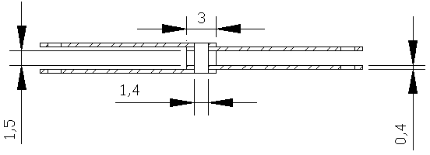
Figure 2.14: Projected Area of the Pin Joint

A = (D * L) (2.8)
where
D is pin diameter in meter.
L is width of roller and plates making contacts with pin
L= (0.014 * (0.004 + 0.004 + 0.004 + 0.004 + 0.015))
L= (0.014 * 0.031) = 0.00043 m² = 0.666 in²
$$F=\frac{2600000*0.666}{3.34+600}=2870.02 lb$$

2.13 Head Shaft And Motor Power
The power required at the head shaft to keep the empty strands conveyor moving can be calculated by the following commonly used formula: [9]
$K=\left(\left(\frac{F*v}{33000}\right)*n\right)-0.15*\left(\left(\frac{F*v}{33000}\right)*n\right)$ (2.9)
where
K is the power transmitted by an empty two strand of chain hours power
n is number of chain strands
$$K=\left(\left(\frac{2870.02*3.34}{33000}\right)*2\right)-0.15*\left(\left(\frac{2870.02*3.34}{33000}\right)*2\right)=0.493 hp$$

There are two chain strands, so that we multiplied the power value of one empty strand by number of strands which are two strands, and then we decreased the result by about 15 percent, because the load will not be perfectly distributed among the two strands.
This value is the power required to move an empty two strands of chain, but there are two loads will enter in power which are the mass of 14 bread dough and the mass of the chain components (m₂), and there is an starting force called inertial force which measures the resistance of sprockets to rotation, by entering these two loads and inertial force in power calculation we can determine the true value of motor power needed, so that the motor power becomes:

$P=K+(v*(W+\frac{Fi}{33000})$ (2.10)
where
P is motor power needed in horse power.
W is the weight of chain components lb.
Total carried load of bread in kg = 7 plates * 0.200 kg = 1.4 kg
Total load of chain components in kg = 59.06 kg

W = (1.4 kg + 59.06 kg) * 9.81 = 593.112 N = 133.34 lb

F_{i} is the sprockets and shafts inertial force (lb) and it can be calculated by the following formulas:
Firstly we have to determine the sprockets inertial force as follows:

T = N * I * α (2.11)

where
T is the inertia torque N.m
N is number of sprockets = 4
I is disk inertia kg.m²
α is sprocket radial acceleration (rps²)

I = 0.5 m r² (2.12)

where
ms is sprocket mass (kg) = 6.714 kg
r is sprocket radius (m) = 0.15 m

I = 0.5 * 6.714 * (0.15) ² = 0.075 kgm²

We will suppose that the time required getting the motor reach the steady state value is 1 second, so we can determine the value of α by using the following formula:

ω_{f} = ω_{i} + α t (2.13)
where
ω_{f} is steady state angular velocity of sprocket in rps = 1.11 rpm / 60 sec = 0.018 rps
ω_{i} is initial angular velocity of sprocket in rps = 0
α is angular acceleration of sprocket in rps²
t is the time required getting the motor reach the steady state value = 1 second
So that
α ( rps²) = magnitude of ω_{f} = 0.018 ( rps²)
By substitute in equation (2.10)

T = 4 * 0.075 * 0.018 = 0.0055 Nm
T = F_{s} * r (2.14)
where
F_{s} is sprocket inertial force in Ib
F_{s} $=\frac{T}{r}=\frac{0.0055}{0.15}=0.037 N=0.008 lb$

And then we have to determine the shafts inertial force, there are two shafts one has 2.042 kg mass and the other has 2.697 kg mass, α = 0.018 rps², by using equations (2.11), (2.12) and (2.14) we can determine the shafts inertial force

I = 0.5 * m * r²
I₁ = 0.5 * 2.042 * 0.0125² = 0.00015 kgm²
I₂ = 0.5 * 2.697 * 0.0125² = 0.00021 kgm²
T = (I₁ + I₂) * α
T= (0.00015 + 0.00021) * 0.018 = 0.0000064 Nm
T = F_{sh} * r
F_{sh} $=\frac{T}{r}$
where
F_{sh} is shaft inertial force lb
F_{sh} $=\frac{0.0000064}{0.0125}=0.000488 N=0.0001 lb$

Now we can say that the inertial force of the system F_{i} equals the sprockets inertial force F_{s} plus the shafts inertial force F_{sh}

F_{i} = F_{s} + F_{sh}
F_{i} = 0,008 + 0.0001 = 0.0081 lb

And now we have to enter values of the loads by weight of bread dough and steel plates and inertial force in equation (2.9)

$$P=K+\left(v*\frac{W+Fi}{33000}\right)$$
P = 0.493 + (3.34 * (133.34 + 0.0081) / 33000)
P = 0.506 hp = 377.3 W
2.14 Factor of Safety
Chain manufacturers specify the chain in their product range by breaking load. Some have quoted average breaking loads; some have quoted minimum breaking loads depending upon their level of confidence in their product.
By using table (2.1) and table (2.2), we have to use a 12 factor of safety since the temperature inside the oven in our design is more than 250 C, and lubrication will be regular.

Table 2.1: CLEALINESS/LUBRICATION [10]
Lubrication | Clean | Moderately Clean | Dirty | Abrasive
Regular | 8 | 10 | 12 | 14
Occasional | 10 | 12 | 14 | 16
None | 12 | 14 | 16 | 18
Table 2.2: TEMPERATURE /LUBRICATION [11]
Lubrication | -30/+150˚C | 150-200˚C | 200-300˚C
Regular | 8 | 10 | 12
Occasional | 19 | 12 | 14
None | 12 | 14 | 16

By choosing factor of safety of 12 then working load will multiplied by 12 to determine the breaking load ,
Breaking load = working load * 12
2.15 Chain Roller Friction
In conveyor calculations the value of the coefficient of friction of the chain roller has a considerable effect on chain selection. When a
Chain roller rotates on a supporting track there are two aspects of friction to be considered.
Firstly there is a resistance to motion caused by rolling friction and the value for a steel roller rolling on a steel track is normally taken as 0.00013. therefore: [12]

Coefficient of rolling friction = 0.00013 / Roller radius (m) (2.15)
= 0.00013 / 0.015 = 0.008

Secondly a condition of sliding friction exists between the roller bore and the bush periphery. For well lubricated a coefficient of sliding friction μ_{F} of 0.15 is used and for poor lubrication approaching the unduplicated state, a value of 0.25 should be used. Again this applies at the bush/roller contact faces and needs to be related to their diameters. So that we chose μ_{F} of 0.15.

Coefficient of sliding friction = μ_{F} x Roller bore (mm) / Roller diameter (mm), (2.16) [13]
$=\frac{0.15*14}{30}=0.07$
As shown in figure 2.15,
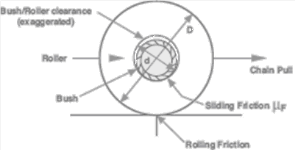
Figure 2.15: Chain Roller Friction

Thus the overall theoretical coefficient of chain rollers moving on a rolled steel track
$$=0.26+\left(μF*\frac{Rollerbore\left(mm\right)}{Roller diameter \left(mm\right)}\right)$$
$$=0.26+\left(0.15*\frac{14}{30}\right)=0.07$$
$μF =(1.90+μF d)/D$ (2.17) [14]
$$μC=\frac{1.90+\left(0.15*14\right)}{30}=0.13$$

where
μ_{C} = overall coefficient of friction for chain.
μ_{F} = bush/roller sliding friction coefficient.
d = roller bore diameter in mm.
D = roller outside diameter in mm.
We will neglect the friction in our design because of little loads on the chain.

2.16 Roller Selection and Roller Loading
2.16.1 Roller materials
1. Unhardened mild steel rollers are used in lightly loaded, clean and well lubricated applications subject to occasional use.
2. Hardened steel rollers are used in the majority of applications where a hard wearing surface is required.
3. Cast iron rollers are used in applications where some corrosion is likely and a measure of self-lubrication is required.
4. Synthetic rollers, e.g. Delrin, nylon or other plastics can be used where either noise or corrosion is a major problem.

2.16.2 Roller loading (Bush/Roller Wear)
In the majority of cases a conveyor roller chain will meet bush/roller wear requirements if it has been correctly selected using factors of safety on breaking load. Doubt can arise where heavy unit loading is involved, which could cause the bearing pressure between the chain bush and roller to be excessively high, or where the chain speed may exceed the recommended maximum. In such cases further checks have to be made.

2.16.3 Bearing pressure
The formula of bearing pressure is:
$B=\frac{R}{A}$ (2.18)
where
B is bearing pressure in N/mm²
R is roller load in N
A is bearing area in mm²
$$B=\frac{\frac{F+W+Fi}{number of rollers}}{A}$$
F = 2870.02 lb= 12766.48 N
W = 133.34 lb = 593.112 N
F_{i} = 0.0081 lb = 0.031 N
Number of rollers = 36
A = Pin diameter * Roller width (2.19)
As shown in figure 2.16, A = 14 * 15 = 210 mm²
Figure 2.16: Bearing Area

$$B=\frac{\frac{13359.6}{36}}{210}=1.76 N/mm²$$

This value is used first to check whether actual pressure exceeds the above recommendation. If it does, or if the conveyor speed exceeds 0.5m/sec, the chain may still be acceptable if alternative conditions can be met. These depend upon a combination of bearing pressure and rubbing speed between bush and roller, known as the PVR value, and the degree of cleanliness and lubrication on the application. If cleanliness and lubrication are much better than average for example, higher bearing pressures and PVR values than normal can be tolerated. In order to make this judgment, the following table (2.3) is used along with the formula: [15]

$VR=\frac{v*Bd}{Rd } (m/s)$ (2.20)
where
V_{R} is Rubbing Speed in m/sec
v is chain speed in m/sec
B_{d} is pin diameter in mm
R_{d} is Roller diameter in mm
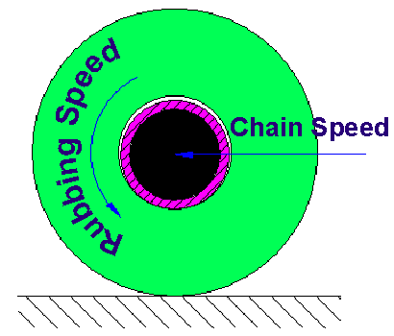
Figure 2.17: Rubbing Speed and Chain Speed

V_{R} $=\frac{0.017*14}{30}=0.007$ m/s

Table 2-3 [16]
Roller  Material | Rubbing Speed  VR(m/sec) |  |  | Max. Bearing Pressure  P(N/mm²)
 | Very Good  Conditions | Average  Conditions |  | Very Good  Conditions | Average  Conditions
Case hardened  Mild steel | 0.025-0.15  Over0.15 | 0.025-0.15  Over0.15 |  | 10.35  Use PVt=1.55 | 1.80  Use PVt=0.45
Sintered Through-hardened steel | 0.025-0.15  Over 0.15 | 0.025-0.15  Over 0.15 |  | 6.90  Use PVt=1.04 | 1.20  Use PVt=0.30
Cast iron | 0.025-0.15  Over 0.15 | 0.025-0.25  Over 0.25 |  | 3.91  Use PVt=0.59 | 0.68  Use PVt=0.17

From table 2-3 our design is in average condition since roller material is cast hardened mild steel, maximum bearing pressure is 1.76 N/mm², and rubbing speed is 0.007 m/s

2.17 Shaft Diameter Design
Having selected the size of conveyor chain required for a system, another important consideration is the diameter of the sprocket shafts. The head shaft takes the greatest stress and this is where attention is focused.
Most conveyor systems use two strands of conveyor chain and the head shaft is driven usually by either a transmission chain drive or by an in-line motorized reduction gearbox. Stresses are induced in the shaft material by bending and twisting moments, and these need to be evaluated first in order to select a suitable shaft size, as shown in figure 2.18.
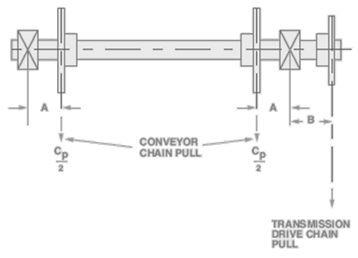
Figure 2.18: loads that applied on chain [17]
A is Distance from shaft bearing to nearest conveyor sprocket (m)
= 0.050 m
B is Distance from shaft bearing to transmission chain sprocket (m)
= 0.075 m
C_{p} is chain pull (N) = F + W + F_{i} = $13359.6$ N
The maximum bending moment induced in the conveyor head shaft may be related either to the transmission drive chain pull, or the conveyor chain pull. The diagram shows a head shaft arrangement where the two conveyor sprockets are located equidistant from the respective nearby shaft bearings (distance A), whilst the transmission chain sprocket is positioned on the overhanging shaft, a distance B from the nearest bearing. Assuming both strands of conveyor chain are experiencing equal tension then the bending moment due to the conveyor chain pull will be half the total chain pull C_{P} (N) multiplied by distance A (m). Hence,

$MC=\frac{CP*A}{2 } (Nm)$ (2.21) [18]

$$MC=\frac{13359.6*0.050}{2 }=333.99 Nm$$

By comparison, the bending moment due to the transmission chain pull will be the transmission chain pull (N) multiplied by the distance B (m). Hence,

Bending moment Mc = C_{p} * B (Nm) (2.22) [19]
M_{c} = $13359.6$ * 0.075 = 1001.97 Nm

The maximum twisting moment or head shaft torque is the product of the total conveyor chain pull (N) and the pitch circle radius of the Conveyor sprocket (m). Hence,
Twisting moment $Mt=\frac{Cp*Dp}{2 (Nm)}$ (2.23) [20]
where
Dp is pitch circle diameter of the Conveyor sprocket = 0.30 m

$$Mt=\frac{13359.6*0.30}{2 }=2003.94 Nm$$
The greater of the two bending moment values calculated as above, along with the twisting moment are now used to establish the constant K.
$$K=\frac{Max.Bending Moment}{Twisting Moment}$$
$$K=\frac{1001.97}{2003.94}=0.50$$

Table (2.4) below gives the method for determining shaft diameter based on the use
of mild steel bar of 430/490 N/mm2 (28/32 tons/in2) tensile strength

From the table we determined the minimum diameter of shaft by interpolation method

$$\frac{65.53-X}{2178-2003.94}=\frac{65.53-61.65}{2178-1815}$$
X = 63.66 mm
where
X is the minimum shaft diameter in mm.
Shaft minimum diameter equals 63.66 mm, we will assume it equals 65 mm which equals the bearing bore , to get more safety.
Table 2-4: Shaft Diameter [21]
 | Shaft diameters(minimum)
Twisting  Moment | For bending and twisting
M_{t}  Nm | K=0.5  mm | K=0.75  mm | K=1.0  Mm | K=1.58  mm
87 | 22.38 | 24.08 | 25.63 | 28.47
181 | 28.60 | 30.81 | 32.77 | 36.42
362 | 36.27 | 38.81 | 41.28 | 45.37
544 | 41.25 | 44.45 | 47.39 | 52.58
726 | 45.42 | 48.92 | 52.07 | 57.84
1089 | 51.99 | 55.93 | 59.56 | 66.22
1452 | 57.28 | 61.60 | 65.53 | 72.90
1815 | 61.65 | 66.42 | 70.61 | 78.49
2178 | 65.53 | 70.61 | 74.93 | 83.31
2541 | 68.83 | 74.17 | 78.99 | 87.88
2904 | 72.14 | 77.72 | 82.55 | 91.95
3268 | 74.93 | 80.77 | 85.85 | 95.50
3631 | 77.72 | 83.57 | 88.90 | 99.06
4357 | 82.55 | 88.90 | 94.74 | 106.16
5088 | 86.87 | 93.47 | 99.57 | 110.74
5809 | 90.93 | 97.79 | 104.14 | 115.82
6535 | 94.49 | 101.85 | 108.20 | 120.40
7261 | 97.79 | 105.16 | 112.01 | 124.46
9077 | 105.41 | 113.54 | 120.90 | 134.37
10892 | 112.01 | 120.65 | 128.27 | 142.75
12707 | 117.06 | 127.00 | 135.13 | 150.37
14523 | 123.44 | 132.84 | 141.13 | 156.97
16338 | 128.27 | 138.18 | 147.07 | 163.58
18153 | 132.84 | 143.00 | 152.40 | 169.16
19969 | 136.91 | 147.57 | 156.97 | 174.50
21784 | 141.22 | 151.89 | 161.80 | 179.83
23599 | 145.03 | 156.21 | 166.12 | 184.66
25415 | 148.59 | 160.02 | 170.18 | 189.23
2.18 Bearing Selection
Bearing selection depends on shaft diameter , in our design we find that minimum shaft diameter equals 63.66 mm , we assume it equals 65 mm for getting more safety , by using table (2-5) , we select Single-Row 02-Series Deep Groove Ball Bearing with the following dimensions and Load ratings :
Bore= 65 mm , Outer Diameter= 120 mm , Width= 23 mm , Fillet Radius= 1.5 mm , Shoulder Diameter d_{S}= 74 mm d_{H}= 109 mm , Load ratings C₁₀= 55.9 kN C₀= 34 kN.

Table 2-5: Dimensions and Load Ratings for Single-Row 02-Series Deep Groove Ball Bearing [22].
Bore,  mm | OD,  mm | Width,  mm | Fillet Radius,  mm | Shoulder Diameter,  mm  d_{S} d_{H} | Load Ratings,  kN  C₁₀ C₀
10 | 30 | 9 | 0.6 | 12.5 27 | 5.07 2.24
12 | 32 | 10 | 0.6 | 14.5 28 | 6.89 3.10
15 | 35 | 11 | 0.6 | 17.5 31 | 7.80 3.55
17 | 40 | 12 | 0.6 | 19.5 34 | 9.56 4.50
20 | 47 | 14 | 1.0 | 25 41 | 12.7 6.20
25 | 52 | 15 | 1.0 | 30 47 | 14.0 6.95
30 | 62 | 16 | 1.0 | 35 55 | 19.5 10.0
35 | 72 | 17 | 1.0 | 41 65 | 25.5 13.7
40 | 80 | 18 | 1.0 | 46 72 | 30.7 16.6
45 | 85 | 19 | 1.0 | 52 77 | 33.2 18.6
50 | 90 | 20 | 1.0 | 56 82 | 35.1 19.6
55 | 100 | 21 | 1.5 | 63 90 | 43.6 25.0
60 | 110 | 22 | 1.5 | 70 99 | 47.5 28.0
65 | 120 | 23 | 1.5 | 74 109 | 55.9 34.0
70 | 125 | 24 | 1.5 | 79 114 | 61.8 37.5
75 | 130 | 25 | 1.5 | 86 119 | 66.3 40.5
80 | 140 | 26 | 2.0 | 93 127 | 70.2 45.0
85 | 150 | 28 | 2.0 | 99 136 | 83.2 53.0
90 | 160 | 30 | 2.0 | 104 146 | 95.6 62.0
95 | 170 | 32 | 2.0 | 110 156 | 108 69.5

2.19 Noise and Vibration
When the chain engages the sprockets, it will definitely make noise as shown in Figure 2.19. This is caused by several factors:
1. The chain roller strikes the sprocket tooth bottom.
2. There is space between the roller and the bushing; the roller makes noise by its elastic vibration (in the case of thin rollers, like S-roller).
3. Sprockets vibrate.
4. The fluid held between each part (usually air or lubrication oil) makes shock sounds.
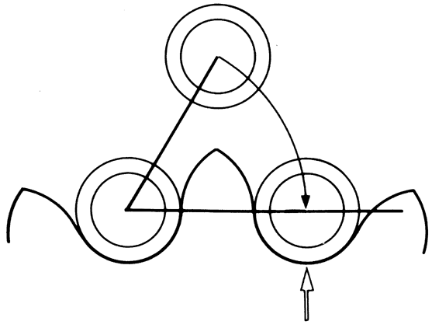
Figure 2.19: Noise Occurs when the Chain Engages the Sprocket [23]

2.20 Use in Wet Conditions
When metal chains are splashed with water or go through heated vapor, the following problems may occur:

Increase in wear due to improper or insufficient lubrication.
Decrease in strength due to corrosive attack.
Shortened chain life due to rust or corrosion of the chain.

Following steps are taken to reduce the effect of wet conditions in several ways:
larger-sized chain was used to decrease the bearing pressure and increase wear resistance.
plated steel was used in chain, since wear of engineered plastic chains may increase if they are used in water. In wet applications, steel or stainless steel chains will wear less than engineered plastic chains.

CHAPTER THREE
OVEN THERMAL DESIGN

3.1 Introduction
In bread-making, baking process is one of the key steps to produce the final product qualities including texture, color and flavor by heat transfer mechanisms inside an oven chamber as well as inside the dough pieces.
During baking, heat is transferred through the combination of all the three well-known mechanisms: conduction, convection and radiation. However, the actual form of combination and proportions are very different for heat transfer within dough pieces and heat transfer within an oven chamber.
The heat transfer phenomena causing a series of physical, chemical and structural transformations in bread.

3.2 Physical Changes
3.2.1 Structural changes
There are 2 major structural phenomena in a baking process.
The first one is the transformation of semi-fluid dough to a predominantly solid baked product.
The second structural phenomenon is the expansion of dough in the oven until its structure is fixed.

3.2.2 Color and flavor development
The temperature must be suitable in bread forming process to produce acceptable flavor and color.

3.2.3 Moisture loss
Almost all moisture loss in bakery products takes place during the baking process because of evaporation, due to the effect of heat during baking.

3.3 Effect of Baking Parameters On Product Quality
3.3.1 Temperature
Temperature affects baking quality; the optimum level of temperature is needed to be supplied at a right time. Otherwise, product quality can be degraded. For example, supplying too high temperature at the early stage of baking might cause an early crust formation, shrunk bread loaf and too dark crust, Use of too high temperature at the bottom may cause holes towards the bottom of a loaf, and then triangular shape. Moreover, cavity at the bottom is possibly found.

3.3.2 Airflow velocity
In addition to temperature, airflow velocity affects baking quality.
When bread is baked under very low temperature, very high air flow velocity is required to increase the drying rate at surface, airflow velocity was increased. As a result, heat and mass transfer coefficients were increased.

3.3.3 Baking time
The combination of baking temperature and baking time should be optimized to produce a desired product; quality of the product baked by short and long baking times can still be quite different. Longer baking time can produce loaf side caving as well as less softness.

3.3.4 Humidity
Humidity affects baking quality so it must be controlled by other parameters which mentioned previous.

3.4 Baking Oven Design
Our oven will be dedicated to Arab bread; by diameter 15 cm to accommodate 14 of loaf, each one of bread must stay in the oven for one minute, at a temperature not exceeding 250 C.
An oven is composed of a baking chamber and a heating system, the baking chamber is designed as a rectangular box formed by steel lining sheet supported by steel frame.
Oven walls on top , sides and bottom are insulated for the heating, the oven was supplied heat by the electricity which provides 3142 BTU per kWh, and the temperature can be controlled through the voltage, electricity is cleaner and easier for maintenance.

3.5 Heat Required For Bread
For this oven the maximum amount of dough that could be baked is 1.4 kilogram’s. The water temperature is assumed to be 30 degrees Celsius therefore:
The amount of heat required in kilojoules to convert the bread dough into ripe bread is the sum of: [25]
1) the amount of heat to bring the water (approx 45% of the weight of the dough) in the flour to 100°C.

$Q1={Cp}_{w}×W×0.45×(T_{100}-T_{w})$ (3.1)
$$Q1=4.184×1.4×0.45×\left(100-30\right)=148.51 J$$

2) the amount of heat to bring the flour to 100°C.

$Q2={Cp}_{f}×W×0.55×(T_{100}-T_{d})$ (3.2)
$$Q2=1.8×1.4×0.55×\left(100-30\right)=97.02 J$$

3) the amount of heat required to evaporate water which accounts for approx 10% of the weight of the dough and heat it to approx 230°C

$Q3=h_{1}×W×0.1$ (3.3)
$$Q3=2519×1.4×0.1=352 J$$

$$Q_{total}=633.53 J$$

Let us assume that the baking time will be in the order of 1 minute. The amount of heat that is needed over a 1 minute period is:
The heat in kilowatts is then:
$Q4= \frac{Q_{total}}{t}$ (3.4)
$$Q4= \frac{633.53}{60×1}=10.56 KW$$
where:
${Cp}_{w }$is specific heat H20
${Cp}_{f}$ is specific Heat of flour
$W$ is weight dough
$T_{100}$ is temperature to evaporate water
$T_{w}$ is temperature of water
$T_{d}$ is temperature of dough
$h_{1}$ is latent heat
$t$ is baking time in second
3.6 Heat losses from Oven
3.6.1 Conduction heat transfer
The Fourier equation may be used to assess the amount of heat transfer by conduction.
The Fourier equation in this form is used for non-composite structures i.e. one layer of thickness.
$Q=U×A×△T$ (3.5) [26]
Q

l

T₁

T₂

Figure 3.1: Heat flow through the wall

Total thermal resistance of wall given by following:
R _{total} $=∑\frac{X}{K}$ (3.6)

Overall heat transfer coefficient can be written as:
$U=\frac{1}{Rtotal}$ (3.7)
Q

A = cross sectional
area

Figure 3.2: Heat loss through the wall

where:
A: projection area in m²
R: thermal resistance in m²C/W
K: thermal conductivity in W/m°C
X: thickness in meter
U: overall heat resistance in W/m².C
L: length in meter
W: width in meter

3.6.2 Convection heat transfer
Convection is heat transfer by mass motion of a fluid such as air or water when the heated fluid is caused to move away from the source of heat, carrying energy with it.
Natural Convection:
Where heat transfer takes place by natural convection, with either turbulent or laminar flow, the movement of the fluid occurs because of the density variations brought about by temperature gradients.
Free Convection:-
Free convection occurs when air is heated by a warm surface so that the density is altered causing colder and denser air to replace it.
A useful "Free Convection" formula is by ‘Heilmann’ where;
$q_{c}=\frac{C(Ts-To)^{1.266}}{d^{0.2}[\left(\frac{Ts+To}{2}\right)]^{0.181}}$ (3.8) [27]
where;
$q_{c}$ = heat transferred by free convection W/m²
$Ts$ = surface temperature ºC
$To$ = external temperature ºC
d = diameter function – For flat surfaces d = 0.61 meter.

C = coefficient
- Coefficient for Horizontal cylinder = 2.909
- Coefficient for Long vertical cylinders =3.536
- Coefficient for Vertical plate = 3.992
- Coefficient for hot horizontal plates facing upward = 5.125
- Coefficient for hot horizontal plates facing downwards = 2.548

  - heat Losses From Oven Walls
3.7.1 Heat losses from side walls
By conduction:
K_{steel} = 50.5 W/m°C X _{steel}= 4mm
K _{Rockwool}= 0.04 W/m°C X _{Rockwool} = 80mm
$$A=L×W$$
$$A=(1×0.71)+(0.25×0.43)$$
$$A=0.8175$$
$$Rtotal=∑\frac{X}{K}$$
$$Rtotal=\frac{0.004}{50.5}+\frac{0.08}{0.04}+\frac{0.004}{50.5}=2.00016$$

$U=\frac{1}{Rtotal}=0.5$W/m². °C

$$Q=U×A×△T$$
$$Q=0.5×0.8175×225$$
Q (for one wall) = 92 W
Q (for two wall) = 184 W

By convection outside:
$Ts$ = 47 °C $To$ = 25 °C C _{for vertical} = 3.992 T _{s, inside} = 250 °C T _{s outside} = 47 °C d= 0.61

$$qc=\frac{C(Ts-To)^{1.266}}{d^{0.2}[\left(\frac{Ts+To}{2}\right)]^{0.181}}$$

$$qc=\frac{3.992(47-25)^{1.266}}{{0.61}^{0.2}[\left(\frac{47+25}{2}\right)]^{0.181}}=115.31$$

$$Qc=A×qc=0.8175×115.31=94.3 W$$

$$Qc\left(two wall\right)=2×Qc=188W$$
By convection inside:
$Ts$ = 250 °C $To$ = 25 °C C _{for vertical} = 3.992 d= 0.61

$$qc=\frac{C(Ts-To)^{1.266}}{d^{0.2}[\left(\frac{Ts+To}{2}\right)]^{0.181}}$$

$$qc=\frac{3.992(250-25)^{1.266}}{{0.61}^{0.2}[\left(\frac{250+25}{2}\right)]^{0.181}}=1716$$

$$Qc=A×qc=0.8175×1716=1.4 KW$$

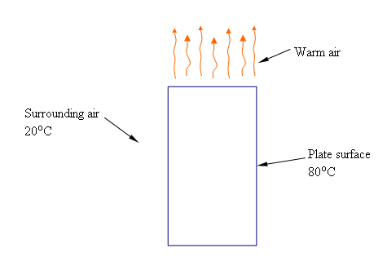
$Qc\left(two wall\right)=2×Qc=1.8 KW$

Figure 3.3: Vertical plate [

3.7.2 Heat losses from front wall
By conduction:
$$A=L×W$$
A= 0.48 x 0.43 = 0.2064 m²
$$Rtotal=\frac{0.004}{50.5}+\frac{0.08}{0.04}+\frac{0.004}{50.5}=2.00016$$
$U=\frac{1}{Rtotal}=0.5$W/m².°C
$$Q=U×A×△T$$
$$Q=0.5×0.2064×225$$
Q= 23 W

By convection outside:
$Ts$ = 47 °C $To$ = 25 °C C _{for vertical} = 3.992 d= 0.61 50.062 1.913 0.906

$$qc=\frac{C(Ts-To)^{1.266}}{d^{0.2}[\left(\frac{Ts+To}{2}\right)]^{0.181}}$$

$$qc=\frac{3.992(47-25)^{1.266}}{{0.61}^{0.2}[\left(\frac{47+25}{2}\right)]^{0.181}}=115.31$$

$$Qc=A×qc=0.2064×115.31=23.8 W$$

By convection inside:
$Ts$ = 250 °C $To$ = 25°C C _{for vertical} = 3.992 d= 0.61
$$qc=\frac{C(Ts-To)^{1.266}}{d^{0.2}[\left(\frac{Ts+To}{2}\right)]^{0.181}}$$

$$qc=\frac{3.992(250-25)^{1.266}}{{0.61}^{0.2}[\left(\frac{250+25}{2}\right)]^{0.181}}=1716$$

$$Qc=A×qc=0.2064×1716=534 W$$

3.7.3 Heat losses from back wall
By conduction:
$$A=L×W$$
A= (0.48 x 0.20) + (0.48 x 0.10) = 0.144 m²
$$Rtotal=\frac{0.004}{50.5}+\frac{0.08}{0.04}+\frac{0.004}{50.5}=2.00016$$

$U=\frac{1}{Rtotal}=0.5$W/m².°C
$$Q=U×A×△T$$
$$Q=0.5×0.144×225$$
Q= 16 W

By convection outside:
$Ts$ = 47 °C $To$ = 25 °C C _{for vertical} = 3.992 d= 0.61
$$qc=\frac{C(Ts-To)^{1.266}}{d^{0.2}[\left(\frac{Ts+To}{2}\right)]^{0.181}}$$

$$qc=\frac{3.992(47-25)^{1.266}}{{0.61}^{0.2}[\left(\frac{47+25}{2}\right)]^{0.181}}=115.31$$

$$Qc=A×qc=0.144 ×115.31=16.6 W$$

By convection inside:
$Ts$ = 250 °C $To$ = 25 °C C _{for vertical} = 3.992 d= 0.61

$$qc=\frac{C(Ts-To)^{1.266}}{d^{0.2}[\left(\frac{Ts+To}{2}\right)]^{0.181}}$$

$$qc=\frac{3.992(250-25)^{1.266}}{{0.61}^{0.2}[\left(\frac{250+25}{2}\right)]^{0.181}}=1716$$
$$Qc=A×qc=0.144 ×1716=247 W$$

3.7.4 Heat losses from ceiling
By conduction:
$$A=L×W$$
$$A=1.07×0.62$$
$$A=0.6634{ m}^{2}$$
$$Rtotal=∑\frac{X}{K}$$
$$Rtotal=\frac{0.004}{50.5}+\frac{0.08}{0.04}+\frac{0.004}{50.5}=2.00016$$

$U=\frac{1}{Rtotal}=0.5$W/m².C
$$Q=U×A×△T$$
$$Q=0.5×0.6634×225$$
Q= 75 W
By convection outside:
$Ts=47 °C$ $To=25 °C$ C _{for horizontal} (upward) = 5.125 d= 0.61
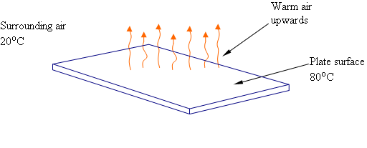
$$qc=\frac{C(Ts-To)^{1.266}}{d^{0.2}[\left(\frac{Ts+To}{2}\right)]^{0.181}}$$

$qc=\frac{5.125 (47-25)^{1.266}}{{0.61}^{0.2}[\left(\frac{47+25}{2}\right)]^{0.181}}= 148.15$
Figure 3.4: hot horizontal plates facing upward

$$Qc=A×qc= 0.6634×148.15=98 W$$

By convection inside:
$Ts$ = 250 °C $To$ = 25 °C C _{for horizontal} (downward) = 2.548 d= 0.61
$$qc=\frac{C(Ts-To)^{1.266}}{d^{0.2}[\left(\frac{Ts+To}{2}\right)]^{0.181}}$$
$$qc=\frac{2.548 (250-25)^{1.266}}{{0.61}^{0.2}[\left(\frac{250+25}{2}\right)]^{0.181}}=1095$$
$$Qc=A×qc=0.6634 ×1095 = 726 W$$

3.7.5 Heat losses from floor
By conduction:
$$A=L×W$$
$$A=0.62×1.39$$
$$A=0.8168{ m}^{2}$$
$$Rtotal=∑\frac{X}{K}$$
$$Rtotal=\frac{0.004}{50.5}+\frac{0.08}{0.04}+\frac{0.004}{50.5}=2.00016$$
$U=\frac{1}{Rtotal}=0.5$W/m².C
$$Q=U×A×△T$$
$$Q=0.5×0.8168×225$$
Q= 92 W

By convection:
$Ts=47 °C$ $To=25 °C$ C _{for horizontal} (downward) = 2.548 d= 0.61

$$qc=\frac{C(Ts-To)^{1.266}}{d^{0.2}[\left(\frac{Ts+To}{2}\right)]^{0.181}}$$

$$qc=\frac{2.548 (47-25)^{1.266}}{{0.61}^{0.2}[\left(\frac{47+25}{2}\right)]^{0.181}}= 73.6$$

$$Qc=A×qc=0.8168 ×73.6=60.2 W$$

3.7.6 Heat losses from chain
By convection:
$Ts$ = 250 C $To$ = 25 C C _{for horizontal} (upward) = 5.125 d= 0.61

$$qc=\frac{C(Ts-To)^{1.266}}{d^{0.2}[\left(\frac{Ts+To}{2}\right)]^{0.181}}$$

$$qc=\frac{5.125 (250-25)^{1.266}}{{0.61}^{0.2}[\left(\frac{250+25}{2}\right)]^{0.181}}=2203$$

$$Qc=A×qc=0.8618×2203=1.9 KW$$

3.7.7 Heat losses by radiation:
Radiation is heat transfer by the emission of electromagnetic waves which carry energy away from the emitting object. For ordinary temperatures (less than red hot"), the radiation is in the infrared region of the electromagnetic spectrum. The relationship governing radiation from hot objects is called the Stefan-Boltzmann law:

$Q_{net}=A×e×σ×({Ti}^{4})$ (3.9) [28]

Internal surface area of oven = 2.7 m².
The internal surface can be considered as black, i.e. e = 1.0

$$Q_{net}=2.7×1.0×5.67×{10}^{-8}×({523}^{4})$$
$$=11.45 KW$$

3.7.8 The output of the heat in kilowatts
It is the sum of heat losses with the heat absorbed by dough

Q (Total) = 27.5 KW + 10% = 30 KW

3.7.9 Efficiency of the oven:

$$ζ=\frac{Eoutput}{Einput}×100\%$$

$$ζ=\frac{10.5}{30}×100\%=35\%$$

