

Graduation Project

Masters online store

Course: Graduation Project in MIS
Academic year: 2019-2020
Semester: First semester
Supervisor: Mohammad Dweikat
Students:
Khaled Abdo Yossi Serawi Yousef Aghbar

1-Historical Background:
The company was a sewing workshop in the center of Nablus in 1998, then developed and became a company in 2004, and there’s an exhibition and a factory to produce the products and presenting them, where advanced machines and modern machines are used over time, and became its main office in the industrial zone, where the number of employees in the current time day thirty-five Employee.
The costumes and garments are imported from China by containers, the goods arrive at the port in the occupied territories, and then shipped to the company.
Then the work on the fashions and clothes is done in multiple stages by the machines and then move them to the stage of packaging, which is known as "Finishing stage".
The final stage is to send the finishing goods to the inventories, display samples of the goods in the company's exhibition, and sell them to wholesalers in the West Bank and inside the occupied.

2-The company organizational structure:

3-Business process in sales department:
After the completion of the manufacturing phase the goods are sent to the inventories and the details of each product are recorded manually on the books and samples of each product are presented in the company exhibition.
The merchant can visit the company's exhibition and choose the items and quantities he wants of a specific presented products and tell the exhibition employee, what the customer needs is recorded manually on the papers in order to prepare the order papered invoice.
The exhibition employee prepares the requested order and put it in large bags, then gives the necessary information to the accountant to prepare a paper sales invoice for the customer and records on the paper the amount received and the remaining amount if there is a residual amount (recording financial details on paper), the order is placed in the customer's car or shipped to the area he wants through company trucks.
There is also another way, where the customer can request a special order (Customization) as of his desire for an item that has not been working on it or an item that is not available in sufficient quantity in the stores and inventories, he request an order in required details (such as color, size, quantity and address to be shipped). Make an agreement for the payment method with the customer, then the order is sent to the workers in the factory to be produced and then the accountant will register the order on the books, prepare a papered invoice and send the order to the customer through the truck company.
The last way is to send photos through the WhatsApp application or any other application such as messenger to the customers to choose the quantities and items required, the order is registered on the book and send the order after finishing it to the customer and receive money from him, or come to receive it and pay for it.

4-Moral Objectives:
- To facilitate the work in all organization’s departments.
- To increase the customers satisfaction through the services will be provided, and to facilitate the purchasing process.
- To save time and efforts using computerized system.
- To reduce costs resulting from using the old manual system.
- Assisting and help the manager to make decisions based on computerized reports.

5-Programing Objectives: -
- Store employees and customers’ data, sales, purchases and inventory data.
- Ability to modify and manipulate the stored data.
- The ability to retrieve and display the requested data in addition various reports.
- Get notifications related to follow-up orders or inventory management.
- Log in/out of the system.
6- Services provided by the system for the sales:
- The ability to browse the products.
- The ability to filter the products.
- The possibility of customers to place an order through the Website
- The ability to choose the quantity and the color of the desired product.
- The ability to leave any customization needs in a specific field
- The ability to leave ratings and comments about the product
7- Additional services placed in the website: -
In addition to services related to the sales department, the following services are placed in the website:
• View the total amount of debts accumulated on customers with their details.
• View daily, monthly and annual reports to the sales and inventory manager.
• Receive notifications from the system for each new order, for example when an order is received or the customer receives a notification of the shipment of the order or upon arrival.
• Provide each driver with details of the orders responsible for each day through a personal account in the system.
• Recording he input and output of the inventories.
• The factory staff receive instructions and orders by a computerized system.

Context diagram
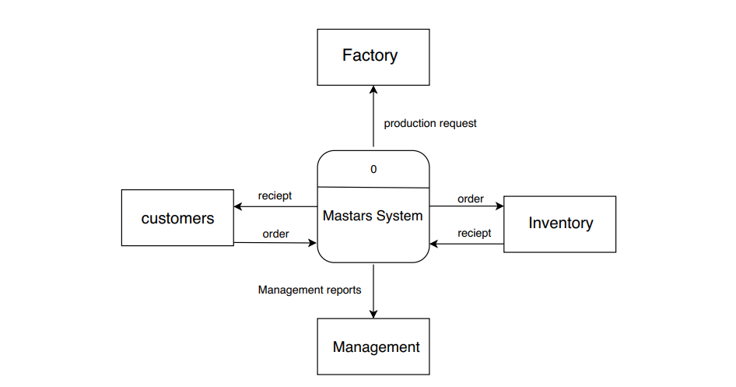

The mechanism of action of the system
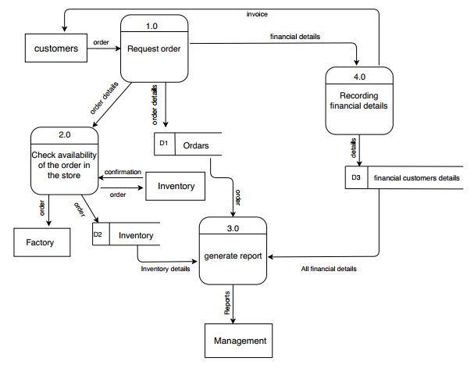

Level 2 - process 1 “Request Order”

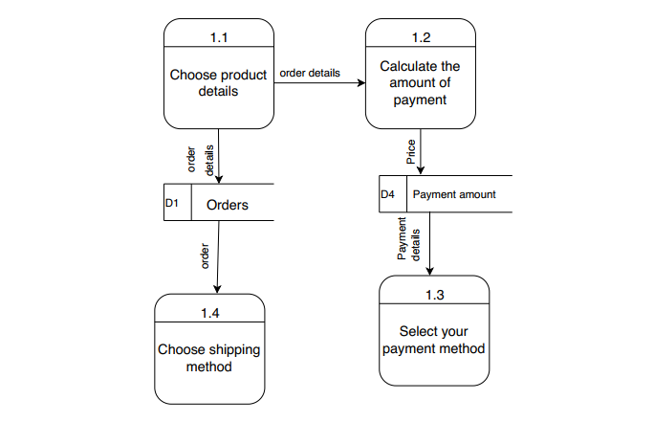

Level 2 process 3 “Generate Report”

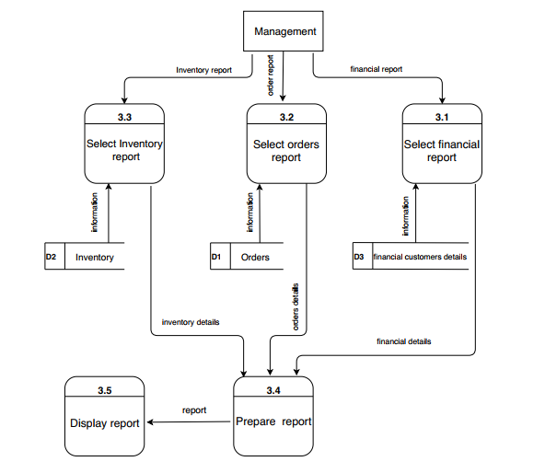

Scenario
1- An order is made through the system.
2- The order details will be selected.
3- The amount of money to be paid and the method of payment of cash or checks will be calculated and stored in its database.
4 - The order is checked to ensure the availability of the required quantities of products in stores.
5- If they are not available even if part of it, request is sent to the factory for manufacturing and stored in its database.
6 - The financial details of the order are calculated and recorded in the database of customers' financial matters.
An invoice is sent to the customer.
7 - Reports from the system are requested by the manager on financial matters in addition to reports on stock and also orders made during a certain period.

Use Case
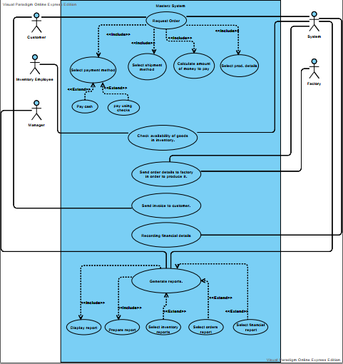
ER diagram
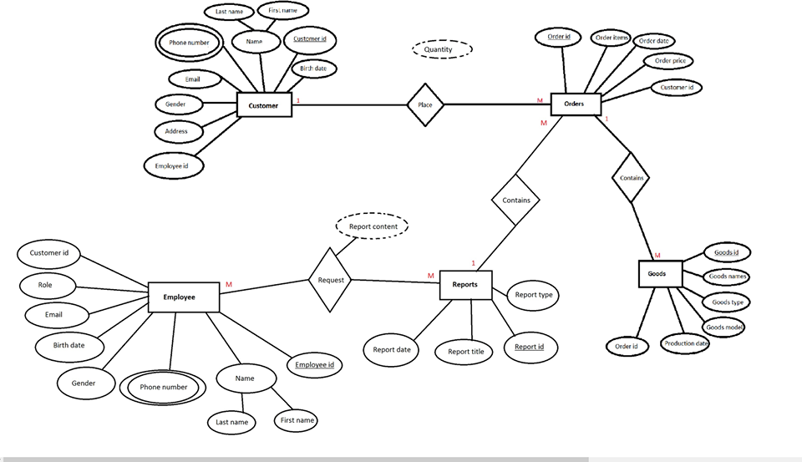

Sign Up/Log in Form
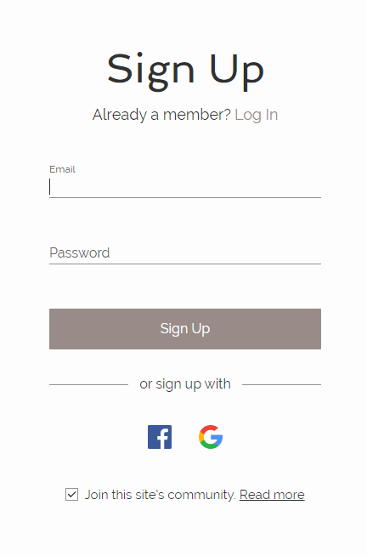
Attribute Name | Data Type | Size | Example | Description | Validation
Email | Email | - | Graduatedproject2019@gmail.com | Email for entering the site as a customer or an Admin | -
Password | Alphanumeric | Between 15-30 | 123456789 | Password | At least 15, at most 30 Alphanumeric, At least 3 capital letters.
Customer’s notes form
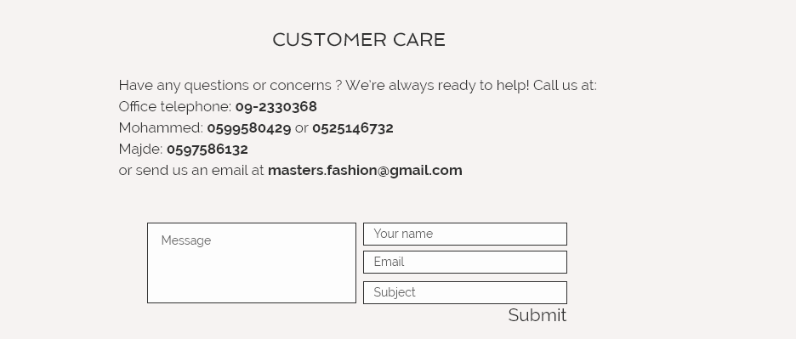

Attribute Name | Data Type | Size | Example | Description | Validation
Message | Alphanumeric | 600 | A problem to discuss | A problem to discuss | Required
Name | Text | 20 | Ali | Name of the customer | -
Email | Email | - | Graduatedproject2019@gmail.com | Email of the customer | -
Subject | Alphanumeric | 15 | A problem to discuss | A problem to discuss | Required

Customer information form
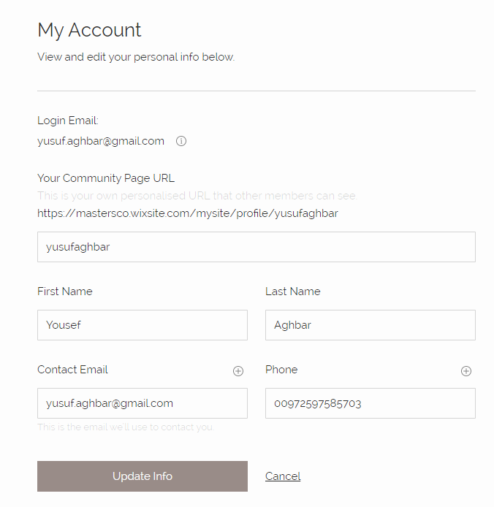

Attribute Name | Data Type | Size | Example | Description | Validation
Custom URL | Alphanumeric | 1-20 | Ali Masri | Custom URL to directly enter the user’s Account | 1-20 letters or numbers
First Name | Text | 20 | Ali | First Name | Required
Last Name | Text | 20 | Masri | Last Name | required
Contact Email | Email | - | Graduatedproject2019@gmail.com | Contact Email | -
Phone | Number | 10 | 0592597585 | Phone number to contact | 10 Numbers

Checkout – shipping form
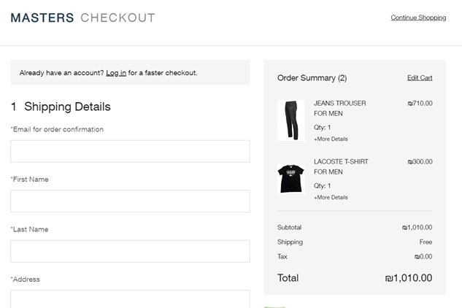

Attribute Name | Data Type | Size | Example | Description | Validation
Contact Email | Email | - | Graduatedproject2019@gmail.com | Contact Email | -
First Name | Text | 20 | Ali | First Name | Required
Last Email | Text | 20 | Masri | Last Name | required
Address | Text | 50 | Asera street | Customer address | -

Products - Coding System

Code: 2X032P5Re

Code | Mean | Description
2X | Size | 2X: 2XL
03 | Product Type | 03: Sleeping shirt
2 | Number of buttons | 2: Two buttons
P | Style | P: Paint
5 | Brand | 5: Lacoste
Re | Color | Red

Size:
0S: Small 0M: Medium 0L: Large 1X: X-Large 2X: 2X-Large
3X: 3X-Large 4X: 4X-Large 5X: 5X-Large

Product Types:
1: T-shirt 2: blouse 3: Sleeping shirt 4: Half sleeve shirt
5: Sleeve shirt 6: Lycra trousers 7: Trousers are not Lycra
8: shorts

Number of buttons:
0: Without buttons 1: One button and so on……

Style:
P: Paint E: Embroidery S: Steam

Brand:
1: Boss 2: Polo 3: Nike 4: Adidas 5: Lacoste

Color:
Re: Red Ye: Yellow Gr: Green Bk: Black Wh: White
Bl: Blue

Customer ID - Coding System

Customer id is: 1801

18 : The first two digits indicate the year of the customer's created account in Mastars system.

01: The last two numbers refer to the customer's serial number in terms of a system record that year

Coding system for delivery vehicles

Registration plate number
For example: 1257

Type of vehicles:
V: Cargo Vans. T: Box Trucks. C: Car

Vehicles Model:
For example: 2018

Order of the code:
- Registration plate number.
- Type of Vehicle
- Vehicle Model.

Example: Car model 2018 have Registration plate number 1257

Code is 1257C2018

