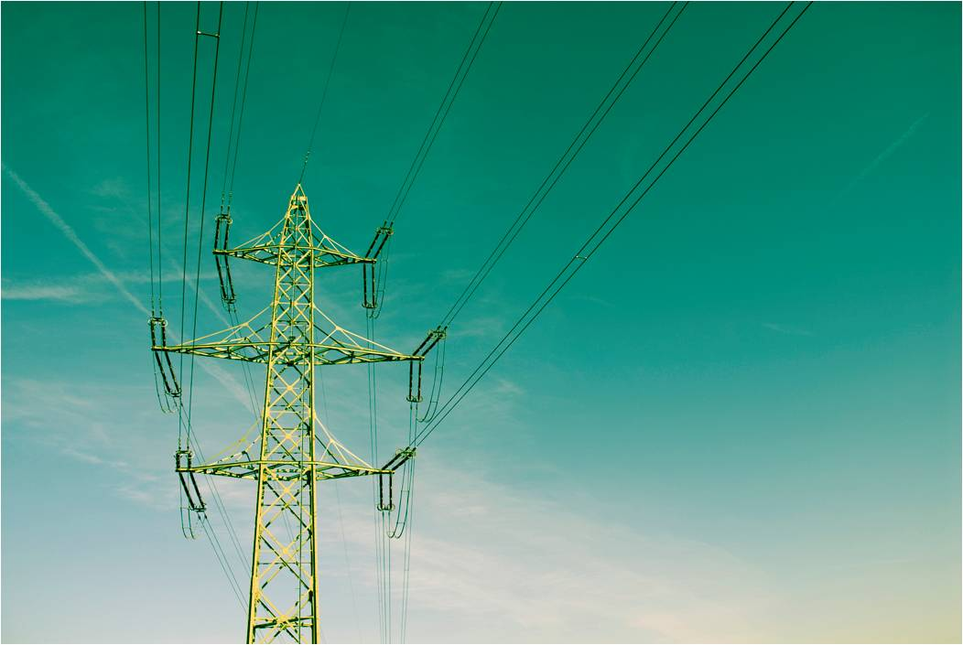


Contents
Contents 1
Index of Figures 5
Index of Tables 7
Abstract 9
Chapter 1 : Introduction
1.1 Electrical Power System: 10
1.2 Load Flow Study: 10
1.3 ETAP power station 7 : 11
1.4 About Our Project : 12
Chapter 2 : Information about Aqraba Network
2.1 Elements Of Network: 14
2.1.1 Electrical Supply: 14
2.1.2 Distribution Transformers: 14
2.1.3 Over Head Line: 16
2.1.4 Under Ground Cable : 17
Chapter 3 : Load Flow Analysis
3.1 Transformer Loading (At Max. Case ) : 18
Chapter 4 : Maximum Case Improvement
4.1 The Original Maximum Case: 20
4.1.1 The Result Of Load Flow: 20
4.1.2 The swing bus result: 20
4.1.3 Summary of total generation ,loading and demand: 21
4.2 Increasing the swing bus voltage: 23
4.2.1 The Result Of Load Flow: 23
4.2.2 The swing bus result: 24
4.2.3 Summary of total generation ,loading and demand: 24
4.3 Improvement the max. case using tap changing : 25
4.3.1 The Result Of Load Flow: 25
4.3.2 The swing bus result: 25
4.3.3 Summary of total generation ,loading and demand: 25
4.4 Power Factor Improvement in the Max. Case: 27
4.4.1 The Result Of Load Flow: 28
4.4.2 The swing bus result: 29
4.3.3 Summary of total generation ,loading and demand: 29
4.5 The Voltage Level Improvement Using Capacitors in the Max. Case: 30
4.5.1 The Result Of Load Flow: 31
4.5.2 The swing bus result: 31
4.5.3 Summary of total generation ,loading and demand: 31
Chapter 5 : Minimum Case Improvement
5.1 The Original Minimum Case: 33
5.1.1 Transformer Loading : 33
5.1.2 The Result Of Load Flow: 34
5.1.3 The swing bus result: 34
5.1.4 Summary of total generation ,loading and demand: 34
5.2 Improvement the minimum case using tap changing : 36
5.2.1 The Result Of Load Flow: 37
5.2.2 The swing bus result: 37
5.2.3 Summary of total generation ,loading and demand: 37
5.3 Power Factor Improvement in the Min. Case: 39
5.3.1 The Result Of Load Flow: 39
5.3.2 The swing bus result: 39
5.3.3 Summary of total generation ,loading and demand: 40
5.4 The Voltage Level Improvement Using Capacitors in the Min. Case: 41
5.4.1 The Result Of Load Flow: 41
5.4.2 The swing bus result: 42
5.4.3 Summary of total generation ,loading and demand: 42
Chapter 6 : Low Voltage Analysis In Max. Case
6.1 Low Voltage Side: 45
6.2 The Original Low Voltage Max. Case : 45
6.2.1 Loading For Each Feeder: 46
6.2.2 The Result Of Load Flow: 47
6.2.3 The swing bus result: 48
6.2.4 Summary of total generation ,loading and demand: 48
6.3 Improvement The Low Voltage Max. Case Using Tap Changing: 50
6.3.1 The Result Of Load Flow: 51
6.3.2 The swing bus result: 52
6.3.3 Summary of total generation ,loading and demand: 52
6.4 Power Factor Improvement in the Low Voltage Max. Case: 53
6.4.1 The Result Of Load Flow: 53
6.4.2 The swing bus result: 55
6.4.3 Summary of total generation ,loading and demand: 55
6.5 The Voltage Level Improvement Using Capacitors in Low Voltage Max. Case: 56
6.5.1 The Result Of Load Flow: 56
6.5.2 The swing bus result: 58
6.5.3 Summary of total generation ,loading and demand: 58
Chapter 7 : Low Voltage Analysis In Min. Case
7.1 The Original Low Voltage Min. Case : 60
7.1.1 Loading For Each Feeder: 60
7.1.2 The Result Of Load Flow: 61
7.1.3 The swing bus result: 62
7.1.4 Summary of total generation ,loading and demand: 63
7.2 Improvement The Low Voltage Min. Case Using Tap Changing: 64
7.2.1 The Result Of Load Flow: 64
7.2.2 The swing bus result: 66
7.2.3 Summary of total generation ,loading and demand: 66
7.3 Power Factor Improvement in the Low Voltage Min. Case: 67
7.3.1 The Result Of Load Flow: 67
7.3.2 The swing bus result: 69
7.3.3 Summary of total generation ,loading and demand: 69
7.4 The Voltage Level Improvement Using Capacitors in Low Voltage Min. Case: 70
7.4.1 The Result Of Load Flow: 70
7.4.2 The swing bus result: 72
7.4.3 Summary of total generation ,loading and demand: 72

Chapter 8 : The Economical Study
8.1 Saving In Panelties : 74
8.2 Saving In Losses : 75
8.3 Simple Pay Back Period : 75
Chapter 9 : Solar Energy Station Project
9.1 Solar System: 76
9.1.1 Introduction to Solar System: 76
9.1.2 Solar Building Designs: 77
9.1.3 Solar Photovoltaic Energy: 78
9.2 Consumption Energy Of Network and Solar System Design: 79
9.2.1 Data about Energy Consumption of the Network: 79
9.2.2 Calculations of the power for the Solar System: 80
9.2.3 The Optimization tilt angle Tracking system: 80
9.3 The Design of the solar station system: 87
9.3.1 Design Of Solar System PV system: 88
9.3.2 Calculations For the Fixed Cost of the investment by PV system: 92
9.4 The Design of the solar station system by using Power One (Aurora): 95
9.5 The Economical Study For The Solar Station Project: 100
9.5.1 Calculations to determine the Rating of the step up Transformer: 100
9.5.2 Economical Study for the Solar system Project: 101
Chapter 10 : Sag & Tension In Overhead Lines Problem
10.1 Sag In Overhead Lines 102
10.1.1 Introduction: 102
10.1.1 Calculations Of Sag: 103
10.2 Problem of the Sag in Overhead Lines in the Network: 104
10.3 Solutions and Recommendations for Sag problem: 105
References : 106

Index of Figures
Figure 1: One Line Diagram Of Aqraba Network. 9
Figure 2: ETAP power station 7. 11
Figure 3: Figure Of Transformer. 14
Figure 4: ACSR Cable. 16
Figure 5:XLPE Cable. 17
Figure 6: The power flow for the network in the original max case. 22
Figure 7: A part of power flow for the network after increase swing buse voltage in max.. 24
Figure 8: A part of power flow for the network after increase the tap in max.. 26
Figure 9: A part of power flow after adding capacitor banks in max. case.. 30
Figure 10: A part of the power flow after improvement the voltage level in max.. 32
Figure 11: The power flow in the min original case.. 36
Figure 12 : The power flow after increase the tap in min.. 38
Figure 13: The power flow after improvement the P.F in min.. 41
Figure 14: The power flow after improvement the voltage level in min.. 44
Figure 15: ABC Cable. 45
Figure 16: A part of the low voltage side of original Max. case.. 50
Figure 17: A part of power flow for the network after increase the tap in L. V. max. case.. 53
Figure 18: A part of power flow after adding capacitor banks in L. V. max. case... 56
Figure 19: A part of the power flow after improvement the voltage level in L. V. max. case.. 59
Figure 20: A part of the low voltage side of original Min. case... 64
Figure 21: A part of power flow for the network after increase the tap in L. V. min. case.. 67
Figure 22: A part of power flow after adding capacitor banks in L. V. min. case... 70
Figure 23: A part of the power flow after improvement the voltage level in L. V. min. case.. 73
Figure 24: Solar Cells Station.. 76
Figure 25: Solar Building.. 77
Figure 26: Inverter and Photovoltaic cells.. 78
Figure 27: Angle in the summer and winter semester.. 81
Figure 28: The interface of the link in the internet.. 82
Figure 29: Selecting the geographical area.. 83
Figure 30: Average power produced by the solar system per month.. 84
Figure 31: Average global irradiation per month.. 85
Figure 32: Entering the tilt angle.. 85
Figure 33: Irradiation plane at angle 26 deg. For each month.. 86
Figure 34: Optimal Inclination angle for each month.. 87
Figure 35: The Interface of PV sys. Program.. 88
Figure 36: Syetem specifications in PV system.. 90
Figure 37: Irradiation per month by PV system.. 91
Figure 38: System output energy for each month by PV system.. 92
Figure 39: Calculations For the Fixed Cost of the investment by PV system.. 94
Figure 40: Choosing the assumption in the Aurora program.. 95
Figure 41: Entering the serier module and parallel string in the Aurora program.. 96
Figure 42: System configuration in Aurora program.. 96
Figure 43: Inverter Specifications in Aurora program.. 97
Figure 44: : PV Module Data in Aurora program.. 97
Figure 45: : Array Sizing Parameters in Aurora program .. 98
Figure 46: : Voltage and Current Parameter Check in Aurora program .. 98
Figure 47: System configuration when paralle string = 11 in Aurora program.. 99
Figure 48: Voltage and Current Parameter Check when paralle string = 11 in Aurora program. 100
Figure 49: Conductor suspended between two equal level supports. 102
Figure 50: Conductor between two equal level supports. 103
Figure 51: Effect of ice and wind on the overhead line. 104
Figure 52: A picture of one of the towers destroyed 105

Index of Tables
Table 1: The number & rating of Transformers. 15
Table 2: R &X of Transformers. 15
Table 3: R & X of the ACSR. 16
Table 4: R & X of XLPE CU. 17
Table 5: R & X of XLPE AL. 17
Table 6: The Loading Transformer in Max. Case. 18
Table 7: The Original maximum case. 20
Table 8: The swing bus result in the original maximum case. 20
Table 9: Summary of generation ,loading in original maximum case. 21
Table 10 : The results after increase the swing bus voltage. 23
Table 11: : The swing bus result after increase the swing bus. 24
Table 12: : Summary of generation ,loading after increase the swing . 24
Table 13: The results of improvement of max case using tap changing. 25
Table 14: The swing bus result after improvement of max case using taps. 25
Table 15: Summary of generation ,loading after improvement of max case using taps . 26
Table 16: The penalties of power factor. 28
Table 17: The results of improvement P.F in Max Case. 29
Table 18: The swing bus result of improvement the P.F in max case. 29
Table 19: Summary of generation ,loading of improvement the P.F in max case . 29
Table 20: The results of improvement the voltage level in max case without increase the taps. 31
Table 21: The swing bus result of improvement the voltage level in max. 31
Table 22: Summary of generation ,loading of improvement the voltage level in max case . 31
Table 23: The Loading Transformer in min. case.. 33
Table 24: The Original minimum case.. 34
Table 25: The swing bus result in the original minimum case.. 34
Table 26: Summary of generation ,loading in original minimum case.. 34
Table 27: The results of improvement of min case using tap changing.. 37
Table 28: The swing bus result after improvement of min case using taps. . 37
Table 29: Summary of generation ,loading after improvement of min case using taps .. 37
Table 30: The results of improvement P.F in Min Case. 39
Table 31: The swing bus result of improvement the P.F in min case. . 39
Table 32: Summary of generation ,loading of improvement the P.F in min case . 40
Table 33: The results of improvement the voltage level in min case. 42
Table 34: The swing bus result of improvement the voltage level in min. 42
Table 35: Summary of generation ,loading of improvement the voltage level in min case . 42
Table 36: Loading of each feeder in Low Voltage Max. Case. 46
Table 37: The result of low voltage in original Low Voltage max. case.. 48
Table 38: The swing bus result in the L. V. original Max. case.. 48
Table 39: Summary of generation ,loading in L. V. original Max. case.. 48
Table 40: The results of improvement of L. V. max case using tap changing.. 51
Table 41: The swing bus result after improvement of L. V. max case using taps.. 52
Table 42: Summary of generation ,loading after improvement of L. V. max case using taps . 52
Table 43: The results of improvement P.F in L. V. Max Case. . 54
Table 44: The swing bus result of improvement the P.F in L. V. max case.. 55
Table 45: Summary of generation ,loading of improvement the P.F in L. V. max case .. 55
Table 46: The results of improvement the voltage level in L. V. max case without icrease taps.. 57
Table 47: The swing bus result of improvement the voltage level in L. V. max. case ... 58
Table 48: Summary of generation ,loading of improvement the voltage level in L. V. max case ... 58
Table 49: Loading of each Feeder in Low Voltage in Min. Case... 61
Table 50: The result of low voltage in original min. case... 62
Table 51: The swing bus result in the L. V. original Min. case... 63
Table 52: Summary of generation ,loading in L. V. original Min. case.... 63
Table 53: The results of improvement of L. V. min case using tap changing.... 65
Table 54: The swing bus result after improvement of L. V. min case using taps.... 66
Table 55: Summary of generation ,loading after improvement of L. V. min case using taps ... 66
Table 56: The results of improvement P.F in L. V. Min Case.... 68
Table 57: The swing bus result of improvement the P.F in L. V. min case.... 69
Table 58: Summary of generation ,loading of improvement the P.F in L. V. min case ..... 69
Table 59: The results of improvement the voltage level in L. V. min case.... 71
Table 60: The swing bus result of improvement the voltage level in L. V. min. case ..... 72
Table 61: Summary of generation ,loading of improvement the voltage level in L. V. min case 72
Table 62: Consumption Energy of the Network per Month in 2013 79
Table 63: Average power produce by solar system 84
Table 64: Optimal inclination angle and irradiation on plane in each month 86
Table 65: Fixed investment for the Solar system project by PV system 93
Table 66: Comprasion between two interest rate (5% ,10%). 93

Abstract
Our project is to make a load flow study and analysis for Aqraba Electrical Network using ETAP software to improve the power factor and to reduce the electrical losses in the network and so reducing the penalties in the total tariff for the municipality, increasing the reliability of the network. More over we want to support the electrical grid by solar cells project to supply the network by electric power by adding a new connection point between the solar cells project and Aqraba Electrical network .
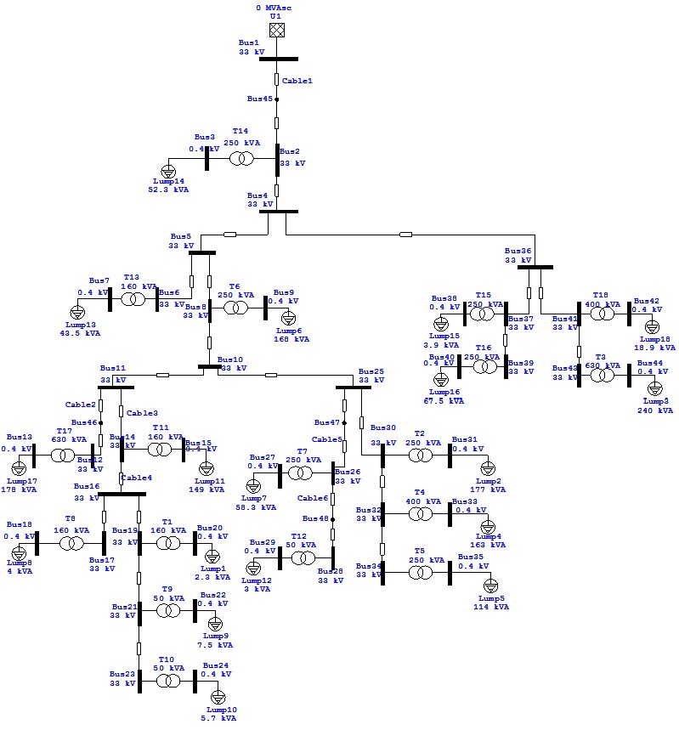 Figure 1: One Line Diagram Of Aqraba Network.

Chapter 1:

Introduction

1.1 Electrical Power System:
Electrical energy is produced through an energy conversion process. The electric power system is a network of interconnected components which generate electricity by converting different form of energy,
(Potential energy, kinetic energy, or chemical energy) are the most common forms of energy converted to electrical energy; and transmit the electrical energy to load centers to be used by the consumer. The production and transmission of electricity is relatively efficient and inexpensive, although unlike other forms of energy, electricity is not easily stored and thus must generally be used as it is being produced.

The electric power system consists of three main subsystems: the generation subsystem, the transmission subsystem , and the distribution subsystem. Electricity is generated at the generation station by converting a primary source of energy to electrical energy. The voltage output of the generators is then stepped-up to appropriate transmission levels using a step-up transformer. The transmission subsystem then transmits the power close to the load centers. The voltage is then stepped-down to appropriate levels.
The distribution subsystem then transmit the power close to the consumer where the voltage is stepped-down to appropriate levels for use by a residential, industrial, or commercial customer.

1.2 Load Flow Study :
In power engineering, the power flow study (also known as load-flow study) is an important tool involving numerical analysis applied to a power system. Unlike traditional circuit analysis, a power flow study usually uses simplified notation such as a one-line diagram and per-unit system, and focuses on various forms of AC power (i.e: reactive, real, and apparent) rather than voltage and current . It analysis the power system in normal steady-state operation. There exit a number of software implementations of power flow studies.

In addition to a power flow study itself , sometimes called the base case, many software implementation perform other type of analysis, such as fault analysis and economic analysis. In practical, some program use linear programming to find the optimal power flow, the conditions which give the lowest cost per KW generated.

The great importance of power flow or load-flow studies is in planning the future expansion of power systems as well as in determining the best operation of existing systems. The principle information obtained from the power flow study is the magnitude and phase angle of the voltage at each bus and the real and reactive power flowing in each line, such as ETAP power station program.

Objectives and Benefits of Load/Power Flow studies:
- Load-flow studies are performed to determine the steady-state operation of an electric power system. It calculates the voltage drop on each feeder, the voltage at each bus, and the power flow(Real and Reactive Power) in all branch and feeder circuits.
- Determine if system voltages remain within specified limits under various contingency conditions, and whether equipment such as transformers and conductors are overloaded.
- Load-flow studies are often used to identify the need for additional generation, capacitive, or inductive VAR support, or the placement of capacitors and/or reactors to maintain system voltages within specified limits.
- Losses in each branch and total system power losses are also calculated.
- Necessary for planning, economic scheduling, and control of an existing system as well as planning its future expansion.

1.3 ETAP power station 7 :

Figure 2: ETAP power station.
ETAP offers a suite of fully integrated Electrical Engineering software solutions including arc flash, load flow, short circuit, transient stability, relay coordination, cable ampacity, optimal power flow, and more. Its modular functionality can be customized to fit the needs of any company, from small to large power systems.
ETAP Real-Time is a fully-integrated suite of software applications that provides intelligent power monitoring, energy management, system optimization, advanced automation, and real-time prediction.
ETAP is the most comprehensive enterprise solution for design, simulation, operation, control, optimization, and automation of generation, transmission, distribution, and industrial power system.
ETAP Smart Grid offers comprehensive applications enabling electrical utilities to plan, coordinate, and safely operate their grid. This real-time system has the ability to manage, control, visualize, optimize, and automate power transmission and distribution networks.
ETAP has been design and developed by engineers to engineers to handle the diverse discipline of power systems for board spectrum of industries in one integrated package with multiple interface views such as AC ,DC networks .cable raceways, ground grid, GIS. Panels, arc flash, WTG, proactive devise coordination\selectivity .and AC and DC control system diagrams.
ETAP users must be proficient of using basic operation of Windows environment. Use of ETAP does not required training. However, to facilitate the learning process. OTI provides workshops throughout the year in several locations. (Refer to www.etap.com for the up-to-date training schedule).
ETAP allows you easily create and edit graphical one line diagrams (OLD),underground cable raceway systems (UGS), three-dimensional cable systems, advanced time-current coordination and selectively plots, geographic information system schematics (GIS) as well as three-dimensional ground grid systems (GCS).
The program has been designed to incorporate to three key concepts:
1. Virtual Reality Operation. 2. Total Integration of Data. 3. Simplicity in Data Entry.
So we will use ETAP 7.0 in our project to analyze the one line diagram for the network as will be shown later.

1.4 About Our Project :
Our project goals to analysis and improve Aqraba electrical network by using the Etap7 software program, and support the grid by solar cells project.
The network consists of :
- one connection point at Za'tara Street.
- 18 Distribution Transformers.
- 48 bus.
- 47 branches.
- 18 loads( residential, industrial, commercial).
The main goals of the study :-
- Increasing of voltage levels.
- Reducing the penalties by improving the P.F.
- Reducing the losses in the distribution level.
- Supporting the grid by solar cells project to see the effect of it on the network.
Methods of improvement the operating condition in electrical network :-
- Swing bus control.
- Change the taps of the transformer.
- Installation of capacitor banks (reactive power compensation).

Chapter 2:

Information about Aqraba Network

2.1 Elements Of Network:
This section study the elements of the network such as transformers, over head lines and underground cables.

2.1.1 Electrical Supply:
Aqraba Electrical Network is provided by Israel electrical company (IEC) through an over head transmission line of 33 kV. The max demand is reached (2MW).
The main supply for Aqraba electrical distribution network in the Za'tara Street.. And the voltage of the existing distribution networks are 33 KV only.IEC supplies electricity to the electrified communities by 33 KV by overhead lines .
Electricity is purchased from IEC and then distributed to the consumers. Palestine has not yet a unified power system , the existing network is local low voltage distributions networks connected to Israeli electrical corporation (IEC).

2.1.2 Distribution Transformers:
Aqraba electrical network consists of 18 (33/0.4 KV) distribution transformers.
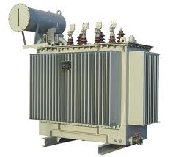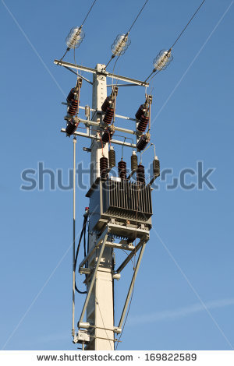
Figure 3: Figure Of Transformer.

The following Table 1-2 shows the number of transformers and the rated KVA for each one.
Rated power (KVA) | Rating | Transformer number
160 | 33/0.4 KV | Tr1 (AL-Ghars)
250 | 33/0.4 KV | Tr2 (Municipality)
630 | 33/0.4 KV | Tr3(Twin company)
400 | 33/0.4 KV | Tr4(Ayman)
250 | 33/0.4 KV | Tr5(Concrete)
250 | 33/0.4 KV | Tr6(Downtown)
250 | 33/0.4 KV | Tr7(AL-jwar)
160 | 33/0.4 KV | Tr8(AL-Qata)
50 | 33/0.4 KV | Tr9(South Yanoon)
50 | 33/0.4 KV | Tr10(North Yanoon)
160 | 33/0.4 KV | Tr11(Bani-Jam'a)
50 | 33/0.4 KV | Tr12(AL-Gore)
160 | 33/0.4 KV | Tr13(Club)
250 | 33/0.4 KV | Tr14(Abu-Hadaba)
250 | 33/0.4 KV | Tr15(Beta Street)
250 | 33/0.4 KV | Tr16(AL-krom)
630 | 33/0.4 KV | Tr17(Bani-Jaber)
400 | 33/0.4 KV | Tr18(Osaren)
Table 1: The number & rating of Transformers.

Z(Ω/Km) | X(Ω/Km) | R(Ω/Km) | Transformer rating(KVA)
0.012 | 0.012 | 0.002 | 630
0.016 | 0.015 | 0.004 | 400
0.025 | 0.024 | 0.008 | 250
0.04 | 0.037 | 0.01 | 160
Table 2: R &X of Transformers.

2.1.3 Over Head Line:
High-voltage overhead conductors are not covered by insulation. The conductor material is nearly always an aluminium alloy, made into several strands and possibly reinforced with steel strands. Copper was sometimes used for overhead transmission but aluminium is lighter, yields only marginally reduced performance, and costs much less. Overhead conductors are a commodity supplied by several companies worldwide. Improved conductor material and shapes are regularly used to allow increased capacity and modernize transmission circuits. Conductor sizes range from 12 mm² to 750 mm² (1,590,000 circular mils area), with varying resistance and current-carrying capacity. Thicker wires would lead to a relatively small increase in capacity due to the skin effect, that causes most of the current to flow close to the surface of the wire. Because of this current limitation, multiple parallel cables (called bundle conductors) are used when higher capacity is needed. Bundle conductors are also used at high voltages to reduce energy loss caused by corona discharge.
- The conductors used in the network are ACSR (Aluminum Conductor Steel Reinforced).
- The resistance and reactance of the ACSR conductor in the table below:

ACSR Cable | R(Ω/Km) | X(Ω/Km)
120mm2 | 0.219 | 0.269
95mm2 | 0.301 | 0.322
50mm2 | 0.543 | 0.333
Table 3: R & X of the ACSR.
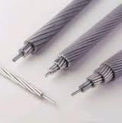
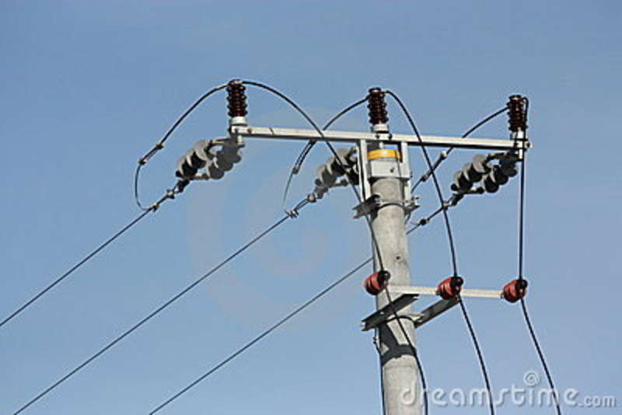
Figure 4: ACSR Cable.

2.1.4 Under Ground Cable :
Electric power can also be transmitted by underground power cables instead of overhead power lines. Underground cables take up less right-of-way than overhead lines, have lower visibility, and are less affected by bad weather. However, costs of insulated cable and excavation are much higher than overhead construction. Faults in buried transmission lines take longer to locate and repair. Underground lines are strictly limited by their thermal capacity, which permits less overload or re-rating than overhead lines. Long underground cables have significant capacitance, which may reduce their ability to provide useful power to loads.
- The underground cable used in the network are XLPE Cu ,XLPE Al .
- The resistance and reactance of XLPE in below tables.
XLPE CU | R(Ω/Km) | X(Ω/Km)
240mm2 | 0.754 | 0.109
120mm2 | 0.196 | 0.117
95mm2 | 0.41 | 0.121
50mm2 | 0.387 | 0.138
Table 4: R & X of XLPE CU.

XLPE AL | R(Ω/Km) | X(Ω/Km)
95mm2 | 0.32 | 0.542
Table 5: R & X of XLPE AL.

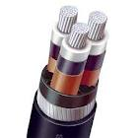
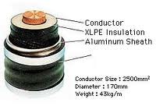
Figure 5:XLPE Cable.

Chapter 3:

Load Flow Analysis
In this semester we do the following steps:
1- Collection of data which consist of :
- Actual loads on transformer and power factor .
- Impedances of transmission lines ( R, X) .
2- Plotting the one line diagram in ETAP .
3- Analysis and improving the network in several cases:
- In maximum case.
- In minimum case.
4- Low voltage analysis.
5- Study the effect of supporting the network by solar cells.

3.1 Transformer Loading :
We have in the network 18 transformers .
The following table shows the loading of transformers and the load factor in the max. case:
# of Transformer | Rated  Power (KVA) | Actual currents for each phase (A) |  |  | Actual power (KVA) | Load  % | Power factor  (Load)
# of Transformer | Rated  Power (KVA) | $$I_{1}$$ | $$I_{2}$$ | $$I_{3}$$ | Actual power (KVA) | Load  % | Power factor  (Load)
Tr1 | 160 | 2.2 | 8.0 | 0.0 | 2.3 | 1.43 | 93
Tr2 | 250 | 246.4 | 282.8 | 247.6 | 176.75 | 70.7 | 88
Tr3 | 630 | 390 | 395 | 263 | 240 | 38.1 | 87
Tr4 | 400 | 156 | 251 | 305 | 163.2 | 40.8 | 86
Tr5 | 250 | 155.3 | 192 | 151 | 114.2 | 45.6 | 86
Tr6 | 250 | 290 | 215.6 | 230 | 168.3 | 67.3 | 88
Tr7 | 250 | 88.8 | 68.4 | 98.1 | 58.3 | 23.3 | 89
Tr8 | 160 | 13.3 | 0.02 | 4.0 | 4.00 | 2.5 | 90
Tr9 | 50 | 5.5 | 14 | 13.1 | 7.5 | 15 | 92
Tr10 | 50 | 15.8 | 4.9 | 4.1 | 5.7 | 11.4 | 92
Tr11 | 160 | 188.2 | 194.2 | 269 | 149 | 93.12 | 88
Tr12 | 50 | 0.0 | 1.6 | 11.8 | 3.00 | 6.00 | 90
Tr13 | 160 | 76.5 | 54.5 | 59 | 43.5 | 27.18 | 89
Tr14 | 250 | 64.4 | 88.2 | 75.6 | 52.3 | 20.9 | 89
Tr15 | 250 | 5.2 | 8.74 | 3.33 | 3.94 | 1.57 | 93
Tr16 | 250 | 89.9 | 103 | 101.9 | 67.5 | 27 | 89
Tr17 | 630 | 292 | 241.9 | 240 | 177.5 | 28.2 | 88
Tr18 | 400 | 33 | 18.3 | 31.2 | 18.94 | 4.73 | 90
Table 6: The Loading Transformer in max. case.

The maximum efficiency of the transformer (98.7%) obtain if the load factor of transformer between (50% - 100%).
As shown in the above table some of the transformer have a load factor less than 50%, so in this case the efficiency is very low.

Chapter 4:

Maximum Case Improvement

4.1 The Original Maximum Case:

4.1.1 The Result Of Load Flow:
The following table shows the voltage of the buses in medium and low voltage.
Transformer Number | Mediam voltage rated (KV) | Mediam voltage actual (KV) | Low voltage rated (KV) | Low voltage actual (KV) | Power factor  (Tr)
Tr1 | 33 | 32.945 | 0.4 | 0.3991 | 93
Tr2 | 33 | 32.942 | 0.4 | 0.3838 | 86.2
Tr3 | 33 | 32.970 | 0.4 | 0.3918 | 86
Tr4 | 33 | 32.937 | 0.4 | 0.3902 | 85
Tr5 | 33 | 32.938 | 0.4 | 0.3891 | 84.8
Tr6 | 33 | 32.948 | 0.4 | 0.3847 | 86.3
Tr7 | 33 | 32.945 | 0.4 | 0.3945 | 88.4
Tr8 | 33 | 32.945 | 0.4 | 0.3988 | 89.9
Tr9 | 33 | 32.945 | 0.4 | 0.3962 | 91.7
Tr10 | 33 | 32.944 | 0.4 | 0.3970 | 91.8
Tr11 | 33 | 32.945 | 0.4 | 0.3787 | 85.6
Tr12 | 33 | 32.945 | 0.4 | 0.3980 | 89.9
Tr13 | 33 | 32.960 | 0.4 | 0.3938 | 88.3
Tr14 | 33 | 32.988 | 0.4 | 0.3955 | 88.5
Tr15 | 33 | 32.976 | 0.4 | 0.3994 | 93
Tr16 | 33 | 32.975 | 0.4 | 0.3941 | 88.4
Tr17 | 33 | 32.945 | 0.4 | 0.3937 | 87.3
Tr18 | 33 | 32.970 | 0.4 | 0.3987 | 89.9
Table 7: The Original maximum case.

4.1.2 The swing bus result:
The Bus 1 is the swing bus.
The following table shows the information of swing bus after analysis.
MW | MVAR | MVA | Amp | P.F%
1.280 | 0.743 | 1.480 | 25.886 | 86.51 Lag
Table 8: The swing bus result in the original maximum case.

4.1.3 Summary of total generation ,loading and demand:
The following table shows the summary of total generation ,loading and demand.
 | MW | MVAR | MVA | P.F %
Swing Bus | 1.280 | 0.743 | 1.480 | 86.51 Lag
Total Demand | 1.280 | 0.743 | 1.480 | 86.51 Lag
Total Motor Load | 1.021 | 0.559 | 1.164 | 87.73 Lag
Total Static Load | 0.242 | 0.132 | 0.276 | 87.73 Lag
Apparent Losses | 0.017 | 0.051
Table 9: Summary of generation ,loading in original maximum case.
There are many problems in the network appears after analysis:
- From the above result the P.F of the swing bus=86.51 Lag,which cases high penalities and losses.
- The voltage of the buses not in the acceptable range 1.05 Vn≤V≤1.1 Vn .
Appendix A shows the load flow results ,the P.F of the buses and the drop voltages.

The following figures show the power flow for the network

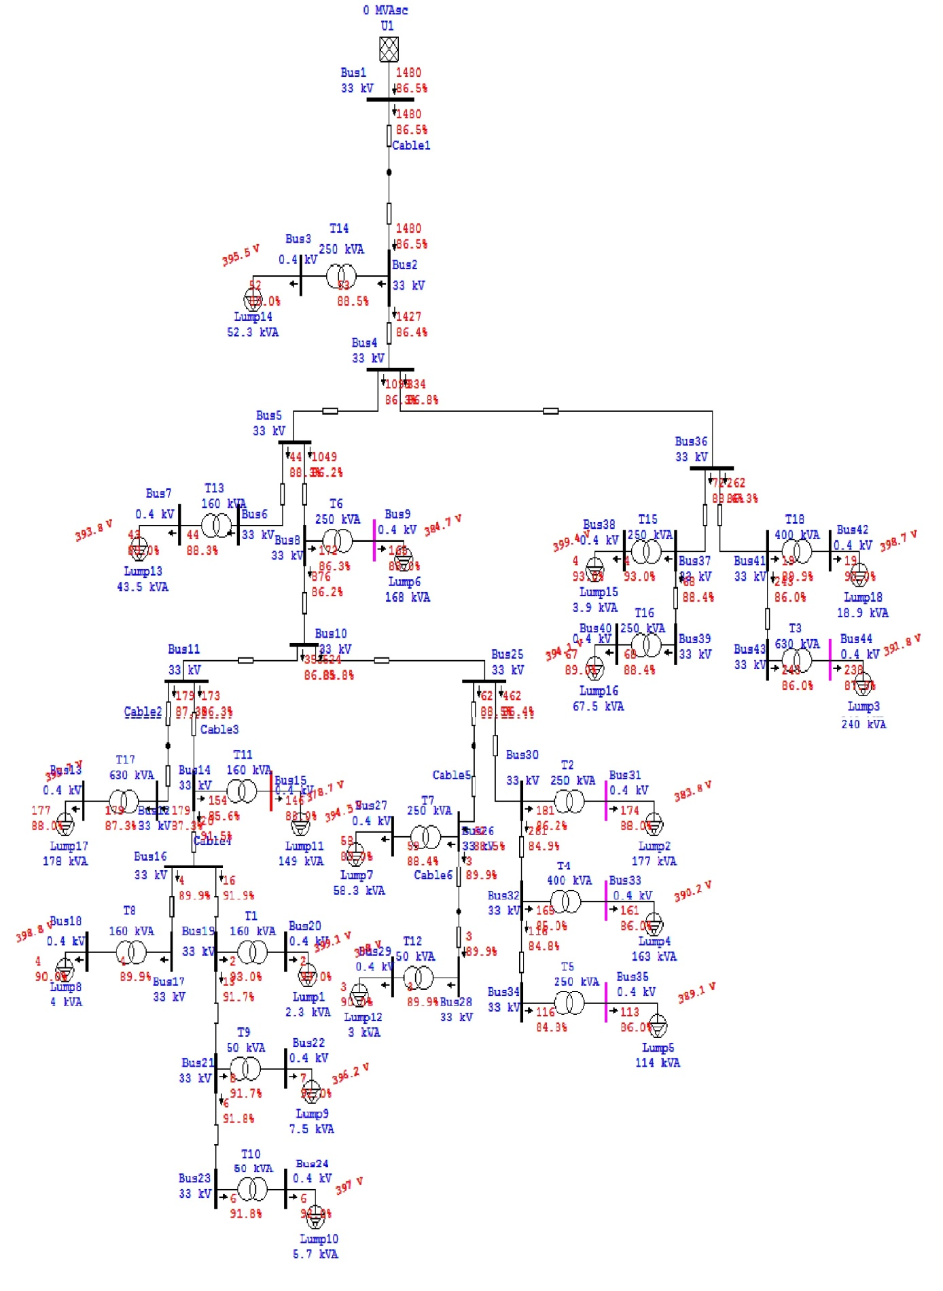Figure 7: The power flow for the network in the original max case.
There is several methods of improvement the operating condition in the electrical networks :-
- Swing bus control.
- Change the taps of transformers.
- Installation of capacitor banks (reactive power compensation).

4.2 Increasing the swing bus voltage:
Increase the voltage on the swing bus up to 5% from the original voltage (33 KV) the new value of the swing bus voltage equal (34.65KV) the result of load flow as the following.

4.2.1 The Result Of Load Flow:
The following table shows the voltage of the buses in the low voltage side and the P.F of these buses.
Transformer Number | $V_{rated}$(KV) | $V_{actual}$(KV) | Power Factor %
T1 | 0.4 | 0.4191 | 93
T2 | 0.4 | 0.4043 | 86.4
T3 | 0.4 | 0.4121 | 86.1
T4 | 0.4 | 0.4105 | 85
T5 | 0.4 | 0.4094 | 84.9
T6 | 0.4 | 0.4052 | 86.4
T7 | 0.4 | 0.4147 | 88.5
T8 | 0.4 | 0.4189 | 89.9
T9 | 0.4 | 0.4163 | 91.7
T10 | 0.4 | 0.4171 | 91.8
T11 | 0.4 | 0.3994 | 85.8
T12 | 0.4 | 0.4181 | 89.9
T13 | 0.4 | 0.4140 | 88.4
T14 | 0.4 | 0.4156 | 88.5
T15 | 0.4 | 0.4194 | 93
T16 | 0.4 | 0.4142 | 88.4
T17 | 0.4 | 0.4139 | 87.3
T18 | 0.4 | 0.4187 | 89.9
Table 10 : The results after increase the swing bus voltage.

- As shown in the above results the voltage of the buses increase.
- But we can't apply this method because the control of swing bus done only by Israel electrical company IEC.

4.2.2 The swing bus result:
The following table shows the information of swing bus after analysis.
MW | MVAR | MVA | Amp | P.F%
1.305 | 0.754 | 1.507 | 26.36 | 86.60 Lag
Table 11: : The swing bus result after increase the swing bus.

4.2.3 Summary of total generation ,loading and demand:

The following table shows the summary of total generation ,loading and demand.
 | MW | MVAR | MVA | P.F %
Swing Bus | 1.305 | 0.754 | 1.507 | 86.60Lag
Total Demand | 1.305 | 0.754 | 1.507 | 86.60Lag
Total Motor Load | 1.021 | 0.559 | 1.164 | 87.73 Lag
Total Static Load | 0.268 | 0.146 | 0.305 | 87.73 Lag
Apparent Losses | 0.016 | 0.048
Table 12: : Summary of generation ,loading after increase the swing .

The following figure show a part of power flow after increase the swing buse voltage.
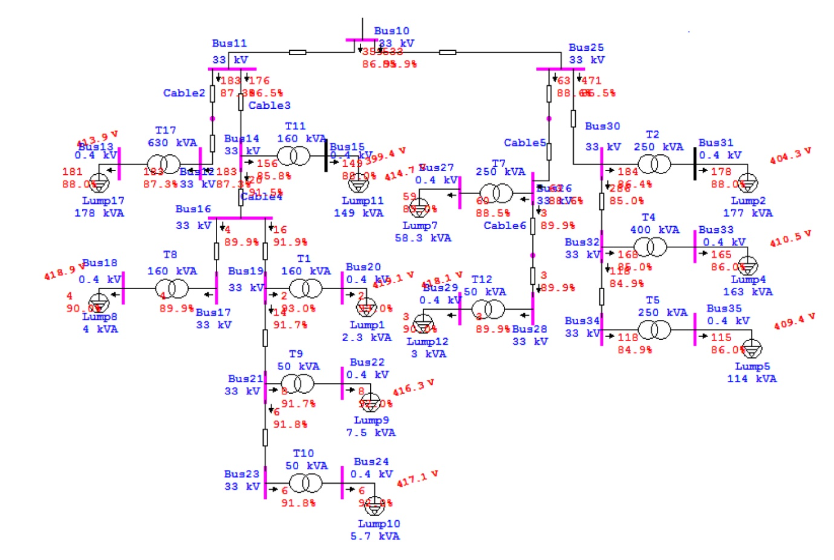
Figure 8: A part of power flow for the network after increase swing buse voltage in max.

4.3 Improvement the max. case using tap changing :
In this method change the tap ratio of the transformers to 5%.

4.3.1 The Result Of Load Flow:
The following table shows the results after changing the tap of the transformers.
Power Factor % | V(KV) after increasing tap | V(KV) before increasing tap | $V_{rated}$(KV) | Transformer Number
93 | 0.4190 | 0.3991 | 0.4 | T1
86.2 | 0.4027 | 0.3838 | 0.4 | T2
86 | 0.4113 | 0.3918 | 0.4 | T3
84.9 | 0.4095 | 0.3902 | 0.4 | T4
84.8 | 0.4084 | 0.3891 | 0.4 | T5
86.3 | 0.4036 | 0.3847 | 0.4 | T6
88.4 | 0.4141 | 0.3945 | 0.4 | T7
89.9 | 0.4188 | 0.3988 | 0.4 | T8
91.7 | 0.4160 | 0.3962 | 0.4 | T9
91.8 | 0.4168 | 0.3970 | 0.4 | T10
85.6 | 0.3972 | 0.3787 | 0.4 | T11
89.9 | 0.4179 | 0.3980 | 0.4 | T12
88.3 | 0.4134 | 0.3938 | 0.4 | T13
88.5 | 0.4152 | 0.3955 | 0.4 | T14
93 | 0.4194 | 0.3994 | 0.4 | T15
88.3 | 0.4137 | 0.3941 | 0.4 | T16
87.2 | 0.4133 | 0.3937 | 0.4 | T17
89.9 | 0.4186 | 0.3987 | 0.4 | T18
Table 13: The results of improvement of max case using tap changing.

4.3.2 The swing bus result:
The following table shows the information of swing bus after analysis.
MW | MVAR | MVA | Amp | P.F%
1.306 | 0.758 | 1.510 | 26.42 | 86.48Lag
Table 14: The swing bus result after improvement of max case using taps.

4.3.3 Summary of total generation ,loading and demand:

The following table shows the summary of total generation ,loading and demand.
 | MW | MVAR | MVA | P.F %
Swing Bus | 1.306 | 0.758 | 1.510 | 86.48Lag
Total Demand | 1.306 | 0.758 | 1.510 | 86.48Lag
Total Motor Load | 1.021 | 0.559 | 1.164 | 87.73Lag
Total Static Load | 0.262 | 0.146 | 0.303 | 87.73Lag
Apparent Losses | 0.018 | 0.053
Table 15: Summary of generation ,loading after improvement of max case using taps .

Note:
After changing the taps of the transformers the voltage of the busses increased and they located in the desired range 1.05 Vn≤V≤1.1 Vn, and the transformers the losses in the network decrease and the total current decrease .
Appendix B shows the load flow results and the P.F of the buses.

The following figure show a part of power flow in the network.

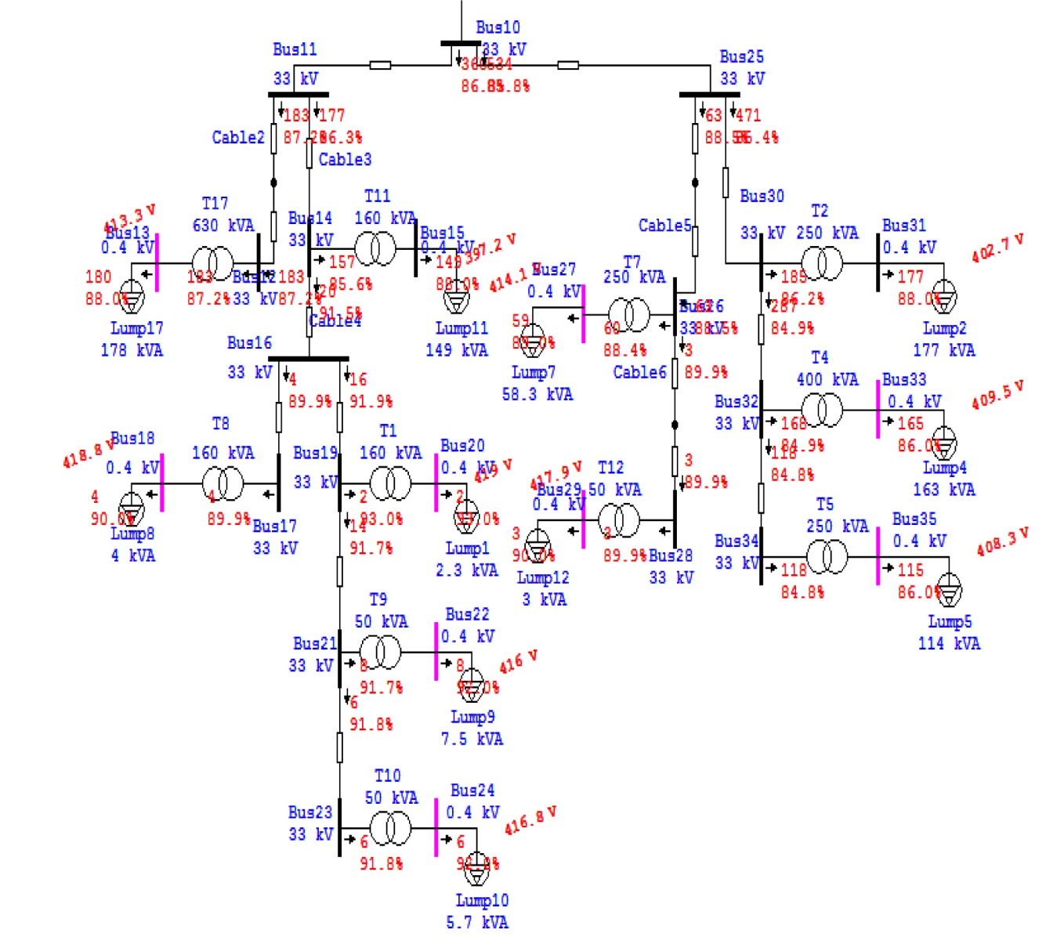
Figure 8: A part of power flow for the network after increase the tap in max.

4.4 Power Factor Improvement in the Max. Case:

The cosine of angle of phase displacement between voltage and current in an AC circuit is known as Power Factor.
How to improve the P.F?

$Q_{c}=P(\tan{θ_{old}- \tan{θ_{new} )}}$

Where:
Qc: The reactive power to be compensated by the capacitor.

P: The real power of the load.

$θ_{old}$: The actual power angle.
$θ_{new}$: The proposed power angle.

Capacitor Banks:

The important of improvement power factor is by adding shunt capacitor banks at the buses at both transmission and distribution levels and loads and there are more effective to add them in the low level voltages.
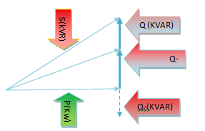

Effect of Low Power Factor :
- Higher Apparent Current .
- Higher Losses in the Electrical Distribution network .
- Low Voltage in the network.
Benefits of Improving Power Factor:
The low P.F is highly undesirable as it causes an increase in the current ,resulting in additional losses of active power in all the elements of power system from power station generator down to the utilization devices .In additional to the losses the low P.F causes penalties.
The following table shows the system of the penalties in our companies:
Power Factor | P.F Penalties
P.F≥ 0.92 | No Penalties.
0.92>P.F ≥0.8 | 1% of total bill for each one under 0.92
0.8>P.F≥0.7 | 1.25%of total bill for each one under 0.92
P.F <0.7 | 1.5%of total bill for each one under 0.92
Table 16: The penalties of power factor.

Our aim to improvement the P.F in order to avoid penalties and to reduce the current flow in the network which reduce the electrical losses in the network .

4.4.1 The Result Of Load Flow (after adding capacitor banks):

The following table shows the results after adding capacitors in order to improve the P.F.
Transformer Number | $Q_{c}$ (KVAR) | Voltage before add capacitor (KV) | Voltage after add capacitor (KV) | P.F old % | P.F after %
T1 |  | 0.4190 | 0.4190 | 93 | 93
T2 | 20 | 0.4027 | 0.4028 | 86.2 | 91
T3 | 25 | 0.4113 | 0.4115 | 86 | 90.6
T4 | 20 | 0.4095 | 0.4097 | 84.9 | 90.5
T5 | 15 | 0.4084 | 0.4085 | 84.8 | 90.7
T6 | 15 | 0.4036 | 0.4037 | 86.3 | 90.1
T7 |  | 0.4141 | 0.4141 | 88.4 | 88.4
T8 |  | 0.4188 | 0.4188 | 89.9 | 89.9
T9 |  | 0.4160 | 0.4160 | 91.7 | 91.7
T10 |  | 0.4168 | 0.4168 | 91.8 | 91.8
T11 | 20 | 0.3972 | 0.399 | 85.6 | 90.2
T12 |  | 0.4179 | 0.4179 | 89.9 | 89.9
T13 |  | 0.4134 | 0.4134 | 88.3 | 88.3
T14 |  | 0.4152 | 0.4152 | 88.5 | 88.5
T15 |  | 0.4194 | 0.4194 | 93 | 93
T16 |  | 0.4137 | 0.4137 | 88.3 | 88.3
T17 |  | 0.4133 | 0.4133 | 87.2 | 87.2
T18 |  | 0.4186 | 0.4186 | 89.9 | 89.9
Table 17: The results of improvement P.F in Max Case.

4.4.2 The swing bus result:

The following table shows the information of swing bus after analysis.
MW | MVAR | MVA | Amp | P.F%
1.306 | 0.635 | 1.452 | 25.4 | 89.94Lag
Table 18: The swing bus result of improvement the P.F in max case.

4.4.3 Summary of total generation ,loading and demand:

The following table shows the summary of total generation ,loading and demand.
 | MW | MVAR | MVA | P.F %
Swing Bus | 1.306 | 0.635 | 1.452 | 89.94Lag
Total Demand | 1.306 | 0.635 | 1.452 | 89.94Lag
Total Motor Load | 1.021 | 0.559 | 1.164 | 87.73Lag
Total Static Load | 0.268 | 0.027 | 0.269 | 99.49Lag
Apparent Losses | 0.016 | 0.049
Table 19: Summary of generation ,loading of improvement the P.F in max case .

Note:
After adding the capacitor banks the losses in the network decrease the total current decrease
- The losses before= 0.018 MW, and the swing current = 26.42 A.
- The losses after=0.016 MW, and the swing current = 25.4 A.
Appendix C shows the load flow results and the P.F of the buses.

The following figure shows where the capacitor banks installed in the network.

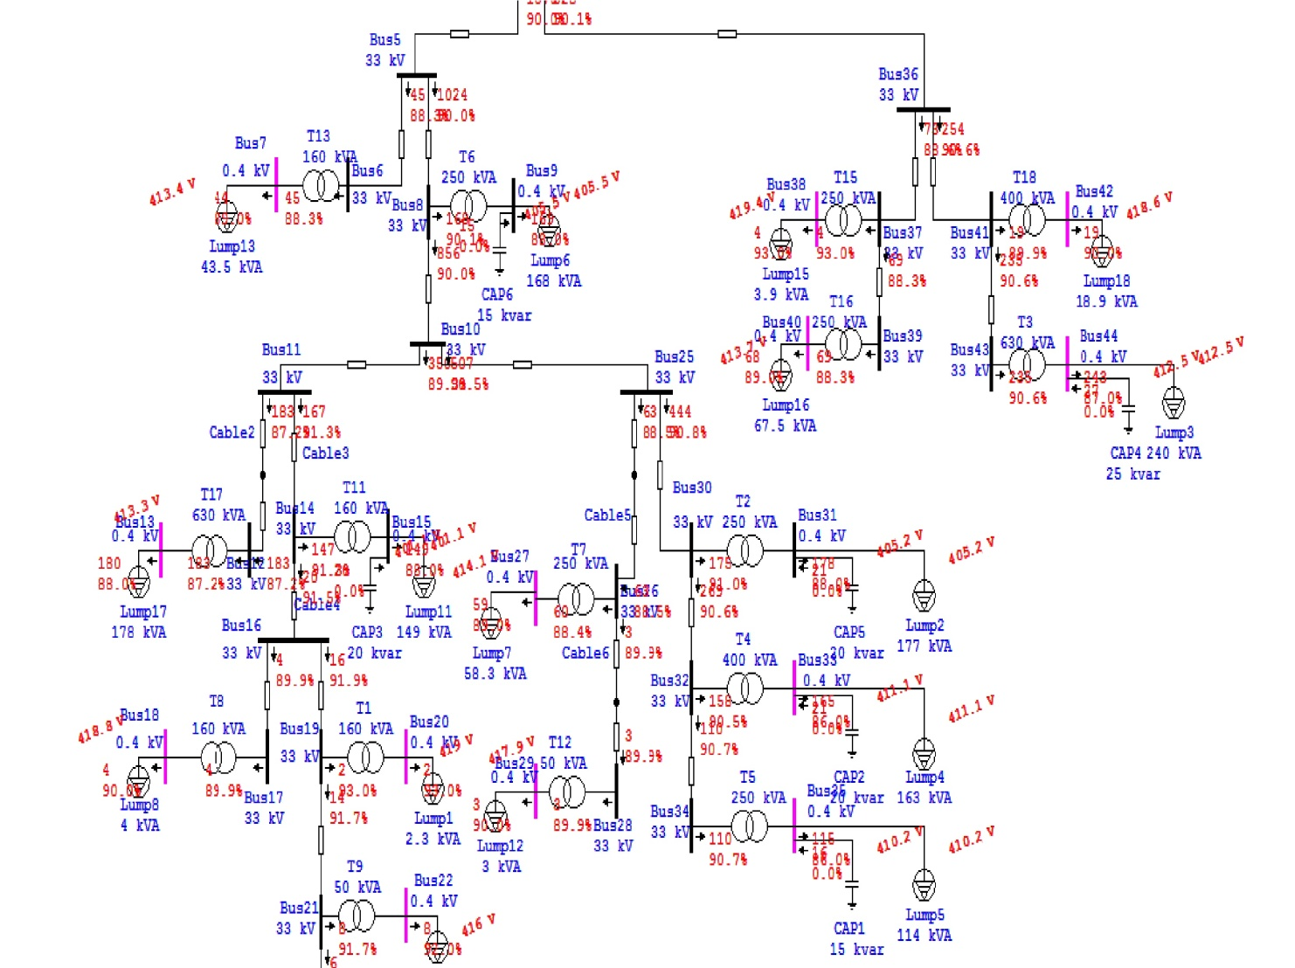
Figure 9: A part of power flow after adding capacitor banks in max. case.

4.5 The Voltage Level Improvement Using Capacitors in the Max. Case:

In this method added capacitor banks to improve the voltage levels without changing the taps.

4.5.1 The Result Of Load Flow:

The following table shows the results after adding capacitors in order to improve the voltage levels .
Transformer Number | $Q_{c}$ (KVAR) | Voltage before add capacitor (KV) | Voltage after add capacitor (KV) | P.F old % | P.F after %
T1 |  | 0.3991 | 0.3991 | 93 | 93
T2 | 20 | 0.3838 | 0.3860 | 86.2 | 90.7
T3 | 25 | 0.3918 | 0.3930 | 86 | 90.3
T4 | 25 | 0.3902 | 0.3919 | 85 | 91.3
T5 | 20 | 0.3891 | 0.3913 | 84.8 | 92.1
T6 | 15 | 0.3847 | 0.3864 | 86.3 | 89.9
T7 |  | 0.3945 | 0.3945 | 88.4 | 88.4
T8 |  | 0.3988 | 0.3988 | 89.9 | 89.9
T9 |  | 0.3962 | 0.3962 | 91.7 | 91.7
T10 |  | 0.3970 | 0.3970 | 91.8 | 91.8
T11 | 25 | 0.3787 | 0.3829 | 85.6 | 92.2
T12 |  | 0.3980 | 0.3980 | 89.9 | 89.9
T13 |  | 0.3938 | 0.3938 | 88.3 | 88.3
T14 |  | 0.3955 | 0.3955 | 88.5 | 88.5
T15 |  | 0.3994 | 0.3994 | 93 | 93
T16 |  | 0.3941 | 0.3941 | 88.4 | 88.4
T17 |  | 0.3937 | 0.3937 | 87.3 | 87.3
T18 |  | 0.3987 | 0.3987 | 89.9 | 89.9
Table 20: The results of improvement the voltage level in max case without increase the taps.

4.5.2 The swing bus result:

The following table shows the information of swing bus after analysis.
MW | MVAR | MVA | Amp | P.F%
1.281 | 0.616 | 1.421 | 24.86 | 90.12Lag
Table 21: The swing bus result of improvement the voltage level in max.

4.5.3 Summary of total generation ,loading and demand:

The following table shows the summary of total generation ,loading and demand.
 | MW | MVAR | MVA | P.F %
Swing Bus | 1.281 | 0.616 | 1.421 | 90.12Lag
Total Demand | 1.281 | 0.616 | 1.421 | 90.12Lag
Total Motor Load | 1.021 | 0.559 | 1.164 | 87.73Lag
Total Static Load | 0.243 | 0.010 | 0.244 | 99.91Lag
Apparent Losses | 0.016 | 0.047
Table 22: Summary of generation ,loading of improvement the voltage level in max case .

Note:
After adding the capacitor banks the losses in the network decrease and the total current decrease
- The losses in the original case = 0.017MW, and the swing current = 25.886 A.
- The losses after =0.016MW, and the swing current = 24.86 A.
- The voltage level in some buses increase .
Appendix D shows the load flow results and the P.F of the buses.
The following figure shows where the capacitor banks installed in the network.

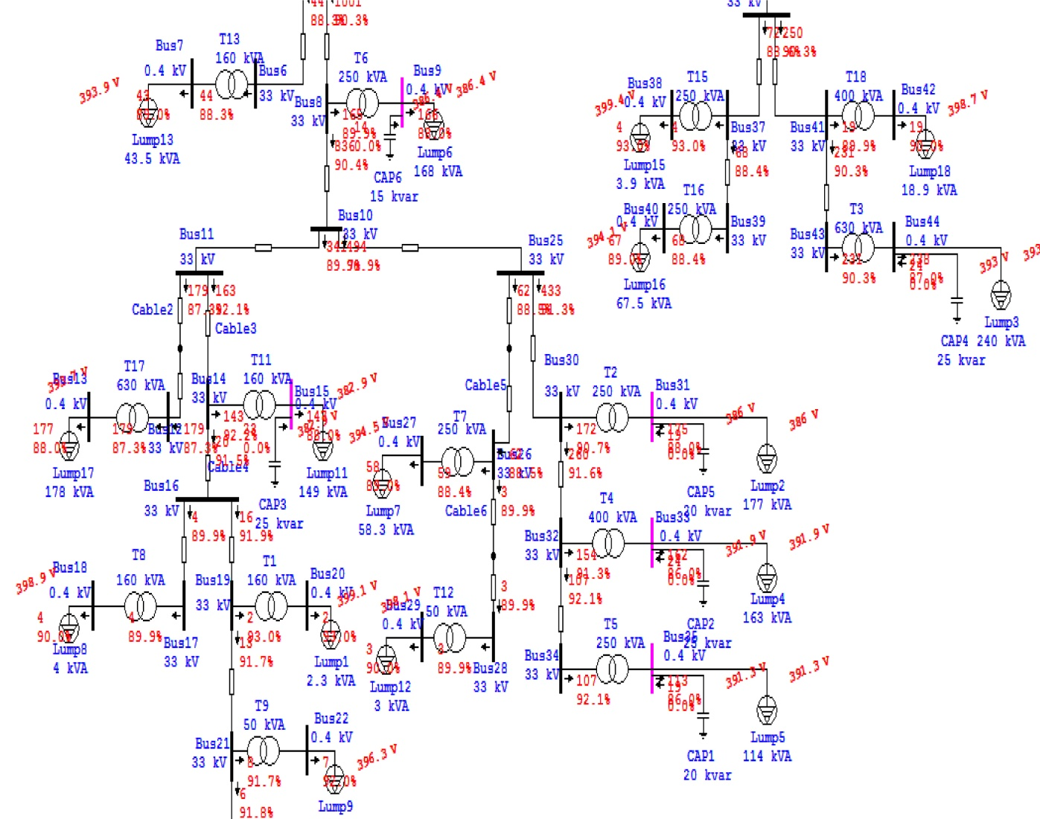
Figure 10: A part of the power flow after improvement the voltage level in max.

Chapter 5:

Minimum Case Improvement

5.1 The Original Minimum Case:

5.1.1 Transformer Loading :
The following table shows the loading of transformers and the load factor in the min. case:
# of Transformer | Rated  Power (KVA) | Actual currents for each phase (A) |  |  | Actual power (KVA) | Power factor  (Load) %
# of Transformer | Rated  Power (KVA) | $$I_{1}$$ | $$I_{2}$$ | $$I_{3}$$ | Actual power (KVA) | Power factor  (Load) %
Tr1 | 160 | 1.5 | 4 | 0 | 1.27 | 94
Tr2 | 250 | 220 | 170 | 190 | 132.6 | 90
Tr3 | 630 | 4 | 6 | 3 | 3 | 93
Tr4 | 400 | 3 | 5 | 4 | 2.8 | 95
Tr5 | 250 | 4 | 10 | 8 | 5 | 94
Tr6 | 250 | 320 | 17.2 | 176 | 152.9 | 89
Tr7 | 250 | 34.5 | 27 | 28 | 20.5 | 90
Tr8 | 160 | 4 | 0 | 3 | 1.6 | 91
Tr9 | 50 | 3.1 | 2.5 | 3 | 1.97 | 93
Tr10 | 50 | 1.6 | 1.3 | 3.4 | 1.44 | 93
Tr11 | 160 | 115 | 144 | 121.5 | 87.4 | 89
Tr12 | 50 | 0 | 1.6 | 6.6 | 1.88 | 91
Tr13 | 160 | 52 | 26 | 22 | 22.9 | 90
Tr14 | 250 | 42 | 30 | 37.7 | 25.2 | 90
Tr15 | 250 | 0.5 | 0.8 | 2 | 0.76 | 94
Tr16 | 250 | 22.2 | 58 | 53 | 30.3 | 90
Tr17 | 630 | 73 | 74 | 59 | 47.3 | 89
Tr18 | 400 | 33 | 18.3 | 31.2 | 18.9 | 90
Table 23: The Loading Transformer in min. case.

5.1.2 The Result Of Load Flow:

The following table shows the voltage of the buses in medium and low voltage.

Transformer Number | Mediam voltage rated (KV) | Mediam voltage actual (KV) | Low voltage rated (KV) | Low voltage actual (KV) | Power factor  (Tr) %
Tr1 | 33 | 32.977 | 0.4 | 0.3996 | 94
Tr2 | 33 | 32.976 | 0.4 | 0.3887 | 88.7
Tr3 | 33 | 32.991 | 0.4 | 0.3998 | 93
Tr4 | 33 | 32.976 | 0.4 | 0.3996 | 95
Tr5 | 33 | 32.976 | 0.4 | 0.3994 | 94
Tr6 | 33 | 32.978 | 0.4 | 0.3867 | 87.5
Tr7 | 33 | 32.977 | 0.4 | 0.3981 | 89.8
Tr8 | 33 | 32.977 | 0.4 | 0.3995 | 91
Tr9 | 33 | 32.977 | 0.4 | 0.3989 | 92.9
Tr10 | 33 | 32.976 | 0.4 | 0.3992 | 92.9
Tr11 | 33 | 32.977 | 0.4 | 0.3881 | 87.7
Tr12 | 33 | 32.977 | 0.4 | 0.3989 | 90.9
Tr13 | 33 | 32.983 | 0.4 | 0.3969 | 89.7
Tr14 | 33 | 32.995 | 0.4 | 0.3979 | 89.8
Tr15 | 33 | 32.991 | 0.4 | 0.3998 | 94
Tr16 | 33 | 23.991 | 0.4 | 0.3974 | 89.7
Tr17 | 33 | 32.977 | 0.4 | 0.3983 | 88.8
Tr18 | 33 | 32.991 | 0.4 | 0.3989 | 89.9
Table 24: The Original minimum case.

5.1.3 The swing bus result:
The Bus 1 is the swing bus.
The following table shows the information of swing bus after analysis.
MW | MVAR | MVA | Amp | P.F%
0.502 | 0.262 | 0.566 | 9.91 | 88.64 Lag
Table 25: The swing bus result in the original minimum case.

5.1.4 Summary of total generation ,loading and demand:

The following table shows the summary of total generation ,loading and demand.
 | MW | MVAR | MVA | P.F %
Swing Bus | 0.502 | 0.262 | 0.566 | 88.64 Lag
Total Demand | 0.502 | 0.262 | 0.566 | 88.64 Lag
Total Motor Load | 0.400 | 0.198 | 0.447 | 89.62 Lag
Total Static Load | 0.069 | 0.047 | 0.107 | 89.63 Lag
Apparent Losses | 0.006 | 0.017
Table 26: Summary of generation ,loading in original minimum case.

Note:
There are many problems in the network appears after analysis:
- From the above result the P.F of the swing bus = 88.64 Lag,which cases high penalities.
- The voltage of the buses not in the acceptable range V≥ Vn .

Appendix E shows the load flow results and the P.F of the buses .

The following figures show the power flow in main feeders.

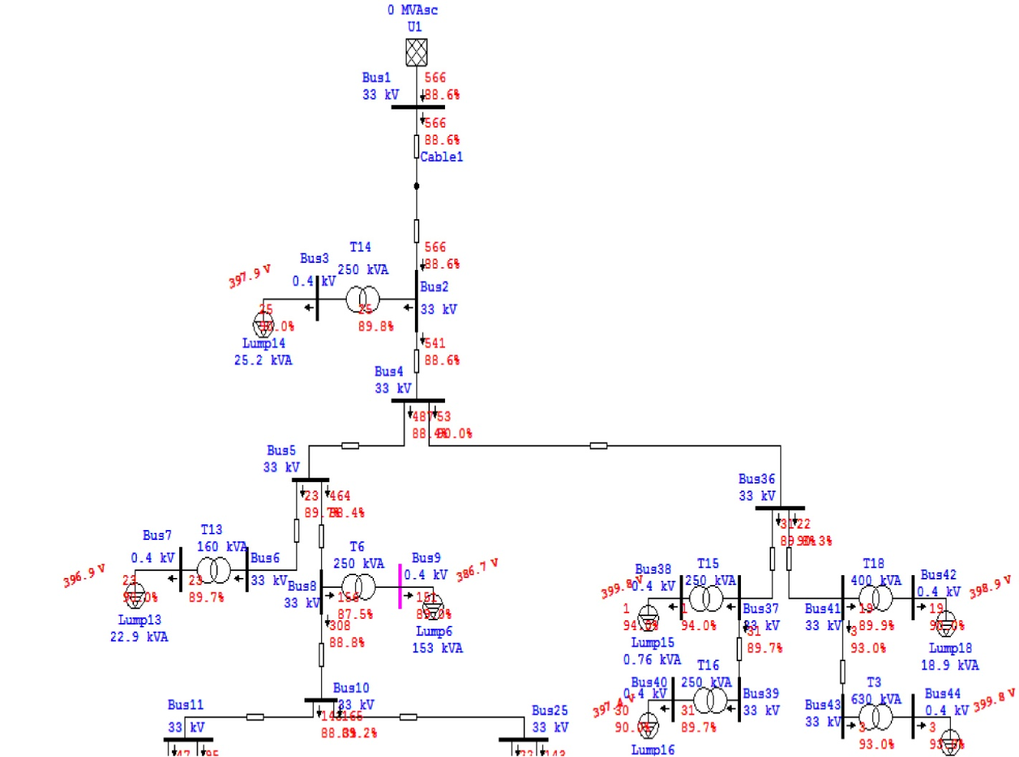

Part of the power flow of the network :

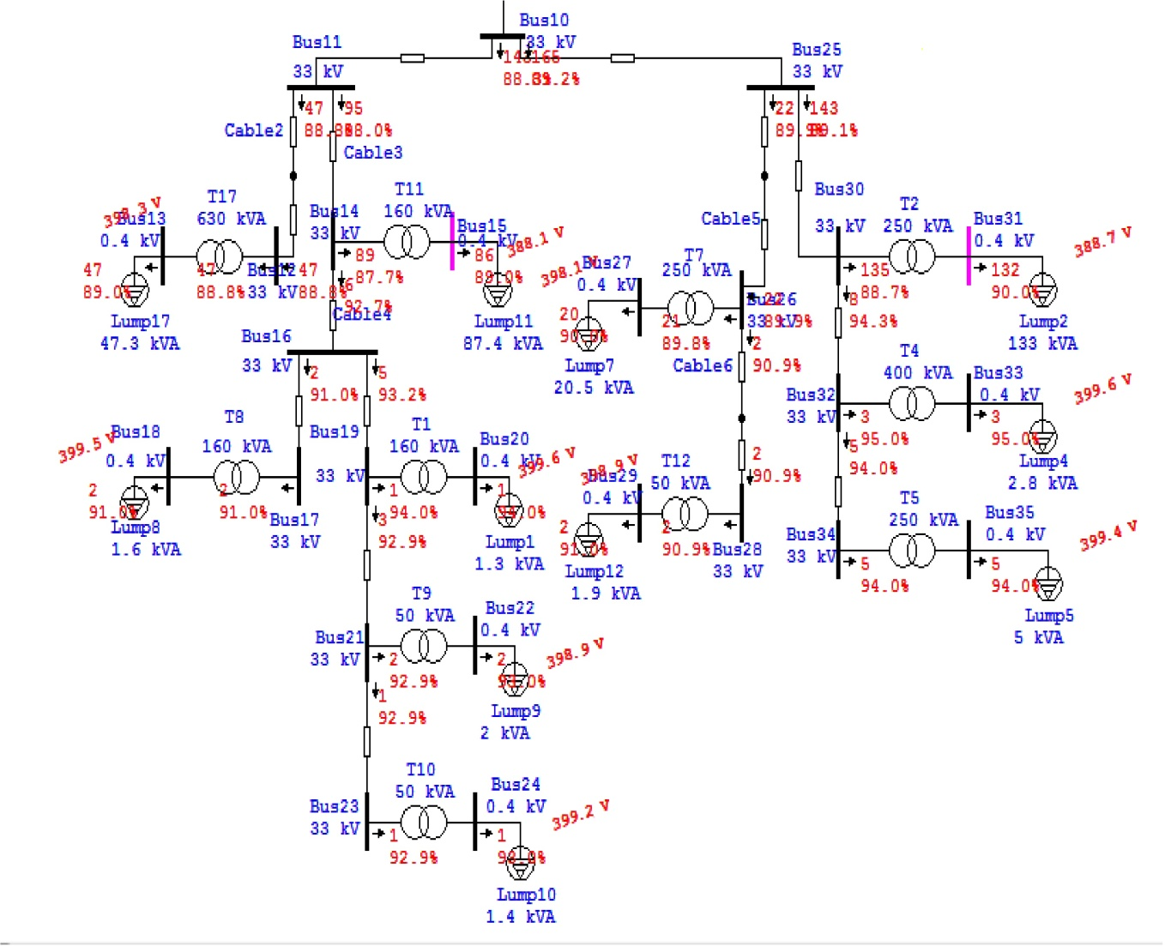
Figure 11: The power flow in the min original case.

5.2 Improvement the min. case using tap changing :

In this method increase the tap ratio of the transformers to 2.5%.

5.2.1 The Result Of Load Flow:
The following table shows the results after changing the tap of the transformers.
Power Factor % | V(KV) after increasing tap | V(KV) before increasing tap | $V_{rated}$(KV) | Transformer Number
94 | 0.4096 | 0.3996 | 0.4 | T1
88.7 | 0.3983 | 0.3887 | 0.4 | T2
93 | 0.4098 | 0.3998 | 0.4 | T3
95 | 0.4096 | 0.3996 | 0.4 | T4
94 | 0.4093 | 0.3994 | 0.4 | T5
87.5 | 0.3962 | 0.3867 | 0.4 | T6
89.8 | 0.4080 | 0.3981 | 0.4 | T7
91 | 0.4095 | 0.3995 | 0.4 | T8
92.9 | 0.4089 | 0.3989 | 0.4 | T9
92.9 | 0.4091 | 0.3992 | 0.4 | T10
87.7 | 0.3977 | 0.3881 | 0.4 | T11
90.9 | 0.4089 | 0.3989 | 0.4 | T12
89.7 | 0.4068 | 0.3969 | 0.4 | T13
89.8 | 0.4078 | 0.3979 | 0.4 | T14
94 | 0.4098 | 0.3998 | 0.4 | T15
89.7 | 0.4073 | 0.3974 | 0.4 | T16
88.8 | 0.4082 | 0.3983 | 0.4 | T17
89.9 | 0.4089 | 0.3989 | 0.4 | T18
Table 27: The results of improvement of min case using tap changing.

5.2.2 The swing bus result:

The following table shows the information of swing bus after analysis.
MW | MVAR | MVA | Amp | P.F%
0.507 | 0.265 | 0.572 | 10 | 88.63 Lag
Table 28: The swing bus result after improvement of min case using taps.

5.2.3 Summary of total generation ,loading and demand:

The following table shows the summary of total generation ,loading and demand.
 | MW | MVAR | MVA | P.F %
Swing Bus | 0.507 | 0.265 | 0.572 | 88.63 Lag
Total Demand | 0.507 | 0.265 | 0.572 | 88.63 Lag
Total Motor Load | 0.400 | 0.198 | 0.447 | 89.62 Lag
Total Static Load | 0.101 | 0.050 | 0.112 | 89.63 Lag
Apparent Losses | 0.006 | 0.017
Table 29: Summary of generation ,loading after improvement of min case using taps .

Appendix F shows the load flow results and the P.F of the buses.

The following figures show the power flow in main feeders.

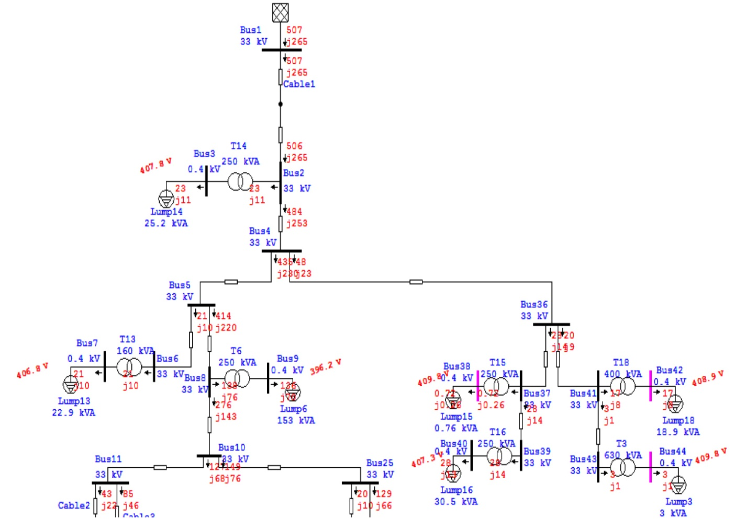
Part of power flow of the network
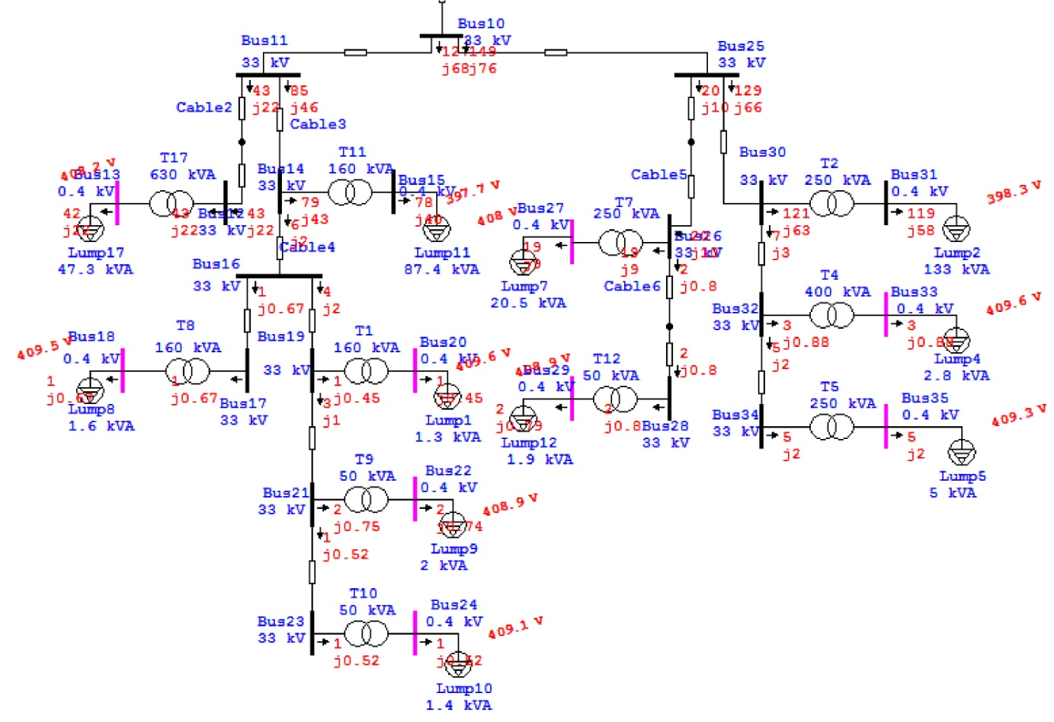
Figure 12 :The power flow after increase the tap in min.

5.3 Power Factor Improvement in the Min. Case:

After increase the taps of the transformers we added capacitor banks to increase the P.F of some buses to avoid the penalties.

5.3.1 The Result Of Load Flow:

The following table shows the results after adding capacitors in order to improve the P.F.
Transformer Number | $Q_{c}$ (KVAR) | Voltage before add capacitor (KV) | Voltage after add capacitor (KV) | P.F old % | P.F after %
T1 |  | 0.4096 | 0.4096 | 94 | 94
T2 | 15 | 0.3983 | 0.4001 | 88.7 | 93.1
T3 |  | 0.4098 | 0.4098 | 93 | 93
T4 |  | 0.4096 | 0.4096 | 95 | 95
T5 |  | 0.4093 | 0.4093 | 94 | 94
T6 | 12.5 | 0.3962 | 0.3990 | 87.5 | 90.8
T7 |  | 0.4080 | 0.4080 | 89.8 | 89.8
T8 |  | 0.4095 | 0.4095 | 91 | 91
T9 |  | 0.4089 | 0.4089 | 92.9 | 92.9
T10 |  | 0.4091 | 0.4091 | 92.9 | 92.9
T11 | 12.5 | 0.3977 | 0.400 | 87.7 | 93.3
T12 |  | 0.4089 | 0.4089 | 90.9 | 90.9
T13 |  | 0.4068 | 0.4068 | 89.7 | 89.7
T14 |  | 0.4078 | 0.4078 | 89.8 | 89.8
T15 |  | 0.4098 | 0.4098 | 94 | 94
T16 |  | 0.4073 | 0.4073 | 89.7 | 89.7
T17 | 2.5 | 0.4082 | 0.4083 | 88.8 | 91
T18 |  | 0.4089 | 0.4089 | 89.9 | 89.9
Table 30: The results of improvement P.F in Min Case.

5.3.2 The swing bus result:
The following table shows the information of swing bus after analysis.
MW | MVAR | MVA | Amp | P.F%
0.507 | 0.221 | 0.553 | 9.78 | 91.65 Lag
Table 31 The swing bus result of improvement the P.F in min case.

5.3.3 Summary of total generation ,loading and demand:

The following table shows the summary of total generation ,loading and demand.
 | MW | MVAR | MVA | P.F %
Swing Bus | 0.507 | 0.221 | 0.553 | 91.65 Lag
Total Demand | 0.507 | 0.221 | 0.553 | 91.65 Lag
Total Motor Load | 0.400 | 0.198 | 0.447 | 89.62 Lag
Total Static Load | 0.101 | 0.008 | 0.101 | 99.72 Lag
Apparent Losses | 0.005 | 0.015
Table 32: : Summary of generation ,loading of improvement the P.F in min case .

Note:
After adding the capacitor banks the losses in the network decrease in small amount and the total current decrease
- The losses before = 0.006 MW, and the swing current = 10 A.
- The losses after = 0.005 MW, and the swing current = 9.78 A.
Appendix G shows the load flow results and the P.F of the buses.
The following figures shows where the capacitor banks installed in the network .
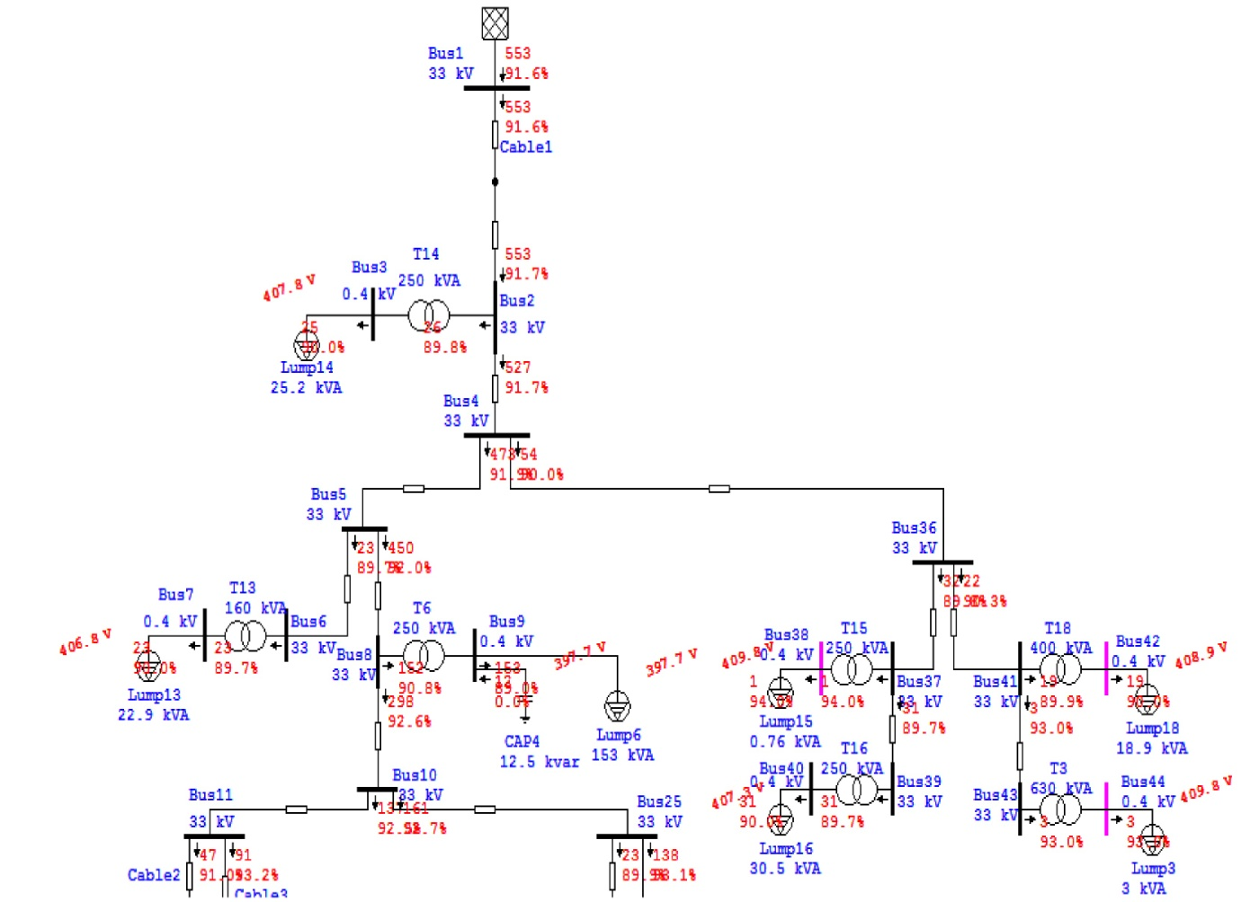
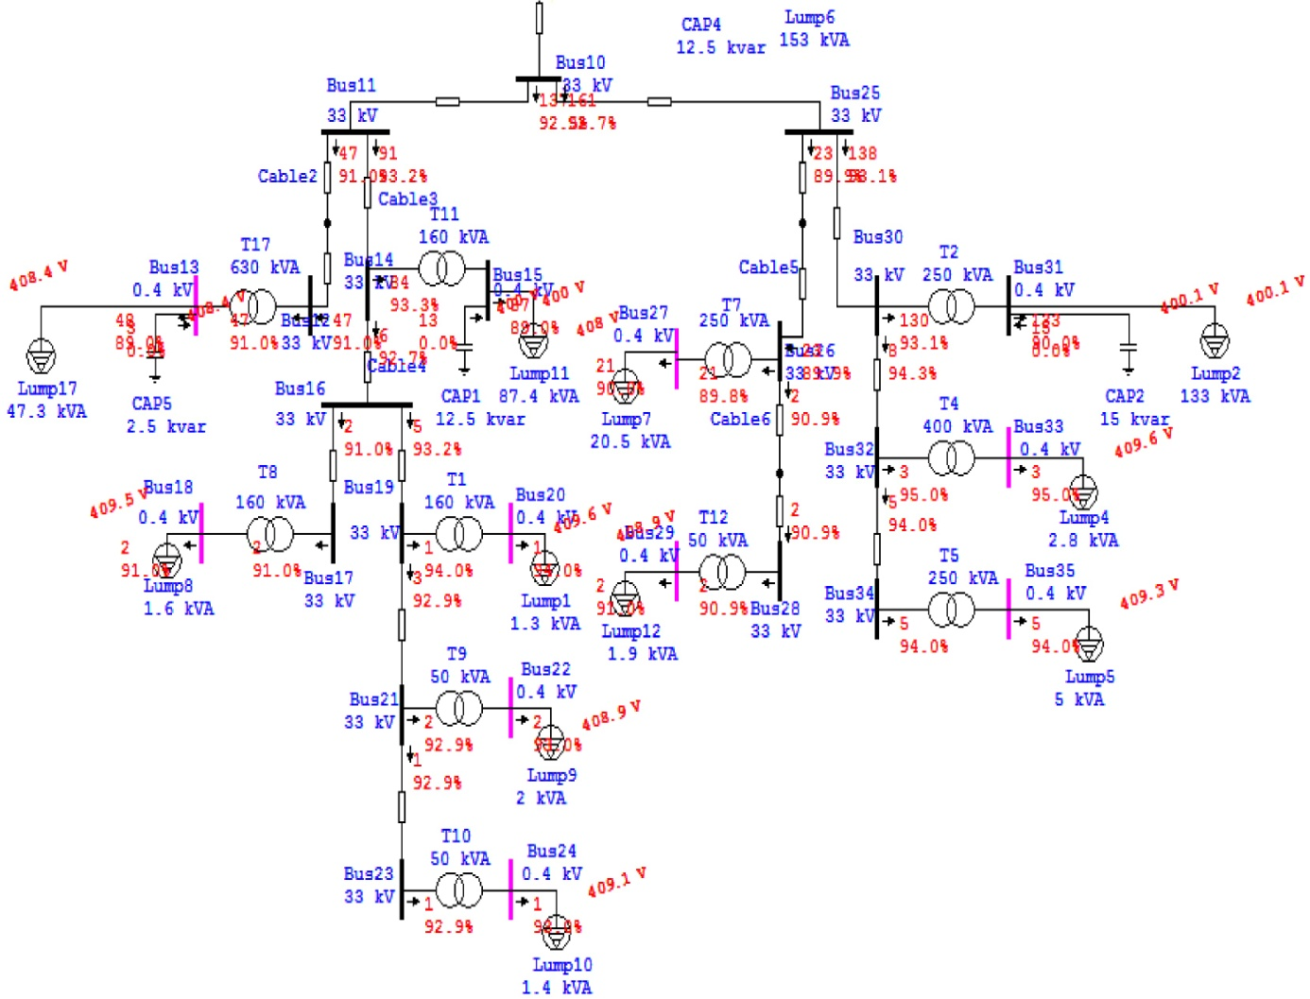
Figure 13: The power flow after improvement the P.F in min.

5.4 The Voltage Level Improvement Using Capacitors in the Min. Case:
In this method added capacitor banks to improve the voltage levels without changing the taps.

5.4.1 The Result Of Load Flow:

The following table shows the results after adding capacitors in order to improve the voltage levels
Transformer Number | $Q_{c}$ (KVAR) | Voltage before add capacitor (KV) | Voltage after add capacitor (KV) | P.F old % | P.F after %
T1 |  | 0.3996 | 0.3996 | 94 | 94
T2 | 10 | 0.3887 | 0.3900 | 88.7 | 91.6
T3 |  | 0.3998 | 0.3998 | 93 | 93
T4 |  | 0.3996 | 0.3996 | 95 | 95
T5 |  | 0.3994 | 0.3994 | 94 | 94
T6 | 20 | 0.3867 | 0.3890 | 87.5 | 92.6
T7 |  | 0.3981 | 0.3981 | 89.8 | 89.8
T8 |  | 0.3995 | 0.3995 | 91 | 91
T9 |  | 0.3989 | 0.3989 | 92.9 | 92.9
T10 |  | 0.3992 | 0.3992 | 92.9 | 92.9
T11 | 12.5 | 0.3881 | 0.3903 | 87.7 | 93.1
T12 |  | 0.3989 | 0.3989 | 90.9 | 90.9
T13 |  | 0.3969 | 0.3969 | 89.7 | 89.7
T14 |  | 0.3979 | 0.3979 | 89.8 | 89.8
T15 |  | 0.3998 | 0.3998 | 94 | 94
T16 |  | 0.3974 | 0.3974 | 89.7 | 89.7
T17 | 2.5 | 0.3983 | 0.3984 | 88.8 | 90.9
T18 |  | 0.3989 | 0.3989 | 89.9 | 89.9
Table 33: The results of improvement the voltage level in min case.

5.4.2 The swing bus result:

The following table shows the information of swing bus after analysis.
MW | MVAR | MVA | Amp | P.F%
0.502 | 0.218 | 0.547 | 9.57 | 91.71 Lag
Table 34: The swing bus result of improvement the voltage level in min.

5.4.3 Summary of total generation ,loading and demand:

The following table shows the summary of total generation ,loading and demand.
 | MW | MVAR | MVA | P.F %
Swing Bus | 0.507 | 0.218 | 0.547 | 91.71 Lag
Total Demand | 0.507 | 0.218 | 0.547 | 91.71 Lag
Total Motor Load | 0.400 | 0.198 | 0.447 | 89.62 Lag
Total Static Load | 0.096 | 0.005 | 0.096 | 99.87 Lag
Apparent Losses | 0.005 | 0.015
Table 35: Summary of generation ,loading of improvement the voltage level in min case .

Note:
After adding the capacitor banks the losses in the network decrease in small amount and the total current decrease .
- The losses in the original case = 0.006 MW, and the swing current = 9.91 A.
- The losses after = 0.005 MW, and the swing current = 9.57 A.
- The voltage level in some buses (where the capacitor banks installed) increase.
Appendix H shows the load flow results and the P.F of the buses.

The following figure shows where the capacitor banks installed in the network.

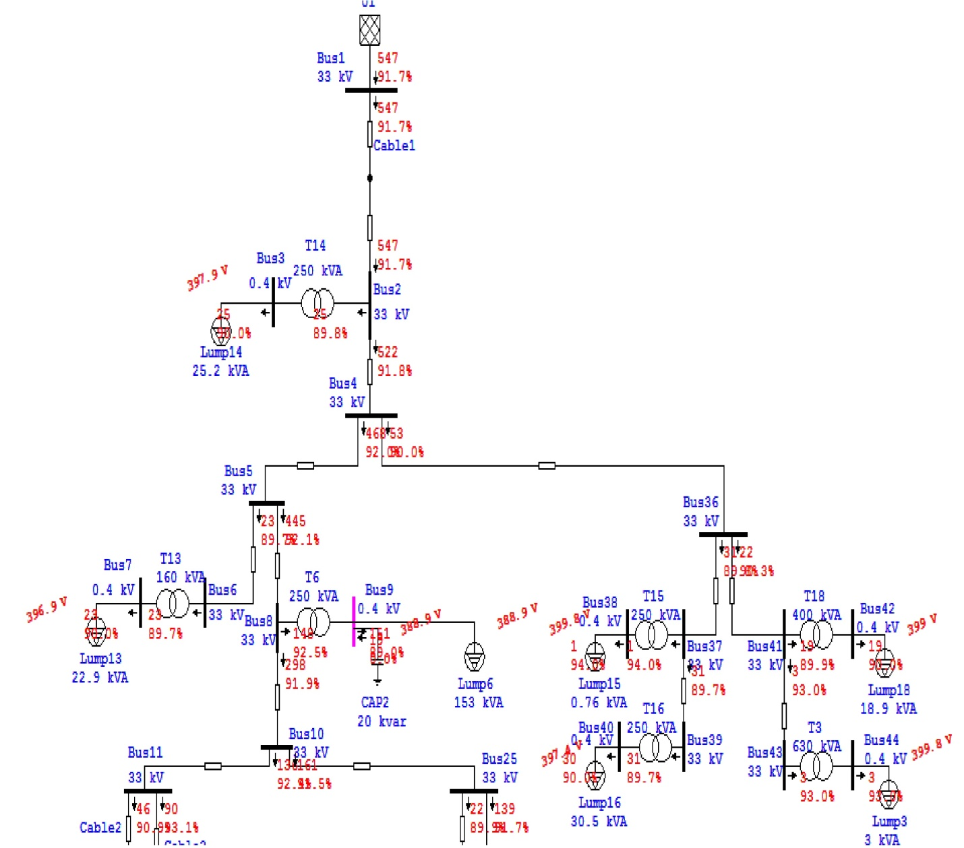

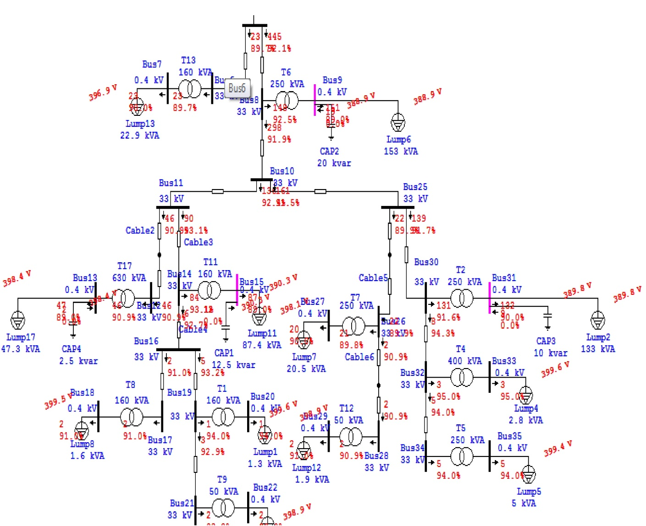
Figure 14: The power flow after improvement the voltage level in min.

Chapter 6:

Low Voltage Analysis In Max. Case

6.1 Low Voltage Side :

Most of the problems of the electrical networks are located in the low voltage side ( Low Tension Side ) , and the most important of these problems are : power losses due to the high current value in this side, and the drop voltage.
In this chapter and in the next chapter the network in low voltage will be studied.
We measured the load ( Real Power, Current for each phase, power factor) for each feeder of each transformer in max. and min. case.
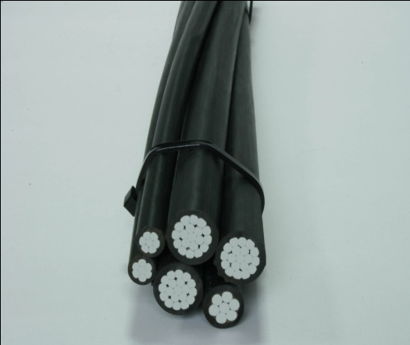
The data of the feeders :
- Type of the feeders is ABC cable ( Arial Bundled Conductor )
- R = 0.308 Ω/Km.
- X = 0.1 Ω/Km.
- Different lengths of the feeders.

6.2 The Original Low voltage Max. Case:

6.2.1 Loading For Each Feeder :
The following table shows the loading for each feeder of each transformers in the max. case :
# of Transformer | # of feeders | feeder | Current For each phase (A) |  |  | S act (KVA) | P.F %
# of Transformer | # of feeders | feeder | $$I_{1}$$ | $$I_{2}$$ | $$I_{3}$$ | S act (KVA) | P.F %
T1 | 2 | 1 | 1 | 3 | 0 | 0.92 | 92.4
T1 | 2 | 2 | 1.2 | 5 | 0 | 1.43 | 92.4
T2 | 4 | 1 | 63 | 65 | 62 | 43.7 | 86.8
T2 | 4 | 2 | 50.2 | 67.1 | 60 | 40.8 | 86.8
T2 | 4 | 3 | 60 | 73 | 70 | 46.7 | 86.8
T2 | 4 | 4 | 73.2 | 74.1 | 70 | 50 | 86.8
T3 | 1 | 1 | 390 | 395 | 263 | 241 | 86.1
T4 | 3 | 1 | 51 | 82.1 | 98.9 | 53.4 | 85.8
T4 | 3 | 2 | 56.2 | 80.3 | 110 | 56.7 | 85.8
T4 | 3 | 3 | 49.1 | 89 | 79.1 | 54 | 85.8
T5 | 4 | 1 | 51.2 | 54.1 | 49.2 | 35.5 | 85.2
T5 | 4 | 2 | 32 | 48.3 | 29.1 | 25.2 | 85.2
T5 | 4 | 3 | 64.3 | 45.2 | 50 | 36.7 | 85.2
T5 | 4 | 4 | 20 | 15 | 25 | 13.8 | 85.2
T6 | 5 | 1 | 57.3 | 64.5 | 60.7 | 41.9 | 86.9
T6 | 5 | 2 | 64 | 53.1 | 51.1 | 38.7 | 86.9
T6 | 5 | 3 | 53.4 | 51.3 | 49.3 | 35.4 | 86.9
T6 | 5 | 4 | 68 | 61.7 | 53.1 | 42 | 86.9
T6 | 5 | 5 | 55.1 | 63.2 | 59.3 | 40.8 | 86.9
T7 | 4 | 1 | 20.5 | 16.1 | 26.2 | 14.4 | 89.3
T7 | 4 | 2 | 25 | 20 | 19.5 | 14.8 | 89.3
T7 | 4 | 3 | 30.1 | 18.3 | 23.5 | 16.5 | 89.3
T7 | 4 | 4 | 16.2 | 22.3 | 26.1 | 14.8 | 89.3
T8 | 2 | 1 | 8.1 | 0 | 3.1 | 2.5 | 90
T8 | 2 | 2 | 5.3 | 0 | 1.5 | 1.5 | 90
T9 | 1 | 1 | 5.5 | 14 | 13.1 | 7.5 | 91.7
T10 | 2 | 1 | 8.3 | 2.1 | 2.3 | 2.9 | 91.8
T10 | 2 | 2 | 7.4 | 2.9 | 2.1 | 2.8 | 91.8
T11 | 4 | 1 | 63.3 | 55.3 | 75.3 | 44.5 | 86.8
T11 | 4 | 2 | 46.1 | 53.1 | 63.5 | 37.4 | 86.8
T11 | 4 | 3 | 45.5 | 56.1 | 67.7 | 38.9 | 86.8
T11 | 4 | 4 | 27.9 | 44.2 | 54.1 | 29 | 86.8
T12 | 3 | 1 | 0 | 0.6 | 4.5 | 1.2 | 90.1
T12 | 3 | 2 | 0 | 0.5 | 3.9 | 1 | 90.1
T12 | 3 | 3 | 0 | 0.5 | 5.1 | 1.3 | 90.1
T13 | 2 | 1 | 41.1 | 32.1 | 33.3 | 24.5 | 88.5
T13 | 2 | 2 | 35.9 | 23.3 | 29.1 | 20.3 | 88.5
T14 | 2 | 1 | 30 | 40.2 | 36.3 | 24.5 | 88.8
T14 | 2 | 2 | 34.4 | 48 | 38.5 | 27.8 | 88.8
T15 | 2 | 1 | 3 | 3.7 | 1.5 | 1.9 | 93.5
T15 | 2 | 2 | 2.2 | 4 | 1.9 | 1.86 | 93.5
T16 | 4 | 1 | 21.3 | 23.2 | 24.2 | 15.8 | 88.7
T16 | 4 | 2 | 24.1 | 26.3 | 23.1 | 16.9 | 88.7
T16 | 4 | 3 | 18.5 | 24.1 | 20.3 | 14.5 | 88.7
T16 | 4 | 4 | 22.1 | 23.2 | 25.1 | 16.2 | 88.7
T17 | 4 | 1 | 77.5 | 67.3 | 57.3 | 46.5 | 89.7
T17 | 4 | 2 | 73.2 | 54.4 | 68.1 | 45 | 89.7
T17 | 4 | 3 | 67.5 | 70.6 | 54.3 | 44.2 | 89.7
T17 | 4 | 4 | 82.1 | 65.3 | 77.1 | 51.6 | 89.7
T18 | 2 | 1 | 28 | 17 | 27 | 16.5 | 90.9
T18 | 2 | 2 | 5 | 1.3 | 5.1 | 2.6 | 90.9
Table 36: Loading of each Feeder in L.V max. case.
Note:
As shown above the loads distributed unsymmetrical which cases high neutral current and so high losses in the network as will be shown later.

6.2.2 The Result Of Load Flow:

The following table show the voltage at the end of each feeder and the drop voltage
# of Transformer | # of feeders | feeder | Drop Voltage % | Low Voltage rated( KV) | Low Voltage actual (V)
T1 | 2 | 1 | 0.1 | 0.4 | 398.1
T1 | 2 | 2 | 0.1 | 0.4 | 398.5
T2 | 4 | 1 | 26 | 0.4 | 276.4
T2 | 4 | 2 | 5.9 | 0.4 | 356.8
T2 | 4 | 3 | 19.5 | 0.4 | 302.6
T2 | 4 | 4 | 30 | 0.4 | 260.5
T3 | 1 | 1 | 3.1 | 0.4 | 379.4
T4 | 3 | 1 | 1.2 | 0.4 | 385.1
T4 | 3 | 2 | 4 | 0.4 | 373.8
T4 | 3 | 3 | 4.5 | 0.4 | 371.9
T5 | 4 | 1 | 1.6 | 0.4 | 382.6
T5 | 4 | 2 | 2.4 | 0.4 | 379.7
T5 | 4 | 3 | 2.2 | 0.4 | 380.5
T5 | 4 | 4 | 1 | 0.4 | 385.3
T6 | 5 | 1 | 17.3 | 0.4 | 311.4
T6 | 5 | 2 | 8.8 | 0.4 | 345.4
T6 | 5 | 3 | 8.9 | 0.4 | 345
T6 | 5 | 4 | 6.8 | 0.4 | 353.5
T6 | 5 | 5 | 8.1 | 0.4 | 348.2
T7 | 4 | 1 | 1.7 | 0.4 | 387.5
T7 | 4 | 2 | 2.1 | 0.4 | 385.8
T7 | 4 | 3 | 3.2 | 0.4 | 381.5
T7 | 4 | 4 | 2.5 | 0.4 | 384.4
T8 | 2 | 1 | 0.1 | 0.4 | 398.3
T8 | 2 | 2 | 0.2 | 0.4 | 397.8
T9 | 1 | 1 | 0.5 | 0.4 | 394
T10 | 2 | 1 | 0.4 | 0.4 | 395.2
T10 | 2 | 2 | 0.3 | 0.4 | 395.6
T11 | 4 | 1 | 10.4 | 0.4 | 335.8
T11 | 4 | 2 | 16.5 | 0.4 | 311.3
T11 | 4 | 3 | 8.9 | 0.4 | 341.7
T11 | 4 | 4 | 5 | 0.4 | 357.2
T12 | 3 | 1 | 0.1 | 0.4 | 397.3
T12 | 3 | 2 | 0.1 | 0.4 | 397.5
T12 | 3 | 3 | 0.1 | 0.4 | 397.2
T13 | 2 | 1 | 7.2 | 0.4 | 364.5
T13 | 2 | 2 | 3.4 | 0.4 | 379.9
T14 | 2 | 1 | 4.1 | 0.4 | 379
T14 | 2 | 2 | 9 | 0.4 | 359.4
T15 | 2 | 1 | 0.4 | 0.4 | 398
T15 | 2 | 2 | 0.3 | 0.4 | 398.3
T16 | 4 | 1 | 3 | 0.4 | 382.3
T16 | 4 | 2 | 3.6 | 0.4 | 379.8
T16 | 4 | 3 | 4.2 | 0.4 | 377.5
T16 | 4 | 4 | 2.7 | 0.4 | 383.5
T17 | 4 | 1 | 27.6 | 0.4 | 282.5
T17 | 4 | 2 | 15.4 | 0.4 | 331.2
T17 | 4 | 3 | 14.4 | 0.4 | 335.5
T17 | 4 | 4 | 10.4 | 0.4 | 351.2
T18 | 2 | 1 | 0.4 | 0.4 | 355.4
T18 | 2 | 2 | 10.8 | 0.4 | 396.9
Table 37: The result of low voltage in original max. case.

6.2.3 The swing bus result:

The following table shows the information of swing bus after analysis.
MW | MVAR | MVA | P.F%
1.434 | 0.794 | 1.639 | 87.48 Lag
Table 38: The swing bus result in the L. V. original Max. case.

6.2.4 Summary of total generation ,loading and demand:

The following table shows the summary of total generation ,loading and demand.
 | MW | MVAR | MVA | P.F %
Swing Bus | 1.434 | 0.794 | 1.639 | 87.48 Lag
Total Demand | 1.434 | 0.794 | 1.639 | 87.48 Lag
Total Motor Load | 1.050 | 0.581 | 1.200 | 87.51Lag
Total Static Load | 0.206 | 0.114 | 0.236 | 87.53 Lag
Apparent Losses | 0.178 | 0.100
Table 39: Summary of generation ,loading in L. V. original Max. case.

Note:
The main problem in the low level side is the unsymmetrical loads between phases which cases many problems :
- High neutral current.
- High drop voltage in feeder which cases low voltage in the consumers.
- High losses in the network
- The losses before adding the low voltage side = 0.017 MW.
- The losses after adding the low voltage side = 0.178 MW.
Appendix I shows the load flow results ,the P.F of the buses and the drop voltages.

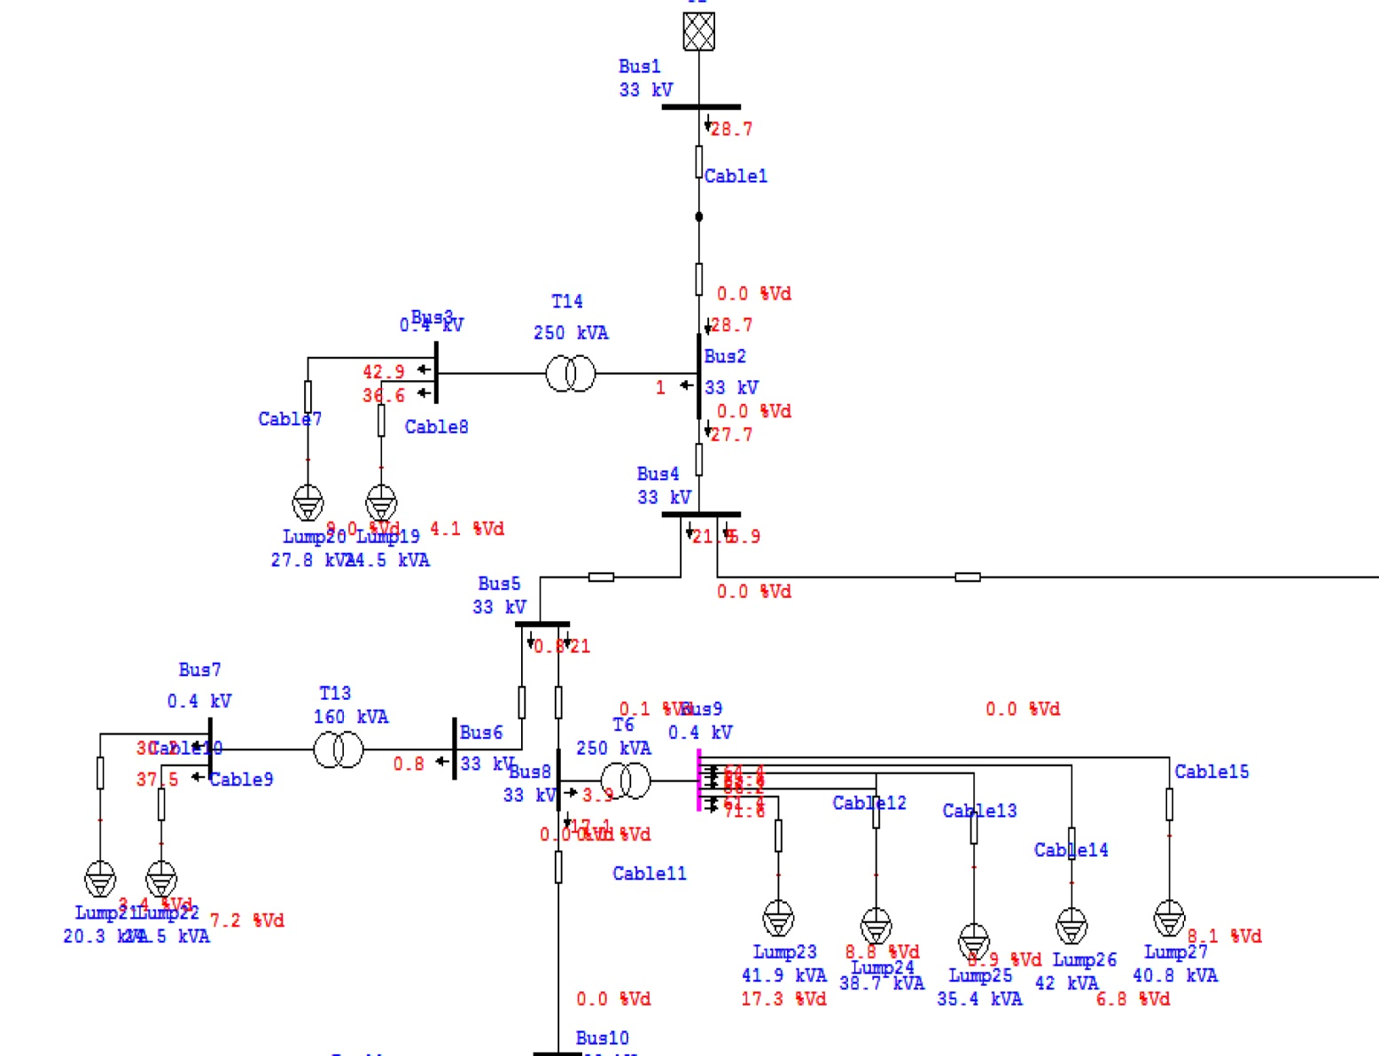
The following figures show the power flow for a part of the network

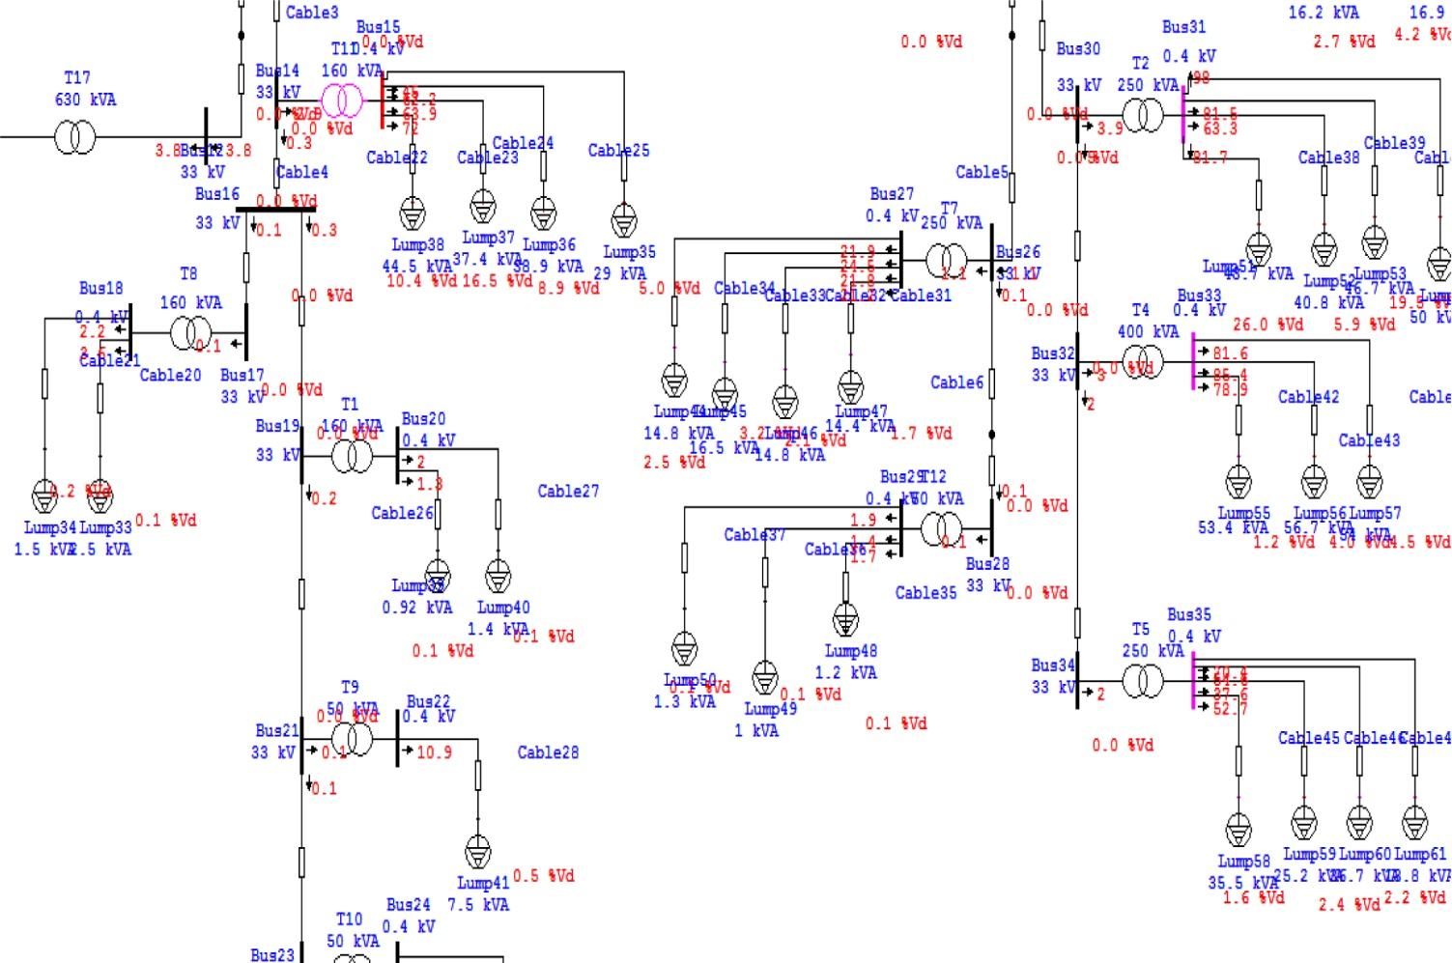
Figure 16: A part of the low voltage side of original Max. case.

6.3 Improvement the L. V. max. case using tap changing :
In this method change the tap ratio of the transformers to 5%.

6.3.1 The Result Of Load Flow:
The following table shows the results after changing the tap of the transformers.
# of Transformer | # of feeders | feeder | Drop voltage % before | Drop voltage % after | Low Voltage rated KV | Low Voltage actual  (V) before | Low Voltage actual (V) after
T1 | 2 | 1 | 0.1 | 0.1 | 0.4 | 398.1 | 418.7
T1 | 2 | 2 | 0.1 | 0.1 | 0.4 | 398.5 | 418.4
T2 | 4 | 1 | 26 | 24.2 | 0.4 | 276.4 | 302.8
T2 | 4 | 2 | 5.9 | 5.7 | 0.4 | 356.8 | 376.8
T2 | 4 | 3 | 19.5 | 18.4 | 0.4 | 302.6 | 326
T2 | 4 | 4 | 30 | 27.6 | 0.4 | 260.5 | 289.4
T3 | 1 | 1 | 3.1 | 3 | 0.4 | 379.4 | 399.2
T4 | 3 | 1 | 1.2 | 1.2 | 0.4 | 385.1 | 404.5
T4 | 3 | 2 | 4 | 3.9 | 0.4 | 373.8 | 393.6
T4 | 3 | 3 | 4.5 | 4.4 | 0.4 | 371.9 | 391.8
T5 | 4 | 1 | 1.6 | 1.6 | 0.4 | 382.6 | 402
T5 | 4 | 2 | 2.4 | 2.3 | 0.4 | 379.7 | 399.2
T5 | 4 | 3 | 2.2 | 1.2 | 0.4 | 380.5 | 400
T5 | 4 | 4 | 1 | 0.9 | 0.4 | 385.3 | 404
T6 | 5 | 1 | 17.3 | 16.5 | 0.4 | 311.4 | 333.6
T6 | 5 | 2 | 8.8 | 8.5 | 0.4 | 345.4 | 365.5
T6 | 5 | 3 | 8.9 | 8.6 | 0.4 | 345 | 365.2
T6 | 5 | 4 | 6.8 | 5.6 | 0.4 | 353.5 | 373.3
T6 | 5 | 5 | 8.1 | 7.8 | 0.4 | 348.2 | 368.2
T7 | 4 | 1 | 1.7 | 1.6 | 0.4 | 387.5 | 407.3
T7 | 4 | 2 | 2.1 | 2.1 | 0.4 | 385.8 | 405.6
T7 | 4 | 3 | 3.2 | 3.1 | 0.4 | 381.5 | 401.5
T7 | 4 | 4 | 2.5 | 2.4 | 0.4 | 384.4 | 404.3
T8 | 2 | 1 | 0.1 | 0.1 | 0.4 | 398.3 | 418.2
T8 | 2 | 2 | 0.2 | 0.2 | 0.4 | 397.8 | 417.7
T9 | 1 | 1 | 0.5 | 0.5 | 0.4 | 394 | 413.8
T10 | 2 | 1 | 0.4 | 0.4 | 0.4 | 395.2 | 415.4
T10 | 2 | 2 | 0.3 | 0.3 | 0.4 | 395.6 | 415.1
T11 | 4 | 1 | 10.4 | 10 | 0.4 | 335.8 | 356.1
T11 | 4 | 2 | 16.5 | 15.7 | 0.4 | 311.3 | 333.1
T11 | 4 | 3 | 8.9 | 8.6 | 0.4 | 341.7 | 361.7
T11 | 4 | 4 | 5 | 4.9 | 0.4 | 357.2 | 376.5
T12 | 3 | 1 | 0.1 | 0.1 | 0.4 | 397.3 | 417.2
T12 | 3 | 2 | 0.1 | 0.1 | 0.4 | 397.5 | 417.3
T12 | 3 | 3 | 0.1 | 0.1 | 0.4 | 397.2 | 417.1
T13 | 2 | 1 | 7.2 | 7 | 0.4 | 364.5 | 385
T13 | 2 | 2 | 3.4 | 3.3 | 0.4 | 379.9 | 399.5
T14 | 2 | 1 | 4.1 | 4 | 0.4 | 379 | 399.2
T14 | 2 | 2 | 9 | 8.7 | 0.4 | 359.4 | 380.4
T15 | 2 | 1 | 0.4 | 0.4 | 0.4 | 398 | 418
T15 | 2 | 2 | 0.3 | 0.3 | 0.4 | 398.3 | 418.3
T16 | 4 | 1 | 3 | 2.9 | 0.4 | 382.3 | 402.3
T16 | 4 | 2 | 3.6 | 3.5 | 0.4 | 379.8 | 399.9
T16 | 4 | 3 | 4.2 | 4.1 | 0.4 | 377.5 | 397.6
T16 | 4 | 4 | 2.7 | 2.6 | 0.4 | 383.5 | 403.5
T17 | 4 | 1 | 27.6 | 25.7 | 0.4 | 282.5 | 309.7
T17 | 4 | 2 | 15.4 | 14.7 | 0.4 | 331.2 | 353.6
T17 | 4 | 3 | 14.4 | 13.7 | 0.4 | 335.5 | 357.6
T17 | 4 | 4 | 10.4 | 10 | 0.4 | 351.2 | 372.4
T18 | 2 | 1 | 0.4 | 0.4 | 0.4 | 355.4 | 376.9
T18 | 2 | 2 | 10.8 | 10.4 | 0.4 | 396.9 | 416.9
Table 40: The results of improvement of L. V. max case using tap changing.

6.3.2 The swing bus result:

The following table shows the information of swing bus after analysis.
MW | MVAR | MVA | P.F%
1.444 | 0.806 | 1.635 | 87.32 Lag
Table 41: The swing bus result after improvement of L. V. max case using taps.

6.3.3 Summary of total generation ,loading and demand:

The following table shows the summary of total generation ,loading and demand.
 | MW | MVAR | MVA | P.F %
Swing Bus | 1.444 | 0.806 | 1.653 | 87.32 Lag
Total Demand | 1.444 | 0.806 | 1.653 | 87.32 Lag
Total Motor Load | 1.050 | 0.581 | 1.200 | 87.51 Lag
Total Static Load | 0.231 | 0.128 | 0.264 | 87.53 Lag
Apparent Losses | 0.163 | 0.097
Table 42: Summary of generation ,loading after improvement of L. V. max case using taps .

Note:
After changing the taps of the transformers the voltage in the consumers increased, also the voltage drop in the feeders decrease and the losses in the network decrease.

Appendix J shows the load flow results ,the P.F of the buses and the drop voltages.

The following figure show a part of power flow in the network.

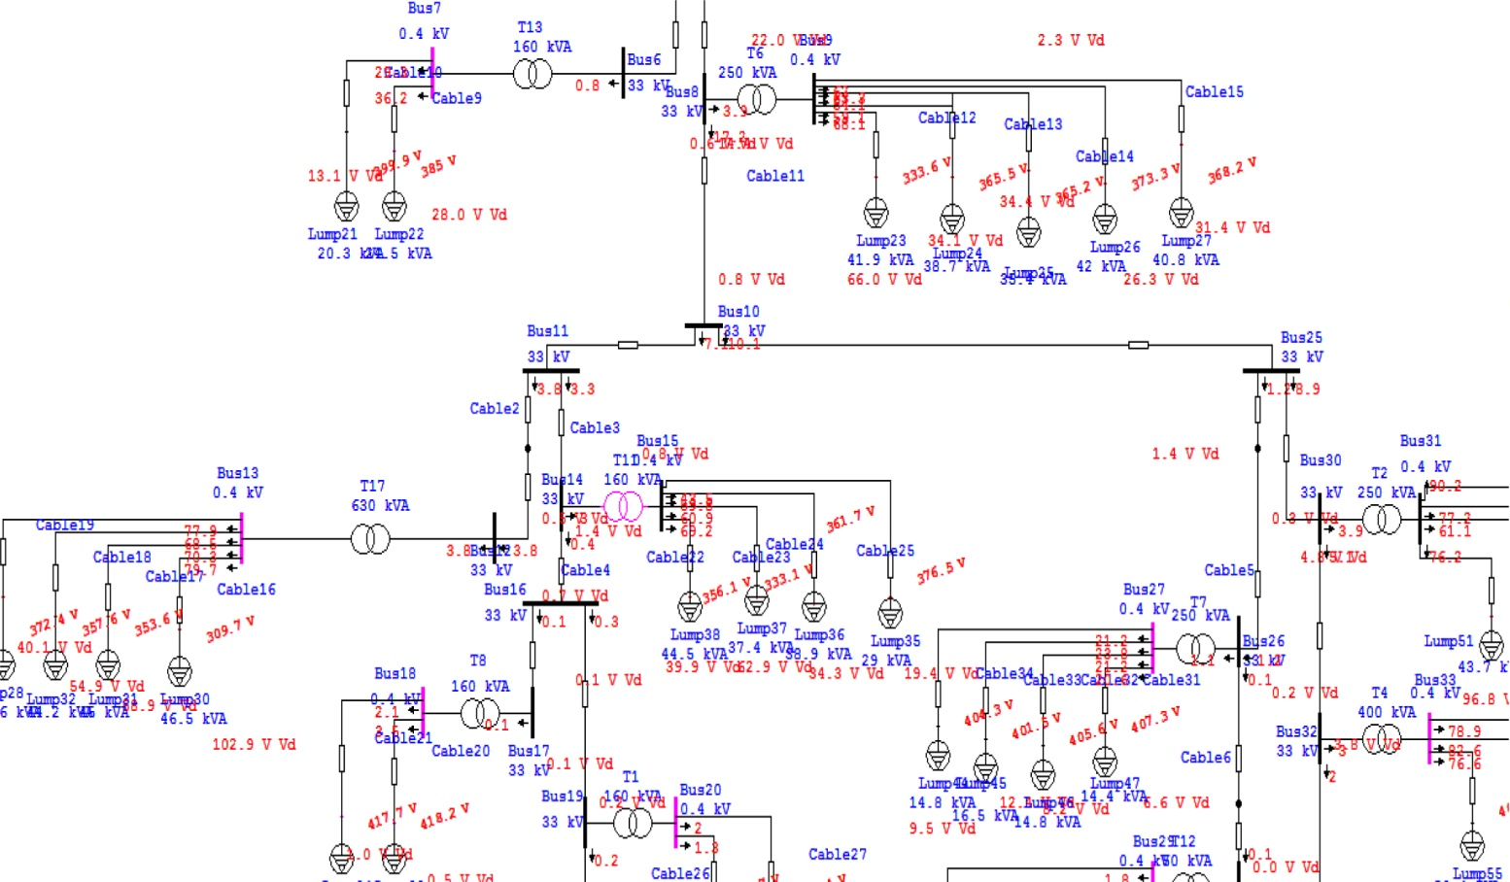
Figure 17: A part of power flow for the network after increase the tap in L. V. max. case

6.4 Power Factor Improvement in the L. V. Max. Case:

After increase the taps of the transformers we added capacitor banks to increase the poor P.F and to reduce the losses in the network .

6.4.1 The Result Of Load Flow (after adding capacitor banks):
The following table shows the results after adding capacitors in order to improve the P.F.
# of Tr | # of feeders | feeder | $Q_{c}$ (KVAR) | Drop voltage % before | Drop voltage % after | P.F % before | P.F % after | L. V. rated (KV) | L. V. actual before (V) | L. V. actual  After (V)
T1 | 2 | 1 |  | 0.1 | 0.1 | 92.4 | 92.4 | 0.4 | 418.7 | 418.7
T1 | 2 | 2 |  | 0.1 | 0.1 | 92.4 | 92.4 | 0.4 | 418.4 | 481.7
T2 | 4 | 1 | 20 | 24.2 | 24 | 86.8 | 90.8 | 0.4 | 302.8 | 306.2
T2 | 4 | 2 | 20 | 5.7 | 5.7 | 86.8 | 90.8 | 0.4 | 376.8 | 379.5
T2 | 4 | 3 | 20 | 18.4 | 18.3 | 86.8 | 90.8 | 0.4 | 326 | 329.1
T2 | 4 | 4 | 20 | 27.6 | 27.3 | 86.8 | 90.8 | 0.4 | 289.4 | 293.1
T3 | 1 | 1 | 25 | 3 | 3 | 86.1 | 90.6 | 0.4 | 399.2 | 400.6
T4 | 3 | 1 | 20 | 1.2 | 1.2 | 85.8 | 91 | 0.4 | 404.5 | 406.2
T4 | 3 | 2 | 20 | 3.9 | 3.9 | 85.8 | 91 | 0.4 | 393.6 | 395.3
T4 | 3 | 3 | 20 | 4.4 | 4.3 | 85.8 | 91 | 0.4 | 391.8 | 393.5
T5 | 4 | 1 | 15 | 1.6 | 1.6 | 85.2 | 91.1 | 0.4 | 402 | 404
T5 | 4 | 2 | 15 | 2.3 | 2.3 | 85.2 | 91.1 | 0.4 | 399.2 | 401.2
T5 | 4 | 3 | 15 | 1.2 | 2.1 | 85.2 | 91.1 | 0.4 | 400 | 402
T5 | 4 | 4 | 15 | 0.9 | 0.9 | 85.2 | 91.1 | 0.4 | 404 | 406.6
T6 | 5 | 1 | 15 | 16.5 | 16.4 | 86.9 | 89.9 | 0.4 | 333.6 | 335.9
T6 | 5 | 2 | 15 | 8.5 | 8.5 | 86.9 | 89.9 | 0.4 | 365.5 | 367.6
T6 | 5 | 3 | 15 | 8.6 | 8.6 | 86.9 | 89.9 | 0.4 | 365.2 | 367.2
T6 | 5 | 4 | 15 | 5.6 | 6.6 | 86.9 | 89.9 | 0.4 | 373.3 | 375.3
T6 | 5 | 5 | 15 | 7.8 | 7.8 | 86.9 | 89.9 | 0.4 | 368.2 | 370.2
T7 | 4 | 1 |  | 1.6 | 1.6 | 89.3 | 89.3 | 0.4 | 407.3 | 407.3
T7 | 4 | 2 |  | 2.1 | 2.1 | 89.3 | 89.3 | 0.4 | 405.6 | 405.7
T7 | 4 | 3 |  | 3.1 | 3.1 | 89.3 | 89.3 | 0.4 | 401.5 | 401.5
T7 | 4 | 4 |  | 2.4 | 2.4 | 89.3 | 89.3 | 0.4 | 404.3 | 404.3
T8 | 2 | 1 |  | 0.1 | 0.1 | 90 | 90 | 0.4 | 418.2 | 418.3
T8 | 2 | 2 |  | 0.2 | 0.2 | 90 | 90 | 0.4 | 417.7 | 417.8
T9 | 1 | 1 |  | 0.5 | 0.5 | 91.7 | 91.7 | 0.4 | 413.8 | 413.8
T10 | 2 | 1 |  | 0.4 | 0.4 | 91.8 | 91.8 | 0.4 | 415.4 | 415.4
T10 | 2 | 2 |  | 0.3 | 0.3 | 91.8 | 91.8 | 0.4 | 415.1 | 415.4
T11 | 4 | 1 | 20 | 10 | 9.9 | 86.8 | 91.9 | 0.4 | 356.1 | 360.3
T11 | 4 | 2 | 20 | 15.7 | 15.5 | 86.8 | 91.9 | 0.4 | 333.1 | 337.6
T11 | 4 | 3 | 20 | 8.6 | 8.5 | 86.8 | 91.9 | 0.4 | 361.7 | 365.9
T11 | 4 | 4 | 20 | 4.9 | 4.8 | 86.8 | 91.9 | 0.4 | 376.5 | 380.6
T12 | 3 | 1 |  | 0.1 | 0.1 | 90.1 | 90.1 | 0.4 | 417.2 | 417.2
T12 | 3 | 2 |  | 0.1 | 0.1 | 90.1 | 90.1 | 0.4 | 417.3 | 417.4
T12 | 3 | 3 |  | 0.1 | 0.1 | 90.1 | 90.1 | 0.4 | 417.1 | 417.1
T13 | 2 | 1 |  | 7 | 7 | 88.5 | 88.5 | 0.4 | 385 | 385.1
T13 | 2 | 2 |  | 3.3 | 3.3 | 88.5 | 88.5 | 0.4 | 399.5 | 399.9
T14 | 2 | 1 |  | 4 | 4 | 88.8 | 88.8 | 0.4 | 399.2 | 399.2
T14 | 2 | 2 |  | 8.7 | 8.7 | 88.8 | 88.8 | 0.4 | 380.4 | 380.4
T15 | 2 | 1 |  | 0.4 | 0.4 | 93.5 | 93.5 | 0.4 | 418 | 418
T15 | 2 | 2 |  | 0.3 | 0.3 | 93.5 | 93.5 | 0.4 | 418.3 | 418.3
T16 | 4 | 1 |  | 2.9 | 2.9 | 88.7 | 88.7 | 0.4 | 402.3 | 402.3
T16 | 4 | 2 |  | 3.5 | 3.5 | 88.7 | 88.7 | 0.4 | 399.9 | 399.9
T16 | 4 | 3 |  | 4.1 | 4.1 | 88.7 | 88.7 | 0.4 | 397.6 | 397.7
T16 | 4 | 4 |  | 2.6 | 2.6 | 88.7 | 88.7 | 0.4 | 403.5 | 303.5
T17 | 4 | 1 |  | 25.7 | 25.7 | 89.7 | 89.7 | 0.4 | 309.7 | 309.7
T17 | 4 | 2 |  | 14.7 | 14.7 | 89.7 | 89.7 | 0.4 | 353.6 | 353.6
T17 | 4 | 3 |  | 13.7 | 13.7 | 89.7 | 89.7 | 0.4 | 357.6 | 357.6
T17 | 4 | 4 |  | 10 | 10 | 89.7 | 89.7 | 0.4 | 372.4 | 372.4
T18 | 2 | 1 |  | 0.4 | 0.4 | 90.9 | 90.9 | 0.4 | 376.9 | 376.9
T18 | 2 | 2 |  | 10.4 | 10.4 | 90.9 | 90.9 | 0.4 | 416.9 | 416.9
Table 43: The results of improvement P.F in L. V. Max Case.

6.4.2 The swing bus result:

The following table shows the information of swing bus after analysis.
MW | MVAR | MVA | P.F%
1.442 | 0.682 | 1.596 | 90.40 Lag
Table 44: The swing bus result of improvement the P.F in L. V. max case.

6.4.3 Summary of total generation ,loading and demand:

The following table shows the summary of total generation ,loading and demand.
 | MW | MVAR | MVA | P.F %
Swing Bus | 1.442 | 0.682 | 1.596 | 90.40 Lag
Total Demand | 1.442 | 0.682 | 1.596 | 90.40 Lag
Total Motor Load | 1.050 | 0.581 | 1.200 | 87.51 Lag
Total Static Load | 0.233 | 0.010 | 0.233 | 99.91 Lag
Apparent Losses | 0.160 | 0.092
Table 45: Summary of generation ,loading of improvement the P.F in L. V. max case .

Note:
After increasing the tap ratio and adding the capacitor banks the losses in the network decrease :
- The losses before= 0.178 MW.
- The losses after=0. 160 MW .
Appendix K shows the load flow results ,the P.F of the buses and the drop voltages.

The following figure shows where the capacitor banks installed in the network.

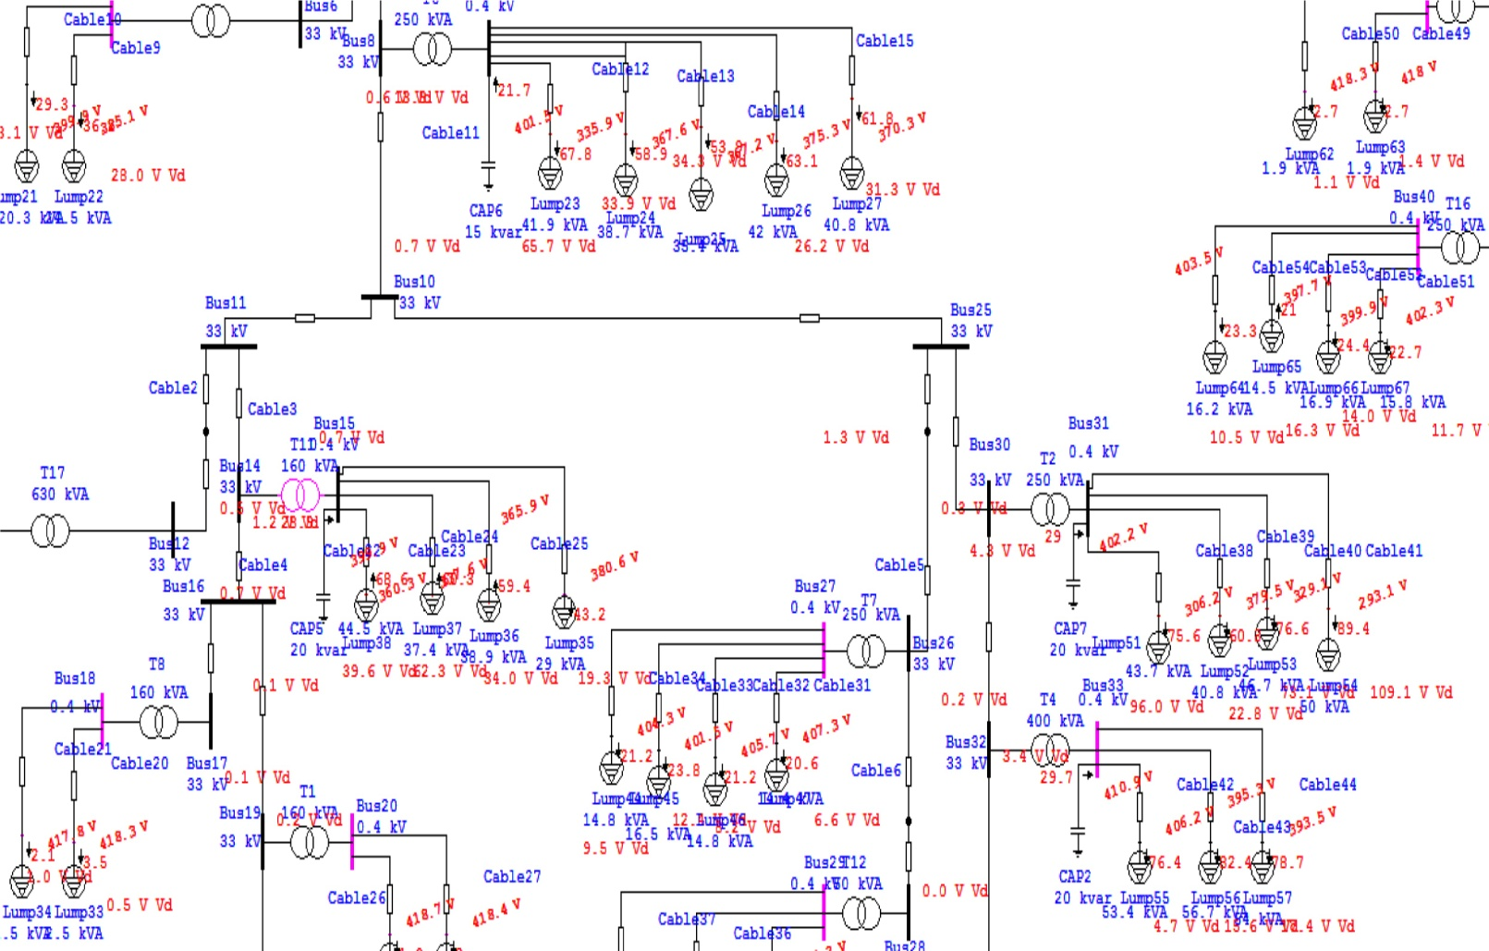
Figure 18: A part of power flow after adding capacitor banks in L. V. max. case.

6.5 The Voltage Level Improvement Using Capacitors in the L. V. Max. Case:

In this method added capacitor banks to improve the voltage levels without changing the taps.

6.5.1 The Result Of Load Flow:
The following table shows the results after adding capacitors in order to improve the voltage levels .
# of Tr | # of feeders | feeder | $Q_{c}$ (KVAR) | Drop voltage % before | Drop voltage % after | P.F % before (old) | P.F % after  (new) | L. V. rated (KV) | L. V. actual  (V) before | L. V. actual (V) after
T1 | 2 | 1 |  | 0.1 | 0.1 | 92.4 | 92.4 | 0.4 | 398.1 | 398.8
T1 | 2 | 2 |  | 0.1 | 0.1 | 92.4 | 92.4 | 0.4 | 398.5 | 398.5
T2 | 4 | 1 | 20 | 26 | 25.8 | 86.8 | 90.7 | 0.4 | 276.4 | 279.7
T2 | 4 | 2 | 20 | 5.9 | 5.9 | 86.8 | 90.7 | 0.4 | 356.8 | 359.2
T2 | 4 | 3 | 20 | 19.5 | 19.3 | 86.8 | 90.7 | 0.4 | 302.6 | 305.4
T2 | 4 | 4 | 20 | 30 | 29.7 | 86.8 | 90.7 | 0.4 | 260.5 | 264.1
T3 | 1 | 1 | 25 | 3.1 | 3 | 86.1 | 90.3 | 0.4 | 379.4 | 380.6
T4 | 3 | 1 | 25 | 1.2 | 1.2 | 85.8 | 91.9 | 0.4 | 385.1 | 386.8
T4 | 3 | 2 | 25 | 4 | 4 | 85.8 | 91.9 | 0.4 | 373.8 | 375.6
T4 | 3 | 3 | 25 | 4.5 | 4.5 | 85.8 | 91.9 | 0.4 | 371.9 | 373.7
T5 | 4 | 1 | 20 | 1.6 | 1.6 | 85.2 | 92.4 | 0.4 | 382.6 | 384.8
T5 | 4 | 2 | 20 | 2.4 | 2.4 | 85.2 | 92.4 | 0.4 | 379.7 | 382
T5 | 4 | 3 | 20 | 2.2 | 2.2 | 85.2 | 92.4 | 0.4 | 380.5 | 382.8
T5 | 4 | 4 | 20 | 1 | 1 | 85.2 | 92.4 | 0.4 | 385.3 | 387.6
T6 | 5 | 1 | 15 | 17.3 | 17.3 | 86.9 | 89.7 | 0.4 | 311.4 | 313.4
T6 | 5 | 2 | 15 | 8.8 | 8.8 | 86.9 | 89.7 | 0.4 | 345.4 | 347.2
T6 | 5 | 3 | 15 | 8.9 | 8.9 | 86.9 | 89.7 | 0.4 | 345 | 346.8
T6 | 5 | 4 | 15 | 6.8 | 6.8 | 86.9 | 89.7 | 0.4 | 353.5 | 355.3
T6 | 5 | 5 | 15 | 8.1 | 8.1 | 86.9 | 89.7 | 0.4 | 348.2 | 350
T7 | 4 | 1 |  | 1.7 | 1.7 | 89.3 | 89.3 | 0.4 | 387.5 | 387.5
T7 | 4 | 2 |  | 2.1 | 2.1 | 89.3 | 89.3 | 0.4 | 385.8 | 385.8
T7 | 4 | 3 |  | 3.2 | 3.2 | 89.3 | 89.3 | 0.4 | 381.5 | 381.5
T7 | 4 | 4 |  | 2.5 | 2.5 | 89.3 | 89.3 | 0.4 | 384.4 | 384.4
T8 | 2 | 1 |  | 0.1 | 0.1 | 90 | 90 | 0.4 | 398.3 | 398.3
T8 | 2 | 2 |  | 0.2 | 0.2 | 90 | 90 | 0.4 | 397.8 | 397.8
T9 | 1 | 1 |  | 0.5 | 0.5 | 91.7 | 91.7 | 0.4 | 394 | 394
T10 | 2 | 1 |  | 0.4 | 0.4 | 91.8 | 91.8 | 0.4 | 395.2 | 395.3
T10 | 2 | 2 |  | 0.3 | 0.3 | 91.8 | 91.8 | 0.4 | 395.6 | 395.6
T11 | 4 | 1 | 25 | 10.4 | 10.3 | 86.8 | 92.7 | 0.4 | 335.8 | 340.5
T11 | 4 | 2 | 25 | 16.5 | 16.3 | 86.8 | 92.7 | 0.4 | 311.3 | 316.3
T11 | 4 | 3 | 25 | 8.9 | 8.8 | 86.8 | 92.7 | 0.4 | 341.7 | 346.3
T11 | 4 | 4 | 25 | 5 | 5 | 86.8 | 92.7 | 0.4 | 357.2 | 361.6
T12 | 3 | 1 |  | 0.1 | 0.1 | 90.1 | 90.1 | 0.4 | 397.3 | 397.3
T12 | 3 | 2 |  | 0.1 | 0.1 | 90.1 | 90.1 | 0.4 | 397.5 | 397.5
T12 | 3 | 3 |  | 0.1 | 0.1 | 90.1 | 90.1 | 0.4 | 397.2 | 397.2
T13 | 2 | 1 |  | 7.2 | 7.2 | 88.5 | 88.5 | 0.4 | 364.5 | 364.5
T13 | 2 | 2 |  | 3.4 | 3.4 | 88.5 | 88.5 | 0.4 | 379.9 | 379.9
T14 | 2 | 1 |  | 4.1 | 4.1 | 88.8 | 88.8 | 0.4 | 379 | 379
T14 | 2 | 2 |  | 9 | 9 | 88.8 | 88.8 | 0.4 | 359.4 | 359.4
T15 | 2 | 1 |  | 0.4 | 0.4 | 93.5 | 93.5 | 0.4 | 398 | 398
T15 | 2 | 2 |  | 0.3 | 0.3 | 93.5 | 93.5 | 0.4 | 398.3 | 398.3
T16 | 4 | 1 |  | 3 | 3 | 88.7 | 88.7 | 0.4 | 382.3 | 382.3
T16 | 4 | 2 |  | 3.6 | 3.6 | 88.7 | 88.7 | 0.4 | 379.8 | 379.9
T16 | 4 | 3 |  | 4.2 | 4.2 | 88.7 | 88.7 | 0.4 | 377.5 | 377.5
T16 | 4 | 4 |  | 2.7 | 2.7 | 88.7 | 88.7 | 0.4 | 383.5 | 383.6
T17 | 4 | 1 |  | 27.6 | 27.6 | 89.7 | 89.7 | 0.4 | 282.5 | 282.5
T17 | 4 | 2 |  | 15.4 | 15.4 | 89.7 | 89.7 | 0.4 | 331.2 | 331.3
T17 | 4 | 3 |  | 14.4 | 14.4 | 89.7 | 89.7 | 0.4 | 335.5 | 335.6
T17 | 4 | 4 |  | 10.4 | 10.4 | 89.7 | 89.7 | 0.4 | 351.2 | 351.2
T18 | 2 | 1 |  | 0.4 | 0.4 | 90.9 | 90.9 | 0.4 | 355.4 | 355.4
T18 | 2 | 2 |  | 10.8 | 10.8 | 90.9 | 90.9 | 0.4 | 396.9 | 396.9
Table 46: The results of improvement the voltage level in L. V. max case without increase the taps.

6.5.2 The swing bus result:

The following table shows the information of swing bus after analysis.
MW | MVAR | MVA | P.F%
1.432 | 0.668 | 1.580 | 90.54 Lag
Table 47: The swing bus result of improvement the voltage level in L. V. max. case .

6.5.3 Summary of total generation ,loading and demand:

The following table shows the summary of total generation ,loading and demand.
 | MW | MVAR | MVA | P.F %
Swing Bus | 1.432 | 0.668 | 1.580 | 90.54 Lag
Total Demand | 1.432 | 0.668 | 1.580 | 90.54 Lag
Total Motor Load | 1.050 | 0.581 | 1.200 | 87.51 Lag
Total Static Load | 0.208 | 0.007 | 0.208 | 99.94 Lag
Apparent Losses | 0.175 | 0.094
Table 48: Summary of generation ,loading of improvement the voltage level in L. V. max case .

Note:
After adding the capacitor banks the losses in the network decrease :
- The losses in the original case = 0.178 MW.
- The losses after =0.175 MW.
The voltage level in some buses increase.
Appendix L shows the load flow results ,the P.F of the buses and the drop voltages.

The following figure shows where the capacitor banks installed in the network.

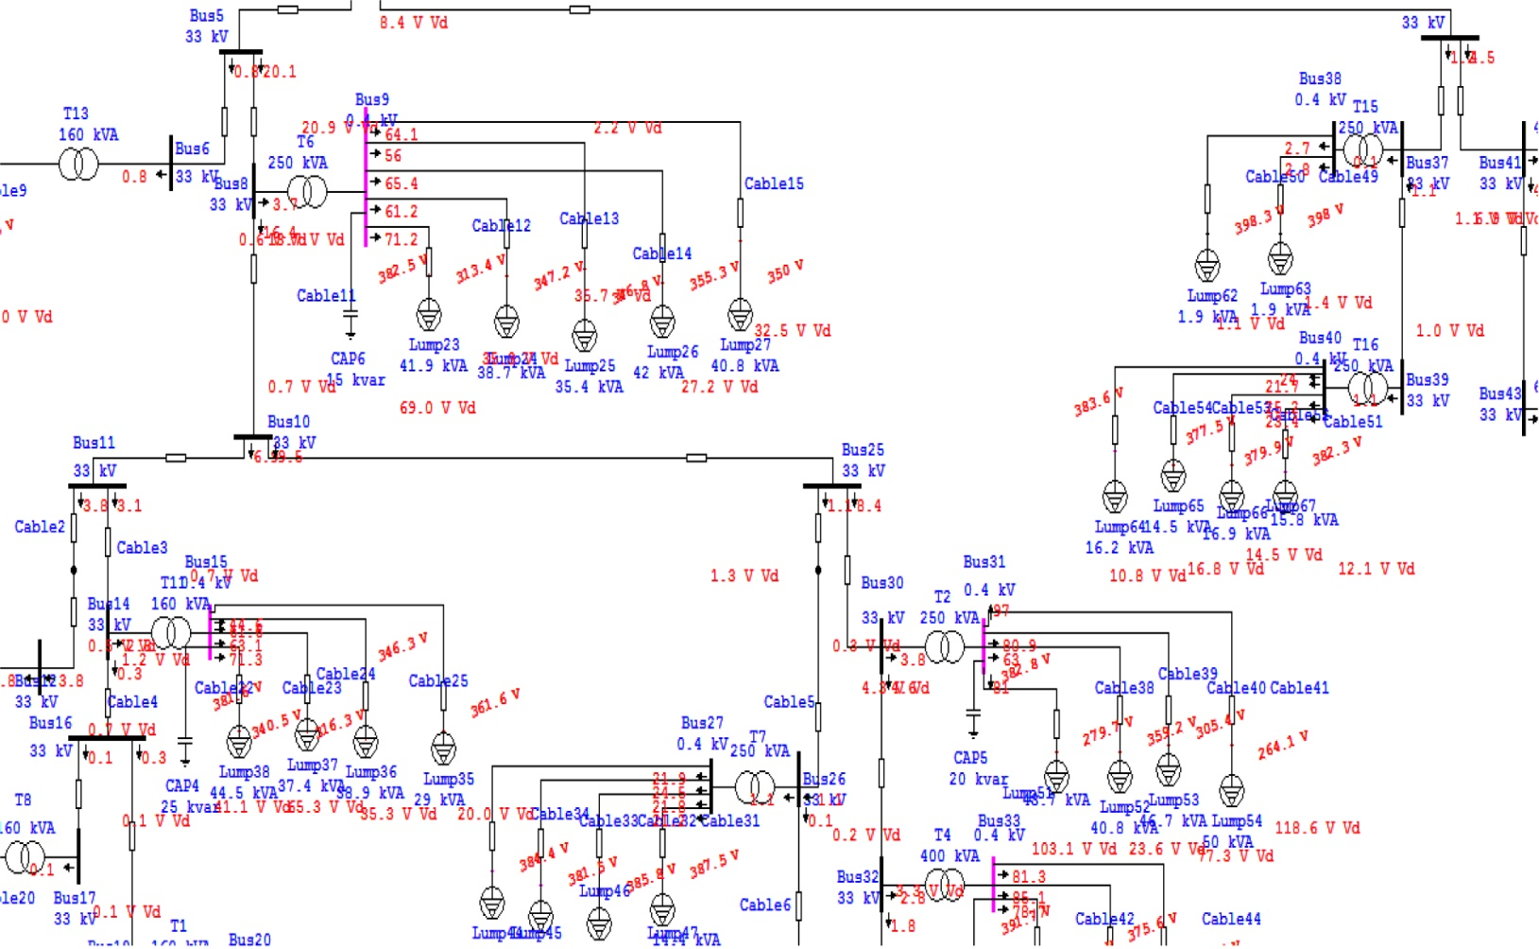
Figure 19: A part of the power flow after improvement the voltage level in L. V. max. case

Chapter 7:

Low Voltage Analysis In Min. Case

7.1 The Original Low Voltage Minimum Case:

7.1.1 Loading For Each Feeder :
The following table shows the loading for each feeder of each transformers in the min. case :
# of Transformer | # of feeders | feeder | Current For each phase (A) |  |  | S act (KVA) | P.F %
# of Transformer | # of feeders | feeder | $$I_{1}$$ | $$I_{2}$$ | $$I_{3}$$ | S act (KVA) | P.F %
T1 | 2 | 1 | 0.6 | 1.3 | 0 | 0.43 | 90.7
T1 | 2 | 2 | 0.8 | 2.8 | 0 | 0.828 | 90.7
T2 | 4 | 1 | 32 | 45 | 38 | 26.45 | 89.6
T2 | 4 | 2 | 41.1 | 37 | 44 | 29.23 | 89.6
T2 | 4 | 3 | 51 | 57 | 62 | 39.1 | 89.6
T2 | 4 | 4 | 50 | 62 | 57 | 38.87 | 89.6
T3 | 1 | 1 | 4 | 6 | 3 | 2.99 | 93
T4 | 3 | 1 | 1.1 | 1.6 | 1.4 | 0.94 | 92
T4 | 3 | 2 | 1.4 | 1.7 | 1.3 | 1 | 92
T4 | 3 | 3 | 1.2 | 1.5 | 1.6 | 0.99 | 92
T5 | 4 | 1 | 0.8 | 2.5 | 1.9 | 1.2 | 92.1
T5 | 4 | 2 | 1.1 | 2.9 | 2 | 1.38 | 92.1
T5 | 4 | 3 | 1.5 | 3 | 2.4 | 1.58 | 92.1
T5 | 4 | 4 | 0.9 | 4 | 3.2 | 1.86 | 92.1
T6 | 5 | 1 | 1.98 | 44 | 47 | 25.4 | 89.6
T6 | 5 | 2 | 44 | 33 | 32 | 25 | 89.6
T6 | 5 | 3 | 54 | 28 | 32 | 26.2 | 89.6
T6 | 5 | 4 | 49 | 50.1 | 42 | 32.5 | 89.6
T6 | 5 | 5 | 47 | 43 | 52 | 32.6 | 89.6
T7 | 4 | 1 | 3.5 | 7.7 | 3.5 | 3.38 | 89.9
T7 | 4 | 2 | 2 | 30 | 27 | 13.6 | 89.9
T7 | 4 | 3 | 18 | 9.4 | 8.8 | 8.3 | 89.9
T7 | 4 | 4 | 47 | 16 | 11.6 | 17.15 | 89.9
T8 | 2 | 1 | 1.6 | 0 | 1.4 | 0.69 | 90.6
T8 | 2 | 2 | 2.4 | 0 | 1.6 | 0.92 | 90.6
T9 | 1 | 1 | 3.1 | 2.5 | 3 | 1.98 | 92.9
T10 | 2 | 1 | 0.6 | 0.6 | 1.4 | 0.6 | 90.5
T10 | 2 | 2 | 0.8 | 0.7 | 2 | 0.8 | 90.5
T11 | 4 | 1 | 48.5 | 12.5 | 22.3 | 19.2 | 88.8
T11 | 4 | 2 | 32 | 21 | 59 | 25.8 | 88.8
T11 | 4 | 3 | 36 | 35 | 18.5 | 13.7 | 88.8
T11 | 4 | 4 | 25 | 40 | 19 | 19.3 | 88.8
T12 | 3 | 1 | 0 | 0.6 | 2.3 | 0.7 | 91.1
T12 | 3 | 2 | 0 | 0.5 | 2 | 0.6 | 91.1
T12 | 3 | 3 | 0 | 0.5 | 1.7 | 0.5 | 91.1
T13 | 2 | 1 | 26.7 | 13 | 13.6 | 12.3 | 91.5
T13 | 2 | 2 | 16.3 | 6 | 2.7 | 5.75 | 91.5
T14 | 2 | 1 | 28 | 19 | 41 | 20.24 | 90.1
T14 | 2 | 2 | 0.4 | 0.7 | 1.5 | 0.6 | 90.1
T15 | 2 | 1 | 0.5 | 0 | 0.3 | 0.2 | 92.2
T15 | 2 | 2 | 0.1 | 0.5 | 0 | 0.13 | 92.2
T16 | 4 | 1 | 1 | 2.1 | 1.3 | 1 | 91.5
T16 | 4 | 2 | 3.2 | 8 | 8.5 | 4.53 | 91.5
T16 | 4 | 3 | 18.6 | 42 | 26.5 | 20.03 | 91.5
T16 | 4 | 4 | 6.2 | 6.7 | 12.7 | 5.88 | 91.5
T17 | 4 | 1 | 27.5 | 28 | 6.5 | 14.3 | 90.5
T17 | 4 | 2 | 36 | 50 | 26 | 25.7 | 90.5
T17 | 4 | 3 | 8.4 | 19.5 | 59 | 19.98 | 90.5
T17 | 4 | 4 | 1.2 | 0.3 | 6 | 1.7 | 90.5
T18 | 2 | 1 | 22 | 21 | 15 | 13.34 | 93.2
T18 | 2 | 2 | 0.1 | 2 | 1.5 | 0.828 | 93.2
Table 49: Loading of each Feeder in Low Voltage min. case.

Note:
As shown above the loads distributed unsymmetrical which cases neutral current and so losses in the network as will be shown .

7.1.2 The Result Of Load Flow:

The following table show the voltage at the end of each feeder and the drop voltage
# of Transformer | # of feeders | feeder | Drop Voltage % | Low Voltage rated( KV) | Low Voltage actual (V)
T1 | 2 | 1 | 0 | 0.4 | 399.4
T1 | 2 | 2 | 0.1 | 0.4 | 399.2
T2 | 4 | 1 | 13.9 | 0.4 | 332.3
T2 | 4 | 2 | 4.3 | 0.4 | 370.7
T2 | 4 | 3 | 15.9 | 0.4 | 324
T2 | 4 | 4 | 20.9 | 0.4 | 304.3
T3 | 1 | 1 | 0 | 0.4 | 399.7
T4 | 3 | 1 | 0 | 0.4 | 399.5
T4 | 3 | 2 | 0.1 | 0.4 | 399.3
T4 | 3 | 3 | 0.1 | 0.4 | 399.2
T5 | 4 | 1 | 0.1 | 0.4 | 399
T5 | 4 | 2 | 0.1 | 0.4 | 392.1
T5 | 4 | 3 | 0.1 | 0.4 | 398.9
T5 | 4 | 4 | 0.1 | 0.4 | 398.7
T6 | 5 | 1 | 9.7 | 0.4 | 348.7
T6 | 5 | 2 | 5.5 | 0.4 | 365.4
T6 | 5 | 3 | 6.5 | 0.4 | 361.5
T6 | 5 | 4 | 5.2 | 0.4 | 366.6
T6 | 5 | 5 | 6.5 | 0.4 | 361.4
T7 | 4 | 1 | 0.4 | 0.4 | 394.7
T7 | 4 | 2 | 1.9 | 0.4 | 388.5
T7 | 4 | 3 | 1.6 | 0.4 | 390
T7 | 4 | 4 | 2.9 | 0.4 | 384.7
T8 | 2 | 1 | 0 | 0.4 | 399.4
T8 | 2 | 2 | 0.2 | 0.4 | 398.9
T9 | 1 | 1 | 0.1 | 0.4 | 398.3
T10 | 2 | 1 | 0.1 | 0.4 | 398.8
T10 | 2 | 2 | 0.1 | 0.4 | 398.8
T11 | 4 | 1 | 4.2 | 0.4 | 372.5
T11 | 4 | 2 | 10.6 | 0.4 | 346.7
T11 | 4 | 3 | 2.9 | 0.4 | 377.5
T11 | 4 | 4 | 3.3 | 0.4 | 376.2
T12 | 3 | 1 | 0.1 | 0.4 | 398.7
T12 | 3 | 2 | 0 | 0.4 | 398.8
T12 | 3 | 3 | 0.1 | 0.4 | 398.7
T13 | 2 | 1 | 3.6 | 0.4 | 383.2
T13 | 2 | 2 | 0.9 | 0.4 | 393.8
T14 | 2 | 1 | 3.4 | 0.4 | 384.6
T14 | 2 | 2 | 0.2 | 0.4 | 397.7
T15 | 2 | 1 | 0 | 0.4 | 399.7
T15 | 2 | 2 | 0 | 0.4 | 399.8
T16 | 4 | 1 | 0.2 | 0.4 | 396.8
T16 | 4 | 2 | 1 | 0.4 | 393.6
T16 | 4 | 3 | 6 | 0.4 | 373.6
T16 | 4 | 4 | 1 | 0.4 | 393.6
T17 | 4 | 1 | 6.9 | 0.4 | 370.1
T17 | 4 | 2 | 8.4 | 0.4 | 364.4
T17 | 4 | 3 | 6.1 | 0.4 | 373.6
T17 | 4 | 4 | 0.3 | 0.4 | 396.6
T18 | 2 | 1 | 8.7 | 0.4 | 364.4
T18 | 2 | 2 | 0.1 | 0.4 | 398.7
Table 50: The result of low voltage in original min. case.

7.1.3 The swing bus result:
The following table shows the information of swing bus after analysis.

MW | MVAR | MVA | P.F%
0.540 | 0.265 | 0.101 | 89.79 Lag
Table 51: The swing bus result in the L. V. original Min. case.

7.1.4 Summary of total generation ,loading and demand:

The following table shows the summary of total generation ,loading and demand.
 | MW | MVAR | MVA | P.F %
Swing Bus | 0.540 | 0.265 | 0.101 | 89.79 Lag
Total Demand | 0.540 | 0.265 | 0.101 | 89.79 Lag
Total Motor Load | 0.404 | 0.197 | 0.456 | 89.88 Lag
Total Static Load | 0.083 | 0.040 | 0.092 | 89.90Lag
Apparent Losses | 0.053 | 0.027
Table 52: Summary of generation ,loading in L. V. original Min. case.

Note:
After the analysis : the losses in the network increase more than the losses in the minimum case at the medium voltage:
- The losses before = 0.00 MW .
- The losses after = 0.53 MW .

Appendix M shows the load flow results ,the P.F of the buses and the drop voltages.

The following figures show the power flow for a part of the network

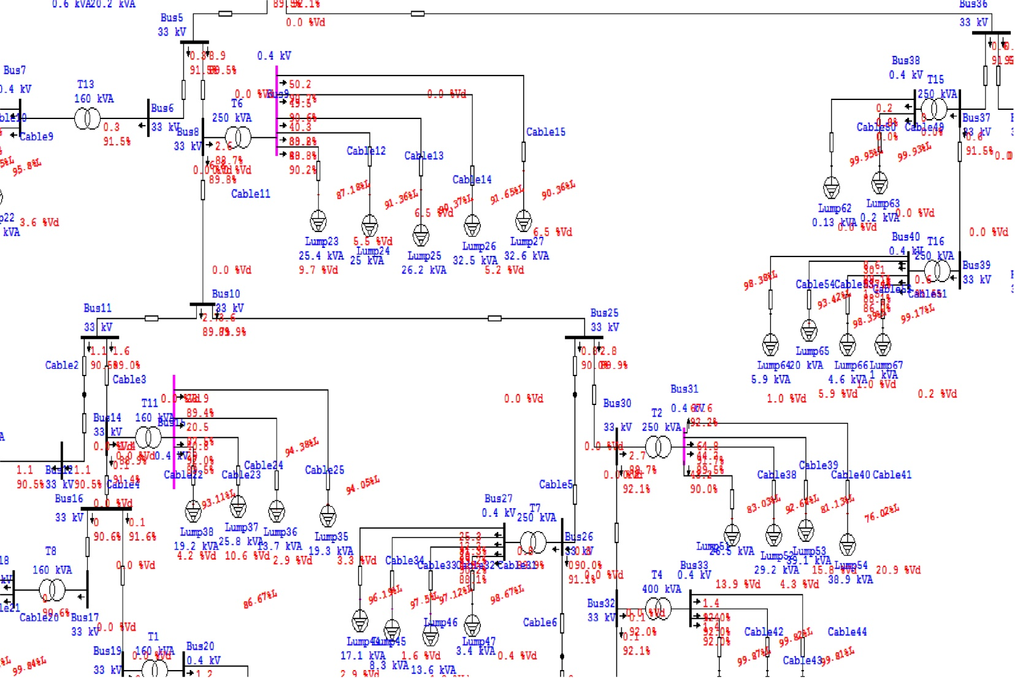
Figure 20: A part of the low voltage side of original Min. case.

7.2 Improvement the L. V. min. case using tap changing :

In this method increase the tap ratio of the transformers to 2.5%.

7.2.1 The Result Of Load Flow:
The following table shows the results after changing the tap of the transformers.
# of Transformer | # of feeders | feeder | Drop voltage % before | Drop voltage % after | Low Voltage rated KV | Low Voltage actual  (V) before | Low Voltage actual (V) after
T1 | 2 | 1 | 0 | 0 | 0.4 | 399.4 | 409.4
T1 | 2 | 2 | 0.1 | 0.1 | 0.4 | 399.2 | 409.2
T2 | 4 | 1 | 13.9 | 13.6 | 0.4 | 332.3 | 343
T2 | 4 | 2 | 4.3 | 4.2 | 0.4 | 370.7 | 380
T2 | 4 | 3 | 15.9 | 15.4 | 0.4 | 324 | 335.7
T2 | 4 | 4 | 20.9 | 20.3 | 0.4 | 304.3 | 316.1
T3 | 1 | 1 | 0 | 0 | 0.4 | 399.7 | 409.7
T4 | 3 | 1 | 0 | 0 | 0.4 | 399.5 | 409.5
T4 | 3 | 2 | 0.1 | 0.1 | 0.4 | 399.3 | 409.3
T4 | 3 | 3 | 0.1 | 0.1 | 0.4 | 399.2 | 409.2
T5 | 4 | 1 | 0.1 | 0.1 | 0.4 | 399 | 409
T5 | 4 | 2 | 0.1 | 0.1 | 0.4 | 392.1 | 408.1
T5 | 4 | 3 | 0.1 | 0.1 | 0.4 | 398.9 | 408.8
T5 | 4 | 4 | 0.1 | 0.1 | 0.4 | 398.7 | 408.7
T6 | 5 | 1 | 9.7 | 9.5 | 0.4 | 348.7 | 359.1
T6 | 5 | 2 | 5.5 | 5.4 | 0.4 | 365.4 | 375.4
T6 | 5 | 3 | 6.5 | 6.4 | 0.4 | 361.5 | 371.5
T6 | 5 | 4 | 5.2 | 5.1 | 0.4 | 366.6 | 376.5
T6 | 5 | 5 | 6.5 | 6.4 | 0.4 | 361.4 | 371.5
T7 | 4 | 1 | 0.4 | 0.4 | 0.4 | 394.7 | 404.6
T7 | 4 | 2 | 1.9 | 1.9 | 0.4 | 388.5 | 398.5
T7 | 4 | 3 | 1.6 | 1.5 | 0.4 | 390 | 400
T7 | 4 | 4 | 2.9 | 2.8 | 0.4 | 384.7 | 394.8
T8 | 2 | 1 | 0 | 0 | 0.4 | 399.4 | 409.4
T8 | 2 | 2 | 0.2 | 0.1 | 0.4 | 398.9 | 408.9
T9 | 1 | 1 | 0.1 | 0.1 | 0.4 | 398.3 | 408.3
T10 | 2 | 1 | 0.1 | 0.1 | 0.4 | 398.8 | 408.7
T10 | 2 | 2 | 0.1 | 0.1 | 0.4 | 398.8 | 408.7
T11 | 4 | 1 | 4.2 | 4.1 | 0.4 | 372.5 | 382.4
T11 | 4 | 2 | 10.6 | 10.4 | 0.4 | 346.7 | 357.2
T11 | 4 | 3 | 2.9 | 2.9 | 0.4 | 377.5 | 387.3
T11 | 4 | 4 | 3.3 | 3.2 | 0.4 | 376.2 | 386.1
T12 | 3 | 1 | 0.1 | 0.1 | 0.4 | 398.7 | 408.6
T12 | 3 | 2 | 0 | 0 | 0.4 | 398.8 | 408.7
T12 | 3 | 3 | 0.1 | 0.1 | 0.4 | 398.7 | 408.7
T13 | 2 | 1 | 3.6 | 3.5 | 0.4 | 383.2 | 393.4
T13 | 2 | 2 | 0.9 | 0.9 | 0.4 | 393.8 | 403.8
T14 | 2 | 1 | 3.4 | 3.3 | 0.4 | 384.6 | 394.9
T14 | 2 | 2 | 0.2 | 0.2 | 0.4 | 397.7 | 407.5
T15 | 2 | 1 | 0 | 0 | 0.4 | 399.7 | 409.7
T15 | 2 | 2 | 0 | 0 | 0.4 | 399.8 | 409.8
T16 | 4 | 1 | 0.2 | 0.2 | 0.4 | 396.8 | 406.6
T16 | 4 | 2 | 1 | 0.9 | 0.4 | 393.6 | 403.5
T16 | 4 | 3 | 6 | 5.8 | 0.4 | 373.6 | 384
T16 | 4 | 4 | 1 | 1 | 0.4 | 393.6 | 403.5
T17 | 4 | 1 | 6.9 | 6.8 | 0.4 | 370.1 | 380.5
T17 | 4 | 2 | 8.4 | 8.2 | 0.4 | 364.4 | 374.9
T17 | 4 | 3 | 6.1 | 6 | 0.4 | 373.6 | 384
T17 | 4 | 4 | 0.3 | 0.3 | 0.4 | 396.6 | 406.5
T18 | 2 | 1 | 8.7 | 8.5 | 0.4 | 364.4 | 375.1
T18 | 2 | 2 | 0.1 | 0.1 | 0.4 | 398.7 | 408.7
Table 53: The results of improvement of L. V. min case using tap changing.

7.2.2 The swing bus result:

The following table shows the information of swing bus after analysis.

MW | MVAR | MVA | P.F%
0.543 | 0.267 | 0.605 | 89.75 Lag
Table 54: The swing bus result after improvement of L. V. min case using taps.

7.2.3 Summary of total generation ,loading and demand:

The following table shows the summary of total generation ,loading and demand.
 | MW | MVAR | MVA | P.F %
Swing Bus | 0.543 | 0.267 | 0.605 | 89.75 Lag
Total Demand | 0.543 | 0.267 | 0.605 | 89.75 Lag
Total Motor Load | 0.404 | 0.197 | 0.450 | 89.88 Lag
Total Static Load | 0.088 | 0.043 | 0.098 | 89.90 Lag
Apparent Losses | 0.051 | 0.027
Table 55: Summary of generation ,loading after improvement of L. V. min case using taps .

Note:
After changing the taps of the transformers the voltage in the consumers increased, also the voltage drop in the feeders decrease and the losses in the network decrease.
Appendix N shows the load flow results ,the P.F of the buses and the drop voltages.

The following figure show a part of power flow in the network.

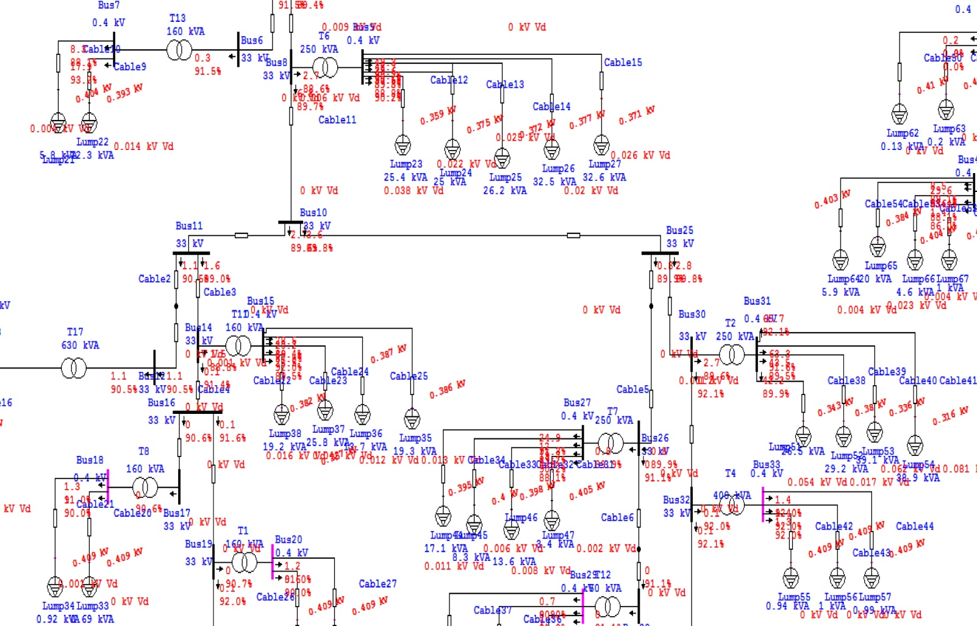
Figure 21: A part of power flow for the network after increase the tap in L. V. min. case

7.3 Power Factor Improvement in the L. V. Min. Case:

After increase the taps of the transformers we added capacitor banks to increase the poor P.F and to reduce the losses in the network .

7.3.1 The Result Of Load Flow (after adding capacitor banks):
The following table shows the results after adding capacitors in order to improve the P.F.
# of Tr | # of feeders | feeder | $Q_{c}$ (KVAR) | Drop voltage % before | Drop voltage % after | P.F % before | P.F % after | L. V. rated (KV) | L. V. actual before (V) | L. V. actual  After (V)
T1 | 2 | 1 |  | 0 | 0 | 90.7 | 90.7 | 0.4 | 409.4 | 409.4
T1 | 2 | 2 |  | 0.1 | 0.1 | 90.7 | 90.7 | 0.4 | 409.2 | 409.2
T2 | 4 | 1 | 15 | 13.6 | 13.5 | 89.6 | 93.4 | 0.4 | 343 | 345.2
T2 | 4 | 2 | 15 | 4.2 | 4.2 | 89.6 | 93.4 | 0.4 | 380 | 382.3
T2 | 4 | 3 | 15 | 15.4 | 15.3 | 89.6 | 93.4 | 0.4 | 335.7 | 337.7
T2 | 4 | 4 | 15 | 20.3 | 20.2 | 89.6 | 93.4 | 0.4 | 316.1 | 318.3
T3 | 1 | 1 |  | 0 | 0 | 93 | 93 | 0.4 | 409.7 | 409.7
T4 | 3 | 1 |  | 0 | 0 | 92 | 92 | 0.4 | 409.5 | 409.5
T4 | 3 | 2 |  | 0.1 | 0.1 | 92 | 92 | 0.4 | 409.3 | 409.3
T4 | 3 | 3 |  | 0.1 | 0.1 | 92 | 92 | 0.4 | 409.2 | 409.2
T5 | 4 | 1 |  | 0.1 | 0.1 | 92.1 | 92.1 | 0.4 | 409 | 409
T5 | 4 | 2 |  | 0.1 | 0.1 | 92.1 | 92.1 | 0.4 | 408.1 | 408.1
T5 | 4 | 3 |  | 0.1 | 0.1 | 92.1 | 92.1 | 0.4 | 408.8 | 408.8
T5 | 4 | 4 |  | 0.1 | 0.1 | 92.1 | 92.1 | 0.4 | 408.7 | 408.7
T6 | 5 | 1 | 12.5 | 9.5 | 9.5 | 89.6 | 92 | 0.4 | 359.1 | 360.7
T6 | 5 | 2 | 12.5 | 5.4 | 5.4 | 89.6 | 92 | 0.4 | 375.4 | 376.9
T6 | 5 | 3 | 12.5 | 6.4 | 6.4 | 89.6 | 92 | 0.4 | 371.5 | 373.1
T6 | 5 | 4 | 12.5 | 5.1 | 5.1 | 89.6 | 92 | 0.4 | 376.5 | 378.1
T6 | 5 | 5 | 12.5 | 6.4 | 6.4 | 89.6 | 92 | 0.4 | 371.5 | 373
T7 | 4 | 1 | 2.5 | 0.4 | 0.4 | 89.9 | 92.2 | 0.4 | 404.6 | 404.9
T7 | 4 | 2 | 2.5 | 1.9 | 1.9 | 89.9 | 92.2 | 0.4 | 398.5 | 398.8
T7 | 4 | 3 | 2.5 | 1.5 | 1.5 | 89.9 | 92.2 | 0.4 | 400 | 400.3
T7 | 4 | 4 | 2.5 | 2.8 | 2.8 | 89.9 | 92.2 | 0.4 | 394.8 | 395.1
T8 | 2 | 1 |  | 0 | 0 | 90.6 | 90.6 | 0.4 | 409.4 | 409.4
T8 | 2 | 2 |  | 0.1 | 0.1 | 90.6 | 90.6 | 0.4 | 408.9 | 408.9
T9 | 1 | 1 |  | 0.1 | 0.1 | 92.9 | 92.9 | 0.4 | 408.3 | 408.3
T10 | 2 | 1 |  | 0.1 | 0.1 | 90.5 | 90.5 | 0.4 | 408.7 | 408.8
T10 | 2 | 2 |  | 0.1 | 0.1 | 90.5 | 90.5 | 0.4 | 408.7 | 408.8
T11 | 4 | 1 | 12.5 | 4.1 | 4.1 | 88.8 | 94.6 | 0.4 | 382.4 | 384.8
T11 | 4 | 2 | 12.5 | 10.4 | 10.4 | 88.8 | 94.6 | 0.4 | 357.2 | 359.7
T11 | 4 | 3 | 12.5 | 2.9 | 2.9 | 88.8 | 94.6 | 0.4 | 387.3 | 389.7
T11 | 4 | 4 | 12.5 | 3.2 | 3.2 | 88.8 | 94.6 | 0.4 | 386.1 | 388.4
T12 | 3 | 1 |  | 0.1 | 0.1 | 91.1 | 91.1 | 0.4 | 408.6 | 408.7
T12 | 3 | 2 |  | 0 | 0 | 91.1 | 91.1 | 0.4 | 408.7 | 408.8
T12 | 3 | 3 |  | 0.1 | 0.1 | 91.1 | 91.1 | 0.4 | 408.7 | 408.7
T13 | 2 | 1 |  | 3.5 | 3.5 | 91.5 | 91.5 | 0.4 | 393.4 | 393.4
T13 | 2 | 2 |  | 0.9 | 0.9 | 91.5 | 91.5 | 0.4 | 403.8 | 403.8
T14 | 2 | 1 |  | 3.3 | 3.3 | 90.1 | 90.1 | 0.4 | 394.9 | 394.9
T14 | 2 | 2 |  | 0.2 | 0.2 | 90.1 | 90.1 | 0.4 | 407.5 | 407.5
T15 | 2 | 1 |  | 0 | 0 | 92.2 | 92.2 | 0.4 | 409.7 | 409.7
T15 | 2 | 2 |  | 0 | 0 | 92.2 | 92.2 | 0.4 | 409.8 | 409.8
T16 | 4 | 1 |  | 0.2 | 0.2 | 91.5 | 91.5 | 0.4 | 406.6 | 406.6
T16 | 4 | 2 |  | 0.9 | 0.9 | 91.5 | 91.5 | 0.4 | 403.5 | 403.5
T16 | 4 | 3 |  | 5.8 | 5.8 | 91.5 | 91.5 | 0.4 | 384 | 384
T16 | 4 | 4 |  | 1 | 1 | 91.5 | 91.5 | 0.4 | 403.5 | 403.5
T17 | 4 | 1 |  | 6.8 | 6.8 | 90.5 | 90.5 | 0.4 | 380.5 | 380.5
T17 | 4 | 2 |  | 8.2 | 8.2 | 90.5 | 90.5 | 0.4 | 374.9 | 374.9
T17 | 4 | 3 |  | 6 | 6 | 90.5 | 90.5 | 0.4 | 384 | 384
T17 | 4 | 4 |  | 0.3 | 0.3 | 90.5 | 90.5 | 0.4 | 406.5 | 406.5
T18 | 2 | 1 |  | 8.5 | 8.5 | 93.2 | 93.2 | 0.4 | 375.1 | 375.1
T18 | 2 | 2 |  | 0.1 | 0.1 | 93.2 | 93.2 | 0.4 | 408.7 | 408.7
Table 56: The results of improvement P.F in L. V. Min Case.

7.3.2 The swing bus result:

The following table shows the information of swing bus after analysis.
MW | MVAR | MVA | P.F%
0.543 | 0.223 | 0.587 | 92.49 Lag
Table 57: The swing bus result of improvement the P.F in L. V. min case.

7.3.3 Summary of total generation ,loading and demand:

The following table shows the summary of total generation ,loading and demand.
 | MW | MVAR | MVA | P.F %
Swing Bus | 0.543 | 0.223 | 0.587 | 92.49 Lag
Total Demand | 0.543 | 0.223 | 0.587 | 92.49 Lag
Total Motor Load | 0.404 | 0.197 | 0.450 | 89.88 Lag
Total Static Load | 0.088 | 0.001 | 0.088 | 99.93 Lag
Apparent Losses | 0.050 | 0.025
Table 58: Summary of generation ,loading of improvement the P.F in L. V. min case .

Note:
After increasing the tap ratio and adding the capacitor banks the losses in the network decrease :
- The losses before= 0.053 MW.
- The losses after=0. 050 MW .
Appendix O shows the load flow results ,the P.F of the buses and the drop voltages.

The following figure shows where the capacitor banks installed in the network.

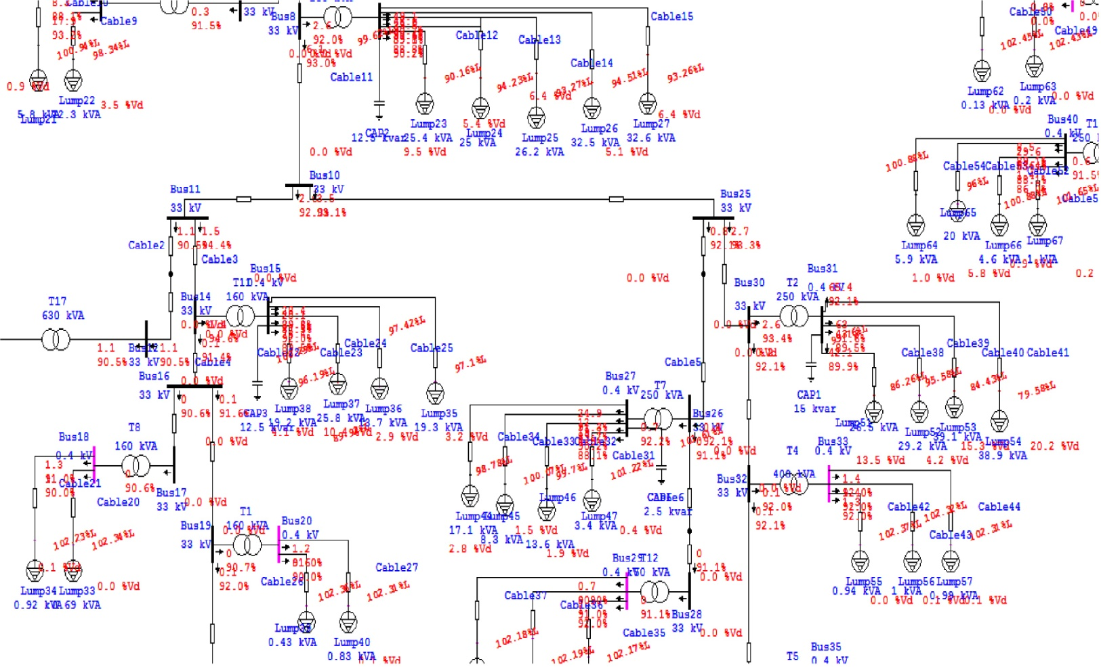
Figure 22: A part of power flow after adding capacitor banks in L. V. min. case.

7.4 The Voltage Level Improvement Using Capacitors in the L. V. Min. Case:

In this method added capacitor banks to improve the voltage levels without changing the taps.

7.4.1 The Result Of Load Flow:
The following table shows the results after adding capacitors in order to improve the voltage levels .
# of Tr | # of feeders | feeder | $Q_{c}$ (KVAR) | Drop voltage % before | Drop voltage % after | P.F % before (old) | P.F % after  (new) | L. V. rated (KV) | L. V. actual  (V) before | L. V. actual (V) after
T1 | 2 | 1 |  | 0 | 0 | 90.7 | 90.7 | 0.4 | 399.4 | 399.4
T1 | 2 | 2 |  | 0.1 | 0.1 | 90.7 | 90.7 | 0.4 | 399.2 | 399.2
T2 | 4 | 1 | 10 | 13.9 | 13.8 | 89.7 | 92.2 | 0.4 | 332.3 | 333.4
T2 | 4 | 2 | 10 | 4.3 | 4.3 | 89.7 | 92.2 | 0.4 | 370.7 | 371.7
T2 | 4 | 3 | 10 | 15.9 | 15.7 | 89.7 | 92.2 | 0.4 | 324 | 325.8
T2 | 4 | 4 | 10 | 20.9 | 20.8 | 89.7 | 92.2 | 0.4 | 304.3 | 305.5
T3 | 1 | 1 |  | 0 | 0 | 93 | 93 | 0.4 | 399.7 | 399.7
T4 | 3 | 1 |  | 0 | 0 | 92 | 92 | 0.4 | 399.5 | 399.5
T4 | 3 | 2 |  | 0.1 | 0.1 | 92 | 92 | 0.4 | 399.3 | 399.3
T4 | 3 | 3 |  | 0.1 | 0.1 | 92 | 92 | 0.4 | 399.2 | 399.2
T5 | 4 | 1 |  | 0.1 | 0.1 | 92.1 | 92.1 | 0.4 | 399 | 399
T5 | 4 | 2 |  | 0.1 | 0.1 | 92.1 | 92.1 | 0.4 | 392.1 | 398.1
T5 | 4 | 3 |  | 0.1 | 0.1 | 92.1 | 92.1 | 0.4 | 398.9 | 398.9
T5 | 4 | 4 |  | 0.1 | 0.1 | 92.1 | 92.1 | 0.4 | 398.7 | 398.7
T6 | 5 | 1 | 15 | 9.7 | 9.6 | 88.7 | 92.5 | 0.4 | 348.7 | 350.5
T6 | 5 | 2 | 15 | 5.5 | 5.5 | 88.7 | 92.5 | 0.4 | 365.4 | 367.1
T6 | 5 | 3 | 15 | 6.5 | 6.5 | 88.7 | 92.5 | 0.4 | 361.5 | 363.2
T6 | 5 | 4 | 15 | 5.2 | 5.2 | 88.7 | 92.5 | 0.4 | 366.6 | 368.3
T6 | 5 | 5 | 15 | 6.5 | 6.5 | 88.7 | 92.5 | 0.4 | 361.4 | 363.2
T7 | 4 | 1 | 2.5 | 0.4 | 0.4 | 89.9 | 92.1 | 0.4 | 394.7 | 395
T7 | 4 | 2 | 2.5 | 1.9 | 1.9 | 89.9 | 92.1 | 0.4 | 388.5 | 388.8
T7 | 4 | 3 | 2.5 | 1.6 | 1.6 | 89.9 | 92.1 | 0.4 | 390 | 390.3
T7 | 4 | 4 | 2.5 | 2.9 | 2.9 | 89.9 | 92.1 | 0.4 | 384.7 | 385
T8 | 2 | 1 |  | 0 | 0 | 90.6 | 90.6 | 0.4 | 399.4 | 399.4
T8 | 2 | 2 |  | 0.2 | 0.2 | 90.6 | 90.6 | 0.4 | 398.9 | 398.9
T9 | 1 | 1 |  | 0.1 | 0.1 | 92.9 | 92.9 | 0.4 | 398.3 | 398.3
T10 | 2 | 1 |  | 0.1 | 0.1 | 90.5 | 90.5 | 0.4 | 398.8 | 398.8
T10 | 2 | 2 |  | 0.1 | 0.1 | 90.5 | 90.5 | 0.4 | 398.8 | 398.8
T11 | 4 | 1 | 12.5 | 4.2 | 4.2 | 88.9 | 94.4 | 0.4 | 372.5 | 374.7
T11 | 4 | 2 | 12.5 | 10.6 | 10.6 | 88.9 | 94.4 | 0.4 | 346.7 | 349
T11 | 4 | 3 | 12.5 | 2.9 | 2.9 | 88.9 | 94.4 | 0.4 | 377.5 | 379.7
T11 | 4 | 4 | 12.5 | 3.3 | 3.2 | 88.9 | 94.4 | 0.4 | 376.2 | 378.4
T12 | 3 | 1 |  | 0.1 | 0.1 | 91.1 | 91.1 | 0.4 | 398.7 | 398.7
T12 | 3 | 2 |  | 0 | 0 | 91.1 | 91.1 | 0.4 | 398.8 | 398.8
T12 | 3 | 3 |  | 0.1 | 0.1 | 91.1 | 91.1 | 0.4 | 398.7 | 398.7
T13 | 2 | 1 |  | 3.6 | 3.6 | 91.5 | 91.5 | 0.4 | 383.2 | 383.2
T13 | 2 | 2 |  | 0.9 | 0.9 | 91.5 | 91.5 | 0.4 | 393.8 | 393.8
T14 | 2 | 1 |  | 3.4 | 3.4 | 90.1 | 90.1 | 0.4 | 384.6 | 384.7
T14 | 2 | 2 |  | 0.2 | 0.2 | 90.1 | 90.1 | 0.4 | 397.7 | 397.8
T15 | 2 | 1 |  | 0 | 0 | 92.2 | 92.2 | 0.4 | 399.7 | 399.7
T15 | 2 | 2 |  | 0 | 0 | 92.2 | 92.2 | 0.4 | 399.8 | 399.8
T16 | 4 | 1 |  | 0.2 | 0.2 | 91.5 | 91.5 | 0.4 | 396.8 | 396.9
T16 | 4 | 2 |  | 1 | 1 | 91.5 | 91.5 | 0.4 | 393.6 | 393.7
T16 | 4 | 3 |  | 6 | 5.9 | 91.5 | 91.5 | 0.4 | 373.6 | 373.7
T16 | 4 | 4 |  | 1 | 1 | 91.5 | 91.5 | 0.4 | 393.6 | 393.7
T17 | 4 | 1 |  | 6.9 | 6.9 | 90.5 | 90.5 | 0.4 | 370.1 | 370.1
T17 | 4 | 2 |  | 8.4 | 8.4 | 90.5 | 90.5 | 0.4 | 364.4 | 364.4
T17 | 4 | 3 |  | 6.1 | 6.1 | 90.5 | 90.5 | 0.4 | 373.6 | 373.6
T17 | 4 | 4 |  | 0.3 | 3 | 90.5 | 90.5 | 0.4 | 396.6 | 396.6
T18 | 2 | 1 |  | 8.7 | 8.7 | 93.2 | 93.2 | 0.4 | 364.4 | 364.4
T18 | 2 | 2 |  | 0.1 | 0.1 | 93.2 | 93.2 | 0.4 | 398.7 | 398.7
Table 59: The results of improvement the voltage level in L. V. min case without increase the taps.

7.4.2 The swing bus result:

The following table shows the information of swing bus after analysis.
MW | MVAR | MVA | P.F%
0.540 | 0.226 | 0.585 | 92.27 Lag
Table 60: The swing bus result of improvement the voltage level in L. V. min. case .

7.4.3 Summary of total generation ,loading and demand:

The following table shows the summary of total generation ,loading and demand.
 | MW | MVAR | MVA | P.F %
Swing Bus | 0.540 | 0.226 | 0.585 | 92. 27 Lag
Total Demand | 0.540 | 0.226 | 0.585 | 92. 27 Lag
Total Motor Load | 0.404 | 0.197 | 0.450 | 89.88 Lag
Total Static Load | 0.083 | 0.003 | 0.084 | 99.95 Lag
Apparent Losses | 0.050 | 0.026
Table 61: Summary of generation ,loading of improvement the voltage level in L. V. min case .

Note:
After adding the capacitor banks the losses in the network decrease :
- The losses in the original case = 0.053 MW.
- The losses after = 0.050 MW.
The voltage level in some buses increase.

Appendix P shows the load flow results ,the P.F of the buses and the drop voltages.

The following figure shows where the capacitor banks installed in the network.

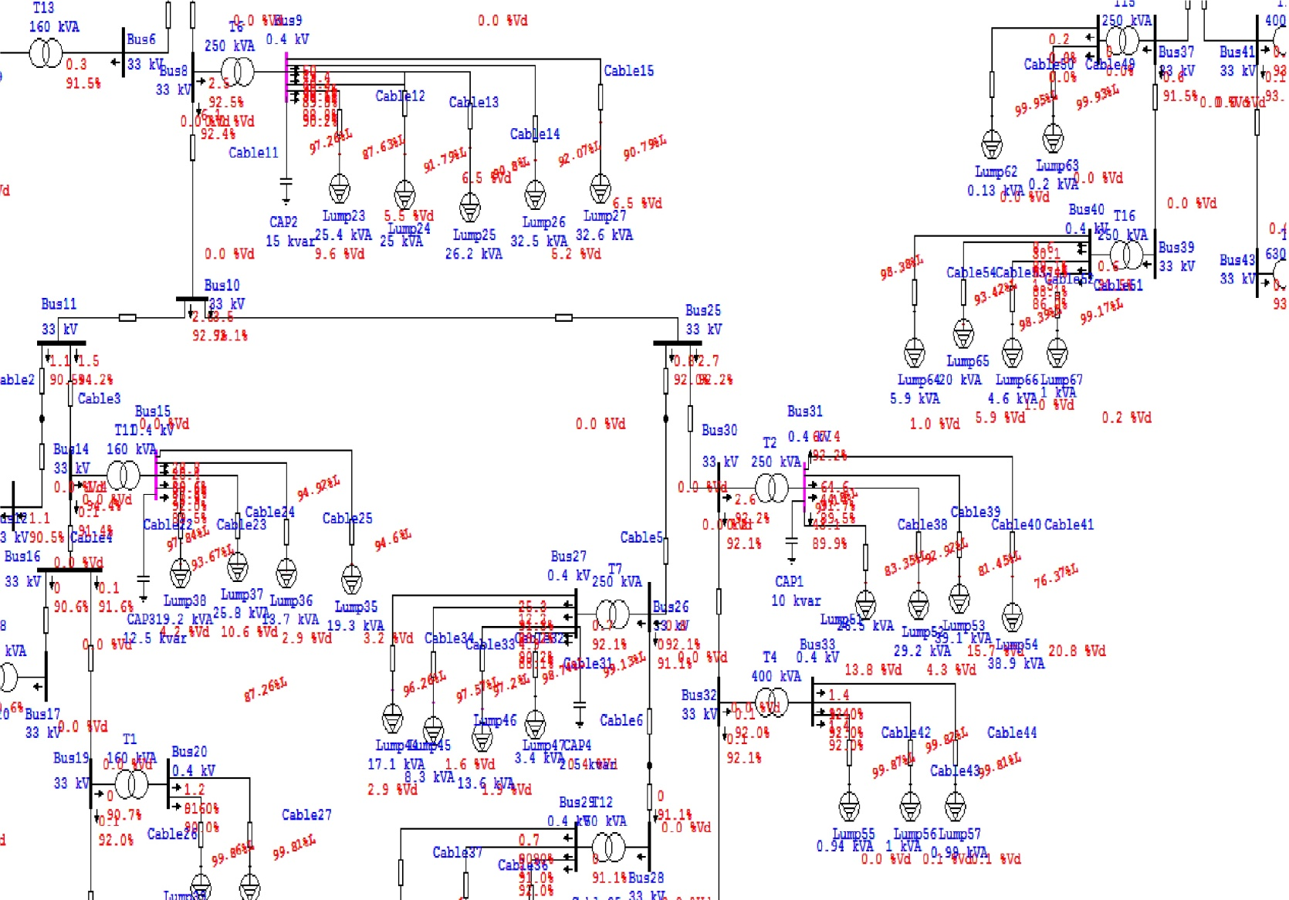
Figure 23: A part of the power flow after improvement the voltage level in L. V. min. case

Chapter 8:

The Economical Study.
In this chapter we will study another face of the project which is a very important in any project, it's the economical study to the system.

8.1 Saving in penalties:

$$The maximum power \left(P_{max}\right)=1.444 MWatt$$
$$The minimum power \left(P_{min}\right)=0.543 MWatt$$
$$The losses before improvement=0.178 MWatt$$
$$The losses after improvement=0.160 MWatt$$
$$The power factor \left(P.f\right) before improvement=87.48 \%= 0.8748$$
$$The power factor \left(P.f\right) after improvement=90.40 \%= 0.9040$$
$$The average power \left(P_{avg}\right)= \frac{P_{max}+ P_{min} }{2}=0.9935 MWatt$$
$$The load factor \left(L.f\right)= \frac{P_{avg }}{P_{max}}=0.69$$
$$The total energy per year= P_{avg} ×\left(8760 Hours\right)=8703.06 MWH$$
$The total cost per year=Total energy ×Cost (NIS/KWH)$
$$=8703.06 ×1000 ×0.65=5656989 NIS/year$$
$$The saving in penalties of the P.f=\left( 1\% \right)×\left( 90.40-87.48 \right)\% ×Total cost of energy$$
$$=1651.84 NIS/year$$

8.2 Saving in losses:

$$The average losses before improvement=0.69×178=122.82 KW$$
$$The energy losses before improvement=122.82 ×8760=1075903.2 KWH$$
$$The cost of the losses before improvement=1075903.2 ×0.65$$
$$=699337.08 NIS/year$$
$$The average losses after improvement=0.69 ×160=110.4 KW$$
$$The energy losses after improvement=110.4 ×8760=967104 KWH$$
$$The cost of the losses after improvement=967104 ×0.65$$
$$=628617.6 NIS/year$$
$$The saving in losses$$
$$=Cost of losses before improvement-Cost of losses after improvement$$
$$=699337.08-628617.6=70719.48 NIS/year$$

8.3 Simple Pay Back Period :

$$The total fixed capacitor banks using in maximum case= 42.5 KVAR$$
$$The cost per KVAR for fixed caoacitor banks=15 NIS$$
$$The total regulated capacitor banks using in maximum case= 72.5 KVAR$$
$$The cost per KVAR for regulated caoacitor bank=75 NIS$$
$$The total cost of the capacitor banks=\left( 42.5 ×15 \right)+ \left(72.5 ×75 \right)$$
$$=6075 NIS$$
$$The total saving=The saving in penalties+The saving in losses$$
$$= 1651.84 + 70719.48=72371.32 NIS$$
$Pay Back Period= \frac{Investment }{Saving}= \frac{6075}{72371.32}=0.084 years≅ ( one month )$

Chapter 9:

Solar energy station project

9.1 Solar system :

9.1.1 Introduction to Solar System:

Energy from the sun falls on our planet on a daily basis. The warmth of the sun creates conditions on earth conducive to life. The weather patterns that occur on the earth are driven by the sun’s energy. Step outside on a sunny day and one is instantly aware of the power of the sun. Spend too much timeout in the sun and this energy can actually burn your skin as effectively as an open flame! The sun drives the process of photosynthesis that all plants depend on. The sun is essentially an inexhaustible supply of energy. It is a gigantic continuous nuclear reaction that has been ongoing for the last 5 billion years. Humans have recently developed technology to directly tap the sun’s energy, although, in many ways we have been using the sun’s energy all along. The energy we get from our food is derived directly or indirectly from plants and most life forms on this planet owes their existence to the sun.
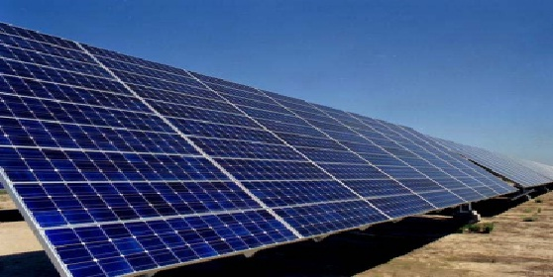
Figure 24: Solar Cells Station.
Solar energy technologies have significantly improved over the last 20 years. These systems are more efficient, reliable and less expensive. Solar energy systems do not produce air or water pollution during operation, can be applied in remote locations and are a renewable source of energy. Some solar energy systems convert the sun’s radiant energy to electrical power that can be used for heating and cooling and even have applications in our transportation systems. As our need for energy increases and our ability to use fossil fuels decreases, solar energy will provide a viable option to meet our future energy needs.

9.1.2 Solar Building Designs:

One of the simplest ways to use the power of the sun is in building design. Most homes can be designed or modified to take advantage of sunlight. Half the energy used by an average residential home goes toward heating and cooling needs. Solar energy can be used to heat buildings by using south facing windows designed to let the sun’s warmth in during the winter months. Thick foundations and walls are used to store the sun’s thermal energy and release the heat during the night. During the summer roof overhangs, shutters, glazes and trees can be used to deflect solar heat helping to keep a building cooler. In areas with significant numbers of cloudy days, can still use sunlight for passive lighting needs. Schools, industries and commercial businesses that are occupied mainly during daylight hours can especially benefit from passive solar lighting and heating. Passive solar lighting can be a major consideration in commercial and industrial buildings where over 30 percent of the energy is consumed for lighting needs.
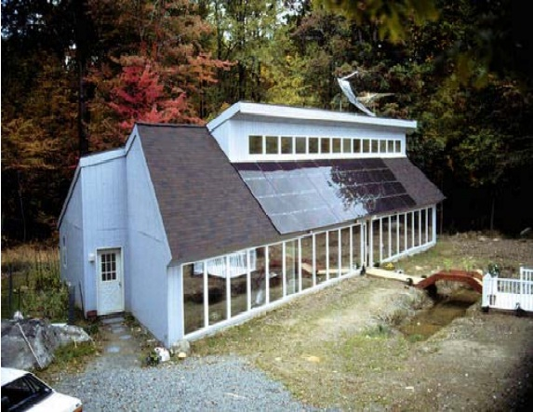
Figure 25: Solar Building.
Tests conducted by the National Renewable Energy Laboratory indicate that passive solar designs use 47 percent less energy than conventional new buildings and 60 percent less energy than older buildings. In most cases passive solar homes are no more expensive to construct than traditional designs. Such homes often offer a more open and pleasing floor plan, reduced indoor air pollution and significantly reduced energy consumption.

9.1.3 Solar Photovoltaic Energy:
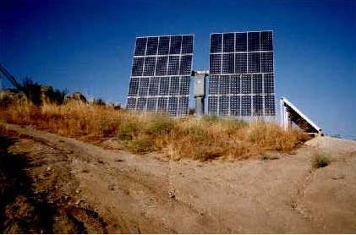
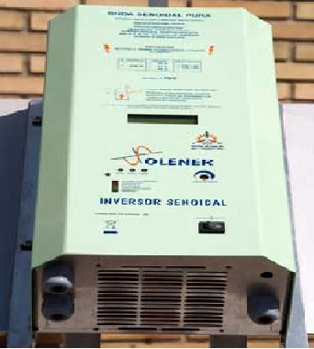
Figure 26: Inverter and Photovoltaic cells.
An easy method to collect the sun's energy is photovoltaic conversion, this consists of the transformation of solar energy to electric energy using solar cells. Solar cells are manufactured from pure silicon with some impurities of other chemical elements, and they are each able to generate from 2 to 4 Amps, at a voltage of 0.46 to 0.48 V, using solar radiation as the source. They capture both direct and diffuse radiation, this means that energy can be generated even on cloudy days. The cells are mounted in series to form PV modules in order to reach a suitable voltage for electrical applications; the PV modules collect the solar energy transforming it directly in electric energy as direct current, which, in isolated applications, it is necessary to store in batteries in order that it may be used during periods of the day in which there is no sunlight. Inverter: Most appliances require alternating current at 220 Volts and frequency of 50 Hz. In order to produce this kind of current, a DC/AC (from DC current to AC current) inverter is necessary to transform the DC current from the battery (12 or 24 Volts), into AC current at 220 Volts and 50 Hz. The kind of inverter to be used depends on the application. For example, if we want AC current to operate a TV or a computer and some small appliances, a square wave inverter can be used. But if the application is to provide energy to appliances such as washing machines, refrigerators, or some AC motors - loads that require a sinusoidal wave form source for their correct operation - a sine wave inverter must be used. Solutions Energetic as produces modified square wave inverters that, apart from producing a wave form suitable for all these applications, have a very high efficiency (higher than 95%), thus minimizing the losses in the DC to AC conversion. In this way, it is possible to have AC current at 220 Volts and 50 Hz to supply the whole installation - appliances and illumination alike - the general efficiency of the system is thereby improved because the voltage drop in 220 Volts lines is much lower than in 12 or 24 Volts.
We also produce a wide range of sine wave inverters of high efficiency controlled by microprocessors and programmable by the user by means of a display. This display also continuously shows information about the state of the system, including the energy consumed.

9.2 Consumption Energy Of Network and Solar System Design:

9.2.1 Data about Energy Consumption of the Network:
In this network we use electrical energy in industrial facilities , shops and houses lighting. The table below shown the monthly consumption of this network in 2013
Interval of bill | Consumption in KWH
16/12/2012-15/1/2013 | 483240
16/1/2013-12/2/2013 | 429930
13/2/2013-16/3/2013 | 480720
17/3/2013-16/4/2013 | 454380
17/4/2013-18/5/2013 | 485460
19/5/2013-14/6/2013 | 426360
15/6/2013-15/7/2013 | 505530
16/7/2013-17/8/2013 | 549450
18/8/2013-10/9/2013 | 400290
11/9/2013-14/10/2013 | 558810
15/10/2013-17/11/2013 | 515910
18/11/2013-17/12/2013 | 426030
TOTAL | 5716110
Table 62: Consumption Energy of the Network per Month in 2013.
In this project we will support this network through the addition of solar cells (on grid) so that these cells produce 20% of the total consumption of the network in one year and we will work on the design of the station so that we get the largest amount of production, and then we make an economic study.

9.2.2 Calculations of the power for the Solar System:

The Energy of the network in year = 5716110 KWH/year.
The Energy of the network in day = The Energy of the network in year / the number of day in year.
The Energy of the network in day = 5716110/365 = 15660.6 KWH/day.
The average energy produced of 1KW solar cells = 5.4KWH/$m^{2}$.day.
We use the penetration factor =20%.
Then the total energy of solar system in day = the penetration factor $×$ The Energy of the network in day.
The total energy of solar system in day = 15660.6 $×$ 0.2 = 3132.1 KWH/day.
Then we calculate the power of the solar system, that will work on the design.
The power of the solar system($P_{PV}$ in KW) = The total energy of solar system in day/ The average energy produced of 1KW solar cells.
$P_{PV}$ (KW) = 3132.1 (KWH/day) /(5.4KWH/m^2.day) = 580 KW.
Then we will design the power of solar system = 580KW.

9.2.3 The Optimization tilt angle Tracking system:

Before we work design the solar system, We must find a better angle of inclination(tilt) of the solar panels. that to get the biggest solar radiation and the reality on these panels in order to produce the largest amount of electric energy that can be obtained by selecting the best angle of inclination of these panels.
To Maximizing power output from a solar system is desirable to increase efficiency. In order to maximize power output from the solar panels, one needs to keep the panels aligned with the sun. As such, a means of tracking the sun is required. This is a far more cost effective solution than purchasing additional solar panels. It has been estimated that the yield from solar panels can be increased by 30 to 60 percent by utilizing a tracking system instead of a stationary array . This project develops an automatic tracking system which will keep the solar panels aligned with the sun in order to maximize efficiency.
The picture below shows the optimization angle in the summer and winter semester ,and the tracker system to be obtained the maximum radiation in two axis,
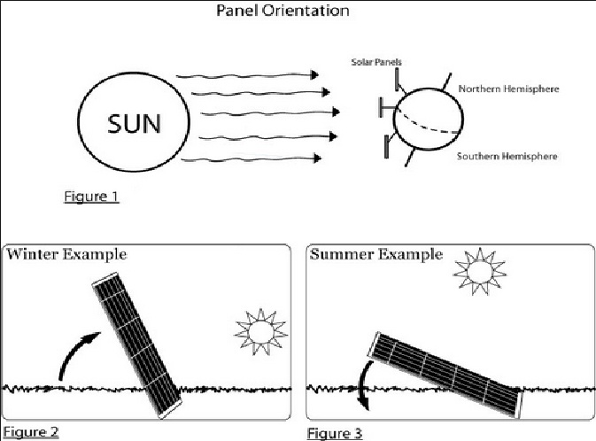
Figure 27: Optimization angle in the summer and winter semester.
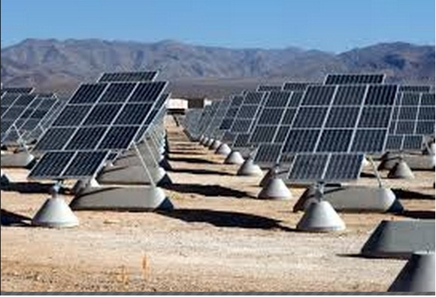

And we worked on a link in the internet to determine the optimization tilt angle , the energy produced in daily and monthly , other Measurements and important curves .
This link: (http://re.jrc.ec.europa.eu/pvgis/apps4/pvest.php?map)
The link when we opened on internet as shown in below picture:
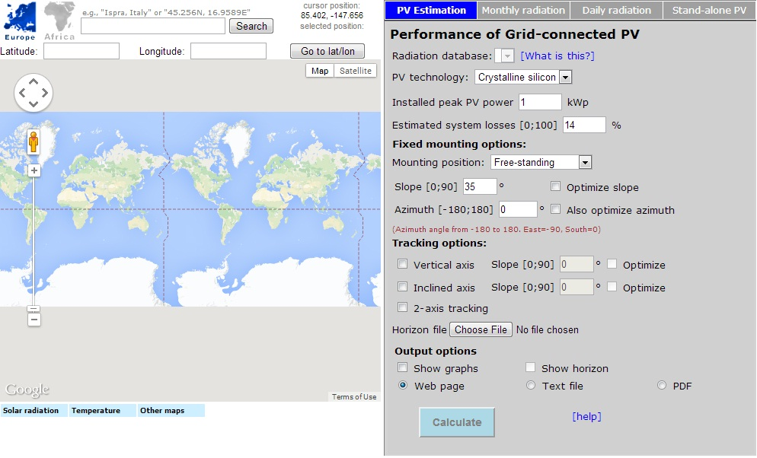
Figure 28: The interface of the link in the internet.

*How to deal with this link?
1. Select the geographical area that will be put solar cells in it as shown in the below picture.
2. Choose the optimize slope.
3. Choose the tracking option

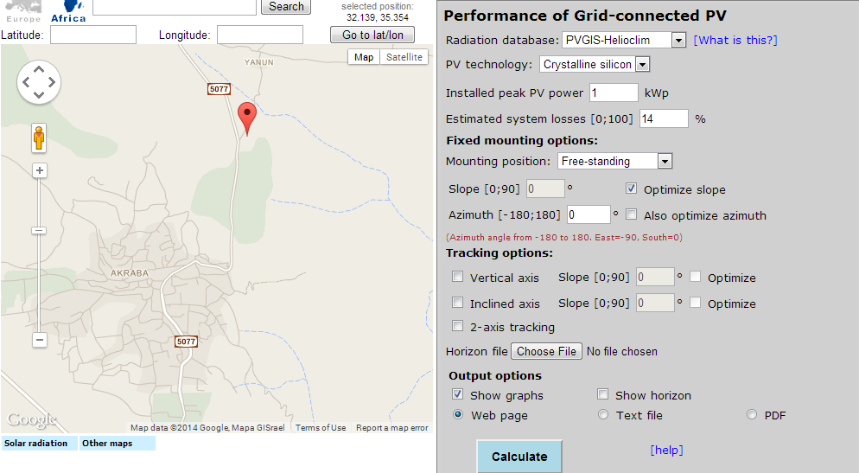
Figure 29: selecting the geographical area.
After we entered all necessary data, the results and calculations of this program are shown below :
*The optimization tilt angle =26 degree, and the optimum azimuth angle = -6 degree
Solar radiation database used: PVGIS-helioclim
Nominal power of the PV system: 1.0 kW (crystalline silicon)
Estimated losses due to temperature and low irradiance: 12.2% (using local ambient temperature)
Estimated loss due to angular reflectance effects: 2.7%
Other losses (cables, inverter etc.): 14.0%
Combined PV system losses: 26.5%
Fixed system: inclination=26°, orientation=0° (Optimum at given orientation)
Month | E_{d} | E_{m} | H_{d} | H_{m}
Jan | 2.75 | 85.3 | 3.48 | 108
Feb | 3.25 | 91.1 | 4.19 | 117
Mar | 3.91 | 121 | 5.19 | 161
Apr | 4.47 | 134 | 6.11 | 183
May | 4.94 | 153 | 6.89 | 214
Jun | 5.32 | 159 | 7.51 | 225
Jul | 5.20 | 161 | 7.39 | 229
Aug | 5.09 | 158 | 7.22 | 224
Sep | 4.74 | 142 | 6.63 | 199
Oct | 4.02 | 125 | 5.49 | 170
Nov | 3.29 | 98.8 | 4.34 | 130
Dec | 2.70 | 83.7 | 3.44 | 107
Yearly average | 4.14 | 126 | 5.66 | 172
Total for year | 1510 |  | 2070
Table 63: Average power produce by solar system .
E_{d}: Average daily electricity production from the given system (kWh)
E_{m}: Average monthly electricity production from the given system (kWh)
H_{d}: Average daily sum of global irradiation per square meter received by the modules of the given system (kWh/m²)
H_{m}: Average sum of global irradiation per square meter received by the modules of the given system (kWh/m²)

The average power produced by the solar system per month is shown in the below figure
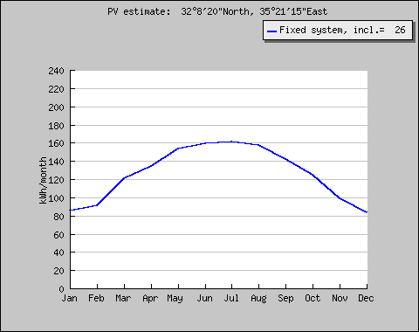
Figure 30: Average power produced by the solar system per month.

The average sum of global irradiation per square meter received by the modules of the solar system is shown in the below picture :

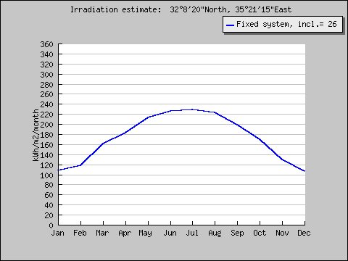
Figure 31: Average global irradiation per month.

- The Optimal inclination angle and the irradiation at the tilt angle =26 degree
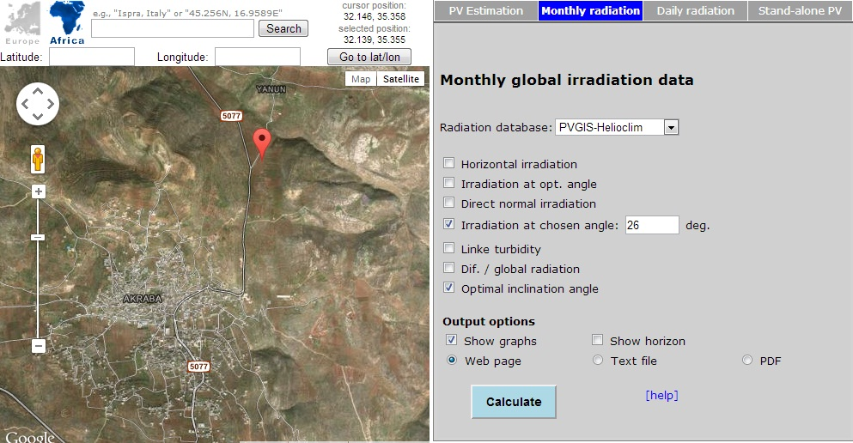
Figure 32: Entering the tilt angle.
The Results :

Optimal inclination angle is: 26 degrees
Annual irradiation deficit due to shadowing (horizontal): 0.4 %

The table below shows the optimal inclination angle and irradiation on plane in each month :
Month | H(26) | I_{opt}
Jan | 3470 | 54
Feb | 4210 | 46
Mar | 5210 | 34
Apr | 6110 | 20
May | 6890 | 6
Jun | 7510 | -1
Jul | 7390 | 3
Aug | 7220 | 15
Sep | 6630 | 30
Oct | 5520 | 43
Nov | 4360 | 53
Dec | 3460 | 57
Year | 5670 | 26

Table 64: the optimal inclination angle and irradiation on plane in each month .
H(26): Irradiation on plane at angle: 26deg. (Wh/m²/day).
I_{opt}: Optimal inclination (deg.).

The curve below shows the Irradiation plane at angle 26 deg. Foe each month:
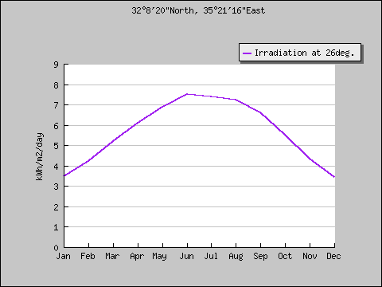
Figure 33: Irradiation plane at angle 26 deg. For each month.
And the below curve shows the Optimal Inclination angle for each month:

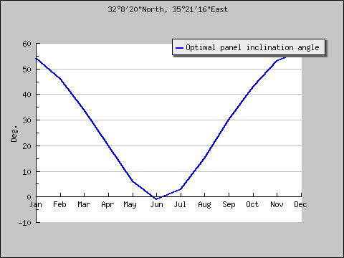
Figure 34: Optimal Inclination angle for each month .

9.3 The Design of the solar station system :

The Power of this station = 580kw, and we will use two program to design this station .
The first program is PV system .
The second program is power-one(aurora designer)

9.3.1 Design Of Solar System PV system:

How to deal with the PV system?
We designed the solar system as you see in the bellow pictures :
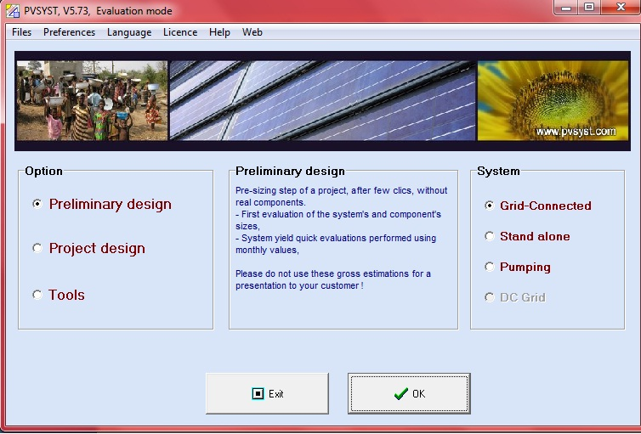
Figure 35: The Interface of PV sys. Program .

After select the desired options (as you see in the last picture ), the press OK.
Then you must select the location ,after that enter to the system and select the type of array specification (nominal power KWp) and write (580) to the power of solar system design then enter the optimization of tilt and azimuth angle ,Then OK.
Then you choose the (Modul type = Standard, Mounting position =Ground based, Tecnology = Polycrystalline, Ventilation Proparty = Free standing), then OK.
The pictures below shows all these steps :

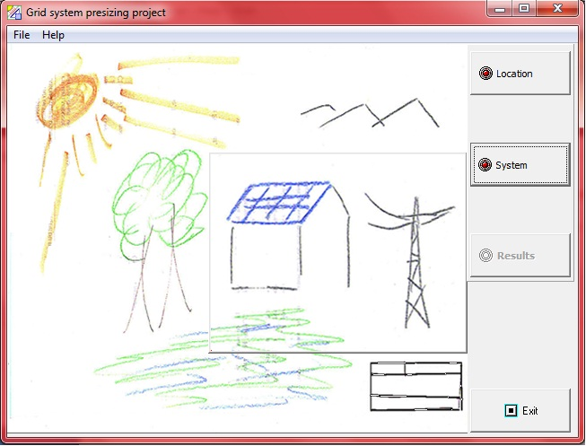
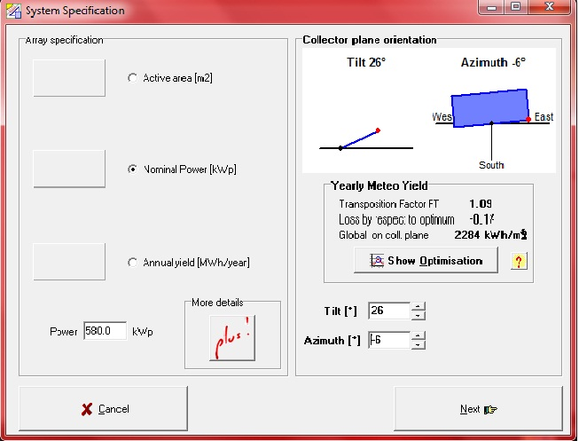

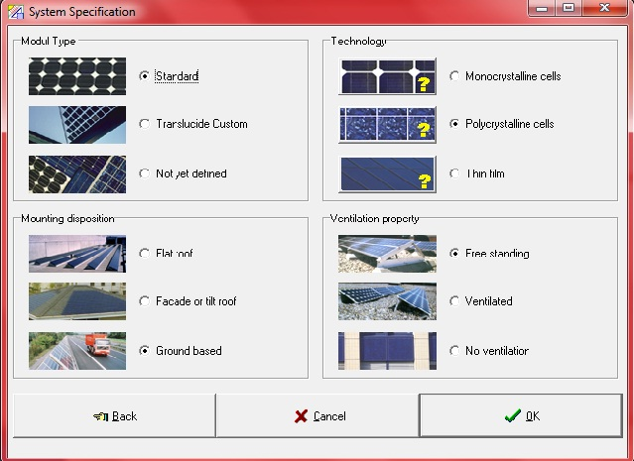
Figure 36: Syetem specifications in PV system .

The Results :
After entering all necessery numbers and data and identify options, the program give us the results as shown in the below curves and tables :

The below curves shown the Irradiation per month:
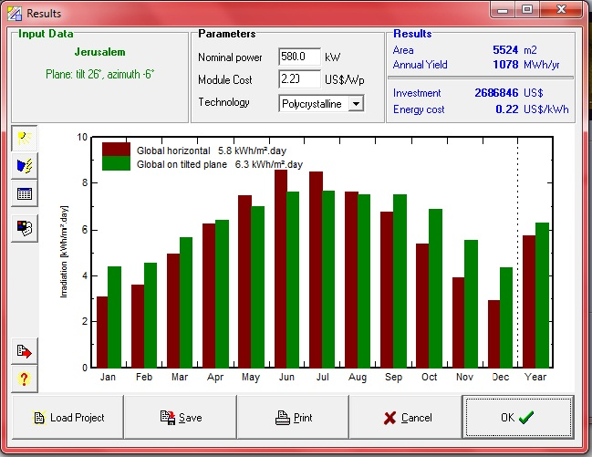
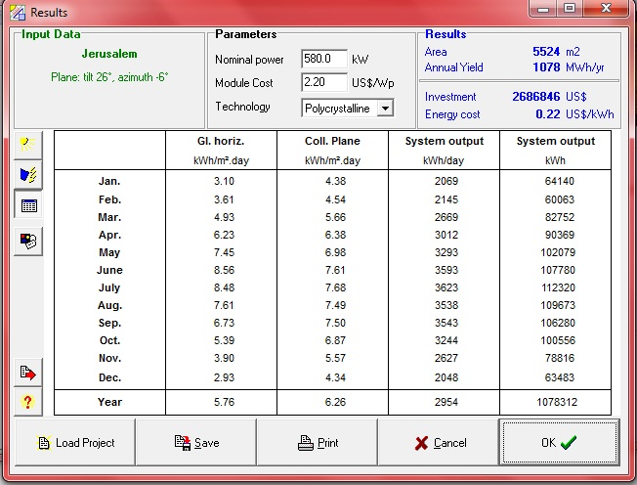
Figure 37: Irradiation per month by PV system .

The below curve show us the System output energy for each month :
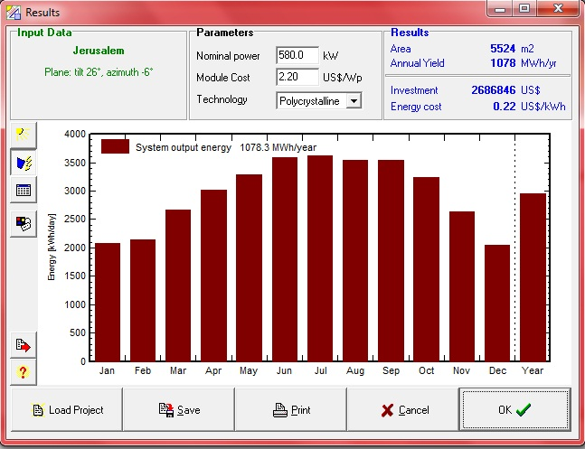
Figure 38: System output energy for each month by PV system .

9.3.2 Calculations For the Fixed Cost of the investment by PV system:

PV system program can calculate the fixed cost of the investment in dollar ($), by entering the price per watt in dollar($), and it can calculate how we will be pay in each year with interest, and determine the period of this project by entering the period and the intreset rate. And it can determine the total cost energy .
- The estimation for the life span of this project is eaqual to 20 years, and the cost for each watt is equal to 2.2 $/watt.

The Results :

The table below show us the fixed investment for this project :
Module cost | 1276000 $
Support cost | 519594 $
Inverter and Wiring | 454645 $
Transport/Mounting | 439259 $
Total investment | 2689497 $
Table 65: Fixed investment for the Solar system project by PV system .

And we made a comprasion between two interest rate (5% ,10%), as we see in the below table:
Intreset Rate | 5% | 10%
Annuities | 215812 $/year | 315907 $/year
Maintenance cost | 23427 $/year | 23427 $/year
Total yearly cost | 239239 $/year | 339334 $/year
Energy cost | 0.22 $/kwh | 0.31 $/kwh
Table 66: Comprasion between two interest rate (5% ,10%).

The pictures below shows thede redults by the PV system program :
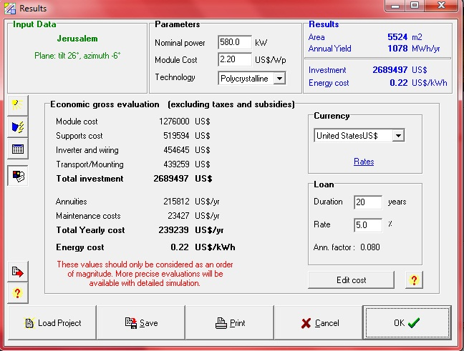
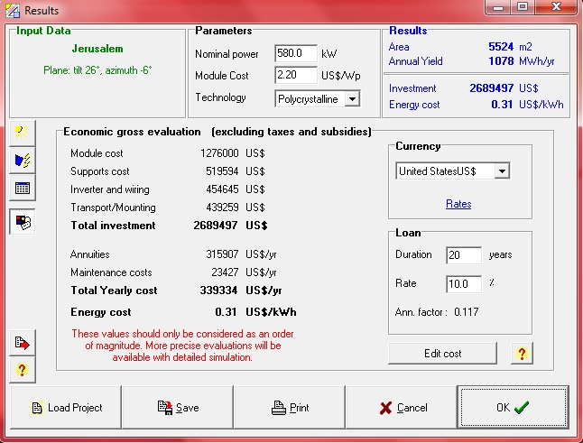
Figure 39: Calculations For the Fixed Cost of the investment by PV system.

9.4 The Design of the solar station system by using Power One (Aurora):

By using the Aurura program in this project, we designed the solar system =580KW ,and we distributed it into 10 groups each group egual to 55KW.
How to deal with the Aurora program ?
- Choosing the Assumption as you see in the below picture

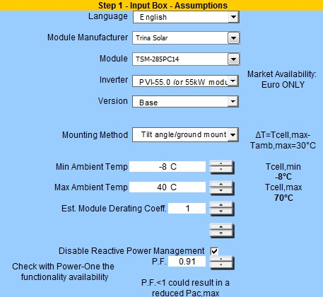
Figure 40: Choosing the assumption in the Aurora program.
- In this design that we work on it, we try to achieve the optimum design (the module in serise to achieve the voltage of the inverter , and the parllel string to achieve the power of the inverter , and the oversize of the inverter that we choosen is between (95%-110%)).
* The number of the module in series =17 module.
* The parllel string =12.
The next figuer shown how to enter the serier module and parallel string in the Aurora program:
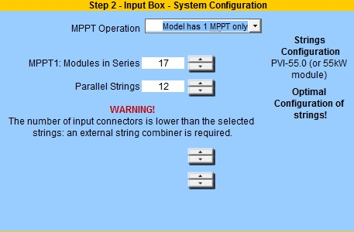
Figure 41: Entering the serier module and parallel string in the Aurora program .

The Results :
- System configuration:
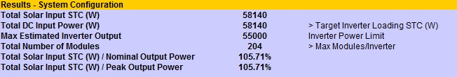
Figure 42: System configuration.

- Inverter Specifications:
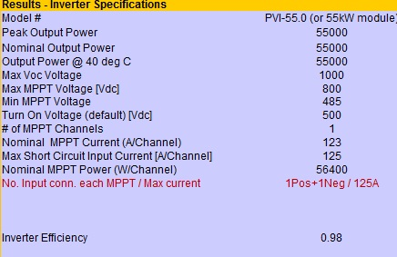
Figure 43: Inverter Specifications.

- PV Module Data:
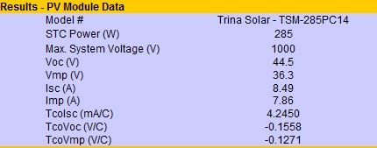
Figure 44: PV Module Data

- Array Sizing Parameters:
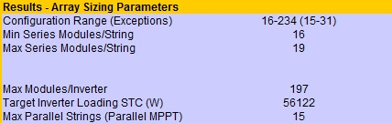
Figure 45: Array Sizing Parameters.
- Voltage and Current Parameter Check:
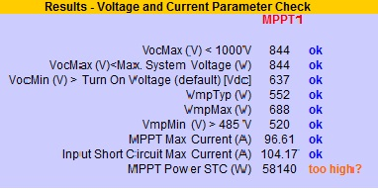
Figure 46: Voltage and Current Parameter Check.

*But when the parllel string is equal to (11), the new results are shown in the below tables ( and this is more acciptable ):
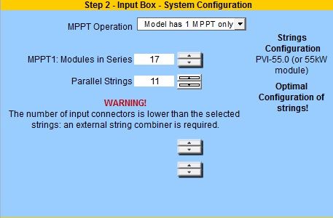

The Results :
- New System configuration:
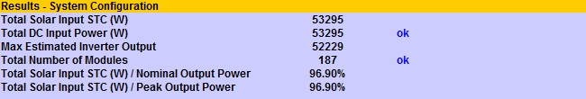
Figure 47: New System configuration when paralle string = 11.

- New Voltage and Current Parameter Check:
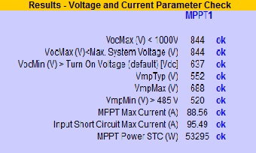
Figure 48: New Voltage and Current Parameter Check when paralle string = 11.

9.5 The Economical Study For The Solar Station Project :

9.5.1 Calculations to determine the Rating of the step up Transformer:

After all the design of the Solar Station Project, we want to connect the solar station to a step up transformer to connect the station with the network.

In this project we distributed the inverter into 10 inverters and the maximum power for each inverter is equal to 55 KW.
The maximum power for all inverters is equal to 550 KW
The rating of the step up transformer can be calculated by these formulas below :
$S_{Tr} ≥1.1 × S_{\max{ for inverter}}$.
$$P_{Tr} ≥1.1 ×550 KW$$
$$P_{Tr}=605 KW$$
$$Then { S}_{Tr}=630 KVA$$

9.5.2 Economical Study for the Solar system Project:
* The life span period of the solar system = 20 years.
* The price of 1kwh of solar = 0.65 NIC.
* The price of transformer = 30000 NIC.
* The price of each watt =2.2 $ =7.7 NIC. The price of 1 kw =2200$=7700 NIC.
* The average of 1kw produce 1700 kwh/year.
The investment = Price of the transformer + Price of the solar system (580kw)
The investment = 30000 + (580*7700) = 4496000 NIC.
- The average producing of the solar system in year = 1700 * 580 = 986000 kwh
- The saving in the year = 986000 kwh * 0.65 NIC = 640900 NIC/ year.

The simple pay back period = investment / saving in year
S.P.B.P = 4496000 / 640900 = 7 YEARS.

Chapter 10:

Sag & Tension In Overhead Lines

10.1 Sag In Overhead Lines:

10.1.1 Introduction:

While erecting an overhead line, it is very important that conductors are under safe tension. If the conductors are too much stretched between supports in a bid to save conductor material, the stress in the conductor may reach unsafe value and in certain cases the conductor may break due to excessive tension. In order to permit safe tension in the conductors, they are not fully stretched but are allowed to have a dip or sag.

The difference in level between points of supports and the lowest point on the conductor is called sag.

The figure below shows a conductor suspended between two equal level supports A and B. The conductor is not fully stretched but is allowed to have a dip. The lowest point on the conductor is O and the sag is S. The following points may be noted :

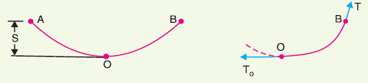
Figure 49: Conductor suspended between two equal level supports.
- When the conductor is suspended between two supports at the same level, it takes the shape of centenary. However, if the sag is very small compared with the span, then sag-span curve is like a parabola.

- The tension at any point on the conductor acts tangentially. Thus tension TO at the lowest point O acts horizontally as shown in the last figure .

- The horizontal component of tension is constant throughout the length of the wire.

- The tension at supports is approximately equal to the horizontal tension acting at any point on the wire. Thus if T is the tension at the support B, then T = To.
- Conductor sag and tension. This is an important consideration in the mechanical design of overhead lines. The conductor sag should be kept to a minimum in order to reduce the conductor material required and to avoid extra pole height for sufficient clearance above ground level. It is also desirable that tension in the conductor should be low to avoid the mechanical failure of conductor and to permit the use of less strong supports. However, low conductor tension and minimum sag are not
- possible. It is because low sag means a tight wire and high tension, whereas a low tension means a loose wire and increased sag. Therefore, in actual practice, a compromise in made between the two.

10.1.2 Calculation Of Sag:

In an overhead line, the sag should be so adjusted that tension in the conductors is within safe limits. The tension is governed by conductor weight, effects of wind, ice loading and temperature variations. It is a standard practice to keep conductor tension less than 50% of its ultimate tensile strength i.e., minimum factor of safety in respect of conductor tension should be 2.

Consider a conductor between two equal level supports A and B with O as the lowest point as shown in the below figure. It can be proved that lowest point will be at the mid-span.

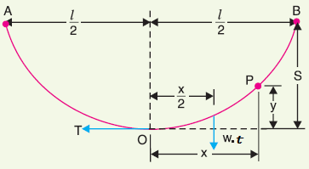
Figure 50: Conductor between two equal level supports.
Let
l = Length of span
$w_{t}$ = total weight per unit length of conductor
T = Tension in the conductor.

The maximum dip (sag) :

$$Sag \left(S\right)= \frac{W_{t} ×{( \frac{l}{2} )}^{2}}{2 ×T}= \frac{W_{t} × l^{2}}{8 ×T}$$

In actual practice, a conductor may have ice coating and simultaneously subjected to wind pressure. The weight of ice acts vertically downwards i.e., in the same direction as the weight of conductor. The force due to the wind is assumed to act horizontally i.e., at right angle to the projected surface of the conductor. Hence, the total force on the conductor is the vector sum of horizontal and vertical forces as shown in the below figure :

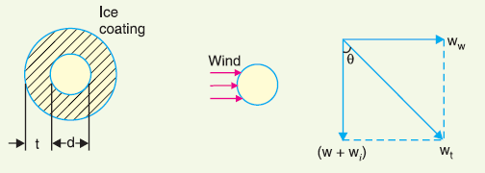
Figure 51: Effect of ice and wind on the overhead line.
So, the total weight of conductor per unit length is

$$W_{t}=\sqrt{{(W+ W_{i} )}^{2}+{( W_{w} )}^{2}}$$

Where

W = weight of conductor per unit length
$W_{i}=$weight of ice per unit length

$W_{w}=$ wind force per unit length

10.2 Problem of the Sag in Overhead Lines in the Network:

The problem lies in the poor and an error in the estimation of the amount of sag when designing and extension for overhead lines in some areas, where the amount of sag was not enough, and in the last winter, a large amount of snow and low degrees of temperature led to a contraction in the tensile strength of the cables and because of the inadequacy of sag, this led to cut in the cable and destruction of some of the towers as shown in the below picture:

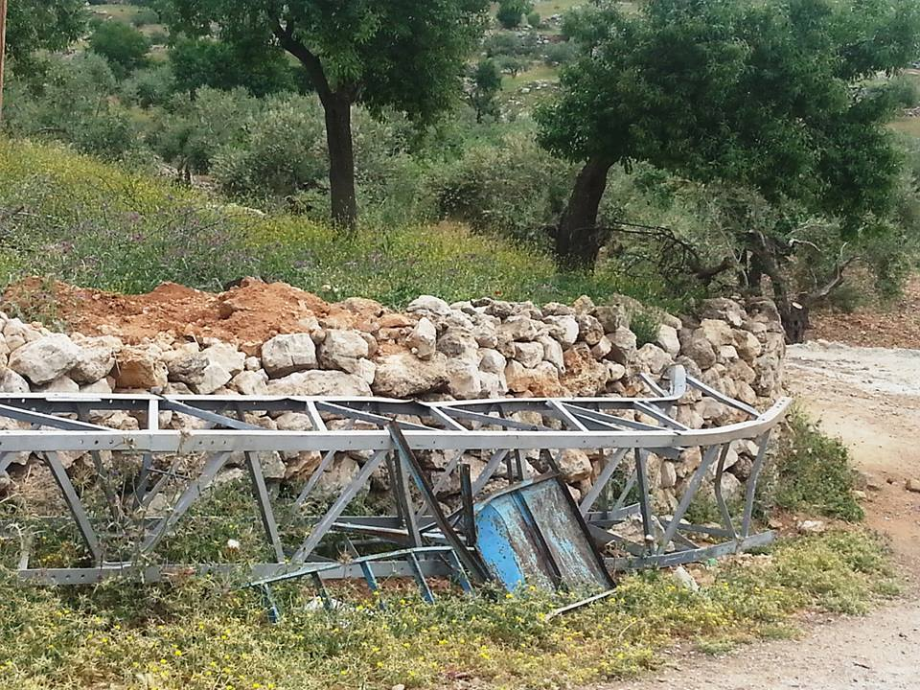
Figure 52: A picture of one of the towers destroyed.

10.3 Solutions and Recommendations for Sag problem:

To avoid the occurrence of the problem that has been raised previously, there is a mathematical relationship whereby estimate and calculate the amount of sag in correct form:
$$Sag \left(S\right)= \frac{W_{t} ×{( \frac{l}{2} )}^{2}}{2 ×T}= \frac{W_{t} × l^{2}}{8 ×T}$$

This gives the freedom of cable stretch in the summer and contraction in the winter without affecting on the cable and without leads to a cut in it.

References :

- Aqraba Municipality.
- http://www02.abb.com/global/huabb/huabb008.nsf/0/c86d99b5c2a7deb1c1257a2c0043e92d/$file/clmd_kondenz%C3%A1torok.pdf
- http://re.jrc.ec.europa.eu/pvgis/apps4/pvest.php?map
- ROHIT MEHTA (2008) . Principles Of Power System . $4^{th} edition$ . Chapter 8 ( page 159 ) .

