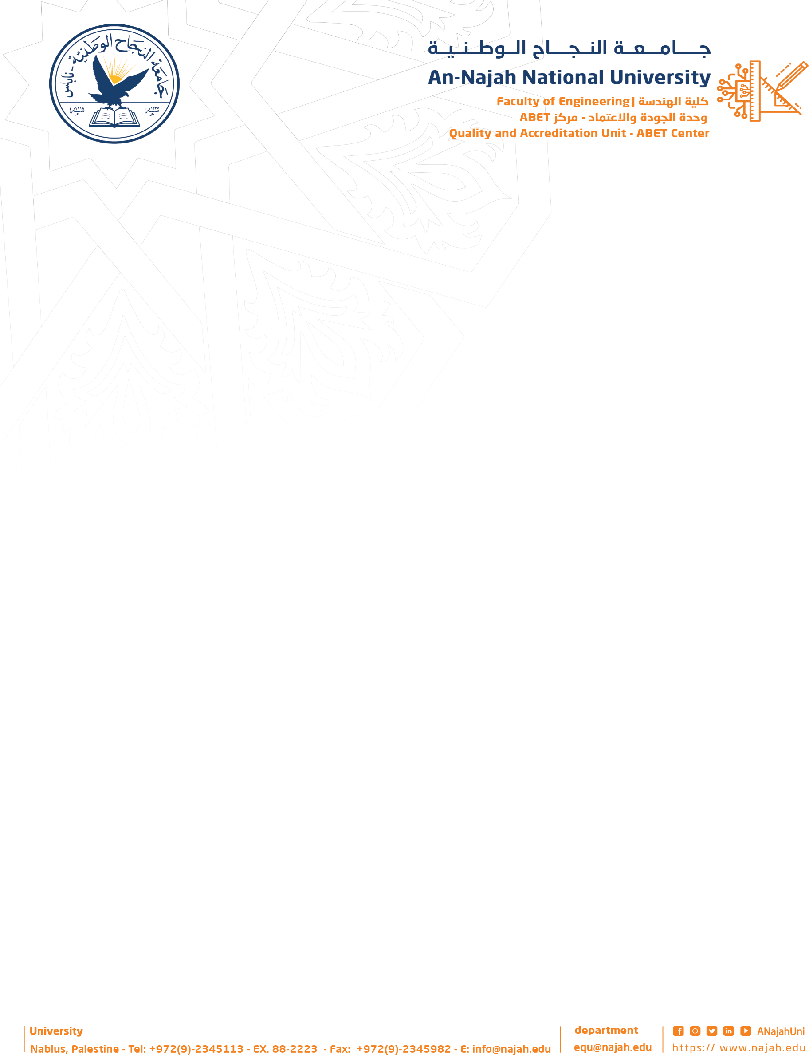



An-Najah National University

Faculty of Engineering and Information Technology Computer Engineering Department
Graduation Project 1

HopeBridge

Prepared By :
Wafa Namroti & Lama Hag

Supervisor :
Luai Malhis & Emad Natsheh

2025

Abstract:
This project aims to empower people with disabilities by providing an inclusive digital platform that connects them with essential services, job opportunities, and accessibility-friendly locations. It promotes independence and social inclusion through the integration of modern technologies, accessibility design, and artificial intelligence. The platform will feature an AI-based sign language translation system to facilitate real-time communication between
deaf users and the community, along with interactive maps displaying accessible universities, restaurants, public facilities, and transport stations. It will also offer access to nearby
rehabilitation, educational, and medical centers, supported by user reviews and updated information. Furthermore, the system will include social networking features that allow people with disabilities to share their stories, inspire others, and build supportive
communities. Organizations and volunteers will be able to post events, training programs, and employment opportunities tailored to users’ needs and abilities. AI-driven personalized recommendations will suggest relevant activities, jobs, and services based on each user’s profile. Overall, the project seeks to create a comprehensive and inclusive digital ecosystem that enhances communication, accessibility, and empowerment for people with disabilities
while supporting families, caregivers, and the wider community.

