

An-Najah National University

FACULTY OF ENGINEERING AND INFORMATION TECHNOLOGY
Computer Engineering Department

Hardware Graduation Project

FlexiMover

Students: Supervisor:
Shareef Nader Salahat Dr.Hanal AbuZant
Momen Anan Ramadan

Septemper,7, 2024

Disclaimer

This report was authored by students Shareef Salahat and Momen Ramadan from the Computer Engineering Department at An-Najah National University. While every effort has been made to ensure accuracy, there may be grammatical and content errors. An-Najah National University holds no responsibility for any inaccuracies present in this report. Additionally, the university is not liable for any unintended use of this report for purposes other than its original intent.

Acknowledgement

To our Computer Engineering Department Doctors we say thank you so much for all the great work each of you have done in the computer engineering department Your wisdom, knowledge and dedication have all contributed to our academic journey.
A special thanks to our supervisor Dr. Muhannad Jabi Your dedication to our project, your guidance and constant encouragement have been amazing. Your guidance has not only helped us academic life but also pushed us to be the best in everything we do.
To those who helped us without asking for anything in return we say thank you for being with us all the way. The collaboration, encouragement and shared enthusiasm from all of you have added to the fun and the sense of achievement.
Finally, but not least we thank you all our parents. Their trust, support, encouragement, patience and faith in us have given us the strength and courage to complete our academic journey.
This project is a team work and we are thankful to all who contributed to it. Thank you for being part of our academic and personal life.

Table of Contents
Acknowledgement 3
Abstract 6
Introduction 7
➢ Problem Statement 7
➢ Objectives 8
➢ Significance of The Work 9
➢ Constraints and earlier work 10
Literature review 12
Methodology 13
➢ Overview 13
➢ Robot design 13
➢ Hardware Components 14
▪ ESP 32 14
▪ Nema-17 stepper motor 14
▪ A4988 stepper driver 15
▪ DIV-268N stepper driver 15
▪ Buck converter 16
▪ LDR 16
▪ White led 17
▪ Mpu6050 17
▪ Push buttons 18
▪ Esp32-cam 18
▪ gripper 19
▪ Servo motor 19
▪ wheels 20
▪ Lithium batteries 20
➢ Circuits diagram 21
➢ Communication diagram 21
➢ Software part 22
➢ code explanation 29
➢ Final design 30
Future Work 31
Conclusions 33
References 34

Table of Figures
Figure 1 3d design 7
Figure 2 ESP32 8
Figure 3 nema 17 9
Figure 4 A4988 9
Figure 5 div268n 10
Figure 6 buck converter 10
Figure 7 LDR 11
Figure 8 white led 11
Figure 9 mpu 6050 12
Figure 10 push button 12
Figure 11 esp32 cam 13
Figure 12 gripper 13
Figure 13 servo motor 14
Figure 14 wheels 14
Figure 15 Lithium batteries 15
Figure 16 basic circuit diagram 15
Figure 17 communication protocol 16

Abstract
The project introduces a robotic system designed to improve automation and efficiency in logistics and warehousing environments. The system consists of a robot with a mechanical arm controlled by a user-operated glove, allowing precise and intuitive object manipulation. The robot uses advanced sensors and actuators to mimic human movements, reducing the learning curve and enhancing remote manipulation capabilities, The system has potential applications in streamlined warehouse operations, cargo handling efficiency, and safer working conditions.

Introduction

Problem Statement
The hassle statement for the "FlexiMover" project highlights the challenges faced in environments wherein human intervention is both unstable or impractical. These environments can consist of catastrophe web sites, poorly lit areas, or business settings. The want for a remotely operated machine is emphasised, as it would allow for safe exploration, object retrieval, and real-time monitoring with out requiring the operator to be bodily gift. Existing robot solutions often lack intuitive manipulate mechanisms for unique manipulation of items, or they fail to provide effective actual-time feedback, specially in low-visibility situations.

The assignment addresses these demanding situations by means of developing a teleoperated robot with a glove-based totally manage system for an articulated robotic arm. This device allows the operator to intuitively manage gadgets. Additionally, the robot is equipped with a digicam and LDR sensor, allowing navigation in dark environments whilst providing actual-time video comments via a web page. By combining superior mobility, particular manage, and sensor integration, the task targets to create a dependable and flexible robotic device appropriate for remote operations in hazardous areas, enhancing each safety and efficiency.

Objectives

- Make a Robot with All Directions Movement: Formulate and set up a robotic that may flow in all the directions allowing it to navigate complex and confined space efficiently.
- Create a Robotic Arm Controlled by Glove: Come up with a hand in the form (two fingers) and which has been enhanced with technology which enables controlled movement of the robotic arm thus allowing the user to reach and manipulate some items from a distance.
- Embed Light Sensor for Low-Visibility Operations: Affix the robot with a low/moderate sensor for detection and modeling in low to moderately windy environments ensuring normal operation in dark areas.
- Install Camera for Real Time Video Broadcast: Use a digital imaging merchandise that wirelessly transmits video feeds in real time to web page.

- test the solution in an operational environment: deploy this robot into dark areas, hazardous environments to further assess its performance and finally optimize it for various use cases.

Significance of The Work

- Enhanced Safety for Operators: By allowing far-fetched motion of the robot through a glove-based interface and real-time video tracking, this mission reduces the need for human presence in hazardous or inaccessible areas thus minimizing danger of injury or exposure to dangerous circumstances.

- Improved Control and Dexterity: The glove-controlled robotic arm offers an intuitive and unique method for controlling objects from a distance, which is more flexible and controllable compared to conventional joystick or keyboard inputs. Such precision is particularly important in jobs that require delicate handling like removing fragile or hazardous materials.
- Adaptability in Low-Light Environments: The robot can thus be utilized effectively in dark or poorly lit spaces by virtue of its built-in light sensor and camera system, making it relevant to many fields where visibility is limited such as when there are collapsed structures or underground tunnels.

Constraints and earlier work

The development of the FlexiMover robotic is situation to several technical and operational constraints, which have to be taken into consideration all through its layout and implementation:

- Communication Latency: One of the primary constraints in teleoperated structures is the capability for conversation delays between the manipulate glove,. High latency can effect the responsiveness of the robot, making it difficult to carry out precise responsibilities in real-time.

- Battery Life: As a cell, remote-controlled robot, battery life is a extensive constraint. The energy required to operate the robotic’s automobiles, sensors, digicam, and communique systems can restrict its operational time. Ensuring enough battery potential whilst preserving a light-weight layout is a important mission.

- Range of Wireless Communication: The robot’s effective variety is confined through the wi-fi verbal exchange device. In environments with boundaries, sign interference, or long distances, the range can be reduced, probably interrupting the robot’s control and statistics transmission.

- Environmental Conditions: Harsh environmental conditions, such as extreme temperatures, dirt, moisture, or difficult terrain, could affect the robot's performance. Ensuring the robotic's additives are long lasting and capable of functioning in diverse conditions is crucial for its reliability in actual-world applications.

- The security and political situation of the country : the conditions of the invasions carried out by the occupation, which the cities of the country are going through, have affected delaying the arrival of the required parts and delaying our work and waiting for them

- Cost and Resource Limitations: Like many engineering initiatives, the design and development of FlexiMover are constrained The cost of additives, sensors, actuators, and substances ought to be balanced in opposition to the want for reliability, capability, and protection.

Literature review

1. Teleoperated Robotics:A evaluation of earlier work in teleoperated structures that permit customers to manipulate robots remotely, emphasizing packages in risky or tough-to-attain environments. This might consist of current solutions for robotic hands, cell robots, and telepresence structures.
2. Control Systems: A look at distinctive manipulate mechanisms used in comparable robot systems, which include glove-based manage, joystick-primarily based control, and others. It might additionally discover the precision and intuitiveness of different manipulate structures, specifically in business or catastrophe-response contexts.
3. Sensor Integration: An analysis of numerous sensors, along with cameras and ldr sensor, used in robotics for navigation and item manipulation. This phase could probably delve into the position of sensors like LDR (Light Dependent Resistors) and cameras in low-light environments, in addition to their significance in improving the robot's capability.
4. Challenges in Remote Operations: This part would possibly cover the challenges in actual-time manage and comments systems, specifically within the context of conversation latency, battery life, and wireless range. It should assessment existing solutions or techniques to address these problems.
5.Robotics in Hazardous Environments: Literature discussing the software of robotics in catastrophe comfort, commercial inspections, and other dangerous environments, focusing on how teleoperation can enhance protection and efficiency.

Methodology

Overview
First, we took bunch of time thinking and designing the robot design, robot body, required hardware components, possible problems and how we could solve it so the next sections will show the procedure step by step.

Robot design
We need a light material, strong, cheap, and can satisfy with our requirements
So, we decide to 3d printing the robot body, using google SketchUp as software for designing robot body.
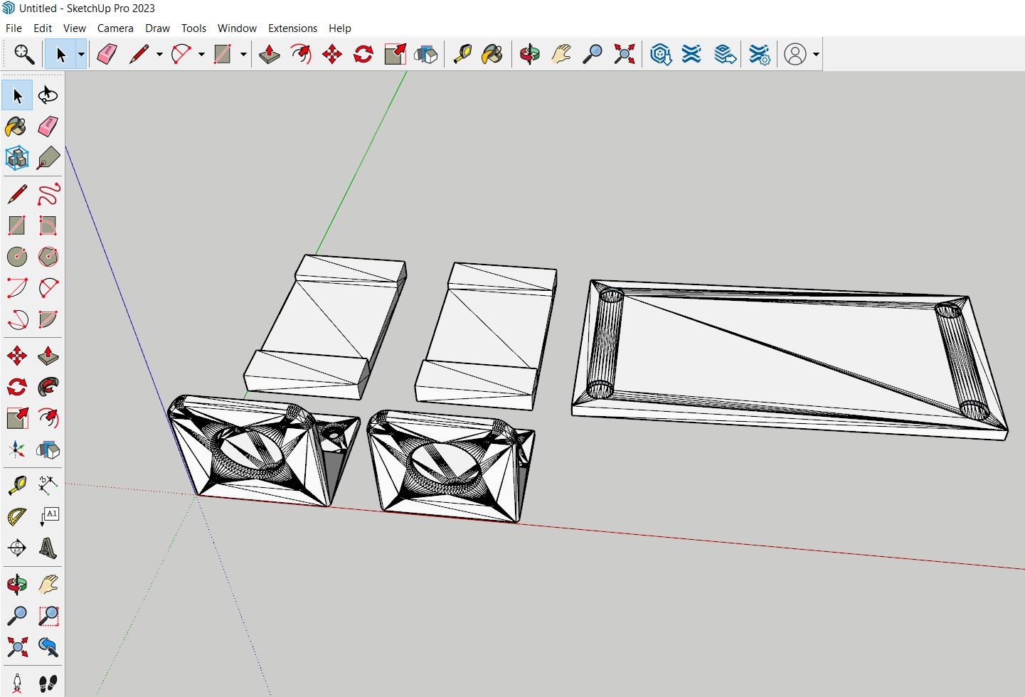
Figure 1 3d design

Hardware Components

ESP 32
- The ESP32 is a low-cost, low-power system on a chip (SoC) with integrated Wi-Fi and Bluetooth capabilities. It’s widely used in Internet of Things (IoT) projects, home automation, and embedded systems. The ESP32 comes with a dual-core processor, plenty of GPIO pins, analog-to-digital converters, pulse-width modulation, and interfaces for peripherals like I2C, SPI, and UART.
- We need two pieces one for glove and the other for controlling the robot
they will communicate through wireless using esp_now protocol which is a protocol used for peer-to-peer communication with high speed and good distance range.
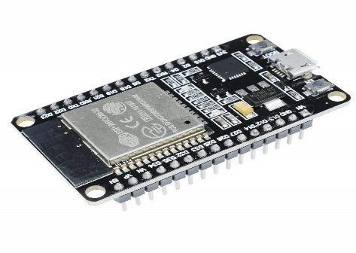
Figure 2 ESP32

Nema-17 stepper motor
- The NEMA 17 is a popular stepper motor that is commonly used in 3D printers, CNC machines, robotics, and other applications requiring precise motion control. The "17" in NEMA 17 refers to the motor's faceplate size, which is 1.7 inches (42mm x 42mm).
- We need two steppers(mini version) as wheels and one for robot arm.

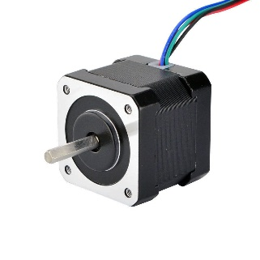
Figure 3 nema 17

A4988 stepper driver
- The A4988 is a micro stepping driver for controlling stepper motors, often used in DIY electronics projects, CNC machines, and 3D printers. It allows for precise control over stepper motors by supporting different step modes like full, half, quarter, eighth, and sixteenth stepping.
- We need two drivers to control wheels steppers.

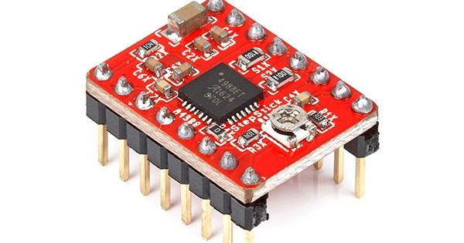
Figure 4 A4988

DIV-268N stepper driver
- The HY-DIV268N is a high-power stepper motor driver that supports up to 5A current and is often used for controlling larger stepper motors. It features adjustable micro stepping and current settings through DIP switches and accepts TTL-compatible input signals. It operates on a supply voltage between 12V and 48V, making it versatile for various applications, including CNC machines and robotics.
- We used it to control the arm stepper which requires high torque and about 2-3 amps.

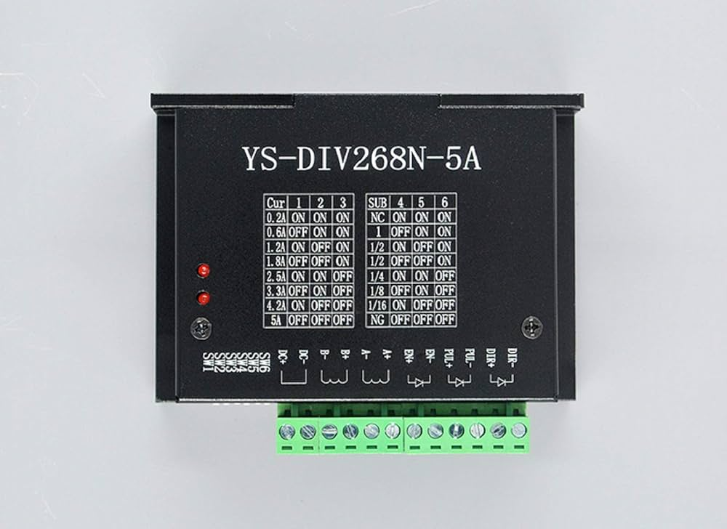
Figure 5 div268n

Buck converter
- A buck converter is a type of DC-DC power converter that steps down (reduces) the input voltage to a lower output voltage. It operates by switching an electronic component (like a transistor) on and off rapidly to control the energy transfer between the input and output.
- We used it to step down the input voltage to 5 volts for components like esp, or any component that requires 5 volt as input voltage.

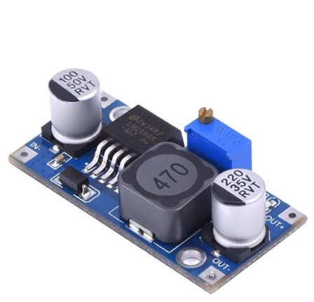
Figure 6 buck converter

LDR
- An LDR (Light Dependent Resistor) module is a sensor used to detect the presence and intensity of light. An LDR, also called a photoresistor, changes its resistance based on the amount of light falling on it. In darkness, the LDR has high resistance, and in bright light, its resistance decreases.
- We used it to detect if the robot in low light conditions then triggers white leds to increase light level this helpful in narrow places especially when the human cannot see the robot they control it using camera and glove.

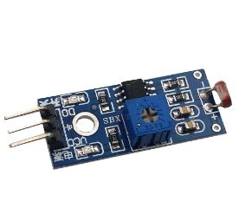
Figure 7 LDR

White led
- A white LED (Light Emitting Diode) light is a semiconductor device that emits white light when an electric current passes through it. Unlike incandescent or fluorescent lights, LEDs are energy-efficient, durable, and long-lasting.
- We used it to when ldr sense low light condition then we trigger them to increase light level.

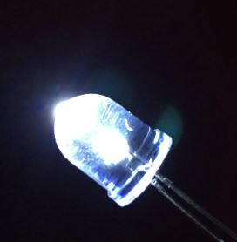
Figure 8 white led

Mpu6050
- The MPU-6050 is a widely used 6-axis Motion Tracking device that integrates a 3-axis accelerometer and a 3-axis gyroscope into a single chip. It is commonly used in applications requiring motion sensing, such as drones, robots, and mobile devices. The device is capable of capturing accelerations in three axes (X, Y, Z) and rotational rates (angular velocity) around the same three axes.
- We used it in the glove area to detect the direction of rebot movement (forward, backward, left, right).

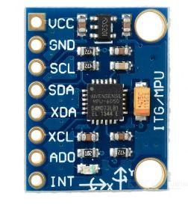
Figure 9 mpu 6050

Push buttons
- A push button is a simple, mechanical switch used to control a circuit. When pressed, it temporarily makes or breaks a connection, allowing current to flow or be interrupted.
- We used it in glove area to control robot arm.

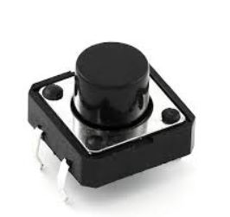
Figure 10 push button

Esp32-cam
- The ESP32-CAM is a powerful, low-cost development board that integrates an ESP32 microcontroller and a camera module, making it ideal for IoT (Internet of Things) and surveillance projects. The board allows you to capture images, stream video, and even perform basic computer vision tasks using the onboard processing power of the ESP32.
- We used it to stream robot view especially in hidden places or narrow areas where human cannot reach it.

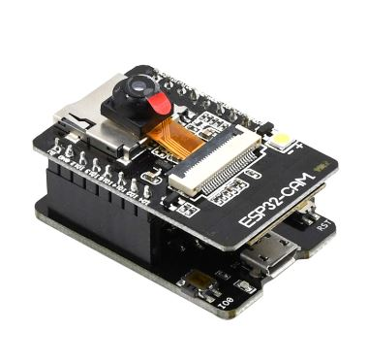
Figure 11 esp32 cam

gripper
- A gripper is a mechanical part used to grasp, hold, and manipulate objects, typically used in robotic arms or automation systems.
- We used it to catch and move things from a place to place.

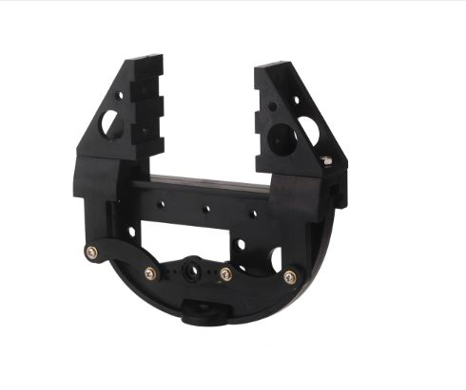
Figure 12 gripper

Servo motor
- A servo motor is a rotary actuator that provides precise control of angular position, velocity, and acceleration. It is commonly used in robotics, automation, and control systems where precision is key, such as in robotic arms.
- We used it to control gripper (open, close).

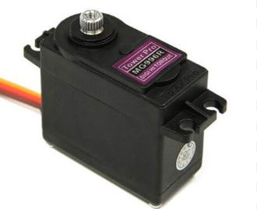
Figure 13 servo motor

wheels
- Robot wheels are a key component in mobile robotics, allowing a robot to move and navigate its environment.
- We used it with steppers for robot movements.

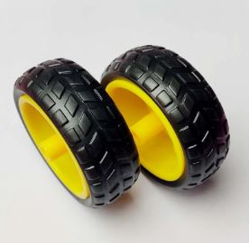
Figure 14 wheels

Lithium batteries
- For power

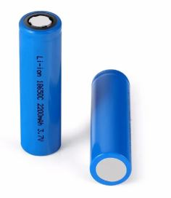
Figure 15 Lithium batteries

Circuits diagram

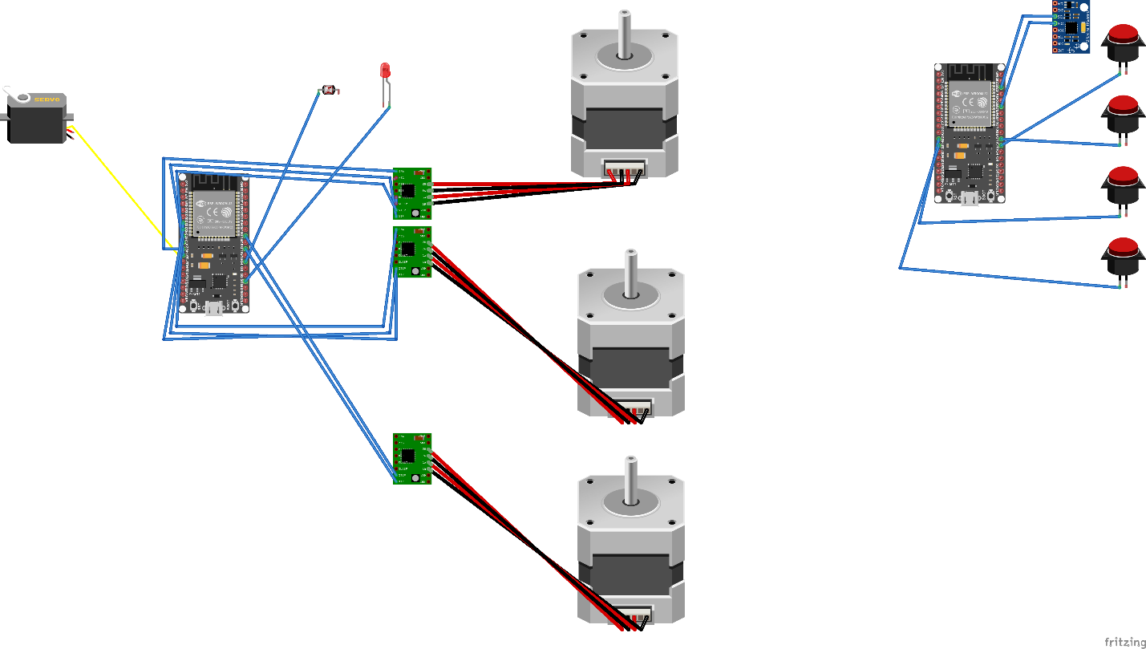
Figure 16 basic circuit diagram

Communication diagram
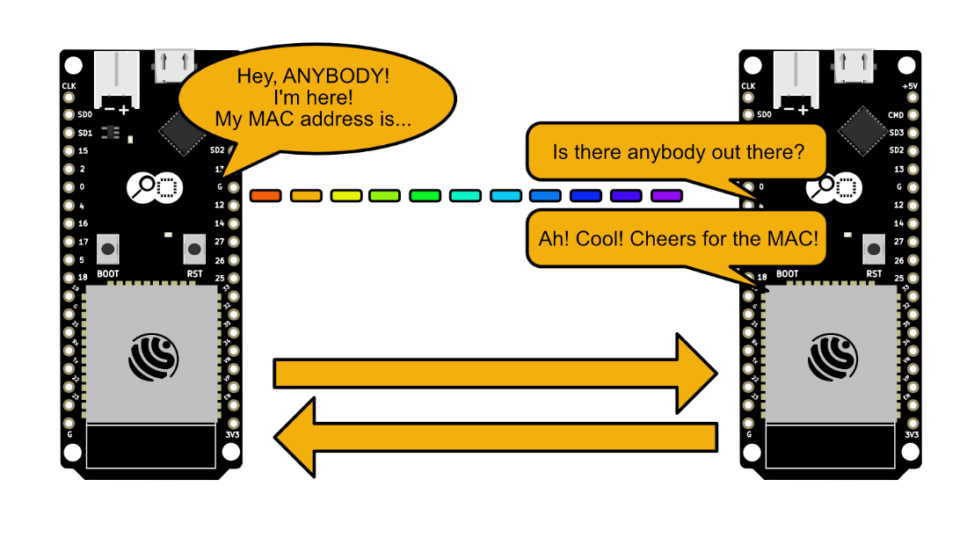
Figure 17 communication protocol

Software part
- robot code
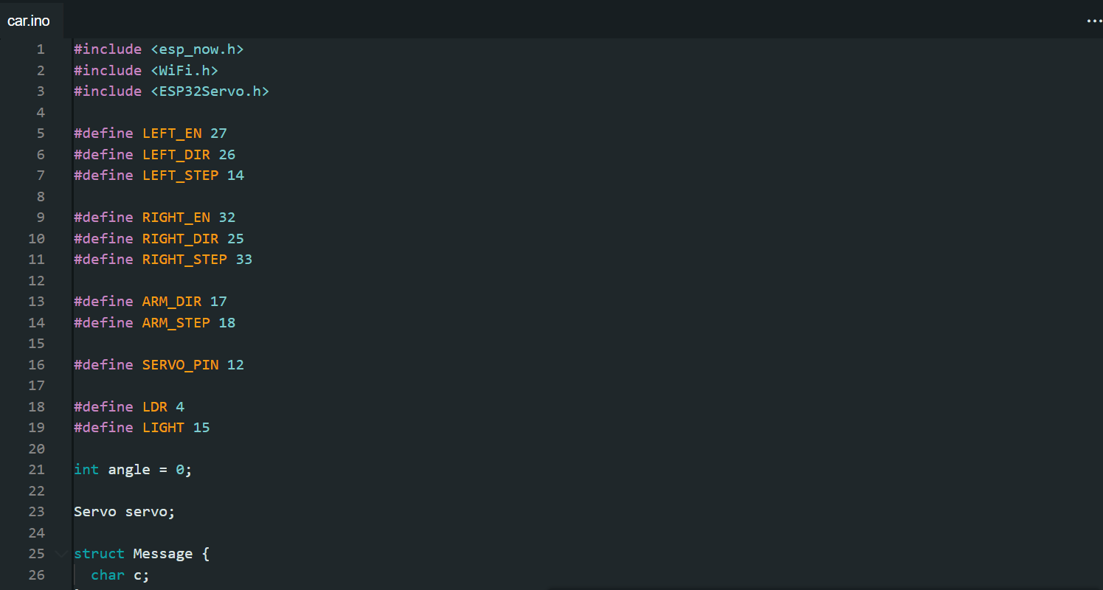

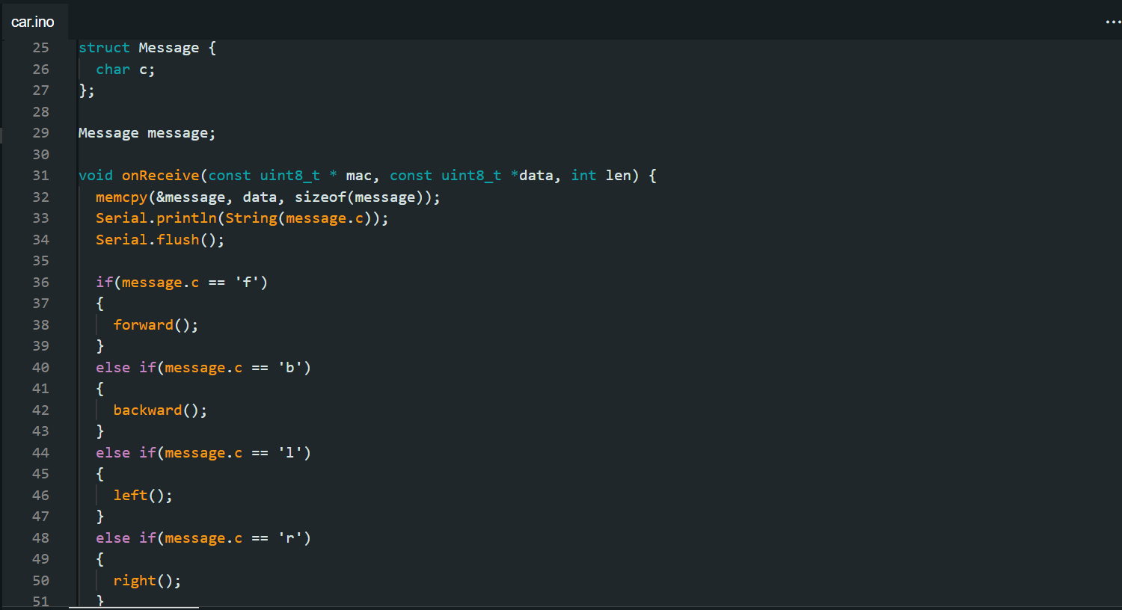

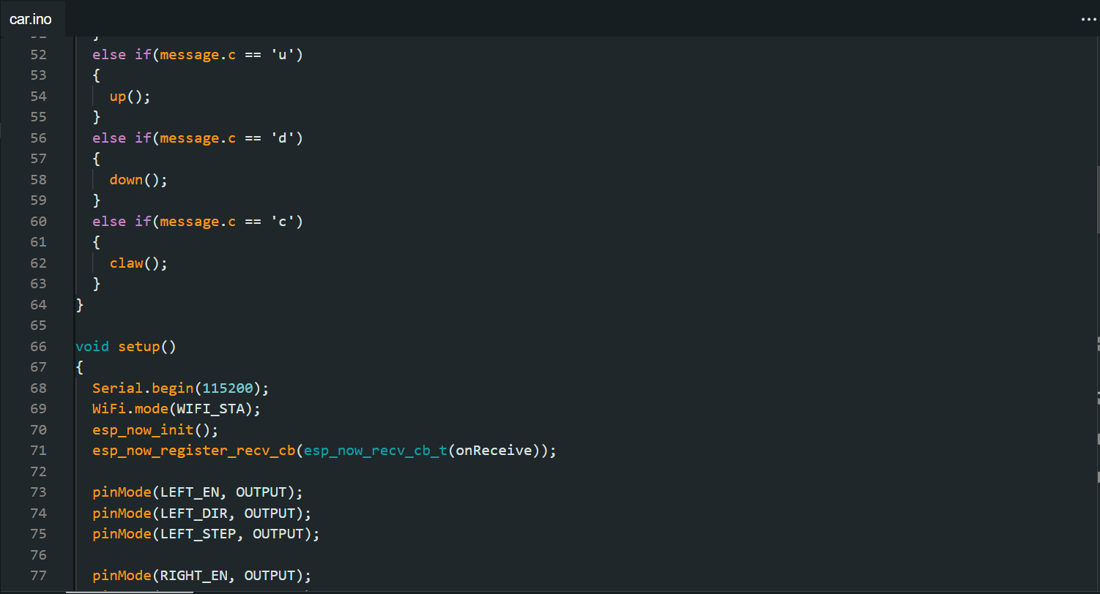
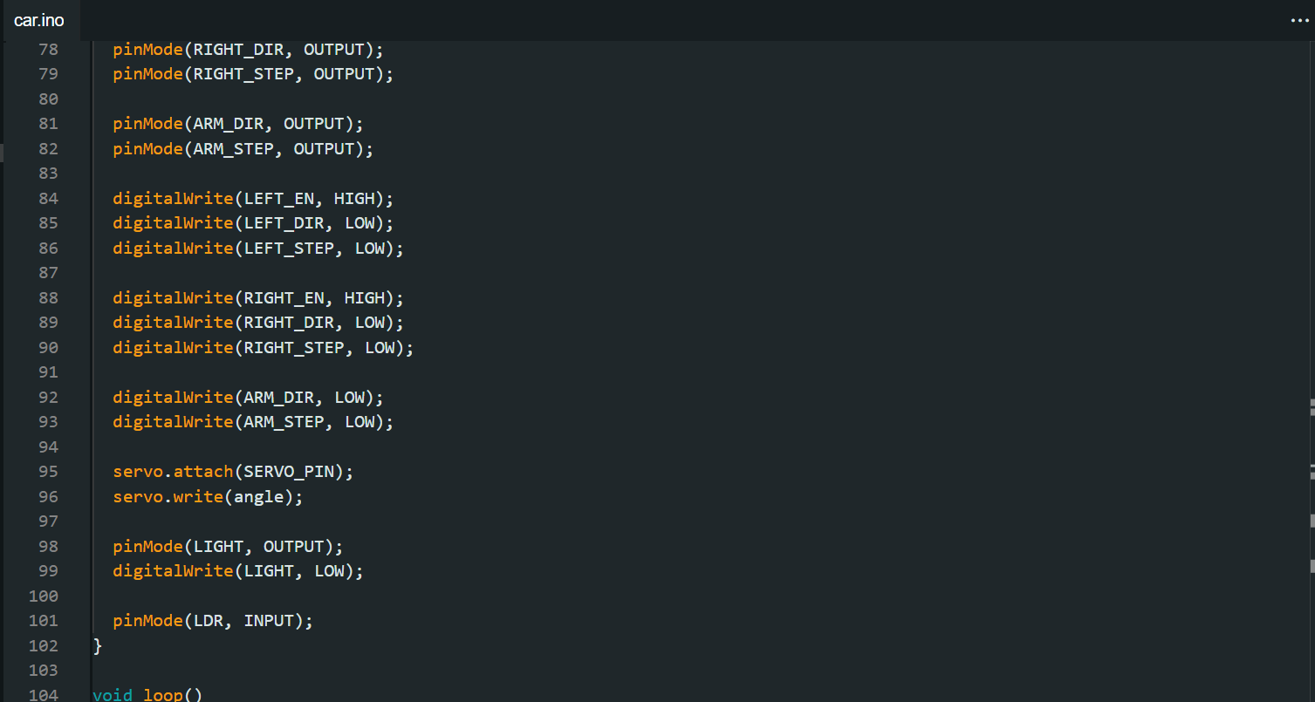

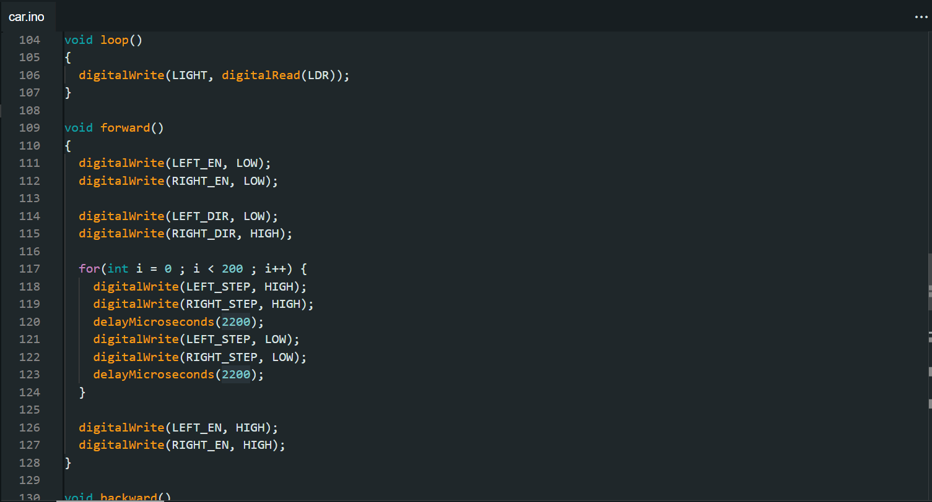
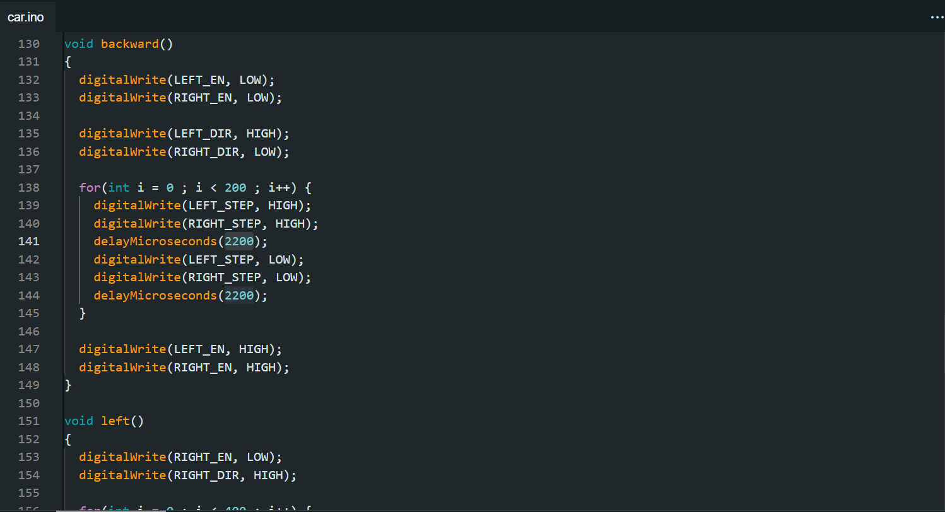

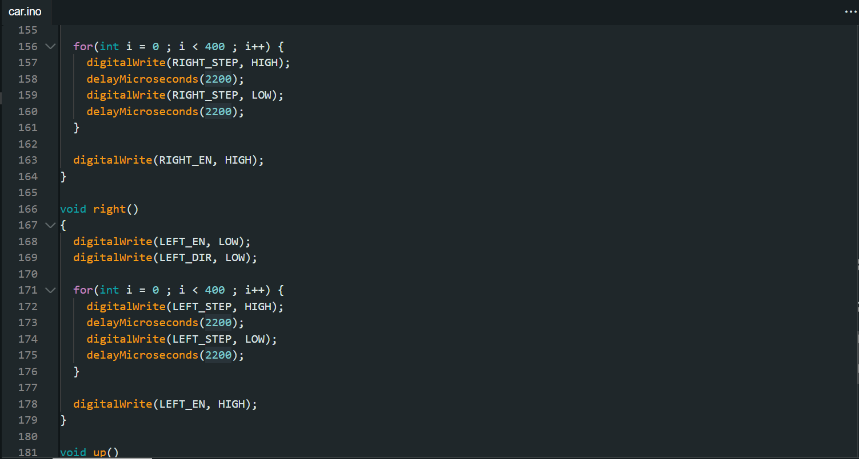
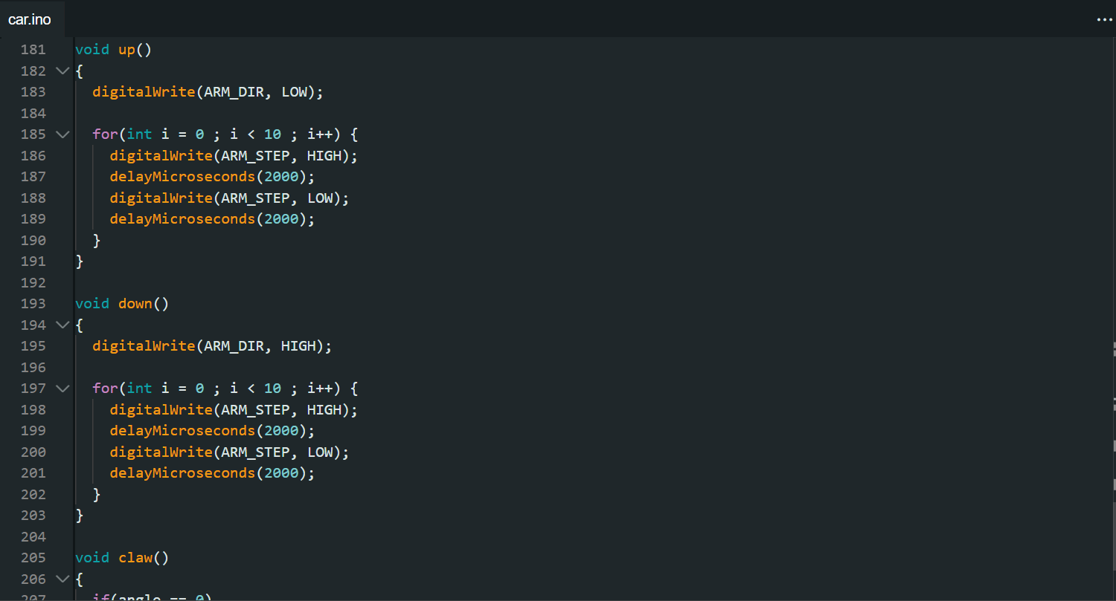

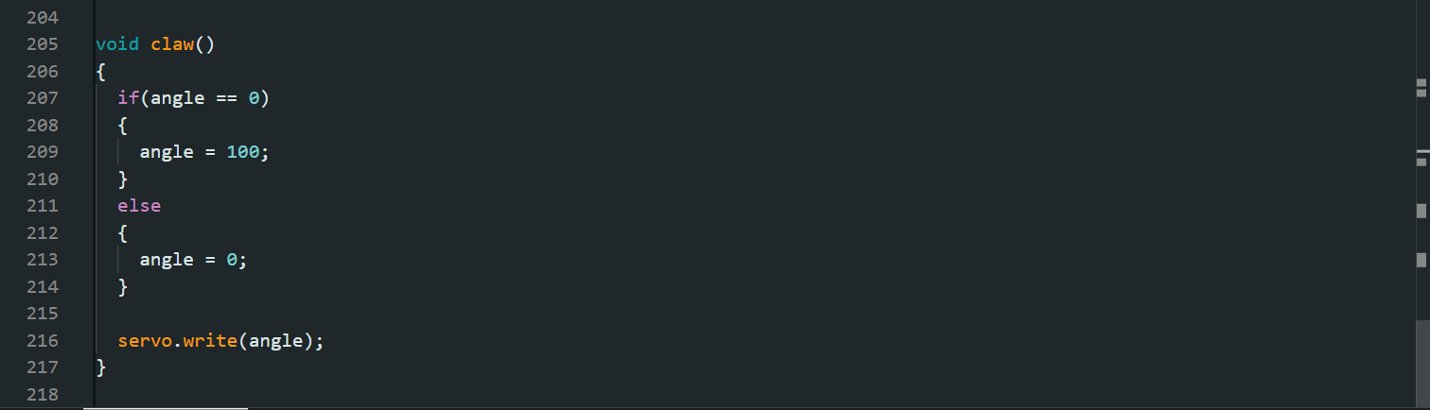
- glove code
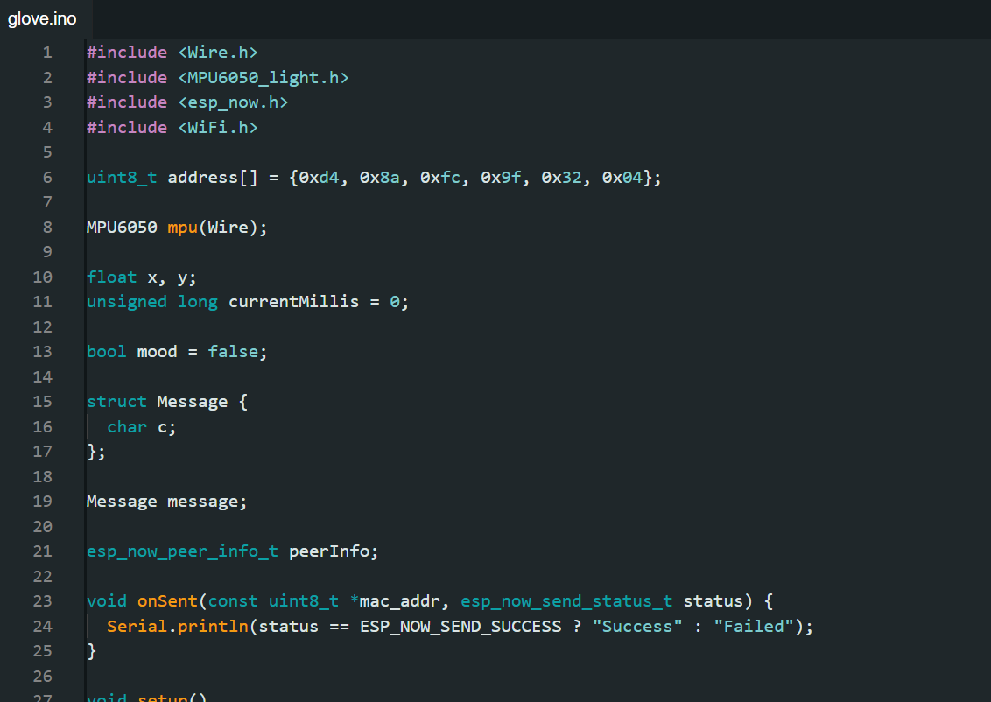
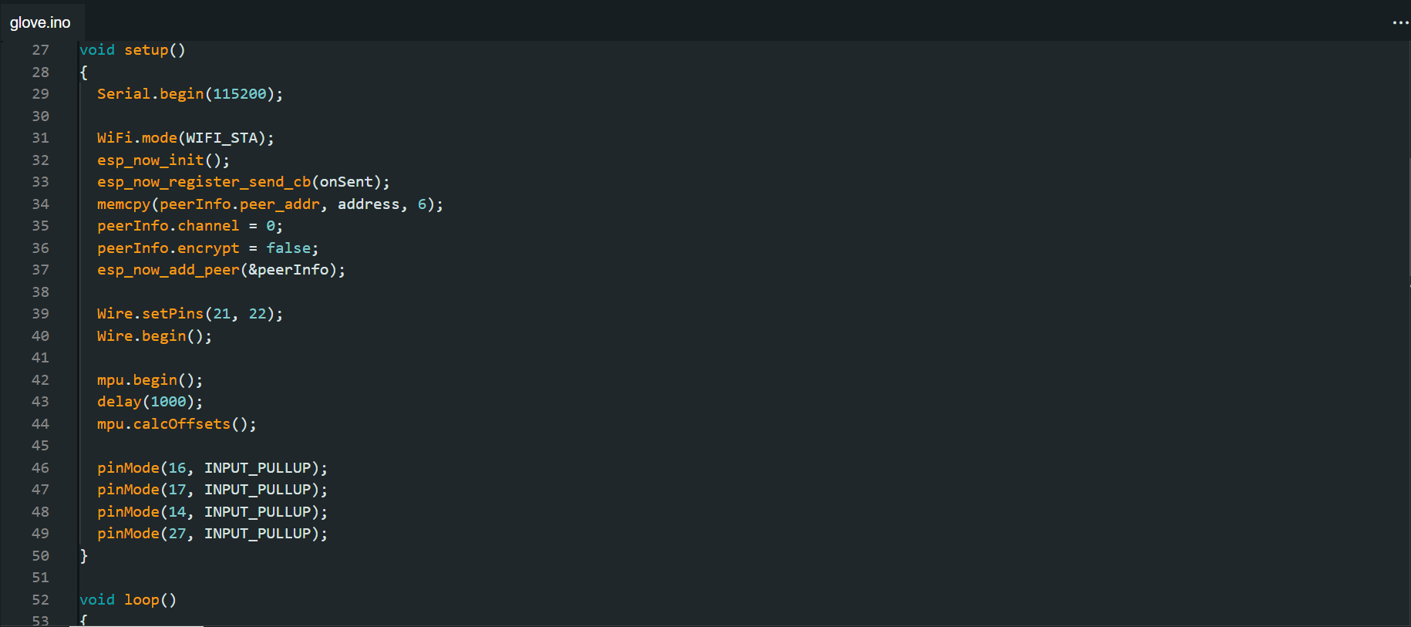

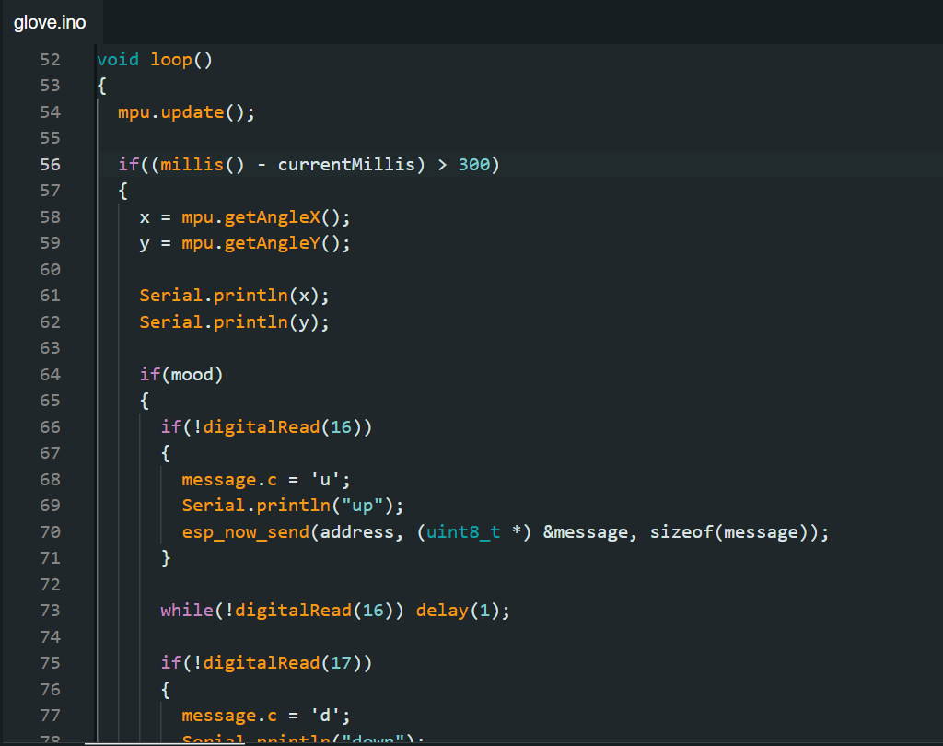
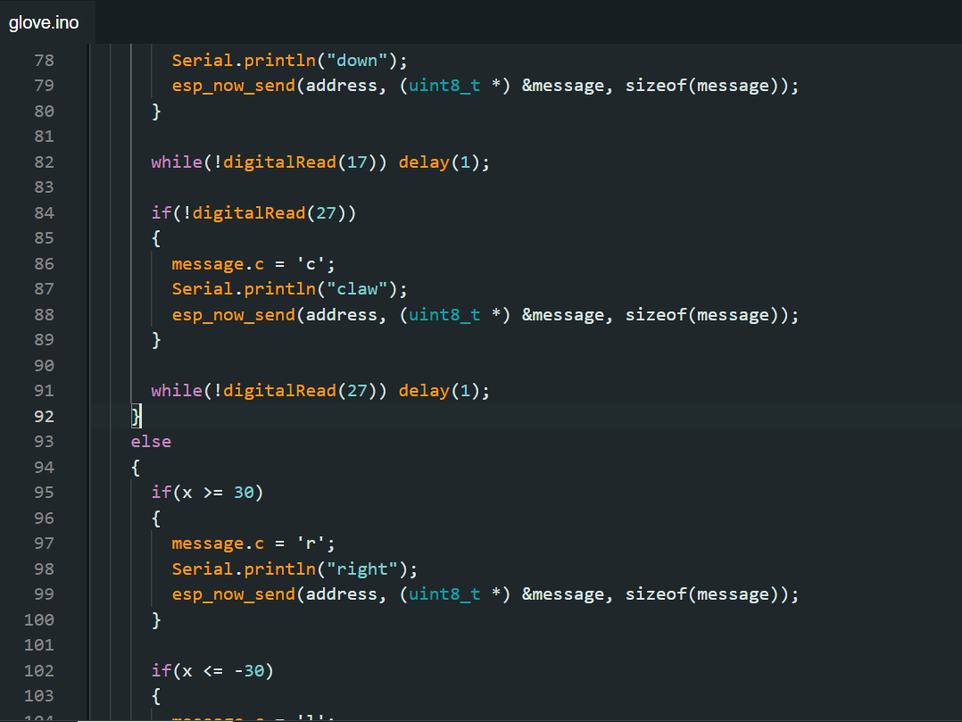
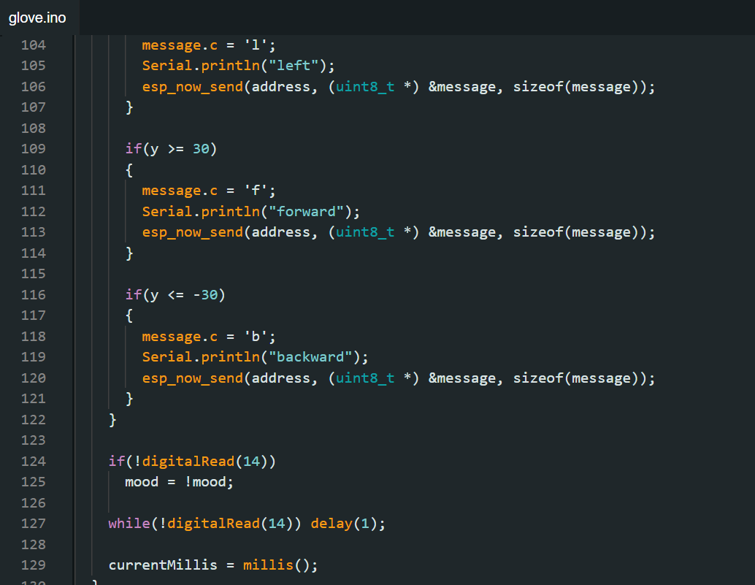

code explanation
- The project consists of a glove-controlled robotic system that uses two ESP32 microcontrollers communicating via the ESP-NOW protocol. The glove is equipped with an MPU6050 accelerometer and gyroscope, which measures the tilt angles and provides orientation data. This data, along with input from several push buttons, is used to send control commands to the robotic car. Specifically, the glove code processes the tilt angles to determine directional movements—such as right, left, forward, and backward—when the glove is tilted beyond a specified threshold. Button presses on the glove are mapped to additional commands for moving the robot's arm up, down, or operating a gripper. These commands are sent as character messages ('u', 'd', 'c', 'r', 'l', 'f', 'b').
- On the car side, the second ESP32 receives these messages and interprets them to control various actuators. It drives two stepper motors through A4988 drivers to control the robot’s movement. The car can move forward or backward and turn left or right based on the received commands. It also controls a stepper motor to move the robot's arm up or down and a servo motor to operate a gripper. Additionally, the car is equipped with a Light Dependent Resistor (LDR) and white LEDs. The LDR is used to detect ambient light levels, and the LEDs are turned on or off based on this light detection. Overall, this system enables the remote control of the robot with real-time feedback, combining sensor data, push button inputs, and motor control to achieve precise and responsive robotic actions.

Final design
- Glove

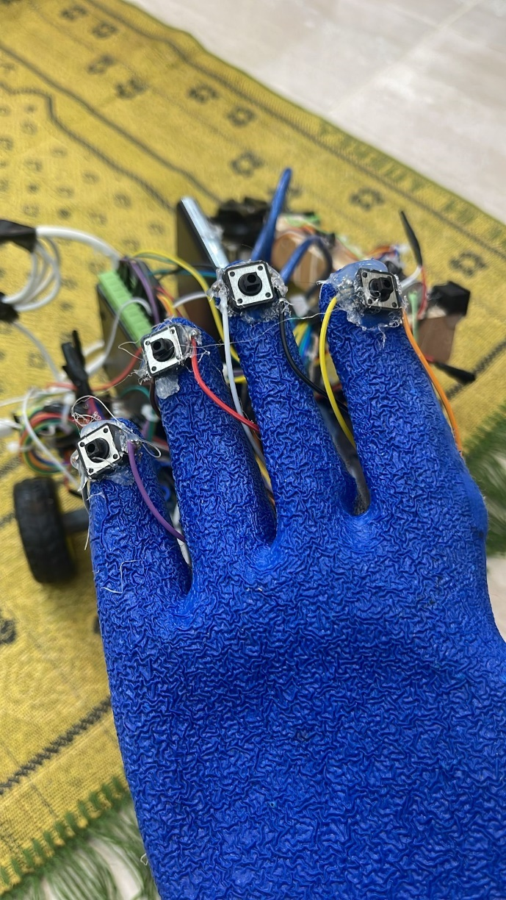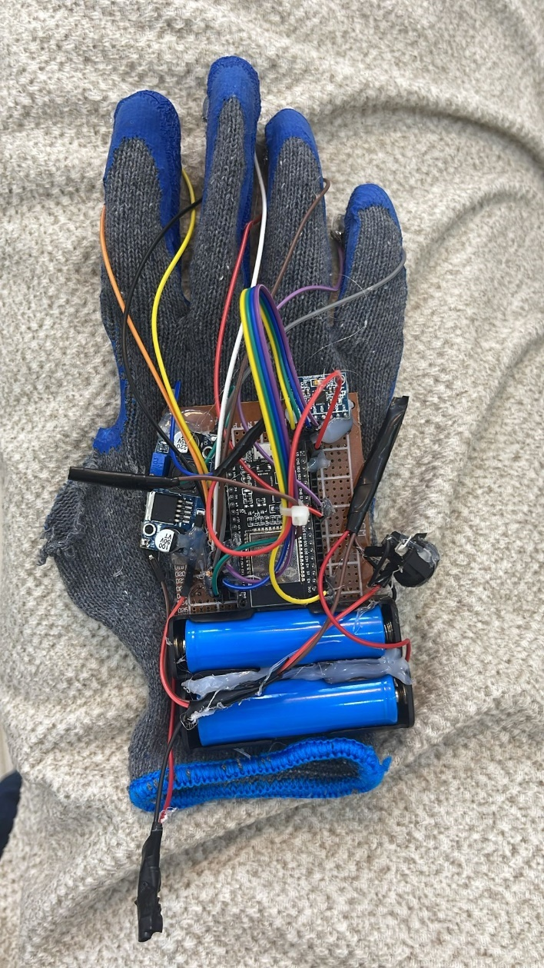

- Robot

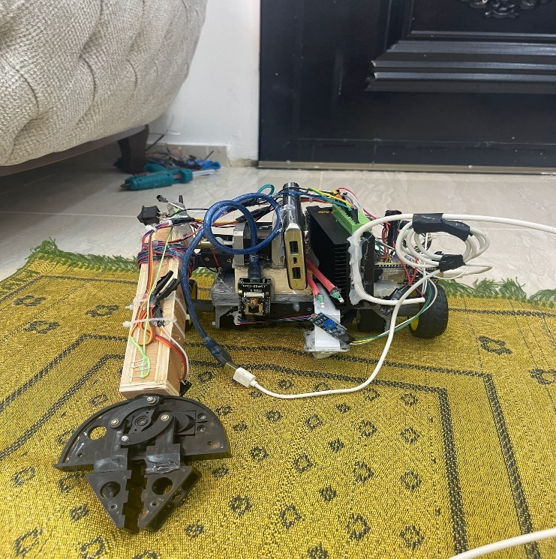
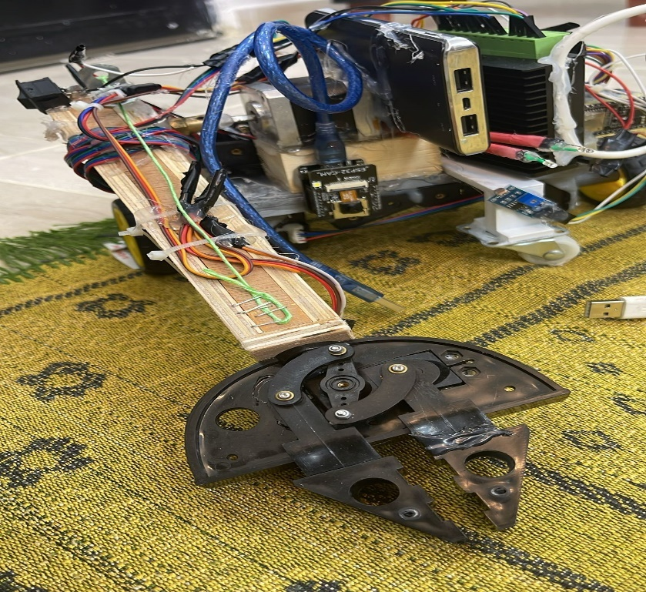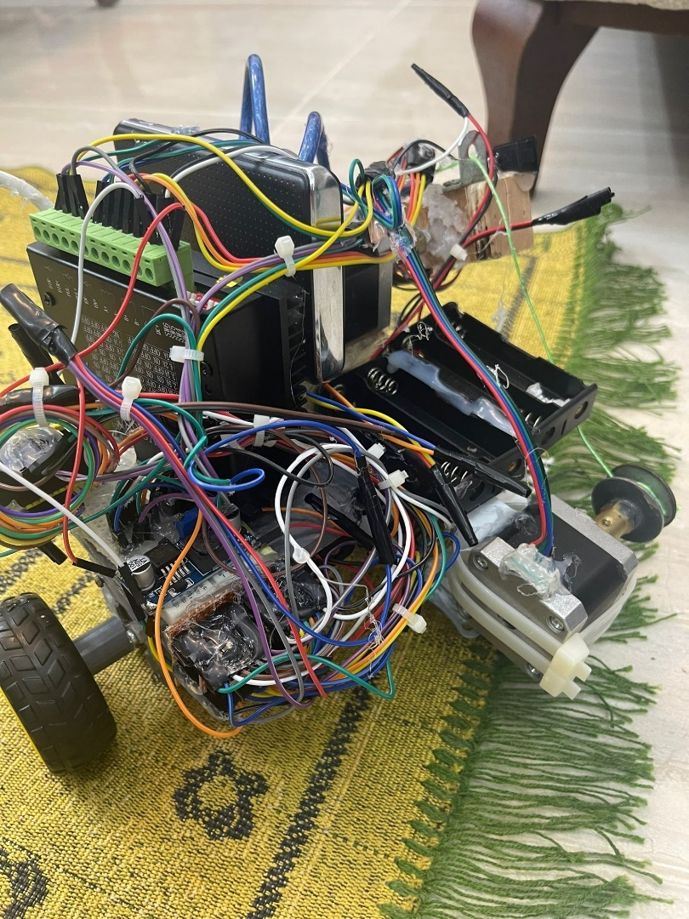

Future Work

- Future Work Integration of Advanced Sensors: Future iterations of the robot can gain from incorporating additional sensors which includes thermal cameras, ultrasonic sensors, and LiDAR systems.
- Advanced Hand Design: Explore the opportunity of a five-fingered hand design, en- hancing the robot arm`s herbal interaction with items and environments, mov- ing beyond the present day gripper layout.
- Improvement of Autonomous Capabilities: While the modern-day system relies heavily on teleoperation, future work should consciousness on enhancing the robotic`s self sufficient abilities.
- By integrating machine getting to know algorithms and advanced sensor fusion, the robotic can be programmed to perform particular responsibilities autonomously, consisting of navigating to a selected region, identifying gadgets, or warding off barriers, even in the absence of operator input.
- And greater compact layout should permit the robotic to get admission to confined spaces, which includes collapsed buildings or narrow pipelines, making it even extra flexible for seek and rescue missions or industrial inspections.
- Research into extra efficient energy management structures, which include power-green automobiles, sun charging options, or power regeneration via movement, may want to amplify the robot`s operational time appreciably.
- Future improvement may also encompass a person-pleasant interface for venture making plans, where operators can set predefined waypoints and obligations for the robotic to execute autonomously.Testing in Real-World Scenarios: Future work ought to consciousness on deploying the robot in real-international eventualities to check its effectiveness in various environments.

Conclusions

A teleoperated robot designed for usage in dangerous areas has been created by the FlexiMover project. It has a camera and light sensor for visual feedback in real time, as well as a glove-based interface for simple control of its mechanical arm. This qualifies it for jobs including disaster response, industrial inspections, and search and rescue. The project illustrates how sensor integration, real-time video streaming, and user-friendly controls can enhance teleoperation in spite of obstacles like communication delay and power management. The field of teleoperated robotic systems will gain from future advancements including AI-driven object recognition, autonomous capabilities, and Advanced Hand Design, which will enhance the robot's capabilities.

References

- https://docs.espressif.com/projects/esp-idf/en/stable/esp32/api-reference/network/esp_now.html

- https://docs.espressif.com/projects/esp-idf/en/stable/esp32/index.html

- https://www.pololu.com/file/0J450/a4988_DMOS_microstepping_driver_with_translator.pdf

- https://www.espressif.com/sites/default/files/documentation/esp32_datasheet_en.pdf

- https://www.arduino.cc/

