

AN-NAJAH NATIONAL UNIVERSITY
FACULITY OF ENGINEERING
COMPUTER ENGINEERING DEPARTMENT

Bluetooth Pedometer

Prepared By:
Ahmad S. Baker (10614007)
Ayman M. Melhem (10611892)
Supervisor:
Dr. Ala’a Almasri

2010 – 2011 Semester

The Contents:

1.0 Introduction.
1.0.1 Parts of the Project

2 .0 High Level Design

2.0.1 Logical structure

2.2 Controlling the car

2.3 The car

3.0 Hardware.
3.0.1 ADXL 335
3.0.2 PIC18F4620
3.0.3 Gold mate Bluetooth device
3.0.4 Mobile device
4.0 Our work
4.0.1 Step detection
4.0.2 Mobile java application
4.0.3 PCB designing
5.0 Problems
6.0 Conclusion

1.0 Introduction:
We have built a pedometer that helps walker or runner user to monitor his steps count, speed, distance and calories that he/she burned during the exercise. All mentioned parameters are viewed on mobile.
1.0.1 So this project consists of two Parts:
- The board that the user ties around his/her leg:
It contains the microcontroller (PIC18F4620), accelerometer ADXL335, and the Bluetooth device.
- Mobile to view the data that the user need.

2.0 High Level Design:

2.0.1 Logical structure:
Bluetooth device
PIC18F4620
Accelerometer

Mobile

Figure 2.1: Logical Structure for the project

3.0 Hardware:
- Accelerometer.
- Microcontroller (PIC18F4620).
- Bluetooth device.
- Mobile device.
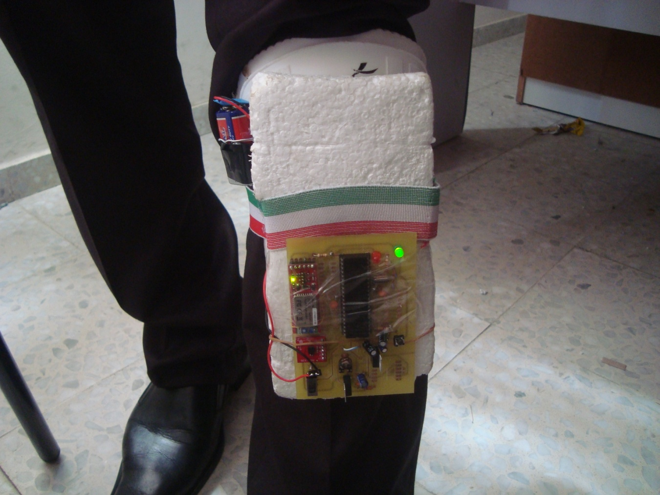
Figure 3.1: The board with its all components.

3.0.1 The accelerometer ADXL335
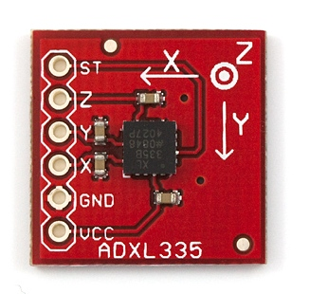
Figure 3.2: The accelerometer we used.

The accelerometer gives us three output values, in the three direction through which we can determine that a step is done or not.

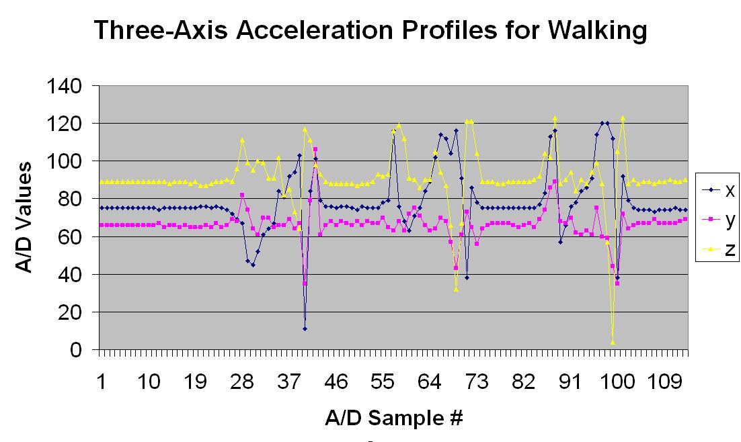
Figure 3.3: The outputs of the accelerometer

3.0.2 The microcontroller (PIC18F4620)
We use this microcontroller to deal with signals from the ADXL335 and pass it via Bluetooth to the mobile.

3.0.3 Bluetooth Gold Mate (RN-41):
The Bluetooth Mate Gold is designed specifically to be used with Arduino Pros and LilyPad Arduinos. These modems work as a serial (RX/TX) pipe, and are a great wireless replacement for serial cables. Any serial stream from 9600 to 115200bps can be passed seamlessly from your device to your target. We've tested these units successfully over open air at 350ft (106m)!
The Bluetooth Mate has on-board voltage regulators, so it can be powered from any 3.3 to 6VDC power supply. We've got level shifting all set up so the RX and TX pins on the remote unit are 3-6VDC tolerant.

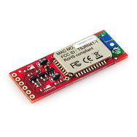
Figure 3.4 The Gold mate Bluetooth
3.0.4 Mobile device
The mobile device must support the java, and it must contain Bluetooth modem. Java to run the software that we build to show us the received data, and Bluetooth modem to deal with data received from the pedometer.

4.0 Our work
4.0.1 Step detection
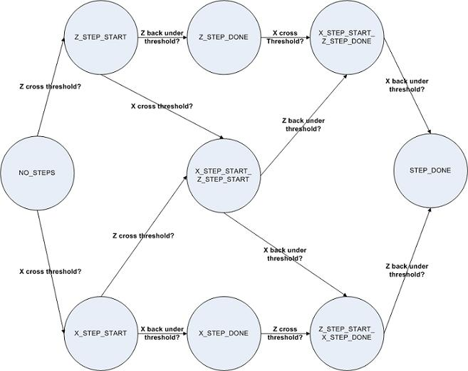

Figure 4.1 Step detection state diagram

4.0.2 Mobile java application:
We wrote a mobile java application that deals with the data received from the board.

4.0.3 Designing the PCB
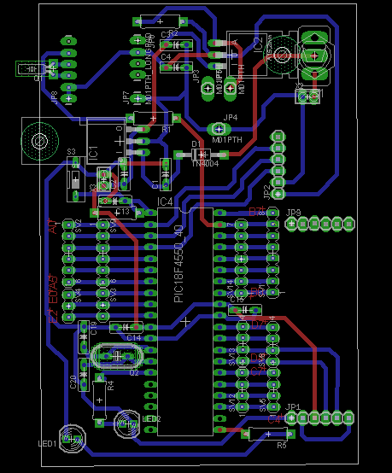
Figure 4.2: The printed circuit board
5.0 Problems:
- Devices availability in market
- Dealing with new software (for us it is new) eagle cad.
- The accelerometer threshold determination.
- Bluetooth device configuration

6.0 Conclusion:
The project was an excellent experience to us,we face many problems and challenges, and we can overcome all of those problems.
Really it add a lot of information to our scientific knowledge. also we expressed our selves.
We hope that the Computer section team are satisfied by the project and benefits us of problems solving and debugging.

