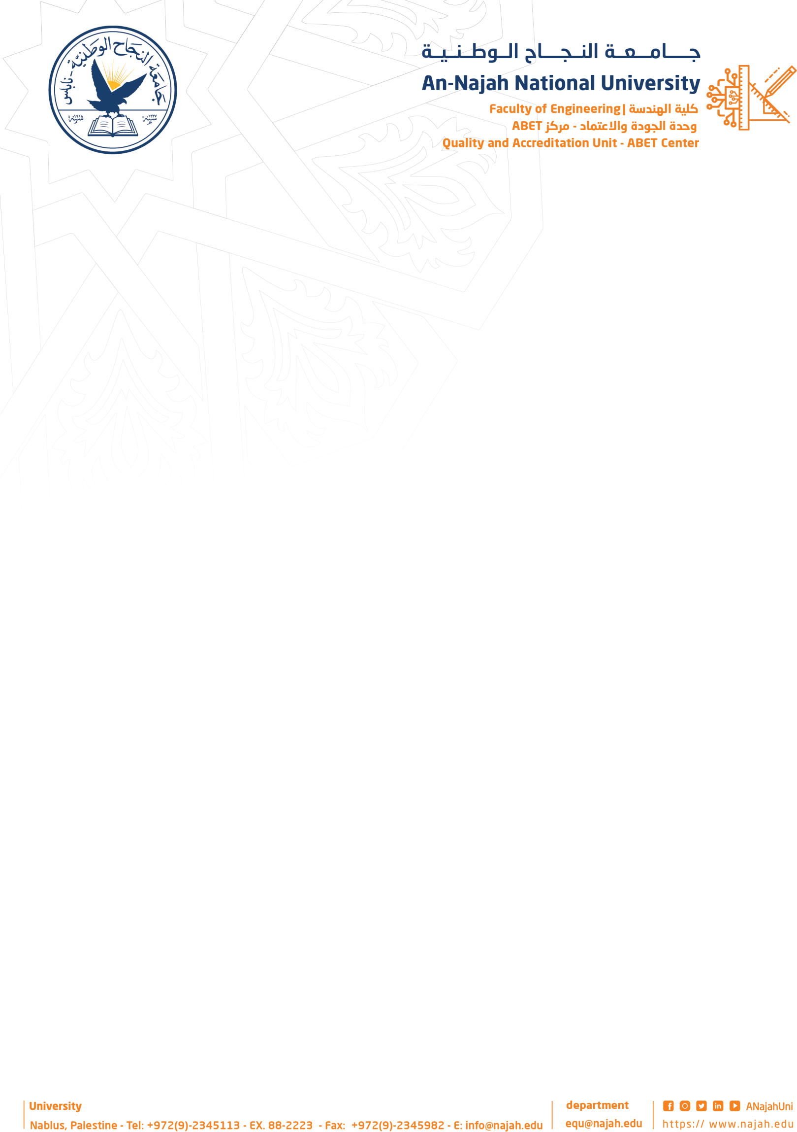

Cover page
Project Title: …………SHAQATI(شّقتي) …………………. Academic Year: …… 2025…………… Group Members: …………Ahmad Hanani………………. Department Name: Computer Engineering.
…………Abd Albaset Rajab…………………
…………………………………………...
……………………………………………
…………………………………………… Supervisor Name: ………Dr.khaled Daud…………………

Format:
- Single space, Times New Roman.
- 12 pt,
- Maximum 1 page.

Abstract Body:
Items must be provided in the Abstract:
  - Why do you think this project is important? Please explain the significance of this Project in brief.
  - In your point of view what are the important aspects that should be covered in the project?
  - Objective(s): In your view, please explain the main objectives of the project.
  - Methodology: Give a brief outline of the application development process.
  - Had this project been done before? Are there any similar applications available today?

  - Note: Please deliver this abstract early to ensure that your Project has been approved by the
department’s projects committee. Registration will not be done without this approval.

Project’s Abstract:

This project proposes the design and development of a comprehensive Smart Real Estate Management System, implemented as both a web and mobile application, aimed at transforming the management, rental, and sale of residential properties. The system provides a unified digital platform that seamlessly connects property owners, tenants, and administrators, enabling streamlined, efficient, and transparent execution of all real estate operations.
Property owners can create and manage profiles on the site, as well as add and update listings with all the necessary information, such as location, price, area, photos, amenities, and descriptive data. Applications for rentals are received and processed, requests are approved or denied, contracts are issued and digitally signed, payment transactions are tracked and managed, and maintenance issues are handled effectively thanks to the system. Property owners are guaranteed to stay up to date on important events and outstanding duties pertaining to their properties thanks to automated notifications and reminders.
Tenants can visit the site to search for available apartments with advanced searching and filtering features, read in-depth property descriptions, submit rental applications online, and e-sign leases. Tenants can safely pay rent and utilities online, see payment history, and submit maintenance requests or report problems in real-time through the portal. The site also includes personalized dashboards and notification alerts to enhance user engagement and satisfaction.
The administrative board provides system administrators full authority over every activity on the platform, including user administration, verification of property ownership, complaint management, tracing financial transactions, and creating detailed analytical reports as well as financial reports. These reports assist in evaluating the performance of the platform, tracking the level of engagement among the users, and making sound decisions to optimize operational efficiency.

In order to guarantee scalability, cross-platform compatibility, data privacy, and strong security, the system was created utilizing contemporary online and mobile technologies. In order to provide a completely digital and efficient approach to real estate administration, a focus was focused on developing an intuitive user interface, automating conventional procedures, and cutting down on paperwork. This project offers a clever, effective, and easily accessible solution that improves communication,

saves time, and enhances the overall experience for all parties engaged in property management by fusing technological innovation with useful functionality.

