Abstract

The goal of our project was to create a device that opens a standard Masterlock® combination lock without knowing the combination to the lock. First we researched a method that one could use to open one of these locks by hand without knowing the combination to the lock. After we mastered this technique we created a machine that could implement the strategy so that one could use the machine to open the combination lock without needing to master the technique. Our final product achieved this goal, and opens the lock without knowing the combination beforehand, displaying the correct combination to the lock when it is finished.

Contents

Chapter one: Introduction:
  - Purpose & Usefulness.
  - Technique of cracking the lock.
Chapter two: Design:
  - Hardware.
    - Main Control Unit.
    - Input Output Unit.
- LCD Display.
- Keypad
    - Driver Units.
- Stepper Motor.
- Stepper Motor Driver.
- Solenoid.
- Solenoid Driver(H-Bridge)
    - Feedback Unit.
- Flywheel.
- Arm.
- Photo sensors.
  - Software.
    - PIC (16F877).
    - Auto Unlock process (Cracking).
** Conclusion.
** Cost.
** Project in Picture.

Chapter one: Introduction

  - Purpose & Usefulness:
** Many people have a lock lying around somewhere that they have forgotten the combination to. The purpose of this project was to exercise our knowledge of circuits, programming, and engineering in general to build a device that would allow them to discover the combination without buying a new one.
** There are many techniques for opening a combination lock without the combination, however most of them will destroy the lock or not reveal the true combination. Our device is very useful because it will not destroy the lock and it will reveal the combination once it has finished.
** Many locker rooms and stores that sell combination locks would be interested in purchasing this device.

  - Technique of cracking the lock:

While researching combination locks we learned a method to crack locks by hand. Our device works by emulating this method; hence some background on this method is useful in understanding our design procedure.

The first step to cracking the lock is to find the internal gates of the lock.
To locate the gates pull up on the latch of the lock while rotating the dial- it will get stuck between two whole numbers or two half numbers. Record the midpoint of where the dial sticks: this is an internal gate to the lock. Repeat this process all the way around the lock- there will be twelve gates in the lock. Five of the numbers will be whole numbers and seven will be half numbers. The last digit of one of the whole numbers will be different than the rest: This is the third number of the combination!
1.5
4.5
8
12 Third number of the combination!
14.5
18
21.5
24.5
28
31.5
34.5
38
Sample Gate Locations

Now take the third number of the combination and divide it by four. Take the remainder of this division and record it- this number is the first possibility of the first number of the combination. Each of the other possible first numbers of the combination are found by adding four to this number until the highest possible number, 39, is reached. In the above example the third number of the combination is 12, and 12 divided by 4 has a remainder of 0. Therefore the possible first numbers of the combination are 0, 4, 8, 12, 16, 20, 24, 28, 32, and 36. Now take the remainder from the division earlier. If it was a 0 or 1 add two to it. If it was a 3 or 4 subtract two from it. This is the first possibility for the second number in the combination. The other possible second numbers to the combination are again found by adding 4 to this number until the highest possible number, 39, is reached. Continuing our example, the remainder from before was 0, so we would add 2 to this to get 2. This makes the possible second numbers of the combination 2, 6, 10, 14, 18, 22, 26, 30, 34, and 38. We now have 10×10 = 100 possible combinations. However all combinations must be either of the type low-high-low or the type high-low-high; this eliminates 20 possible combinations. There are now 100-20= 80 possible combinations. The next and final step is simply to try all 80 of these combinations.

Chapter Two: Design

2.1 Hardware:

Block Diagram:

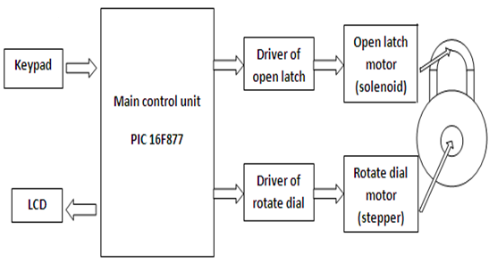

2.1.1 Main control Unit:
- PIC:
It is PIC 16F877 it has 40-Pin 8-Bit CMOS .the connection of the ports as follows:

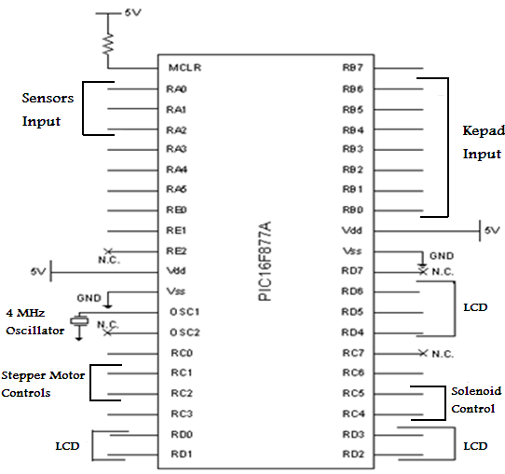

The basic circuit of the PIC:

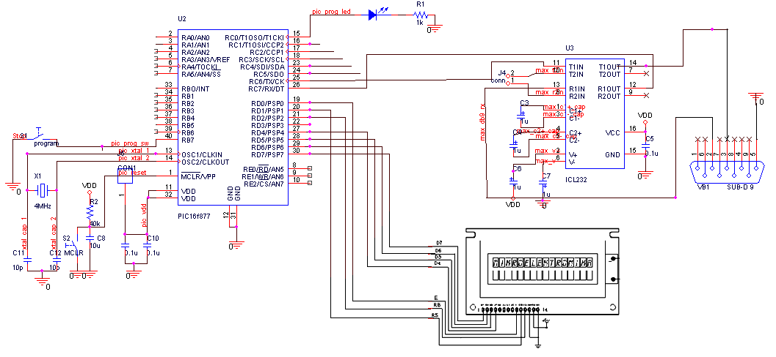

2.1.2 Input Output Unit:
- LCD Display :( Output)
We use an NT-C1627A LCD (16 character * 2 lines).
This display shows the combination that is being used to unlock the lock. When the user is inputting a combination with the keypad, the LCD display will show the combination as he inputs it. When the user has engaged the opener in auto-unlock, the display will show the current combination that the lock is testing, and will display the correct combination after the opener has found it. The display receives its input from the PIC. But they are flickering on and off so fast that it are impossible to detect this flickering with the human eye. The max voltage of the LCD is 5 V.

- Keypad :( input)
The keypad provides the input to the opener. The user can input a combination to the keypad and the opener will then use that combination to attempt to open the lock. In order to input a combination, the user must put in the first number, followed by a # sign, then the second number followed by a # sign, and then the final number followed by a # sign. If at any point the user wants to clear the display and the numbers input, then the he may press the * button. In order to engage the opener in auto-unlock, the user should press the # button when the display is cleared. The input of the keypad goes directly to the PIC, where it is processed accordingly.

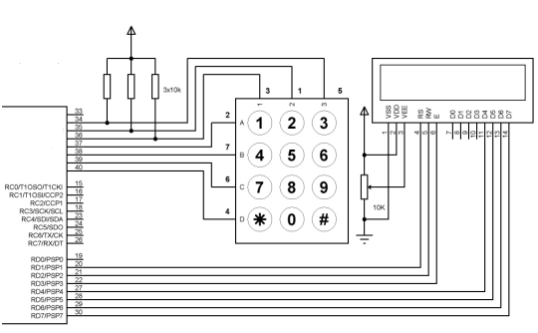
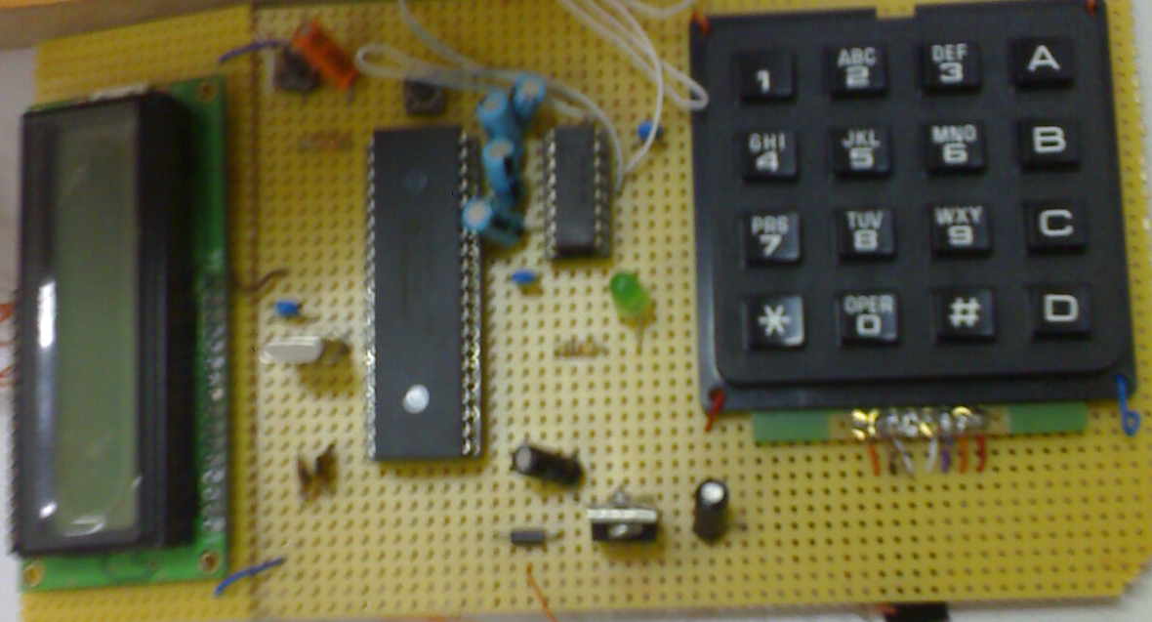

2.1.3 Driver Units:
- Stepper Motor:
We use 1.8^{ₒ} stepper Motor
Why we chose stepper motor?
We do not need to put a negative voltage across it to reverse the direction.
The motor speeds are not controlled by the voltage across the thermals. It is controlled by the frequency of voltage pulses.
A stepper motor would be the most effective, because of its precision at turning certain distances.
Why we chose 1.8^{ₒ} stepper Motor?
To find the internal gates of the lock our device must be able to tell the difference between each half number on the lock dial. This means that the number of degrees we will need to be able to “see” the difference is:
Hence our device will need to be able to turn dial in increments of 4.5°.So, motor step angle 1.8oand we can turn the motor in 0.9o increments. 4.5o /0.9o = 5 half stepper motor steps to turn 1 half number on the lock.
- Problems that we face:
It was hard to find a stepper motor that has such a small number for each step (1.8^{ₒ}).
- Solution: We found it in microprocessor Lab.

- Stepper Motor Driver:
To drive the stepper we use mc3479p stepper motor driver

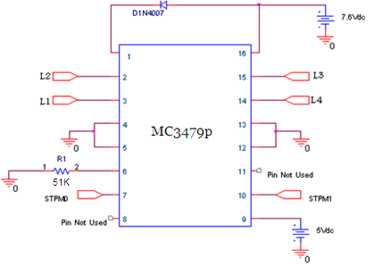

The MC3479p is designed to drive a two−phase stepper motor in the bipolar mode. The circuit consists of four input sections, a logic decoding/sequencing section, two driver−stages for the motor coils, and an output to indicate the Phase A drive state.

This was much simpler and more effective than building our own stepper motor driver. The motor driver took two inputs from the PIC. The first input controlled the direction (clockwise or counterclockwise) that the motor turned. The second input was the clock to the motor driver. For every clock pulse the motor driver turned the stepper motor one half steps or 0.9°.
The current that the motor driver outputs to the stepper motor is determined by the resistor connected between pin 6 and the ground. The value of this resistor was calculated with the following equation from the motor driver data sheet:
Vm: is the voltage we are running the motor driver at.
IBS: how much current we want to output to the stepper motor.

From the data sheet:
In our project:
VM = 7.6 V.
IM: Stepper motor current which equal 30 mA.
IBS = approximately 300 mA.
The closest resistor we had available was 51 kΩ which turned the stepper motor quite well.
- Problem we face:
There was a backward current that inter the coil bins of the stepper motor driver which destroy the first IC.
- The Solution:
The Solution was to add a resistor with a led with each coil of the Stepper motor.
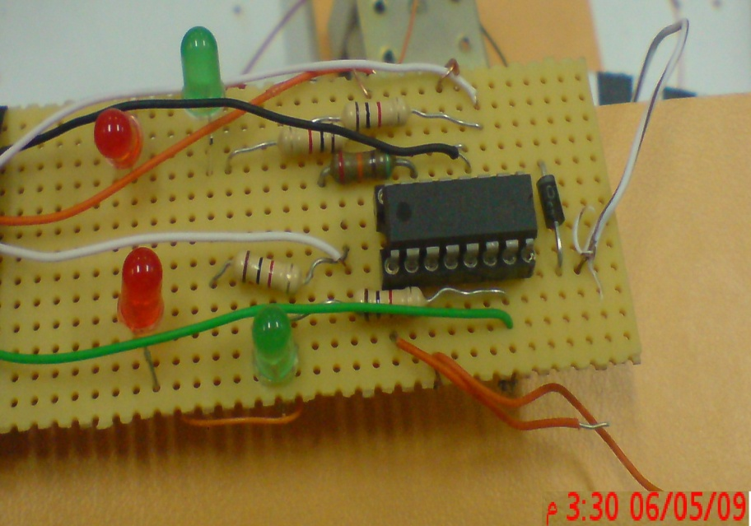

- Solenoid:
We test the force needed to open the latch of the lock and it equals about 11 Newton.
It is a DC Latching Solenoid.
We let it work on the ratings as follows:
V= 12 volt. R (internal) =14.4 Ω.
I (max) =12 ∕ 14.4=0.84 A.
And it was able to open the latch of the lock.
- Problems we face:
It was hard to find the solenoid. All the existed ones was of small latching that used for pulling a very small objects(having light force)they found in Videos.

- The solution:
One of the solution was to build one and it was refused after we found that it is build with trial and error formulation and it have a big degree of error.
Then there was an idea to use (centerlock) that is used in car doors , because they have the desired amount of force that could open the Latch, but we didn’t apply this idea because finally -after along suffer-we found the solenoid we want.

- Solenoid Driver (H- Bridge):

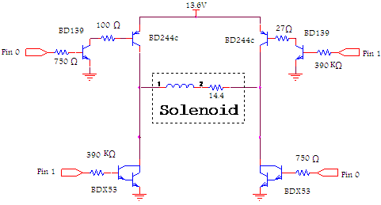

This unit uses signals from the PIC to open the latch of the lock. It does this by using transistors to connect a VDC source across the motor when the correct logic from the PIC is received. It has two pins and the output as it shown in the table:
Pin 0 | Pin1 | output
Low | Low | ----------------------------
Low | High | unlatch
High | Low | pull
High | High | unaccepted
- Problems that we face in Designing H-Bridge:
We want to have about 12v and 0.83 A through the solenoid so we changed the values of the Resistors-many times- to satisfied that.
The collector of the BD139 received higher current from the Base of BD244C
- The solution was to add Series power resistor of 100 Ω, 15 W to tolerate the high power.
We get about 11.2V and 0.74 A and that was enough to open the Latch of the motor.
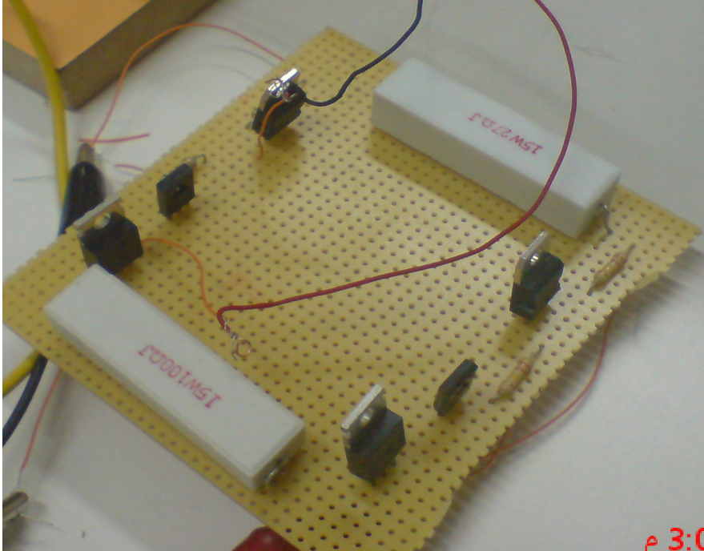

2.1.4 Feedback Unit:
- Fly Wheel:
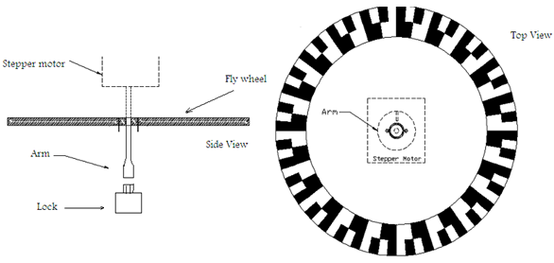

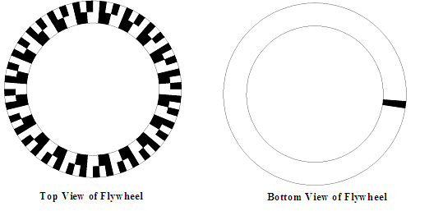
The other component to the sensor is the flywheel. The flywheel is disk that has a decal with black and white divisions. The flywheel is directly connected to the shaft of the motor to ensure that it always rotates with the dial of the lock. The top of the flywheel has two sections; the outer section has 80 divisions that alternate black and white. The inner section has 40 divisions that alternate black and white. The outer section has half number resolution while the inner section has whole number resolution. The top portion is used mainly during gate detection. The bottom of the flywheel has a single division that marks the location of zero. Zeroing the lock is very important for consistency during both gate detection and mass combination entry. Care must be taken when putting the lock into the device to ensure that zero is correctly lined up.
Care must be taken to ensure that the sensors only read from the center of the division. If the senor tries to read from an edge the output voltage is unpredictable. To prevent this from occurring, the device is re-zeroed to its initial position often during operation.

- Arm:
The arm is the connecting piece between the stepper motor and the lock dial. It is critical to our device that it be as straight as possible and that it grips the lock dial as firmly as possible.
It must be light in weight so we made it from aluminum. And we try to be empty inside as possible to reduce its weight, it was perfect straight connection.

- Photo Sensors (OPB742)
How do photo sensor work?

The OPB742 is a reflective photo sensor. The sensor consists of a LED and a photosensitive BJT. The LED produces inferred light that shines through a hole in the device. Depending on the color and characteristics of the surface the light is scattered, reflected or absorbed. In any case some of the photons will enter into the device through a separate hole and strike the base region of the photosensitive BJT. The photons cause electro-hole pairs to manifest within the base region which enables current to flow from the collector to the emitter.
a 100kohm resistor is connected from the emitter to ground. The output of the sensor is read to the PIC directly at this point. For our design it is only necessary to distinguish black and white colors. So the PIC only needs to read a high or a low from the sensor. A high resistance was chosen so that the BJT will operate in either the cutoff region or the saturation region. This type of operation provided good logic levels. The 150ohm resistor connected between the anode of the LED and ground limits the current to 22mA. This reduces the current and ensures that the LED does not exceed the maximum power dissipation. Both devices are powered by a 5V source.
They are 3 sensors two of them are connected to the Top side of the fly wheel (on in the inner radius-40 Divisions- to detect full numbers) the other one is connected on the outer radius of the top side -80 Divisions to detect half numbers in cracking time) and the third one is connected to the bottom side of the fly wheel (to rezeroing the number).
Photo circuit Diagram.

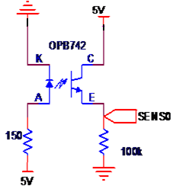

The output from the photo sensor is:

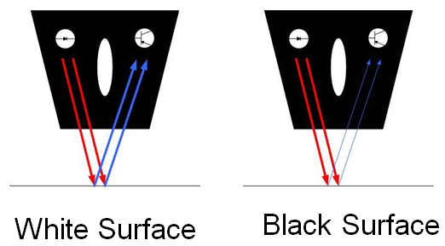
And the test Result as follows:
Vmax = 4.85 volt. Imax = 4.85/100K = 48.5 µA. (White Surface).
Vmin = 1.4 volt. Imin = 1.4/100K = 14 µA. (Black Surface).

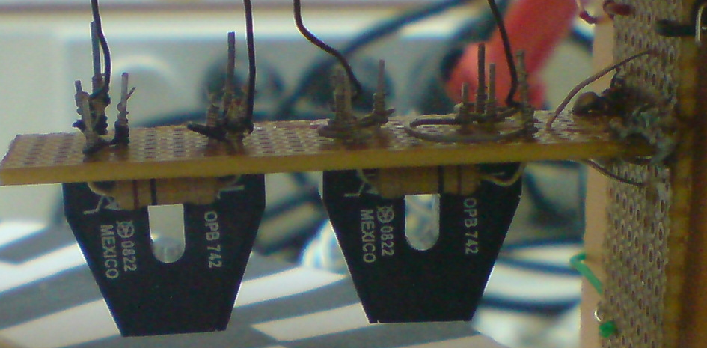

2.2 Software:
2.2.1 PIC (16F877):
The primary piece of the main control unit circuit is the PIC microprocessor PIC16F877 .The PIC is programmed with PIC C programming language. The main function of the code is just an infinite loop which is constantly checking to see if the user has input something via the keypad. When the PIC receives the signal that a keypad input has been received, the PIC enters a corresponding function that handles that specific input.

If the input received by the PIC is a number, it first verifies that it is a valid number to display, and then it modifies the number that it is currently displaying on LCD display according to the number that the user has input. If the input is a clear button (*), the PIC calls an initialize function to clear the LCD, and all stored variables. If the input is an enter signal, the PIC will do the corresponding action based on what numbers the user has already input.
If the user has input a combination and hit enter (#) after each number, the PIC will then tell the stepper motor to input that combination. Then it will print it and it will rotate clock wise for the first number and reverses it direction for the second number then rotates clock wise for the third number each number we inter is converted to a counter that its value is change by feedback from photo sensors we counted how many times it passes through black sections

2.2.2 Auto unlocks process (Cracking):
When the user has hit enter # without entering a combination, the lock opener enters the crack lock function. The purpose of this function is to determine what the last number of the combination is by locating the correct position of the gates. The PIC first tells the solenoid to pull up on the lock and then rotate the lock one half numbers. The PIC then receives an input from the sensors as to whether or not the lock has gotten stuck. If the lock has not gotten stuck, the PIC again tells the solenoid to pull up on the lock while rotating the stepper motor a half number. This process continues until the sensors tell the PIC that the lock has gotten stuck. When the lock has gotten stuck, the lock opener re-calibrates the lock to zero, returns to the position where the lock got stuck, rotates one number without pulling up on the solenoid, and then resumes pulling up on the solenoid and rotating the lock one half number until the next gate is found. If the lock has rotated less than two and a half numbers since the last number it found, both the last number and this number are discarded and ninety is stored, which serves as an error code that the process was unable to determine a location for this trial. When the lock opener has repeated this process around one full dial of the lock, the direction reverses and the lock opener repeats the process. When this rotation is complete, the PIC reverses the direction of the stepper motor and locates the numbers where the lock gets stuck a third time.
Once the PIC has run through these three trials collecting data as to where the lock got stuck, the PIC determines from this where the correct location of the gates is. This process is done by calculating where the gates are expected to be, combined with the data collected as to where the gates are. First the code searches through the data for the first time that all three trials found the same number. If there is no point where all three trials found the same number, then the process is deemed a failure, however this rarely happens. One the PIC has found the first place where all three numbers are the same; it uses this as a starting point. It then goes to the next gate and figures out what the most frequently achieved number over these three trials was for this position. It then verifies that this position is within three or three and a half numbers of the previously recorded gate, because all of the gates are either three or three and a half numbers from the last gate. If the gates are not within this distance, the code checks to see if the less frequently achieved gate is within this distance, and if it is this number is stored. If this number is also not within this distance, the code determines whether the most frequently achieved number is closer to three or three and a half dials from the last gate, and then records the gate as that difference from the last gate. If there is a tie as to what the most frequently achieved number is, the code bases its decision as to the next number on the reliability of the trials, while still verifying that it is three or three and a half numbers from the last gate. The first trial is considered the most reliable, then the third, and the second trial is considered the least reliable. If none of the trials were able to determine a number for the position, then the number stored is the previous number minus seven, because this does not prohibit other correct numbers from being stored. If none of the trials were able to determine more than one numbers, then an error is returned. The process is repeated until all twelve numbers are determined.
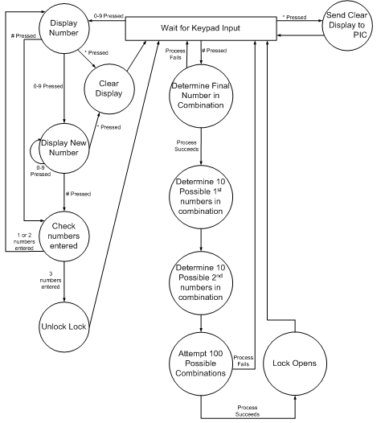
Combination Lock Opener Simplified State Diagram

Light sensor Active or all Combination fail
Counter !=0
Current number not whole number
Current number is whole number
5 number Stored
5 numbers not stored
Light Sensor Activated
Light Sensor not Activated
Lock has complete cycle
# Pressed
0-9 Pressed
No
Yes
* Pressed
# Pressed
No input
0-9 Pressed
* Pressed
No input or 0-9 Pressed
3 number Pressed
#Pressed
1or2 number Pressed
* Pressed
0-9 Pressed
* Pressed
Attempt to open lock
Send Number to LCD
Set Counter to 9
Send Clear to LCD
Activate Opening Motor
Rotate 1\2 Number
Deactivate Opening Motor
Rotate 1\2 Number
Store number in register
Rotate 2* 1\2 Number
Activate Opening Motor
Verify5 numbers stored
Deactivate Opening Motor
Compare number Stored
Move# with Separate last digit to new registe
Divide # by 4 .Stored reminder to Memory
Add 4 to Remainder
Store Remainder to memory Space1
Decrement Counter
Replace Remainder: if 0or1 add 2 else sub 2
Set Counter to 9
Add 4 to Remainder
Store Remainder to memory Space2
Decrement Counter
Test each Possible Combination: 1st # in memory space 1. 2nd # in memory Space 2. 3rd # in Register. Sending these # to the LCD

Attempt to open lock
Wait for Keypad Input
Send Clear to LCD
Check if number is valid

Send Number to LCD
Wait for Keypad input
Send Number to LCD
Increment Number Counter
Wait for Keypad input
Wait for Keypad input
Send Clear to LCD
No input
No input or # Pressed
Counter !=0
Light Sensor Not active

Conclusion:

This device could be the solution for many problems and can offer great benefits for the large number of users like schools, universities and companies.
It can reduce time and effort to open the unknown locks, or to open it in emergency situations.

Future Work:
The obvious future work that can be done on our device is not for an electrical engineer, but perhaps a mechanical engineer or some other type of designer in order to reduce our device’s mechanical inconsistencies. If an electrical engineer was to do more work on our device, it would probably be to further optimize the code to take less time to run the device, or else to possibly come up with some more algorithms to account for the mechanical inconsistencies. One could maybe add more lights to the circuit to make it more visually impressive, but the circuit design is reasonably stable.

COSTS

Cost | Model # | #of part needed | Part
10$ | 16F877 | 1 | Microproccesor
25$ | mc3479p | 2 | Stepper Motor Driver IC
45$ | opb742 | 3 | Photo sensor
9$ | R257-4x4-keypad | 1 | Keypad
11$ | M1632 | 1 | LCD
1.5$ |  | 1 | 4 MHZ Crystal Oscilator
2$ | BDX53 | 3 | NPN Transistor
2$ | BD244C | 3 | PNP Transistor
2$ | BD139 | 3 | NPN Darlington Pair
4$ |  | 10 | Capacitors
2$ |  | 20 | Resistors
Sum =113.5$

Project in Picture:

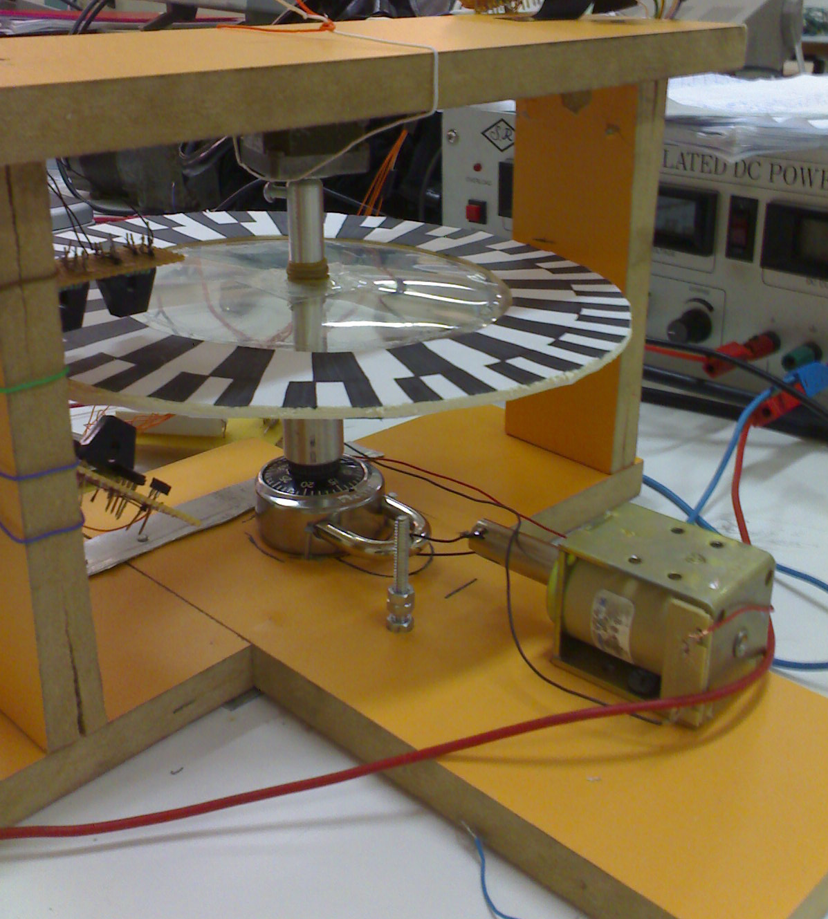

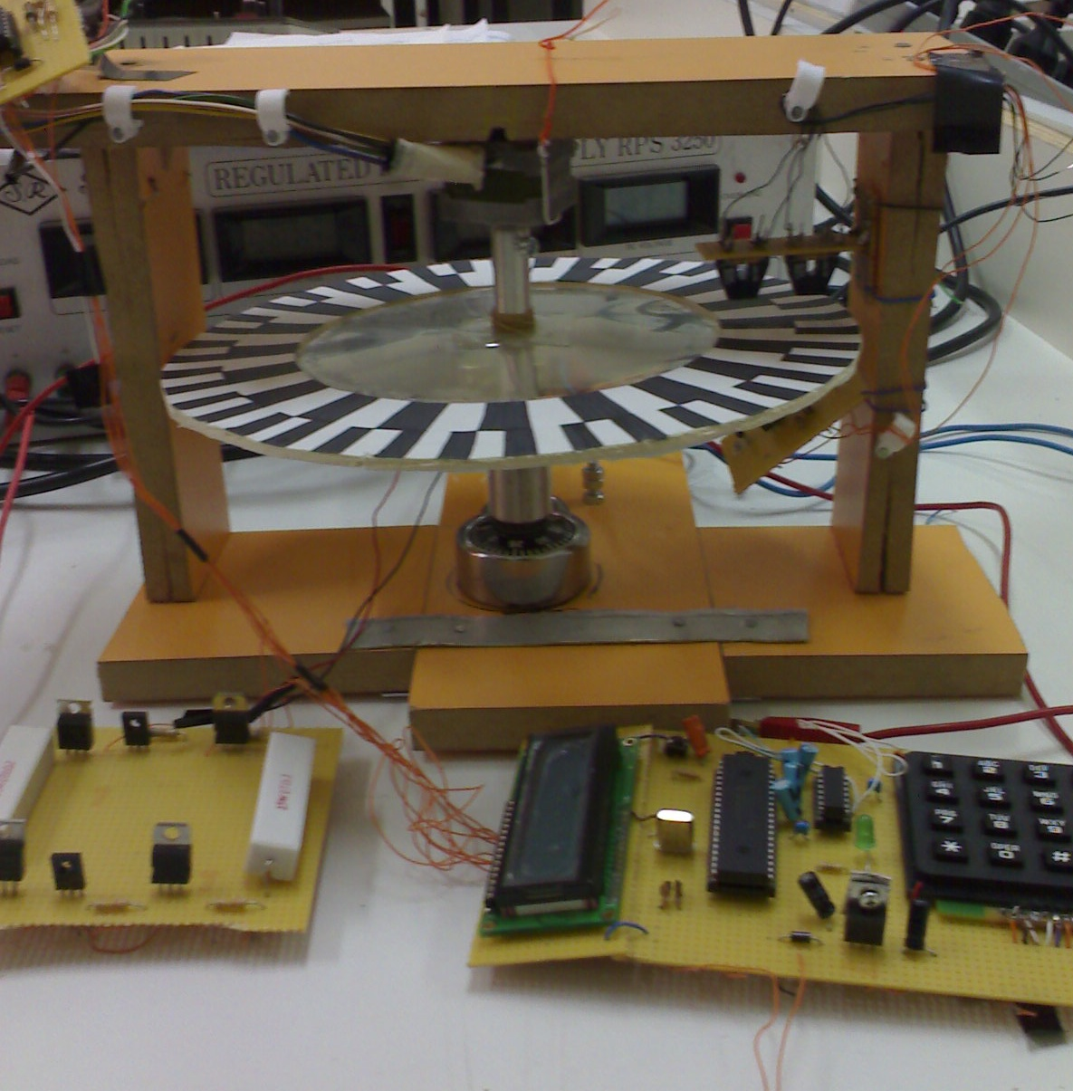

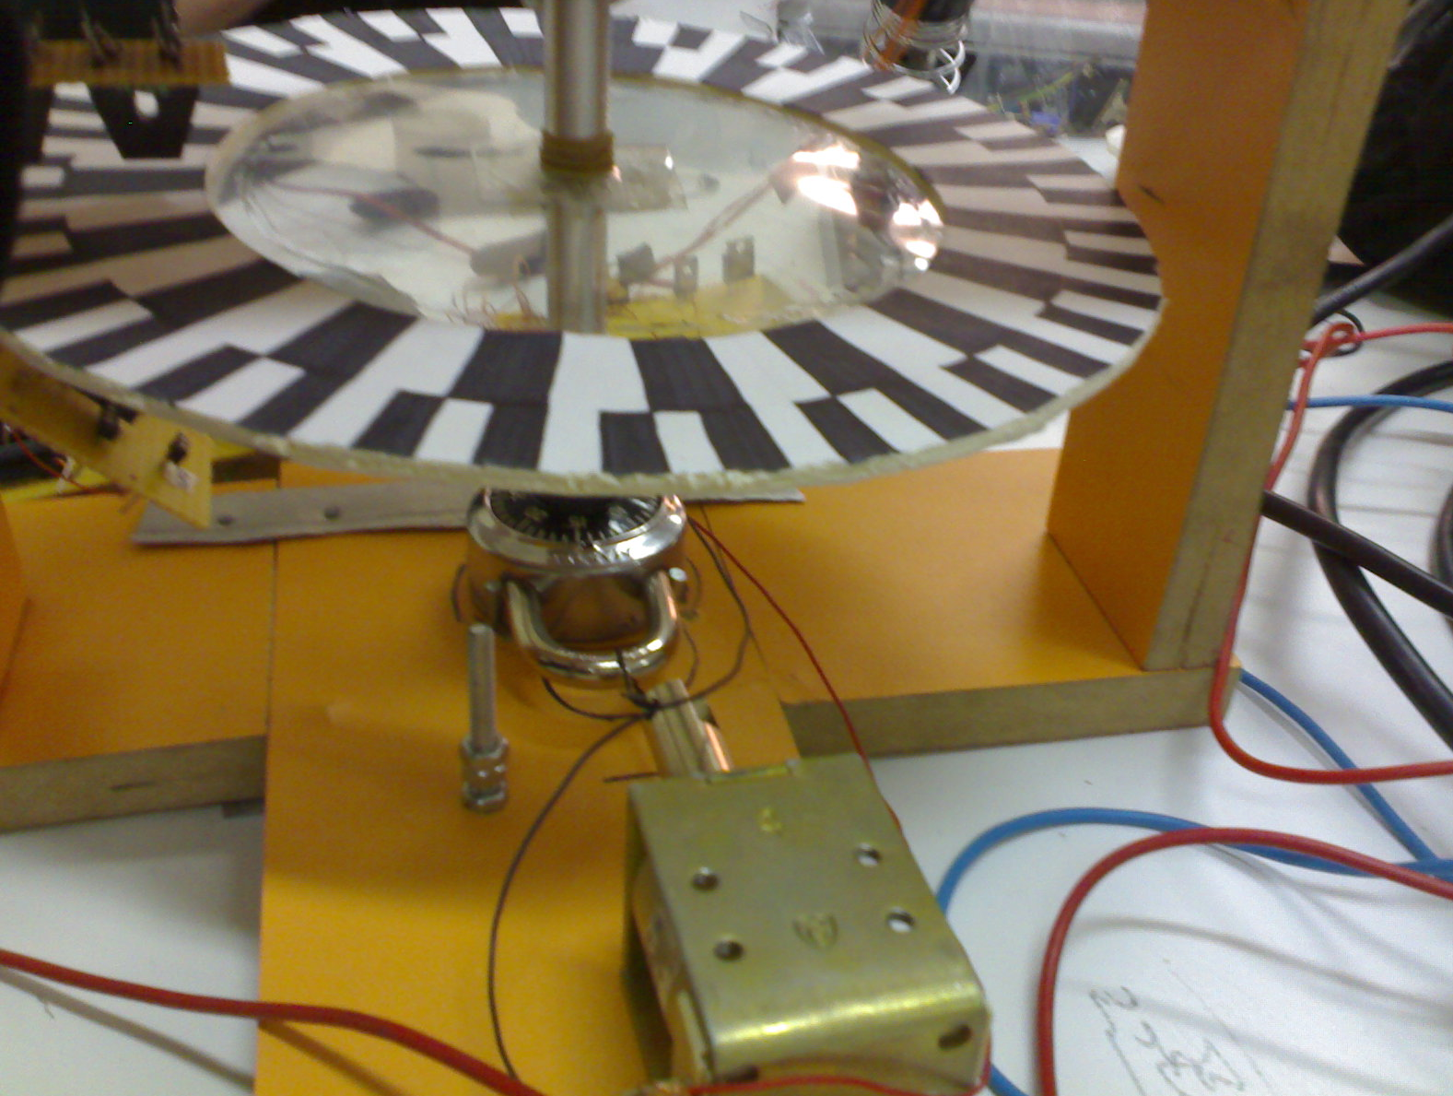
Appendix:
1
#include<lcd.c>
Void main ()
{
setup_adc_ports(NO_ANALOGS);
setup_adc(ADC_OFF);
setup_psp(PSP_DISABLED);
setup_spi(FALSE);
setup_timer_0(RTCC_INTERNAL);setup_wdt(WDT_2304MS);
setup_timer_1(T1_DISABLED);
setup_timer_2(T2_DISABLED,0,1);
lcd_init();
while(true)
{
printf(lcd_putc,"hellow there");
restart_wdt();
}
}

- 2

#include "E:\test\keytest.h"
#use rs232(baud=9600, xmit=PIN_c6,rcv=PIN_c7)
char t='p';
char key(){
output_low(PIN_B0);
output_high(PIN_B6);
output_high(PIN_B5);
if (!input(PIN_B4)){
restart_wdt();
return '1';
}
if (!input(PIN_B3)){
restart_wdt();
return '4';
}
if (!input(PIN_B2)){
restart_wdt();
return '7';
}
if (!input(PIN_B1)){
restart_wdt();
return '*';
}

output_low(PIN_B6);
output_high(PIN_B0);
output_high(PIN_B5);

if (!input(PIN_B4)){
restart_wdt();
return '2';
}
if (!input(PIN_B3)){
restart_wdt();
return '5';
}
if (!input(PIN_B2)){
restart_wdt();
return '8';
}
if (!input(PIN_B1)){
restart_wdt();
return '0';
}

output_low(PIN_B5);
output_high(PIN_B6);
output_high(PIN_B0);

if (!input(PIN_B4)){
restart_wdt();
return '3';
}
if (!input(PIN_B3)){
restart_wdt();
return '6';
}
if (!input(PIN_B2)){
restart_wdt();
return '9';
}
if (!input(PIN_B1)){
restart_wdt();
return '#';
}
else{
restart_wdt();
return 'p';
}}

#include<lcd.c>
void main()
{
setup_adc_ports(NO_ANALOGS);
setup_adc(ADC_OFF);
setup_psp(PSP_DISABLED);
setup_spi(FALSE); setup_timer_0(RTCC_INTERNAL);setup_wdt(WDT_2304MS);
setup_timer_1(T1_DISABLED);
setup_timer_2(T2_DISABLED,0,1);
//port_b_pullups(false);
t='p';
while(1){
restart_wdt();
delay_ms(100);
if(t!='p'){
lcd_init();
printf(lcd_putc ," the key == %c ",t);
}
restart_wdt();
restart_wdt();
}}

- 3
Void main ()
{
int i;
setup_adc_ports(NO_ANALOGS);
setup_adc(ADC_OFF);
setup_psp(PSP_DISABLED);
setup_spi(FALSE); setup_timer_0(RTCC_INTERNAL);setup_wdt(WDT_2304MS);
setup_timer_1(T1_DISABLED);
setup_timer_2(T2_DISABLED,0,1);
set_tris_c(0x10);
restart_wdt();
output_high(pin_c2);
restart_wdt();
for (i=1;i<=12;i++)
{output_low(pin_c1);
restart_wdt();
delay_ms(10);
restart_wdt();
output_high(pin_c1);
delay_ms(10);
restart_wdt();
}}
- 4

char t='p',t1,t2;
int keyy,key1,key2,j;
char r[10]={'0','1','2','3','4','5','6','7','8','9'};
char key(){
output_low(PIN_B0);
output_high(PIN_B6);
output_high(PIN_B5);
if (!input(PIN_B4)){
restart_wdt();
return '1';
}
if (!input(PIN_B3)){
restart_wdt();
return '4';
}
if (!input(PIN_B2)){
restart_wdt();
return '7';
}
if (!input(PIN_B1)){
restart_wdt();
return '*';
}
output_low(PIN_B6);
output_high(PIN_B0);
output_high(PIN_B5);
if (!input(PIN_B4)){
restart_wdt();
return '2';
}
if (!input(PIN_B3)){
restart_wdt();
return '5';
}
if (!input(PIN_B2)){
restart_wdt();
return '8';
}
if (!input(PIN_B1)){
restart_wdt();
return '0';
}
output_low(PIN_B5);
output_high(PIN_B6);
output_high(PIN_B0);
if (!input(PIN_B4)){
restart_wdt();
return '3';
}
if (!input(PIN_B3)){
restart_wdt();
return '6';
}
if (!input(PIN_B2)){
restart_wdt();
return '9';
}
if (!input(PIN_B1)){
restart_wdt();
return '#';
}
else{
restart_wdt();
return 'p';
}}
void main()
{
int i;
setup_adc_ports(NO_ANALOGS);
setup_adc(ADC_OFF);
setup_psp(PSP_DISABLED);
setup_spi(FALSE); setup_timer_0(RTCC_INTERNAL);setup_wdt(WDT_2304MS);
setup_timer_1(T1_DISABLED);
setup_timer_2(T2_DISABLED,0,1);
set_tris_c(0x10);
restart_wdt();
while(t=='p')
{
restart_wdt();
t=key();
}
t1=t;
t='p';
while(t=='p')
{restart_wdt();
t=key();
}
t2=t;
for(i=0;i<=9;i++)
{
restart_wdt();
if (r[i]==t1)
{key1=i;
}
}
for(i=0;i<=9;i++)
{
restart_wdt();
if (r[i]==t2)
{key2=i;
}
}
keyy=key1*10+key2;

output_low(pin_c2);
restart_wdt();
for (j=1;j<=keyy;j++)
{output_low(pin_c1);
restart_wdt();
delay_ms(10);
restart_wdt();
output_high(pin_c1);
delay_ms(10);
restart_wdt();
}
while(1)
{
restart_wdt();
}}

- 5
#include <lcd.c>
void main()
{
int16 i,m;
setup_adc_ports(NO_ANALOGS);
setup_adc(ADC_OFF);
setup_psp(PSP_DISABLED);
setup_spi(FALSE);
setup_timer_0(RTCC_INTERNAL);setup_wdt(WDT_2304MS);
setup_timer_1(T1_DISABLED);
setup_timer_2(T2_DISABLED,0,1);
restart_wdt();
lcd_init();
output_high(pin_c1);
m=260;
for (i=1;i<=m;i++)
{output_low(pin_c2);
delay_ms(10);
output_high(pin_c2);
delay_ms(10);
}
delay_ms(500);
output_low(pin_c1);
m=540;
for (i=1;i<=m;i++)
{output_low(pin_c2);
delay_ms(10);
output_high(pin_c2);
delay_ms(10);
}
delay_ms(500);
output_high(pin_c1);
m=140;
for (i=1;i<=m;i++)
{output_low(pin_c2);
delay_ms(10);
output_high(pin_c2);
delay_ms(10);
}
output_high(pin_c4);
output_low(pin_c5);
delay_ms(500);
printf(lcd_putc,"12");
delay_ms(500);
restart_wdt();
printf(lcd_putc," 26");
delay_ms(500);
restart_wdt();
printf(lcd_putc," 12");
delay_ms(500);
while(1)
{
output_low(pin_c1);
restart_wdt();
}

}

- 6

#include <lcd.c>
char t='p';
char key(){
output_low(PIN_B0);
output_high(PIN_B6);
output_high(PIN_B5);
if (!input(PIN_B4)){
restart_wdt();
return '1';
}
if (!input(PIN_B3)){
restart_wdt();
return '4';
}
if (!input(PIN_B2)){
restart_wdt();
return '7';
}
if (!input(PIN_B1)){
restart_wdt();
return '*';
}
output_low(PIN_B6);
output_high(PIN_B0);
output_high(PIN_B5);
if (!input(PIN_B4)){
restart_wdt();
return '2';
}
if (!input(PIN_B3)){
restart_wdt();
return '5';
}
if (!input(PIN_B2)){
restart_wdt();
return '8';
}
if (!input(PIN_B1)){
restart_wdt();
return '0';
}
output_low(PIN_B5);
output_high(PIN_B6);
output_high(PIN_B0);
if (!input(PIN_B4)){
restart_wdt();
return '3';
}
if (!input(PIN_B3)){
restart_wdt();
return '6';
}
if (!input(PIN_B2)){
restart_wdt();
return '9';
}
if (!input(PIN_B1)){
restart_wdt();
return '#';
}
else{
restart_wdt();
return 'p';
}}
void main()
{
int16 i,m;
setup_adc_ports(NO_ANALOGS);
setup_adc(ADC_OFF);
setup_psp(PSP_DISABLED);
setup_spi(FALSE); setup_timer_0(RTCC_INTERNAL);setup_wdt(WDT_2304MS);
setup_timer_1(T1_DISABLED); setup_timer_2(T2_DISABLED,0,1); setup_comparator(NC_NC_NC_NC);
setup_vref(VREF_LOW|-2);
restart_wdt();
lcd_init();
while(t=='p')
{
t=key();
restart_wdt();
printf(lcd_putc,"%c",t);
restart_wdt();
if (t== '#')
{
printf(lcd_putc,"%c",t);
restart_wdt();
output_high(pin_c2);
m=260;
for (i=1;i<=m;i++)
{output_low(pin_c1);
delay_ms(10);
output_high(pin_c1);
delay_ms(10);
}
delay_ms(500);
output_low(pin_c2);
m=540;
for (i=1;i<=m;i++)
{output_low(pin_c1);
delay_ms(10);
output_high(pin_c1);
delay_ms(10);
}
delay_ms(500);
output_high(pin_c2);
m=140;
for (i=1;i<=m;i++)
{output_low(pin_c1);
delay_ms(10);
output_high(pin_c1);
delay_ms(10);
}
output_high(pin_c4);
output_low(pin_c5);
delay_ms(500);
printf(lcd_putc,"12");
delay_ms(500);
restart_wdt();
printf(lcd_putc," 26");
delay_ms(500);
restart_wdt();
printf(lcd_putc," 12");
delay_ms(500);
}
}
while(1)
{
output_low(pin_c1);
restart_wdt();
}
t=key();

- 7

#include<lcd.c>
int count=0,first11,first22,second11,second22,third11,third22,first,second,third;
char nu[10]={'0','1','2','3','4','5','6','7','8','9'};
char t='p',first1='0',t2,first2='0',second1='0',second2='0',third1='0',third2='0';
int i,ii,j;
char key(){
output_low(PIN_B0);
output_high(PIN_B6);
output_high(PIN_B5);
if (!input(PIN_B4)){
restart_wdt();
return '1';
}
if (!input(PIN_B3)){
restart_wdt();
return '4';
}
if (!input(PIN_B2)){
restart_wdt();
return '7';
}
if (!input(PIN_B1)){
restart_wdt();
return '*';
}
output_low(PIN_B6);
output_high(PIN_B0);
output_high(PIN_B5);
if (!input(PIN_B4)){
restart_wdt();
return '2';
}
if (!input(PIN_B3)){
restart_wdt();
return '5';
}
if (!input(PIN_B2)){
restart_wdt();
return '8';
}
if (!input(PIN_B1)){
restart_wdt();
return '0';
}
output_low(PIN_B5);
output_high(PIN_B6);
output_high(PIN_B0);
if (!input(PIN_B4)){
restart_wdt();
return '3';
}
if (!input(PIN_B3)){
restart_wdt();
return '6';
}
if (!input(PIN_B2)){
restart_wdt();
return '9';
}
if (!input(PIN_B1)){
restart_wdt();
return '#';
}
Else{ restart_wdt();
return 'p';
}}
void convert()
{
for(ii=0;ii<=9;ii++)
{
if(nu[i]==first1)
first11=ii;
if(nu[i]==first2)
first22=ii;
if(nu[i]==second1)
second11=ii;
if(nu[i]==second2)
second22=ii;
if(nu[i]==third1)
third11=ii;
if(nu[i]==third2)
third22=ii;
}
first=first11*10+first22;
second=second11*10+second22;
third=third11*10+third22;
}
void rotate()
{
int k=0;
output_low(pin_c1);
for (k=0;k<=800-first*10;k++)
{
restart_wdt();
output_low(pin_c2);
delay_us(500);
output_high(pin_c2);
delay_us(500);
}
output_high(pin_c1);
for (k=0;k<=800+second*10;k++)
{
restart_wdt();
output_low(pin_c2);
delay_us(500);
output_high(pin_c2);
delay_us(500);
}
output_low(pin_c1);
for (k=0;k<=800- third*10;k++)
{
restart_wdt();
output_low(pin_c2);
delay_us(500);
output_high(pin_c2);
delay_us(500);
}}
void main()
{
count=0,i=0,j=0;
setup_adc_ports(NO_ANALOGS);
setup_adc(ADC_OFF);
setup_psp(PSP_DISABLED);
setup_spi(FALSE);
setup_timer_0(RTCC_INTERNAL);setup_wdt(WDT_2304MS);
setup_timer_1(T1_DISABLED); setup_timer_2(T2_DISABLED,0,1);
t='p';
while(1)
{restart_wdt();
begin:
count=0;
while(t=='p')
{
t=key();
}
if (t<='9' && t>='0')
{
lcd_init();
first1=t;
printf(lcd_putc,"%c",t);
t='p';
loop:
while(t=='p')
{
t=key();
}
t2=t;
printf(lcd_putc,"%c",t2);
if(t=='#')
{t='p';
count++;
if (count==3)
{
convert(); //after entering full number
rotate();
delay_ms(1000);
restart_wdt();
goto begin;
}
goto loop;
}
else if(t=='*')
{goto begin;}
else
{
if (count==0)
first2=t2;
if (count==1)
{
i++;
if(i==1)
{
second1=t2;
}
if(i==2)
{
second2=t2;
} }
if (count==2)
{
j++;
if (j==1)
{
third1=t2;
}
if(j==2)
{third2=t2;
}}
printf(lcd_putc,"%c",t2);
goto loop;
}}
}}

