Chapter one:

Introduction

Contents:
- General introduction.
- Project description.

  - Introduction:
Toqan building is fourteen stories of reinforced concrete building located in Nablus city, the elevation of each story 3.3 m, to be used for commercial goods and basement floor of 4 m height to be used for garage and storage.

In this project we will study the building from mainly structural, architectural, mechanical and electrical points of view. We will perform complete analysis for the building under static and dynamic loads and then prepare detailed design.
The structural part of the project will consist of:
- Static design: in this part we will study the loads and stresses that the structural elements are subjected to, due to the gravity loads and then the appropriate design of the structural elements will be performed.

- Dynamic design: here we will analyze and study the structure under dynamic loads, such as earthquakes. Then the best design that saves structure from failure under seismic loads will be selected to improve the safety requirements.

- Structural modeling: It is one of the most important steps in structural design of buildings. It is the process at which the physical structure is represented by mathematical model that can be analyzed and designed. The more it becomes closer to reality the design will be safer and more economic.

  - Project Description:
    - Location and Function:
Toqan building will be studied from different points of view. The structural design, which looks like the base rule for us as civil engineers will take place.
The following figures show the column centers plan and the 3D model.
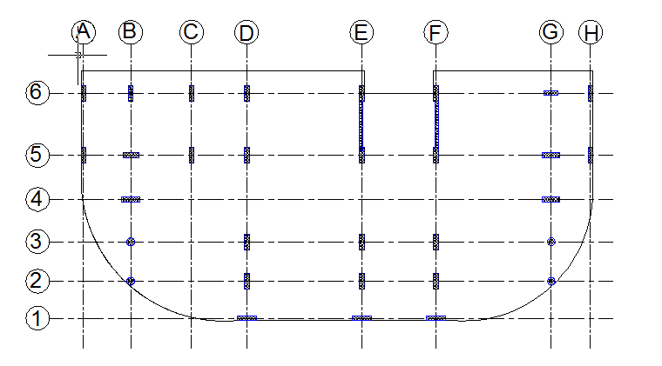
- : Column centers plan.

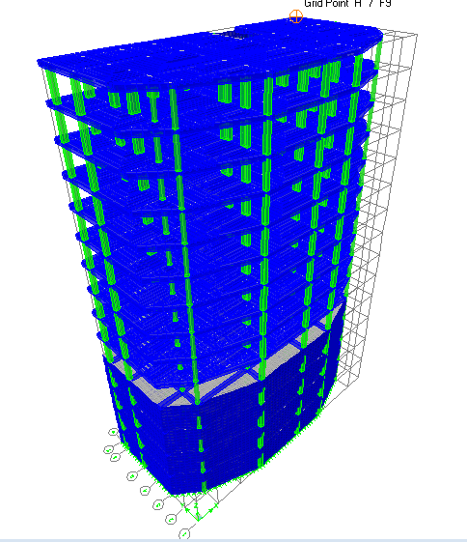
Figure 1.2: 3D model for the building
Site and geology:
The structure will be built on a soil with 250 kN/m² bearing capacity.
    - Design codes:
The project includes static and dynamic design; the design is to be performed using the following codes:
- “ACI -2011” (American Concrete Institute Code 2011) But in ETABS program ACI2008, so we adjust any different if it appear .
- “IBC -2009” (International Building Code 2009).

    - Materials :
The materials used in construction will have the following characteristics:
- Concrete compressive strength “${f'}_{c}$”:
For all elements in structure ${f'}_{c}$ = 28 MPa.
- Steel yield strength f_{y} = 420 MPa.
- Modulus of elasticity $E=4700\sqrt{{f'}_{c}}$ (in MPa) according to section 8.5.1 in (ACI 318-11).
E= 25*10⁶kN/m².
- We will use reinforced concrete with weight per unit volume $γ$ = 25 kN/m³ that is equivalent to density $ρ$= 2.5 ton/m³.

- The following table shows the densities for materials used in construction:
Table1.1: Densities of materials
Material | Unit weight  (kN/m³)
Reinforced concrete | 25
Plain concrete | 23
Sand | 18
Aggregate | 17
Blocks | 12
Masonry stone | 27
Tile | 26

    - Structural system :
The structural systems to be used is two way ribbed slab and two way solid slab .

    - Loading:
The structural elements are subjected to different stresses due to the following loads:
- Vertical loads :
- Dead load: it consists of weight of all permanent construction such as:
- Slab own weight.
- Superimposed dead load.
- Live load: is the load produced by the use and occupancy of the structure, it is based on function of the building. We specify the live load from special table according to table 4.1 in ASCE/SEI 7-05. For this building is to be L.L = 5 kN/ m² for all story. See appendix A.

- Snow loads: the snow loads are not considered here in Nablus for design of reinforced concrete structures since it snows rarely and when it does small amounts of snow falls compared to weight of structure.

- Lateral loads :
- Wind load:
Wind load is a direct dynamic force that affects the structure. It hits the structure as dynamic force, and mainly depends on topography, wind speed and height of building.
We don’t want to design for wind because for reinforced concrete structures of such height in Palestine earthquake load is more critical.
- Earthquake load:
Since Palestine is classified as moderate seismicity zone, earthquake load should be considered in design to achieve safety.
For this structure, the earthquake loads will be calculated later in dynamic analysis part.

    - Computer programs used :
In analysis and design we use:
ETAPS 9 program.

    - Loads combination:
We will use ultimate design method. Thus, the following are the load combinations and factors of safety in design:

The load combinations are according to ACI 318-11 9.2.1:

Wu= 1.4D.L
Wu= 1.2D.L+ 1.6L.L
Wu= 1.2D.L +1.0L.L ±1.0E
Wu= 0.9D.L ±1.0E
Where:
D.L: Dead load.
L.L: live load.
E: Earthquake load.

