

An-Najah National University
Faculty of Engineering and information technology
Department of computer science

Presented by : Nadia zaid
Farah sa’di
With the help of: eng.sami zaid
Under the supervision of:
Dr. Adnan alsalman
dr. ahmad awwad
dr.othman othman

3. Jun. 2018

CHAPTER 1
INTRODUCTION

INTRODUCTION OF PROJECT

Mini CNC machine is the machine that is similar to the usual CNC machine. Mini CNC machine is the small CNC machine that can operate like usual CNC machine but the area of the machining is limited. CNC machine is all about using the computer as a means to control machines that carves useful objects from solid block to material. For example, a CNC machine might begin with a solid block of aluminum, and then carved away just the right material to leave with a door handle.
There are many types of CNC machine. The common CNC machines are two-axis and three-axis CNC machine. The two- axis machine can move on vertical and horizontal only which are X and Y axis. Three-axis machine can do movement starting with three primary axis which are X, Y and Z axis. The Z axis is being parallel with the spindle. The CNC machine operation starts with the collecting the data from the programming that extract from the computer-aided design (CAD) and computer-aided manufacturing 2 (CAM). The programs produce the computer file and then will extract the command to operate the machine. The program will be transfer via post-processor and then be loaded into the CNC machine to start the machining. This is the flow of the CNC machine operation:

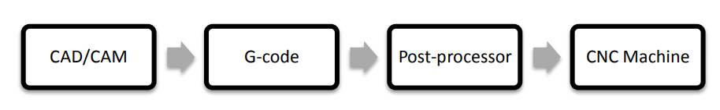
Figure 1.1: Flow of the CNC machine operation

The CNC machine is a system. To complete the system of CNC machine, there are 4 components which are mechanical design, drives module, system software and Automatically Programme Tool (APT) postprocessor. For the mechanical design system, this part is the part of hardware of machine which is the part body. For the drive system, the command signal was received from microprocessor. Microprocessor is consisting of motors, amplifier units and a power supply. For the software system, it is generate the program to the CNC machine to start the movement of tools and workpiece. For the APT postprocessor, it was developed to produce the G-code and M-code that can be used by the CNC machine.
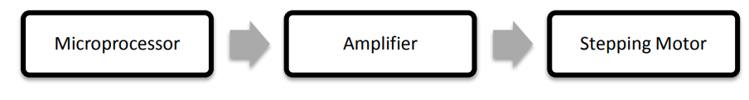
Figure 1.2: Flow of Mini CNC Machine
Besides that, CNC machine also include of wiring in order to connect the power to the machine. To complete the whole CNC machine, all the elements must be in the good condition and must put at the right place.

PROBLEM STATEMENT
Nowadays, the world are becoming highly technology with a lot of things become smaller and thinner. Even now the things especially in engineering and technology have the things in nano and micro size. Same goes to CNC Machine; this machine is now has variety of size in the market. All type of machine have own purpose, even though the size is big or small. The usual CNC machine can machine the big workpiece depends on the machine specification. The mini CNC machine only can machine the small workpiece depend on the machine specification. This project is about to overcome the problem of machining the small part. Even the usual CNC machine can machine the small workpiece, it will increase the time on setup the workpiece to the machine to get the accurate result. The mini CNC machine will give the small area of setup the workpiece and it will be easier to get the accurate place or result for the workpiece.

OBJECTIVES
The objectives of this project is to design and implement a low cost automatic CNC plotter machine (Drawing surface area 30mm x 30mm) which will be able to draw a any image on a solid surface.

PROJECT EXPECTATION
By the end of this project, student is expected to:
- Develop the Mini CNC Machine
- Learn to write G-code
- Learn how to connect the wiring of the circuit

CHAPTER 2
THEORETICAL REVIEW OF THE PROJECT

2.1 INTRODUCTION
The purpose of this chapter is to provide a review of past research efforts related to Mini CNC machine and the important component in developing this machine. From the related journal and article, the idea in CNC machine is developed before go further for the next chapter in completing this project.
2.2 MINI CNC MACHINE
Mini CNC Machine is the small CNC Machine that can operate same likes other CNC machine. This machine is designed for the specific dimension. The CNC machines can be divided into two groups, which are turning machines and milling machine. A turning machine is generally made up of a device that spins a workpiece at high speed and the tool is moved back and forth and in and out until the desired shape is achieved. A milling machine is a machine that has spindle which is same as the router, with a special tool that spins and cuts in various directions and moves in three different directions along the X, Y, and Z axis.
A CNC machine with several unique features, such as simplicity and reliability, was developed for studying computerized numerical control and its associated software. The machine is especially useful for educational and research purposes, and it is easy to integrate with other manufacturing systems. It can also be used to introduce the CNC aspect of CAM systems without involving too many complexities that are present in commercial systems.

The three-axis machine is capable of continuous path movement. Its design is carried out with the following considerations in mind:
- Intended as an instruction or research kit, it should be small in size and lightweight.
- The worktable must have sufficient movement.
- The spindle head must be restrained to a single degree of freedom.

BLOCK DIAGRAM
In this idea of project, Arduino microcontroller platform with ATMEGA 328 core is used. It can be easily interfaced with PC using USB module whereas also with the easy drivers and stepper motors to.
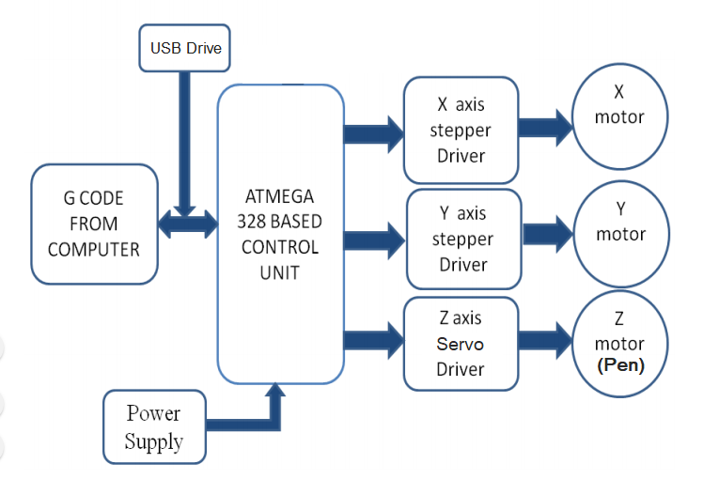

CHAPTER 3
Software

- G-code
G-code To draw a text file or design a circuit layout by the CNC plotter firstly the files need to be converted into G-Code. G-Code is a set of instruction that contains number of X, Y, Z, coordinates depending on the file. G-Code instructs X axis of the machine to travel from X1 to X2 points with a specific speed and same is true for Y axis, but for Z axis the coordinates are fixed because only vertically up & down movements are involved, below example for some G-code instructions:
G0 Rapid Move
- Format G0XxYyZz X,Y,Z = axes on a three-axis machine x, y, z = distance in incremental units, or absolute coordinates, to which the axes specified by the preceding upper case letter is designated to move
- G0X2.00Y2.00Z2.00
- G1 Linear Cutting MoveFormat G0XxYyZz X,Y,Z = axes on a three-axis machine x, y, z = distance in incremental units, or absolute coordinates, to which the axes specified by the preceding upper case letter is designated to move
- G0X2.00Y2.00Z2.00
- Format G0XxYyZz X,Y,Z = axes on a three-axis machine x, y, z = distance in incremental units, or absolute coordinates, to which the axes specified by the preceding upper case letter is designated to move
- G0X2.00Y2.00Z2.00
REFERENCES
REFERENCES
G1 Linear Cutting Move:
- Format G1XxYyZz X,Y,Z = axes on a three-axis machine x, y, z = distance in incremental units, or absolute coordinates, to which the axes specified by the preceding upper case letter is designated to move
- G1X-3.50Y-4.00Z1.00

G2 Clockwise Arc
- G2XxYyIiJi or G2XxZzIiKi or G2YyZzJiKi
- I = X axis, when used to designate a center point position J = Y axis, when used to designate a center point position K = Z axis, when used to designate a center point position i = an incremental value representing the distance in units that the axis specified by the preceding letter is designated to move
- G2X5.00Y-1.00I3.00J2.00
G3 Counterclockwise Arc
- Format G3XxYyIiJi or G3XxZzIiKi or G3YyZzJiK
- G3Y9.00Z15.00J3.00K6.00

- AutoCAD
Exporting table from AutoCAD to Excel using list.lsp uses ActiveX to extract x,y,z coordinates from points, polylines and any drawings and list them in a comma-delimited text file you can open in Excel.
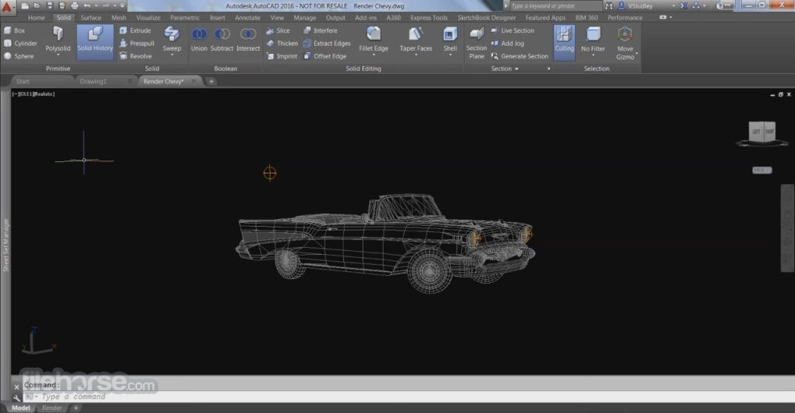

- Processing
Processing Processing is open source programming language software which is used for electronic drawings. GTCRL processing program is used to send G-code file from user interface to CNC plotter. The Fig. 6 shows the user interface of processing 2.2.1 software after running GTCRL program. The port of Arduino Uno is selected by pressing „P‟ button on keyboard hence „G‟ button is used to upload our desired G-code file. Immediately CNC machine will start sketching selected G-code file. Sketching can be stopped by pressing „X‟ button
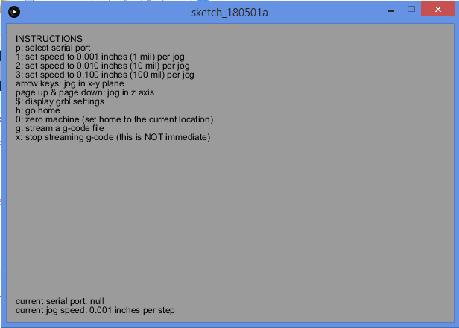

CHAPTER 3
Hardware

The start of the flow work is to understand the fundamental of the Mini CNC machine. After doing some research and study about the Mini CNC machine, the next step that is needed to do is design the machine according to the understanding of the mini CNC machine concept. The designing of the machine including with the wiring connection and the software that is use to generate the program. Develop the machine base of the design that has been drawn

MAIN PARTS OF CNC PLOTTER
- Stepper Motor
Stepper can convert digital pulse in to movement of pen with respect to axis X and Y direction. A stepper motor is a brushless motor that divide a full rotation into a number of equal steps, the stepper motor is known by its property to convert a number of impulses into a defined increment in the shaft position. Each pulses move the shaft through a fixed angle. We have used 2 stepper motors with pulley and belts. Motor output will be in the form of movement of belt with respect to X and Y Axis
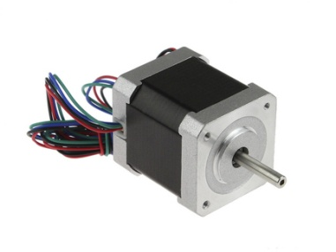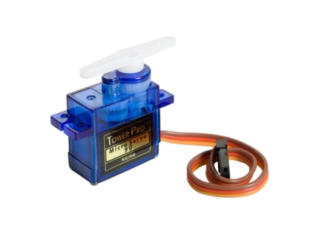
Figure 3.1 Stepper motor and Servo motor

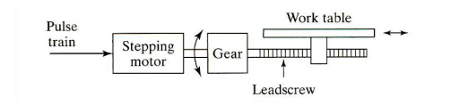
Fig. stepper motor
- Arduino Uno
Arduino is an open-source electronics platform based on easy-to-use hardware and software. Arduino boards are able to read inputs - light on a sensor, a finger on a button, send message - and turn it into an output - activating a motor, turning on an LED, publishing something online. We can tell board what to do by sending a set of instructions to the microcontroller on the board. Arduino UNO is a microcontroller board, it contains everything needed to support the plotter. Hereit controls the position of motors with help of a program. It is open source platform based on easy to use hardware and software. It has digital and analog input/output pins which can interface into various expansion board and other circuits and microcontroller with complementary components that helps in programming and incorporation into other circuits. It works on 5 volts current.
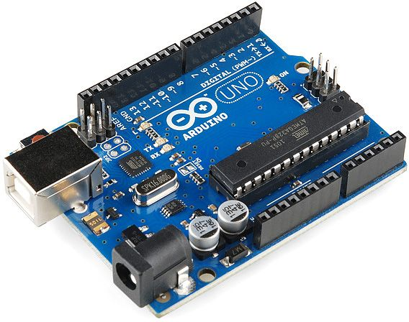
Final CNC Machine:
After all those mounting of motors with the printing mechanism unit and axis with each other also with basement implementation became completed. The Fig. 12 shows complete CNC plotter.
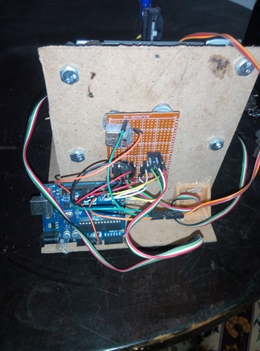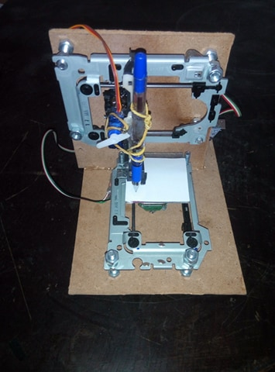

Drawing Experiments and result:

- Bad results, uncertainty:

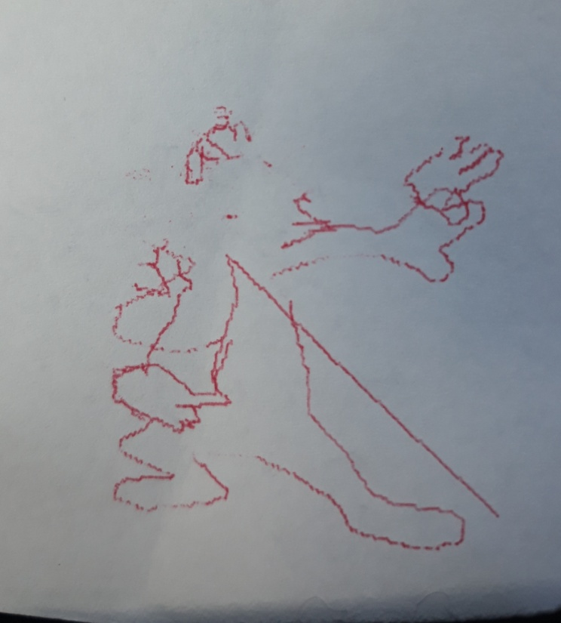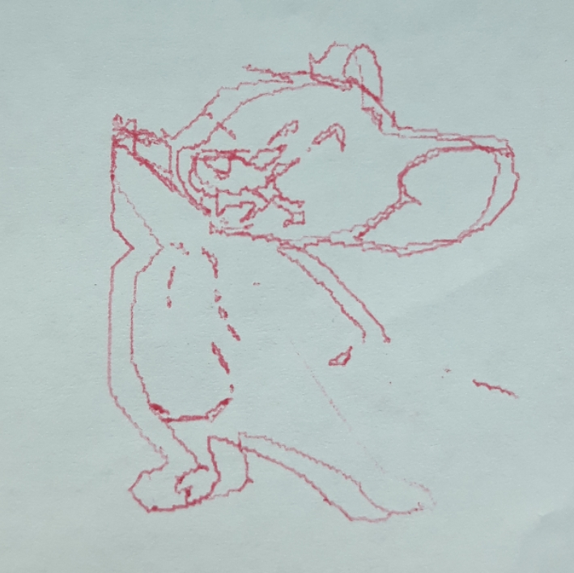

- Better results but still bad accuracy:
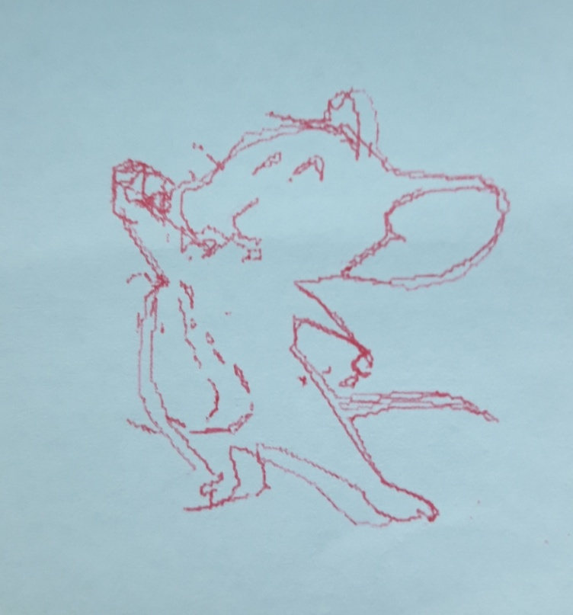

Final results:

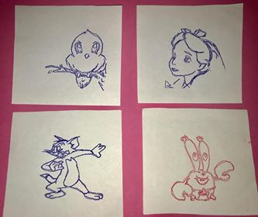

FUTURE SCOPE
The pen of the machine can be replaced by a laser to make it work like a laser engraving or cutting machine. Engraving machine can be used on wood. The pen can also be replaced with a powerful drill so that it can be used for both milling and drilling purposes. The servo can be replaced with a stepper motor and the pen with a 3-D pen to make it a 3-D printer which can print objects with dimensions. By extrapolation of the axes, the working area of the machine can be extended keeping the algorithm unaltered.
- Increase machine size.
- Improve machine Resolution.
- Develop the machine into 3D CNC machine.
- Develop one program to do all process steps

CONCLUSION
This project is about building a mechanical prototype of a CNC plotter machine which is able to draw any draw layout of 3cm by 3cm ( any image/text) on a given solid surface. It consumes low power and works with high accuracy due to precise controlling of stepper motors. This is a low cost project as compared to other CNC product. It is made with easily available components and spare parts. It is designed for private manufacturing and small scale applications in educational institutes. The machine is designed with a very simple construction scheme and can be carried anywhere without much effort. The algorithm used is simple. The pen can be replaced with a pinhead or laser head or any other tool for different purpose of use.

REFERENCES

