

An-Najah National University
Faculty of Engineering & Information Technology Building Engineering Department
Redesign of Jenin chamber of commerce
Graduation project report (I) Prepared by:
Danya Al-atrash Hala Assaf Oday Arafat
Supervised by: Eng. Fady Fatayer.

Presented in partial fulfillment of the requirements for Bachelor degree in Building Engineering.
Jan 2023

DEDICATION
بسم هللا الرحمن الرحيم
يا ُحلُماً ما ها َن يوماً، يا دعا ًء ألحقته بآمين

ٌي ،الحمد هلل حين البدء وعند الختام
ُخت َم سع
ٌب وال
ُخ ّط در
الحمد هلل الذي لوال هداه لما اهتدينا وال

بعد الثناء والصالة على خاتم األنبياء والمرسلين، نهدي مشروع تخرجنا إلى وال ِدينا الذين حصدوا األشواك عن

دربنا ليمهدوا لنا طريق العلم، فنحن هنا بفضل دعواتهم الصادقة التي المست عنان السماء، وإلى كل من علمنا

حرفا أو كلمة، إلى مدرسينا األعزاء في كلية الهندسة، وإلى أصدقائنا وزمالئنا، إلى شهداء الوطن، شهداء فلسطين،

وإلى أسرانا البواسل، وإلى كل من كان في طريقنا، مر عابرا أو استندنا إليه.

ACKNOWLEDGMENT
First and foremost, we thank God for giving us the strength and motivation to pursue this project. We also want to express our sincere appreciation to Eng. Fady Fatayer for his guidance and assistance in researching and writing our report. The faculty at An- Najah National University's Building Engineering Department have also been a valuable source of support, providing us with the necessary information and answering our questions throughout this semester. And we don’t forget to thank our families and friends for their continuous support and encouragement, and for providing all means of comfort for us to do the work in the best possible way.
Finally, we would like to acknowledge the contributions of all those who have helped us complete this project, and we extend our heartfelt thanks to all those who have contributed to the success of this project. As we reflect on the skills and insights gained and the memories made, we hope that our project will be remembered for years to come.

DISCLAIMER STATEMENT

This report was written by Danya Al-Atrash, Hala Assaf and Oday Arafat at the Building Engineering Department, Faculty of Engineering, An-Najah National University. It has not been altered or corrected, other than editorial corrections, as a result of assessment and it may contain language as well as content errors. The views expressed in it together with any outcomes and recommendations are solely those of the student(s). An-Najah National University accepts no responsibility or liability for the consequences of this report being used for a purpose other than the purpose for which it was commissioned.

TABLE OF CONTENTS

DEDICATION I
ACKNOWLEDGMENT I
DISCLAIMER STATEMENT II
List of Figures V
List of Tables VIII
- List of symbols IX
ABSTRACT 1
Introductory 2
  - Introduction 2
  - Project Problem 2
  - Objectives 2
  - Scope of the Work 2
  - Methodology 3
  - Limitations and Constraints: 3
  - Codes and Standards 3
  - Earlier Course Work 4
Environmental- Architectural Aspects 5
Literature Review 5
    - Standards and Specifications 5
Case Study 14
Site analysis 21
    - Location 21
    - Topography 21
    - Site plan 22
    - Sun path diagram 22
    - Climate in Jenin 24
    - Noise readings 26
    - Shading analysis 26
    - Solar radiation analysis 31
    - Wind 55
Architectural modifications 56
    - Bubbles Diagram after modifications 60
    - Conclusion for architectural modifications 63
    - Edited plans 64
Environmental analysis and Design 78
    - Daylight factor 78
    - Heating and cooling load 92
    - Environmental treatment strategies 94
Structural Aspects 101
Introduction: 101
Assumptions 101
    - STRUCTURAL CODE AND DESIGN 101
    - Material 101
    - Loads 101
Structural system 102
    - Slab Design: 102
    - Columns Design 104
    - Expansion Joint 105
Structural Model 105
    - Structural model checks 107
Quantity surveying & Cost Estimate 125
  - Introduction: 125
  - Cost estimation Techniques: 125
    - Analogous estimation 125
    - Parametric estimation 125
    - Three-point estimation 125
    - Bottom-Up estimation 126
  - Methodology 126
  - Limitations 126
  - Summary 126
Conclusion 127
ARCHITECTURAL Aspects 127
  - ENVIRONMENTAL Aspects 128
  - Structural Aspects 131
  - Quantity surveying & Cost Estimation 131
- References 132

LIST OF FIGURES
Figure 2.1: Computer work station. 5
Figure 2.2: disable people. 6
Figure 2.3: disable people path requirements. 6
Figure 2.4: disable people ramp requirements 6
Figure 2.5: Toilets design requirements 7
Figure 2.6: Disable people Toilets design requirements 7
Figure 2.7: Disable people Toilets design requirements 8
Figure 2.8: Meeting hall stairs standards. 9
Figure 2.9: Stairs distribution in the meeting hall according to standards. 10
Figure 2.10: Stage standards 10
Figure 2.11: Restaurant tables layout 11
Figure 2.12: Parking spaces standard distances. 12
Figure 2.13: Chamber of commerce building 17
Figure 2.14: ground floor plan 17
Figure 2.15: First floor plan 18
Figure 2.16: Third floor plan. 19
Figure 2.17: Ground floor plan 20
Figure 2.18 : Location of the project. 21
Figure 2.19: Topography of the project 21
Figure 2.20: site plan. 22
Figure 2.21: Sun path diagram. 22
Figure 2.21: Revit model 23
Figure 2.22: Monthly climate in Jenin 24
Figure 2.23: Average High and Low Temperature 24
Figure 2.24: Average Monthly Rainfall 25
Figure 2.25: Hours of Daylight and Twilight 25
Figure 2.26: Average Wind Speed in Jenin 25
Figure 2.27: Noise readings 26
Figure 2.28: Elevations of the building 26
Figure 2.29: Shading in winter at 8AM. 27
Figure 2.30: Shading in winter at 12PM. 27
Figure 2.31: Shading in winter at 2PM. 28
Figure 2.32: Shading in summer at 8AM. 29
Figure 2.33 Shading in summer at 12PM. 29
Figure 2.34 Shading in summer at 2PM. 30
Figure 2.35: Solar radiation on south east elevation in winter at 8 am 31
Figure 2.36: Solar radiation on south west elevation in winter at 8 am 32
Figure 2.37: Solar radiation on North West elevation in winter at 8 am 33
Figure 2.38: Solar radiation on north east elevation in winter at 8 am 34
Figure 2.39: Solar radiation on south east elevation in winter at 12 Pm 35
Figure 2.40: Solar radiation on south west elevation in winter at 12 Pm 36
Figure 2.41: Solar radiation on North West elevation in winter at 12 Pm 37
Figure 2.42: Solar radiation on north east elevation in winter at 12 Pm 38
Figure 2.43: Solar radiation on south east elevation in winter at 2 Pm 39
Figure 2.44: Solar radiation on south west elevation in winter at 2 Pm 40
Figure 2.45: Solar radiation on North West elevation in winter at 2 Pm 41
Figure 2.46: Solar radiation on north east elevation in winter at 2 Pm 42

Figure 2.47: Solar radiation on South East elevation in summer at 8 am 43
Figure 2.48: Solar radiation on South West elevation in summer at 8 am 44
Figure 2.49: Solar radiation on North West elevation in summer at 8 am 45
Figure 2.50: Solar radiation on north east elevation in summer at 8 am 46
Figure 2.51: Solar radiation on South East elevation in summer at 12 Pm 47
Figure 2.52: Solar radiation on South West elevation in summer at 12 Pm 48
Figure 2.53: Solar radiation on North West elevation in summer at 12 Pm 49
Figure 2.54: Solar radiation on North East elevation in summer at 12 Pm 50
Figure 2.55: Solar radiation on south east elevation in summer at 2 Pm 51
Figure 2.56: Solar radiation on south west elevation in summer at 2 Pm 52
Figure 2.57: Solar radiation on North West elevation in summer at 2 Pm 53
Figure 2.58: Solar radiation on north east elevation in summer at 2 Pm 54
Figure 2.59: Wind direction. 55
Figure 2.60: Wind direction of the building 55
Figure 2.61: Bubbles diagram legend. 60
Figure 2.62: Ground floor bubbles diagram 60
Figure 2.63: first floor bubbles diagram 61
Figure 2.64: second and third floor bubbles diagram 61
Figure 2.65: fourth floor bubbles diagram 5th floor 62
Figure 2.66: fifth floor bubbles diagram 5th floor 62
Figure 2.67: First basement plan before modifications. 64
Figure 2.68: Second basement plan before modifications. 64
Figure 2.69: First basement plan before modifications. 65
Figure 2.70: Second basement plan before modifications. 65
Figure 2.71: Third basement plan before modifications. 66
Figure 2.72: Ground floor before modifications. 66
Figure 2.73: Ground floor after modifications. 67
Figure 2.74: First floor before modifications. 67
Figure 2.75: First floor after modifications. 68
Figure 2.76: Second floor before modifications. 68
Figure 2.77: Second floor after modifications. 69
Figure 2.78: Third floor before modifications. 69
Figure 2.79: Third floor after modifications. 70
Figure 2.80: Fourth floor before modifications. 70
Figure 2.81: Fourth floor after modifications. 71
Figure 2.82: Fifth floor before modifications. 71
Figure 2.83: Fifth floor after modifications. 72
Figure 2.84: sixth floor before modifications. 72
Figure 2.85: Sixth floor after modifications. 73
Figure 2.86: North- East Elevation. 74
Figure 2.87: South- East Elevation. 74
Figure 2.88: South- West Elevation. 75
Figure 2.89: North- West Elevation. 75
Figure 2.90: Section A-A. 76
Figure 2.91: Section B-B. 77
Figure 2.92: Daylight factor in ground floor before 78
Figure 2.93: Daylight factor in first floor before 79
Figure 2.94: Daylight factor in second floor before 80
Figure 2.95: Daylight factor in third floor before 81
Figure 2.96: Daylight factor in fourth floor before 82

Figure 2.97: Daylight factor in fifth floor before 83
Figure 2.98: Daylight factor in sixth floor before 84
Figure 2.99: Daylight factor in ground floor after. 85
Figure 2.100: Daylight factor in first floor after. 86
Figure 2.101: Daylight factor in second floor after. 87
Figure 2.102: Daylight factor in third floor after. 88
Figure 2.103: Daylight factor in fourth floor after. 89
Figure 2.104: Daylight factor in fifth floor after. 90
Figure 2.105: Daylight factor in sixth floor after. 91
Figure 2.106: Horizontal and vertical louvers used. 94
Figure 2.107: Horizontal louvers used. 94
Figure 2.108: Skylight used. 95
Figure 2.109: Ground floor daylight factor after treating 96
Figure 2.110: First floor daylight factor after treating 96
Figure 2.111: Second floor daylight factor after treating 97
Figure 2.112: Third floor daylight factor after treating 97
Figure 2.113: Fourth floor daylight factor after treating 98
Figure 2.114: Fifth floor daylight factor after treating 98
Figure 2.115: Sixth floor daylight factor after treating 99
Figure 3.1: Section in Upoot 103
Figure 3.2: Upoot dimensions 103
Figure 3.3: Upoot arrangement. 103
Figure 3.4: Expansion Joint location. 105
Figure 3.5: 3d structural model before separation. 105
Figure 3.6: part 1 structural model. 106
Figure 3.7: part 2 structural model. 106
Figure 3.8: Compatibility check for part 1 107
Figure 3.9: Compatibility check for part 2 107
Figure 3.10: Deflection from live load for part 1 108
Figure 3.11: Deflection from service load for part 1 109
Figure 3.12: Deflection from live load for part 2 109
Figure 3.13: Deflection from service load for part 2 110
Figure 3.14: Shear for B3 floor from ETABS for part 1 model. 111
Figure 3.15:Shear for B2 floor from ETABS for part 1 model. 111
Figure 3.16: Shear for B1 floor from ETABS for part 1 model. 112
Figure 3.17: Shear for GF floor from ETABS for part 1 model. 112
Figure 3.18: Shear for f1 floor from ETABS for part 1 model. 113
Figure 3.19: Shear for f2 floor from ETABS for part 1 model. 113
Figure 3.20: Shear for f3 floor from ETABS for part 1 model. 114
Figure 3.21: Shear for f4 floor from ETABS for part 1 model. 114
Figure 3.22: Shear for f5 floor from ETABS for part 1 model. 115
Figure 3.23: Shear for f6 floor from ETABS for part 1 model. 115
Figure 3.24: Shear for f7 floor from ETABS for part 1 model. 116
Figure 3.25: Shear for B3 floor from ETABS for part 2 model. 116
Figure 3.26: Shear for B2 floor from ETABS for part 2 model. 117
Figure 3.27: Shear for B1 floor from ETABS for part 2 model. 117
Figure 3.28: Shear for GF floor from ETABS for part 2 model. 118
Figure 3.29: Shear for F1 floor from ETABS for part 2 model. 118
Figure 3.30: Shear for F2 floor from ETABS for part 2 model. 119
Figure 3.31: Shear for F3 floor from ETABS for part 2 model. 119

Figure 3.32: Shear for F4 floor from ETABS for part 2 model. 120
Figure 3.33: Shear for F5 floor from ETABS for part 2 model. 120
Figure 3.34: Shear for F6 floor from ETABS for part 2 model. 121
Figure 3.35: Shear for F7 floor from ETABS for part 2 model. 121
Figure 3.36: Design results for part 1 model. 123
Figure 3.37: Design results for part 2 model. 124
Figure 5.1: Horizontal and vertical louvers used. 128
Figure 5.2: Horizontal louvers used. 129
Figure 5.3: Skylight used 130
Figure 5.4: Slab section. 131

LIST OF TABLES
Table I.1: List of symbols and abbreviations. IX
Table 2.1: Staff required toilets. 8
Table 2.2: Number of required Toilets in each floor. 8
Table 2.3: Tables standard dimensions. 11
Table 2.4: General spaces standard areas. 13
Table 2.5: Average High and Low Temperature 24
Table 2.6: Shading analysis summary in winter. 28
Table 2.7: Shading analysis summary in summer. 30
Table 2.8: Ground floor spaces assessment 56
Table 2.9: 1st floor spaces assessment 56
Table 2.10: 2nd and 3rd floors spaces assessment 57
Table 2.11: 4th floor spaces assessment 58
Table 2.12: 5th floor spaces assessment 58
Table 2.13: 6th floor spaces assessment 59
Table 2.14: Floors functions before and after modifications. 63
Table 2.15: Elements u-value before and after 92
Table 2.16: Total cooling and heating load before 92
Table 2.17: Total cooling and heating load after 93
Table 2.18: Elements u-value for treated model. 95
Table 2.19: Total cooling and heating load after treating 100
Table 3.1: Live loads for floors. 101
Table 3.2: Building parts weight 102
Table 3.3: Upoot pattern used. 104
Table 3.4: Equilibrium check results for part 1 model. 108
Table 3.5: Equilibrium check results for part 2 model. 108
Table 3.6: Stress strain check result for columns in part 1 model. 122
Table 3.7: Stress strain check result for columns in part 2 model. 122
Table 3.8: Stress strain check result for slab in part 1 model. 122
Table 3.9: Stress strain check result for slab in part 2 model. 122
Table 4.1: Cost estimation results. 126
Table 5.1: Floors functions before and after modifications. 127
Table 5.2: Elements u-value for treated model. 130
Table 5.3: Cost estimation results. 131

List of symbols
Table I.1: List of symbols and abbreviations.

Symbol | Description
₪or ILS | Israeli shekel
% | Parentage
N | North direction
mm | millimeter
cm | Centimeter
m | Meter
mm2 | Square millimeter
cm2 | Square centimeter
m2 | Square meter
mm3 | Cubic millimeter
cm3 | Cubic centimeter
m3 | Cubic meter
KN | Kilo newton
Pa | Pascal
Mpa | Mega Pascal
Kw | Kilo watt
W | watt
Wh | Watt hour
DF% | Daylight factor
dB | Decibels (acoustics measurement unit)
Lux | Unit used to quantify illumination
fʹc | Compressive strength of concrete
fy | Yield stress of steel
D.L | Dead load
L.L | Live load
S.I. D | Super imposed dead load
W | Load
Wu | Ultimate load
Ws | Service load
W. L | Wind load
S. L | Snow load
M | Moment
Mu | Ultimate moment
V | Shear force
Vu | Ultimate shear force
@ | at
Z | Seismic zone factor

Symbol | Description
L/s | Liter per second
Symbol | Description
m/s | Meter per second
C.S | Column strip
M.S | Middle strip
C/C | Center to center
Psf | Pound per square foot

ABSTRACT
All countries want to enhance its economics. In order to enhance the country situation to provide the better life for the people, promote initiatives and businesses, and form partnerships. Which leads to the prosperity of the country.
Redesigning the Jenin Chamber of Commerce building is the planned graduation project, and it will serve a variety of objectives, including achieving comfort for the people working in this place to enhance productivity. That’s will lead to more accurate work, which will lead to enhance the quality of work done by this vital institution.
A strategy that is based on search, analysis and make the best solution will be followed to achieve the previous goals.
The aforementioned procedure will be carried out in two parts, the first one in this semester which will based on the assessment of the current building situation by making a literature review which based on reading books, research, articles and case studies to collect all needed standards that will help in the assessment process, making site analysis where the building located, environmental assessment for the current situation, schematic of a structural design.
To perform the first part, some computer programs were needed, for Environmental analysis assessment and architectural modeling Revit software will used, for structural design verification ETABS 2016 will used.
The second one during the second stage of Graduation Project, which will base the mechanical distribution, which includes water, HVAC, and sewerage systems, as well as the electrical distribution, which includes power systems and a control panel, will be designed in conjunction with the architectural, detailed structural designs, and finishing materials details.
The outputs of our project will be presented at the conclusion in the form of a report with associated tender papers, which will contain design details, tables of quantities, and shop drawings. The final results will be shown at a presentation.

INTRODUCTORY

Introduction

During the rapid increase in companies, there are needs to provide an institution that protect these companies. (Jamie Johnson, 2021)
Chamber of commerce is very vital institution located in each city in the world, and contains a group of business people to protects and promote the interest if its members.
(Jamie Johnson, 2021)

The first chamber of commerce was established in 1599 in France, and all over the world the chamber of commerce exists. (Jamie Johnson, 2021)

Project Problem

There are many problems existing in office buildings, the most important problem is environmental comfort which based on providing natural lighting in the building, which causes uncomfortable work area also the visual design comfort which impacts on the productivity inside the building.(FIVE OFFICE DESIGN PROBLEMS THEIR AND SOLUTIONS, 2022) Therefore, an integrated redesign will make for this project.

Objectives

There are many objectives in this study, but the main objective is to perform an integrated redesign of Jenin Chamber of Commerce building based on the retrieved architectural plans from Al-Aqsa engineering office located in Jenin. Also seeking to provide fully environmentally comfort building considering safety instructions in the design which based on compliance with civil defense laws in the design.
Based on that, there are many stages will be followed step by step to make this, the first stage is making an evaluation for the architectural design which will based on literature review that contains the architectural design standards and codes also analyzing a case study related to these types of the facilities. The second stage is making an evaluation for the environmental design which contains the following steps: the first step is making sun analysis and over shadowing analysis; the second step is making sound analysis by visiting the site in the rush hours the final step is CFD analysis for air movement outside and inside the building. The third stage is analyzing of the structural system which base on the making a model verification check for the ETABS structural model.

Scope of the Work

The scope of this research is to reach to an integrated building and comfortable.

Methodology

The methodology contains many stages, the first stage is collecting data by conducting a literature review that contains codes, standards, and case studies to help for making the assessment and evaluation to make the modifications. After that, the environmental assessment will be made as in the second stage which is about the environmental analysis and evaluation based on the original architectural plans to enhance the environmental situation, to make this, some computer tools and programs will be used such that Revit for solar radiation analysis, overshadowing assessment and heating and cooling assessment, flow design for wind analysis. After that the fourth stage is making all needed modifications and checking it another time, the final stage is about structural design verification which is about making a structural design for all structural elements followed by structural design verification using Etabs software and the final stage is estimating the total cost of the building which will be based on the collected data that depends on previous buildings that have the same function.

Limitations and Constraints:

There are many limitations and constraints that may effect on the redesign phase:

- The original architectural plans don’t contain the detailed site plan.
- Accuracy in topography received from the office is not high.
- Surrounding buildings.
- Street directions in the region.
- Outdoor noise.
- Land area.
- Allowable building area.

Codes and Standards

- ACI 318-14 for concrete design
- ASCE/SEI 7-16 for structural design loads
- Metric Handbook for architectural design standards
- Neufert for architectural design standards

Earlier Course Work

Architectural Design
Design of concrete structures 1,2 and 3 Construction building materials Building construction engineering 1, 2 Thermal design
Acoustics design Lighting design Building core systems HVAC design
Operation and maintenance
Construction economics and quantity surveying Integration of building systems
Steel design

ENVIRONMENTAL- ARCHITECTURAL ASPECTS

Literature Review

Literature review was divided into two parts, the first one is standard and specifications and the second is needed spaces for that facility.

Standards and Specifications

      - General design standards

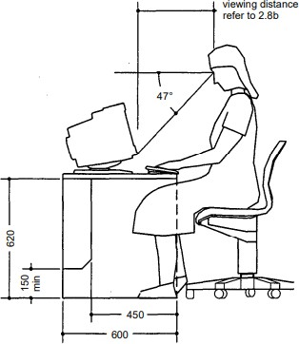

Figure 2.1: Computer work station.(ADLER, 2007)

      - Disabled people requirements (ADLER, 2007)

Entrance width >=1.3m  Width of door >=0.9 Threshold height<=15mm Tread width >=0.3m Raise height <=0.15m Ramp slop <=6%
Providing handrails at 0.90 height for two ends

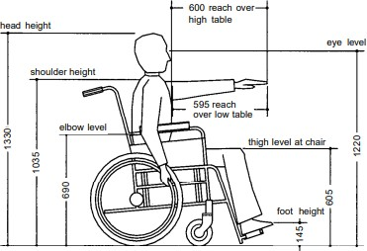

Figure 2.2: disable people.(ADLER, 2007)

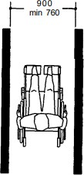

Figure 2.3: disable people path requirements.(ADLER, 2007)
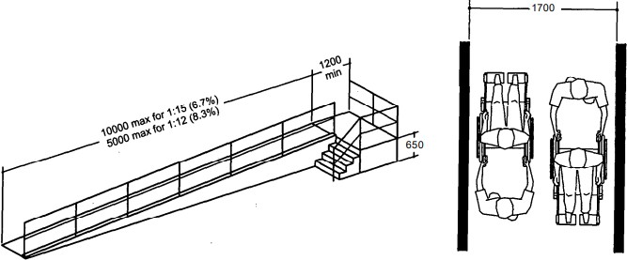

Figure 2.4: disable people ramp requirements.(ADLER, 2007)

Toilets
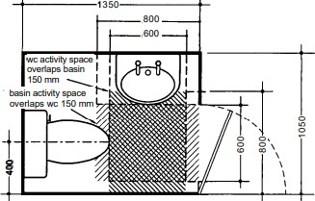

Figure 2.5: Toilets design requirements.(ADLER, 2007)

Minimum toilet area = 1.41 m2(ADLER, 2007)
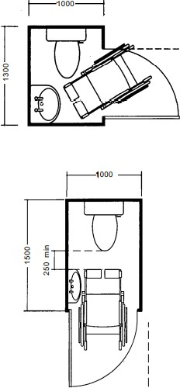

Figure 2.6: Disable people Toilets design requirements.(ADLER, 2007)

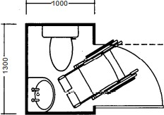

Figure 2.7: Disable people Toilets design requirements.(ADLER, 2007)

Minimum area = 1.30m2

Table 2.1: Staff required toilets. (ADLER, 2007)
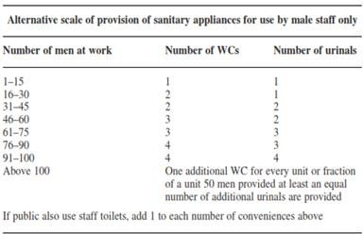

Table 2.2: Number of required Toilets in each floor. (ADLER, 2007)

Floor | Needed Men and women WC |  | Case | Needed Disabled WC |  | Case
Floor | Exists | Required | Case | Exists | Required | Case
GF | 8 | 6 | Ok | 1 | 1 | Ok
1st | 9 | 8 | Ok | 1 | 1 | Ok
2nd | 13 | 10 | Ok | 0 | 1 | Add one toilet for disabled
3rd | 13 | 10 | Ok | 0 | 1 | Add one toilet for disabled
4th | 4 | 4 | Ok | 1 | 1 | Ok
5th | 13 | 10 | Ok | 1 | 1 | Ok
6th | 4 | 4 | Ok | 1 | 1 | Ok

For meeting hall

Chairs:

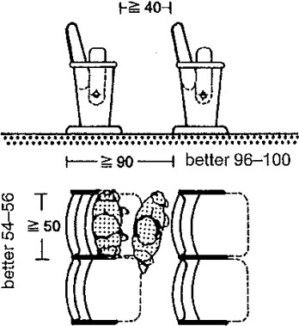

Figure 2.8: Meeting hall stairs standards. (Neufert & Neufert, 2012)
As shown, stairs width >=0.50 m and clear distance between chairs >=0.40 m
(Neufert & Neufert, 2012)

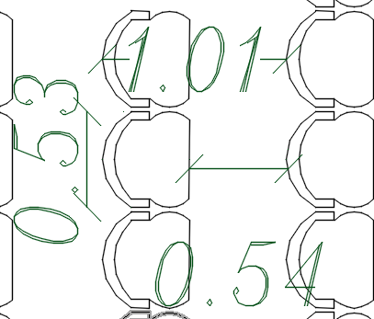

Figure 2.9: Stairs distribution in the meeting hall according to standards.

Stage:
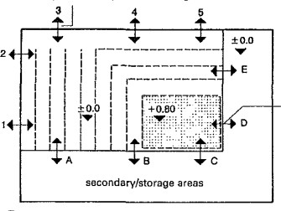

Figure 2.10: Stage standards.(Neufert & Neufert, 2012)

The stage height = 0.80 m, and the dimensions is based on the space dimensions.(Neufert & Neufert, 2012)

Restaurant and coffee shop

Table 2.3: Tables standard dimensions.(ADLER, 2007)

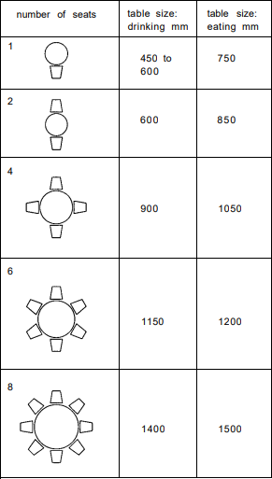
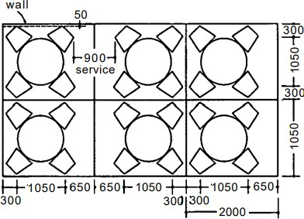

Figure 2.11: Restaurant tables layout(ADLER, 2007)

Parking spaces and car ramps

The required number of parking spaces = 1/60m2(Jittrapirom, 2010)

Total building area = 6000m2 >number of parking spaces = 100

A three additional parking spaces are needed for disabled people. (Jittrapirom, 2010)

A one floor needed to add for the building Total number of needed parking spaces = 103
      - Parking space dimensions

The standard dimensions of the parking space are 5.00 m length and 2.20 m width.
(ADLER, 2007)
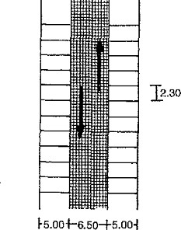

Figure 2.12: Parking spaces standard distances. (ADLER, 2007)

      - Car ramp slope<=15% (ADLER, 2007)

Elevators

After calculations, the total number of elevators required = 3

Emergency exits

      - The number of emergency exists >=2 (Ontario Building Code 2012, 2012)
      - Stairs width not less than 1 m. (Ontario Building Code 2012, 2012)
      - Width of emergency exits door not less than 1m. (Ontario Building Code 2012, 2012)

Fire egressing distance

Codes define the distance of travel required to enter an exit, this is extremely important where the taken time to find an exit, people may be exposed to fire or smoke.
A general rule is that the overall travel distance for at least one exit must not exceed 150 feet (45.72m) in non-sprinkled buildings or 200 feet (61.00m) in buildings that Covered by a sprinkler system. (Life Safety - Means of Egress / Exits – NFPA 101, 2020)

Corridors

The width corridor >=1.8m (Neufert & Neufert, 2012)

Spaces standard areas

Table 2.4: General spaces standard areas.

Space name | Standard Area | Reference
WC | 1.41 | (ADLER, 2007)
WC Disabled | 2.20 | (ADLER, 2007)
Office | 9.00 | (ADLER, 2007)
Bedroom | 12.00 | (Mahajan, 2022)
Kitchen | 3.00 | (ADLER, 2007)
Public Services | 60.00 | (Ambiencedore, 2022)
Secretary | 15.00 | (ADLER, 2007)
Waiting Room | 12.00 | (Mahajan, 2022)
President office | 20.00 | (ADLER, 2007)
General manager office | 20.00 | (ADLER, 2007)
Secretary | 15.00 | (Ambiencedore, 2022)
Meeting Room | 22.00 | (Ambiencedore, 2022)

Case Study

Adana Chamber of Commerce Service Building
“The building, on the land of Turhan Cemal Beriker Boulevard, as being Adana’s outward gate meets at the same time, new comers to the city”(YEGENAarchitectural, 2022).
Design concept:
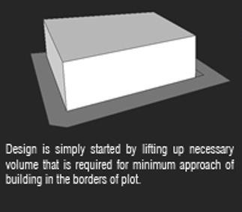
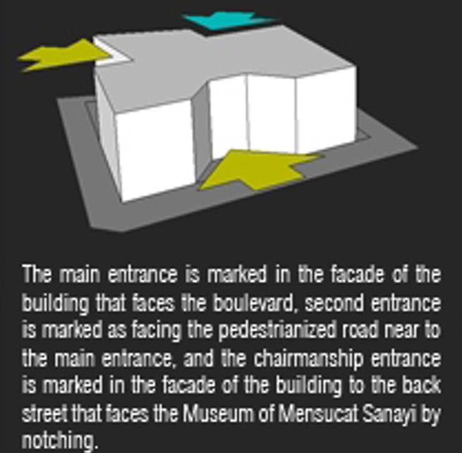

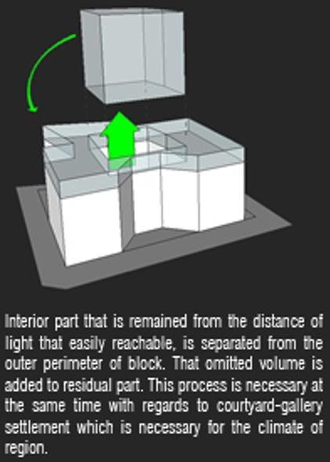
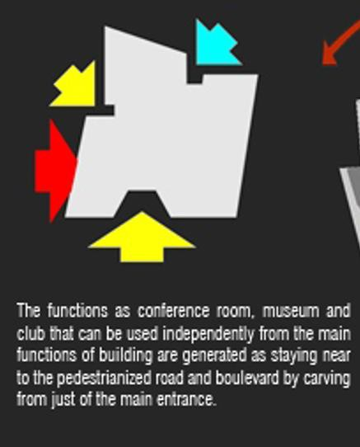

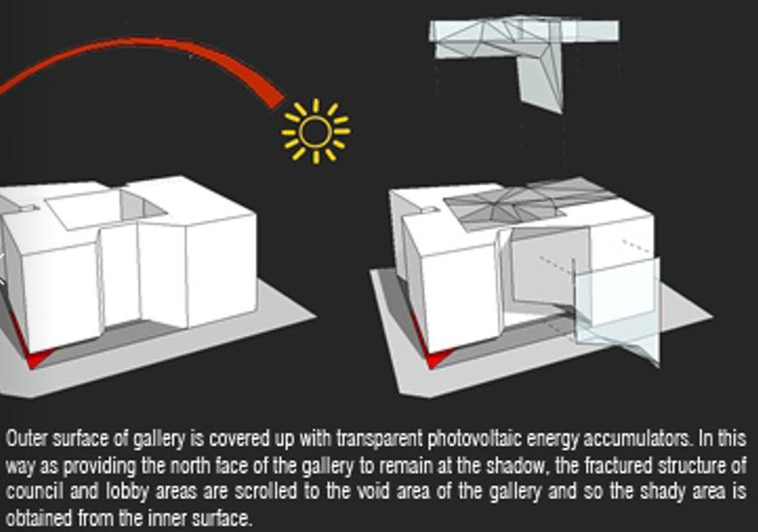
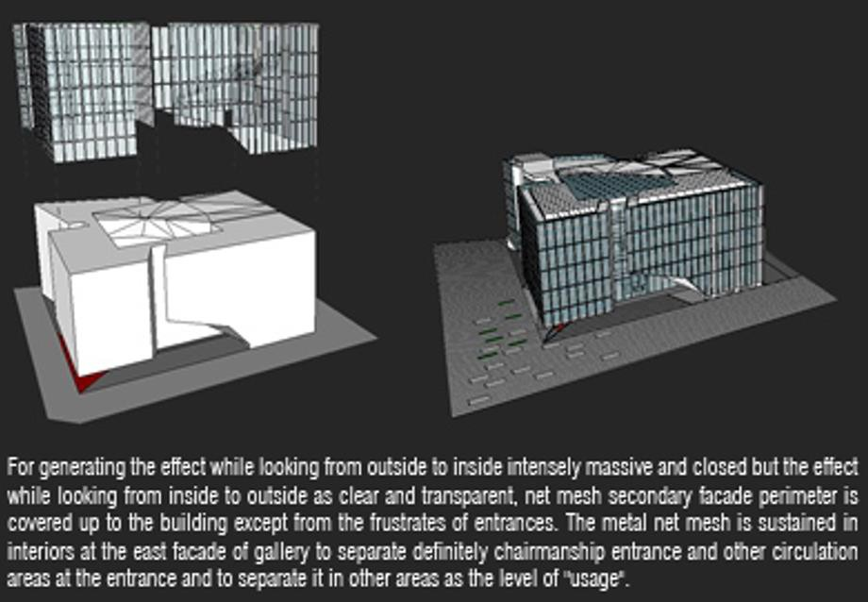

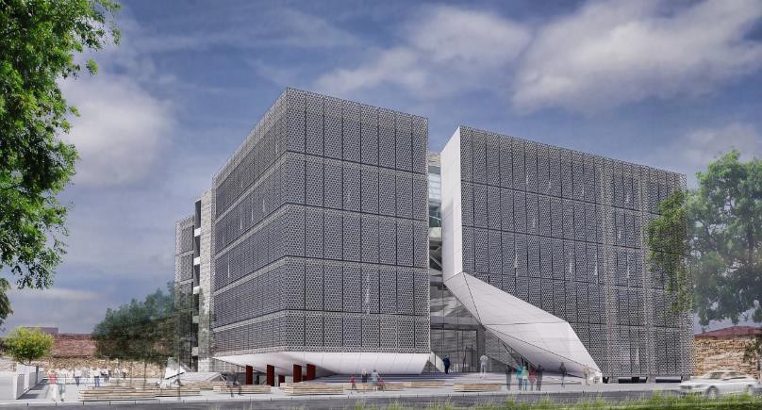

Figure 2.13: Chamber of commerce building.

Plans:

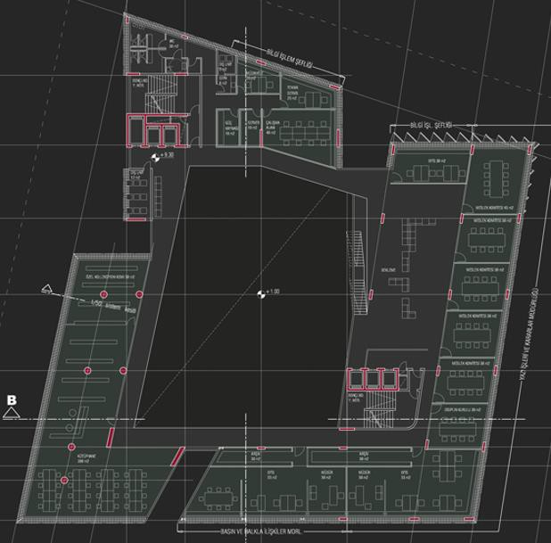

Figure 2.14: ground floor plan

This floor contains meeting rooms.

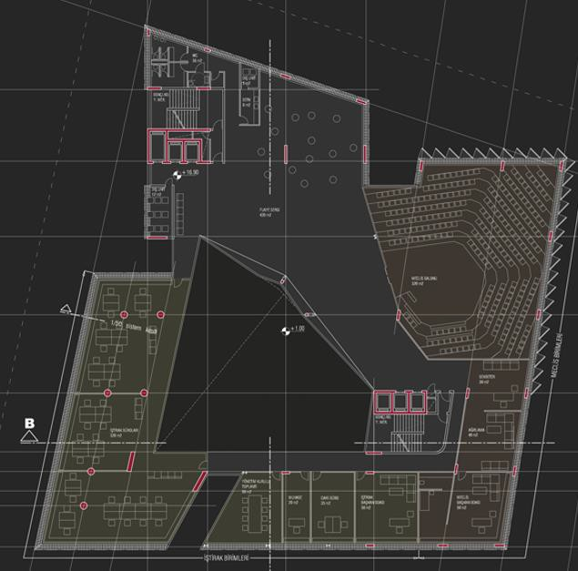

Figure 2.15: First floor plan

This floor contains offices and meeting hall.

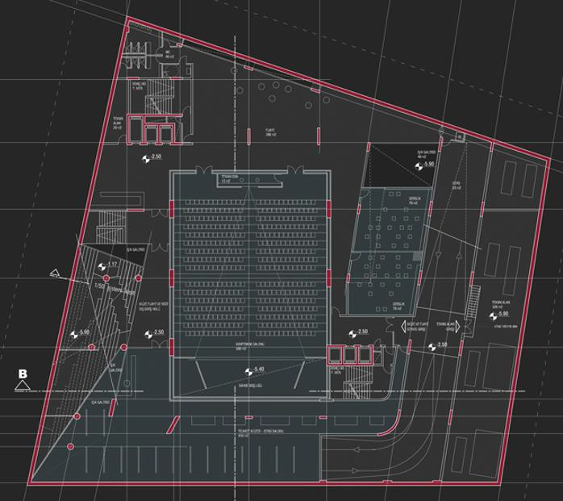

Figure 2.16: Third floor plan.

This floor contains meeting hall.

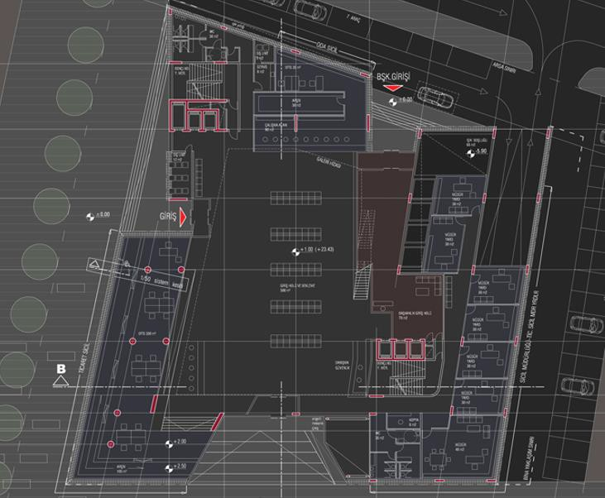

Figure 2.17: Ground floor plan

This floor contains public service hall, offices and president office.

Spaces existed in the facility and its achievement in this project: Offices 
Meeting hall  Public service hall  President office  Kitchen 
Archive 

IT and servers' room 

Reception 

Waiting areas 

Site analysis

Location

The location of the building in Jenin-Haifa street.
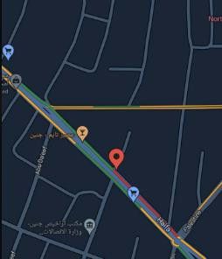

Figure 2.18 : Location of the project.

Topography

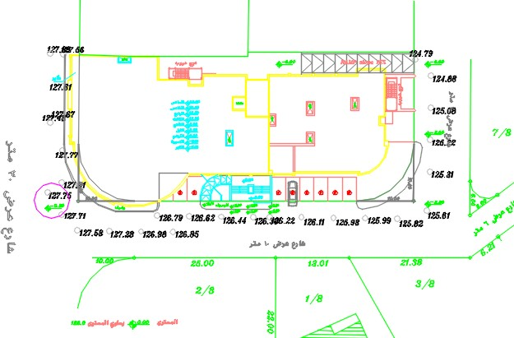
Figure 2.19: Topography of the project

Site plan
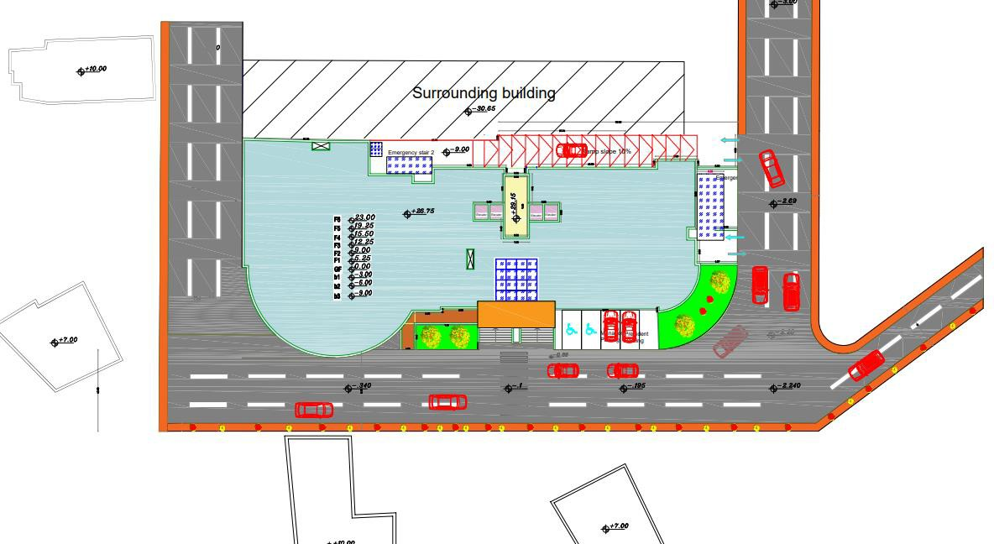

Figure 2.20: site plan.

Sun path diagram

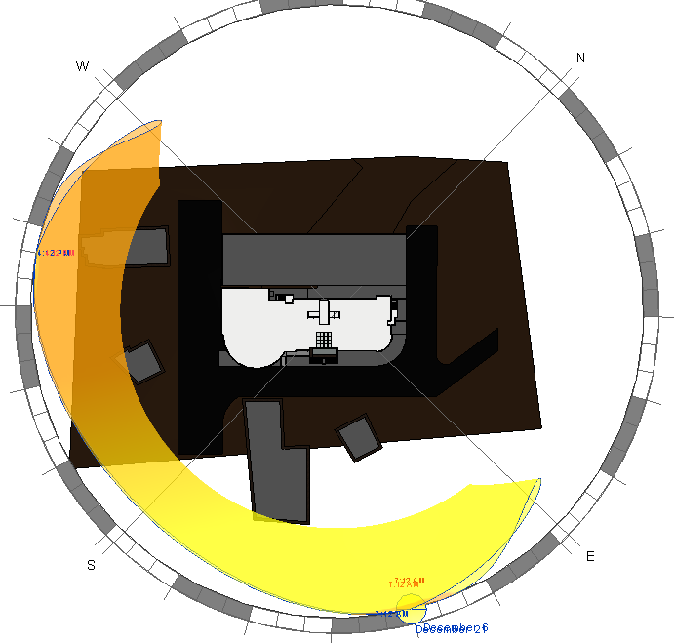

Figure 2.21: Sun path diagram.

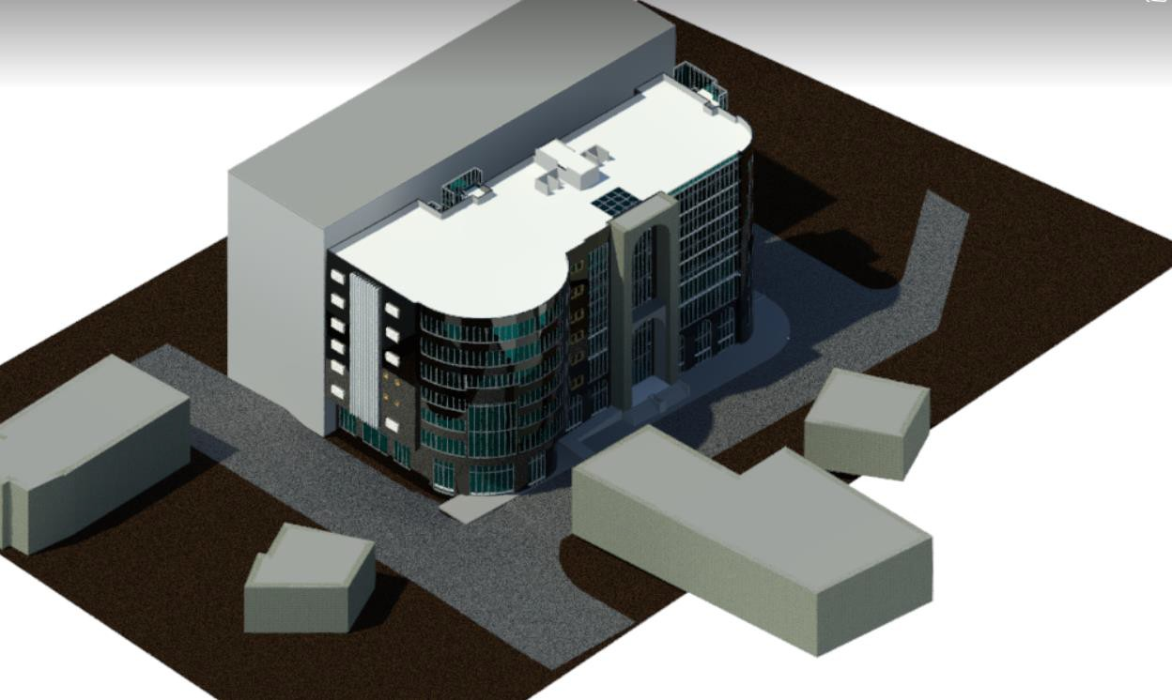

Figure 2.22: Revit model.

Climate in Jenin
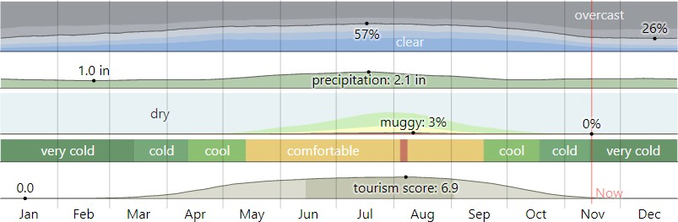

Figure 2.23: Monthly climate in Jenin(weatherspark, 2022)
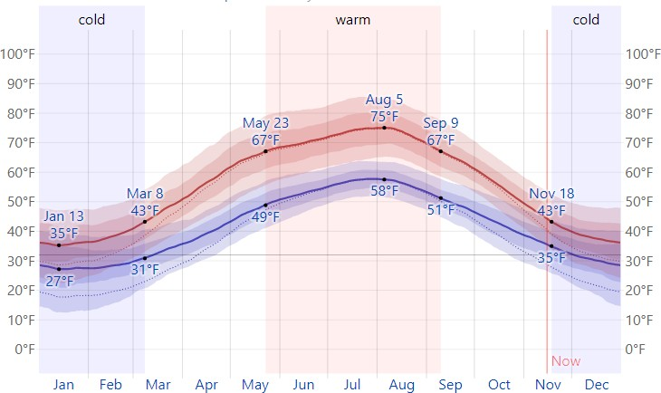
Figure 2.24: Average High and Low Temperature(weatherspark, 2022) Table 2.5: Average High and Low Temperature(weatherspark, 2022)
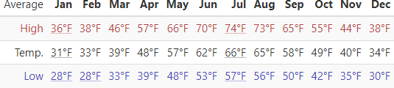

.
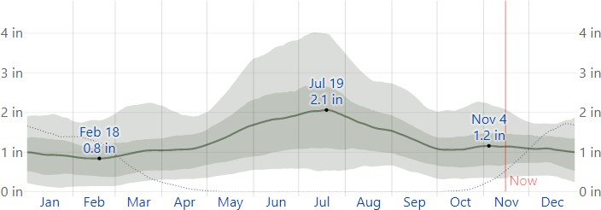

Figure 2.25: Average Monthly Rainfall(weatherspark, 2022)

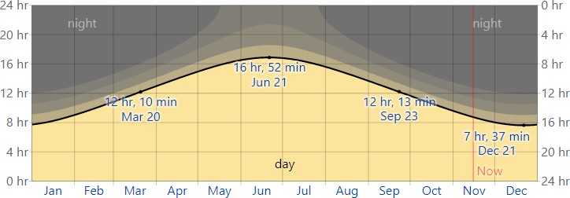

Figure 2.26: Hours of Daylight and Twilight(weatherspark, 2022)
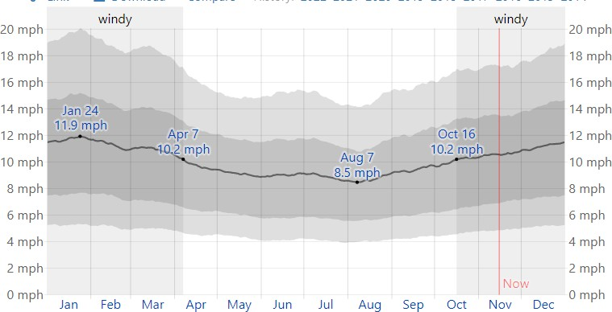

Figure 2.27: Average Wind Speed in Jenin(weatherspark, 2022)

Noise readings

The readings were done using mobile application for sound level meter.

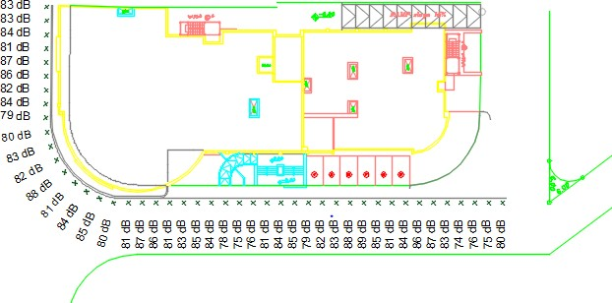
Figure 2.28: Noise readings

From the previous readings, the background noise from vehicles is high, which will need a treatment for example: acoustical barriers.

Shading analysis
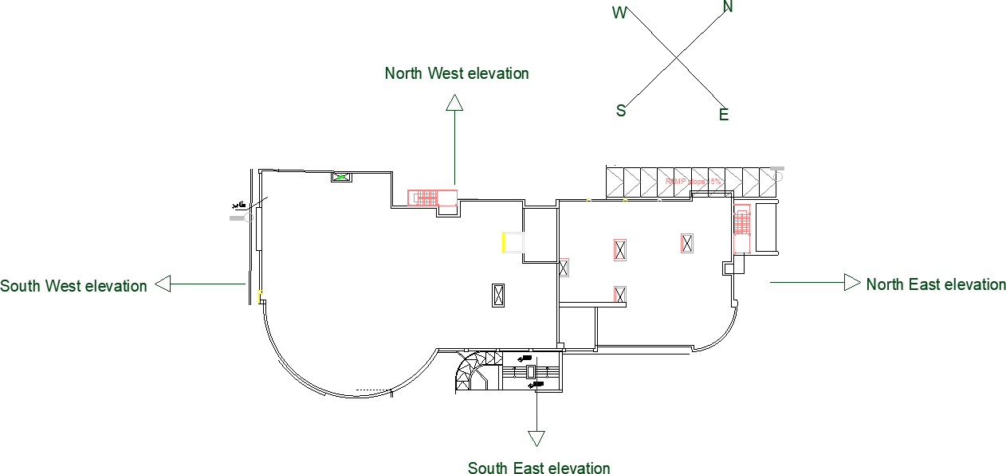

Figure 2.29: Elevations of the building.

The shading analysis will be divided into two parts, the first one is winter shading analysis and the second is summer shading analysis and through these two parts, three times will be analyzed (8.00AM, 12.00PM and 2.00 AM) before and after modifications.
Summer day: 21/6 Winter day: 21/12
      - Before modifications
- Winter:
At 8AM
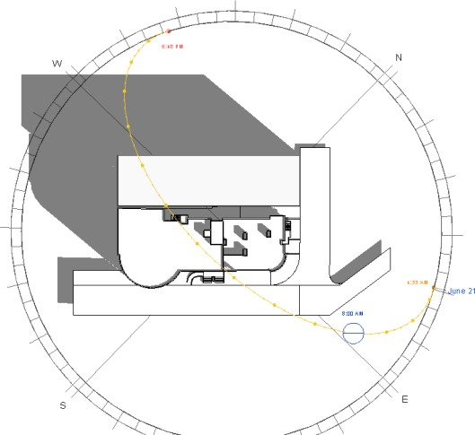

Figure 2.30: Shading in winter at 8AM.

At 12PM
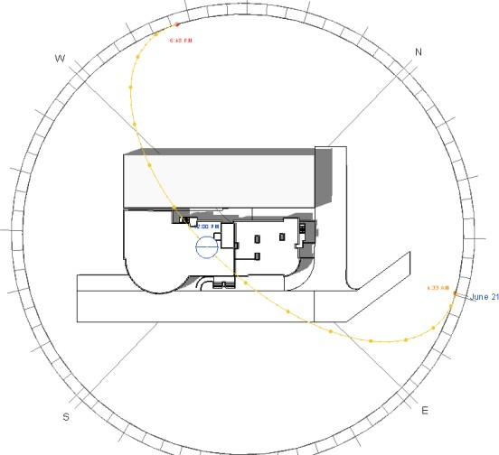

Figure 2.31: Shading in winter at 12PM.

At 2PM

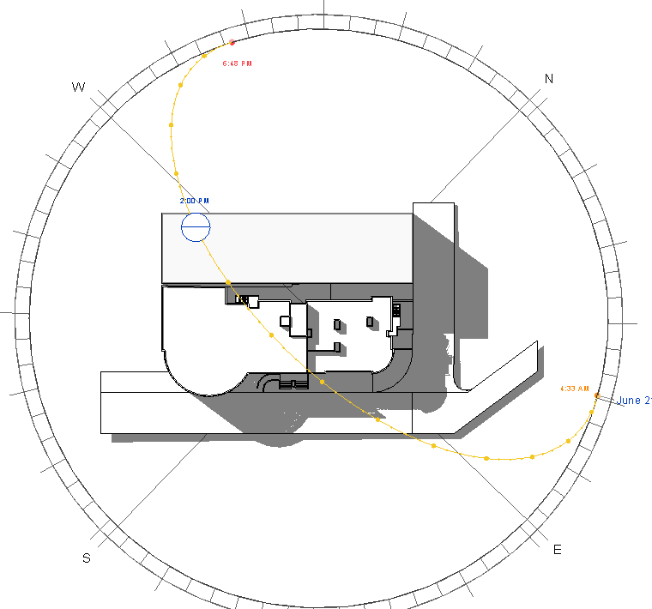

Figure 2.32: Shading in winter at 2PM.

Summary

Table 2.6: Shading analysis summary in winter.

Time | Elevation Name | Shading | Shadowing | Case
8AM | North West | Yes | Yes | Not ok
8AM | South East | No | No | Ok
8AM | North East | No | No | Ok
8AM | South West | No | Yes | Ok
12PM | North West | Yes | No | Not ok
12PM | South East | No | Yes | Ok
12PM | North East | No | No | Ok
12PM | South West | No | No | Ok
2PM | North West | Yes | No | Not ok
2PM | South East | No | Yes | Ok
2PM | North East | No | Yes | Ok
2PM | South West | No | No | Ok

The big problem is that the high building faces the chamber of commerce building.

- Summer:
At 8AM

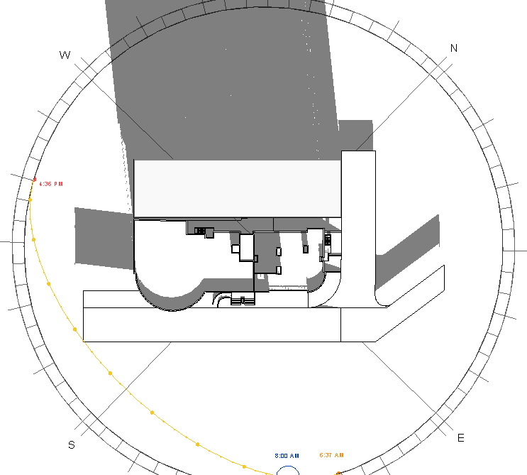

Figure 2.33: Shading in summer at 8AM.

At 12PM

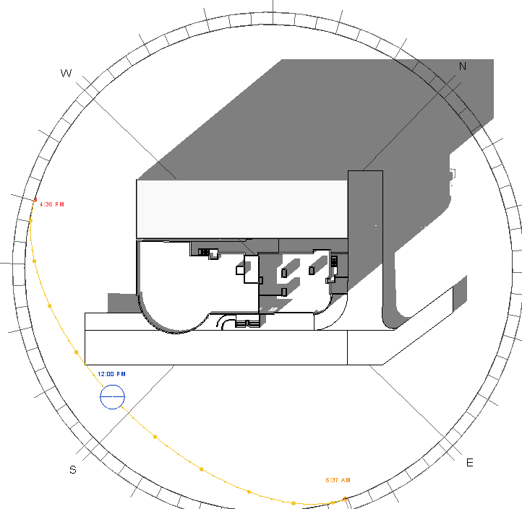
Figure 2.34 Shading in summer at 12PM.

At 2PM

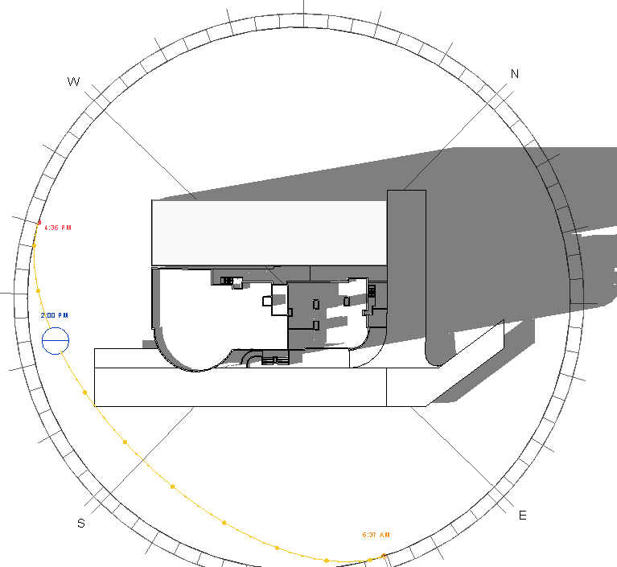

Figure 2.35 Shading in summer at 2PM.

Summary

Table 2.7: Shading analysis summary in summer.

Time | Elevation Name | Shading | Shadowing | Case
8AM | North West | Yes | No | Not ok
8AM | South East | No | No | Ok
8AM | North East | No | No | Ok
8AM | South West | No | Yes | Ok
12PM | North West | Yes | No | Not ok
12PM | South East | No | Yes | Ok
12PM | North East | No | No | Ok
12PM | South West | No | No | Ok
2PM | North West | Yes | No | Not ok
2PM | South East | No | Yes | Ok
2PM | North East | No | Yes | Ok
2PM | South West | No | No | Ok

Summary:

From the previous analysis, the environmental treatments will be for west and east elevations.

Solar radiation analysis

Solar radiation analysis will be in summer and winter at three different times (8.00AM, 12.00PM and 2.00 AM) before and after architectural modifications because there is no changing in building shape after modifications.
Summer day: 21/6 and Winter Day: 21/12

- Winter (21/12) At 8AM
South East elevation

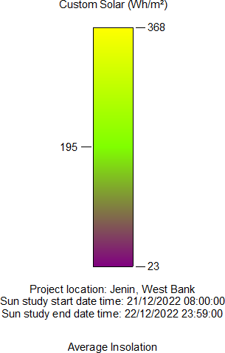

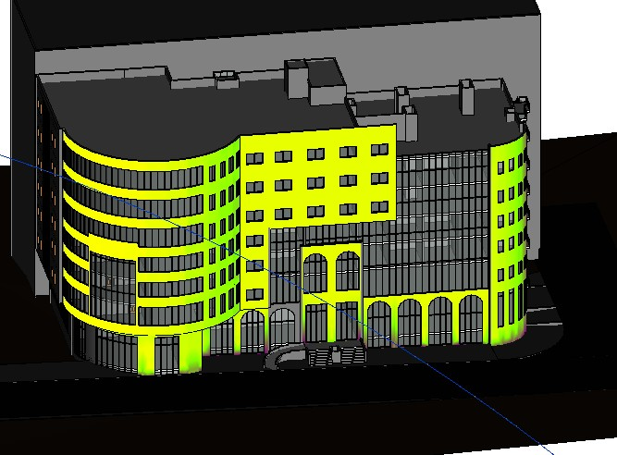

Figure 2.36: Solar radiation on south east elevation in winter at 8 am

As shown in the previous figure the solar radiation is high, which is good for daylighting and in winter for heating purposes.

South West elevation

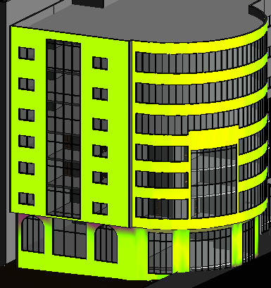
Figure 2.37: Solar radiation on south west elevation in winter at 8 am

As shown in the previous figure the solar radiation is high, which is good for daylighting and in summer there is no high gain.

North West elevation

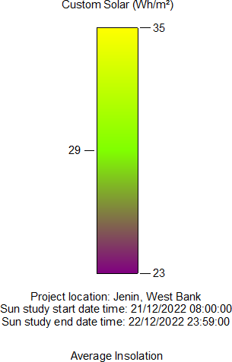
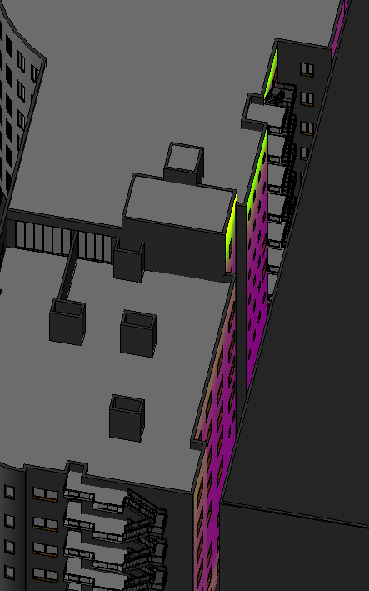

Figure 2.38: Solar radiation on North West elevation in winter at 8 am

As shown in the previous figure the solar radiation is very bad because of the existing of the adjacent building which is very bad and there is no solution for that just artificial lighting.

North East elevation
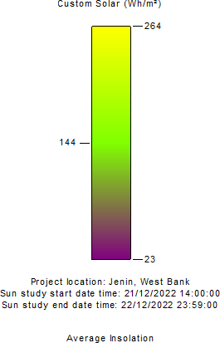

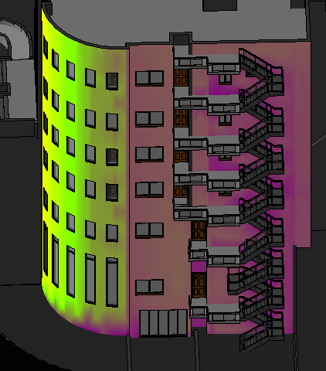
Figure 2.39: Solar radiation on north east elevation in winter at 8 am

As shown in the previous figure the solar radiation is not a big on the north elevation which is not good for daylight factor and artificial lighting needed.

At 12PM

South East elevation

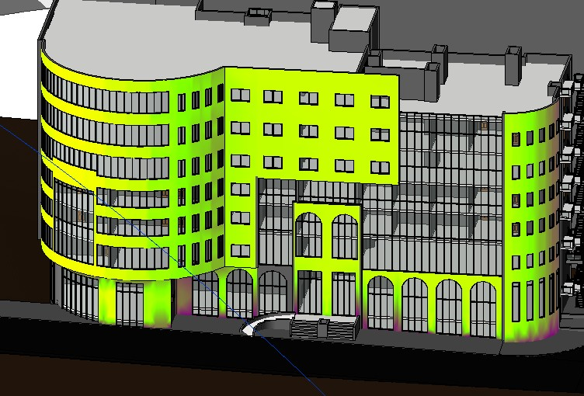

Figure 2.40: Solar radiation on south east elevation in winter at 12 Pm

As shown in the previous figure the solar radiation is high, which is good for daylighting and in winter for heating purposes.

South West elevation

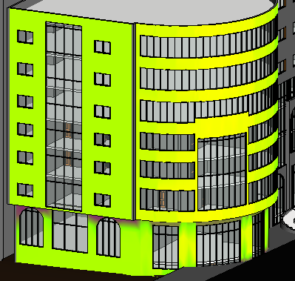

Figure 2.41: Solar radiation on south west elevation in winter at 12 Pm

As shown in the previous figure the solar radiation is high, which is good for daylighting and in summer there is no high gain.

North West elevation

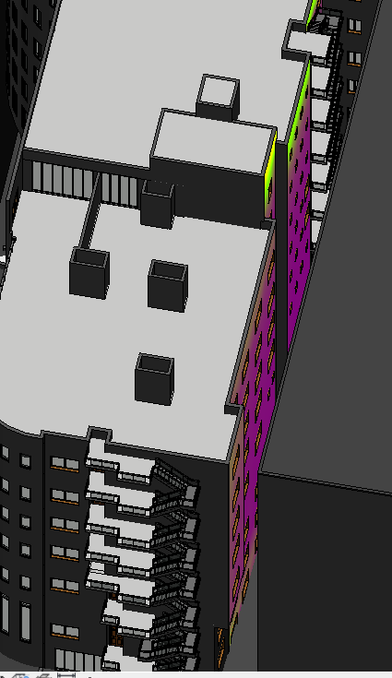

Figure 2.42: Solar radiation on North West elevation in winter at 12 Pm

As shown in the previous figure the solar radiation is very bad because of the existing of the adjacent building which is very bad and there is no solution for that just artificial lighting.

North East elevation

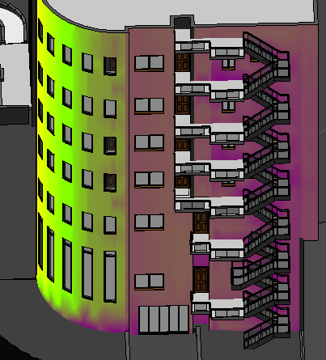
Figure 2.43: Solar radiation on north east elevation in winter at 12 Pm

As shown in the previous figure the solar radiation is not good.

At 2PM

South East elevation

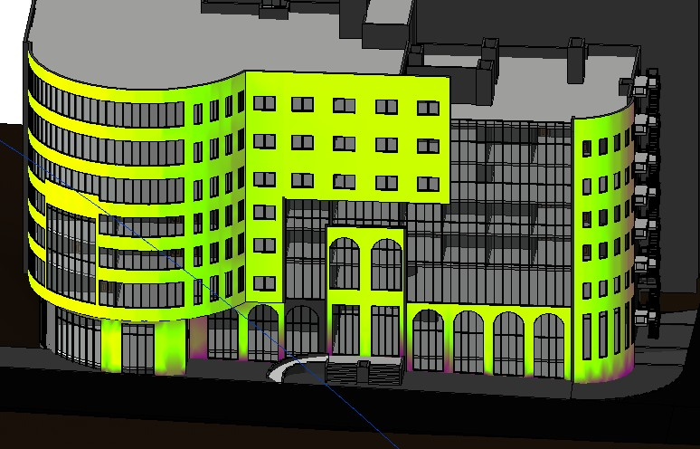

Figure 2.44: Solar radiation on south east elevation in winter at 2 Pm

As shown in the previous figure the solar radiation is high, which is good for daylighting and in winter for heating purposes.

South West elevation

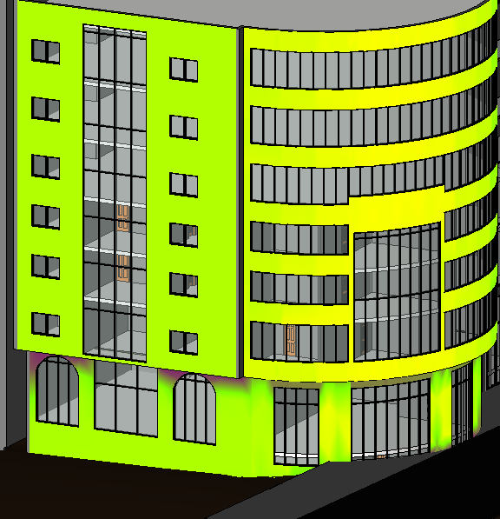

Figure 2.45: Solar radiation on south west elevation in winter at 2 Pm

As shown in the previous figure the solar radiation is high, which is good for daylighting and in winter for heating purposes.

North West elevation

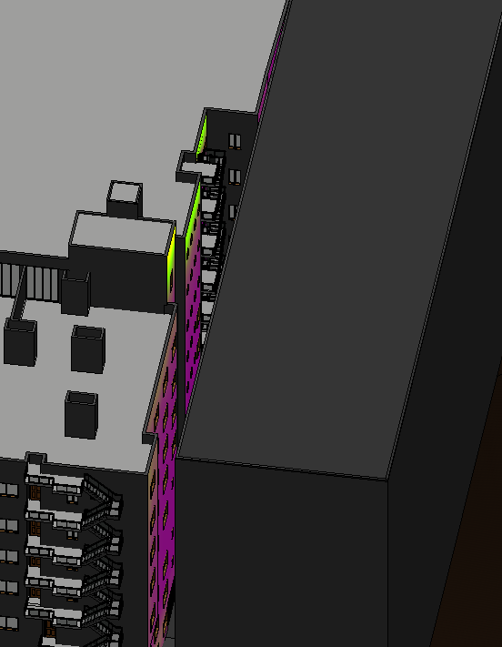
Figure 2.46: Solar radiation on North West elevation in winter at 2 Pm

As shown in the previous figure the solar radiation is very bad because of the existing of the adjacent building which is very bad and there is no solution for that just artificial lighting.

North East elevation

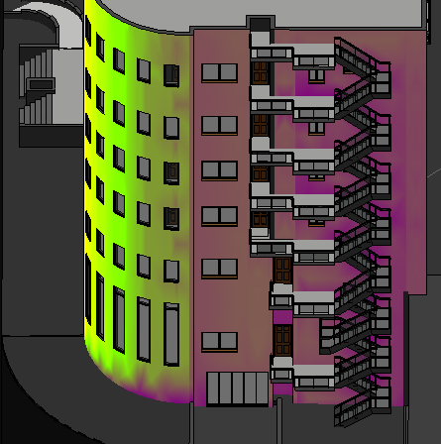

Figure 2.47: Solar radiation on north east elevation in winter at 2 Pm

As shown in the previous figure the solar radiation is not good

- Summer (21/6) At 8AM
South East elevation

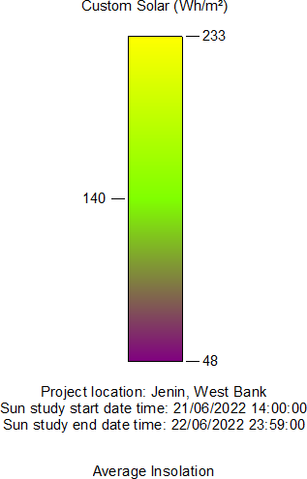
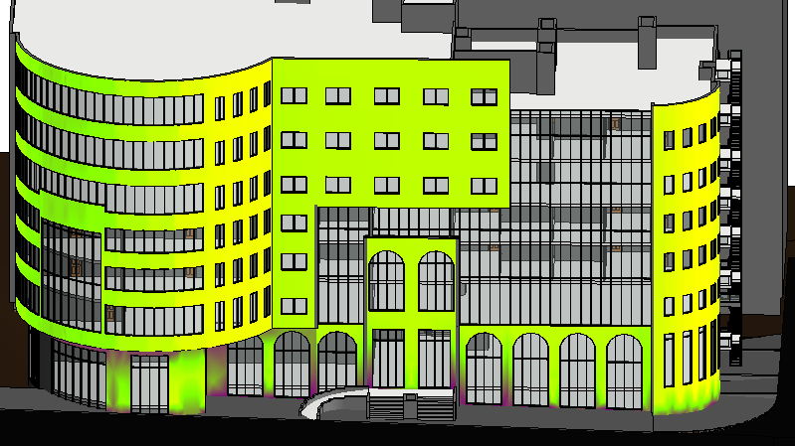

Figure 2.48: Solar radiation on South East elevation in summer at 8 am

As shown in the previous figure the solar radiation is high, which is good for daylighting and in summer there is no high gain.

South West elevation

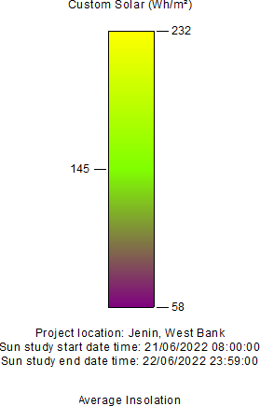

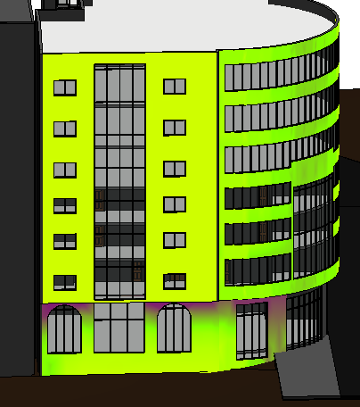

Figure 2.49: Solar radiation on South West elevation in summer at 8 am

As shown in the previous figure the solar radiation is high, which is good for daylighting and in winter for heating purposes.

North West elevation

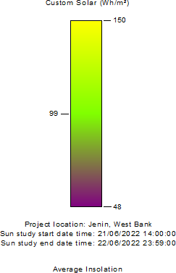

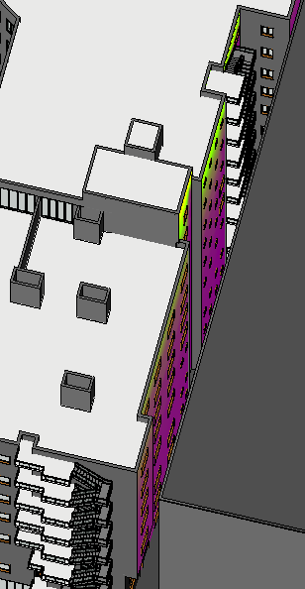
Figure 2.50: Solar radiation on North West elevation in summer at 8 am

As shown in the previous figure the solar radiation is very bad because of the existing of the adjacent building which is very bad and there is no solution for that just artificial lighting

North East elevation
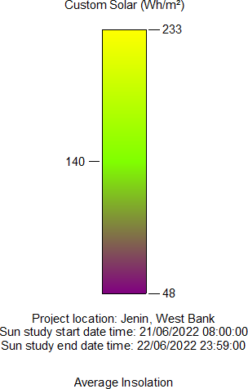

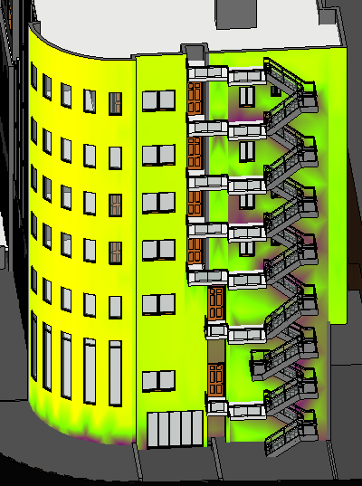

Figure 2.51: Solar radiation on north east elevation in summer at 8 am

As shown in the previous figure the solar radiation fair which is good for daylighting.

At 12PM

South East elevation

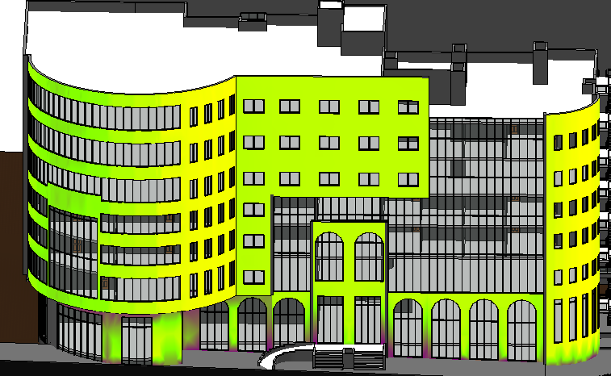

Figure 2.52: Solar radiation on South East elevation in summer at 12 Pm

As shown in the previous figure the solar radiation is high, which is good for daylighting and in summer there is no high gain.

South West elevation

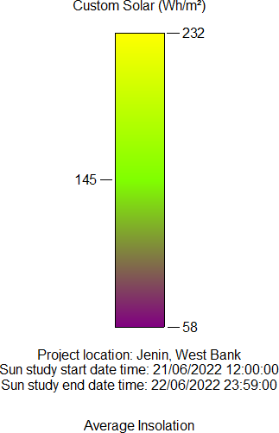
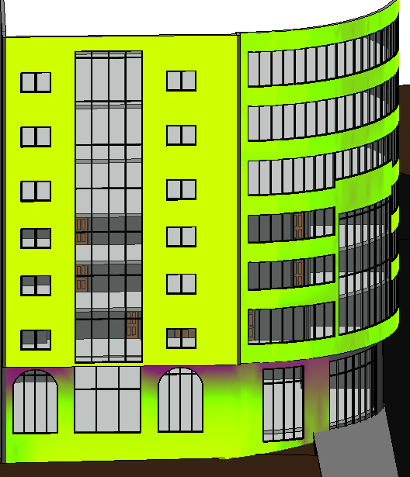

Figure 2.53: Solar radiation on South West elevation in summer at 12 Pm

As shown in the previous figure the solar radiation is high, which is good for daylighting and in summer there is no high gain. .

North West elevation

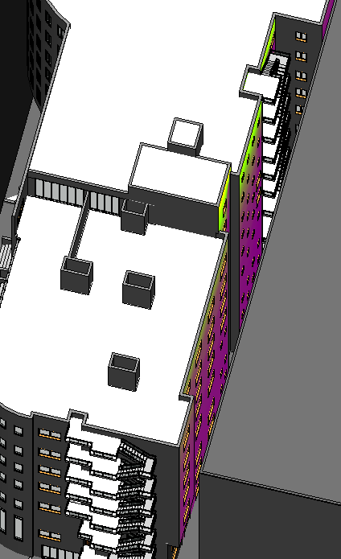

Figure 2.54: Solar radiation on North West elevation in summer at 12 Pm

As shown in the previous figure the solar radiation is very bad because of the existing of the adjacent building which is very bad and there is no solution for that just artificial lighting.

North East elevation
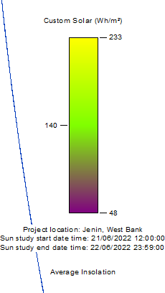
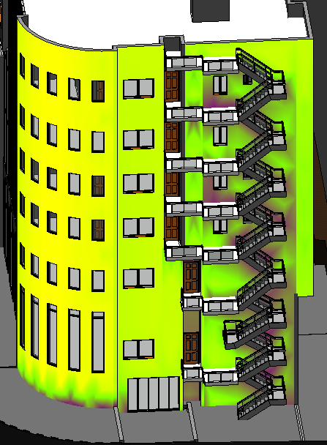

Figure 2.55: Solar radiation on North East elevation in summer at 12 Pm

As shown in the previous figure the solar radiation is high, which is good for daylighting and in summer there is no high gain.

At 2PM

South East elevation

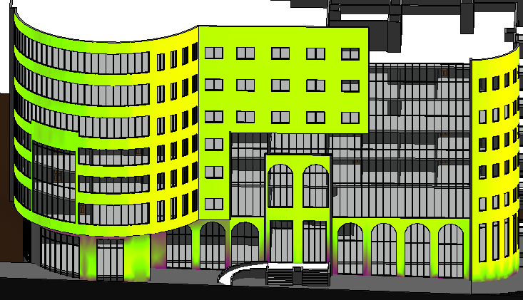

Figure 2.56: Solar radiation on south east elevation in summer at 2 Pm

As shown in the previous figure the solar radiation is high, which is good for daylighting and in summer there is no high gain.

South West elevation

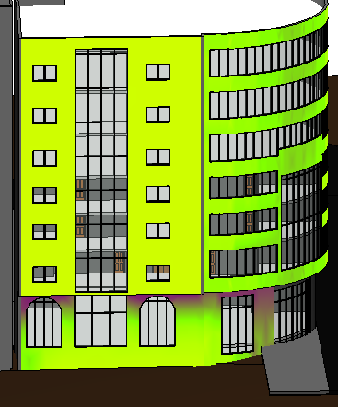

Figure 2.57: Solar radiation on south west elevation in summer at 2 Pm

As shown in the previous figure the solar radiation is high, which is good for daylighting and in summer there is no high gain.

North West elevation

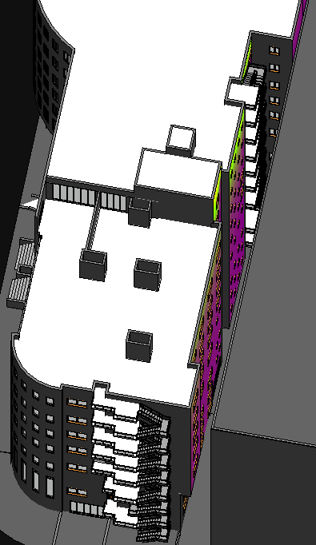

Figure 2.58: Solar radiation on North West elevation in summer at 2 Pm

As shown in the previous figure the solar radiation is very bad because of the existing of the adjacent building which is very bad and there is no solution for that just artificial lighting.

North East elevation

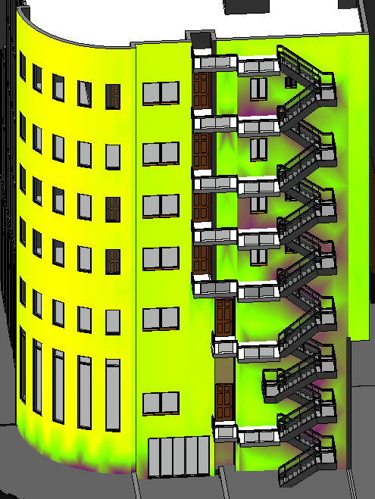

Figure 2.59: Solar radiation on north east elevation in summer at 2 Pm

As shown in the previous figure the solar radiation is good.

Wind
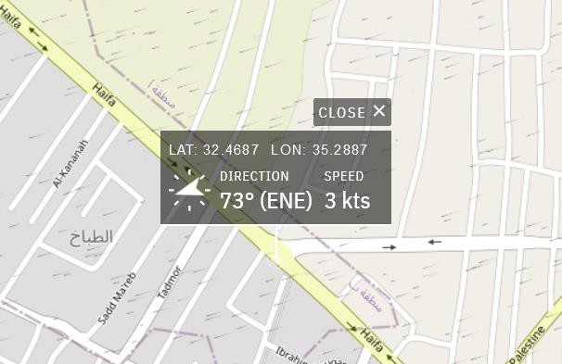

Figure 2.60: Wind direction.
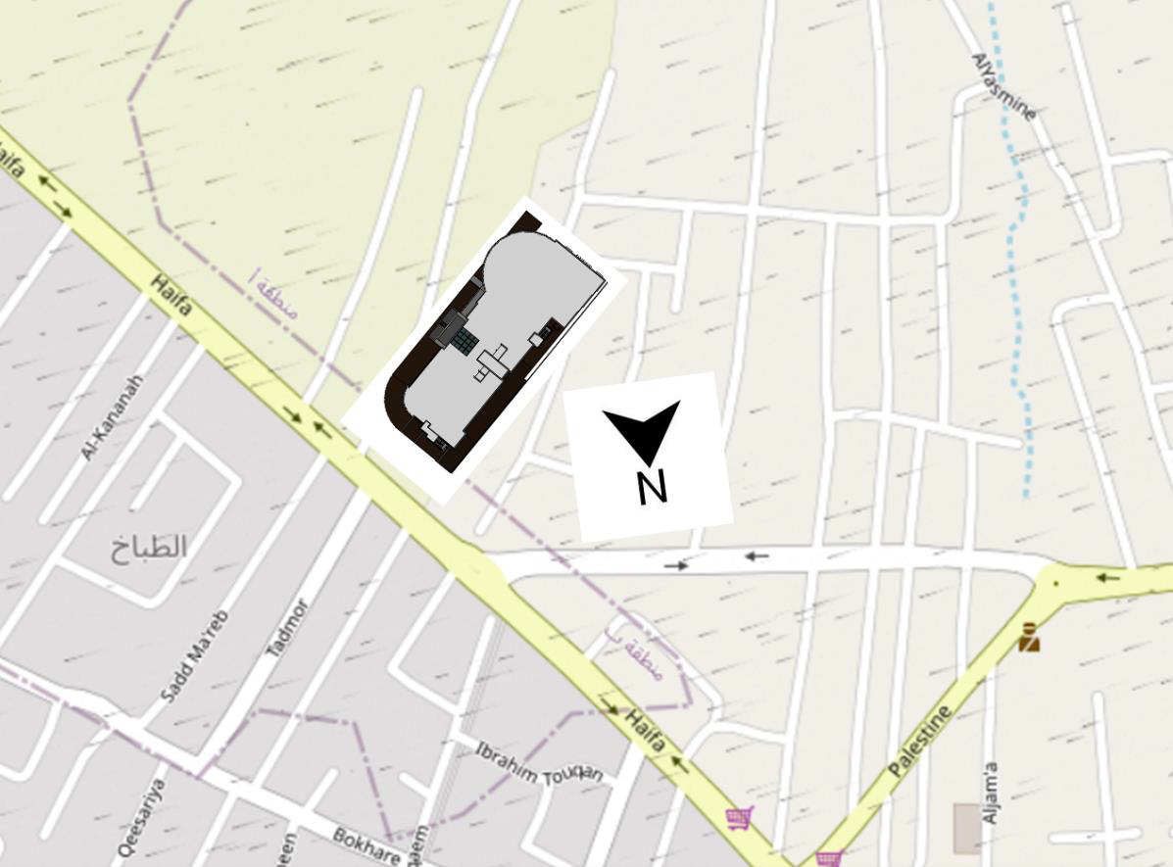
Figure 2.61: Wind direction of the building.

Architectural modifications

Spaces area assessment:

- Ground floor

Table 2.8: Ground floor spaces assessment

Space Name | Current Area | Count | Standard Area | Case
WC1 | 1.5 | 4 | 1.41 | Ok
WC2 | 1.8 | 2 | 1.41 | Ok
WC security | 2.4 | 1 | 1.41 | Ok
WC3 | 2.65 | 1 | 1.41 | Ok
WC4 | 2.18 | 1 | 1.41 | Ok
WC disabled | 4.14 | 1 | 2.2 | Ok
Investment unit 1 | 375 | 1 | - | Ok
Investment unit 2 | 200 | 1 | - | Ok
Investment unit 3 | 360 | 1 | - | Ok

- 1st floor
Table 2.9: 1st floor spaces assessment

Space Name | Current Area | Count | Standard Area | Case
IT Room | 24.3 | 1 | 20 | Ok
Archive | 8.18 | 1 | 12 | Not ok
Department of Economic | 29 | 1 | 20 | Ok
Kitchen | 13.95 | 1 | 3 | Ok
Store | 3.68 | 1 | - | Ok
Servers room | 7.36 | 1 | - | Ok
Meeting Room | 30.46 | 1 | 22 | Ok
WC1 | 1.65 | 1 | 1.41 | Ok
WC2 | 1.53 | 1 | 1.41 | Ok
WC3 | 3.27 | 1 | 1.41 | Ok
WC4 | 1.8 | 6 | 1.41 | Ok
WC disabled | 4.14 | 1 | 2.2 | Ok
Public Relations | 26.04 | 1 | 20 | Ok
President of the Chamber of Commerce | 22.4 | 1 | 20 | Ok
General manager | 28 | 1 | 20 | Ok
Secretary | 17.5 | 1 | 24 | Not ok
Public Services | 69.3 | 1 | 60 | Ok
Waiting area | 104.5 | 1 | - | Ok
Meeting Hall | 365 | 1 | - | Ok
WC | 1.8 | 2 | 1.41 | Ok
Meeting Hall Kitchen | 4.32 | 1 | 3 | Ok

- 2nd and 3rd floor
Table 2.10: 2nd and 3rd floors spaces assessment

Space Name | Current Area | Count | Standard Area | Case
Office 1 | 27.00 | 1 | 9.00 | Ok
Office 2 | 20.58 | 1 | 9.00 | Ok
Office 3 | 18.90 | 1 | 9.00 | Ok
Office 4 | 27.93 | 1 | 9.00 | Ok
Office 5 | 35.73 | 1 | 9.00 | Ok
Office 6 | 17.22 | 1 | 9.00 | Ok
Office 7 | 18.45 | 1 | 9.00 | Ok
Office 8 | 18.00 | 1 | 9.00 | Ok
Office 9 | 18.00 | 1 | 9.00 | Ok
Office 10 | 12.94 | 1 | 9.00 | Ok
Office 11 | 17.25 | 1 | 9.00 | Ok
Office 12 | 18.00 | 1 | 9.00 | Ok
Office 13 | 18.00 | 1 | 9.00 | Ok
Office 14 | 16.44 | 1 | 9.00 | Ok
Office 15 | 19.21 | 1 | 9.00 | Ok
Office 16 | 19.00 | 1 | 9.00 | Ok
Waiting 1 | 22.00 | 1 | 12.00 | Ok
Waiting 2 | 28.56 | 1 | 12.00 | Ok
Waiting 3 | 54.00 | 1 | 12.00 | Ok
Waiting 4 | 25.10 | 1 | 12.00 | Ok
Waiting 5 | 24.30 | 1 | 12.00 | Ok
Waiting 6 | 24.30 | 1 | 12.00 | Ok
Waiting 7 | 16.48 | 1 | 12.00 | Ok
Waiting 8 | 13.50 | 1 | 12.00 | Ok
Waiting 9 | 21.24 | 1 | 12.00 | Ok
Waiting 10 | 24.30 | 1 | 12.00 | Ok
Waiting 11 | 17.86 | 1 | 12.00 | Ok
Waiting 12 | 13.60 | 1 | 12.00 | Ok
Waiting 13 | 19.00 | 1 | 12.00 | Ok
Kitchen1 | 6.00 | 1 | 4.00 | Ok
Kitchen2 | 5.70 | 1 | 3.00 | Ok
Kitchen3 | 6.75 | 1 | 3.00 | Ok
Kitchen4 | 4.32 | 1 | 3.00 | Ok
Kitchen5 | 3.65 | 1 | 3.00 | Ok
Kitchen6 | 6.00 | 1 | 3.00 | Ok
Kitchen7 | 3.00 | 1 | 3.00 | Ok
Kitchen8 | 3.00 | 1 | 3.00 | Ok
Kitchen9 | 6.00 | 1 | 3.00 | Ok
Kitchen10 | 3.65 | 1 | 3.00 | Ok
Kitchen11 | 3.45 | 1 | 3.00 | Ok

Space Name | Current Area | Count | Standard Area | Case
Kitchen12 | 3.00 | 1 | 3.00 | Ok
Kitchen13 | 4.00 | 1 | 3.00 | Ok
WC1 | 2.43 | 1 | 1.41 | Ok
WC2 | 2.50 | 1 | 1.41 | Ok
WC3 | 3.55 | 1 | 1.41 | Ok
WC4 | 2.40 | 1 | 1.41 | Ok
WC5 | 2.15 | 1 | 1.41 | Ok
WC6 | 2.58 | 1 | 1.41 | Ok
WC7 | 1.95 | 1 | 1.41 | Ok
WC8 | 1.50 | 1 | 1.41 | Ok
WC9 | 2.58 | 1 | 1.41 | Ok
WC10 | 2.15 | 1 | 1.41 | Ok
WC11 | 1.80 | 1 | 1.41 | Ok
WC12 | 1.62 | 1 | 1.41 | Ok
WC13 | 2.52 | 1 | 1.41 | Ok
Store1 | 6.60 | 1 | - | Ok
Store2 | 5.00 | 1 | - | Ok
- 4th floor

Table 2.11: 4th floor spaces assessment

Space Name | Current Area | Count | Standard Area | Case
Show Area 1 | 640.00 | 1 | - | Ok
Show Area 2 | 365.00 | 1 | - | Ok
WC1 | 1.50 | 4 | 1.41 | Ok
WC disabled | 4.14 | 1 | 2.2 | Ok

- 5th floor

Table 2.12: 5th floor spaces assessment

Space Name | Current Area | Count | Standard Area | Case
Convention Hall | 640 | 1 | - | Ok
Room1 | 16.65 | 1 | 12.00 | Ok
Room2 | 17.10 | 1 | 12.00 | Ok
Room3 | 15.75 | 1 | 12.00 | Ok
Room4 | 15.20 | 1 | 12.00 | Ok
Bed Room1 | 14.30 | 1 | 12.00 | Ok
Bed Room2 | 12.20 | 1 | 12.00 | Ok
Bed Room3 | 18.00 | 1 | 12.00 | Ok
Salon1 | 13.50 | 1 | 10.00 | Ok
Salon2 | 16.23 | 1 | 10.00 | Ok
Salon3 | 24.30 | 1 | 10.00 | Ok
Reception | 47.70 | 1 | 40.00 | Ok

Space Name | Current Area | Count | Standard Area | Case
Kitchen1 | 3.00 | 1 | 3.00 | Ok
Kitchen2 | 4.00 | 1 | 3.00 | Ok
Kitchen3 | 4.94 | 1 | 3.00 | Ok
Kitchen4 | 6.51 | 1 | 3.00 | Ok
Kitchen5 | 7.68 | 1 | 3.00 | Ok
WC1 | 2.55 | 1 | 1.41 | Ok
WC2 | 2.50 | 1 | 1.41 | Ok
WC3 | 3.44 | 1 | 1.41 | Ok
WC4 | 1.65 | 1 | 1.41 | Ok
WC5 | 1.87 | 1 | 1.41 | Ok
WC6 | 3.87 | 1 | 1.41 | Ok
WC7 | 3.44 | 1 | 1.41 | Ok
WC8 | 3.44 | 1 | 1.41 | Ok
WC9 | 3.20 | 1 | 1.41 | Ok
WC10 | 1.50 | 2 | 1.41 | Ok
WC11 | 1.50 | 2 | 1.41 | Ok
WC disabled | 2.66 | 1 | 2.20 | Ok
Store | 1.68 | 1 | - | Ok

- 6th floor

Table 2.13: 6th floor spaces assessment

Space Name | Current Area | Count | Standard Area | Case
Restaurants | 640 | 1 | - | Ok
WC | 1.50 | 4 | 1.41 | Ok
WC disabled | 4.14 | 1 | 2.20 | Ok

There are some weakness points in the previous design:

- Spaces relations.
- Lack of elevators.
- Inappropriate locations of shafts.
- Lack of disabled people Wc’s
- Lack of parking spaces needed.

Bubbles Diagram after modifications



Figure 2.62: Bubbles diagram legend.

      - Ground floor
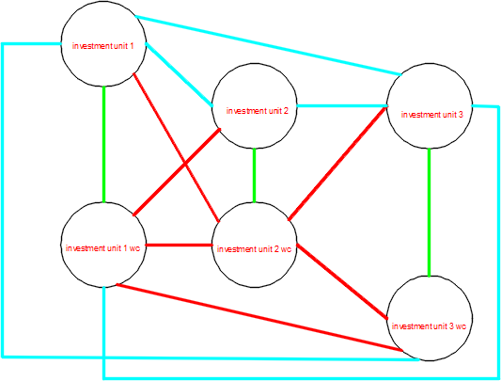

Figure 2.63: Ground floor bubbles diagram

All spaces in the ground floor are within the standards and the functional relationships are ok but the function will change to Shops for all floor.

      - 1st floor
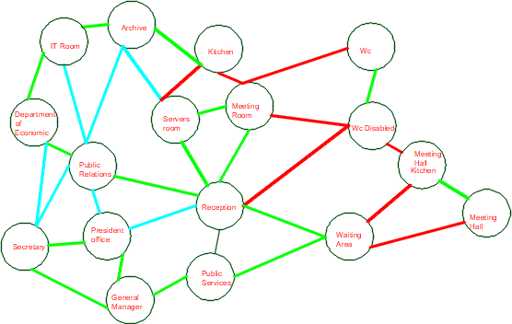

Figure 2.64: first floor bubbles diagram

All spaces in the first floor are within the standards and the functional relationships are ok, but there is needing to increase some areas such that Manger room and adding Wc for management department
      - 2nd and 3rd and floors
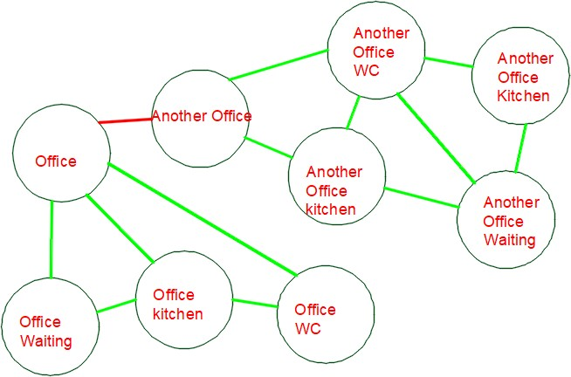

Figure 2.65: second and third floor bubbles diagram

Not all spaces in the second and third floor are within the standards especially the waiting areas are big than offices, so a redistribution and increasing offices areas will made and the functional relationships are ok.

      - 4th floor

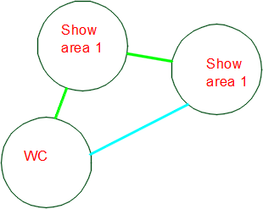

Figure 2.66: fourth floor bubbles diagram 5th floor

All spaces in the fourth floor are within the standards and the functional relationships are ok, but the function will change to be furniture showroom and the location of this floor will in the first floor and chamber of the commerce floor will be in the third floor.
      - 5th floor
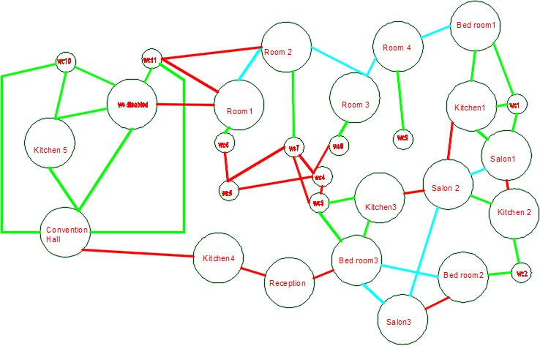
Figure 2.67: fifth floor bubbles diagram 5th floor

All spaces in the 5th floor are within the standards and the functional relationships are ok but the convention hall area will change to be a coffee shop.

Note: For 6th floor there is only Restaurant and its area is fair.

Conclusion for architectural modifications

After making the assessment for the existed spaces and based on literature review data and asking architectural engineers in the faculty, all spaces are within the standards, but the modifications will only make on the floor's functions arrangement, changing some of the floors functions and rearrange of the floors.
The importance points that added and changings to the floors are the following:

- Adding three elevators, so total number of elevators will be 4 elevators for people, and service elevator will be added as service elevator for restaurant and coffee shop.
- Adding shops in the ground floor.
- Adding WC’s in the third and fourth floors for people and disabled people.
- Distribution of restaurant spaces.
- Increasing doors areas.
- Increasing the width of the main entrance.
- Changing the shape of the disabled people ramp and its slope to be 6% as per standards.
- Adding a new basement to increase the number of parking spaces and considering an extra three parking spaces will add for disabled people at the main entrance of the building.
Here is a summary of the floors’ functions before and after

Table 2.14: Floors functions before and after modifications.

Floor Name | Function before | Function After
Ground floor | Investments units | Shops
First floor | Chamber of commerce | Furniture show areas
Second floor | offices | Chamber of commerce
Third floor | offices | offices
Fourth floor | Furniture show areas | offices
Fifth floor | Sweets | Sweets and coffee shop
Sixth floor | Restaurant | Restaurant

Edited plans

After making modifications there is a comparison between before and after plans.

1- Parking
Before
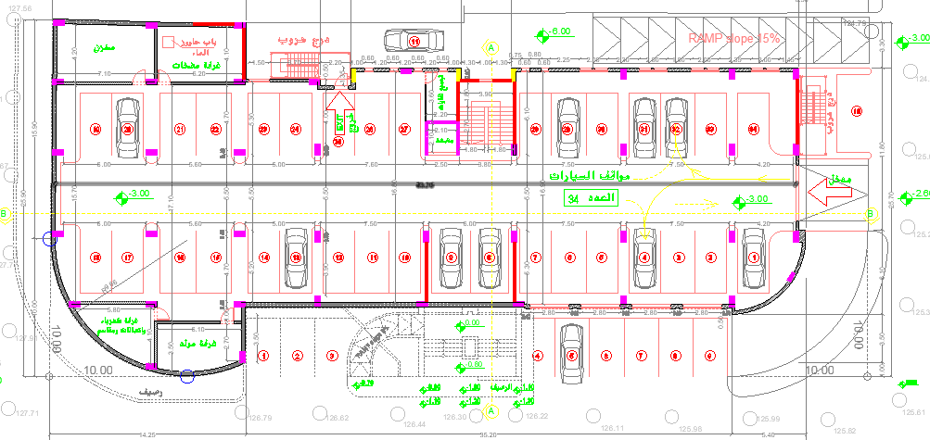

Figure 2.68: First basement plan before modifications.
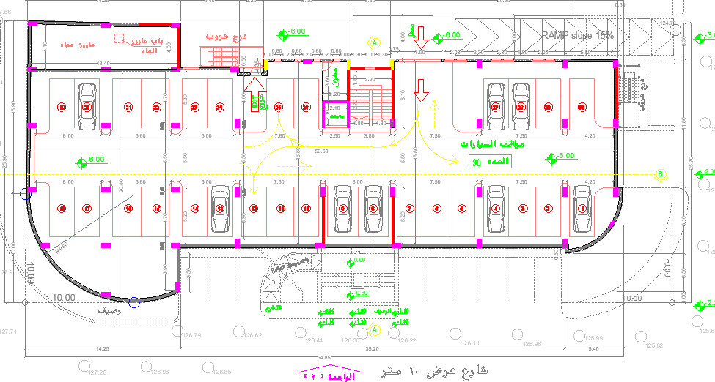

Figure 2.69: Second basement plan before modifications.

Two basements with total number of parking spaces of 77.

After
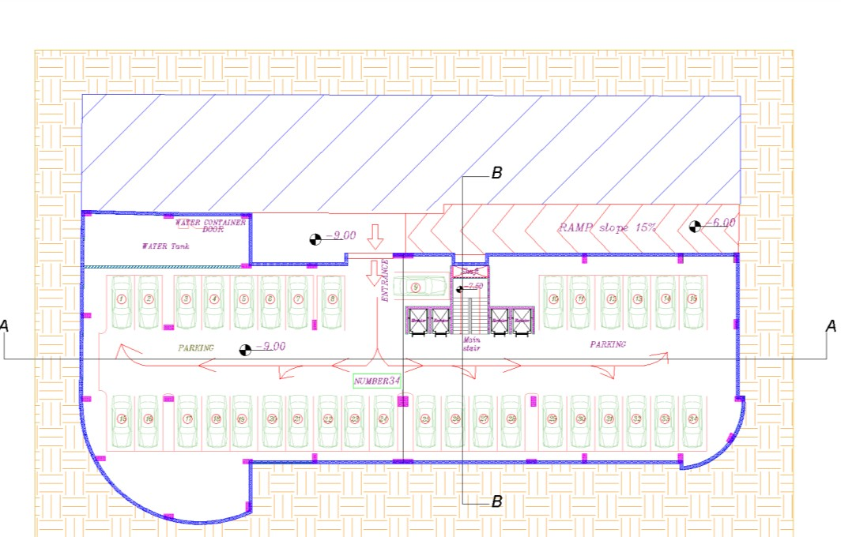

Figure 2.70: First basement plan before modifications.
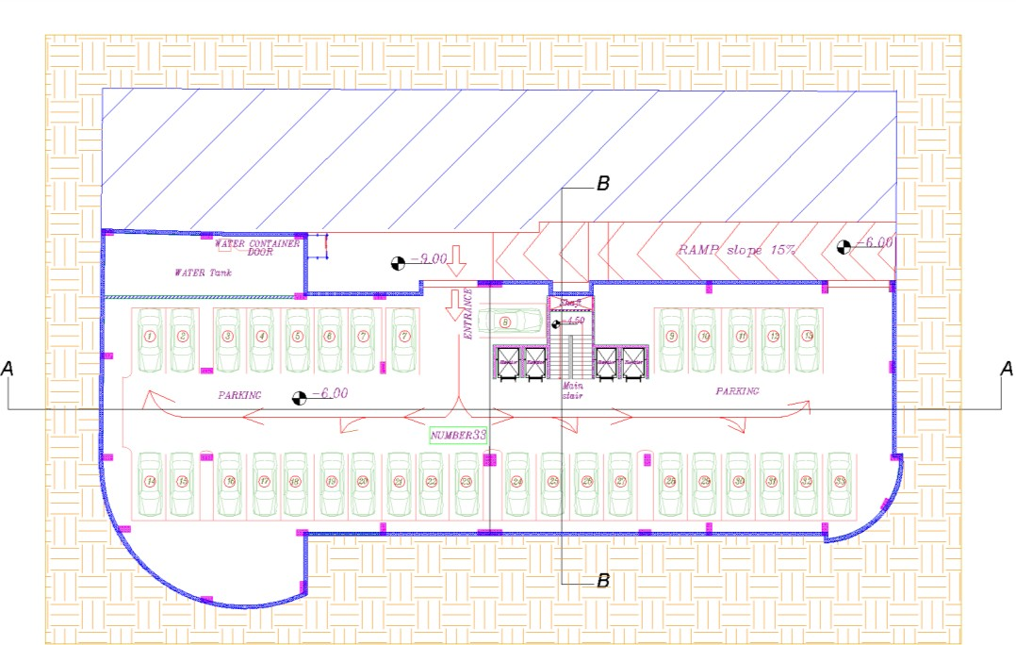

Figure 2.71: Second basement plan before modifications.

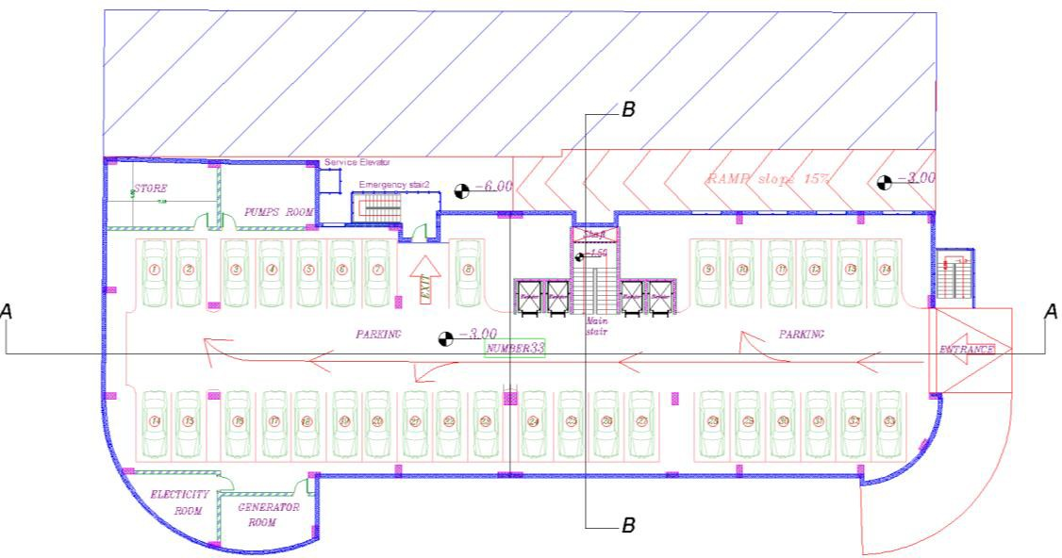

Figure 2.72: Third basement plan before modifications.

Another basement was added and the total number of parking spaces is 100.

- Ground floors Before
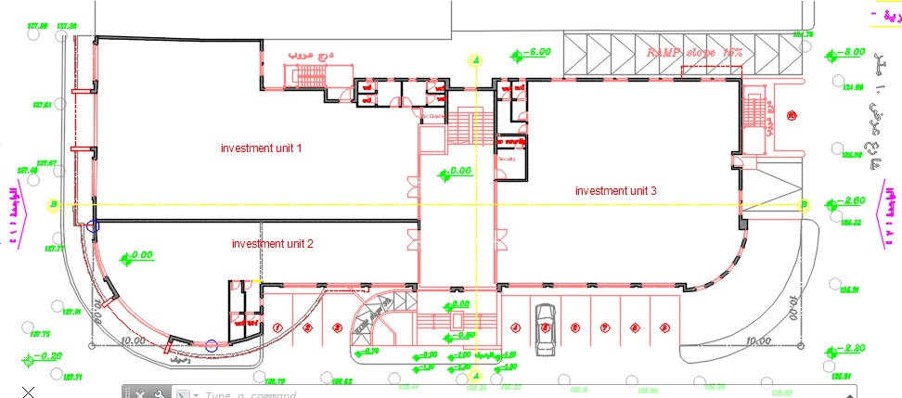
Figure 2.73: Ground floor before modifications.

After

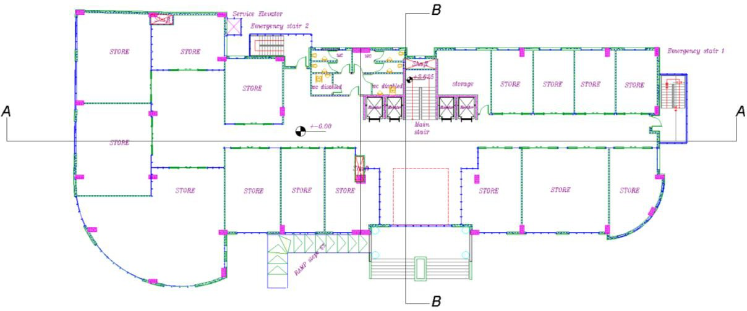

Figure 2.74: Ground floor after modifications.

- 1st floors Before
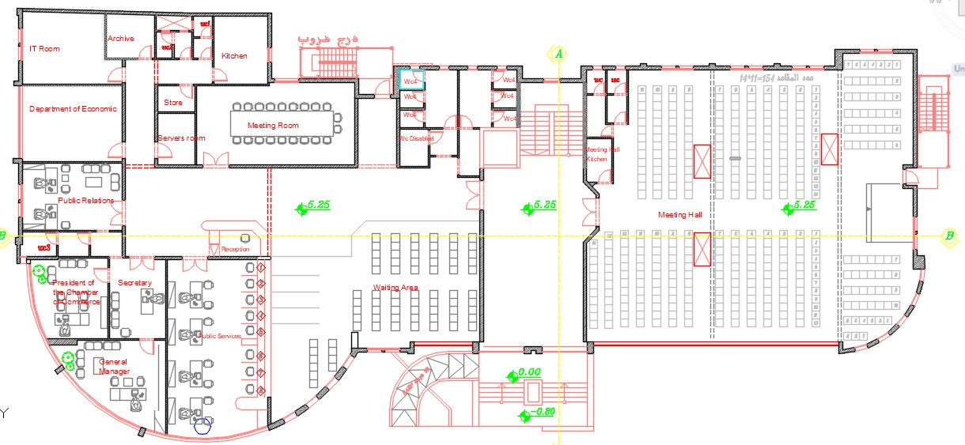

Figure 2.75: First floor before modifications.

The function was chamber of commerce floor.

After
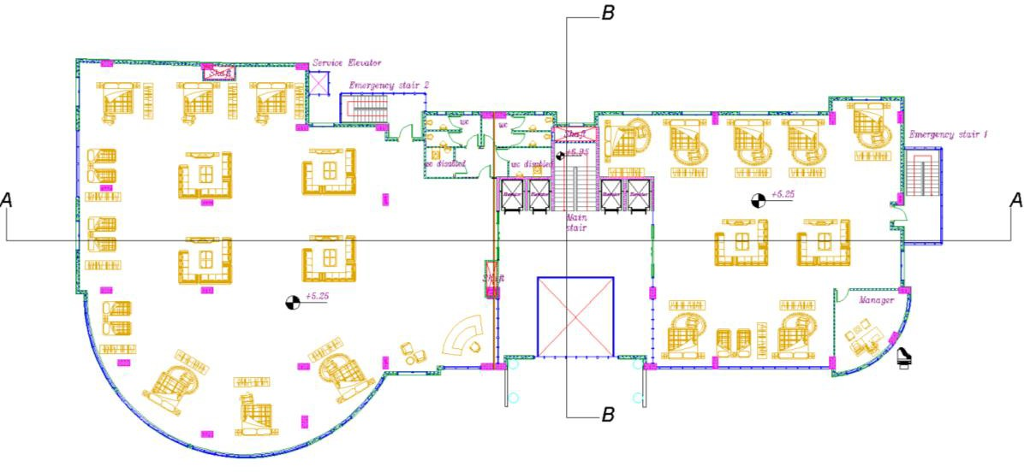

Figure 2.76: First floor after modifications.

The function has become a furniture showroom

- 2nd floor Before
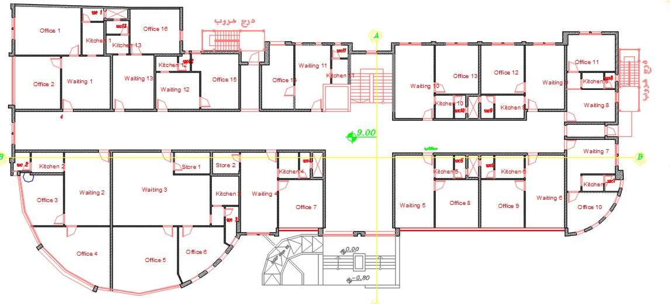

Figure 2.77: Second floor before modifications.

The function was offices

After
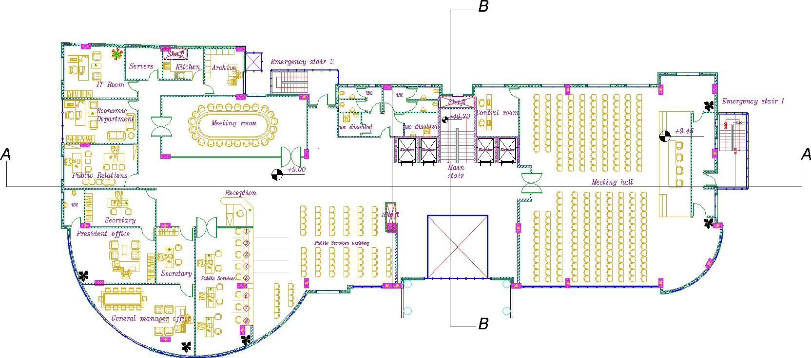

Figure 2.78: Second floor after modifications.

The function has become chamber of commerce floor.

- 3rd floor Before

Figure 2.79: Third floor before modifications.

The function was offices

After
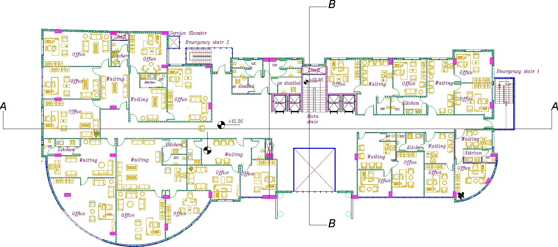

Figure 2.80: Third floor after modifications.

The function has still offices

- 4th floors Before

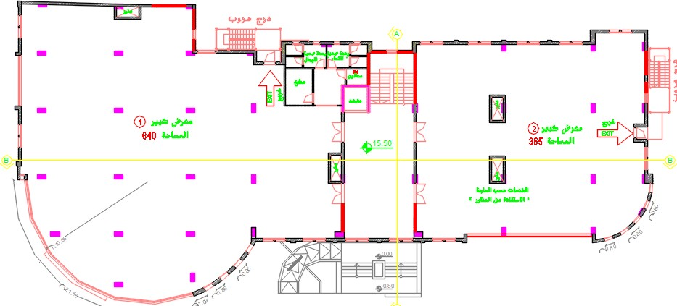

Figure 2.81: Fourth floor before modifications.

The function was show areas.

After
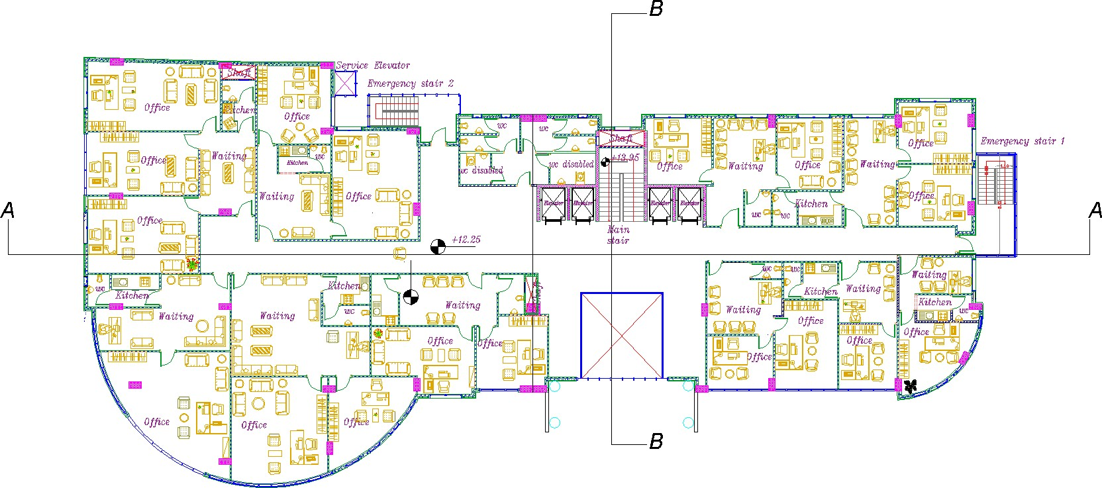

Figure 2.82: Fourth floor after modifications.

The function has become offices.

- 5th floor

Before
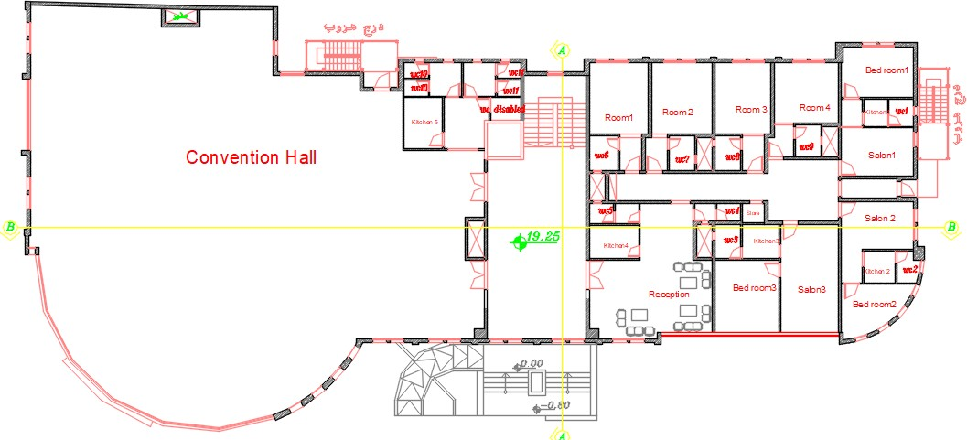

Figure 2.83: Fifth floor before modifications.

After
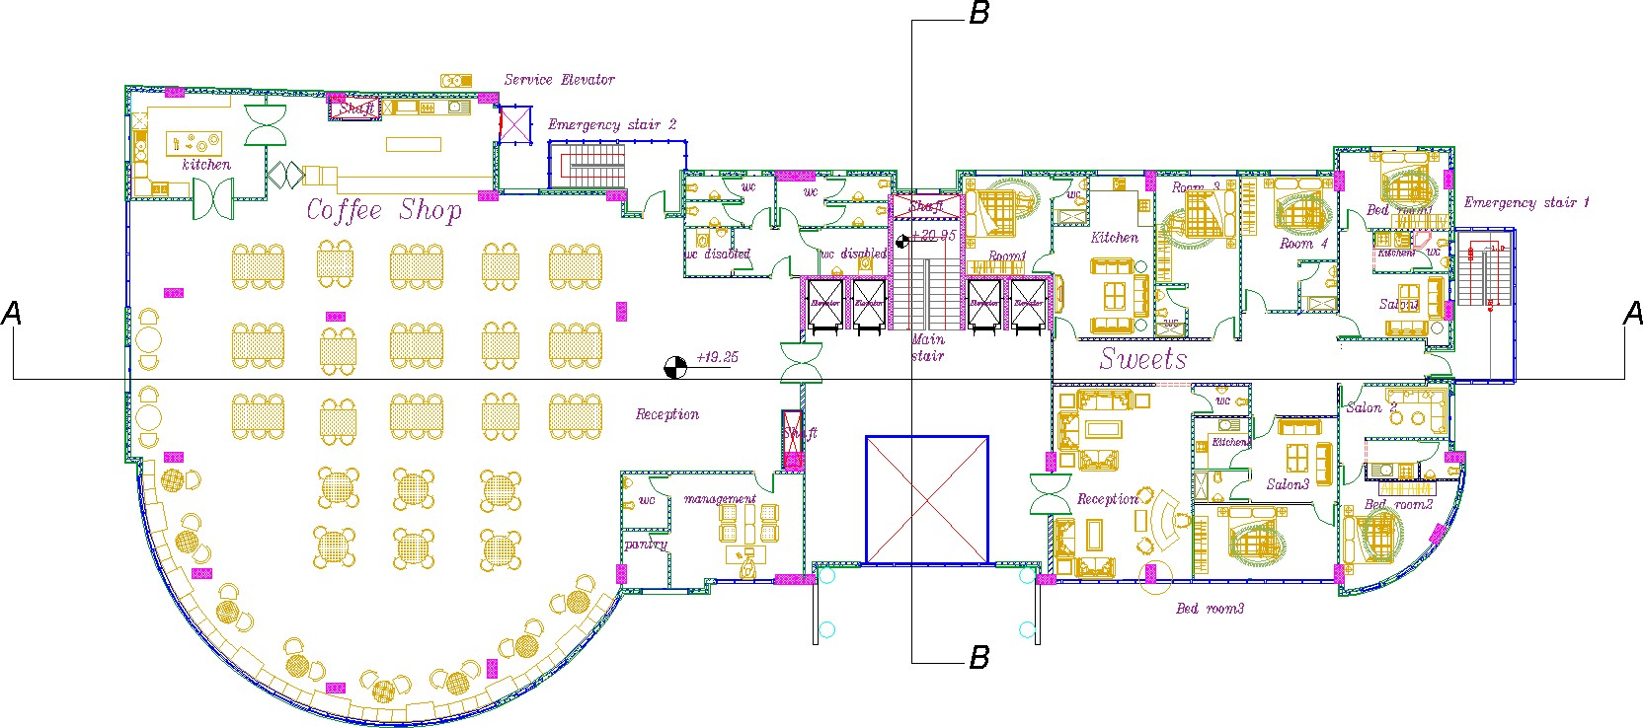

Figure 2.84: Fifth floor after modifications.

- 6th floor Before
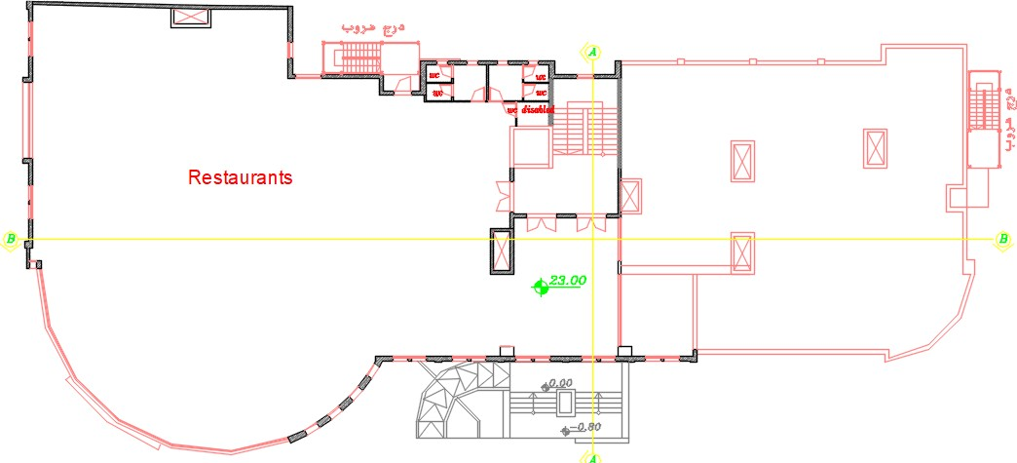

Figure 2.85: sixth floor before modifications.

After

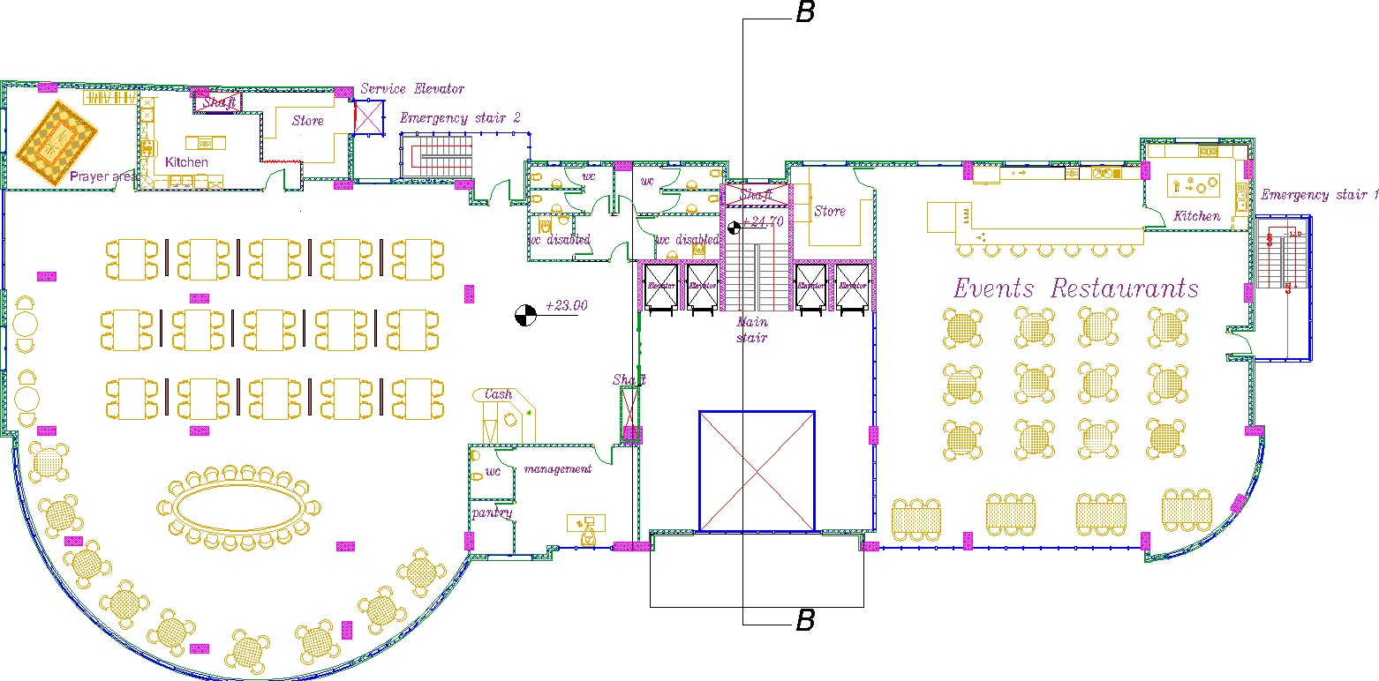

Figure 2.86: Sixth floor after modifications.

- Elevations:

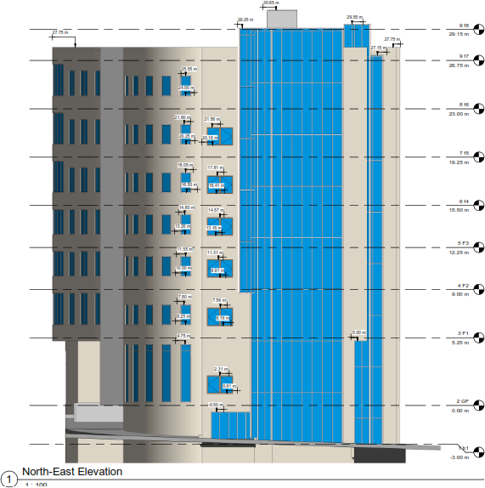

Figure 2.87: North- East Elevation.

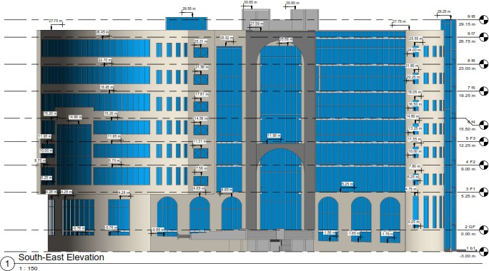

Figure 2.88: South- East Elevation.

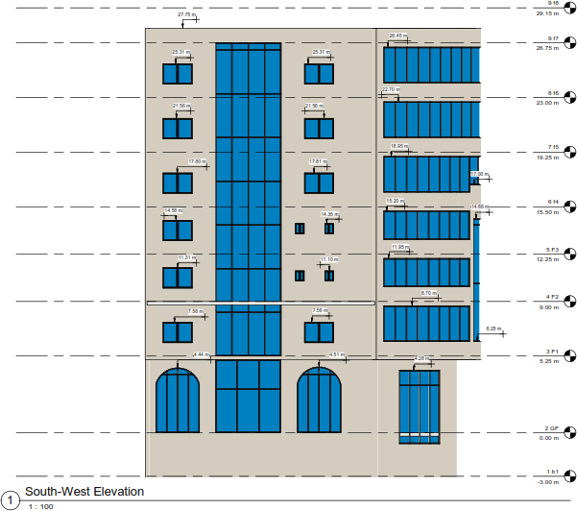

Figure 2.89: South- West Elevation.

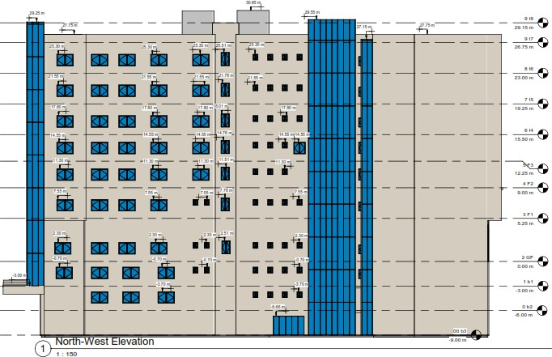

Figure 2.90: North- West Elevation.

- Sections:
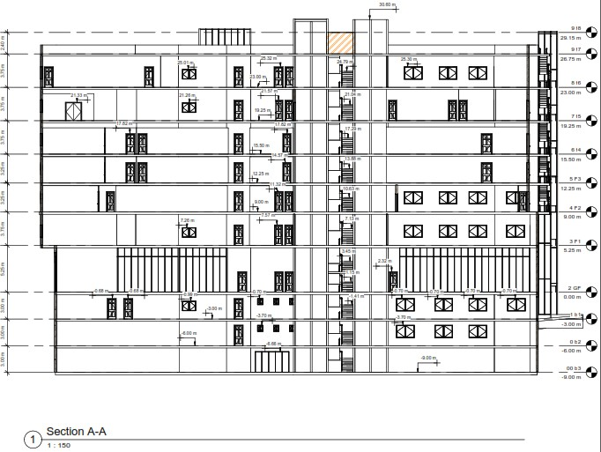

Figure 2.91: Section A-A.

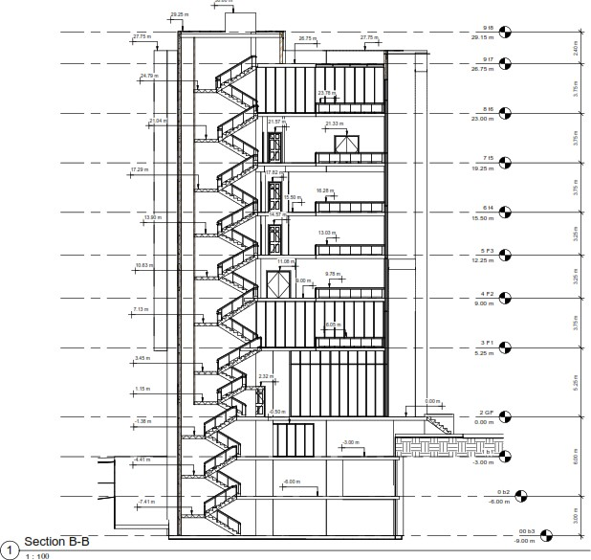

Figure 2.92: Section B-B.

Environmental analysis and Design

Daylight factor

Daylight factor between 2-5%

      - Before modifications:
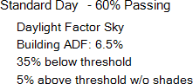

Ground floor:

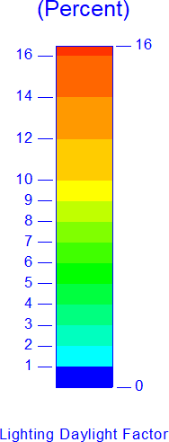
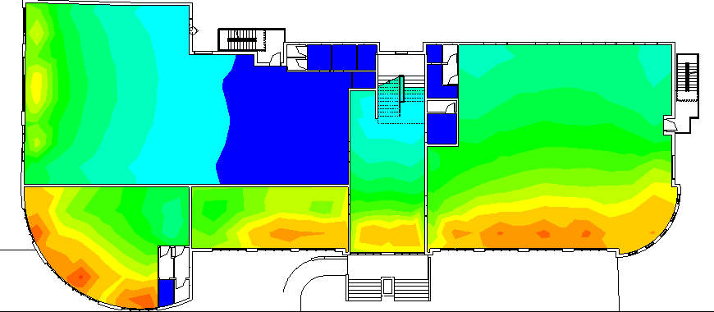

Figure 2.93: Daylight factor in ground floor before.

From the previous analysis the daylight factor in most of spaces is between 2-5% as show in the previous figure and there is a space more than 5% which need a treatment.

First floor:

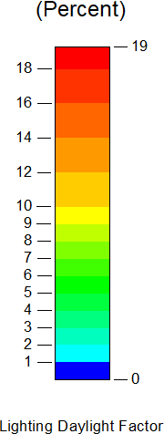

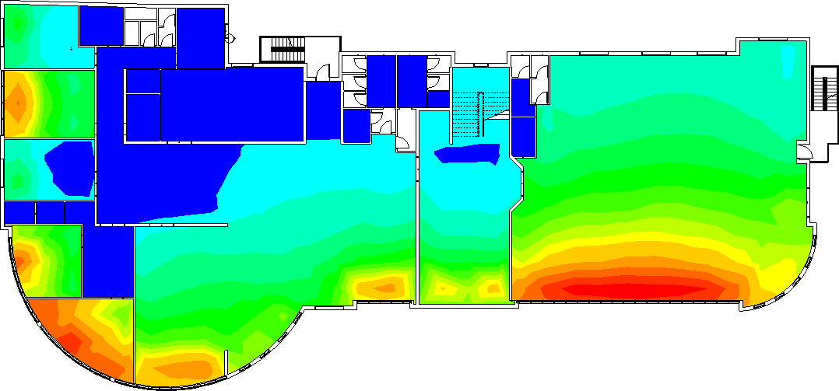
Figure 2.94: Daylight factor in first floor before.

From the previous analysis the daylight factor in most of spaces is between 2-5% as show in the previous figure and there is a space more than 5% which need a treatment.

Second floor:

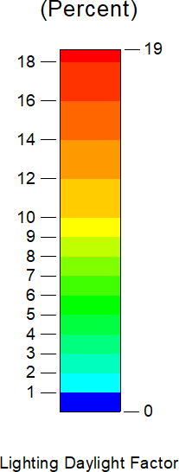

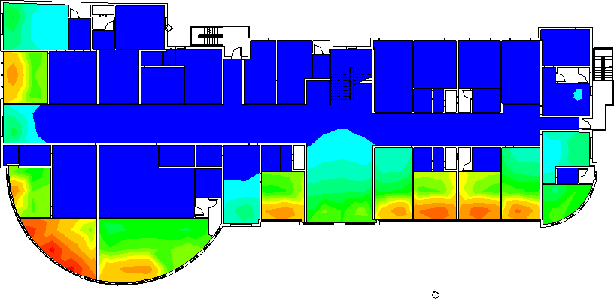
Figure 2.95: Daylight factor in second floor before.

From the previous analysis the daylight factor in most of spaces is between 2-5% as show in the previous figure and there is a space more than 5% which need a treatment.

Third floor:

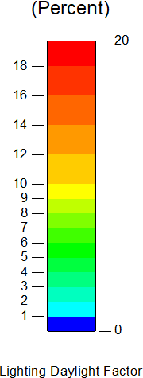

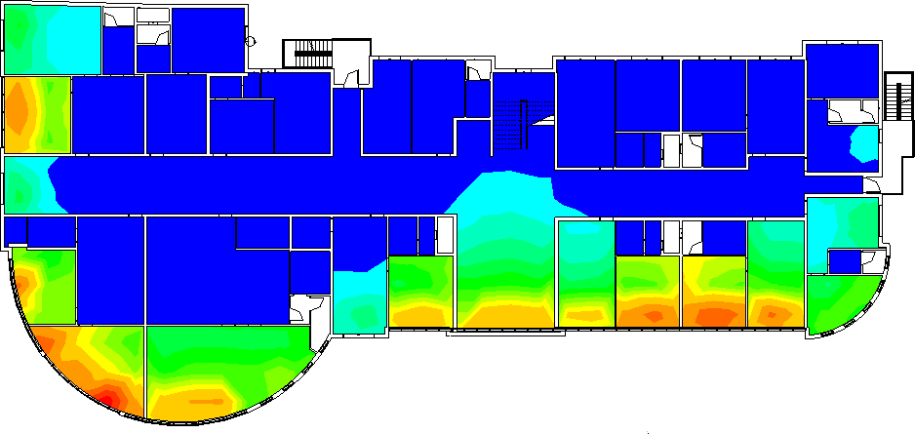
Figure 2.96: Daylight factor in third floor before.

From the previous analysis the daylight factor in most of spaces is between 2-5% as show in the previous figure and there is a space less than 1% and more than 5% which need a treatment.

Fourth floor:

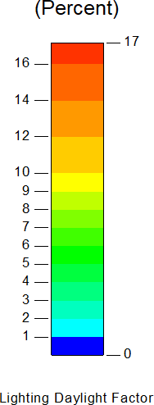

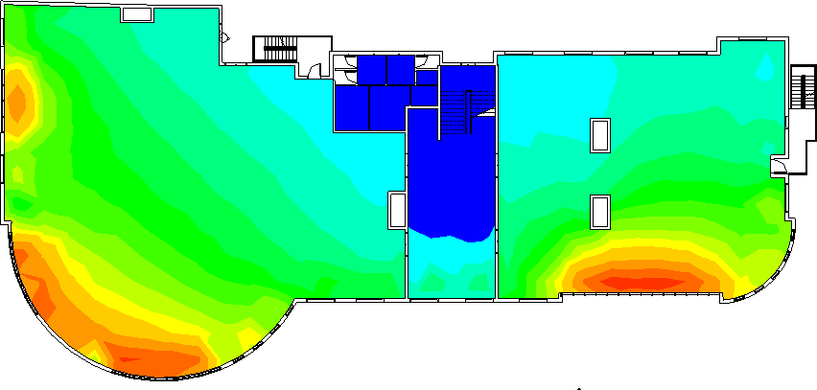

Figure 2.97: Daylight factor in fourth floor before.

From the previous analysis the daylight factor in most of spaces is between 2-5% as show in the previous figure and there is a space less than 1% and more than 5% which need a treatment.

Fifth floor:

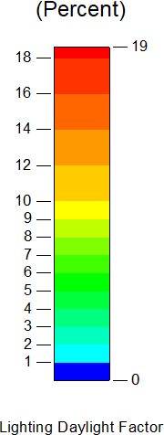

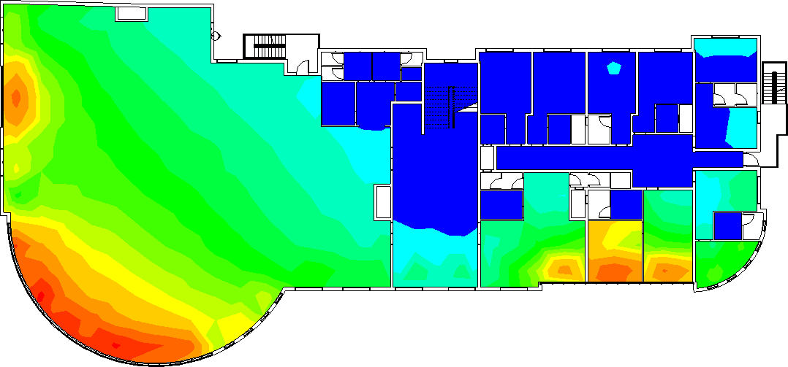

Figure 2.98: Daylight factor in fifth floor before.

From the previous analysis the daylight factor in most of spaces is between 2-5% as show in the previous figure and there is a space less than 1% and more than 5% which need a treatment.

Sixth floor:

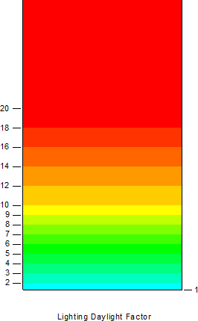

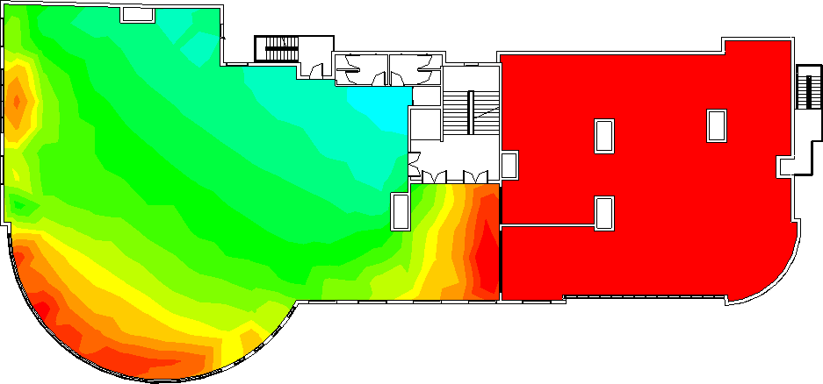
Figure 2.99: Daylight factor in sixth floor before.

From the previous analysis the daylight factor in most of spaces is between 2-5% as show in the previous figure and there is a space less than 1% and more than 5% which need a treatment.
Summary:

In general daylight factor before is not good.

After modifications

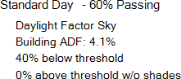

Ground floor

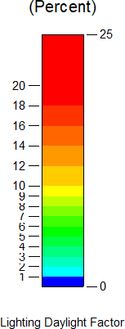

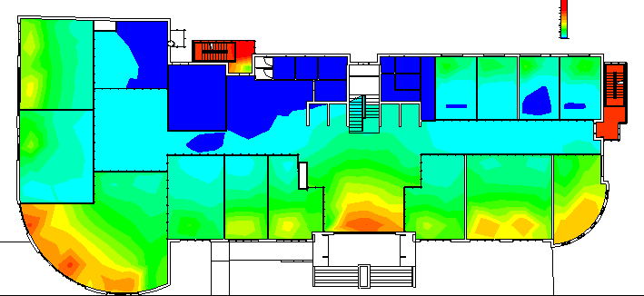

Figure 2.100: Daylight factor in ground floor after.

From the previous analysis the daylight factor in most of spaces is between 2-5% as show in the previous figure and there is a space less than 1% and more than 5% which need a treatment.

First floor

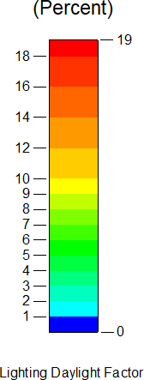

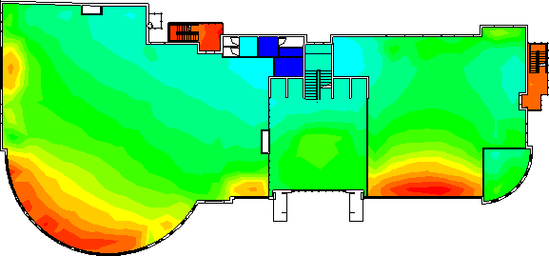
Figure 2.101: Daylight factor in first floor after.

From the previous analysis the daylight factor in most of spaces is between 2-5% as show in the previous figure and there is a space less than 1% and more than 5% which need a treatment.

Second floor

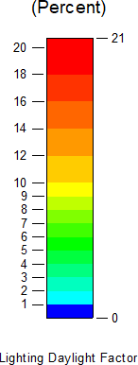

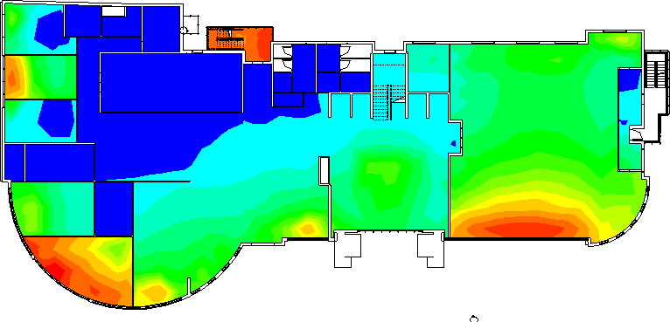
Figure 2.102: Daylight factor in second floor after.

From the previous analysis the daylight factor in most of spaces is between 2-5% as show in the previous figure and there is a space less than 1% and more than 5% which need a treatment.

Third floor

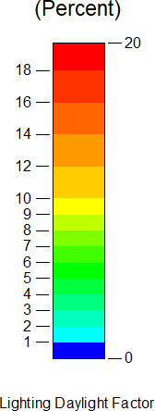

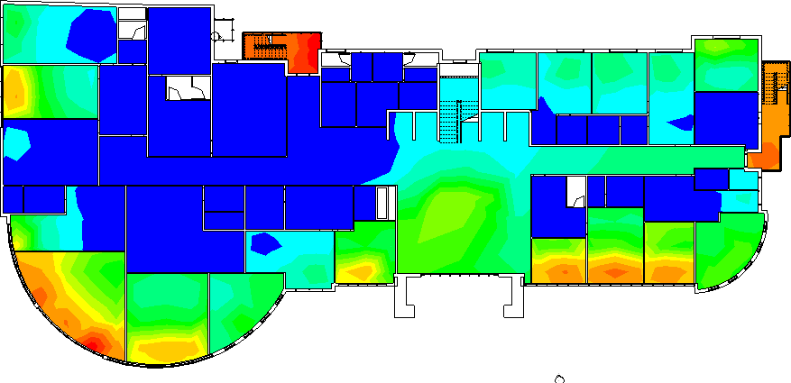
Figure 2.103: Daylight factor in third floor after.

From the previous analysis the daylight factor in most of spaces is between 2-5% as show in the previous figure and there is a space less than 1% and more than 5% which need a treatment.

Fourth floor

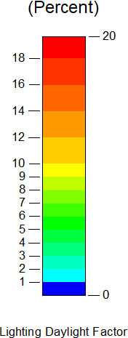

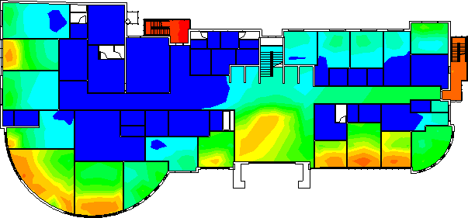

Figure 2.104: Daylight factor in fourth floor after.

From the previous analysis the daylight factor in most of spaces is between 2-5% as show in the previous figure and there is a space less than 1% and more than 5% which need a treatment.

Fifth floor

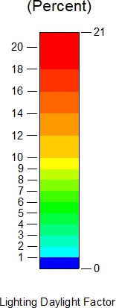

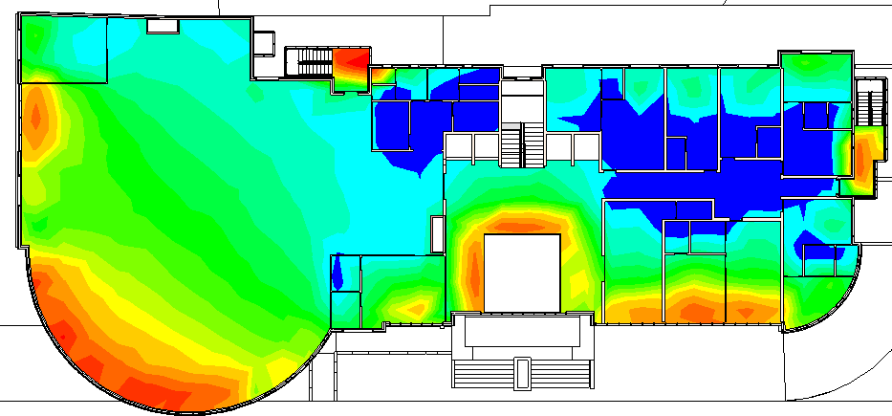

Figure 2.105: Daylight factor in fifth floor after.

From the previous analysis the daylight factor in most of spaces is between 2-5% as show in the previous figure and there is a space less than 1% and more than 5% which need a treatment.

Sixth floor

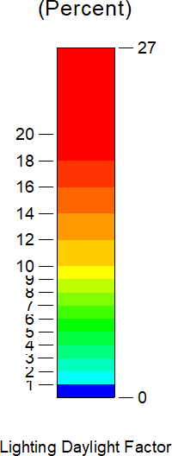

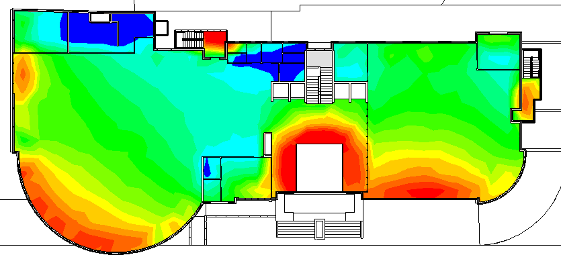

Figure 2.106: Daylight factor in sixth floor after.

From the previous analysis the daylight factor in most of spaces is between 2-5% as show in the previous figure and there is a space less than 1% and more than 5% which need a treatment.

Heating and cooling load

- Elements U-value

Table 2.15: Elements u-value before and after

Element Type | U-Value
Exterior wall | 2.05 W/m2-K
Glass (Sql Clr 6mm.) | 5.778 W/m2-K
Roof | 3.745 W/m2-K
Floors | 1.201 W/m2-K

- Before modifications
Table 2.16: Total cooling and heating load before
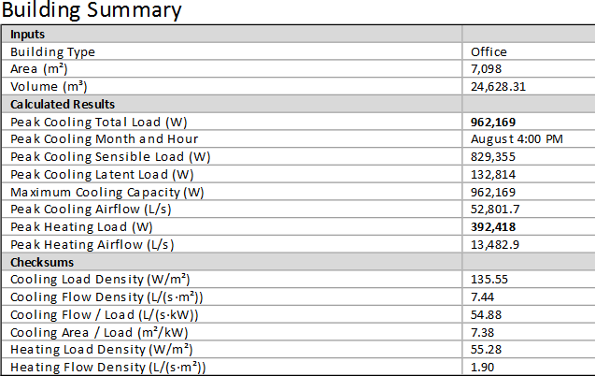

The total cooling load before modifications =962.16 Kw The total heating load before modifications =392.42 Kw

- After modifications

Table 2.17: Total cooling and heating load after
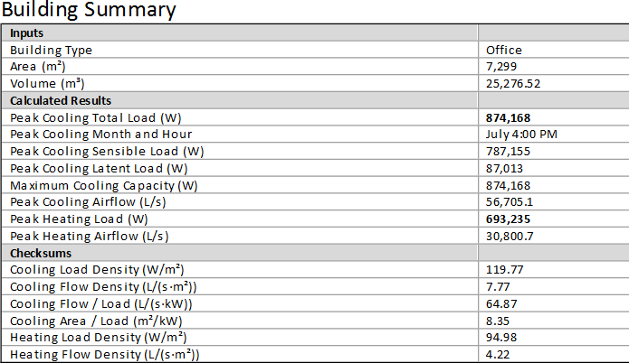

The total cooling load after modifications = 874.16 Kw The total heating load after modifications = 693.23 Kw

Environmental treatment strategies

- Using horizontal and vertical louvers
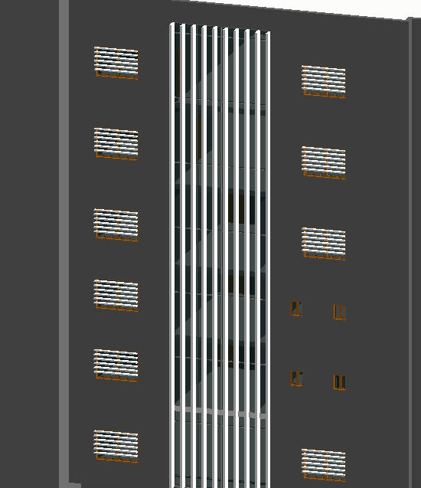
Figure 2.107: Horizontal and vertical louvers used.
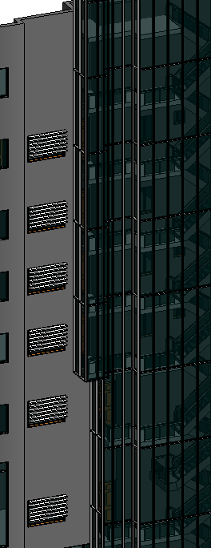

Figure 2.108: Horizontal louvers used.

- Using double low e glass
- Using thermal insulation in walls and roof to enhance cooling load
- Skylight and make court concept in courtyard
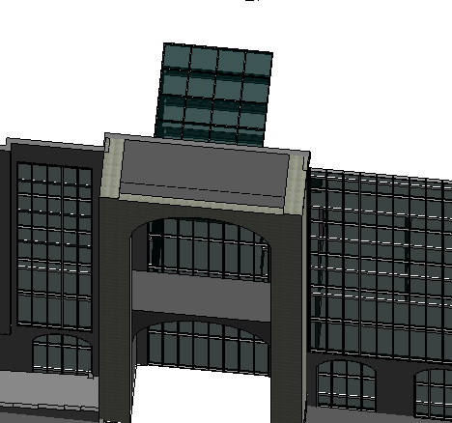
Figure 2.109: Skylight used.

Table 2.18: Elements u-value for treated model.

Element | U-value
Exterior walls | 0.44
Interior floors | 1.21
Roof | 0.65
Partitions | 1.58
Doors | 2.30
Windows | 1.38

Ground floor

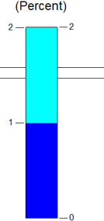

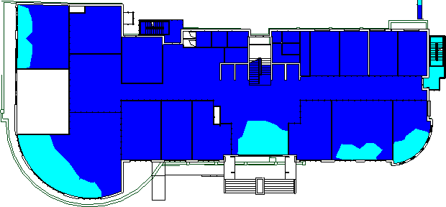
Figure 2.110: Ground floor daylight factor after treating.

First floor

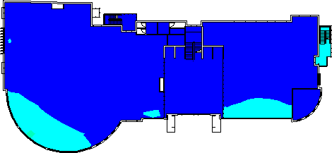

Figure 2.111: First floor daylight factor after treating.

Second floor

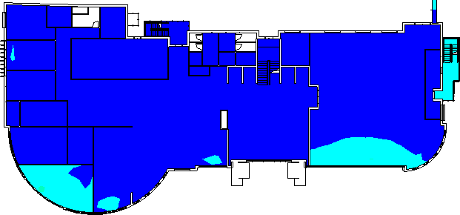

Figure 2.112: Second floor daylight factor after treating.

Third floor

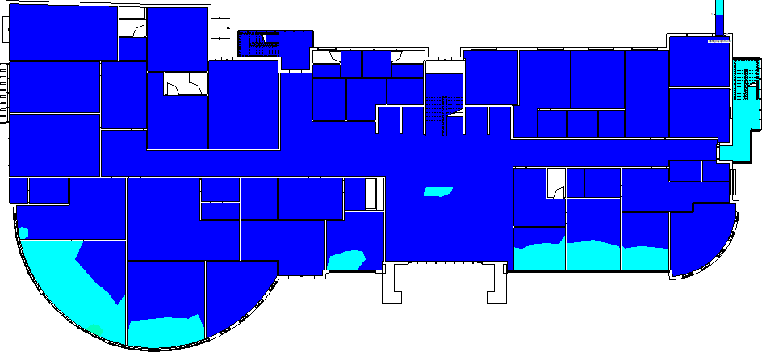

Figure 2.113: Third floor daylight factor after treating.

Fourth floor

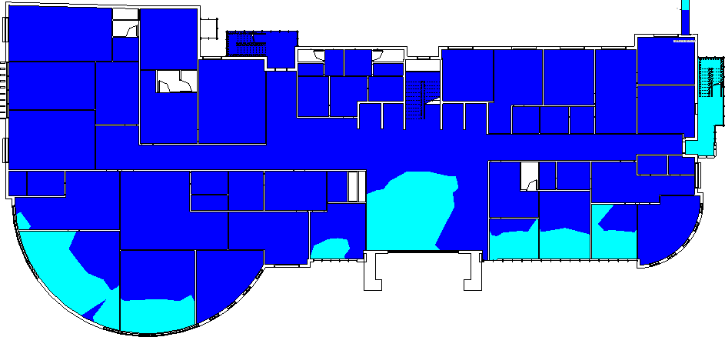

Figure 2.114: Fourth floor daylight factor after treating.

Fifth floor

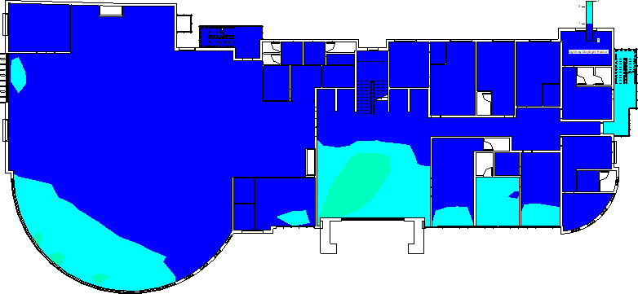

Figure 2.115: Fifth floor daylight factor after treating.

Sixth floor

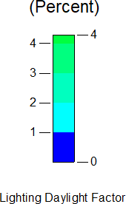

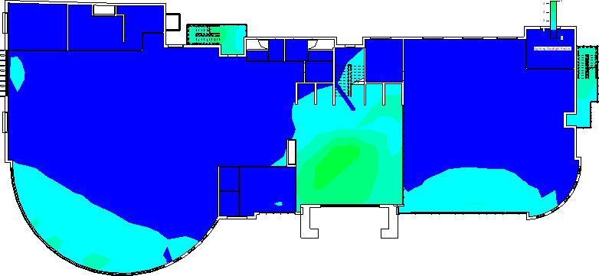

Figure 2.116: Sixth floor daylight factor after treating.

From the previous results, the daylight factor in the edges was enhanced but other strategies will be followed for enhancements during the second stage.

Table 2.19: Total cooling and heating load after treating.
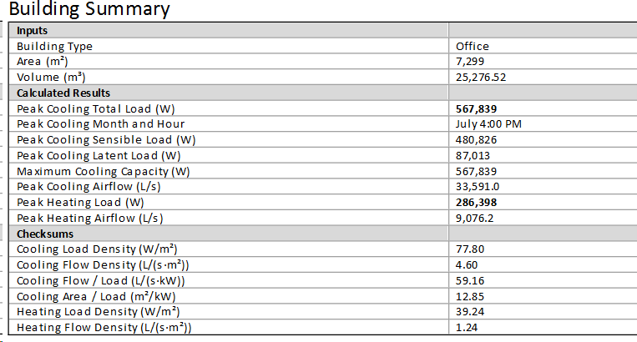

The total cooling load after modifications = 567.84 Kw The total heating load after modifications = 286.40 Kw The percentage of enhancement in cooling load = 35% The percentage of enhancement in heating load = 58%

STRUCTURAL ASPECTS

Introduction:

In this part of the project, all parts of the structural model of the building were designed, and the building was separated into two parts construction separators then inspections were carried out to verify the correct design.

Assumptions

STRUCTURAL CODE AND DESIGN

- American concrete Institute ACI 318-2014. (Building Code Requirements for Structural Concrete (ACI318-14), 2014)
- American Society of Civil Engineer (ASCE) (Minimum design loads for buildings and other structures-ASCE 7-16, 2016)
- The specific weight of concrete = 25 KN/ 𝑚2.

Material

- Reinforcement steel:
The structural element that resists tensile forces fy= 420 mpa

- Concrete:
A structural element that withstands stress, but is weak in resisting the tensile forces on it.
fc’ =28 mpa.

Loads

- Live load:
Table 3.1: Live loads for floors.

Floor category | Live load (KN/m2)
Parking | 4.78
Stores | 6.00
Offices | 4.78
Sweets | 2.87
Restaurants | 4.78

- Weight of wall =15KN/m
- Superimposed dead load
Table 3.2: Building parts weight. (Minimum Design Loads for Buildings and Other Structures, 2005)

Element | Weight (KN/m2)
Ceramic or quarry tile | 1.1
Partition | 1.87
Sand | 0.328
CEILINGS | 0.05
Mortar | 0.816
Total | 3.348
Superimposed dead load used = 4 KN/M2

- Loads combination:
1.00 D. L+1.00 L.L +1.00 S.I.D as service load combination

1.2 D. L+1.6 L.L +1.2 S.I.D as Ultimate load combination

To ensure more safety in the structural design, the code (ACI 318-14) required using specific equations that include a safety factor.
We will deal with the first two equations in the previous table because they deal with live weights and dead weights.

Structural system

Slab Design:

The flat plate with upoot system will used because of the high spans between columns.
H= thickness of slab

αm = 0

from ACI code

hs=Ln/33 = 16 /33 = 0.48 m h equivalent = 0.60m

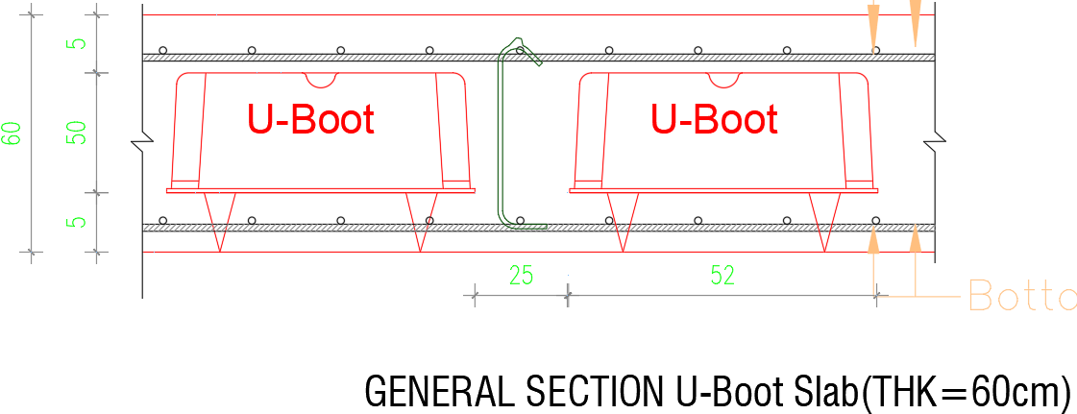

Figure 3.1: Section in Upoot
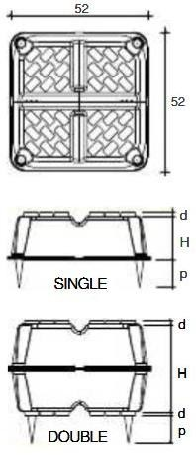

Figure 3.2: Upoot dimensions.

The Upoot dimensions is 52 cm * 52 cm
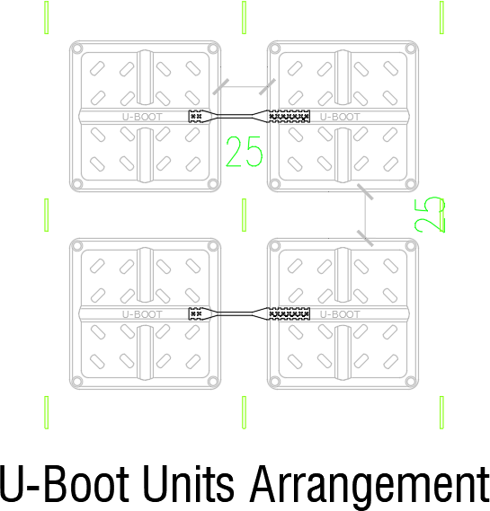

Figure 3.3: Upoot arrangement.

Table 3.3: Upoot pattern used.
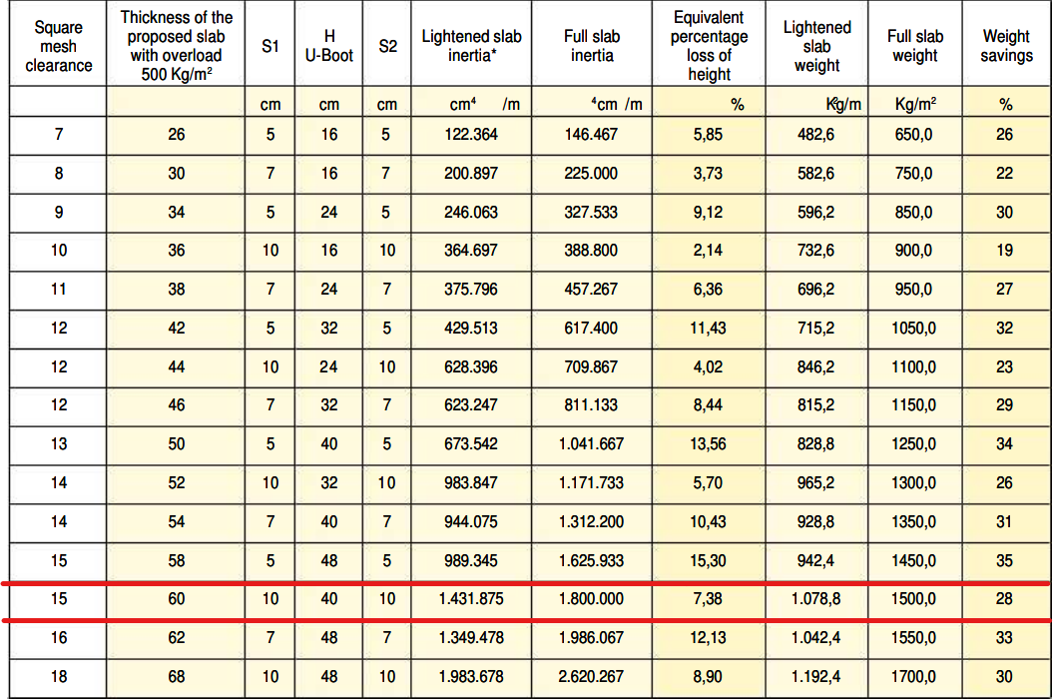

Slab unit weight = 10.78 kN/m2.

Columns Design

The columns dimensions are calculated based on the building loads, For interior column:
Tributary area = 47 m2

Slab unit load = 10.78 KN/m2 --->Approximate column’s load = 47*10.78*9 = 4560.94 KN
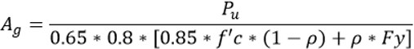

Ag = 315867.56 mm2 >Assumed column’s dimension = 80*40ccm

Expansion Joint
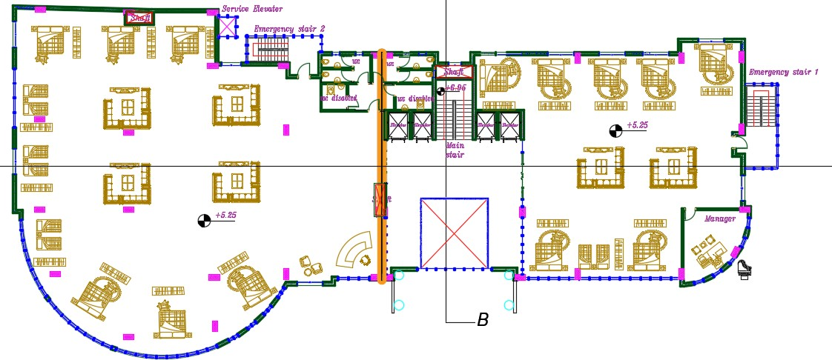

Figure 3.4: Expansion Joint location.

Because of the existing of expansion joint, the structural model will be divided into two parts (Part 1 and Part 2).

Structural Model

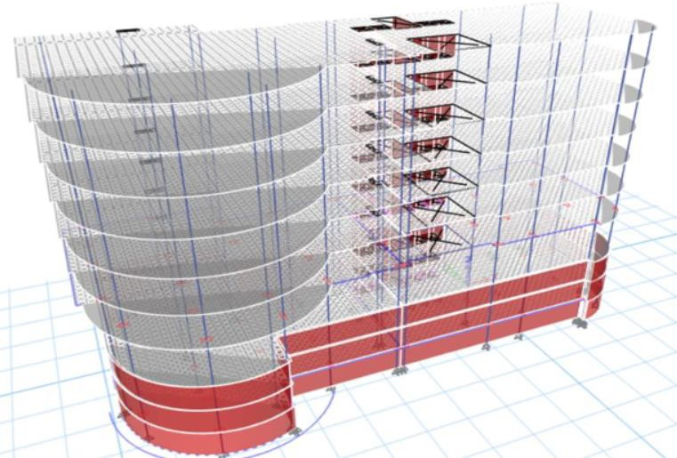
Figure 3.5: 3d structural model before separation.

- Part 1

- Part 2

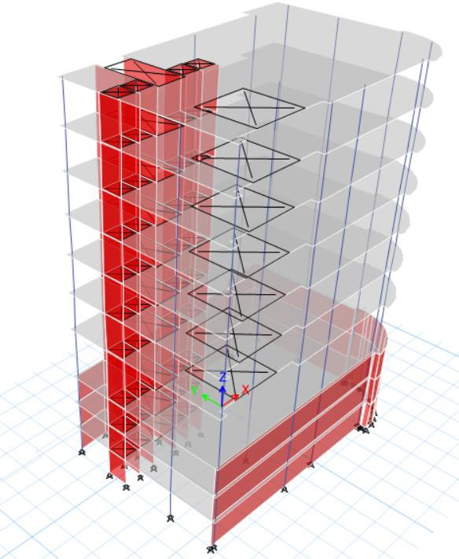

Figure 3.6: part 1 structural model.

.

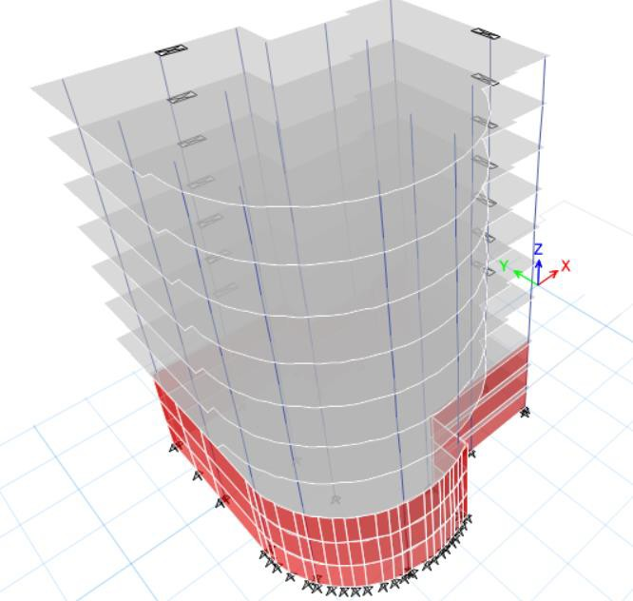

Figure 3.7: part 2 structural model.

Structural model checks

      - Compatibility check

- Part 1
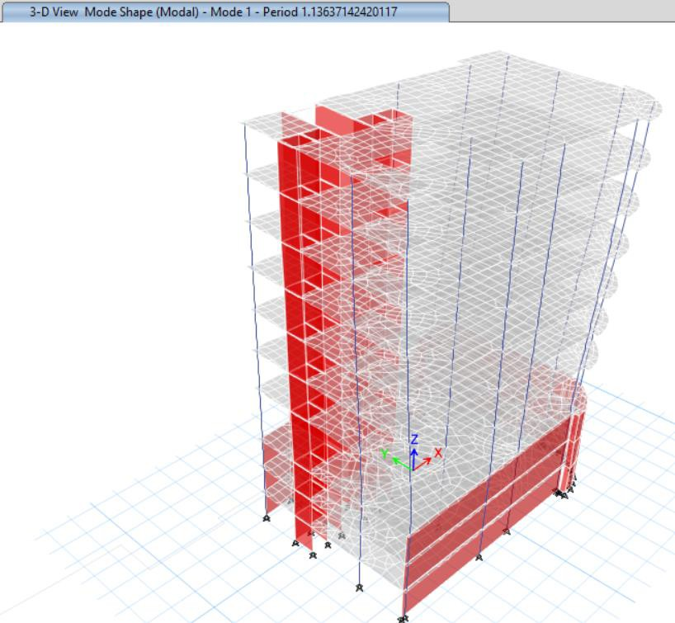
Figure 3.8: Compatibility check for part 1.

- Part 2
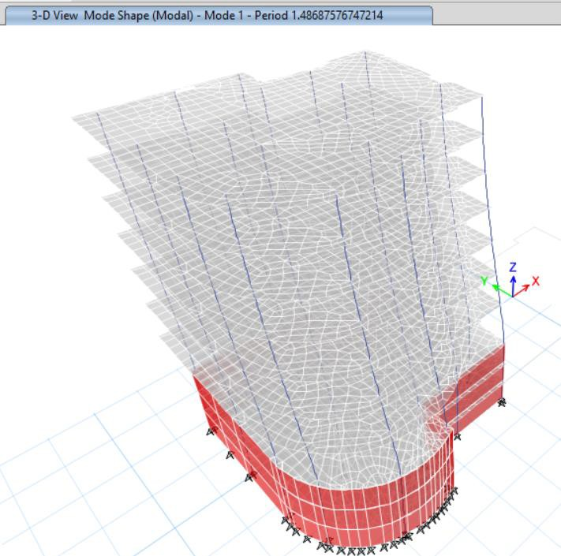

Figure 3.9: Compatibility check for part 2.

Equilibrium check:

Part 1
Table 3.4: Equilibrium check results for part 1 model.

Load | Manual | Base reaction | %Error | Ok/Not
Live | 20661.105 | 20634.28 | 0.13% | ok
SID | 17121.69 | 17082.4 | 0.23% | ok
Dead | 71533.447 | 69476.93 | 2.96% | ok

Part 2
Table 3.5: Equilibrium check results for part 2 model.

Load | Manual | Base reaction | %Error | Ok/Not
Live | 28997.121 | 28947.91 | 0.17% | ok
SID | 24027.272 | 23950.63 | 0.32% | ok
Dead | 89769.524 | 86499.83 | 3.78% | ok

Deflection check

- Part 1
  - From Live load
ΔLimit = 𝐿/360 = 16.5/360= 45.8 mm. From ETABS:
Maximum deflection:
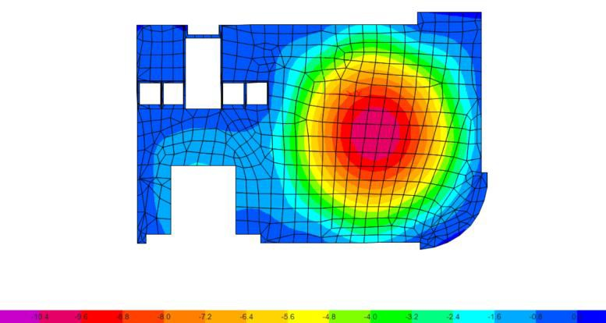

Figure 3.10: Deflection from live load for part 1.

ΔETABS = 10.4- ((3.4+3+3+3.6)/4) = 7.06mm<45mm >OK.

  - From service load
ΔLimit = 𝐿/240 = 16.5/240= 68.75mm. From ETABS:
Maximum deflection:
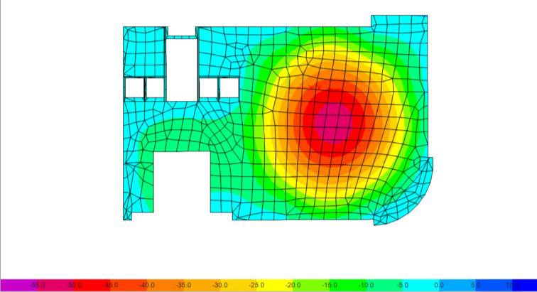

Figure 3.11: Deflection from service load for part 1.

deflection from service load

ΔETABS = 55-((11.7+13.6+9+13)/4) = 43.18mm<68mm---OK.

- Part 2
  - From Live load
ΔLimit = 𝐿/360 = 12/360= 33.3mm. From ETABS:
Maximum deflection:
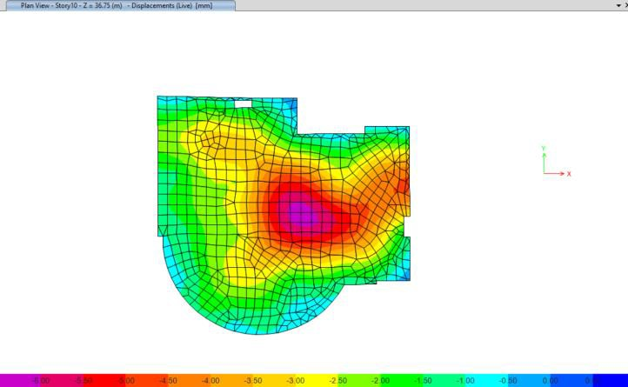

Figure 3.12: Deflection from live load for part 2.

deflection from Live load

ΔETABS = 6.00- ((3.1+2.1+3+3.2)/4) = 3.15mm<33.33mm---OK.

  - From service load ΔLimit = 𝐿/240 = 12/240= 50mm. From ETABS:
Maximum deflection:
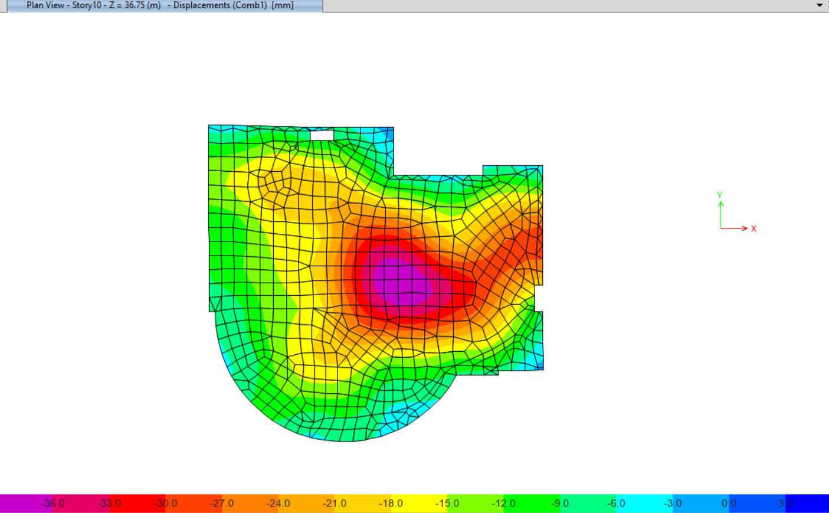
Figure 3.13: Deflection from service load for part 2.

ΔETABS = 36-((11.7+12.3+9.15+13.2)/4)= 24.4mm<50mm---OK.

Shear check

Part 1
ØVc = (0.75/6) * √𝑓𝑐 * bw *d =(0.75/6)*√40 *250 * 520=182.7 KN/ rib

  - B3 floor

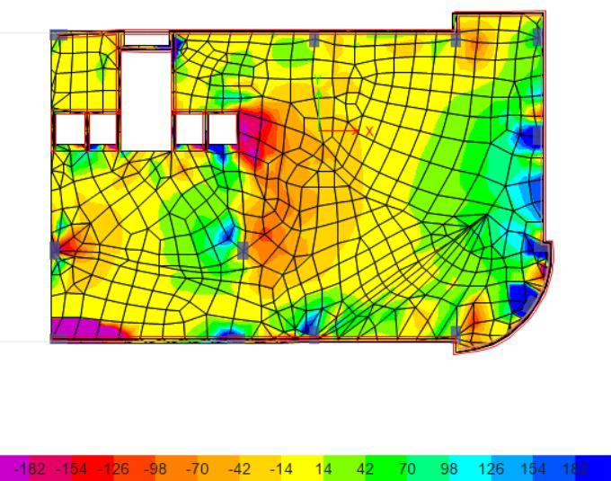

Figure 3.14: Shear for B3 floor from ETABS for part 1 model.

  - B2 floor
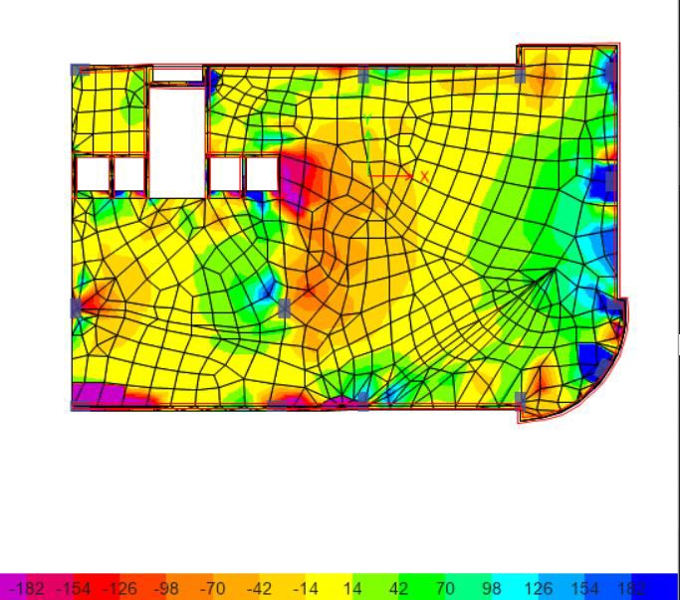

Figure 3.15:Shear for B2 floor from ETABS for part 1 model.

  - B1 floor

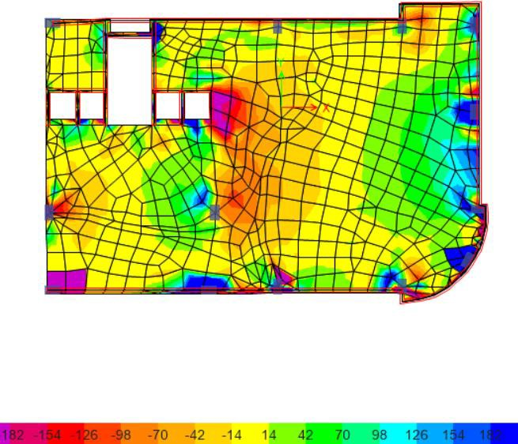

Figure 3.16: Shear for B1 floor from ETABS for part 1 model.

  - GF floor
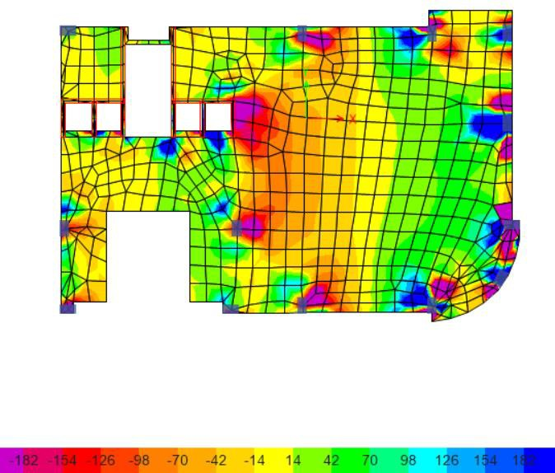

Figure 3.17: Shear for GF floor from ETABS for part 1 model.

  - F1 floor

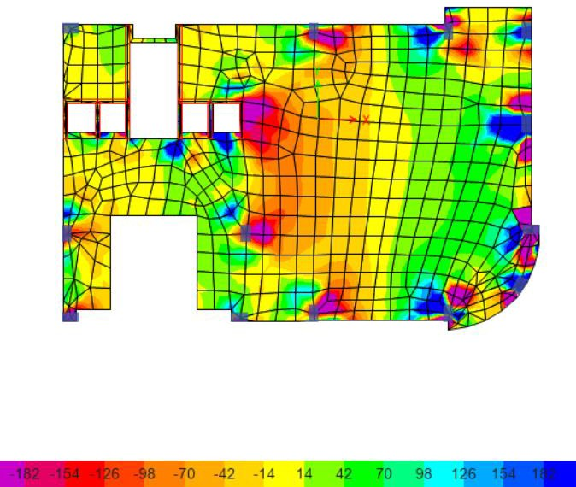

Figure 3.18: Shear for f1 floor from ETABS for part 1 model.

  - F2 floor
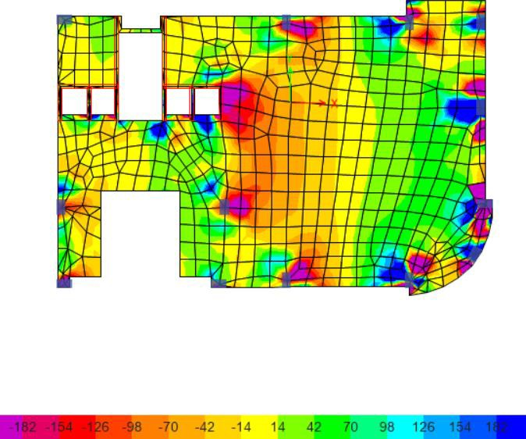

Figure 3.19: Shear for f2 floor from ETABS for part 1 model.

  - F3 floor

Figure 3.20: Shear for f3 floor from ETABS for part 1 model.

  - F4 floor

Figure 3.21: Shear for f4 floor from ETABS for part 1 model.

  - F5 floor
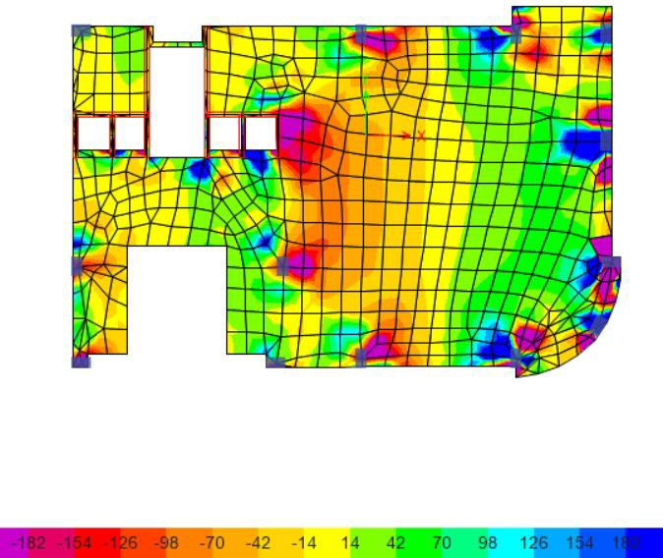

Figure 3.22: Shear for f5 floor from ETABS for part 1 model.

  - F6 floor

Figure 3.23: Shear for f6 floor from ETABS for part 1 model.

  - F7 floor

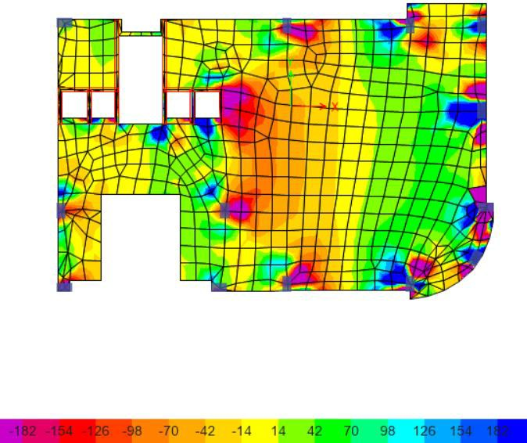

Figure 3.24: Shear for f7 floor from ETABS for part 1 model.

Part 2
  - B3 floor
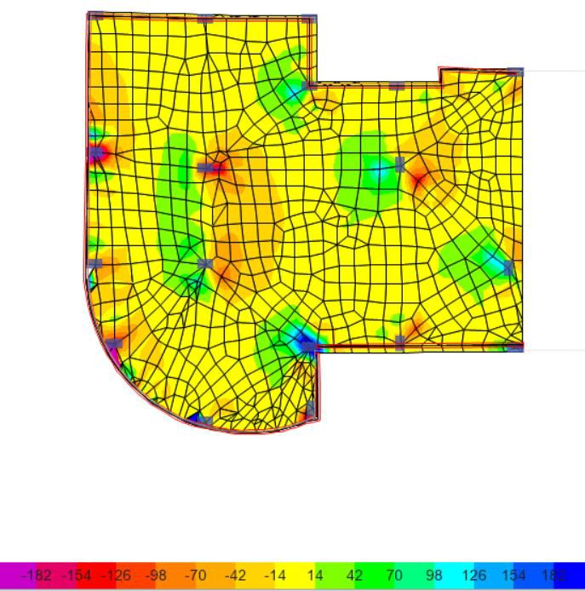

Figure 3.25: Shear for B3 floor from ETABS for part 2 model.

  - B2 floor
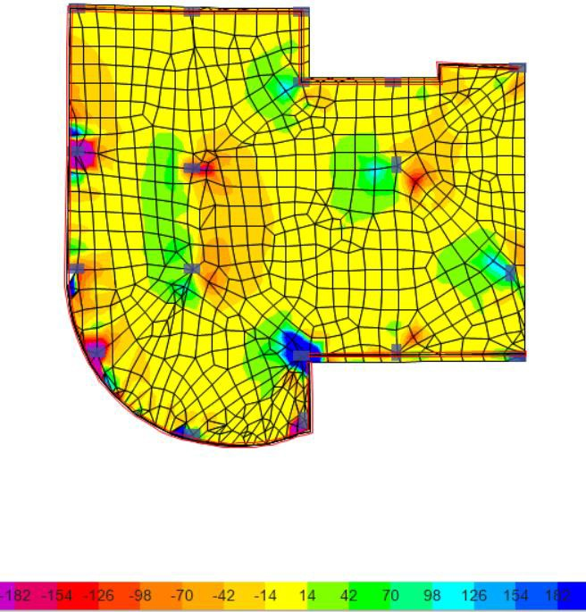

Figure 3.26: Shear for B2 floor from ETABS for part 2 model.

  - B1 floor

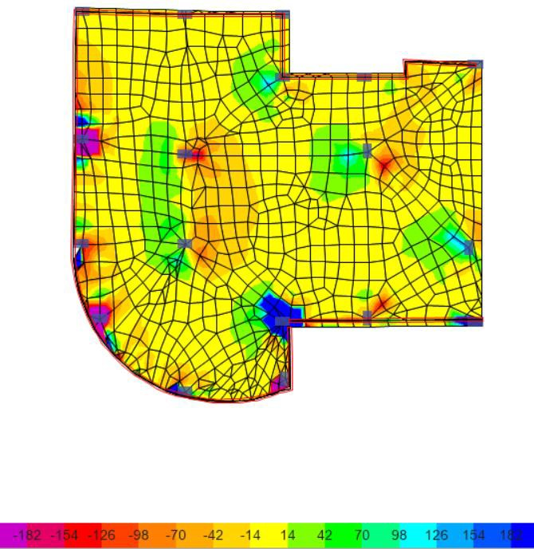

Figure 3.27: Shear for B1 floor from ETABS for part 2 model.

  - GF floor
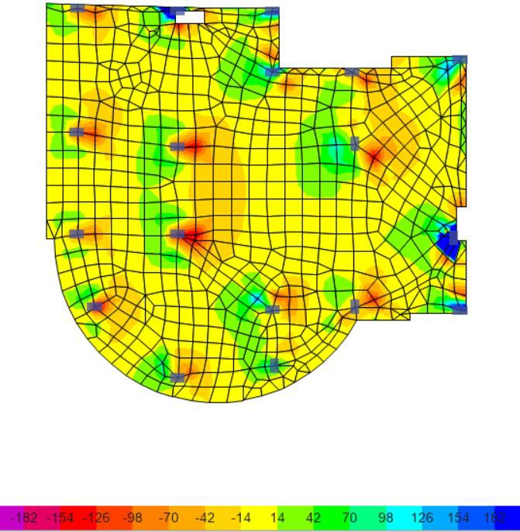

Figure 3.28: Shear for GF floor from ETABS for part 2 model.

  - F1 floor

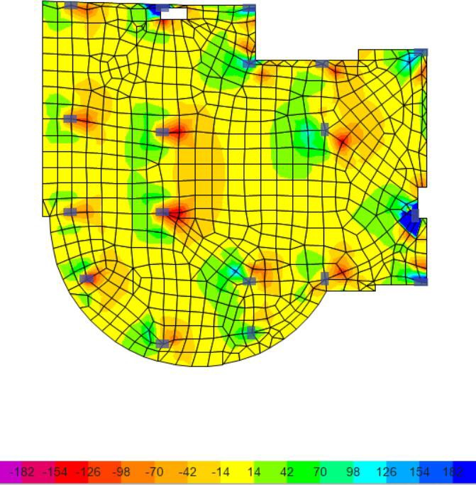

Figure 3.29: Shear for F1 floor from ETABS for part 2 model.

  - F2 floor

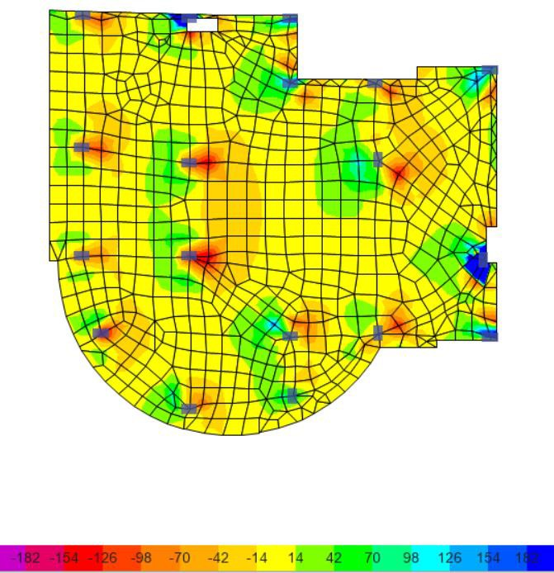

Figure 3.30: Shear for F2 floor from ETABS for part 2 model.

  - F3 floor

Figure 3.31: Shear for F3 floor from ETABS for part 2 model.

  - F4 floor

Figure 3.32: Shear for F4 floor from ETABS for part 2 model.

  - F5 floor

Figure 3.33: Shear for F5 floor from ETABS for part 2 model.

  - F6 floor

Figure 3.34: Shear for F6 floor from ETABS for part 2 model.

  - F7 floor

Figure 3.35: Shear for F7 floor from ETABS for part 2 model.

The previous check is ok, but at the regions that exceed ØVc, the solution is increase reinforcement or put a stirrup at these regions.

Stress strain check

        - Columns check From ultimate loads

Part 1
Table 3.6: Stress strain check result for columns in part 1 model.

Column Type | Etabs | Manual | %Error | Ok/Not
Interior | 12633.28 | 13151.24 | 4.10% | Ok
Corner | 1574.09 | 1576.14 | 0.13% | Ok
Edge | 5104.97 | 5213.71 | 2.13% | Ok

Part 2
Table 3.7: Stress strain check result for columns in part 2 model.

Column Type | Etabs | Manual | %Error | Ok/Not
Interior | 16587.23 | 17205.93 | 3.73% | Ok
Corner | 1653.81 | 1672.33 | 1.12% | Ok
Edge | 4187.15 | 4322.39 | 3.23% | Ok
Slab check From live load

Part 1
Table 3.8: Stress strain check result for slab in part 1 model.

Panel type | Etabs | Manual | %Error | Ok/Not
Exterior | 22 | 24.01 | -9.13% | Ok

Part 2
Table 3.9: Stress strain check result for slab in part 2 model.

Panel type | Etabs | Manual | %Error | Ok/Not
Exterior | 33.1 | 37.17 | -12.30% | Ok

Design check

Part 1

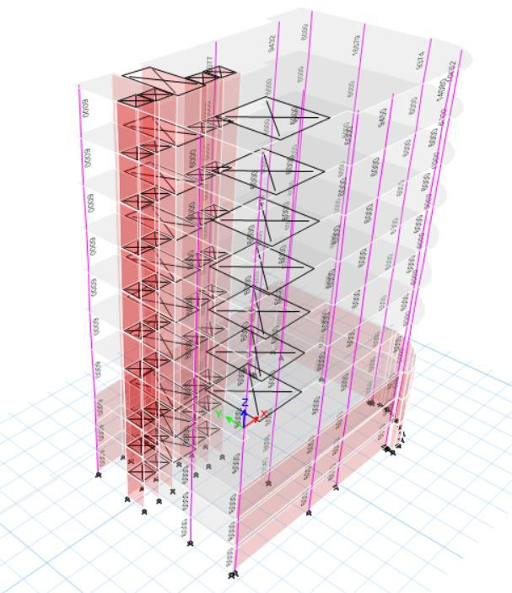
Figure 3.36: Design results for part 1 model.

As shown, the check is ok

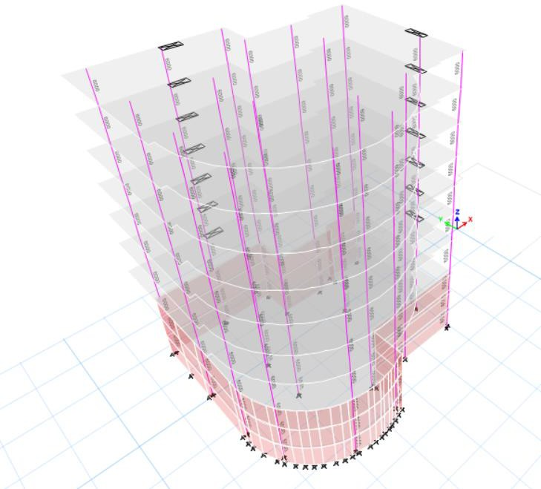

Figure 3.37: Design results for part 2 model.

As shown, the check is ok

QUANTITY SURVEYING & COST ESTIMATE

Introduction:

Quantity surveying was utilized by the ancient Egyptian culture when they assigned people to estimate costs. It was developed in the 17th century following the great fire in London's rebuilding. (Reddy, 2017)
Money is the only thing that can govern any operation in our lives all over the universe. What precisely is Quantity Surveying?
It may be defined as a position that guarantees that the project's assets are utilized most efficiently and cost-effectively possible by employing project management techniques. (Reddy, 2017)

This chapter will provide a rapid building cost estimate based on a certain technology.

Cost estimation Techniques:

There are several cost-estimating procedures, however, the following include the most common:

Analogous estimation

It is also called top-down approximation, and it is utilized when there is no valuable knowledge about the project. It requires less deep knowledge of the project. (4 Most Used Cost Estimation Techniques Used by Project Managers | Opus Kinetic, 2018)

Parametric estimation

This strategy, also known as past project unit cost, is based upon statistical historical information from previous projects and components. (4 Most Used Cost Estimation Techniques Used by Project Managers | Opus Kinetic, 2018)

Three-point estimation

Three parameters must be established when employing this strategy, which are as follows:

- Most likely cost (Cm): a normal situation is studied, and everyone is assumed to be ordinary. (4 Most Used Cost Estimation Techniques Used by Project Managers | Opus Kinetic, 2018)
- Pessimistic cost (Cp): considers a worst situation and assumes all goes very wrong. (4 Most Used Cost Estimation Techniques Used by Project Managers | Opus Kinetic, 2018)
- Optimistic cost (Co): the best result scenario is examined, and it all works out better than anticipated. (4 Most Used Cost Estimation Techniques Used by Project Managers | Opus Kinetic, 2018)

Bottom-Up estimation

This strategy relies on determining the cost for project tasks, which provides a more precise assessment that roughly represents the project's final price. (4 Most Used Cost Estimation Techniques Used by Project Managers | Opus Kinetic, 2018)

Methodology

Since there is no precise knowledge concerning all of the facility's elements, the conventional estimating approach is employed at this phase.
It is performed by determining the net surface area of the structure and multiplying by the unit price ($/1 sq.m) which is the average unit price for a structure identical to this kind of construction as determined by a professional in this sector.

Limitations

The biggest limitation is that there isn't enough valuable data about a facility to get an accurate estimate.

Summary

Table 4.1: Cost estimation results.

Floor | Area(m2) | Cost/area($/m2) | Total cost ($)
Parking | 1947.29 | 400 | $778,914.56
Ground-6th floors | 6645.34 | 1200 | $7,974,402.48
Building Total cost ($) | $ 8,753,317.04
Building unit cost($/m2) | $/m2 1,018.70

CONCLUSION

ARCHITECTURAL Aspects

After making the assessment for the existed spaces and based on literature review data and asking architectural engineers in the faculty, all spaces are within the standards, but the modifications will only make on the floor's functions arrangement, changing some of the floors functions and rearrange of the floors.
The importance points that added and changings to the floors are the following:

- Adding three elevators, so total number of elevators will be 4 elevators for people, and service elevator will be added as service elevator for restaurant and coffee shop.
- Adding shops in the ground floor.
- Adding WC’s in the third and fourth floors for people and disabled people.
- Distribution of restaurant spaces.
- Increasing doors areas.
- Increasing the width of the main entrance.
- Changing the shape of the disabled people ramp and its slope to be 6% as per standards.
- Adding a new basement to increase the number of parking spaces and considering an extra three parking spaces will add for disabled people at the main entrance of the building.
Here is a summary of the floors’ functions before and after

Table 5.1: Floors functions before and after modifications.

Floor Name | Function before | Function After
Ground floor | Investments units | Shops
First floor | Chamber of commerce | Furniture show areas
Second floor | offices | Chamber of commerce
Third floor | offices | offices
Fourth floor | Furniture show areas | offices
Fifth floor | Sweets | Sweets and coffee shop
Sixth floor | Restaurant | Restaurant

ENVIRONMENTAL Aspects

Environmental treatment strategies:

- Using horizontal and vertical louvers
Figure 5.1: Horizontal and vertical louvers used.

Figure 5.2: Horizontal louvers used.

- Using double low e glass
- Using thermal insulation in walls and roof to enhance cooling load
- Skylight and make court concept in courtyard

Figure 5.3: Skylight used.

Table 5.2: Elements u-value for treated model.

Element | U-value
Exterior walls | 0.44
Interior floors | 1.21
Roof | 0.65
Partitions | 1.58
Doors | 2.30
Windows | 1.38

Structural Aspects

The design was performed to resist the earthquake forces

    - Design of concrete columns All columns are 40*80

    - Design of concrete slab
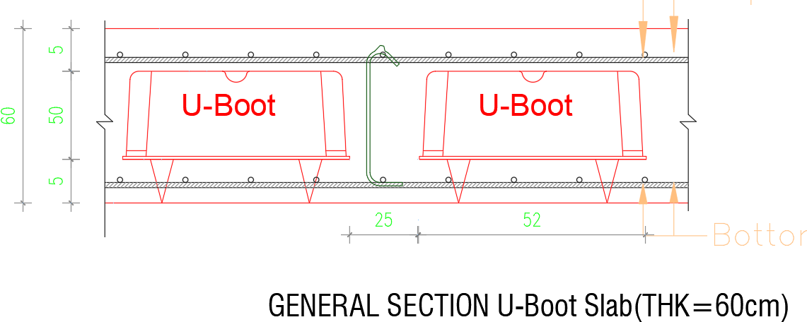

Figure 5.4: Slab section.

Quantity surveying & Cost Estimation

Based on the bottom up estimation technique

Total building cost = $ 8,753,317.04, and Building’s unit cost = $/m2 1,018.70

Table 5.3: Cost estimation results.

Floor | Area(m2) | Cost/area($/m2) | Total cost ($)
Parking | 1947.29 | 400 | $778,914.56
Ground-6th floors | 6645.34 | 1200 | $7,974,402.48
Building Total cost ($) | $ 8,753,317.04
Building unit cost($/m2) | $/m2 1,018.70

REFERENCES
- ADLER, D. (2007). Metric Handbook Planning and Design Data. 1–851.
- Ambiencedore. (2022). The How To of Conference Room Planning. Ambiencedore. https://www.ambiencedore.com/conference-room-planning- guide/?fbclid=IwAR1vHGYk9S8e2pNO2_kDYdS82kHjbYDfQYpPOGDAA3_ 9q9Ck1vfpQDgdLEU
- Building Code Requirements for Structural Concrete (ACI318-14). (2014). Building Code Requirements for Structural Concrete (ACI 318-14) (14th ed.). ACI Committee 318. https://doi.org/10.14359/51716937
- FIVE OFFICE DESIGN PROBLEMS THEIR AND SOLUTIONS. (2022). FIVE OFFICE DESIGN PROBLEMS THEIR AND SOLUTIONS. Ciaogreen.
Available at: https://www.ciaogreen.com/blog/five-office-design-problems-and-their- solutions/
- Jamie Johnson. (2021). What Is a Chamber of Commerce? Us Chamber. Availe at: https://www.uschamber.com/co/start/strategy/what-is-a-chamber-of-
commerce
- Jittrapirom, P. (2010). Sustainable Transport System and Parking Organisation: A case study of Bangkok´s Parking Standard.
- Life Safety - Means of Egress / Exits – NFPA 101. (2020). Life Safety - Means of Egress / Exits – NFPA 101.
- Mahajan, B. (2022). The Standard Room Size. Civiconcepts. Available at: https://civiconcepts.com/blog/standard-room-size
- Minimum design loads for buildings and other structures-ASCE 7-16. (2016). Minimum design loads for buildings and other structures-ASCE 7-16. ASCE Standard, 7–5, 1–456.
- Neufert, E., & Neufert, P. (2012). Neufert Architects’ Data Fourth Edition. In
Journal of Chemical Information and Modeling (Vol. 53, Issue 9).
- Ontario Building Code 2012. (2012). Ontario Building Code 2012. 1, 9–10.
- weatherspark. (2022). Climate and Average Weather Year Round in Jenin. Weatherspark.
Available at: https://weatherspark.com/y/79953/Average-Weather-in-Jenin-Poland- Year-Round
- YEGENAarchitectural. (2022). Adana Chamber of Commerce Service Building. Available at: https://archello.com/project/adana-chamber-of-commerce-service- building

  - “4 Most Used Cost Estimation Techniques Used By Project Managers | Opus Kinetic.” 2018. https://www.opuskinetic.com/2018/03/4-most-used-cost-
estimation-techniques-used-by-project-managers/ (December 21, 2020).
Available At: https://www.opuskinetic.com/2018/03/4-most-used-cost-estimation- techniques-used-by-project-managers
  - A Common Definition for Zero Energy Buildings. 2015. “A Common Definition for Zero Energy Buildings.” (September): 22.
  - ACI-318. 2014. American Concrete Institute Building Code Requirements for Structural Concrete (ACI 318S-14) and Commentary (ACI 318SR-14).
  - ADLER, DAVID. 2007. “Metric Handbook Planning and Design Data.” : 1– 851. file:///Volumes/750G/%23 setting/%23 Papers2 Library/Papers2/Files/Metric Handbook_ Planning and Design Data, Third Edition - David Littlefield.pdf%5Cnpapers2://publication/uuid/1B514042- DB7B-4A29-B7D2-7521D5BBE614.
  - Aelenei, Laura et al. 2018. COST Action TU 1403 Adaptive Facade Network
Case Studies – Adaptive Facade Network.
  - AISC-360. 2016. “Specification for Structural Steel Buildings, ANSI / AISC 360-16.” American Institute of Steel Construction: 676.
  - Al-Dabbeek, Jalal N., and Radwan J. El-Kelani. 2008. “Site Effect and Expected Seismic Performance of Buildings in Palestine-Case Study: Nablus City.” AIP Conference Proceedings 1020(PART 1): 191–98.
  - Arnold, Christopher. 2016. “Earthquake Effects on Buildings.” Tall Building Design: 69–221.
  - Building Code Requirements for Structural Concrete (ACI318-14). 2014. Building Code Requirements for Structural Concrete (ACI 318-14). 14th ed. Texas: ACI Committee 318.
  - Daylight Factor | Daylighting Pattern Guide. 2020. “Daylight Factor | Daylighting Pattern Guide.” https://patternguide.advancedbuildings.net/using- this-guide/analysis-methods/daylight-factor (November 13, 2020).
Available At: https://patternguide.advancedbuildings.net/using-this-guide/analysis- methods/daylight-factor
  - Energy Use Intensity by Property Type. 2013. “Technical Reference: Technical Reference Canadian Energy Use Intensity by Property Type.” (July): 1–6. https://portfoliomanager.energystar.gov/pdf/reference/Canadian National Median Table.pdf.
Avaliable At: https://portfoliomanager.energystar.gov/pdf/reference/Canadian National Median Table.pdf.
  - Fire prevention code. 1993. Fire Prevention Code. Royal Society Building Research Focus.
  - Gravity Density Specific Weight and Specific. 2021. “Density, Specific Weight and Specific Gravity.” https://www.engineeringtoolbox.com/density- specific-weight-gravity-d_290.html (March 13, 2021).
Avaliable At: https://www.engineeringtoolbox.com/density-specific-weight- gravity-d_290.html

  - “IMPORTANCE OF STRUCTURAL DESIGN - Aarushi Associates.” 2020.
http://www.aarushiassociates.in/uncategorized/importance-of-structural- design/ (December 18, 2020).
Avaliable At: //www.aarushiassociates.in/uncategorized/importance-of-structural- design/
  - International Code Council. 2012. “International Code Council.”
  - IS. 2000. “Concrete, Plain and Reinforced.” Bureau of Indian Standards,New Dehli: 1–114.
  - Keerthirathna, W. A. D., Gayani Karunasena, and V. A. K. Rodrigo. 2018. “Disability Access in Public Buildings.” International Research Conference on Sustainability in Built Environment (June 2010).

  - Kimley, Bob, Bill Horn, and Ed Vick. 2016. “Recommended Parking Ramp Design Guidelines.”
  - Life Safety - Means of Egress / Exits – NFPA 101. 2020. “Life Safety - Means of Egress / Exits – NFPA 101.”
  - MATHalino Unit Weights and Densities of Soil | Geotechnical Engineering Review at. 2021. “Unit Weights and Densities of Soil | Geotechnical Engineering Review at MATHalino.” https://mathalino.com/reviewer/geotechnical-engineering/unit-weights-and- densities-soil (March 13, 2021).
Avaliable At: https://mathalino.com/reviewer/geotechnical-engineering/unit-weights- and-densities-soil
  - Minimum design loads for buildings and other structures-ASCE 7-16. 2016. “Minimum Design Loads for Buildings and Other Structures-ASCE 7-16.” ASCE Standard (7–5): 1–456.
  - Minimum Design Loads for Buildings and Other Structures. 2005. Minimum Design Loads for Buildings and Other Structures Supplement to Minimum Design Loads for Buildings and Other Structures (ASCE/SEI 7-05).
Avaliable At: http://mapleintegration.com/noise_cri.php
  - National Fire Alarm and Signaling Code. 2010. National Fire Alarm and Signaling Code. http://www.nfpa.org/aboutthecodes/AboutTheCodes.asp?DocNum=72.
  - Office Building Elevators. 2021. “Office Building Elevators.” FUJIHD. https://www.fujihd.net/elevator/officebuilding.html?gclid=Cj0KCQjwytOEBh D5ARIsANnRjViFRNiJ5L6D1J2SFol88N2uzsyOz2L3kXY0lC8hPhspLpDw ppL0zYEaAvXtEALw_wcB (May 7, 2021).
Avaliable At:
//www.fujihd.net/elevator/officebuilding.html?gclid=Cj0KCQjwytOEBhD5ARIs ANnRjViFRNiJ5L6D1J2SFol88N2uzsyOz2L3kXY0lC8hPhspLpDwppL0zYEaA vXtEALw_wcB
  - Ontario Building Code 2012. 2012. “Ontario Building Code 2012.” (1): 9–10.

  - Palestinian Environmental NGOs Network. 2016. “Pre Master Plan Solar Energy Production in Palestine : Opportunities and Challenges.” (December).
Avaliable At: http://www.pengon.org/uploads/articles/4.pdf.
  - Reddy, Yeshwanth Babu. 2017. “Modern Quantity Surveying- A Complete Package Adding Values to Projects.” (March).
  - Rizos, Claire. 2013. “How Many Fire Exits Are Required in a Building?”
IFSEC Global’. https://www.ifsecglobal.com/fire/how-many-fire-exits-are- required-in-a-building/ (November 27, 2020).
Avaliable At: https://www.ifsecglobal.com/fire/how-many-fire-exits-are-required- in-a-building/
  - Scarlet, Douglas. 2013. 53 Journal of Chemical Information and Modeling
ERNST NEUFERT 4th.
  - The Importance Of Structural Design | ipl.org. 2020. “The Importance Of Structural Design | Ipl.Org.” https://www.ipl.org/essay/The-Importance-Of- Structural-Design-F38MBAHEAJF6 (December 18, 2020).
Avaliable At: https://www.ipl.org/essay/The-Importance-Of-Structural-Design- F38MBAHEAJF6
  - Uniform Building Code 1997. 1997. “Uniform Building Code 1997.”
Immunological Reviews 57(1): 107–26.



