Engineering Faculty
Electrical Engineering Department

Graduation Project

Wireless Communications
Multiple Access Techniques

Prepared by
Mahdi Nazmi Alssadah

Submitted to
Dr. Allam Musa
Contents
* Introduction
* Chapter 1: Comparison in equations and graphs
1.1- TDMA system math description.
1.2- CDMA system math description.
1.3- CDMA/TDMA math description.
1.4- comparisons between the three systems.
1.4.1- Delay equations.
1.4.2- The packet loss equations.
1.4.3- The network throughput equations.
1.4.4- bit error probability equations.
1.5- Users with different bit rates.
1.6- Numerical analysis and graphs.
* Chapter 2: Capacity of the CDMA and TDMA systems.
2.1- capacity of cellular TDMA systems.
2.1.1A- digital cellular systems.
A. The GSM system.
B. the ADC system.
C. the JDC system.
2.2- Capacity of CDMA systems
2.2.1A- Natural Advantages of CDMA.
2.2.2B- Single Cell CDMA Capacity.
2.2.3C- Reverse Link CDMA Capacity for the Multi-cell Case.
2C.1. Reverse Link (from M.S. to B.S.) Power Control.
2C.2. Reverse link outer-cell interference.
2.2.4D- Forward Link CDMA Capacity for the Multi-cell case.
4D.1. Forward Link (from B.S. to M.S.) Power Control.
2.3- Conclusion and Comparisons of this chapter.

* Conclusion
* References

Introduction
We see that beyond the developing of wireless communication system and the transition from generation to the next one there are so many technologies to be developed so that the total performance of the system enhanced in certain aspects but you have to pay for this enhancement in other aspects. One of these technologies is the multiple access techniques.
Now in this research we will make detailed comparison between two multiple access methods (TDMA VS CDMA) in time and code domains in Additive White Gaussian Noise channels (AWGN channels). TDMA has been used for many years and its features are well-known. Characteristics of code division multiple accesses (CDMA) and its advantages over TDMA are studied in this research. The following points are used as criteria to compare the performance of the two techniques.
- Delay.
- Throughput.
- Packet loss.
- Bit error probability.
- Capacity.
This is considered as performance parameters, are evaluated and computed for data and voice traffics. Capability of CDMA in noticeable improvement in the performance of CDMA over TDMA when features of spread spectrum techniques are taken into consideration.
1. Multiple Access Techniques
Multiple access schemes are used to allow many mobile users to share simultaneously a finite amount of radio spectrum without severe degradation in the performance of the system. The sharing of spectrum is required to achieve high capacity by simultaneously allocating the available bandwidth (or the available amount of channels) to multiple users. For high quality communications, this must be done without severe degradation in the performance of the system.

Frequency division multiple access (FDMA), time division multiple access (TDMA), and code division multiple access (CDMA) are the three major access techniques used to share the available bandwidth in a wireless communication system. These techniques can be grouped as narrowband and wideband systems, depending upon how the available bandwidth is allocated to the users. The duplexing technique of a multiple access system is usually described along with the particular multiple access scheme, as shown in the examples that follow.

The main access schemes:
1.1- FDMA Frequency Division Multiple Access.
1.2- TDMA Time Division Multiple Access.
1.3- SSMA Spread Spectrum Multiple Access.
1.4- SDMA Space Division Multiple Access.
1.5- PR Packet Radio.
1.6- OFDMA Orthogonal Frequency Division Multiple Access.
These methods can be combined to make hybrid systems. e.g.: SDMA/FDMA/TDMA

There are two basic spread spectrum (CDMA) techniques:
1. A • pure CDMA
1.Direct Sequence Spread Spectrum (DSSS):
The signal is multiplied by a spreading code in the time domain the
spreading code is a pseudo random sequence that looks like noise.
And it can be classified into as narrowband and wideband systems.
2• Frequency Hopping Spread Spectrum (FHSS):
The signal changes of carrier frequency– sequence of frequency changes is
determined via a pseudo random sequence. and it can be classified as fast
frequency hopping and slow frequency hopping.

1. C • Hybrid systems
Combines good aspects between various systems.
1.C.1 Hybrid Direct Sequence freq/time Hopped Multiple Access
This type can be classified as:
1.(DS/FH)
2.(DS/TH)
3.(FH/TH)
4.(DS/FH/TH)
1. C.2 Hybrid Time Division CDMA (TCDMA) (also called TDMA/CDMA).
In this system the time frame is divided into slots and in each slot just one
user is transmitting . Using TCDMA has an advantage in that it avoids the
near-far effect since only one user transmits at a time within a cell.
- C.3 Hybrid FDMJCDMA (FCDMA).
This type contains the two types which are:
1-MC-CDMA
2-MT-CDMA
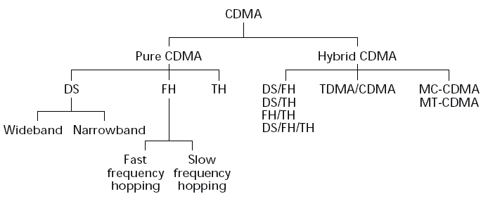

Chapter 1:

Comparison in equations and graphs
After a successful utilization of code division multiple access (CDMA) technique in military communications, it is now being used in many commercial applications such as satellite communications, cellular mobile communications, and factory automation. The most important features of CDMA are the protection against multipath fading, which is unavoidable aspect of wireless channels. Some other desirable features of CDMA such as inherent security, graceful performance degradation, flexibility in accommodating multimedia (voice/data) traffic with variable data rate, use of silent times of voice traffic, etc., make it a potential candidate for local area networks (LANs) and many other applications .new service in LANs that permit file rate. ATM (Asynchronous Transfer Mode) - (broadband switching and transmission technology) - increases the cost of the network due to star connection, and token ring limits the bit rate when the active users are small. In this chapter CDMA is applied as an alternative multiple access method for LANs.
Some parts of LANs in the newly emerging indoor communications are wireless in which usage of CDMA methods seems to be evident. Application of CDMA in the wired backbone of wireless LAN increases the compatibility between the two divisions and reduces the interface overhead.
Various aspects of spread spectrum methods especially direct sequence (DS/SS), such as admission policies for voice and data traffic, performance analysis of CDMA over optical fiber channels multiuser detection and error probability for CDMA systems have been investigated in the literature. Also a comparison between code and non-code division multiple access methods has been performed, especially for fading channels. the advantages of CDMA over other multiple access methods in Rayleigh and Rician fading channels have been reported in other researches .unfortunately in these researches some inherent aspects of CDMA were not considered resulting in a poor performance of CDMA in additive white Gaussian noise (AWGN) channels. The bursty nature of voice traffic and unequal time duration of bit transmission in CDMA and other multiple access methods are some of these aspects.
Throughout of this chapter, the approach we used is by considering and deriving the probability of error, packet loss throughput and delay. The results we obtained are generalized for AWGN channels i.e. - channel that adds white Gaussian noise to the signal that passes through it.- with variable SNR, bursty sources and different user bit rates. In particular, three systems: TDMA, DS-wideband CDMA and the hybrid system is called TDMA/CDMA are compared. The performance parameters for these systems in an AWGN channels are computed and compared .the results represent a better throughput, delay and packet loss for CDMA when compared to TDMA for low SNR and bursty sources. This shows that the CDMA methods are suitable not only for fading channels but also for AWGN channels. These results are not agreed with some researches where results are only applicable to very high SNR and non-bursty sources. The inferior performance of CDMA for non-fading channels in other researches is consequence of certain constrains. Here, these constrains are further explored and the performance measures are derived in their absence.
In this section, the three mentioned systems are described. Then, the performance parameters i.e. delay, throughput and packet loss are computed for both voice and data traffic.
NOTE: to compare TDMA, CDMA and TDMA/CDMA it is assumed that the input parameters i.e.$A$ ,$\overline{E} , \overline{E^{2}} , U$ are the same. The time axis’s is divided into frames with Frames length $T_{f}$ and only one packet is transmitted in each frame.
$A_{CDMA} ={ A}_{TDMA} = A_{HYB}$ Message arrival rate. [message per user per unit time].
${\overline{E }}_{CDMA} = {\overline{E }}_{TDMA} ={\overline{E }}_{HYB}$ Average number of packets per message.
${\overline{E^{2}}}_{CDMA}= {\overline{E^{2}}}_{TDMA}={\overline{E^{2}}}_{HYB}$ Mean square message length.
$U_{CDMA} = U_{TDMA} =U_{HYB}$ Number of users.
${T_{f}}_{CDMA}={T_{f}}_{TDMA}={T_{f}}_{HYB}$ Frame length.
1.1:
TDMA SYSTEM
In TDMA the frame time is divided into U slots one slot is assigned to each user for transmitting a packet. Each packet includes L bits. The packet user arrival rate in TDMA given as:
$Puar=λ+A*T_{f}*\overline{E} ---(1)$
Where
$Puar$: Packet user arrival rate [packet per user per second].
$λ$ : Total user arrival rate for system [packets per user per frame].
A : message arrival rate [message per user unit time].
$T_{f}$ : frame time [second].
$\overline{E}$ : Average number of packets per message
We have to notice that in TDMA system each user transmits only one packet in each time frame. So we can say that the service rate is equal to 1 (${ μ}_{TDMA}$=1).
Because of that the utilization factor OR the traffic intensity ($ρ$ ) which is:
$ρ=\frac{total user arrival rate [ packets per user per frame for system] }{service rate }$
$ρ_{TDMA}=\frac{λ_{TDMA}}{(μ_{TDMA} = 1 )}= A_{(TDMA)} * {T_{f}}_{(TDMA)} * {\overline{E}}_{(TDMA)}---(2)$
Errors can occur in bits due to noise and other channel imperfections, if a packet is received in error it will be retransmitted until it is correctly received. Retransmission is incorporated analysis by increasing the average number of packet per message from ${\overline{E}}_{old}$ to ${\overline{E}}_{new}$
$${{\overline{E}}_{new} }_{ } = \frac{{\overline{E}}_{old} }{P_{c}^{\left(TDMA\right)}} ---(3)$$
Where

${\overline{E}}_{new}$ : New average num of packets per message. [Packets per message]
${\overline{E}}_{old}$ : Old average number of packets per message. [Packets per message]
$P_{c}$ : The probability of correct detection for packet.

In fact Pc is the ratio of the correctly received packets to the total transmitted packets.
$$Pc=\frac{ \# correctly received packets }{\# total transmitted packets}$$
So we can say that the useful throughput or useful traffic intensity for each user is
$\tilde{ρ}=ρ*P_{c}^{(TDMA)}---(4)$ Where
$\tilde{ρ}: is the useful traffic intensity$.
$$ρ:is the original traffic intensity.$$
$P_{c}^{(TDMA)}:is the probability of correct detection for packet in TDMA$.
And the useful mean square message length ($\tilde{\overline{E^{2}}}$)
$${\tilde{\overline{E^{2}}}}_{TDMA } =\frac{2- P_{c}^{\left(TDMA\right)}}{{(P_{c}^{\left(TDMA\right)})}^{2}} * {\overline{{E_{ }}^{2}}}_{TDMA} ---(5)$$

1.2:
CDMA SYSTEM

In CDMA all active users transmit their packets in the whole frame time. Again it is assumed that each user transmits one packet in each frame thus,
$$Slot time (T_{s}) = frame time (T_{f})$$
$$T_{s}^{\left(CDMA\right)} = T_{f} ---(6)$$
In CDMA similar to all spreading spectrum direct sequence systems, the source data bits are multiplied by the code sequences which generated by shift registers. there are different kinds of codes used in DS/SS ,however ,gold sequences are more suitable for CDMA applications .the chip period of the gold sequences ,$T_{c}$ , is selected such that the BW of the coded signal is equal to the channel BW .
The spread spectrum processing gain ($PG$) in packet per bit is defined as:
$${{PG}_{ }}^{(CDMA)}=\frac{T_{f}/L}{T_{c}^{\left(CDMA\right)}} ≅ 2^{N}-1≈U ---(7)$$
$${PG}^{(CDMA)} = \frac{f_{c}}{f_{b}*L} ≅ 2^{N}-1≈ U$$
Where
N : is the length of shift register generating the Gold sequences
U : number of users.
L : number of bits per packet.
$T_{c}^{\left(CDMA\right)}$ : The chip period of the gold sequences in CDMA technique.
$T_{f}$ : frame time.
$f_{c}$ : spread spectrum bandwidth.
$f_{b}$ : Data bandwidth.

The processing gain for TDMA in packets per bit is given by:
${PG}^{(TDMA)} = 1 ---(8)$

Using an approach similar to TDMA the equations for CDMA are:
$λ_{CDMA} = A_{cdma} * {T_{f}}_{cdma}*{\overline{E}}_{cdma} --- (9)$
$ρ_{CDMA} =\frac{λ_{CDMA}}{(μ_{CDMA}=1)}= A * T_{f} * \overline{E } ---(10)$
${\tilde{ρ_{ }}}_{CDMA}=ρ_{CDMA}*P_{c}^{CDMA} ---(11)$
${\tilde{\overline{{E_{ }}^{2}}}}_{CDMA} =\frac{2-Pc}{{Pc}^{2}} * {\overline{{{ E}_{ }}^{2}}}_{CDMA} ---(12)$

The number of over lapping users in slot ($M_{CDMA}$) is equal to:
$$M_{CDMA}=\left[ρ*U\right]≈[ ρ*PG] ---(13)$$
Where
The parentheses [x] denote the smallest integer greater than or equal to x.
$ρ$: Traffic density utilization factor for system.
$U$ : Number of users.
1.3:
CDMA/TDMA SYSTEM

The hybrid CDMA/TDMA is a trade-off between the TDMA and CDMA systems. Anew parameter N is defined that takes values between 1 and U. the frame time is divided into N slots. Each slot is shared by U/N users. The hybrid CDMA/TDMA system is identical to TDMA for N= U and to CDMA for N=1. Such as before:
$PG_{(hyb)}=\frac{U}{N} ---(14)$ Processing gain

$T_{s}^{\left(hyb\right)}=\frac{T_{f}}{N} ---(15)$ Slot time

$ρ_{(hyb)}=\frac{λ_{hyb}}{μ_{hyb}}=A*T_{f}*\overline{E} ---(16 )$ Traffic intensity (utilization factor)

${\tilde{ρ}}_{(hyb)}= ρ*{P_{c}}_{(hhhhyb)}h ---(17)$ Useful Traffic intensity (utilization factor)

${\tilde{\overline{E^{2}}}}_{(hyb)} =\frac{2-P_{c}^{\left(hyb\right)} _{ }}{ {P_{c}^{2}}^{(hyb)}}* {\overline{{E_{ }}^{2}}}_{hyb}---(18)$ Mean square message length
$M_{(hyb)}=\left[\frac{ρU}{N}\right] ---(19)$ Number of over lapping users in slot

If the bit errors are assumed to be independent, ${P_{c_{ }}}^{(i)}$ is related to the bit error probability ${p_{b}}^{(i)}$ by:
${P_{c_{ }}}^{(i)}={\left[1-{p_{b}}^{(i)}\right]}^{L} ---(20)$ Where
${P_{c_{ }}}^{(i)}$ : The probability of correct detection for packet.
$L$ : Number of bits per packet.
$i$ : TDMA, CDMA, or Hybrid CDMA/TDMA.
Bit error probability will be evaluated shortly in a direct sequence PSK modulation system in a fading free AWGN channel.
1.4:
Comparisons between the three systems.
1.4.1-Delay equation
Although the above three cases are different, in all of them the same frame structure is used. Thus TDMA is used as reference model to evaluate the packet delays. The total message transfer delay for TDMA is given by:
$T=T_{a}+T_{b}---(21)$ Where
$T_{a}$ : is the mean waiting time in an M/G/L queue.
$T_{b}$: is the packet transmission delay.
In the sequel a closed form is derived for the delay. Using Pollaczek-Khinchin formula:
${ T}_{a}=A*\overline{\frac{x^{2}}{2(1-ρ)}} ---(22)$ Where
X is the service time of each message and is given as
$X=K*T_{f} ---(23)$ Where
K is the random variable representing the number of packets in each message with an average of $\overline{E}$ , then:
$$\overline{x^{2}}= T_{f}^{ 2}*\overline{E^{2}} ---(24)$$
Substituting equation (24) in equation (22) and using
$λ_{i}=A*T_{f}*\overline{E} \underset{→}{yields} A=\frac{λ_{i}}{T_{f}*\overline{E}}$
$$T_{a}=\frac{λ_{i}*T_{f}*\overline{E^{2}}}{2\left(1-ρ\right)\overline{E}} ---(25)$$

As shown in figure 1, if message length $\overline{E}$ arrives at time$t_{0}$, its total transmission delay is given as:
$T_{b}=\overline{Y}+T_{s}+\left(\overline{E}-1\right)T_{f}---(26)$ Where
$\overline{Y}$ : is the average of random variable Y with values between 0 and$T_{f}$ . Assuming uniform distribution for Y.
$\overline{Y}=\frac{T_{f}}{2} ---(27)$
Hence $T_{b}=\frac{T_{f}}{2}+T_{s}+\left(\overline{E}-1\right)T_{f}$
$$T_{b}=\frac{2\overline{E}-1}{2}T_{f}+T_{s}---(28)$$
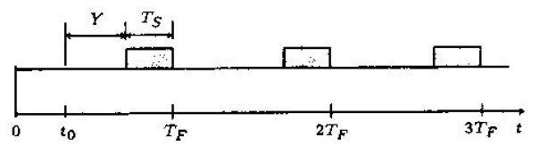
Figure -1- A framing scheme is a slotted digital communication system.
To apply this equation in all three systems, two changes are to be made. The first is to replace $\overline{E} and \overline{E^{2}} by \check{\overline{E}} and \tilde{\overline{E^{2}}}$ , respectively due to erroneous packet transmission. The second is to use the corresponding parameters for each system. Therefore, the total message transfer delay is given by:
$T_{i}=T_{a}+T_{b}$
By substituting equations of $T_{a} and T_{b}$ we get the following:
$$T_{i}=\frac{ρ_{i}*T_{f}}{2(1-ρ_{i})} *\frac{\tilde{\overline{E_{i}^{2}}}}{ \check{{\overline{E}}_{i}}} +\frac{ 2 {\check{\overline{E}}}_{i}-1}{2}T_{f}+{T_{s}}^{(i)}---(29)$$

Using equations (2) to (5) for TDMA, equations (6), (10) and (12) for CDMA and equations (15) to (18) for CDMA/TDMA in the above relation results in:

$${T_{ }}_{TDMA}^{d}=\frac{ρT_{f}\left(2-{P_{c}^{TDMA}}_{ }\right)}{2\left(1-ρ\right){P_{c}}^{TDMA}}*\frac{ \overline{E^{2}} }{\overline{E} }+\frac{2 \overline{E}- P_{c}^{TDMA} }{2 P_{c}^{TDMA}} T_{f}+\frac{T_{f}}{U}---\left(30\right)$$

$${T_{ }}_{CDMA}^{d}=\frac{ρT_{f}(2-{P_{c}^{CDMA}}_{ })}{2\left(1-ρ\right){P_{c}}^{CDMA}}*\frac{ \overline{E^{2}} }{\overline{E} }+\frac{2 \overline{E}- P_{c}^{CDMA} }{2 P_{c}^{CDMA}} T_{f}+T_{f}---(31)$$

$${T_{ }}_{hyb}^{d}=\frac{ρT_{f}\left(2-{P_{c}^{hyb}}_{ }\right)}{2\left(1-ρ\right){P_{c}}^{hyb}}*\frac{ \overline{E^{2}} }{\overline{E} }+\frac{2 \overline{E}- P_{c}^{hyb} }{2 P_{c}^{hyb}} T_{f}+\frac{T_{f}}{N} ---\left(32\right)$$
Where the subscript “$d$” represents data traffic.
In transmission of the voice traffic, the amount of acceptable delay is limited. Therefore, retransmission of packet is meaningless. This can be considered through replacing ${ P}_{c}^{\left(i\right) }$=1 in equation (30),
$${T_{ }}_{TDMA}^{v}=\frac{ρT_{f} \overline{E^{2}} }{2\left(1-ρ\right) \overline{E}} +\frac{(2 \overline{E}-1) }{2 }T_{f} +\frac{T_{f}}{U} ---\left(33\right)$$
In addition, the CDMA related systems have more useful features obtained from their structures. For fair comparison of the multiple access methods these features have been not been accommodated in other researches resulting in a poor performance for CDMA.
As explained in the previous section, due to the bursty nature of voice traffic, an activity ratio $α$ is defined which about 0.3 and 0.6 is depending on the modulation and the techniques used for bandwidth compression. It represents the ratio of useful channel utilization by each user. $ρ_{r}=α* ρ$ Is substituted in equations (31) and (32) and the following is obtained:
$${T_{ }}_{CDMA}^{v}=\frac{α . ρ .{ T}_{f} . \overline{E^{2}}}{2(1-αρ)\overline{E}} + \left(\frac{2\overline{E}-1}{2}\right)T_{f} + T_{f}---(34)$$
$${T_{ }}_{hyb}^{v} = \frac{α . ρ .{ T}_{f} . \overline{E^{2}}}{2(1-αρ)\overline{E}} + \left(\frac{2\overline{E}-1}{2}\right)T_{f} +\frac{{ T}_{f}}{N} ---(35)$$
In equations (33) to (35), the superscript “$v$” indicates voice traffic. It’s evident that the transmission of the voice traffic, some packets might be lost.
    - The packet loss equations

Packet loss is estimated as:
$$P_{loss}^{\left(i\right)}=ρ\left(1-P_{c}^{\left(i\right)}\right)---(36)$$
Where $i$ = either TDMA, or CDMA, or hybrid CDMA/TDMA system.
    - The network throughput equations

The throughput for systems is given by:
$$S^{(i)}=ρP_{c}^{\left(i\right)} ---(37)$$
Where $i$ = either TDMA, or CDMA, or hybrid CDMA/TDMA system.
    - bit error probability equations
Now, delay, throughput and packet loss for voice and data traffic are computed, first, $P_{b}^{\left(i\right)}$ , is evaluated which are related to each other by equation (20)
${{ P}_{c_{ }}}^{(i)}={\left[1-{p_{b}}^{(i)}\right]}^{L}---(20)$.
Figure 2 shows the direct sequence multiple access system models. In this model, a channel simply adds a white Gaussian noise. At the receiver input,
$$r\left(t\right)=\sum_{k=0}^{M}{\sqrt{2p} α_{k}\left(t-τ_{k}\right) b_{k}\left(t-τ_{k}\right) \cos\left(ω_{c}t + φ_{k}\right)} + n\left(t\right)---(38)$$
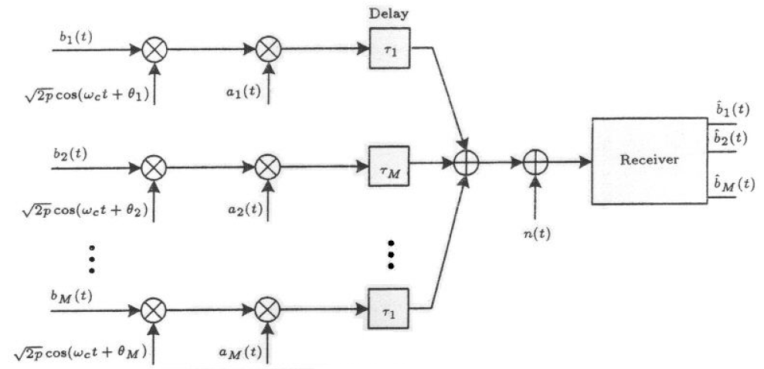
Figure -2- the phase-coded spread spectrum multiple access system model.

Where
$n(t)$ : is AWGN with density $\frac{N_{0}}{2} .$
$α_{k}\left(t\right)$ : is the code used by the $kth$ user.
$b_{k}\left(t\right)$ : is the $kth$ user data sequence.
$τ_{k}$ : is the delay.
M : is the number of active users (number of over lapping users per slot).
At the output of the $ith$ matched filter in the receiver.
$Z_{i}= \int_{0}^{T_{f}}{τ(t)} α_{i}\left(t\right)\cos\left(ω_{c} t\right)---(39)$
The signal to noise ratio is $PT^{2}/2$ divided by the variance of $Z_{i}$ which is evaluated by Pursley formula as:

$Var\left\{Z_{i}\right\}=\{ \frac{P{ T}_{f}^{2}}{12N_{s}^{3}} (\sum_{\begin{aligned}K=1 \\ K≠i\end{aligned}}^{\begin{aligned}M \\ \end{aligned}}{ τ_{K},_{i}) \}} + \frac{N_{0} T_{f}}{4} ---(40)$

Where $N_{s}$ is the sequence length and:

$τ_{K},_{i}=\sum_{\begin{aligned} \\ \\ t=0\end{aligned}}^{\begin{aligned}N_{s}-1 \\ \end{aligned}}{\begin{aligned} \\ \begin{aligned} \\ \\ \{{ C}_{K}^{2},_{i}\left(L-N_{s}\right)+C_{K},_{i}\left(L-N_{s}\right)C_{K},_{i}\left(L-N_{s}+1\right)+C_{K}^{2},_{i}\left(L-N_{s}+1\right) \\ +C_{K}^{2},_{i}\left(L\right)C_{K},_{i}\left(L\right)C_{K},_{i}\left(L+1\right)C_{K}^{2},_{i}\left(L+1\right) \} ----(41)\end{aligned}\end{aligned}}$

With $C_{K},_{i}\left(L\right)$ being the discrete a periodic cross correlation function for sequences ${ α}_{j}^{\left(K\right)} and { α}_{j}^{\left(i\right)} ,$ defined as:

$C_{K},_{i}\left(L\right)=\left\{\begin{aligned}\sum_{j=0}^{N_{s}-1-L}{α_{j}^{\left(K\right)}{α_{j+L}^{\left(i\right)}}_{ }} , 0≤L{≤N}_{s}-1 \\ \\ \\ \sum_{j=0}^{N_{s}-1-L}{α_{j-L}^{\left(K\right)}{{ α}_{j}^{\left(i\right)}}_{ }} , L-N_{s}≤L≤0 \\ \\ \\ 0 , |L|≥N_{s}\end{aligned}\right.$ $---(42)$

For each specified code sequence, $Var\{Z_{i} \}$ could be computed from equation (40) by evaluation of the expressions (41) and (42). Using a very good approximation so that,
$Var\left\{Z_{i}\right\}= \frac{1}{6 N_{s}^{3} } \sum_{\begin{aligned}K=1 \\ K≠i\end{aligned}}^{M_{i}}{τ_{K},_{i}≈\frac{M_{i}-1}{{ 3 N}_{s}^{3}}} ---(43)$
It is obtained that:
$SNR_{i}≈{\{\frac{N_{0}}{2E_{b}} +\frac{M_{i}-1}{3(P{G)}_{i}} \}}^{-1} ---(44)$
It can be shown that expression (43) is an exact expression when random sequences are employed but we do not care to show it now.

The bit error probability is related to $SNR_{i}$ by:
$P_{b}^{\left(i\right)} =\frac{1}{2}erfc\left(\sqrt{SNR_{i}} \right)---(45)$
Where $erfc\left( . \right)$ is the complementary error function and it defined as:
$$erfc\left(x\right)=\frac{2}{\sqrt{π}}\int_{x}^{∞}{e^{-x^{2}}} dx---(46)$$
In equation (44), the first term$N_{0}/2E_{b}$ is the signal to noise ratio and the second $(M_{i}-1)/3(P{G)}_{i}$ shows the interference from other users. This term diminishes for TDMA since there is no overlapping user ($M_{TDMA}=1$).
According to equation (44), the bit energy $E_{b}$ is the same for TDMA, CDMA, CDMA/TDMA systems. However, the duration of transmission of a bit in these three cases is different. Therefore, to keep $E_{b}$ the same, a CDMA or CDMA/TDMA user exerts much smaller peak power than a TDMA user. Assuming equal maximum power for all three systems, equation (44) changed to:
$SNR_{i}≈{\{\frac{N_{0}}{2E_{b}} \frac{T_{b}^{\left(TDMA\right)}}{T_{b}^{\left(i\right)} ^{ }} +\frac{M_{i}-1}{3(P{G)}_{i}} \}}^{-1} ---(47)$
Where $T_{b}^{\left(i\right)}$ is the duration of bit transmission in the one of the three systems and is given by:
$T_{b}^{\left(TDMA\right)}=\frac{T_{f}}{U*L} ---(48)$
$T_{b}^{\left(CDMA\right)}= \frac{T_{f}}{ L} ---(49)$
$T_{b}^{\left(hyb\right)} =\frac{T_{f}}{N*L} ---(50)$

1.5:
Users with different bit rates
Another advantage of CDMA is the flexibility in accommodating different bit rate traffic. To explain it, consider a scenario in which the bit rate of some of the users is half the others (K: full rate users) (U: half rate users). In TDMA, $T_{f}$ is determined according to the higher bit rate and the users with smaller bit rate send their traffic in alternative frames leaving some slots empty in the other frames. This reduces the over all utilization factor of the system.
In CDMA, $T_{f}$ is the same as TDMA, with each user utilizing the whole frame time. Thus, there will be U users in half the frames and K users in the others, with $1≤K≤U$ representing the number of full-rate users. This tends to reduce the probability of error in the frames with a smaller number of users.
Let $P_{b}(e|U)$ be the bit error probability in CDMA technique when U users are active in a given frame. Then the overall bit error probability for this scenario is given by:
$$P_{b}=\frac{1}{2}\left[P_{b}\left(e | U\right)+P_{b}\left(e | K\right)\right]---\left(51\right)$$
Note that since $K≤U , P_{b}≤P_{b}\left(e | U\right).$ thus, it can be concluded that CDMA performs better when sources have different bit rates.

1.6:
Numerical results
For all three systems, it is assumed that:
$U=256 user, L=256 \frac{bit}{packet} , \overline{E}= \overline{E^{2}}=1 \frac{packets}{message} , and T_{f}=1 second.$
The signal to noise ratio $(SNR_{b}=2E_{b}/N_{0} )$ was left to be variable and the performances of the systems were obtained for different values of $SNR_{b}.$
The division factor in the CDMA/TDMA is assumed to be N=8. The delay voice traffic in packets is shown in figure3. In this figure, the corresponding curves for the CDM and CDMA/TDMA systems, with the activity ratio $α=1,$ are shown.

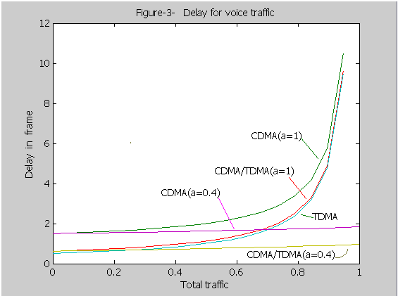
It is noticed that the activity ratio of voice traffic is not considered, TDMA outperforms the two other systems. However, only the CDMA related systems can efficiently use the bursty characteristic for voice to reduce the total delay. Surprisingly, the delay is almost invariant to traffic variation. Similar results are obtained for various values of $α$ as illustrated in figure4. The figure shows that the results are correct for a wide range of $α.$

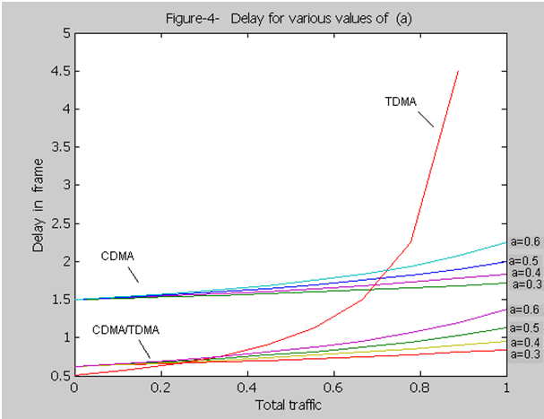

Figure5 illustrates the packet loss for traffic with $SNR_{b}=3.$this figure shows that the equal bit power assumption for three systems causes the CDMA to outperform the other two systems. The CDMA/TDMA technique also has a very close performance. Up to$ρ≤0.4$, packet loss is nearly zero for the CDMA and CDMA/TDMA techniques, whereas packet loss increases linearly with traffic in TDMA.

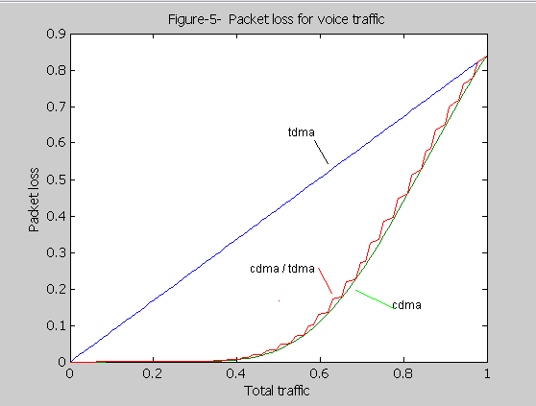
Corresponding curves for data traffic are shown in figures 6 and 7. The delay for data traffic is relatively large. This is due to a small$SNR_{b}$. In this case, similar to figure 5, assuming equal bit power causes a better performance in CDMA.

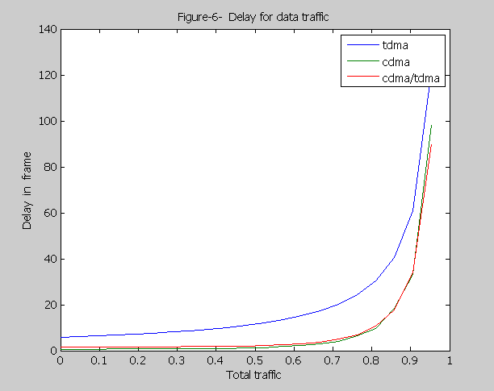

Figure 7 shows the throughput in TDMA is about 0.16 which is largely due to small $R_{b}$.

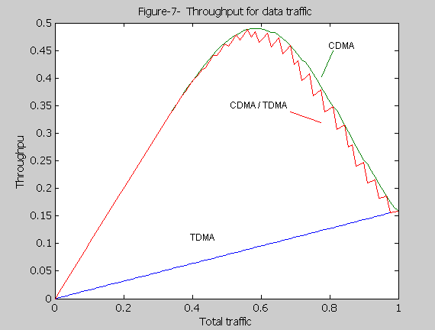
However, the CDMA and CDMA/TDMA systems have a much better throughput with a maximum of about 0.49. Note that the spread spectrum based systems represent low bit error probability for small values of$SNR_{b}$. This is achieved by increasing the bandwidth.
To see the effect of variation of $SNR_{b}$in the performance of these systems, the throughput for data traffic and the packet loss for voice traffic are computed and sketched for $SNR_{b}$ in the range of 0.01 to10. The results for TDMA and CDMA systems are presented in figure8 and 9. The throughput of TDMA varies rapidly when $SNR_{b}$ increases from 2 to 6, whereas in CDMA it remains almost constant for all values of $SNR_{b}$. Therefore, the performance of CDMA is not very sensitive to noise power
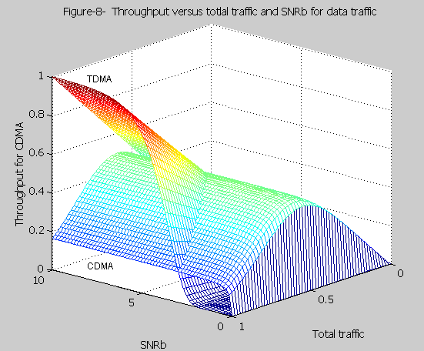

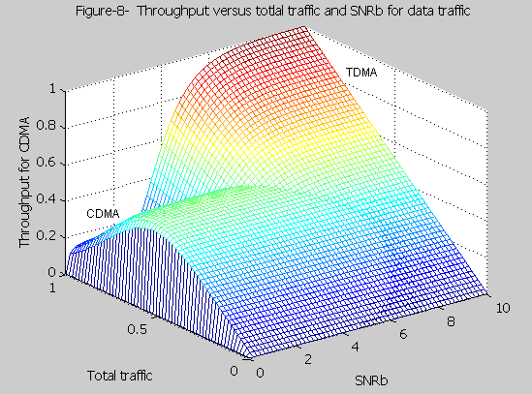

On the other hand, for small values of$SNR_{b}$, the packet loss of voice traffic for TDMA is more than that for CDMA (figure9). However, by increasing$SNR_{b}$, TDMA shows a small packet loss as compared to CDMA. The packet loss for the CDMA system remains constant in a wide range of$SNR_{b}$. In addition to this, for traffic below 0.5, the packet loss is negligible is CDMA.
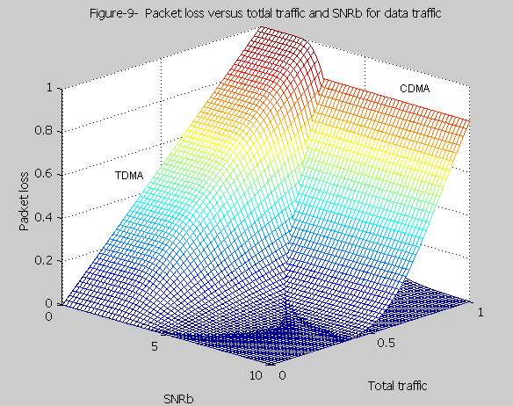
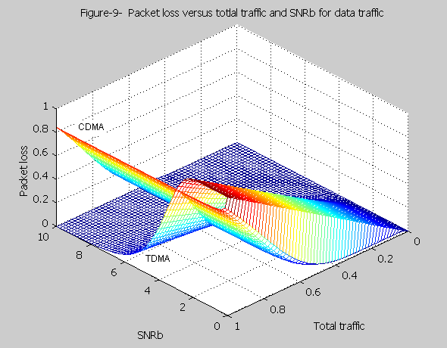
The bit error probability verses normalized K is plotted in figure10. This figure shows that the bit error probability in CDMA decreases with decreasing K, whereas it remains constant in TDMA. Hence, the smaller bit rate of some sources in CDMA improves the performance of the system in terms of bit error probability; however, they do not have any impact on the bit error probability in TDMA.
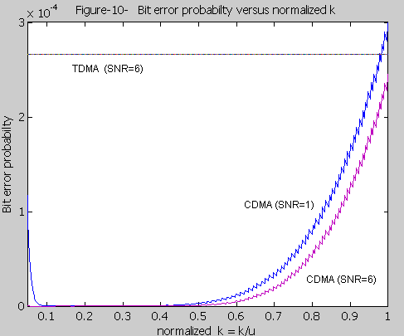
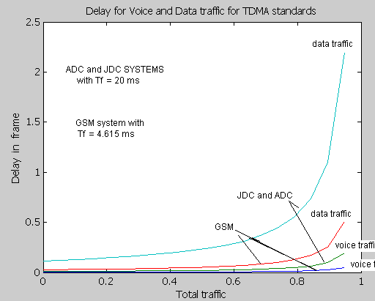
The figure above shows a comparison between three different standards which they use TDMA access technique ADC (American Digital Cellular) ,JDC( Japanese Digital Cellular)which they have time frame of (20 ms) and GSM standard which use time frame of (4.615 ms) the effect of frame time on delay for voice traffic we can see that frame time inversely proportional with time delay, and we can see also that the delay in data traffic is larger than the voice traffic because of the reasons explained earlier.

Chapter 2:
Capacity of the CDMA and TDMA systems.

Abstract. The market for cellular radio telephony was expected to increase dramatically during the 1990’s and it still increasing till now. Service may be needed for 50% of population. This beyond what can be achieved with the analogue cellular systems. The evolving digital time division multiple access (TDMA) cellular standards in Europe, North America, and Japan will give important capacity improvements and may satisfy much of the improvements needed for personal communication. The capacity of digital TDMA systems is addressed in this chapter. Capacity improvement will be of the order 5-10 times that of the analogue FM without adding any cell sites. For example the North American TIA standard offers around 50 Erlang/Km² with a 3-Km site to site distance. However, in addition, the TDMA principle allows faster hand off mechanism (mobile assisted hand off , “MAHO”),which makes it easier to introduce microcells with cell radius of, say, 200 m. this gives substantial additional capacity gain beyond the 5-10 factor given above. Furthermore, TDMA makes it possible to introduce adaptive channel allocation (ACA) methods. ACA is vital mechanism to provide efficient microcellular capacity.ACA also eliminates the need to plan frequencies for cells. A conclusion is that the air-interface of digital TDMA cellular may be used to build personal communication networks. The TDMA technology is the key to providing efficient hand-over and channel allocation methods.

This chapter also presents an overview of the Capacity of Code Division Multiple Access (CDMA) System. In the past decade, it has been shown that CDMA is the most suitable multiple access transmission technology for Mobile Communications and all the 3rd Generation Mobile Communication Standards suggest CDMA for the Air-Interface. The main reason for the success of this technology is the huge increase in capacity offered by CDMA systems when compared to other analog (FM) or digital (TDMA) transmission systems. This chapter summarizes some of the early work done on the capacity calculations of CDMA systems.

2.1 - capacity of cellular TDMA systems
High capacity radio access technology is vital for cellular radio. Digital time division multiple access (TDMA) is becoming standard in major geographical areas (in Europe, North America, and Japan). Digital technology is capable of giving higher capacity than the analogue FM systems. For example, the demonstration performed by Ericsson in 1988 showed that multiple conversations (voice traffic) could be carried out on a 30-Khz radio channel without degradation in radio range or carrier-to-interference (C/I) radio performance.
This chapter gives capacity estimates for all digital TDMA standards and compares this with analog FM. First the different standards are described section 3.1.1A.
Section3.1.2B deals with a capacity comparison between different systems. In
section 3.1.3D the benefits of digital for microcellular operation is discussed.
2.1.1A- digital cellular systems
Digital cellular technology was introduced in 1991. There were three emerging standards, the pan-Europe GSM system specified by European Telecommunications Standards Institute (ETSI), the American digital cellular(ADC) specified by Telecommunications Industry Association(TIA), and the Japanese Digital cellular (JDC) specified by the ministry of post and telegraph (MPT).
The standardization bodies have had different driving forces, time plans and scopes of work but all three have had in common that they address the lack of capacity in existing analog systems and that the new systems are digital and use TDMA as access method.
The GSM and ADC systems will be described in more detail in the following text. The JDC standardization work started recently, and detailed decisions have not yet been made. In short, the JDC system can be described as being very similar to ADC system regarding the digital traffic channels whereas it has more in common with GSM system in the lack of backward compatibility and in that the scope of the work is single phase standardization process. Table I describes some of the characteristics regarding the air-interface for all the three systems.
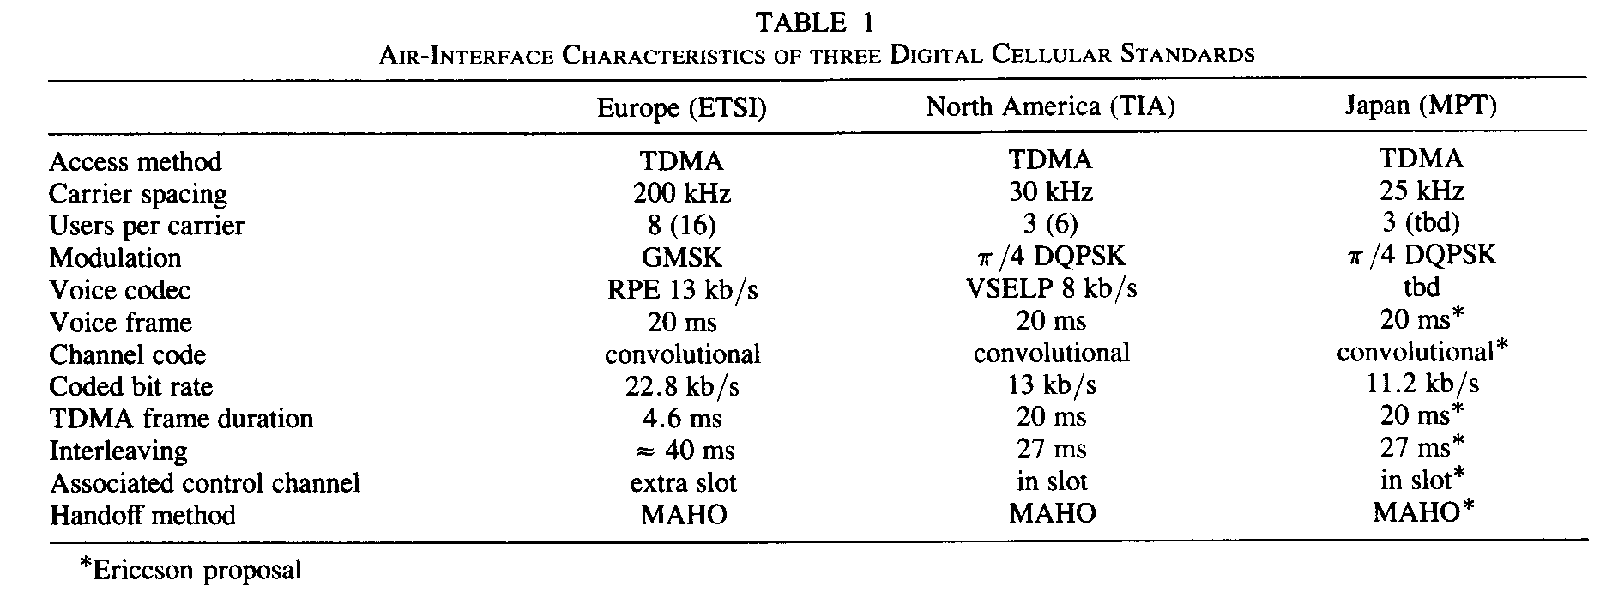
- the GSM system
The GSM system specifies many interface but only apart of the air-interface will be considered here. The frame and slot structure is shown in figure 11. There are also a super- and hyper frame (not shown in the figure) for various purposes, e.g., synchronization of crypto and provision or mobiles to identify surrounding base stations.

There are 8 channels on the carrier (full rate) with capability to introduce half rate speech codec’s in the future. The carrier spacing is 200 KHz. Thus 25 KHz (200/8) is allocated to a full rate user. In all, there is a bandwidth of 25 KHz giving 125 radio channels i.e., 1000 traffic channels.

The gross bit rate is 270.8 Kb/s. the modulation scheme is GMSK with the normalized pre-Gaussian filter bandwidth equal to 0.30 e.g., constant envelope allowing a class-C amplifier. The 33.85 Kb/s per user are divided into
Speech codec. 13.0 Kb/s.
Error protection of speech. 9.8 Kb/s.
SACCH (gross rate). 0.95 Kb/s.
Guard time, ramp up, synch. 10.1 Kb/s.
The overhead part could be defined to be 10.1/33.85 = 30%.

The bits in a speech block (20 ms) consist of two main classes according to sensitivity to bit errors. The most sensitive bits (class 1) are protected by cyclic redundant check (CRC) code and a rate =1/2 conventional code with constraint length equal to 5. The coded speech block is interleaved over eight TDMA frames to combat burst errors. To further enhance the performance, frequency hopping, where each slot is transmitted on different carriers, can be used by the system. This is mandatory function for the mobile but is optional for the system operator to use.
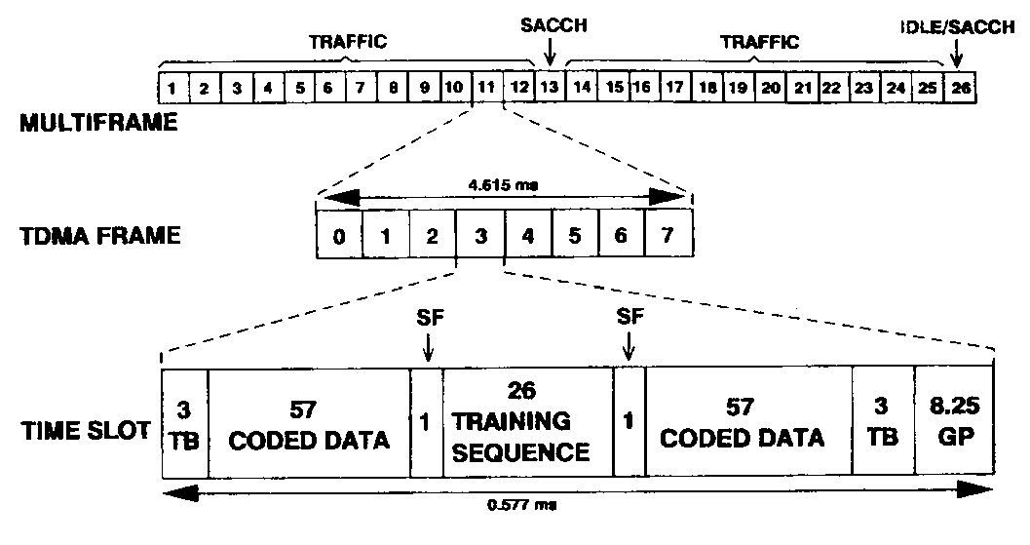
Figure11. GSM slot and frame structure showing 130.25 b per time slot (0.577 ms), eight time slots/TDMA frame (full rate), and 13 TDMA frames/multi-frames.
TB= TAIL BITS
GP=GURD PERIOD
SF=STEALING FLAG

There are two control channels associated with the traffic channels, the slow and fast ACCH. The FACCH is a blank-and-burst channel and replaces a speech block when ever it is to be used. Two frames in the multi-frame (see figure 11) are allocated for the Slow Associated Control Channel (SACCH). With full rate users the second SACCH frame is idle. In a SACCH frame the slot are assigned in the same wave as for traffic frames. The gross bit rate on this channel is interleaved over four multi-frames.

With the fast growing number of subscribers anticipated in conjunction with smaller cell sizes it becomes increasingly important that the locating of mobiles shall measure the signal strengths on channels from neighboring base stations and report the measurements to their current base station (Mobile Assisted Hand Off “MAHO”). The land system evaluates these measurements and determines to which base station the mobile shall be transferred (hand off) if the mobile is about to leave its present cell or for other reasons would gain in radio link quality by a handoff. The number of hand offs increases with the amount of traffic carried in a cell and the reduction of cell size. In analog systems where neighboring base stations measure the signal transmitted from mobile, a vey high signaling load is introduced on the links between base stations and the switch and also higher processing requirements in the switch. Thus a decentralized location procedure where each mobile is measurement point will reduce the burden on the network.

Of the eight time slots in TDMA frame, two are used on different frequencies for transmission and reception. In the remaining time the mobile can measure the received signal strength on a broadcast control channel (BCCH) form it is own and surrounding base stations. These measurements are averaged surrounding base station using the SACCH. The maximum number of surrounding base stations contained in the measurements list is 32 but only the result from the six strongest ones is reported back to the land system. Thus the mobiles preprocess the measurements and reports contain results from different base stations for every SACCH block. Since there is a possibility that the signal strength measurement can be affected by a strong co-channel, and thereby be highly unreliable, the mobile is required to identify the associated base stations on regular time basis. Therefore, it is necessary for the mobile to synchronize to and demodulate data on the BCCH in order to extract the base station identity code. This code is included in the measurement report informing the land system which base station is measured.

The mobile performs this identification process in its idle TDMA frame. There is one of these per multi-frame, see figure 11, for half rate, this idle frame is used for SACCH for the new traffic channels created. The mobile measurements reported also contain an estimate of bit error rate on the traffic channel used. This additional information is useful to determine the radio link quality since the received signal strength measurement cannot indicate a co-channel interferes or severe time dispersion.

- the ADC system
This standard covers only the air-interference. Another sub-group of TIA is currently dealing with the inter-system connection. Since there is a single analog standard in North America and roaming is already possible, it has been decided that the first mobiles shall be dual mode, i.e., they should be capable of operating on both analog and digital voice channels. This makes it possible for the operators to introduce digital radio channels according to capacity needs. In this first phase of digital technology the current analog control channels are used. Later on, provision for digital mode only mobiles will be made by introducing digital control channels.
With the dual mode requirement, it was natural to select a 30 KHz TDMA radio format. Each burst is 6.7 ms and for full rate users the TDMA frame length is 20 ms see figure 12. Thus 10 KHz are allocated to a full rate user. In all, this gives 2500 traffic channels over a 25-MHz bandwidth.

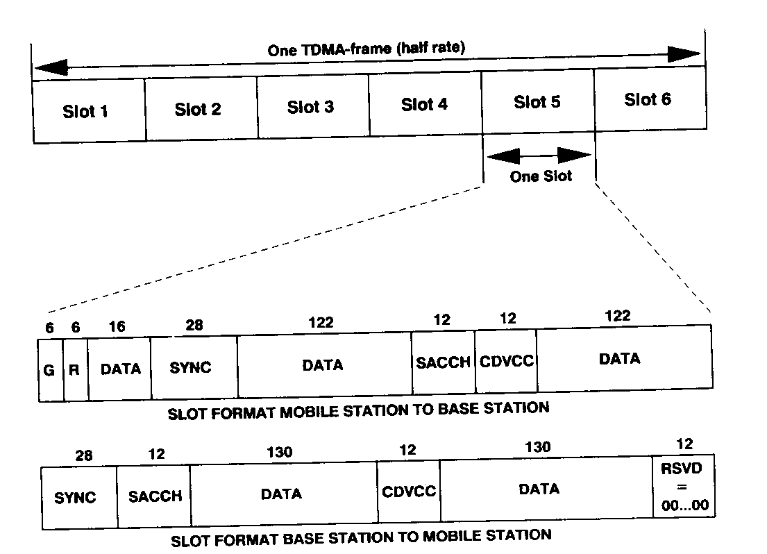
Figure 12. ADC slot and frame structure for down-and uplink with 324 bits per time slot(6.67 ms) and 3(6) time slots/TDMA frame for full rate(half-rate).

G =GUARD TIME
R =RAMP TIME
RSVD= RESERVED BITS

The gross bit rate is 48.6 Kb/s. the modulation scheme is differentially encoded $\frac{π}{4}QPSK$ with root-raised cosine pulse shaping and a roll off equal to 0.35. the 16.2 Kb/s per user are divided into:

Speech codec 7.95 Kb/s
Error protection of speech 5.05 Kb/s
SACCH (gross rate) 0.6 Kb/s
Guard time, ramp up, synch. Color code 2.6 Kb/s

The overhead part could be defined to be 2.6/16.2=16% (compare corresponding calculations for the GSM system). The color code is an 8-bit signature to provide the capability to distinguish between connections using the same physical channel i.e., co-channel. This signature is transmitted in each burst and is protected by a shortened hamming code to form 12- bit fields CDVCC.

The 20- ms speech block consisting of 159 b has two classes of bits with different sensitivity to bit errors, the most sensitive class of bits is protected by a CRC code and then coded with rate =1/2. The other part (class 2 b) is not protected at all. The channel coding methods used for speech and signaling is a conventional code with constraint length equal to six. The coding rate for speech (and FACCH) is diagonal over two slots. A SACCH message is distributed over 22 slots by means of self-synchronized interleaving process. The net rate on SACCH is b/s.

Mobile assisted hand off is also used in the ADC system. Perhaps the major difference in comparison to the GSM system is that the mobiles are not required to extract the base station identity code. In the dual mode phase of the ADC system there are no digital control channels on which to perform these tasks. There are only three time slots in a TDMA frame, and there is no idle frame as for GSM. Thus there is not enough remaining time to synchronize and demodulate data on another carrier without introducing high complexity in the mobile. Instead, there is the capability for neighboring base station to identify a mobile, using the unique synchronization. Word to identify a time slot and CDVCC to distinguish the intended user from a co-channel.

Thus an implementation of the handoff process in an ADC system is that the land system evaluates the measurements from mobile and lets the candidate base station verify that it can take over the call, before ordering the intended hand off. The MAHO is mandatory function in the mobile but optionally be turned on or off by the system. thus , a traditional handoff implementation is also a possible method in which only information related to the traffic channel in use is considered.

The measurement reported contain the same information as in GSM (signal strength and estimated bit error rate) with the difference that in ADC the measurements from all base stations are reported, rather than only the six strongest. The list may contain up to 12 channels including the current traffic channel. For the same number of channels in the channel list, the GSM measurement reports are somewhat more accurate because of better averaging out the Rayleigh fading. The total number of samples with a certain time period is dependent on the number of TDMA frames within that time. There are 50 TDMA frames per second in the ADC system and approximately 216 per second in the GSM system. The reporting interval is once every second in the ADC system and once every 0.48 s in the GSM system.

- the JDC system
As stated earlier, the JDC system is very similar to the ADC system i.e., it has a three-split TDMA air-interface. The main difference lies in the narrower channel bandwidth of 25 KHz compared to the 30 KHz bandwidth selected for the ADC system. The same modulation, $\frac{π}{4} DQPSK,$ as for the ADC system has been selected. To avoid extreme complexity in the power amplifier the gross bit rate has to be lower than in the ADC system (48.6 Kb/s) and has been chosen to be 42.0 Kb/s. the pulse shaping in the modulation scheme is root-raised cosine with a roll off factor equal to 0.5.

As was the case in North America, the speech and channel coding algorithm will be selected by testing candidates implemented in hardware. 11.2 Kb/s has been selected for the total bit rate of the test. The difference between the gross bit rate per user (14 Kb/s) and the protected speech rate(11.2 Kb/s) is 2.8 Kb/s and it will be allocated to the same functions as in the ADC system but the details will be different. Since the JDC system does not have any backward compatibility, all the control channels have to be specified within the first specification.

The capacity equation of TDMA system is given in simple forma as,

$$capacity=\frac{total bandwidth / cluster size }{ channel bandwidth/ numberof slots in this channel } ---\left(52\right)$$

$$capacity = \frac{total_{bw} ×numberof slots in this channel }{ch_{bw} × \sqrt[3]{{\left( \frac{E_{b}}{N_{0}} - \frac{R_{b}}{ch_{bw}} \right)}^{2}}} .$$

$cluster size = \sqrt[3]{{\left( \frac{E_{b}}{N_{0}} - \frac{R_{b}}{ch_{bw}} \right)}^{2}}---\left(53\right)$
e.g.
Consider a digital TDMA based USDC (ADC) system with total bandwidth of 12.5 Mhz where each 30 KHz channel (as in the AMPS system) carries 3 users using TDMA. and with frequency reuse pattern of 7.

$capacity= \frac{12.5 MHz / 7}{30kHz / 3}=178$users/cell.

Figure 13. represents the capacity per cell for the three digital cellular standards (GSM , ADC and JDC) which the use TDMA as an access technique. This graph drawn assuming a ruse factor of 7 , and it shows that when the system is using the half rate the capacity will be doubled , and also we can see the Japanese standard is the largest capacity per cell among the other two standards.

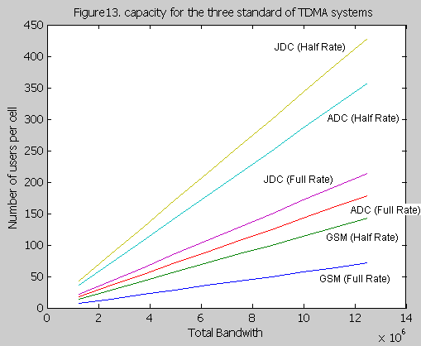

2.2- Capacity of CDMA systems

Any multiple-access technique (FDMA, TDMA or CDMA) theoretically offers the same Capacity in an ideal environment. But in environments typically encountered in Cellular Communications, some techniques provide better capacity than the others. The capacity limitation of earlier analog cellular systems employing frequency modulation (like the AMPS) became evident around 1987 and digital techniques offering more capacity were proposed for overcoming the limitation. Time Division Multiple Access (TDMA) and Code Division Multiple Access (CDMA) were the primary digital transmission techniques that were researched and it was found that CDMA systems offer the highest capacity than the other competing digital technologies (like TDMA) and analog technologies (like FM). This section begins with a brief overview of some of the natural advantages of CDMA which contribute to the capacity increase.

2.2.1A- Natural Advantages of CDMA
CDMA possess some natural attributes that are suitable to the mobile radio environment.

1A.1. Voice Activity Detection (VAD).
The human voice activity cycle is 35 percent. When users assigned to a cell are not talking, VAD will allow all other users to benefit due to reduced mutual interference. Thus interference is reduced by a factor of 65 percent. CDMA is the only technology that takes advantage of this phenomenon. It can be shown that the capacity of CDMA is increased by about 3 times due to VAD.
1A.2. Soft Capacity.
CDMA capacity is interference limited, while TDMA and FDMA capacities are bandwidth limited. The capacity of CDMA has a soft limit in the sense that we can add one additional user and tolerate a slight degradation of the signal quality. On the other hand, the capacities of TDMA and FDMA are hard-limited. Another conclusion that can be drawn from this fact is that any reduction in the multiple access interference (MAI) converts directly and linearly into an increase in the capacity. Further, it is shown in other researches that even the blocking experienced by users in a CDMA system has a soft-limit, which can be relaxed during heavy loading to allow an additional 13 dB increase in the interference to noise ratio.
1A.3. Multipath Resolution.
Since CDMA spreads the bandwidth over a wide frequency range, the mobile propagation channel appears to be frequency selective and this allows multipath resolution (using a RAKE receiver). This inherent multipath diversity is one of the major contributors to the increased capacity of the CDMA system. Further, a correlator (in CDMA) is much simpler to implement than an equalizer (in TDMA or FDMA).
1A.4. Sectorization for Capacity.
In FDMA and TDMA systems, sectoring is done to reduce the co-channel interference. The trunking efficiency of these systems decreases due to sectoring and this in turn reduces the capacity. On the other hand, sectorization increases the capacity of CDMA systems. Sectoring is done by simply introducing three (similar) radio equipments in three sectors and the reduction in mutual interference due to this arrangement translates into a three fold increase in capacity (in theory). In general, any spatial isolation through the use of multi-beamed or multi-sectored antennas provides an increase in the CDMA capacity.
1A.5. Frequency Reuse Considerations.
The previous comparisons of CDMA capacity with those of conventional systems primarily apply to mobile satellite (single-cell) systems. In the case of terrestrial cellular systems, the biggest advantage of CDMA over conventional systems is that it can reuse the entire spectrum over all the cells since there is no concept of frequency allocation in CDMA. This increases the capacity of the CDMA system by a large percentage (related to the increase in the frequency reuse factor).

2.2.2B- Single Cell CDMA Capacity.
Consider a single celled CDMA system with N users. It is assumed that proper power control is applied so that all the reverse link signals are received at the same power level. Each cell-site demodulator processes a desired signal at a power level S and N-1 interfering signals, each of them having a power level S. The signal-to-interference noise power is:
$$SNR =\frac{S}{(N 􀀀- 1)S} =\frac{1}{N 􀀀- 1} ---\left(54\right)$$

It's interesting to note that the number of users is limited by the per user SNR. Further, when the Energy per bit to Noise density ratio is considered:
$$\frac{E_{b}}{N_{0}} =\frac{S/R}{\left(N-􀀀 1\right)S/W}=\frac{W/R }{N-1} = SNR \frac{W}{R} ---\left(55\right)$$
Where,
R is the information bit rate.
W is the total spread bandwidth, W.
The term W/R is the processing gain of the CDMA system.

If background noise$η$, due to spurious interference and thermal noise is also considered the above equation becomes,
$$SNR =\frac{S}{\left(N 􀀀- 1\right)S+η }$$

$$\frac{E_{b}}{N_{0}} = \frac{W/R }{\left(N-1\right)+(η/S)} ---\left(56\right)$$

This implies that the capacity in terms of the number of users is given by,
$$N=1+( \frac{W/R }{E_{b}/N_{0}} ) -\left( \frac{η}{S} \right) ---\left(57\right)$$

Here, $Eb/N0$is the value required for adequate performance of the demodulator/decoder and for digital voice transmission, this implies a BER of 10⁻³ or better. At this stage, using the above equation, we can do a simple comparison of the CDMA system with the other multiple-access systems. Consider a bandwidth of 1.25 MHz and a bit rate of 8 $kpbs$ using voice coders. Let's assume that a minimum $Eb/N0$ of 5 (7dB) is required to achieve adequate performance (BER of 10⁻³). Ignoring the effect of the spurious interference and thermal noise, the number of users in the CDMA system (in 1.25 MHz bandwidth) works out to be,

$$N = 1 +\frac{\left(1.25 MHz / 8 kHz\right)}{5} = 32 users$$

On the other hand for a (single-celled) AMPS system which uses FDMA technology operating over the same bandwidth, the number of users is given by,

$\frac{1.25MHz}{30kHz}=42$users.

For a D-AMPS based 3-slot which use TDMA technology, this will be

$\frac{1.25MHz}{30kHz/3}=126 users.$.

i.e. the 30 kHz will serve 3 users Till now, the CDMA capacity is much less than that of other conventional systems (since the number of users is much less than the processing gain (W/R) of the system). However, it is important to consider the fact that we still haven't taken attributes like VAD, Sectoring, Frequency Reuse, etc, into account yet (which, as shown later, will increase the capacity by orders of magnitude). Note that, in a multi-celled AMPS system (with a frequency reuse factor of 7 ), the number of users per cell reduces from 42 to 6 in FDMA,
$\frac{1.25MHz / 7}{30kHz}=6$users/cell.
(and a reduction from 126 to18 in 3-slot TDMA)
$\frac{1.25MHz / 7}{30kHz / 3}=18$users/cell.
We have to notice that the reuse factor for CDMA always equal to 1 and thus the CDMA will show a capacity increase when compared to these systems.

One way of improving the CDMA capacity is the use of complicated modulation and channel coding schemes that reduce the $Eb/N0$ requirement and increase capacity as shown by the equation (57). But beyond a particular limit, these methods reach a point of diminishing returns for increasing complexity. The other way is to reduce the interference, which translates to an increase the capacity according to equations (55) and (56). The following sections discuss the effect of VAD and sectoring which are two methods to decrease the effect of mutual interference in a CDMA system.

2B.1. Sectorization.
Any spatial isolation of users in a CDMA system translates directly into an increase in the system capacity. Consider an example where three directional antennas having 120⁰ effective beam-widths are employed. Now, the interference sources seen by any of these antennas are approximately one-third of those seen by the Omni-directional antenna. This reduces the interference term in the denominator of equation (56)
$$\frac{E_{b}}{N_{0}} = \frac{W/R}{ \left[\left(N-1\right)+\left(\frac{η}{S}\right)\right]⟶will multipled by 1/3} ---\left(56\right)'$$

$$\underset{→}{yields} N=1+( \frac{3 ×W/R }{Eb/N0} ) -\left( \frac{η}{S} \right) ---\left(57\right)'$$

By a factor of 3 and the number of users (N) is approximately increased by the same factor. Consider Ns to be the number of users per sector and thus the interference received by the antenna in that particular sector is proportional to Ns. The number of users per cell is approximately given by $N = 3N$s.

2B.2. Voice Activity Detection.

Voice Activity monitoring is a feature present in most digital vocoders where the transmission is suppressed for that user when no voice is present. Consider the term, voice activity factor ($α$), to be 3/8 (corresponding to the human voice activity cycle of 35-40 percent). The interference term in the denominator of equation (56) is thus reduced from (N -1) to [(N -1)$α$]. (In reality, the net improvement in the capacity will be reduced from 8/3 to 2 due to the fact that with a limited number of calls per sector, there is a non-negligible probability that an above average number of users are talking at once). Thus, with VAD and Sectorization, the $Eb/N0$ now becomes,

$$\frac{E_{b}}{N_{0}} = \frac{W/R }{\left(N-1\right)α+(η/S)} ---\left(58\right)$$

The number of users per cell now works out to be,

$$N = 3Ns = 3[ 1+ \frac{1}{α}\{ ( \frac{W/R }{ E_{b}/N_{0} } )-\left( \frac{η}{S} \right)\} ]---\left(59\right)$$

For the same conditions and assumption discussed previously, the capacity of the CDMA system is now,

$$N =3×[ 1 +\frac{8}{3}\{ \frac{\left(1.25 MHz/8 kHz\right)}{5} \} = 253 users$$

That's works out to be a 8-fold capacity increase when compared to the previous case
(Without VAD and sectoring). In reality, due to the variability of $Eb/N0$, the capacity increase has to be backed off to 5 or 6 times. Even this capacity increase is enough to bring the number of users much closer to the processing gain (W/R) of the system. This makes the CDMA capacity comparable to the TDMA and FDMA capacity. Again, it's important to note that these calculations are for a single-celled system, where frequency reuse considerations are not taken into account at all. The biggest advantage of CDMA comes from the fact that it can reuse the same frequencies in all the cells (unlike TDMA and FDMA). To take this into account, the CDMA capacity (for both forward and reverse links) has to be calculated for the multi-cell case, where additional interference is caused by the users in the adjacent cells.

Figurer 14. Shows the effect of using the natural advantages of CDMA on its capacity which as obvious in the graph there is an enormous increase in the capacity.

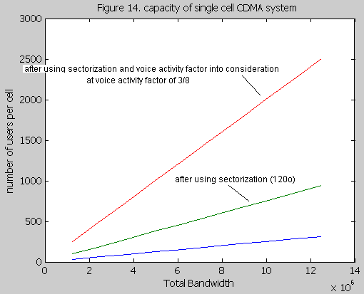

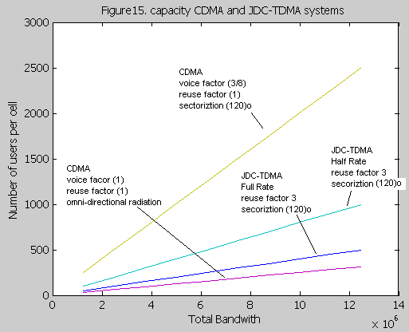
Figure 15. Shows comparison between CDMA and the Japanese cellular digital standard which use TDMA access method (JDC-TDMA) - and as we have seen before that (JDC-TDMA) has the greatest capacity among the other two standards (GSM and ADC) – from this graph (JDC-TDMA) is plotted on a frequency reuse factor equal to 3 which is used in an excellent environment against interference we can see that CDMA capacity is less than (JDC-TDMA) in case we did not apply the advantages of CDMA like voice activity factor and sectoriztion , but after getting advantage of these parameters CDMA has a huge increase in capacity over (JDC-TDMA) even if we were operating on half rate voice codec.

The capacity of hybrid CDMA/TDMA is equal to the capacity of usual narrow band CDMA.

2.2.3C- Reverse Link CDMA Capacity for the Multi-cell Case.

2C.1. Reverse Link (from M.S. to B.S.) Power Control.
Power Control plays an important role in determining the interference and capacity of the reverse link of a CDMA system. It is evident that equitable sharing of resources among users in a CDMA system can be achieved only if power control is exercised. Proper power control maximizes the capacity of a CDMA system. Variations in the relative path losses and the shadowing effects are usually slow and controllable, while fast variations due to Rayleigh fading are usually too rapid to be tracked by power control techniques.

3C.2. Interference and Capacity Calculations.
In a multi-cell CDMA system, the interference calculations become complicated in both the forward and reverse directions. This is because the reverse link subscribers are power-controlled by the base-station of their own cell. The cell-membership in a multi-cell CDMA system is determined by the maximum pilot power among all the cell-sites, as received by the mobile (and not the minimum distance from a cell site). Because of power control, the interference level received from subscribers in other cells depends on two factors:

1- Attenuation in the path to the desired user's cell-site.
2- Attenuation in the path to the interfering subscriber's cell-site (power-control).

Assuming a log-normal shadowing model, the path loss between a subscriber and the corresponding cell-site is proportional to
${P_{loss} ∝10}^{(ζ/10)}r^{-4}$, Where,
$ζ$: is the log-normal Gaussian random variable with zero mean and standard deviation $σ= 8$ dB.
$r$: is the distance from the subscriber to the cell-site.

Since, average power-levels are considered; the effects of fast fading are ignored.

Consider an interfering subscriber in a cell at a distance $r_{m}$ from its cell-site and $r_{0}$ from the cell-site of the desired user.
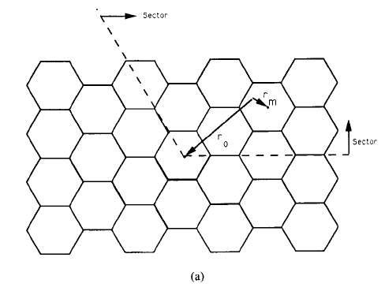

Fig-17- capacity calculation geometrics. (a) Reverse link geometry

The interferer, when active, will produce interference in the desired user's cell-site equal to,
$$\frac{I\left(r_{0},r_{m}\right)}{S}=\left(\frac{{10}^{\left(\frac{ζ_{0}}{10}\right)} }{r_{0}^{4}}\right)\left(\frac{{r_{m}}^{4}}{{10}^{\left(\frac{ζ_{m}}{10}\right)}}\right)={\left(\frac{r_{m}}{r_{0}}\right)}^{4}{10}^{( ζ_{0}-ζ_{m})/10}≤1 ---\left(60\right)$$
Where the first term is due to the attenuation caused by distance and blockage to the given cell site, while the second term is the effect of power control to compensate for the corresponding attenuation to the cell site of the out-of-cell interfere. Of course $ζ_{m} and ζ_{0}$ are independent so that the difference has zero mean and variance $2σ^{2}$.for all values of the above parameters, the expression is less than unity,
Otherwise the subscriber will switch to the cell-site which makes the value in above equation to be less than unity (i.e., for which the attenuation is minimized).

Then assuming an uniform density of subscribers, normalizing the hexagonal cell- radius to unity and considering the fact that$N = 3Ns$, the density of users is
$ρ=\frac{2N}{3× \sqrt{3}}=\frac{2N_{s}}{\sqrt{3}} ---\left(61\right)$
We can calculate the total interference-to-signal ration (I/S),

$$\frac{I}{S}=\iint{ψ{\left(\frac{{r_{m}}^{ }}{r_{0}^{ }}\right)}^{4}\left({10}^{\left(\frac{ζ_{0}-ζ_{m}}{10}\right)}\right)}\left\{Φ\left(ζ_{0}-ζ_{m} ,\frac{r_{0}}{r_{m}}\right)\right\}ρ dA---\left(62\right)$$

Where,
$m$ is the cell-site index for which,

$$r_{m}^{4} .10􀀀^{-ζ_{m}} = \min_{k≠0}{ r_{k}^{4} .10􀀀^{-ζ_{k}}}---\left(63\right)$$

And$Φ$ is a function that ensures the validity of the inequality in the equation (60).
$Φ\left(ζ_{0}-ζ_{m} ,\frac{r_{0}}{r_{m}}\right)$ =

$$=\left\{\begin{aligned}\begin{aligned}1 , if {\left(\frac{{r_{m}}^{ }}{r_{0}^{ }}\right)}^{4}\left({10}^{\left(\frac{ζ_{0}-ζ_{m}}{10}\right)}\right) ≤ 1 \\ OR ζ_{0}-ζ_{m} ≤ 40\log_{10}{r_{0}/r_{m}} \\ \\ 0 , otherwise \end{aligned} \\ \end{aligned}\right.---\left(64\right)$$

$ψ$ : is the voice activity variable, which equals 1 with a probability $α$ and 0 with
Probability $\left(1-α\right) .$

To determine the moment statistics of random variable$I$, the calculation is much simplified and the results only slightly increased if for $m$ we use the smallest distance rather than the smallest attenuation. Thus ($62$), with ($64$), holds as an upper bound if in place of ($63$) we use that value of m for which
$$r_{m}^{ } = \min_{k≠0}{ r_{k}^{ } }---\left(63'\right)$$

In 2C.2 section, it is shown that the mean or the first moment, of the random variable $I/S$ is upper bounded using $\left(63'\right)$ rather than $\left(63\right)$ for $m$ by the expression,
$E\left(\frac{I}{S}\right)=α\iint{ \frac{{r_{m}^{ }}^{4}}{r_{0}^{ }} f(\frac{{r_{m}^{ }}^{ }}{r_{0}^{ }})} ρ dA---\left(64\right)$

Where
$$f\left(\frac{{r_{m}^{ }}^{ }}{r_{0}^{ }}\right)=exp⁡[{\left(\frac{σ ln10}{10}\right)}^{2}\{1-Q[\frac{40}{\sqrt{2σ^{2}}} .\log_{10}\left(\frac{{r_{0}^{ }}^{ }}{r_{m}^{ }}\right)- \sqrt{2σ^{2}}\frac{ln10}{10}]\}]---\left(65\right)$$
And
$$Q\left(x\right)=\int_{x}^{∞}{ \frac{e^{\frac{{-y}^{2}}{2}}}{\sqrt{2π}} dy ---\left(65\right) }$$

This integral is over the two-dimensional area comprising the totality of all sites in the sector fig -13- the integration, which needs to be evaluated numerically, involves finding for each point in the space the value of $r_{0}$ the distance to the4 desired cell site and$r_{m}$ , which according to ($r_{m}^{ } = \min_{k≠0}{ r_{k}^{ } }-\left(63'\right)$) is the distance to the closest cell site, prior to evaluating at the given point the function ($65$). The result for $σ=8 dB$ is $E\left(\frac{I}{S}\right)≤ 0.247Ns$ .

Calculation of the second moment, $var\left(I/S\right)$ of the random variable requires an additional assumption on the second-order statistics of $ζ_{0}$ and$ζ_{m}$. While it is clear that the relative attenuations are independent of each other, and that both are identically distributed (i.e., have constant first-order distribution) over the areas, their second-order statistics (spatial correlation functions) are also needed to compute$var \left(I\right)$. Based on the experimental evidence that blockage statistics vary quit rapidly with spatial displacement in any direction, we shall take the spatial autocorrelation function of $ζ_{0}$ and ${ ζ}_{m}$ to be extremely narrow in all directions, the two dimensional spatial equivalent of white noise. With this assumption, we obtain in 2C.2 section that

$var\left(\frac{I}{S}\right)≤\iint{{\left(\frac{{r_{m}^{ }}^{ }}{r_{0}^{ }}\right)}^{8} \left[ α .g\left( \frac{{r_{m}^{ }}^{ }}{r_{0}^{ }}\right)–α^{2}f\left(\frac{{r_{m}^{ }}^{ }}{r_{0}^{ }}\right)\right]} ρ. dA---\left(66\right)$
Where
$$g\left(\frac{{r_{m}^{ }}^{ }}{r_{0}^{ }}\right)=\exp\left[{\left(\frac{σ ln10}{5}\right)}^{2}\left\{1-Q\left[\frac{40}{\sqrt{2σ^{2}}} .\log_{10}\left(\frac{{r_{0}^{ }}^{ }}{r_{m}^{ }}\right) – \sqrt{2σ^{2}}\frac{ln10}{5}\right]\right\}\right]---\left(67\right)$$

This integral is also evaluated numerically over the area of fig -13 a- with $r_{m}^{ }$ defined at any point by condition ($63'$).The result $σ=8 dB$ is$Var\left(I/S\right)≤0.078Ns$.The above argument also suggests that I, as defined by$\left(62\right)$, being a linear functional on a two-dimensional white random process, is well modeled as a Gaussian random variable.

We may now proceed to obtain a distribution on the total interference, both from other users in the given cell, and from other-cell interference statistics just determined; the received $E_{b}/N_{0}$ on the reverse link of any desired user becomes the random variable
$$\frac{E_{b}}{N_{0}}= \frac{W/R}{\sum_{\begin{aligned} \\ i=1\end{aligned}}^{\begin{aligned}Ns-􀀀1 \\ \end{aligned}}{x_{i}+ \left(I/S\right)+ (η/S)}} ---\left(68\right)$$

Where
$Ns :$ is the user/sector. And,
$I$: is the total interference from users outside the desired user’s cell.
This follows easily from $(56$) with the recognition that the $Ns -1$ same sector normalized power users, instead of being unity all the time, now the random variables $x_{i}$ with distribution

$$x_{i}=\left\{\begin{aligned}1 , with probabilty α \\ 0 ,with probabilty 1-α \end{aligned}\right. ---(69)$$

The additional term $I$ represents the other (multiple) cell user interface for which we have evaluated mean and variance,

$$E\left(I/S\right)≤ 0.247Ns and Var\left(I/S\right)≤0.078Ns---(70)$$

And have justified taking it to be a Gaussian random variable. The remaining terms in ($68$), $W/R$ and$S/η$ , are constants.

As previously stated, with an efficient modem and a powerful convolutional code and two-antenna diversity, adequate performance ($BER<{10}^{-3}$) is achievable on the reverse link with $E_{b}/N_{0}>5 (7dB).$ consequently, the required performance is achieved with probability$P= P_{r} \left(BER<{10}^{-3}\right)=P_{r}\left(\frac{E_{b}}{N_{0}}>5 \right)$. We may lower bound the probability of achieving this level of performance for any desired fraction of users at any given time (e.g. $P=0.99$) by obtaining an upper bound on its complement, which according to$\left(68\right)$, depends on the distribution of $x_{i}$ , and I ,as follows
$$1-P= P_{r} \left(BER>{10}^{-3}\right)= P_{r} \left(\sum_{i=1}^{N_{s}}{x_{i}+I/S>δ}\right)---(71)$$
Where
$δ=\frac{W/R}{E_{b}/N_{0}}-\frac{η}{S}$ $\frac{E_{b}}{N_{0}}=5 .$

Since the random variable $x_{i}$ has the binomial distribution given by ($69$) and$I/S$ is a Gaussian variable with mean and variance given by $(70)$ and all variables are mutually independent, (72) is easily calculated to be

$$1-P= \sum_{k=0}^{N_{s}-1}{P_{r}( \frac{I}{S} > δ-k |\sum{x_{i}=k})}{ × P}_{r} \left(\sum_{ }^{ }{x_{i}=k}\right)$$
$$P_{r} \left(BER>{10}^{-3}\right)= \sum_{ k=0}^{Ns 􀀀-1}{\left({Ns-1 \atop k}\right)} α^{k} {\left(1 􀀀-α\right)}^{Ns-􀀀1􀀀-k} Q\left(\frac{δ-k -0.247Ns}{\sqrt{0.078Ns}}\right)---\left(72\right)$$

This expression is plotted for $δ=30$ (a value chosen as discussed in the conclusion) and$α=3/8$ , as the left most curve of figure-18- the rightmost curve applies to a single cell without other cell interference$(I=0)$, while the other intermediate curves assume that all cells other than the desired user’s cells are on the average loaded less heavily (with averages of ½ and ¼ of the desired user’s cell).

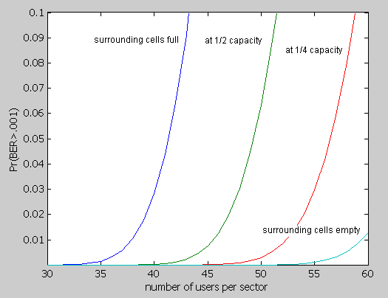

Figure -18 –Reverse link capacity/sector. (W=1.25 MHz, R=8kb/s, voice activity=3/8.)

2C.2- Reverse link outer-cell interference
Outer-cell normalized interference, I/S, is a random variable defined by $(62), (63), (64),$and upper bounded by replacing $(63),$ by $(63').$ Then the upper bound on its first moment, taking into account also the voice activity factor of the outer-cell subscribers,$α$ becomes
$$E(I/S)≤\iint_{sector}^{ }{{\left(\frac{r_{m}}{r_{0}}\right)}^{4}E(ψ.{10}^{\frac{x}{10}} .ϕ(x,r_{0}/r_{m}) )ρ.dA}$$
Where
$r_{m}$: is defined by $(63'),$ for every point in the sector
$ψ=1$ with probability $α$ and 0 with probability (1-$α$), and $x=ζ_{0}-ζ_{m}$ is a Gaussian random variable of zero mean and variance $2σ^{2}$ with $ϕ(x,r_{0}/r_{m})$ defined by $\left(64\right).$
$$ϕ(x,r_{0}/r_{m})=\left\{\begin{aligned}1 , if x≤40log(r_{0}/r_{m}) \\ 0 , otherwise \end{aligned}\right.$$

The expectation is readily evaluated as
$$α.f\left(\frac{r_{m}}{r_{0}}\right) ≜E\left(ψ\right).E\left(e^{\frac{xln10}{10}}ϕ\left(x,\frac{r_{0}}{r_{m}}\right)\right)$$

$$=α \int_{-∞}^{40logr_{0}/r_{m}}{e^{\frac{xln10}{10}}\frac{e^{-\frac{x^{2}}{4σ}}}{\sqrt{4πσ^{2}}} dx}$$

$$=α.e^{{\left(\frac{σln10}{10}\right)}^{2}}\int_{-∞}^{40logr_{0}/r_{m}}{\exp{[\frac{{-\frac{1}{2}(x/\sqrt{2σ^{2}}-x/\sqrt{2σ^{2}} ln10/10)}^{2}}{\sqrt{2{π(2σ}^{2})}}dx ]}}$$
$$=α.e^{{\left(\frac{σln10}{10}\right)}^{2}}\left\{1-Q\left[ \frac{40log{(r}_{0}/r_{m})}{\sqrt{2σ^{2}}} - \sqrt{2σ^{2}}\frac{ln10}{10} \right]\right\}$$
Which yields$(65).$

To evaluate $var(I/S),$ assuming the “spatial whiteness” of the blockage variable, we have $var\left(\frac{I}{S}\right)=\iint_{sector}^{ }{{\left(\frac{r_{m}}{r_{0}}\right)}^{8}.var(ψ.{10}^{\frac{x}{10}} .ϕ(x,r_{0}/r_{m}) )ρ.dA}$
Rewriting the variance in the integral as
$$E\left(ψ^{2}\right)E\left[{10}^{\frac{x}{10}} .ϕ^{2}\left(x,\frac{r_{0}}{r_{m}}\right)\right]-{\left\{E\left(ψ^{ }\right)E\left[{10}^{\frac{x}{10}} .ϕ^{ }\left(x,\frac{r_{0}}{r_{m}}\right)\right]\right\}}^{2}$$

$$=α.g\left(\frac{r_{m}}{r_{0}}\right)-α^{2} f^{2}\left(\frac{r_{m}}{r_{0}}\right)$$
Where $f^{ }(\frac{r_{m}}{r_{0}})$ was derived above and
$$α.g\left(\frac{r_{m}}{r_{0}}\right)=E\left(ψ^{2}\right)E\left[{10}^{\frac{xln10}{5}} .ϕ^{2}\left(x,\frac{r_{0}}{r_{m}}\right)\right]$$

$$α.e^{{\left(\frac{σln10}{5}\right)}^{2}}\left\{1-Q\left[ \frac{40log{(r}_{0}/r_{m})}{\sqrt{2σ^{2}}} - \sqrt{2σ^{2}}\frac{ln10}{5} \right]\right\}$$
This yield $(67)$
3.2.4D- Forward Link CDMA Capacity for the Multi-cell case

4D.1. Forward Link (from B.S. to M.S.) Power Control.
As noted earlier, although with a single cell no power control is required, with multiple cells it becomes important, because near the boundaries of cells considerable interference can be received from other cell-site transmitters fading independently.

In the forward link, power control takes the form of power allocation at the cell-site transmitter according to the needs of the individual subscribers in the given cell. This requires measurement by the mobile of its relative SNR, which is the ratio of the power from its own cell-site transmitter to the total power received. Practically, this is done by acquiring (correlating to) the highest power pilot and measuring its energy, and also measuring the total energy received by the mobile’s Omni-directional antenna from all cell site transmitters. Both measurements can be transmitted to the selected (largest power) cell site when the mobile starts to transmit. Suppose then that the based on these two measurements, the cell site has reasonably accurate estimates of $ST1$ and $\sum_{ j=1}^{K}{STj }$,
Where
$S_{T1}> S_{T2}>. . . S_{Tk}>0 ---\left(73\right)$

Are the powers received by the given mobile from the cell site sector facing it, assuming all but K (total) received powers are negligible. (We shall assume hereafter that all sites beyond the second ring around a cell contribute negligible received power, so that$K≤19$). Note that the ranking indicated in ($73$) is not required of the mobile-just the determination of which cell site is largest and hence which is to be designated${ T}_{1}$.

The $ith$subscriber served by a particular cell site will receive a fraction of $S_{T1}$ the total power transmitted by its cell sit, which by choice and definition ($73$) is the greatest of all the cell site powers it receives, and all the remainder of ${ S}_{T1}$ as well as the other cell site powers are received as noise. Thus its received ${ E}_{b}/N_{0}$ can be lower bounded by

$${\left(\frac{E_{b}}{N_{0}}\right)}_{i}≥ \frac{β{ Φ}_{i} S_{T1} /R}{\left[ \left(\sum_{ j=1}^{K}{S_{Tj} }\right)+η \right] /W} ---\left(74\right)$$
Where
$STj$ : is defined in (73)
$β$: is the fraction of the total cell-site power devoted to all subscribers
(The remaining i.e. ($1-β$) is devoted to the pilot).
$Φ_{i}$: is the fraction of the power devoted to the subscriber$i$.
Because of the importance of the pilot in acquisition and tracking, we shall take $β=0.8$. It is clear that the greater the sum of other cell-site powers relative to$S_{T1}$ , the larger the fraction${ Φ}_{i}$ which must be allocated to the $ith$ subscriber to achieve its required$E_{b}/N_{0}$ . In fact, from ($74$) we obtain

$$Φ_{i}≤\left(\frac{{\left(E_{b}/N_{0}\right)}_{i} }{βW/R}\right) \left[ 1+{\left(\frac{\sum_{ j=2}^{K}{S_{Tj} }}{S_{T1}}\right)}_{i}+\frac{η}{{\left(S_{T1}\right)}_{i}} \right] ---\left(75\right)$$
Where
$$\sum_{i=1}^{N_{s}}{Φ_{i}≤1---(76)}$$
Since $β.S_{T1}$ is the maximum total power allocated to the sector containing the given subscriber and $N_{s}$ is the total number of subscribers in the sector. If we define the relative received cell-site power measurements as $fi$ as,
$$f_{i}=( 1 +\sum_{j=2}^{K}{\frac{S_{Tj}}{S_{T1}}} )---\left(77\right)$$

$$i = 1, 2 , ...;Ns$$
Then from (75) and ($76$) it follows that their sum over all subscribers of the given cell site sector is constrained by
$$\sum_{i=1}^{N_{s}}{f_{i}≤ \frac{βW/R}{E_{b}/N_{0}}-\sum_{i=1}^{N_{s}}{\frac{η}{{\left(S_{T1}\right)}_{i}} ≜}}{ δ}^{'}---\left(78\right)$$

Generally, the background noise is well below the total largest received cell site signal power, so the second sum is almost negligible. Note the similarity to$δ$ in ($71$) for the reverse link. We shall take $β=0.8$ as noted above to provide 20% of the transmitted power on the sector to the pilot signal, and the required $E_{b}/N_{0}=5 dB$ to ensure $BER≤10􀀀^{-3}$ . This reduction of 2-dB relative to the reverse link is justified by the coherent reception using the pilot as reference, as compared to the non-coherent modem in the reverse link. Note that this is partly offset by the 1-dB loss of power due to the pilot.

Since the desired performance $BER≤10􀀀^{-3}$can be achieved with $N_{s}$ subscribers per sector provided ($78$) is satisfied$E_{b}/N_{0}=5 dB$ , capacity is again a random variable whose distribution is obtained from the distribution of variable${ f}_{i}$. That is, the $BER$ can not be achieved for all $N_{s}$ users/sector if the $N_{s}$ subscribers combined exceed the total allocation constraint of (78). Then following ($71$),
$$1-P= P_{r} \left(BER>{10}^{-3}\right)= P_{r} \left(\sum_{i=1}^{N_{s}}{f_{i}>δ^{'}}\right)---(79)$$
Where,
$$δ^{'}=\frac{βW/R}{E_{b}/N_{0}}$$
But unlike the reverse link, the distribution of the$f_{i}$, which depends on the sum of the ratios of ranked log-normal random variables, does not lend itself to analysis. Thus we restored Monte Carlo simulation, as follows.

For each of a set of points equally spaced on the triangle shown in figure-17 b- the attenuation relative to its own cell center and the 18 other cell centers comprising the first three neighboring rings was simulated. This consisted of the product of the fourth power of the distance and log-normally distributed attenuation.
$${ 10􀀀^{{\frac{ζ_{k}}{10}}_{ }}. r}_{k}^{-4} , k=0,1,2 . . .,18.$$

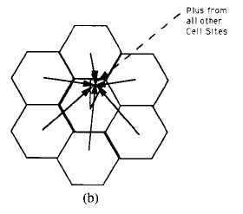
Figure-17b- capacity calculation geometrics. (b) Forward link allocation geometry.

Note that by the symmetry, the relative position of users and cell sites is the same throughout as for the triangle of figure-17 b-. For each sample, the 19 values were ranked to determine the maximum ($S_{T1}$), after which the ratio of the sum of all other 18 values to the maximum was computed to obtain$f_{i}-1$. This was repeated 10000 times per point for each of 65 equally spaced points on the triangle of figure-17 b-. From this, the histogram of $f_{i}-1$.was constructed, as shown in figure -19-.
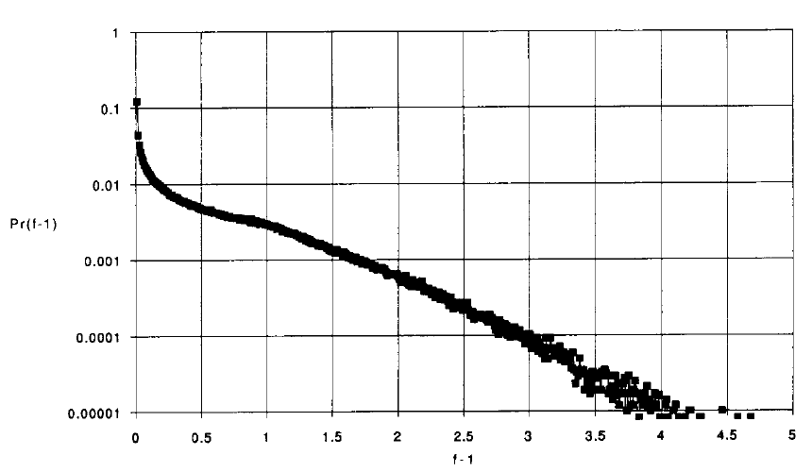
Figure19. Histogram of forward power allocation.

From this histogram the Chernoff upper bound on ($79$) is obtained as
$$1-P=<\min_{s>0}{ E\exp\left[ s \sum_{i=1}^{N_{s}}{f_{i}-{s.δ}^{'}}\right]}$$
$$p_{r}(BER>{10}^{-3})=\min_{s>0}{\left[ \left(1-α\right)+α \sum_{k}^{ }{P_{k}\exp\left(s{. f}_{k}\right)} \right]}^{Ns} e^{-{s.δ}^{'}}--(80)$$
Where $P_{k}$ is the probability (histogram values) that $f_{i}$ falls in the $K_{th}$ interval. The result of the minimization over $s$ based on the histogram of figure 19 is shown in figure 20.
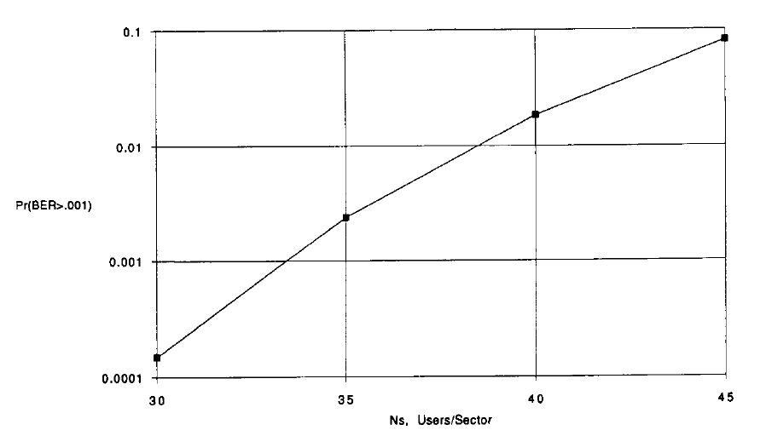
Figure -20- forward link capacity/sector. (W=1.25 MHz, R=8Kb/s, voice activity =3/8, pilot power=20%).

2.3- Example for Comparison

Figure 18 and 20 summarize performance of reveres and forward links. Both are theoretically pessimistic (upper bounds on the probability). Practically, both models assume only moderately accurate power control.

The parameters for both links were chosen for the following reasons. The allocated total spread bandwidth W=1.25MHz,represents 10% of the total spectral allocation, 12.5MHz, for cellular telephone service of each service provider. Which as will be discussed below, is a reasonable fraction of the band to devote initially to CDMA and also for a gradual incremental transition from analog FM/FDMA to digital CDMA. The bit rater=8Kb/s is that of an acceptable nearly toll quality vocoder. The voice activity factor, 3/8, and the standard sectorization factor of 3 are used. For the reverse channel, the received SNR per user $S/η=-1 dB$ reflects a reasonable subscriber transmitter power level. In the forward link, 20% of each site’s power is devoted to the pilot signal for a reduction of 1dB ($β=0.8$) in the effective processing gain. This ensures each pilot signal (per sector) is at least 5 dB above the maximum subscriber signal power. The role of the pilot, as noted above, is critical to acquisition, power control in both directions and phase tracking as well as for power allocation in the forward link. Hence, the investment of 20% of the total cell site power is well justified. These choices of parameters imply the choices $δ^{'}≈38$ $and δ^{ }=30$ in ($81$) and ($72$) for reveres and forward links, respectively.

Parameters.
1- The spread bandwidth W is chosen to be 1.25 MHz
2- The bit-rate is 8 kbps for a nearly acceptable toll-quality vocoder.
3- A voice activity factor $α$ of 3/8 and sectorization of 3.
4- In the forward link, $β$ = 0.8.
5- BER's of 10⁻³ better than 99 percent of the time.
These parameters imply choices of$δ= 30 and { δ}^{'}= 38$.

With these parameters, the reverse link can support (according to equation (66)),
Or according to figure -18 -
$Ns$ =36 users/sector or $N=$108 users/cell. This number becomes
$Ns$ =44 users/sector or $N=$132 users/cell. If the neighboring cells are kept to half this loading. With 10⁻³ bit error rates better than 99% of the time.

For the same performance conditions, the forward link (equation (69)) Or figure-20-tha system can handle
$Ns$ =38 users/sector or$N$ = 114 users/cell.

Clearly, if the entire cellular allocation is devoted to CDMA, these numbers are increased ten fold. Similarly, if a lower bit rate vocoder algorithm is developed, or if narrower sectors are employed, the number of users may be increased further.

Remaining parameters assumed, interesting comparisons can be drawn to existing analog FM/FDMA cellular systems as well as other proposed digital systems. First, the former employs 30-KHz channel allocation, and assuming 3 sectors/cell, requires each of the six cells in the first ring about a given cell to use a different frequency band. This results in a “frequency reuse factor” of 1/7. Hence, given the above parameters, the number of channels in a 1.25-MHz band is slightly less than 42, and with a frequency reuse factor of 1/7, this results in,
$⟹\frac{1.25MHz / 7}{30kHz}=6$users/cell.
Thus, CDMA offers at least an 18 fold increase in capacity. Note further that use of CDMA over just ten percent of the band supports over 108 users/cell whereas analog FM/FDMA supports only 60 users/cell using the entire bandwidth 12.5 MHz band. Thus by converting only 10% of the band from analog FDMA to digital CDMA, overall capacity is increased almost three fold.

Comparisons of CDMA with other digital systems are more speculative. However, straightforward approaches such as narrower frequency channelization with FDMA or multiple time slotting with TDMA can be readily compared to the analog system. The proposed TDMA standard for the U.S. is based on the current 30KHz channelization but sharing of channels by three users each of whom is provided one of three TDMA slots. Obviously, this triples the analog capacity $⟹ \frac{1.25MHz / 7}{30kHz / 3}=18$users/cell.
But falls over a factor of 6 short of CDMA capacity.

Conclusion
In chapter1 The delay, bit error probability, throughput and packet loss of the TDMA, CDMA and CDMA/TDMA techniques for voice and data traffic in AWGN channels were studied. Some special capabilties of CDMA such as the activity ratio of voice traffic and the bit energy were taken into consideration. It was shown that the CDMA-related systems can effeciently use the bursty nature of sources which has a factor called voice activity factor to reduce the total delay in packet transmission. For CDMA and CDMA/TDMA techniques, up to $ρ≈0.4$, packet loss was nearly zero whereas it increased linearly with traffic in TDMA.
The inherent capability of CDMA in using the activity factor of the voice traffic causes a nearly constant delay for a wide range of traffic. Spread spectrum based systems represent better performance for small signal to noise ratios. Therefore, they are more appropriate for the power limited channels or where the noise power changes rapidly, since they are not very sensitive to noise power.

In this chapter, the inherent features of CDMA have been discussed and how these factors affect the performance of CDMA in comparison with TDMA is explained. In addition, it is illustrated that when the sources in the system have different bit rates, the bit error probability for CDMA is even smaller than that for the other multiple access systems. which shows flexibility in supporting multiple services and multiple voice and data rate. It is evident that the conditions of each channel and the characteristics of the traffic sources determine which method is more appropriate

In chapter2, we see that the properly augmented and power-controlled multiple-cell CDMA promises a quantum increase in current cellular capacity. No other proposed schemes appears to even approach this performance. other advantages of CDMA not treated here include inherent privacy, lower average transmit power requirements and soft limit on capacity, Since if the bit error rate requirements is relaxed more users can be supported. With all these inherent advantages, CDMA appears to be the logical choice henceforth for all cellular telephone application.

References
[1] William C Y Lee, \Overview of Cellular CDMA", IEEE Transactions on Vehicular Technology, v 40, n 2, May 1991, pp 291-302.
[2] Klien S Gilhousen, Irwin M Jacobs, Roberto Padovani, Andrew J Viterbi, Lindsay A Weaver Jr, Charles E Wheatley III, \On the Capacity of a Cellular CDMA System", IEEE Transactions on Vehicular Technology, v 40, n 2, May 1991, pp 303-312.
[3] Audrey M Viterbi, Andrew J Viterbi, \Erlang capacity of a power controlled CDMA system", IEEE Journal on Selected Areas in Communications, v 11, n 6, Aug 1993, pp 892-900.
[4] Klien S Gilhousen, Irwin M Jacobs, Roberto Padovani, Andrew J Viterbi, Lindsay A Weaver Jr, Charles E Wheatley III, \On the Capacity of a Cellular CDMA System", IEEE Transactions on Vehicular Technology, v 40, n 2, May 1991, pp 303-312.v 12, n 8, Oct 1994, pp 1281-1288.
[5] William C Y Lee, \Overview of Cellular CDMA", IEEE Transactions on Vehicular Technology, v 40, n 2, May 1991, pp 291-302.8, n 4, May 1990, pp 503-514.
[6] Linda M Zeger, Mark E Newbury, \CDMA Capacity with Added Carriers in a Cellular Network", Bell Labs Technical Journal, July-Sep 1999, p 104-119.
[7] Theodore S Rappaport, \Wireless Communications", Prentice Hall PTR, Upper Saddle River, New Jersey. EECS Deparment, the University of Kansas
[8] Audrey M Viterbi , Andrew J Viterbi, \Erlang capacity of a power controlled CDMA system", IEEE
Journal on Selected Areas in Communications, v 11, n 6, Aug 1993, pp 892-900.
[9] Walker, E.L.”A theoretical analysis of the performance of code division multiple access communication over multimode optical fiber channels-part I: Transmission and detection”, IEEE j.Select. Areas commun. 12(4) pp 751-761(May 1994)

