An-Najah National University
Faculty of Engineering & Information Technology

Thermal Energy Storage Using PCM in Domestic Solar Water Heaters

Prepared by:
Deema Balalta
Lama Habayeb
Nida Assaf

Supervisor:
Dr. Abdelrahim Abusafa

A Graduation Project Report Submitted to Energy Engineering and Environment Department in Partial Fulfillment of the Requirements for Bachelor Degree in Energy Engineering and Environment
Nablus, 2017
Dedication

To whoever is a Light … a Direction … a Road …
Or even a Rock … in our Journey …
We dedicate this to you …

Acknowledgement

We would first like to thank our project advisor Dr. Abdelrahim Abusafa of the Faculty of Engineering at An-Najah National University. The door to Dr. Abusafa office was always open whenever we ran into a trouble spot or had a question about the research or writing. He steered us in the right the direction whenever he thought we needed it.
We would also like to acknowledge Dr. Aysar Yassin and Dr. Mohammed Alsayed as the second readers of this project, and we are gratefully indebted to them for their very valuable comments on this project.

Table of Contents

List of Figures II
List of Tables IV
Nomenclature V
Abstract VII
Introduction 1
Literature Review 3
Energy Storage Systems 5
Thermal energy storage 10
Phase Change Materials (PCM) 15
Domestic Water Heating Systems 22
Configurations of PCM in Thermal Storage Systems 32
Methodology 36
Results and Discussion 42
Conclusion and Recommendations 56
References 57

List of Figures

Figure 2.1: Solar domestic hot water tank and the PCM module used in the experiment 3
Figure 2.2: Schematic of the experimental model 4
Figure 3.1: A pumped hydro storage plant 7
Figure 3.2: Flywheel energy storage 8
Figure 3.3: Thermal Energy Storage Types 9
Figure 4.1: Possible methods of reversible storage of heat and cold 10
Figure 4.2: Heat storage as sensible heat 11
Figure 4.3: Latent heat storage for solid –liquid phase change 13
Figure 5.1: classification of phase change materials. 18
Figure 5.2: Classes of PCM and their typical range of melting temperature and enthalpy. 18
Figure 6.1: Energy consumption in domestic buildings 22
Figure 6.2: storage tank water heater 23
Figure 6.3: Instantaneous water heater 24
Figure 6.4: Heat pump water heater 24
Figure 6.5: Solar water heater 25
Figure 6.6: Direct active circulation heating systems 26
Figure 6.7: Indirect circulation heating system 26
Figure 6.8: Integral collector-storage passive system 27
Figure 6.9: Thermosyphon system 27
Figure 6.10: Flat-plate solar collector 29
Figure 6.11: Evacuated tube collectors 30
Figure 6.12: Concentrating solar collector 31
Figure 7.1: Schematic of a LHESS for SDHW 32
Figure 7.2: Solar water heater 33
Figure 7.3: Layout of the storage system 34
Figure 7.4: Cylindrical PCM containers 35
Figure 8.1: Schematics of a solar water heating system 39
Figure 8.2: Layout of the SWHS with PCM 39
Figure 8.3: Daily load profile of the domestic hot water 41
Figure 9.1: SWHS (Flat plate, 3.42 m², 180 L) outcomes 42
Figure 9.2: SWHS (Flat plate, 1.71 m², 180 L) outcomes 43
Figure 9.3: SWHS (Flat plate, 3.42 m², 80 L) outcomes 44
Figure 9.4: SWHS (evacuated tube, 3 m², 180 L) outcomes 45
Figure 9.5: RT42 Paraffin 46
Figure 9.6: hourly solar fraction 47
Figure 9.7: monthly average solar fraction 47
Figure 9.8: hourly storage tank temperature 48
Figure 9.9: monthly maximum storage tank temperature 49
Figure 9.10: Hourly losses of the storage tank 50
Figure 9.11: Monthly average losses of the storage tank 50
Figure 9.12: Hourly collector efficiency 51
Figure 9.13: Monthly average collector efficiency 52
Figure 9.14: Hourly melted PCM 53
Figure 9.15: Hourly modified melted PCM 53
Figure 9.16: Hourly comparison between (100 L &180 L) storage tank on April 54
Figure 9.17: Hourly comparison between (Evacuated tube & Flat plate) collector on April 55

List of Tables

Table 4.1: Typical Parameters of Thermal Energy Storage Systems 14
Table 4.2: Comparison of typical storage densities of different TES systems 14
Table 5.1: main desirable properties of phase change materials 17
Table 5.2: advantages and disadvantages of phase change materials 21
Table 9.1: RT42 important data 46

Nomenclature

eia | Energy Information Administration | $$m_{PCM}$$ | is the mass of phase change material $(kg)$
GHG | Green House Gases | DWH | Domestic Water Heating
PCM | Phase Change Material | $$h_{PCM}$$ | Phase change Enthalpy $(kJ/kg)$
LHS | Latent Heat Storage | EF | Energy Factor
PS | Paraffin and Stearic Acid | $$A_{C}$$ | collector area in$m^{2}$
PP | Paraffin and Palmitic Acid | $$U_{L}$$ | Overall heat loss coefficient in$w/m^{2}.℃$
SM | Stearic and Meristic Acid | $$S$$ | absorbed incident solar irradiance in$w/{m^{2}}$
SDWH | Solar Domestic Water heater | FPC | Flat Plate Collector
DC | Direct current | ETC | evacuated-tube collectors
AC | Alternating Current | LHESS | Latent Heat Energy Storage Systems
ES | Energy Storage | ETSS | Encapsulation Thermal Storage Systems
TES | Thermal Energy Storage | $$C_{P}$$ | specific heat capacity of the fluid in ${kJ}/{kg}.℃$
CSP | concentrating solar power | $$C_{P_{W}}$$ | specific heat of water (${kg}/{kg}.°C$).
TCS | Thermo-Chemical Storage | $$C_{P_{PCM}}$$ | specific heat of water (${kg}/{kg}.°C$).
$$Q$$ | Heat $(kJ)$ | $$T_{P}$$ | average absorber plate temperature in $℃$
$$Q_{u}^{°}$$ | rate of useful energy collected ($W)$ | $$T_{a}$$ | Is the ambient temperature in$℃$
$$q_{solar}$$ | is the solar heat gain obtained by collectors $(kJ)$ | $$T_{°}$$ | desired outlet fluid temperature in$℃$
$$q_{load}$$ | is the heat load supplied from the tank in $(kJ)$ | $$T_{i}$$ | fluid inlet temperature in$℃$
$$q_{loss}$$ | the heat loss of the tank $(kJ)$ | $$T_{s}$$ | storage tank temperature in $℃$
$$q_{aux}$$ | the auxiliary heater load $(kJ)$ | $$T_{w}$$ | is the utility water temperature in $℃$
$$m$$ | Mass $(kg)$ | $$T_{PCM}$$ | Phase Change Temperature $℃$
$$m_{w}$$ | the mass of water $(kg)$ | $$ρ$$ | density of water $({kg}/{m^{3})}$
$$∆h$$ | Enthalpy Difference ${kJ}/{kg}$ | $$V_{s}$$ | volume of the storage tank $(m^{3})$
T | the time horizon | $$λ$$ | latent heat of fusion
$$U_{s}$$ | heat loss coefficient | $$α$$ | elevation angle
$$A_{s}$$ | surface area of the storage tank | $$β$$ | tilt angle
H | height of a cylindrical tank | $$φ$$ | latitude
D | diameter of a cylindrical tank | $$δ$$ | declination angle
F | Solar fraction | d | Day of the year

Abstract

The energy source and the demands of a building, in general, do not match each other, especially in solar water heating applications where the peak solar radiation occurs near noon, while the peak heating demand is in the late evening or early morning when solar radiation is not available or adequate.
Innovative methods for providing sustainable thermal energy storage (TES) have gained increasing attention; as thermal energy storage is essential in the solar water heating system. Latent heat storage (LHS) is an efficient TES method as it stores large amount of heat with small temperature variation due to phase changing, LHS can be achieved using special materials called phase change materials (PCM).
This study aimed at studding the possibility of using PCM in the domestic solar water heaters at Palestinian weather conditions and its feasibility. The solar water heater was modeled and simulated using different parameters; two types of solar collectors were studied (Flat plate & evacuated tube).
The PCM was introduced to the evacuated tube collector system, placing it in capsules at the hot water storage tank; the solar fraction almost doubled at the first hours of the day. The simulation results showed that the tank temperature became more uniform and did not exceed the melting temperature of the PCM which is 43$℃$; moreover the losses of 100 Litter storage tank reduced.
The results showed that using 100 Litter storage tank with evacuated tube collector and about 58 kg of PCM has the best performance over the different studied systems.
However, further researches are needed in order to round the subject such as studying different configurations for the PCM in the system from heat transfer point of view and conducting an economic evaluation and a feasibility study for an optimized system.

Chapter One

Introduction

The worldwide energy demand is continuously increasing, according to the forecasts of Energy Information Administration (eia), it is expected to rise by approx. 48 percent until 2040 [1]. Currently, fossil fuels are the major energy source that are being used in the world today with over 80 percent of the primary energy demand [2]. Although their reserves will last for the next decades, they will not be able to cover the worldwide energy consumption in the long term. In addition, the over-consumption is leading to serious environmental issues such as air pollution; burning fossil fuels release most of the greenhouse gases (GHG) like carbon dioxide, nitrogen dioxide, sulphur dioxide, carbon monoxide etc. Which causes the ozone depletion that leads to global warming and climate change.
In view of possible climatic changes due to the increase in the atmospheric CO₂-content as well as the conceivable decrease of fossil fuels, it becomes clear that future energy supply can only be guaranteed through increasing the use of renewable energy sources.
Renewable energy is widely available from different resources like sun, wind, water, tides, geothermal or biomass. They are sustainable, cheap and available, also they produce little or no waste products and so have minimal impacts on the environment. However it is still inefficient, too expensive in many cases to take over significant parts of the energy supply. Another disadvantage of renewable energy sources in the reliability of the supply; renewable energy often relies on the weather or its source of power (intermittency).
With global trend towards the renewable energy generation, the investments are significantly growing and so the prices of renewable energies are expected to be reduced. Already today, wind, water and sun are economically competitive in some regions. However, to solve energy and climate problems, it is not only necessary to economically utilize renewable alternatives to fossil fuels, but to optimize the whole chain of energy, i.e. from development and conversion, transport and storage up to the consumers’ utilization.
Energy storage system is a vital component in the chain of energy. It provides a wide range of technological approaches in order to manage the power supply, create a more resilient energy infrastructure and bring cost savings to utilities and consumers.
Different forms are available for energy storage such as biological, chemical, magnetic, mechanical and thermal. Each has various systems and technologies. For example chemical energy can be stored using batteries, also mechanical energy can be stored using flywheels and so many. But thermal storage is receiving a great attention because it allows energy use in a far more efficient manner and it can be applied in different applications and scales.
In Macro scale power stations produce a large amount of thermal energy that can be stored or recovered to increase the efficiency and improve the output power. Also it is used in a micro scale applications as for a domestic use in solar water heaters or in the building envelope to contribute providing comfort in the spaces.
Sensible and latent heat storage are used to store thermal energy, but the second is more interesting since it provides a high energy storage density and has the capacity to store energy at a constant temperature “or over a limited range of temperature variation” which is the temperature that corresponds to the phase transition temperature of the material.
Materials used to store thermal energy in the form of latent heat are called phase change materials (PCM). It is a substance with a high heat of fusion which melting and solidifying at a certain temperature, that is capable of storing and releasing large amounts of energy. Heat is absorbed or released when the material changes from solid to liquid and vice versa; thus, PCM are classified as latent heat storage (LHS) units.
PCM are used in a wide range of applications in different fields such as air conditioning, transportation of perishable foods and temperature sensitive pharmaceuticals, green houses, temperature peak stabilization, construction materials, house heating and warm water.
Installing PCM in the SWH system increases the thermal storage density, and gives a more uniform storage tank.
The main objectives of this project are:
- Review the different methods for energy storage.
- Investigate different types of PCM and their properties.
- Investigate solar thermal systems and their different configurations.
- Study different configurations of thermal energy storage systems using PCM.
- Simulate a proper thermal energy storage system using PCM for DSWH and compare between systems with and without PCM.
Chapter Two

Literature Review

Several studies were performed to study the utilization of phase change materials with solar water heater storage systems. Mazman et al. [3] developed an experimental model to study the thermal performance of a tank with PCM. A storage tank with 150 L capacity and three modules of PCM with a cylindrical geometry, the melting temperature of PCMs and the size of the module were discussed by the author. The PCM was added at the top of the tank, a three kilograms of new PCM-graphite compounds with optimized thermal properties were used, such as 80:20 weight percent ratio mixtures of paraffin and stearic acid (PS), paraffin and palmitic acid (PP), and stearic acid and myristic acid (SM), graphite was added to the mixture to increase heat transfer in PCM modules. Figure 2.1 below show the PCM module and the storage tank. Thermocouples were used to measure the temperature.
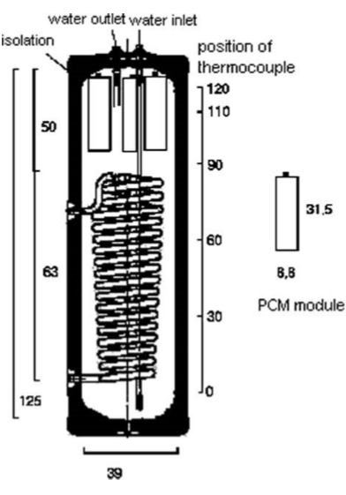
Figure 2.1: Solar domestic hot water tank and the PCM module used in the experiment

The result of this experiment show that three kg of PCM could increase the temperature of (14-16) L of water at upper part of solar domestic water heater (SDWH) by 3-4 ᵒϹ, it took place in 10-15 min. It was found that the PS has the best thermal performance since it has the highest recovery efficiency.
Fazilati & Alemrajabi [4] studied experimentally the performance of solar water heaters. A jacket shell tank was used as heat exchanger, spherical encapsulated PCM was used, and these were filled with paraffin wax, the schematic of this model is shown in Figure 2.2. The experiment study the system in three different solar radiation intensities and different flow rates. This study compares between two models with and without PCM, the results showed that applying these materials improve the energy density and the extending period of hot water supply.
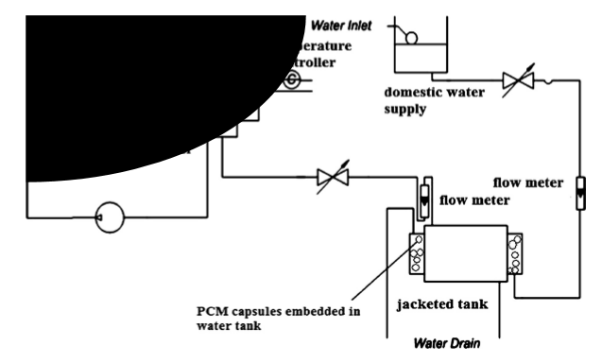
Figure 2.2. Schematic of the experimental model.
Dzikevics et al. [5] Used COMOSOL multiphysic to analyze the accumulated energy and to predict the temperature change in PCM. The studied system used paraffin as the phase change material which encapsulated in spheres. The aim of this research is to validate that at small volume and small Rayleigh number, thermal conductivity can be only used as a heat transfer method, where the convective heat transfer is negligible. The results of the modeled system were compared with experimental results for the same system and both results were closed to each other with correlation factor of 0.992. However, the difference between the results can be observed after the melting has started which affected the accuracy of the model.

Chapter Three

Energy Storage Systems

Energy storage (ES) is one of the areas that holds great promise to allow all of us to use energy in a far more efficient manner. Since energy consumption is generally not constant, devices & processes are constantly starting, stopping & adjusting as needed. This variation on energy demand allows for energy and cost saving measures to be implemented through energy storage. [6] Energy storage systems have five categories:
Magnetic
Magnetic traditional storage systems store energy within capacitors and newer systems currently use superconducting materials and their magnetic fields to store energy. [6] Energy can be stored in a magnetic field (e.g., in a large electromagnet). An advanced scheme that employs superconducting materials is under development. At temperatures near absolute zero, certain metals have almost no electrical resistance and thus large currents can circulate in them with almost no losses. Because this scheme stores DC electricity, some losses are accounted in converting standard AC power to and from DC, and some energy is used to drive the refrigeration device to maintain the required low temperatures. Overall storage efficiencies of 80–90% are anticipated for these superconducting magnetic ES systems.
Magnetic storage is considered for two main purposes. First, large superconducting magnets capable of storing 1000–10,000 MWh of electricity for central power stations, and may be cost-effective at such capacities. Second, smaller magnets with storage capacities in the 10-kWh range may be cost-effective in smoothing out transmission line loads.
The potential for highly efficient electrical ES is especially attractive for utilities, particularly when energy costs increase. The storage coil in a superconducting magnetic ES would likely be helical and located below ground. In order to obtain high current densities in the coil, and thereby reduce the quantity of costly superconductor needed, one proposed storage system is recommended for operation at 1.85 Kelvin. The storage unit could be charged during off-peak hours, with the electricity discharged back to the grid at a later time to meet peaking needs.
The unit would generally operate on one charging and discharging cycle per day and would be connected to a three-phase utility transmission line. As noted earlier, the storage system requires the conversion of alternating to direct current for storage in the superconducting coil.
An ES capacity of 1 GWh is typical of the size that is considered commonly. As the costs are projected to be high, no large-scale superconducting magnetic ES device is expected to be built in the foreseeable future. [7]

Biological
Living organisms use two major types of energy storage. Energy-rich molecules such as glycogen and triglycerides store energy in the form of covalent chemical bonds. Cells synthesize such molecules and store them for later release of the energy. The second major form of biological energy storage is electrochemical and takes the form of gradients of charged ions across cell membranes. [8]
Biological energy storage systems are still in their infancy and little information is available currently. Such technology works through exploring energy potential of molecules that are used to store energy in living organisms. It is considered an important method for long term storage, meanwhile efficiencies of such levels are still low and further research is required for significant interest to develop in this area. [6]

Mechanical
Mechanical energy may be stored as the kinetic energy of linear or rotational motion, as the potential energy in an elevated object, as the compression or strain energy of an elastic material, or as the compression energy in a gas. It is difficult to store large quantities of energy in linear motion because one would have to chase after the storage medium continually. However, it is quite simple to store rotational kinetic energy. There are three main mechanical storage types: hydro storage, compressed-air storage, and flywheels. [7]
Hydro storage systems are perhaps one of the most commonly used systems of energy storage due to its simplicity, with all hydro power stations working on this principle. At night, when energy demand is low, pumps pump water upward from the river Figure 3.1. The water is pumped through a pipe to a reservoir. During the day, when energy demand is high, the reservoir releases water, allowing it to flow downhill. The flowing water turns the turbine to generate electricity.

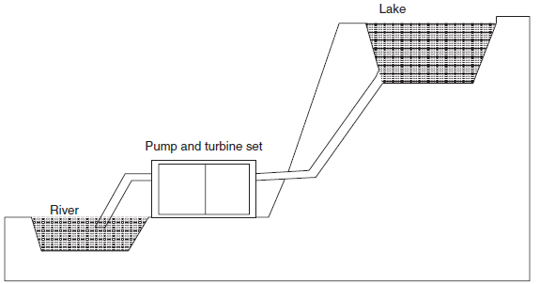
Figure 3.1: A pumped hydro storage plant

The efficiency of a pumped water storage plant is about 50%. When water is pumped uphill, about 30% of the energy is lost. When the water flows down, another 20% of the energy is lost. A pumped water storage plant operates for more than 20 years. When the energy is needed, the plant only needs 30 s to reach 100% of its power. Hydrostorage has been proved economically viable, but its use is geographically limited to only a few percentage of the total hydroelectric capacity. [7]

Compressed air systems compress air into storage reservoirs (usually underground) during off peak hours and then later released through a gas turbine generator. Suitable reservoirs for such systems are through the use of natural caverns, salt domes, abandoned mine shafts, depleted oil wells and porous rock formations. Such systems are comparable to hydro storage.
The technique used by such a system to compress air to store energy is relatively straightforward. In a conventional gas turbine, high-pressure hot gas is supplied, and about two-thirds of the gross power output is used to drive the compressor. Such system is advantageous when an appreciable part of the power load is carried by nuclear stations, and where suitable spent salt caverns make it easy to build the compressed gas reservoirs. [7, 9]
Flywheels store rotational energy in an accelerated rotor; a large mass rotating cylinder Figure3.2. The energy is maintained in the flywheel by keeping the rotating cylinder at a constant speed. An increase in the speed results in a higher amount of energy stored, to accelerate the flywheel electricity is supplied by a transmission device. If the flywheel’s rotational speed is reduced electricity may be extracted from the system by the same transmission device. These systems have long been used to smooth out the power output from one- or two-cycle (stroke) engines and to adjust for uneven loads. In fact almost every reciprocating engine utilizes a flywheel. However, new uses for flywheels are emerging by connecting them to electric motor/generators to smooth out peak energy demands. The main features of flywheels are the excellent cycle stability and a long life, little maintenance, high power density and the use of environmentally inert material. However, flywheels have a high level of self-discharge due to air resistance and bearing losses and suffer from low current efficiency. [9]
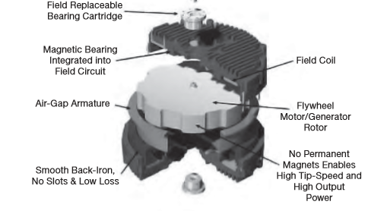
Figure 3.2: Flywheel energy storage
Chemical
The most familiar chemical ES device is the battery. Energy stored in batteries is frequently referred to as electrochemical energy because chemical reactions in the battery are caused by electrical energy and subsequently produce electrical energy. Some chemical storage systems are thermally charged and discharged. Many chemical reactions are endothermic and proceed forward with absorption of thermal energy. Then, when the temperature of the system falls below a certain value, the energy stored in the system during the original reaction is released as the reaction is reversed. Thus, energy is stored by utilizing the heats of chemical reactions. Such chemical storage is considered for solar thermal applications, but is still at the developmental stage.
Chemical storage also consist of storing energy as Hydrogen which can be produced electrochemically by the electrolysis of water or thermochemically by direct chemical reactions in multistage processes. Hydrogen can then be used to generate heat (through direct burning) or to generate electricity through the use of a fuel cell. [7]

Thermal
Thermal energy storage TES may be achieved by elevating or lowering the temperature of a substance (i.e., altering its sensible heat), by changing the phase of a substance (i.e., altering its latent heat) or through a combination of the two. TES is the temporary storage of high- or low-temperature energy for later use, it can be an important means of offsetting the mismatch between thermal energy availability and demand. [7] Thermal storage can be subdivided into different technologies: storage of sensible heat, storage of latent heat, and thermo-chemical Figure 3.3. Further explanation will be in chapter four.
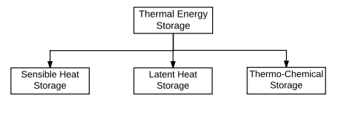
Figure 3.3: Thermal Energy Storage Types

Chapter Four

Thermal energy storage

Thermal energy storage TES is a technology that stocks thermal energy by heating or cooling a storage medium so that the stored energy can be used at a later time for heating and cooling applications and power generation. Energy demands in the commercial, industrial, and utility sectors vary on daily, weekly, and seasonal bases. In these applications, approximately half of the energy consumed is in the form of thermal energy. Therefore, TES systems can help balance energy demand and supply. They can also reduce peak demand, energy consumption, CO2 emissions and costs, while increasing overall efficiency of energy systems. Furthermore, the conversion and storage of variable renewable energy in the form of thermal energy can also help increase the share of renewable in the energy mix. TES is becoming particularly important for electricity storage in combination with concentrating solar power (CSP) plants where solar heat can be stored for electricity production when sunlight is not available.
Thermal energy storage systems can be either centralized or distributed systems.Centralized applications can be used in district heating or cooling systems, large industrial plants, combined heat and power plants, or in renewable power plants(e.g. CSP plants). Distributed systems are mostly applied in domestic or commercial buildings to capture solar energy for water and space heating or cooling. [10]
TES deals with the storage of energy by cooling, heating, melting, solidifying, or vaporizing a material; the thermal energy becomes available when the process is reversed. [7] Figure 4.1 shows some possible methods; they can be divided into physical and chemical processes.
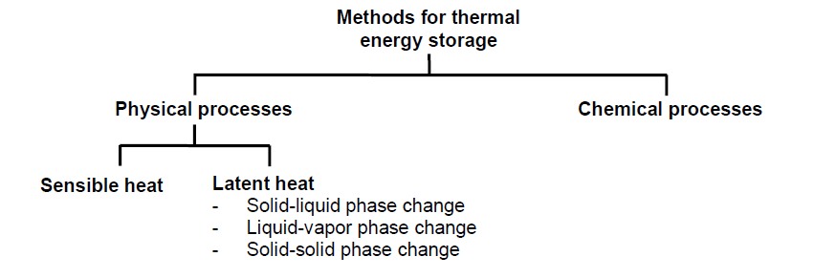
Figure 4.1: Possible methods of reversible storage of heat and cold [11]

To understand the advantages of each method, and especially of latent heat storage, it is necessary to get an overview on the different methods of thermal energy storage:

Thermo-chemical storage (TCS)
When a chemical reaction takes place, there is a difference between the enthalpy of the substances present at the end of the reaction and the enthalpy of the substances at the beginning of the reaction. This enthalpy difference is known as heat of reaction which the thermo-chemical storage TCS is based on. If the reaction is endothermic, it will absorb this heat while it takes place; if the reaction is exothermic, it will release this heat. Any chemical reaction with high heat of reaction can be used for thermal energy storage if the products of the reaction can be stored and if the heat stored during the reaction can be released when the reverse reaction takes place. [11] Systems based on this principle have negligible heat losses. Thermo chemical materials have the highest storage capacity of all storage media. As the binding energy in a chemical reaction is usually large, the temperature necessary to destroy the bond is usually high. [12]

Sensible heat storage
Sensible heat storage systems utilize the heat capacity and the change in temperature of the material during the process of charging or discharging - temperature of the storage material rises when energy is absorbed and drops when energy is withdrawn. One of the most attractive features of sensible heat storage systems is that charging and discharging operations can be expected to be completely reversible for an unlimited number of cycles, i.e., over the life-span of the storage. [12]
Heat transferred to the storage medium leads to a temperature increase of the storage medium as shown in Figure 4.2.
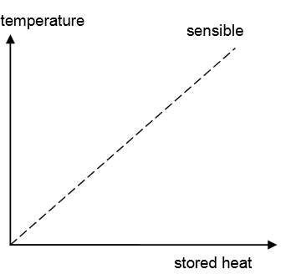
Figure 4.2: Heat storage as sensible heat [11]

The sensible heat Q gained or lost by a material in changing temperature from T1 to T2 is

$∆Q=m c_{p}\left(T2-T1\right)$ (4.1)
Where:
$m$: is the mass (kg),
$c_{p}$: is the specific heat (kJ/kg.°C).
Sensible heat storage is often used with solids like stones or bricks, or liquids like water, as storage material. It is by far the most common method for heat storage. Hot water heat storages are used for domestic heating and domestic hot water in every household. [11]
Thermal energy storage in the form of sensible heat is based on the specific heat of a storage medium, which is usually kept in storage tanks with high thermal insulation. The most popular and commercial heat storage medium is water, which has a number of residential and industrial applications. Underground storage of sensible heat in both liquid and solid media is also used for typically large-scale applications. Gases have very low volumetric heat capacity and therefore are not used for sensible heat or cold storage. However, TES systems based on sensible heat storage offer a storage capacity that is limited by the specific heat of the storage medium. [10]

Latent heat storage
Latent heat is the amount of heat absorbed or released during the change of the material from one phase to another phase. If heat is stored as latent heat, a phase change of the storage material is used; these materials are called phase change materials PMC. As the source temperature rises, the chemical bonds within the PCM break up as the material changes phase from solid to liquid (as is the case for solid-liquid PCM). The phase change is a heat-seeking (endothermic) process and therefore, the PCM absorbs heat. Upon storing heat in the storage material, the material begins to melt when the phase change temperature is reached. The temperature then stays constant until the melting process is finished. [13] Heat storage as latent heat for solid liquid phase change is shown in Figure 4.3.

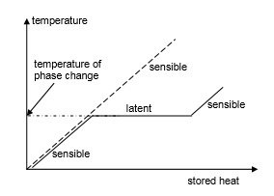
Figure 4.3: Latent heat storage for solid –liquid phase change [11]

The stored heat Q is equal:
$∆Q=m.∆h$ (4.2)
Where:
$m$: is the mass,
$∆h$: is the enthalpy difference. [11]
Latent heat storage has two main advantages: (a) it is possible to store large amounts of heat with only small temperature changes and therefore to have a high storage density; (b) because the change of phase at a constant temperature takes some time to complete, it becomes possible to smooth temperature variations. The comparison between latent and sensible heat storage shows that using latent heat storage, storage densities typically 5 to 10 times higher can be reached. PCM storage volume is two times smaller than that of water. Latent heat storage can be used in a wide temperature range. [13]
Thermal energy storage includes a number of different technologies, each one with its own specific performance, application and cost. TES systems based on sensible heat storage offer a storage capacity ranging from 10-50 kWh/ton and storage efficiencies between 50-90%, depending on the specific heat of the storage medium and thermal insulation technologies.
Phase change materials PCM can offer higher storage capacity and storage efficiencies from 75-90%. In most cases, storage is based on a solid/liquid phase change with energy densities on the order of 100 kWh/m³ (e.g. ice). Thermo-chemical storage TCS systems can reach storage capacities of up to 250 kWh/ton with operation temperatures of more than 300°C and efficiencies from 75% to nearly 100%.
The cost of a complete system for sensible heat storage ranges between €0.1-10/kWh, depending on the size, application and thermal insulation technology. The costs for PCM and TCS systems are in general higher. In these systems, major costs are associated with the heat (and mass) transfer technology, which has to be installed to achieve a sufficient charging/discharging power. Costs of latent heat storage systems based on PCM range between €10-50/kWh while TCS costs are estimated to range from €8-100/kWh. The economic viability of a TES depends heavily on the application and operation needs, including the number and frequency of the storage cycles. [10] Table 4.1 shows typical figures for TES systems.

Table 4.1: Typical Parameters of Thermal Energy Storage Systems. [10]
Costs (€/kWh) | Efficiency (%) | Capacity (kWh/ton) | TES System
0.1-10 | 50-90 | 10-50 | Sensible (hot water)
10-50 | 75-90 | 50-150 | PCM
8-100 | 75- 100 | 120-250 | Chemical reaction

A comparison of energy storage densities achieved with different methods shown in Table 4.2.
Table 4.2: Comparison of typical storage densities of different TES systems. [11]
$${ MJ}/{m^{3}}$$ |  | $${kJ}/{kg}$$ | Comment
Latent heat of melting
Water | 306 | 330 | Melting temperature $5℃-130℃$
Paraffins | 180 | 200 | Melting temperatures $5℃-130℃$
Salt hydrates | 300 | 200 | Melting temperatures $0℃$
salts | 600-1500 | 300-700 | Melting temperatures $300℃-800℃$
Latent heat of evaporation
water | 2452 | 2450 | Ambient conditions
Heat of chemical reaction
H₂ gas (oxidation) | 11 | 120000 | 300K, 1bar
H₂ gas (oxidation) | 2160 | 120000 | 300K, 200 bar
H₂ liquid (oxidation) | 8400 | 120000 | 20K, 1bar
Fossil gas | 32 | - | 300K, 1bar
Gasoline (petroleum) | 33000 | 43200 | -
Chapter Five

Phase Change Materials (PCM)

Phase Change Materials offer the possibility of thermal protection due to their high thermal inertia. This protection could be used against heat and cold, during transport or storage. Protection for food, beverages, pharmaceutical products, blood derivatives, electronic circuits, biomedical products, and many others, is possible. [14]

Phase change materials
When a material melts or vaporizes, it absorbs heat; when it changes to a solid (crystallizes) or to a liquid (condenses), it releases this heat. [7] This phase change is used for storing heat in PCM. The purpose for which they are designed is to prevent heat loss by absorption or release heat.
PCM is used as storage medium to store latent heat at constant temperature through its phase transition, this can be accomplished through solid-liquid, liquid-gas, solid-gas and solid-solid phase transformations. The solid-gas and liquid-gas systems are of limited utility because of the large volumes required for such systems. The solid-solid systems are recently being studied but it shows much promise, the most commonly commercially and the most studied is solid-liquid system. [15]
The change in the substance enthalpy resulting from providing energy, typically heat, to a specific quantity of the substance to change its state from a solid to a liquid at constant pressure and temperature is called enthalpy of fusion, also known as (latent) heat of fusion. This energy includes the contribution required to make room for any associated change in volume by displacing its environment against ambient pressure. The temperature at which the phase transition occurs is the melting point. [7]
Physical, technical, and economic requirements:
A suitable phase change temperature and a large melting enthalpy are two obvious requirements on a phase change material. They have to be fulfilled in order to store and release heat at all. However, there are more requirements for most, but not all applications. These requirements can be grouped into physical, technical, and economic requirements.
Physical requirements, regarding the storage and release of heat:
- Suitable phase change temperature $T_{pc}$ ⇒ to assure storage and release of heat in an application with given temperatures for heat source and heat sink.
- Large phase change enthalpy$Δh_{pc}$ ⇒ to achieve high storage density compared to sensible heat storage.
- Reproducible phase change, also called cycling stability ⇒ to use the storage material as many times for storage and release of heat as required by an application.
- Little subcooling ⇒ to assure that melting and solidification can proceed in a narrow temperature range.
- Good thermal conductivity ⇒ to be able to store or release the latent heat in a given volume of the storage material in a short time, that is with sufficient heating or cooling power.

Technical requirements, regarding the construction of a storage:
- Low vapour pressure ⇒ to reduce requirements of mechanical stability and tightness on a vessel containing the PCM.
- Small volume change ⇒ to reduce requirements of mechanical stability on a vessel containing the PCM.
- Chemical stability of the PCM ⇒ to assure long lifetime of the PCM if it is exposed to higher temperatures, radiation, gases.
- Compatibility of the PCM with other materials ⇒ to assure long lifetime of the vessel that contains the PCM, and of the surrounding materials in the case of leakage of the PCM this includes destructive effects as for example the corrosivity of the PCM with respect to other materials, but also other effects that significantly reduce or stop important functions of another material.
- Safety constraints ⇒ the construction of a storage can be restricted by laws that require the use of non-toxic, non-flammable materials. Other environmental and safety consideration can apply additionally.
Economic requirements, regarding the development of a marketable product:
- Low price ⇒ to be competitive with other options for heat and cold storage, and to be competitive with methods of heat and cold supply without storage at all.
- Good recyclability ⇒ for environmental and economic reasons. [11]
Table 5.1 below shows the selection criteria in terms of thermodynamics, kinetic, chemical, and economical properties.

Table 5.1: main desirable properties of phase change materials. [15]
Thermodynamic properties | - Melting temperature in the desired operating temperature range  - High latent heat of fusion per unit volume  - High specific heat, high density and high thermal conductivity  - Small volume changes on phase transformation and small vapor pressure at operating temperatures to reduce the containment problem  - Congruent melting
Kinetic properties | - High nucleation rate to avoid super cooling of the liquid phase  - High rate of crystal growth, so that the system can meet demands of heat recovery from the storage system
Chemical properties | - Chemical stability  - Complete reversible freeze/melt cycle  - Non degradation after a large number of freeze/melt cycle  - Non-corrosiveness, non-toxic, non-flammable and non-explosive materials
Economic properties | - Low cost  - Large-scale availabilities

Types of PCM
PCM are classified in to three main categories organic, inorganic and eutectic as shown in Figure 5.1
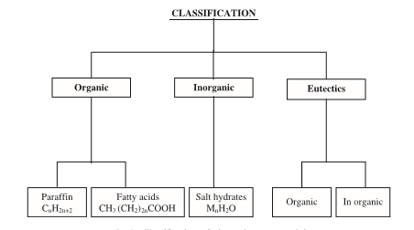
Figure 5.1: classification of phase change materials [15]
Because the two most important criteria, the melting temperature and the melting enthalpy, it is not surprising that materials within a material class behave similar. Figure 5.2 shows the typical range of melting enthalpy and melting temperature of common material classes used as PCM.
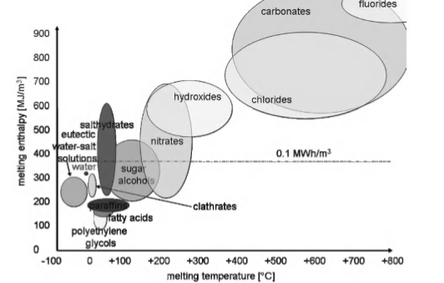
Figure 5.2: Classes of PCM and their typical range of melting temperature and enthalpy [11]
Inorganic PCM
Inorganic materials such as water, metal, salts and salt hydrates cover a wide range of melting temperature, so they can be used in different applications. Thanks to their density, usually larger than 1 g/cm3, they have larger melting enthalpies per volume than organic materials. Their main disadvantage is material compatibility with metals, since severe corrosion can be developed in some PCM-metal combinations. [11, 14]
Salt hydrates are salts with a large and defined amount of crystal water. They often have comparatively high storage density with respect to mass, but even more with respect to volume due to their high density. The high storage density of salt hydrate materials is difficult to maintain and usually decreases with cycling. This is because most hydrated salts melt congruently with the formation of the lower hydrated salt, making the process irreversible and leading to the continuous decline in their storage efficiency. [11]
Because the melting enthalpy rises roughly proportional to the melting temperature, salts with high melting temperatures often show a very high melting enthalpy. A salt always consists of two components, so theoretically phase separation is a potential problem. However, unless the rare case that two different salt compositions exist, phase separation is not possible. [11]

Organic PCM
Organic materials like paraffin, fatty acids, and sugar alcohol, the main advantages of these materials that they do not show any or little subcooling and stability, in addition that there are no segregation during its phase transition. The main draw backs are its low volumetric heat capacity and its low thermal conductivity in their solid state. High heat transfer rates are required during the freezing cycle. [11]
Paraffins show good storage density with respect to mass, and melt and solidify congruently with little or no subcooling. Their thermal conductivity is however comparatively low. It may refer to Alkanes (C_{n} H_{2n+2)}, and with the rising number of C atoms the melting temperature increases. Pure alkanes are rather expensive. Commercial paraffin is usually obtained from petroleum distillation and contains a number of different hydrocarbons. These mixtures show a melting range and a lower heat of fusion than the pure alkanes.
Fatty acid is characterized by the formula CH₃ (CH₂)_{2n}COOH. Saturated fatty acids melting enthalpy is similar to that of paraffins, and their melting temperature increases with the length of the molecule. Fatty acids are stable upon cycling; because they consist of only one component there cannot be phase separation. Like paraffins, fatty acids also show little or no subcooling and have a low thermal conductivity. [11]

Eutectic
A eutectic is a minimum melting composition of two or more components, each of which melts and freezes congruently. Eutectic nearly always melts and freezes without segregation since they freeze to an intimate mixture of crystals, leaving little opportunity for the components to separate. On melting both components liquefy simultaneously. [16] Table 5.2 below conclude all advantages and disadvantages for organics, inorganics, and eutectics phase change materials.

Applications of phase change materials
Different applications can be accomplished by using phase change materials. As mentioned before the most important selection criteria is phase change temperature. Phase change materials can be used in transport and storage container to maintain the food and beverage. Also it can be used in electronic equipment as it must be at constant temperature range to increase its life time. In addition it can be used in medical treatment in sport injuries. Moreover it can be applied in building envelops for the purpose of heating and cooling to involve human comfort. As well as it can be integrated in domestic water heating systems to store hot water for longer periods which may lead to increase in the energy savings.

Table 5.2: advantages and disadvantages of phase change materials. [15]
Advantages |  | Disadvantages
Organics | - Available in large temperature range  - Freeze without much super cooling  - Ability to melt congruently  - Self-nucleating properties  - Compatibility with conventional material of construction  - No segregation  - Chemically stable  - High heat of fusion  - Safe and non-reactive  - Recyclable | - Low thermal conductivity in their solid state. High heat transfer rates are required during the freezing cycle  - Volumetric latent heat storage capacity is low  - Flammable. This can be easily alleviated by a paper container  - Due to the cost consideration only technical grade paraffins may be used which are essentially paraffin mixture and are completely refined of oil.
Inorganic | - High volumetric latent heat storage capacity  - Low cast and easy availibility  - Sharp melting point  - High thermal conductivityhigh heat of fussion  - Non-falmmable | - Change of volume is very high  - Super cooling is major problem in solid-liquid transition  - Nucleation agents are needed only they often become imperative after repeated cycle
Eutectic | - Eutectics have sharp melting point similar to bure substances  - Volumetric storage density is slightly above organic compounds | - Only limited data is available on thermo physical properties as the use of these materials are very new to thermal storage applications

Chapter Six

Domestic Water Heating Systems

Properly designing the domestic hot water supply system for any building is extremely important to ensure a safe and adequate supply of hot water. Heating of water consumes nearly 20% of total energy consumption for an average family.as shown in Figure 6.1.
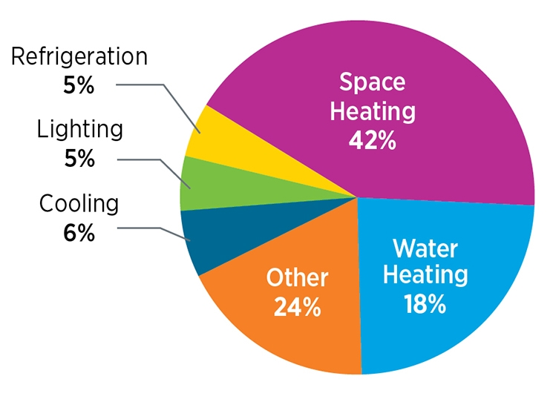
Figure 6.1: Energy consumption in domestic buildings

Domestic water heating (DWH) units are generally categorized using energy efficiency factor ratings. These relative efficiencies are then used as guidelines for current manufacturing water heaters.
Energy Efficiency and Load Factors
The energy factor (EF) was established by the U.S. Department of Energy to measure and rate the overall efficiency of a DWH unit. It is the ratio of the energy output which is, heat delivered as hot water by the water heater to the total amount of energy consumed by the water heater. More specifically, EF is the added energy content of the water drawn from the water heater divided by the energy required to heat and maintain the water at the water heater’s setpoint temperature.
$EF= \frac{M×C_{p}×(T_{tank }-T_{inlet})}{Q_{dm}}$ (6.1)
Where:
EF: energy factor,
M: mass of water drawn (kg),
C_{p}: specific heat of water (kWh/kg.°C),
T_{tank}: water heater thermostat setpoint temperature (°C),
T_{inlet}: inlet water temperature (°C),
Q_{dm}: water heater’s daily energy consumption (kWh).
The EF also takes into account standby losses that are estimated as the percentage of heat lost per hour from the stored water compared to the heat content of the water. While higher EF ratings are equated with higher efficiency, they do not include operating costs. Higher EF values may not always mean lower operating costs. However, in general, the lower the EF rating, the higher the operating costs. [17]

Domestic Water Heater Types, Relative Cost Efficiencies
Domestic water heater types include: conventional storage tanks, demand or instantaneous, heat pump, solar, and integrated or duel appliance storage systems, and demand or instantaneous systems.
Storage Tank: Water is kept constantly heated in the storage tank (Figure 6.2) by electricity, natural gas, oil, or propane. These domestic water heaters have a large storage capacity – 20 to 80 gallons and are able to supply high flow rates of hot water, although only for limited periods of time. Hot water is drawn out of the top of the tank when a tap is turned on and cold water flows in the bottom to replace it. As water heating is constantly maintained, regardless of an existing demand for hot water, these types of water heaters are subject to standby as well as distribution heat losses. [18]
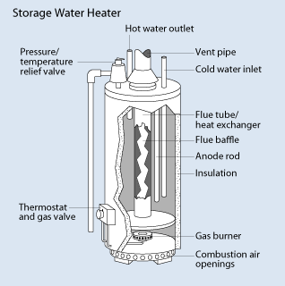
Figure 6.2: storage tank water heater
Demand or Instantaneous Water Heaters: Also known as tankless water heaters as shown in Figure 6.3. Water is heated by electricity or gas when the water flows through it without the need for a tank. Hot water is delivered on demand, thus allowing for a reduction in stand-by heat losses.
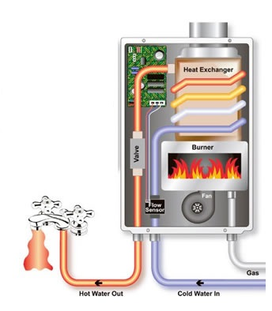
Figure 6.3: Instantaneous water heater

Heat Pump: Instead of creating heat directly, heat pump water heaters (Figure 6.4) transfer heat. This type of heater uses an electrically driven compressor to remove heat energy from a low-temperature heat source and move it to a higher-temperature heat sink where the water stored in the hot-water tank. Heat pumps can be used for water heating alone or in combination with the heating and air conditioning system. For any given energy amount, heat pump water heaters are capable of heating two to three times as much water as electric resistance heaters. [19]
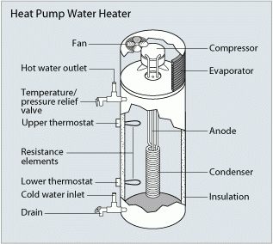
Figure 6.4: Heat pump water heater [19]
Solar: Solar water heater is very interesting way to generate hot water because it does not need any type of fuel or electricity, but it uses solar radiation (direct and diffuse) which is free and available. Solar water heating systems include storage tanks and solar collectors. And note that both the orientation and tilt of the collector will affect the solar water heating system's performance, so they should be optimized. (Figure 6.5)
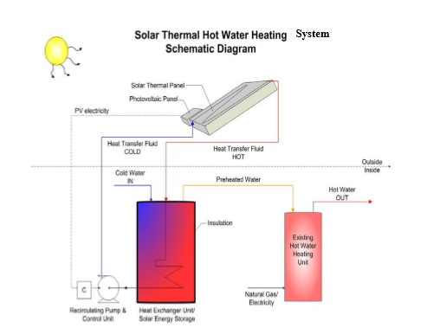
Figure 6.5: Solar water heater [20]

There are many classifications of solar water heaters such as standalone and supplementary systems the first one depends only on solar energy as a source, the second can use the electricity in addition to the solar energy, the main objective of such system is to reduce the electricity bill.
Another form of these classifications is active and passive systems. Active systems use electrically driven pumps to circulate water or another heat absorbing fluid, and sometimes use electrically operated valves for freeze protection. There are two types of active solar water heating systems:
Direct circulation systems heat up water as it flows directly in the collector, a pumps circulate household water through the collectors and into the tank. They work well in climates where it rarely freezes. These systems always require a check valve to prevent reverse thermosyphoning at night .A typical direct active system is shown in Figure 6.6
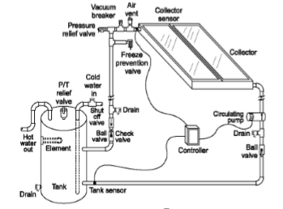
Figure 6.6: Direct active circulation heating systems [20]

Indirect circulation systems heat up water through a heat exchanger employed between the collector and the hot water storage tank. Pumps circulate a non-freezing, heat-transfer fluid through the collectors and a heat exchanger. This heats the water that then flows into the home. They are popular in climates prone to freezing temperatures. Figure 6.7 shows the indirect heating system.
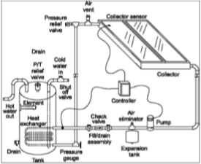
Figure 6.7: Indirect circulation heating system [20]
Passive systems have no electrical pumps. They rely upon convection to circulate hot water through the collector and storage tank. Hot water is either stored in the collector itself or transferred to a storage tank. There are two basic types of passive systems:
Integral collector-storage (batch water heaters) passive systems, water is heated directly by the sun and the storage tank serves as the solar collector. Batch water heaters are almost always passive systems in which hot water is delivered from the solar heated tank to a backup tank or the point of use by the water pressure in the house. see Figure 6.8
These work best in areas where temperatures rarely fall below freezing. They also work well in households with significant daytime and evening hot-water needs.
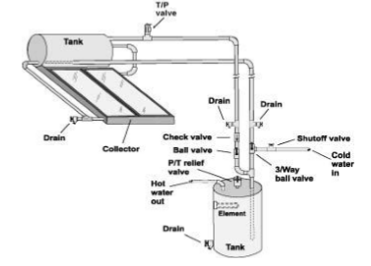
Figure 6.8: Integral collector-storage passive system [20]

Thermosyphon systems, water flows through the system when warm water rises as cooler water sinks. The collector must be installed below the storage tank (Figure 6.9) so that warm water will rise into the tank. These systems are reliable. They are usually more expensive than integral collector-storage passive systems.
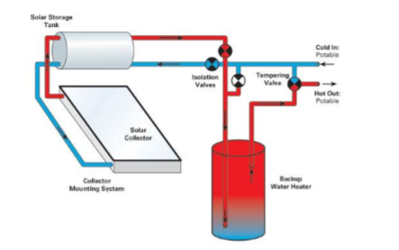
Figure 6.9: Thermosyphon system [20]
As mentioned before solar water heaters include solar collectors which are special kind of heat exchangers, which is a device that absorbs the incoming solar radiation, converts it into heat, and transfers this heat to a fluid (usually air, water, or oil) flowing through the collector. The solar energy thus collected is carried from the circulating fluid either directly to the hot water or space conditioning equipment or to a thermal energy storage tank from which can be drawn for use at night and/or cloudy days.
There are basically two types of solar collectors; non-concentrating or stationary collectors and concentrating collectors. A non-concentrating collector has the same area for intercepting and for absorbing solar radiation, whereas a sun-tracking concentrating solar collector usually has concave reflecting surfaces to intercept and focus the sun’s beam radiation to a smaller receiving area, thereby increasing the radiation flux.
In general, under steady-state conditions, the useful heat delivered by a solar collector is equal to the energy absorbed by the heat transfer fluid minus the direct or indirect heat losses from the surface to the surroundings. The useful energy collected from a collector can be obtained from the following formula:
$Q_{u}^{°}= A_{C}S-A_{C}U_{L}\left(T_{P}-T_{a}\right)= m^{°}C_{p} (T_{°}-T_{i})$ (6.2)
Where:
$Q_{u}^{°}$: is the rate of useful energy collected in$W$,
S: is the absorbed incident solar irradiance in$w/{m^{2}}$,
$A_{C}$: is the collector area in$m^{2}$,
$T_{P}$: is the average absorber plate temperature in $℃$,
$T_{a}:$Is the ambient temperature in$℃$,
$U_{L}$: is the Overall heat loss coefficient in$w/m^{2}.℃$ ,
$T_{°}$: is the desired outlet fluid temperature in$℃$,
$T_{i}$: is the fluid inlet temperature in$℃$,
And$C_{p}$: is the specific heat capacity of the fluid in ${kJ}/{kg}.℃$ .
There are various types of solar collectors currently available. These include flat-plate collectors (FPC), evacuated-tube collectors (ETC), and concentrating collector. [20]

Flat plate collector
Flat-plate collectors as shown in Figure 6.10 are commonly used in solar water-heating systems in homes and in solar space heating. They consist basically of an insulated metal box with a glazed glass cover and a dark-colored absorber plate. Heat from the sun strikes the absorber plate, a large portion of this energy is absorbed by the plate and then transferred to the transport medium in the fluid tubes to be carried away for storage or use. These collectors heat liquid or air at temperatures less than 80°C. [21]
FPC is usually permanently fixed in position and requires no tracking of the sun. The collectors should be oriented directly towards the equator, facing south in the northern hemisphere and north in the southern. [22]
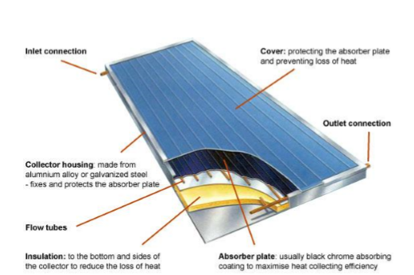
Figure 6.10: Flat-plate solar collector [20]

Conventional simple flat-plate solar collectors were developed for use in sunny and warm climates. Their benefits however are greatly reduced when conditions become unfavorable during cold, cloudy and windy days. [23]
Evacuated tube collectors
The Evacuated tube collector (Figure 6.11) consists of a number of rows of parallel transparent glass tubes connected to a header pipe and which are used in place of the blackened heat absorbing plate. These glass tubes are cylindrical in shape. Therefore, the angle of the solar radiation is always perpendicular to the heat absorbing tubes which enables these collectors to perform well even when solar radiation is low such as when it is early in the morning or late in the afternoon, or when shaded by clouds. Evacuated tube collectors are particularly useful in areas with cold, cloudy wintry weathers.
Unlike flat panel collectors, evacuated tube collectors do not heat the water directly within the tubes. Instead, air is removed or evacuated from the space between the two tubes, forming a vacuum (hence the name evacuated tubes). This vacuum acts as an insulator reducing any heat loss significantly to the surrounding atmosphere either through convection or radiation making the collector much more efficient than the internal insulating that flat plate collectors have to offer. [24]
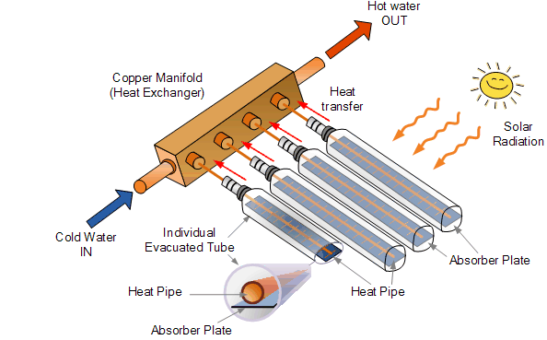
Figure 6.11: Evacuated tube collectors [24]

Concentrating collectors
Concentrating collectors (Figure 6.12) use mirrored surfaces to concentrate the sun's energy on an absorber called a receiver. Concentrating collectors also achieve high temperatures, but unlike evacuated-tube collectors, they can do so only when direct sunlight is available. The mirrored surface focuses sunlight collected over a large area onto a smaller absorber area to achieve high temperatures. Some designs concentrate solar energy onto a focal point, while others concentrate the sun's rays along a thin line called the focal line. The receiver is located at the focal point or along the focal line. A heat-transfer fluid flows through the receiver and absorbs heat. These collectors reach much higher temperatures than flat-plate collectors. However, concentrators can only focus direct solar radiation, with the result being that their performance is poor on cloudy days. [25]

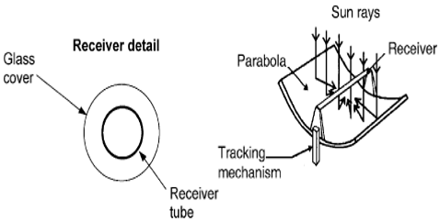
Figure 6.12: Concentrating solar collector [20]

The effective use of solar energy is obstructed by the intermittent nature of its availability, limiting its use and effectiveness in domestic and industrial applications especially in water heating. Storing heat is an attractive solution for this problem, an efficient storage system is needed to reserve the energy and maintain the temperature. Using PCM in a storage system with the proper design guarantees an effective storage system.

Chapter Seven

Configurations of PCM in Thermal Storage Systems

Solar thermal energy for domestic hot water heating is one of the most cost effective and efficient areas of alternative energy exploitation. The use of phase change materials PCM in latent heat energy storage systems (LHESS) can reduce the volume and weight of storage due to their high storage density, and overcome major obstacles in the further deployment of solar thermal energy. The latent heat storage systems offer high storage capacity as compared to sensible heat storage and also involve low heat losses. Figure 7.1 shows a simple schematic of a SDHW system with PCM energy storage. [26]
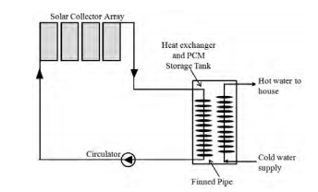
Figure 7.1: Schematic of a LHESS for SDHW. [26]

A storage system operates in three modes as follows:
Charging mode
The charging mode starts with circulation of the heat transfer fluid heated in the collection system at a temperature higher than the PCM melting temperature. This mode occurs during day time when solar energy collection takes place and terminates with complete melting of the PCM, charging of the store does not terminate with complete melting of the PCM if the inlet fluid temperature is above the melt temperature, charging of sensible heat continues.

Discharging mode
The discharging mode is started by circulation of the cold heat transfer fluid having inlet temperature lower than the PCM melting temperature. The heat transfer fluid exit temperature is time dependent because the rate of solidification of the PCM varies with time. This mode terminates with complete solidification of the PCM.
Standby mode
This mode occurs when there is no further storage of energy occurring because of decreasing heat transfer fluid temperature or the storage tank is completely charged or the energy is directly fed to the utility without using storage and/or no heating from the bed is required. This is the transition period between the charge and discharge modes. [27]

Energy storage using PCMs in combination with solar collectors has many designs and configurations, methods of heat transfer intensification that has been studied mathematically and experimentally and shown to be advantageous. The most common thermal energy storage systems with PCM are: [28]
- Novel built in storage system
Solar water heaters have gotten popular since they are relatively inexpensive and simple to fabricate and maintain. Utilizing PCM for a solar water heater concludes that the efficiency of the system and the outlet water temperature during the evening hours increases with the increase in the thermal conductivity of the solid-liquid phases of the materials. Hot water can be obtained throughout the day if water pipes are placed near the surface of the storage material. Figure 7.2 shows a novel built in storage type water heater containing a layer of PCM filled capsules at the bottom. [29]
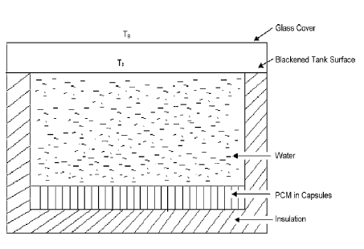
Figure 7.2: Solar water heater [29]
During the sunshine hours, the water gets heated up which in turn transfers heat to the PCM below it. The PCM collects energy in the form of latent heat and melts. During off sunshine hours, the hot water is withdrawn and is substituted by cold water, which gains energy from the PCM. The energy is released by the PCM on changing its phases from liquid to solid. This type of system may not be effective due to the poor heat transfer between PCM and water. [29]
- Encapsulation and packed bed thermal storage systems
In most cases, the PCM needs to be encapsulated. The two main reasons are to hold the liquid phase of the PCM, and to avoid contact of the PCM with the environment, which might harm the environment or change the composition of the PCM. Further on, the surface of the encapsulation acts as heat transfer surface. In some cases, the encapsulation also serves as a construction element, which means it adds mechanical stability. Encapsulations are usually classified by their size into macro- and microencapsulation. [28]
Macroencapsulation means filling the PCM in a macroscopic containment that fit amounts from several ml up to several liters. These are often containers and bags made of metal or plastic. Macroencapsulation is very common because such containers or bags are available in a large variety already from other applications.
Microencapsulation is the encapsulation of solid or liquid particles of 1 µm to 1000 µm diameter with a solid shell. Physical processes used in microencapsulation are spray drying, centrifugal and fluidized bed processes, or coating processes e.g. in rolling cylinders.
Encapsulation thermal storage systems (ETSS) and packed bed storage systems have the advantage of the higher storage density with the higher efficiency, analyzing this configuration requires investigating the following aspects: storage system designs and their configurations, the PCM materials used; heat transfer enhancement methods deployed, and the flow and heat transfer processes during both the charging and discharging processes.
Figure 7.2 presents the layout model with a storage container filled with spherical capsules filled with paraffin wax. These were in the flow of the heat transfer fluid.
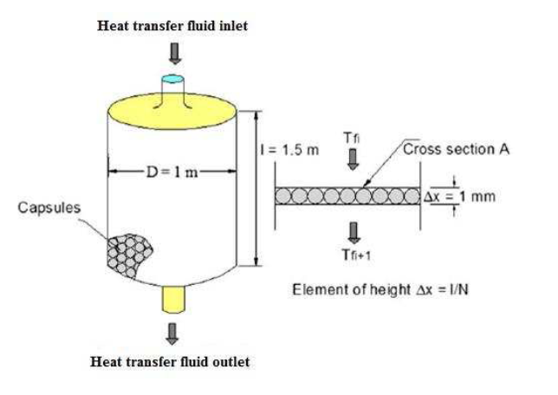
Figure 7.3: Layout of the storage system [27]

- Cylindrical PCM container storage systems
Cylindrical PCM containers have been classified in three types. In the first type the PCM fills the shell and the HTF flows through a single tube (Figure 7.3a), this is called a pipe model. The second type the PCM fills the tube and HTF flows parallel to the tube (Figure 6.3b); this is called the cylinder model. The third type is called a shell and tube model (Figure 6.3c). This contains several parallel tubes, and the HTF flows through the tubes while the PCM fills the space around them. Cylinders can be either horizontal or vertical depending on the application. [28]
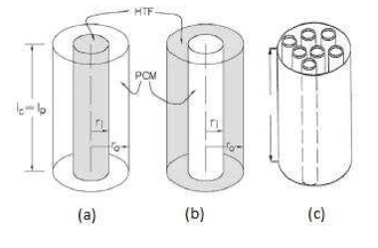
Figure 7.3: Cylindrical PCM containers [28]

Chapter Eight

Methodology

The first step in designing the model was obtaining the metrological data of Nablus city [30], the ambient temperature and the solar radiation on a horizontal surface. Since the solar collector is placed on a 45$°$ tilted surface the amount of solar radiation incident on a tilted surface can be obtained by [31]:
$I_{tilted}=\frac{I_{Horizental} \sin{(α+β)}}{\sin{α}}$ (8.1)
Where:
α: is the elevation angle,
β: is the tilt angle of the collector measured from the horizontal.
The elevation angle equals:
$α=90-φ+δ$ (8.2)

Where:
φ: is the latitude,
δ: is the declination angle which is given as:
$δ=23.45° \sin{[\frac{360}{365}\left(284+d\right)]}$ (8.3)

Where d: is the day of the year.

SWHS mathematical model
A detailed mathematical model [32] was developed to simulate and analyze the system. The model features include a number of simplifying assumptions that were adopted during the model development:
- The temperature of water in the collector is higher than the storage temperature by ten degrees.
- The storage tank is will mixed so that the storage temperature is the same at any location in the storage tank and hence there is no thermal stratification.
- The utility water temperature is higher by 5 degrees if the ambient temperature is less than 15$℃$(winter), and lower by 5 degrees if the ambient Temperature is more than 15$℃$(summer).
- The hot water load temperature use is 43ᵒC according to ASPE. [33]
- There is enough time for the heat transfer to occur so there is enough time for PCM to melt.
Model Equations
The water temperature of the storage tank (Ts) is one of the most important parameters of the SWH system. The variations of this temperature depends upon the dynamic energy balance of the storage tank. In a well-mixed tank, the water temperature can be calculated by Eq. (8.4)
$T_{s}(t)=T_{s}(t-1)+3600*\frac{∆Q_{s}(t)}{ρC_{P}V_{s}}$ (8.4)
Where:
t: represents the time horizon(1 h, 2 h,…, 8760 h),
$ρ$: is the density of water$({kg}/{m^{3})}$,
$C_{P}$: is the specific eat of water (${kg}/{kg}.°C$),
$V_{s}$: is the volume of the storage tank$(m^{3})$,
$∆Q_{s}$: is the energy change (kWh) of the storage tank over the considered time horizon, which is determined as follows:
$∆Q_{s}(t)=q_{solar}(t)-q_{load}(t)-q_{loss}(t)$ (8.5)

Where:
$q_{solar}\left(t\right)$: is the solar heat gain obtained by collectors at the time step t,
$q_{load}(t)$: is the heat load supplied from the tank at the time step t,
$q_{loss}(t)$: is the heat loss of the tank at the time step t.

The solar heat gain obtained by the collector array is calculated by using Eq. (8.6).
$q_{solar}\left(t\right)=A_{C}\left[I_{T}\left(t\right)F_{R}\left(τα\right)-F_{R}U_{L}\left\{T_{S}\left(t-1\right)+10-T_{a}\left(t-1\right)\right\}\right]*\frac{1}{1000}$ (8.6)
Where:
$A_{C}$: is the area of the collector$(m^{2})$,
$I_{T}$: is the total solar flux incident on tilted surface$(W/{m^{2})}$,
$F_{R}(τα)$ and ${F_{R}U}_{L}(W/{m^{2}.℃)}$: are the coefficients of the collectors,
$T_{a}$: is the ambient temperature$(℃)$.

When the storage tank is exposed to the ambient air, the hourly heat loss of the tank can be estimated using Eq. (8.7).
$q_{loss}(t)=U_{S}A_{S}*\left[T_{S}(t-1)-T_{a}(t-1)\right].*\frac{1}{1000}$ (8.7)
Where:
$U_{S}$: is the overall heat loss coefficient$(W/{m^{2}.℃)}$,
$A_{s}$: is the surface area of the storage tank${(m}^{2}).$
For a cylindrical tank, the surface area of the tank is related to the storage volume of the tank as shown in Eq. (8.8).
$A_{S}=1.845\left(2+\frac{h}{d}\right)V_{S}^{2/3}$ (8.8)
Where:
$h and d$: are the height and the diameter of a cylindrical tank$(m)$ respectively.
The heat load supplied from the tank $q_{load}$ can be determined by Eq. (8.9).
$Q_{load}=\left\{\begin{aligned}m_{w}C_{P_{w}}\left(43-T_{w}\right)*\frac{1}{3600} ; T_{S}>43 \\ m_{w}C_{P_{w}}\left(T_{s}-T_{w}\right)*\frac{1}{3600} ;T_{S}<43 \end{aligned}\right.$ (8.9)
Where:
$m_{w}$: is the mass of water$\left(kg\right)$,
$C_{P_{w}}$: is the specific heat of water (${kg}/{kg}.°C$),
$T_{w}:$is the utility water temperature$\left(℃\right)$.

The solar fraction of the system $F$ is calculated by using Eq. (8.10).
$F=\frac{q_{solar}}{q_{load}}=1-\frac{q_{aux}}{q_{load}}$ (8.10)

Where${ q}_{aux}$: is the auxiliary heater load$(kW)$.
The schematics of the SWHS is shown in Figure 8.1.

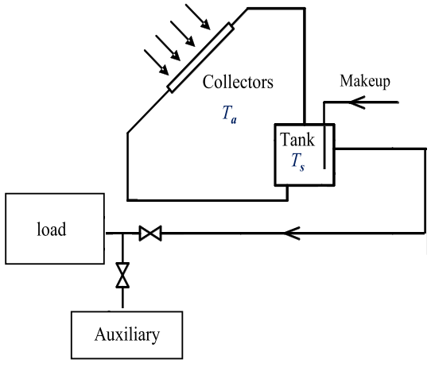
(a): Heat flow of the main components (b) configuration of the solar water heating system
Figure 8.1: Schematics of a solar water heating system [32]
SWHS with PCM
Adding PCM to the storage tank can be implementer as illustrated in Figure 8.2.
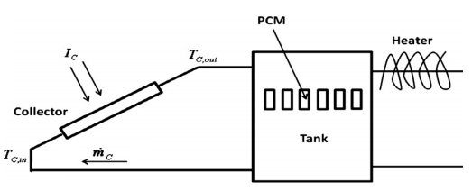
Figure 8.2: Layout of the SWHS with PCM [34]
The storage tank temperature using phase change material $T_{s}\left(t\right)$calculate by Eq. (8.11).
$T_{s}\left(t\right)=T_{s}\left(t-1\right)+[3600*\frac{∆Q_{s}\left(t\right)}{m_{w}C_{P_{w}}+m_{PCM}C_{P_{PCM}}}]$ (8.11)
Where:
$m_{PCM}$: is the mass of water$\left(kg\right)$,
$C_{P_{PCM}}$: is the specific heat of water (${kJ}/{kg}.°C$).

The amount of melted PCM in the tank can be determined by Eq. (8.12).
$m_{melted}=\left[m_{w}C_{P_{w}}+m_{PCM}C_{P_{PCM}}\right]\left(T_{s}\left(t-1\right)-43\right)*\frac{1}{λ}$ (8.12)
The amount of melted PCM in the tank is determined by the modified Eq. (8.13)
$m_{melted}=\left[m_{w}C_{P_{w}}+m_{PCM}C_{P_{PCM}}\right]\left(T_{s}\left(t\right)-43\right)*\frac{1}{λ}$(8.13)

Where$λ$: is the latent heat of fusion for the phase change material$({kJ}/{kg)}$.

Note that choosing the appropriate PCM depends on the criteria mentioned in chapter five.
Table 8.1 shows the different parameters of the system. The model “Rand Ral 4S” is the flat plate collector model; manufactured by “Rand Solar Energy Systems”. The evacuated model is “Thermomax CS-40”; manufactured by “Kingspan Solar”. The data was obtained from RETScreen software.

Table 8.1: Parameters of the model.
Hot water load | Domestic hot water load: 196 LPD (liters per day) at 43$℃$  Daily load profile is shown in Figure 8.2
Collector | 3$m^{2}$, Evacuated tube collector, $F_{R}$($τα$): 0.55 $F_{R}U_{L}$: 0.7 $W/{m^{2}.℃}$  3$m^{2}$, Flat plate collector, $F_{R}$($τα$): 0.72 $F_{R}U_{L}$: 4.79 $W/{m^{2}.℃}$
Storage tank | Storage tank .1 m³, Cylindrical with (h/d) = 2, Tank loss coefficient: 0.80 $W/{m^{2}.℃}$

Figure 8.2: Daily load profile of the domestic hot water system [30]

The volume ratio between PCM and water was an optimization parameter to find the maximum amount of melted PCM each month. The final ratio of PCM was determined based on the month with the maximum melted PCM during the year.

Chapter Nine

Results and Discussion

The SWHS models were implemented using hourly data over one year, many parameters were changed to see their effect on the system
Flat plate collector with an area of 3.42 $m^{2}$ (Two collectors) and a 180 Litter storage tank:
The system has an average solar fraction of 89%, a collector average efficiency of 36% and the maximum storage tank temperature is 98$℃.$ Figure 9.1 shows the hourly data of the system.

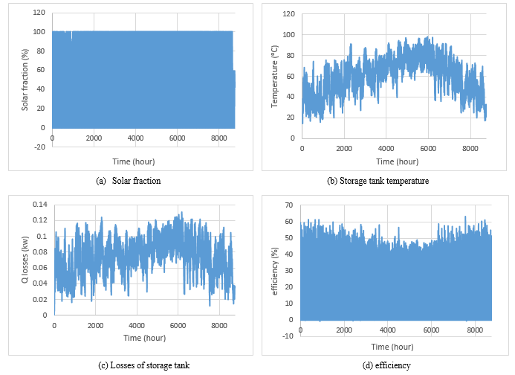
Figure 9.1: SWHS (Flat plate, 3.42$m^{2}$, 180 L) outcomes

Flat plate collector with an area of 1.71${ m}^{2}$ (One collector) and a 180 Litter storage tank:
The system average solar fraction decreased to 71% as well as the tank losses, yet the average efficiency of the collector increased by almost 10% due to the reduction in the collector loss area. The maximum storage tank temperature dropped to 65$℃$. Figure 9.2 shows the hourly data of the system.
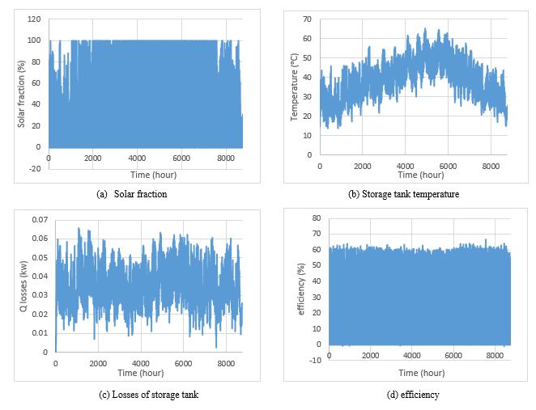
Figure 9.2: SWHS (Flat plate, 1.71$m^{2}$, 180 L) outcomes

Flat plate collector with an area of 3.42 $m^{2}$ (Two collectors) and an 80 Litter storage tank:
The system average solar fraction almost remained the same as the system with 180 L storage tank as well as the average efficiency of the collector. While the maximum storage tank temperature increased to about 124$℃$, the tank losses reduced a bit since the storage tank loss area decreased. Figure 9.3
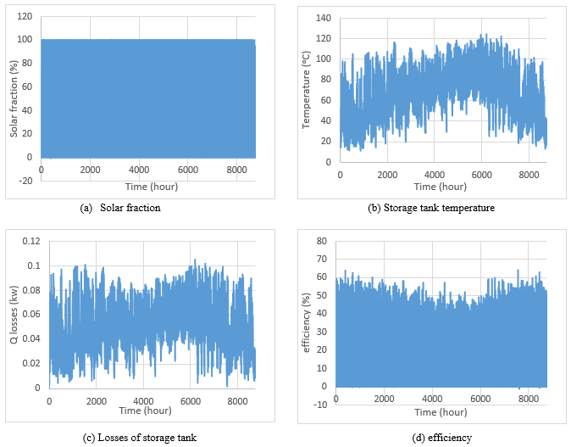
Figure 9.3: SWHS (Flat plate, 3.42$m^{2}$, 80 L) outcomes

Evacuated tube collector with an area of 3$m^{2}$ (One collectors) and a 180 Litter storage tank:
The system has an average solar fraction of 91%, a collector average efficiency of 43% and the maximum storage tank temperature is around 140$℃$, the tank losses are quite higher due to the high temperature. See Figure 9.4.
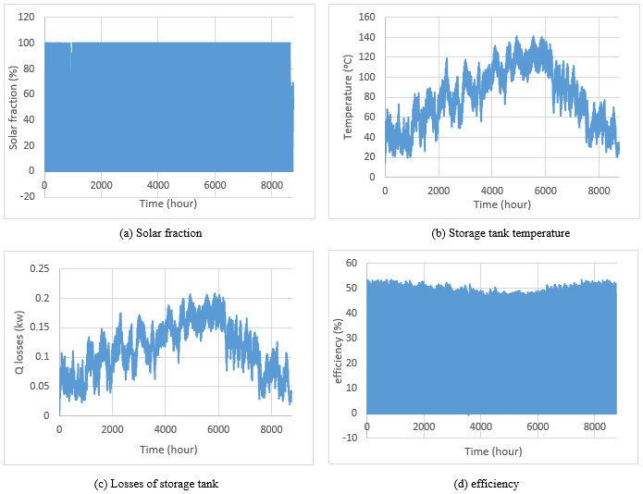
Figure 9.4: SWHS (evacuated tube, 3$m^{2}$, 180 L) outcomes

SWHS model with PCM
Adding the PCM to the system's model required minimizing the data (solar radiation & ambient temperature) from 8760 hour to 288 hour as an average hour monthly data due to programing necessities.
The selected PCM is RT42 Paraffin Figure 9.5, its properties are [35]:
- High thermal energy storage capacity.
- Heat storage and release take place at relatively constant temperatures.
- No supercooling effect, chemically inert.
- Long life product, with stable performance through the phase change cycles.
- Melting temperature range between -4 °C and 100 °C.

RT42 most important physical properties are mentioned in Table 9.1.

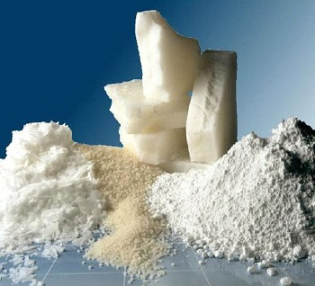
Figure 9.5: RT42 Paraffin [35]

Table 9.1: RT42 important data [35]
Melting temperature | $$43 °C$$
Heat storage capacity | $$165 {kJ}/{kg}$$
Specific heat capacity | $$2 {kJ}/{kg.°C}$$
Density | $$0.88 {kg}/L$$
Max operation temperature | $$72 °C$$

the behavior of the system was almost the same all over the year so a representative samples from the months were chosen to represent each season (i.e. January for Winter, April for Spring, July for Summer and October for Autumn). The main model of study is:
Evacuated tube collector with an area of 3${ m}^{2}$ (One collectors) and a 100 Litter storage tank:

Solar fraction
The solar fraction changes over the day. By adding the phase change material to the system it was found that the solar fraction almost doubled in the first hours of the day. In the afternoon period the solar fraction for both systems was the same where the systems were able to cover the load without the need for an auxiliary heater. As shown in Figure 9.6.
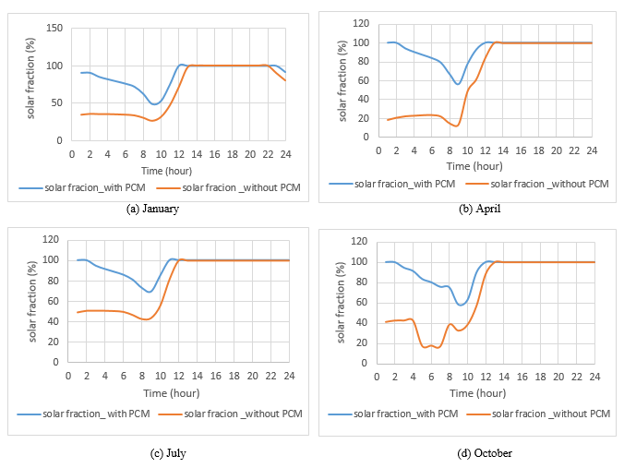
Figure 9.6: hourly solar fraction
The monthly average solar fraction is illustrated in Figure 9.7. The average monthly solar fraction for the system that uses PCM is higher than the system without PCM which means that the first is more efficient since the utilization of the auxiliary heater is lowered.

Figure 9.7: monthly average solar fraction
Storage tank temperature
For the no-PCM system, the temperature of the storage tank is quite low since there is no solar radiation, once there is solar radiation the temperature of the tank starts to increase until it reaches its maximum, then decreases as the solar radiation decrease and the hot water load increases. As for the system with PCM, the temperature of the storage tank is almost uniform during the day. The tank temperature does not exceed the melting temperature of the PCM which is 43℃. Figure 9.8.
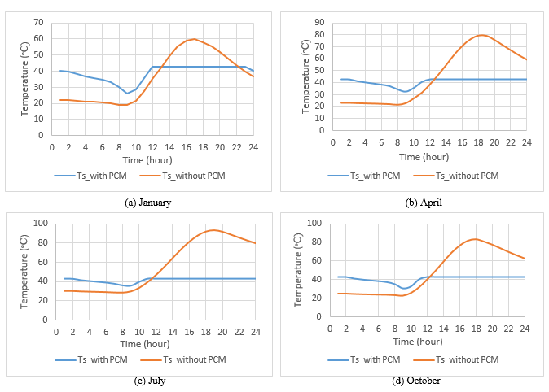
Figure 9.8: hourly storage tank temperature
The monthly maximum storage tank temperature for the two systems is illustrated in Figure9.9. The temperature is uniform and constant for the tank that incorporated PCM and its value equals 43℃ which is its melting temperature. While the storage temperature of the no-PCM tank varied over the months, (i.e. in the winter season the temperature of the storage tank was lower than the summer season).

Figure 9.9: monthly maximum storage tank temperature

Losses of the storage tank
The losses of the storage tank with respect to time were shown in Figure 9.10. At the early hours of the day the losses of the system with PCM is higher than the system without PCM because the tank losses are between the tank and the surrounding. As the storage tank temperature is higher the losses would be higher too. After noon the losses of the storage tank without PCM rises since the storage temperature of the tank also rises.
The losses of the no-PCM system is much higher than the losses of the system with PCM since the temperature of the storage tank in the second one is much lower and more uniform. See Figure 9.11.

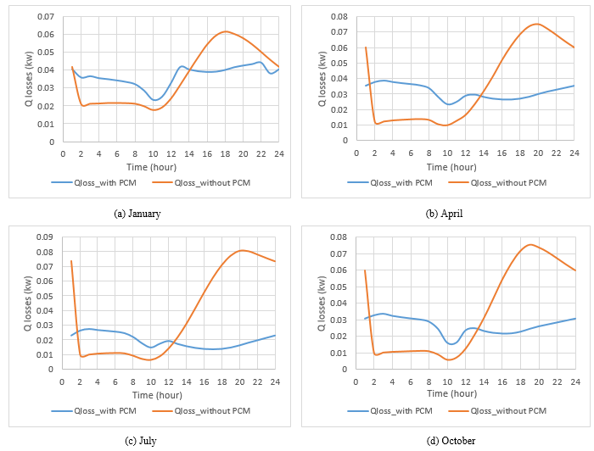Figure 9.10: Hourly losses of the storage tank

Figure 9.11: Monthly average losses of the storage tank

Collector efficiency
The collector efficiency for most of the months was nearly the same for both systems. The efficiency of the collector for the PCM system at the sun set period is a bet higher than the other system. Figure 9.12.
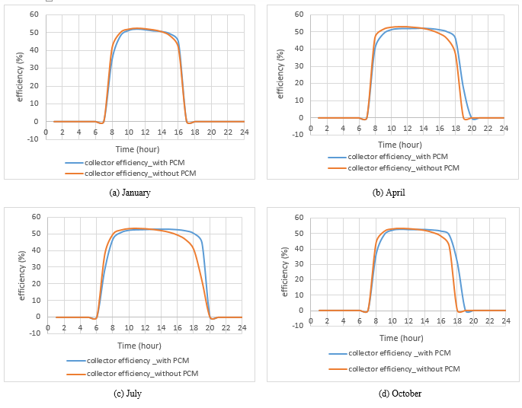
Figure 9.12: Hourly collector efficiency

As for the monthly average efficiency of the collector all over the year. The efficiency of the system with PCM increases in the summer months. Figure 9.13.

Figure 9.13: Monthly average collector efficiency
PCM melted
The PCM remains in its solid state as long as the tank’s temperature is below its melting point which is 43$°C$. Once it reaches 43$°C$ the PCM begins to melt until all of it turns into its liquid form as long as there is enough excess heat, then it continues to store heat as sensible heat storage which will not happen as the amount of the implemented PCM in the system is more than the maximum amount of PCM that will be melted.
When heat is being discharged from the tank as hot water load or losses; the PCM releases its latent stored heat through re-solidifying. By the time the tank’s temperature drops below the melting point all the PCM will be solid again.
The obtained results for most of the months showed an oscillating in the melted amount of PCM (see Figure 9.14). Which was unacceptable since the increase in the melted material happened at night when there was no solar radiation (heat source).
This led to a modification on the mathematical model, where the amount of melted PCM depends on the temperature at the current hour $T_{s}(t)$ instead on the previous one${ T}_{s}(t-1)$. Where the curves made sense in terms of melting and solidifying but it showed an increase in the maximum amount of melted PCM that’s larger than the existing kilograms of PCM which indicates a sensible heating. See Figure9.15.

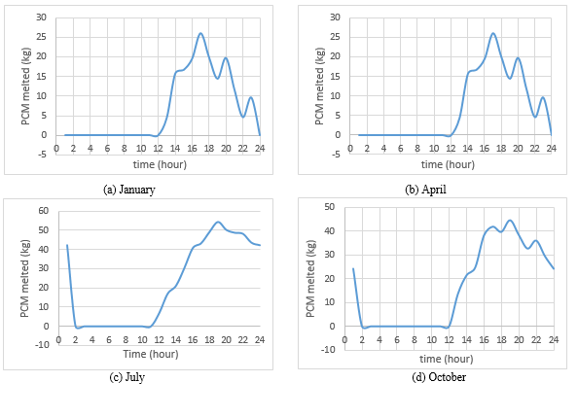
Figure 9.14: Hourly melted PCM

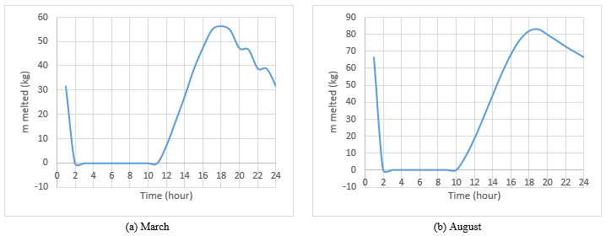
Figure 9.15: Hourly modified melted PCM

Two alterations were tested on the main model, the first is changing the storage tank volume and the second is switching to the flat plate collector.
Evacuated tube collector with an area of 3$m^{2}$ (One collectors) and a 180 Litter storage tank:
The study was implemented on April's data where the average solar fraction with the 180 L storage tank is 94% and with the 100 L storage tank it is 93%. Figure 9.16 shows that at 180 L storage tank at the early mornings has a solar fraction higher than that exists at 100 L storage tank but the rest of the day it is almost the same.
The temperature of the storage tank is nearly the same except in the hours of the early morning it was higher for the 180 L tank. Note that both tanks have the same type of PCM with the same volume ratio.
As for the losses of the two systems. The losses at 180 L storage tank was higher than the losses at 100 L storage tank since the loss area of the first tank is higher.
The efficiency of the collector was not affected by the variation of the storage tank volume.

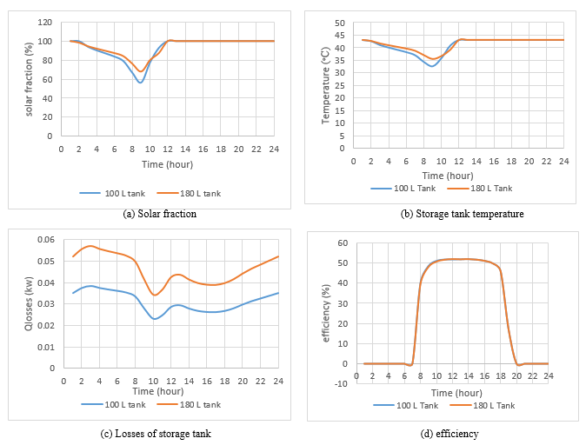
Figure 9.16: Hourly comparison between (100 L &180 L) storage tank on April
Flat plate collector with an area of 3 $m^{2}$ (One collectors) and a 100 Litter storage tank:
The study was conducted on April's data. The average solar fraction for the evacuated tube is about 92% and for the flat plate it's 90.3%. The temperature of the storage tank in the evacuated tube is higher than in the flat plate at the middle of the day but at the night and morning it is almost the same.
The losses of the storage tank for the two systems is quite the same as they have the same storage tank temperature at night and but at the morning but at midday it's higher for the evacuated tube as its collector temperature is higher. See figure 9.17.
The average efficiency of the evacuated tube collector is around 47% and for the flat plate its about 44% Figure 9.17(d) shows that the evacuated tube cover larger time range of the day.
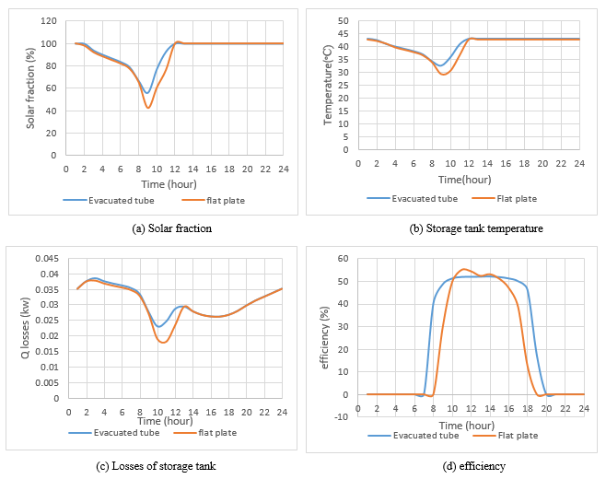
Figure 9.17: Hourly comparison between (Evacuated tube & Flat plate) collector on April

Chapter Ten

Conclusion and Recommendations

Different parameters (average solar fraction, storage tank temperature, losses of the storage tank and the collector efficiency) were studied while performing different models for the SWHS through changing the type or the area of the collector, the volume of the storage tank and adding PCM.
The findings of the model analysis are:
- The conducted mathematical model for DSWH resulted a realistic data were the efficiency of the flat plate collector was about 36% which is common.
- Reducing the area of the flat plate collector by half decreases the storage tank temperatures and the average solar fraction, while increasing the efficiency of the collector by 10%.
- Reducing the storage tank volume by 80 litters caused an increase in the tank's temperatures.
- Using an evacuated tube collector caused an increase in the collector's efficiency, storage tank temperatures and the average solar fraction.
- Adding PCM to the system of a 3 m² evacuated collector and 80 Litter storage tank resulted an increase in the average solar fraction by third. The storage tank temperature became more uniform and did not exceed the PCM melting temperature which is 43$℃$. Monthly average tank losses decreased and the monthly average efficiency increased for most on the months.
- The amount of added PCM to the system is 58.7 kg with a volume ratio (PCM/water) equals 2. The maximum amount of melted PCM occurred in August with a 58 kg melted material.
- The Model for the amount of melted PCM was modified to achieve a reasonable approach.
- Increasing the volume of the storage tank in the evacuated tube system has no significant effect on the system except increasing the heat losses of the tank.
- Replacing the evacuated tube by Flat plate showed a reduction in the efficiency, solar fraction, storage tank temperature and so the heat losses of the storage tank.
Our recommendations for any future work are:
- Study different configurations for the PCM in the system from heat transfer point of view and consider adding a pump to increase the heat transfer rate.
- Design and optimum Model where the PCM undergoes a sensible heat storage so that the temperature of the storage tank increases above the melting point in order to kill the living organisms.
- Study the system using different types of PCM with different melting points.
- Conduct an experimental work to justify the mathematical model.
- Perform an economic evaluation and a feasibility study for the optimized system.

References

[1] | "International Energy Outlook 2016," U.S. Energy Information Administration , Washington, 2016.
[2] | "Energy for the World - Why Uranium?," december 2012. [Online]. Available: http://www.world-nuclear.org/information-library/nuclear-fuel-cycle/introduction/energy-for-the-world-why-uranium.aspx. [Accessed 9 2016].
[3] | Mazmen, M.; Cabeza, L.; Melhing, H.; Nogues, M.; Evliya, H; Paskoy, H. O.;, "Utilization of Phase change Materials in Solar Domestic Hot Systems," Renewable Energy, vol. 34, pp. 1639-1643, 2008.
[4] | M. Fazilati and A. Alemrajabi, "Phase Change Materials for Enhancing Solar Water Heater,an experimental approach," Energy Conversion and Management, vol. 71, pp. 138-145, 2013.
[5] | M. Dzikevics, A. Ance and D. Blumberga, "Modeling of phase change in spheres for applications in solar theemal heat storage systems," vol. 95, pp. 112-118, 2016.
[6] | S. Schunemann, "Thermal energy storage – how it fits in with the other systems," Areous, 2013. [Online]. Available: http://www.areous.com.au/case-studies/thermal-energy-storage-how-it-fits-in-with-the-other-energy-storage-systems/. [Accessed 3 10 2016].
[7] | I. Dinc¸er and M. Rosen, THERMAL ENERGY STORAGE SYSTEMS AND APPLICATIONS, Second Edition ed., Ontario, Canada: WILEY, 2011.
[8] | "Energy Storage in Biological Systems," [Online]. Available: https://en.wikiversity.org/wiki/Energy_Storage_in_Biological_Systems. [Accessed octobar 2016].
[9] | E. E. S. p. team, "Electrical Energy Storage," IEC, 2010.
[10] | "Thermal Energy Storage," IEA-ETSAP and IRENA , 2013.
[11] | H. Mehling and L. Cabeza, Heatandcoldstorage withPCM, Berlin: Springer, 2008.
[12] | H. Garg, s. C. Mullick and A. K. Bhargava, Solar Thermal Energy Storage, Dordrecht, Holland : D. Reidel Publishing Company, 1985.
[13] | G. Kandalkar , S. J. Deshmukh and R. R. Kolhekar , "Latent Heat Storage for Cooling Application: A Review," 2016.
[14] | H. ¨. Paksoy, Thermal Energy Storage for Sustainable Energy Consumption Fundamentals, Case Studies and Design, Dordrecht, The Netherlands: Springer, 2005.
[15] | Pasupathy,A.; Velraj,R.; Seenraj,R.V., "Phase Change Material-based Building architecture for thermal managment in residential and commercial establishment," Renewable& Sustainable Energy Reviewa, vol. 12, pp. 39-64, 2008.
[16] | D. SHARMA and H. KITANO, "Phase Change Materials for Low Temperature Solar Thermal Applications," vol. 29, 2004.
[17] | C. Aguilar, D. .. White and D. L. Ryan , "Domestic Water Heating and Water Heater Energy Consumption in Canada," 2005.
[18] | "Storage Water Heaters," n.d. [Online]. Available: http://energy.gov/energysaver/storage-water-heaters. [Accessed November 2016].
[19] | "Heat Pump Water Heaters," n.d. [Online]. Available: http://energy.gov/energysaver/heat-pump-water-heaters. [Accessed November 2016].
[20] | O. K. AMOABENG , "ASSESSING THE FEASIBILITY OF A SOLAR WATER HEATING SYSTEM BASED ON PERFORMANCE AND ECONOMIC ANALYSIS," Kwame Nkrumah University of Science and , Kumasi, Ghana , 2012.
[21] | "Flat Plate Solar Collector," 11 November 2013. [Online]. Available: http://greenterrafirma.com/flat_plate_collector.html. [Accessed november 2016].
[22] | B. Sørensen, P. Breeze, G. J, Suppes, N. E. Bassam, D. S. Silveira, S.-T. Yang, A. V. d. Rosa, H. K. Gupta, S. Roy, M. Doble, M. Broussely, P. Maegaard, F. Barbir, G. Pistoia, S. Kalogirou and Trum, Renewable Energy Focus e-Mega Handbook, ELESVIER, 2009.
[23] | S. A. Kalogirou, Solar Energy Engineering: Processes and Systems, ELSEVIER, 2014.
[24] | "Evacuated Tube Collector," n.d. [Online]. Available: http://www.alternative-energy-tutorials.com/solar-hot-water/evacuated-tube-collector.html. [Accessed 11 November 2016].
[25] | "Solar Concentrating Collectors," n.d. [Online]. Available: http://www.iklimnet.com/save/solarconcentratingcollectors%20.html. [Accessed November 2016].
[26] | R. Murray, L. Desgrosseilliers, J. Stewart, N. Osbourne, G. Marin, A. Safatli, D. Groulx and M. A. White, "Design of a Latent Heat Energy Storage System Coupled with a Domestic Hot Water Solar Thermal System," 2011.
[27] | A. F. Regin, S. C. Solanki and J. S. Saini, "An analysis of a packed bed latent heat thermal energy storage system using PCM capsules: Numerical investigation," Renewable Energy, vol. 34, no. 7, p. 1765–1773, 2009.
[28] | Al-Maghalseh,Maher;, " Compact Solar Thermal Energy Storage Systems Using Phase Change Materials," the University of Northumbria at Newcastle, 2014.
[29] | A. Sharma and C. R. Chen, "Solar Water Heating System with Phase Change Materials," International Review of Chemical Engineering (I.RE.CH.E.), vol. 1, 2009.
[30] | M. Abu Arrah, Efficiency Improvment of Solar Water Heater by Using PV-Powered Pump, nablus , 2017.
[31] | "solar radiation on a tilted surface," PVeducation. org, 2017. [Online]. Available: http://pveducation.org/pvcdrom/properties-sunlight/solar-radiation-tilted-surface. [Accessed 2 2017].
[32] | C. Yan, s. Wang, Z. Ma and W. Shi, "A Simplified method for optimal design of solar water heating systems based on life- cycle energy analysis," Elsevier, vol. 24, pp. 271-278, 2015.
[33] | ASPE, Domestic Hot Water System, 2015.
[34] | T. Kousksou, P. Bruel, G. Cherreau, V. Leoussoff and T. El Rhafiki, "PCM storage for solar DHW: From an unfulfilled promise to a real benefit," Elsevier, vol. 85, pp. 2033-2040, 2011.
[35] | "1," Rubitherm, 2017. [Online]. Available: https://www.rubitherm.eu/en/index.php/productcategory/organische-pcm-rt. [Accessed 3 4 2017].

