Palestine

An-Najah National University

Faculty of Information Technology

Computerized Information Systems



دولــــــــــــــــــة فلســـــــــــــــــطين

جامعةالنـجـاح الـوطنـيـة

كليـة تكنولوجيا المعلومات

قسم نظم المعلومات المحوسبة

Gaz Station System

*Students:*

|  |  |
| --- | --- |
| Mohammad Abdullah Saleh Swedan | 10719385 |
| Ahmed Mammon Mohammad Swedan | 10719387 |

*Supervisor:*

Dr. Emad Saadeh

*A project report submitted in partial fulfillment of the requirements   
for B.Sc. degree in Computer Information Systems.*

*An-Najah National University*

*2012 / 2013*

**Table of Contents**

Table of Contents ii

List of Figures iv

List of Tables iv

Acknowledgement v

Abstract vi

Chapter One

Introduction 1

1.1 Introduction 1

1.2 Project Scope 1

1.3 Problem Specification 1

1.4 Goals and Objectives 2

1.5Motivation 2

1.6 System Requirement 2

1.7 Project Plan and Schedule 3

1.8Outline of the Project 3

Chapter Two

Literature and Methodology 4

2.1Introduction 4

2.2 Current Systems 4

2.3 Proposed System 4

2.4 Feasibility Study 5

2.5Methodology 5

Chapter Three

System Analysis And Design 6

3.1System Analysis 6

3.1.1 Requirement Collection 6

3.1.2 Requirement Studied 6

3.1.3 Requirement Structured 7

3.1.4 DFDs 7

3.2System Design 7

Chapter Four:

System Implementation 9

4.1 Programming Languages 9

4.1.1 Why Using Python 9

4.1.2 Why Using PHP And HTML 9

4.2Implementation 9

4.2.1 Introduction 9

4.2.2Sample of Forms 10

4.2.3 Sample of Reports 11

Chapter Five:

System Testing 12

5.1 Testing Plans 12

5.2 Types and Steps of Testing 12

Chapter Six:

The Conclusions 13

6.1Conclusion 13

6.2 Future Work 13

References 14

**List of Figures**

Figure 1: USE Case Diagram figure 1

Figure 2: Sequence Diagram figure 1

Figure 3: Table Employee figure 1

Figure 4: Table Customer figure 1

Figure 5: Add Customer figure 1

Figure 6: Buy Fuel figure 1

Figure 7: Customer Card figure 1

Figure 8: Customer Action Report figure 1

**List of Tables**

Table 1: Customer table 1

Table 2: Employee table 1

Table 3: User table 1

Table 4: Branch table 1

Table 5: Fuel table 1

Table 6: Fuel for branch table 1

Table 7: Order table 1

Table 8: Payment table 1

Table 9: Request Order table 1

Table 10: Notification table 1

Table 11: Customer transaction table 1

Table 12: Employee transaction table 1

Table 13: Fuel transaction table 1

Table 14: Note table 1

Table 15: Massages table 1

Table 15: Replies massages table 1

Acknowledgement

I would like to thank Mr. Emad Saadeh and Mr. Adnan Salman for the efforts that they provided for our team

*Student of Computer Information Systems*

Abstract

In this project we will create a company gas station regulates the work in terms of purchases and sales of fuel.

Since this company is based on several branches and each branch where several staff (manager and customer service seller) and there is also a director of this institution for the company overall.

The work of customer service to set up an account for a new customer and to add money to their account, or print a report for the company's operations

The seller will fill the fuel to customers based on the data entered from the customer .

As branch manager, he follows up on fuel and send orders to the main branch to provide them with fuel .

Seller also monitors the fuel and send notices to Mir same branch .

The manager can monitor the work of staff and directed them and reports can also bring out the reports of the same branch.

General Manager can modify evidence branches and fuel and their evidence or amend the staff and their positions and their descendants, and can follow-up reports for all staff and fuel in all branches and follow-up reports of customers and their operations .

Chapter 1

Introduction

1.1 Introduction

We doing in this project to develop the software that will make the work more easier and faster , and we work together with the employee information section Gas Station , and hope will the new software Satisfies the requirement of employee working in this directory .

1.2 Project Scope

We will take the process of gasoline filling fully with all their needs and represent programmatically so that we can provide the service easy for the customer and stored the correct information.

1.3 Problem Specification

In the manual system of the process there will be a waste of information and the difficulty in dealing and lack of regulation.

1.4 Goals and Objectives

Our goals of development of this project is to improve the design and Ntam to save the information and convenience of staff and workers in this institution and make it easier for the customer at the headwaters movements and dealings with this company.

1.5 Motivation

Our motivation to aim arrive our goal of project .

1.6 System Requirement

• Develop in easies Operation .

• Develop an privilege level in doing Operation .

• Develop an direct connection with Customer

• Develop an direct connection between employees.

• Develop an manual operation to doing in technical operation

1.7 Project Plan and Schedule

We divide project into steps that will arrive of our goal :

Analysis :

we collect information about the steps and the operation that doing and dealing with vehicle tax and how it will come more easier and faster than before.

Design :

we built the design and prototype of system with the user responsible for doing operation to achieve the satisfying level of operation.

Implementation:

we implement the software and developing it ,use the tool that will be help us in developing the project.

Maintenance :

we maintain system by developing the system after use to achieve the optimal mode of system with user satisfy with no operation error .

1.8 Outline of the Project

In next chapter we study the current system(situation of the system) and the weakness of that system and that uses and how will develop the system to achieve more level of satisfies in user side.

Chapter Two

Literature and Methodology

2.1 Introduction

We describe the weakness and powerful point of the current system and what the methodology and that will uses in developing the software and how will this methodology will satisfy our purpose .

2.2 Current System

The current system is based on manual transactions and movements recorded and written reports on the sheets, making it difficult to store and process information and keeping it leads to loss in most cases.

2.3 Proposed System

Focus on keeping the information correctly and to organize the company's operations this first. And also this system provide the company the need for some workers and provide expenses and make sure not to lose any information leading to losses in the company's Third ensures the customer the right to pursue its assets and help end this system in the stability of the customer deal with this institution because of the organization is based.

2.4 Feasibility Study

The operation feasibility is that the system will make the operation and function that will be doing from the employee more easier and more faster than before will increase the productivity of employee and will increase the productivity of the system .

2.5 Methodology (SDLC)

We use prototyping methodology used this method in order to make the employee is a key partner in the development of the project and in order to reach high employee satisfaction at the completion of the project and reduce the effort in the maintenance process.

And in this we make the connection in all steps of developing with the information system employee in the organization .

Chapter Three

System Analysis And Design

In this chapter we describe how we collect information from user of system and how will uses this in information to structure the system to develop it later .

3.1 System Analysis

In this step we identify the main function of system that will develop and the main and the main users of system and how will system serve the actors of it .

3.1.1 Requirement Collection

Requirement which mean what is the function of system and how will it serve the user of system and how it will connect to achieve the goal of system , which it make the system more easier and increase the usability and productivity of system .

In interview we make the interview with main actors of system which is Of the most important elements of the system represented employees and managers IT department , and make the interview individual on the work hour inside the directory and collect the notes about the work ,and discuss with employee the main problem of system and how will him see the most important point must develop and maintain in the current system .

3.1.2 Requirement Studied

In this section we study the requirements and how will connect it to achieve the goal and how will it more describe and design it in charts .

3.1.3 Requirement Structured

In this section we represent actors of project which is : manger and employee , admin of system and how every actor connect with main function of system .

3.2 System Design

1-Use Case Diagram :

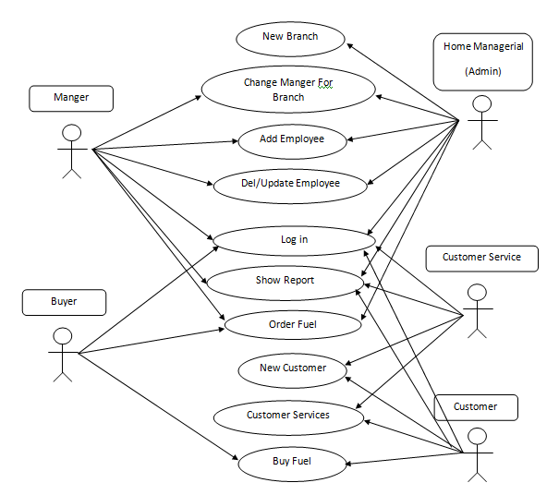

2- Sequence Diagram for report :



3- Table of System :

1-Employee Table

|  |  |  |  |  |  |  |
| --- | --- | --- | --- | --- | --- | --- |
| ID | ID Number | ADDRESS | EMAIL | PHONE | BRANCH ID | SALARY |
|  |  |  |  |  |  |  |

2-Customer Table

|  |  |  |  |  |  |  |
| --- | --- | --- | --- | --- | --- | --- |
| ID | ID Number | ADDRESS | EMAIL | PHONE | PAYMENT | POINT |
|  |  |  |  |  |  |  |

Chapter Four

System Implementation

In this chapter we describe how will we develop an system and the steps of developing methods that uses , tools that uses to write the code and design and run the system .

4.1 Programming Languages

1- Python , PHP With HTML And JavaScript , SQL Server .

4.1.1 Why Using Python :

It’s good and easy to design A desktop program for Employee Using .

4.1.2 Why Using HTML And PHP :

To make connection between Customer And this organization .

4.1.3 Why Using SQL Server :

It’s good service , High performance and availability to save all the data that the system needed .

4.2 Implementation

In this section we describe the steps of implementation of software and how to build it and the form uses .

4.2.1 Introduction

In this section we describe the steps of implementation of software and how to build it and the form uses .

4.2.2 Sample of Forms

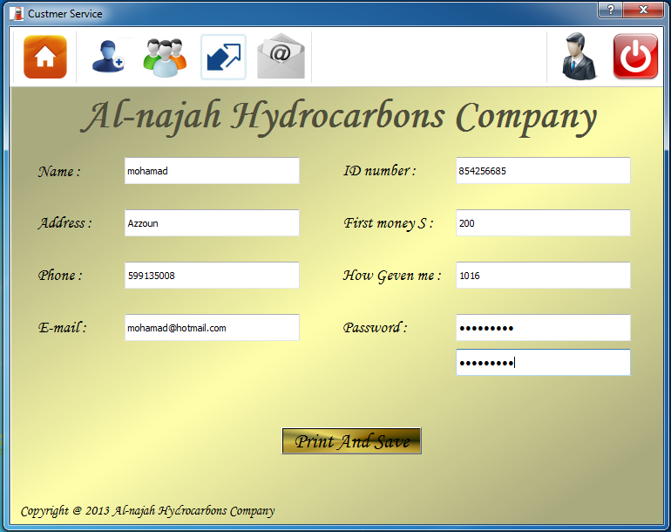

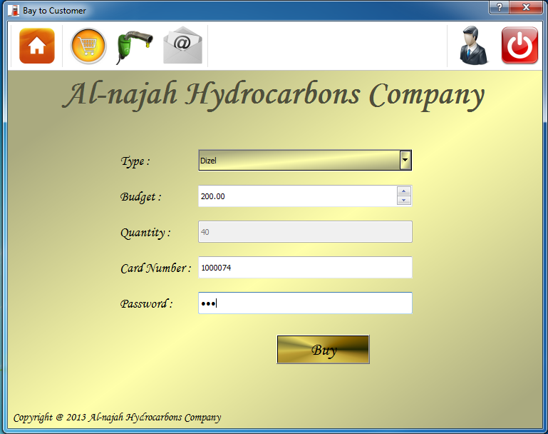

4.2.3 Sample of Reports

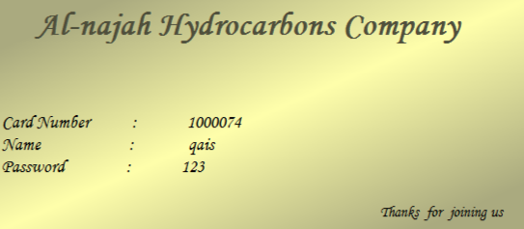

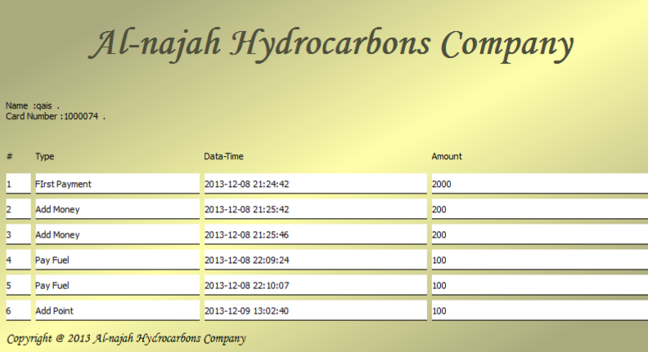

Chapter Five

System Testing

In this section we describe the steps of testing the system

5.1 Testing Plans

Testing process will this process to collect the largest possible number of experts in the use of the system and staff long-term with use and we will do the basic operations of the system and give each staff questionnaire to fill contain specific questions such tasks and evaluate the performance of tasks and observations they have about the use of the system .

5.2 Types and Steps of Testing

Unit testing :

in this section we test the basic operation on system that related to expert employee that will use this function each one will be doing independent from other and give the user questionnaire to fill it about the operation and what note and the citizen will be test the system .

Integration test :

after unit test will be done we test group of function parlay with other and retrieve the feedback about it.

System testing :

in this section we test all the function of system and all service provided by web site .

Chapter Six

The Conclusions

6.1 Conclusion

There are many challenges and constraints that we faced in the project, such as lack of compatibility with the staff in the company so that this system was not programmed new, tempting them earlier, which led to the amendment and change the prayer degrees of the project.

6.2Future Work

The system must include all the processes and makes all virtual operations and to protect customer and employee from the use of documents and papers .

References

1. Websites Ex : W3school.com //// www.python.org/