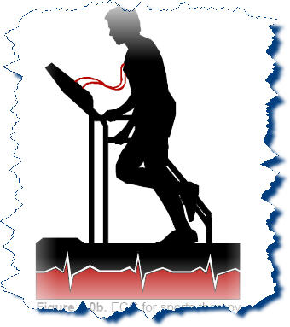

  - INTRODUCTION

In medical diagnostics it is required to monitor the electrocardiogram (ECG) of the patient. It is also necessary to record ECG signals during the critical periods, for example, when the patient is having symptoms of a heart attack, or is feeling uneasy. Each recorded signal is considered to be an event. These events may be easily monitored and stored by a cardiac event recorder.
A Cardiac Event Recorder is a device, which records ECG signals of a patient during the critical periods, for a specific time interval. The recorded events can then be observed or analyzed on a personal computer to determine the cause of uneasiness. The advantage of this system is that the patient can control the device and it maintains a history of his heart condition. This portable device accepts inputs from patient’s body through standard ECG electrodes and logs them on its onboard memory for 1-minute interval (30 seconds before and 30 seconds after the switch is pressed by the patient). A maximum of64/127 such events can be recorded. Each event can be displayed on a PC in Graphical format.
Instead of using a magnetic tape, as was the practice so far, this device employs semiconductor memory. It is powered by rechargeable batteries and can monitor the events for a period of 24 hours.

  - Physiological Structure of the Heart

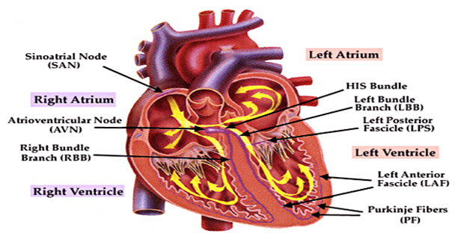
Figure 1 Distribution of specialized conductive tissues in the atria and the ventricles

The heart is basically a four chamber pumping system where the ventricles perform must of the pumping functions. The atria are only chambers used for storing blood, when the ventricles are performing their pumping functions. The phase where the ventricles are filled with blood is referred to as the “diastole stage”. The pumping of the blood out of the ventricles is referred to as the “systole” stage. It has been shown over the past century that rhythmic contraction of the atria and ventricles has an electrical characteristic. The rhythmic contraction of the atria and the ventricles is set up by a pattern of electrical activity in the muscular structure of the atria and ventricular walls.
The pace-making cells located at the sinoatrial (SA) node, located between the vena cava and the right atrium is where the rhythmic cardiac impulse is generated. It can be seen that there are

three routes or directions from the SA to the Atrio-Ventricular node, there are as follows: Anterior, Middle and Posterior internodal tracts. Bachman’s Bundle connects the SA node and the Left Atrium through the anterior tract. Therefore, it can be inferred that the right atrium is activated before the left atrium. The impulse is delayed at the AV node before it goes into the Bundle of His, Right Bundle Branch, the Common Left Bundle Branch, Anterior & Posterior divisions of the left Bundle Branch, the Purkinje network
Right Bundle Branch: This runs along the right side of the interventricular septum to the apex of the right ventricular before branching.
Left Common Bundle: This crosses the left side of the septum and splits into anterior division (does under the aortic valve into the outflow tract to the anterolateral papillary muscle) and the posterior division (goes to posterior papillary muscle lying in the inflow tract).
The specialized conduction system is relatively small is relation to the heat’s overall size. The wall of the left ventricle is approximately three times the size of the wall of the right ventricle. The septum is also as thick as the left ventricular wall. The majority of the muscle mass of the ventricular wall consists of the free walls of the left and right ventricles and the septum. If we consider the heart being an electrical source, the signal strength is proportional to the mass of active muscle (also referred to active myocardial cells). Therefore it can be seen that the free wall of both the atria and ventricles and the septum are major contributors to this electrical source.

  - Cardiac Cycle

Cardiac cycle begins at the Sino-Atria node, located in the right atrium at the superior cava. The beginning of the cycle corresponds to the contraction of the atria. Following this is a 100ms delay until the activation of the Atria-ventricular node. This delay is important because it allows time for the ventricles to fill, increasing the efficiency of the heart. This signal is then propagated down the ventricular spectrum resulting in ventricular contraction. The signal generated over one period of the cardiac cycle is depicted in the following figure. (P-Wave: Atria Depolarization, QRS-Complex: Ventricular Depolarization, T-Wave: Ventricular Re-Polarization).
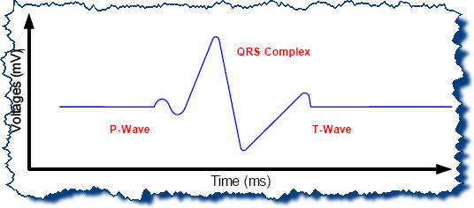
Figure 2 One period of the cardiac cycle
Note that the signal generated from the cardiac is extremely small ( about 2mV’s in amplitude), and at a very low frequency, having a bandwidth of about 150Hz.
The heart can be considered as an electric dipole, repetitively changing both in magnitude and direction as it goes through the cardiac cycle. The magnitude of the dipole will be at a maximum during ventricular contraction. This is important note, as it quite likely that the smaller P and T waves will be lost in the effects of noise. Therefore the theory behind detecting the cardiac signal is to place electrodes on the surface of the body, and simply measure the different differences in potential that arise as the dipole moves through its cycle.
The measured differences in potential are referred to as ‘leads’. Note that it is always a difference in potential between at least two electrodes that is being measured, as there is no absolute zero reference voltage in the body, only a dipole changing in both space and time. According to cardiac theory, in order to detect the strongest difference in potential ( the peak signal); the optimum electrode placement is to have one on the right shoulder, and one on the left hip. This is what is usually referred to as “lead II” a convention that arises from the work of William Einthoven, a pioneer in ECG development, who observed the differences in signal strength as he took measurements between two electrodes with placement on the left shoulder, the right shoulder and the left hip (Einthoven’s Triangle).

  - Electrodes
The role of the electrodes is to act as bio-electric transducers at the interface between the body and the ECG. Inside the body, electricity exists in the form of ions. Thus, the purpose of the electrodes is to convert electricity from its ionic form in the body into electric current in the wires.

ECG Amplifier

There are many factors that should be taken into consideration in the design of an ECG amplifier, such as the frequency distortion, saturation distortion, interference from electric devices and other sources. The most important kind of noise in an ECG amplifier is the 50 Hz noises, since using a band-pass filter can easily reject both the DC and high frequency noise. A major source of noise when one is recording or monitoring the ECG is the electric power system. Electromagnetic interference from nearby high power radio or television can also be picked up by a close loop of lead wires.
So, at first it appears that an operational amplifier could be used, but two vexing subtitles make most op-amps unsuitable. First, when two electrodes are placed at widely separated locations on the skin, the epidermis acts like a crude battery, generating a continuously shifting potential difference that can exceed 2V. the cardiac signal is small in comparison. Second, the body and the wires in the device make good radio antennas, which readily pick up the 50Hz hum that emanates from every power cable connected to the mains supply. This adds a sinusoidal voltage that further swamps the tiny pulse from heart and because these oscillations lie so close to the frequency range needed to rack the heart’s action, this unwanted signal is difficult to filter out.
Following figure shows a simple ECG amplifier using AD624AD instrumentation amplifier. A gain of 1000 is selected by shorting certain pins together as shown, the two-stage RC filter weeds out frequencies higher than 250Hz and less than 10Hz, which can be removed by a band pass filter, we use also notch filter to remove 50Hz noise signal. The signal is show below.
The values of the resistors are as follows:

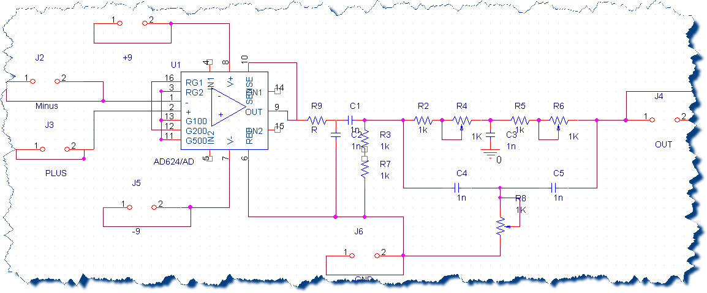
Figure 3 Amplifer circuit
The is the Amplifier printed circuit, we used the Orcad for outing this printed circuit so as to remove the noise as possible as we can.

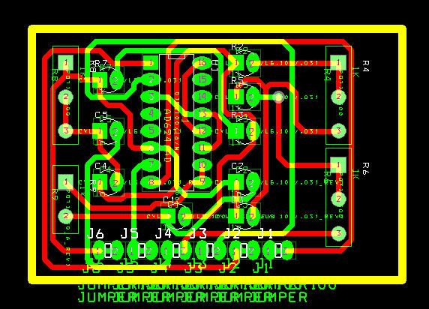
Figure 4 Amplifier Printed Circuit

Hardware Development
The purpose of this project is to design, built and test a low cost digital real-time ECG Monitor. The main reasoning behind hardware development was to keep the hardware cost to an absolute minimum.
We used PIC18F6420 which has a large RAM , and runs at 20MHz.

Digital Circuit Component

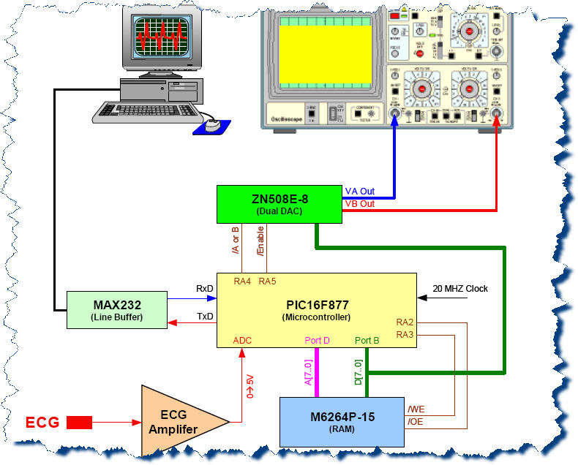
Figure 5 Hardware Component Circuit

software Development
The philosophy used during the development of the PIC code was to keep it simple, straightforward, comprehensible, and to minimum.
The high-level programming C was chosen, there are many advantages for using C including: ease of programming, ease of modification, reusability of code, use of standard functions ( e.g. printf, getc, putc, etc … ), etc…
The program is designed to display ECG signal on a G-LCD ( Graphical LCD ), the scenario used to draw the signal, is by storing the ADC reading - on the PIC – in a large array from left to right, the G-LCD is refreshed by continuously scanning through the array[]. Because ADC readings scroll through the array[] from right to left, this gives the appearance that the ECG signal is scrolling across the G-LCD.

