66582- Graduation Project 2
Computer Engineering Department
An-Najah National University

MiWi Controller
2010/2011

DARWESH ALSHAKAA
MOHAMMAD ALKHARRAZ
Abstract:
MiWi Controller is a game controller that is fully USB compatible. No need for extra software on your PC to use the project. Also it’s a play n plug device no need for a drivers.

Problem:
In order to build such a system we need to include in our design an effective way to start our game controller smoothly and fast enough. Also we need a microcontroller that can communicate using USB and serial ports so that we can receive the data serially(rs232) and send it to the PC using USB.
Motivation:
The motivation for making USB game controller includes the following:
- Most old methods to do the same project involve some software to be intermediary between the controller and the OS which more complexity but this project is done to achieve simplicity.
- The tools required for the project were all available at affordable prices.
- The methodology has never been implemented before in the same way and in the same price.
- There were several successful projects concerning this project.

Methodology:
The steps carried out for implementing the project are:
- Tools Search and Implementation
- Assembling Parts
- Accelerometer calibration and equation.
- Wireless component setup and starting.
- Hid Configuration.

Tools Search and Implementation:
The tools required for building game controller are:
1-PIC18F4550 ‘has a USB Port’.
2-Two PIC18LF4620.
Because the Code memory isn't enough in the USB PIC 4550 to start the MiWi stack.
3-Adxl335 ±3g accelerometer.
4-MIWI mrf24j40.
5-And a PC.

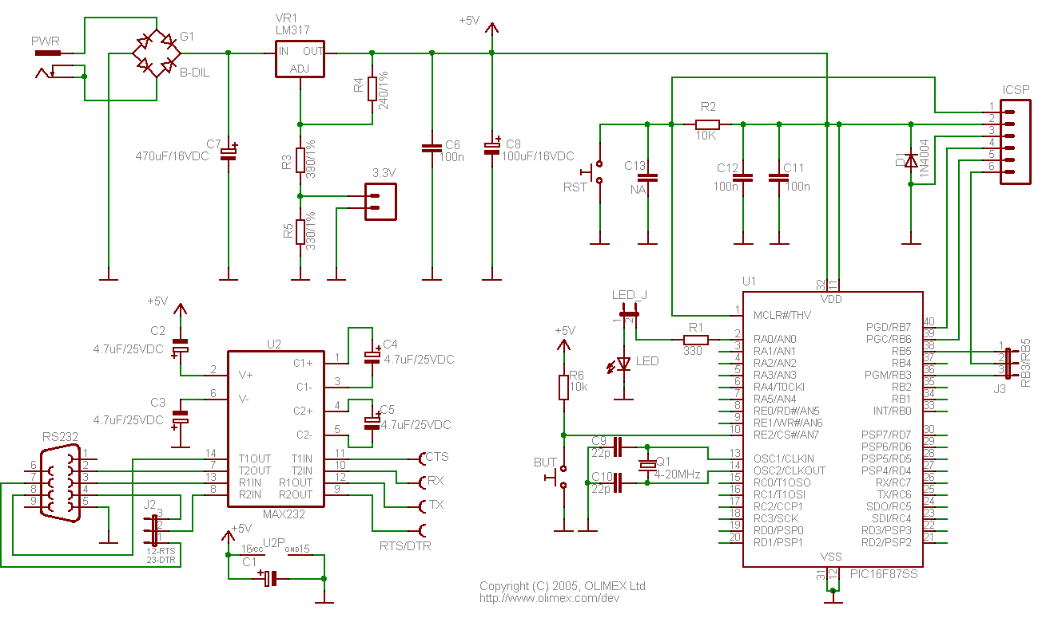

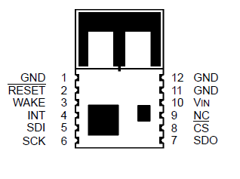
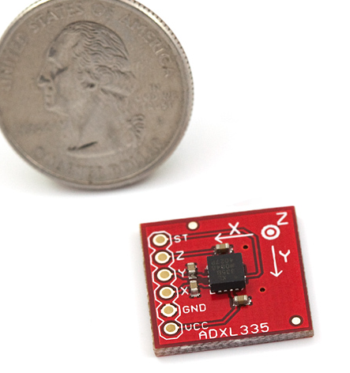
Assembling Parts:
We first start assembling the PICs CCT and connect its necessary component to start the PICs Boot-loader. After that we connected the wireless MRF. Finally we connect the accelerometer.
Accelerometer calibration and equation:
The accelerometer is the most difficult part of the project, since the range of acceleration the adxl335 give is so noisy and inconsistent so by trial and calculation we tried to find the best range and after that we compiled an equation to output the right and suitable result.
<note: that the equation is included in the code…>
MIWI mrf24j40 :

We connected the SPI of the mrf to the SPI of the PIC and we burned the MiWi stack to the PIC and start to send the data.
The MRF have different modes the we used is the star topology which allow us to connect as many as we need of the remote part of the project. 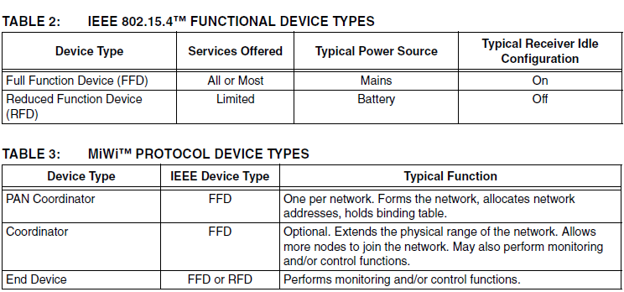
Hid Configuration:
- HID Report Descriptor.
- Adding the Descriptor to your Code.
- Sending Data to the PC.
- The Hardware.

HID Report Descriptor is a software created by the USB.org and used to:-

Device Class Definition HID
The Device Class Definition for HID is intended to supplement the USB Specification and provide HID manufacturers with the information necessary to build USB-compatible devices. It also specifies how the HID class driver should extract data from USB devices. The primary and underlying goals of the HID class definition are to:
- Be as compact as possible to save device data space.
- Allow the software application to skip unknown information.
- Be extensible and robust
- Support nesting and collections.
- Be self-describing to allow generic software applications
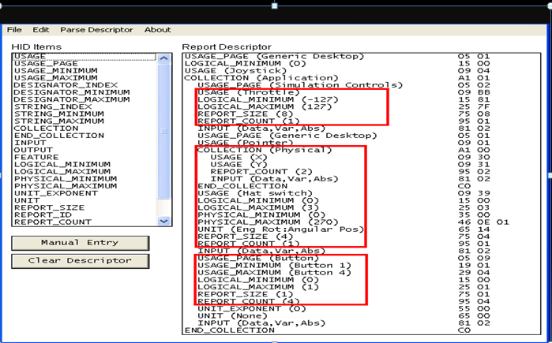
Just import the hid header file to your “MpLab” project.
Make sure that the data in the array sent by the ‘hidtxpacket’ is in the same order as the report.
Results and Discussion:
We designed a game controller that is fully USB compatible without extra software on your PC that is a play n plug device no need for a drivers.
Solutions and Suggestions:
Problem 1: MiWi keeps stalling
Solution is to have good batteries.
Problem 2: MiWi stop sending and needs reset.
Solution is to terminate floating Pins properly.
Problem 3: Accelerometer calibration.
Conclusion:
Simple hardware can be used to design game controller with accelerometer that is play n plug.

Recommendations:
To make the project more effective we can:
- Make the project on PCB.
- Use more sensitive accelerometer.
- Add more buttons and have better packaging.

