AN-NAJAH NATIONAL UNIVERSITY

FACULTY OF ENGINEERING

COMPUTER ENGINEERING DEPARTMENT

Project Name :E-commerce

Student Name:
Mohammed amer (10302401)

Dr :Raid Alqadi

Introduction :
E-commerce what does it mean???
Now a days the internet has entered all our domains of life and one of these is our shopping and buying products now you and through the internet make shopping and you can search for your product from your home without going to the market .all you need is to enter the site and pick the product that you want you bay using your credit or visa card and give your information and the product will be sent to you .
The project is simplified E-commerce website that offers products such as mobiles and mobile accessories for many companies like Nokia and Motorola.
The customer pick the product(s) that he want And bay from his credit and after that the customer should fill the shipment form to send him the products that he bought .

The following pages describe the different sides of the project

First the index or the home page the following image shows the home page of the site
The home page shows the new products that has been added to the site.

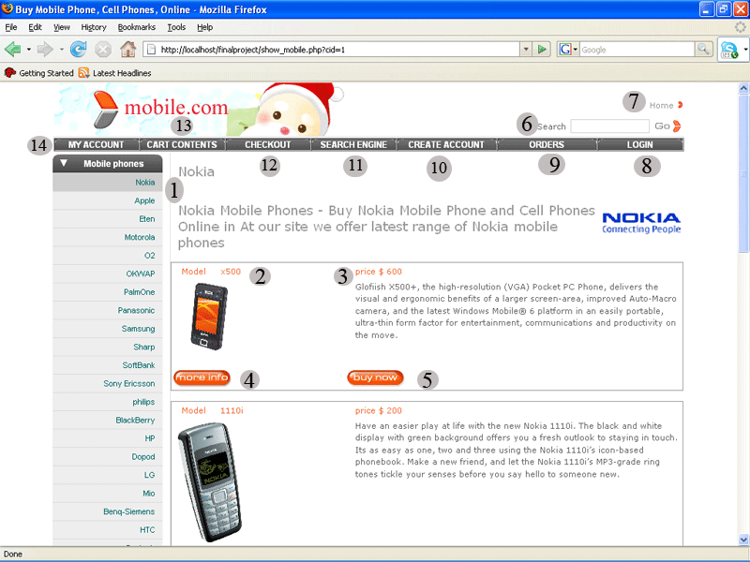

In the image above which describe the home the circles with the number descries as the following :
(1) this point to the menu from which contain he names of different companies that we offer their products its for mobile companies such as Nokia Motorola and so on clicking any menu will display a list of all the products that belong to for example the tow mobiles described above
(2) its represent the mobile model or name.
(3) the mobile price and brief description about it
(4)and (5) it take the customer to information page that provide the features of the mobile and form there the customer can buy the product after he get enough information about it
(6) the user can search for a specific the key word the user type in the box is taken as it belong to the brief description of the mobile or accessories
(7) its alink to the home page .
(8) link to login page from which the user can login to his account .and so buy products because the user must be registered to have the ability to buy products .
(9) the orders page that display the orders that the user have order form the company and that is not shipped for him yet.
(10) link to create account page in which the user can create his own account .
(11) the search engine that help the user t search for a product according to its family mobile or accessory according to its model , description or features.
(12) the checkout page from which the user confirm that he want the products in his cart and bay form there . after filling the shipment information.
(13) the cart content can be displayed from here the customer can edit his cart from here .
(14) to view the account information and edit them.

The login page

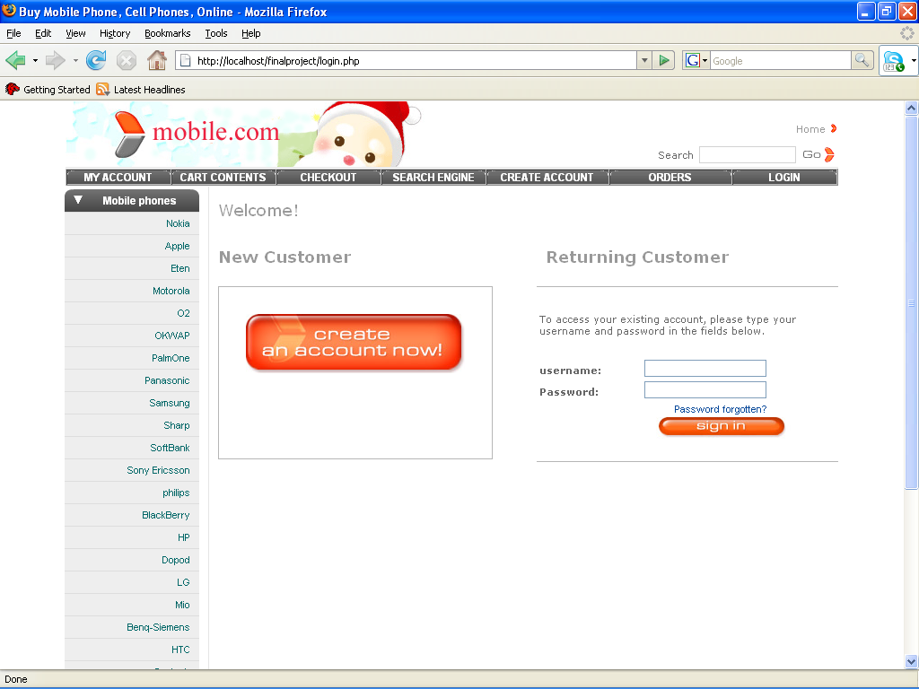

as shown in the image above the login page is divided into tow parts one for the registered users to login and the other part is to register or create new account.

Typing the correct user name and password will take the user to the account page from which he can edit his information and change his password if he want
Other wise an error message will appear to indicate that there is an error in username or password as the following image :

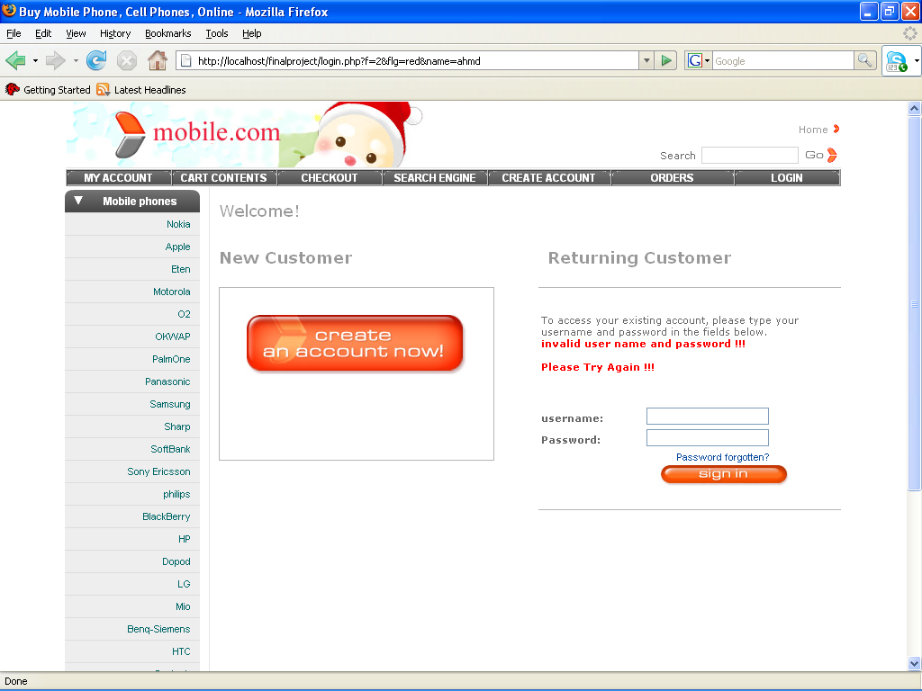

In the other part of the page under the title (New Customer) the button there take the user to the registration page to get registered .as following:

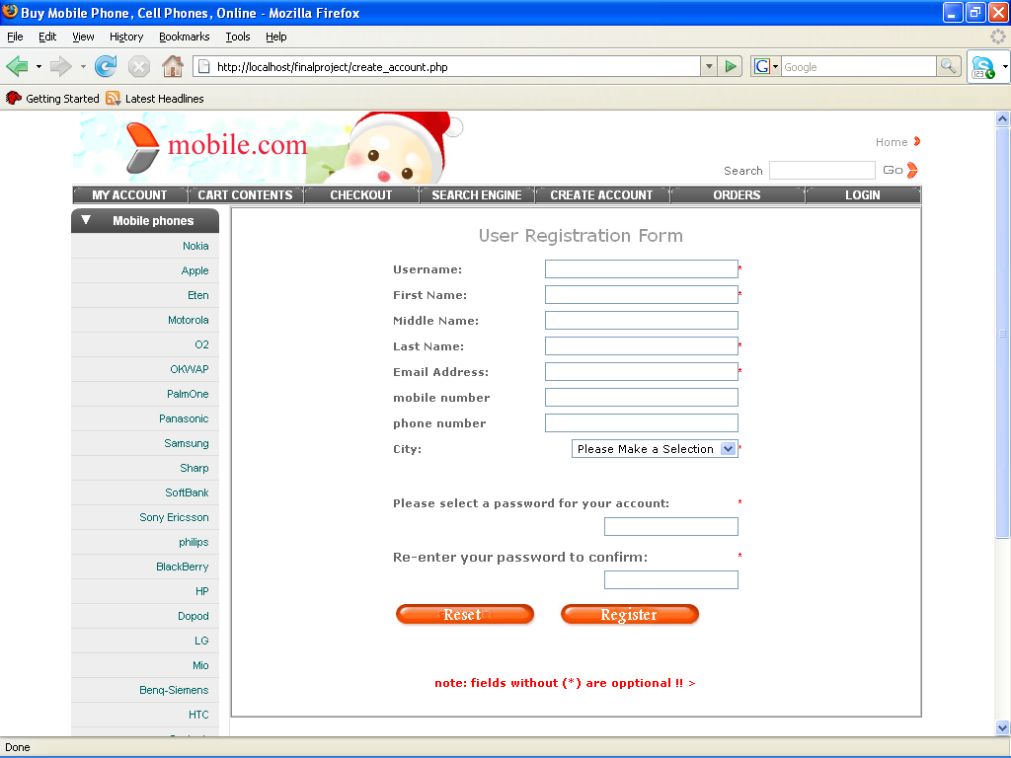

The image show the registration form after the customer fill the form he click register to get registered or reset the information to fill another information's

After that the site will redirect the user to its profile or account page or redirect him again to the form with a red message indicate that the username in taken by another user .as the following image show.

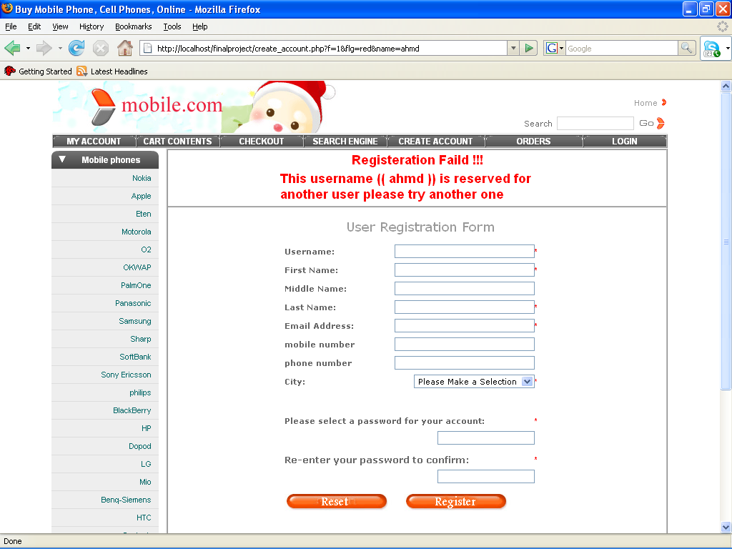

The account information page:

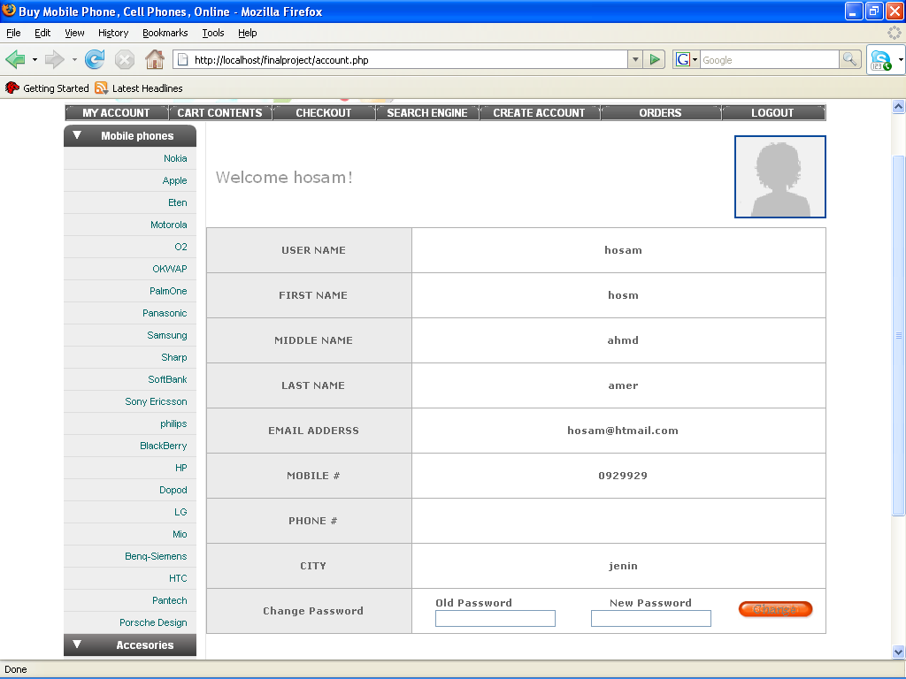

the page displays the user information
the default image is a link that enables the user to change it and store his image instead and in the end of the page there is a form for changing the password .

the search engine:
enable the user to search for products according to model , description ,company or features

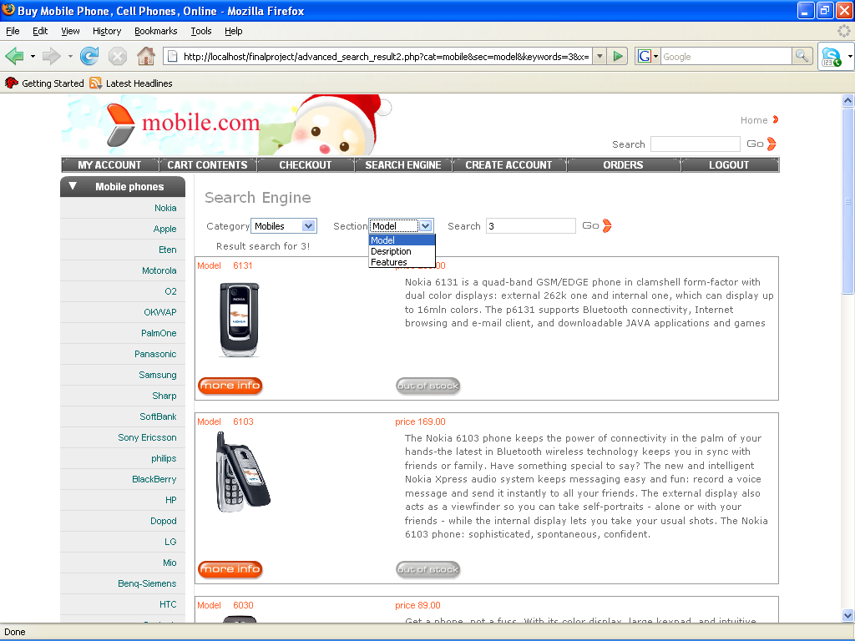

the above picture shows the search page after perform a search for 3 as keyword in mobiles as a model

the product information and buy page:

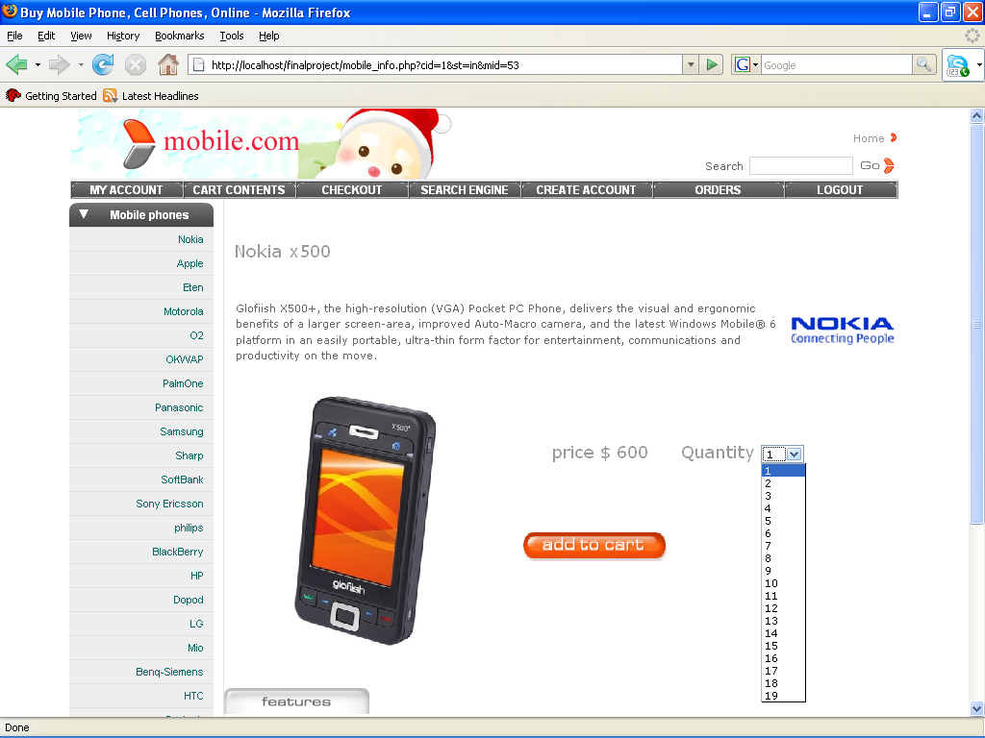

the page shows the product information and the quantities form this product the button add to cart will add the product to the customer cart and the customer should be logged in to get the ability of buying from the site
so clicking the button will add the product to the cart .

Cart content:
the following image displays the cart content of the customer :
the numbers in circles:
1:represent the quantity of the product in the cart which can be increased or decreased for there
(2) link to delete the product from the cart .
(3) delete all the product in the cart.
(4) update total after the user change the quantities of the products in his cart the total price will be changed so to update it the user must click it
(5)go back to catalogue to buy other products

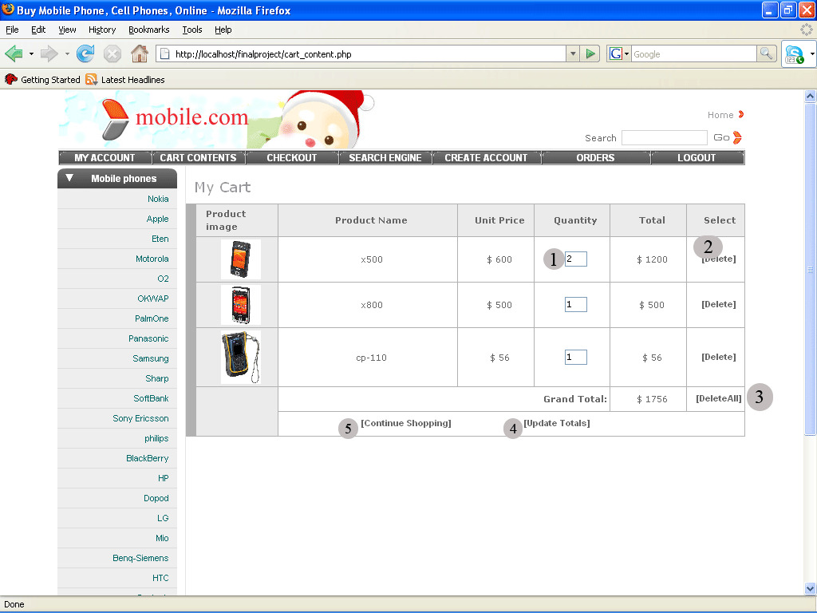

Checkout
After the user select the products to buy he goes to check out to fill his information to send him the products in his cart and also from there the user must pay the company uses copons that it gives for their customers so the customer must provide the card number and also the password to bay from his credit the following image shows that:

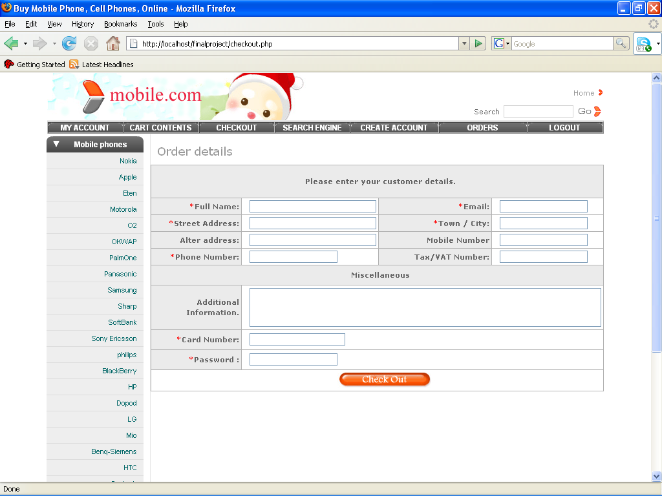

The Orders : this will display the orders that the customer has ordered this orders is not shipped yet the shipped ones will not be displayed here .
Clicking the details link will give a list of all product in that order with their prices and quantities.
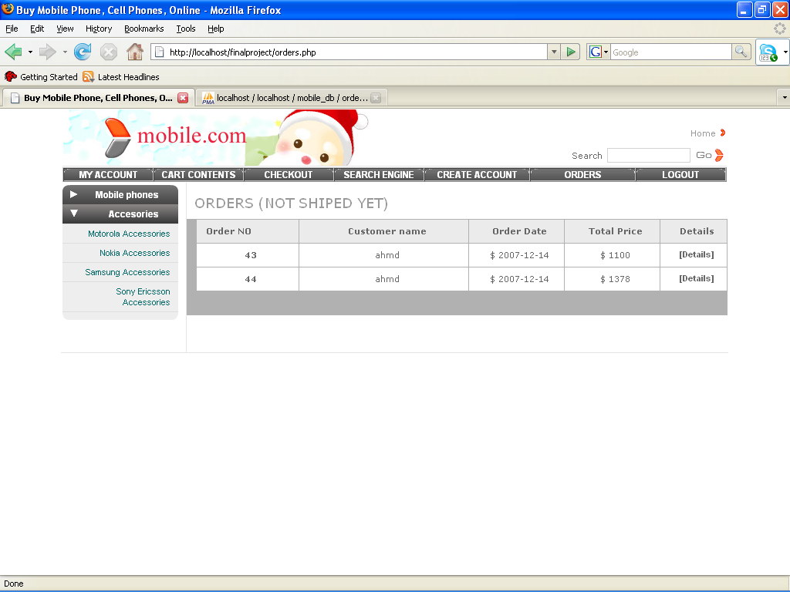

The administrator page:
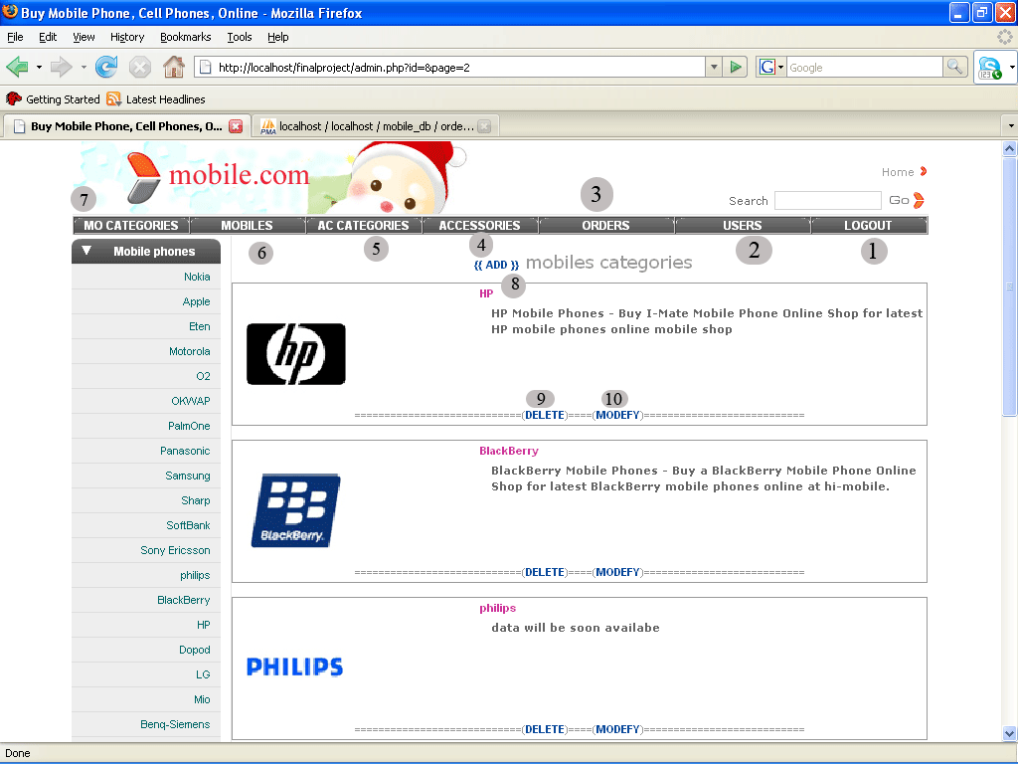

the circles in the previous image:
(1) exit and log out from the administrator page .
(2)will give the admin alist of all registered users in the site
(3)display the orders that was asked by the customers
give all accessories in the site and give the admin the ability to change the accessory info or even delete it an(4)
and add new accessories .
(5)gives all accessories categories or companies and give the admin the ability to add delete modify any company
(4)(5)respectively are as(6)and(7)
but they are for mobiles categories and mobiles instead of accessories as 4 and 5 .
(8) add new mobile category .
(9)delete this category.
(10)modify this category.
Add mobile category:
The admin should fill the form below and click save .
Note if the admin did not select a picture for the category a default one will be selected and he can modify it later
Clicking back will redirect him back to the admin page in other words the whole list.
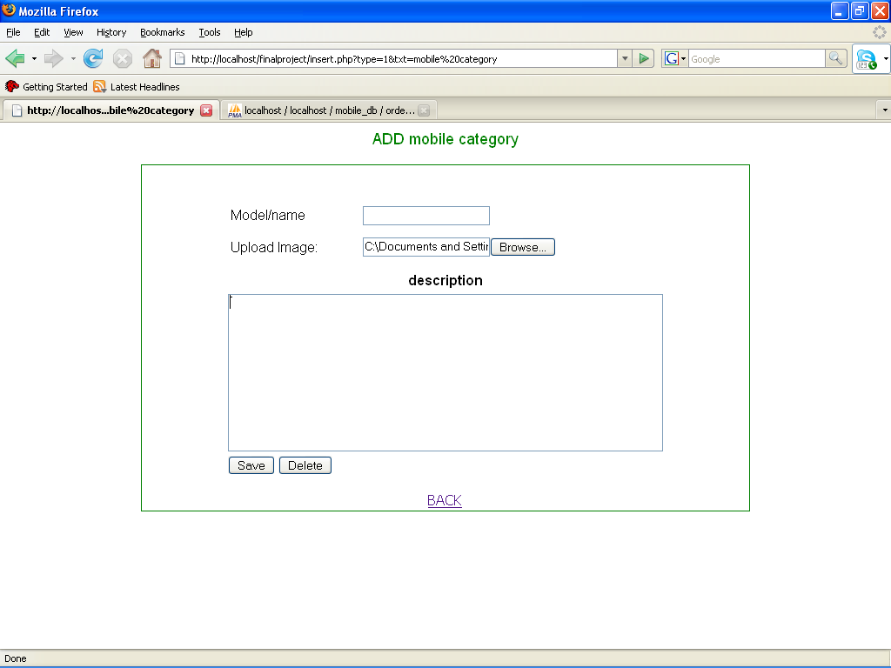

to delete the category the admin must confirm the following message

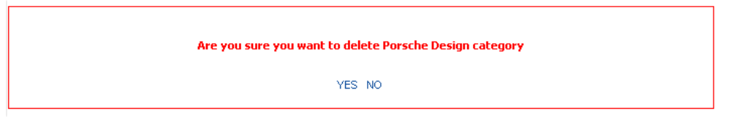

Add new mobile : simply the admin can fill the following form.

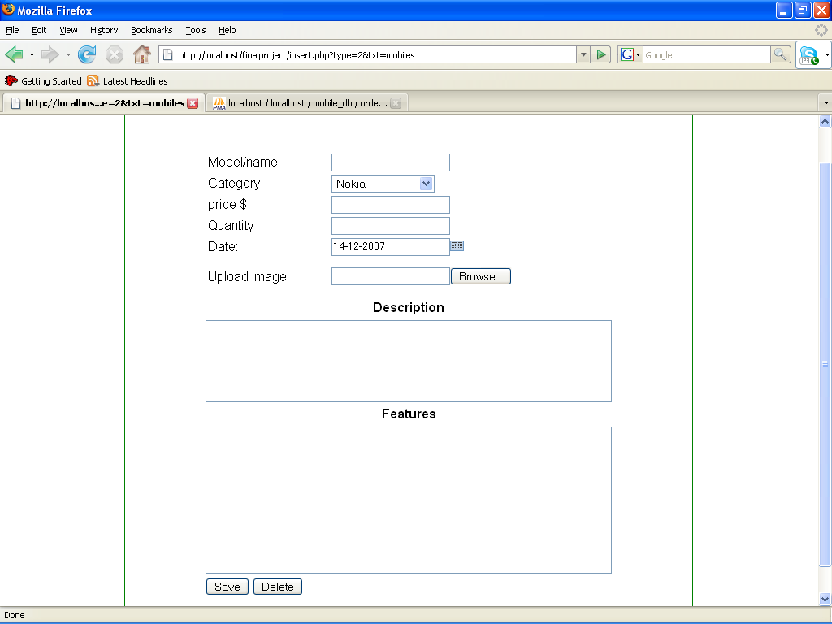

Modify category imformation:
The form provide the original information that the admin can modify as he want.

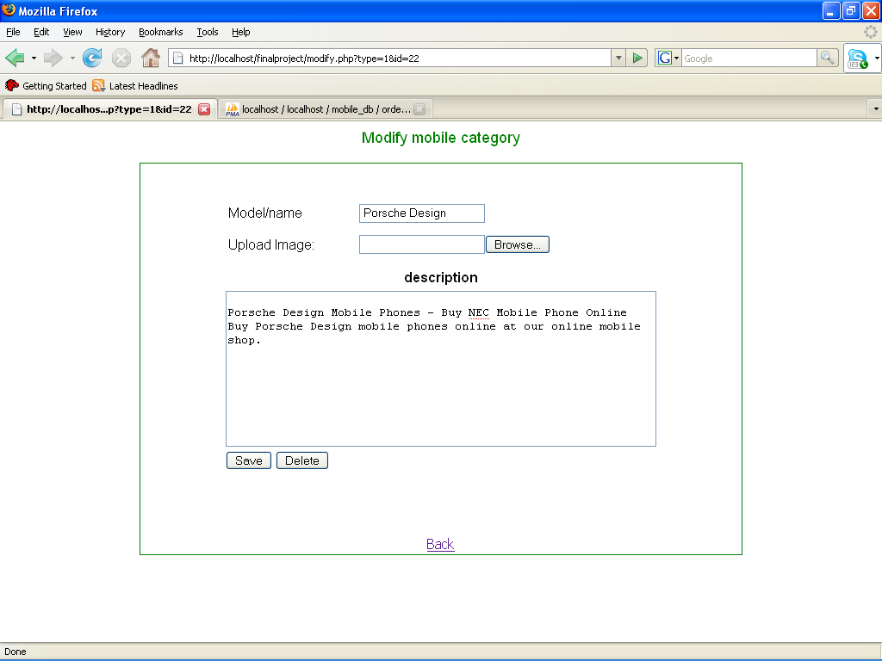

Modify mobile information:
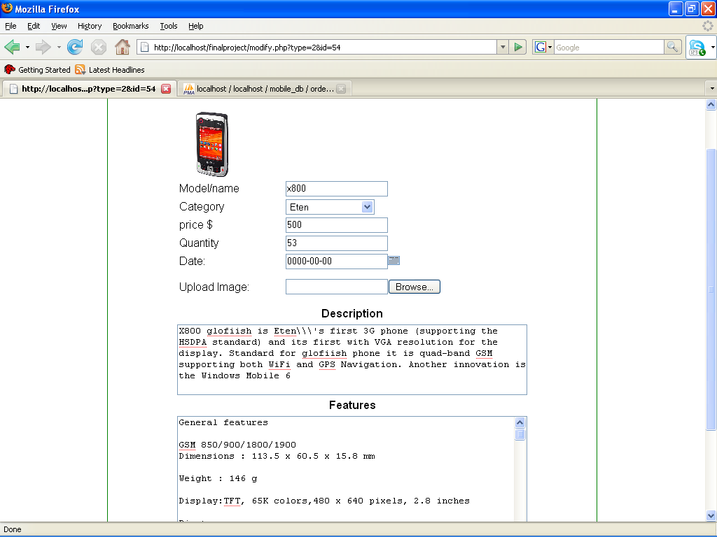

the same forms of add and modify is provided for accessories and accessories categories .

The users page give a list of users that is already registered in the site and their full information's
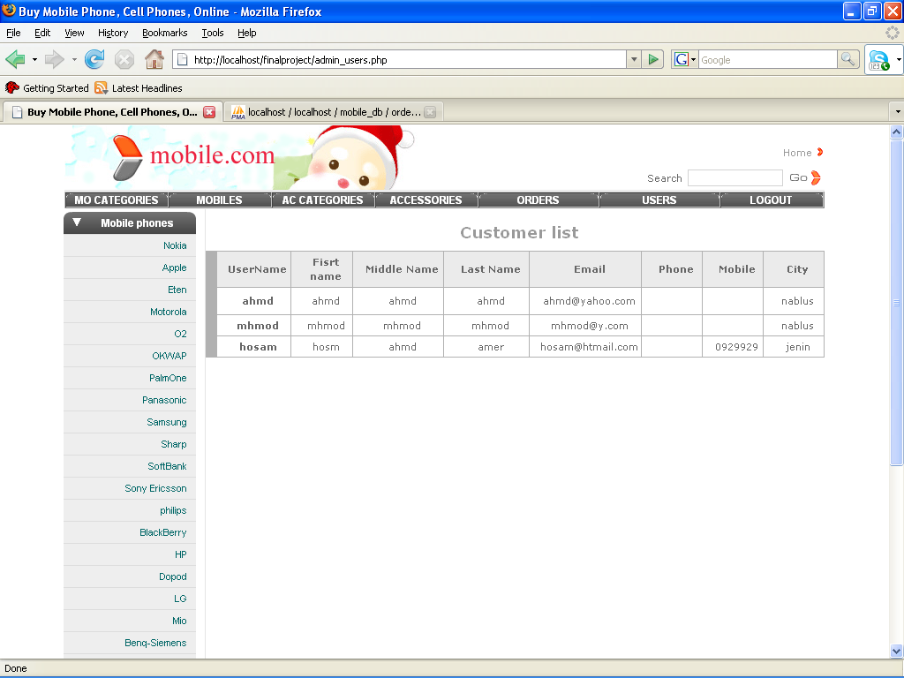

Orders page:
This page display the orders that was received for the admin from users for each one there is a link called[details]
Which display the details of order and also the shipment details . in the table bellow the column delete contains links to delete the order but it will be disables until the admin agree to ship the product then he will be able to delete it from his list
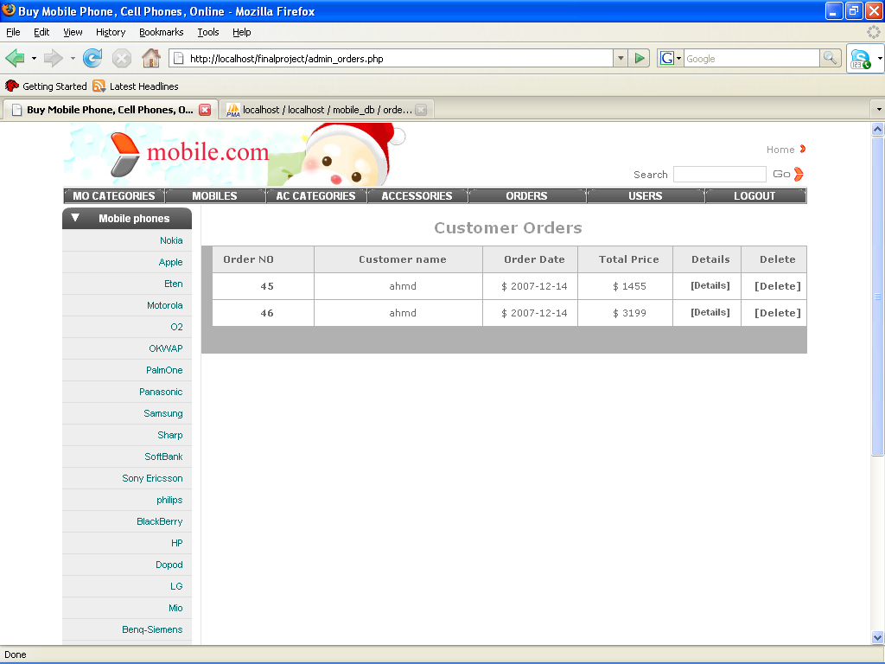
'

after clicking the link Details the following page will appear :the page view the shipment details

in the order in the order details table there is a column called ship contains a link called ship for each product in the order by which the admin can ship the product and thus he will be able to delete it from the orders list


