An-Najah National University
Computer Engineering Department
Graduation project Documentation
Palestine Travel Agency (PTA)

Introduction:
Palestine travel Agency is a tourism web site, which provides a Guide for users to know much more about tourism places; In this website we offer many real service s to our customers, some example, Real weather condition, currency conversion, Google maps, SMS, and others.

Programming language used:
ASP.NET with SQL Server2005 Database

WHY DOT NET?
- Common Language that both me and my classmate can work in with high efficiency.
- Common Runtime Engine: The Common Language Runtime (CLR) is the virtual machine component of the .NET framework. All .NET programs execute under the supervision of the CLR, guaranteeing certain properties and behaviors in the areas of memory management, security, and exception handling.
- Language Independence: The .NET Framework introduces a Common Type System, or CTS. The CTS specification defines all possible datatypes and programming constructs supported by the CLR and how they may or may not interact with each other. Because of this feature, the .NET Framework supports the exchange of instances of types between programs written in any of the .NET languages. This is discussed in more detail in Microsoft .NET Languages.
- Base Class Library: The Base Class Library (BCL), part of the Framework Class Library (FCL), is a library of functionality available to all languages using the .NET Framework. The BCL provides classes which encapsulate a number of common functions, including file reading and writing, graphic rendering, database interaction and XML document manipulation.
- Simplified Deployment: Installation of computer software must be carefully managed to ensure that it does not interfere with previously installed software, and that it conforms to security requirements. The .NET framework includes design features and tools that help address these requirements.
- Security: The design is meant to address some of the vulnerabilities, such as buffer overflows, that have been exploited by malicious software. Additionally, .NET provides a common security model for all applications.
- Portability: The design of the .NET Framework allows it to theoretically be platform agnostic, and thus cross-platform compatible. That is, a program written to use the framework should run without change on any type of system for which the framework is implemented. Microsoft's commercial implementations of the framework cover Windows, Windows CE, and the Xbox 360.[ In addition, Microsoft submits the specifications for the Common Language Infrastructure (which includes the core class libraries, Common Type System, and the Common Intermediate Language), the C# language, and the C++/CLI language[ to both ECMA and the ISO, making them available as open standards. This makes it possible for third parties to create compatible implementations of the framework and its languages on other platforms.
- Flexibility: Asp.net is a flexible language specially for the interface design which should be well done for a travel agency website.

Project features:
- security
Security is one major issue that we look into while programming this site, important user info like password have been saved encrypted in database, so that in cause hacker attacks, such info will not be lost, we use one way decryption algorithm called MD5.

- MD5 is a widely used, partially insecure cryptographic hash function with a 128-bit hash value. As an Internet standard (RFC 1321), MD5 has been employed in a wide variety of security applications, and is also commonly used to check the integrity of files. An MD5 hash is typically expressed as a 32 digit hexadecimal number.

MD5 encryption is an example of a one-way encryption algorithm; specifically, MD5 encryption maps a plain-text string of an arbitrary length to a small encrypted string of a fixed length. Two important properties of the MD5 algorithm are that given an encrypted output it is impossible to revert back to the initial, plain-text input, and that any given input always maps to the same encrypted value. The former property means that even if a hacker sees the encrypted output of the MD5 algorithm, they can't "unwind it" and get back at the plain-text input; the latter property means that if you wish to encrypt a particular plain-text input that it will always result in the same encrypted output.

Sample Code:
public byte[] EncriptByMD5(string pass)
{
MD5CryptoServiceProvider md5Hasher = new MD5CryptoServiceProvider();
UTF8Encoding encoder = new UTF8Encoding();
byte[] newpassHased = md5Hasher.ComputeHash(encoder.GetBytes(pass.Trim()));
return newpassHased;

}
- 3-Lier Architecture:

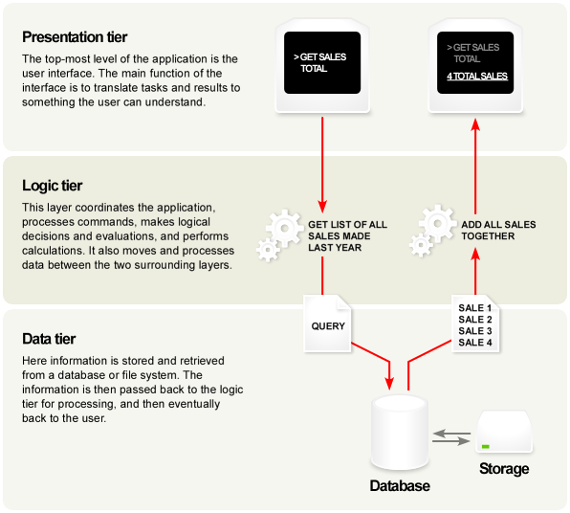

Typically, the user interface runs on a desktop PC or workstation and uses a standard graphical user interface, functional process logic may consist of one or more separate modules running on a workstation or application server, and an RDBMS on a database server or mainframe contains the computer data storage logic. The middle tier may be multi-tiered itself (in which case the overall architecture is called an "n-tier architecture").
The 3-Tier architecture has the following three tiers:
Presentation Tier
This is the topmost level of the application. The presentation tier displays information related to such services as browsing merchandise, purchasing, and shopping cart contents. It communicates with other tiers by outputting results to the browser/client tier and all other tiers in the network.
Application Tier (Business Logic/Logic Tier)
The logic tier is pulled out from the presentation tier and, as its own layer, it controls an application’s functionality by performing detailed processing.
Data Tier
This tier consists of Database Servers. Here information is stored and retrieved. This tier keeps data neutral and independent from application servers or business logic. Giving data its own tier also improves scalability and performance.

Comparison with the MVC architecture
At first glance, the three tiers may seem similar to the MVC (Model View Controller) concept; however, topologically they are different. A fundamental rule in a three-tier architecture is the client tier never communicates directly with the data tier; in a three-tier model all communication must pass through the middleware tier. Conceptually the three-tier architecture is linear. However, the MVC architecture is triangular: the View sends updates to the Controller, the Controller updates the Model, and the View gets updated directly from the Model.
From a historical perspective the three-tier architecture concept emerged in the 1990's from observations of distributed systems (e.g., web applications) where the client, middleware and data tiers ran on physically separate platforms. Whereas MVC comes from the previous decade (by work at Xerox PARC in the late 1970's and early 1980's) and is based on observations of applications that ran on a single graphical workstation; MVC was applied to distributed applications much later in its history.

Web Development usage
In the Web development field, three-tier is often used to refer to Websites, commonly Electronic commerce websites, which are built using three tiers:
- A front end Web server serving static content.
- A middle dynamic content processing and generation level Application server, for example Java EE platform.
- A back end Database, comprising both data sets and the Database management system or RDBMS software that manages and provides access to the data.

Other considerations
The data transfer methods between the 3 tiers must also be considered. The data exchange may be file-based, client-server, event-based, etc. Protocols involved may include one or more of SNMP, CORBA, Java RMI, .NET Remitting, Windows Communication Foundation, Sockets, UDP, or other proprietary combinations/permutations of the above types and others. Typically a single "middle-ware" implementation of a single protocol is chosen as the "standard" within a given system, such as J2EE (which is Java specific) or CORBA (which is language/OS neutral). Which protocol is chosen affects such issues as the ability to include legacy applications/libraries, performance, maintainability, etc. When choosing a "middle-ware protocol" (not to be confused with the "middle-of-the-three-tiers"), engineers should not be swayed by public opinion about a protocol's modernisms, but should consider the technical benefits and suitability given the problem at hand. For example CGI is very old and "out of date" but is still quite useful and powerful, so is shell scripting, and UDP for that matter.
Ideally the high-level system abstract design is based on business rules and not on the front-end/back-end technologies. The tiers should be populated with functionality in such a way as to minimize dependencies, and isolate functionalities in a coherent manner - knowing that everything is likely to change, and changes should be made in the fewest number of places, and be testable.
Security being top on agenda, today’s tiers is more physically separated and in fact lives in separate network segments. Thus web servers live in web-tier, application servers live in app-tier and data and legacy systems live in fared data-tier.

- PayPal sandbox integration: we used PayPal for payment, where payment is made from a credit card. We used the sandbox which is a test site from PayPal for learning. The communication with PayPal was through HTTPS which provides security for the customer.

- HTTP Communications: for communication with the airline sites we used HTTP communication with XML formatted requests and responses.

- SMS: we got a service from palhost.ps for sending emails. The following code is a sample code:
private static string sendSms()
{
WebClient client = new WebClient();

string baseurl = "http://srv1.palhost.ps/api/sendsms.php ";
client.Headers.Add("user-agent", "Mozilla/4.0 (compatible; MSIE 6.0; Windows NT 5.2; .NET CLR1.0.3705;)");
client.QueryString.Add("username", "ptasms");
client.QueryString.Add("password", "ptasms");

client.QueryString.Add("zcode", "23055");
client.QueryString.Add("to", mobileText.Text);
client.QueryString.Add("from", "P.T.A");
client.QueryString.Add("text", "Hello");

Stream data = client.OpenRead(baseurl);
StreamReader reader = new StreamReader(data);
string s = reader.ReadToEnd();
data.Close();
reader.Close();
return (s);
}

- Email: we used the Gmail server in order to send our emails. We sent email at sign in for verification. The following is a sample code:
SmtpClient mailClient = new SmtpClient();

mailClient.EnableSsl = true;
mailClient.Send("P.T.A.website@gmail.com", uInf.EMAIL, "Your New Password in P.T.A", " Dear " + user.LOGIN_ID + " your new Password is: " + newPass);
- Dynamic and real time programming: where everything was taken dynamically from the database without the necessity to make a page for every country for example. This also makes changed and addition easier.

- Web services: we used many web services which give real and instant data such as the current weather at some country, currency converter between different currencies, email verification to check if emails really exist and other services.

- Google maps: we made an integration with Google maps to show the maps of the countries with some extra information like information about the main cities and airports. To make this we used Google API and we also made the information to be dynamically taken from the database like the location of the cities and he information about them. This was done using javascript and asp.net.
The following code is an example:
<script type="text/javascript">
var map;
function initializeMap()
{
var url = (String(window.location)).split('?');
var variables = (String(url)).split('&');

var lat = (String(variables[1])).split('=');
var lng = (String(variables[2])).split('=');
var res = (String(variables[3])).split('=');

if (GBrowserIsCompatible())
{
var map = new GMap2(document.getElementById("map"));
map.setCenter(new GLatLng(lat[1], lng[1]), parseInt(res[1])/*5*/);

<%string countryName = Request.QueryString["Country"];
System.Data.DataTable dt = Cities.GetCitiesLngLatByCountry(countryName);
%>
var cityIcon = new GIcon(G_DEFAULT_ICON);
cityIcon.image = "icons/red-dot.png";
cityIcon.iconSize = new GSize(20, 26);
cityIcon.shadowSize = new GSize(30, 25);
cityIcon.iconAnchor = new GPoint(9, 26);

var marker = new Array(<%=dt.Rows.Count %>);

<%
for (int i = 0; i < dt.Rows.Count; i++)
{
string cityID = dt.Rows[i]["City_Name"].ToString();
string cityName = dt.Rows[i]["City_Name"].ToString();
double cityLat = Convert.ToDouble(dt.Rows[i]["Latitude"].ToString());
double cityLng = Convert.ToDouble(dt.Rows[i]["Longitude"].ToString());
string info = dt.Rows[i]["Info"].ToString();
%>

marker[<%=i %>] = new GMarker(new GLatLng(<%=cityLat %>, <%=cityLng %>), { icon:cityIcon });

map.addOverlay(marker[<%=i %>]);

GEvent.addListener(marker[<%=i %>], "mouseover", function() {
marker[<%=i %>].openInfoWindowHtml('<%=cityName %>'+'<br>'+'<%=info %>');

<%
}
%>

var AirportBlue = new GIcon(G_DEFAULT_ICON);
AirportBlue.image = "icons/Airport-Blue-24x24.png";

<%

//get airports
System.Data.DataTable airportsTable = AirPort.GetAllAirPortsByCountry(countryName);
for (int i = 0; i < airportsTable.Rows.Count; i++)
{
string airPortID = airportsTable.Rows[i]["AirPort_ID"].ToString();
string airPortName = airportsTable.Rows[i]["AirPort_Name"].ToString();
double airPortLat = Convert.ToDouble(airportsTable.Rows[i]["Latitude"].ToString());
double airPortLng = Convert.ToDouble(airportsTable.Rows[i]["Longitude"].ToString());
%>
var airPortMarker = new GMarker(new GLatLng(<%=airPortLat %>, <%=airPortLng %>), { icon:AirportBlue });

GEvent.addListener(airPortMarker, "mouseover", function() {
airPortMarker.openInfoWindowHtml('<%=airPortName %>' + '<br>' +
"<a href='./SearchFlights.aspx?country="+'<%=countryName %>'+"&airport="+'<%=airPortID %>'+"'>Click Here to Book a Flight</a>");
});

map.addOverlay(airPortMarker);
<%
}
%>

map.addControl(new GLargeMapControl());
map.addControl(new GMapTypeControl());
}
}
</script>

- Real data for airline companies: we used the time tables provided from some airline companies in order to fill our airline database.

Websites:
We made three websites; one is the main site and another two websites which the main website connect to in order to get the flights and to book them.

- Main web site:
It has two main parts; tourism and airlines booking part. In tourism we display info about different countries, slide show, map with info in and with ability to book from and real time weather info.
In the other part, we give the user the ability to display and book flights from the airline countries. In flights searching, we give many options, like two or one way, flexibility, class and different number of travelers.

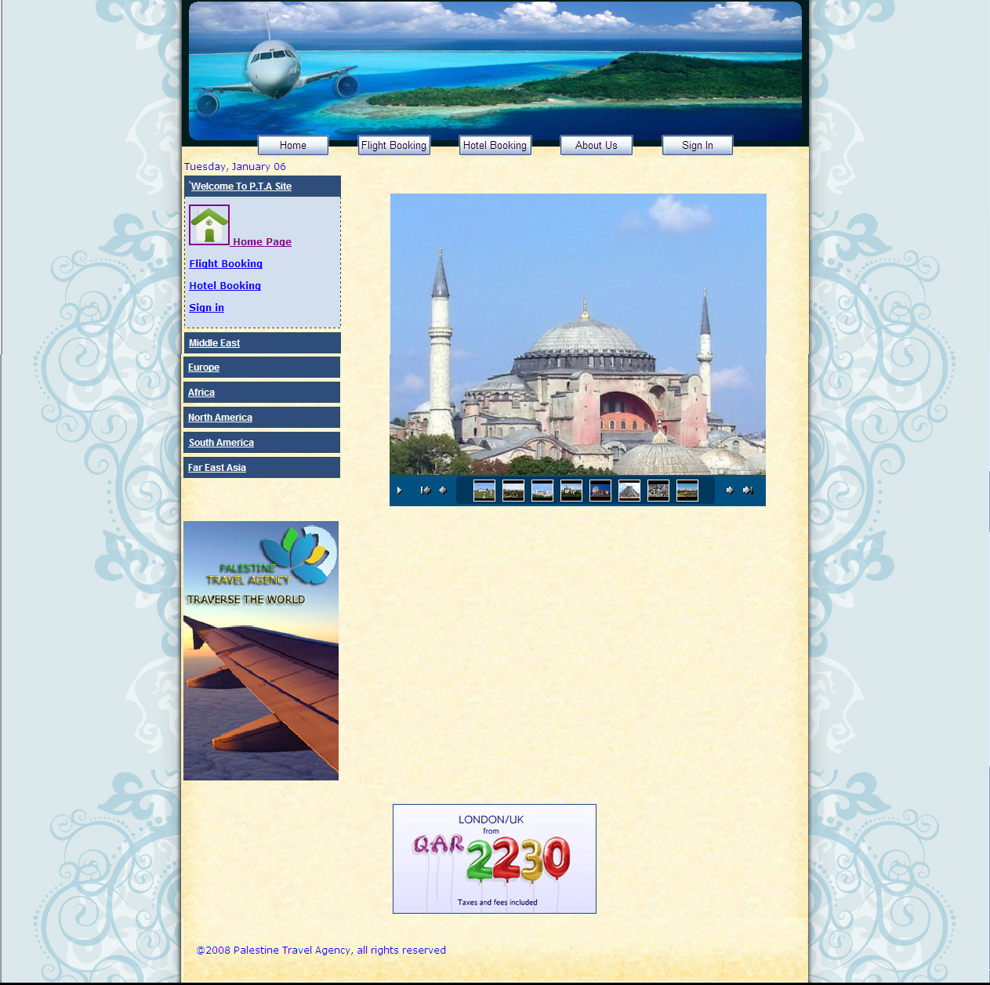
Main page of PTA site

- The Airline websites:
We made two airlines sites for different two airlines companies. Those sites where mainly made for handling the incoming searching and booking requests, but we also made some pages for the site’s admin in order to be able to add or delete flights.

