**Chapter I**

**Introduction**

Each power system has main four parts like our network Ramallah these parts are:

1. Generators are one of the essential components of the power systems. Synchronous generators are widely used in power systems.
2. Transmission lines which have property to link between buses and carry the high voltages for long distance and minimize losses.
3. Distribution networks are the parts of the system which connect the transmission network to the loads.

There are two parts of distribution networks:

Primary distribution lines: the range of voltage between 6.6-33Kv.Almost no direct loads connected to the high voltages at this part.

Secondary distribution network reduces the voltage for utilization by commercial and residential consumers.

4- loads: there are real and reactive power loads

**Palestine Network**

**Electricity status in Palestine**

Due to the Israeli occupation Palestine has not yet a unified power system; the existing networks are local low voltage distribution networks.

The main supply for electrical distribution networks in the West Bank and Gaza is the Israeli Electrical Company (IEC).

The voltages of the existing distribution networks are 0.4, 6.6, 11, 22, and 33 KV. IEC supplies electricity to the electrified communities by 22 or 33 KV by overhead lines, Electricity is purchased from IEC and then distributed to the consumers.

The results of the survey indicated that 99.6%of households in the Palestinian Territory were connected to the public electricity network in April 2008, where this percentage was 99.3% during April 2006, and was 97.2% during July 2005, while it was 97.2% during the same month 1999, 0.3% have no electricity services, 0.1% of the households have their own generators.

From the results of the survey, it is noted that south of the West Bank has the lowest percentage of households connected to electricity network (99.0%). The situation is different in Gaza Strip which has 99.6% of the households connected to electricity network during April 2006.

**Purchases of Electrical Energy**

Due to the Palestinian Central Bureau of Statistics during 2006 , total electrical energy purchases in the Palestinian Territory reached 3,441,700 MWhr; 2,331,110 MWhr in the West Bank and 1,110,590 MWhr in Gaza Strip(765,290 MWhr imported from Israel and 345,300 MWhr produced by Gaza Power Plant).

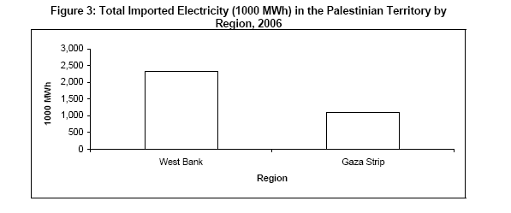

**Household Consumption of electricity**

The results of the survey indicated that the average household electricity consumption (from the households that used electricity) in the Palestinian Territory during April2008 was 282 KWh.

While during April2006 was 211 KWh, where this average was 380.1 KWh during July 2005, and it was 380.1KWh during the same month 1999. This average ranged by region and type of locality in April 2008, it reached 367 KWh in the Middle of the West Bank and didn’t exceed 217 KWh in the North of West Bank. This average was about 293 KWh in urban localities and 205 KWh in rural localities, and 357 KWh in refugee camps.

And the average per capita electricity consumption in the Palestinian Territory during April 2008 was 48.6 KWh.

While during April 2006 was 39.7 KWh.

**Electrical Sources and Network problems**

There are many problems that the consumer faces it in the network, the level of electrical services provided by the IEC is inadequate, which constitutes a handicap for the industrial sector, high economic losses, and an obstacle for the development of the country. With an electricity consumption level of 583 kWh/person (1999), the lowest consumption level in the region, the Palestinian Territories barely manage to satisfy their electric needs, whereas in Israel electricity consumption exceeds 6000 kWh/person.



This gap can be mainly explained by inadequate electricity

Infra-structure, high transmission losses (25%) and high electricity prices.

Palestinian electricity consumption appears to be inelastic. However, the Palestinian electricity sector shows a high vulnerability to political shocks. The influence of conflict on the electricity sector goes beyond direct destruction. It results in a modification of the trajectory of electricity consumption, a deceleration in the growth rate, and the retardation of a “healthy” recovery.

**Electricity problems and priorities can be summarized as follows**:

The lack of investment and public expenditure, high prices, and high transmission losses constitute fundamental problems for the electricity sector. The quality of the electrical services is inadequate and below standard.



Another problem that the Israeli Electricity Corporation (IEC) imposes the municipalities and large consumer in Palestine to pay penalties if they cause a power factor less than 0.92. The Jerusalem Electricity company (JEDCO) is the only company that imposes the three phase industrial consumers with PF penalties if their PF is less than 0.92. On other hand, several municipalities in the West Bank and Gaza strip are in the process of imposing power factor penalties on industrial customers with low PF.

Table below show relation of PF to the penalties

|  |  |
| --- | --- |
| PF | penalties |
| 0.92 or more | No penalties |
| Less than 0.92 to 0.8 | 1%of the total bill for every 0.01 of PF less than 0.92 |
| Less than 0.8 to 0.7 | 1.25%of the total bill for every 0.01 of PF less than 0.92 |
| Less than 0.7 | 1.5%of the total bill for every 0.01 of PF less than 0.92 |

**Energy consumption in different sector in Palestine**

Electricity utilization is considered essential not only for the industrial and residential sectors, but also for water pumping and street lights. Data from the Palestinian Energy Authority for

Electricity consumption indicates that the residential sector consumes (50 – 60) % of the total electricity against (12 – 14) % for the commercial sector and (10 – 12)% for industrial sector. Electricity consumption for both water pumping and street lights is 15%, (3 – 4) % respectively.

It can be shown as a table below:

|  |  |
| --- | --- |
| Type of sector | Percentage |
| Residential sector | (50 – 60)% |
| Industrial sector | (12 – 14) % |
| Commercial sector | (10 – 12)% |
| Water pumping | 15% |
| Street lighting | (3 – 4)% |

**Improvement of the power distribution of electrical network**

In power system analysis The Load Flow and Voltage Drop study is the most basic and commonly needed electrical study. The Load Flow study will show the power in KVA or Amperes that is being handled by all of the individual electrical components, e.g. transformers, conductors and panels in the system. This allows a determination of equipment rating margins and reserve capacity loading percentage.

Analysis and study of distribution electrical networks may cover conventional voltage drop analysis, power losses analysis, power factor considerations, capacitors’ placements (correction of power factor), and long line charging effect

**The aim of this improvement:**

1. Reduction of power losses

2. Increasing of voltage levels

3. Correction of power factor and so reduction of penalties.

4. Increasing the capability of the distribution transformers and also for the transmission lines.

**The methods of the improvement are**:

1. Swing bus control

2. Transformer taps

3. Installation of capacitor banks (reactive power compensation)

4. Changing the configuration of distribution network (radial or ring)

**Swing bus**

Swing bus is a generator that will affect all the network buses and the bus that is connected to it is called the swing bus.

It’s important to make the balance for all buses in the network.

The balance achieved as the sum of all real power in buses must equal the real power in the swing bus

The sum of reactive power in all buses must equal the reactive power in the swing bus.

**Transformer taps and capacitor banks**

Transformer provides an additional means of control of the flow of both real and reactive power.

our usual concept of the function of transformers in a power system is that of changing from one voltage level to another some transformers regulate both magnitude and phase angle.

Almost all transformers provide taps on windings to adjust the ratio of transformation by changing taps down when we need to raise the voltages up and vice versa

There are two types of transformer taps

1-tap changing under load (TCUL): The tap changing is automatic and operated by motor which response to relays set to hold the voltage at the prescribe level

2. Tap changing without loads

3. Capacitor banks (compensation)

Shunt capacitor banks is very important method of controlling voltage at the buses at both transmission and distribution levels along lines or at substation and load. Essentially capacitor is a means of supplying mega-vars (MVAR) at the point of installation. Capacitor banks may be permanently connected, but as regulators of voltage they may be switches on and off the system as changes in load demand. Switching may be manually or automatically controlled either by time clock or in response to voltage or reactive - power requirement. When they parallel with a load having lagging power factor, the capacitor are the source of some or perhaps the entire reactive power factor of the load. Thus as we discusses before, capacitor reduces the line current necessary to supply the load and reduce the voltage drop in the line as the power factor is improved. Since capacitor lower the reactive requirement from generators, more real power output is available.

**Distribution system configurations**

**Primary distribution system**

There are two fundamental types of primary distribution systems;

Radial and network. Simply defined, a radial system has a single simultaneous path of power flow to the load. A network has more than one simultaneous path. Each of the two types of systems has a number of variations.

Showing tie, loop, radial and parallel feeders. There are other more complex systems, such as the

Primary network (interconnected substations with feeders forming a grid) and dual-service network (alternate feeder to each load). These systems, however, are simply variations of the two basic feeder arrangements.

**Tie Feeder:**

The main function of a tie feeder is to connect two sources. It may

Connect two substation buses in parallel to provide service continuity for the load supplied from each bus.

**Loop Feeder**:

A loop feeder has its ends connected to a source (usually a single

Source), but its main function is to supply two or more load points in between. Each load point can be supplied from either direction; so it is possible to remove any section of the loop from service without causing an outage at other load points. The loop can be operated normally closed or normally open. Most loop systems are, however, operated normally open at some point by means of a switch. The operation is very similar to that of two radial feeders.

**Radial Feeder**:

A radial feeder connects between a source and a load point, and it may supply one or more additional load points between the two, each load point can be supplied from one direction only. Radial feeders are most widely used by the Navy because the circuits are simple, easy to protect, and low in cost.

**Parallel Feeder:**

Parallel feeders connect the source and a load or load center and

Provide the capability of supplying power to the load through one or any number of the parallel feeders, Parallel feeders provide for maintenance of feeders (without interrupting service to loads) and quick restoration of service when one of the feeders fails.

**Secondary distribution system**

The secondary distribution system is that portion of the network between the primary feeders and utilization equipment. The secondary system consists of step-down transformers and secondary circuits at utilization voltage levels.

Residential secondary systems are predominantly single-phase, but commercial and industrial systems generally use three-phase power.

**Secondary Voltage Levels**

The voltage levels for a particular secondary system are determined by the loads to be served. The utilization voltages are generally in the range of 120 to 600 V. Standard nominal system voltages are:

|  |  |  |
| --- | --- | --- |
| Volts | Phase | Wire |
| ___  120  120/240  208Y/120  240  480Y/277  480  600 | ___  Single  Single  Three  Three  Three  Three  Three | __  2  3  4  3  4  3  3 |

In residential and rural areas the nominal supply is a 120/240 V, single-phase, three-wire grounded system. If three-phase power is required in these areas, the systems are normally 208Y/120 V or less commonly 240/120 V. In commercial or industrial areas, where motor loads are predominant, the common three-phase system voltages are 208Y/120 V and 480Y/277 V. The preferred utilization voltage for industrial plants, however, is 480Y/277 V. Three-phase power and other 480 V loads are connected directly to the system at 480 V and fluorescent lighting is connected phase to neutral at 277 V. Small dry-type transformers, rated 480-208Y/120 or 480-120/240 V, are used to provide 120 V single-phase for convenience outlets and to provide 208 V single- and three-phase for small tools and other machinery.

**Chapter II**

**Ramallah Network**

**Main comp**

**About Al-Quds electrical company**

Covering the concession area company is currently approximately 25% of the West Bank and the equivalent of 366 square kilometers distributed as follows:

**Jerusalem area**

47 villages and covers an area of 82 square kilometers (not including, of course, Jerusalem was occupied in 1948)   
Ramallah area: of the 72 villages and covers an area of 174 square kilometers.

The Bethlehem area: of the 43 villages, town and covers an area of 80 square kilometers. Jericho area: of the 7 places and covers an area of 30 square kilometers.

The central station is located in Shu'fat about 2 km from the status of Jerusalem and built in 1956 on an area of 15639 square meters, was officially inaugurated in 17/8/1959.

**The sub-stations at the basic construction were:**

Station Bethlehem / Pincushion   
Issuing the Ramallah / transmission   
Main offices in Jerusalem   
Jericho station

In 18/6/1985 the company took a land leased from the municipality of Jerusalem area 5000 m2 the value of 12500 thousand shekels annually has tried to abolish the municipal lease contract from one party to that agreement was reached in the end to the rent increase to 15 thousand dollars a year, the company used a piece of land in question as a repository of the pillars of iron, wood and electrical cables a result of the steady expansion witnessed by the company.

**Substations**

We have in Ramallah network 7 main substations that feed the city as follow

* Silvana which has two transformers (33\11) KV of 15 MVA Capacity.
* Al Tera which has one transformer (33\11) KV of 5 MVA Capacity.
* Ramallah north which has two transformers (33\11) KV of 15 MVA and 10 MVA Capacity.
* Betien west which has two transformers (33\11) KV of 10 MVA and 15 MVA Capacity.
* Betien centeral which has one transformer (33\6.6) KV of 3 MVA Capacity.
* Ras Al Tahona which has one transformer (33\11) KV of 10 MVA Capacity.
* Dar Al Moalmen which has two transformers (33\11) KV of 10 MVA and 15 MVA Capacity.

There is transmission lines between the main buses is 33 KV, the network is ring configuration, all Ramallah loads take power from these buses

These buses feed from five feeders as follows:

* Pereq has 20 MVA Capacity.
* Ofer has 20 MVA Capacity.
* Ramallah 20 MVA Capacity.
* Rama1 20 MVA Capacity.
* Al Ram 20 MVA Capacity.

**These feeders come from the main connection grid with the Israelis electric company.**

**Elements of the network**

**I. Transformers**

* The high voltage transformers on the main substations (33KV/11KV)

|  |  |  |
| --- | --- | --- |
| MVA | # of transformers | Total capacity(MVA) |
| 15 | 5 | 75 |
| 10 | 4 | 40 |
| 5 | 1 | 5 |
| 3(33KV/6.6KV) | 1 | 3 |
| Total | 10 | 123 |

TABLE -1- (Ratings of HV transformers)

**All transformers has tap changer with load= ±10%**

* The low voltage transformers in the network (11KV/0.4KV)

|  |  |  |
| --- | --- | --- |
| KVA | # of transformers | Total Capacity(KVA) |
| 100 | 21 | 21000 |
| 160 | 112 | 17920 |
| 250 | 120 | 30000 |
| 400 | 169 | 67600 |
| 500 | 44 | 22000 |
| 630 | 118 | 74340 |
| 1000 | 18 | 18000 |
| Total | 602 | 231960 |

TABLE -2- (Ratings of LV transformers)

**500, 630, 1000 has tap changer without load= ±5%**

**II. Transmission lines**

* **33KV transmission**

Overhead transmission lines ACSR (3X120+1X50) mm

Underground CABLE COPPER XLPE single core 150mm

* **11KV transmission**

Overhead transmission lines ACSR (3X50+1X50) mm

Underground CABLE COPPER XLPE (3X95 +1X50) mm

**Load categories**

The nature of the loads in Ramallah city varies between residential, commercial, industry, water pumps and light streets, and the following table shows each category and it’s percentage from the total consumption.

|  |  |
| --- | --- |
| Load type | Consumption % |
| Residential | **60** |
| Commercial | **24.7** |
| Industry | **14.6** |
| Water Pumps & Light | **10.7** |

Load category and its percentage consumption from total consumption

**Chapter III**

**Network Analysis**

We have started our analysis by collecting the data from our multiple sources such as AutoCAD plans, SCADA monitoring system, Monthly reports from Al-Quds Company, and Engineers in the company to give us feedback.

We divided the project into multiple stages and parts which make the analysis easier to us

**Stage one:**

Plotting the One Line Diagram from Ground zero by Gathering the data we achieve from Al-Quds Company into the reality

**Note:** There was no one line diagram for the network!! So we build it by our own hands through the two semester starting with the (33/11)KV transmission lines from the Israeli Company to the main substations and the second to continue with the (11/0.4)KV to the consumer!!

**Stage two:**

Calculation and Analyzing of the yearly load curves for the transformers in the network in order to achieve a real time values for the maximum demand, average demand and minimum demand

**Stage three:**

Plotting the completed one line diagram and the real time loads into the ETAP software which we used in our network study

**Stage four:**

Improvement of the voltage levels in the network and the power factor and decreasing the power losses if needed using multiple methods

**Stage five:**

Future Expectations for the network load demands and consumptions.

**Average Demand case**

We will start by taking a look to the original case here which is in case of average demand in the network:

We have the average value of loads by using the load factor of each load which we got from the real data of network and real daily load curves from SCADA system

The table below shows the load factor witch used in each load

|  |  |
| --- | --- |
| **LOADS** | **L.F%** |
| L2 | 72 |
| L4 | 73 |
| L5 | 75 |
| L58 | 73 |
| L25 | 74 |
| L23 | 63 |
| L22 | 65 |
| L21 | 65 |
| L30 | 63 |
| L7 | 72 |
| L8 | 73 |
| L29 | 67 |
| L24 | 65 |
| L26 | 70 |
| L28 | 64 |
| L19 | 64 |
| L27 | 67 |
| L14 | 70 |
| L15 | 64 |
| L31 | 64 |
| L16 | 64 |
| L56 | 75 |
| L47 | 69 |
| L50 | 65 |
| L48 | 65 |
| L51 | 65 |
| L52 | 65 |
| L49 | 65 |
| L55 | 65 |
| L54 | 65 |

The average demand load factor in our network is 68% that means the average load to the maximum load ratio is 68% which considered as a very good operating load factor.

Here are some examples of the network load in the original case:

**This figure on high voltage level 33kv**

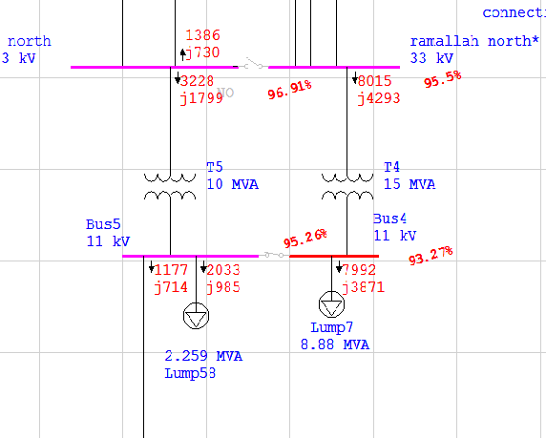

**Figure on medium voltage level 11kv**

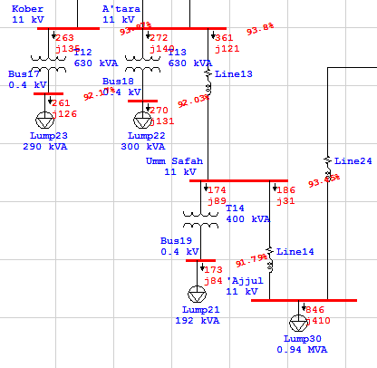

We can summarize the average case in table below:

|  |  |  |  |  |
| --- | --- | --- | --- | --- |
|  | MW | MVAR | MVA | %PF |
| Swing bus | 40.297 | 21.282 | 45.572 | 88.43 |
| Total demand | 40.297 | 21.282 | 45.572 | 88.43 |
| Total motor load | 16.553 | 8.017 | 45.572 | 90 |
| Total static load | 22.415 | 10.856 |  |  |
| Apparent losses | 1.328 | 2.409 |  |  |

And we see that the network suffers from drop voltages in most of the buses and a relatively low power factor too.

**Maximum Demand Case**

From our analysis of the max demand case we saw that when the network is in the max demand mode, it’s going to suffer from a huge drop voltages at the (11kv/0.4kv) and (33kv-11kv) too which is due to the huge demand and the long distances between the buses and the load’s since our network is considered as a huge network and also we saw that is suffers from a low power factor below the allowable power factor limit in the ordinary networks which is usually 92% and also we have a considerable amount of power losses in the network, so our aim is to improve the voltage levels in both the 0.4kv and the 11kv buses and to improve the power factor above the 92% limit and also to reduce the power losses in the network.

And here is the table summary of the power, power losses, power factor and total demand

|  |  |  |  |  |
| --- | --- | --- | --- | --- |
|  | MW | MVAR | MVA | %PF |
| Swing bus | 60.089 | 32.859 | 68.486 | 87.74 |
| Total demand | 60.089 | 32.859 | 68.486 | 87.74 |
| Total motor load | 21.029 | 10.185 | 23.366 | 90 |
| Total static load | 36.226 | 17.545 |  |  |
| Apparent losses | 2.834 | 5.129 |  |  |

We see that we have 5% power losses in the grid and also we have 87.74% power factor so we will try to improve the power factor

And here some examples from our grid in maximum demand show the large drop voltage in the buses before and after tap enhancing, where we see that the drop voltage was between 90%-93% and after taps enhancing we reach a 105%-110% which is a very good percentage without the need of using capacitor bank to enhance the voltage drop.

**Before taps enhancing**

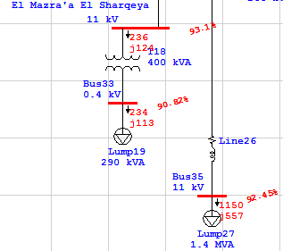

Bus sample

**After taps enhancing**

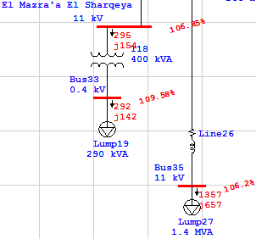

Bus example

Still we need to improve the voltage drop in the 33kv-11kv drop voltage which there is no taps to control in the buses which is feed directly from the Israel electric company, in spite of this we can improve the voltages at some buses by manipulating the ring configuration in the 33kv level, indeed we did this and we achieved our aim so here is an example of what we did.

You can see here that in some 33kv buses the voltage drop reaches 93.49% and you can notice that there is ring configuration that is not activated so we manipulate our ring configuration to enhance the voltage drop as possible as we can.

**Before manipulating the ring configuration**

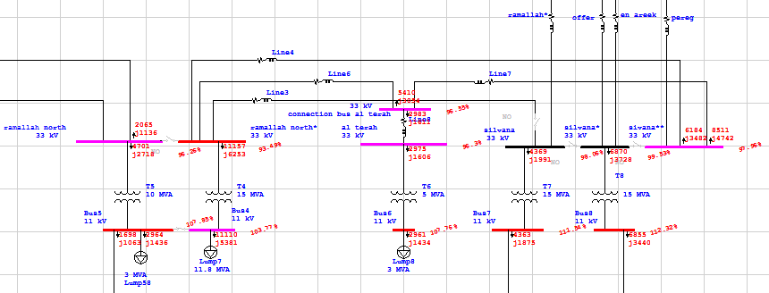

**After manipulating the ring configuration**

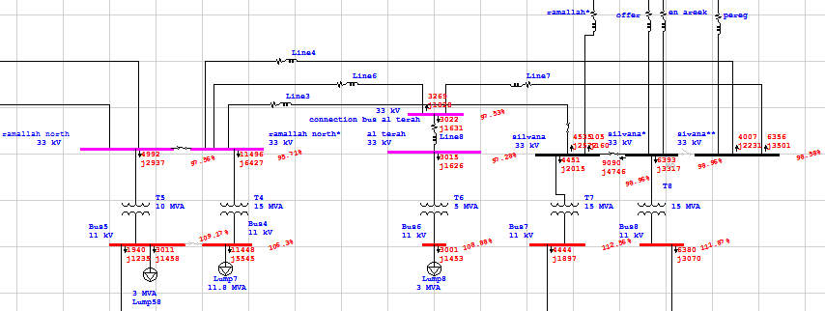

You can see that we closed three switches on the primary side (33kv) between the Silvana and Ramallah north station, and we achieved a considerable drop voltage instead of 93% to 96% within the allowable range.

**Chapter IV**

**Power factor improvement**

Finally, we come to the power losses and the power factor in Ramallah network, as we did our analysis to the network we find an important advantage that the network has which is that the Israel electric company doesn’t account al Quds electric company for the power factor so there is no penalties on the power factor, in the contrary Al Quds Electric Company charges it’s consumers for the power factor penalties!!

We asked about the reason why the Israeli Company doesn’t charge Al Quds Company for the low power factor and we have been informed that there is and understanding between the two companies which is:

Al Quds Electric Company does not pay penalties for the power factor in return of supplying the Jewish settlements and Army camping with electricity, which we couldn’t have any data about it in our project, so we eliminate it from our analysis.

* **Percentage of power losses in the average demand is:**

Power factor is

88.43% lagging

* **Percentage of power losses in the maximum demand is:**

Power factor is

87.43% lagging

Which we can see is an acceptable percentage in the losses considering the nature of the network, so adding the capacitor banks in order to improve the power factor would be good, but not worthy since there are no penalties charges on the power factor and no huge power losses which require a power factor improvement.

**Chapter V**

**Future demand forecasting**

Our aim in this chapter is to make a study about the annual Demand growth in Ramallah network through a time period of 20 years, until 2020 so from our Demand data in the period from 2005 till 2009 we have calculated the network Demand using the economic studies, means that we treat the data as a cash flow and the yearly demand as single payments, so we calculated the interest rate i% for the total years and demand and then we calculate the future value of the network demand, and here are our result.

**Graph-1- Original Demand growth**

And we can see our analysis result in the following graph, which shows the Demand growth for the next 11 years till the 2020 year.

**Graph-1- Original Demand growth**

We see that the total demand KWhr in 2020 is to be 804040493 KWhr; it means that the network average power consumption is to be 91.785 MW, and a maximum demand of 121.156 MW assuming that the load factor is still as we calculated in 2009 which is 68%.

**Abstract**

After a lot of hard work and long hours spent during the two semesters in taking out the network data indirectly from multiple sources and establishing the whole One Line Diagram of Ramallah Network and then filling it in the ETAP software we managed to make it ready in the fixed time.

By seeing the results we achieved from our analysis we can see that the Network was suffering from multiple problems such as drop voltage most of the buses and relatively low power factor.

We did our analysis to the 33 KV network as a first part of the project and then we go for the 11 KV part till the 0.4 KV to the consumer and completed the full network by the well of the god, and have our full network analysis with our real time values “not approximate data” from our multiple sources “AutoCAD, SCADA system, al Quds company monthly reports, engineers in the company,,, etc.

After that we did our enhancement to the network to fix the problems that we found in it starting with the low drop voltage and ending in the relatively low power factor using all the possible ways we could such as, taps changer transformers in both the HV and LV transformers and manipulating the Ring configuration in some of the buses

And we ended our analysis by a future demand podcasting till the year 2020,

At last not at least, we did a very hard work in analyzing this network, and a harder work in gathering the real time data and the hardest work we’ve done is to gather, rearrange and fill the data in our software that which no one before us could have, and we can see why no one done this network analysis after we suffered a lot, which it could not be out to the reality without the help and encouraging from our supervisor Dr. Maher Khammash in taking the acceptance from Al Quds company.

**-The End-**