Contents

Title page number
Dedicate………………………………………... 3
Summary……………………………………...... 4
Why this project………………………………... 4
Goals Objectives……………………………….. 4
Usage………………………………………….... 5
The tasks and abilities of the robot……………… 5
The construction of the project…………………. 5
Factors of safety……………………………….... 9
Minimization and optimization of the design…… 11
Function Sequence…………………………….... 16
Electrical design………………………………… 19
The difficulties………………………………….. 30
What I learned in this project…………………… 30
Additions……………………………………….. 30
Conclusion……………………………………… 31
The codes……………………………………….. 32
The Importance of Robots……………………… 47
Principles of robotics…………………………… 50
More about motors……………………………… 52
Example: simple mechanism …………………… 52
References ……………………………………… 61
Data sheets………………………………………. 62

إهداء

إلى من سهروا الليالي...........

إلى من تعبت وربت..............

إلى من كافح وتعب وضحا.........

إلى أبي الحنون وأمي الغالية اهدي هذا العمل المتواضع علي أعوضهم به بعضا مما تعبوا وعانوا وكافحوا وضحوا به
من اجلي
إلى من قومنا وصححنا كلما ضللنا الطريق الصحيح أو كدنا نضل
إلى من سهرت الليالي وكدت بالنهار

هو نتاج خمس سنوات مضت فليس أقل
من أن اهديه لمن أنا نتاجهم عبر ثلاثة وعشرين عاما مضت

إلى أسرتي وإخوتي واخص من هو اصغر مني سنا........
إلى أصدقائي.........
إلى من يحبونني ومن أحبهم........
ولا انس طبعا من كان لهم الفضل الأكبر بعد الله كي أصل إلى مرحلة التخرج الأولى
أنهم دكاترتي الأفاضل واخص منهم مشرف هذا المشروع الدكتور الفاضل سامر ميالة

Summary

It is a general educational robot which can do complex movement with 13 degree of free dome.
And applicable for many applications such as Islamic praying and as a police on a certain junction with four directions an supported by three languages which is Arabic, English and Spanish.
And this type of projects is not spread widely in my country so, this project will be the first one in my university.

Why this project

I choose this project because:-
1. I am interested in this field.
2. It contains all of the subjects and topics that I studied in
the electrical engineering such as: power courses, control,
Digital, electronics, power electronics, communications and
Machine drive.
3. Robotics is big technology nowadays around the world and
doesn’t exist strongly in my country.
4. I try to create this technology in Palestine by my modest project
and encourage others to work in this field in the future.
5. This project will be the first one in my department.
6. I am very interested in doing it.

Goals Objectives.

I choose this project to Harness the most of the knowledge that I know and that I studied in electrical engineering as far as possible and to convince others that we can do it and it is not impossible.
Open the domain for me and expand my prospects in order to be stronger in this field in the future because I am interested in this field and I will do more and more robotics things to serve humanity.
To make some thing different from others and distinct.
To encourage others to do it.
Usage
It can be used in many applications in the life and make things more clearer and easier to people.
For example it can be used in each school as educational aids and to take the attention of students their.
It can be used on a road junction to draw the direction of the cars instead of a police man and traffic light and you must know that the people respect the police man more than the traffic light and respect the robot and enjoy with him too.
With the mode of alarm the robot can send an alarm and message if it face a risk .

The tasks and abilities of the robot

1. It will be able to do some complex movement such as praying “Islamic praying” to be an educational robot.

2. I aimed through the previous period to increase the capability of the mechanical structure to walk in addition to praying i.e. [it will do many thing’s after that like sensing different data that may needed like temperature, humidity, rate of gas, existing of smoke.........etc, in closed areas which is difficult and dangerous on human being to enter there like mines and ditches and will be controlled wirelessly [by infrared wave].

3. It carry a distance sensor may be [GP2Y0A700K0F] to send message to the pic if some thing interrupt its track speak when some thing interrupt its movement and may make a decision to change direction of the movement as he saw.

The construction of the project

- A plastic (Ocolone) carry 8 DC motors and 5 stepper motors at least fixed at the joints of the robot to give it the ability of movement.

- voice recorder ic→[ISD25120P] to record some sentences that match to the movements of the robot for a time up to 120 seconds.

- Speaker 8 ohm and microphone.

- One stepper motor carry a distance sensor→[Gp2y0A21/F/74] which sense the track of the robot, fixed on the head of the robot.

- AV camera to transfer the picture around the robot.

- Two Microcontrollers chips →[pic16f877]to control the function of each part and each device of the robot and connect the electrical and logical parts to each others.

- Three H-Bridges baskets i.e [6 build in H-Bridges].

- Three ULN2003 ic’s (Darlington pairs).

- 18 moc3020 ic’s to isolate the control circuit physically from the power circuit of the H-Bridges.

- Two decoder 74139 to minimize the number of pin’s from the microcontroller in order to drive the stepper motors.

- Series of Encoders (Infra reed transmitter).

- Series of Decoders receiver(Infra reed receiver).

- Free whiling diodes to free wheel the reverse current if it ocures from the DC motors.

- Two serial cable and two serial sockets to used for two reasons: program the pic’s and to connect the two kits together.

- four 5 volt regulators to regulate the control logic voltage.

- Two 4 mega hertz oscillator to the pic’s and one 455 mega hertz oscillator to the I.R remote control.

- Four 9 volt batteries.

- Peripherals like resistances, capacitors, zenar diodes, sockets, led’s, and wires surely ☺.

Some details of the function of the motors;-
The following is a table summery about the number of the motors needed, types, functions, and the maximum range in degrees for each joint.

The joints | Motor type | Repetition | Rotational direction | Maximum angle | direction
1 | Stepper | 1 | L,R | 180 º | Unidirectional
2 | Stepper | 2 | U,D | 90º,90º | Unidirectional
3 | 2 Stepper  2 DC | 2 | L,R,U,D | 90º,90º | Bidirectional
4 | Non | 2 | Static | 0º, 0º | Unidirectional
5 | DC | 2 | FW,BW | 90º,90º | Unidirectional
6 | DC | 2 | BW,FW | 90º,90º | Unidirectional
7 | DC | 2 | FW,BW | 90º,90º | Unidirectional
Total number of motors : 8 DC motors.
5 Stepper motors.

Picture(1): The following is the general shape of the module with distribution of the motors as shown numbers.

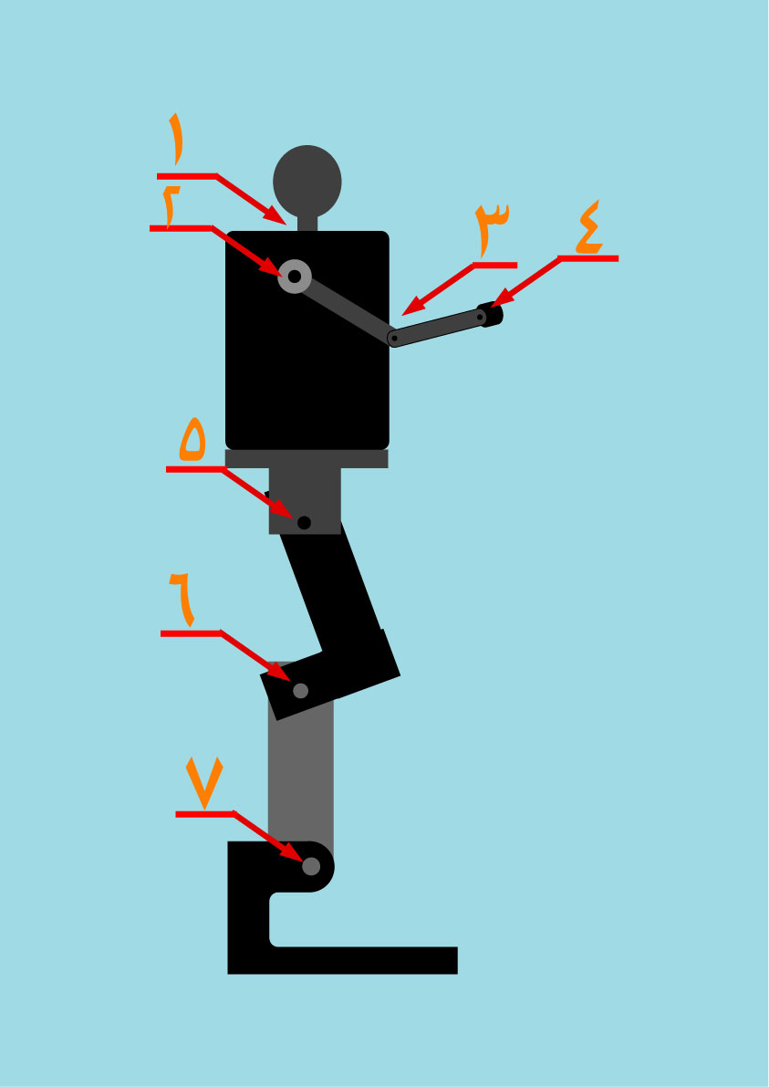
Picture(1)
The general shape of the module

Factors of safety

Using a photo coupler (moc3020):-
It is used to isolate the control circuit from the power circuit and it is consist of a light emitting diode with the cathode with ground and the anode with one terminals of the pic and when this terminal give a signal then this diode emit a light.
This light act as a gate current for a triak part which source part connected to 5 volt level and the drain connected to one pin of the H-bridge.
For each input of the H-bridge there is one moc to isolate it from the control circuit.
Picture(2): shows the traditional connection of moc2030/3010
Picture(3): shows the lay out of this IC.
Picture(4): shows the IC it self.
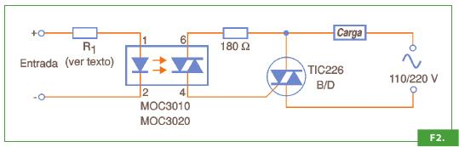
Picture(2)
traditional connection of moc2030/3010

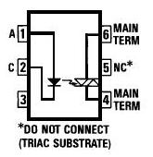
Picture(3)
The lay out of this moc3020/3010
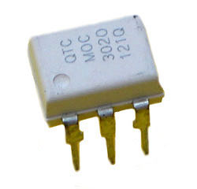

Picture(4)
The moc3020

Using a free wheeling diodes:-
It is used to free wheel the residual current if it occur and return back from the D.C motors, and it is may occurs because the motors facing a high load which may force the motor to rotate in opposite direction which produce reverse current.
You must remember that the H-bridge affected by the reverse currents when it enter to the output sides.
Picture(5): shows the free whiling diodes connection with the D.C motor.
Picture(6): the diode used

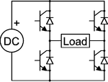

Picture(5)
The free whiling diodes connection with the D.C motor.

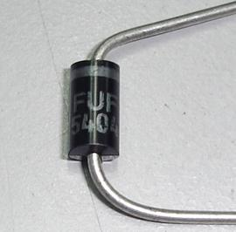

Picture(6): The diode

Minimization and optimization of the design

Using decoder 74139:-
The using of decoder 74139 minimize the number of pins necessary to control four stepper motors with four terminals and a common terminals from four pits for each one to two pits only, so, 16 pins for the four motors to 8 pins for them, i.e[I provided 8 pins in this action]
For more details:
The sequence needed to control and drive the stepper motor for one step is as following:-
Terminal one: 1 0 0 1 1
Terminal two: 1 1 0 0 1
Terminal three: 0 1 1 0 0
Terminal four: 0 0 1 1 0

And using the following sequence on a 74139 decoder provide the above sequence twice as shown bellow:-
. First Second .
A1 B1 A2 B2
0 0 0 0
0 1 0 1
1 0 0 0
0 1 1 1
1 0 1 0
1 1 1 1
0 0 1 0
0 1 1 1
When the selection lines(A1, B1, A2, B2) are controlled by the micro controller as shown in the previous table then the output sequence on the outputs of the decoder will be as following:-

Y01 Y11 Y21 Y31
0 1 1 1
1 1 0 1
0 0 1 1
1 1 0 1
1 0 1 1
1 1 1 0
0 1 1 1
1 1 0 1

Y02 Y12 Y22 Y32
0 1 1 1
1 1 0 1
0 1 1 1
1 1 1 0
1 0 1 1
1 1 1 0
1 0 1 1
1 1 1 0

For the first stepper:
Taking the Y21 to terminal one(T1).
Taking the Y22 to terminal two(T2).
Taking the Y31 to terminal three(T3).
Taking the Y42 to terminal four(T4).

Give the following sequence:-

T1 T2 T3 T4
Y21 Y22 Y31 Y32
1 1 1 1
0 0 1 1
1 1 1 1
0 1 1 0
1 1 1 1
1 1 0 0
1 1 1 1
0 1 1 0

Look to the table horizontally you will find that the sequence is as we want but with raw of ones between each two steps which is does not effect the stepper but increase the delay twice, because the pic make the sequence very fast which cannot recognized by the winding of the stepper i.e [if we want the delay 10 ms between each sequence then we do by the cod the delay 5 ms which multiplied by two and become 10 ms]
And this is possible.
For the second stepper:
Taking the Y21 to terminal one(T1).
Taking the Y22 to terminal two(T2).
Taking the Y31 to terminal three(T3).
Taking the Y42 to terminal four(T4).

Give the following sequence:-
T1 T2 T3 T4
Y01 Y02 Y11 Y12
0 0 1 1
1 1 1 1
1 0 0 1
1 1 1 1
1 1 0 0
1 1 1 1
0 1 1 0
1 1 1 1
The following is the truth table of the 74139 decoder

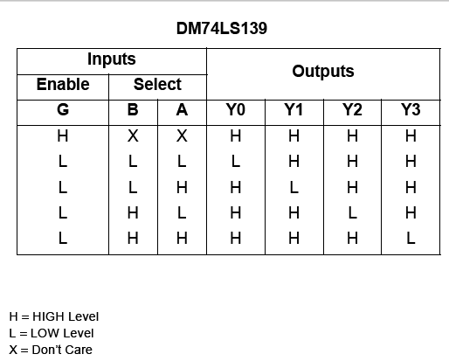

The following is the 74139 decoder lay out

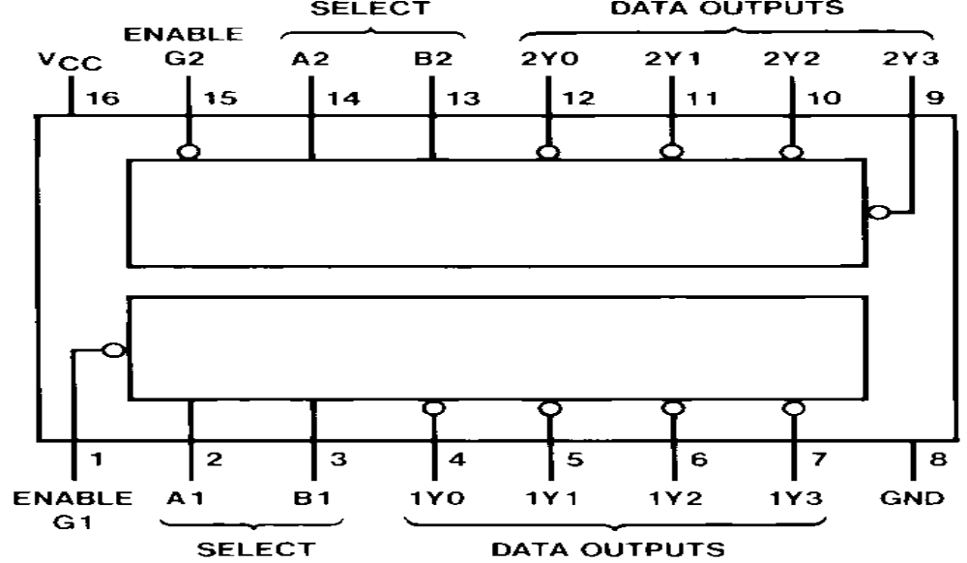

Using the push button mode in stead of addressing mode:-

The ISD2510 ic has 6 modes which is two type
- push botton mode
- addressing mode
addressing mode need 9 bit control word and 3 bits for play, record and start from beginning, which mean 12 bin from the pic
but using push button mode need the first three mentioned bits only which mean 3 bin from the pic
there is 9 bits were minimized.

The following is the typical push button circuit that used for the voice
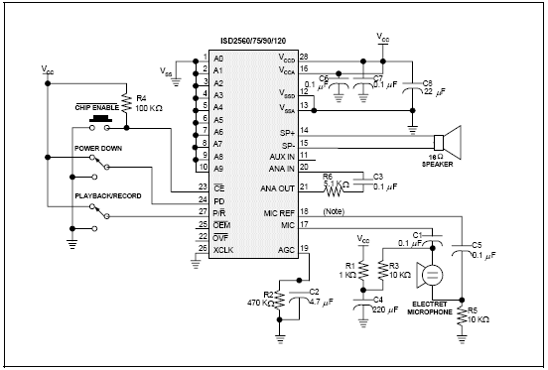

The conclusion by using minimization issue
8 bits + 9 bits = 17 bits were minimized and avoiding using other pic and stay on two pic.
But I have to face the difficulty in driving the stepper and longer thinking and longer coad
In the other hand the I have the difficulty in recording and displaying voice.
Function Sequence

Over all block diagram

The following is the sequence of the functions of each device in the project as a block diagram:

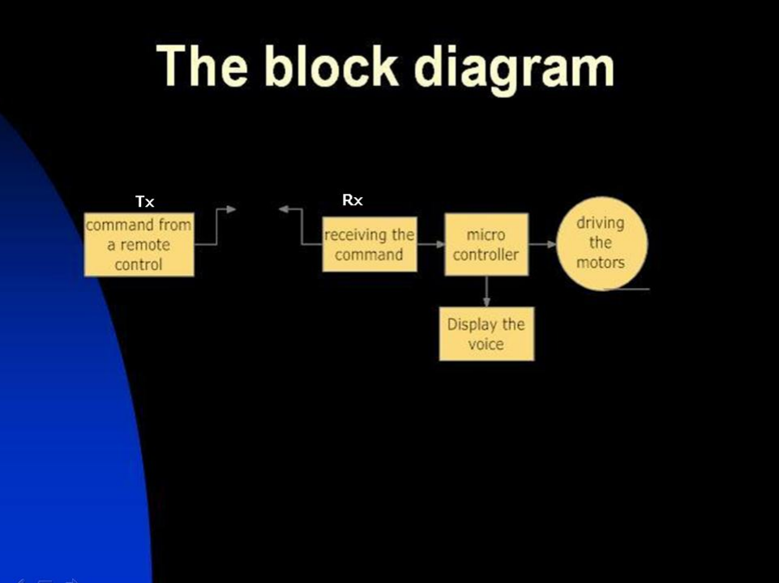

The algorithm sequence of the DC and stepper motors function and the voice display time as a chart:-

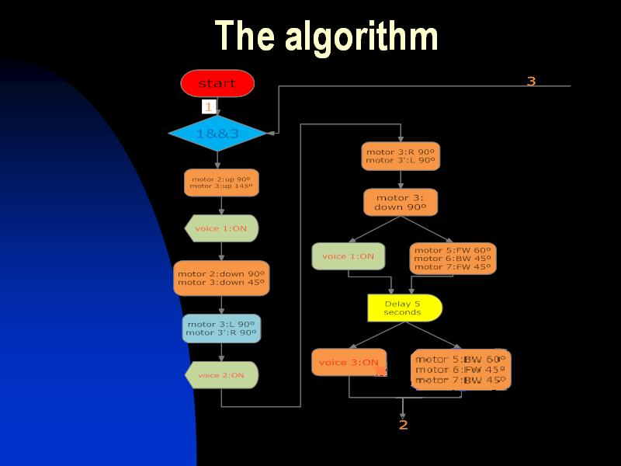
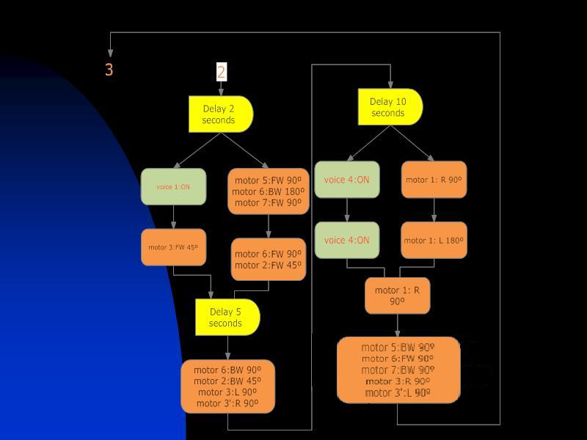

Electrical design

Some conventional circuit (basic circuit) for some devices

DC motor drive circuit “H-bridge basic circuit”:-

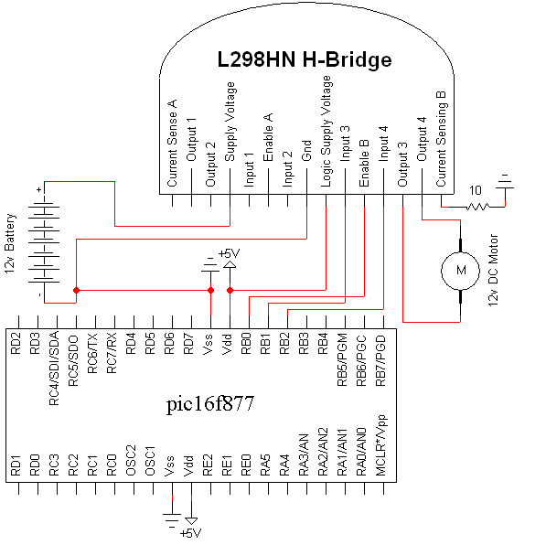

The connection of the free wheeling diodes with the H-bridge:-

Stepper motor drive circuit “stepper basic circuit”:-

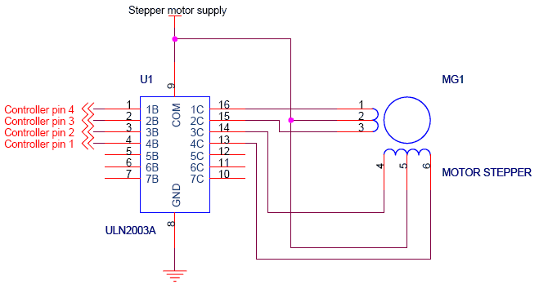

ISD25120 voice integrated circuit “ISD25120 typical application circuit”:-
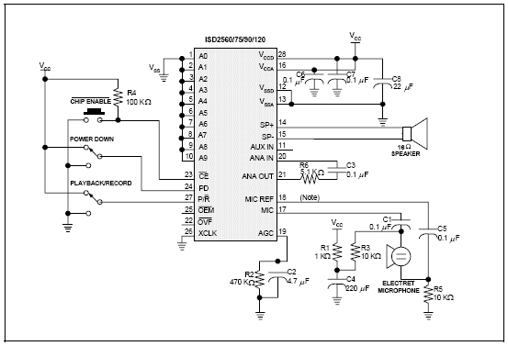

ISD25120 block diagram
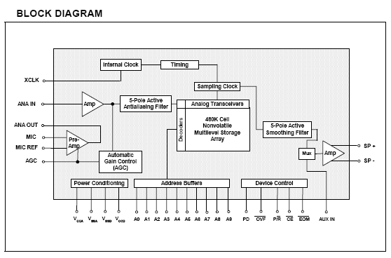
The timing diagram for push button mode recode is shown bellow:-

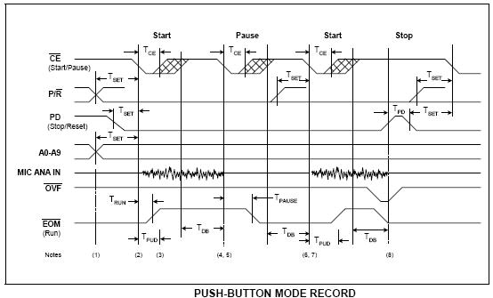

The timing diagram for push button mode playback is shown bellow:-
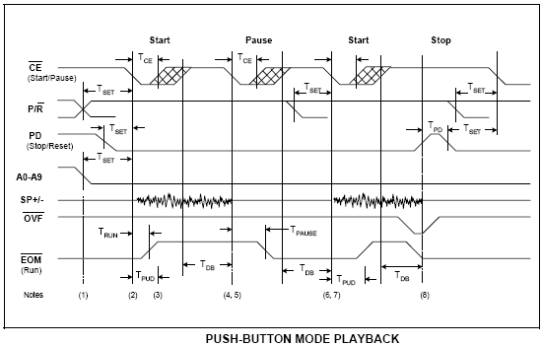

Recording in Push-Button Mode
1. The PD pin should be LOW, usually using a pull-down resistor.
2. The P/R pin is taken LOW.
3. The CE pin is pulsed LOW. Recording starts, EOM goes HIGH to indicate an
operation in progress.
4. When the CE pin is pulsed LOW. Recording pauses, EOM goes back LOW. The
internal address pointers are not cleared, but the EOM marker is stored in memory to
indicate as the message end. The P/ R pin may be taken HIGH at this time. Any
subsequent CE would start a playback at address 0.
5. The CE pin is pulsed LOW. Recording starts at the next address after the previous set
EOM marker. EOM goes back HIGH.[3]
6. When the recording sequences are finished, the final CE pulse LOW will end the last
record cycle, leaving a set EOM marker at the message end. Recording may also be
terminated by a HIGH level on PD, which will leave a set EOM marker.

Playback in Push-Button Mode
1. The PD pin should be LOW.
2. The P/R pin is taken HIGH.
3. The CE pin is pulsed LOW. Playback starts, EOM goes HIGH to indicate an operation
in progress.
4. If the CE pin is pulsed LOW or an EOM marker is encountered during an operation,
the part will pause. The internal address pointers are not cleared, and EOM goes back
LOW. The P/R pin may be changed at this time. A subsequent record operation would
not reset the address pointers and the recording would begin where playback ended.
5. CE is again pulsed LOW. Playback starts where it left off, with EOM going HIGH to
indicate an operation in progress.
6. Playback continues as in steps 4 and 5 until PD is pulsed HIGH or overflow occurs.
7. If in overflow, pulling CE LOW will reset the address pointer and start playback from the
beginning. After a PD pulse, the part is reset to address 0.

The program used to convert the text to voice is “Talk It” program

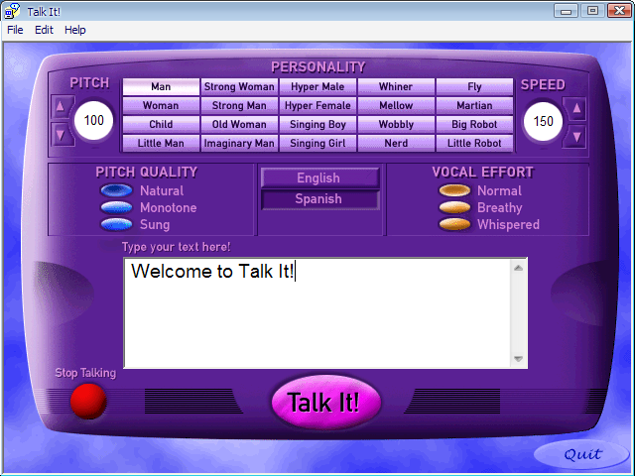

The infra reed receiver “HT12D”
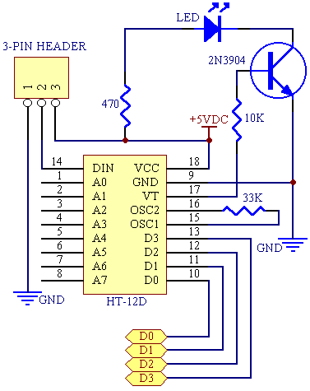

The block diagram
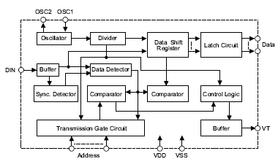
Address data wave form for HT12A

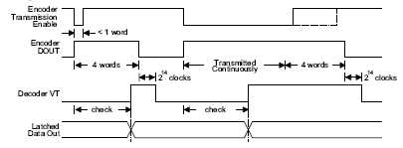

The flowchart

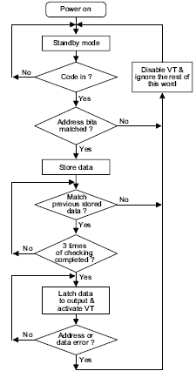

The Infra reed transmitter “HT12A”

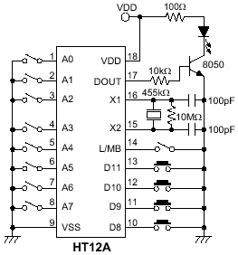

The block diagram
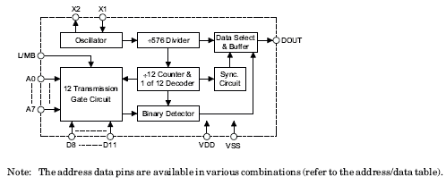
Address data wave form for HT12A

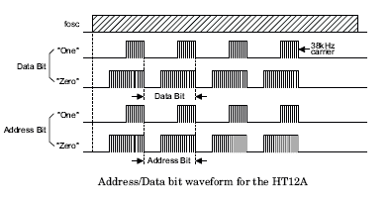

HT12A flow chart

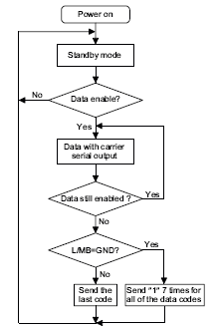

The difficulties

The difficulties embodied in many things as follow:-

- The magnitude of the system is too big and the need of control bins are big too, that is 8 DC motors and 3 bins for each which is 24 bin and 5 stepper motors and 4 bins for each to control which is 20 bin and 12 bins for the voice circuit, 4 bins for the commands from the ir decoder
- The synchronization between the two microcontroller which is too difficult.
- The MICANICAL STRUCTURE.
- The computation of current which mean the tourque available in each motor and match it with the mechanical and springs.
- Some devices access which does not exist in nablus and some time in Palestine like the distance sensor, IR decoder and encoder, the motors which I bring them from more than 25 scrap printers.

What I learned in this project

1) pic-c language and how to use it to program a robot.
2) Breaking the barrier of fear of the robotics technology.
3) Many software’s and programs like Talk it program, eagle, workbench and multizem
4) Now I am good in using serial port.
5) learning lathe skills, welding, and mechanical torque computation.
6) Now I am good in compacting the electrical circuits by hand.
7) The low current power supply.

Additions

The infra reed decoder and encoder which increase the command availability.
The number of languages.
The distance sensor

Conclusion

I did my robot design as I want which speak in three languages Arabic, English and Spanish
And its really the first one in my university
And this is the end result

The codes

PIC-C master microcontroller code

#include "C:\Documents and Settings\m7md\Desktop\mide\master.h"
pulse_f3(int x);
pulse_f4(int x);
pulse_b3(int x);
pulse_b4(int x);

int16 i=0;
int8 x = 0x66;

void main()
{

setup_adc_ports(NO_ANALOGS);
setup_adc(ADC_OFF);
setup_psp(PSP_DISABLED);
setup_spi(FALSE);
setup_timer_0(RTCC_INTERNAL|RTCC_DIV_1);
setup_timer_1(T1_DISABLED);
setup_timer_2(T2_DISABLED,0,1);

set_tris_A(0x0f);
set_tris_B(0x00);
set_tris_E(0x00);

while((input(pin_A0)==1)&&(input(pin_A1)==1)&&(input(pin_A2)==1)&&(input(pin_A3)==1))
restart_wdt();

if((input(pin_A0)==0)&&(input(pin_A1)==1)&&(input(pin_A2)==1)&&(input(pin_A3)==1))
{

output_high(PIN_E0);//////////////TO SLAVE PIC
set_tris_E(0xff);
while((input(pin_E0)==0))
restart_wdt();

if(input(pin_E0==1))
{
/////////////////////// F3 &F4

output_high(PIN_B3);
output_high(PIN_B6);

output_low(PIN_B2);
output_low(PIN_B5);

for(i=0;i<100;i++)
{
pulse_f3(5);
pulse_f4(5);

restart_wdt();
}
restart_wdt();

delay_ms(1000);///////////// delay # 1

output_low(PIN_B1);
output_low(PIN_B4);
for(i=0;i<100;i++)
{
pulse_b3(8);
pulse_b4(7);

restart_wdt();
}
restart_wdt();
//////////*********finish the seet*********

///////////////*********sgod*********
for(i=0;i<100;i++)
{
pulse_f3(8);
pulse_f4(7);

restart_wdt();
}
delay_ms(10);/////////////

//////////*********finish the sogod*********
}/////if

for(i=0;i<270;i++)
{
rotate_right( &x, 1);
OUTPUT_D(x);
delay_ms(5);
restart_wdt();
}

delay_ms(3000);
restart_wdt();

for(i=0;i<270;i++)
{
rotate_left( &x, 1);
OUTPUT_D(x);
delay_ms(5);
restart_wdt();
}
delay_ms(6000);
restart_wdt();

set_tris_E(0x00);
output_high(PIN_E1);//////////////TO SLAVE PIC

output_low(PIN_B2);
output_low(PIN_B5);
for(i=0;i<100;i++)
{
pulse_f3(8);
pulse_f4(7);

restart_wdt();
}
restart_wdt();

}/////if

}/////main

//////////////////////////////functions
pulse_f3(int x)
{
output_high(PIN_B1);
delay_ms(x);
output_low(PIN_B1);
delay_ms(10-x);
restart_wdt();
}

pulse_f4(int x)
{
output_high(PIN_B4);
delay_ms(x);
output_low(PIN_B4);
delay_ms(10-x);
restart_wdt();
}

pulse_b3(int x)
{
output_high(PIN_B2);
delay_ms(x);
output_low(PIN_B2);
delay_ms(10-x);
restart_wdt();
}

pulse_b4(int x)
{
output_high(PIN_B5);
delay_ms(x);
output_low(PIN_B5);
delay_ms(10-x);
restart_wdt();

PIC-C slave microcontroller code

#include "C:\Documents and Settings\m7md\Desktop\mide\slave.h"
pulse_f1(int x);
pulse_f2(int x);
pulse_f5(int x);
pulse_f6(int x);
pulse_b1(int x);
pulse_b2(int x);
pulse_b5(int x);
pulse_b6(int x);

int16 i=0;

void main()
{

setup_adc_ports(NO_ANALOGS);
setup_adc(ADC_OFF);
setup_psp(PSP_DISABLED);
setup_spi(FALSE);
setup_timer_0(RTCC_INTERNAL|RTCC_DIV_1);
setup_timer_1(T1_DISABLED);
setup_timer_2(T2_DISABLED,0,1);

set_tris_A(0X00);
set_tris_B(0X00);
set_tris_E(0Xff);
set_tris_D(00f);
if((input(pin_E0)==1))
{

set_tris_E(0X00);
output_low(PIN_E0);
for(i=0;i<200;i++)////stepper 7 & 8 F.W
{
////1
output_bit( PIN_D0, 0);
output_bit( PIN_D1, 0);
output_bit( PIN_D2, 0);
output_bit( PIN_D3, 0);

delay_ms(3);
restart_wdt();
////2
output_bit( PIN_D0, 0);
output_bit( PIN_D1, 1);
output_bit( PIN_D2, 1);
output_bit( PIN_D3, 0);

delay_ms(3);
restart_wdt();
////3
output_bit( PIN_D0, 1);
output_bit( PIN_D1, 0);
output_bit( PIN_D2, 0);
output_bit( PIN_D3, 0);

delay_ms(3);
restart_wdt();
////4
output_bit( PIN_D0, 1);
output_bit( PIN_D1, 1);
output_bit( PIN_D2, 0);
output_bit( PIN_D3, 1);

delay_ms(3);
restart_wdt();
////5
output_bit( PIN_D0, 1);
output_bit( PIN_D1, 0);
output_bit( PIN_D2, 1);
output_bit( PIN_D3, 0);

delay_ms(3);
restart_wdt();
////6
output_bit( PIN_D0, 1);
output_bit( PIN_D1, 1);
output_bit( PIN_D2, 1);
output_bit( PIN_D3, 1);

delay_ms(3);
restart_wdt();
////7
output_bit( PIN_D0, 0);
output_bit( PIN_D1, 0);
output_bit( PIN_D2, 1);
output_bit( PIN_D3, 0);

////8
output_bit( PIN_D0, 0);
output_bit( PIN_D1, 1);
output_bit( PIN_D2, 1);
output_bit( PIN_D3, 1);

delay_ms(3);

restart_wdt();

}//for

delay_ms(10);

restart_wdt();

for(i=0;i<150;i++)///////////////////// steper 9 & 10 F.W
{
////1
output_bit( PIN_D4, 0);
output_bit( PIN_D5, 0);
output_bit( PIN_D6, 0);
output_bit( PIN_D7, 0);

delay_ms(3);
restart_wdt();
////2
output_bit( PIN_D4, 0);
output_bit( PIN_D5, 1);
output_bit( PIN_D6, 1);
output_bit( PIN_D7, 0);

delay_ms(3);
restart_wdt();
////3
output_bit( PIN_D4, 1);
output_bit( PIN_D5, 0);
output_bit( PIN_D6, 0);
output_bit( PIN_D7, 0);

delay_ms(3);
restart_wdt();
////4
output_bit( PIN_D4, 1);
output_bit( PIN_D5, 1);
output_bit( PIN_D6, 0);
output_bit( PIN_D7, 1);
delay_ms(3);
restart_wdt();
////5
output_bit( PIN_D4, 1);
output_bit( PIN_D5, 0);
output_bit( PIN_D6, 1);
output_bit( PIN_D7, 0);

delay_ms(3);
restart_wdt();
////6
output_bit( PIN_D4, 1);
output_bit( PIN_D5, 1);
output_bit( PIN_D6, 1);
output_bit( PIN_D7, 1);

delay_ms(3);
restart_wdt();
////7
output_bit( PIN_D4, 0);
output_bit( PIN_D5, 0);
output_bit( PIN_D6, 1);
output_bit( PIN_D7, 0);

////8
output_bit( PIN_D4, 0);
output_bit( PIN_D5, 1);
output_bit( PIN_D6, 1);
output_bit( PIN_D7, 1);

delay_ms(3);

restart_wdt();

}//for

delay_ms(4000);

restart_wdt();

for(i=0;i<200;i++)////stepper 7 & 8 B.W
{

////8
output_bit( PIN_D0, 0);
output_bit( PIN_D1, 1);
output_bit( PIN_D2, 1);
output_bit( PIN_D3, 1);

delay_ms(3);
restart_wdt();
////7
output_bit( PIN_D0, 0);
output_bit( PIN_D1, 0);
output_bit( PIN_D2, 1);
output_bit( PIN_D3, 0);

delay_ms(3);
restart_wdt();
////6
output_bit( PIN_D0, 1);
output_bit( PIN_D1, 1);
output_bit( PIN_D2, 1);
output_bit( PIN_D3, 1);

delay_ms(3);
restart_wdt();
////5
output_bit( PIN_D0, 1);
output_bit( PIN_D1, 0);
output_bit( PIN_D2, 1);
output_bit( PIN_D3, 0);

delay_ms(3);
restart_wdt();
////4
output_bit( PIN_D0, 1);
output_bit( PIN_D1, 1);
output_bit( PIN_D2, 0);
output_bit( PIN_D3, 1);

delay_ms(3);
restart_wdt();
////3
output_bit( PIN_D0, 1);
output_bit( PIN_D1, 0);
output_bit( PIN_D2, 0);
output_bit( PIN_D3, 0);

delay_ms(3);
restart_wdt();
////2
output_bit( PIN_D0, 0);
output_bit( PIN_D1, 1);
output_bit( PIN_D2, 1);
output_bit( PIN_D3, 0);

////1
output_bit( PIN_D0, 0);
output_bit( PIN_D1, 0);
output_bit( PIN_D2, 0);
output_bit( PIN_D3, 0);

delay_ms(3);
restart_wdt();

}//for

delay_ms(10);

restart_wdt();////stepper 9 & 10 B.W

set_tris_D(00f);

for(i=0;i<150;i++)
{
////8
output_bit( PIN_D4, 0);
output_bit( PIN_D5, 1);
output_bit( PIN_D6, 1);
output_bit( PIN_D7, 1);

delay_ms(3);
restart_wdt();

////7
output_bit( PIN_D4, 0);
output_bit( PIN_D5, 0);
output_bit( PIN_D6, 1);
output_bit( PIN_D7, 0);

delay_ms(3);
restart_wdt();
////6
output_bit( PIN_D4, 1);
output_bit( PIN_D5, 1);
output_bit( PIN_D6, 1);
output_bit( PIN_D7, 1);

delay_ms(3);
restart_wdt();

////5
output_bit( PIN_D4, 1);
output_bit( PIN_D5, 0);
output_bit( PIN_D6, 1);
output_bit( PIN_D7, 0);

delay_ms(3);
restart_wdt();

////4
output_bit( PIN_D4, 1);
output_bit( PIN_D5, 1);
output_bit( PIN_D6, 0);
output_bit( PIN_D7, 1);

delay_ms(3);
restart_wdt();

////3
output_bit( PIN_D4, 1);
output_bit( PIN_D5, 0);
output_bit( PIN_D6, 0);
output_bit( PIN_D7, 0);

delay_ms(3);
restart_wdt();

////2
output_bit( PIN_D4, 0);
output_bit( PIN_D5, 1);
output_bit( PIN_D6, 1);
output_bit( PIN_D7, 0);

delay_ms(3);
restart_wdt();

////1
output_bit( PIN_D4, 0);
output_bit( PIN_D5, 0);
output_bit( PIN_D6, 0);
output_bit( PIN_D7, 0);

delay_ms(3);
restart_wdt();

}//for

delay_ms(8000);

restart_wdt();

set_tris_E(0X00);
output_high(PIN_E0);////////////////to master pic

{
output_high(PIN_A0);
output_low(PIN_A1);

for(i=0;i<100;i++)
{
pulse_b1A2(8);

restart_wdt();
}

restart_wdt();

for(i=0;i<1000;i++)
{
pulse_f5(8);
pulse_f6(7);

restart_wdt();

delay_ms(10);/////////////
for(i=0;i<1000;i++)
{
pulse_f1A2(8);

restart_wdt();
}

//////////*********finish the seet*********
///////////////*********sogod*********
//////////*********finish the sogod*********

output_low(PIN_B2);
output_low(PIN_B5);

for(i=0;i<1000;i++)
{
pulse_b5(10);
pulse_b6(10);

restart_wdt();

delay_ms(10);/////////////

for(i=0;i<1000;i++)
{
pulse_b1A2(10);

restart_wdt();
}
}

////////////////////////////////////////// THE FUNCTIONS

pulse_f1A2(int x)
{
output_high(PIN_A2);
delay_ms(x);
output_low(PIN_A2);
delay_ms(10-x);
restart_wdt();
}

pulse_f5(int x)
{
output_high(PIN_B1);
delay_ms(x);
output_low(PIN_B1);
delay_ms(10-x);
restart_wdt();
}

pulse_f6(int x)
{
output_high(PIN_B4);
delay_ms(x);
output_low(PIN_B4);
delay_ms(10-x);
restart_wdt();
}

pulse_b1A2(int x)
{
output_high(PIN_A1);
delay_us(x);
output_low(PIN_A1);
delay_us(10-x);
restart_wdt();
}

pulse_b5(int x)
{
output_high(PIN_B2);
delay_ms(x);
output_low(PIN_B2);
delay_ms(10-x);
restart_wdt();

}

pulse_b6(int x)
{
output_high(PIN_B5);
delay_ms(x);
output_low(PIN_B5);
delay_ms(10-x);
restart_wdt();

}

set_tris_E(0X00);

output_high(PIN_E0);//////////////////to master pic

The Importance of Robots

Robots in antiquity and through the Middle Ages were used primarily for entertainment. However, the 20th century featured a boom in the development of industrial robots. Through the rest of the century, robots changed the structure of society and allowed for safer conditions for labor. In addition, the implementation of advanced robotics in the military and NASA has changed the landscape of national defense and space exploration. Robots have also been influential in the media and profitable for for toy manufacturers

History
Robots began as entertainment for royalty. Inventors such as Al-Jazari and Leonardo Da Vinci worked to build automatons for their benefactors. Al-Jazari built a floating band that resembled humans and performed various songs and drum beats depending on the programming of a series of pegs. Da Vinci created a automaton based on the knight's armor. It could stand and move itsarms and neck, as well as open its mouth.
It wasn't until 1961--when an inventor named George Devol installed his robot, Unimate, into a General Motors factory in Trenton, New Jersey--that the first modern industrial use of the robot was attempted. Unimate would lift die-cut metal pieces and stack them for the human workers. This development changed the dynamics of robotics and brought them into the workplace, making them pivotal to a business.

Significance
Industry has benefited drastically from the expanse of a robotic work force. Automated machines have taken over the duties of dangerous and mundane jobs from humans, allowing greater productivity. Because robots never tire, extra shifts have been added to factories. Farmers have taken advantage of new technology with automated harvesters, the waste disposal industry has implemented robots in some of its dirtier jobs, and the medical industry benefits from advancements in assisted surgical robotics.
The idea of a factory with no human workers has come to fruition. IBM runs a "lights off" factory in Texas completely staffed by fully autonomous robots making keyboards.
The military has launched various programs in robotic technology, most successfully the Predator and Reaper unmanned aerial reconnaissance vehicles that allow a pilot to control the robot from vast distances. The vehicles can do high-altitude surveillance for long periods without having to support a live pilot, and when needed the planes can launch small strikes on targets in zones that normal aircraft cannot operate.

Features
Robots' main position in society are in a capacity to assist humans by taking on the jobs that are dirty, dull or dangerous. Beyond the factory floor, robots have been instrumental in space exploration and performing other tasks that would be impossible for humans to accomplish. The Mars rovers Spirit and Opportunity lasted years longer than NASA predicted and stayed on the mission far past the time any manned mission could have functioned. The Deep Impact probe that crashed into a comet literally functioned at a capacity impossible for humans.
The Chernobyl meltdown site contains radiation levels that would kill any human. As such, the Pioneer robot was developed to enter the remains of the facility to address structural stability. Also, the Dante II was utilized to enter volcanic eruptions, which are impossible for humans to investigate.

Considerations
Robots have had a long importance in the media, between our fascination with real-life robotics and their fictional counterparts. The first instance of a robot in a film was in Fritz Lang's "Metropolis." It introduced the concept of a functioning automaton programmed to act as a human. Robots appeared frequently over the course of the next century in films such as "Forbidden Planet" and television programs like "Star Trek." Probably the most famous duo of robots ever are C-3PO and R2-D2 from the "Star Wars" films. The characters brought a humanistic attitude to the previously dry image of robots. In modern cinema, robots have portrayed heroes and villains, both elaborately sophisticated and starkly simplistic. The machines featured in "The Terminator" have long held a scary yet fascinating influence over the culture of robotics.

Misconceptions
Modern robotics are present everywhere in society, from a DVD burner in a computer to the microwave in most American kitchens. The invention of the microprocessor in 1971 caused the computerization of virtually every appliance and tool the modern home uses. Toasters and stoves utilize microprocessors that control sensors to reduce the likelihood of fires, while cellular phones implement virtual memory to enhance interaction.
Most toy stores now feature hundreds of robots for educational and entertainment use. With the introduction of the "Furby" in the late 1990s, robots with limited artificial intelligence become a boon for the marketplace, generating vast amounts of revenue in simple consumer-ready robotics.

Principles of Robotics
The word robot comes from the Czech word for forced labor, or serf. It was introduced by playwright Karel Capek, whose fictional robotic inventions were created by chemical and biological, rather than mechanical, methods.

Basically a robots consists of :
• A mechanical structure, such as a wheeled platform, arm, or other construction, capable of interacting with its environment.
• Motors, DC motors, AC motors, Stepping motors, Servomotors
• Sensors, to sense the environment and give useful feedback to the device.
• power supply.
• Systems, to process sensory input in the context of the current situation and instruct the device to perform actions in response to the situation.

1.Mechanical Structure
The robot structure consists basically of the robot body that includes arms and wheels. Some force such as electricity is required to make the arms and wheels turn under command. One of the most interesting aspects of robot in general is its behavior, which requires a form of intelligence
2.Motors
A variety of electric motors provide power to robots, making them move with various programmed motions. The efficiency rating of a motor describes how much of the electricity consumed is converted to mechanical energy.
1. DC motors. Permanent-magnet DC motors require only two leads, and use an arrangement of fixed- and electro-magnets (stator and rotor) and switches. These form a commutator to create motion through a spinning magnetic field.
2. AC motors. These motors cycle the power at the input-leads, to continuously move the field.
3. Stepping motors. They are like a brushless DC or AC motor. They move the rotor by applying power to different magnets in the motor in sequence (stepped). Stepping motors are designed for fine control and will not only spin on command, but can spin at any number of steps-per-second (up to their maximum speed).
4. Servomotors. Servos are simple DC motors with gearing and a feedback control system. They adjust themselves until they match the signal. Servos are used in radio control airplanes and cars.

More About Motors
Mechanisms
Gears and chains. Gears and chains are mechanical parts that provide a mechanism to transmit rotational motion from one place to another with a possibly of changing it along the way. The speed change between two gears depends on the number of teeth on each gear.
Pulleys and belts. Pulleys and belts, two other simple machines used in robots, work the same way as gears and chains. Pulleys are wheels with a groove around the edge, and belts are the rubber loops that fit in that groove.

Gearboxes. A gearbox operates on the same principles as the gear and chain, without the chain. Examples of gearboxes are found on the transmission in a car and the paper-feed of a printer.

Example : Simple Mechanism.
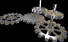
There are many different types of machines with varying capabilities and functions. This section is about common simple machines which are everywhere around us.
Inclined Plane
An inclined plane is a simple machine with no moving parts. It is simply a straight slanted surface set at an angle (other than a right angle) against a horizontal surface used to raise an object. Examples of inclined planes include ramp, slanted road, slide, and path up a hill.
The following figure shows an inclined plane. The length A is the base, length B is the height, and length C is the inclined plane. With the use of the inclined plane a given resistance can be overcome with a smaller force than if the plane is not used. For example, in the figure, suppose we wish to raise a weight of 100 kg through the vertical distance B = 2 m. If this weight were raised vertically and without the use of the inclined plane the force 100 kg would have to be exerted through the distance B. However, if the inclined plane is used and the weight is moved over the inclined plane C, a force of only 2/3 of 100 kg or 66.7 kg is required. Remember, this force is exerted through a distance C which is greater than distance B.
Using an inclined plane requires a smaller force exerted through a greater distance to do a certain amount of work. Letting F represent the force required to raise a given weight on the inclined plane, and W the weight to be raised, we have the proportion:
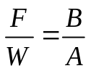
In our daily life, lifting an object straight up is heavier than pulling it up an incline plane, we do not need to use as much force. However, the inclined plane is longer. Inclined planes can also be used in reverse to slow things down to a stop. It is easy to find applications of inclined planes everywhere: Ramps for wheelchairs, steps, a ski jump, car ramps, playground slide, boat ramps, etc.

A

B
C
100 kg
66.7 kg
wheels
The gear, the wheel and axle, and the pulley are all kinds of wheels, with small alterations. A gear is a wheel with accurately machined teeth round its edge. Its purpose is to transmit rotary motion and force. Basic relationships for a gear are the number of teeth, the diameter, and the rotary velocity of gears. Gears being an important part of a machine have many applications within various industries. These industries include automotive industries, steel plants industry, paper industry, in mining and many more. They are used as conveyors, elevators, separators, cranes and lubrication systems.
The following figure shows the ends of two shafts A and B connected by 2 gears of 12 and 24 teeth respectively. The larger gear will make only one-half turn while the smaller makes a complete turn. That is, the ratio of speeds (velocity ratio) of the large to the smaller is as 1 to 2. The gear that is closer to the source of power is called the driver, and the gear that receives power from the driver is called the driven gear. The ratio between the rotation speed of the driven gear and the rotation speed of the driver is called the gear ratio.

B: 12 teeth A: 24 teeth
Levers
Another basic mechanism is the lever, a bar which rests, or pivots, on a fulcrum. A seesaw is a familiar example of a lever in which one weight balances the other. The hammer is another example of lever when it is used to pull a nail out of a piece of wood.
All levers have at least two basic purposes. One is to lift or move a load at one place on the lever by making an effort at another location of the bar. The second is to apply a force to an object by exerting the force elsewhere.
Levers can be used to change the distance and power of movement. All levers have three basic parts: the fulcrum, a force or effort, and a weight.
There are three types of levers as shown in the figure. The location of the fulcrum in relation to the resistance (or weight) and the effort determine the lever class.
First Class
Second Class
Third Class
Fulcrum
Fulcrum

Weight
Fulcrum

Weight

Force
Weight
Force

Force
Common examples of first-class levers include crowbars, scissors, pliers, tin snips and playground seesaws. Examples of second-class levers include nut crackers, wheel barrows, and certain types of bottle openers. The human bicep muscle is an example of a third class lever.
Screws

A screw is a shaft with a thread or groove wrapped around it to form a helix. While turning, a screw converts a rotary motion into a forward or backward motion. By rotating the screw (applying a torque), the force is applied perpendicular to the groove, therefore translating a rotational force into a linear one. It is frequently used to fasten objects together.
Wedges

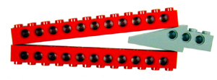
The wedge allows motion from objects such as hammers to be transferred into a breaking, cutting, or splitting motion. The force is perpendicular to the inclined surfaces, so it pushes two objects (or portions of a single object) apart. A wedge converts motion in one direction into a splitting motion that acts at right angles to the blade. Nearly all cutting machines use the wedge including knifes. A lifting machine may use a wedge to get under a load.
Belt and pulleys
Belts and pulleys are an important part of most machines. Pulleys are gears without teeth and instead of running together directly they are made to drive one another by cords, ropes, cables, or belting of some kinds. As with gears, the velocities of pulleys are inversely proportional to their diameters. Examples of where pulleys can be used include flag poles, sailboats, blinds, and cranes. The following figure shows belt and pulleys. Pulleys can also be arranged as a block and tackle.

Focus on Engineering
Simple machines are common today in the form of various tools . The same physical principles and mechanical application of simple machines used by ancient engineers to build pyramids are employed by modern engineers to construct various structures such as houses, roads, bridges, and skyscrapers.

3.Sensors
Robots operate according to a basic measurement, requiring different kinds of sensors. A sense of time is usually built-in through perceptual hardware and software, which updates quickly. Sensors interact with external environment and transforms the energy associated with what is being measured (sound, light, pressure, temperature, distance, commands, etc.)
into another form of energy. Common sensors used in robotics include light sensors, touch sensors, sound sensors, and acceleration sensor.
A sound sensor is installed at the ear position of the robot in order to detect the voice of a subject. An acceleration sensor is installed in the body to detect shaking. A touch sensor is installed in the forehead of the robot to detect touch

4.Power Supply
In general, power supply is provided by two types of sources: batteries that are used once only and then discarded; and rechargeable batteries that operate from a reversible chemical reaction and can be recharged many times. The first use of a rechargeable battery gives up to 4 hours of continuous operation in an application.

5.Control System
There are two main systems to control robots: logic circuit and a microcontroller.
Logic Circuit
A digital logic circuit controls the mechanical system. The circuit is usually coupled to the mechanical structure through a bridge relay. A control signal generates a magnetic field in the relay's coil that mechanically closes a switch. transistors, for example, are good silicon switches, available in many technologies to control the mechanical systems.

Microcontroller
Microcontrollers are intelligent electronic devices that are used inside robots. They deliver functions similar to those performed by a microprocessor (CPU) inside a personal computer. Microcontrollers are slower and have less memory than CPUs, but are designed for real-world control problems. One of the major differences between CPUs and microcontrollers is the number of external components needed to operate them. Microcontrollers may run with no external parts, and typically need only an external crystal or oscillator.
There are three main characteristics of a microcontroller for consideration: speed, size, and memory. Speed is designated in clock cycles, and is usually measured in millions of cycles per second (Megahertz, MHz). Size specifies the number of bits of information the Microcontroller can process in one step (for example, 4-, 8-, 16-, and 32-bits). Microcontrollers count most of their read-only memory (ROM) in thousands of bytes (kB) and random access memory (RAM) in single bytes.

References

http://www.g9toengineering.com/resources/robotics.htm

http://www.ehow.com/about_4596141_importance-robots.html

